Name of Journal: World Journal of Psychiatry
Manuscript NO: 84637
Manuscript Type: ORIGINAL ARTICLE

Retrospective Study
Effects of health concept model-based detailed behavioral care on mood and quality of life in elderly patients with chronic heart failure

Zheng AD et al. Health concept model-based detailed behavioral care

Ai-Di Zheng, Li-Li Cai, Jing Xu

Ai-Di Zheng, Li-Li Cai, Jing Xu, Department of Cardiology, Affiliated Hangzhou First People’s Hospital, Zhejiang University School of Medicine, Hangzhou 310006, Zhejiang Province, China

Author contributions: Zheng AD and Xu J carried out the studies, and conceived and designed the study; Zheng AD and Cai LL performed the analyses and collected the data; Zheng AD drafted the manuscript; all authors approved the final manuscript submitted.

Supported by Zhejiang Medical and Health Science and Technology Program (Project Name: Construction and Application of Exercise Fear Intervention Program for Elderly Patients with Chronic Heart Failure Based on HBM and TPB Theory), No. 2023KY180.

Corresponding author: Jing Xu, BSc, Associate Chief Nurse, Department of Cardiology, Affiliated Hangzhou First People’s Hospital, Zhejiang University School of Medicine, No. 261 Huansha Road, Shangcheng District, Hangzhou 310006, Zhejiang Province, China. xujing68711@163.com

Received: April 7, 2023
Revised: May 17, 2023
Accepted: May 23, 2023
Published online: July 19, 2023

Abstract
BACKGROUND
With the intensification of social aging, the susceptibility of the elderly population to diseases has attracted increasing attention, especially chronic heart failure (CHF) that accounts for a large proportion of the elderly.

AIM
To evaluate the application value of health concept model-based detailed behavioral care in elderly patients with CHF.

METHODS
This study recruited 116 elderly CHF patients admitted from October 2018 to October 2020 and grouped them according to the nursing care that they received. The elderly patients who underwent health concept model-based detailed behavioral care were included in a study group (SG; n = 62), and those who underwent routine detailed behavioral nursing intervention were included as a control group (CG; n = 54). Patients’ negative emotions (NEs), quality of life (QoL), and nutritional status were assessed using the self-rating anxiety/depression scale (SAS/SDS), the Minnesota Living with Heart Failure Questionnaire (MLHFQ), and the Modified Quantitative Subjective Global Assessment (MQSGA) of nutrition, respectively. Differences in rehabilitation efficiency, NEs, cardiac function (CF) indexes, nutritional status, QoL, and nursing satisfaction were comparatively analyzed.

RESULTS
A higher response rate was recorded in the SG vs the CG after intervention (P < 0.05). After care, the left ventricular ejection fraction was higher while the left ventricular end-diastolic dimension and left ventricular end systolic diameter were lower in the SG compared with the CG (P < 0.05). The post-intervention SAS and SDS scores, as well as MQSGA and MLHFQ scores, were also lower in the SG (P < 0.05). The SG was also superior to the CG in the overall nursing satisfaction rate (P < 0.05).

CONCLUSION
Health concept model-based detailed behavioral care has high application value in the nursing care of elderly CHF patients, and it can not only effectively enhance rehabilitation efficiency, but also mitigate patients’ NEs and improve their CF and QoL.

Key Words: Chronic heart failure; Elderly patients; Health concept model; Detailed behavioral care; Patient mood; Quality of life; Nursing effect

©The Author(s) 2023. Published by Baishideng Publishing Group Inc. All rights reserved.

Citation: Zheng AD, Cai LL, Xu J. Effects of health concept model-based detailed behavioral care on mood and quality of life in elderly patients with chronic heart failure. World J Psychiatry 2023; 13(7): 444-452
URL: https://www.wjgnet.com/2220-3206/full/v13/i7/444.htm
DOI: https://dx.doi.org/10.5498/wjp.v13.i7.444

Core Tip: Elderly patients with chronic heart failure (CHF) are prone to negative emotions (NEs) such as depression and anxiety during treatment. Although some drugs can alleviate NEs, they are not conducive to the cardiac function of patients. Therefore, effective means should be explored clinically to improve the mood and quality of life of elderly patients with CHF.

INTRODUCTION
Chronic heart failure (CHF) is a clinically common cardiovascular disorder that may cause various complications^{[1,2]}. The disease is difficult to treat with a high death rate, re-hospitalization rate, and bleak prognosis, resulting in great clinical attention to its treatment and nursing care^{[3]}. In the current aging society, CHF patients account for a large proportion of the elderly population^{[4]}. CHF in the elderly is characterized by a long course, multiple underlying comorbidities, and declined self-care ability, bringing huge economic burden to patients' families and society^{[5]}. Elderly CHF patients are also predisposed to negative emotions (NEs) due to their age and unpredictable conditions^{[6]}. Although drugs such as duloxetine can be used to relieve depression and other NEs, they may be disadvantageous to patients’ cardiac function (CF)^{[7,8]}. Effective nursing intervention is therefore extremely necessary, which is the key to improving patients' quality of life (QoL) and disease prognosis^{[9]}.
Conventional nursing intervention, being single and inflexible, cannot meet the actual needs of elderly CHF patients^{[10]}. Health concept model-based detailed behavioral care, on the other hand, formulates nursing intervention programs through behavioral and social psychology, which encourages patients to take the initiative to adopt healthy behaviors, thus improving the treatment effect^{[11]}. In addition, there is a positive correlation between health beliefs and healthy behaviors. Establishing correct health beliefs allows people to accept persuasion, change unhealthy behaviors, and actively adopt healthy behaviors^{[12]}. At present, the health belief model has been widely used in the health education of various diseases with good effects achieved^{[13]}. Besides, chronic and unremitting symptoms and long treatment process significantly reduces the QoL of CHF patients while causing NEs such as anxiety and depression^{[14]}. Health education can mitigate the NEs of elderly CHF patients and enhance their disease awareness to mitigate their fear of the disease due to insufficient awareness^{[15]}.
Based on the above, this study explored the application value of health concept model-based detailed behavioral care in the care of elderly CHF patients.

MATERIALS AND METHODS
Patient information
The clinical data of 116 elderly patients with CHF admitted to the Affiliated Hangzhou First People's Hospital Zhejiang University School of Medicine from October 2018 to October 2020 were analyzed retrospectively. Patients who underwent health concept model-based detailed behavioral care were included in a study group (SG; n = 62, male-female ratio 40:22) and those who underwent routine detailed behavioral nursing intervention were included in a control group (CG; n = 54, male-female ratio 29:25).

Eligibility criteria
The enrolled patients all were aged ≥ 60 years, with a confirmed diagnosis of CHF^{[16]}, complete clinical data, and active cooperation with treatment. Patients and their families were informed and consented to participate in the study.
Patients with chronic obstructive pulmonary disease, cerebral toxicosis, hyperthyroidism, inability to eat normally, cognitive and consciousness disorders, serious infections, malignant diseases, and limited mobility or those who were otherwise unable to complete all care measures were excluded from the study.

Nursing methods
Patients in the CG were intervened by routine detailed behavioral nursing. Following the doctor's advice, patients were instructed to stay in bed or carry out appropriate activities. Besides, their body temperature and pulse were monitored on time until discharge, and their conditions were closely observed.
Patients in the SG received health concept model-based detailed behavioral care. Before carrying out the nursing work, the nursing staff introduced the disease to the elderly patients in detail, and guided them to relax and cooperate with the care. In addition, each patient's condition and physical function were assessed in a timely manner by means of echocardiography and 24-h continuous ECG monitoring, and the corresponding nursing plan was formulated based on the evaluation results. Furthermore, medication management was strengthened. The patient's indicators (e.g., blood pressure and blood lipid) were strictly monitored and controlled within the reference range as far as possible to prevent complications. The emotional status of patients was always concerned during daily care. When they were found to develop NEs, the causes of unhealthy psychological states were analyzed in time, based on which targeted psychological nursing intervention was developed and implemented. During the nursing intervention, patients’ bad daily behavioral habits were corrected, and they were guided to keep good hours to reduce the burden on their hearts. In addition, a certain amount of exercise was also ensured, which was realized by developing an appropriate exercise program for each patient to help improve his/her physical fitness and blood circulation. Moreover, a reasonable diet plan was formulated based on the patient's nutritional status and physical function. In the daily diet, patients were advised to take easy-to-digest, crude fiber, and light foods, and avoid oily and high-fat foods.

Outcome measures
The rehabilitation of the two groups of patients after nursing was compared. It was considered markedly effective if the patient had CF improvement ≥ grade II, with obviously improved condition. Effective referred to CF improvement > grade I and alleviation of clinical symptoms. Ineffective corresponded to CF improvement < grade I, non-improvement, or disease worsening^{[17]}. Overall response rate was calculated as (markedly effective cases + effective cases)/total cases × 100%.
Alterations in CF indexes [left ventricular ejection fraction (LVEF), left ventricular end-diastolic dimension (LVEDD), and left ventricular end systolic diameter (LVESD)] were compared before and after care.
Assessment of patients’ anxiety and depression was performed 7 d after nursing using the self-rating anxiety/depression scale (SAS/SDS)^{[18]}. Both scales have a total score of 100, with the scores in direct proportion to anxious and depressive symptoms.
The Minnesota Living with Heart Failure Questionnaire (MLHFQ)^{[19]}, which comprises 3 dimensions and 21 items (8, 5, and 8 items in physical field, emotional field, and other fields, respectively), was used for QoL assessment of elderly CHF patients. The total score is 105 points, and the score is inversely proportional to the patient’s QoL. Patients’ overall nutritional status was evaluated by the Modified Quantitative Subjective Global Assessment (MQSGA) of nutrition^{[20]}, with a total score of 35 points, and the score is inversely proportional to the nutritional status.
Nursing satisfaction was investigated using the self-made nursing satisfaction questionnaire (total score: 100) from the aspects of comfort, health knowledge, working ability, service attitude, and comprehensive level. Patients or their families filled it out according to the actual situation. A score of > 90, 70-90, and < 70 points was considered as very satisfied, satisfied, and dissatisfied, respectively, and the total satisfaction = very satisfied + satisfied. The overall nursing satisfaction was compared.

Statistical analysis
In this study, SPSS 19.0 medical statistical analysis software was used to statistically analyze the collected data, with P < 0.05 regarded as the significance level for all analyses. The chi-square test (χ²) was performed for counting data expressed as percentages (%). The mean ± SD was used to denote quantitative data, which all followed a normal distribution and were analyzed between groups by the independent sample t test and between different time points by the paired t test.

RESULTS
Patients’ baseline data
Comparing patients’ baseline data, it was found that the two patient cohorts were comparable in age, sex, course of disease, body mass index, systolic blood pressure, complications (hypertension, diabetes, coronary heart disease, and atrial fibrillation), CF grade^{[17]}, and heart rate (P > 0.05), as shown in Table 1.

Comparison of rehabilitation efficacy
Comparing the rehabilitation effects after intervention, it was found that the total rehabilitation effective rate in the SG was 95.16%, significantly higher than that of the CG (83.33%; P < 0.05), as shown in Table 2.

CF improvement
The observation of patients’ CF revealed no evident difference in LVEF, LVEDD, and LVESD between the two groups prior to nursing intervention (P > 0.05), while elevated LVEF and decreased LVEDD and LVESD were found in both cohorts post intervention (P < 0.05). And in comparison with the CG, LVEF was higher while LVEDD and LVESD were lower in the SG (P < 0.05; Figure 1).

Relief of patients' NEs
We comparatively analyzed the relief of patients’ NEs and found significantly reduced SAS and SDS scores in both cohorts after intervention (P < 0.05), with more significant reductions in the SG compared with the CG (P < 0.05; Figure 2).

Improvement of nutritional status and QoL of patients after nursing
Comparing the MQSGA and MLHFQ scores before and after patient care, it was found that both scores decreased after nursing (P < 0.05), with more significant reductions in the SG as compared to the CG (P < 0.05; Figure 3).

Comparison of patients' nursing satisfaction
Statistics on patient satisfaction revealed a nursing satisfaction of 93.55% in the SG, statistically higher than that of the CG (81.48%; P < 0.05; Table 3).

DISCUSSION
Due to CF abnormalities, CHF patients experience many physiological and psychological problems such as restricted daily activities, disordered sleep patterns, and depression, resulting in the need of care from family members in daily life^{[21]}. However, there may be unsatisfactory nursing effects due to inadequate nursing training of family caregivers, and improper care may adversely impact patients both physically and psychologically. Educational interventions can effectively improve people's awareness of various health issues, thus affecting patients' detailed behaviors. In recent years, an increasing number of researchers have devoted themselves to exploring a better nursing intervention model for CHF. For example, Taniguchi et al^{[22]} adopted a self-monitoring outpatient care model for CHF patients, and Jin et al^{[23]} suggested cluster care in their study^{[22,23]}.
This study put forward the view that health concept model-based detailed behavioral care can better promote the rehabilitation of elderly CHF patients and improve their CF than the routine one. Previous studies have also shown that interventions based on the health concept model can accelerate recovery from chronic diseases^{[24]}. In addition, under the health concept model-based detailed behavioral care, appropriate exercise programs will be developed for patients, with the exercise intensity gradually increased according to the patient's tolerance, thus facilitating patient recovery. It has been shown that CF recovery in heart failure patients is accelerated with increasing intensity of exercise training. However, too much exercise in a short period of time will lead to poor exercise experience, reduced comfort, and increased NEs, which cannot motivate patients’ treatment and compliance^{[25,26]}. Therefore, we increased the amount of exercise step by step to play a better role in rehabilitation.
Middle-aged and aged people are more susceptible to coronary heart disease as their physical fitness will be partially degraded with age, which will affect their physical resistance and psychological status, reducing their QoL^{[27]}. The detailed behavior nursing based on the health concept model can mitigate patients' NEs while enhancing their nutritional status and QoL. The introduction of a more nutritious diet into daily life, coupled with effective rehabilitation, resulted in significant improvements in the patient's nutritional status, QoL, and NEs. Li et al^{[28]} mentioned in their study that intervention based on the health concept model can effectively improve the self-management ability of patients and enhance their professional knowledge during the intervention process, contributing to enhanced confidence in treatment and better QoL, which is similar to our research. In addition, detailed nursing can reflect the quality of care services. Nursing disputes arising from nursing defects, errors, and accidents should be effectively avoided during clinical treatment and nursing care. Meanwhile, ward inspections should be strengthened during treatment, so as to ensure nursing safety, enhance nursing service quality, and improve patient satisfaction^{[29,30]}. In our research, health concept model-based detailed behavioral care also significantly outperformed conventional detailed behavioral nursing in terms of patient satisfaction, consistent with the satisfaction results of Smeulders et al^{[31]} on patients with heart failure.
The novelty of this study lies in the comparative analysis of the clinical differences in the rehabilitation effect, CF, SAS, SDS, nutritional status, QoL, and nursing satisfaction between health concept model-based detailed behavioral care and routine detailed behavioral nursing in elderly CHF patients. However, this study also has some limitations. CHF is a long-term condition, but patient outcomes have not been explored in this study, resulting in little understanding of the impact of this care model on patient prognosis. Second, we only included patients aged over 60 years, since the elderly were the main patient group of CHF. However, it is still unclear whether our intervention methods are also applicable to those younger than 60 years, which needs to be explored by re-incorporating samples in subsequent studies.

CONCLUSION
In conclusion, health concept model-based detailed behavioral care has high application value in elderly CHF patients, which can improve patients’ rehabilitation efficiency, significantly mitigate NEs, and enhance their CF and QoL.

ARTICLE HIGHLIGHTS
Research background
Chronic heart failure (CHF), a clinical condition that affects a large proportion of the elderly population, is characterized by a long course of disease, many complications, and decreased self-care ability, often bringing a huge economic burden to the families of patients and society.

Research motivation
To help people understand CHF in the elderly and provide reference for the clinical optimization of this disease.

Research objectives
To evaluate the application value of health concept model-based detailed behavioral care in elderly patients with CHF.

Research methods
Sixty-two cases of CHF who underwent health concept model-based detailed behavioral care were included in a study group, and patients’ rehabilitation efficiency, negative emotions (NEs), cardiac function (CF) parameters, nutritional status, quality of life (QoL), and nursing satisfaction were recorded. In addition, 54 cases who underwent routine detailed behavioral care were included in a control group (CG) for analysis.

Research results
The rehabilitation efficiency and CF parameters of the study group were significantly improved after intervention. In addition, more significant alleviation in NEs and improvement in QoL were recorded in the study group as compared to the CG. A higher degree of overall nursing satisfaction was also noted in the research group.

Research conclusions
Health concept model-based detailed behavioral care has high application value in elderly patients with CHF, which can improve patients’ rehabilitation efficiency, significantly relieve NEs, and enhance their CF and QoL.

Research perspectives
This study discusses the application value of health concept model-based detailed behavioral care in the nursing of elderly CHF patients, and focuses on patients’ NEs and QoL, hoping to provide some references for improving the clinical care of such patients.

REFERENCES
1 Teplyakov AT, Berezikova EN, Shilov SN, Popova AA, Samsonova EN, Yakovleva IV, Molokov AV, Grakova EV, Kopeva KV. [The effect of bisphosphonate therapy on reducing the risk of cardiovascular complications associated with chronic heart failure, type 2 diabetes and osteoporosis in postmenopausal women]. Ter Arkh 2019; 91: 63-69 [PMID: 32598633 DOI: 10.26442/00403660.2019.10.000162]
2 Liskova YV, Stadnikov AA, Salikova SP. [The role of telocytes in myocardial remodeling and the development of cardiovascular complications in patients with chronic heart failure after coronary artery bypass grafting]. Kardiologiia 2018; 58: 29-37 [PMID: 30131051]
3 Zhang Z, Bai J, Huang Y. The efficacy of a nursing care and follow-up program for patients with heart failure: Study protocol for a randomized controlled trial. Medicine (Baltimore) 2020; 99: e23380 [PMID: 33285722 DOI: 10.1097/MD.0000000000023380]
4 Al-Naher A, Downing J, Scott KA, Pirmohamed M. Factors Affecting Patient and Physician Engagement in Remote Health Care for Heart Failure: Systematic Review. JMIR Cardio 2022; 6: e33366 [PMID: 35384851 DOI: 10.2196/33366]
5 Sousa JP, Santos M. Symptom Management and Hospital Readmission in Heart Failure Patients: A Qualitative Study From Portugal. Crit Care Nurs Q 2019; 42: 81-88 [PMID: 30507668 DOI: 10.1097/CNQ.0000000000000241]
6 Puto G, Repka I, Zurzycka P, Kowalska U. Socio-demographic determinants of the acceptance of systemic connective tissue diseases. Reumatologia 2018; 56: 31-36 [PMID: 29686440 DOI: 10.5114/reum.2018.74746]
7 Behlke LM, Lenze EJ, Carney RM. The Cardiovascular Effects of Newer Antidepressants in Older Adults and Those With or At High Risk for Cardiovascular Diseases. CNS Drugs 2020; 34: 1133-1147 [PMID: 33064291 DOI: 10.1007/s40263-020-00763-z]
8 Park K, Kim S, Ko YJ, Park BJ. Duloxetine and cardiovascular adverse events: A systematic review and meta-analysis. J Psychiatr Res 2020; 124: 109-114 [PMID: 32135389 DOI: 10.1016/j.jpsychires.2020.02.022]
9 Huang L, Zhang C, Xu J, Wang W, Yu M, Jiang F, Yan L, Dong F. Function of a Psychological Nursing Intervention on Depression, Anxiety, and Quality of Life in Older Adult Patients With Osteoporotic Fracture. Worldviews Evid Based Nurs 2021; 18: 290-298 [PMID: 34231962 DOI: 10.1111/wvn.12518]
10 Watanabe N, Morikawa G, Kubota K, Okazawa K, Tanaka C, Horiuchi M. [A Clinical Pathway Based on Medical and Nursing Teamwork in Drug Management Facilitates Integrated Community Care for Elderly Patients with Chronic Heart Failure]. Yakugaku Zasshi 2018; 138: 797-806 [PMID: 29863050 DOI: 10.1248/yakushi.17-00209-4]
11 Sun J, Zhang ZW, Ma YX, Liu W, Wang CY. Application of self-care based on full-course individualized health education in patients with chronic heart failure and its influencing factors. World J Clin Cases 2019; 7: 2165-2175 [PMID: 31531312 DOI: 10.12998/wjcc.v7.i16.2165]
12 Liu W, Zhang Y, Liu HJ, Song T, Wang S. Influence of Health Education Based on IMB on Prognosis and Self-Management Behavior of Patients with Chronic Heart Failure. Comput Math Methods Med 2022; 2022: 8517802 [PMID: 35432589 DOI: 10.1155/2022/8517802]
13 Azadi NA, Ziapour A, Lebni JY, Irandoost SF, Abbas J, Chaboksavar F. The effect of education based on health belief model on promoting preventive behaviors of hypertensive disease in staff of the Iran University of Medical Sciences. Arch Public Health 2021; 79: 69 [PMID: 33952339 DOI: 10.1186/s13690-021-00594-4]
14 Conley S, Jeon S, Breazeale S, O'Connell M, Hollenbeak CS, Jacoby D, Linsky S, Yaggi HK, Redeker NS. Symptom Cluster Profiles Among Adults with Insomnia and Heart Failure. Behav Sleep Med 2023; 21: 150-161 [PMID: 35388730 DOI: 10.1080/15402002.2022.2060226]
15 Law T, Jones S, Vardaman S. Implementation of a Shared Medical Appointment as a Holistic Approach to CHF Management. Holist Nurs Pract 2019; 33: 354-359 [PMID: 31609872 DOI: 10.1097/HNP.0000000000000353]
16 Alem MM. Endothelial Dysfunction in Chronic Heart Failure: Assessment, Findings, Significance, and Potential Therapeutic Targets. Int J Mol Sci 2019; 20 [PMID: 31261886 DOI: 10.3390/ijms20133198]
17 Zhang S, Yang ZG, Sun JY, Wen LY, Xu HY, Zhang G, Guo YK. Assessing right ventricular function in patients with hypertrophic cardiomyopathy with cardiac MRI: correlation with the New York Heart Function Assessment (NYHA) classification. PLoS One 2014; 9: e104312 [PMID: 25180597 DOI: 10.1371/journal.pone.0104312]
18 Du H, Fu H, Yu J, Cheng Z, Zhang Y. Efficacy of Buqi Huoxue Decoction Combined with Cardiac Rehabilitation Nursing after Coronary Intervention in Patients with Acute ST-Segment Elevation Myocardial Infarction and Its Influence on Prognosis. J Healthc Eng 2022; 2022: 4008966 [PMID: 35345661 DOI: 10.1155/2022/4008966]
19 Abdellatif YA, Addow HA, Elias RR. Myocardial Contraction Fraction is Superior to Ejection Fraction in Predicting Functional Capacity in Patients with Heart Failure with Reduced Ejection Fraction. J Saudi Heart Assoc 2022; 34: 15-23 [PMID: 35433246 DOI: 10.37616/2212-5043.1295]
20 Plytzanopoulou P, Papasotiriou M, Politis P, Parissis C, Paraskevopoulou P, Kehagias I, Goumenos DS, Papachristou E. Malnutrition as a risk factor for cardiac valve calcification in patients under maintenance dialysis: a cross-sectional study. Int Urol Nephrol 2020; 52: 2205-2212 [PMID: 32964341 DOI: 10.1007/s11255-020-02590-z]
21 Hajika Y, Kawaguchi Y, Hamazaki K, Kumeda Y. Adaptive support ventilation as an effective treatment option for central sleep apnea in an older adult with heart failure with preserved ejection fraction: a case report. BMC Geriatr 2022; 22: 55 [PMID: 35033005 DOI: 10.1186/s12877-021-02743-4]
22 Taniguchi C, Seto N, Shimizu Y. Outpatient nursing support for self-monitoring in patients with chronic heart failure. PLoS One 2021; 16: e0254019 [PMID: 34214121 DOI: 10.1371/journal.pone.0254019]
23 Jin Q, Zhou Y, Yin D, He H, Liu Y, Wu Y. Effects of cluster nursing on cardiac function and quality of life in coronary heart disease patients with chronic heart failure: A protocol of randomized controlled trial. Medicine (Baltimore) 2022; 101: e29091 [PMID: 35446292 DOI: 10.1097/MD.0000000000029091]
24 Rideout A, Tolmie E, Lindsay G. Health locus of control in patients undergoing coronary artery surgery - changes and associated outcomes: a seven-year cohort study. Eur J Cardiovasc Nurs 2017; 16: 46-56 [PMID: 26957513 DOI: 10.1177/1474515116636501]
25 Bai Y, Hua B, Zhang F, Zhou W, Deng B. Effect of different intensity exercises intervention on cardiovascular functions and quality of life on patients with chronic heart failure: A protocol for systematic review and meta-analysis. Medicine (Baltimore) 2022; 101: e28554 [PMID: 35029219 DOI: 10.1097/MD.0000000000028554]
26 Peng X, Tang L. Exercise Rehabilitation Improves Heart Function and Quality of Life in Elderly Patients with Chronic Heart Failure. J Healthc Eng 2022; 2022: 8547906 [PMID: 35070244 DOI: 10.1155/2022/8547906]
27 Yang Y, Tian J, Zeng C, Wei J, Li LJ, Xie X, Yang T, Li H, Lei GH. Relationship between hyperuricemia and risk of coronary heart disease in a middle-aged and elderly Chinese population. J Int Med Res 2017; 45: 254-260 [PMID: 28222629 DOI: 10.1177/0300060516673923]
28 Li Y, Zhang S, Song J, Tuo M, Sun C, Yang F. Effects of Self-Management Intervention Programs Based on the Health Belief Model and Planned Behavior Theory on Self-Management Behavior and Quality of Life in Middle-Aged Stroke Patients. Evid Based Complement Alternat Med 2021; 2021: 8911143 [PMID: 34707678 DOI: 10.1155/2021/8911143]
29 Slåtten T, Lien G, Mutonyi BR. Precursors and outcomes of work engagement among nursing professionals-a cross-sectional study. BMC Health Serv Res 2022; 22: 21 [PMID: 34983510 DOI: 10.1186/s12913-021-07405-0]
30 Newell S, Jordan Z. The patient experience of patient-centered communication with nurses in the hospital setting: a qualitative systematic review protocol. JBI Database System Rev Implement Rep 2015; 13: 76-87 [PMID: 26447009 DOI: 10.11124/jbisrir-2015-1072]
31 Smeulders ES, van Haastregt JC, Janssen-Boyne JJ, Stoffers HE, van Eijk JT, Kempen GI. Feasibility of a group-based self-management program among congestive heart failure patients. Heart Lung 2009; 38: 499-512 [PMID: 19944874 DOI: 10.1016/j.hrtlng.2009.01.007]

Footnotes
Institutional review board statement: This study was reviewed and approved by the Ethics Committee of the Affiliated Hangzhou First People’s Hospital, Zhejiang University School of Medicine (Opinion No.: [2022] Scientific Research Medical Lun Shen No. (230)).

Informed consent statement: All study participants, or their legal guardian, provided informed written consent prior to study enrollment.

Conflict-of-interest statement: All the authors report no relevant conflicts of interest for this article.

Data sharing statement: No additional data are available.

Open-Access: This article is an open-access article that was selected by an in-house editor and fully peer-reviewed by external reviewers. It is distributed in accordance with the Creative Commons Attribution NonCommercial (CC BY-NC 4.0) license, which permits others to distribute, remix, adapt, build upon this work non-commercially, and license their derivative works on different terms, provided the original work is properly cited and the use is non-commercial. See: https://creativecommons.org/Licenses/by-nc/4.0/

Provenance and peer review: Unsolicited article; Externally peer reviewed.

Peer-review model: Single blind

Peer-review started: April 7, 2023
First decision: April 19, 2023
Article in press: May 23, 2023

Specialty type: Psychiatry
Country/Territory of origin: China
Peer-review report’s scientific quality classification
Grade A (Excellent): 0
Grade B (Very good): B
Grade C (Good): C
Grade D (Fair): 0
Grade E (Poor): 0

P-Reviewer: Prati G, Italy; Twenge JM, United States S-Editor: Fan JR L-Editor: Wang TQ P-Editor: Fan JR

Figure Legends
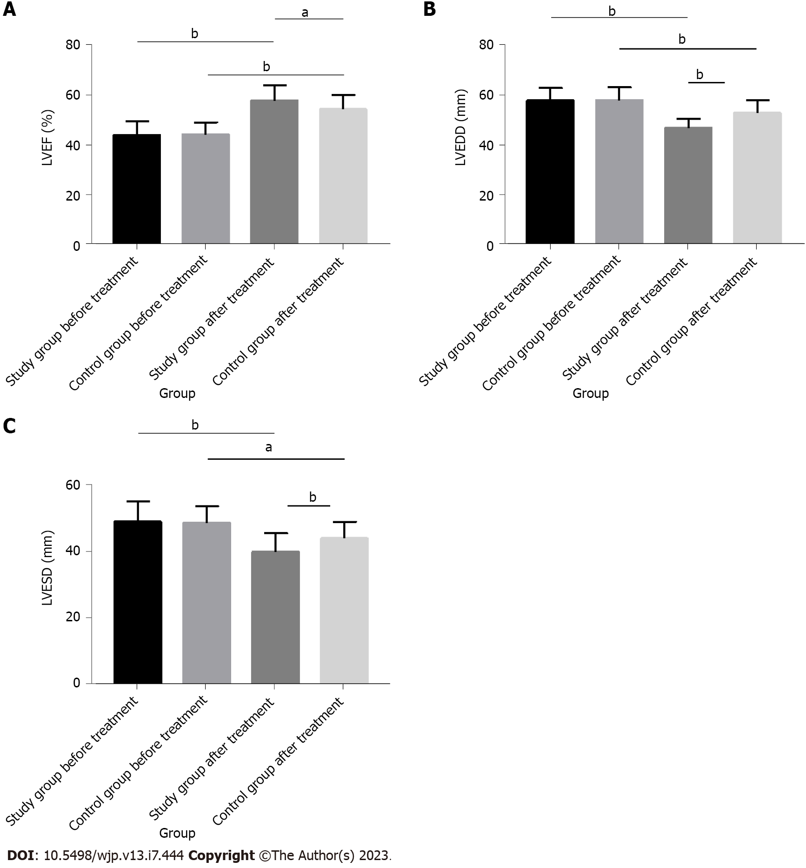
Figure 1 Comparison of patients' cardiac function. A: After nursing, the left ventricular ejection fraction of patients in both groups were significantly improved, with a higher level in the study group as compared to the control group; B: Left ventricular end diastolic diameter was significantly reduced in both groups after nursing, and was statistically lower in the study group compared with the control group; C: After nursing, left ventricular end systolic diameter in the two groups dropped obviously and was lower in the study group compared with the control group. ªP < 0.01; ^{b}P < 0.001. LVEF: Left ventricular ejection fraction; LVEDD: Left ventricular end diastolic diameter; LVESD: Left ventricular end systolic diameter.
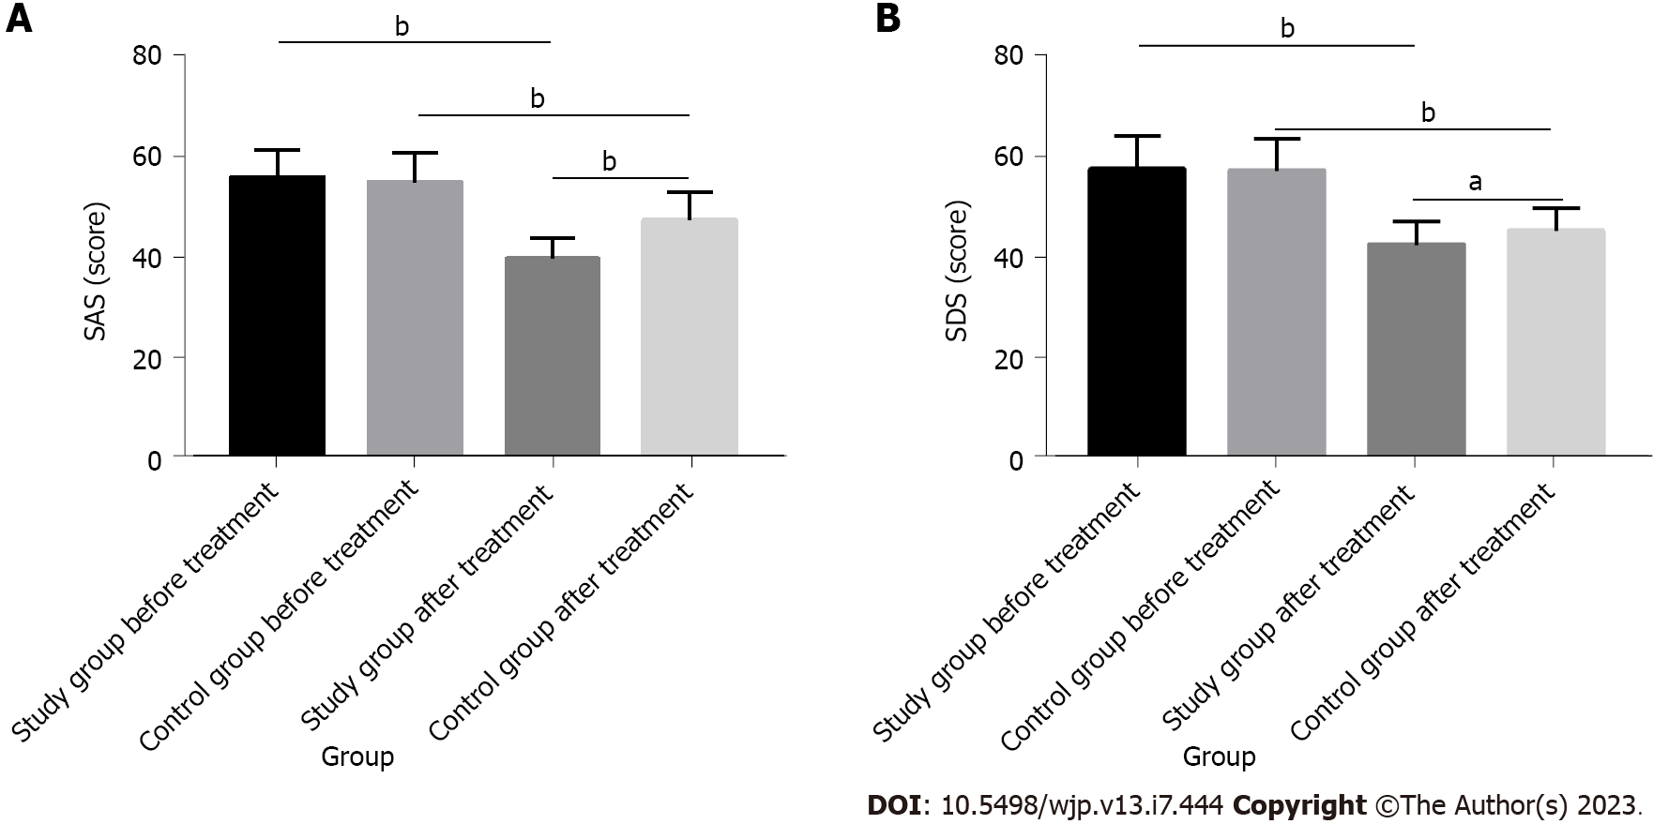
Figure 2 Comparison of patients' negative emotions. A: After nursing, the self-rating anxiety scale score of both groups of patients dropped markedly and was lower in the study group compared with the control group; B: The self-rating depression scale score decreased statistically in both groups after nursing and was lower in the study group compared with the control group. ªP < 0.01; ^{b}P < 0.001. SAS: Self-rating anxiety scale; SDS: Self-rating depression scale.
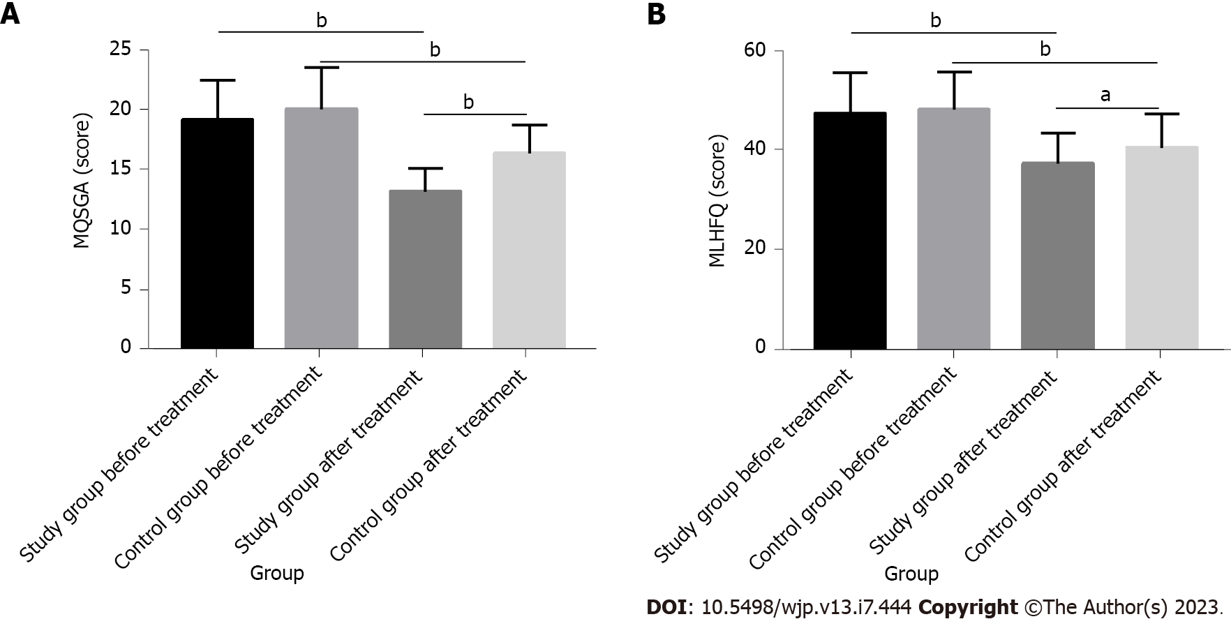
Figure 3 Improvement of nutritional status and quality of life of patients. A: The modified quantitative subjective global assessment score of the two groups dropped statistically after nursing, and was lower in the study group compared with the control group; B: After nursing, the Minnesota living with heart failure questionnaire score of the two groups dropped statistically and was lower in the study group compared with the control group. ªP < 0.01; ^{b}P < 0.001. MQSGA: Modified quantitative subjective global assessment; MLHFQ: Minnesota living with heart failure questionnaire.
Table 1 Baseline data
 |  | Study group (n = 62) | Control group (n = 54) | χ²/t | P value
Age (years old) |  | 78.16 ± 6.58 | 77.19 ± 6.94 | 0.772 | 0.442
Sex |  |  |  | 1.400 | 0.237
 | Male | 40 (64.52) | 29 (53.70)
 | Female | 22 (35.48) | 25 (46.30)
Course of disease (years) |  | 5.55 ± 1.34 | 5.43 ± 1.56 | 0.446 | 0.657
BMI (kg/m²) |  | 23.71 ± 3.27 | 23.93 ± 3.11 | 0.370 | 0.712
Systolic pressure (mmHg) |  | 147.97 ± 12.45 | 149.94 ± 14.28 | 0.794 | 0.429
Complications
 | Hypertension | 12 (19.35) | 14 (25.93) | 0.717 | 0.397
 | Diabetes mellitus | 8 (12.90) | 10 (18.52) | 0.694 | 0.404
 | Coronary heart disease | 29 (46.77) | 23 (42.59) | 0.204 | 0.652
 | Atrial fibrillation | 13 (20.97) | 7 (12.96) | 1.296 | 0.255
Cardiac function grade |  |  |  | 2.772 | 0.250
 | Ⅱ | 30 (48.39) | 21 (38.89)
 | Ⅲ | 20 (32.26) | 25 (46.30)
 | Ⅳ | 12 (19.35) | 8 (14.81)
Heart rate (beats/min) |  | 80.11 ± 5.24 | 80.98 ± 5.7 | 0.856 | 0.394
BMI: Body mass index.
Table 2 Rehabilitation efficacy
 | Study group (n = 62) | Control group (n = 54) | χ² | P value
Markedly effective | 38 (61.29) | 25 (46.30)
Effective | 21 (33.87) | 20 (37.03)
Ineffective | 3 (4.84) | 9 (16.67)
Overall response | 59 (95.16) | 45 (83.33) | 4.354 | 0.037

Table 3 Nursing satisfaction
 | Study group (n = 62) | Control group (n = 54) | χ² | P value
Very satisfied | 35 (56.45) | 27 (50.00)
Satisfied | 23 (37.10) | 17 (31.48)
Dissatisfied | 4 (6.45) | 10 (18.52)
Total satisfaction | 58 (93.55) | 44 (81.48) | 3.960 | 0.047

Published by Baishideng Publishing Group Inc
7041 Koll Center Parkway, Suite 160, Pleasanton, CA 94566, USA
Telephone: +19253991568
Email: bpgoffice@wjgnet.com
Help Desk: https://www.f6publishing.com/helpdesk
https://www.wjgnet.com

© 2023 Baishideng Publishing Group Inc. All rights reserved.

