Name of journal: World Journal of Gastroenterology
ESPS Manuscript NO: 14011
Columns: ORIGINAL ARTICLE
Prospective Study
Perfact procedure: A new concept to treat highly complex anal fistula

Garg P et al. PERFACT procedure for highly complex fistula-in-ano

Pankaj Garg, Mahak Garg

Pankaj Garg, Mahak Garg, Indus Super Specialty Hospital, Haryana 134113, India

Author contributions: Garg P and Garg M thought of the concept, designed the study, acquired the data, analyzed it, drafted, revised and finally approved the draft; Garg P submitted the manuscript.

Correspondence to: Pankaj Garg, MBBS, MS, Indus Super Specialty Hospital, Mohali 1042, Sector-15, Panchkula, Haryana 134113, India. drgargpankaj@yahoo.com
Telephone: +91-950-1011000 Fax: +91-172-2594556

Received: September 13, 2014 Revised: October 22, 2014
Accepted: November 7, 2014

Published online:

Abstract
AIM: To check the efficacy of Perfact procedure in highly complex fistula-in-ano.

METHODS: Perfact procedure (Proximal superficial cauterization, emptying regularly of fistula tracts and curettage of tracts) entails two steps- superficial cauterization of mucosa at and around the internal opening and keeping all the tracts clean. The principle is to permanently close the internal opening by granulation tissue. This is achieved by superficial electrocauterization at and around the internal opening and subsequently allowing the wound to heal by secondary intention. Along with this, all the tracts are curetted and it is ensured that they remain empty and clean in the postoperative period till they heal completely. The latter step also facilitates the closure of the internal opening by preventing collected fluid in the tracts from entering the internal opening and thus not letting it close. Objective incontinence scoring was done preoperatively and at 3 months after the operation.

RESULTS: Fifty-one patients of complex fistula-in-ano were prospectively enrolled. The median follow-up was 9 mo (5-14 mo). The mean age was 42.7 ± 11.3 years. Males/Female ratio was 43/8. Fistula was recurrent in 76.5% (39/51), horseshoe in 50.1% (26/51), had multiple tracts in 52.9% (27/51), had associated abscess in 41.2% (21/51), was anterior in 33.3% (17/51), the internal opening was not found in 15.7% (8/51) and 9.8% (5/51) fistulas had supralevator extension. Seven patients were excluded (lost to follow up - 5, Tuberculosis leading to/ associated with fistula-in-ano-2). The success rate was 79.5% (35/44) and the recurrence rate was 20.5% (9/44). Out of these recurrences, three underwent reoperation (two- perfact procedure, one- fistulotomy) and all three became alright. Thus the overall success rate was 86.4%. The only complication was a non-healing tract in 9.1% (4/44) patients. There was no significant change in objective incontinence scores three months after the operation. The pain was minimal with all patients resuming their normal activities within 72 h of operation.

CONCLUSION: Perfact procedure is a new effective method for complex fistula-in-ano, effective even in fistula associated with abscess, supralevator fistula-in-ano and where the internal opening is non-localizable.

© 2014 Baishideng Publishing Group Inc. All rights reserved.

Key words: Anal fistula; Fistula-in-ano; Incontinence; Recurrent; Perfact; Procedure; Abscess; Supralevator

Core tip: Perfact procedure is a simple, economical and novel method to cure complex fistula-in-ano. It is associated with little pain, least morbidity and minimal risk of incontinence as both the anal sphincters are completely preserved. It is quite effective in complex fistula cases where other methods do not have a high success rate like horseshoe fistula, fistula with multiple tracts, recurrent fistula and fistula with supralevator extension. Perfact procedure is also quite successful in cases where internal opening cannot be localized and in patients presenting with perianal/ischiorectal abscess where it can be done as a definitive procedure on the initial presentation.

Garg P, Garg M. Perfact procedure: A new concept to treat highly complex anal fistula. World J Gastroenterol 2014; In press

INTRODUCTION
There is no satisfactory treatment of complex fistula-in-ano till date. A fistula-in-ano is termed “complex” when the track crosses > 30%-50% of the external sphincter (high-transsphincteric, suprasphincteric, and extrasphincteric), is anterior in a female, is recurrent, has multiple tracks, or the patient has preexisting incontinence, local irradiation, or Crohn’s disease^{[1-4]}. Inspite of several new procedures like anal fistula plug (AFP)^{[5,6]}, ligation of intersphincteric fistula tract (LIFT)^{[7]}, video assisted anal fistula treatment (VAAFT)^{[8]}, Laser-FiLaC^{[9]} and OTSC Proctology procedure^{[10]} tried in the last decade, the challenge of successfully treating complex anal fistula remains intact. The two main issues in managing such fistula are to minimize the recurrence rate and prevent any deterioration in the continence levels.
Proximal superficial cauterization, emptying regularly of fistula tracts and curettage of tracts (Perfact procedure) is a novel concept in the management of complex fistula-in-ano. In this procedure, the fistula healing is planned as two steps- closure of internal opening and healing of the tract/tracts. The aim is to use body’s natural healing tissue (granulation tissue) to close the internal opening. This is done by electrocauterizing the internal opening and the area around it in the anal canal. The tract/tracts are thoroughly curetted and the infected tract lining (epithelium) of the tracts is taken out. To ensure proper healing, it is important to keep the anal canal wound clean and the tracts empty in the postoperative period.

MATERIALS AND METHODS
Patients with complex fistula-in-ano were enrolled in a prospective study over a period of one and a half year. The institutional ethics committee reviewed and approved the study. Informed written consent was taken from every patient.

Inclusion criteria
All types of complex fistula-in-ano which included: (1) fistula associated with multiple tracts; (2) horse shoe fistulas; (3) recurrent fistulas; (4) anterior fistula in females; (5) fistula with long tracts (any tract length > 10 cm); (6) fistula with supralevator blind extension (not with high rectal opening); (7) fistula where internal opening cannot be localized; and (8) fistula associated with abscess/ pus collections. It was used as a first line definitive procedure in patients of anal fistulas presenting with ischiorectal or perianal abscess.

Exclusion creteria
Simple low fistula: Vaizey objective incontinence scoring was done preoperatively and at 3 months after the operation^{[11]}. On a scale of 0-24, a score 0 implied perfect continence and a score of 24 meant total incontinence.

Fistula with supralevator rectal opening (on MRI and/or examination on operating table): A pre-operative MRI scan was done in every case to accurately map all the fistula tracts (Figure 1). A schematic diagram consisting of coronal and transverse sections (Figure 1) was made based on the MRI.
Perfact procedure had three steps (Figure 2). (1) proximal superficial cauterization- The area around the internal opening was freshened and de-epithelized by electrocautery (Figure 3) and the wound was encouraged to heal by secondary intention (granulation tissue). This usually closed the internal opening in about 10-12 d; (2) curettage of tracts- All the tracts were thoroughly curetted and debrided of their lining with a curette; and (3) emptying regularly of fistula tracts- The curetted tracts were kept clean and empty of any serous fluid so as to ensure that the tracts healed (close) by granulation tissue. Keeping all the tracts clean till they healed completely was a challenging task and the most demanding step of the procedure. It took 4-8 wk (occasionally even longer) for all the tracts to heal fully. Till that time, regular cleaning of the tracts was done.
To ensure proper cleaning of the tracts, the following steps (one or multiple depending upon the requirement and fistula characteristics) could be done in a patient: (1) multiple holes were made along the straight or the horseshoe tract (Figures 4-8) in such a way that the farthest corner of the tract could be cleaned with ease; (2) the external opening was widened and the scarred puckered skin (if present) was excised. The aim was to make the opening bigger than 1 cm × 1 cm (Figure 3). This facilitated cleaning of the tracts for a longer duration; and (3) loose rubber setons were inserted in the holes to prevent their premature closure. These were removed 10-12 d after the operation (Figures 4- 8).

Intra-operative
A saddle block (spinal anesthesia) or a short general anesthesia was given. The patient was positioned in a lithotomy or a prone jack-knife position. The internal opening was localized. This was facilitated by injecting saline, povidine iodine or hydrogen peroxide through the external opening.
Proximal superficial cauterization (Figure 3) was carried out with electrocautery around the internal opening, cauterizing only the mucosa and superficial part of the internal sphincter. The crypt glands, the internal opening and the tissue around it were cauterized. This usually resulted in an oval area, approximately 1 cm (wide) and 2 cm (long), with internal opening at the centre of the wound (Figure 3). After cauterization, the wound was left as such and no attempt was made to close the internal opening with any suture, stapler, glue or plug.
After this, the tracts were curetted in accordance with the MRI diagram and the tract lining was scrapped out as much as possible with a blunt curette. While doing so, a finger was kept in the rectum so as to ensure that the curette didn’t accidentally perforate the rectum.
The patient was discharged on the operation day (if done under short general anesthesia) or the first postoperative day (if done under saddle or spinal anesthesia). He/she could resume all his/her normal activities on the same day. The patient was encouraged to walk briskly for 5 km every day. This helped in keeping the tracts empty.
Postoperative cleaning aimed at healing of two areas - the cauterized wound in the anal canal (around the internal opening) and the curetted tracts. The former was pivotal as the closure of the internal opening depended upon it and generally took about 10-12 days to heal. The latter was also needed for the complete closure of the fistula and took a variable time (4-8 wk) depending on the fistula characteristics (number, length and complexity of the tracts) and the patient co-morbidities (diabetes, anemia, hypoproteinemia etc.).
The cleaning process entailed cleaning the cauterized wound in the anal canal and regular cleaning and emptying of the curetted tracts. The former was done by gentle rubbing of the wound by doing a per rectal finger insertion. The latter was done by a cotton swab mounted on an artery forceps. No povidine iodine, hydrogen peroxide or any liquid was injected in the tract during the cleaning process as this would have prevented the internal opening from closing. The cleaning was done by a trained nurse, a medical attendant or a relative. In our setting, teaching a relative was an economical and a preferred option.
The cleaning process was done four times a day. For the first 10 d, the patient was called to the outpatient clinic for supervised cleaning once or twice a day depending upon the complexity of the fistula. After this, the patient could do the cleaning process at home.

Statistical analysis
Comparison of categorical variables was performed by chi-squared analysis or Fisher’s exact test, where appropriate. The significant cut off point was set at P < 0.05.

RESULTS
Fifty-one patients of complex fistula-in-ano were prospectively enrolled. The median follow-up was 9 mo (5-14 mo). The mean age was 42.7 ± 11.3 years. Males/Female ratio was 43/8. The fistula characteristics were - recurrent in 76.5% (39/51), horseshoe in 50.1% (26/51), multiple tracts in 52.9% (27/51), associated abscess in 41.2% (21/51) and anterior fistula in 33.3% (17/51). Internal opening could not be definitely traced intraoperatively in 15.7% (8/51) and there was associated supralevator extension in 9.8% (5/51) (Table-1). Seven patients were excluded from the analysis (5- lost to follow, 2 had biopsy proven Mycobacterium Tuberculosis). The fistula and all the associated tracts healed completely in 79.5% (35/44) patients and there was recurrence of symptoms in 20.5% (9/44) patients. Out of these, three underwent reoperation (two- perfact procedure, one- fistulotomy) and all three became alright (Table 2). The subgroup analysis showed that though the presence of multiple tracts and an abscess reduced the cure rate but it was not statistically significant (Fisher exact test P > 0.05) (Table 2). The only complication was a non-healing tract in 9.1% (4/44) patients. There was no significant change in objective incontinence scores after the operation. The pain was minimal with all patients resuming their normal activities within 72 h of operation.

DISCUSSION
Perfact procedure is a novel concept to treat complex fistula-in-ano. It is simple to perform and easy to reproduce. The results (initial 79.5%, overall 86%) are quite impressive considering that all these patients had highly complicated fistula-in-ano (Table 1).
The concept behind Perfact procedure was very simple. It aimed to close the internal opening by proximal superficial cauterization in the anal canal (Figure 3). In the postoperative period, it was ensured that the wound healed by secondary intention so that the internal opening was sealed by granulation tissue.
The second step was curettage of the tracts. This ensured that the infected epithelium was removed and the freshened raw wound in the tracts led to the generation of the granulation tissue which would facilitate the closure of the tracts. However, the serous discharge of the granulation tissue needed to be thoroughly cleaned/ removed from the tracts. Otherwise the stagnant discharge would get infected leading to a collection. The latter would not only lead to the rapid reepithelialization of the tracts but would also flow into internal opening preventing its closure.
The postoperative management was quite significant. It had two components- to keep the cauterized anal wound clean and to keep the tracts clean and empty. Any inadequacy in this care was detrimental to the final outcome.
The cauterization of the internal opening has been tried earlier without much success. The reason of the success of the same step in Perfact procedure needs explanation. Undoubtedly, the internal opening is the prime culprit in a fistula-in-ano by allowing ingress of the bacteria from the anal canal into the fistula tracts. However, once the tracts are formed and get lined by the infected epithelium, then it’s a mutually propagating situation. The patent internal opening keeps the tracts infected and the infected collection in the tracts keep the internal opening patent. Therefore isolated attempt to close the internal opening would fail till it is accompanied by the meticulous cleaning, emptying and healing of all the associated tracts. This perhaps explains the rigorous need for regular tract cleaning in the post-operative period.
The concept behind this procedure was undoubtedly simple but to achieve good results in complex anal fistulas, it required detailed analysis of the MRI scan, careful planning and mapping of the tracts (preoperatively), meticulous curettage and cleaning of all the tracts (intraoperatively), and disciplined post-operative care (postoperatively). The main benefit of this procedure was minimal morbidity and the least risk of incontinence. The morbidity was minimal as no extensive tissue cutting was done. Apart from a small superficial wound in the anal canal, external opening was widened (Figure 3) or few holes were made in the perianal region (made to drain accessory tracts) (Figures 4-8). The anal wound was usually small as the internal opening was located mostly at the dentate line (Figure 3). So the resultant wound was usually about 2 cm long and 1 cm wide. Due to the small wound and little pain, the patients were able to resume all their normal daily activities from the first postoperative day. The patients were encouraged to walk briskly 4-5 kilometers from the first postoperative day as it facilitated in keeping the tracts empty. Secondly as the external sphincter was completely spared, the negative impact on the incontinence was minimal.
The procedure worked quite well in all types of complex fistula-– fistula associated with multiple tracts, horse shoe fistulas, recurrent fistulas, anterior fistula in females, fistula with long tracts, fistula with supralevator blind extension (not with high rectal opening), fistula associated with abscess/ pus collections and fistula where no definite internal opening could be localized intraoperatively (Figures 4- 8).
Perfact procedure was quite effective in horseshoe fistula and fistula with multiple tracts. About half of the fistula (50.1%) in our series had a horseshoe fistula and the cure rate was 76.2% (16/21) (Table-2) (Figures 4 and 5). Infact one of the patients presented with a double horseshoe intersphincteric abscess which was encircling the rectum circumferentially all around. This patient was also cured by this procedure (Figure 5). About 53% patients had multiple tracts and the success rate in this subgroup was 71.4% (15/21). One of the patients had eight external openings and he got alright after undergoing this procedure (Figure 8).
In fistula with associated abscess, the abscess was drained and the Perfact procedure was carried out as described. There was no need to make a large incision as the seton and regular cleaning of the cavity in the postoperative period ensured that there was no recollection and good healing ensued. In our series, 41.2 % patients presented with an abscess or had an associated significant abscess (Table 1). Perfact procedure was done as the definitive first line procedure and the cure rate was 72%. (Table 2; Figures 4, 5 and 7).
Perfact procedure was effective in fistula cases where no definite internal opening could be localized intraoperatively. Failure to identify the internal opening during the operation perhaps happens because of the temporary closure of the internal opening due to debris or the oblique course of the collapsible tract through the sphincters. As per literature, this can happen in up to 15%-20% of cases^{[8]}. In our series, this happened in 15.7% (8/44) cases (Table 1). This procedure worked quite successfully in 87.5% (7/8) of such cases in our series (Figure 5) (Table 2). As the MRI was done preoperatively in every case, it helped to fairly localize the tracts in the majority of cases and gave a reasonable idea where the tract was coursing towards the rectum. This information along with the intraoperative examination findings (induration of the sphincter complex in the region of internal opening) helped to determine the possible site of internal opening. At that place, the superficial cauterization was done. In two patients, the MRI picture was creating doubt that the tracts could be going both anteriorly and posteriorly and hence superficial cauterization was done at both the places (Figure 5). Superficial cauterization was a safe step to do. Though it created a wound, but it was not associated with any risk of incontinence as the wound was quite superficial. Therefore in case of confusion/ doubt, the superficial cauterization can be done at two places as well.
This procedure was also effective in fistula with supralevator extension (blind). The procedure was carried out as described. The position of supralevator tract was carefully assessed on MRI and intraoperatively, this tract was carefully curetted while keeping a finger in the rectum (to avoid injuring the rectal wall). During the postoperative dressings, the supralevator tract was regularly cleaned for at least 2-3 wk (or as needed). While doing so, a finger was inserted in the rectum to avoid any injury. In our series, it was effective in providing cure in 75% patients (3/4) with supralevator extension (Figure 6).
With careful postoperative management, most of the fistulas healed between 4-10 wk. In 9 (20.5%) patients, the procedure failed. The internal opening didn’t close and one or multiple tracts failed to heal. The likely reason was inability to regularly clean all the tracts in the postoperative leading to a collection in one of the tracts. This perhaps prevented the tracts as well as the internal opening from healing. Four (9%) of the patients had persistent serous/watery discharge for prolonged period (10-16 wk). This happened in cases with long fistula tracts. The cauterized wound in the anal canal and the internal opening healed quite well in these cases leading to the cessation of pus formation. However the serous drainage was perhaps due to the reepithelialization of the outer portion of the tract. We did gentle curettage of the tract in the office under topical anesthesia (lidocaine gel) and it helped to close the recalcitrant tract. However multiple curettings were needed in two cases.
There are certain patients in whom the internal opening is enlarged/ widened due to previous surgical interventions (like tightening setons). In these patients, proximal superficial cauterization fails or takes much longer to heal. In this subgroup, advancement flap plus the intensified mechanical cleaning of the fistula tract could be a better option.
Perfact procedure adds a potentially useful treatment option in our armamentarium against complex fistula-in-ano. It complements the mucosal advancement flap, anal fistula plug, OTSC proctology, LIFT, VAAFT and glue procedures. Perfact procedure is simple, associated with least morbidity and minimal risk of incontinence. Compared to mucosal advancement flap, Perfact procedure is technically less demanding. Unlike anal fistula plug, Laser-FiLaC and OTSC proctology procedure^{[9,10]}, Perfact procedure can be done as a definitive procedure in the fistula patients presenting with acute abscess or collection. Unlike other existing procedures, Perfact procedure can be done in the patients where the internal opening cannot be definitely localized. Lastly, compared to fistulotomy and cutting tightening seton, Perfact procedure is associated with a minimal risk of incontinence.
Perfact procedure had certain distinct advantages. It was associated with least risk of incontinence. The morbidity was minimal. The pain was not much and the patient was able to resume normal activities within 1-2 d of operation. It had a high success rate in all types of complex fistula-in-ano including horseshoe fistula, recurrent fistula and fistula with multiple tracts. It was effective in highly complicated cases where the other procedures did’t work well such as fistula with supralevator extension, fistula with associated abscess and the fistulas where internal opening cannot be localized. Moreover, Perfact procedure could be done as the first line definitive procedure in the fistulas presenting with anorectal or ischiorectal abscess (rather than doing an incision and drainage initially and a definitive procedure later). Another advantage of this procedure was its cost effectiveness. No expensive equipment/gadget was required, operation duration was 15-30 min and hospital stay was only 12-24 h (could be done as a day care procedure). As there was minimal incision/cutting, it led to very little scarring and distortion of the anatomy. Last but not the least, this procedure was quite simple to do and reproduce.
The procedure had its limitations. The Perfact procedure was not effective in cases where a supralevator tract had a high rectal opening. It was also not indicated in low fistula where there was no sphincter involvement. Secondly, meticulous post-operative care was required especially for the first two weeks. Though most of the patients were back to their normal routine after the first day of the operation, yet they were needed to come for twice daily follow-up for at least ten days. Active participation/ cooperation were needed from one of the relatives/acquaintances. In our country, teaching a relative (spouse in majority of cases) was an economically viable and acceptable option. Thirdly, the problem of prolonged serous discharge added to the morbidity in few patients. Lastly, the long term follow up (> 3 years) results are awaited.
To conclude, Perfact procedure is a simple novel method to treat complex and highly complex anal fistula. This include fistula-in-ano with multiple tracts, horse shoe fistulas, recurrent fistulas, anterior fistula in females, supralevator fistula, fistula where internal opening cannot be localized and as a first line definitive procedure in patients of fistula-in-ano presenting with ischiorectal or perianal abscess. However, long term multicentre trials are needed in larger number of patients to substantiate these findings.

COMMENTS
Background
Complex anal fistula is difficult to treat because of high risk of recurrence of the disease and the danger of incontinence (losing control over the bowel motions). Apart from regular pus discharge and pain, a complex anal fistula on long term basis also increases the risk of ano-rectal cancer.

Research frontiers
Apart from several existing methods, many new procedures have been developed to cure this dreaded illness. However, achieving high success rate (low recurrence) and low incontinence rate at the same time remains a challenge. The procedures which have low recurrence rate (high cure rate) have high incidence of incontinence and the procedures which have low risk of incontinence have high recurrence rates.

Innovations and breakthroughs
Perfact procedure in a new procedure. It involves no cutting of anal sphincters (muscles which control bowel motions). Hence the risk of incontinence is negligible after this procedure. At the same time, this procedure is associated with high success rate (low recurrence rate). The morbidity of this procedure is also quite low as the patient can resume his/her normal activities within 1-2 d of operation.

Applications
The medium term follow up results are quite encouraging. If these results are replicated on a larger scale, then this method has the potential to become the procedure of choice for complex anal fistulas.

Terminology
“Perfact” in Perfact procedure doesn’t mean perfect (ideal). Here Perfact is a mnemonic which stands for proximal superficial cauterization, emptying regularly of fistula tracts and curettage of tracts. In proximal superficial cauterization, proximal implies that only the lower part of the anal canal is cauterized (as the internal opening is usually located at the dentate line) and superficial implies that only the mucosa and few medial fibres of the internal sphincter are cauterized leaving a majority of internal sphincter and complete external sphincter intact.

Peer review
This is an interesting description of a novel method of anal fistula closure, including cauterization of the internal opening, curretage of the fistula tract, and mechanical debridement of the tract.
REFERENCES
1 Whiteford MH, Kilkenny J, Hyman N, Buie WD, Cohen J, Orsay C, Dunn G, Perry WB, Ellis CN, Rakinic J, Gregorcyk S, Shellito P, Nelson R, Tjandra JJ, Newstead G. Practice parameters for the treatment of perianal abscess and fistula-in-ano (revised). Dis Colon Rectum 2005; 48: 1337-1342 [PMID: 15933794 DOI: 10.1007/s10350-005-0055-3]
2 Parks AG, Stitz RW. The treatment of high fistula-in-ano. Dis Colon Rectum 1976; 19: 487-499 [PMID: 964106 DOI: 10.1007/BF02590941]
3 Mizrahi N, Wexner SD, Zmora O, Da Silva G, Efron J, Weiss EG, Vernava AM, Nogueras JJ. Endorectal advancement flap: are there predictors of failure? Dis Colon Rectum 2002; 45: 1616-1621 [PMID: 12473884 DOI: 10.1007/s10350-004-7248-z]
4 Kodner IJ, Mazor A, Shemesh EI, Fry RD, Fleshman JW, Birnbaum EH. Endorectal advancement flap repair of rectovaginal and other complicated anorectal fistulas. Surgery 1993; 114: 682-69; discussion 682-69; [PMID: 8211682]
5 Johnson EK, Gaw JU, Armstrong DN. Efficacy of anal fistula plug vs. fibrin glue in closure of anorectal fistulas. Dis Colon Rectum 2006; 49: 371-376 [PMID: 16421664 DOI: 10.1007/s10350-005-0288-1]
6 Garg P, Song J, Bhatia A, Kalia H, Menon GR. The efficacy of anal fistula plug in fistula-in-ano: a systematic review. Colorectal Dis 2010; 12: 965-970 [PMID: 19438881 DOI: 10.1111/j.1463-1318.2009.01933.x]
7 Rojanasakul A. LIFT procedure: a simplified technique for fistula-in-ano. Tech Coloproctol 2009; 13: 237-240 [PMID: 19636496 DOI: 10.1007/s10151-009-0522-2]
8 Meinero P, Mori L. Video-assisted anal fistula treatment (VAAFT): a novel sphincter-saving procedure for treating complex anal fistulas. Tech Coloproctol 2011; 15: 417-422 [PMID: 22002535 DOI: 10.1007/s10151-011-0769-2]
9 Giamundo P, Geraci M, Tibaldi L, Valente M. Closure of fistula-in-ano with laser--FiLaC™: an effective novel sphincter-saving procedure for complex disease. Colorectal Dis 2014; 16: 110-115 [PMID: 24119103 DOI: 10.1111/codi.12440]
10 Prosst RL, Joos AK, Ehni W, Bussen D, Herold A. Prospective pilot study of anorectal fistula closure with the OTSC Proctology. Colorectal Dis 2014; [PMID: 25175824 DOI: 10.1111/codi.12762]
11 Vaizey CJ, Carapeti E, Cahill JA, Kamm MA. Prospective comparison of faecal incontinence grading systems. Gut 1999; 44: 77-80 [PMID: 9862829 DOI: 10.1136/gut.44.1.77]
P-Reviewer: Mennigen R S-Editor: Qi Y L-Editor: E-Editor:

Figure 1 Preoperative magnetic resonance imaging of Perianal region and its Schematic diagram showing a recureent horseshoe abscess and fistula from 2 to 10 o’clock position in a 29-year-old female patient. There was no external opening and the internal opening was at posterior midline. Arrows in the upper pictures show the position of the horseshoe abscess.
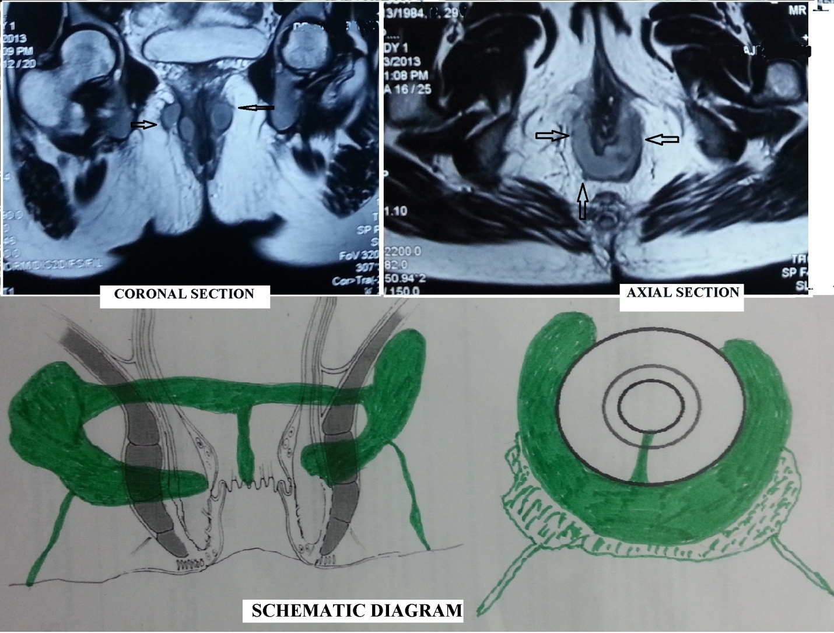

Figure 2 PERFACT procedure- an overview.
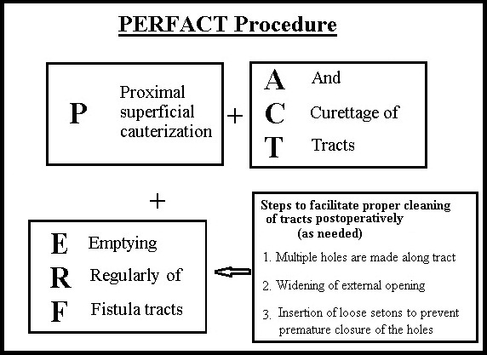

Figure 3 Management of a 45-year-old male patient by Perfact procedure having a recurrent transsphincteric fistula with external opening at 2 o’clock and internal opening at 6 o’clock posterior midline. Shows proximal superficial cauterization and widening of the external opening. Horizontal arrows show the external opening – preoperative in the left picture and postoperative in the right. The vertical arrow in the left picture shows the position of proximal superficial cauterization.
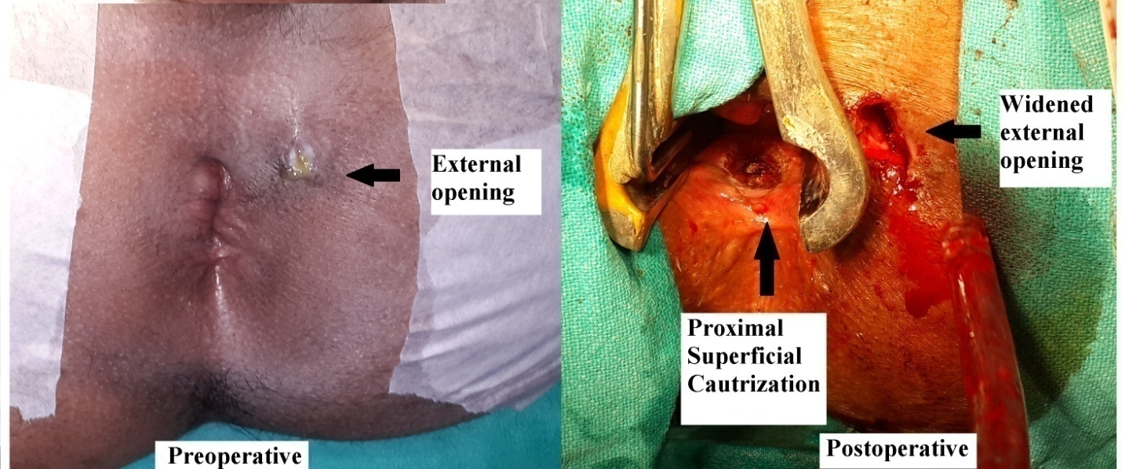

Figure 4 Management of a 29 yr old female patient by Perfact procedure having a horseshoe abscess and fistula from 2 to 10 o’clock. There was no external opening and the internal opening was at posterior midline. The right bottom picture shows complete healing of the fistula (MRI and diagram of this patient shown in Figure 2).
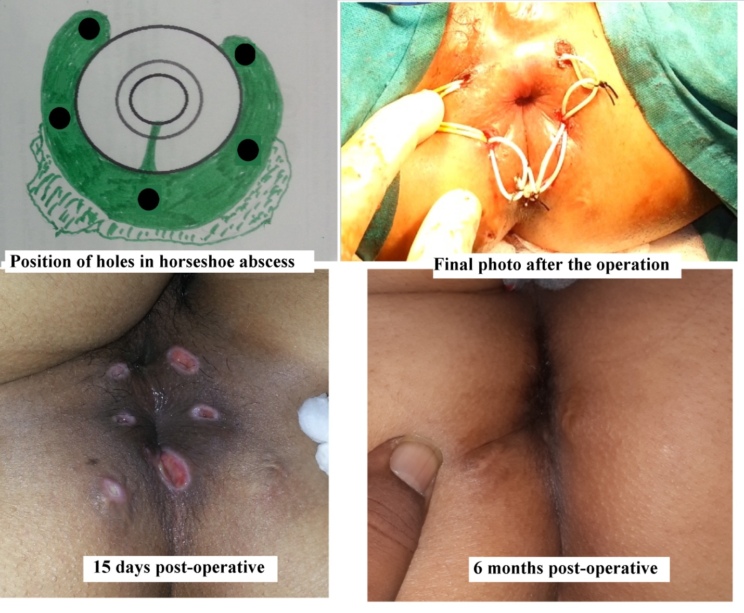

Figure 5 Management of a 22-year-old male patient by Perfact procedure having a double horseshoe intersphincteric abscess and fistula. External opening is at 11 o’clock and the internal opening was not traceable intraoperatively. Electrocauterization was done at both anterior and posterior midline. The left upper picture shows the MRI and the right bottom picture was taken after the final cure (Posterior horseshoe abscess shown by green colour was at a higher level). Arrows in the upper left pictures show the position of the horseshoe abscess and tracts.
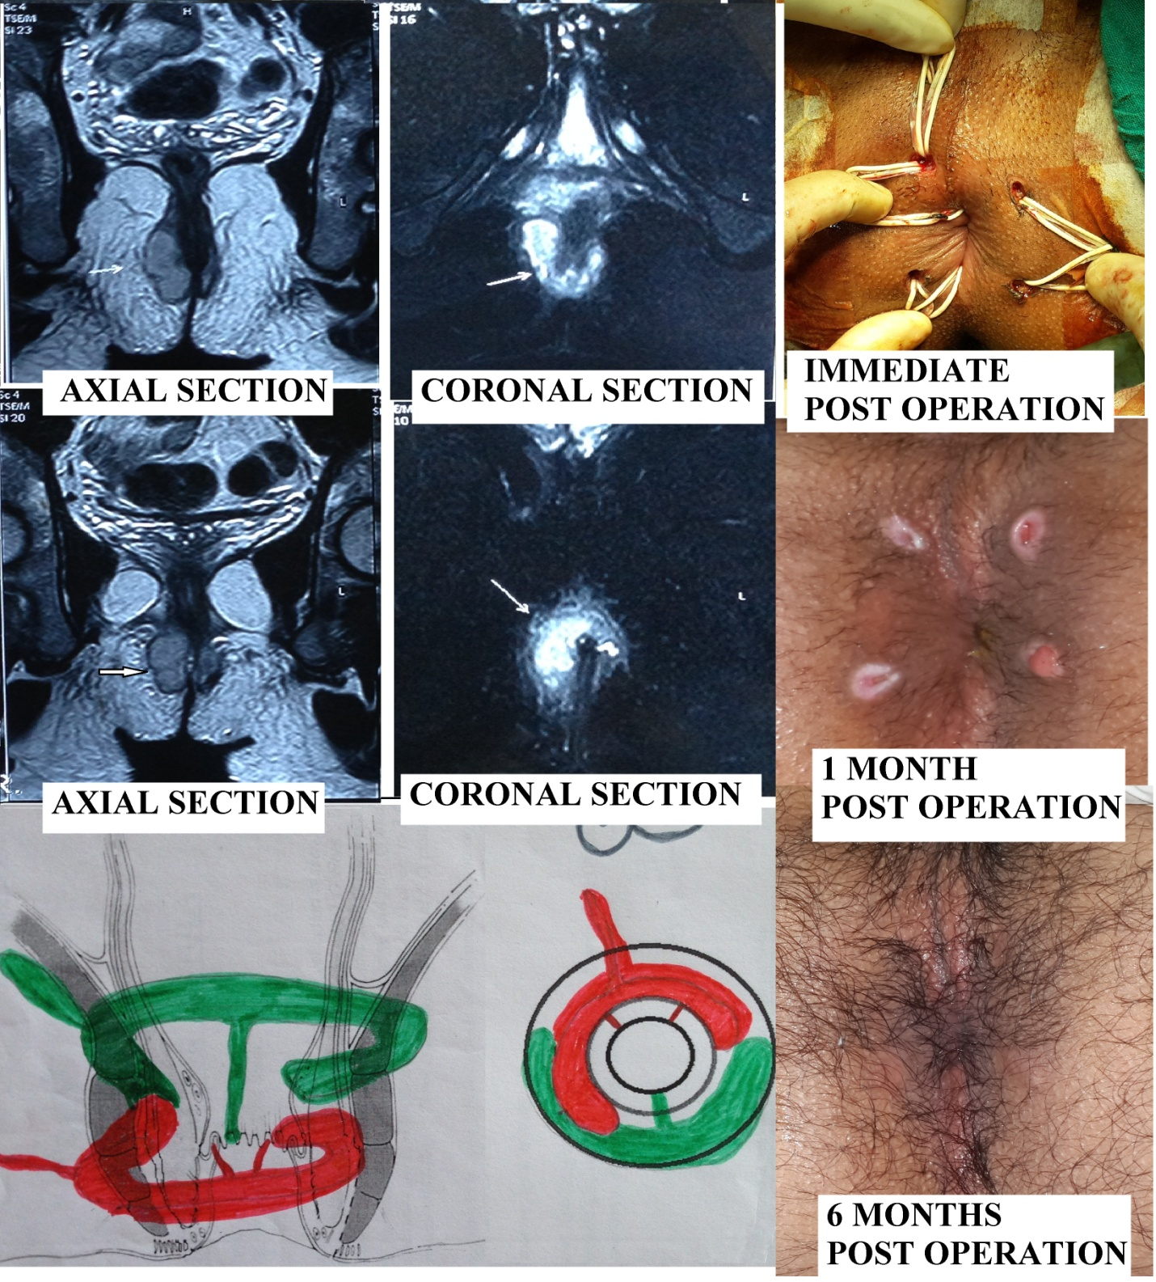

Figure 6 Management of a 36-year-old male patient by Perfact procedure having a supralevator extension at 3 o’clock. External opening is at 3 o’clock and internal opening at 6 o’clock posterior midline. The left upper picture shows the MRI (Arrows show the supralevator extension) and the right bottom picture was taken after the patient was fully cured.
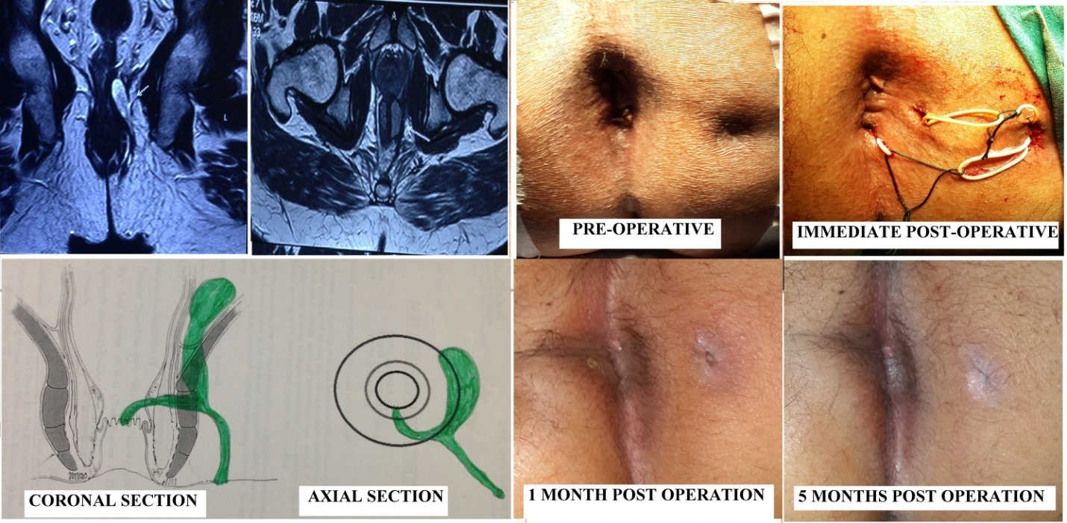

Figure 7 Management of a 55-year-old female patient by Perfact procedure having a large anterior abscess and a fistula. External opening is at 11 o’clock and internal opening at 12 o’clock anterior midline. The left upper picture shows the MRI & the right bottom picture is taken after the final cure.
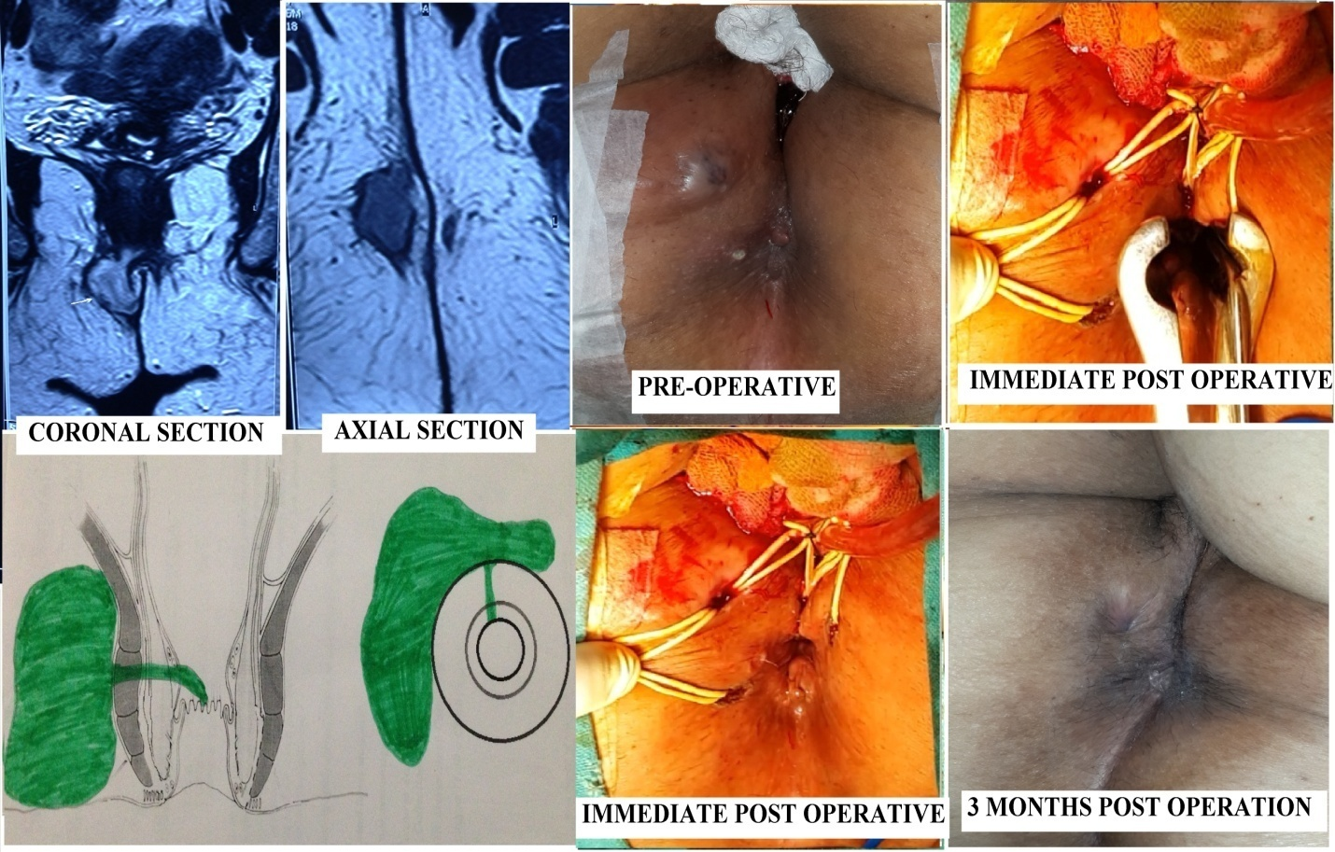

Figure 8 Management of a 38-year-old male patient by Perfact procedure having a total of eight external openings and tracts (including a horseshoe one). The left upper picture shows the MRI and the right bottom picture is taken after the final cure. Arrows in the upper left picture show the position of the multiple tracts and in the upper middle picture shows the multiple external openings.
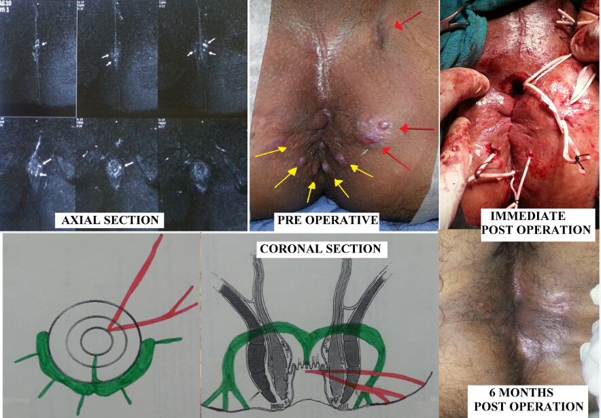

Table 1 Fistula characteristics n (%)
Fistula characteristics | n = 51
Recurrent | 39 (76.5)
Multiple tracts | 27 (52.9)
Horseshoe fistula | 26 (50.1)
Associated/ presented with Abscess | 21 (41.2)
Anterior tract | 17 (33.3)
Internal opening not found | 8 (15.7)
Supralevator extension (blind) | 5 (9.8)

Table 2 Results- subgroups and overall n (%)

Parameter |  | Number (n = 44) | Healed | P-value (Fisher’s exact test)
Recurrent | Recurrent | 33 | 26 (78.8) | 0.2 (Not sig.)
 | Non-recurrent (Primary) | 11 | 9 (81.8)
Multiple tracts | Multiple tracts | 21 | 15 (71.4) | 0.16 (Not sig.)
 | Single tract | 23 | 20 (86.9)
Horseshoe fistula | Horseshoe | 21 | 16 (76.2) | 0.17 (Not sig.)
 | Non-horseshoe | 23 | 19 (82.6)
Associated/ presented with Abscess | Abscess | 18 | 13 (72.2) | 0.17 (Not sig.)
 | No abscess | 26 | 22 (84.6)
Anterior tract | Anterior | 15 | 13 (86.6) | 0.18 (Not sig.)
 | Non-anterior | 29 | 22 (75.8)
Internal opening not found |  | 8 | 7 (87.5)
Supralevator extension (blind) |  | 4 | 3 (75)
Overall | After 1 procedure | 44 | 35 (79.5)
 | After 2nd procedure in 3 patients | 44 | 38 (86.4)

