Name of Journal: World Journal of Psychiatry
Manuscript NO: 89035
Manuscript Type: ORIGINAL ARTICLE

Case Control Study
Brain protective effect of dexmedetomidine vs propofol for sedation during prolonged mechanical ventilation in non-brain injured patients

Yuan HX et al. Brain protective effect of dexmedetomidine vs propofol

Hong-Xun Yuan, Li-Na Zhang, Gang Li, Li Qiao

Hong-Xun Yuan, Gang Li, Li Qiao, Intensive Care Unit, Peking University International Hospital, Beijing 102206, China

Li-Na Zhang, Central Operating Room, The Affiliated Beijing Chaoyang Hospital of Capital Medical University, Beijing 102206, China

Co-first authors: Hong-Xun Yuan and Li-Na Zhang.

Co-corresponding authors: Gang Li and Li Qiao.

Author contributions: Yuan HX and Zhang LN contributed to conception, writing, and statistical analysis; Li G and Qiao L contributed to project, manuscript writing, review, and revision; all authors were involved in the critical review of the results and have contributed to, read, and approved the final manuscript. Yuan HX and Zhang LN contributed equally to this work as co-first authors; Li G and Qiao L contributed equally to this work as co-corresponding authors. The reasons for designating Gang Li and Li Qiao as co-corresponding authors are listed below: The research was performed as a collaborative effort, and the designation of co-corresponding authorship accurately reflects the distribution of responsibilities and burdens associated with the time and effort required to complete the study and the resultant paper. This also ensures effective communication and management of post-submission matters, ultimately enhancing the paper’s quality and reliability. The choice of these researchers as co-corresponding authors acknowledges and respects this equal contribution, while recognizing the spirit of teamwork and collaboration of this study. In summary, we believe that designating Li G and Qiao L as co-corresponding authors of is fitting for our manuscript as it accurately reflects our team’s collaborative spirit, equal contributions, and diversity.

Corresponding author: Gang Li, BSc, Consultant, Intensive Care Unit, Peking University International Hospital, No. 1 Life Park Road, Zhongguancun Life Science Park, Changping District, Beijing 102206, China. ligang1@pkuih.edu.cn

Received: October 18, 2023
Revised: December 21, 2023
Accepted: January 15, 2024
Published online:

Abstract
BACKGROUND
Dexmedetomidine and propofol are two sedatives used for long-term sedation. It remains unclear whether dexmedetomidine provides superior cerebral protection for patients undergoing long-term mechanical ventilation.

AIM
To compare the neuroprotective effects of dexmedetomidine and propofol for sedation during prolonged mechanical ventilation in patients without brain injury.

METHODS
Patients who underwent mechanical ventilation for > 72 h were randomly assigned to receive sedation with dexmedetomidine or propofol. The Richmond Agitation and Sedation Scale (RASS) was used to evaluate sedation effects, with a target range of -3 to 0. The primary outcomes were serum levels of S100-β and neuron-specific enolase (NSE) every 24 h. The secondary outcomes were remifentanil dosage, the proportion of patients requiring rescue sedation, and the time and frequency of RASS scores within the target range.

RESULTS
A total of 52 and 63 patients were allocated to the dexmedetomidine group and propofol group, respectively. Baseline data were comparable between groups. No significant differences were identified between groups within the median duration of study drug infusion [52.0 (IQR: 36.0-73.5) h vs 53.0 (IQR: 37.0-72.0) h, P = 0.958], the median dose of remifentanil [4.5 (IQR: 4.0-5.0) μg/kg/h vs 4.6 (IQR: 4.0-5.0) μg/kg/h, P = 0.395], the median percentage of time in the target RASS range without rescue sedation [85.6% (IQR: 65.8%-96.6%) vs 86.7% (IQR: 72.3%-95.3), P = 0.592], and the median frequency within the target RASS range without rescue sedation [72.2% (60.8%-91.7%) vs 73.3% (60.0%-100.0%), P = 0.880]. The proportion of patients in the dexmedetomidine group who required rescue sedation was higher than in the propofol group with statistical significance (69.2% vs 50.8%, P = 0.045). Serum S100-β and NSE levels in the propofol group were higher than in the dexmedetomidine group with statistical significance during the first six and five days of mechanical ventilation, respectively (all P < 0.05).

CONCLUSION
Dexmedetomidine demonstrated stronger protective effects on the brain compared to propofol for long-term mechanical ventilation in patients without brain injury.

Key Words: Dexmedetomidine; Propofol; Sedation; Prolonged mechanical ventilation; Brain protective

Yuan HX, Zhang LN, Li G, Qiao L. Brain protective effect of dexmedetomidine vs propofol for sedation during prolonged mechanical ventilation in non-brain injured patients. World J Psychiatry 2024; In press

Core Tip: In this study, we designed a single center, prospective, randomized controlled study to compare the brain protective effect of dexmedetomidine vs propofol for sedation during prolonged mechanical ventilation in non-brain injured patients.

INTRODUCTION
Patients who require intensive care may experience a strong stress response due to their own serious illness, leading to long-term negative emotions such as anxiety and irritability. In addition, most of these patients also necessitate mechanical ventilation, which can readily result in conflict between the individual and the machine, thereby affecting the efficacy of mechanical ventilation^{[1,2]}. Analgesic and sedative therapies can alleviate pain, anxiety, and restlessness in patients, reduce oxygen consumption, reduce stress reactions, playing a crucial role in intensive care unit (ICU) treatment^{[3]}. However, long-term sedation may cause serious adverse reactions, including extended mechanical ventilation, impaired cognitive function, coma, and post-traumatic stress disorder. These outcomes are closely related to the choice of sedation regimen.
Dexmedetomidine and propofol are two sedatives used for long-term sedation^{[4]}. Dexmedetomidine, an adrenergic receptor agonist, possesses analgesic, sedative, and inhibitory effects on sympathetic nervous activity^{[5,6]}., contributing to enhanced patient safety and comfort during long-term sedation^{[5,6]}. Previous studies have demonstrated that compared to propofol or midazolam, dexmedetomidine can reduce the incidence of coma and delirium, as well as decrease mechanical ventilation time in ICU patients^{[6,7]}. A multicenter randomized controlled trial from Europe revealed that in ICU patients undergoing long-term mechanical ventilation, dexmedetomidine is non-inferior to midazolam or propofol in maintaining mild to moderate sedation, while also shortening the duration of mechanical ventilation and improving patients’ ability to communicate pain^{[4]}. Additionally, several clinical trials^{[8,9]} and animal studies^{[10,11]} have confirmed the brain-protective effects of dexmedetomidine. Nevertheless, it remains unclear whether dexmedetomidine provides superior cerebral protection for patients undergoing long-term mechanical ventilation.
In this study, we designed a single-center, prospective, randomized controlled study to compare the brain-protective effects of dexmedetomidine versus propofol for sedation during prolonged mechanical ventilation in non-brain-injured patients.

MATERIALS AND METHODS
Patients and ethical statement
This single-center, prospective, randomized controlled study was approved by the Ethics Committee of Peking University International Hospital (Approval No. 2021-KY-0037-01). Patients or their legal representatives signed an agreement to voluntarily participate in the present study.
The inclusion criteria of patients included: (1) Age ≥ 18 years and ≤ 75 years; (2) mechanical ventilation time ≥ 72 h and sedation time ≥ 24 h; and (3) patients without brain injuries.
Exclusion criteria: (1) Body mass index (BMI) < 18 kg/m² or > 30 kg/m²; (2) acute severe neurological disorders; (3) brain injury, including head trauma, cerebral hemorrhage, cerebral infarction, and neurosurgery; and (4) acute hepatitis or serious hepatic dysfunction (Child-Pugh class C); (5) chronic kidney disease with glomerular filtration rate < 60 mL/min/1.73 m²; (6) alcohol consumption or drug addiction; (7) myasthenia gravis, pregnancy or lactation, study drug allergies, or contraindications; and (8) patients with malignant tumors.

Randomization and intervention
Eligible patients received sedative drugs by doctors who were blind to the research details. The patients were unaware of the sedative medications administered as well.
All patients received analgesia at a dosage ranging from 4.0 to 9.0 μg/kg/h. Patients in the dexmedetomidine group received dexmedetomidine hydrochloride injection (0.1-1.2 μg/kg/h) (H20183219, Yangzijiang Pharmaceutical Group Co., Ltd, China) for sedation, while patients in the propofol group were given propofol medium long chain fat emulsion injection (0.3-4.0 mg/kg/h) (HJ20150655, Beijing Feisenyuskabi Pharmaceutical Co., Ltd, China) for sedation.

Primary outcome
Serum S100-β and neuron-specific enolase (NSE) levels were measured to assess brain function. Briefly, venous blood was collected every 24 h during mechanical ventilation, followed by centrifugation (1000 × g, room temperature, 10 min) to separate the serum. The central laboratory detects serum S100-β and NSE levels using enzyme-linked immunosorbent assay.

Secondary outcomes
The secondary outcomes included the remifentanil dosage, the proportion of patients receiving rescue sedation, and the time and frequency of Richmond Agitation Sedation Scale (RASS) within the target range. Briefly, patients eventually included in the analysis recorded the dose of remifentanil used during the study. If a patient’s RASS score was above the target range (-3 to 0) and required rescue sedation, the patient was recorded as requiring rescue sedation. RASS scores were assessed every 4 h prior to any administration of rescue therapy.

Statistical analysis
Due to a lack of assumptions, sample size estimation was not conducted in this study. Data were collected using an Excel table and analyzed by SPSS 25.0 (IBM, United States). Continuous data were presented as median and interquartile range (IQR). Differences between groups were compared utilizing Student’s t-test or the Mann-Whitney U test, based on the results of the Kolmogorov-Smirnov test. Count data were expressed as percentages (%), and differences between groups were compared utilizing the chi-square test or Fisher’s exact test. Statistical significance was set at P < 0.05.

RESULTS
Demographics and diagnostic results at baseline
We screened 3047 ICU patients and ultimately included 115 patients in the final analysis: 52 in the dexmedetomidine group and 63 in the propofol group (Figure 1). Their median age was 61.0 years (IQR: 54.00-65.00), with 69 male patients (60.0%) and a median BMI of 21.32 kg/m² (IQR: 19.35-22.98). No significant differences were observed in the baseline clinical characteristics between groups, such as the SAPS II score, the main reason for ICU admission, infection at ICU admission, SOFA score of organs (including respiratory, cardiovascular, renal, coagulation, and liver), total SOFA score, RASS score at enrollment, and time from ICU admission to drug initiation (Table 1).

Details of dexmedetomidine and propofol administered
The median infusion time of dexmedetomidine in the dexmedetomidine group was 52.0 (IQR: 36.0-73.5) hours, and the median infusion time of propofol in the propofol group was 53.0 (IQR: 37.0-72.0) hours, with no significant difference between groups (P = 0.958) (Table 2). Meanwhile, there was also no significant difference in the dose of remifentanil between groups (P = 0.395). However, the proportion of patients undergoing rescue sedation in the dexmedetomidine group was significantly higher in contrast with that in the propofol group (69.2% vs 50.8%, P = 0.045, Table 2).

Sedative effects
During the absence of rescue sedation, the median percentage of time within the target RASS in the dexmedetomidine group was similar to the propofol group [85.6% (IQR: 65.8%-96.6%) vs 86.7% (IQR: 72.3%-95.3%), P = 0.592] (Table 3). Patients in the dexmedetomidine group underwent 1428 RASS evaluations, with 1031 (72.2%) reaching the target RASS range (-3 to 0) (Figure 2A), and patients in the propofol group underwent a total of 1740 RASS evaluations, with 1297 (74.5%) patients in the target RASS range (Figure 2B). The median percentage of the target RASS score in the dexmedetomidine group was different from the propofol group without statistical significance [72.2% (60.8%-91.7%) vs 73.3% (60.0%-100.0%)], P = 0.880] (Table 3).

Brain function index levels
Starting with mechanical ventilation, sedation, and analgesia, we evaluated the brain function of all patients every 24 h by measuring serum S100-β and NSE levels. Serum S100-β levels in patients in the propofol group were higher in contrast with those in the dexmedetomidine group during the first 7 d of mechanical ventilation and were significantly higher from day 1 to day 6, with no significant difference on day 7 (Table 4, Figure 3A). The levels of serum NSE in patients in the propofol group were also higher in contrast with those in the dexmedetomidine group during the first 7 d of mechanical ventilation and were significantly higher from day 1 to day 5, with no significant difference from day 6 to day 7 (Table 5, Figure 3B).

DISCUSSION
In this study, we initially observed that the sedative effects of dexmedetomidine and propofol during prolonged mechanical ventilation in patients without brain injury were similar. There were no significant differences in remifentanil dosage, RASS target range time ratio, and frequency. However, it is important to note that the proportion of patients in the dexmedetomidine group requiring rescue sedation was significantly higher than that in the propofol group. These research results were in accordance with previous studies; for instance, Jakob et al^{[4]} found that the dexmedetomidine/propofol ratio in time at target sedation was 1.00 (95% confidence interval: 0.92-1.08), and the proportion of patients undergoing rescue sedation in the dexmedetomidine group was significantly higher in contrast with that in the propofol group (72.5% vs 64.4%, P = 0.05).
In addition, we found some unreported results: Serum S100-β and NSE levels in the propofol group were higher in contrast with those in the dexmedetomidine group during prolonged mechanical ventilation in patients without brain injury. As a marker of glial cells, S100-β protein is a calcium-binding protein mainly present in mature perivascular astrocytes. It is primarily found in glial cells and Schwann cells, released from the cytoplasm into the cerebrospinal fluid after central nervous system cell injury, and then enters the bloodstream via the damaged blood-brain barrier^{[12,13]}. NSE represents a marker enzyme for neuronal damage and is a key enzyme in the glycolytic pathway. It is specifically localized within neurons and predominantly exists in the cytoplasm of brain nerve cells as well as neuroendocrine cells^{[14,15]}. The content of NSE in body fluids is very low under normal circumstances, but a large amount of NSE quickly leaks out of damaged neurons in the case of nerve cell damage and passes through the blood-brain barrier, entering the cerebrospinal fluid and bloodstream^{[16,17]}. Therefore, serum S100-β and NSE levels can be utilized to evaluate the degree of brain injury, particularly the brain-protective effects of anesthetic drugs in non-cerebral injury^{[18,19]}.
We observed that serum levels of S100-β (first 6 d) as well as NSE (first 5 d) in the propofol group were obviously higher in contrast with those in the dexmedetomidine group during the early stage of mechanical ventilation and sedation. However, as the 7-d mechanical ventilation observation period progressed, although these levels remained higher in the propofol group compared to the dexmedetomidine group, the difference was not statistically significant. Therefore, our results indicate that dexmedetomidine has a stronger brain protective effect in the early stages of prolonged mechanical ventilation and sedation compared to propofol in patients. Studies have demonstrated that dexmedetomidine are neuroprotective based on various pathways, including binding to α2-adrenal receptor subtype binding^{[20]}, reducing the brain metabolic rate^{[21,22]}, curtailing excitatory amino acid release^{[23]}, mitigating intracellular calcium overload^{[24]}, and regulating apoptotic protein expression to inhibit neuronal apoptosis^{[25,26]}. On one hand, uncontrolled inflammation is the main cause of neuronal apoptosis/necrosis, and dexmedetomidine has been proven to exert anti-inflammatory effects by inhibiting the production of pro-inflammatory factors and microglial M1 phenotype, inhibiting neuroinflammation, and protecting neurons from apoptosis caused by inflammatory factors^{[27,28]}. On the other hand, dexmedetomidine can inhibit oxidative stress and cell apoptosis by regulating the NRF2/ARE pathway and Trx1 dependent Akt pathway. Dexmedetomidine can also eliminate excess oxygen free radicals in the body by reducing the content of malondialdehyde and reactive oxygen species, increasing the activity of superoxide dismutase, and alleviating the damage caused by the chain reaction caused by oxygen free radicals, It has a protective effect on oxidative stress and neuronal apoptosis triggered by ischemia-reperfusion injury^{[29,30]}. Moreover, our results suggested that the brain-protective effect of dexmedetomidine was not markedly superior to that of propofol in the later stages of mechanical ventilation and sedation. However, given that only a small number of patients (10 in the dexmedetomidine group and 14 in the propofol group) completed the full 7-d mechanical ventilation, we believe that the findings regarding the brain protective effect in the later stage of mechanical ventilation and sedation may be biased.
There were several limitations in this study. Firstly, as a single-center randomized controlled study, its generalizability is limited, and the results require further validation with a larger sample size from multiple centers. Secondly, hundreds of nursing staff members randomly participated in the care of all patients, eliminating the impact of nursing practices. Lastly, due to the distinct nature of propofol, patient allocation was not blinded to healthcare professionals.

CONCLUSION
Overall, dexmedetomidine exhibited stronger protective effects on the brain than propofol for long-term mechanical ventilation in patients without brain injury.

ARTICLE HIGHLIGHTS
Research background
Dexmedetomidine and propofol are two sedatives used for long-term sedation. It remains unclear whether dexmedetomidine provides superior cerebral protection for patients undergoing long-term mechanical ventilation.

Research motivation
In this study, we designed a single-center, prospective, randomized controlled study to compare the brain-protective effects of dexmedetomidine versus propofol for sedation during prolonged mechanical ventilation in non-brain-injured patients.

Research objectives
To compare the neuroprotective effects of dexmedetomidine and propofol for sedation during prolonged mechanical ventilation in patients without brain injury.

Research methods
Patients who underwent mechanical ventilation for > 72 h were randomly assigned to receive sedation with dexmedetomidine or propofol. The Richmond Agitation and Sedation Scale (RASS) was used to evaluate sedation effects, with a target range of -3 to 0. The primary outcomes were serum levels of S100-β neuron-specific enolase (NSE) every 24 h. The secondary outcomes were remifentanil dosage, the proportion of patients requiring rescue sedation, and the time and frequency of RASS scores within the target range.

Research results
The sedative effects of dexmedetomidine and propofol during prolonged mechanical ventilation in patients without brain injury were similar. Serum S100-β and NSE levels in the propofol group were higher in contrast with those in the dexmedetomidine group during prolonged mechanical ventilation in patients without brain injury. Serum levels of S100-β (first 6 d) as well as NSE (first 5 d) levels in the propofol group were obviously higher in contrast with those in the dexmedetomidine group during the early stage of mechanical ventilation and sedation.

Research conclusions
Dexmedetomidine exhibited stronger protective effects on the brain than propofol for long-term mechanical ventilation in patients without brain injury.

Research perspectives
We believe that the findings regarding the brain protective effect in the later stage of mechanical ventilation and sedation may be biased.

REFERENCES
1 Jacobs JM, Marcus EL, Stessman J. Prolonged Mechanical Ventilation: Symptomatology, Well-Being, and Attitudes to Life. J Am Med Dir Assoc 2021; 22: 1242-1247 [PMID: 32907755 DOI: 10.1016/j.jamda.2020.07.037]
2 Tetiker S, Türktan M, Esquinas AM. Predictors of survival after prolonged weaning from mechanical ventilation. J Crit Care 2021; 63: 269 [PMID: 33279334 DOI: 10.1016/j.jcrc.2020.11.011]
3 Pearson SD, Patel BK. Evolving targets for sedation during mechanical ventilation. Curr Opin Crit Care 2020; 26: 47-52 [PMID: 31764193 DOI: 10.1097/MCC.0000000000000687]
4 Jakob SM, Ruokonen E, Grounds RM, Sarapohja T, Garratt C, Pocock SJ, Bratty JR, Takala J; Dexmedetomidine for Long-Term Sedation Investigators. Dexmedetomidine vs midazolam or propofol for sedation during prolonged mechanical ventilation: two randomized controlled trials. JAMA 2012; 307: 1151-1160 [PMID: 22436955 DOI: 10.1001/jama.2012.304]
5 Ojha S, Abramson J, Dorling J. Sedation and analgesia from prolonged pain and stress during mechanical ventilation in preterm infants: is dexmedetomidine an alternative to current practice? BMJ Paediatr Open 2022; 6 [PMID: 36053596 DOI: 10.1136/bmjpo-2022-001460]
6 Riker RR, Shehabi Y, Bokesch PM, Ceraso D, Wisemandle W, Koura F, Whitten P, Margolis BD, Byrne DW, Ely EW, Rocha MG; SEDCOM (Safety and Efficacy of Dexmedetomidine Compared With Midazolam) Study Group. Dexmedetomidine vs midazolam for sedation of critically ill patients: a randomized trial. JAMA 2009; 301: 489-499 [PMID: 19188334 DOI: 10.1001/jama.2009.56]
7 Pandharipande PP, Pun BT, Herr DL, Maze M, Girard TD, Miller RR, Shintani AK, Thompson JL, Jackson JC, Deppen SA, Stiles RA, Dittus RS, Bernard GR, Ely EW. Effect of sedation with dexmedetomidine vs lorazepam on acute brain dysfunction in mechanically ventilated patients: the MENDS randomized controlled trial. JAMA 2007; 298: 2644-2653 [PMID: 18073360 DOI: 10.1001/jama.298.22.2644]
8 Goettel N, Bharadwaj S, Venkatraghavan L, Mehta J, Bernstein M, Manninen PH. Dexmedetomidine vs propofol-remifentanil conscious sedation for awake craniotomy: a prospective randomized controlled trial. Br J Anaesth 2016; 116: 811-821 [PMID: 27099154 DOI: 10.1093/bja/aew024]
9 Li Y, Wang C, Bi M, Gao J, Zhang X, Tian H. Effect of dexmedetomidine on brain function and hemodynamics in patients undergoing lung cancer resection. Oncol Lett 2020; 20: 1077-1082 [PMID: 32724346 DOI: 10.3892/ol.2020.11675]
10 Chen Z, Ding Y, Zeng Y, Zhang XP, Chen JY. Dexmedetomidine reduces propofol-induced hippocampal neuron injury by modulating the miR-377-5p/Arc pathway. BMC Pharmacol Toxicol 2022; 23: 18 [PMID: 35337381 DOI: 10.1186/s40360-022-00555-9]
11 Lv J, Wei Y, Chen Y, Zhang X, Gong Z, Jiang Y, Gong Q, Zhou L, Wang H, Xie Y. Dexmedetomidine attenuates propofol-induce neuroapoptosis partly via the activation of the PI3k/Akt/GSK3β pathway in the hippocampus of neonatal rats. Environ Toxicol Pharmacol 2017; 52: 121-128 [PMID: 28411582 DOI: 10.1016/j.etap.2017.03.017]
12 Kanner AA, Marchi N, Fazio V, Mayberg MR, Koltz MT, Siomin V, Stevens GH, Masaryk T, Aumayr B, Vogelbaum MA, Barnett GH, Janigro D. Serum S100beta: a noninvasive marker of blood-brain barrier function and brain lesions. Cancer 2003; 97: 2806-2813 [PMID: 12767094 DOI: 10.1002/cncr.11409]
13 Kato Y, Yoshida S, Kato T. New insights into the role and origin of pituitary S100β-positive cells. Cell Tissue Res 2021; 386: 227-237 [PMID: 34550453 DOI: 10.1007/s00441-021-03523-7]
14 Hajduková L, Sobek O, Prchalová D, Bílková Z, Koudelková M, Lukášková J, Matuchová I. Biomarkers of Brain Damage: S100B and NSE Concentrations in Cerebrospinal Fluid--A Normative Study. Biomed Res Int 2015; 2015: 379071 [PMID: 26421286 DOI: 10.1155/2015/379071]
15 Arnason S, Molewijk K, Henningsson AJ, Tjernberg I, Skogman BH. Brain damage markers neuron-specific enolase (NSE) and S100B in serum in children with Lyme neuroborreliosis-detection and evaluation as prognostic biomarkers for clinical outcome. Eur J Clin Microbiol Infect Dis 2022; 41: 1051-1057 [PMID: 35665437 DOI: 10.1007/s10096-022-04460-1]
16 Barbu M, Jónsson K, Zetterberg H, Blennow K, Kolsrud O, Ricksten SE, Dellgren G, Björk K, Jeppsson A. Serum biomarkers of brain injury after uncomplicated cardiac surgery: Secondary analysis from a randomized trial. Acta Anaesthesiol Scand 2022; 66: 447-453 [PMID: 35118644 DOI: 10.1111/aas.14033]
17 Lindblad C, Nelson DW, Zeiler FA, Ercole A, Ghatan PH, von Horn H, Risling M, Svensson M, Agoston DV, Bellander BM, Thelin EP. Influence of Blood-Brain Barrier Integrity on Brain Protein Biomarker Clearance in Severe Traumatic Brain Injury: A Longitudinal Prospective Study. J Neurotrauma 2020; 37: 1381-1391 [PMID: 32013731 DOI: 10.1089/neu.2019.6741]
18 Andropoulos DB. Effect of Anesthesia on the Developing Brain: Infant and Fetus. Fetal Diagn Ther 2018; 43: 1-11 [PMID: 28586779 DOI: 10.1159/000475928]
19 Gong J, Zhang R, Shen L, Xie Y, Li X. The brain protective effect of dexmedetomidine during surgery for paediatric patients with congenital heart disease. J Int Med Res 2019; 47: 1677-1684 [PMID: 30966831 DOI: 10.1177/0300060518821272]
20 Ma D, Hossain M, Rajakumaraswamy N, Arshad M, Sanders RD, Franks NP, Maze M. Dexmedetomidine produces its neuroprotective effect via the alpha 2A-adrenoceptor subtype. Eur J Pharmacol 2004; 502: 87-97 [PMID: 15464093 DOI: 10.1016/j.ejphar.2004.08.044]
21 Tang Y, Liu J, Huang X, Ding H, Tan S, Zhu Y. Effect of Dexmedetomidine-Assisted Intravenous Inhalation Combined Anesthesia on Cerebral Oxygen Metabolism and Serum Th1/Th2 Level in Elderly Colorectal Cancer Patients. Front Surg 2021; 8: 832646 [PMID: 35145993 DOI: 10.3389/fsurg.2021.832646]
22 Laaksonen L, Kallioinen M, Långsjö J, Laitio T, Scheinin A, Scheinin J, Kaisti K, Maksimow A, Kallionpää RE, Rajala V, Johansson J, Kantonen O, Nyman M, Sirén S, Valli K, Revonsuo A, Solin O, Vahlberg T, Alkire M, Scheinin H. Comparative effects of dexmedetomidine, propofol, sevoflurane, and S-ketamine on regional cerebral glucose metabolism in humans: a positron emission tomography study. Br J Anaesth 2018; 121: 281-290 [PMID: 29935583 DOI: 10.1016/j.bja.2018.04.008]
23 Lin S, Zhou G, Shao W, Fu Z. Impact of dexmedetomidine on amino acid contents and the cerebral ultrastructure of rats with cerebral ischemia-reperfusion injury. Acta Cir Bras 2017; 32: 459-466 [PMID: 28700007 DOI: 10.1590/s0102-865020170060000006]
24 Ok SH, Bae SI, Shim HS, Sohn JT. Dexmedetomidine-induced contraction of isolated rat aorta is dependent on extracellular calcium concentration. Korean J Anesthesiol 2012; 63: 253-259 [PMID: 23060983 DOI: 10.4097/kjae.2012.63.3.253]
25 Unchiti K, Leurcharusmee P, Samerchua A, Pipanmekaporn T, Chattipakorn N, Chattipakorn SC. The potential role of dexmedetomidine on neuroprotection and its possible mechanisms: Evidence from in vitro and in vivo studies. Eur J Neurosci 2021; 54: 7006-7047 [PMID: 34561931 DOI: 10.1111/ejn.15474]
26 Liaquat Z, Xu X, Zilundu PLM, Fu R, Zhou L. The Current Role of Dexmedetomidine as Neuroprotective Agent: An Updated Review. Brain Sci 2021; 11 [PMID: 34202110 DOI: 10.3390/brainsci11070846]
27 Qiu Z, Lu P, Wang K, Zhao X, Li Q, Wen J, Zhang H, Li R, Wei H, Lv Y, Zhang S, Zhang P. Dexmedetomidine Inhibits Neuroinflammation by Altering Microglial M1/M2 Polarization Through MAPK/ERK Pathway. Neurochem Res 2020; 45: 345-353 [PMID: 31823113 DOI: 10.1007/s11064-019-02922-1]
28 Sun Z, Lin Y, Li Y, Ren T, Du G, Wang J, Jin X, Yang LC. The effect of dexmedetomidine on inflammatory inhibition and microglial polarization in BV-2 cells. Neurol Res 2018; 40: 838-846 [PMID: 30071186 DOI: 10.1080/01616412.2018.1493849]
29 Xu D, Zhou C, Lin J, Cai W, Lin W. Dexmedetomidine provides protection to neurons against OGD/R-induced oxidative stress and neuronal apoptosis. Toxicol Mech Methods 2021; 31: 374-382 [PMID: 33648426 DOI: 10.1080/15376516.2021.1888363]
30 Wu ZL, Davis JRJ, Zhu Y. Dexmedetomidine Protects against Myocardial Ischemia/Reperfusion Injury by Ameliorating Oxidative Stress and Cell Apoptosis through the Trx1-Dependent Akt Pathway. Biomed Res Int 2020; 2020: 8979270 [PMID: 33299886 DOI: 10.1155/2020/8979270]

Footnotes
Institutional review board statement: This study has been reviewed and approved by the Ethics Committee of Peking University International Hospital (Approval No. 2021-KY-0037-01).

Informed consent statement: All study participants, or their legal guardian, provided informed written consent prior to study enrollment.

Conflict-of-interest statement: The authors declare that there is no conflict of interest.

Data sharing statement: Technical appendix, statistical code, and dataset available from the corresponding author at ligang1@pkuih.edu.cn.

STROBE statement: The authors have read the STROBE Statement—checklist of items, and the manuscript was prepared and revised according to the STROBE Statement—checklist of items.

Open-Access: This article is an open-access article that was selected by an in-house editor and fully peer-reviewed by external reviewers. It is distributed in accordance with the Creative Commons Attribution NonCommercial (CC BY-NC 4.0) license, which permits others to distribute, remix, adapt, build upon this work non-commercially, and license their derivative works on different terms, provided the original work is properly cited and the use is non-commercial. See: https://creativecommons.org/Licenses/by-nc/4.0/

Provenance and peer review: Unsolicited article; Externally peer reviewed.
Peer-review model: Single blind

Peer-review started: October 18, 2023
First decision: December 6, 2023
Article in press:

Specialty type: Anesthesiology
Country/Territory of origin: China
Peer-review report’s scientific quality classification
Grade A (Excellent): 0
Grade B (Very good): B
Grade C (Good): 0
Grade D (Fair): 0
Grade E (Poor): 0

P-Reviewer: Amornyotin S, Thailand S-Editor: Chen YL L-Editor: A P-Editor:
Figure Legends
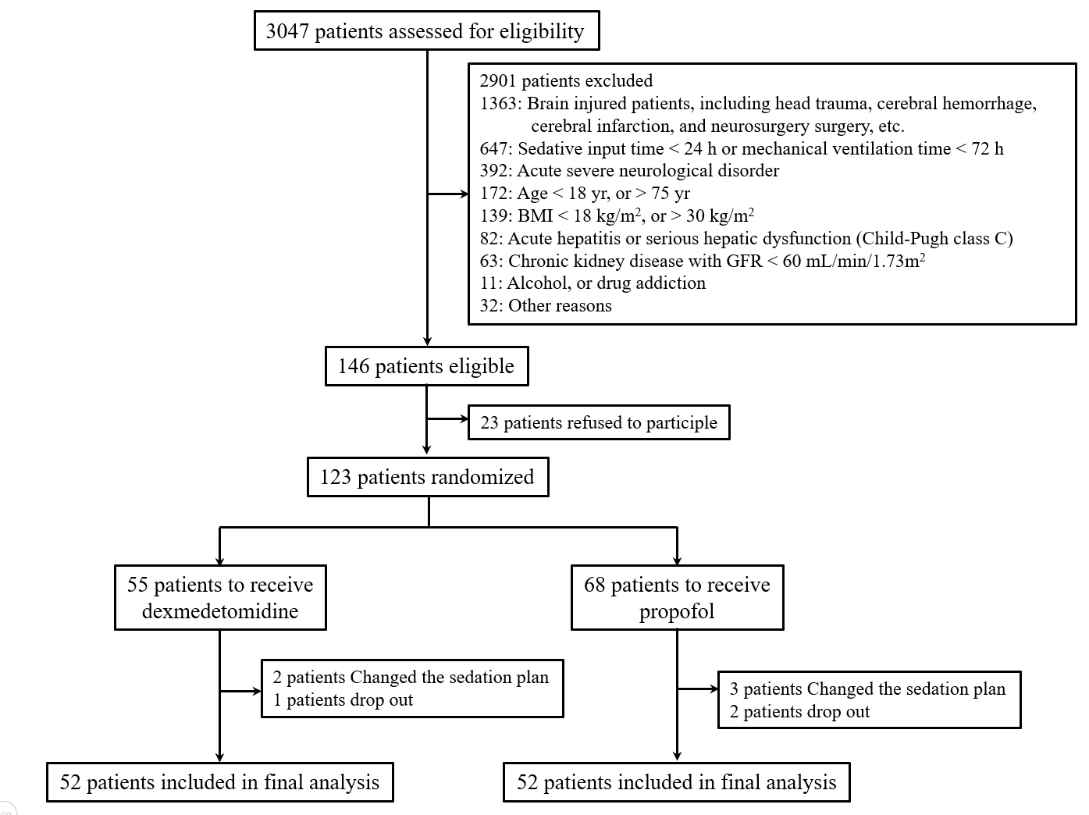
Figure 1 Flow diagrams for the trials. BMI: Body mass index; GFR: Glomerular filtration rate.
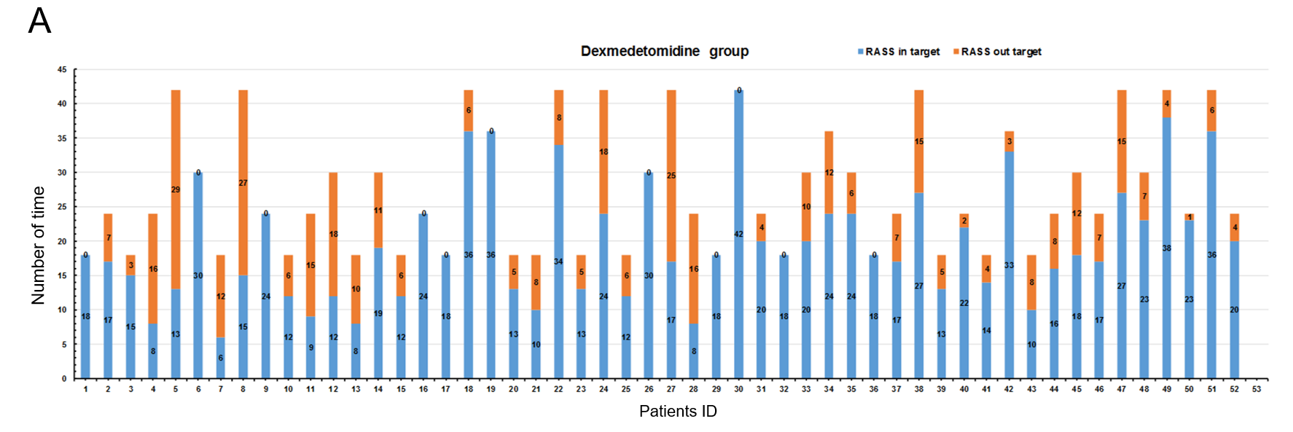
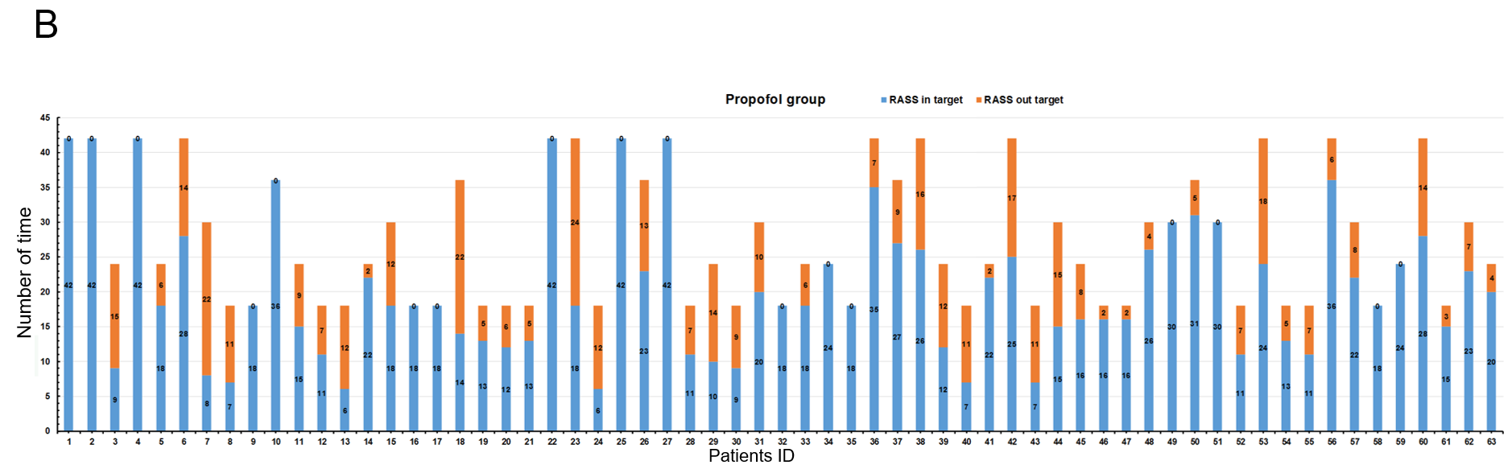
Figure 2 Number of times Richmond Agitation Sedation Scale scores in and out the target range. A: Dexmedetomidine group; B: Propofol group. RASS: Richmond Agitation Sedation Scale scores.
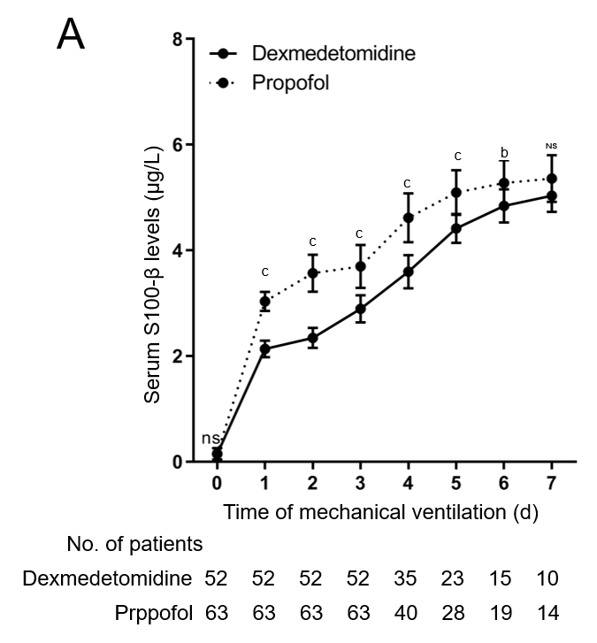
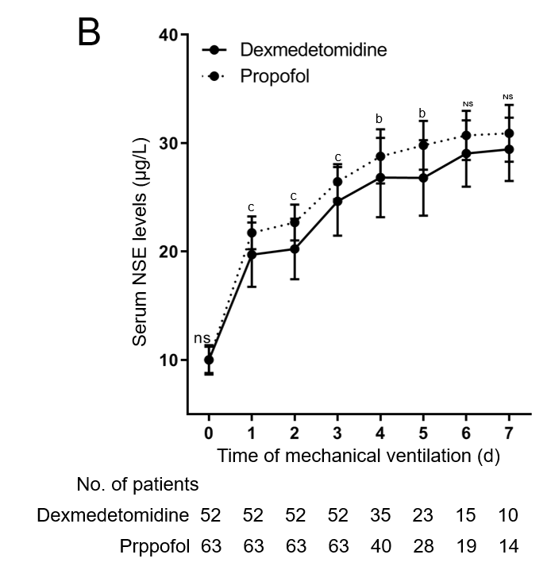
Figure 3 Dynamic changes of serum S100-β and neuron-specific enolase levels in patients with mechanical ventilation. A: S100-β; B: Neuron-specific enolase. NSE: Neuron-specific enolase; NS: Not significant. ªP < 0.05; ^{b}P < 0.01; ^{c}P < 0.001.

Table 1 Baseline characteristics of non-brain injured patients, n (%)
 | Dexmedetomidine (n = 52) | Propofol (n = 63) | P value
Age (yr), median (IQR) | 61.0 (55.0-64.0) | 61.0 (53.0-66.0) | 0.663
Male | 30 (57.7) | 39 (61.9) | 0.646
BMI (kg/m²), median (IQR) | 21.8 (19.6-24.3) | 21.1 (19.0-22.3) | 0.191
SAPS II, median (IQR) | 46.0 (38.0-54.0) | 46.0 (36.0-53.0) | 0.675
Main reason for ICU
Medical | 37 (71.2) | 44 (69.9) | 0.983
Surgical | 10 (19.2) | 13 (20.6)
Trauma | 5 (9.6) | 6 (9.5)
Infection at ICU admission | 24 (46.2) | 30 (47.6) | 0.875
SOFA score of organ > 2
Respiratory | 30 (57.7) | 35 (55.6) | 0.818
Cardiovascular | 26 (50.0) | 27 (42.9) | 0.444
Renal | 8 (15.4) | 10 (15.9) | 0.943
Coagulation | 4 (7.7) | 6 (9.5) | 0.729
Liver | 1 (1.9) | 1 (1.6) | 0.891
Total SOFA score, median (IQR) | 7.0 (4.0-9.0) | 6.0 (3.0-9.0) | 0.954
RASS score at enrollment, median (IQR) | -2 (-3 to -1) | -3 (-3 to -1) | 0.247
Time from ICU admission to drug initiation (h), median (IQR) | 32.0 (20.0-35.0) | 31.0 (20.0-42.0) | 0.798
ICU: Intensive care unit.
Table 2 Dosage of study drugs during mechanical ventilation
 | Dexmedetomidine (n = 52) | Propofol (n = 63) | P value
Duration of study drug infusion (h), median (IQR) | 52.0 (36.0-73.5) | 53.0 (37.0-72.0) | 0.958
Dose of study drug (μg or mg/kg/h), median (IQR) | 0.58 (0.34-0.79) | 0.82 (0.65-1.32) | -
Dose of remifentanil (μg/kg/h), median (IQR) | 4.5 (4.0-5.0) | 4.6 (4.0-5.0) | 0.395
Receiving rescue sedation, n (%) | 36.0 (69.2) | 32.0 (50.8) | 0.045

Table 3 Comparison of sedative effect between the two groups
 | Dexmedetomidine (n = 52) | Propofol (n = 63) | P value
Percentage of time within the target RASS (%), median (IQR) | 85.6 (65.8-96.6) | 86.7 (72.3-95.3) | 0.592
Percentage of target RASS score (%), median (IQR) | 72.2 (60.8-91.7) | 73.3 (60.0-100.0) | 0.880
RASS: Richmond Agitation and Sedation Scale.
Table 4 Comparison of S100-β serum levels between the two groups
Time | Dexmedetomidine |  | Propofol |  | P value
 | n | S100-β | n | S100-β
Day 0 | 52 | 0.12 (0.06-0.18) | 63 | 0.14 (0.08-0.23) | 0.4080
Day 1 | 52 | 2.12 (2.03-2.22) | 63 | 3.02 (2.92-3.18) | < 0.001
Day 2 | 52 | 2.30 (2.18-2.48) | 63 | 3.53 (3.32-3.85) | < 0.001
Day 3 | 52 | 2.88 (2.67-3.05) | 63 | 3.62 (3.39-4.06) | < 0.001
Day 4 | 35 | 3.58 (3.36-3.85) | 40 | 4.70 (4.35-4.97) | < 0.001
Day 5 | 22 | 4.46 (4.34-4.58) | 28 | 4.98 (4.86-5.44) | < 0.001
Day 6 | 15 | 4.83 (4.68-5.03) | 19 | 5.33 (4.98-5.65) | 0.0026
Day 7 | 10 | 5.06 (4.81-5.32) | 14 | 5.38 (5.19-5.67) | 0.0562

Table 5 Comparison of neuron-specific enolase serum levels between the two groups
Time | Dexmedetomidine |  | Propofol |  | P value
 | n | NSE | n | NSE
Day 0 | 52 | 9.95 (9.08-10.65) | 63 | 9.86 (9.35-10.56) | 0.9570
Day 1 | 52 | 20.09 (17.63-21.43) | 63 | 21.42 (20.71-23.08) | < 0.001
Day 2 | 52 | 20.35 (17.96-21.50) | 63 | 22.35 (21.38-23.92) | < 0.001
Day 3 | 52 | 24.89 (21.87-26.85) | 63 | 26.25 (25.15-27.35) | < 0.001
Day 4 | 35 | 26.62 (23.43-29.35) | 40 | 29.17 (26.61-31.14) | 0.0082
Day 5 | 22 | 26.75 (24.93-29.37) | 28 | 29.66 (27.72-31.14) | 0.0047
Day 6 | 15 | 28.93 (26.35-30.52) | 19 | 30.72 (28.65-31.98) | 0.0774
Day 7 | 10 | 28.34 (26.95-31.23) | 14 | 30.54 (28.90-32.46) | 0.2060
NSE: Neuron-specific enolase.

