Name of journal: World Journal of Gastroenterology
Manuscript NO: 35863
Manuscript type: ORIGINAL ARTICLE

Clinical Trials Study
Preliminary exploration of the application of super microvascular imaging in focal liver lesions

He MN et al. The application of SMI in FLLs

Meng-Na He, Ke Lv, Yun-Xin Jiang, Tian-An Jiang

Meng-Na He, Tian-An Jiang, Department of Ultrasound, The First Affiliated Hospital, College of medicine, Zhejiang University, Hangzhou 310000, Zhejiang Province, China

Ke Lv, Yun-Xin Jiang, Department of Ultrasound, Peking Union Medical College Hospital, Peking Union Medical College, Chinese Academy of Medical Sciences, Beijing 100730, China

ORCID number: Meng-Na He (0000-0002-8178-3531); Ke Lv (0000-0001-8779-9860); Yun-Xin Jiang (0000-0003-3430-4080); Tian-An Jiang (0000-0002-7672-8394).

Author contributions: He MN, Lv K and Jiang YX designed research; He MN and Lv K performed research; Jiang TA contributed new reagents or analytic tools and analyzed data; He MN wrote the paper.

Institutional review board statement: The study was reviewed and approved by the ethical committee of Peking union medical college hospital.

Informed consent statement: Informed consent was provided by each patient before examination.

Conflict-of-interest statement: This article has no conflict of interests to disclose.

Data sharing statement: No additional data are available.

Open-Access: This article is an open-access article which was selected by an in-house editor and fully peer-reviewed by external reviewers. It is distributed in accordance with the Creative Commons Attribution Non Commercial (CC BY-NC 4.0) license, which permits others to distribute, remix, adapt, build upon this work non-commercially, and license their derivative works on different terms, provided the original work is properly cited and the use is non-commercial. See: http://creativecommons.org/licenses/by-nc/4.0/

Manuscript source: Unsolicited manuscript

Correspondence to: Yun-Xin Jiang, MD, Department of Ultrasound, Peking Union Medical College Hospital, Peking Union Medical College, Chinese Academy of Medical Sciences, Beijing 100730, China. jiangyuxinxh@163.com
Telephone: +86-10-69155494
Fax: +86-10-69155494

Received: August 13, 2017
Peer-review started: August 15, 2017
First decision: August 30, 2017
Revised: September 14, 2017
Accepted: September 20, 2017
Article in press:
Published online:

Abstract
AIM
To explore the ability of super micro-vascular imaging (SMI) to differentiate diagnose focal liver lesions and compare the SMI morphology to Color Doppler Ultrasound and enhanced imaging.

METHODS
24 patients with 31 focal liver lesions were involved in our study, consisting of hemangioma (HE) (n = 17), hepatocellular carcinoma (HCC) (n = 5), metastatic lesions (n = 5), primary hepatic lymphoma (n = 1), focal nodular hyperplasia (FNH) (n = 2), adenoma (n = 1). 9 lesions were pathologically diagnosed and 22 lesions were radiologically confirmed which were at least had been done two-kinds of enhanced imaging techniques. All patients had been done SMI. The patients were divided into subgroups based on the pathological and radiological diagnosis to analyze the SMI manifestations. We also compared the SMI manifestations between the most common malignant FLLs of HCCs and metastatic lesions with the most common benign FLLs of HEs.

RESULTS
The HEs were described as three SMI subgroups: diffuse dot-like type (n = 6); strip rim type (n = 8); nodular rim type (n = 3), the size of the three groups were obviously different (P = 0.00, < 0.05); The HCCs were described as two subgroup: diffuse honeycomb type (n = 2); non-specific type (n = 3). Four of the metastatic lesions were like strip rim type of HE; the other one shared the same type of thick rim type with lymphoma. The FNH was described as spoke-wheel type, and the adenoma was diffuse honeycomb type. The SMI types were significant different between HCCs and metastatic lesions with HEs (P = 0.048, < 0.05).

CONCLUSION
SMI technology made the evaluation of micro-vascular of focal liver lesions possible without any enhanced agents. For HEs, the size of the lesions may affect the SMI performance. SMI had the potential to add useful information to differential diagnosis between HCCs and metastatic lesions with HEs.

Key words: Super microvascular imaging; Color Doppler Ultrasound; Focal liver lesions; Primary hepatic lymphoma; Hemangioma

© The Author(s) 2017. Published by Baishideng Publishing Group Inc. All rights reserved.

Core tip: We evaluated a novel ultrasound technique of super-micro vascular imaging (SMI) to assess the microvascular morphology of focal liver lesions in order to provide additional diagnostic information. The focal liver lesions consisted of hemangioma, hepatocellular carcinoma, metastatic lesions, primary hepatic lymphoma, focal nodular hyperplasia and adenoma. We also compared SMI manifestations to Color Doppler ultrasound and enhanced imaging features.

He MN, Lv K, Jiang YX, Jiang TA. Preliminary exploration of the application of super microvascular imaging in focal liver lesions. World J Gastroenterol 2017; In press

INTRODUCTION
The frequency of focal liver lesions (FLLs) detection is increasing obviously because of the development and prevalence of imaging technology especially the ultrasound examinations. Kaltenbach et al^{[1]} investigated 45319 hospital patients showed the prevalence of benign FLLs achieved 15.1%. Hepatocellular carcinoma (HCC) is the second most common cause of mortality from cancer^{[2,3]}.The subsequent challenge we faced with is not only how to distinguish between malignant and benign among the various FLLs efficiently^{[4,5]}, but also to exactly identify the characteristic of all kinds of FLLs due to the different clinical treatment and outcomes, such as the treatment between hemangioma (HE) and adenoma, HCC and lymphoma had a great difference.
To well solve this challenge involves choosing a diagnostic method which costs less time and effort, but can reach a high diagnostic accuracy. Contrast enhanced ultrasound (CEUS) has been gradually recognized as a comparable imaging technique to contrast enhanced computer tomography (CECT) and contrast enhanced magnetic resonance imaging (CEMRI) in the diagnosis of FLLs^{[6,7]}, the common advantage of the above three techniques is to visualize the microvascular structure, one of the most important element of the tumor microenvironment^{[8]} , which plays an important role in the development and progression of the lesions and is the key points to differential diagnosis. While these techniques also have inevitable drawbacks: first, some patients may limited to these examinations because of the contraindications caused by the contrast agents, such as the risk of triggering or worsening renal failure by the contrast agents of iodine used for CT and Gd-DTPA (gadolinium diethylene-trianmine pentaacetic acid) used for MRI^{[9]}; besides, the agents used in CEUS, CECT and CEMRI were foreign bodies, each of them may cause hypersensitivity reactions^{[10]} ; secondly, the three techniques take additional economic costs and time consuming, so widely available is difficult.
Super microvascular imaging (SMI) is a novel Doppler technique developed by Toshiba Medical System (Tokyo, Japan)^{[11]}, the design goal of SMI is to simulated enhanced ultrasound by using advanced clutter elimination to obtain only vascular flow signals without any contrast agents^{[12]}. Like Color Doppler and power Doppler imaging, SMI can provide a real-time examination of vascularity in FLLs, while compared with them, SMI has the obvious advantage of detecting more slow blood flow and reveal micro-vessels. Researches about SMI technology in the superficial field like thyroid and breast tumor had been reported in succession and got some useful information for differential diagnosis^{[11,13]}, Machado et al^{[13]} evaluated the capability of SMI to visualize the microvascular flow in normal thyroid tissue and thyroid nodules compared with CDFI, and the results showed SMI had better depiction of vessel branching; Zhan et al^{[14]} compared the ability to discover penetrating vessels (PVs) of breast cancer between CDFI and SMI, the results showed more PVs were observed by SMI than CDFI; while studies of SMI about FLLs are still rare^{[15]}, the purpose of our study is to investigate the SMI features of FLLs and to analyze the ability to provide additional information for clinical differential diagnosis.

MATERIALS AND METHODS
Patients and focal liver lesions identification
The study was from November 2016 to March 2017 at Peking union medical college hospital, approved by the ethical committee of the hospital and informed consent was provided by each patient before examination. 24 patients (mean age, 53.5 ± 12.9 years, range 24-79; M:F = 13:11) with 31 focal liver lesions were involved in our study, All FLLs had been done at least one of CE-US/CT/MRI, among them, 9 lesions were pathologically diagnosed including 2 lesions of HE in 2 patients, 5 lesions of HCCs in 4 patients, 1 lesion of hepatic adenoma and 1 lesion of primary hepatic lymphoma；22 lesions were radiologically confirmed，including 15 HEs in 12 patients (single lesion in 9 patients and two lesions in 3 patients), which were diagnosed by CE-CT and/or CE-MRI with typical manifestations like centripetal enhancement from peripheral nodular or strip beginning followed with persistently enhanced on portal venous phase and delay phase; 5 lesions of metastatic mass (one has single lesion and the other one has four lesions) were diagnosed by the primary tumor history and CE-CT/CE-US which showed malignant characteristics with arterial enhancement and quickly exist on portal venous phase; 2 lesions of FNH were diagnosed by CECT for persistent enhancement from arterial phase to portal venous/delayed phase with clear-defined outline and a central scar. Table 3 summarized the clinical, SMI types and pathologic features of the 31 FLLs.

Super microvascular imaging examination and imaging analysis
Patients were placed in the supine or left lateral position after 6 h’ fasting, all US examinations including B-mode US, CDFI and SMI were performed with a curved transducer (6C1Aplio 500; Toshiba Medical Systems Corporation, Tochigi, Japan). B-mode US was the first step to scan the liver thoroughly and find the FLL, once detected, the general features were observed and the lesion size (maximal diameter in the maximum section) were measured. Subsequently, conventional CDFI mode and SMI mode were also performed to observe the vascular of the FLLs, when for CDFI examination, the scale was set as low as possible until arrived at the appropriate level without any pseudo color flow like color flow spillover, the lowest scale was at 4 cm/s, and the flow gain was adjusted high enough until noise emerged; for SMI examination, the parameters setting as following: color velocity scale was adjusted to no more than 2.0 cm/s, the frame rate > 30 fps, the color frequency was control to 5-7 MHz, the gain setting was adjusted to show optimal imaging. All US examinations were performed by a single operator, and the imaging data were analyzed by two experienced radiologists, both operator and readers had > 10 years’ experience in liver ultrasound, and the latter classified the SMI characteristics of the FLLs into 7 types，if any disagreement happened, decision would be made until reach a consensus after consultation. (Figure 1): Type I, diffuse dot-like type; Type II, strip rim type; Type III, nodular rim type; Type IV, diffuse honeycomb type; Type V, non-specific type; Type VI, thick rim type with lymphoma; Type VII, spoke-wheel type^{[15]}. The SMI type of each FLLs was recorded, and discussion will be made to determine the SMI type in cases of disagreement. We divided the 31 FLLs into small FLLs (≤ 3.0 cm) group and > 3.0 cm group^{[16]}, and compare the vascular visibility between CDFI and SMI. We also compared the SMI types between the most common malignant FLLs of HCCs and metastatic lesions with the most common benign FLLs of HEs.

Statistical analysis
The differences of SMI types between the most common malignant FLLs of HCCs and metastatic lesions with the most common benign FLLs of HEs were evaluated by Fisher’s exact test, and we used X² test to compare the sex distribution of HEs between different SMI types, the difference of size and year were evaluated by one-way ANOVA test. P < 0.05 was considered to have a statistically significant difference. SPSS 16.0 was used for all data analysis.

RESULTS
All 31 FLLs had been successfully completed the US examinations including B-mode US, CDFI and SMI, satisfactory images were got. Of all 17 HEs, the SMI features can be divided into three types: 6 were diffuse dot-like type (Type I, Figure 2 ); 8 were strip rim type(Type II, Figure 3); 3 were nodular rim type(Type III, Figure 4), the size of HEs in the three types were obviously different (P = 0.00, < 0.05), and the average age and sex distribution of the corresponding patients showed no difference (Table 1).
The SMI features of the rest 14 FLLs were manifested as followings: 2 of the HCCs were described as diffuse honeycomb type (Type IV, Figure 5) and 3 were non-specific type (Type V, Figure 6); 4 of the metastatic lesions were from the tumor of breast in one patient, classified to strip rim type (Type II) and the other one was from pancreatic, and shared the same type of thick rim type (Type VI, Figure 7) with the lesion of primary hepatic lymphoma; the 2 FNH lesions were described as spoke-wheel type (Type VII, Figure 8), and the adenoma was showed as diffuse honeycomb type. The distribution of SMI types between the most common malignant FLLs of HCCs and metastatic lesions with the most common benign FLLs of HEs were significant different (P = 0.048, < 0.05) (Table 2), and these morphology findings of SMI types between different FLLs were corresponding to the enhanced ultrasound/CT/MRI. The characteristics of all FLLs and the corresponding patients were summered in Table 3.
Among the 31 FLLs, 13 were small FLLs with the maximum diameter less than 3.0 cm, and 17 were large than 3.0 cm. SMI mode had the ability to detect the vascular of all the 31 lesions, while CDFI mode missed the vascular of 9 lesions (69.2%) in small group and 2 lesions (11.8%) in > 3.0 cm group.

DISCUSSION
Angiogenesis, an important part of the tumor microenvironment^{[17]}, plays a key role in the development of FLLs. At the same time, the blood vessels morphology of the lesions is the major point to differential diagnosis. CDFI had been widely used to depict tumor vessels, however, the CDFI is limited to identify low-speed flow signals because of the wall filter, which suppress clutter and motion artifacts but also lose the low-speed flow signals. The novel technique, SMI overcome the difficulty and has the ability to distinguish the slow vessels information from artifacts effectively without any contrast agents. In the current study, we compared the ability of CDFI mode and SMI mode to detect the vascular of all the 31 FLLs, and the results showed that SMI had found the flow information in all lesions, while CDFI mode missed the vascular of 9 lesions (69.2%) in small group (< 3.0 cm) and 2 lesions (11.8%) in > 3.0 cm group, which means SMI has obvious advantages in detecting vessels of FLLs, which is a good addition for the limitation of CDFI especially for the micro-vessels description in small lesions.
Researches about the application of SMI in FLLs are rare to date, and only two investigations have been reported: one was reported by Wu et al^{[18]}, SMI clearly demonstrated the typical “spoke-wheel” vascular type of FNH in the liver without using any contrast agent; another one was reported by Lee et al^{[15]}, the application of SMI in three kinds of 29 FLLs including HE, HCC and FNH and concluded that the SMI types were significant different between FLLs. In the present study, we analyzed the SMI features in 6 kinds, 31 cases of FLLs including HE, HCC, metastatic lesions, FNH, hepatic adenoma and primary hepatic lymphoma, we used 7 types to further depict the vessel distribution and morphology of the 31 FLLs, the SMI type distribution between the most common malignant FLLs of HCCs and metastatic lesions with the most common benign FLLs of HEs were significant different, which would provide meaningful additional differential diagnostic information. Meanwhile, we also found that some different FLLs shared the same SMI type, for example, the metastatic lesions from the tumor of breast shared strip rim type (type II) with HE; the other metastatic lesion from pancreatic had the same SMI type of thick rim type (type VI) with the primary hepatic lymphoma; the hepatic adenoma and partial HCCs had the same type of diffuse honeycomb type (Type IV). Thus, when a FLLs was suspected as a SMI type we classified, we still need to integrate the result with clinical history.
For HEs, the average maximum diameter of type I, type II and type III were 2.07 ± 0.63 cm, 3.68 ± 1.12 cm and 7.73 ± 1.24 cm, the lesion size of the three different SMI types was obviously different. Histology of HE can explain the SMI manifestation, first, the original etiology for HE was not clear, mostly recognized that congenital vessel malformation caused by the hyperplasia of endothelial cells may be the probably reason^{[19]}, consequently, the microscopical features of HE showed like a blood pool constituted by cavernous vascular spaces, which were lined by a single layer with different size of flat endothelium. The vascular cavities vary in size and corresponding the size of HE lesions, some HEs may contain thrombus which will gradually turn into fibrous scars or nodules, especially for large lesions^{[20]}. Therefore, for the larger HEs, the internal blood flow may be slower and even completely replaced by the thrombus, so the enhanced examination can be shown as peripheral nodules or ring enhanced patterns, and the corresponding SMI also manifested this way, like type II and type III. While for small HEs, both enhanced techniques and SMI could show internal slow vascular signals, like type I. According to the previous statements, type I and type III were significantly distinctive as to discriminate HEs from other FLLs.
Regarding for the other kinds of FLLs, the previous SMI study about FLLs by Lee et al^{[15]} obtained that the SMI manifestation of HCC had non-specific vascular types, while in the present study, we used two SMI types to summarize HCC including type IV, diffuse honeycomb type and type V, non-specific type. The general pathology of the former also showed that the inter-tumor blood vessels were distributed in a grid pattern like honeycombs. The SMI feature of the latter one showed like strip trunk with tiny branches, but we have not got enough evidence of other enhanced techniques or pathology results to supported it, thus we classified it to non-specific type. This research including two cases of FNH, and both CDFI and SMI manifested as typical “spoke-wheel” type, while without the basic echo of liver parenchyma, the vascular structure by SMI seemed much more clear, which is the same with the previous studies^{[15,18]}.
For metastatic lesions, it is always assumed that their imaging performance is particularly confusing because metastatic lesions can simulate various other kinds of FLLs, just as the present study, the SMI types of metastatic lesions were similar to HE and lymphoma. Therefore, in the diagnosis of metastatic lesions, clinical history such as the primary tumor is critical important in addition to imaging manifestations.
For hepatic adenoma, researches about the ultrasound features of HA were relatively rare because of the low morbidity compared to other FLLs, Dong et al^{[21]} had done a retrospective study to analyze the difference of ultrasound and CEUS features between HA and HCC, the results showed that most cases of HAs were manifested as homogenous, rapid and complete enhancement in the arterial phase which is similar to HCC. The identical result was obtained from this study that HA shared the same SMI type (type IV, diffuse honeycomb type) with some HCC. This patient was diagnosed as benign lesion or relatively mild malignant mass before surgery because of the very clear margin and slow wash-out pattern on CECT. SMI manifestation of this case had no unique characteristic performance and was limited to the diagnosis of hepatic adenoma, thus enhanced imaging examination must to be combined with.
Primary hepatic lymphoma (PHL) is also a rare disease, only constitutes 0.016% of all cases of Non-Hodgkin's Lymphoma (NHL)^{[22]}. And the treatment for PHL need to combine surgery, chemotherapy and radiotherapy which strikingly different from HCC or other malignant FLLs, hence it is important to be accurately diagnosed before operation. Researches by Lu et al^{[23]} had found the CECT manifestation of some PHLs showed rim-like enhancement which is similar to the CEUS and SMI performance of this case. Thus, SMI may provide some helpful information for the diagnosis of some PHLs.
Our study has some limitations. First, for hepatic adenoma and primary hepatic lymphoma, the basic incidence is very low and there are inevitable sample errors. Second, only 9 lesions were pathologically diagnosed in this study, there are still very low possibilities of miss diagnosis for the other 22 lesions which were radiologically confirmed because as the results showed different kinds of FLLs may have same imaging manifestation, despite at least two-kinds of enhanced imaging techniques had been done.
In conclusion, SMI technology made the evaluation of microvascular of focal liver lesions possible without any enhanced agents, for HEs, the size of the lesions may affect the SMI performance. And SMI is a good addition for the limitation of CDFI especially for the micro-vessels description in small lesions; the SMI characteristic between the most common malignant FLLs of HCCs and metastatic lesions with the most common benign FLLs of HEs were significant different.
ARTICLE HIGHLIGHTS
Research background
The frequency of focal liver lesions (FLLs) detection is increasing obviously because of the development and prevalence of imaging technology especially the ultrasound examinations. The subsequent challenge we faced with is not only how to distinguish between malignant and benign among the various FLLs efficiently, but also to exactly identify the characteristic of all kinds of FLLs due to the different clinical treatment and outcomes.
To well solve this challenge involves choosing a diagnostic method which costs less time and effort, but can reach a high diagnostic accuracy. some patients may limited to the present imaging techniques like CEUS/CT/MRI, because the risk of triggering or worsening renal failure by the contrast agents of iodine used for CT and Gd-DTPA (gadolinium diethylene-trianmine pentaacetic acid) used for MRI, besides, the agents used in CEUS, CECT and CEMRI were foreign bodies, each of them may cause hypersensitivity reactions, secondly, the three techniques take additional economic costs and time consuming, so widely available is difficult.

Research motivation
Super microvascular imaging (SMI) is a novel Doppler technique to simulated enhanced ultrasound by using advanced clutter elimination to obtain only vascular flow signals without any contrast agents. The purpose of our study is to investigate the SMI features of FLLs and to analyze the ability to provide additional information for clinical differential diagnosis.

Research objectives
To explore the ability of SMI to differentiate diagnose focal liver lesions and compare the SMI morphology to Color Doppler Ultrasound and enhanced imaging.

Research methods
24 patients with 31 focal liver lesions were involved in our study, consisting of hemangioma (HE) (n = 17), hepatocellular carcinoma (HCC) (n = 5), metastatic lesions (n = 5), primary hepatic lymphoma (n = 1), focal nodular hyperplasia (FNH) (n = 2), adenoma (n = 1). 9 lesions were pathologically diagnosed and 22 lesions were radiological confirmed which were at least had been done two-kinds of enhanced imaging techniques. All patients had been done SMI. The patients were divided into subgroups based on the pathological and radiological diagnosis to analyze the SMI manifestations. We also compared the SMI manifestations between the most common malignant FLLs of HCCs and metastatic lesions with the most common benign FLLs of HEs.

Research results
The HEs were described as three SMI subgroups: diffuse dot-like type (n = 6); strip rim type (n = 8); nodular rim type (n = 3), the size of the three groups were obviously different (P = 0.00, < 0.05); The HCCs were described as two subgroup: diffuse honeycomb type (n = 2); non-specific type (n = 3). Four of the metastatic lesions were like strip rim type of HE; the other one shared the same type of thick rim type with lymphoma. The FNH was described as spoke-wheel type, and the adenoma was diffuse honeycomb type. The SMI types were significant different between HCCs and metastatic lesions with HEs (P = 0.048, < 0.05).

Research conclusions
SMI technology made the evaluation of micro-vascular of focal liver lesions possible without any enhanced agents. For HEs, the size of the lesions may affect the SMI performance. SMI had the potential to add useful information to differential diagnosis between HCCs and metastatic lesions with HEs.

REFERENCES
1 Kaltenbach TE, Engler P, Kratzer W, Oeztuerk S, Seufferlein T, Haenle MM, Graeter T. Prevalence of benign focal liver lesions: ultrasound investigation of 45,319 hospital patients. Abdom Radiol (NY) 2016; 41: 25-32 [PMID: 26830608 DOI: 10.1007/s00261-015-0605-7]
2 Mazzanti R, Arena U, Tassi R. Hepatocellular carcinoma: Where are we? World J Exp Med 2016; 6: 21-36 [PMID: 26929917 DOI: 10.5493/wjem.v6.i1.21]
3 Chow PK, Choo SP, Ng DC, Lo RH, Wang ML, Toh HC, Tai DW, Goh BK, Wong JS, Tay KH, Goh AS, Yan SX, Loke KS, Thang SP, Gogna A, Too CW, Irani FG, Leong S, Lim KH, Thng CH. National Cancer Centre Singapore Consensus Guidelines for Hepatocellular Carcinoma. Liver Cancer 2016; 5: 97-106 [PMID: 27386428 DOI: 10.1159/000367759]
4 Dietrich CF, Sharma M, Gibson RN, Schreiber-Dietrich D, Jenssen C. Fortuitously discovered liver lesions. World J Gastroenterol 2013; 19: 3173-3188 [PMID: 23745019 DOI: 10.3748/wjg.v19.i21.3173]
5 Collin P, Rinta-Kiikka I, Räty S, Laukkarinen J, Sand J. Diagnostic workup of liver lesions: too long time with too many examinations. Scand J Gastroenterol 2015; 50: 355-359 [PMID: 25578122 DOI: 10.3109/00365521.2014.999349]
6 Dietrich CF, Maddalena ME, Cui XW, Schreiber-Dietrich D, Ignee A. Liver tumor characterization--review of the literature. Ultraschall Med 2012; 33 Suppl 1: S3-10 [PMID: 22723026 DOI: 10.1055/s-0032-1312897]
7 Dietrich CF. Liver tumor characterization--comments and illustrations regarding guidelines. Ultraschall Med 2012; 33 Suppl 1: S22-S30 [PMID: 22723025 DOI: 10.1055/s-0032-1312892]
8 Hanahan D, Weinberg RA. Hallmarks of cancer: the next generation. Cell 2011; 144: 646-674 [PMID: 21376230 DOI: 10.1016/j.cell.2011.02.013]
9 Bedoya M A, White A M, Edgar J C, Pradhan M, Raab EL, MPH1, Meyer J S. Effect of Intravenous Administration of Contrast Media on Serum Creatinine Levels in Neonates. Radiology 2017; 284: 160895 [DOI: 10.1148/radiol.2017160895]
10 Kolenda C, Dubost R, Hacard F, Mullet C, Le Quang D, Garnier L, Bienvenu J, Piriou V, Bérard F, Bienvenu F, Viel S. Evaluation of basophil activation test in the management of immediate hypersensitivity reactions to gadolinium-based contrast agents: a five-year experience. J Allergy Clin Immunol Pract 2017; 5: 846-849 [PMID: 28341169 DOI: 10.1016/j.jaip.2017.01.020]
11 Park AY, Seo BK, Cha SH, Yeom SK, Lee SW, Chung HH. An Innovative Ultrasound Technique for Evaluation of Tumor Vascularity in Breast Cancers: Superb Micro-Vascular Imaging. J Breast Cancer 2016; 19: 210-213 [PMID: 27382399 DOI: 10.4048/jbc.2016.19.2.210]
12 Ma Y, Li G, Li J, Ren WD. The Diagnostic Value of Superb Microvascular Imaging (SMI) in Detecting Blood Flow Signals of Breast Lesions: A Preliminary Study Comparing SMI to Color Doppler Flow Imaging. Medicine (Baltimore) 2015; 94: e1502 [PMID: 26356718 DOI: 10.1097/MD.0000000000001502]
13 Machado P, Segal S, Lyshchik A, Forsberg F. A Novel Microvascular Flow Technique: Initial Results in Thyroids. Ultrasound Q 2016; 32: 67-74 [PMID: 25900162 DOI: 10.1097/RUQ.0000000000000156]
14 Zhan J, Diao XH, Jin JM, Chen L, Chen Y. Superb Microvascular Imaging-A new vascular detecting ultrasonographic technique for avascular breast masses: A preliminary study. Eur J Radiol 2016; 85: 915-921 [PMID: 27130051 DOI: 10.1016/j.ejrad.2015.12.011]
15 Lee DH, Lee JY, Han JK. Superb microvascular imaging technology for ultrasound examinations: Initial experiences for hepatic tumors. Eur J Radiol 2016; 85: 2090-2095 [PMID: 27776663 DOI: 10.1016/j.ejrad.2016.09.026]
16 Cong WM, Bu H, Chen J, Dong H, Zhu YY, Feng LH, Chen J, Committee G. Practice guidelines for the pathological diagnosis of primary liver cancer: 2015 update. World J Gastroenterol 2016; 22: 9279-9287 [PMID: 27895416 DOI: 10.3748/wjg.v22.i42.9279]
17 Drudi FM, Cantisani V, Gnecchi M, Malpassini F, Di Leo N, de Felice C. Contrast-enhanced ultrasound examination of the breast: a literature review. Ultraschall Med 2012; 33: E1-E7 [PMID: 22623129 DOI: 10.1055/s-0031-1299408]
18 Wu L, Yen HH, Soon MS. Spoke-wheel sign of focal nodular hyperplasia revealed by superb micro-vascular ultrasound imaging. QJM 2015; 108: 669-670 [PMID: 25614615 DOI: 10.1093/qjmed/hcv016]
19 Massironi S, Branchi F, Rossi R E, Fraquelli M, Elli L, Bardella MT, Cavalcoli F, Conte D. Hepatic hemangioma in celiac patients: data from a large consecutive series. Gastroenterol Res Pract 2015; 2015: 749235
20 Ishak K G, Rabin L. Benign tumors of the liver. Med Clin North Am 1975; 59: 995-1013 [DOI: 10.1016/S0025-7125(16)31998-8]
21 Dong Y, Zhu Z, Wang W P, Mao F, Ji ZB. Ultrasound features of hepatocellular adenoma and the additional value of contrast-enhanced ultrasound. Hepatobiliary Pancreat Dis Int, 2016; 15: 48-54 [DOI: 10.1016/S1499-3872(15)60039-X]
22 Padhan RK, Das P, Shalimar. Primary hepatic lymphoma. Trop Gastroenterol 2015; 36: 14-20 [PMID: 26591949 DOI: 10.7869/tg.239]
23 Lu Q, Zhang H, Wang W P, Jin YJ, Ji ZB. Primary non-Hodgkin's lymphoma of the liver: sonographic and CT findings. Hepatobiliary Pancreat Dis Int 2015; 14: 75-81 [DOI: 10.1016/S1499-3872(14)60285-X]
P-Reviewer: Dietrich CF, Eleftheriadis NP, Tarantino G S-Editor: Wei LJ
L-Editor: E-Editor:
Specialty type: Gastroenterology and hepatology
Country of origin: China
Peer-review report classification
Grade A (Excellent): 0
Grade B (Very good): 0
Grade C (Good): C, C, C
Grade D (Fair): 0
Grade E (Poor): 0

Table 1 The size, average age and sex distribution between three types of hemangiomas
Types | Size | Yr | Sex
I | 2.07 ± 0.63 | 48.5 ± 21.3 | 2\4
II | 3.68 ± 1.12 | 52.0 ± 11.2 | 6\2
III | 7.73 ± 1.24 | 53.7 ± 8.3 | 0\3
P value | 0 | 0.89 | 0.06
Type I: Diffuse dot-like type; Type II: Strip rim type; Type: III Nodular rim type.

Table 2 The distribution of super micro-vascular imaging types between the most common malignant focal liver lesions of hepatocellular carcinoma and metastatic lesions with the most common benign focal liver lesions of hemangioma were significant different n (%)
Group | I | II | III | IV | V | VI | VII
HE (17) | 6 (35.2) | 8 (47.1) | 3 (17.6) | 0 (0) | 0 (0) | 0 (0) | 0 (0)
M (5) | 0 (0) | 4 (80) | 0 (0) | 0 (0) | 0 (0) | 1 (20) | 0 (0)
HCC (5) | 0 (0) | 0 (0) | 0 (0) | 2 (40) | 3 (60) | 0 (0) | 0(0)
FNH (2) | 0 (0) | 0 (0) | 0 (0) | 0 (0) | 0 (0) | 0 (0) | 2 (100)
HA (1) | 0 (0) | 0 (0) | 0 (0) | 1 (100) | 0 (0) | 0 (0) | 0 (0)
PHL (1) | 0 (0) | 0 (0) | 0 (0) | 0 (0) | 0 (0) | 1 (100) | 0 (0)
(P = 0.048, < 0.05), Type I: Diffuse dot-like type; Type II: Strip rim type; Type III: Nodular rim type; Type IV: Diffuse honeycomb type; Type V: Non-specific type; Type VI: Thick rim type; Type VII: Spoke-wheel type; HE: Hemangioma; M: Metastatic lesion; HCC: Hepatocellular carcinoma; FNH: Focal nodular hyperplasia; HA: Hepatic adenoma; PHL: Primary hepatic lymphoma.

Table 3 Summary of focal liver lesions’ and the corresponding patients’ characteristics
No. | Clinical  diagnosis | Pathological  diagnosis | SMI type  (I~VII) | size  (cm) | Age  (yr) | sex | other
1 | HE | - | I | 1.7 | 79 | M
2 | HE | - | I | 1.1 | 58 | F
3 | HE | - | I | 2.6 | 54 | M
4 | HE | - | I | 2.5 | 52 | F
5 | HE | - | I | 1.8 | 24 | F | same person
6 | HE | - | I | 2.7 | 24 | F
7 | HE | - | II | 2.3 | 63 | M
8 | HE | - | II | 3.9 | 61 | M | same person
9 | HE | - | II | 4.8 | 61 | M
10 | HE | - | II | 3.7 | 61 | F
11 | HE | - | II | 2.8 | 48 | M | same person
12 | HE | - | II | 3.1 | 48 | M
13 | HE | - | II | 3.1 | 41 | M
14 | HE | - | II | 5.7 | 33 | F
15 | HE | - | III | 6.3 | 63 | F
16 | - | HE | III | 8.4 | 51 | F
17 | - | HE | III | 8.5 | 47 | F
18 | B-M | - | II | 1.4 | 39 | F | same person
19 | B-M | - | II | 2.3 | 39 | F
20 | B-M | - | II | 2.6 | 39 | F
21 | B-M | - | II | 3.3 | 39 | F
22 | P-M | - | VI | 3.9 | 64 | M
23 | - | HCC | IV | 7.4 | 68 | M
24 | - | HCC | IV | 6.1 | 57 | M
25 | - | HCC | V | 2.5 | 60 | M
26 | - | HCC | V | 2.9 | 48 | M | same person
27 | - | HCC | V | 4.7 | 48 | M
28 | - | HA | IV | 5.3 | 41 | M
29 | - | LYM | VI | 5.8 | 71 | M
30 | FNH | - | VII | 4.1 | 62 | F
31 | FNH | - | VII | 4.3 | 39 | F
Type I: Diffuse dot-like type; Type II: Strip rim type; Type III: Nodular rim type; Type IV: Diffuse honeycomb type; Type V: Non-specific type; Type VI: Thick rim type; Type VII: Spoke-wheel type; FLL: Focal liver lesion; HE: Hemangioma; M: Metastatic lesion; HCC: Hepatocellular carcinoma; FNH: Focal nodular hyperplasia; HA: Hepatic adenoma; PHL: Primary hepatic lymphoma.

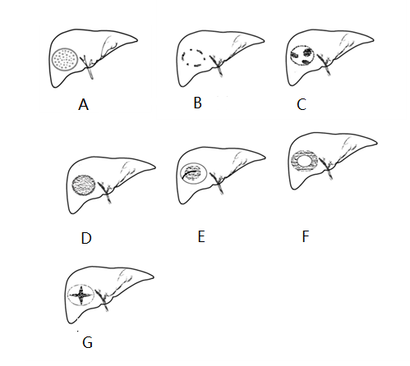
Figure 1 the simplified diagram of the 7 SMI types. A: Type I, diffuse dot-like type; B: Type II, strip rim type; C: Type III, nodular rim type; D: Type IV, diffuse honeycomb type; E: Type V, non-specific type; F: Type VI, thick rim type with lymphoma; G: Type VII, spoke-wheel type. SMI: Super micro-vascular imaging.

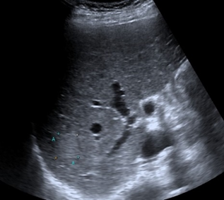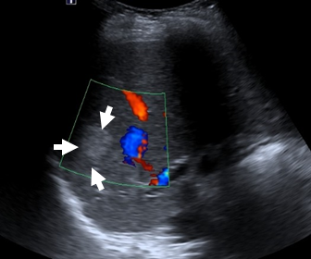
b
a

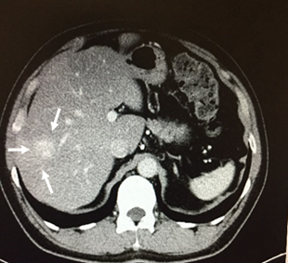
c
d
Figure 2 Type I diffuse dot-like type, male, 52 yr, diagnosed as hemangioma. A: Showed a high-echo lesion with clear margin in the right liver lobe; B: CDFI showed none blood flow signal of this lesion; C: SMI showed diffuse dot-like microvascular; D: contrast enhanced CT showed diffused enhancement of the lesion in the arterial phase. SMI: Super micro-vascular imaging.

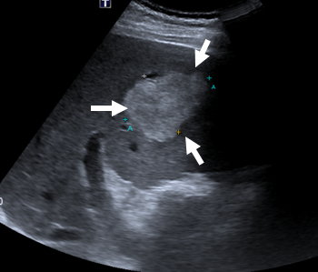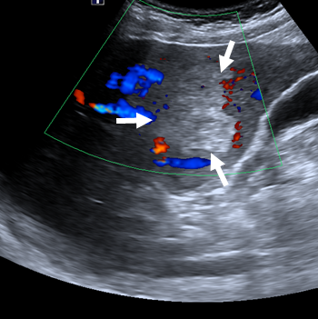
a
b

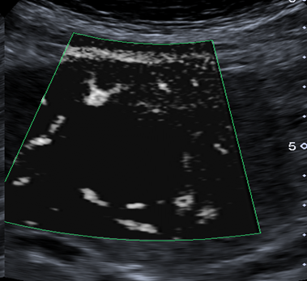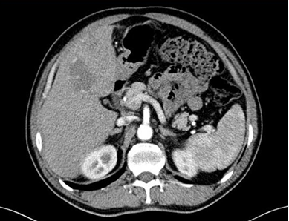
c
dd

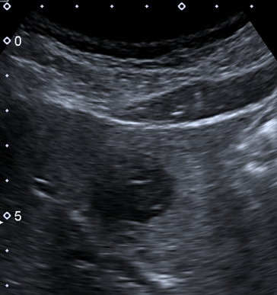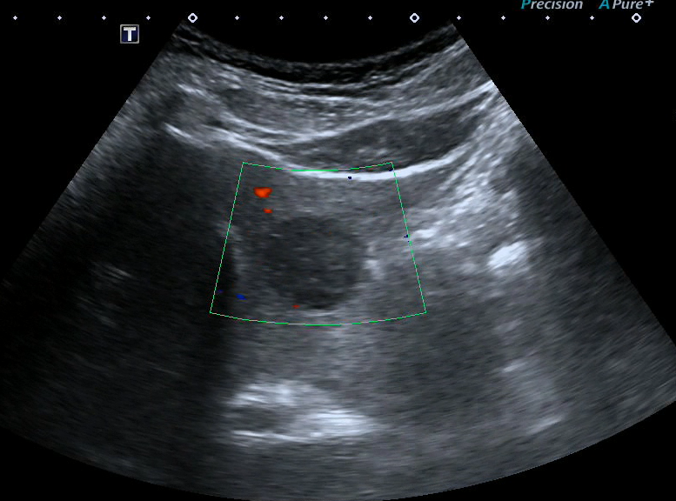
e
f

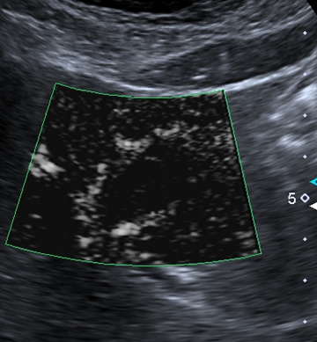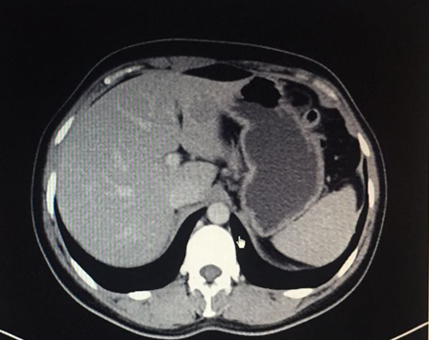
g
h
Figure 3 Type II strip rim type. A-D: Male, 61 yr, diagnosed as hemangioma. A: Showed a high-echo lesion with clear margin in the left liver lobe; B: CDFI showed interrupted strip blood flow signal around the edge of this lesion; C: SMI showed relatively continuous strip rim distributed microvascular; D: contrast enhanced CT showed strip rim enhancement of the lesion in the arterial phase. E-H: Male, 63 yr, diagnosed as hemangioma. E: Showed a hypo-echo lesion with clear margin in the left liver lobe; F: CDFI showed none blood flow signal of this lesion; G: SMI showed continuous strip rim microvascular; H: contrast enhanced CT showed strip rim enhancement of the lesion in arterial phase. SMI: Super micro-vascular imaging.

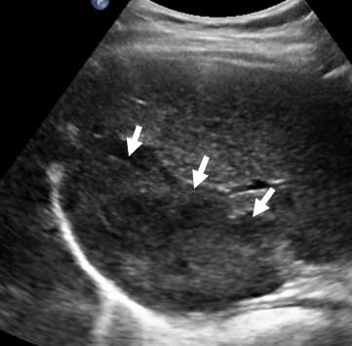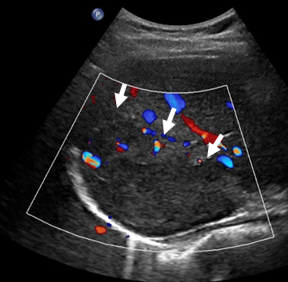
a
b

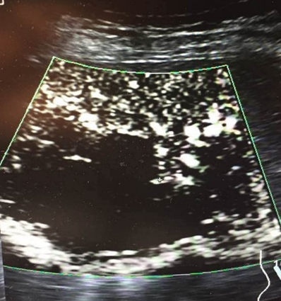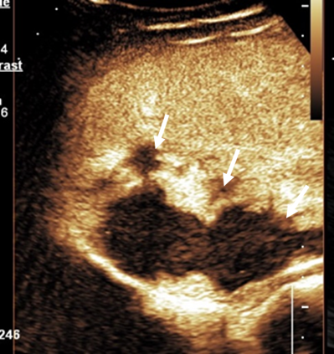
c
d
Figure 4 Type III nodular rim type, female, 51 yr, diagnosed as hemangioma. A: Showed a mixed-echo lesion with relatively clear margin in the right liver lobe; B: CDFI showed sporadic short strip blood flow signal around the edge of this lesion; C: SMI showed nodular rim distributed microvascular; D: contrast enhanced ultrasound showed nodular rim enhancement of the lesion in the arterial phase. SMI: Super micro-vascular imaging.

a
b

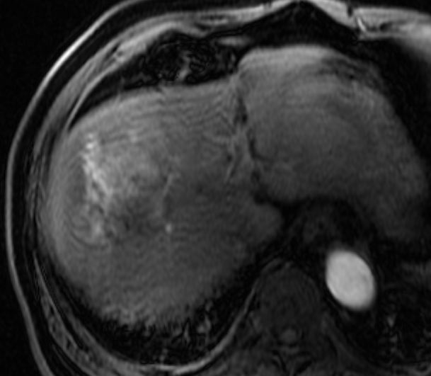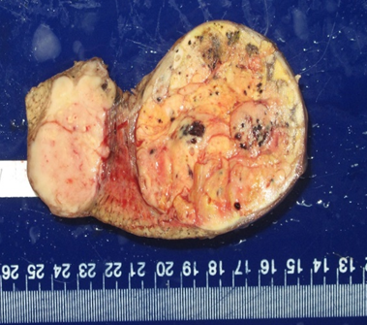
c
d

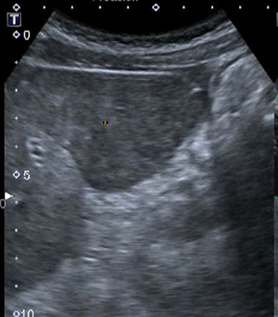
e
f

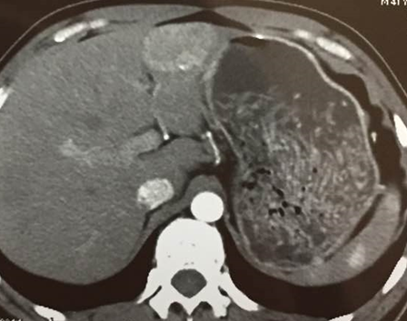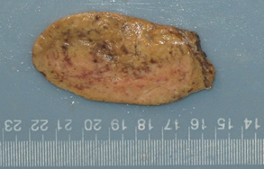
g
h
Figure 5 Type IV diffuse honeycomb type. A-D: Male, 68 yr, diagnosed as hepatic cellular carcinoma. A: Showed a mixed-echo lesion with relatively not clear margin in the right liver lobe; B: SMI showed diffuse honeycomb distributed microvascular; C: contrast enhanced MRI showed diffuse enhancement of the lesion in the arterial phase; D: pathology result showed the inter-tumor blood vessels were distributed in a grid pattern like honeycombs. E-H: Male, 41 yr, diagnosed as hepatic adenoma. E: Showed a hypo-echo lesion with clear margin in the left liver lobe; F: SMI showed diffuse honeycomb distributed microvascular; G: contrast enhanced CT showed diffuse enhancement of the lesion in the arterial phase; H: pathology result showed the inter-tumor blood vessels were distributed in a grid pattern like honeycombs. SMI: Super micro-vascular imaging.

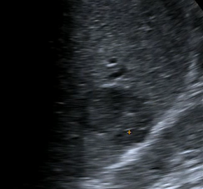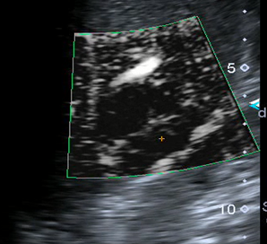
a
b

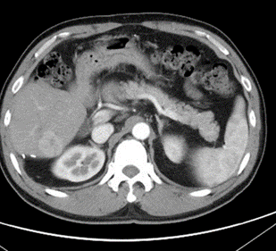
c
Figure 6 Type V non-specific type, male, 48 yr, diagnosed as hepatic cellular carcinoma. A: Showed a hypo-echo lesion with relatively clear margin in the right liver lobe; B: SMI showed strip trunk with tiny branches distributed microvascular; C: contrast enhanced CT showed diffuse enhancement of the lesion in the arterial phase. SMI: Super micro-vascular imaging.

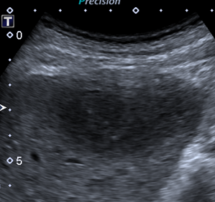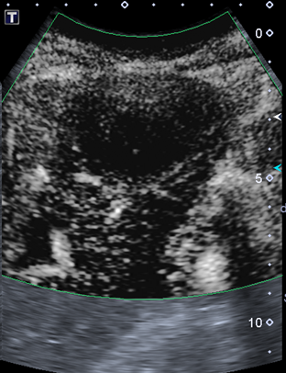
a
b

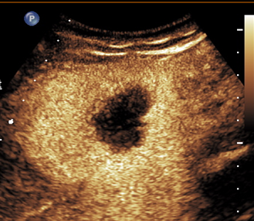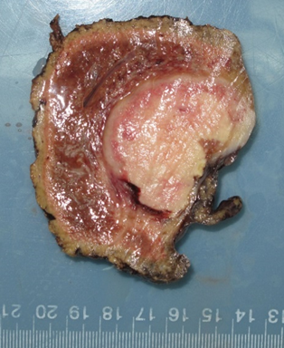
c
d
Figure 7 Type VI thick rim type, male, 71 yr, diagnosed as primary hepatic lymphoma. A: Showed a hypo-echo lesion with relatively clear margin in the left liver lobe; B: SMI showed thick rim distributed microvascular; C: contrast enhanced ultrasound showed thick rim enhancement of the lesion in the arterial phase; D: the general pathology result showed a thick rim distribution of vascular. SMI: Super micro-vascular imaging.

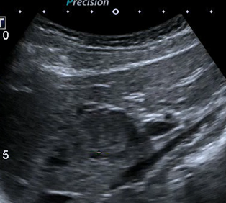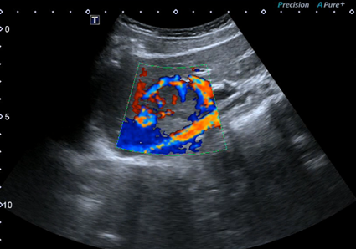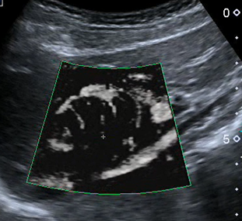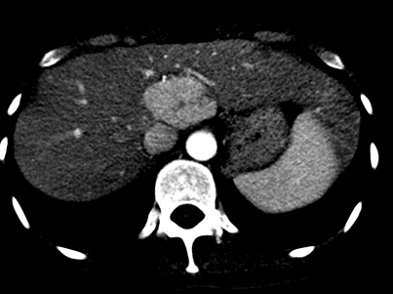
d
c
b
a

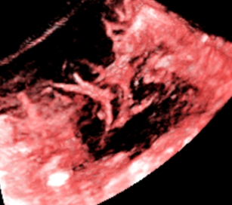
e
Figure 8 Type VII spoke-wheel type, female, 39 yr, diagnosed as focal nodular hyperplasia. A: Showed a hypo-echo lesion with relatively clear margin in the caudate liver lobe; B: CDFI showed spoke-wheel blood flow signal of this lesion; C: SMI showed spoke-wheel distributed microvascular; D: contrast enhanced CT showed diffuse enhancement with central scar of the lesion in the arterial phase; E: 3-D vascular remodeling of this lesion was successfully got and showed as spoke-wheel blood flow. SMI: Super micro-vascular imaging.

