Name of Journal: World Journal of Clinical Cases
Manuscript NO: 56977
Manuscript Type: CASE REPORT

Traumatic neuroma of remnant cystic duct mimicking duodenal subepithelial tumor: A case report

Kim DH et al. Traumatic neuroma of the cystic duct

Dong-Hwan Kim, Ji-Ho Park, Jin-Kyu Cho, Jung-Wook Yang, Tae-Han Kim, Sang-Ho Jeong, Young-Hye Kim, Young- Joon Lee, Soon-Chan Hong, Eun-Jung Jung, Young-Tae Ju, Chi-Young Jeong, Ju-Yeon Kim

Dong-Hwan Kim, Ji-Ho Park, Jin-Kyu Cho, Tae-Han Kim, Sang-Ho Jeong, Young-Hye Kim, Young- Joon Lee, Soon-Chan Hong, Eun-Jung Jung, Young-Tae Ju, Chi-Young Jeong, Ju-Yeon Kim, Department of Surgery, Gyeongsang National University College of Medicine, Gyeongsang National University Hospital, Jinju 52727, South Korea

Jung-Wook Yang, Department of Pathology, Gyeongsang National University College of Medicine, Gyeongsang National University Hospital, Jinju 52727, South Korea

Author contributions: All authors equally contributed to this paper.

Corresponding author: Ji-Ho Park, MD, Assistant Professor, Department of Surgery, Gyeongsang National University College of Medicine, Gyeongsang National University Hospital, 79 Gangnam-ro, Jinju 52727, South Korea. goodgsdr@gmail.com

Received: May 23, 2020
Revised: June 22, 2020
Accepted: August 22, 2020
Published online:

Abstract
BACKGROUND
Gastrointestinal subepithelial tumors (GSTs), incidentally detected during upper gastrointestinal (GI) endoscopy, may be lesions derived from the GI wall or may be caused by compression from external organs. In general, traumatic neuroma is a benign nerve tumor that results from postoperative nerve injury, occurring in the bile duct as one of the complications after cholecystectomy. This is the first case report demonstrating that neuroma of the cystic duct can be incorrectly perceived as a duodenal subepithelial tumor by compressing the duodenal wall.

CASE SUMMARY
We report the case of a 72-year-old man with traumatic neuroma of the cystic duct after cholecystectomy. This tumor was mistaken for a duodenal subepithelial tumor on preoperative upper GI endoscopy and endoscopic ultrasonography due to external compression of the GI wall. The patient had no symptoms, and his laboratory test results were normal. However, in a series of follow-up endoscopies, the tumor was found to have grown in size, so it was surgically resected. The lesion was completely removed by laparoscopic endoscopic cooperative surgery. The patient was discharged on postoperative day 7 without complications.

CONCLUSION
Traumatic neuroma of the cystic duct can be mistaken for GSTs in GI endoscopy.

Key words: Case report; Neuroma; Tumor; Endoscopy; Laparoscopy; Cholecystectomy

Kim DH, Park JH, Cho JK, Yang JW, Kim TH, Jeong SH, Kim YH, Lee YJ, Hong SC, Jung EJ, Ju YT, Jeong CY, Kim JY. Traumatic neuroma of remnant cystic duct mimicking duodenal subepithelial tumor: A case report. World J Clin Cases 2020; In press

Core tip: Traumatic neuroma of the cystic duct is rare. In these cases; we have shown that this tumor can be mistaken for gastrointestinal subepithelial tumors (GSTs) by compression of the gastrointestinal wall. Abdominal computed tomography reports and patients’ medical history need to be considered before choosing surgical ablation of GSTs. In addition, it is recommended to consider laparoscopy and endoscopy cooperative surgery when surgically resecting a gastroduodenal subepithelial tumor.
INTRODUCTION
A gastrointestinal subepithelial tumor (GST) is defined as a mass that arises from outside the gastrointestinal (GI) wall or from layers other than the submucosa (lamina propria to muscularis propria)^{[1]}. According to several previous studies, GSTs are found in 0.36%-1.94% of upper GI endoscopy procedures depending on patient characteristics^{[2,3]}. Although GSTs can cause GI symptoms such as abdominal pain, bleeding, GI tract obstruction, and weight loss, most patients with GSTs have no symptoms or signs specific to the disease, and GSTs are generally incidental findings during upper GI endoscopy^{[4]}. The prevalence of GST has been increasing due to endoscopic screening for medical examinations^{[3,4]}. The indication for surgical resection is symptomatic GST, histologically diagnosed as a malignant or potentially malignant tumor such as a gastrointestinal stromal tumor (GIST) or neuroendocrine tumor. The size of GST is more than 5 cm or is increasing^{[2,5]}.
Traumatic neuroma (TN) is a non-neoplastic proliferation at the site of nerve injury and is a known complication of surgery. It was reported in a previous study that TNs are found in autopsies of up to 10% of patients who underwent cholecystectomy^{[6]}. It can also occur in the bile duct after open or laparoscopic cholecystectomy, or after biopsy by cholangiography^{[7,8]}. Some patients with TN are diagnosed with acute cholangitis, with symptoms such as right upper quadrant pain and jaundice^{[9]}. In addition, elevated CA 19–9 levels can be detected on laboratory findings, even though it is a benign lesion^{[10]}. However, most patients do not have clinical symptoms or signs^{[11]}.
Here, we present the case of a 72-year-old man with TN of the cystic duct after cholecystectomy that was mistaken for a GST on upper GI endoscopy and endoscopic ultrasonography (EUS) before surgical resection. In addition, we discuss laparoscopic endoscopic cooperative surgery for duodenal neoplasms (D-LECS).

CASE PRESENTATION
Chief complaints
A 72-year-old man visited our outpatient clinic because of a duodenal subepithelial tumor (DSET) seen on upper gastrointestinal endoscopy during a medical checkup at another hospital.

History of present illness
The DSET was an incidental finding during an upper GI endoscopy procedure performed on the patient 6 years ago, and since then, the patient has been regularly followed-up at local clinics.

History of past illness
He had a history of abdominal surgery that included a cholecystectomy performed 30 years ago because of abdominal trauma.

Physical examination
There were no special findings on physical examination, and the patient had no upper abdominal symptoms.

Laboratory examinations
The results of his laboratory test, which included tests for tumor markers, were normal.

Imaging examinations
On endoscopy, a round, elevated mass, approximately 2 cm in size, was found in the duodenal bulb. On comparing the current size of the lesion on endoscopy 6 years ago, it was suspected that the lesion had increased in size (Figure 1A).

Further diagnostic workup
We performed EUS and contrast-enhanced computed tomography (CT) to identify the tumor. On EUS, an 18 mm hypoechoic mass was found in the muscularis propria layer of the duodenal wall (Figure 1B). On CT, a 1.4 cm mass was observed near the duodenal wall and the cystic duct stump, and a round cyst was seen along the side (Figures 1C and 1D). It was difficult to determine if the lesion originated from the duodenal wall or from the cystic duct. Although the patient did not have any symptoms, such as pain, jaundice, or weight loss, and the results of laboratory tests, which included tests for tumor markers, were normal, we decided to surgically resect the tumor because serial follow-up endoscopy showed that the tumor had increased in size.

FINAL DIAGNOSIS
Based on the surgical resection of the tumor, microscopic examination of the specimen revealed spindle cell proliferation arranged in short bundles and intervening cleft artifacts. Prominent palisading was not found, and spindle cells were positive for S100 protein (Figure 2A and 2B). The pathological diagnosis was neuroma of the remnant cystic duct.

TREATMENT
Under general anesthesia and using the laparoscopic approach, we accessed the abdominal cavity. The abdominal cavity had very severe adhesions due to previous surgery, and the pylorus of the stomach and the duodenal bulb were fully attached to the gallbladder bed. After careful adhesiolysis and dissection of the gastroduodenal ligament, we isolated the mass between the common bile duct and the duodenal wall (Figure 3A). It was difficult to visually determine the origin of the mass. We performed D-LECS to remove the lesion while minimizing injury to adjacent organs.
An intraoperative endoscope was inserted into the duodenum to determine the exact location of the lesion. The wall around the lesion was incised using an insulation-tipped electrosurgical knife so that the lesion could be examined under the laparoscope (Figure 3B). The duodenal wall and the lesion were resected circumferentially using an ultrasonically activated device, and primary repair of the duodenal wall defect was performed using the laparoscopic barbed suture. After resection of the mass and duodenal wall, en-block resection of the mass and cystic duct origin was performed as the mass could not be resected separately from the cystic duct stump (Figures 3C and 3D). Frozen biopsy of the specimen (Figure 2C and 2D) was performed. The result of the frozen biopsy was not DSET but the TN of the cystic duct. Finally, endoscopy was performed to ensure that the defect was properly closed and that there were no immediate complications such as bleeding or stricture.

OUTCOME AND FOLLOW-UP
The patient was discharged on postoperative day 7 with no complications. During the 1-month follow-up period, the patient had no particular symptoms. We are going to have a follow-up abdomen CT after 3-mo.

DISCUSSION
We report a case of TN of the remnant cystic duct that was mistaken for DSET on upper GI endoscopy.
GST seen on upper GI endoscopy is a protruding lesion or lump with an intact mucosa. It can be divided based on etiology into 2 categories, namely non-neoplastic GST and neoplastic GST. In general, non-neoplastic GST is caused by compression by extra-GI organs, malignant tumors, or benign pathologic lesions^{[5,12]}. It has been reported in previous studies that further evaluation using techniques such as EUS, EUS-guided fine-needle aspiration, and abdominal CT is recommended to obtain additional information about the lesion for differential diagnosis^{[1,4,5]}. In this case, we performed EUS and abdominal CT to obtain more information on the lesion. EUS revealed a hypoechoic mass in the muscularis propria layer of the duodenal wall, and this finding was considered to be consistent with DSETs. Abdominal computed tomography (CT) revealed a mass between the duodenal bulb and the cystic duct. It was difficult to make an accurate diagnosis due to the discrepancy between EUS and abdominal CT findings.
Bile duct neuroma is a rare lesion caused by trauma secondary to cholecystectomy, and it is found in the autopsies of up to 10% of patients who underwent cholecystectomy^{[6]}. It has been reported that bile duct neuroma occurs between several months to 40 years after cholecystectomy, and most patients with bile duct neuroma have no symptoms ^{[11]}. Our patient underwent cholecystectomy 30 years ago, and the lesion was discovered in our patient by accident even though he had no symptoms.
In a retrospective study of patients with small (< 2 cm in size) GSTs who underwent surgery due to an increase in the size of the lesions, the diagnosis was GIST in > 90% of the patients and benign schwannoma in < 10% of the patients^{[13]}. Therefore, it is recommended to resect GSTs that increase in size^{[5,13]}. Due to similarities in clinical presentation such as intermittent symptoms and jaundice, cholangiocarcinoma is considered in the differential diagnosis of bile duct neuroma^{[7,11]}. Therefore, surgery is indicated in most cases to confirm the diagnosis^{[6,11,14]}. If the duodenal wall is the origin of the lesion, an increase in size is observed, and if the origin of the lesion is the cystic duct, it should be distinguished from cholangiocarcinoma. For this reason, we recommended surgical resection of the lesion in our patient.
We performed D-LECS to surgically resect the lesion. Since Hiki et al^{[15,16]} described laparoscopic endoscopic cooperative surgery (LECS) for gastric SETs, many surgeons have used this procedure. It has been reported that LECS is safe and suitable for patients with gastric SETs. It has also been reported in some studies that LECS was used to treat patients with duodenal lesions (i.e., D-LECS) and that it is a safe and feasible procedure^{[17–19]}. We performed D-LECS on our patient, and he was discharged without complications.
A limitation in this case report is our inability to find a single or specific diagnostic method to identify TN or to distinguish TN from GST. However, a single case report is insufficient to achieve this. Further studies with more patients with TN will be needed.

CONCLUSION
It is known from numerous reports in medical literature that external compression can result in various medical conditions that mimic GST. We have shown in this case that TN can result in external compression of the GI wall. It has been reported that EUS can differentiate GST from other lesions caused by external compression. However, for accurate diagnosis of GST, EUS imaging alone is not recommended because EUS has a low accuracy rate of diagnosis for GST (30.8%-66.7%)^{[5,20,21]}. Therefore, when determining the surgical treatment of GST, information on the lesions obtained using different diagnostic methods and information on patient medical history should be comprehensively considered.

REFERENCES
1 Humphris JL, Jones DB. Subepithelial mass lesions in the upper gastrointestinal tract. J Gastroenterol Hepatol 2008; 23: 556-566 [PMID: 18086121 DOI: 10.1111/j.1440-1746.2007.05232.x]
2 Song JH, Kim SG, Chung SJ, Kang HY, Yang SY, Kim YS. Risk of progression for incidental small subepithelial tumors in the upper gastrointestinal tract. Endoscopy 2015; 47: 675-679 [PMID: 25961444 DOI: 10.1055/s-0034-1391967]
3 Hedenbro JL, Ekelund M, Wetterberg P. Endoscopic diagnosis of submucosal gastric lesions. The results after routine endoscopy. Surg Endosc 1991; 5: 20-23 [PMID: 1871670 DOI: 10.1007/bf00591381]
4 Kim SG, Song JH, Hwang JH. Current Status of Endoscopic Ultrasonography in Gastrointestinal Subepithelial Tumors. Clin Endosc 2019; 52: 301-305 [PMID: 31286747 DOI: 10.5946/ce.2019.024]
5 Nishida T, Kawai N, Yamaguchi S, Nishida Y. Submucosal tumors: comprehensive guide for the diagnosis and therapy of gastrointestinal submucosal tumors. Dig Endosc 2013; 25: 479-489 [PMID: 23902569 DOI: 10.1111/den.12149]
6 Pickens A, Vickers SM, Brown KL, Reddy VV, Thompson JA. An unusual etiology of biliary hilar obstruction and the potential role of acidic fibroblast growth factor in the development of a biliary neuroma. Am Surg 1999; 65: 47-51 [PMID: 9915531 DOI: 10.1134/s1070427207080113]
7 McCarthy AJ, Karamchandani DM, Chetty R. Neural and neurogenic tumours of the gastroenteropancreaticobiliary tract. J Clin Pathol 2018; 71: 565-578 [PMID: 29419412 DOI: 10.1136/jclinpath-2017-204895]
8 Toyonaga H, Taniguchi Y, Inokuma T, Imai Y. Traumatic bile duct neuroma diagnosed by boring biopsy with cholangioscopy. Gastrointest Endosc 2018; 87: 1361-1362 [PMID: 29102735 DOI: 10.1016/j.gie.2017.10.015]
9 Lalchandani P, Korn A, Lu JG, French SW, Hou L, Chen KT. Traumatic bile duct neuroma presenting with acute cholangitis: A case report and review of literature. Ann Hepatobiliary Pancreat Surg 2019; 23: 282-285 [PMID: 31501819 DOI: 10.14701/ahbps.2019.23.3.282]
10 Hyman J, Wilczynski SP, Schwarz RE. Extrahepatic bile duct stricture and elevated CA 19-9: malignant or benign? South Med J 2003; 96: 89-92 [PMID: 12602726 DOI: 10.1097/01.smj.0000047961.88745.d2]
11 Paquette IM, Suriawinata AA, Ornvold K, Gardner TB, Axelrod DA. Neuroma of the bile duct: a late complication after cholecystectomy. J Gastrointest Surg 2009; 13: 1517-1519 [PMID: 19184244 DOI: 10.1007/s11605-009-0814-x]
12 Chen TK, Wu CH, Lee CL, Lai YC, Yang SS, Tu TC. Endoscopic ultrasonography to study the causes of extragastric compression mimicking gastric submucosal tumor. J Formos Med Assoc 2001; 100: 758-761 [PMID: 11802535 DOI: 10.1016/s0885-3924(01)00338-4]
13 Miyazaki Y, Nakajima K, Kurokawa Y, Takahashi T, Takiguchi S, Miyata H, Yamasaki M, Hirota S, Nishida T, Mori M, Doki Y. Clinical significance of surgery for gastric submucosal tumours with size enlargement during watchful waiting period. Eur J Cancer 2013; 49: 2681-2688 [PMID: 23664093 DOI: 10.1016/j.ejca.2013.04.006]
14 Ueno Y, Ikeda K, Maehara M, Sakaida N, Omura N, Kurokawa H, Sawada S. Traumatic neuroma of the bile duct. Abdom Imaging 2008; 33: 560-562 [PMID: 18360736 DOI: 10.1007/s00261-007-9318-x]
15 Hiki N, Yamamoto Y, Fukunaga T, Yamaguchi T, Nunobe S, Tokunaga M, Miki A, Ohyama S, Seto Y. Laparoscopic and endoscopic cooperative surgery for gastrointestinal stromal tumor dissection. Surg Endosc 2008; 22: 1729-1735 [PMID: 18074180 DOI: 10.1007/s00464-007-9696-8]
16 Hiki N, Nunobe S. Laparoscopic endoscopic cooperative surgery (LECS) for the gastrointestinal tract: Updated indications. Ann Gastroenterol Surg 2019; 3: 239-246 [PMID: 31131352 DOI: 10.1002/ags3.12238]
17 Sakon M, Takata M, Seki H, Hayashi K, Munakata Y, Tateiwa N. A novel combined laparoscopic-endoscopic cooperative approach for duodenal lesions. J Laparoendosc Adv Surg Tech A 2010; 20: 555-558 [PMID: 20578925 DOI: 10.1089/lap.2009.0392]
18 Irino T, Nunobe S, Hiki N, Yamamoto Y, Hirasawa T, Ohashi M, Fujisaki J, Sano T, Yamaguchi T. Laparoscopic-endoscopic cooperative surgery for duodenal tumors: a unique procedure that helps ensure the safety of endoscopic submucosal dissection. Endoscopy 2015; 47: 349-351 [PMID: 25479560 DOI: 10.1055/s-0034-1390909]
19 Ojima T, Nakamori M, Nakamura M, Hayata K, Katsuda M, Takifuji K, Yamaue H. Laparoscopic and Endoscopic Cooperative Surgery Versus Endoscopic Submucosal Dissection for the Treatment of Low-Risk Tumors of the Duodenum. J Gastrointest Surg 2018; 22: 935-940 [PMID: 29352442 DOI: 10.1007/s11605-018-3680-6]
20 Karaca C, Turner BG, Cizginer S, Forcione D, Brugge W. Accuracy of EUS in the evaluation of small gastric subepithelial lesions. Gastrointest Endosc 2010; 71: 722-727 [PMID: 20171632 DOI: 10.1016/j.gie.2009.10.019]
21 Hwang JH, Saunders MD, Rulyak SJ, Shaw S, Nietsch H, Kimmey MB. A prospective study comparing endoscopy and EUS in the evaluation of GI subepithelial masses. Gastrointest Endosc 2005; 62: 202-208 [PMID: 16046979 DOI: 10.1016/s0016-5107(05)01567-1]

Footnotes
Informed consent statement: We have obtained the Informed consent statement from the patient.

Conflict-of-interest statement: All authors have no any conflicts of interest.

CARE Checklist (2016) statement: The authors have read the CARE Checklist (2016), and the manuscript was prepared and revised according to the CARE Checklist (2016).

Open-Access: This article is an open-access article that was selected by an in-house editor and fully peer-reviewed by external reviewers. It is distributed in accordance with the Creative Commons Attribution NonCommercial (CC BY-NC 4.0) license, which permits others to distribute, remix, adapt, build upon this work non-commercially, and license their derivative works on different terms, provided the original work is properly cited and the use is non-commercial. See: http://creativecommons.org/licenses/by-nc/4.0/

Manuscript source: Unsolicited manuscript

Peer-review started: May 23, 2020
First decision: June 13, 2020
Article in press:

Specialty type: Gastroenterology and hepatology
Country/Territory of origin: South Korea
Peer-review report’s scientific quality classification
Grade A (Excellent): 0
Grade B (Very good): B, B
Grade C (Good): C
Grade D (Fair): 0
Grade E (Poor): 0

P-Reviewer: Ghnnam WM, Morelli L, Perrotti S S-Editor: Ma YJ L-Editor: P-Editor:
Figure Legends
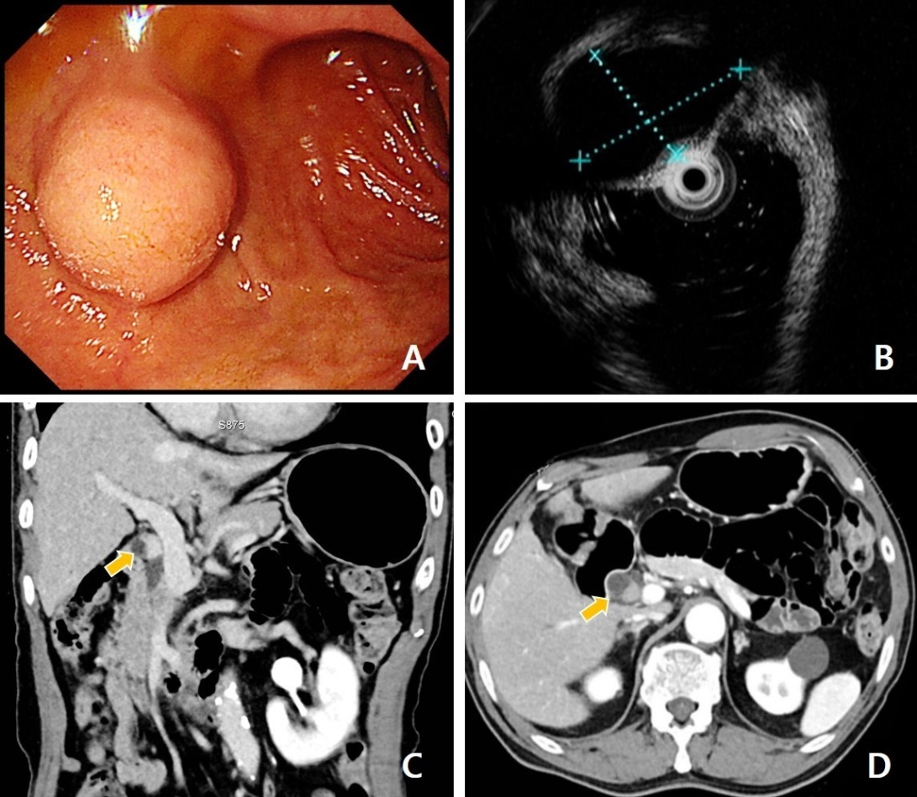
Figure 1 Preoperative tumor evaluation A: Upper gastrointestinal endoscopy showing a lesion protruding into the lumen of the duodenal bulb; B: endoscopic ultrasonography showing a hypoechoic lesion 1.8 cm in size; C: Coronary view of abdominal computed tomography (CT) showing a small enhancing nodule 1.4 cm in size (yellow arrow) between the cystic duct and the duodenal bulb; D: Axial view of abdominal CT showing the lesion (yellow arrow).
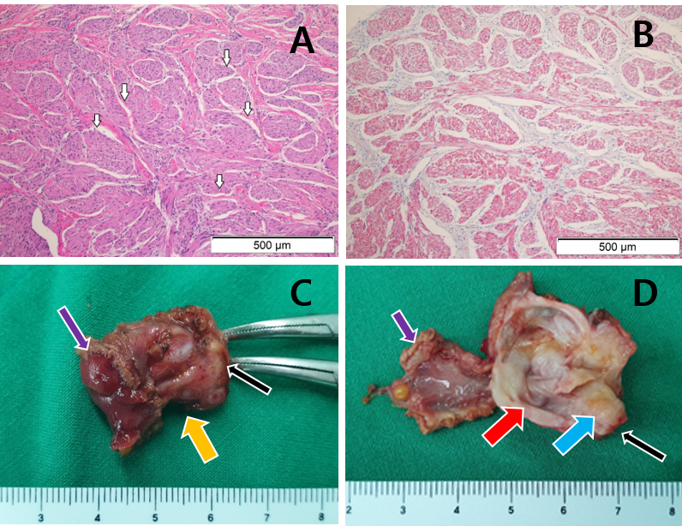
Figure 2 Histological findings of tumor and specimen. A: Microscopic view of a neuroma showing spindle cell proliferation arranged in short bundles and intervening cleft artifact (white arrows, hematoxylin and eosin staining; magnification x 200); B: Lesion tests positive for S100 protein; C: Macroscopic findings of resected duodenal wall (purple arrow), lesion (yellow arrow), and cystic duct (black arrow); D: Incised specimen showing a hard mass (blue arrow) with the cystic portion (red arrow) adjacent to the duodenal wall (purple arrow) and the cystic duct (black arrow).
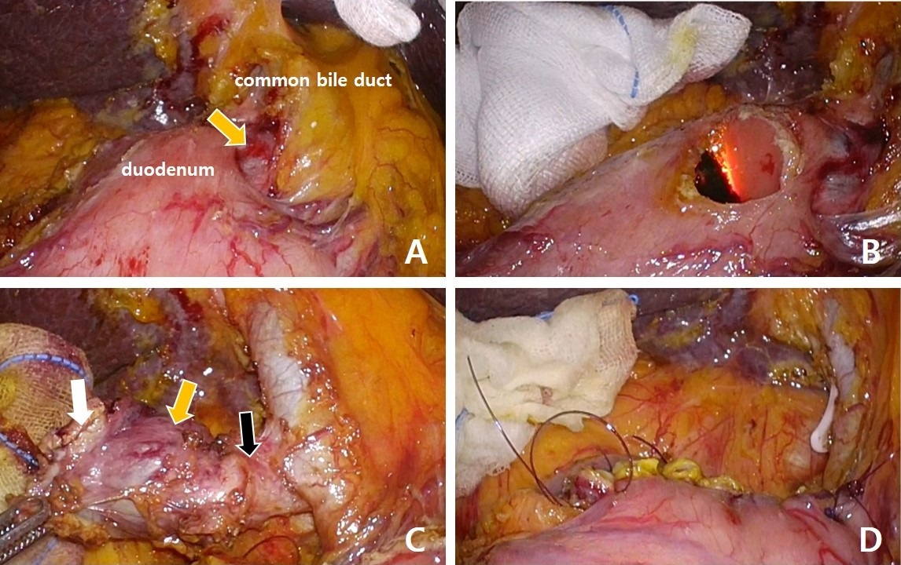
Figure 3 Operative procedure of laparoscopic endoscopic cooperative surgery for duodenal neoplasms A: Lesion (yellow arrow) between the duodenal bulb and common bile duct; B: Partial perforation of the duodenal wall using insulation-tipped electrosurgical knife during endoscopy; C: Lesion (yellow arrow) is difficult to identify between the resected duodenal wall (white arrow) and cystic duct (black arrow); D: View after resection of lesion and repair of duodenal wall.

