Name of journal: World Journal of Anesthesiology
ESPS Manuscript NO: 2636
Columns: CASE REPORT

Fractured tracheostomy tube obturator: A rare cause of respiratory distress in a tracheostomized patient

Afzal1M et al. Respiratory distress in a tracheostomized patient

Mussarat Afzal, Hadi Al Mutairi, Ikram Chaudhary

Mussarat Afzal, Hadi Al Mutairi, Ikram Chaudhary, King Fahad Specialist Hospital, Dammam, PC 31444, Eastern Province, Saudi Arabia

Author contributions: All the authors contributed to this work.

Correspondence to: Dr. Mussarat Afzal, Consultant Anesthetist, King Fahad Specialist Hospital, PO Box 15215, Dammam 31444, Eastern Province, Saudi Arabia. dr_mussarat_a@hotmail.com

Telephone: +966-56-1116907 Fax: +966-56-1116907

Received: March 5, 2013 Revised: May 3, 2013
Accepted: June 8, 2013

Published online:

Abstract
Foreign body aspiration is a worldwide health problem which often results in life threatening complications. Tracheostomy tube fracture, resulting in airway obstruction, is a serious condition which has been reported in medical literature. We report a rare case of tracheostomy obturator, fractured and lodged in tracheobronchial tree, in a patient who was presented with acute respiratory distress. Rigid or flexible bronchoscopy is frequently necessary for the diagnosis as well as the treatment. In adults, removal of the foreign body can be attempted during diagnostic examination with a fiberoptic bronchoscope under lignocaine local infiltration with sedation, which may help to avoid any further invasive procedures. Flexible bronchoscopy should always be considered in foreign body aspiration. A periodic review of the techniques of tracheostomy care including timely check-ups for signs of wear and tear can possibly eliminate such avoidable late complications.

© 2013 Baishideng. All rights reserved.

Key words: Respiratory distress; Tracheostomy; Foreign body; Aspiration; Bronchoscopy

Core tip: Foreign-body aspiration is often a serious medical condition demanding timely recognition and prompt action. Delayed diagnosis and subsequent delayed treatment is associated with serious and sometimes life threatening complications. We describe a case of acute respiratory distress following aspiration of part of the obturator of tracheostomy tube during a routine change of tracheostomy tube.

Afzal M, Al Mutairi H, Chaudhary I. Fractured tracheostomy tube obturator: A rare cause of respiratory distress in a tracheostomized patient.

Available from:
DOI:

INTRODUCTION
Foreign-body aspiration is often a serious medical condition demanding timely recognition and prompt action. Delayed diagnosis and subsequent delayed treatment is associated with serious and sometimes fatal complications^{[1]}. In adults, however, foreign-body aspiration can be tolerated and remains undetected for a long time. We describe a case, in which part of the tracheostomy obturator was broken and migrated in the tracheobronchial tree, resulting in acute respiratory distress.

CASE REPORT
A sixty-eight-year-old male tracheostomized, known to have hypertension and diabetes, was presented in our E.R with progressive acute respiratory distress. During routine change of the tracheostomy tube, medical staff noticed that the tracheostomy obturator was fractured and had migrated in the trachea. His bronchoscopic removal in a referral hospital was unsuccessful. Therefore, patient was referred to our hospital for further management. Past medical history revealed that the patient had cardiac arrest 3 mo back due to myocardial ischemia and was successfully resuscitated. After prolonged CPR, the patient remained on ventilator for three weeks. Thus, tracheostomy was done after the few unsuccessful attempts of weaning from the ventilator. Pre anesthesia evaluation revealed electrocardiography showing periodical superficial vein thrombosis with antero-lateral ischemic changes, whereas the Echocardiography showed a moderately dilated left ventricle with severely impaired systolic function, with ejection fraction of 10%-25%.
His computed tomography of the Brain showed an old infarct and microangiopathic ischemic change. His respiratory rate was 35/min, O₂ saturation 88%-89%, blood pressure 90/50 mmHg. He was conscious and oriented but both his upper and lower limbs were spastic. Auscultation of the chest revealed decreased breath sounds on the right side. A subsequent X-ray of the chest did not show any foreign body (Figure 1). He was immediately shifted to the operating room.
After putting ECG leads, pulse oximeter, oxygen through face mask and noninvasive blood pressure measurement, Xylocaine 2% was infiltrated in the trachea through the tracheostomy tube. About 1 mg of Midazolam was given intravenously and 15 mL/h propofol infusion was commenced.
The Fiber optic bronchoscopy revealed a fractured part of the obturator, deeply lodged in the right bronchus (Figure 2A). After suction of secretions, the obturator was removed with endoscopic forceps and it was pulled out from the tracheostomy tube with artery forceps (Figure 2B). After the uneventful procedure, the patient was sent to the recovery room. Two days later, the patient was referred back to the primary hospital for long term management.

DISCUSSION
The first case of fractured, metallic tracheostomy tube was reported by Bassoe et al in 1960^{[2]}. Since then, this kind of a complication has been published in medical literature frequently, with all kinds of tracheostomy tubes (TT).The composition of TT range from metal, poly vinyl chloride to silicone^{[3]}. A number of factors predispose to fracture of one of the flanges of the TT. The most frequent weak points of TT are the junctions between the tube and the neck plate, the distal end of the tube and the fenestration site^{[4,5]}. In our case, it was not the TT but part of the obturator (introducer) which was fractured and migrated to distal trachea that was noticed during a routine change of tracheostomy tube by the staff.
Foreign body aspiration can be a life-threatening emergency. An aspirated solid or semisolid object may lodge in the larynx or trachea. If the object is large enough to cause nearly complete obstruction of the airway, asphyxia may rapidly lead to death^{[6]}.
Tracheobronchial foreign body (TFB) aspiration is rare in adults, although incidence rate rises with advancing age. Risk factors for TFB aspiration in adults are a depressed mental status or impairment in the swallowing reflex^{[5]}. Symptoms associated with TFB aspiration may range from to cough, dyspnea, fever, and acute asphyxiation with or without complete airway obstruction. In adults, many other medical conditions mimic breathing abnormalities similar to those associated with TFB aspiration. In our case, there was a definitive history of missing a part of obturator during change of the TT.
If the history is not suggestive, then only a high index of suspicion can ensure proper diagnosis and timely removal of the foreign body^{[6]}. Initial treatment is airway management. Radiographic imaging may assist in localizing the foreign body. Bronchoscopic removal of the foreign body is necessary to avoid long-term sequelae. Flexible bronchoscopy is effective both in the diagnosis and removal of foreign bodies^{[7]}.
Almost all aspirated foreign bodies can be extracted bronchoscopically. If rigid or flexible bronchoscopy is unsuccessful, surgical bronchotomy or segmental resection may be necessary. Chronic bronchial obstruction with bronchiectasis and destruction of lung parenchyma may require segmental or lobar resection.
A pulmonologist or thoracic surgeon with experience in foreign body extraction should immediately perform bronchoscopic inspection and extraction of the object^{[8]}.
An anesthesiologist may be needed to maintain adequate ventilation and control of the upper airway during diagnostic and therapeutic procedures. Rigid bronchoscopy is performed with the patient under general anesthesia or heavy sedation^{[8]}.
As foreign bodies in the TBT are uncommon in adults, the clinician must be vigilant of their possibility. Foreign body aspiration should be considered especially in the etiology of recurrent lung diseases and in the presence of risk factors for aspiration, in particular with different neurologic and neuromuscular diseases. They can be safely and successfully removed in the majority of patients by using fiber optic bronchoscopy under local anesthesia alone or under local anesthesia with sedation. An Endotracheal intubation is recommended in case of a repeated procedure.
An intermittent review of the techniques of tracheostomy care should be done including timely check-ups for signs of wear and tear which possibly eliminate such avoidable late complications^{[9]}.
Since there are no universally accepted and published standards of care for tracheostomy tube, the policy should be to provide patients, who require indwelling tracheostomy tube, with the following recommendations for home care: (1) Replace tracheostomy tube every 6 mo; (2) Change/ clean the inner cannula every 48 h; (3) Replace tracheostomy ties weekly; (4) Change dressing daily; and (5) Use nocturnal humidification^{[10]}.
In conclusion, cases of tracheostomy tube fractures and aspiration into TBT have been reported in the literature. We, hereby, report a rare case of the TT obturator that had fractured and migrated to right main stem bronchus. Proper care and high vigilance, when the obturator is removed during suction and cleaning of TT, is of high clinical importance.

REFERENCES
1 Qureshi A, Behzadi A. Foreign-body aspiration in an adult. Can J Surg 2008; 51: E69-E70 [PMID: 18682760]
2 BASSOE HH, BOE J. Broken tracheotomy tube as a foreign body. Lancet 1960; 1: 1006-1007 [PMID: 13797429 DOI: 10.1016/S0140-6736(60)90890-4]
3 Piromchai P, Lertchanaruengrit P, Vatanasapt P, Ratanaanekchai T, Thanaviratananich S. Fractured metallic tracheostomy tube in a child: a case report and review of the literature. J Med Case Rep 2010; 4: 234 [PMID: 20678211 DOI: 10.1186/1752-1947-4-234]
4 Majid AA. Fractured silver tracheostomy tube: a case report and literature review. Singapore Med J 1989; 30: 602-604 [PMID: 2699679]
5 Alqudehy ZA, Alnufaily YK. Fractured tracheostomy tube in the tracheobronchial tree of a child: case report and literature review. J Otolaryngol Head Neck Surg 2010; 39: E70-E73 [PMID: 21144353]
6 Boyd M, Chatterjee A, Chiles C, Chin R. Tracheobronchial foreign body aspiration in adults. South Med J 2009; 102: 171-174 [PMID: 19139679 DOI: 10.1097/SMJ.0b013e318193c9c8]
7 Swanson KL, Prakash UBS, McDougall JC, Mithan DE ,Edeu ES, Brutinel WM, UtzJP. Airway foreign bodies in adults. J Bronchol 2003; 10: 107-111 [DOI: 10.1097/00128594-200304000-00004]
8 Warshawsky ME, Mosenifar Z. Foreign body aspiration.emedicine.medscape.com/article/298940-overview. Updated: June 6, 2012
9 White AC, Kher S, O'Connor HH. When to change a tracheostomy tube. Respir Care 2010; 55: 1069-1075 [PMID: 20667154]
10 Krempl GA, Otto RA. Fracture at fenestration of synthetic tracheostomy tube resulting in a tracheobronchial airway foreign body. South Med J 1999; 92: 526-8 [PMID: 10342904]

P-Reviewer Feltracco P S-Editor Song XX L-Editor E-Editor

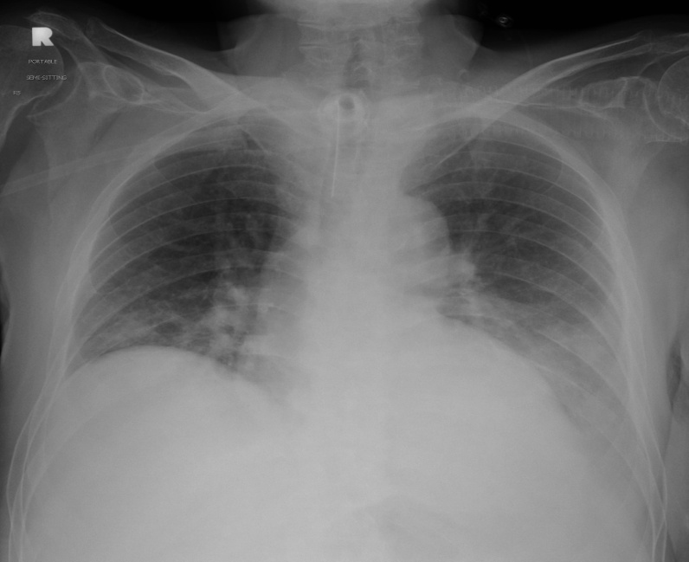
Figure 1 The prominent broncho-pulmonary markings without a radio-opaque foreign body in the right lung.

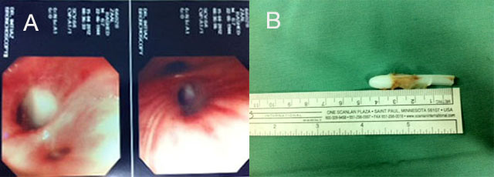
Figure 2 A bronchoscopic view showing tracheostomy tube obturator lodged in the right main stem bronchus. Figure B shows a tracheostomy obturator after removal from the right main bronchus. The length of the broken obturator measures to be 4.5 cm.

