Name of Journal: World Journal of Stem Cells
Manuscript NO: 92114
Manuscript Type: ORIGINAL ARTICLE

Basic Study
Gossypol acetic acid regulates leukemia stem cells by degrading LRPPRC via inhibiting IL-6/JAK1/STAT3 signaling or resulting mitochondrial dysfunction

Ai CJ et al. GAA regulates survival of LSCs

Cheng-Jin Ai, Ling-Juan Chen, Li-Xuan Guo, Ya-Ping Wang, Zi-Yi Zhao

Cheng-Jin Ai, Ling-Juan Chen, Li-Xuan Guo, Department of Laboratory Medicine, Hospital of Chengdu University of Traditional Chinese Medicine, Chengdu 641000, Sichuan Province, China

Ya-Ping Wang, Department of Ophthalmology, Hospital of Chengdu University of Traditional Chinese Medicine, Chengdu 641000, Sichuan Province, China

Zi-Yi Zhao, Central Laboratory, Hospital of Chengdu University of Traditional Chinese Medicine, Chengdu 641000, Sichuan Province, China

Zi-Yi Zhao, Traditional Chinese Medicine Regulating Metabolic Diseases Key Laboratory of Sichuan Province, Chengdu University of Traditional Chinese Medicine, Chengdu 641000, Sichuan Province, China

Co-first authors: Cheng-Jin Ai and Ling-Juan Chen.

Author contributions: Ai CJ and Zhao ZY designed the experiments and wrote manuscript; Ai CJ, Chen LJ, Guo LX, and Wang YP performed molecular-related experiments in this study; Ai CJ and Chen LJ performed experiments on processing cells, and they are co-first authors of this manuscript; Zhao ZY is responsible for data collection and performed statistical analysis and revised manuscript; and all authors read and approved the final manuscript.

Corresponding author: Zi-Yi Zhao, PhD, Professor, Central Laboratory, Hospital of Chengdu University of Traditional Chinese Medicine, Shi-er-qiao Road, Chengdu 641000, Sichuan Province, China. zhaoziyi@cdutcm.edu.cn

Received: January 15, 2024
Revised: February 11, 2024
Accepted: March 14, 2024
Published online:

Abstract
BACKGROUND
Leukemia stem cells (LSCs) are found to be one of the main factors contributing to poor therapeutic effects in acute myeloid leukemia (AML), as they are protected by the bone marrow microenvironment (BMM) against conventional therapies. Gossypol acetic acid (GAA), which is extracted from the seeds of cotton plants, exerts anti-tumor roles in several types of cancer and has been reported to induce apoptosis of LSCs by inhibiting Bcl2.

AIM
To investigate the exact roles of GAA in regulating LSCs under different microenvironments and the exact mechanism.

METHODS
In this study, LSCs were magnetically sorted from AML cell lines and the CD34⁺CD38⁻ population was obtained. The expression of leucine-rich pentatricopeptide repeat-containing protein (LRPPRC) and forkhead box M1 (FOXM1) was evaluated in LSCs, and the effects of GAA on malignancies and mitochondrial function were measured.

RESULTS
LRPPRC was found to be upregulated, and GAA inhibited cell proliferation by degrading LRPPRC. GAA induced LRPPRC degradation and inhibited the activation of interleukin 6 (IL-6)/janus kinase (JAK) 1/signal transducer and activator of transcription (STAT) 3 signaling, enhancing chemosensitivity in LSCs against conventional chemotherapies, including L-Asparaginase, Dexamethasone, and cytarabine. GAA was also found to downregulate FOXM1 indirectly by regulating LRPPRC. Furthermore, GAA induced reactive oxygen species accumulation, disturbed mitochondrial homeostasis, and caused mitochondrial dysfunction. By inhibiting IL-6/JAK1/STAT3 signaling via degrading LRPPRC, GAA resulted in the elimination of LSCs. Meanwhile, GAA induced oxidative stress and subsequent cell damage by causing mitochondrial damage.

CONCLUSION
Taken together, the results indicate that GAA might overcome the BMM protective effect and be considered as a novel and effective combination therapy for AML.

Key Words: Leukemia stem cells; Gossypol acetic acid; Reactive oxygen species; Mitochondrial dysfunction; Interleukin 6/janus kinase 1/signal transducer and activator of transcription 3 signaling

Ai CJ, Chen LJ, Guo LX, Wang YP, Zhao ZY. Gossypol acetic acid regulates leukemia stem cells by degrading LRPPRC via inhibiting IL-6/JAK1/STAT3 signaling or resulting mitochondrial dysfunction. World J Stem Cells 2024; In press

Core Tip: Gossypol acetic acid (GAA) inhibited janus kinase 1/signal transducer and activator of transcription 3 signaling activated by interleukin 6 in leukemia stem cells (LSCs). GAA sensitizes to chemoagent, including cytarabine, Dexamethasone and L-Asparaginase in LSCs. GAA decreased leucine-rich pentatricopeptide repeat-containing protein and subsequent downregulated forkhead box M1, which are critical and necessary for stemness of LSCs. GAA induces mitochondrial dysfunction via inducing reactive oxygen species accumulation. GAA might eliminate the effects of inflammatory environment on LSCs.

INTRODUCTION
Acute myeloid leukemia (AML) is a hematopoietic disorder characterized by uncontrolled proliferation of immature, abnormal blast cells and loss of functional blood cells, resulting in remarkably chemoresistant disease and poor prognosis^{[1]}. Therapy failure is common in many cases of risk karyotype AML, and most patients develop chemotherapy relapses, depending on the mechanisms of recurrence^{[2]}.
Rare subsets labeled as the CD34⁺CD38⁻ population are considered leukemia stem cells (LSCs), which possess remarkable proliferative potential^{[3,4]}, as also reported in other studies^{[5,6]}. It is well-established that primary chemotherapeutic agents might eliminate AML blast cells but not LSCs, indicating that LSCs could be responsible for chemoresistance in AML^{[7,8]}. Moreover, original AML behaves differently compared to LSCs^{[9,10]}. Therefore, investigating LSCs is critical for eliminating cancer cells in AML.
Bone marrow microenvironment (BMM) is a key component of leukemia pathogenesis by exerting protective effects on LSC against various types of stress, such as oxidative and hypoxic stress^{[11]}. Therefore, novel therapeutic strategies have been developed targeting BMM. Inactivation of interleukin 6 (IL-6) via inhibition of janus kinase 1/signal transducer and activator of transcription 3 (JAK1/STAT3) signaling leads to the inhibition of LSC survival^{[12,13]}. In chronic myeloid leukemia, which is characterized by TKI-resistance, inhibition of JAK1/STAT3 signaling has been found to reduce LSC survival and impair its stemness^{[14]}. Recently, it has also been reported that activation of the JAK1 kinase and subsequent STAT3 signaling contributes to poor therapeutic outcomes and prognosis in chronic myeloid leukemia cells^{[15]}. However, the development of effective and efficient BMM-targeted chemotherapeutic agents is still largely needed.
GAA is a traditional Chinese herbal medicine widely used clinically to treat different diseases with significant antitumor effects^{[16]}. Previous studies have reported that GAA exerts anti-tumor effects by inhibiting cell proliferation via blocking cell cycle progression and inducing cell apoptosis. Yang et al^{[17]} reported that, in colorectal cancer, GAA treatment specifically degrades leucine-rich pentatricopeptide repeat-containing protein (LRPPRC), a key regulator of mitochondrial homeostasis and function, thereby acting as an anti-tumor agent. This prompted us to investigate GAA’s potential anti-tumor effects on LSCs^{[17]}.
To investigate this possibility, we analyzed the LRPPRC profile status in LSCs derived from AML cell lines. As expected, LSCs exhibited higher expression levels of LRPPRC than original AML cells. GAA degraded LRPPRC and thus inhibited IL-6/JAK1/STAT3 signaling. Moreover, GAA also downregulated forkhead box M1 (FOXM1), which is positively correlated with LRPPRC, in an IL-6/JAK1/STAT3-independent manner.

MATERIALS AND METHODS
Cell cultures and treatment
Human AML cell lines Kasumi-1 and KG1a were bought from Guangzhou Institute of Biomedicine and Health, Chinese Academy of Sciences. Cells were maintained in RPMI1640 medium supplemented with 20% fetal calf serum (Gibco) stored in the incubator (Life Technology, United States) at 37 °C and 5% CO₂ saturation humidity. Culture medium was changed for passage every 2-3 d. For GAA treatment, GAA bought from Sigma-Aldrich (Figure 1A) was added into original medium at final concentration of 2.5, 5, 7.5, or 10 μmol/L for 24-h incubation followed by certain detection. For IL-6 incubation, IL-6 bought from Sigma-Aldrich was added into original medium at final concentration of 5, 10, 25, or 50 μmol/L for 6-h incubation followed by certain detection. For S3I-210 incubation, S3I-210 bought from Selleck was added into original medium at final concentration of 10 μmol/L for 24-h incubation followed by certain detection.

Sorting of LSCs from KG1a and Kasumi-1
Of 5 × 10⁷ cultured cells was collected and washed using 1× Dulbecco’s phosphate-buffered saline (DPBS) for three times. After brief centrifugation, supernatant was discard and cell pellet was resuspended in 10 mL of 1× DPBS. CD34⁺CD38⁻ cells were selected using a magnetic bead selection protocol (Miltenyi Biotech, Bergisch Gladbach, Germany). Briefly, the CD34⁺/CD38⁻ population (Kasumi-1 cells) or CD34⁺/CD38⁻ population (KG-1 cells) was obtained by incubating with CD34-FITC (Biolegend, San Diego, CA United States) and CD38-R-phycoerythrin cyanine7 (CD38-PE-Cy™7; Biolegend) in Cell Staining Buffer (Biolegend).

GEPIA analysis
The GEPIA 2 online analysis tool (http://gepia2.cancer-pku.cn) was employed for gene expression analysis by comparing to The Cancer Genome Atlas dataset. GEPIA 2 provides a variety of functions, including tumor/normal differential expression and correlation analysis. Expression correlation of LRPPRC and FOXM1 in whole blood samples, AML cell lines and LAML samples was analyzed. |R| > 0.1 and P value < 0.05 were set as selection criteria for identifying as statistically significant.

Cell viability assay
Cells were plated into 96-well plates at 1 × 10⁵ cells/well and allowed to attach overnight. Then, different concentrations of cytarabine (Ara-C) (0, 0.5, 1, 2, 4 μmol/L), Dexamethasone (Dex) (0, 0.5, 1, 2, 4 μmol/L) or L-Asparaginase (L-Asp) (0, 0.5, 1, 2, 4 μmol/L) were added into wells for 24-h culture. CCK-8 reagent (Sigma-Aldrich) was added (10 μL/well) for extra 4 h incubation. The absorbance (A) at 450 nm was measured using a microplate reader (Synergy 2 Multi-Mode Microplate Reader; BioTek, Winooski, VT, United States). By using the following formula: Cell survival rate (%) = [(administration group A - negative control group A)/(non-administration group A - negative control group A)] × 100%, cell survival rate was calculated.

Colony formation assay
Of 1 × 10⁵ LSCs was suspended in Human Methylcellulose Complete Media (R&D Systems, Inc, Minneapolis, MN, United States) and were added into a 6-well dish. Cells were then cultured in 5% CO₂ at 37 °C with more than 95% humidity for 7 d. On day 7, an optical microscope was employed to observe and count the formed colonies.

Total reactive oxygen species measurement
Of 1 × 10⁶ cells were collected and washed using 1× PBS for three times. Then, 10 μmol/L 2’,7’-dichlorodihydrofluorescein diacetate (H2DCFDA, Life Technologies, Cat# D-399) was added and incubated for 1 h. Cells were collected and washed using 1× PBS for three times to remove free H2DCFDA. Oxidation of H2DCFDA to the highly fluorescent 2’,7’-dichlorofluorescein is proportional to reactive oxygen species (ROS) generation and the signals were then read at EX485 nm/Em535 nm using a GloMax 96 Microplate Luminometer (Promega). Samples were also detected immediately by using a flow cytometer (Fortessa, BD Biosciences). A minimum of 10000 cells was analyzed per condition.

Western blot analysis
Total proteins were extracted using Animal Tissue/cells/bacteria total protein isolation kit (DocSense, Chengdu, China) from cells. Then, quantification of protein lysates was measured with a protein BCA assay Kit (Bio-Rad) and fractionated by 10% sodium-dodecyl sulfate gel electrophoresis and transferred to a nitrocellulose membrane, followed by blockage using 5% non-fat milk in TBST for 60 min at 25 °C and then incubated with primary antibody diluted in blocking buffer at 4 °C overnight: Anti-LRPPRC/GP130 antibody (ab259927, 1:1000); anti-FOXM1 antibody (ab207298, 1:2000); anti-Peroxiredoxin 3/PRDX3 antibody (ab128953, 1:2000); anti-SOD2/MnSOD antibody (ab68155, 1:1000); anti-catalase antibody (ab209211, 1:1000); anti-cleaved caspase-3 antibody (ab32042, 1:1000); anti-cleaved PARP1 antibody (ab32064, 1:1000); anti-JAK1 antibody (ab133666, 1:2000); anti-JAK1 (phosphor Y1022 + Y1023) antibody (ab138005, 1:1000); anti-STAT3 antibody (ab68153, 1:2000); anti-STAT3 (phosphor Y705) antibody (ab267373, 1:1000); anti-beta actin antibody (ab8226, 1:4000). Washed membranes were then incubated with horseradish peroxidase-coupled Goat Anti-Rabbit IgG H&L secondary antibody (1:50000; abcam, ab6721) for 1 h at room temperature and signal was imaged using enhanced chemiluminescence according to the manufacturer’s instructions (ECL kit, Life Technologies).

Measurement of mitochondrial membrane potential
Mitochondrial membrane potentials were observed in cells stained with JC-1 dye bought from Life Technology by employing a confocal microscope (LSM880, Zeiss, Jena, Germany). Specifically, cells were harvested, washed with ice-cold PBS. Then JC-1 was added for 20 min incubation at 37 °C. Green florescence emission in its monomer forma and red florescence emission in its polymer forms were collected separately. Cells were analyzed by performing flow cytometry using a 3 Laser Navios flow cytometers (Beckman Coulter, Brea, CA, United States).

ATP measurement
Before ATP analyzing, cells were cultured in original medium for 24 h and then collected and washed using 1× PBS. Then CellTiterGlo kit was employed to detect ATP content by using luciferase chemiluminescence Multiskan spectrum microplate reader (Thermo Electron Corporation, Waltham, MA, United States).

Data analysis and statistics
All data are presented as mean ± SD. Statistical differences between different groups were analyzed by one way ANOVA post hoc Dunnett T-test using Prism 6 (GraphPad Software, San Diego, CA, United States). The correlation of gene expression was evaluated in the GEPIA database using Spearman’s correlation analysis. Value of P < 0.05, P < 0.01, P < 0.001 was considered statistically significant.

RESULTS
LRPPRC promotes malignancies in SCs derived from KG1a and Kasumi-1
To evaluate the potential roles of LRPPRC in SCs derived from KG1a and Kasumi-1, we adopted magnetic bead sorting to enrich LSCs from these two cell lines, separately, to investigate whether LRPPRC expresses differentially in LSCs compared to AML cells. LSCs were selected by being co-cultured with PE-labeled CD34 and FITC-labeled CD38. As shown in Figure 2A, over 85% of cells were CD34⁺CD38⁻, which was regarded as LSCs after magnetic bead sorting followed by flow cytometry assay, which was significantly higher than those in KG1a or Kasumi-1 cells. This result indicated successful enrichment of LSCs from KG1a and Kasumi-1 cells. Then, total protein was fractionated and detected by western blot to evaluate LRPPRC expression levels. As shown in Figure 2B, LRPPRC was detected to be upregulated in KG1a-SCs and Kasumi-1-SCs significantly, demonstrating that LSCs maintained significant higher LRPPRC levels.
Based on the widely investigated oncogenic role, we further conjectured that LRPPRC expression could affect LSCs to alter the in vitro biological functions and subsequently affecting leukemia progression. We transfected short hairpin RNA targeting to LRPPRC mRNA and efficiently knockdown LRPPRC expression in LSCs after 48-h transfection (Figure 2C). We then evaluate the effects of LRPPRC knockdown in LSCs by detecting cell viability from day 1 to 5 and colony assays. Expectedly, LRPPRC knockdown significantly decreased cell viability in LSCs from day 1 to 5 and inhibited colony formation (Figure 2D and E).

GAA degraded LRPPRC and inhibited LSCs progression
It is reported that GAA acts as an anti-tumor agent, via targeting to LRPPRC and resulted in protein degradation^{[16]}, we treated KG1a-SCs and Kasumi-1-SCs with GAA with different concentrations ranged from 2.5-10 μmol/L for 24 h. By performing western blot, it is presented that 5-10 μmol/L GAA treatment significantly decreased LRPPRC protein levels after 24 h via promoting protein degradation (Figure 1B), without affecting LRPPRC transcription (data not shown). By considering that LRPPRC acts as a oncogenic factor in several kinds of cancer^{[18,19]}, we then evaluate the effect of GAA on KG1a-SCs and Kasumi-1-SCs cell viability and colony formation. As shown in Figure 1C, GAA treatment ranged from 5-10 μmol/L significantly decreased cell viability. In colony assay, long-term GAA treatment also inhibited colony formation ability in KG1a-SCs and Kasumi-1-SCs (Figure 1D).

GAA induced chemosensitivity via degrading LRPPRC
LRPPRC is reported to be critical for chemoresistance in cancer cells^{[17]}, and promotes us to confirm whether GAA treatment affects chemoresistance in KG1a-SCs and Kasumi-1-SCs. Three commonly used chemotherapeutic agents, including Ara-c, Dex, or L-Asp, were used to treat KG1a-SCs and Kasumi-1-SCs with or without addition of 5 μmol/L of GAA. As it is shown in Figure 3A, presence of GAA significantly decreased cell viability with the presence of GAA. It is also observed that co-treatment of chemoagent and GAA obviously increased cleaved-caspase 3 and cleaved-PARP, demonstrating that GAA might increase chemosensitivity in KG1a-SCs and Kasumi-1-SCs. To further confirm whether GAA promotes apoptosis induced by chemoagent, we then detected cleaved-caspase 3 and cleaved-PARP after chemotreatment. Expectedly, addition of 5 μmol/L GAA obviously increased cleaved-caspase 3 and cleaved-PARP with the presence of 1 μmol/L Ara-c, Dex or L-Asp (Figure 3B).
To confirm whether the impact of GAA on LSCs is due to degrade LRPPRC or not, LRPPRC was overexpressed before GAA treatment. As it is shown in Figure 4A, LRPPRC overexpression significantly reversed degradation of LRPPRC caused by GAA treatment. As expected, in LRPPRC overexpressed cells, chemosensitivity was significantly decreased (Figure 4B), indicating that the effect of GAA on promoting chemosensitivity is mainly via inducing LRPPRC degradation.

GAA inhibited JAK1/STAT3 signaling activated by IL-6
IL-6 is a pleiotropic inflammatory cytokine that has a central role in inflammatory response and malignancy^{[20]}. In classic IL-6 signaling, binding of IL-6 to IL-6R on the cell surface is critical to initiate intracellular signaling. By considering that GAA affects IL-6/STAT3 signaling in human non-small cell lung cancer cells^{[21,22]}, we detected whether GAA treatment affects IL-6/JAK1/STAT3 signaling or not. As it is presented in Figure 5A, after 4-h incubation with different concentration of IL-6 ranged from 5-50 ng/mL, phosphorylation of JAK1 (p-JAK1) and phosphorylation of STAT3 (p-STAT3) were obviously activated, without disturbing p-JAK1 and p-STAT3 protein levels. Thus, we further added 10 ng/mL IL-6 to KG1a-SCs or Kasumi-1-SCs pretreated with 5 μmol/L GAA for 24 h, for 4-h incubation. As shown in Figure 5B, IL-6 treatment activated JAK1/STAT3 signaling, without affecting p-JAK1, p-STAT3 or LRPPRC protein levels. Expectedly, pretreatment of GAA significantly inhibited JAK1/STAT3 stimulated by IL-6.
The roles of IL-6 in BMM controls leukemic multipotent progenitor cell fate and contributes to maintenance of self-renewal capacity of LSCs^{[23,24]}. To further evaluate whether IL-6/JAK-1/STAT3 signaling regulation of self-renewal capacity of LSCs is reversed by GAA, we employed 5 μmol/L S3I-201, a pharmacological inhibitor of STAT3 signaling. As shown in Figure 6A and B, addition of GAA or S3I-201 respectively inhibited cell viability and colony formation. Notably, addition of S3I-201 to KG1a-SCs or Kasumi-SCs pretreated with GAA further decreased malignancies. These results indicated that IL-6/JAK1/STAT3 signaling is partially inhibited by GAA and results in loss of self-renewal in LSCs.

GAA decreased FOXM1 via regulating LRPPRC
FOXM1 is a crucial regulator of cancer development and found often to be overexpressed in AML^{[25]}. It is also reported to be tightly involved in regulating LSC survival^{[26]}. By considering that LRPPRC is reported to tightly regulate FOXM1^{[27,28]}, we employed GEPIA database online tool to analyze correlation of LRPPRC with FOXM1 in whole blood, AML cell lines and AML pathological samples. As it is shown in Figure 7A, FOXM1 and LRPPRC are transcriptionally and positively correlated in whole blood (r = 0.47; P < 0.001), AML cell lines (r = 0.44; P = 0.00016) and LAMA samples (r = 0.19; P = 0.012). LRPPRC knockdown or overexpression decreased or increased FOXM1 (Figure 7B), indicating that LRPPRC positively regulates FOXM1 in KG1a-SCs and Kasumi-1-SCs. We then measured the expression of FOXM1 downstream ROS scavenger genes, including PRDX3, MnSOD, and catalase. To confirm whether LRPPRC affects FOXM1 via IL-6/JAK1/STAT3 signaling, S3I-210 was employed. As shown in Figure 7C, without being affected by S3I-210, GAA treatment significantly decreased FOXM1 and its downstream target genes, indicating that LRPPRC regulates FOXM1 and its downstream genes in an IL-6/JAK1/STAT3-independent manner.

GAA decreased mitochondrial homeostasis via degrading LRPPRC
In our precious findings, LRRPRC was presented to be a mitochondrial protector against oxidative stress^{[17]}. This promotes us to evaluate the effect of GAA on mitochondrial function. As presented in Figure 8A, GAA treatment, but not S3I-210, significantly induced ROS accumulation, especially under hypoxic condition. By performing flow cytometry, it is also observed that both in hypoxia and normoxia condition, GAA treatment obviously increased ROS levels in KG1a-SCs and Kasumi-1-SCs (Figure 8B). Then we evaluate the effect of GAA treatment on mitochondrial homeostasis by performing JC-1 staining. Expectedly, GAA treatment significantly increased JC-1 FITC-positive proportion in KG1a-SCs and Kasumi-1-SCs, indicating that GAA might affect mitochondrial homeostasis and potentially result in mitochondrial dysfunction (Figure 8C). Analysis of LDH leakage presented that GAA treatment significantly increased cell membrane impact (Figure 8D). We further confirmed whether disturbance of mitochondrial homeostasis induced by GAA induces mitochondrial dysfunction by detecting mitochondrial DNA (mtDNA) content (Figure 8E) and ATP synthesis (Figure 8F). Expectedly, GAA treatment significantly decreased mtDNA content and ATP synthesis, indicating that GAA might regulate stemness of LSCs via inducing mitochondrial dysfunction.

DISCUSSION
Our study has established the critical role of GAA in the regulation of cell proliferation, chemosensitivity, and self-renewal of LSCs derived from AML cells. Our results show that GAA exerts anti-tumor effects by inhibiting the IL-6/JAK1/STAT3 signaling pathway through promoting the degradation of LRPPRC, which is a critical component of IL-6/JAK1/STAT3 signaling. In addition, we have identified the role of GAA in degrading LRPPRC, resulting in the downregulation of FOXM1, which plays a critical role in the regulation of survival, quiescence, and self-renewal of LSCs. Furthermore, considering that LRPPRC regulates redox homeostasis, mitochondrial homeostasis, gene expression, and energy metabolism^{[29,30]}, we also found that GAA induces oxidative stress, loss of mitochondrial homeostasis, mitochondrial mass, and energy metabolism.
Bone marrow samples were used to predict a novel functional profile for predicting prognosis in pediatric patients with AML^{[31]}. It has been demonstrated that the sensitivity of AML cells to ligand-induced activation of STAT3 might be considered as a predictor of event-free survival and overall survival in pediatric patients with AML. IL-6 activates the JAK1/STAT3 signaling and thus acts as a key cytokine^{[32]}. GAA was reported to inhibit IL-6/JAK1/STAT3 signaling and result in suppressing the STAT3-DNA binding activity and its regulatory roles in its downstream target genes, including Bcl-2 and Bcl-xL^{[27]}. In the present study, we found that GAA pretreatment inhibited activation of JAK1/STAT3 signaling stimulated by IL-6. GAA inhibited phosphorylation of JAK1 and STAT3 after IL-6 was added, indicating that GAA might affect IL-6 and IL-6 receptor interaction. However, further investigation is necessary to reveal the exact molecular mechanism.
FOXM1 is a critical member of forkhead box transcription factor family, reported to be involved in regulating multiple physiological processes. In contrast to other family members of forkhead box transcription factor family, FOXM1 is mainly expressed and activated in proliferating cells due to its role in promoting cell cycle progression^{[33,34]}. Many studies have implicated FOXM1 in tumorigenesis as it is overexpressed in a variety of human malignancies. For instance, gene expression profiles in a number of carcinomas^{[35]}. High expression of FOXM1 in glioblastoma correlates with the tumorigenicity of the glioma cells^{[36]}. In prostate cancer, FOXM1 overexpression is also highly correlated with metastasis^{[37]}. Importantly, FOXM1 is reported to be required for survival, quiescence and self-renewal of LSCs in vivo via activation of Wnt/β-catenin signaling pathway by directly binding to β-catenin and subsequently stabilizing β-catenin protein. By considering its promoting effects on LSCs, FOXM1 is considered as a potential therapeutic target for selectively eliminating LSCs^{[24]}. In this study, we found LRPPRC is upregulated in LSCs compared to AML cells. More importantly, in whole blood sample, AML cell lines and LAML samples, LRPPRC and FOXM1 are positively correlated transcriptionally. It is observed that, in LSCs, LRPPRC is positively associated with FOXM1 and thus modified its downstream target genes, including PRDX3, MnSOD and catalase. However, IL-6/JAK1/STAT3 signaling is irrelevant with FOXM1 expression, indicating that GAA affects LSCs survival and proliferation, at least partially, via two different manners.
There is growing evidence that mitochondria play an important role in tumor growth as they regulate apoptosis and ROS production^{[38]}. ROS are by-products of oxidative respiration, which can be generated in the tricarboxylic acid cycle. mtDNA, a small circular genome, encodes 13 proteins of the ETC machinery. Dysregulated mtRNA could lead to mitochondrial protein alterations, influencing ETC activity and leading to excess ROS production. FOXM1 is required for redox homeostasis and survival of several cancers via the regulation of tricellular ROS accumulation^{[39]}. In our results, GAA treatment significantly induced ROS accumulation, especially under hypoxic conditions, but not by inhibiting IL-6/JAK1/STAT3 signaling. Moreover, we found that GAA treatment decreased mitochondrial membrane potential, causing disturbance of mitochondrial homeostasis, cell membrane impact, energy metabolism, and mitochondrial mass. However, it is still unclear whether LRPPRC degradation caused by GAA or subsequent downregulation of FOXM1 is the main cause of mitochondrial dysfunction, which needs further investigation. Moreover, in this study, we failed to evaluate the effects of LRPPRC in nude mice, which is worth to be performed in further investigation.

CONCLUSION
In summary, our study provides the first evidence of GAA used as a potential chemoagent specifically targeting LSCs by blocking BMM and LRPPRC in AML cells. GAA blocks pro-inflammatory cytokines and also induces mitochondrial dysfunction via the LRPPRC/FOXM1 axis. Thus, this study suggests GAA as a novel chemoagent targeting LSCs for the treatment of AML.

ARTICLE HIGHLIGHTS
Research background
The presence of leukemia stem cells (LSCs) is one of the major contributors of poor prognosis and outcome of myeloid leukemia. By considering the anti-chemoagent property of LSCs, it is still a major challenge of developing chemoagent targeting to this sub-population of acute myeloid leukemia (AML).

Research motivation
The subpopulation of AML is characterized by remarkable anti-agent property, which leads to poor therapeutic effects. Instead of searching chemoagent exerting cytotoxic effect against LSCs, developing chemoagent or molecule exerting anti-stemness might be a promising strategy.

Research objectives
We aimed to evaluate the effects of gossypol acetic acid (GAA) on stemness of LSCs. We also evaluated the malignent behaviors after GAA treatment.

Research methods
LSCs were magnetically sorted from AML cell lines and the CD34⁺CD38⁻ population was obtained. The expression of leucine-rich pentatricopeptide repeat-containing protein (LRPPRC) and forkhead box M1 was evaluated in LSCs, and the effects of GAA on malignancies and mitochondrial function were measured.

Research results
GAA treatment decreased LRPPRC, and thus inhibiting interleukin 6/janus kinase 1/signal transducer and activator of transcription 3 signaling. As a result, GAA treatment decreased stemness and enhanced chemosensitivity in LSCs.

Research conclusions
Our results indicate that GAA might overcome the bone marrow microenvironment protective effect and be considered as a novel and effective combination therapy for AML.

Research perspectives
It is worth investigating how GAA results degradation of LRPPRC. Meanwhile, it is worth to evaluate the effects of GAA in AML mice model to evaluate the therapeutic effect in vivo.

REFERENCES
1 Short NJ, Rytting ME, Cortes JE. Acute myeloid leukaemia. Lancet 2018; 392: 593-606 [PMID: 30078459 DOI: 10.1016/S0140-6736(18)31041-9]
2 Döhner H, Estey E, Grimwade D, Amadori S, Appelbaum FR, Büchner T, Dombret H, Ebert BL, Fenaux P, Larson RA, Levine RL, Lo-Coco F, Naoe T, Niederwieser D, Ossenkoppele GJ, Sanz M, Sierra J, Tallman MS, Tien HF, Wei AH, Löwenberg B, Bloomfield CD. Diagnosis and management of AML in adults: 2017 ELN recommendations from an international expert panel. Blood 2017; 129: 424-447 [PMID: 27895058 DOI: 10.1182/blood-2016-08-733196]
3 Bonnet D, Dick JE. Human acute myeloid leukemia is organized as a hierarchy that originates from a primitive hematopoietic cell. Nat Med 1997; 3: 730-737 [PMID: 9212098 DOI: 10.1038/nm0797-730]
4 Lapidot T, Sirard C, Vormoor J, Murdoch B, Hoang T, Caceres-Cortes J, Minden M, Paterson B, Caligiuri MA, Dick JE. A cell initiating human acute myeloid leukaemia after transplantation into SCID mice. Nature 1994; 367: 645-648 [PMID: 7509044 DOI: 10.1038/367645a0]
5 Eppert K, Takenaka K, Lechman ER, Waldron L, Nilsson B, van Galen P, Metzeler KH, Poeppl A, Ling V, Beyene J, Canty AJ, Danska JS, Bohlander SK, Buske C, Minden MD, Golub TR, Jurisica I, Ebert BL, Dick JE. Stem cell gene expression programs influence clinical outcome in human leukemia. Nat Med 2011; 17: 1086-1093 [PMID: 21873988 DOI: 10.1038/nm.2415]
6 Sarry JE, Murphy K, Perry R, Sanchez PV, Secreto A, Keefer C, Swider CR, Strzelecki AC, Cavelier C, Récher C, Mansat-De Mas V, Delabesse E, Danet-Desnoyers G, Carroll M. Human acute myelogenous leukemia stem cells are rare and heterogeneous when assayed in NOD/SCID/IL2Rγc-deficient mice. J Clin Invest 2011; 121: 384-395 [PMID: 21157036 DOI: 10.1172/JCI41495]
7 Hanekamp D, Denys B, Kaspers GJL, Te Marvelde JG, Schuurhuis GJ, De Haas V, De Moerloose B, de Bont ES, Zwaan CM, de Jong A, Depreter B, Lammens T, Philippé J, Cloos J, van der Velden VHJ. Leukaemic stem cell load at diagnosis predicts the development of relapse in young acute myeloid leukaemia patients. Br J Haematol 2018; 183: 512-516 [PMID: 29076143 DOI: 10.1111/bjh.14991]
8 Ho TC, LaMere M, Stevens BM, Ashton JM, Myers JR, O'Dwyer KM, Liesveld JL, Mendler JH, Guzman M, Morrissette JD, Zhao J, Wang ES, Wetzler M, Jordan CT, Becker MW. Evolution of acute myelogenous leukemia stem cell properties after treatment and progression. Blood 2016; 128: 1671-1678 [PMID: 27421961 DOI: 10.1182/blood-2016-02-695312]
9 Boyd AL, Aslostovar L, Reid J, Ye W, Tanasijevic B, Porras DP, Shapovalova Z, Almakadi M, Foley R, Leber B, Xenocostas A, Bhatia M. Identification of Chemotherapy-Induced Leukemic-Regenerating Cells Reveals a Transient Vulnerability of Human AML Recurrence. Cancer Cell 2018; 34: 483-498.e5 [PMID: 30205048 DOI: 10.1016/j.ccell.2018.08.007]
10 Vu LP, Kharas MG. Targeting the Residual Leukemia Cells after Chemotherapy. Cancer Cell 2018; 34: 353-355 [PMID: 30205040 DOI: 10.1016/j.ccell.2018.08.012]
11 Lane SW, Wang YJ, Lo Celso C, Ragu C, Bullinger L, Sykes SM, Ferraro F, Shterental S, Lin CP, Gilliland DG, Scadden DT, Armstrong SA, Williams DA. Differential niche and Wnt requirements during acute myeloid leukemia progression. Blood 2011; 118: 2849-2856 [PMID: 21765021 DOI: 10.1182/blood-2011-03-345165]
12 Welner RS, Amabile G, Bararia D, Czibere A, Yang H, Zhang H, Pontes LL, Ye M, Levantini E, Di Ruscio A, Martinelli G, Tenen DG. Treatment of chronic myelogenous leukemia by blocking cytokine alterations found in normal stem and progenitor cells. Cancer Cell 2015; 27: 671-681 [PMID: 25965572 DOI: 10.1016/j.ccell.2015.04.004]
13 Guschin D, Rogers N, Briscoe J, Witthuhn B, Watling D, Horn F, Pellegrini S, Yasukawa K, Heinrich P, Stark GR. A major role for the protein tyrosine kinase JAK1 in the JAK/STAT signal transduction pathway in response to interleukin-6. EMBO J 1995; 14: 1421-1429 [PMID: 7537214 DOI: 10.1002/j.1460-2075.1995.tb07128.x]
14 Florian S, Sonneck K, Hauswirth AW, Krauth MT, Schernthaner GH, Sperr WR, Valent P. Detection of molecular targets on the surface of CD34+/CD38-- stem cells in various myeloid malignancies. Leuk Lymphoma 2006; 47: 207-222 [PMID: 16321850 DOI: 10.1080/10428190500272507]
15 Kuepper MK, Bütow M, Herrmann O, Ziemons J, Chatain N, Maurer A, Kirschner M, Maié T, Costa IG, Eschweiler J, Koschmieder S, Brümmendorf TH, Müller-Newen G, Schemionek M. Stem cell persistence in CML is mediated by extrinsically activated JAK1-STAT3 signaling. Leukemia 2019; 33: 1964-1977 [PMID: 30842608 DOI: 10.1038/s41375-019-0427-7]
16 Zhou W, Sun G, Zhang Z, Zhao L, Xu L, Yuan H, Li S, Dong Z, Song Y, Fang X. Proteasome-Independent Protein Knockdown by Small-Molecule Inhibitor for the Undruggable Lung Adenocarcinoma. J Am Chem Soc 2019; 141: 18492-18499 [PMID: 31657561 DOI: 10.1021/jacs.9b08777]
17 Yang Y, Yuan H, Zhao L, Guo S, Hu S, Tian M, Nie Y, Yu J, Zhou C, Niu J, Wang G, Song Y. Targeting the miR-34a/LRPPRC/MDR1 axis collapse the chemoresistance in P53 inactive colorectal cancer. Cell Death Differ 2022; 29: 2177-2189 [PMID: 35484333 DOI: 10.1038/s41418-022-01007-x]
18 Wang L, Luo J, Li Y, Lu Y, Zhang Y, Tian B, Zhao Z, Hu QY. Mitochondrial-Associated Protein LRPPRC is Related With Poor Prognosis Potentially and Exerts as an Oncogene Via Maintaining Mitochondrial Function in Pancreatic Cancer. Front Genet 2021; 12: 817672 [PMID: 35237297 DOI: 10.3389/fgene.2021.817672]
19 Liu ZX, Li LM, Sun HL, Liu SM. Link Between m6A Modification and Cancers. Front Bioeng Biotechnol 2018; 6: 89 [PMID: 30062093 DOI: 10.3389/fbioe.2018.00089]
20 Wang SW, Sun YM. The IL-6/JAK/STAT3 pathway: potential therapeutic strategies in treating colorectal cancer (Review). Int J Oncol 2014; 44: 1032-1040 [PMID: 24430672 DOI: 10.3892/ijo.2014.2259]
21 Ren T, Shan J, Qing Y, Qian C, Li Q, Lu G, Li M, Li C, Peng Y, Luo H, Zhang S, Zhang W, Wang D, Zhou SF. Sequential treatment with AT-101 enhances cisplatin chemosensitivity in human non-small cell lung cancer cells through inhibition of apurinic/apyrimidinic endonuclease 1-activated IL-6/STAT3 signaling pathway. Drug Des Devel Ther 2014; 8: 2517-2529 [PMID: 25548514 DOI: 10.2147/DDDT.S71432]
22 Ren T, Shan J, Li M, Qing Y, Qian C, Wang G, Li Q, Lu G, Li C, Peng Y, Luo H, Zhang S, Yang Y, Cheng Y, Wang D, Zhou SF. Small-molecule BH3 mimetic and pan-Bcl-2 inhibitor AT-101 enhances the antitumor efficacy of cisplatin through inhibition of APE1 repair and redox activity in non-small-cell lung cancer. Drug Des Devel Ther 2015; 9: 2887-2910 [PMID: 26089640 DOI: 10.2147/DDDT.S82724]
23 Stevens AM, Miller JM, Munoz JO, Gaikwad AS, Redell MS. Interleukin-6 levels predict event-free survival in pediatric AML and suggest a mechanism of chemotherapy resistance. Blood Adv 2017; 1: 1387-1397 [PMID: 29296780 DOI: 10.1182/bloodadvances.2017007856]
24 Reynaud D, Pietras E, Barry-Holson K, Mir A, Binnewies M, Jeanne M, Sala-Torra O, Radich JP, Passegué E. IL-6 controls leukemic multipotent progenitor cell fate and contributes to chronic myelogenous leukemia development. Cancer Cell 2011; 20: 661-673 [PMID: 22094259 DOI: 10.1016/j.ccr.2011.10.012]
25 Chesnokov MS, Borhani S, Halasi M, Arbieva Z, Khan I, Gartel AL. FOXM1-AKT Positive Regulation Loop Provides Venetoclax Resistance in AML. Front Oncol 2021; 11: 696532 [PMID: 34381718 DOI: 10.3389/fonc.2021.696532]
26 Sheng Y, Yu C, Liu Y, Hu C, Ma R, Lu X, Ji P, Chen J, Mizukawa B, Huang Y, Licht JD, Qian Z. FOXM1 regulates leukemia stem cell quiescence and survival in MLL-rearranged AML. Nat Commun 2020; 11: 928 [PMID: 32066721 DOI: 10.1038/s41467-020-14590-9]
27 Cui J, Wang L, Ren X, Zhang Y, Zhang H. LRPPRC: A Multifunctional Protein Involved in Energy Metabolism and Human Disease. Front Physiol 2019; 10: 595 [PMID: 31178748 DOI: 10.3389/fphys.2019.00595]
28 Wei WS, Wang N, Deng MH, Dong P, Liu JY, Xiang Z, Li XD, Li ZY, Liu ZH, Peng YL, Li Z, Jiang LJ, Yao K, Ye YL, Lu WH, Zhang ZL, Zhou FJ, Liu ZW, Xie D, Yu CP. LRPPRC regulates redox homeostasis via the circANKHD1/FOXM1 axis to enhance bladder urothelial carcinoma tumorigenesis. Redox Biol 2021; 48: 102201 [PMID: 34864630 DOI: 10.1016/j.redox.2021.102201]
29 Kühl I, Kukat C, Ruzzenente B, Milenkovic D, Mourier A, Miranda M, Koolmeister C, Falkenberg M, Larsson NG. POLRMT does not transcribe nuclear genes. Nature 2014; 514: E7-11 [PMID: 25297440 DOI: 10.1038/nature13690]
30 Holzmann J, Frank P, Löffler E, Bennett KL, Gerner C, Rossmanith W. RNase P without RNA: identification and functional reconstitution of the human mitochondrial tRNA processing enzyme. Cell 2008; 135: 462-474 [PMID: 18984158 DOI: 10.1016/j.cell.2008.09.013]
31 Redell MS, Ruiz MJ, Gerbing RB, Alonzo TA, Lange BJ, Tweardy DJ, Meshinchi S; Children's Oncology Group. FACS analysis of Stat3/5 signaling reveals sensitivity to G-CSF and IL-6 as a significant prognostic factor in pediatric AML: a Children's Oncology Group report. Blood 2013; 121: 1083-1093 [PMID: 23243289 DOI: 10.1182/blood-2012-04-421925]
32 Schmidt T, Kharabi Masouleh B, Loges S, Cauwenberghs S, Fraisl P, Maes C, Jonckx B, De Keersmaecker K, Kleppe M, Tjwa M, Schenk T, Vinckier S, Fragoso R, De Mol M, Beel K, Dias S, Verfaillie C, Clark RE, Brümmendorf TH, Vandenberghe P, Rafii S, Holyoake T, Hochhaus A, Cools J, Karin M, Carmeliet G, Dewerchin M, Carmeliet P. Loss or inhibition of stromal-derived PlGF prolongs survival of mice with imatinib-resistant Bcr-Abl1(+) leukemia. Cancer Cell 2011; 19: 740-753 [PMID: 21665148 DOI: 10.1016/j.ccr.2011.05.007]
33 Laoukili J, Kooistra MR, Brás A, Kauw J, Kerkhoven RM, Morrison A, Clevers H, Medema RH. FoxM1 is required for execution of the mitotic programme and chromosome stability. Nat Cell Biol 2005; 7: 126-136 [PMID: 15654331 DOI: 10.1038/ncb1217]
34 Wang IC, Chen YJ, Hughes D, Petrovic V, Major ML, Park HJ, Tan Y, Ackerson T, Costa RH. Forkhead box M1 regulates the transcriptional network of genes essential for mitotic progression and genes encoding the SCF (Skp2-Cks1) ubiquitin ligase. Mol Cell Biol 2005; 25: 10875-10894 [PMID: 16314512 DOI: 10.1128/MCB.25.24.10875-10894.2005]
35 Pilarsky C, Wenzig M, Specht T, Saeger HD, Grützmann R. Identification and validation of commonly overexpressed genes in solid tumors by comparison of microarray data. Neoplasia 2004; 6: 744-750 [PMID: 15720800 DOI: 10.1593/neo.04277]
36 Liu M, Dai B, Kang SH, Ban K, Huang FJ, Lang FF, Aldape KD, Xie TX, Pelloski CE, Xie K, Sawaya R, Huang S. FoxM1B is overexpressed in human glioblastomas and critically regulates the tumorigenicity of glioma cells. Cancer Res 2006; 66: 3593-3602 [PMID: 16585184 DOI: 10.1158/0008-5472.CAN-05-2912]
37 Chandran UR, Ma C, Dhir R, Bisceglia M, Lyons-Weiler M, Liang W, Michalopoulos G, Becich M, Monzon FA. Gene expression profiles of prostate cancer reveal involvement of multiple molecular pathways in the metastatic process. BMC Cancer 2007; 7: 64 [PMID: 17430594 DOI: 10.1186/1471-2407-7-64]
38 Vyas S, Zaganjor E, Haigis MC. Mitochondria and Cancer. Cell 2016; 166: 555-566 [PMID: 27471965 DOI: 10.1016/j.cell.2016.07.002]
39 Park HJ, Carr JR, Wang Z, Nogueira V, Hay N, Tyner AL, Lau LF, Costa RH, Raychaudhuri P. FoxM1, a critical regulator of oxidative stress during oncogenesis. EMBO J 2009; 28: 2908-2918 [PMID: 19696738 DOI: 10.1038/emboj.2009.239]

Footnotes
Institutional review board statement: No human or animal subjects was involved in this study.

Conflict-of-interest statement: All the authors report no relevant conflicts of interest for this article.

Data sharing statement: All data generated or analyzed during this study are included in this published article.

Open-Access: This article is an open-access article that was selected by an in-house editor and fully peer-reviewed by external reviewers. It is distributed in accordance with the Creative Commons Attribution NonCommercial (CC BY-NC 4.0) license, which permits others to distribute, remix, adapt, build upon this work non-commercially, and license their derivative works on different terms, provided the original work is properly cited and the use is non-commercial. See: https://creativecommons.org/Licenses/by-nc/4.0/

Provenance and peer review: Unsolicited article; Externally peer reviewed.
Peer-review model: Single blind

Peer-review started: January 15, 2024
First decision: January 29, 2024
Article in press:

Specialty type: Cell and tissue engineering
Country/Territory of origin: China
Peer-review report’s scientific quality classification
Grade A (Excellent): 0
Grade B (Very good): 0
Grade C (Good): C
Grade D (Fair): 0
Grade E (Poor): 0

P-Reviewer: Dabla PK, India S-Editor: Wang JJ L-Editor: A P-Editor:

Figure Legends
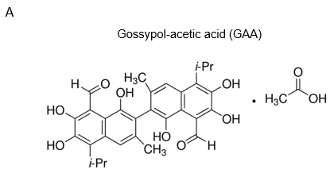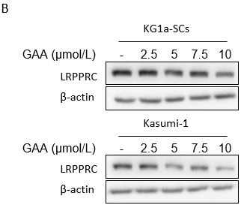
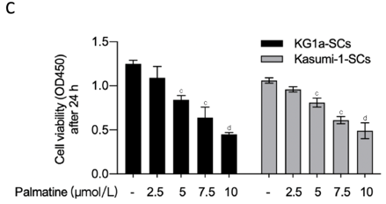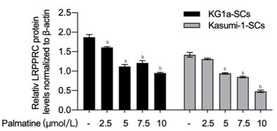
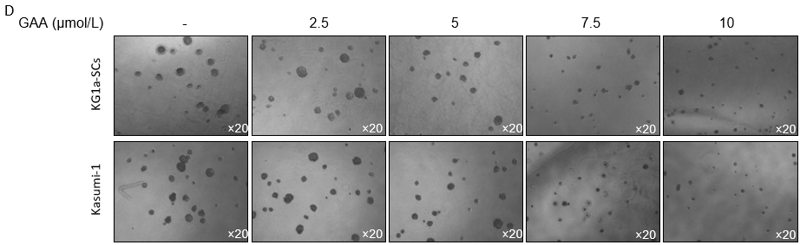
Figure 1 Gossypol acetic acid decreased leucine-rich pentatricopeptide repeat-containing protein and inhibited leukemia stem cell progression. A: Molecular structure of gossypol acetic acid (GAA) was presented; B: After being treated with 2.5, 5, 7.5, 10 μmol/L GAA for 24 h, leucine-rich pentatricopeptide repeat-containing protein was measured by performing western blot; C: After being cultured with 2.5, 5, 7.5, 10 μmol/L GAA for 24 h, cell viability was measured by performing CCK-8 assay. ªP < 0.05, vs KG1a-SCs; ^{b}P < 0.01, vs KG1a-SCs; ^{c}P < 0.05, vs Kasumi-1-SCs; ^{d}P < 0.01, vs Kasumi-1-SCs; D: With presence of 2.5, 5, 7.5, 10 μmol/L GAA, colony formation assay was performed. LRPPRC: Leucine-rich pentatricopeptide repeat-containing protein; GAA: Gossypol acetic acid.

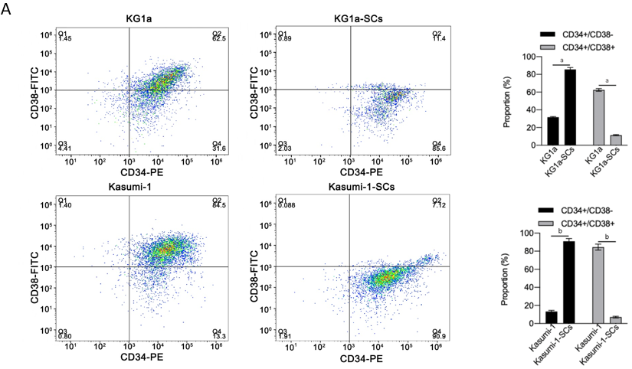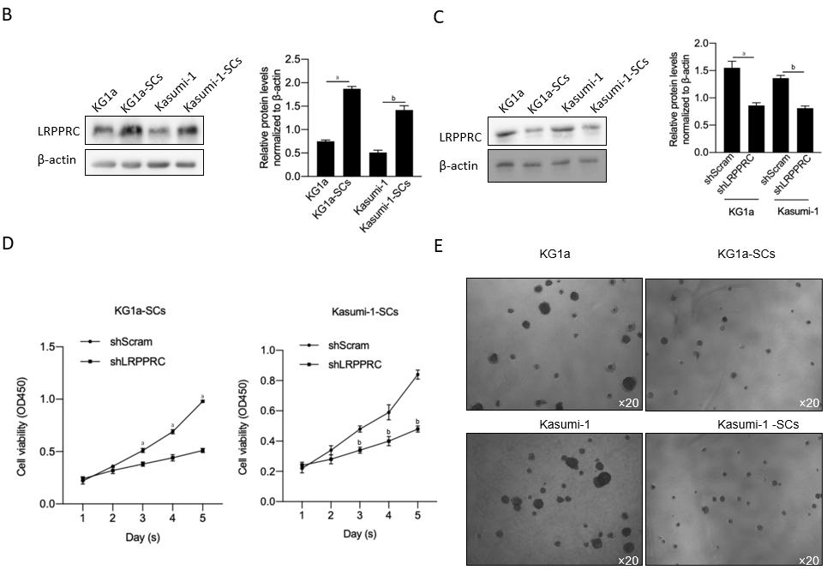Figure 2 Leucine-rich pentatricopeptide repeat-containing protein knockdown decreased cell viability and colony formation in KG1a-SCs and Kasumi-1-SCs. A. After magnetic sorting, sorted or original cells were analyzed by flow cytometry after double staining using CD34-PE/CD38-FITC. CD34⁺/CD38⁻ proportion was considered as leukemia stem cell subpopulation. ªP < 0.05, vs KG1a group; ^{b}P < 0.05, vs Kasumi-1 group; B: Leucine-rich pentatricopeptide repeat-containing protein (LRPPRC) expression was measured by performing western blot. ªP < 0.05, vs KG1a group; ^{b}P < 0.05, vs Kasumi-1 group; C: After short hairpin RNA (shRNA) transfection targeting to LRPPRC mRNA for 48 h, LRPPRC protein level was measured. ªP < 0.05, vs KG1a group or Kasumi-1 group; ^{b}P < 0.05, vs Kasumi-1 group; D: Cell viability was measured from day 1 to 5 after LRPPRC knockdown (shLRPPRC group). ªP < 0.05, vs KG1a-SCs shScram group; ^{b}P < 0.05, vs Kasumi-1-SCs shScram group; E: Colony formation assay was performed to evaluate the effect of LRPPRC knockdown. LRPPRC: Leucine-rich pentatricopeptide repeat-containing protein.

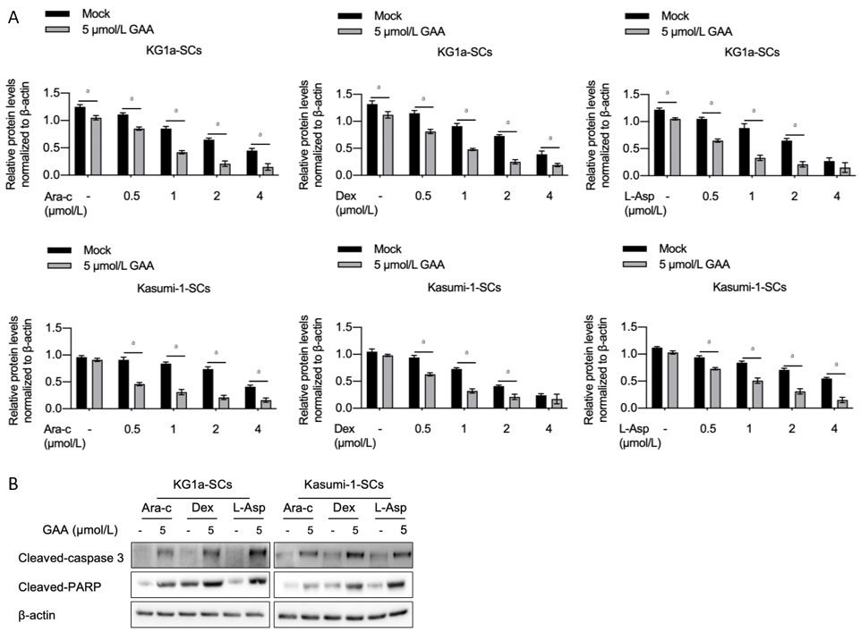
Figure 3 Gossypol acetic acid treatment enhanced chemosensitivity and apoptosis after chemotreatment. A: 0.5, 1, 2 or 4 μmol/L of cytarabine (Ara-C), Dexamethasone (Dex) or L-Asparaginase (L-Asp) was used for chemotreatment with or without presence of 5 μmol/L of gossypol acetic acid (GAA), 24-h later, cell viability was measured by performing CCK-8 assay. ªP < 0.05, vs mock group; B: KG1a-SCs or Kasumi-1-SCs was co-cultured with 1 μmol/L of Ara-c, Dex or L-Asp with or without 5 μmol/L of GAA for 24 h, and cleaved-caspase 3 and cleaved-PARP were measured by performing western blot. LRPPRC: Leucine-rich pentatricopeptide repeat-containing protein; GAA: Gossypol acetic acid; Ara-C: Cytarabine; Dex: Dexamethasone; L-Asp: L-Asparaginase.

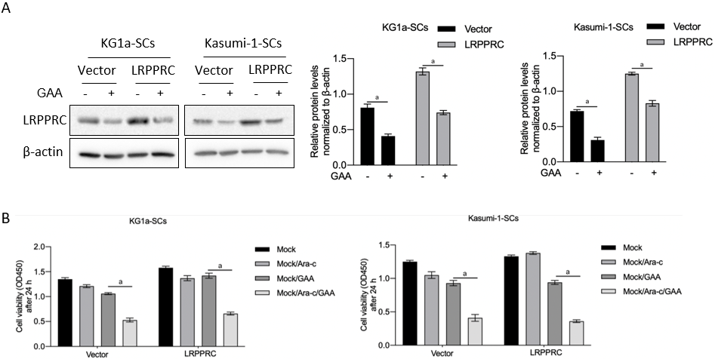
Figure 4 Gossypol acetic acid induced chemosensitivity via degrading leucine-rich pentatricopeptide repeat-containing protein. A: After being transfected with leucine-rich pentatricopeptide repeat-containing protein-coding plasmid, overexpression efficiency was measured by performing western blot. ªP < 0.05, vs vector group; B: After being pre-treated with gossypol acetic acid (GAA), KG1a-SCs or Kasumi-1-SCs were treated with cytarabine for extra 24 h and cell viability was measured. ªP < 0.05, mock/GAA group. LRPPRC: Leucine-rich pentatricopeptide repeat-containing protein; GAA: Gossypol acetic acid.

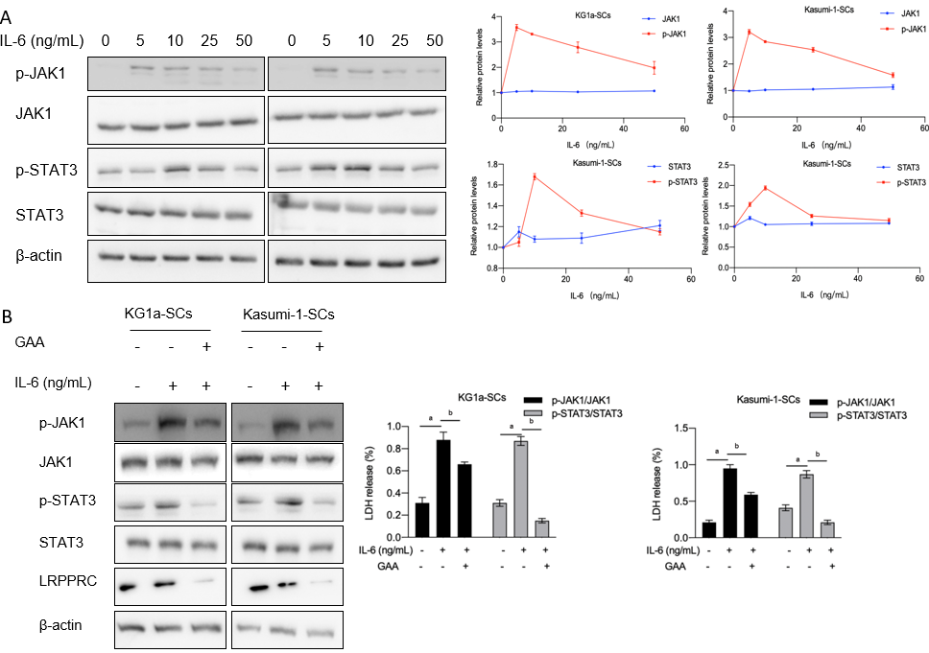
Figure 5 Gossypol acetic acid treatment inhibited interleukin 6/janus kinase 1/signal transducer and activator of transcription 3 signaling. A: After being treated with 5-50 ng/mL interleukin 6 (IL-6) for 6 h, western blot was performed to detect IL-6/janus kinase 1/signal transducer and activator of transcription 3 (IL-6/JAK1/STAT3) signaling including STAT3, p-STAT3, JAK1, p-JAK1; B: After being pre-treated with gossypol acetic acid for 24 h, 10 ng/mL IL-6 was added for 6-hour extra incubation and IL-6/JAK1/STAT3 signaling including STAT3, p-STAT3, JAK1, p-JAK1 was detected. ªP＜0.05, vs IL-6 (-) group; ^{b}P＜0.05, vs IL-6 (+) group. LRPPRC: Leucine-rich pentatricopeptide repeat-containing protein; GAA: Gossypol acetic acid; IL-6: Interleukin 6; JAK1: Janus kinase 1; STAT3: Signal transducer and activator of transcription 3.

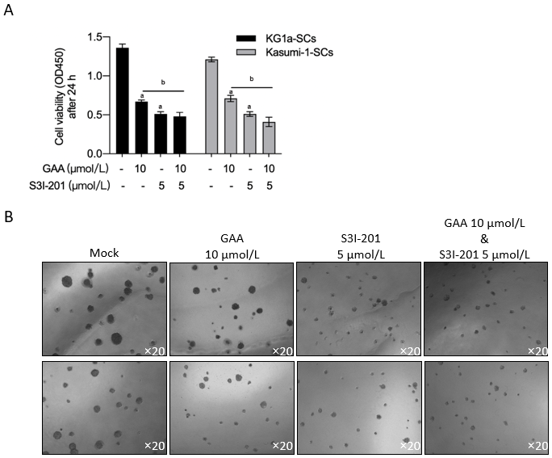
Figure 6 Gossypol acetic acid inhibits leukemia stem cells partially via inhibiting interleukin 6/janus kinase 1/signal transducer and activator of transcription 3 signaling. A and B: After being treated with gossypol acetic acid (GAA) or treated with S3I-210 for 24 h, cell viability was performing by employing CCK-8 assay (A), and colony formation ability was measured (B). ªP＜0.05, vs GAA/S3I-201(-) group; ^{b}P＜0.05, vs GAA (+) group. GAA: Gossypol acetic acid.

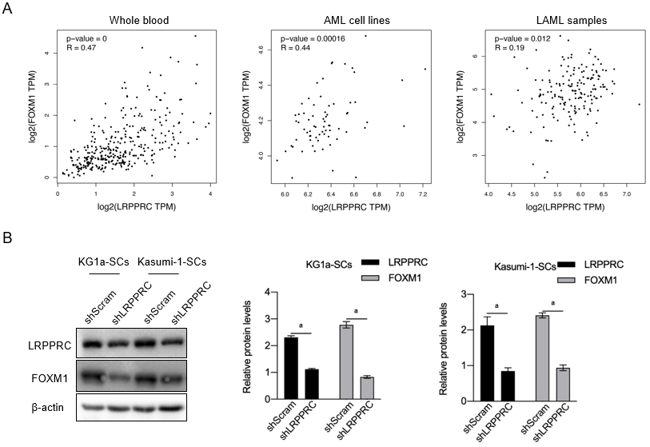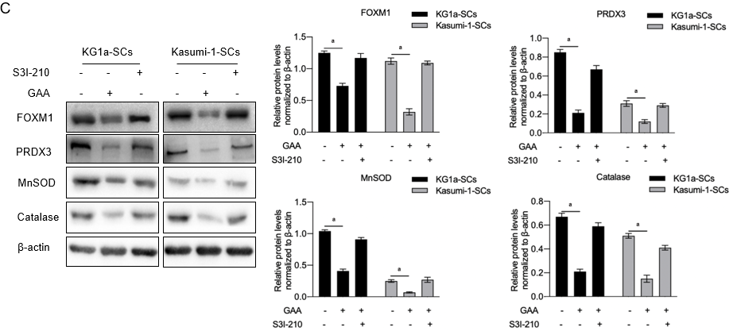
Figure 7 Gossypol acetic acid positively regulates forkhead box M1 in and interleukin 6/janus kinase 1/signal transducer and activator of transcription 3 signaling independent manner. A: By employing GEPIA online tool, the correlation between leucine-rich pentatricopeptide repeat-containing protein (LRPPRC) and forkhead box M1 (FOXM1) in whole blood, acute myeloid leukemia cell lines and LAML samples were analyzed; B: After efficiently knockdown LRPPRC in KG1a-SCs and Kasumi-1-SCs, LRPPRC and FOXM1 protein levels were measured by performing western blot. ªP＜0.05, vs shScram group; C: After being cultured with gossypol acetic acid (GAA), or pharmacology inhibitor S3I-210 for 24 h, FOXM1 and its downstream target genes, including PRDX3, MnSOD and catalase, were measured by performing western blot. ªP＜0.05, vs GAA(-)/S3I-210(-) group. LRPPRC: Leucine-rich pentatricopeptide repeat-containing protein; GAA: Gossypol acetic acid; FOXM1: Forkhead box M1.

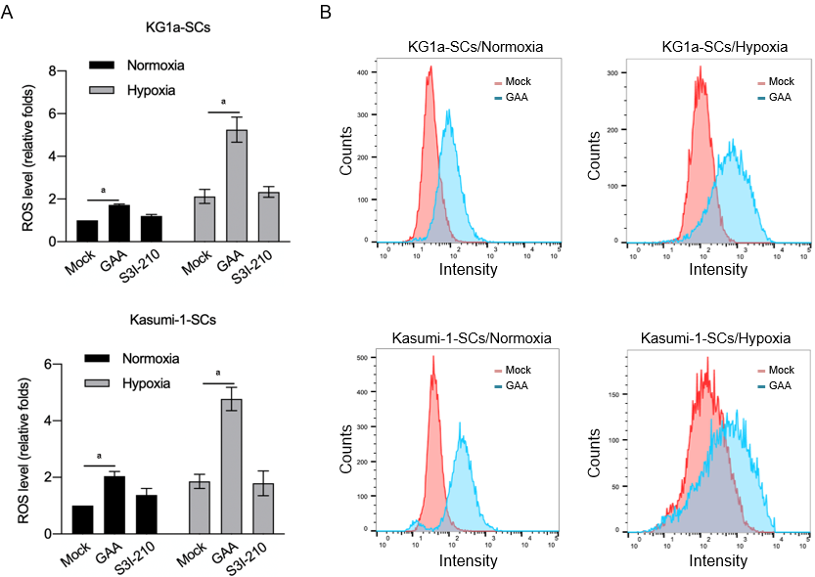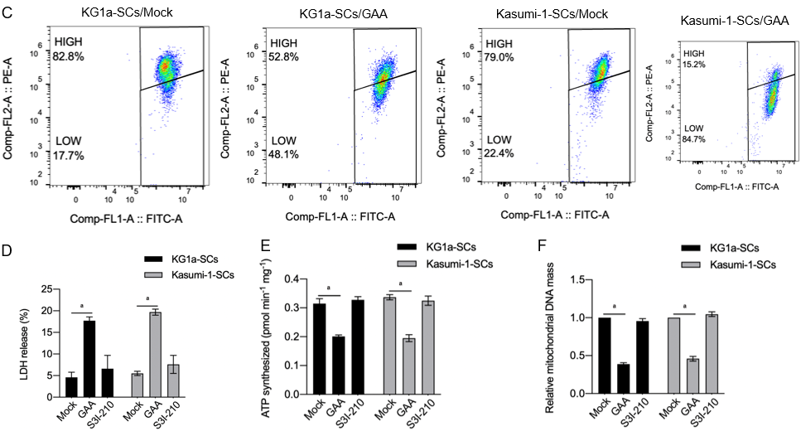
Figure 8 Gossypol acetic acid induced reactive oxygen species, disturbed mitochondrial homeostasis and resulted in mitochondrial dysfunction. A: Under normoxia and hypoxia conditions, after being treated with gossypol acetic acid (GAA) or S3I-210 for 24 h, cell viability was measured by performing CCK-8 assay. ªP＜0.05, vs mock group; B: After being treated with or without GAA, cells were stained using H2DCFDA and detected by performing flow cytometry; C: After being cultured by GAA under hypoxia condition, mitochondrial homeostasis was measured by performing JC-1 staining. JC-1 FITC proportion was considered as disturbed mitochondrial homeostasis; D-F: After being cultured by GAA or S3I-210, LDH leakage was detected to measure cellular membrane impact (D); total ATP synthesis (E) and mitochondrial DNA mass (F) were measured to confirm the effects of GAA on mitochondrial function. ªP < 0.05, vs mock group.

