Name of Journal: World Journal of Clinical Cases
Manuscript NO: 81492
Manuscript Type: CASE REPORT

Development of Henoch-Schoenlein purpura in a child with idiopathic hypereosinophilia syndrome with multiple thrombotic onset: A case report

Xu YY et al. IHES, HSP, and multiple thrombosis

Yan-Yan Xu, Xiao-Bi Huang, Yun-Gong Wang, Li-Yun Zheng, Min Li, Yu Dai, Sheng Zhao

Yan-Yan Xu, Xiao-Bi Huang, Yun-Gong Wang, Li-Yun Zheng, Sheng Zhao, Department of Pediatric Cardiovascular, Anhui Province Children's Hospital, Anhui Hospital of Children's Hospital Affiliated with Fudan University, Hefei 230051, Anhui Province, China

Min Li, Department of Pediatric Intensive Care Unit, Anhui Province Children's Hospital, Anhui Hospital of Children's Hospital affiliated with Fudan University, Hefei 230051, Anhui Province, China

Yu Dai, Department of Pediatrics, The Fourth Affiliated Hospital of Anhui Medical University, Hefei 230032, Anhui Province, China

Author contributions: Xu YY contributed to manuscript writing and editing and data collection; Wang YG, Zheng LY, Li M, and Dai Y contributed to data analysis; Huang XB and Zhao S contributed to conceptualization and supervision; all authors have read and approved the final manuscript.

Corresponding author: Sheng Zhao, MMed, Chief Doctor, Department of Pediatric Cardiovascular, Anhui Province Children's Hospital, Anhui Hospital of Children's Hospital affiliated with Fudan University, No. 39 Wangjiang East Road, Hefei 230051, Anhui Province, China. 382877830@qq.com

Received: November 16, 2022
Revised: December 11, 2022
Accepted: January 9, 2023
Published online:

Abstract
BACKGROUND
The incidence of pulmonary embolism (PE) in children is low, but its mortality is high. Hypereosinophilic syndrome (HES) is a group of diseases caused by an abnormal increase in eosinophilic granulocytes resulting in multiple-organ dysfunction. The urgent event of thromboembolism in the pulmonary region provoked by eosinophils in idiopathic HES (IHES) is relatively unusual. This article reports a case of IHES with multiple PEs and left leg venous thrombosis as the first manifestation. One month later, the patient developed Henoch-Schonlein purpura (HSP), which is very rare.

CASE SUMMARY
We report the case of a 12-year-old boy who was admitted to the hospital with dyspnea, left leg pain, and aggravation. He had bilateral PE and left leg venous embolism with mild eosinophilia. Low-molecular-weight heparin and urokinase were given. At the same time, the interventional department was contacted about filter implantation, followed by urokinase thrombolysis. The left leg thrombus was aspirated under ultrasound guidance. He was discharged from the hospital on rivaroxaban. One month later, he developed a rash on both legs and ankle pain consistent with HSP, with severe eosinophilia and motor and sensory disturbances. The patient was diagnosed with IHES with multiple embolisms complicated by HSP after excluding other causes of the eosinophil elevation. After glucocorticoid treatment, the symptoms were relieved, but the patient later developed purpura nephritis.

CONCLUSION
We report a rare and life-threatening case of IHES with multiple embolisms associated with HSP. A mild elevation of eosinophils early in the disease leads to difficulties in diagnosis and delayed treatment.

Key Words: Eosinophil; Hypereosinophilic syndrome; Henoch-Schoenlein purpura; Thrombosis; Case report

Xu YY, Huang XB, Wang YG, Zheng LY, Li M, Dai Y, Zhao S. Development of Henoch-Schoenlein purpura in a child with idiopathic hypereosinophilia syndrome with multiple thrombotic onset: A case report. World J Clin Cases 2023; In press

Core Tip: Pulmonary embolism (PE) in children usually occurs in the presence of an underlying condition, systemic disease, or other risk factors. Idiopathic PE accounts for less than 4% of these. The child has no risk factors for thrombosis other than obesity at the first hospitalization. A month later, he developed a purpuric rash on both legs, and pain in his ankles consistent with Henoch-Schönlein purpura (HSP) was accompanied by severe eosinophilia and motor and sensory impairments. Persistent eosinophilia in peripheral blood can lead to tissue infiltration and even organ damage. If end-organ damage occurs, hypereosinophilic syndrome (HES) can be diagnosed immediately. According to monist principles, patients are diagnosed with idiopathic HES with multiple embolisms complicated by HSP. After glucocorticoids, eosinophils quickly return to normal, neurological symptoms gradually improve, and the rash disappears. Eosinophils are only mildly elevated in PE, making clinical diagnosis more difficult.

INTRODUCTION
Hypereosinophilic syndrome (HES) is a group of clinical syndromes characterized by a persistent and significant increase in eosinophilic granulocytes in the peripheral blood and surrounding tissues, resulting in organ dysfunction. This condition, which has an unknown cause, is called idiopathic HES (IHES). This disease mostly occurs in people between 20 years and 50 years of age, with an incidence rate of 0.04/100000 and a mortality rate of 9.3%^{[1]}. It is rare in children, in whom its incidence is unknown. Pulmonary embolism (PE) caused by IHES is even rarer. Patients with HES also have autoimmune diseases such as ulcerative colitis, autoimmune hepatitis, autoimmune thyroiditis, multiple sclerosis, systemic lupus erythematosus, antiphospholipid syndrome, myasthenia gravis, and rheumatoid arthritis^{[2-4]}. Henoch-Schoenlein purpura (HSP) is a common vasculitis in school-aged children that can affect the skin, joints, kidneys, and other organs. Children diagnosed with IHES with multiple embolisms complicated by HSP are very rare. This case extends the list of HES patients with autoimmune diseases. To improve the understanding of this disease among pediatric clinicians, a case of IHES with dyspnea and leg pain as the initial presentation and subsequent concomitant HSP was reported in our hospital.

CASE PRESENTATION
Chief complaints
A 12-year-old boy was admitted to our hospital for the first time on January 11, 2021 because of dyspnea for 2 wk, left leg pain for 1 wk, and aggravation for 3 d. He also had a fever and occasional cough. On February 24 and April 2, 2021, the patient was admitted to the hospital with a symmetrical, dark red rash on both legs that did not face when pressed, accompanied by ankle swelling and pain.

History of present illness
The child had a history of respiratory infections prior to labored breathing.

History of past illness
The child was previously healthy.

Physical examination
First hospital admission: the patient was 168 cm tall, weighed 76 kg, and had a body mass index (BMI) of 26.9 kg/m². His vital signs were as follows: Body temperature, 37.4 °C; blood pressure 128/81 mmHg; heart rate, 104 beats per min; respiratory rate 32/min; and SpO₂ 92% (room air). The patient’s skin was normal, but he displayed slight shortness and exertion of breath. The circumference of his left leg was 39.5 cm and right leg 37.5 cm, and his limb muscle tension was normal.
Second and third admissions: His legs showed a scattered, symmetrical, pressing dark red rash that did not fade, and both ankles were swollen and painful. On April 4, 2021, the child had decreased pain and temperature sensation in the right plantar, the toe could not bend to the ventral side, and the skin temperature of the right plantar was higher than that of the opposite side.

Laboratory examinations
His platelet count was 50 × 10⁹/L, and his eosinophil count (EC) was slightly high at 0.63 × 10⁹/L (Figure 1). On the other hand, his D-dimer level was 11.12 μg/mL (Figure 2). Serum potassium was 3.32 mmol/L. On day 8, blood tests showed normal levels of potassium. C4 was slightly high at 0.46 g/L (normal: 0-0.4). Protein C was 50.2% (normal: 75-130). Neuronal enolase was slightly high at 21.96 μg/L (normal: 0-16.3). N-terminal pro-brain natriuretic peptide (NT-proBNP) and troponin I (TnI) were high at 3116 pg/mL and 0.145 ng/mL, respectively, on January 11, 2021. No abnormalities were found in TnI on January 16, 2021 or in NT-proBNP on January 19, 2021. On February 24, 2021, the patient’s IgE level was significantly high at 531 IU/mL (normal: 0-52). No abnormalities were found in hemoglobin, glucose, lipid, liver function, renal function parameters, C-reactive protein, activated partial thromboplastin time, or protein C. Anti-neutrophil cytoplasmic antibody, antinuclear antibodies, anticardiolipin antibody, HIV tests, hepatitis B, hepatitis C, mycoplasma pneumonia antibody, borrelia, and treponema pallidum were negative. Chlamydia pneumoniae IgG was positive. Human chorionic gonadotropin, alpha-fetoprotein, carcinoembryonic antigen, ferritin, and C3 were within the reference ranges. Allergen IgE detection, food intolerance, stool for Giardia lamblia, cryptosporidium, pinworm, and genetics were negative. On February 26, 2021, the microalbumin level in urine was 13.01 mg/L, but total urinary protein was not found due to the problem of specimen retention. The 24-h urinary total protein and microalbumin levels reviewed at later stages are shown in Figure 3.

Imaging examinations
On January 11, 2021, color Doppler echocardiography revealed right atria and ventricle enlargement, mild tricuspid regurgitation with insufficiency, and pulmonary hypertension. Color Doppler ultrasonography of the blood vessels of the legs showed thrombosis of the superficial femoral vein, popliteal vein, and posterior tibial vein of the left leg (Figure 4A). The lung computed tomography (CT) showed scattered wedge-shaped consolidation of both lungs with an outward-facing base and apex pointing to the hilum, a relatively widened pulmonary artery, and pulmonary infarction cannot be excluded. CT angiography of the pulmonary artery showed extensive embolization of both pulmonary arteries with enlargement of the pulmonary artery and the right heart (Figure 4B). On February 4, 2021, color Doppler ultrasound of the left lower extremity vein showed patency of blood flow. On April 6, 2021, color Doppler echocardiography showed a plump right atrium, mild tricuspid regurgitation with regurgitation insufficiency, and mild pulmonary hypertension. Bone marrow puncture and cranial and spinal MRI were not performed.

MULTIDISCIPLINARY EXPERT CONSULTATION
HSP was diagnosed given the child's typical symmetry of the two legs, nonfading compression, dark-red rash, and ankle swelling and pain. Symptomatic treatment was recommended, and glucocorticoids were added when necessary.

FINAL DIAGNOSIS
The patient was diagnosed with IHES with multiple embolisms complicated by HSP.

TREATMENT
First hospital admission: Immediately afterward, he was given low-molecular-weight heparin and urokinase. At the same time, the interventional department was contacted for inferior vena cava filter implantation followed by urokinase thrombolysis. Angiography showed a marked reduction in filling defects. Rivaroxaban tablets were taken orally after the operation. On January 15, 2021, the left leg thrombus was aspirated under ultrasound guidance, and numerous long strips of thrombus were extracted (Figure 4C). Postoperative angiography showed that the filling defect had disappeared. On January 21, 2021, the filter was removed, and a thrombosis was attached to the filter (Figure 4D). He was discharged from the hospital on rivaroxaban.
Second hospital admission: He was given anti-anaphylactic treatment while rivaroxaban was continued orally.
Third hospital admission: Methylprednisolone sodium succinate (2.0 mg/kg/d) was administered. Prednisone (0.5 mg/kg/d) and rivaroxaban were administered orally at discharge. Prednisone and rivaroxaban were gradually discontinued over 3 mo.

OUTCOME AND FOLLOW-UP
After methylprednisolone sodium succinate treatment was administered, EC decreased significantly, and the patient’s skin rash, arthralgia, pain, temperature sensation, and toe activity gradually recovered. After following the child for one year, on November 8, 2021, the child showed signs of respiratory tract infection, skin rash in the legs again, and ankle pain. On November 10, 2021, purpura nephritis was diagnosed, and prednisone was given (0.2 mg/kg/d). The child has no symptoms at present, and his EC has decreased. His total urinary protein and micro urinary albumin levels gradually returned to normal. Presently, prednisone is being gradually reduced.

DISCUSSION
A 30% mortality rate in patients with PE was reported in some studies that included autopsy-based PE diagnosis^{[5]}. PE in children is associated with central venous catheterization, malignancy, congenital heart disease, systemic lupus erythematosus, trauma, surgery, long-term total parenteral nutrition, dehydration, infection, hospitalization with a state of acquired or congenital hypercoagulability, oral contraceptive usage, and inactivity. There were no risk factors in our patient. One month later, the child had significantly elevated eosinophils (EOSs) and a symmetrical, dark-red rash on both legs that did not fade when pressed, accompanied by ankle swelling and pain. The rash was diagnosed as HSP after consultation with the nephrology department. HES can cause thrombi. A retrospective review of the English literature (Table 1) found 16 articles^{[6-21]}, a total of 21 patients were diagnosed with HES and complicated with thrombotic events, of which deep venous thrombosis accounted for 38%, and PE 33%. The mortality rate was 19%. HES is characterized by a consistently elevated EC of 1.5 × 10⁹/L or more that lasts for at least 6 mo or across 2 examinations (≥ 1 mo between tests) and can be diagnosed immediately in the event of life-threatening end-organ injuries, such as PE and cerebrovascular thromboembolism, to avoid delayed treatment^{[22]}. HES is more common in men than in women, and fever is the most common symptom, which can cause functional impairment of the skin, heart, nerves, lungs, digestive tract, and other organs. Thrombotic events are rare. The patient reported here presented with PE and left leg venous thrombosis as the first manifestation, and the peripheral blood eosinophil level was only slightly elevated at this time. Rato reported a case of IHES with a maximum peripheral eosinophil count of 0.83 × 10⁹/L, but the pleural pathological examination was consistent with eosinophil pleurisy. Bronchoalveolar lavage revealed EOSs with a large pericardial effusion and left ventricular perforation. A pericardial biopsy indicated the presence of many EOSs^{[23]}. According to the principles of monism, HES was considered likely in this case. HES has a complex etiology and can be divided into primary (mainly hematological tumors), secondary (allergic diseases such as asthma, parasitic or fungal infections, drugs, and rheumatic diseases), and idiopathic^{[24]}. Our patient was negative for HES-related etiology and screening indicators, including infection, allergens, rheumatic diseases, immune deficiency, and tumors. The child was healthy and showed normal growth and development. He denied a history of rhinitis, asthma, intractable eczema, or repeated bacterial infections. He did not lose weight recently, nor did he have an enlargement of the liver, spleen, or lymph nodes, so primary HES was not supported. The onset age was young, there was no history of thrombotic disease in his lineal or collateral relatives, and no positive results were found in the genetic test. The diagnosis was IHES with multiple embolisms associated with HSP.
In most cases, PE originates from deep vein thrombosis of the legs. The child first had dyspnea, followed by left leg pain. PE may come from in situ thrombosis. In HES, symptoms similar to PE are usually caused by a large increase in EOSs in the pulmonary vasculature. Thus, this “thrombus” that is subsequently detected clinically is not a true thrombus but rather an accumulation of EOSs^{[25]}. This pulmonary accumulation leaves fewer EOSs in peripheral blood, which may explain the EOS reduction in the PE with leg thrombosis in the present case. Furthermore, EOS release eosinophilic cationic protein (ECP), EOS peroxidase (EPO), major basic protein (MBP), and EOS-derived neurotoxin (EDN) to damage vascular endothelial cells through degranulation. MBP, ECP, and EPO can also improve the activity of tissue factors. Coagulation factors VI and X activate the endogenous coagulation pathway, inhibit the production of activated protein C, and cause hypercoagulability. In addition, EOSs can directly activate tissue factor, platelet-activating factor, and leukotriene; activate the exogenous coagulation pathway; activate and aggregate platelets; and promote thrombosis, while direct EC infiltration leads to vascular endothelial cell injury^{[26]}. These mechanisms suggest that IHES may involve blood vessels and cause thrombi. The child's EC fluctuated between 2.63 × 10⁹/L-7.85 × 10⁹/L in the late stage, and neurological damage occurred. EOS particles contain EDN and MBP, which may be associated with neurological damage^{[27]}.
Glucocorticoids (0.5-1.0 mg/kg/d) are currently recommended as the mainstream treatment for IHES. It has been reported all patients’ EC decreased, and 98.3% achieved complete remission after treatment with glucocorticoids. Standard anticoagulation treatments also effectively prevented the recurrence of venous thromboembolism, and no severe bleeding events were observed during the short-term follow-up. There is no published information about the long-term outcomes of glucocorticoids and anticoagulant therapy in patients with idiopathic eosinophilia (including HES) and venous thromboembolism^{[28]}. Glucocorticoids inhibit EOS maturation and the production of cytokines and chemokines, induce EOS apoptosis, and reduce tissue and organ damage. Interferon-α, imatinib, hydroxyurea, or mepolizumab is recommended for glucocorticoid deficiency, intolerance, or long-term maintenance therapy^{[24]}. In the case of thrombosis, anticoagulation, catheter interventional thrombolytic therapy, and surgical treatment can be selected, according to the location of the thrombosis, the time of embolization, and the specific situation of the patient^{[29]}. The first symptom in the present child was multiple systemic embolisms. After the elimination of anticoagulant contraindications, anticoagulant and thrombolytic therapy were administered, and catheter interventional thrombolytic therapy was performed simultaneously. When IHES was combined with HSP, there was no recurrence of the rash after glucocorticoid administration. With anticoagulant therapy, the neurological damage gradually recovered, and the EOSs quickly returned to normal.
HSP, also known as IgA vasculitis, is the most common small vasculitis in childhood. It may affect the skin, joints, gastrointestinal tract, and kidneys. HSP can be complicated by venous thrombosis^{[30,31]}, but there was no evidence of HSP before the occurrence of thrombosis in this child. It is not clear whether IHES and HSP have a common pathogenesis. Interleukin-4 (IL-4) and IL-5 are cytokines secreted by Th2 cells. IL-5 specifically promotes terminal differentiation and proliferation of EOSs and is an important chemokine in EOSs. When inflammation occurs, EOSs aggregate and become activated, and a large amount of IL-5 is secreted, which leads to increased EOS proliferation and infiltration and leukotriene synthesis, resulting in a self-amplification effect and aggravation of the inflammatory response^{[32,33]}. IL-5 and IL-4 can promote the expression of vascular endothelial cell adhesion molecules, thereby enhancing EOS, basophil, and endothelial cell binding and causing inflammatory cells to infiltrate local tissues. IL-5 not only activates EOSs but can also recruit transforming growth factor β and various cytokines to promote IgA production in B lymphocytes, all of which play an important role in the pathogenesis of HSP^{[34]}. IL-5 and ECP-activated EOSs may be factors in the pathogenesis of purpura nephritis^{[35]}. The serum ECP of children with HSP during the acute episode was significantly higher than that of healthy children and children in remission with hormone therapy. The serum ECP of those with kidney involvement was significantly higher than that of those without kidney involvement. Late respiratory tract infection in children leads to recurrent rash, joint pain, increased urinary protein, and EC. This leads to the progression of purpura nephritis, in which IL-5, ECP, and mast cells also play a certain role^{[36]}. The current case was isolated, and whether there are other pathways between eosinophilia and HSP needs to be further investigated.

CONCLUSION
In this case, a 12-year-old boy diagnosed with IHES presented with dyspnea and lower limb pain as the first presentation, with only mild eosinophilia, and later developed HSP. Respiratory infections can cause recurrence of HSP and an increase in eosinophils. For atypical rare diseases with multidisciplinary treatment and poor prognosis, clinical expertise should be paid more attention.

REFERENCES
1 Shomali W, Gotlib J. World Health Organization-defined eosinophilic disorders: 2022 update on diagnosis, risk stratification, and management. Am J Hematol 2022; 97: 129-148 [PMID: 34533850 DOI: 10.1002/ajh.26352]
2 Markusse HM, Schravenhoff R, Beerman H. Hypereosinophilic syndrome presenting with diarrhoea and anaemia in a patient with systemic lupus erythematosus. Neth J Med 1998; 52: 79-81 [PMID: 9557531 DOI: 10.1016/s0300-2977(97)00086-7]
3 Kane SP. Ulcerative colitis with chronic liver disease, eosinophilia and auto-immune thyroid disease. Postgrad Med J 1977; 53: 105-108 [PMID: 876921 DOI: 10.1136/pgmj.53.616.105]
4 Chaudhuri K, Dubey S, Zaphiropoulos G. Idiopathic hypereosinophilic syndrome in a patient with long-standing rheumatoid arthritis: a case report. Rheumatology (Oxford) 2002; 41: 349-350 [PMID: 11934978 DOI: 10.1093/rheumatology/41.3.349]
5 Heit JA, Silverstein MD, Mohr DN, Petterson TM, O'Fallon WM, Melton LJ 3rd. Predictors of survival after deep vein thrombosis and pulmonary embolism: a population-based, cohort study. Arch Intern Med 1999; 159: 445-453 [PMID: 10074952 DOI: 10.1001/archinte.159.5.445]
6 Liao YH, Su YW, Tsay W, Chiu HC. Association of cutaneous necrotizing eosinophilic vasculitis and deep vein thrombosis in hypereosinophilic syndrome. Arch Dermatol 2005; 141: 1051-1053 [PMID: 16103348 DOI: 10.1001/archderm.141.8.1051]
7 Sui T, Li Q, Geng L, Xu X, Li Y. A case of hypereosinophilic syndrome presenting with multiorgan thromboses associated with intestinal obstruction. Turk J Haematol 2013; 30: 311-314 [PMID: 24385812 DOI: 10.4274/Tjh.2012.0141]
8 Li D, Xu L, Lin D, Jiang S, Feng S, Zhu L. Acute pulmonary embolism and deep vein thrombosis secondary to idiopathic hypereosinophilic syndrome. Respir Med Case Rep 2018; 25: 213-215 [PMID: 30237972 DOI: 10.1016/j.rmcr.2018.09.006]
9 Todd S, Hemmaway C, Nagy Z. Catastrophic thrombosis in idiopathic hypereosinophilic syndrome. Br J Haematol 2014; 165: 425 [PMID: 24456103 DOI: 10.1111/bjh.12729]
10 Grigoryan M, Geisler SD, St Louis EK, Baumbach GL, Davis PH. Cerebral arteriolar thromboembolism in idiopathic hypereosinophilic syndrome. Arch Neurol 2009; 66: 528-531 [PMID: 19364940 DOI: 10.1001/archneurol.2009.36]
11 Schulman H, Hertzog L, Zirkin H, Hertzanu Y. Cerebral sinovenous thrombosis in the idiopathic hypereosinophilic syndrome in childhood. Pediatr Radiol 1999; 29: 595-597 [PMID: 10415185 DOI: 10.1007/s002470050656]
12 Tai CP, Chung T, Avasarala K. Endomyocardial fibrosis and mural thrombus in a 4-year-old girl due to idiopathic hypereosinophilia syndrome described with serial cardiac magnetic resonance imaging. Cardiol Young 2016; 26: 168-171 [PMID: 25683059 DOI: 10.1017/S1047951115000013]
13 Fujita K, Ishimaru H, Hatta K, Kobashi Y. Hypereosinophilic syndrome as a cause of fatal thrombosis: two case reports with histological study. J Thromb Thrombolysis 2015; 40: 255-259 [PMID: 25388084 DOI: 10.1007/s11239-014-1151-9]
14 Gao SJ, Wei W, Chen JT, Tan YH, Yu CB, Litzow MR, Liu QJ. Hypereosinophilic syndrome presenting with multiple organ infiltration and deep venous thrombosis: A case report and literature review. Medicine (Baltimore) 2016; 95: e4658 [PMID: 27583887 DOI: 10.1097/MD.0000000000004658]
15 Sakuta R, Tomita Y, Ohashi M, Nagai T, Murakami N. Idiopathic hypereosinophilic syndrome complicated by central sinovenous thrombosis. Brain Dev 2007; 29: 182-184 [PMID: 16996710 DOI: 10.1016/j.braindev.2006.08.004]
16 Yamada Y, Hoshino K, Shimojima N, Shinoda M, Obara H, Kawachi S, Fuchimoto Y, Tanabe M, Kitagawa Y, Morikawa Y. Idiopathic hypereosinophilic syndrome in a case with ABO-incompatible liver transplantation for biliary atresia complicated by portal vein thrombosis. Pediatr Transplant 2010; 14: e49-e53 [PMID: 20042017 DOI: 10.1111/j.1399-3046.2009.01170.x]
17 Silva MS, Ramalho C, Ferreira F, Maia I, Joosten A. Idiopathic Hypereosinophilic Syndrome Presenting With Embolic Stroke. Cureus 2021; 13: e19307 [PMID: 34900483 DOI: 10.7759/cureus.19307]
18 Eisa N, Shaheen K, Alraiyes AH, Alraies MC. Loeffler's endocarditis with biventricular mural thrombi. BMJ Case Rep 2013; 2013 [PMID: 24081624 DOI: 10.1136/bcr-2013-009609]
19 Numagami Y, Tomita T, Murakami K, Masaki I, Kubo K, Michiharu N. Sinus thrombosis in idiopathic hypereosinophilic syndrome causing fatal cerebral haemorrhage. J Clin Neurosci 2008; 15: 585-587 [PMID: 18308571 DOI: 10.1016/j.jocn.2006.12.021]
20 Chen TS, Xing LH, Wang SL, Liu QH, Zhao SL, Yuan CC. Pulmonary embolism, deep vein thrombosis and recurrent bone cysts in a patient with hypereosinophilic syndrome. Blood Coagul Fibrinolysis 2016; 27: 831-834 [PMID: 26780165 DOI: 10.1097/MBC.0000000000000501]
21 Terrier B, Piette AM, Kerob D, Cordoliani F, Tancrède E, Hamidou L, Lebbé C, Blétry O, Kahn JE. Superficial venous thrombophlebitis as the initial manifestation of hypereosinophilic syndrome: study of the first 3 cases. Arch Dermatol 2006; 142: 1606-1610 [PMID: 17178987 DOI: 10.1001/archderm.142.12.1606]
22 Akuthota P, Weller PF. Spectrum of Eosinophilic End-Organ Manifestations. Immunol Allergy Clin North Am 2015; 35: 403-411 [PMID: 26209892 DOI: 10.1016/j.iac.2015.04.002]
23 Rueff Rato I, Rigor J, Ferreira P, Laranjinha J, Santos-Silva G, Martins-Mendes D. Investigating Febrile Polyserositis: An Unusual Case of Idiopathic Hypereosinophilic Syndrome. Eur J Case Rep Intern Med 2021; 8: 002426 [PMID: 33987122 DOI: 10.12890/2021_002426]
24 Butt NM, Lambert J, Ali S, Beer PA, Cross NC, Duncombe A, Ewing J, Harrison CN, Knapper S, McLornan D, Mead AJ, Radia D, Bain BJ; British Committee for Standards in Haematology. Guideline for the investigation and management of eosinophilia. Br J Haematol 2017; 176: 553-572 [PMID: 28112388 DOI: 10.1111/bjh.14488]
25 Karnak D, Kayacan O, Beder S, Delibalta M. Hypereosinophilic syndrome with pulmonary and cardiac involvement in a patient with asthma. CMAJ 2003; 168: 172-175 [PMID: 12538545]
26 Noh HR, Magpantay GG. Hypereosinophilic syndrome. Allergy Asthma Proc 2017; 38: 78-81 [PMID: 28052805 DOI: 10.2500/aap.2017.38.3995]
27 Moertel CL, Kazacos KR, Butterfield JH, Kita H, Watterson J, Gleich GJ. Eosinophil-associated inflammation and elaboration of eosinophil-derived proteins in 2 children with raccoon roundworm (Baylisascaris procyonis) encephalitis. Pediatrics 2001; 108: E93 [PMID: 11694677 DOI: 10.1542/peds.108.5.e93]
28 Liu Y, Meng X, Feng J, Zhou X, Zhu H. Hypereosinophilia with Concurrent Venous Thromboembolism: Clinical Features, Potential Risk Factors, and Short-term Outcomes in a Chinese Cohort. Sci Rep 2020; 10: 8359 [PMID: 32433573 DOI: 10.1038/s41598-020-65128-4]
29 Kearon C, Akl EA, Comerota AJ, Prandoni P, Bounameaux H, Goldhaber SZ, Nelson ME, Wells PS, Gould MK, Dentali F, Crowther M, Kahn SR. Antithrombotic therapy for VTE disease: Antithrombotic Therapy and Prevention of Thrombosis, 9th ed: American College of Chest Physicians Evidence-Based Clinical Practice Guidelines. Chest 2012; 141: e419S-e496S [PMID: 22315268 DOI: 10.1378/chest.11-2301]
30 Diana A, Gaze H, Laubscher B, De Meuron G, Tschantz P. A case of pediatric Henoch-Schönlein purpura and thrombosis of spermatic veins. J Pediatr Surg 2000; 35: 1843 [PMID: 11101753 DOI: 10.1053/jpsu.2000.9293]
31 Dhaliwal KK, Lile NA, Tan CL, Lim CH. Life-threatening complications of Henoch-Schönlein purpura: diffuse alveolar haemorrhage, venous thrombosis and bowel ischaemia. BMJ Case Rep 2020; 13 [PMID: 32994270 DOI: 10.1136/bcr-2020-235905]
32 Horii Y, Muraguchi A, Iwano M, Matsuda T, Hirayama T, Yamada H, Fujii Y, Dohi K, Ishikawa H, Ohmoto Y. Involvement of IL-6 in mesangial proliferative glomerulonephritis. J Immunol 1989; 143: 3949-3955 [PMID: 2592764]
33 Yamaguchi Y, Suda T, Suda J, Eguchi M, Miura Y, Harada N, Tominaga A, Takatsu K. Purified interleukin 5 supports the terminal differentiation and proliferation of murine eosinophilic precursors. J Exp Med 1988; 167: 43-56 [PMID: 3257253 DOI: 10.1084/jem.167.1.43]
34 Sonoda E, Matsumoto R, Hitoshi Y, Ishii T, Sugimoto M, Araki S, Tominaga A, Yamaguchi N, Takatsu K. Transforming growth factor beta induces IgA production and acts additively with interleukin 5 for IgA production. J Exp Med 1989; 170: 1415-1420 [PMID: 2677210 DOI: 10.1084/jem.170.4.1415]
35 Kawasaki Y, Hosoya M, Suzuki H. Possible pathologenic role of interleukin-5 and eosino cationic protein in Henoch-Schönlein purpura nephritis. Pediatr Int 2005; 47: 512-517 [PMID: 16190956 DOI: 10.1111/j.1442-200x.2005.02115.x]
36 Namgoong MK, Lim BK, Kim JS. Eosinophil cationic protein in Henoch-Schönlein purpura and in IgA nephropathy. Pediatr Nephrol 1997; 11: 703-706 [PMID: 9438647 DOI: 10.1007/s004670050370]

Footnotes
Informed consent statement: Informed written consent was obtained from the patient for publication of this report and any accompanying images.

Conflict-of-interest statement: The authors declare that they have no conflict of interest to disclose.

CARE Checklist (2016) statement: The authors have read the CARE Checklist (2016), and the manuscript was prepared and revised according to the CARE Checklist (2016).

Open-Access: This article is an open-access article that was selected by an in-house editor and fully peer-reviewed by external reviewers. It is distributed in accordance with the Creative Commons Attribution NonCommercial (CC BY-NC 4.0) license, which permits others to distribute, remix, adapt, build upon this work non-commercially, and license their derivative works on different terms, provided the original work is properly cited and the use is non-commercial. See: https://creativecommons.org/Licenses/by-nc/4.0/

Provenance and peer review: Unsolicited article; Externally peer reviewed.
Peer-review model: Single blind

Peer-review started: November 16, 2022
First decision: November 25, 2022
Article in press:

Specialty type: Immunology
Country/Territory of origin: China
Peer-review report’s scientific quality classification
Grade A (Excellent): 0
Grade B (Very good): B
Grade C (Good): C, C
Grade D (Fair): 0
Grade E (Poor): 0

P-Reviewer: Dragonieri S, Italy; Ji X, China S-Editor: Chen YL L-Editor: A P-Editor: Chen YL

Figure Legends
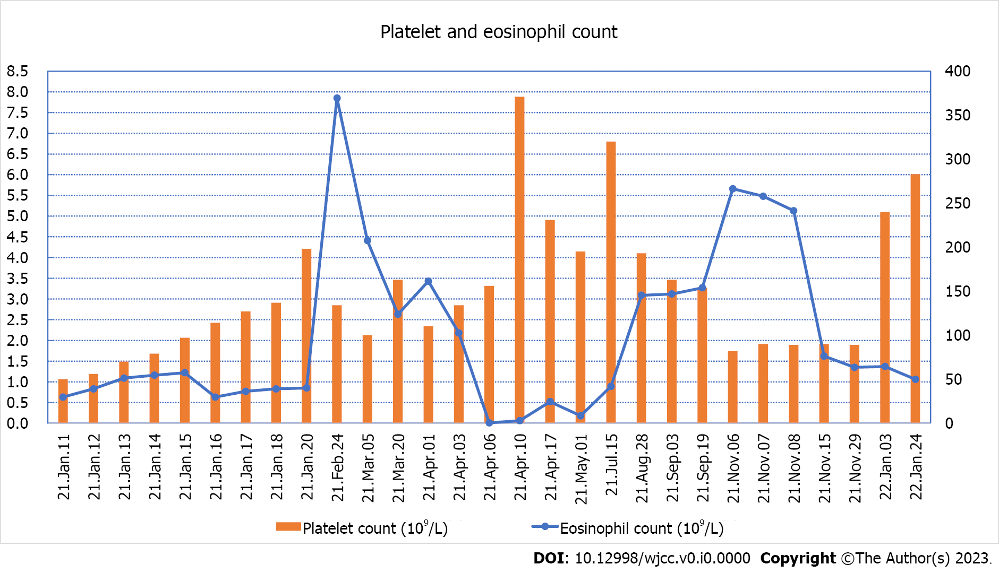
Figure 1 Changes in platelet and eosinophil count from the first hospitalization to the end of follow-up.

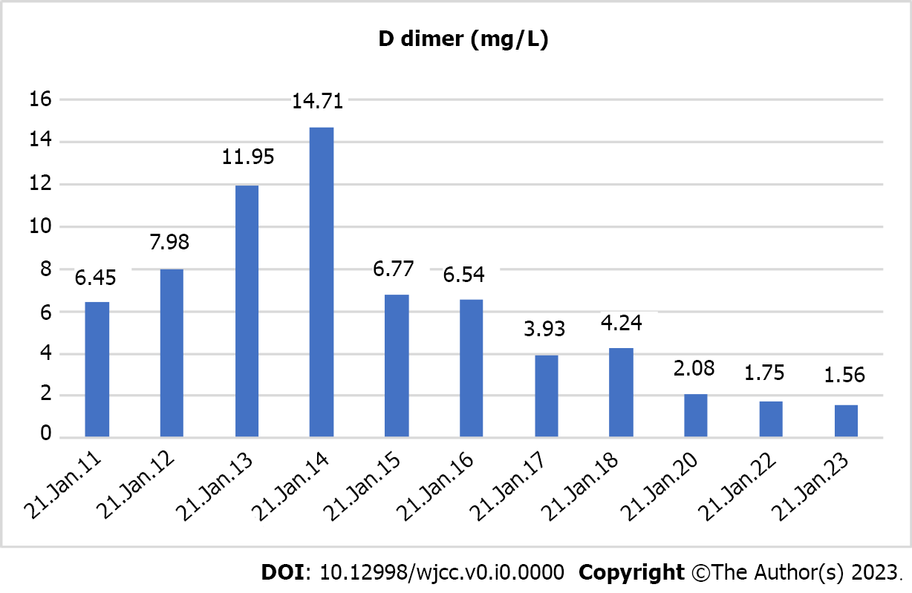
Figure 2 D dimer changes during the child's first hospitalization.

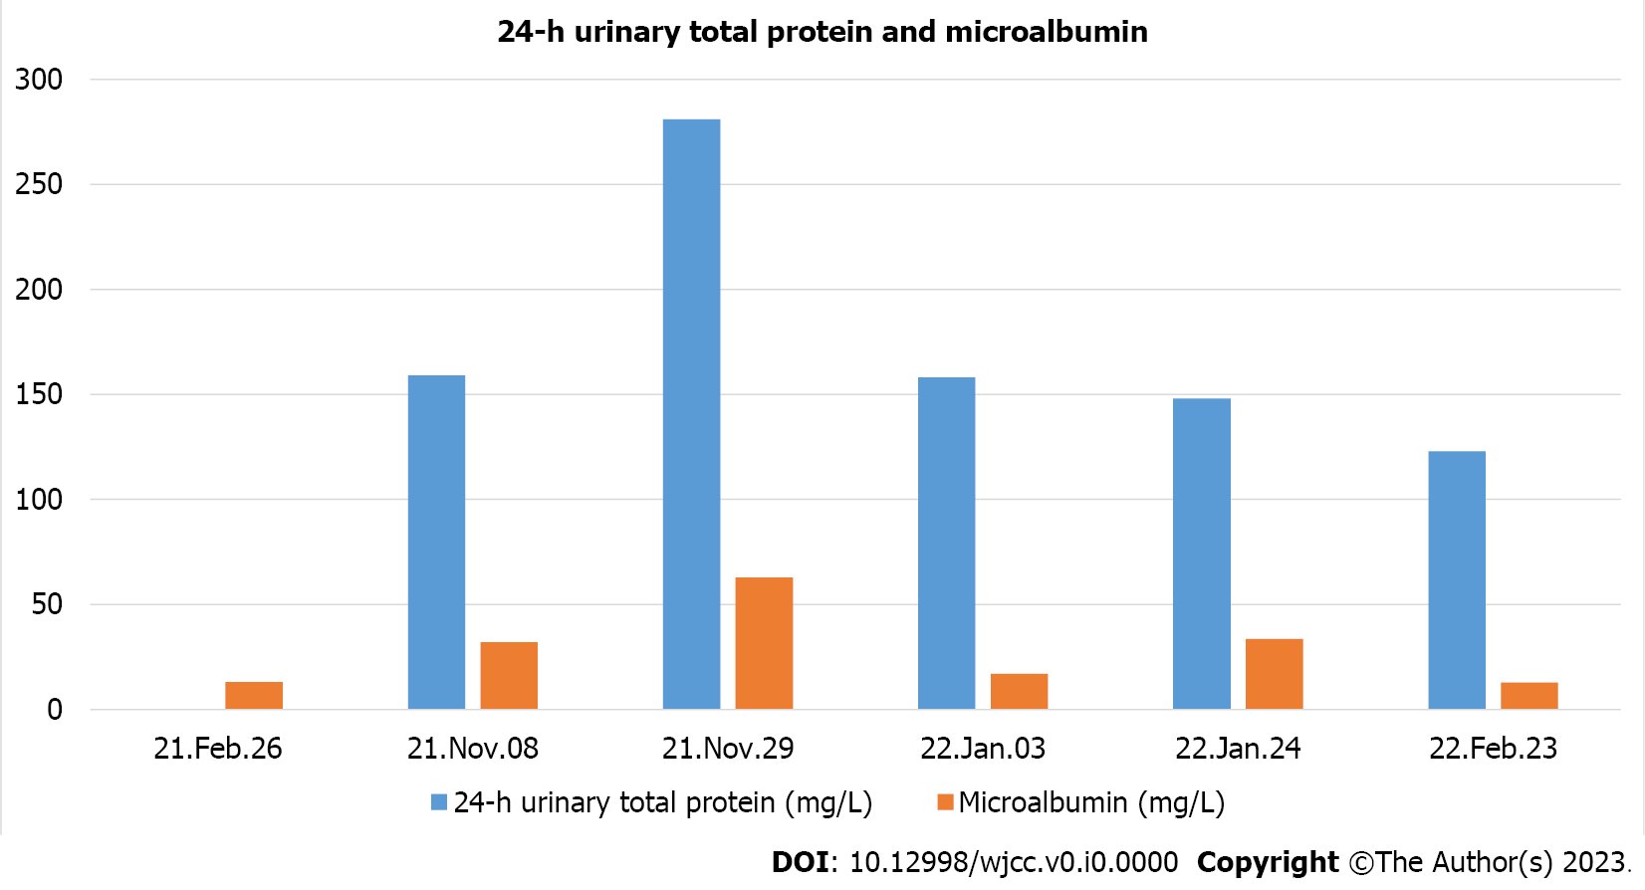
Figure 3 The 24-h urinary total protein and microalbumin levels reviewed at later stages.

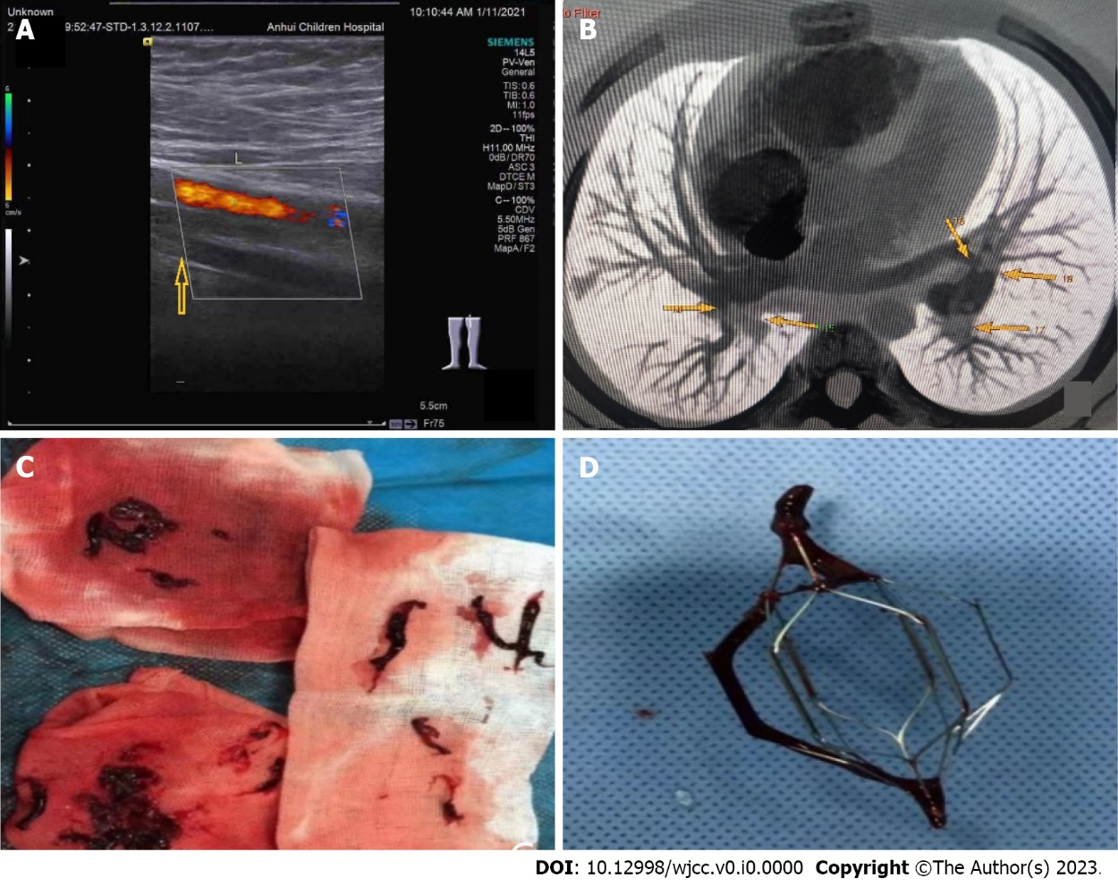
Figure 4 The 24-h urinary total protein and microalbumin levels reviewed at later stages. A: The arrow in the figure indicates the superficial femoral vein of the left lower extremity, through which no blood flow passes. The color flow is the superficial femoral artery of the left lower extremity; B: The arrows in the figure indicate multiple filling defects in the main pulmonary arteries of both lobes and segments; C: Many long thrombi aspirated from the left leg; D: When the filter was removed, a thrombosis was attached to the filter.

Table 1 Before and after are different patients
No. | Ref. | Number of cases | Symptom | Thrombotic events | Treat | Prognosis
1 | [6] | 2 | Papules/multiple painful, papules and; plaques over both legs | DVT of the lower extremities, PE, left renal vein thrombosis/dermal microthrombi | Prednisolone and anticoagulants/unknown | Died/unknown
2 | [7] | 1 | Pain and swelling of both legs accompanied with fever | DVT of the lower extremities, PE, portal thrombosis, mesenteric venous thrombosis | Prednisone, coumadin | Improved
3 | [8] | 2 | Progressive chest pain, cough, hemoptysis, painless right leg swelling and 10 d history of intermittent diarrhea/pain and swelling of right leg, hemoptysis | DVT of the right lower extremity, PE | Anticoagulant, corticosteroids | Improved
4 | [9] | 1 | Shortness of breath, chest pain, digital ischaemia | DVT of the lower extremities, PE, portal vein; thrombus, vena cava thrombus | Inferior vena cava filter insertion, thrombolysis, prednisolone, anticoagulation | Improved
5 | [10] | 1 | Distal lower extremity paresthesias and fatigue | Cerebral arteriolar thromboembolism | Methylprednisolone | Died
6 | [11] | 1 | Headaches, vomiting, a rise in blood pressure | Sagittal sinus vein thrombosis | Anticoagulation | Died
7 | [12] | 1 | Fever, respiratory distress | Right atrial and ventricular thrombosis | Anticoagulation | Improved
8 | [13] | 2 | Pain in the left inguinal region/palsy and pain in the right middle finger | Thrombus formation from the trunk of the portal  vein, superior mesenteric vein, splenic vein, and right hepatic vein to deep veins in the lower extremities/A thrombus of the muscular artery in the subcutaneous region | Splenectomy, prednisolone, anticoagulation/prednisolone, cyclosporin A, prostaglandin E1, the finger was amputated | Improved
9 | [14] | 1 | Left upper abdominal pain, dry cough, a painful, swollen left leg | DVT of the left lower extremity | Prednisolone, anticoagulation | Improved
10 | [15] | 1 | Headache, vomiting | Superior sagittal sinus thrombosis | Anticoagulation | Improved
11 | [16] | 1 | Fever | Portal vein thrombosis | Corticosteroids, anticoagulation | Improved
12 | [17] | 1 | Disorientation, decreased muscle strength in the upper limbs, nonspecific chest pain | Arch of the aorta thrombus | Corticosteroids, anticoagulation | Aggravation
13 | [18] | 1 | Cough, malaise, loss of appetite, and fever | DVT of the lower extremities, PE, and both right and left biventricular mural thrombi | Glucocorticoids | Improved
14 | [19] | 1 | Swelling in the right parotid gland | Transverse and sigmoid sinuses thrombosis | Methylprednisolone | Died
15 | [20] | 1 | Fever, hemoptysis, and chest pain | DVT of the lower extremities, PE | Dexamethasone, anticoagulation | Improved
16 | [21] | 3 | Unknown | Superficial venous thrombophlebitis of the lower extremities | Prednisone, anticoagulation | Improved
DVT: Deep venous thrombosis; PE: Pulmonary embolism.

