Name of Journal: World Journal of Clinical Cases
Manuscript NO: 78181
Manuscript Type: CASE REPORT

Gastric ulcer treated using an elastic traction ring combined with clip: A case report

Pang F et al. Treat GU with ring and clips

Fei Pang, Yan-Jun Song, Yin-He Sikong, Ai-Jun Zhang, Xiu-Li Zuo, Ru-Yuan Li

Fei Pang, Yin-He Sikong, Ai-Jun Zhang, Ru-Yuan Li, Department of Gastroenterology, Qilu Hospital (Qingdao), Cheeloo College of Medicine, Shangdong University, Qingdao 266035, Shandong Province, China

Yan-Jun Song, Department of Hematology, Qilu Hospital (Qingdao), Cheeloo College of Medicine, Shangdong University, Qingdao 266035, Shandong Province, China

Xiu-Li Zuo, Department of Gastroenterology, Qilu Hospital, Cheeloo College of Medicine, Shangdong University, Jinan 250012, Shandong Province, China

Author contributions: Pang F wrote this article; Sikong YH and Song YJ managed this patient’s hospitalization; Zuo XL and Zhang AJ made the diagnosis and treatment plan; Li RY performed the operation of this patient.

Corresponding author: Ru-Yuan Li, MM, Attending Doctor, Department of Gastroenterology, Qilu Hospital (Qingdao), Cheeloo College of Medicine, Shangdong University, No. 758 Hefei Road, Qingdao 266035, Shandong Province, China. liruyuan163@163.com

Received: June 21, 2022
Revised: August 28, 2022
Accepted: September 23, 2022
Published online: November 6, 2022

Abstract
BACKGROUND
There is a high annual incidence of acute, nonvariceal upper gastrointestinal bleeding in Chinese adults. Early endoscopic intervention can reduce rates of rebleeding, surgery, and mortality. The metal clip is the most common method for establishing homeostasis; however, it possesses several limitations. In patients with bleeding secondary to large gastric ulcers, the clip will often fail to stop the bleeding. This article highlights the use of an elastic traction ring as a novel hemostatic method for patients with upper gastrointestinal bleeding.

CASE SUMMARY
An elderly male presented to the emergency room with complaints of hematemesis and melena. Endoscopic examination revealed an ulcer (Forrest IIa) in the lesser curvature of the gastric antrum. Six tissue clips and one elastic traction ring were inserted into the stomach cavity to suture the ulcer. The patient recovered quickly without postoperative gastrointestinal bleeding. Two months later, the patient's ulcer was significantly healed.

CONCLUSION
To our best knowledge, this is the first report to demonstrate the safety and efficacy of elastic traction rings for upper gastrointestinal bleeding. Elastic traction rings should be considered a routine therapeutic modality for patients with upper gastrointestinal bleeds.

Key Words: Gastric ulcer; Elastic traction ring; Acute nonvariceal upper gastrointestinal bleeding; Endoscopic hemostasia; Tissue clips; Case report

©The Author(s) 2022. Published by Baishideng Publishing Group Inc. All rights reserved.

Citation: Pang F, Song YJ, Sikong YH, Zhang AJ, Zuo XL, Li RY. Gastric ulcer treated using an elastic traction ring combined with clip: A case report. World J Clin Cases 2022; 10(31): 11574-11578
URL: https://www.wjgnet.com/2307-8960/full/v10/i31/11574.htm
DOI: https://dx.doi.org/10.12998/wjcc.v10.i31.11574

Core Tip: Acute, nonvariceal, upper gastrointestinal bleeds are common medical emergencies. Gastric ulcers often cause this condition. Early endoscopic intervention can reduce rates of rebleeding, surgery, and mortality. Presently, various methods are available for establishing endoscopic hemostasis. Metal clips are a popular method; however, they possess specific limitations. Elastic traction rings are widely used during endoscopic submucosal dissection procedures. We were the first to apply elastic traction rings for ulcer suturing for hemostasis with excellent results. We are presently evaluating the effectiveness and limitations of this hemostatic method.

INTRODUCTION
The annual incidence of acute upper gastrointestinal bleeding in Chinese adults is high; 80%-90% are acute nonvariceal upper gastrointestinal bleeding. Early endoscopic intervention can reduce rates of rebleeding, surgery, and mortality. Various methods of establishing hemostasis using endoscopic submucosal dissection (ESD) exist. The metal clip is the most common method for establishing homeostasis; however, it possesses several limitations for larger gastric ulcers.
We invented an elastic traction ring and used it during ESD surgery to assist with wound resection and suturing.

CASE PRESENTATION
Chief complaints
A 66-year-old Chinese male presented to the emergency department with hematemesis and melena.

History of present illness
The patient’s symptoms started 1 d before presentation.

History of past illness
His past medical history was significant for gout with intermittent gouty arthritis (> 10 years, treated with oral nonsteroidal anti-inflammatory drugs) and poorly-controlled hypertension (> 5 years, treated with oral aspirin and Apocynum).

Personal and family history
The patient denied any family history of malignant tumors.

Physical examination
A physical examination revealed: a body temperature of 36.8°C; blood pressure of 118/48 mmHg; heart rate of 76 beats per min; and respiratory rate of 19 breaths per min. His skin, mucus membranes, and lips were pale. His abdomen was soft and without tenderness. He exhibited normal rebound in response to pain and bowel sounds. There were no abnormal masses noted.

Laboratory examinations
All serum tumor marker levels were normal. His hemoglobin (Hgb) was 67 g/L, and blood urea nitrogen (BUN) was 14.27 mmol/L. All other laboratory results were unremarkable.

Imaging examinations
The patient’s abdominal computed tomography scan was normal.

FINAL DIAGNOSIS
Considering the patient's medical history, he was finally diagnosed with an upper gastrointestinal ulcer with bleeding.

TREATMENT
The patient was diagnosed with an upper gastrointestinal bleed. To determine the location and cause of the bleeding, the patient underwent gastroscopy after providing written informed consent. Endoscopy revealed one 1.5 cm × 2.0 cm ulcer (Forrest IIa) in the lesser curvature of the gastric antrum with a bare leak of blood vessels noted in the base. Using only a tissue clip, we were unable to completely occlude the ulcer. To achieve hemostasis, we adopted a novel approach, as follows.
We inserted a tissue clip with an elastic traction ring through the gastroscopic biopsy channel and into the stomach cavity where it was fixed to the normal mucosa surrounding the ulcer. We used a second tissue clip to secure the large circle of the elastic traction ring and provide sufficient tension. The ring was then fixed to the normal mucosa on the other side of the ulcer. The elastic traction ring’s tensile forces successfully narrowed the ulcer’s surface. The tissue clips were used again to suture the ulcer completely (Figure 1). This treatment was well tolerated and the patient did not experience any postoperative discomfort.
OUTCOME AND FOLLOW-UP
The patient was able to tolerate a thin liquid diet 1 d after surgery and was discharged 3 d after surgery. He experienced no postoperative bleeding and his Hgb increased to 88 g/L and his BUN normalized. His second postoperative defecation after endoscopy was yellow and soft. After 6 wk of regular medication, he underwent a repeat gastroscopy which revealed a healed ulcer (Figure 2).

DISCUSSION
The current annual incidence of acute upper gastrointestinal bleeding in Chinese adults is 100–180/100000^{[1]}; of these, 80%-90% are acute nonvariceal upper gastrointestinal bleeds^{[2]}. The Forrest classification includes four severity levels (Ia, Ib, IIa, and IIc) that correspond to rebleeding rates of 90%, 50%, 25%-30%, and 10%-20%, respectively^{[3]}. Patients at risk for bleeding ulcers require timely endoscopic intervention^{[4]}. Early endoscopy can reduce rates of rebleeding, surgery, and mortality^{[1,5,6]}. After ESD, rebleeding was observed to decrease from 18.4% to 10.6%, emergency surgery decreased from 11.3% to 7.6%, and mortality decreased from 5.1% to 2.6%^{[7]}. At present, endoscopic hemostatic measures mainly include topical drug application, local drug injection, laser, microwave, argon plasma coagulation (APC), thermal hemostatic clamping, hemostatic clamping, nylon rope combined with hemostatic clamping, and the over the scope clip hemostatic clip^{[8]}. The metal clip is the most common method for establishing homeostasis; however, it possesses several limitations. Meanwhile, other methods are expensive or complicated. While metal clips are good for addressing routine bleeding ulcers, they can be ineffective for large, deep, or unusually situated lesions.
ESD surgery uses traction technology to maximize the operator’s surgical field of view while enhancing safety and clinical efficacy^{[9]}. Various kinds of traction aids exist; however, the novel elastic traction ring is becoming more popular^{[10,11]}. Because these rings are new, their application and function require additional study. Therefore, there is currently a lack of relevant data on its use and efficacy.
We have used the elastic traction ring for gastroscopic suturing of upper gastrointestinal ulcers. To our best knowledge, this is the first report of successful hemostasis using an elastic traction ring to rapidly shrink the ulcer surface during a very simple operation. The ulcer can then be occluded using a metal clip. This allows for complete occlusion during a single endoscopy. Moreover, the postclipping rebleeding rate is lower than rates of rebleeding following topical treatments, APC, and heated hemostatic forceps.
Our traction ring features a double ring and is approximately 1 cm relaxed and approximately 1.5 cm when in a tensile state. As described here, we easily use the elastic traction ring to suture a 2-cm diameter gastric ulcer. We are continuing to try and determine the maximum ulcer diameter where our ring could be successfully deployed.

CONCLUSION
In conclusion, this is the first report of a new technique for establishing homeostasis under endoscopy. Importantly, our novel elastic traction ring appears both safe and effective for use with upper gastrointestinal ulcers. We recommend that surgeons consider the elastic traction ring as a potential therapeutic modality for use with patients who present with bleeding upper gastrointestinal ulcers. Our method can also be used for suturing after ESD. We believe that our method d further study and discussion.

REFERENCES
1 Chinese Medical Association Emergency Physician Branch. Expert consensus on emergency diagnosis and treatment process of acute upper gastrointestinal hemorrhage. Zhongguo Jijiu Yixue 2015; 10: 856-873
2 Lau JY, Sung J, Hill C, Henderson C, Howden CW, Metz DC. Systematic review of the epidemiology of complicated peptic ulcer disease: incidence, recurrence, risk factors and mortality. Digestion 2011; 84: 102-113 [PMID: 21494041 DOI: 10.1159/000323958]
3 Chinese Journal of Internal Medicine; National Medical Journal of China; Chinese Journal of Digestion; Chinese Journal of Digestive Endoscopy; Chinese Digestive Endoscopist Association. [Guidelines for the diagnosis and treatment of acute non-variceal upper gastrointestinal bleeding (2018, Hangzhou)]. Zhonghua Nei Ke Za Zhi 2019; 58: 173-180 [PMID: 30803174 DOI: 10.3760/cma.j.issn.0578-1426.2019.03.005]
4 Camus M, Jensen DM, Kovacs TO, Jensen ME, Markovic D, Gornbein J. Independent risk factors of 30-day outcomes in 1264 patients with peptic ulcer bleeding in the USA: large ulcers do worse. Aliment Pharmacol Ther 2016; 43: 1080-1089 [PMID: 27000531 DOI: 10.1111/apt.13591]
5 Sung JJ, Chan FK, Chen M, Ching JY, Ho KY, Kachintorn U, Kim N, Lau JY, Menon J, Rani AA, Reddy N, Sollano J, Sugano K, Tsoi KK, Wu CY, Yeomans N, Vakil N, Goh KL; Asia-Pacific Working Group. Asia-Pacific Working Group consensus on non-variceal upper gastrointestinal bleeding. Gut 2011; 60: 1170-1177 [PMID: 21471571 DOI: 10.1136/gut.2010.230292]
6 Laine L, Jensen DM. Management of patients with ulcer bleeding. Am J Gastroenterol 2012; 107: 345-60; quiz 361 [PMID: 22310222 DOI: 10.1038/ajg.2011.480]
7 Calvet X, Vergara M, Brullet E, Gisbert JP, Campo R. Addition of a second endoscopic treatment following epinephrine injection improves outcome in high-risk bleeding ulcers. Gastroenterology 2004; 126: 441-450 [PMID: 14762781 DOI: 10.1053/j.gastro.2003.11.006]
8 Gralnek IM, Dumonceau JM, Kuipers EJ, Lanas A, Sanders DS, Kurien M, Rotondano G, Hucl T, Dinis-Ribeiro M, Marmo R, Racz I, Arezzo A, Hoffmann RT, Lesur G, de Franchis R, Aabakken L, Veitch A, Radaelli F, Salgueiro P, Cardoso R, Maia L, Zullo A, Cipolletta L, Hassan C. Diagnosis and management of nonvariceal upper gastrointestinal hemorrhage: European Society of Gastrointestinal Endoscopy (ESGE) Guideline. Endoscopy 2015; 47: a1-46 [PMID: 26417980 DOI: 10.1055/s-0034-1393172]
9 Isomoto H, Shikuwa S, Yamaguchi N, Fukuda E, Ikeda K, Nishiyama H, Ohnita K, Mizuta Y, Shiozawa J, Kohno S. Endoscopic submucosal dissection for early gastric cancer: a large-scale feasibility study. Gut 2009; 58: 331-336 [PMID: 19001058 DOI: 10.1136/gut.2008.165381]
10 Liu X, Yu X, Wang Y, Yu J, Liu X, Liu Z, Hao J. Effectiveness of a novel traction device in endoscopic submucosal dissection for colorectal lesions. Surg Endosc 2022 [PMID: 35941305 DOI: 10.1007/s00464-022-09228-4]
11 Zhang A, Song Y, Cui X, Wang B, Li R. Application of in vivo traction-assisted resection of proximal colon lesions: a case series (with video). Surg Endosc 2022 [PMID: 35511341 DOI: 10.1007/s00464-022-09266-y]

Footnotes
Informed consent statement: Informed written consent was obtained from the patient for publication of this report and any accompanying images.

Conflict-of-interest statement: All authors declare that they have no conflict of interest to disclose.

CARE Checklist (2016) statement: The authors have read the CARE Checklist (2016), and the manuscript was prepared and revised according to the CARE Checklist (2016).

Open-Access: This article is an open-access article that was selected by an in-house editor and fully peer-reviewed by external reviewers. It is distributed in accordance with the Creative Commons Attribution NonCommercial (CC BY-NC 4.0) license, which permits others to distribute, remix, adapt, build upon this work non-commercially, and license their derivative works on different terms, provided the original work is properly cited and the use is non-commercial. See: https://creativecommons.org/Licenses/by-nc/4.0/

Provenance and peer review: Unsolicited article; Externally peer reviewed.
Peer-review model: Single blind

Peer-review started: June 21, 2022
First decision: August 1, 2022
Article in press: September 23, 2022

Specialty type: Gastroenterology and hepatology
Country/Territory of origin: China
Peer-review report’s scientific quality classification
Grade A (Excellent): 0
Grade B (Very good): B
Grade C (Good): C
Grade D (Fair): 0
Grade E (Poor): 0

P-Reviewer: Piltcher-da-Silva R, Brazil; Yoshikawa T, Japan S-Editor: Liu JH L-Editor: A P-Editor: Liu JH
Figure Legends
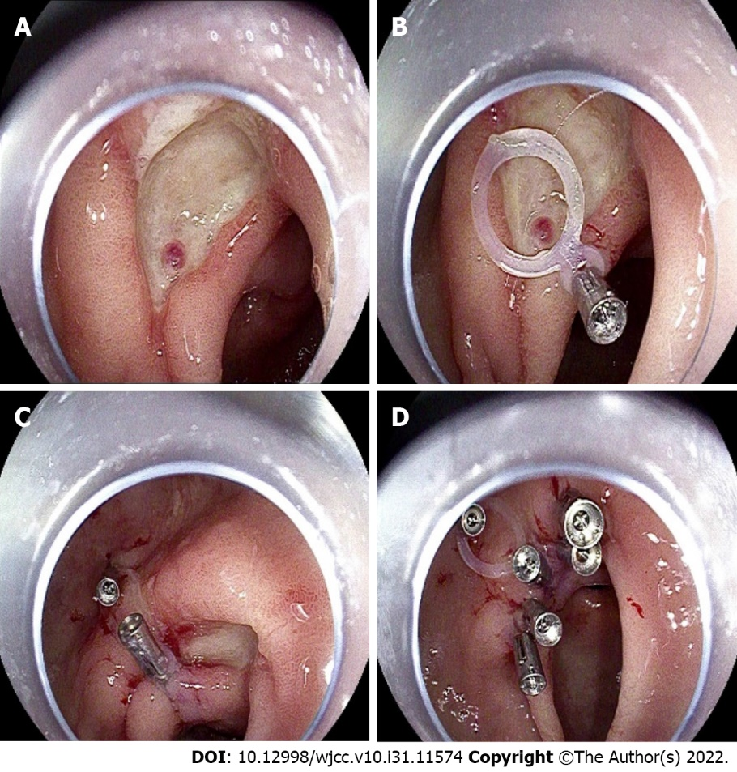
Figure 1 Gastric ulcer treated by an elastic traction ring in combination with a clip. A: One 1.5 cm × 2.0 cm ulcer in the lesser curvature of the gastric antrum with a bare leak of blood vessels in the base; B: A tissue clip with an elastic traction ring fixed to the normal mucosa surrounding the ulcer; C: The second tissue clip clips the large circle of the elastic traction ring and then is fixed to the normal mucosa on the other side of the ulcer; D: The tissue clips are used to suture the ulcer completely.
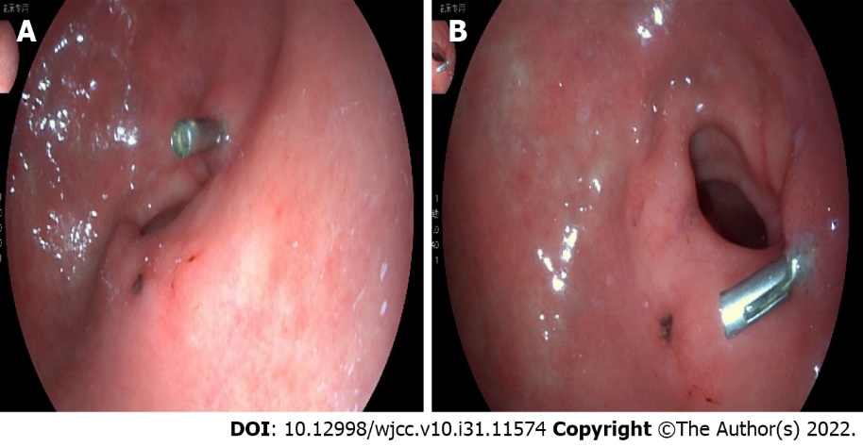
Figure 2 Pathological changes of atrophic gastritis after two months, the ulcer was healed. A and B: Ulcer was healed.

Published by Baishideng Publishing Group Inc
7041 Koll Center Parkway, Suite 160, Pleasanton, CA 94566, USA
Telephone: +1-925-3991568
E-mail: bpgoffice@wjgnet.com
Help Desk: https://www.f6publishing.com/helpdesk
https://www.wjgnet.com

© 2022 Baishideng Publishing Group Inc. All rights reserved.

