Name of Journal: World Journal of Gastroenterology
Manuscript NO: 87313
Manuscript Type: ORIGINAL ARTICLE

Basic Study
First report on establishment and characterization of the extrahepatic cholangiocarcinoma sarcoma cell line CBC2T-2

Jing NZ et al. First extrahepatic cholangiocarcinoma sarcoma cell line

Ning-Zu Jiang, Ming-Zhen Bai, Chong-Fei Huang, Ze-Long Ma, Ru-Yang Zhong, Wen-Kang Fu, Long Gao, Liang Tian, Ning-Ning Mi, Hai-Dong Ma, Ya-Wen Lu, Zi-Ang Zhang, Jin-Yu Zhao, Hai-Ying Yu, Bao-Ping Zhang, Xian-Zhuo Zhang, Yan-Xian Ren, Chao Zhang, Yong Zhang, Ping Yue, Yan-Yan Lin, Wen-Bo Meng

Ning-Zu Jiang, Ming-Zhen Bai, Chong-Fei Huang, Ze-Long Ma, Ru-Yang Zhong, Wen-Kang Fu, Long Gao, Liang Tian, Ning-Ning Mi, Hai-Dong Ma, Ya-Wen Lu, Zi-Ang Zhang, Jin-Yu Zhao, Hai-Ying Yu, Bao-Ping Zhang, Xian-Zhuo Zhang, Yan-Xian Ren, Chao Zhang, Yong Zhang, Ping Yue, Yan-Yan Lin, The First Clinical Medical College, Lanzhou University, Lanzhou 730000, Gansu Province, China

Ning-Zu Jiang, Ming-Zhen Bai, Chong-Fei Huang, Ze-Long Ma, Ru-Yang Zhong, Wen-Kang Fu, Long Gao, Liang Tian, Ning-Ning Mi, Hai-Dong Ma, Ya-Wen Lu, Zi-Ang Zhang, Jin-Yu Zhao, Hai-Ying Yu, Bao-Ping Zhang, Xian-Zhuo Zhang, Yan-Xian Ren, Chao Zhang, Yong Zhang, Ping Yue, Yan-Yan Lin, Department of General Surgery, The First Hospital of Lanzhou University, Lanzhou 730000, Gansu Province, China

Ning-Zu Jiang, Ming-Zhen Bai, Chong-Fei Huang, Ze-Long Ma, Ru-Yang Zhong, Wen-Kang Fu, Long Gao, Liang Tian, Ning-Ning Mi, Hai-Dong Ma, Ya-Wen Lu, Zi-Ang Zhang, Jin-Yu Zhao, Hai-Ying Yu, Bao-Ping Zhang, Xian-Zhuo Zhang, Yan-Xian Ren, Chao Zhang, Yong Zhang, Ping Yue, Yan-Yan Lin, Laboratory of Biological Therapy and Regenerative Medicine Transformation Gansu Province, The First Hospital of Lanzhou University, Lanzhou 730000, Gansu Province, China

Wen-Bo Meng, Department of General Surgery, The First Hospital of Lanzhou University and Laboratory of Biological Therapy and Regenerative Medicine Transformation Gansu Province, Lanzhou 730000, Gansu Province, China

Author contributions: Jiang NZ and Ren YX interpreted the study design; Bai MZ and Gao L supervised our study; Yue P, Lin YY, and Meng WB obtained the research fund; Huang CF, Ma ZL, and Mi NN screened the publications, performed statistics, and drafted the manuscript; Ma HD and Lu YW helped perform statistics; Fu WK, Tian L, Zhao JY, Zhang BP, Zhang XZ, Zhang C, and Zhang Y revised the manuscript; and all authors contributed to the article and approved the submitted version.

Supported by the National Natural Science Foundation of China, No. 82060551; and Lanzhou Chengguan District Science and Technology Planning Project, No. 2019JSCX0092.

Corresponding author: Wen-Bo Meng, MD, PhD, Doctor, Professor, Department of General Surgery, The First Hospital of Lanzhou University and Laboratory of Biological Therapy and Regenerative Medicine Transformation Gansu Province, No. 1 Donggang West Road, Chengguan District, Lanzhou 730000, Gansu Province, China. mengwb@lzu.edu.cn

Received: August 3, 2023
Revised: September 20, 2023
Accepted: October 11, 2023
Published online:

Abstract
BACKGROUND
Extrahepatic cholangiocarcinoma sarcoma is extremely rare in clinical practice. These cells consist of both epithelial and mesenchymal cells. Patient-derived cell lines that maintain tumor characteristics are valuable tools for studying the molecular mechanisms associated with carcinosarcoma. However, cholangiocarcinoma sarcoma cell lines are not available in cell banks.

AIM
To establish and characterize a new extrahepatic cholangiocarcinoma sarcoma cell line, namely CBC2T-2.

METHODS
We conducted a short tandem repeat (STR) test to confirm the identity of the CBC2T-2 cell line. Furthermore, we assessed the migratory and invasive properties of the cells and performed clonogenicity assay to evaluate the ability of individual cells to form colonies. The tumorigenic potential of CBC2T-2 cells was tested in vivo using non-obese diabetic/severe combined immunodeficient (NOD/SCID) mice. The cells were injected subcutaneously and tumor formation was observed. In addition, immunohistochemical analysis was carried out to examine the expression of epithelial marker CK19 and mesenchymal marker vimentin in both CBC2T-2 cells and xenografts. The CBC2T-2 cell line was used to screen the potential therapeutic effects of various clinical agents in patients with cholangiocarcinoma sarcoma. Lastly, whole-exome sequencing was performed to identify genetic alterations and screen for somatic mutations in the CBC2T-2 cell line.

RESULTS
The STR test showed that there was no cross-contamination and the results were identical to those of the original tissue. The cells showed round or oval-shaped epithelioid cells and mesenchymal cells with spindle-shaped or elongated morphology. The cells exhibited a high proliferation ratio with a doubling time of 47.11 h. This cell line has migratory, invasive, and clonogenic abilities. The chromosomes in the CBC2T-2 cells were polyploidy, with numbers ranging from 69 to 79. The subcutaneous tumorigenic assay confirmed the in vivo tumorigenic ability of CBC2T-2 cells in NOD/SCID mice. CBC2T-2 cells and xenografts were positive for both the epithelial marker, CK19, and the mesenchymal marker, vimentin. These results suggest that CBC2T-2 cells may have both epithelial and mesenchymal characteristics. The cells were also used to screen clinical agents in patients with cholangiocarcinoma sarcoma, and a combination of paclitaxel and gemcitabine was found to be the most effective treatment option.

CONCLUSION
We established the first human cholangiocarcinoma sarcoma cell line, CBC2T-2, with stable biogenetic traits. This cell line, as a research model, has a high clinical value and would facilitate the understanding of the pathogenesis of cholangiocarcinoma sarcoma.

Key Words: Carcinosarcoma; Drug resistance; Xenograft; Cell line; Establishment

Jiang NZ, Bai MZ, Huang CF, Ma ZL, Zhong RY, Fu WK, Gao L, Tian L, Mi NN, Ma HD, Lu YW, Zhang ZA, Zhao JY, Yu HY, Zhang BP, Zhang XZ, Ren YX, Zhang C, Zhang Y, Yue P, Lin YY, Meng WB. First report on establishment and characterization of the extrahepatic cholangiocarcinoma sarcoma cell line CBC2T-2. World J Gastroenterol 2023; In press

Core Tip: The study established and characterized the CBC2T-2 cell line as a potential model for studying human extrahepatic cholangiocarcinoma sarcomas. The cells exhibited both epithelial and mesenchymal characteristics and demonstrated high proliferation, migration, invasion, and clonogenic abilities. Chromosomal analysis revealed polyploidy with varying chromosome numbers and in vivo tumorigenicity was confirmed in non-obese diabetic/severe combined immunodeficient mice. Immunohistochemistry indicated positive expression for both epithelial marker CK19 and mesenchymal marker vimentin. The cell line was also used to screen clinical agents, and paclitaxel and gemcitabine exhibited optimal effects. Whole-exome sequencing further revealed genetic insights.

INTRODUCTION
Extrahepatic cholangiocarcinoma sarcomas are extremely rare clinically because they represent a mixture of carcinomas and sarcomas, accounting for < 0.1% of cholangiocarcinoma^{[1]}. Polypoid growth and ossification within the carcinoma are representative features of extrahepatic cholangiocarcinoma sarcoma^{[2]}. It is composed of epithelial and stromal cells, with a sarcomatous component that differentiates from the spindle or pleomorphic cells^{[3]}. Carcinosarcoma is commonly observed in the elderly, and it is mostly diagnosed in the lungs, bladder, pancreas, ovary, esophagus, thyroid gland, and breast and rarely occurs in the liver or biliary system^{[4,5]}. Extrahepatic cholangiocarcinoma sarcoma with chondrogenic differentiation is a poorly differentiated and aggressive cancer with poor prognosis. The effectiveness of radiotherapy and chemotherapy for cholangiocarcinoma sarcoma is limited; hence, complete surgical resection of the tumor is the ultimate treatment option for cholangiocarcinoma sarcoma^{[6-8]}. However, most patients experience local recurrence even after extensive local excision. Many patients receive treatment for jaundice or abnormal liver function without significant increases in the levels of tumor markers, and their prognosis is worse than that of patients with common bile duct cancer, with a low survival rate of 1 mo to 5 years^{[9-11]}. Therefore, the development of novel therapeutic strategies for cholangiocarcinoma sarcoma is crucial.
Patient-derived cell lines can maintain tumor characteristics and are valuable tools for studying the molecular mechanisms of carcinosarcoma, disease progression, and biological features^{[12,13]}. Owing to the rarity of cholangiocarcinoma sarcoma and its incompletely elucidated oncogenicity, its clinical and therapeutic significance remain uncertain. Basic research models are essential for thorough analysis of the developmental processes of cholangiocarcinoma sarcoma. Therefore, we established CBC2T-2, the first histologically confirmed cell line for cholangiocarcinoma sarcoma and comprehensively described its application in research.

MATERIALS AND METHODS
Patient’s background
A 62-year-old female, was admitted to the First Hospital of Lanzhou University in July 2022 with intermittent pain in her right upper abdomen and lower back. The results of physical examination were unremarkable, except for slight pressure pain in the upper right abdomen. Preoperative computed tomography and magnetic resonance imaging revealed the dilatation of the common bile duct and intrahepatic bile duct. This was accompanied by a soft tissue shadow in the upper part of the common bile duct showing arterial phase enhancement, indicative of bile duct cancer (Figures 1A and B; arrow). Radical surgery was performed under general anesthesia without any treatment prior to surgery. Intraoperative frozen section confirms negative margins. However, the postoperative pathological diagnosis revealed cholangiocarcinoma sarcoma of the porta hepatis, comprising 90% adenocarcinoma and 10% chondrosarcoma. The American Joint Committee on Cancer staging system of the tumor was T2aN2Mx (Figures 1C and G; arrow). The tumor markers were within the normal range, with alpha-fetoprotein at 2.1 U/mL, carbohydrate antigen 19-9 (CA19-9) at 9.4 U/mL, and carcinoembryonic antigen (CEA) at 0.7 U/mL (Figure 1G). Hematoxylin and eosin (HE) staining revealed microscopic epithelial heterogeneous hyperplasia with striated, nested, and glandular arrangements; increased cell volume; large deep-stained nuclei with pathological nuclear abnormalities; localized mucus and mucous cartilage; and infiltrative growth of cancer cells (Figures 1D and E; arrow).
This study was approved by the Ethics Committee of the First Hospital of Lanzhou University (LDYYLL-2022-489) and informed consent was obtained from all the patients. This study adhered to the 1964 Declaration of Helsinki and its subsequent amendments and similar ethical standards^{[14]}.

Cell culture
The specimens were collected under the guidance of a pathologist to ensure that the diagnosis in the pathology report was unaffected. The tumor specimens were rinsed thrice with phosphate buffer saline (PBS; BI), cut into 1-2 mm³ pieces using a sterile blade, and then digested with collagenase type IV (0.1 mg/mL; Gibco) for 10 min in a 37 °C incubator. The cell pellet was maintained in DMEM/F-12 (Gibco) supplemented with 10% fetal bovine serum (FBS; Gibco) and 1% penicillin/streptomycin (Gibco). It was cultured at 37 °C under humidified air containing 5% CO₂. For continuous culture, the cells were periodically passaged and frozen in liquid nitrogen at regular intervals. No contamination with other cells or foreign microorganisms was observed during the culture process. No external growth factors or stimulatory cytokines were added during the establishment of the cell lines.

Short tandem repeat analysis for cell line validation
Freshly cultured human cholangiocarcinoma sarcoma cell line CBC2T-2 (p25) and frozen tumor tissues were collected following the manufacturer’s instructions. The genomic DNA of the cells was extracted using an Animal Genome Extraction Kit and then subjected to polymerase chain reaction with fluorescently labeled primers at the 5’ end. The resulting products were sequenced and analyzed for sequence repeats of 21 short tandem repeat (STR) loci, including AMEL, D19S433, D5S818, D21S11, D18S51, D6S1043, D3S1358, D13S317, D7S820, D16S539, CSF1PO, Penta D, D2S441, vWA, D8S1179, TPOX, Penta E, TH01, D12S391, D2 S1338, and FGA. The obtained STR profiles were compared with reference STRs from public cell repositories, including the American Type Culture Collection (ATCC), Deutsche Sammlung Mikroorganismenund Zelkulturen (DSMZ), and the CELLOSAURUS cell database.

Chromosome analysis
Cells in the logarithmic growth phase (p25) were incubated with 10 μg/mL of colchicine for 2 h in a cell culture incubator. Chromosomes were prepared using standard methods and their numbers were mostly distributed across the G-dominant band. Representative images of chromosomes were obtained for karyotype analysis. Karyotype interpretation was based on the International System for Human Cytogenetic Nomenclature (1995)^{[15]}.

Spheroid formation assay
In total, 1 × 10⁵ cells in the logarithmic growth phase (p25) were digested and inoculated into ultra-low-attachment 96-well plates (Corning). Sphere formation was monitored on days 3, 7, 10, and 14 after inoculation to assess the ability of the cells to form spheres.

Cell counting kit-8 cell growth assay
CBC2T-2 cells were inoculated into 96-well plates at a density of 5000 cells per 100 μL. Cell counting kit 8 (CCK-8) (APEx BIO) was added at time points of 0, 24, 48, 72, 96, and 120 h at a ratio of 1:10. The cell growth curve was plotted with time on the horizontal axis and absorbance on the vertical axis. The ploidy doubling time (PDT) software was used to calculate the cell doubling time (http://www.doubling-time.com).

Live cell imaging
CBC2T-2 cells were inoculated into 96-well plates at a density of 4000 cells per 100 μL. The plate was then placed in a Cytation 1 imaging system (Biotek) under a 4 × objective, and the field of view was selected for each well. Images were taken every 2 h for 120 h and processed using the Gen5 Software.

Flow cytometry
Tumor cells (p25) in the logarithmic growth phase were washed with PBS, digested with ethylenediaminetetraacetic acid-free trypsin, and prepared as a single-cell suspension. The CBC2T-2 cell precipitates were washed twice with PBS and the density was adjusted to 1 × 10⁷/mL. The cells were fixed by adding pre-cooled 75% ice-cold ethanol to each tube for 1-2 h. After incubating away from light for 15-30 min, the cells were stained with 0.5 mL of propidium iodide stain [consisting of 0.5 mL staining buffer, 25 μL propidium iodide staining solution, and 10 μL RNaseA (50 ×)] (Bioscience).

Migration and invasion abilities
To assess the migratory ability of the cells, a suspension of 200 μL of cells (1 × 10⁵/mL) was evenly distributed in the upper chamber of a transwell without matrix gel (BD). To evaluate the invasive ability of the cells, a suspension of 200 μL of cells (1 × 10⁵/mL) was evenly distributed in the upper chamber of a transwell with matrix gel (Corning). The lower chamber was filled with medium containing 15% FBS and incubated in a cell culture incubator. After 24 and 48 h of incubation, the contents of the upper lumen were removed. After staining the cells with 0.1% crystal violet solution (Beyotime) for 20 min, they were rinsed with PBS; next, they were observed under an inverted microscope and the images were captured. This procedure was repeated using TFK-1 cells from the extrahepatic bile duct as controls for the CBC2T-2 cells.

Wound healing assay
CBC2T-1 and TFK-1 cells were seeded into 6-well plates. When the cells reached 95% confluence, the cell monolayers were scraped into a cross-shape using a pipette tip and gently washed thrice with PBS. Medium containing 10% FBS was added to continue the culture. The images were captured at 0, 24, and 48 h, and the entire scratch area was measured using the ImageJ software.

Colony formation assay
The cells were digested with 0.25% trypsin, and the cell density was adjusted to 700 cells/well before inoculation into 6-well plates. Colony formation was monitored at 3, 7, 10, and 14 d after inoculation. On day 14, the colonies were fixed with 4% paraformaldehyde, stained with 0.5% crystal violet for 20 min, photographed, and analyzed using ImageJ software.

Histology and immunostaining
Patient and mouse tumor tissues and crawling cells were fixed in formaldehyde solution. Subsequently, the specimens were subjected to baking, decolonization, hydration, antigen retrieval, peroxidase blocking, and goat serum closure. The slides were incubated with antibodies against CK19, Vimentin, S100, Desmin, CD56, CD117, and S100. Drops of DAB liquid were added, followed by reaction for 1-5 min before color development was promptly terminated.

Whole-exome sequencing
Sequencing and data analyses were conducted using the BGI software (Wuhan, China). The exome region DNA was captured using probe capture technology and the target region DNA was sequenced using high-throughput sequencing technology. Genomic DNA was extracted from CBC2T-2 cells and compared with that from normal tissues adjacent to the patient’s resected tumor. Library construction and whole-exome capture of genomic DNA were performed using SureSelect Human All Exon V6 (Agilent Clara, Technologies, Santa CA, United States) and the captured DNA library was sequenced on the DNBSEQ platform. This procedure uses FACETS^{[16]} software to detect somatic copy number variation (CNV) in tumor and normal paired samples, the depth distribution of reads to compare copy number variation with the reference genome, and Ensemble VEP^{[17]} to annotate the CNV. We performed InDel detection using the results of the GATK^{[18]} comparison, followed by the annotation of the detected InDels. We used the GATK MuTect2 tool to identify somatic single-nucleotide variant (SNV) loci and the GATK Funcotator tool to annotate these loci.

Tumor driver gene analysis
We compared somatic mutations with known driver genes from databases and the literature and screened for known driver genes in tumor samples. The reference data sources were Integrative OncoGenomics (IntOGen), the Cancer Gene Census (CGC), three highly cited articles, and pan-cancer data^{[19-22]}.

Tumorigenesis in mice
To study the in vivo tumorigenicity of CBC2T-2 cells, cells at a concentration of 1 × 10⁷/mL were injected into the axillae of three 4-wk-old non-obese diabetic/severe combined immunodeficient (NOD/SCID) mice. The mice were housed in a specific pathogen-free laminar flow animal facility and observed for 8 wk. Tumor diameters were measured every 3 d during this period. After 8 wk, the mice were euthanized, the tumors were excised and photographed, and the samples portions were immersed in a 10 % formalin solution for routine processing.

Screening of anticancer drugs
CBC2T-2 cells (p30) at the logarithmic growth phase were washed with PBS and digested with 0.25% trypsin. The concentration of the cell suspension was adjusted to 10000 cells/100 μL. After culturing the cells for 24 h, different concentrations of chemotherapeutic drugs, including gemcitabine, oxaliplatin, cisplatin, paclitaxel, and 5-fluorouracil were added. Following a drug exposure period of 72 h, the viability of each group was measured by incubating the cells with CCK-8 reagent for 2 h.

Statistical analysis
The results are presented as the mean ± standard error of at least three independent experiments. Graphs were created using GraphPad Prism 9.0, and a one-way analysis of variance was used to compare the two groups. Statistical significance was set at P < 0.05.

RESULTS
Establishment and identification of the CBC2T-2 cell line
We successfully established the cell line, namely CBC2T-2, from a patient with cholangiocarcinoma sarcoma. The cells were cultured in monolayers for > 13 mo and subjected to > 100 generations. The cell line was established from the original tumor tissue by comparing the 21 STR loci of both the tissue and cell lines using the assay currently recommended by the ATCC. The genomic characteristics of the CBC2T-2 cell line and the originating tumor tissue are presented in Table 1. The assay measurements showed that the cholangiocarcinoma sarcoma cell line was of human origin, and its genetic information was comparable with those from three prestigious culture collections (ATCC, DSMZ, and CELLOSAURUS). No sequences matching other cells were found, indicating that the cells were not contaminated. The cells were maintained at the China Center for Type Culture Collection (CCTCC No. C2022273).

Phenotypic characterization, doubling time, and cell cycle
CBC2T-2 cells (P1, P10, P20, and P50) were observed microscopically as they actively proliferate and grow in a monolayer against the wall. Two types of cell morphology were observed: Typical polygonal cholangiocarcinoma cell morphology and long spindle-shaped chondrosarcoma cell morphology (Figure 2A). Transmission electron microscopy revealed the presence of numerous mitochondria, rough endoplasmic reticulum, ribosomes, and irregular nuclei with deep indentations in the nuclear membrane. Scanning electron microscopy demonstrated microvilli-like protrusions on the cell surface as well as tight junctions and intercellular bridges (Figure 2B).
Flow cytometry was used to detect cell cycle progression in CBC2T-2 cells. Diploid cells were observed in G0/G1 phase, tetraploid cells in G2/M phase, and hyperdiploid cells in S phase (Figure 2C). The PDT of CBC2T-2 cells was calculated to be approximately 47.11 h using both live cell imaging and CCK-8 with the PDT software (PDT) (Figures 2D and E). A short PDT indicated active cell proliferation.

Sphere formation, wound healing assay, and migration, invasion, and clonogenic abilities
The novel cell line CBC2T-2 was inoculated into an ultra-low-attachment 96-well plate and observed for 14 d. The cells demonstrated their ability to form spheroids (Figure 3A). The results of the wound healing assay showed that CBC2T-2 cells showed higher levels of wound repair at both 24 and 48 h (Figures 3B and C). Furthermore, compared with TFK-1 cells, CBC2T-2 cells exhibited greater migratory and invasive capacities (Figure 3D). Moreover, CBC2T-2 cells exhibited significantly stronger clonogenic ability than TFK-1 cells (Figures 3E and F). These findings indicate that the cell line CBC2T-2 has a high capacity for healing, invasion, migration, and sphere formation, making it a valuable tool for studying the pathogenesis of cholangiocarcinoma sarcoma.

Cytogenetic analysis and genomic characteristics
Karyotype analysis of representative single cells from the CBC2T-2 cell line revealed abnormalities in both chromosome number and structure, with polyploidy chromosomes ranging from 69 to 79 and structural aberrations, including gain, deletion, and translocation (Figure 4A). When the value of the black line exceeds 2, it indicates an increase in the copy number, whereas a value below 2 suggests a decrease. Copy number alterations occurred throughout almost the entire chromosomal section of the cells and tumor tissues (Figure 4B). Single-nucleotide polymorphism analysis showed that the cell line CBC2T-2 had extensive insertions and deletions in almost the entire chromosomal fraction (Figure 4C). Somatic SNVs are single nucleotide variants of somatic mutations. On average, 521 SNVs were found in all samples, with an average of 91 missense mutations, eight nonsense mutations, and zero SNV invalidating the termination codon (Figure 4D).
A comparison of the detected mutated genes with the CGC database was used to screen for possible cancer susceptibility genes (Table 2). The major tumor susceptibility genes in CBC2T-2 cells included BALK, BARD1, KDR, FAT1, WRN, HNF1A, BRCA1, AXIN2, and SETBP1. We compared somatic mutations in CBC2T-2 with known driver genes from databases and the literature and identified known driver genes (Table 3). TP53 and ARID1A are the most frequently reported genetic alterations in extrahepatic cholangiocarcinoma^{[23]}.

Subcutaneous tumorigenesis assay and immunophenotyping
Xenograft tumor formation assays were performed and tumor growth was monitored weekly to confirm the tumorigenic ability of CBC2T-2 cells in NOD/SCID mice. Within 3 wk, tumors developed in all the three mice, indicating that the established cell lines exhibited good tumorigenicity and could be used to establish an in vivo model (Figures 5A-C).
After 8 wk, the mice were euthanized, and their tumors were removed for measurement and photography. HE and immunohistochemical staining were performed on the tumor xenografts. We observed tumors in mouse tumor grafts, CBC2T-2 (P30) cells, and the patient’s primary tumor tissue using HE staining. The histological consistency was confirmed by the staining procedure (Figure 5D, first row). In addition, CK19, S-100, Vimentin, Desmin, CD117, and CD68 were positively expressed. These findings demonstrated that the primary tumor tissue had both an epithelial component (carcinoma) and a mesenchymal component (chondrosarcoma). Furthermore, in vivo and in vitro experiments were conducted to demonstrate histological concordance through immunohistochemistry (Figure 5D).

Sensitivity to anticancer drugs
The sensitivity of CBC2T-2 cells to the first-line anticancer drugs used for the treatment of cholangiocarcinoma was assessed. Among the chemotherapeutic agents tested, oxaliplatin (IC₅₀ = 77.51 μM), paclitaxel (IC₅₀ = 0.002 μM), 5-fluorouracil (IC₅₀ = 7.516 μM), cisplatin (IC₅₀ = 19.24 μM), and gemcitabine (IC₅₀ = 0.009 μM) were evaluated. Our results demonstrated that among the five anticancer drugs, paclitaxel was the most sensitive, followed by gemcitabine. These findings provide clinical guidelines for the treatment of patients with cholangiocarcinoma sarcoma, suggesting a preference for combined paclitaxel and gemcitabine as the most effective treatment option (Figure 6).

DISCUSSION
Bile duct cancer is a highly aggressive malignant tumor that originates in the epithelial cells of the bile ducts. Its incidence and mortality rates are increasing worldwide and account for approximately 2% of all cancers, with autopsy detection rates ranging from 0.01% to 0.046%^{[24]}. There are a few bile duct tumors with specific histological manifestations, among which carcinosarcomas are observed in the liver, gallbladder, pancreas, and jugular abdomen^{[25,26]}. The pathological features of carcinosarcomas include tumor tissues with both epithelial and mesenchymal components^{[27,28]}. The sarcomatous component typically comprises undifferentiated spindle cells and a variety of heterogeneous elements, including cartilage, bone, smooth muscle, and rhabdomyosarcoma cells^{[29]}. The carcinoma component usually consists of adenocarcinoma and, rarely, squamous, small cell, and undifferentiated carcinomas. Moreover, the tissues are well defined and not transformed^{[30]}. Recently, a new hypothesis of epithelial-mesenchymal transition (EMT) suggested that during EMT, cancer cells lose their epithelial properties and intercellular adhesion, transform into mesenchymal cells, and acquire the ability to migrate^{[31,32]}. In contrast, cholangiocarcinoma sarcoma with chondrocytes is a very rare malignancy that has rarely been reported in domestic and international literature^{[33]}.
The patient-derived cell lines were consistent with the principles of precision medicine and translational research^{[34]}. Although cell lines derived from rare tumors have significant utility in research, they are difficult to obtain from public cell banks. The development and evaluation of new therapeutic approaches for cholangiocarcinoma sarcoma are limited by the lack of available models. A tumor model is necessary for gaining a deeper understanding and developing effective solutions to overcome the poor prognosis of patients diagnosed with this disease^{[35]}. Herein, we report the successful establishment of a new cell line, CBC2T-2, derived from a patient with cholangiocarcinoma sarcoma, along with detailed clinical and pathological data from the donor patient. This newly established cell line is a breakthrough in the establishment of cholangiocarcinoma sarcoma cell lines and fills a gap in the sarcoma cell lines. This cell line may provide a valuable tool for studying the mechanisms of cholangiocarcinoma progression and developing new therapeutic approaches.
We confirmed that CBC2T-2 cells can proliferate, form spheroids and clones, and migrate for invasion. The short ploidy time and high migratory aggressiveness observed in vitro may have contributed to the poor clinical outcomes of cholangiocarcinoma sarcoma. It is biologically stable in culture and capable of undergoing stable passages, which now exceed 100 generations. To determine the tumorigenic potential of CBC2T-2 cells, they were xenografted into NOD/SCID mice. The resulting solid tumors were histologically identical to the original surgical specimens, indicating that CBC2T-2 may serve as a reliable tool for preclinical in vivo studies.
The cell line CBC2T-2 (P30) and the primary tumor tissue of the patient were subjected to immunohistochemistry and immunocytochemistry to verify histological consistency. Sarcoma cells are locally positive for keratin (CK19), an epithelial marker^{[36]}. The sarcoma component markers, Vimentin and Desmin, and the mesenchymal cartilage differentiation marker, S-100, are positively expressed^{[37-41]}. This confirmed that the tumor was composed of adenocarcinoma and sarcomatous components with chondroid differentiation^{[42]}. The sarcomatous component was mixed with and was adjacent to the carcinomatous component. Based on the histological findings, it is possible that the sarcomatous component resulted from an invasive carcinomatous component^{[43]}. However, determining the histogenesis of this tumor remains challenging, similarly to the histogenesis of carcinosarcomas in other organs^{[43]}.
We performed whole-exome sequencing (WES) on CBC2T-2 cells and normal tissues adjacent to primary tumors to screen for somatic mutations. In this study, we identified the cancer susceptibility genes associated with cholangiocarcinoma, including BALK, BARD1, KDR, FAT1, WRN, HNF1A, BRCA1, AXIN2, and SETBP1. Additionally, we identified the tumor driver genes, TP53 and ARID1A, in the CBC2T-2 cell line, which are common driver genes for extrahepatic cholangiocarcinoma and play important roles in the CBC2T-2 cell line. The identification of the most commonly mutated genes associated with cholangiocarcinoma using WES in the CBC2T-2 cell line makes the cells a potential model for studying the pathogenesis of this disease.
We characterized the response of CBC2T-2 cells to treatment with anticancer drugs. Furthermore, we calculated the semi-inhibitory concentration of the drugs on CBC2T-2 cells. Among the tested compounds, paclitaxel exhibited the lowest semi-inhibitory concentration, followed by gemcitabine. Although other anticancer drugs exhibited significant antiproliferative effects, their semi-inhibitory concentrations were lower than those of paclitaxel and gemcitabine. This drug sensitivity analysis can provide clinical treatment information and guide the clinical use of paclitaxel in combination with gemcitabine.

CONCLUSION
We established the first human cholangiocarcinoma sarcoma cell line, CBC2T-2, with stable biogenetic traits. This cell line, as a research model, has a high clinical value and would facilitate the understanding of the pathogenesis of cholangiocarcinoma sarcoma.

ARTICLE HIGHLIGHTS
Research background
Cholangiocarcinoma sarcoma is a rare tumor composed of epithelial and mesenchymal cells, and the sarcomatous component in carcinosarcoma is differentiated from spindle cells or pleomorphic cells.

Research motivation
There is no extrahepatic cholangiocarcinoma sarcoma cell line.

Research objectives
To establish and characterize a new extrahepatic cholangiocarcinoma sarcoma cell line.

Research methods
Establish cell lines through primary culture and subculture, and identify their biological characteristics.

Research results
In this study, we successfully established and characterized of a extrahepatic cholangiocarcinoma sarcoma cell line CBC2T-2, from the primary tumor of a patient with cholangiocarcinoma sarcoma.

Research conclusions
To date, first report of the extrahepatic cholangiocarcinoma sarcoma cell line CBC2T-2.

Research perspectives
The establishment of extrahepatic cholangiocarcinoma sarcoma cell line provides suitable experimental models for further study of cholangiocarcinoma sarcoma.

ACKNOWLEDGEMENTS
We would like to thank Professor Hao Xu and Chun-Lu Dong for providing critical revisions to the manuscript.

REFERENCES
1 Yao Y, Xiang HG, Jin L, Xu M, Mao SY. Carcinosarcoma of common bile duct: A case report. World J Gastrointest Oncol 2023; 15: 562-570 [PMID: 37009312 DOI: 10.4251/wjgo.v15.i3.562]
2 Xie JM, Li W, Chen W. Hepatobiliary and pancreatic: A case of stone-like carcinosarcoma of the common bile duct. J Gastroenterol Hepatol 2020; 35: 711 [PMID: 31943369 DOI: 10.1111/jgh.14967]
3 Liu LI, Ahn E, Studeman K, Campbell K, Lai J. Primary Hepatic Carcinosarcoma Composed of Hepatocellular Carcinoma, Cholangiocarcinoma, Osteosarcoma and Rhabdomyosarcoma With Poor Prognosis. Anticancer Res 2020; 40: 2225-2229 [PMID: 32234918 DOI: 10.21873/anticanres.14184]
4 Goetze TO. Gallbladder carcinoma: Prognostic factors and therapeutic options. World J Gastroenterol 2015; 21: 12211-12217 [PMID: 26604631 DOI: 10.3748/wjg.v21.i43.12211]
5 Chen X, Zhou Y, Shu X, Wei G, Qiu M. Gallbladder carcinosarcoma: current perspectives and new development. Expert Rev Gastroenterol Hepatol 2021; 15: 1107-1114 [PMID: 33878994 DOI: 10.1080/17474124.2021.1919509]
6 Thomakos N, Rodolakis A, Zagouri F, Zacharakis D, Sotiropoulou M, Akrivos N, Haidopoulos D, Papadimitriou CA, Dimopoulos MA, Antsaklis A. Serum CA 125, CA 15-3, CEA, and CA 19-9: a prognostic factor for uterine carcinosarcomas? Arch Gynecol Obstet 2013; 287: 97-102 [PMID: 22941327 DOI: 10.1007/s00404-012-2529-6]
7 Siddiqui M, Hegde S, Nguyen T, DePaul S. Sarcomatoid carcinoma of the gallbladder: A rare form of gallbladder cancer. SAGE Open Med Case Rep 2020; 8: 2050313X20906739 [PMID: 32095246 DOI: 10.1177/2050313X20906739]
8 Ayoub M, Jabi R, Achraf M, Benani A, Soumia EA, Imane K, Mohamed B. Surgical management of gallbladder carcinosarcoma: A case report and review of the Literature. Int J Surg Case Rep 2020; 75: 460-463 [PMID: 33076195 DOI: 10.1016/j.ijscr.2020.09.114]
9 Kadono J, Hamada N, Higashi M, Ishizaki N, Nakamura N, Sakata R. Carcinosarcoma of the extrahepatic bile duct. J Hepatobiliary Pancreat Surg 2005; 12: 328-331 [PMID: 16133703 DOI: 10.1007/s00534-005-0988-x]
10 Loud PA, Warshauer DM, Woosley JT, Hartmann TM. Carcinosarcoma of the extrahepatic bile ducts: cholangiographic and CT appearance. Abdom Imaging 1997; 22: 85-86 [PMID: 9000363 DOI: 10.1007/s002619900146]
11 Tanaka M, Ajiki T, Matsumoto I, Asari S, Fukumoto T, Masuda A, Shiomi H, Hayakumo T, Ku Y. Duodenal protrusion by carcinosarcoma of the extrahepatic bile duct. Dig Endosc 2012; 24: 484 [PMID: 23078453 DOI: 10.1111/j.1443-1661.2012.01341.x]
12 Song S, Xu Y, Huo L, Zhao S, Wang R, Li Y, Scott AW, Pizzi MP, Wang Y, Fan Y, Harada K, Jin J, Ma L, Yao X, Shanbhag ND, Gan Q, Roy-Chowdhuri S, Badgwell BD, Wang Z, Wang L, Ajani JA. Patient-derived cell lines and orthotopic mouse model of peritoneal carcinomatosis recapitulate molecular and phenotypic features of human gastric adenocarcinoma. J Exp Clin Cancer Res 2021; 40: 207 [PMID: 34162421 DOI: 10.1186/s13046-021-02003-8]
13 Noguchi R, Yoshimatsu Y, Sin Y, Tsuchiya R, Ono T, Akiyama T, Hirabayashi K, Ozawa I, Nakagawa R, Kikuta K, Kondo T. Establishment and characterization of two novel patient-derived myxoid liposarcoma cell lines. Hum Cell 2022; 35: 1279-1289 [PMID: 35637403 DOI: 10.1007/s13577-022-00717-1]
14 World Medical Association. World Medical Association Declaration of Helsinki: ethical principles for medical research involving human subjects. JAMA 2013; 310: 2191-2194 [PMID: 24141714 DOI: 10.1001/jama.2013.281053]
15 Schreck RR, Distèche C. Karyotyping. Curr Protoc Hum Genet 2001; Appendix 4: Appendix 4A [PMID: 18428228 DOI: 10.1002/0471142905.hga04as18]
16 McLaren W, Gil L, Hunt SE, Riat HS, Ritchie GR, Thormann A, Flicek P, Cunningham F. The Ensembl Variant Effect Predictor. Genome Biol 2016; 17: 122 [PMID: 27268795 DOI: 10.1186/s13059-016-0974-4]
17 Shen R, Seshan VE. FACETS: allele-specific copy number and clonal heterogeneity analysis tool for high-throughput DNA sequencing. Nucleic Acids Res 2016; 44: e131 [PMID: 27270079 DOI: 10.1093/nar/gkw520]
18 DePristo MA, Banks E, Poplin R, Garimella KV, Maguire JR, Hartl C, Philippakis AA, del Angel G, Rivas MA, Hanna M, McKenna A, Fennell TJ, Kernytsky AM, Sivachenko AY, Cibulskis K, Gabriel SB, Altshuler D, Daly MJ. A framework for variation discovery and genotyping using next-generation DNA sequencing data. Nat Genet 2011; 43: 491-498 [PMID: 21478889 DOI: 10.1038/ng.806]
19 Bailey MH, Tokheim C, Porta-Pardo E, Sengupta S, Bertrand D, Weerasinghe A, Colaprico A, Wendl MC, Kim J, Reardon B, Ng PK, Jeong KJ, Cao S, Wang Z, Gao J, Gao Q, Wang F, Liu EM, Mularoni L, Rubio-Perez C, Nagarajan N, Cortés-Ciriano I, Zhou DC, Liang WW, Hess JM, Yellapantula VD, Tamborero D, Gonzalez-Perez A, Suphavilai C, Ko JY, Khurana E, Park PJ, Van Allen EM, Liang H; MC3 Working Group; Cancer Genome Atlas Research Network, Lawrence MS, Godzik A, Lopez-Bigas N, Stuart J, Wheeler D, Getz G, Chen K, Lazar AJ, Mills GB, Karchin R, Ding L. Comprehensive Characterization of Cancer Driver Genes and Mutations. Cell 2018; 173: 371-385.e18 [PMID: 29625053 DOI: 10.1016/j.cell.2018.02.060]
20 Bergstrom EN, Luebeck J, Petljak M, Khandekar A, Barnes M, Zhang T, Steele CD, Pillay N, Landi MT, Bafna V, Mischel PS, Harris RS, Alexandrov LB. Mapping clustered mutations in cancer reveals APOBEC3 mutagenesis of ecDNA. Nature 2022; 602: 510-517 [PMID: 35140399 DOI: 10.1038/s41586-022-04398-6]
21 Vogelstein B, Papadopoulos N, Velculescu VE, Zhou S, Diaz LA Jr, Kinzler KW. Cancer genome landscapes. Science 2013; 339: 1546-1558 [PMID: 23539594 DOI: 10.1126/science.1235122]
22 Kandoth C, McLellan MD, Vandin F, Ye K, Niu B, Lu C, Xie M, Zhang Q, McMichael JF, Wyczalkowski MA, Leiserson MDM, Miller CA, Welch JS, Walter MJ, Wendl MC, Ley TJ, Wilson RK, Raphael BJ, Ding L. Mutational landscape and significance across 12 major cancer types. Nature 2013; 502: 333-339 [PMID: 24132290 DOI: 10.1038/nature12634]
23 Montal R, Sia D, Montironi C, Leow WQ, Esteban-Fabró R, Pinyol R, Torres-Martin M, Bassaganyas L, Moeini A, Peix J, Cabellos L, Maeda M, Villacorta-Martin C, Tabrizian P, Rodriguez-Carunchio L, Castellano G, Sempoux C, Minguez B, Pawlik TM, Labgaa I, Roberts LR, Sole M, Fiel MI, Thung S, Fuster J, Roayaie S, Villanueva A, Schwartz M, Llovet JM. Molecular classification and therapeutic targets in extrahepatic cholangiocarcinoma. J Hepatol 2020; 73: 315-327 [PMID: 32173382 DOI: 10.1016/j.jhep.2020.03.008]
24 Kim HJ, Kim JS, Joo MK, Lee BJ, Kim JH, Yeon JE, Park JJ, Byun KS, Bak YT. Hepatolithiasis and intrahepatic cholangiocarcinoma: A review. World J Gastroenterol 2015; 21: 13418-13431 [PMID: 26730152 DOI: 10.3748/wjg.v21.i48.13418]
25 Zhang S, Jia J, Bi X, Jiang Q, Zhao Y, Chen Y, Xu Q, Lan Z, Zhang J, Zhang Z, Wang C. Sarcomatoid carcinoma of the common bile duct: A case report. Medicine (Baltimore) 2017; 96: e5751 [PMID: 28099333 DOI: 10.1097/MD.0000000000005751]
26 Kim HM, Kim H, Park YN. Sarcomatoid cholangiocarcinoma with osteoclast-like giant cells associated with hepatolithiasis: A case report. Clin Mol Hepatol 2015; 21: 309-313 [PMID: 26523274 DOI: 10.3350/cmh.2015.21.3.309]
27 Pezzicoli G, Moscaritolo F, Silvestris E, Silvestris F, Cormio G, Porta C, D'Oronzo S. Uterine carcinosarcoma: An overview. Crit Rev Oncol Hematol 2021; 163: 103369 [PMID: 34051304 DOI: 10.1016/j.critrevonc.2021.103369]
28 Li B, Zhang Y, Hou J, Cai L, Zhou J, Shi H. Gastric Carcinosarcoma and 18F-FDG PET/CT. Clin Nucl Med 2015; 40: e506-e507 [PMID: 26359557 DOI: 10.1097/RLU.0000000000000928]
29 Sasamoto S, Aoki T, Tashiro Y, Matsuda K, Koizumi T, Kusano T, Wada Y, Shibata H, Tomioka K, Yamashita T, Date H, Ariyoshi T, Goto S, Yamazaki K, Fujimori A, Watanabe M, Enami Y, Otsuka K, Norose T, Ohike N, Yamochi T, Takimoto M, Murakami M. Experience of the pancreas duodenectomy for so-called carcinosarcoma of the common bile duct:a case report and review of literature. Int Cancer Conf J 2021; 10: 134-138 [PMID: 33786287 DOI: 10.1007/s13691-020-00462-y]
30 Zhu CC, Li MR, Lin TL, Zhao G. Sarcomatoid carcinoma of the stomach: A case report and literature review. Oncol Lett 2015; 10: 1385-1389 [PMID: 26622678 DOI: 10.3892/ol.2015.3460]
31 Mittal V. Epithelial Mesenchymal Transition in Tumor Metastasis. Annu Rev Pathol 2018; 13: 395-412 [PMID: 29414248 DOI: 10.1146/annurev-pathol-020117-043854]
32 Pang A, Carbini M, Moreira AL, Maki RG. Carcinosarcomas and Related Cancers: Tumors Caught in the Act of Epithelial-Mesenchymal Transition. J Clin Oncol 2018; 36: 210-216 [PMID: 29220296 DOI: 10.1200/JCO.2017.74.9523]
33 Okabayashi T, Shima Y, Iwata J, Iiyama T, Sumiyoshi T, Kozuki A, Tokumaru T, Hata Y, Noda Y, Morita M. Surgical outcomes for 131 cases of carcinosarcoma of the hepatobiliary tract. J Gastroenterol 2014; 49: 982-991 [PMID: 24162331 DOI: 10.1007/s00535-013-0882-2]
34 Li Z, Zhuo W, Chen L, Zhang X, Chen C, Hu D, Chen Y, Yang J, Zhou Y, Mao M, Xu L, Ju S, Shen J, Wang Q, Dong M, Xie S, Zhou J, Wang L. Establishment and Characterization of a HER2-Positive Cell Line Derived From the Pleural Effusion of a Drug-Resistant Breast Cancer Patient. Front Cell Dev Biol 2021; 9: 680968 [PMID: 34141711 DOI: 10.3389/fcell.2021.680968]
35 Takahashi Y, Kupferman ME, Bell D, Jiffar T, Lee JG, Xie TX, Li NW, Zhao M, Frederick MJ, Gelbard A, Myers JN, Hanna EY. Establishment and characterization of novel cell lines from sinonasal undifferentiated carcinoma. Clin Cancer Res 2012; 18: 6178-6187 [PMID: 23032744 DOI: 10.1158/1078-0432.CCR-12-1876]
36 Zhuo JY, Lu D, Tan WY, Zheng SS, Shen YQ, Xu X. CK19-positive Hepatocellular Carcinoma is a Characteristic Subtype. J Cancer 2020; 11: 5069-5077 [PMID: 32742454 DOI: 10.7150/jca.44697]
37 Magdy M, Abdel Karim N, Eldessouki I, Gaber O, Rahouma M, Ghareeb M. Myeloid Sarcoma. Oncol Res Treat 2019; 42: 224-229 [PMID: 30840960 DOI: 10.1159/000497210]
38 Peroni A, Colato C, Schena D, Rongioletti F, Girolomoni G. Histiocytoid Sweet syndrome is infiltrated predominantly by M2-like macrophages. J Am Acad Dermatol 2015; 72: 131-139 [PMID: 25440433 DOI: 10.1016/j.jaad.2014.09.025]
39 Ridge KM, Eriksson JE, Pekny M, Goldman RD. Roles of vimentin in health and disease. Genes Dev 2022; 36: 391-407 [PMID: 35487686 DOI: 10.1101/gad.349358.122]
40 Agnetti G, Herrmann H, Cohen S. New roles for desmin in the maintenance of muscle homeostasis. FEBS J 2022; 289: 2755-2770 [PMID: 33825342 DOI: 10.1111/febs.15864]
41 Bresnick AR, Weber DJ, Zimmer DB. S100 proteins in cancer. Nat Rev Cancer 2015; 15: 96-109 [PMID: 25614008 DOI: 10.1038/nrc3893]
42 Sodergren MH, Silva MA, Read-Jones SL, Hubscher SG, Mirza DF. Carcinosarcoma of the biliary tract: two case reports and a review of the literature. Eur J Gastroenterol Hepatol 2005; 17: 683-685 [PMID: 15879734 DOI: 10.1097/00042737-200506000-00016]
43 Ajiki T, Nakamura T, Fujino Y, Suzuki Y, Takeyama Y, Ku Y, Kuroda Y, Ohbayashi C. Carcinosarcoma of the gallbladder with chondroid differentiation. J Gastroenterol 2002; 37: 966-971 [PMID: 12483254 DOI: 10.1007/s005350200162]

Footnotes
Institutional review board statement: This study was approved by the Ethics Committee of the First Hospital of Lanzhou University (LDYYLL-2022-489) and informed consent was obtained from all the patients. This study adhered to the 1964 Declaration of Helsinki and its subsequent amendments and similar ethical standards.

Institutional animal care and use committee statement: All procedures involving animals were reviewed and approved by the Institutional Animal Care and Use Committee of the First Hospital of Lanzhou University.

Conflict-of-interest statement: All the authors report no relevant conflicts of interest for this article.

Data sharing statement: The datasets used and/or analysed during the current study are available from the corresponding author upon reasonable request.

ARRIVE guidelines statement: The authors have read the ARRIVE guidelines, and the manuscript was prepared and revised according to the ARRIVE guidelines.

Open-Access: This article is an open-access article that was selected by an in-house editor and fully peer-reviewed by external reviewers. It is distributed in accordance with the Creative Commons Attribution NonCommercial (CC BY-NC 4.0) license, which permits others to distribute, remix, adapt, build upon this work non-commercially, and license their derivative works on different terms, provided the original work is properly cited and the use is non-commercial. See: https://creativecommons.org/Licenses/by-nc/4.0/

Provenance and peer review: Unsolicited article; Externally peer reviewed.
Peer-review model: Single blind

Peer-review started: August 3, 2023
First decision: September 18, 2023
Article in press:

Specialty type: Gastroenterology and hepatology
Country/Territory of origin: China
Peer-review report’s scientific quality classification
Grade A (Excellent): A
Grade B (Very good): B, B
Grade C (Good): 0
Grade D (Fair): 0
Grade E (Poor): 0

P-Reviewer: wang GX, China; Yildiz K, Turkey; Zharikov YO, Russia S-Editor: Wang JJ L-Editor: A P-Editor:

Figure Legends
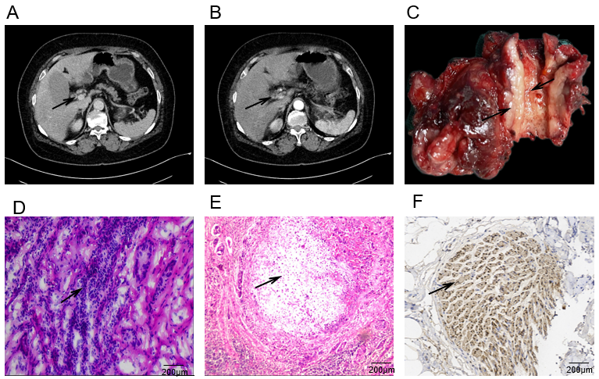
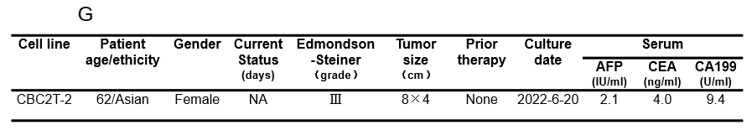
Figure 1 Clinical and pathological profile of CBC2T-2. A and B: Contrast-enhanced computed tomography of the abdomen showing a high-grade occupying lesion of the common bile duct with high level obstruction of the common bile duct (black arrows); C: Specimen of postoperative carcinosarcoma of the extrahepatic bile duct with thickened duct wall and polyp-like protrusion into the lumen; D and E: Hematoxylin and eosin and immunohistochemistry staining of primary tumor tissue. Scale bars, 200 μm; F: Immunohistochemistry staining of primary tumor tissue. Antibodies against Vimentin, Scale bars, 200 μm; G: Clinicopathological characteristics of patients. AFP: Alpha-fetoprotein; CEA: Carcinoembryonic antigen; CA199: Carbohydrate antigen199.

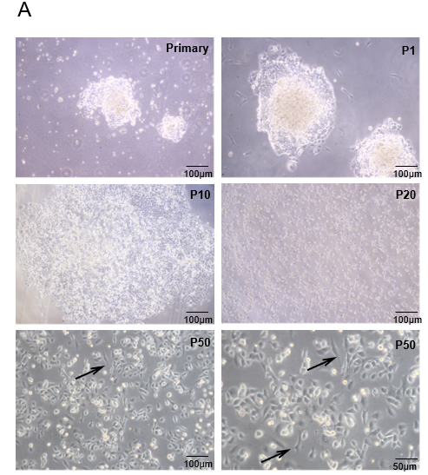
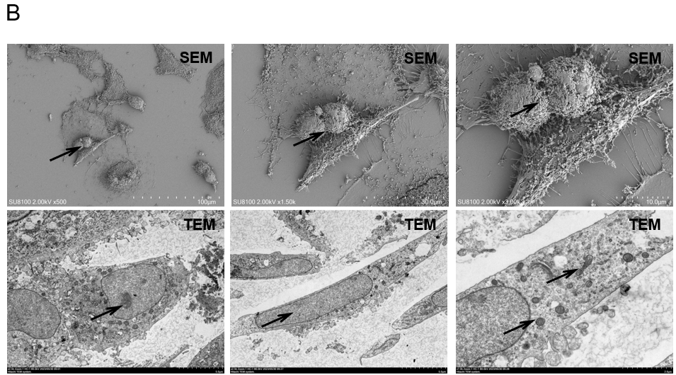
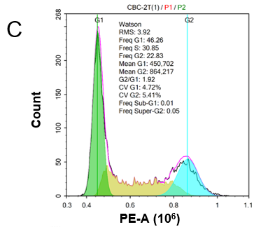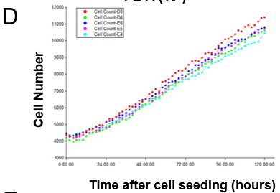
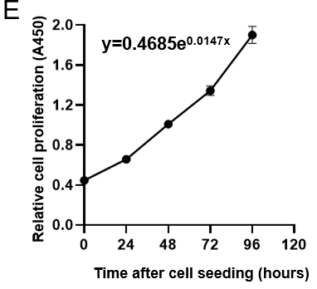
Figure 2 Morphological features, doubling time and cell cycle of CBC2T-1 cells. A: Bright field morphology of CBC2T-2 cells in the primary,1st, 10th, 20th and 50th passages (scale bars, 100 μm); B: SEM and TEM electron microscopy were used to observe the cellular ultrastructure (scale bars, 100, 30, 10 μm); C: Flow cytometry of CBC2T-2 cells; D and E: Cumulative growth curve of CBC2T-2 cells.

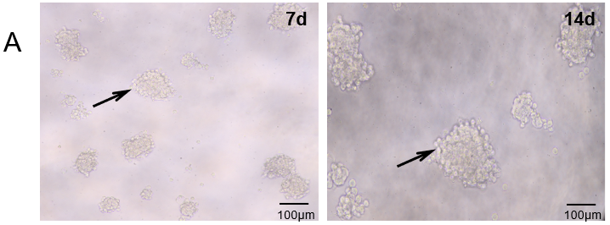
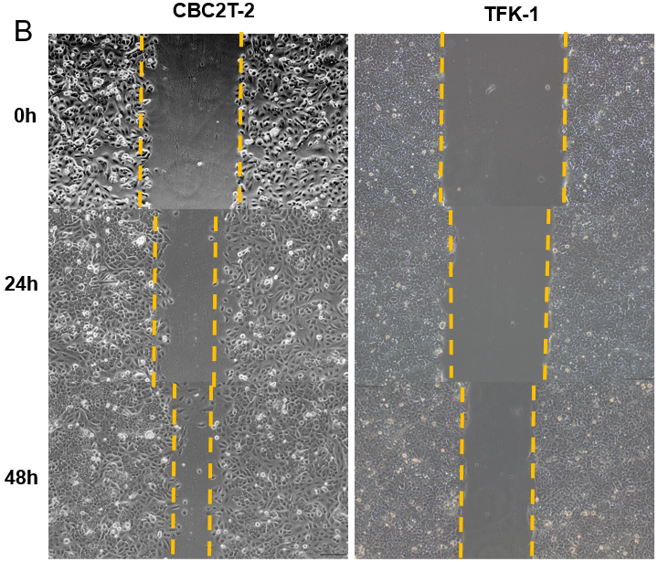
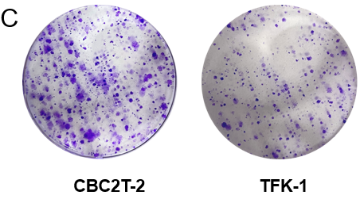
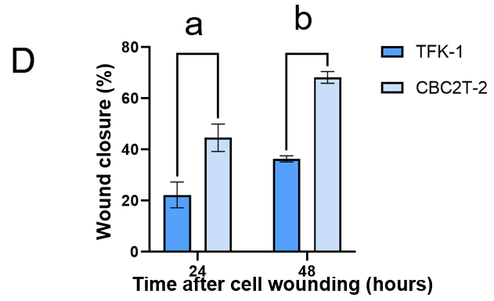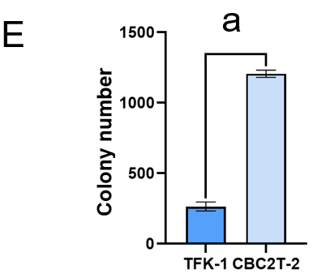
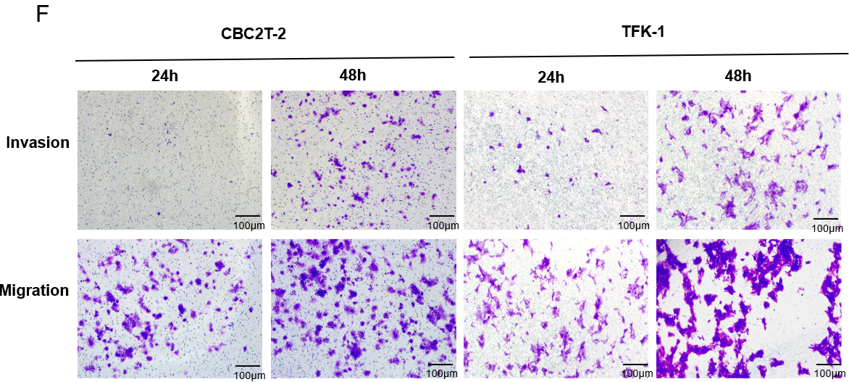
Figure 3 Characterization of CBC2T-2 cell behavior. A: Representative images of the ability of CBC2T-2 cells to form spheres at days 7 and 14; B and C: Wound healing assay of CBC2T-2 and TFK-1 cells after 24 and 48 h; D: The migratory and invasive abilities of CBC2T-1 and TFK-1 cells were detected by transwell assay; E and F: Representative images showing the colony formation of CBC2T-1 and TFK-1 cells. Scale bars, 100 μm. ªP < 0.01; ^{b}P < 0.001.

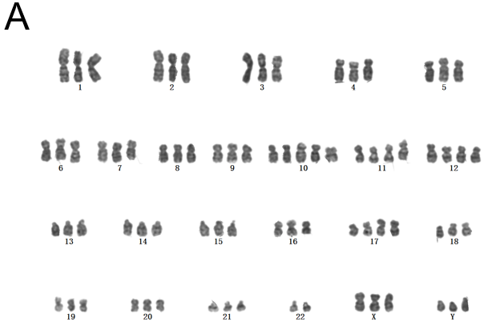
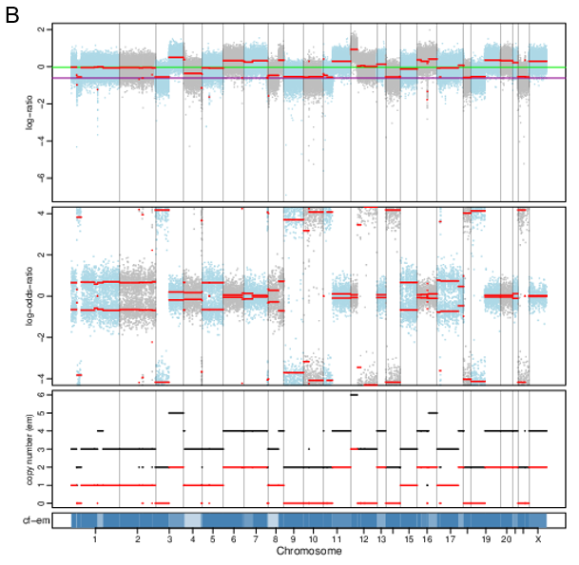
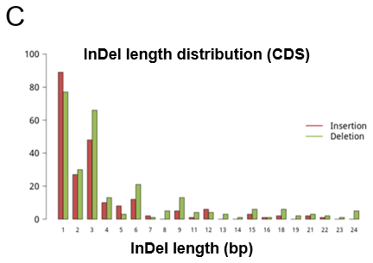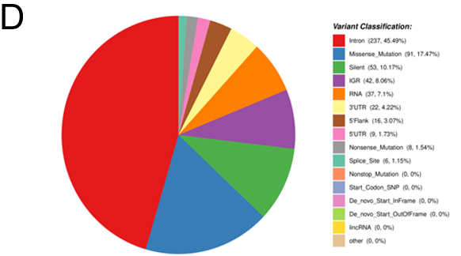
Figure 4 Cytogenetic analysis and genomic characteristics. A: Chromosome karyotype analysis shows that the cells are triploid and there is variation in the number of structures; B: Cells and tumor tissues have copy number increases and decreases in almost the entire chromosome section; C: Histogram of the distribution of somatic cell InDel annotation results; D: Somatic somatic single-nucleotide variant annotation result distribution map.

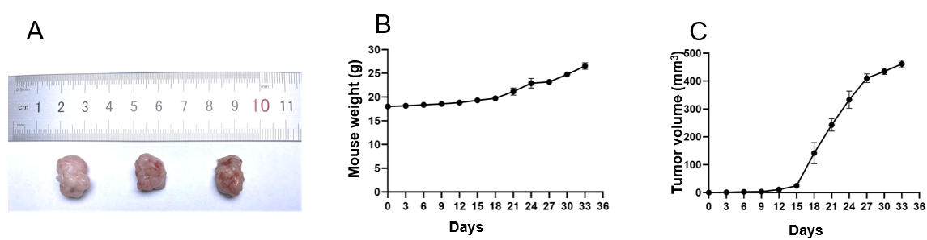
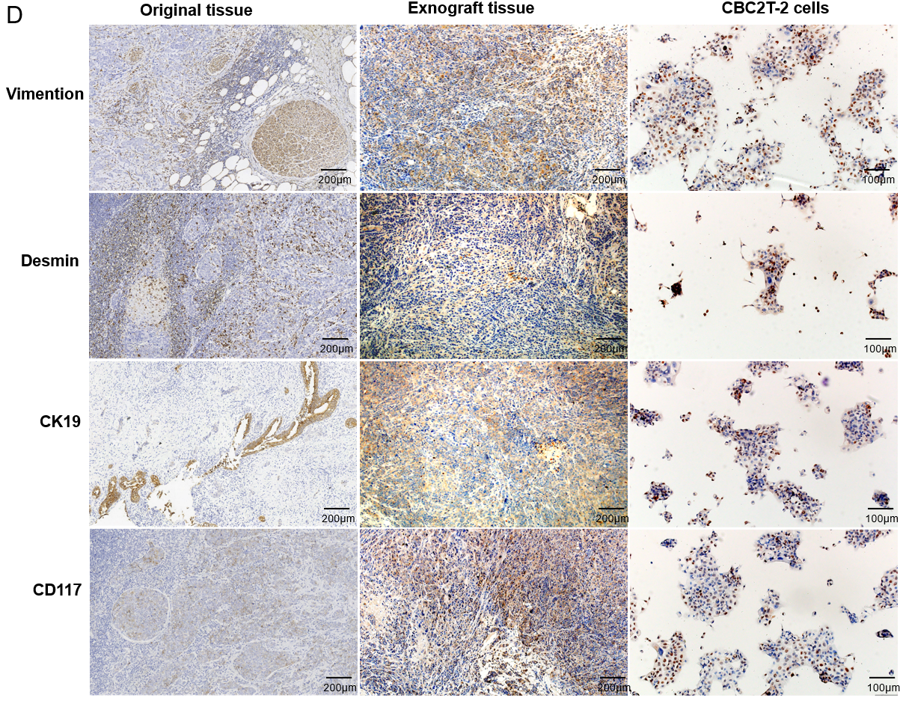
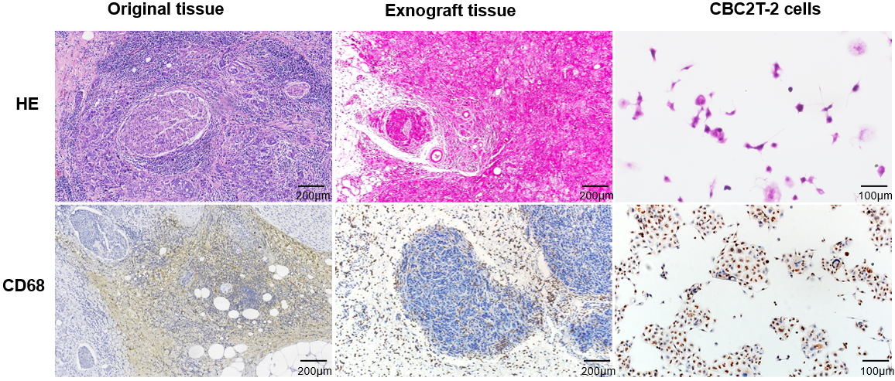
Figure 5 Verification the tumorigenic ability of CBC2T-2 cells in non-obese diabetic/severe combined immunodeficient mice. A: Tumor formation in non-obese diabetic/severe combined immunodeficient mice; B: Body weight gain curves in xenograft mice; C: Tumor size over time in three xenograft mice; D: Hematoxylin and eosin staining and immunohistochemical (CK19, CD68, CD117, Vmention, Desmin) results of primary tumors, CBC2T-2 xenografts and CBC2T-2. Scale bars, 50 and 100 μm. HE: Hematoxylin and eosin.

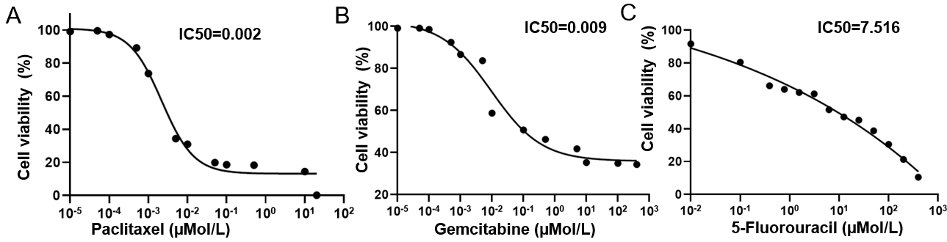
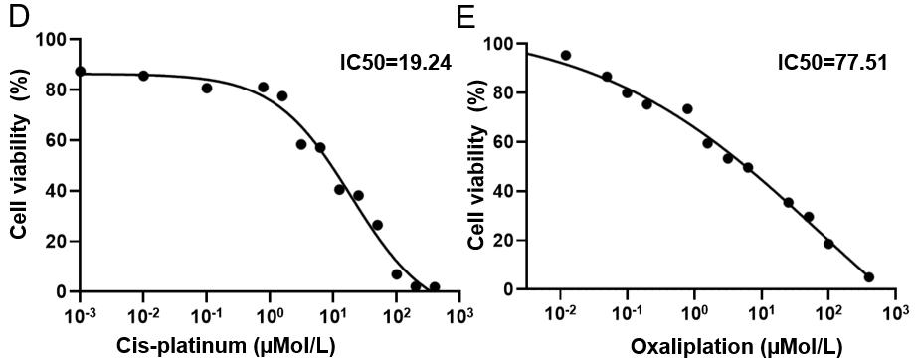
Figure 6 Sensitivity of CBC2T-2 cell line to anticancer drugs. A-E: Sensitivity of CBC2T-2 cells to paclitaxel, gemcitabine, 5-fluorouracll, cisplatin, and oxaliplatin.

Table 1 Short tandem repeat profile of tumor tissue and cell line
STR loci | CBC2T-2 | Tumor tissue
AMEL | X, X | X, X
D19S433 | 13 | 13
D5S818 | 11, 13 | 11, 13
D21S11 | 30, 31.2 | 30, 31.2
D18S51 | 13, 13 | 13, 13
D6S1043 | 12, 18 | 12, 18
D3S1358 | 16, 16 | 16, 16
D13S317 | 8, 11 | 8, 11
D7S820 | 9, 10 | 9, 10
D16S539 | 9 | 9
CSF1PO | 10, 12 | 10, 12
Penta D | 9, 11 | 9, 11
D2S441 | 11, 12 | 11, 12
vWA | 17, 18 | 17, 18
D8S1179 | 14, 15 | 14, 15
TPOX | 10, 11 | 10, 11
Penta E | 12, 14 | 12, 14
TH01 | 9 | 9
D12S391 | 19, 20 | 19, 20
D2S1338 | 19, 22 | 19, 22
FGA | 23, 23.2 | 23, 23.2
STR: Short tandem repeat.

Table 2 Comparison of somatic mutant genes detected with the Cancer Gene Census database
Gene name | Chrom | Pos | Ref | Alt | CGC-cancers
ALK | chr2 | 29221210 | G | T | Neuroblastoma
BARD1 | chr2 | 214809500 | G | A | Ovariancancer; breastcancer; endometrioid cancer
KDR | chr4 | 55106807 | T | A | Melanoma
FAT1 | chr4 | 186621601 | T | C | Pancreatic
WRN | Chr8 | 31167138 | T | C | Osteosarcoma; meningioma; other tumour types
HNF1A | Chr12 | 120999418 | T | C | Hepatic adenoma; hepatocellular carcinoma
BRCA1 | chr17 | 43071077 | T | C | Breast; ovarian
BRCA1 | chr17 | 43092418 | T | C | Breast; ovarian
AXIN2 | chr17 | 65535650 | G | A | Colorectal carcinoma
SETBP1 | chr18 | 44876688 | G | A | Neuroepithelial tumours
Chrom: Chromosome; Pos: Position on chromosome; Ref: Reference base on the genome; Alt: Mutated base; CGC-Cancers: Tumour types with driver genes included in the Cancer Gene Census database.

Table 3 Results of screening for known driver genes
Gene name | Chrom | Pos | Ref | Alt
ARID1A | chr1 | 26780184 | - | A
SFPQ | chr1 | 35192164 | G | C
DNMT3A | chr2 | 25244384 | G | A
CAD | chr2 | 27237546 | G | A
FBXO11 | chr2 | 47839654 | C | T
LRP1B | chr2 | 140683563 | C | T
NEB | chr2 | 151529162 | G | A
NEB | chr2 | 151540532 | G | A
HOXD13 | chr2 | 176093701 | C | T
MECOM | chr3 | 169112718 | C | A
MECOM | chr3 | 169112734 | C | G
ETV5 | chr3 | 186081304 | G | C
NSD2 | chr4 | 1955726 | C | T
NSD1 | chr5 | 177135451 | G | C
AKAP9 | chr7 | 92097135 | G | A
KMT2C | chr7 | 152182489 | G | A
BRD3 | chr9 | 134040128 | C | T
FAS | chr10 | 89014231 | G | C
KIF20B | chr10 | 89738070 | C | G
NUP98 | chr11 | 3683422 | G | T
NUP98 | chr11 | 3683472 | C | T
TNKS1BP1 | chr11 | 57317951 | T | C
KMT2D | chr12 | 49040044 | G | A
NAV3 | chr12 | 78159123 | C | A
BTG1 | chr12 | 92145413 | G | C
SRCAP | chr16 | 30698165 | G | A
CNOT1 | chr16 | 58538927 | G | T
CNOT1 | chr16 | 58576526 | C | T
TP53 | chr17 | 7661876 | C | T
TP53 | chr17 | 7675217 | T | C
PRKACA | chr19 | 14092743 | G | C
ASXL1 | chr20 | 32359040 | C | G
CLTCL1 | chr22 | 19210202 | G | A
MYH9 | chr22 | 36321935 | G | C
DMD | chrX | 33077488 | C | T
KDM5C | chrX | 53211367 | C | T
Chrom: Chromosome; Pos: Position on chromosome; Ref: Reference base on the genome; Alt: Mutated base.

