Name of Journal: World Journal of Gastroenterology
Manuscript NO: 53626
Manuscript Type: META-ANALYSIS

Dysregulation of microRNA in cholangiocarcinoma identified through a meta-analysis of microRNA profiling

Likhitrattanapisal S et al. miRNA dysregulation in cholangiocarcinoma

Somsak Likhitrattanapisal, Supeecha Kumkate, Pravech Ajawatanawong, Kanokpan Wongprasert, Rutaiwan Tohtong, Tavan Janvilisri

Somsak Likhitrattanapisal, National Center for Genetic Engineering and Biotechnology, Pathumthani 12120, Thailand

Somsak Likhitrattanapisal, Supeecha Kumkate, Department of Biology, Faculty of Science, Mahidol University, Bangkok 10400, Thailand

Pravech Ajawatanawong, Division of Bioinformatics and Data Management for Research, Faculty of Medicine Siriraj Hospital, Mahidol University, Bangkok 10700, Thailand

Kanokpan Wongprasert, Department of Anatomy, Faculty of Science, Mahidol University, Bangkok 10400, Thailand

Rutaiwan Tohtong, Tavan Janvilisri, Department of Biochemistry, Faculty of Science, Mahidol University, Bangkok 10400, Thailand

Author contributions: Likhitrattanapisal S and Janvilisri T designed the research; Likhitrattanapisal S and Janvilisri T performed the research; Likhitrattanapisal S, Kumkate S, Ajawatanawong P and Janvilisri T analyzed the data; Wongprasert K, Tohtong R and Janvilisri T facilitated project administration; all authors substantially contributed to the interpretation of data, made critical revisions related to the intellectual content of the manuscript, and approved the final version of the article to be published.

Supported by the Thailand Research Fund, No. DBG5980006; UK-Thailand Research Collaborations (Newton Fund), No. MR/N01247X/1.

Corresponding author: Tavan Janvilisri, PhD, Professor, Department of Biochemistry, Faculty of Science, Mahidol University, No. 272, Rama VI Road, Bangkok 10400, Thailand. tavan.jan@mahidol.ac.th

Received: December 27, 2019
Revised: May 16, 2020
Accepted: July 22, 2020
Published online: August 7, 2020

Abstract
BACKGROUND
In the past decades, the potential of microRNA (miRNA) in cancer diagnostics and prognostics has gained a lot of interests. In this study, a meta-analysis was conducted upon the pooled miRNA microarray data of cholangiocarcinoma (CCA).

AIM
to identify differentially expressed (DE) miRNAs and perform functional analyses in order to gain insights to understanding miRNA-target interactions involved in tumorigenesis pathways of CCA.

METHODS
Raw data from 8 CCA miRNA microarray datasets, consisting of 443 samples in total, were integrated and statistically analyzed to identify DE miRNAs via comparison of levels of miRNA expression between CCA and normal bile duct samples using t-tests (P < 0.001). The 10-fold cross validation was performed in order to increase the robustness of the t-test results.

RESULTS
Our data showed 70 up-regulated and 48 down-regulated miRNAs in CCA. Gene Ontology and pathway enrichment analyses revealed that mRNA targets of DE miRNAs were significantly involved in several biological processes. The most prominent dysregulated pathways included phosphatidylinositol-3 kinases/Akt, mitogen-activated protein kinase and Ras signaling pathways.

CONCLUSION
DE miRNAs found in our meta-analysis revealed dysregulation in major cancer pathways involved in the development of CCA. These results indicated the necessity of understanding the miRNA-target interactions and the significance of dysregulated miRNAs in terms of diagnostics and prognostics of cancers.

Key words: Cholangiocarcinoma; Microarray; MicroRNA; Meta-analysis

Citation: Likhitrattanapisal S, Kumkate S, Ajawatanawong P, Wongprasert K, Tohtong R, Janvilisri T. Dysregulation of microRNA in cholangiocarcinoma identified through a meta-analysis of microRNA profiling. World J Gastroenterol 2020; 26(29): 4356-4371
URL: https://www.wjgnet.com/1007-9327/full/v26/i29/4356.htm
DOI: https://dx.doi.org/10.3748/wjg.v26.i29.4356

Core tip: At present, there is an accumulating mass of cholangiocarcinoma microRNA (miRNA) profiling data, however, it is challenging to gain the maximal information from these data because the experimental designs in each study tend to focus on only a few specific research questions. This work therefore integrates and inter-validates the cholangiocarcinoma miRNA expression profiles from multiple independent datasets to identify the differential dysregulation of miRNA and their corresponding downstream pathways underlying mechanism of pathogenesis. The significant merit of our findings offers a valuable reference for future studies and further investigation of these miRNA/genes and their interactions will eventually lead to the identification of genes and pathways important to the overall mechanism of the dysregulated processes in cholangiocarcinoma development.

INTRODUCTION
Cholangiocarcinoma (CCA), first described by Durand-Fardel in 1840, is a form of malignant tumor that originate from biliary epithelial cells in the liver and/or extrahepatic bile ducts^{[1,2]}. CCA accounts for 10%-15% of hepato-biliary neoplasm. Thus, it is the second most common primary hepato-biliary malignancy after hepatocellular carcinoma (HCC)^{[3]}. Moreover, the incidence and mortality rate of CCA have been reportedly increasing worldwide over the past three decades^{[2,4–6]}. However, the prevalence of CCA vary greatly among different geographical regions of the world. Incidence of CCA in most Western countries ranges from 2 to 6 cases per 100000 people per year^{[7]}. There is a higher prevalence of CCA in Asia and in people of Asian descent, which has been attributed to endemic chronic parasitic infestation^{[6,7]}. Primary sclerosing cholangitis, inflammation that causes scars within the bile ducts, is the most common known predisposing factor for CCA^{[6]}. In East and Southeast Asia, where the disease is common, CCA has been pathogenically associated with liver fluke infestation, particularly the endemic Clonorchis sinensis^{[8]} and Opisthorcis viverrini^{[9]}. In addition, hepatitis C virus infection and liver cirrhosis have been suggested as potential risk factors for CCA^{[6]}.
MicroRNAs (miRNAs) are a family of endogenous, non-coding RNAs found in plants, animals, and some viruses^{[10-13]}. miRNA genes are highly-conserved and may be located either within the introns or exons of protein-coding genes (70%) or in intergenic areas (30%)^{[10,14]}. A miRNA in its single-stranded functional form is usually 21-22 nucleotides long (though it can vary from 19-25 nucleotides)^{[10,13]}. In present, the latest release of miRBase (version 22) (http://www.mirbase.org/) contains 38589 hairpin precursors and 48860 mature miRNA from 271 organisms^{[15]}. Several hundreds of miRNA genes in the human genome have been discovered in the last decade^{[10,13,16]}. However, it is estimated that the human genome may encode over 1000 miRNAs in total^{[17,18]}. The primary function of miRNAs is to control gene expression at post-transcriptional level. miRNAs suppress the target mRNA expression, mostly through interaction with the 3’ untranslated region^{[13,19]}, resulting in inhibition of target mRNA translation activity and, to a lesser extent, targeting mRNA cleavage^{[11,16,20]}. Each miRNA may be responsible for regulation of the expression of hundreds of gene targets^{[19]}.
Although the functions of dysregulated miRNAs in human cancers remain largely a mystery, multiple miRNAs and their corresponding target genes have been reported to be associated with tumor initiation and progression^{[18,21,22]}. Many transcriptional profiling data demonstrated that miRNA expression profiling efficiently classified different tumour types more reliably than did mRNA profiling^{[23,24]}. Systematic expression analyses using miRNA microarray technology have been performed in several types of cancer; for example, hepatic^{[25]}, colorectal^{[26]}, lung^{[27]}, and breast cancers^{[28]}.
However, due to insufficient control of false positives and the small sample sizes relative to the large sets of microarray probes, individual microarray-based studies are often deficient in terms of statistical robustness^{[29,30]}. Meta-analysis is the use of statistical techniques to combine results from independent but related studies, hence it is one of the most preferable ways to increase the statistical power of the readily available microarray data. Moreover, it is relatively inexpensive in terms of financial and time investments^{[31]}.
Our meta-analysis of miRNA microarray datasets was aimed to identify the differentially expressed (DE) miRNA in various CCA samples compared to the non-cancerous counterparts. The results from the robust statistical tests would provide insights to understanding the regulatory potential of miRNAs in tumorigenesis pathways of CCA.

MATERIALS AND METHODS
miRNA microarray data collection
The miRNA microarray datasets were retrieved from the public repository database Gene Expression Omnibus (http://ncbi.nlm.nih.gov/geo) via the computerized search using combinations of relevant keywords, including (miRNA OR microRNA) AND (cholangiocarcinoma OR CCA OR CCC). All dataset search hits were initially checked whether raw data were provided. Datasets without raw data were promptly omitted. A matrix series tables and raw data package(s) of each available dataset were downloaded and extracted. Eight miRNA microarray datasets from independent research studies were employed in our meta-analysis. Six out of these 8 datasets (GSE32958, GSE47764, GSE50894, GSE51429, GSE53870, GSE53992) were conducted using biopsied tissue samples. One study (GSE59856) used serum miRNA and another (GSE47396) used miRNA samples from cell lines.

Data processing
After extraction and background-correction, the GPR or TXT raw data files of each dataset were converted to comma-separated values file format and then imported as a data frame into R software version 3.1.2^{[32]}. Before pooling samples of all datasets, the identification name of every miRNA probe was checked against identification entries registered in miRBase database (www.mirbase.org/)^{[15]} and was subsequently renamed in accordance with miRBase identification, in order to avoid confusion from naming system of different microarray platforms. Log₂ transformation was applied to all intensity values. The transformed data were then normalized following 2 steps, i.e., within-array normalization using a median centering method, followed by between-array normalization using a quantile normalization method. Hence normalized data would exhibit normal distribution with the same standard deviation across datasets which is an essential assumption of parametric statistical tests.

Statistical analysis
In order to identify DE miRNA in CCA, the pooled samples were grouped into 2 groups: “CCA” and “Normal”. The normalized intensity values of each miRNA were compared between these two groups using t-tests conducted in MultiViewer Experiment version 4.6 in TM4 software suite^{[33]}. P value threshold was set at below 0.001 (P < 0.001). As clinical validation in our study is restricted, k-fold cross validation was applied to verify the integrity of significant DE miRNAs from t-test analysis. The 10-fold cross validation was performed by randomly assigning samples into 10 different sets and repeating t-test statistical analysis with the same parameter (P < 0.001) for 10 rounds. In each round, one set was chosen as the validation set whereas the rest were test sets. DE miRNA which showed statistical significance among test sets and validation sets from all 10 rounds were collected as validated DE miRNAs for further analysis.

Bioinformatics analysis and visualization of miRNA-target interactions
In order to assess the biological functions of the gene targets of DE miRNAs, Gene Ontology (GO) and Kyoto Encyclopedia of Genes and Genomes (KEGG) enrichment analyses were employed using DIANA miRPath version 3.0^{[34]}. The lists of up- and down-regulated miRNAs were categorized and separately uploaded as inputs to DIANA miRPath. The human KEGG and GO analyses were selected with P-value threshold at 0.01. The KEGG pathways, which were the most enriched by target genes of DE miRNAs, were selected to analyze the miRNA-target interactions. Unique targets of each DE miRNA in the selected pathways were filtered into the list, which was then used in the network visualizer software. Visualized miRNA-target interaction networks were constructed using Cytoscape version 3.3.0^{[35]} with CyTargetLinker plugin version 2.1^{[36]}.

RESULTS
Differentially-expressed miRNA
A framework of our meta-analysis approach is depicted in Figure 1. In total, there were eligible 246 CCA and 197 normal samples from 8 independent miRNA microarray datasets, which included tissue samples, serum and cell lines as detailed in Table 1. Initial t-tests results identified 224 DE miRNAs consisting 114 up-regulated and 110 down-regulated miRNAs. Following statistical validation of these results using k-fold cross validation, the numbers of up-regulated and down-regulated miRNAs were confined to 70 (Table 2) and 48 (Table 3), respectively. The overall expression profiling of DE miRNAs is presented in Figure 2.

Enrichment analyses
To explore the biological functions of DE miRNAs found in the meta-analysis results, GO and KEGG pathway enrichment analyses were performed using DIANA miRPath v3.0 with P-value threshold at 0.01 and MicroT score threshold at 0.8. The miRPath v.3.0 results indicated that there were 4407 and 7236 predicted target genes of up-regulated and down-regulated miRNAs, respectively, involved in GO biological processes. GO enrichment analysis showed 72 biological processes associated with up-regulated miRNAs (Supplmentary table 1), where as 95 biological processes were identified to be associated with down-regulated miRNAs (Supplmentary table 2).
KEGG pathway enrichment analysis showed that gene targets of up-regulated miRNAs were significantly involved (P < 0.01) in 48 molecular biological processes (Supplmentary table 3) while gene targets of down-regulated miRNAs were significantly involved (P < 0.01) in 32 processes (Supplmentary table 4). Figure 3 represents the most prominent dysregulated pathways of up-regulated miRNAs including phosphatidylinositol-3 kinases/Akt (PI3K/Akt) signaling pathway (215 gene targets of 57 miRNAs, P = 0.00424), mitogen-activated protein kinase (MAPK) signaling pathway (169 gene targets of 55 miRNAs, P = 0.00034), and Ras signaling pathway (159 gene targets of 58 miRNAs, P = 2.34E-06). These three pathways were also the most prominent dysregulated pathways of down-regulated miRNAs, which were PI3K/Akt signaling pathway (209 gene targets of 42 miRNAs, P = 1.91E-05), MAPK signaling pathway (147 gene targets of 39 miRNAs, P = 0.0079), and Ras signaling pathway (147 gene targets of 39 miRNAs, P = 2.03E-06).

Visualization of miRNA-target interaction networks
According to the results of KEGG pathway analysis, PI3K/Akt, MAPK and Ras signaling pathways were the most enriched biological processes with which target genes of DE miRNAs were associated. For up-regulated miRNAs associated with these three pathways, 7 miRNAs including miR-330-5p, miR-519d-3p, miR-548a-5p, miR-548d-3p, miR-1207-3p, miR-1304-5p, and miR-2113 were chosen as representative miRNAs of this group. For down-regulated miRNAs, 9 miRNAs including let-7b-5p, let-7c-3p, let-7f-5p, miR-195-5p, miR-20a-5p, miR-26b-5p, miR-27b-3p, miR-29b-3p, and miR-330-3p were chosen as representatives. Using regulatory interaction networks data from TargetScan and miRTarBase, 35 and 46 unique target genes of up- and down-regulated miRNAs, respectively, were identified to be involved in these three pathways (Figure 4).

DISCUSSION
At present, a global view of miRNA roles in the development of cancers remains incomplete. Due to widespread usage of microarray technology, there has been an enormous expansion of publicly available datasets^{[37]}, which could be integrated and analysed with a statistically robust meta-analysis approach. In our meta-analysis, miRNA microarray datasets from multiple independent studies were analyzed with highly stringent statistics and cross validation, leading to identification of DE miRNAs in CCA compared to non-cancerous cells across the pooled samples. The lack information on whether the samples were from primary or metastatic sites would pose as one of the limitations of this study.
Many DE miRNA observed in our study are significantly related to 3 major cancer signaling pathways, namely the MAPK signaling pathway, PI3K/Akt signaling pathway, and Ras signaling pathway. Among the up-regulated miRNAs found in our meta-analysis, miR-519d and miR-330 are of particular interest as dysregulated expression of these miRNAs have been reported in several types of cancers. miR-519d belongs to the chromosome 19 miRNA cluster, which is the largest human miRNA cluster described so far^{[17]}. Although there is no direct evidence on the relationship of miR-519d and CCA development, however, miR-519d has been shown to be up-regulated in HCC patient’s tissues, exerting oncogenic activity by inhibiting the tumor suppressor proteins such as CDKN1A/p21, PTEN, AKT3 and TIMP2^{[38]}. In contrast, overexpression of miR-519d in a human HCC cell line QGY-7703 has been shown to block cell proliferation. On the contrary, down-regulation of miR-519d has been reported to promote cell proliferation in many cancers, including cervical cancer, breast cancer, and ovarian cancer^{[39-42]}.
Another up-regulated miRNA identified in our study includes miR-330. This miRNA has been previously reported to be up-regulated in glioblastoma^{[43]}, colorectal cancer^{[44]}, non-small cell lung cancer^{[45]}, and esophageal cancer^{[46]} whereas its down-regulated expression has been demonstrated in prostate cancer^{[47-49]}. miR-330 has been shown to promote cancer cell proliferation via suppression of CDC42, a Rho GTPase-associated with MAPK signaling pathway^{[44]}. Besides, hypoxia-induced upregulation of integrin-alpha 5, a predicted target of miR-330 and a critical receptor in PI3K/Akt signaling pathway, has been shown to enhance cell proliferation, metastasis and apoptosis resistance of CCA cell lines^{[50-52]}. Paradoxically, miR-330 has been reported to induce apoptosis in prostate cancer cells through E2F1-mediated suppression of Akt phosphorylation in prostate cancer cells^{[47]}.
One of the down-regulated miRNAs identified in our study was miR-20a, one of the mature miRNA products of the miR-17-92 cluster pri-miRNA. Down-regulation of miR-20a has been shown to mediate cellular differentiation and growth arrest induced by HIF-1 in acute myeloid leukemia cells by targeting p21 and STAT3^{[52]}, demonstrating an oncogenic role of miR-20a. In addition, the miR-17-92 cluster miRNAs have been shown to be upregulated and play oncogenic roles in many types of cancer including CCA^{[53]}. In contrast, down-regulation of miR-20a has been shown to promote HCC cell proliferation via upregulation of Mcl-1, an antiapoptotic member of the Bcl-2 family, suggesting a tumor-suppressor role^{[54]}.
Besides, our meta-analysis of CCA miRNA microarrays has revealed down-regulation of several members of the let-7 miRNA family (let-7b, -7c, -7f), whose members are estimated to comprise 1%-5% of the mammalian genome^{[10,17]}. This miRNA family has been shown to generally play a tumor suppressor role^{[55]}, where ectopic expression of the let-7 family inhibits cell proliferation through down-regulation of c-Myc in nasopharyngeal carcinoma cells, whereas down-regulation of let-7 promotes cancer cell growth by increasing the activity of Ras protein, in lung cancer^{[56]} and liver cancer^{[57]} cells.
Altogether, the meta-analysis of miRNA microarray datasets with highly stringent statistical methodology provides new insights into the role of miRNA and its dysregulations in CCA. Our findings of miRNA dysregulations in the cancer signaling pathways including PI3K/Akt pathway, MAPK pathway, and Ras pathway give clues into underlying miRNA-mRNA interplays of CCA. However, the analyses reported herein were based on the different origins of miRNAs, validations of such findings are warranted. Of clinical relevance, since many miRNAs have been reported as highly specific biomarkers for several types of cancers^{[58-60]}, the identified miRNA in this study may have predictive values for CCA cases. Also, there are conflicting results in adjuvant settings for CCA^{[61]}, the detection of a specific miRNA may be associated with an increased risk of recurrence after surgery. Further investigation of the miRNAs reported herein will bring about the novel knowledge of the dysregulated processes in CCA development at post-transcriptional level which could offer novel diagnostic and therapeutic approaches in the future.

ARTICLE HIGHLIGHTS
Research background
The incidence of cholangiocarcinoma (CCA) is alarmingly elevating in many countries. Patients with CCA usually have poor prognosis as there is still no effective screening and treatment available. Therefore, it is essential to identify biomarkers for CCA.

Research motivation
Differential expression profiles of microRNA (miRNA) have been reported for many different types of cancer. Thus, a growing number of miRNA microarray data can be a valuable resource for the discovery of biomarkers to tackle challenges in the clinical management of CCA.

Research objectives
This work integrates and intervalidates the CCA miRNA expression profiles from multiple independent datasets to identify the differential dysregulation of miRNA and their corresponding downstream pathways underlying mechanism of pathogenesis.

Research methods
Eight independent CCA miRNA profiling microarray datasets, including 246 CCA and 197 normal samples were assimilated into a meta-analysis and cross-validation to identify a cohort of miRNA that were significantly dysregulated in CCA.

Research results
Of 118 dysregulated miRNA identified in our study, 70 were up-regulated and 48 were down-regulated miRNAs in CCA. Bioinformatic analyses revealed that mRNA targets of differentially expressed miRNAs were significantly distributed across various biological processes. The most prominent dysregulated pathways included phosphatidylinositol-3 kinases/Akt, mitogen-activated protein kinase and Ras signaling pathways.

Research conclusions
This current study represents the meta-analysis of miRNA microarray datasets with highly stringent statistical methodology and provides new insights into the role of miRNA and its dysregulations in CCA.

Research perspectives
The merit of our findings offers a valuable reference for future studies and further investigation of these miRNA/genes and their interactions will eventually lead to the identification of genes and pathways important to the overall mechanism of the dysregulated processes in CCA development.

ACKNOWLEDGEMENTS
We appreciate a scholarship from the Development and Promotion of Science and Technology Talented Project awarded to Likhitrattanapisal S.

REFERENCES
1 de Groen PC, Gores GJ, LaRusso NF, Gunderson LL, Nagorney DM. Biliary tract cancers. N Engl J Med 1999; 341: 1368-1378 [PMID: 10536130 DOI: 10.1056/NEJM199910283411807]
2 Olnes MJ, Erlich R. A review and update on cholangiocarcinoma. Oncology 2004; 66: 167-179 [PMID: 15218306 DOI: 10.1159/000077991]
3 Aljiffry M, Walsh MJ, Molinari M. Advances in diagnosis, treatment and palliation of cholangiocarcinoma: 1990-2009. World J Gastroenterol 2009; 15: 4240-4262 [PMID: 19750567 DOI: 10.3748/wjg.15.4240]
4 Patel T. Worldwide trends in mortality from biliary tract malignancies. BMC Cancer 2002; 2: 10 [PMID: 11991810 DOI: 10.1186/1471-2407-2-10]
5 Singal AK, Vauthey JN, Grady JJ, Stroehlein JR. Intra-hepatic cholangiocarcinoma--frequency and demographic patterns: thirty-year data from the M.D. Anderson Cancer Center. J Cancer Res Clin Oncol 2011; 137: 1071-1078 [PMID: 21207060 DOI: 10.1007/s00432-010-0971-z]
6 Shaib Y, El-Serag HB. The epidemiology of cholangiocarcinoma. Semin Liver Dis 2004; 24: 115-125 [PMID: 15192785 DOI: 10.1055/s-2004-828889]
7 Khan SA, Toledano MB, Taylor-Robinson SD. Epidemiology, risk factors, and pathogenesis of cholangiocarcinoma. HPB (Oxford) 2008; 10: 77-82 [PMID: 18773060 DOI: 10.1080/13651820801992641]
8 Choi BI, Han JK, Hong ST, Lee KH. Clonorchiasis and cholangiocarcinoma: etiologic relationship and imaging diagnosis. Clin Microbiol Rev 2004; 17: 540-552, table of contents [PMID: 15258092 DOI: 10.1128/CMR.17.3.540-552.2004]
9 Watanapa P, Watanapa WB. Liver fluke-associated cholangiocarcinoma. Br J Surg 2002; 89: 962-970 [PMID: 12153620 DOI: 10.1046/j.1365-2168.2002.02143.x]
10 Bartel DP. MicroRNAs: genomics, biogenesis, mechanism, and function. Cell 2004; 116: 281-297 [PMID: 14744438 DOI: 10.1016/s0092-8674(04)00045-5]
11 Bartels CL, Tsongalis GJ. MicroRNAs: novel biomarkers for human cancer. Clin Chem 2009; 55: 623-631 [PMID: 19246618 DOI: 10.1373/clinchem.2008.112805]
12 Farazi TA, Spitzer JI, Morozov P, Tuschl T. miRNAs in human cancer. J Pathol 2011; 223: 102-115 [PMID: 21125669 DOI: 10.1002/path.2806]
13 Smolle MA, Prinz F, Calin GA, Pichler M. Current concepts of non-coding RNA regulation of immune checkpoints in cancer. Mol Aspects Med 2019; 70: 117-126 [PMID: 31582259 DOI: 10.1016/j.mam.2019.09.007]
14 Garzon R, Calin GA, Croce CM. MicroRNAs in Cancer. Annu Rev Med 2009; 60: 167-179 [PMID: 19630570 DOI: 10.1146/annurev.med.59.053006.104707]
15 Kozomara A, Birgaoanu M, Griffiths-Jones S. miRBase: from microRNA sequences to function. Nucleic Acids Res 2019; 47: D155-D162 [PMID: 30423142 DOI: 10.1093/nar/gky1141]
16 Liu B, Li J, Cairns MJ. Identifying miRNAs, targets and functions. Brief Bioinform 2014; 15: 1-19 [PMID: 23175680 DOI: 10.1093/bib/bbs075]
17 Bentwich I, Avniel A, Karov Y, Aharonov R, Gilad S, Barad O, Barzilai A, Einat P, Einav U, Meiri E, Sharon E, Spector Y, Bentwich Z. Identification of hundreds of conserved and nonconserved human microRNAs. Nat Genet 2005; 37: 766-770 [PMID: 15965474 DOI: 10.1038/ng1590]
18 Matsuyama H, Suzuki HI. Systems and Synthetic microRNA Biology: From Biogenesis to Disease Pathogenesis. Int J Mol Sci 2019; 21: 132 [PMID: 31878193 DOI: 10.3390/ijms21010132]
19 Stavast CJ, Erkeland SJ. The Non-Canonical Aspects of MicroRNAs: Many Roads to Gene Regulation. Cells 2019; 8: 1465 [PMID: 31752361 DOI: 10.3390/cells8111465]
20 Carthew RW, Sontheimer EJ. Origins and Mechanisms of miRNAs and siRNAs. Cell 2009; 136: 642-655 [PMID: 19239886 DOI: 10.1016/j.cell.2009.01.035]
21 Croce CM, Calin GA. miRNAs, cancer, and stem cell division. Cell 2005; 122: 6-7 [PMID: 16009126 DOI: 10.1016/j.cell.2005.06.036]
22 Palanichamy JK, Rao DS. miRNA dysregulation in cancer: towards a mechanistic understanding. Front Genet 2014; 5: 54 [PMID: 24672539 DOI: 10.3389/fgene.2014.00054]
23 Jay C, Nemunaitis J, Chen P, Fulgham P, Tong AW. miRNA profiling for diagnosis and prognosis of human cancer. DNA Cell Biol 2007; 26: 293-300 [PMID: 17504025 DOI: 10.1089/dna.2006.0554]
24 Olson P, Lu J, Zhang H, Shai A, Chun MG, Wang Y, Libutti SK, Nakakura EK, Golub TR, Hanahan D. MicroRNA dynamics in the stages of tumorigenesis correlate with hallmark capabilities of cancer. Genes Dev 2009; 23: 2152-2165 [PMID: 19759263 DOI: 10.1101/gad.1820109]
25 Murakami Y, Yasuda T, Saigo K, Urashima T, Toyoda H, Okanoue T, Shimotohno K. Comprehensive analysis of microRNA expression patterns in hepatocellular carcinoma and non-tumorous tissues. Oncogene 2006; 25: 2537-2545 [PMID: 16331254 DOI: 10.1038/sj.onc.1209283]
26 Michael MZ, O' Connor SM, van Holst Pellekaan NG, Young GP, James RJ. Reduced accumulation of specific microRNAs in colorectal neoplasia. Mol Cancer Res 2003; 1: 882-891 [PMID: 14573789]
27 Yanaihara N, Caplen N, Bowman E, Seike M, Kumamoto K, Yi M, Stephens RM, Okamoto A, Yokota J, Tanaka T, Calin GA, Liu CG, Croce CM, Harris CC. Unique microRNA molecular profiles in lung cancer diagnosis and prognosis. Cancer Cell 2006; 9: 189-198 [PMID: 16530703 DOI: 10.1016/j.ccr.2006.01.025]
28 Iorio MV, Ferracin M, Liu CG, Veronese A, Spizzo R, Sabbioni S, Magri E, Pedriali M, Fabbri M, Campiglio M, Ménard S, Palazzo JP, Rosenberg A, Musiani P, Volinia S, Nenci I, Calin GA, Querzoli P, Negrini M, Croce CM. MicroRNA gene expression deregulation in human breast cancer. Cancer Res 2005; 65: 7065-7070 [PMID: 16103053 DOI: 10.1158/0008-5472.CAN-05-1783]
29 Dupuy A, Simon RM. Critical review of published microarray studies for cancer outcome and guidelines on statistical analysis and reporting. J Natl Cancer Inst 2007; 99: 147-157 [PMID: 17227998 DOI: 10.1093/jnci/djk018]
30 Ioannidis JP. Microarrays and molecular research: noise discovery? Lancet 2005; 365: 454-455 [PMID: 15705441 DOI: 10.1016/S0140-6736(05)17878-7]
31 Ramasamy A, Mondry A, Holmes CC, Altman DG. Key issues in conducting a meta-analysis of gene expression microarray datasets. PLoS Med 2008; 5: e184 [PMID: 18767902 DOI: 10.1371/journal.pmed.0050184]
32 Zhao JH, Tan Q. Integrated analysis of genetic data with R. Hum Genomics 2006; 2: 258-265 [PMID: 16460651 DOI: 10.1186/1479-7364-2-4-258]
33 Saeed AI, Sharov V, White J, Li J, Liang W, Bhagabati N, Braisted J, Klapa M, Currier T, Thiagarajan M, Sturn A, Snuffin M, Rezantsev A, Popov D, Ryltsov A, Kostukovich E, Borisovsky I, Liu Z, Vinsavich A, Trush V, Quackenbush J. TM4: a free, open-source system for microarray data management and analysis. Biotechniques 2003; 34: 374-378 [PMID: 12613259 DOI: 10.2144/03342mt01]
34 Vlachos IS, Zagganas K, Paraskevopoulou MD, Georgakilas G, Karagkouni D, Vergoulis T, Dalamagas T, Hatzigeorgiou AG. DIANA-miRPath v3.0: deciphering microRNA function with experimental support. Nucleic Acids Res 2015; 43: W460-W466 [PMID: 25977294 DOI: 10.1093/nar/gkv403]
35 Shannon P, Markiel A, Ozier O, Baliga NS, Wang JT, Ramage D, Amin N, Schwikowski B, Ideker T. Cytoscape: a software environment for integrated models of biomolecular interaction networks. Genome Res 2003; 13: 2498-2504 [PMID: 14597658 DOI: 10.1101/gr.1239303]
36 Kutmon M, Kelder T, Mandaviya P, Evelo CT, Coort SL. CyTargetLinker: a cytoscape app to integrate regulatory interactions in network analysis. PLoS One 2013; 8: e82160 [PMID: 24340000 DOI: 10.1371/journal.pone.0082160]
37 Campain A, Yang YH. Comparison study of microarray meta-analysis methods. BMC Bioinformatics 2010; 11: 408 [PMID: 20678237 DOI: 10.1186/1471-2105-11-408]
38 Fornari F, Milazzo M, Chieco P, Negrini M, Marasco E, Capranico G, Mantovani V, Marinello J, Sabbioni S, Callegari E, Cescon M, Ravaioli M, Croce CM, Bolondi L, Gramantieri L. In hepatocellular carcinoma miR-519d is up-regulated by p53 and DNA hypomethylation and targets CDKN1A/p21, PTEN, AKT3 and TIMP2. J Pathol 2012; 227: 275-285 [PMID: 22262409 DOI: 10.1002/path.3995]
39 Zhou JY, Zheng SR, Liu J, Shi R, Yu HL, Wei M. MiR-519d facilitates the progression and metastasis of cervical cancer through direct targeting Smad7. Cancer Cell Int 2016; 16: 21 [PMID: 27006642 DOI: 10.1186/s12935-016-0298-1]
40 Deng X, Zhao Y, Wang B. miR-519d-mediated downregulation of STAT3 suppresses breast cancer progression. Oncol Rep 2015; 34: 2188-2194 [PMID: 26238950 DOI: 10.3892/or.2015.4160]
41 Pang Y, Mao H, Shen L, Zhao Z, Liu R, Liu P. MiR-519d represses ovarian cancer cell proliferation and enhances cisplatin-mediated cytotoxicity in vitro by targeting XIAP. Onco Targets Ther 2014; 7: 587-597 [PMID: 24790458 DOI: 10.2147/OTT.S60289]
42 Hou YY, Cao WW, Li L, Li SP, Liu T, Wan HY, Liu M, Li X, Tang H. MicroRNA-519d targets MKi67 and suppresses cell growth in the hepatocellular carcinoma cell line QGY-7703. Cancer Lett 2011; 307: 182-190 [PMID: 21524841 DOI: 10.1016/j.canlet.2011.04.002]
43 Qu S, Yao Y, Shang C, Xue Y, Ma J, Li Z, Liu Y. MicroRNA-330 is an oncogenic factor in glioblastoma cells by regulating SH3GL2 gene. PLoS One 2012; 7: e46010 [PMID: 23029364 DOI: 10.1371/journal.pone.0046010]
44 Li Y, Zhu X, Xu W, Wang D, Yan J. miR-330 regulates the proliferation of colorectal cancer cells by targeting Cdc42. Biochem Biophys Res Commun 2013; 431: 560-565 [PMID: 23337504 DOI: 10.1016/j.bbrc.2013.01.016]
45 Liu X, Shi H, Liu B, Li J, Liu Y, Yu B. miR-330-3p controls cell proliferation by targeting early growth response 2 in non-small-cell lung cancer. Acta Biochim Biophys Sin (Shanghai) 2015; 47: 431-440 [PMID: 25935837 DOI: 10.1093/abbs/gmv032]
46 Meng H, Wang K, Chen X, Guan X, Hu L, Xiong G, Li J, Bai Y. MicroRNA-330-3p functions as an oncogene in human esophageal cancer by targeting programmed cell death 4. Am J Cancer Res 2015; 5: 1062-1075 [PMID: 26045986]
47 Lee KH, Chen YL, Yeh SD, Hsiao M, Lin JT, Goan YG, Lu PJ. MicroRNA-330 acts as tumor suppressor and induces apoptosis of prostate cancer cells through E2F1-mediated suppression of Akt phosphorylation. Oncogene 2009; 28: 3360-3370 [PMID: 19597470 DOI: 10.1038/onc.2009.192]
48 Mao Y, Chen H, Lin Y, Xu X, Hu Z, Zhu Y, Wu J, Xu X, Zheng X, Xie L. microRNA-330 inhibits cell motility by downregulating Sp1 in prostate cancer cells. Oncol Rep 2013; 30: 327-333 [PMID: 23670210 DOI: 10.3892/or.2013.2452]
49 Seubwai W, Kraiklang R, Wongkham C, Wongkham S. Hypoxia enhances aggressiveness of cholangiocarcinoma cells. Asian Pac J Cancer Prev 2012; 13 Suppl: 53-58 [PMID: 23480765]
50 Schlegel NC, von Planta A, Widmer DS, Dummer R, Christofori G. PI3K signalling is required for a TGFβ-induced epithelial-mesenchymal-like transition (EMT-like) in human melanoma cells. Exp Dermatol 2015; 24: 22-28 [PMID: 25363503 DOI: 10.1111/exd.12580]
51 Xu W, Yang Z, Lu N. A new role for the PI3K/Akt signaling pathway in the epithelial-mesenchymal transition. Cell Adh Migr 2015; 9: 317-324 [PMID: 26241004 DOI: 10.1080/19336918.2015.1016686]
52 He M, Wang QY, Yin QQ, Tang J, Lu Y, Zhou CX, Duan CW, Hong DL, Tanaka T, Chen GQ, Zhao Q. HIF-1α downregulates miR-17/20a directly targeting p21 and STAT3: a role in myeloid leukemic cell differentiation. Cell Death Differ 2013; 20: 408-418 [PMID: 23059786 DOI: 10.1038/cdd.2012.130]
53 Zhu H, Han C, Lu D, Wu T. miR-17-92 cluster promotes cholangiocarcinoma growth: evidence for PTEN as downstream target and IL-6/Stat3 as upstream activator. Am J Pathol 2014; 184: 2828-2839 [PMID: 25239565 DOI: 10.1016/j.ajpath.2014.06.024]
54 Fan MQ, Huang CB, Gu Y, Xiao Y, Sheng JX, Zhong L. Decrease expression of microRNA-20a promotes cancer cell proliferation and predicts poor survival of hepatocellular carcinoma. J Exp Clin Cancer Res 2013; 32: 21 [PMID: 23594563 DOI: 10.1186/1756-9966-32-21]
55 Jérôme T, Laurie P, Louis B, Pierre C. Enjoy the Silence: The Story of let-7 MicroRNA and Cancer. Curr Genomics 2007; 8: 229-233 [PMID: 18645597 DOI: 10.2174/138920207781386933]
56 Johnson SM, Grosshans H, Shingara J, Byrom M, Jarvis R, Cheng A, Labourier E, Reinert KL, Brown D, Slack FJ. RAS is regulated by the let-7 microRNA family. Cell 2005; 120: 635-647 [PMID: 15766527 DOI: 10.1016/j.cell.2005.01.014]
57 Johnson CD, Esquela-Kerscher A, Stefani G, Byrom M, Kelnar K, Ovcharenko D, Wilson M, Wang X, Shelton J, Shingara J, Chin L, Brown D, Slack FJ. The let-7 microRNA represses cell proliferation pathways in human cells. Cancer Res 2007; 67: 7713-7722 [PMID: 17699775 DOI: 10.1158/0008-5472.CAN-07-1083]
58 Calin GA, Croce CM. MicroRNA signatures in human cancers. Nat Rev Cancer 2006; 6: 857-866 [PMID: 17060945 DOI: 10.1038/nrc1997]
59 Nappi L, Thi M, Lum A, Huntsman D, Eigl BJ, Martin C, O'Neil B, Maughan BL, Chi K, So A, Black PC, Gleave M, Wyatt AW, Lavoie JM, Khalaf D, Bell R, Daneshmand S, Hamilton RJ, Leao RRN, Nichols C, Kollmannsberger C. Developing a Highly Specific Biomarker for Germ Cell Malignancies: Plasma miR371 Expression Across the Germ Cell Malignancy Spectrum. J Clin Oncol 2019; 37: 3090-3098 [PMID: 31553692 DOI: 10.1200/JCO.18.02057]
60 Seeree P, Pearngam P, Kumkate S, Janvilisri T. An Omics Perspective on Molecular Biomarkers for Diagnosis, Prognosis, and Therapeutics of Cholangiocarcinoma. Int J Genomics 2015; 2015: 179528 [PMID: 26421274 DOI: 10.1155/2015/179528]
61 Messina C, Merz V, Frisinghelli M, Trentin C, Grego E, Veccia A, Salati M, Messina M, Carnaghi C, Caffo O. Adjuvant chemotherapy in resected bile duct cancer: A systematic review and meta-analysis of randomized trials. Crit Rev Oncol Hematol 2019; 143: 124-129 [PMID: 31563828 DOI: 10.1016/j.critrevonc.2019.09.002]

Footnotes
Conflict-of-interest statement: The authors declare no conflict of interest.

PRISMA 2009 Checklist statement: This study was written according to the PRISMA 2009 Checklist.

Open-Access: This article is an open-access article that was selected by an in-house editor and fully peer-reviewed by external reviewers. It is distributed in accordance with the Creative Commons Attribution NonCommercial (CC BY-NC 4.0) license, which permits others to distribute, remix, adapt, build upon this work non-commercially, and license their derivative works on different terms, provided the original work is properly cited and the use is non-commercial. See: http://creativecommons.org/licenses/by-nc/4.0/

Manuscript source: Invited Manuscript

Peer-review started: December 27, 2019
First decision: Feburary 14, 2020
Article in press: July 22, 2020

Specialty type: Gastroenterology and hepatology
Country/Territory of origin: Thailand
Peer-review report’s scientific quality classification
Grade A (Excellent): 0
Grade B (Very good): B
Grade C (Good): 0
Grade D (Fair): 0
Grade E (Poor): 0

P-Reviewer: Messina C S-Editor: Zhang H L-Editor: A E-Editor: Ma YJ

Figure Legends
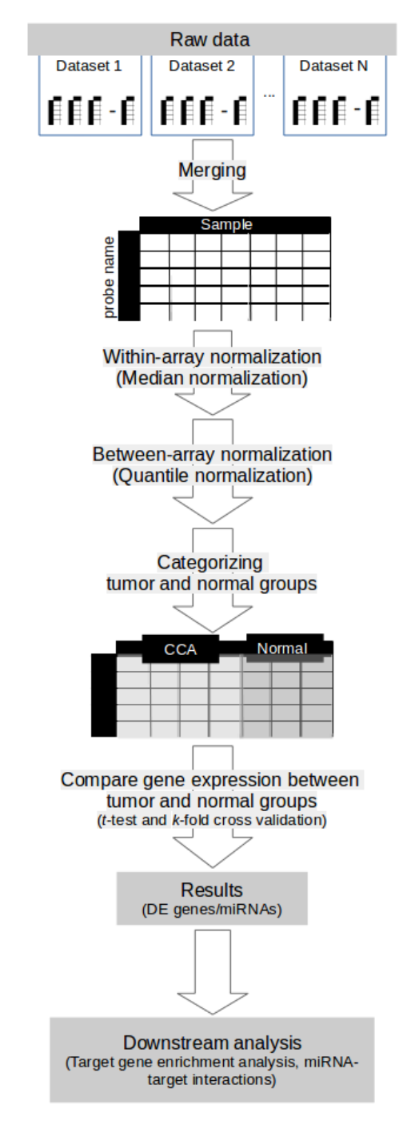
Figure 1 Overview of a meta-analysis approach in this study. CCA: Cholangiocarcinoma; DE: Differentially expressed; miRNA: MicroRNA.

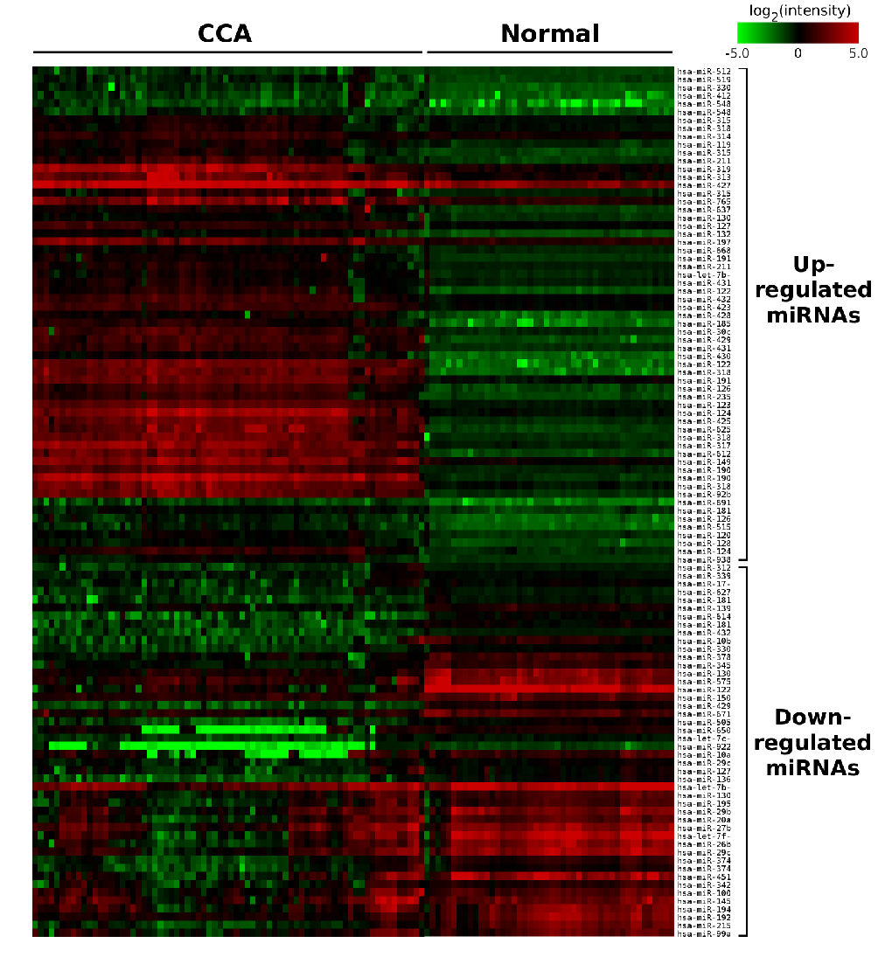
Figure 2 Heatmap of microRNA expression in cholangiocarcinoma and normal samples. The color gradient of each cell represents the log₂ of normalized intensity value of microRNA microarray spot. CCA: Cholangiocarcinoma; miRNA: MicroRNA.
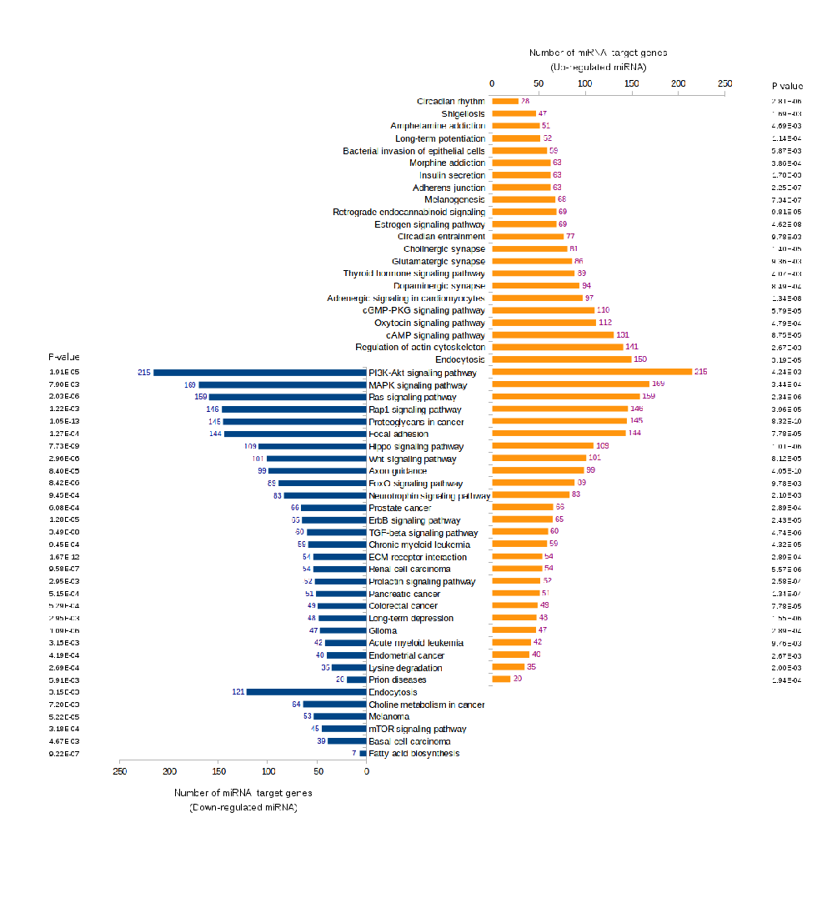
Figure 3 Pathway enrichment analyses of predicted target genes of differentially expressed microRNAs. The differentially expressed microRNAs obtained from meta-analysis were input to DIANA miRPath version 3.0. P-value thresholds were set at 0.01. PI3K: Phosphatidylinositol-3 kinases; MAPK: Mitogen-activated protein kinase.

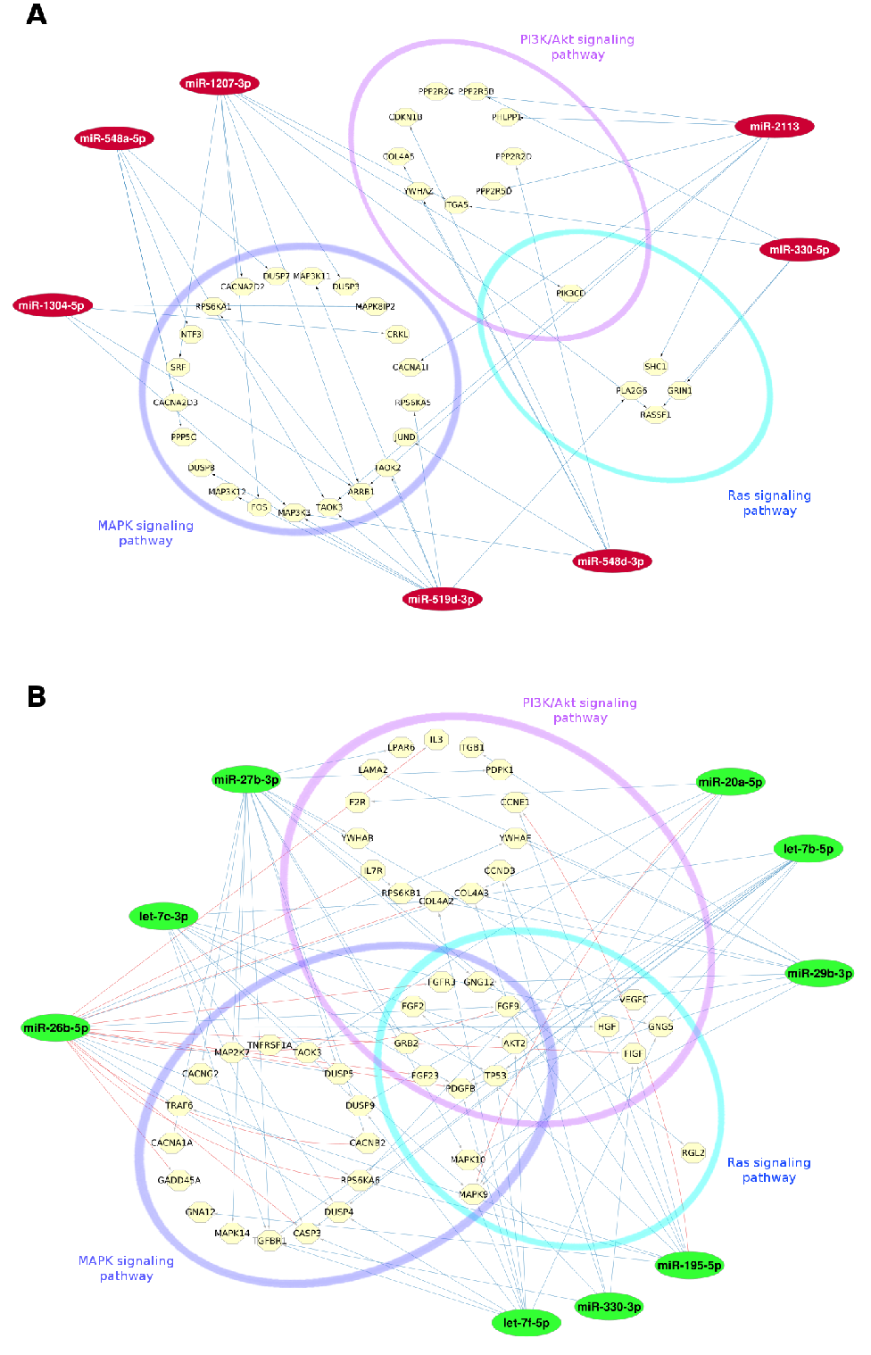
Figure 4 MicroRNA-target interaction networks. A: Up-regulated; B: Down-regulated. MicroRNA (miRNA)-target interaction networks of 7 up-regulated and 9 down-regulated miRNAs associating in phosphatidylinositol-3 kinases/Akt, mitogen-activated protein kinase, and Ras signaling pathways based on pathway enrichment analysis via DIANA miRPath version 3.0. Blue and red lines indicate the miRNA-target prediction or information based on TargetScan and miRTarBase databases, respectively. PI3K: Phosphatidylinositol-3 kinases; MAPK: Mitogen-activated protein kinase.

Table 1 Summary of microRNA microarray datasets used in this study
Dataset | Sample type | Number of samples |  | Microarray platform
 |  | CCA | Normal
GSE32958 | Tissue | 19 | 5 | Nanostring nCounter human miRNA expression
GSE47396 | Cell lines | 2 |  | miRCURY LNA miRNA Array, 5th generation
GSE47764 | Tissue | 3 | 3 | Agilent-021827 human miRNA microarray
GSE50894 | Tissue | 16 |  | Exiqon miRCURY LNA miRNA array version 10.0 extended and version 11.0 (condensed version)
GSE51429 | Tissue | 29 |  | Applied Biosystems human miRNA array version 2.0
GSE53870 | Tissue | 63 | 9 | State Key Laboratory human miRNA array 1104
GSE53992 | Tissue | 16 | 30 | Agilent-031181 unrestricted human miRNA version 16.0
GSE59856 | Serum | 98 | 150 | 3D-Gene human miRNA version 20_1.0.0
Total |  | 246 | 197
CCA: Cholangiocarcinoma; miRNA: MicroRNA.

Table 2 List of 10-fold-cross-validated differentially-expressed microRNAs which were up-regulated in cholangiocarcinoma
miRNA | FC | Abs. t value | DF | Adj. P value | FDR
hsa-let-7b-3p | 1.482 | 6.603 | 74 | 0.000 | 0.000
hsa-miR-1193 | 1.579 | 7.409 | 112 | 0.000 | 0.000
hsa-miR-1207-3p | 1.516 | 10.533 | 120 | 0.000 | 0.000
hsa-miR-1224-3p | 5.164 | 7.024 | 66 | 0.000 | 0.000
hsa-miR-1227-3p | 2.039 | 7.963 | 117 | 0.000 | 0.000
hsa-miR-1237-3p | 1.594 | 5.7 | 355 | 0.000 | 0.000
hsa-miR-1247-5p | 1.781 | 7.406 | 126 | 0.000 | 0.000
hsa-miR-1249-3p | 3.877 | 9.138 | 137 | 0.000 | 0.000
hsa-miR-1267 | 2.433 | 7.758 | 119 | 0.000 | 0.000
hsa-miR-1269a | 1.647 | 7.209 | 72 | 0.000 | 0.000
hsa-miR-1273d | 1.665 | 7.159 | 80 | 0.000 | 0.000
hsa-miR-1284 | 1.606 | 7.019 | 127 | 0.000 | 0.000
hsa-miR-1304-5p | 1.651 | 6.863 | 89 | 0.000 | 0.000
hsa-miR-1322 | 1.731 | 9.986 | 132 | 0.000 | 0.000
hsa-miR-147b | 2.727 | 8.195 | 52 | 0.000 | 0.000
hsa-miR-149-3p | 3.022 | 8.11 | 88 | 0.000 | 0.000
hsa-miR-181a-2-3p | 1.476 | 7.004 | 90 | 0.000 | 0.000
hsa-miR-185-3p | 5.044 | 9.684 | 113 | 0.000 | 0.000
hsa-miR-1908-5p | 9.384 | 7.977 | 150 | 0.000 | 0.000
hsa-miR-1909-3p | 2.19 | 6.502 | 129 | 0.000 | 0.000
hsa-miR-1913 | 2.222 | 6.861 | 137 | 0.000 | 0.000
hsa-miR-1914-5p | 1.575 | 6.615 | 140 | 0.000 | 0.000
hsa-miR-1972 | 2.043 | 8.605 | 111 | 0.000 | 0.000
hsa-miR-2113 | 1.634 | 7.74 | 358 | 0.000 | 0.000
hsa-miR-2116-3p | 1.656 | 9.782 | 115 | 0.000 | 0.000
hsa-miR-219a-2-3p | 1.6 | 6.436 | 125 | 0.000 | 0.000
hsa-miR-2355-5p | 2.762 | 9.902 | 113 | 0.000 | 0.000
hsa-miR-30c-1-3p | 1.976 | 7.144 | 114 | 0.000 | 0.000
hsa-miR-3131 | 2.446 | 6.211 | 114 | 0.000 | 0.000
hsa-miR-3147 | 1.371 | 7.617 | 115 | 0.000 | 0.000
hsa-miR-3150a-3p | 1.894 | 7.004 | 112 | 0.000 | 0.000
hsa-miR-3151-5p | 1.387 | 6.831 | 115 | 0.000 | 0.000
hsa-miR-3153 | 1.994 | 9.741 | 115 | 0.000 | 0.000
hsa-miR-3178 | 4.752 | 8.999 | 97 | 0.000 | 0.000
hsa-miR-3180 | 4.161 | 9.232 | 92 | 0.000 | 0.000
hsa-miR-3184-5p | 4.809 | 6.949 | 81 | 0.000 | 0.000
hsa-miR-3185 | 3.193 | 8.217 | 96 | 0.000 | 0.000
hsa-miR-3186-3p | 1.446 | 6.611 | 104 | 0.000 | 0.000
hsa-miR-3197 | 4.454 | 13.341 | 95 | 0.000 | 0.000
hsa-miR-325 | 1.498 | 5.994 | 168 | 0.000 | 0.000
hsa-miR-330-5p | 1.808 | 8.061 | 161 | 0.000 | 0.000
hsa-miR-412-3p | 1.933 | 7.414 | 144 | 0.000 | 0.000
hsa-miR-423-3p | 1.784 | 8.826 | 81 | 0.000 | 0.000
hsa-miR-4258 | 3.644 | 8.72 | 99 | 0.000 | 0.000
hsa-miR-4270 | 3.705 | 6.216 | 113 | 0.000 | 0.000
hsa-miR-4288 | 2.393 | 7.991 | 84 | 0.000 | 0.000
hsa-miR-4292 | 2.93 | 7.318 | 83 | 0.000 | 0.000
hsa-miR-4301 | 2.558 | 8.404 | 93 | 0.000 | 0.000
hsa-miR-4310 | 2.22 | 8.196 | 99 | 0.000 | 0.000
hsa-miR-4312 | 1.462 | 7.004 | 115 | 0.000 | 0.000
hsa-miR-4323 | 1.915 | 9.85 | 109 | 0.000 | 0.000
hsa-miR-512-5p | 1.484 | 6.579 | 172 | 0.000 | 0.000
hsa-miR-515-3p | 1.833 | 7.931 | 97 | 0.000 | 0.000
hsa-miR-517c-3p | 1.635 | 6.22 | 186 | 0.000 | 0.000
hsa-miR-519d-3p | 1.833 | 7.499 | 164 | 0.000 | 0.000
hsa-miR-520a-5p | 1.627 | 6.71 | 151 | 0.000 | 0.000
hsa-miR-520d-5p | 5.392 | 7.514 | 342 | 0.000 | 0.000
hsa-miR-520g-3p | 2.047 | 6.687 | 119 | 0.000 | 0.000
hsa-miR-548a-5p | 1.79 | 6.719 | 131 | 0.000 | 0.000
hsa-miR-548d-3p | 2.938 | 6.573 | 62 | 0.000 | 0.000
hsa-miR-612 | 1.79 | 6.952 | 376 | 0.000 | 0.000
hsa-miR-615-5p | 1.691 | 7.028 | 116 | 0.000 | 0.000
hsa-miR-625-3p | 3.763 | 8.618 | 104 | 0.000 | 0.000
hsa-miR-637 | 2.081 | 7.404 | 159 | 0.000 | 0.000
hsa-miR-668-3p | 1.437 | 6.341 | 153 | 0.000 | 0.000
hsa-miR-765 | 2.014 | 7.266 | 338 | 0.000 | 0.000
hsa-miR-891a-5p | 2.297 | 13.332 | 105 | 0.000 | 0.000
hsa-miR-891b | 2.052 | 7.342 | 117 | 0.000 | 0.000
hsa-miR-92b-5p | 2.802 | 6.499 | 106 | 0.000 | 0.000
hsa-miR-938 | 1.556 | 8.445 | 155 | 0.000 | 0.000
The P value was set to lower than 0.001 (P < 0.001). miRNA: MicroRNA; FC: Fold change (ratio of mean signal intensities of cholangiocarcinoma to those of normal samples); DF: Degree of freedom; Abs. t value: Absolute t value; Adj. P value: Adjusted P value; FDR: False discovery rate.

Table 3 List of 10-fold-cross-validated differentially-expressed microRNAs which were down-regulated in cholangiocarcinoma
miRNA | FC | Abs. t value | DF | Adj. P value | FDR
hsa-let-7b-5p | 0.336 | 6.655 | 186 | 0.000 | 0.000
hsa-let-7c-3p | 0.686 | 9.519 | 138 | 0.000 | 0.000
hsa-let-7f-5p | 0.226 | 6.65 | 89 | 0.000 | 0.000
hsa-miR-100-5p | 0.424 | 7.984 | 144 | 0.000 | 0.000
hsa-miR-10a-5p | 0.458 | 5.943 | 196 | 0.000 | 0.000
hsa-miR-10b-3p | 0.352 | 8.834 | 72 | 0.000 | 0.000
hsa-miR-1225-5p | 0.097 | 6.448 | 88 | 0.000 | 0.000
hsa-miR-127-3p | 0.62 | 6.167 | 84 | 0.000 | 0.000
hsa-miR-1288-3p | 0.394 | 7.17 | 61 | 0.000 | 0.000
hsa-miR-1305 | 0.311 | 7.255 | 66 | 0.000 | 0.000
hsa-miR-130a-3p | 0.459 | 7.775 | 101 | 0.000 | 0.000
hsa-miR-136-5p | 0.51 | 7.184 | 191 | 0.000 | 0.000
hsa-miR-139-3p | 0.626 | 7.227 | 95 | 0.000 | 0.000
hsa-miR-145-5p | 0.359 | 7.026 | 129 | 0.000 | 0.000
hsa-miR-150-3p | 0.51 | 7.109 | 139 | 0.000 | 0.000
hsa-miR-17-3p | 0.638 | 7.108 | 115 | 0.000 | 0.000
hsa-miR-181c-3p | 0.602 | 6.651 | 133 | 0.000 | 0.000
hsa-miR-181d-5p | 0.598 | 7.741 | 138 | 0.000 | 0.000
hsa-miR-192-5p | 0.267 | 7.582 | 69 | 0.000 | 0.000
hsa-miR-194-5p | 0.283 | 8.454 | 90 | 0.000 | 0.000
hsa-miR-195-5p | 0.449 | 7.441 | 101 | 0.000 | 0.000
hsa-miR-20a-5p | 0.386 | 6.929 | 99 | 0.000 | 0.000
hsa-miR-215-5p | 0.271 | 8.404 | 70 | 0.000 | 0.000
hsa-miR-26b-5p | 0.305 | 7.657 | 121 | 0.000 | 0.000
hsa-miR-27b-3p | 0.317 | 8.02 | 146 | 0.000 | 0.000
hsa-miR-29b-3p | 0.432 | 6.216 | 110 | 0.000 | 0.000
hsa-miR-29c-3p | 0.25 | 9.578 | 93 | 0.000 | 0.000
hsa-miR-29c-5p | 0.755 | 6.521 | 122 | 0.000 | 0.000
hsa-miR-3120-3p | 0.673 | 6.341 | 90 | 0.000 | 0.000
hsa-miR-330-3p | 0.691 | 6.605 | 99 | 0.000 | 0.000
hsa-miR-339-3p | 0.746 | 7.662 | 90 | 0.000 | 0.000
hsa-miR-342-3p | 0.516 | 8.228 | 193 | 0.000 | 0.000
hsa-miR-345-5p | 0.531 | 8.154 | 69 | 0.000 | 0.000
hsa-miR-374a-5p | 0.439 | 8.25 | 99 | 0.000 | 0.000
hsa-miR-374b-5p | 0.568 | 6.771 | 117 | 0.000 | 0.000
hsa-miR-378b | 0.489 | 7.181 | 101 | 0.000 | 0.000
hsa-miR-4294 | 0.471 | 7.279 | 96 | 0.000 | 0.000
hsa-miR-4326 | 0.69 | 6.513 | 115 | 0.000 | 0.000
hsa-miR-451a | 0.143 | 7.636 | 85 | 0.000 | 0.000
hsa-miR-483-5p | 0.412 | 7.272 | 166 | 0.000 | 0.000
hsa-miR-505-3p | 0.625 | 6.612 | 105 | 0.000 | 0.000
hsa-miR-575 | 0.311 | 7.35 | 62 | 0.000 | 0.000
hsa-miR-614 | 0.341 | 7.8 | 412 | 0.000 | 0.000
hsa-miR-627-5p | 0.601 | 6.504 | 190 | 0.000 | 0.000
hsa-miR-650 | 0.252 | 9.369 | 148 | 0.000 | 0.000
hsa-miR-671-5p | 0.594 | 6.372 | 402 | 0.000 | 0.000
hsa-miR-922 | 0.323 | 8.522 | 148 | 0.000 | 0.000
hsa-miR-99a-5p | 0.328 | 9.611 | 117 | 0.000 | 0.000
The P value was set to lower than 0.001 (P < 0.001). miRNA: MicroRNA; FC: Fold change (ratio of mean signal intensities of cholangiocarcinoma to those of normal samples); DF: Degree of freedom; Abs. t value: Absolute t value; Adj. P value: Adjusted P value; FDR: False discovery rate.

