Name of journal: World Journal of Gastroenterology
Manuscript NO: 32903
Manuscript Type: ORIGINAL ARTICLE

Basic Study

Human liver-chimeric mouse model based on inducible liver injury by diphtheria toxin

Ren XN et al. Human liver-chimeric mouse model

Xiao-Nan Ren, Rong-Rong Ren, Hua Yang, Bo-Yin Qin, Xiu-Hua Peng, Li-Xiang Chen, Shun Li, Meng-Jiao Yuan, Chao Wang, Xiao-Hui Zhou

Xiao-Nan Ren, Rong-Rong Ren, Hua Yang, Bo-Yin Qin, Xiu-Hua Peng, Li-Xiang Chen, Shun Li, Meng-Jiao Yuan, Chao Wang, Xiao-Hui Zhou, Shanghai Public Health Clinical Center, Fudan University, Shanghai 201508, China

Xiao-Hui Zhou, Key Laboratory of Medical Molecular Virology, Ministry of Education and Health, Fudan University, Shanghai 201508, China

Author contributions: Zhou XH and Ren XN designed the experiments; Ren XN, Ren RR and Yang H performed the majority of experiments; Ren XN and Zhou XH analyzed the data; Qin BY, Peng XH, Chen LX, Meng JY and Wang C contributed to genotyping; Zhou XH and Ren XN wrote the paper; Shun L revised the paper.

Supported by Shanghai Science and Technology Development Foundation Project, No.12140900300; Shanghai Municipal Commission of Health and Family Planning Project, No.20144Y0073; Shanghai Public Health Clinical Center Project, No.2014M08; National Science and Technology Major Project, No.2017ZX10304402-001-012.

Institutional animal care and use committee statement: All procedures involving animals were reviewed and approved by the Institutional Animal Care and Use Committee of Shanghai Public Health Clinical Center Affiliated to Fudan University.

Conflict-of-interest statement: No conflicts of interest exist in this study.

Data sharing statement: No additional data are available.

Manuscript source: Invited manuscript

Open-Access: This article is an open-access article which was selected by an in-house editor and fully peer-reviewed by external reviewers. It is distributed in accordance with the Creative Commons Attribution Non Commercial (CC BY-NC 4.0) license, which permits others to distribute, remix, adapt, build upon this work non-commercially, and license their derivative works on different terms, provided the original work is properly cited and the use is non-commercial. See: http://creativecommons.org/licenses/by-nc/4.0/

Manuscript source: Invited manuscript

Correspondence to: Xiao-Hui Zhou, MD, PhD, Professor, Shanghai Public Health Clinical Center, Key Laboratory of Medical Molecular Virology, Ministry of Education and Health, Fudan University, 2901 Caolang Road, Jin Shan District, Shanghai 201508, China. zhouxiaohui@shaphc.org
Telephone: +86-21-37990333
Fax: +86-21-37990333
Received: January 25, 2017
Peer-review started: February 1, 2017
First decision: March 16, 2017
Revised: April 1, 2017
Accepted:
Article in press:
Published online:

Abstract
AIM
To establish an inducible liver injury mouse model and transplant human hepatocytes to obtain liver-humanized mice.

METHODS
We crossed three mouse strains including Alb-cre transgenic mice, inducible diphtheria toxin receptor (DTR) transgenic mice and SCID-beige mice to create Alb-cre/DTR/SCID-beige (ADSB) mice, which coincidentally harbor Alb-cre and DTR transgenes and are immunodeficient. As the Cre expression is driven by the liver-specific promoter (Alb), the DTR stop signal flanked by two loxP sites can be deleted in ADSB mice, resulting in DTR expression in the liver. ADSB mice aged 8-10 wk were injected intraperitoneally (i.p.) with diphtheria toxin (DT) and liver damage was assessed by serum alanine aminotransferase (ALT) level. Two days later, mouse livers were sampled for histological analysis, and human hepatocytes were transplanted into the livers on the same day. A human albumin enzyme-linked immunosorbent assay was performed 7, 14, 21 and 28 d after transplantation. Human CD68 immunohistochemistry was performed 30 and 90 d after transplantation.

RESULTS
We crossed Alb-cre with DTR and SCID-beige mice to obtain ADSB mice. These mice were found to have liver damage 4 d after i.p. injection of 2.5 ng/g bodyweight DT. Bodyweight began to decrease on day 2, increased on day 7, and was lowest on day 4 (range, 10.5% - 13.4%). Serum ALT activity began to increase on day 2 and reached a peak value of 289.7 ± 16.2 IU/mL on day 4, then returned to background values on day 7. After transplantation of human liver cells, peripheral blood human albumin level was 1580 ± 454.8 ng/mL (range, 750.2 - 3064.9 ng/mL) after 28 d and Kupffer cells were present in the liver at 30 d in ADSB mice.

CONCLUSION
Human hepatocytes were successfully repopulated in the livers of ADSB mice. The inducible mouse model of humanized liver in ADSB mice may have functional applications such as hepatocyte transplantation, hepatic regeneration, and drug metabolism.

Key words: Liver disease; Liver injury; Liver-chimeric mouse model; Diphtheria toxin

© The Author(s) 2017. Published by Baishideng Publishing Group Inc. All rights reserved.

Core tip: We established a novel liver-chimeric mouse model following liver damage caused by intraperitoneal injection of diphtheria toxin, and transplanted human hepatocytes to obtain liver-humanized mice. After 28 d, human albumin was detected in these mice. Human hepatocytes were successfully repopulated in the livers of ADSB mice, i.e., Alb-cre/DTR/SCID-beige mice. Our inducible mouse model of humanized liver in ADSB mice may have functional applications, such as studies on hepatocyte transplantation, hepatic regeneration, and drug metabolism.

Ren XN, Ren RR, Yang H, Qin BY, Peng XH, Chen LX, Li S, Yuan MJ, Wang C, Zhou XH. Human liver-chimeric mouse model based on inducible liver injury by diphtheria toxin. World J Gastroenterol 2017; In press

INTRODUCTION
Liver diseases are a serious global health issue, particularly viral hepatitis infection and related diseases. The hepatitis B virus (HBV) and hepatitis C virus (HCV) are representative hepatotropic viruses. HBV is the prototype of the hepadnaviridae family of hepatotropic, partially double-stranded DNA viruses^{[1]}, while HCV is a single-stranded RNA virus^{[2]}. Although different at the molecular level, they share much similarities as pathogens, and both infections can be acute or chronic^{[3]}. Persistent HBV and HCV infections can lead to cirrhosis and/or hepatocellular carcinoma^{[4-5]}. Despite the availability of vaccines and drugs, a huge number of patients suffer from the liver diseases related to these viral infections.
Animal models play a critical role in immunological or therapeutic drug development. The narrow species of HBV and HCV restricts preclinical studies. Although chimpanzees have played an important role in studying HBV and HCV infection, there are few studies on chimpanzees due to high costs, ethics and their limited availability^{[6-8]}. Other hepadnaviruses which infect woodchucks^{[9]}, ducks^{[10]}, and ground squirrels^{[11]}, are confronted with limitations due to genetic heterogeneity.
Fundamental questions regarding hepatotropic pathogen biology in vivo need to be addressed. However, this requires a suitable small animal model to guide the challenging and expensive studies. The transgenic 1.2 or 1.3 copy of the HBV genome in mice shows immunological tolerance to HBV antigens. Adenovirus associated virus-based transduction or hydrodynamic transfection of mouse liver by the 1.2 or 1.3 copy of the HBV genome has also been used to study HBV immunobiology, but does not support viral replication for re-infection in the cycle. Human liver chimeric mouse models are useful in human liver disease research.
In this study, severe combined immune deficient (SCID)-beige mice were crossed with transgenic Alb-cre mice which expressed cre enzyme^{[12]} under the control of a liver cell-specific albumin promoter, and DT receptor (DTR)^{[13-14]} transgenic mice, in which the DTR transgene is located in the ubiquitous gt(ROSA26)Sor(R26) locus after a loxp-flanked transcriptional stop sequence.
The resulting Alb-cre/DTR/SCID-beige (ADSB) mice specifically expressed DTR in the liver. Following administration of diphtheria toxin (DT), these mice developed liver injury. We further generated humanized liver in ADSB mice by the transplantation of human hepatocytes. The human hepatocytes were repopulated in the mouse liver, which were functional and secreted human albumin. Human Kupffer cells were also found to chimerize in the mouse liver.
Thus, we developed a novel animal model to investigate hepatocyte proliferation^{[15-17]} and hepatotropic viruses.

MATERIALS AND METHODS
Generation of ADSB transgenic mice
To generate Alb-cre/DTR/SCID-beige (ADSB) mice, we crossed Alb-cre mice (a gift from Dr. Qiang Deng, Institute Pasteur of Shanghai, Chinese of Academy Sciences) with DTR mice (a gift from Dr. Yuelei Shen, Beijing Biocytogen Co., Ltd) to obtain Alb-cre/DTR mice. Transgenic mice were selected from the offspring by genomic PCR of tail DNA, and then Alb-cre/DTR transgenic mice were crossed with SCID-beige mice (purchased from the Shanghai SLAC Laboratory Animal Co., Ltd), and ADSB mice were selected by genomic PCR of tail DNA.

Transaminase activity in the blood
Diphtheria toxin (Sigma-Aldrich, St. Louis, United States) was intraperitoneally administered (2.5 ng/g) to 8-10-wk-old ADSB mice, and blood was collected from these mice at different time points after DT administration. Samples were centrifuged at 600 ×g for 15 min to separate the serum. Serum alanine aminotransferase (ALT) activity was measured with the Roche Kit according to the manufacturer’s instructions (Roche modular, Basel, Switzerland). Serum ALT activity levels in mice used for hepatocyte transplantation were measured 3 d after DT injection.

Histological assessments
The livers were fixed with 4% formaldehyde for 24 h and stored in 75% ethanol. They were then embedded in paraffin and serial sections were cut and stained with hematoxylin and eosin (H&E).

Humanization protocol
We found that a single DT dose of 2.5 ng/g bodyweight was the maximum dose tolerated with a 100% survival. Using this dose, serum ALT activity levels were determined prior to cell transplantation. Human cryopreserved hepatocytes (Bioreclamation IVT, Baltimore, United States) were thawed and the the cryopreservation solution was removed by centrifugation at 100 ×g for 5 min at 4 ℃ followed by resuspension in Dulbecco’s Modified Eagle’s Medium (DMEM). The resuspended hepatocytes were diluted 1:1 in trypan blue and then centrifuged again at 100 × g for 5 min at 4 ℃ and reconstituted in HCM at 1 × 10⁷ cells/mL, and 1 × 10⁶ viable hepatocytes suspended in 100 µL DMEM were injected into the inferior splenic pole.

Human albumin ELISA assay
Starting one week after transplantation, human albumin levels were monitored. Blood samples (10 µL) were collected and centrifuged at 600 × g for 15 min. Serum samples were assayed using the Quantitative Human Albumin ELISA quantitation Kit (Bethyl Laboratory, Texas, United States) according to the manufacturer’s protocol.

Immunohistochemistry
At the time of harvest, the liver was fixed in 4% formaldehyde for 24 h and stored in 75% ethanol. Sections were then prepared and incubated with primary human CD68 antibody (1:200 dilution) (Servicebio, Shanghai, China) and were used to detect specific Kupffer cells in the chimeric mice, and then incubated with HRP-goat anti-rabbit secondary antibody (1:200 dilution) (Servicebio, Shanghai, China).

Statistical analysis
Statistical analyses were performed using Prism 5.0 software (GraphPad Software, San Diego, CA, United States). A P value of < 0.05 was considered significant.

RESULTS
Experimental design and PCR analysis of Alb-cre/DTR transgenic mice
The experimental design is outlined in Figure 1. In this study, we crossed Alb-cre with DTR and SCID-beige mice to obtain ADSB mice. In PCR used to identify the Alb-cre gene, Tg1, Tg2 and Tg4 mice were cre positive (Figure 1B) and in PCR for DTR gene, Tg1, Tg2 and Tg5 were found in homozygous DTR mice, and Tg3 and Tg4 in heterozygous DTR mice (Figure 1C). Genotyping of SCID-beige mice was performed as previously described^{[18]}. The mice were then injected intraperitoneally with DT to induce liver injury, and adult human hepatocytes were transplanted to obtain chimeric mice.

Specific inducible liver injury in ADSB mice by diphtheria toxin
To examine the liver damage caused by DT, ADSB mice and non-transgenic mice (C57BL/6) were injected i.p. with 2.5 ng/g bodyweight of DT in 200 µL PBS. Both groups of mice were sacrificed 4 d later. The livers of non-transgenic mice appeared normal and dark red (Figure 2A), whereas the livers from ADSB mice were pale and almost white (Figure 2B). Liver sections from both types of mice were stained with H&E. Microscopically, the liver sections from non-transgenic mice were of normal histological appearance, the structure of the hepatic lobule was complete, the hepatic cord and hepatic sinusoid were appropriately arranged, and degeneration or necrosis of hepatocytes was not observed (Figure 2C). Hepatocyte nucleus fragmentation disappeared in ADSB mice, suggesting that ADSB mice had characteristic histological hepatocellular injury (Figure 2D).

Kinetic study of bodyweight and liver injury
ADSB mice and non-transgenic mice were injected i.p. with 2.5 ng/g bodyweight of DT. At different time points, bodyweight was recorded and blood samples were collected to determine ALT activity. In ADSB mice, after DT injection, bodyweight began to decrease on day 2, was regained on day 7, and was lowest on day 4 (range, 10.5% - 13.4%). No weight reductions were found in non-transgenic mice (Figure 3A). Serum ALT activity in ADSB mice began to increase on day 2, reached a peak value of 289.7 ± 16.2 IU/mL on day 4, and then returned to background values on day 7 (Figure 3B). In non-transgenic mice, ALT activity remained at basal levels (< 50 IU/mL). Therefore, from day 2 to day 7 after DT injection liver damage occurred, proving that proliferation of transplanted hepatocytes took place in this mouse model.

Human hepatocyte reconstitution in ADSB mice
ADSB mice were transplanted 3 d after DT injection, and then peripheral blood albumin levels were determined on day 7, 14, and 21 after hepatocyte transplantation (Figure 4A). Serum levels of human albumin in ADSB mice are shown on day 7, 14, 21 and 28 after hepatocyte transplantation. Before 28 d, no human albumin was detected both in ADSB mice and non-transgenic mice. However, 28 d after transplantation we detected serum human albumin in ADSB mice at the level of 1580 ± 454.8 ng/mL (range, 750.2 - 3064.9 ng/mL), no human albumin was detected in non-transgenic mice (Figure 4B). These results demonstrated that human albumin was expressed at least 4 weeks after hepatocyte transplantation.

Human Kupffer cells in the liver of ADSB mice
CD68 is considered a specific marker for activated Kupffer cells. Kupffer cells are essential for many hepatic functions and play a major role in inflammatory responses in this organ^{[19-21]}. CD68 immunohistochemistry was used to measure CD68 expression in Kupffer cells. In ADSB mouse liver sections, CD68⁺ cells were present 4 wk and 12 wk after transplantation, and more CD68⁺ cells were found at 12 wk after transplantation than at 4 wk after transplantation (Figure 5).

DISCUSSION
Human liver chimeric mouse models are useful in human liver disease research. The urokinase-type plasminogen activator (μPA) transgenic mouse^{[22]}, was the first reported liver humanized mouse model; however, μPA mice have low breeding efficiency, are unhealthy and die due to hypofibrinogenemia, thus the transplant time for μPA mice is limited. Two reports showed successful engraftment based on genetic knockout of the fumarylacetoacetate hydrolase (Fah) genes^{[23-24]}. Fah is the last enzyme in the tyrosine breakdown pathway and its deficiency leads to lethal type I hypertyrosinemia in humans and liver failure in mice. However, Fah mice also have mouse health problems, and 2-(2-nitro-4-trifluoro-methylbenzoyl)-1,3-cyclohexanedione controls liver injury so that impacts its application in drug metabolism. More recently，two additional transgenic models have been developed, the TK-NOG^{[25]} and the AFC8^{[26]} models, which express active caspase 8 fused with the FK506 binding domain and has inducible suicidal activity in mouse liver under albumin promoter control, but its repopulation rate of human liver cells is only 30%. The FRG model was then developed. FRG^{[23]} mice are immune-deficient, Fah knockout mice crossed with mice lacking the Rag-2 gene and the common gamma chain of the interleukin receptor.
We report here a novel ADSB mouse model which can be efficiently repopulated with human hepatocytes. The transplanted human hepatocytes can reside in the mouse host’s natural environment and maintain normal functions. Theoretically, these mouse models can be infected with HBV and HCV in a reproducible manner.
In this model, recipient mouse hepatocytes were destroyed by DT, and the transplanted human mature hepatocytes had a selective advantage in the mouse liver. We confirmed that these mice have the ability to engraft adult human hepatocytes, and the liver can harbor human Kupffer cells. Thus, this model provides a platform for basic biology in liver regeneration research and liver disease development.
Our mouse model has distinct advantages over the other chimeric models. First, ADSB mouse breeding is not as difficult as μPA mice, thus, it is possible to obtain sufficient ADSB mice for experiments. In addition, these mice are healthy and long-lived, and can be used for long-term transplantation studies. Second, the transplantation time points are flexible following DT injection to induce murine liver injury. Furthermore, we determined the appropriate dose of DT to be 2.5 ng/g bodyweight, which can sustain acute liver injuries with only one dose of DT, resulting in no death of mice, and can efficiently support the proliferation of transplanted hepatocytes.
In conclusion, this study introduced a new in vivo mouse model, which will serve as a promising tool for research into the interaction between host and virus in vivo, and in the development of new treatment approaches. This model is convenient for studies on hepatocyte transplantation, human drug metabolism research and drug-drug interactions^{[27-28]}. Our model achieved the establishment of human liver without hemopoietic reconstitution. In a future study, we will attempt to establish human liver/immune dual chimeric mice in order to investigate HBV or HCV infections in these chimeric animals.

ACKNOWLEDGMENTS
We appreciate Yue-Lei Shen from Biocytogen Co., Ltd, Beijing, China for kindly providing the DTR mice; Qiang Deng from Institut Pasteur of Shanghai, Chinese of Academy Sciences for kindly providing the Alb-cre mice; Professor Zheng-Hong Yuan from Fudan University, Shanghai, China for his intensive discussion. We thank the animal facilities in Shanghai Public Clinical Center, Fudan University, China for providing the platform and helping with animal experiments.

COMMENTS
Background
Hepatitis B virus and hepatitis C virus are hepatotropic viruses that represent a serious global health issue. Humanized mouse models are useful in human liver disease research. However, mouse models have disadvantages and need to be improved.

Research frontiers
Recently, many humanized mouse models have been reported, such as the AFC8 mouse and Fah mouse models. However, these mouse models have disadvantages, such as low breeding efficiency, limited time window for transplantation and low repopulation rate.

Innovations and breakthroughs
In the present study, the authors developed a novel liver-chimeric mouse model. Liver failure was induced by diphtheria toxin and then human hepatocytes were transplanted and repopulated in the mice.

Applications
The results of this study suggest that the liver-chimeric mouse model based on ADSB mice may provide a more stable platform for human drug metabolism research and viral hepatitis infections.

Terminology
A liver-chimeric mouse is established using transgenic or knockout techniques to cause liver failure and human liver cells are transplanted to construct a chimeric mouse. In order to avoid host immune rejection following human hepatocyte transplantation, the mice used are usually immunodeficient.

Peer-review
The researchers provide a novel mouse model of human liver-chimeric based on diphtheria toxin receptor transgenic mice, in which liver injury can be induced by diphtheria toxin injection. This model could serve as a promising tool for research on the interaction between host and hepatitis virus in vivo, and in the development of new treatment approaches against related liver diseases.

REFERENCES
1 Seeger C, Mason WS. Hepatitis B virus biology. Microbiol Mol Biol Rev 2000; 64: 51-68 [PMID: 10704474]
2 Wieland SF, Chisari FV. Stealth and cunning: hepatitis B and hepatitis C viruses. J Virol 2005; 79: 9369-9380 [PMID: 16014900 DOI: 10.1128/JVI.79.15.9369-9380.2005]
3 Dienstag JL. Hepatitis B virus infection. N Engl J Med 2008; 359: 1486-1500 [PMID: 18832247 DOI: 10.1056/NEJMra0801644]
4 Blumberg BS. Hepatitis B virus, the vaccine, and the control of primary cancer of the liver. Proc Natl Acad Sci U S A 1997; 94: 7121-7125 [PMID: 9207053]
5 Rogler CE, Chisari FV. Cellular and molecular mechanisms of hepatocarcinogenesis. Semin Liver Dis 1992; 12: 265-278 [PMID: 1439879 DOI: 10.1055/s-2007-1007398]
6 Barker LF, Chisari FV, McGrath PP, Dalgard DW, Kirschstein RL, Almeida JD, Edington TS, Sharp DG, Peterson MR. Transmission of type B viral hepatitis to chimpanzees. J Infect Dis 1973; 127: 648-662 [PMID: 4574998]
7 Guidotti LG, Rochford R, Chung J, Shapiro M, Purcell R, Chisari FV. Viral clearance without destruction of infected cells during acute HBV infection. Science 1999; 284: 825-829 [PMID: 10221919]
8 Abe K, Inchauspe G, Shikata T, Prince AM. Three different patterns of hepatitis C virus infection in chimpanzees. Hepatology 1992; 15: 690-695 [PMID: 1312987]
9 Summers J, Smolec JM, Snyder R. A virus similar to human hepatitis B virus associated with hepatitis and hepatoma in woodchucks. Proc Natl Acad Sci U S A 1978; 75: 4533-4537 [PMID: 212758]
10 Mason WS, Seal G, Summers J. Virus of Pekin ducks with structural and biological relatedness to human hepatitis B virus. J Virol 1980; 36: 829-836 [PMID: 7463557]
11 Marion PL, Oshiro LS, Regnery DC, Scullard GH, Robinson WS. A virus in Beechey ground squirrels that is related to hepatitis B virus of humans. Proc Natl Acad Sci U S A 1980; 77: 2941-2945 [PMID: 6930677]
12 Austin S, Ziese M, Sternberg N. A novel role for site-specific recombination in maintenance of bacterial replicons. Cell 1981; 25: 729-736 [PMID: 7026049]
13 Buch T, Heppner FL, Tertilt C, Heinen TJ, Kremer M, Wunderlich FT, Jung S, Waisman A. A Cre-inducible diphtheria toxin receptor mediates cell lineage ablation after toxin administration. Nat Methods 2005; 2: 419-426 [PMID: 15908920 DOI: 10.1038/nmeth762]
14 Roberts LM, Ledvina HE, Tuladhar S, Rana D, Steele SP, Sempowski GD, Frelinger JA. Depletion of alveolar macrophages in CD11c diphtheria toxin receptor mice produces an inflammatory response. Immun Inflamm Dis 2015; 3: 71-81 [PMID: 26029367 DOI: 10.1002/iid3.51]
15 Rhim JA, Sandgren EP, Degen JL, Palmiter RD, Brinster RL. Replacement of diseased mouse liver by hepatic cell transplantation. Science 1994; 263: 1149-1152 [PMID: 8108734]
16 Rhim JA, Sandgren EP, Palmiter RD, Brinster RL. Complete reconstitution of mouse liver with xenogeneic hepatocytes. Proc Natl Acad Sci U S A 1995; 92: 4942-4946 [PMID: 7761429]
17 Dandri M, Burda MR, Török E, Pollok JM, Iwanska A, Sommer G, Rogiers X, Rogler CE, Gupta S, Will H, Greten H, Petersen J. Repopulation of mouse liver with human hepatocytes and in vivo infection with hepatitis B virus. Hepatology 2001; 33: 981-988 [PMID: 11283864 DOI: 10.1053/jhep.2001.23314]
18 Araki R, Fujimori A, Hamatani K, Mita K, Saito T, Mori M, Fukumura R, Morimyo M, Muto M, Itoh M, Tatsumi K, Abe M. Nonsense mutation at Tyr-4046 in the DNA-dependent protein kinase catalytic subunit of severe combined immune deficiency mice. Proc Natl Acad Sci U S A 1997; 94: 2438-2443 [PMID: 9122213]
19 Ajakaiye M, Jacob A, Wu R, Nicastro JM, Coppa GF, Wang P. Alcohol and hepatocyte-Kupffer cell interaction (review). Mol Med Rep 2011; 4: 597-602 [PMID: 21468548 DOI: 10.3892/mmr.2011.471]
20 Gregory SH, Wing EJ. Neutrophil-Kupffer cell interaction: a critical component of host defenses to systemic bacterial infections. J Leukoc Biol 2002; 72: 239-248 [PMID: 12149414]
21 Roberts RA, Ganey PE, Ju C, Kamendulis LM, Rusyn I, Klaunig JE. Role of the Kupffer cell in mediating hepatic toxicity and carcinogenesis. Toxicol Sci 2007; 96: 2-15 [PMID: 17122412 DOI: 10.1093/toxsci/kfl173]
22 Heckel JL, Sandgren EP, Degen JL, Palmiter RD, Brinster RL. Neonatal bleeding in transgenic mice expressing urokinase-type plasminogen activator. Cell 1990; 62: 447-456 [PMID: 1696178 DOI: 10.1016/0092-8674(90)90010-C]
23 Azuma H, Paulk N, Ranade A, Dorrell C, Al-Dhalimy M, Ellis E, Strom S, Kay MA, Finegold M, Grompe M. Robust expansion of human hepatocytes in Fah-/-/Rag2-/-/Il2rg-/- mice. Nat Biotechnol 2007; 25: 903-910 [PMID: 17664939 DOI: 10.1038/nbt1326]
24 Bissig KD, Le TT, Woods NB, Verma IM. Repopulation of adult and neonatal mice with human hepatocytes: a chimeric animal model. Proc Natl Acad Sci U S A 2007; 104: 20507-20511 [PMID: 18077355 DOI: 10.1073/pnas.0710528105]
25 Hasegawa M, Kawai K, Mitsui T, Taniguchi K, Monnai M, Wakui M, Ito M, Suematsu M, Peltz G, Nakamura M, Suemizu H. The reconstituted 'humanized liver' in TK-NOG mice is mature and functional. Biochem Biophys Res Commun 2011; 405: 405-410 [PMID: 21238430 DOI: 10.1016/j.bbrc.2011.01.042]
26 Washburn ML, Bility MT, Zhang L, Kovalev GI, Buntzman A, Frelinger JA, Barry W, Ploss A, Rice CM, Su L. A humanized mouse model to study hepatitis C virus infection, immune response, and liver disease. Gastroenterology 2011; 140: 1334-1344 [PMID: 21237170 DOI: 10.1053/j.gastro.2011.01.001]
27 Nowak G, Ericzon BG, Nava S, Jaksch M, Westgren M, Sumitran-Holgersson S. Identification of expandable human hepatic progenitors which differentiate into mature hepatic cells in vivo. Gut 2005; 54: 972-979 [PMID: 15951545 DOI: 10.1136/gut.2005.064477]
28 Bateman TJ, Reddy VG, Kakuni M, Morikawa Y, Kumar S. Application of chimeric mice with humanized liver for study of human-specific drug metabolism. Drug Metab Dispos 2014; 42: 1055-1065 [PMID: 24700822 DOI: 10.1124/dmd.114.056978]

P-Reviewer: De Ponti F S-Editor: Qi Y L-Editor: E-Editor:
Specialty type: Gastroenterology and hepatology
Country of origin: China
Peer-review report classification
Grade A (Excellent): 0
Grade B (Very good): 0
Grade C (Good): C
Grade D (Fair): 0
Grade E (Poor): 0

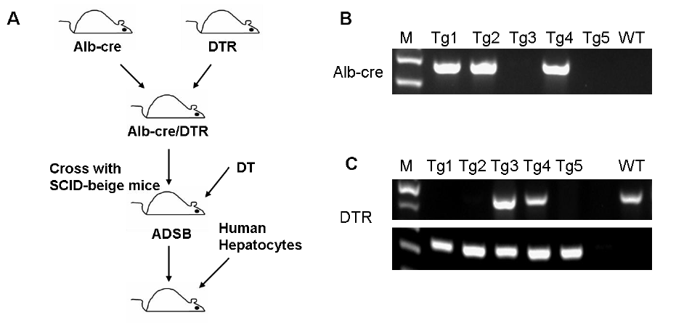 Figure 1 Experimental design and PCR analysis of Alb-cre/DTR transgenic mice. A: Experimental design used to characterize DT liver injury in ADSB mice, which were used for human hepatocyte transplantation; B: PCR analysis of the Alb-cre gene, Tg1, Tg2 and Tg4 mice are cre positive; C: PCR analysis of DTR gene, Tg1, Tg2 and Tg5 are homozygous DTR mice, and Tg3 and Tg4 are heterozygous DTR mice.
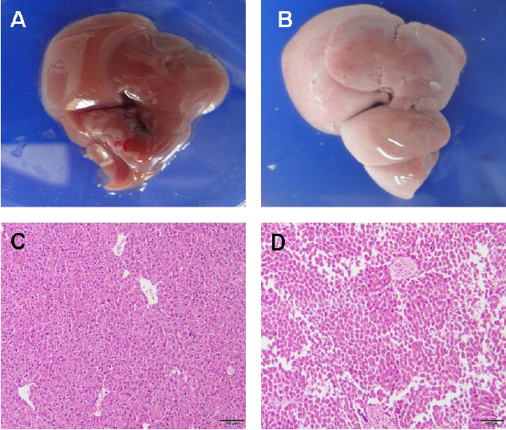
Figure 2 Histological analysis of liver injury. Two days after DT treatment, liver sections from non-transgenic mice and ADSB mice were stained with HE. A: The liver from non-transgenic mice (C57BL/6); B: The liver from ADSB mouse; C: Liver sections from non-transgenic mice showed normal histological appearance; D: Liver sections from ADSB mice showed liver injury.

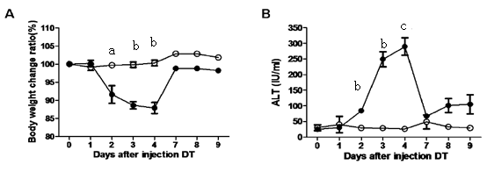
Figure 3 Bodyweight and alanine aminotransferase analysis after diphtheria toxin injection. ADSB mice (filled circle) and non-transgenic mice (open circle) were injected with 2.5 ng/g bodyweight diphtheria toxin. A: The bodyweight change ratio in the two groups of mice after injection of DT B: Analysis of serum ALT activity in the mice. Data are shown as the mean of each group, and error bars represent SD (n = 3), ^{b}P < 0.01, ^{c}P < 0.001.
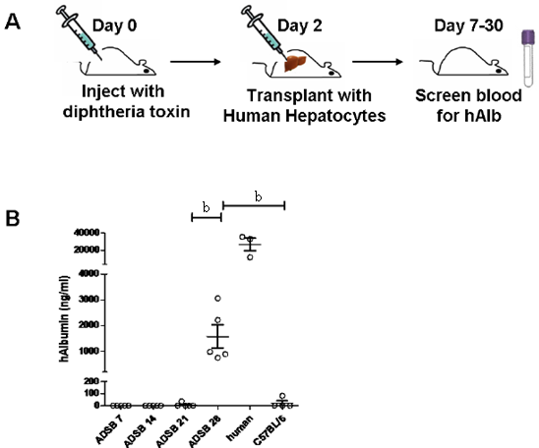
Figure 4 Human albumin plasma concentration in Alb-cre/DTR/SCID-beige mice after adult hepatocyte transplantation. A: Schematic of liver humanization. Two days after the intraperitoneal injection of diphtheria toxin (DT), serum was collected for ALT assay. Human hepatocytes were transplanted into these mice on the same day; B: Serum levels of human albumin are shown for ADSB mice (n = 5) on day 7, 14, 21 and 28 after hepatocyte transplantation by enzyme-linked immunosorbent assay. Results are mean ± SEM (n ≥ 3). ^{b}P < 0.01.

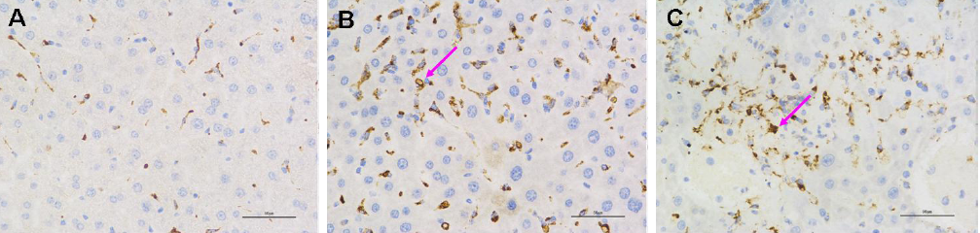
Figure 5 Human Kupffer cells in the liver of Alb-cre/DTR/SCID-beige mice. Human Kupffer cells stained with CD68, showing the high degree of liver chimerism. A: Non-transplanted C57BL/6 mice; B: ADSB mice 4 wk after transplantation; C: ADSB mice 12 wk after transplantation. Red arrows exhibit positive staining. Scale bar = 50 µm, × 400.

