Name of Journal: World Journal of Meta-Analysis
Manuscript NO: 77022
Manuscript Type: META-ANALYSIS

Outcomes of microwave versus radiofrequency ablation for hepatocellular carcinoma: A systematic review and meta-analysis

Tang MJ et al. Microwave versus radiofrequency ablation for HCC

Myo Jin Tang, Guy D Eslick, John S Lubel, Ammar Majeed, Avik Majumdar, William Kemp, Stuart K Roberts

Myo Jin Tang, John S Lubel, Ammar Majeed, William Kemp, Stuart K Roberts, Department of Gastroenterology, Alfred Hospital, Melbourne 3004, Victoria, Australia

Myo Jin Tang, Monash Medical School, Monash University, Melbourne 3004, Victoria, Australia

Guy D Eslick, Department of Statistics, Clued Pty Ltd, Sydney 2006, New South Wales, Australia

John S Lubel, Ammar Majeed, William Kemp, Stuart K Roberts, Central Clinical School, Monash University, Melbourne 3004, Victoria, Australia

Avik Majumdar, Department of Gastroenterology, Austin Hospital, Heidelberg 3084, Victoria, Australia

Avik Majumdar, Department of Medicine, Austin Campus, University of Medicine, Melbourne 3084, Victoria, Australia

Author contributions: Tang MJ performed the systematic review, acquisition and interpretation of the data, drafting the article, and final approval; Eslick GD performed the statistical analysis and interpretation of the data, drafting the article, and final approval; Lubel JS performed the systematic review, acquisition and interpretation of the data, drafting the article, and final approval; Majeed A performed interpretation of the data, review of the article, and final approval; Majumdar A contributed to the study design, interpretation of the data, review of the article, and final approval; Kemp W contributed to study concept and design, interpretation of the data, drafting and review of the article, and final approval; Roberts SK contributed to study concept and design, interpretation of the data, drafting and review of the article, and final approval.

Corresponding author: Stuart K Roberts, FAASLD, AGAF, FRACP, MBBS, MD, Adjunct Professor, Department of Gastroenterology, Alfred Hospital, 99 Commercial Rd, Melbourne 3004, Victoria, Australia. s.roberts@alfred.org.au

Received: April 24, 2022
Revised: July 1, 2022
Accepted: August 10, 2022
Published online: August 28, 2022

Abstract
BACKGROUND
Studies to date comparing outcomes of microwave ablation (MWA) with radiofrequency ablation (RFA) on patients with hepatocellular carcinoma have yielded conflicting results, with no clear superiority of one technique over the other. The aim of this systematic review and meta-analysis was to compare the efficacy and safety of MWA with RFA.

AIM
To perform a systematic review and meta-analysis comparing the efficacy and safety of MWA with RFA.

METHODS
A systematic literature search was performed using Ovid Medline, Embase, PubMed, Reference Citation Analysis, Cochrane Central and Cochrane Systematic Review databases, and Web of Science. Abstracts and full manuscripts were screened for inclusion utilising predefined inclusion and exclusion criteria comparing outcomes of MWA and RFA. A random-effects model was used for each outcome. Meta-regression analysis was performed to adjust for the difference in follow-up period between the studies. Primary outcome measures included complete ablation (CA) rate, local recurrence rate (LRR), survival [local recurrence-free survival (LRFS), overall survival (OS)] and adverse events.

RESULTS
A total of 42 published studies [34 cohort and 8 randomised controlled trials (RCT)] with 6719 patients fulfilled the selection criteria. There was no significant difference in tumour size between the treatment groups. CA rates between MWA and RFA groups were similar in prospective cohort studies [odds ratio (OR) 0.95, 95% confidence interval (CI) 0.28–3.23] and RCTs (OR 1.18, 95%CI 0.64–2.18). However, retrospective studies reported higher rates with MWA (OR 1.29, 95%CI 1.06–1.57). Retrospective cohort studies reported higher OS (OR 1.54, 95%CI 1.15–2.05 and lower LRR (OR 0.67, 95%CI 0.51–0.87). No difference in terms of LRFS or 30-d mortality was observed between both arms. MWA had an increased rate of adverse respiratory events when compared to RFA (OR 1.99, 95%CI 1.07–3.71, P = 0.03).

CONCLUSION
MWA achieves similar CA rates and as good or better longer-term outcomes in relation to LRR and OS compared to RFA. Apart from an increased rate of respiratory events post procedure, MWA is as safe as RFA.

Key Words: Microwave ablation; Radiofrequency ablation; Hepatocellular carcinoma; Survival; Recurrence; Meta-analysis

©The Author(s) 2022. Published by Baishideng Publishing Group Inc. All rights reserved.

Citation: Tang MJ, Eslick GD, Lubel JS, Majeed A, Majumdar A, Kemp W, Roberts SK. Outcomes of microwave versus radiofrequency ablation for hepatocellular carcinoma: A systematic review and meta-analysis. World J Meta-Anal 2022; 10(4): 220-237
URL: https://www.wjgnet.com/2308-3840/full/v10/i4/220.htm
DOI: https://dx.doi.org/10.13105/wjma.v10.i4.220

Core Tip: Studies to date comparing outcomes of microwave ablation with radiofrequency ablation have yielded conflicting results, with no clear superiority of one technique over the other. To our knowledge, this is the most comprehensive study on this topic. A large cohort of 6719 patients were examined, enabling us to identify outliers and provide results with a smaller margin of error. The primary outcomes of this study were complete ablation, local recurrence rate, overall and local recurrence free survival and safety.

INTRODUCTION
Hepatocellular carcinoma (HCC) now ranks worldwide as the seventh most common cancer and the second leading cause of cancer mortality^{[1-3]} and is rapidly increasing in incidence in several developed regions including North America, Europe, and Australasia^{[4-6]}. Furthermore, an increasing proportion of HCC patients are being diagnosed at an early stage and are eligible for curative therapy^{[7,8]} including local ablation which is considered standard of care for those not suitable for surgery^{[9-11]}.
Of the common modalities used to ablate HCC, radiofrequency ablation (RFA) is the most strongly recommended^{[12]}. This is based on evidence from randomised controlled trials (RCTs)^{[13-16]} and three meta-analyses^{[17-19]} showing that RFA provides better local disease control and overall survival (OS) outcomes than percutaneous ethanol injection, particularly among nonsurgical candidates^{[20]}. Recently, microwave ablation (MWA) has become a popular ablative technique because of its reduction in heat-sink effect, ability to produce wider and more predictable ablation volumes that result in high complete ablation rates, and the ability to simultaneously treat multiple and/or larger lesions more effectively and over a shorter procedural time^{[12,21]}. Studies to date comparing outcomes of MWA with RFA have yielded conflicting results, with no clear superiority of one technique over the other^{[22-24]}. A Cochrane review reported that there were insufficient data to recommend RFA over other thermal ablation techniques in the management of HCC^{[25]}, with the authors emphasising that only a single small RCT comparing MWA with RFA, with a total of 72 patients, had been performed^{[23]}. Subsequently, a further six RCTs have been performed with the latest meta-analysis only including five RCTs and 21 cohort studies^{[26]}. In this context, additional evidence, particularly from a comprehensive meta-analysis that incorporated all RCTs, and data from large real-world observational cohort studies would provide clinicians with a better understanding of whether the comparative overall efficacy and safety of MWA over RFA supports the current preferential use of MWA for the treatment of early-stage HCC.
This study was a contemporary systematic review and meta-analysis of RCTs and cohort studies to determine whether MWA is equivalent to or more effective than RFA in relation to the primary treatment endpoints of complete ablation (CA), local recurrence rate (LRR), local recurrence-free survival (LRFS), OS, and safety including adverse events.

MATERIALS AND METHODS
Literature search
The Preferred Reporting Items for Systematic reviews and Meta-Analyses (PRISMA) guidelines^{[27]} were followed and the Assessment of Multiple Systematic Reviews (AMSTAR) measurement tool^{[28]} was used to perform this study. A systematic electronic search was conducted independently by two authors in the Ovid Medline, Embase, PubMed, Reference Citation Analysis, Cochrane library databases, and Web of Science was performed from the inception of each until the first week of October 2021 inclusive of the database of articles that were accepted but not yet published, as well as the clinicaltrials.gov website to identify relevant articles for our review (Supplementary Tables 1–5). The search strategy used the search terms “radiofrequency ablation”, “microwave ablation” and “hepatocellular carcinoma” both as exploded medical subject headings where possible, and as text words. In addition, reference lists of relevant articles including recent reviews, and systematic reviews related to locoregional therapy of HCC were searched. Studies were limited to cohort studies and RCTs using appropriate hedges for each database. A search for unpublished literature was also performed.

Eligibility criteria
Studies were included using the following criteria: (1) patient age ≥ 18 years; (2) diagnosis of HCC by American Association for the Study of Liver Disease imaging criteria^{[29]} or histopathology; (3) HCC of any size; and (4) no evidence of macrovascular invasion or extrahepatic spread. Studies were excluded based on the following criteria: (1) case series; (2) studies from the same group that contain overlapping patient populations; (3) treatment with any other modality in conjunction with local ablation therapy with microwave ablation or radiofrequency ablation; (4) non-HCC liver cancer; and (5) Studies where treatment was given as a bridge to liver transplantation.

Study outcomes
The primary outcomes of this study were CA, LRR, LRFS, OS and safety including adverse events and complications. CA was defined in studies as the absence of residual HCC on follow-up imaging postablation. LRR was defined in studies as the development of HCC lesions within the same liver segment as the treated tumour on imaging after CA. LRFS was defined as the proportion of patients alive at various timepoints in the absence of any evidence of local recurrence of HCC after treatment. Included studies had to have reported at least one of the primary endpoints as part of an RCT or observational cohort study.

Selection process
The initial literature search was performed independently by two reviewers (MJT and JL) to identify relevant articles based on the above inclusion and exclusion criteria. Where a difference of opinion occurred on the inclusion of studies for the review, consensus agreement was obtained via formal discussion between the two reviewers.

Data collection and bias assessment
Included RCTs were assessed for methodological quality and were classified as being of low, high, or unclear risk of bias according to the Jadad scale^{[30]}. Included cohort studies were quality assessed using the Newcastle–Ottawa Scale^{[31]} where a value ≥ 7 qualified the study as high quality. Data were extracted from the selected studies independently using a data extraction form to collect data on the following: (1) study details (first author, publication year, journal, country, study design, interventions used, intervention group size); (2) baseline participant characteristics (age, sex, and cirrhosis status); (3) tumour characteristics (tumour stage and staging system, largest nodule size, nodule number, alfa-fetoprotein level, mean-tumour size); (4) intervention details; and (5) outcome measures: (complete ablation, local recurrence rate, overall and local recurrence free survival, adverse events, 30-d mortality).

Statistical analysis
A random-effects model using the method of DerSimonian and Laird was used for each outcome. Meta-regression analysis was performed to adjust for the difference in follow-up period between the studies. Analysis was also performed individually for RCTs, prospective and retrospective cohort studies. Heterogeneity was assessed using the I² statistic with results of 30%–60% (moderate), and > 50% (high) levels of heterogeneity^{[32]}. Outcomes were reported using a pooled odds ratio (OR) and hazard ratio (HR) with 95% confidence interval (CI). We assessed publication bias using the Egger’s regression model only if there were > 10 studies. All analyses were performed with Comprehensive Meta-analysis (version 3.0), Biostat, Englewood, NJ (2014). The statistical methods of this study were reviewed by academic statistician Guy Eslick from Clued Ptd Ltd.

RESULTS
Study selection and characteristics of included studies
As shown in Figure 1, the search strategy utilised for this meta-analysis identified 2758 studies initially. After removing duplicates and excluding studies based on our inclusion and exclusion criteria, 170 studies were assessed for eligibility from which a total of 42 studies, eight RCTs^{[22,23,33-38]} and 34 cohort studies^{[33,39-71]} were finally included in the meta-analysis. The main characteristics of included studies are reported in Table 1. The sample size of included studies (eight RCTs and 34 cohort studies) ranged from 42 to 879, with males forming the majority. In total, we examined a cohort of 6719 patients. A total of 24 studies were conducted in Asia, nine in Europe, five in Egypt, two in the USA, and one each in Australia and Turkey. Study follow-up duration ranged from 3 to 126 mo and was performed through the utilisation of computed tomography or magnetic resonance imaging. Across all studies, the mean age reported was 61 years. Most studies recruited patients with Child–Pugh stage A and B liver disease with only one RCT and nine cohort studies recruiting stage C patients. Notably, all 42 studies were comparable with regards to clinical and tumoral parameters. Maximum nodule sized ranged from 9 to 55 mm in RCTs and 8 to 60 mm in cohort studies. In total, six RCTs and 18 cohort studies reported mean tumour size. There was no significant difference in tumour size treated with MWA compared to RFA in both RCTs (OR 1.13, 95%CI 0.88–1.46) and cohort studies (OR 0.96, 95%CI 0.77–1.20) (Supplementary Figure 1). Furthermore, there was no significant difference in mean tumour size amongst RCTs (OR 0.05, 95%CI -0.07 to 0.18; P = 0.395) and cohort studies (OR -0.01, 95%CI -0.09 to 0.07; P = 0.777) (Supplementary Figure 2). The total number of lesions treated per study with MWA and RFA ranged from 15 to 1090 and 20 to 562, respectively.

Quality assessment
Seven of the eight RCTs assessed were deemed to be high quality with one study^{[22]} deemed to be of low quality (Supplementary Table 6). All RCTs were determined to be at high risk of performance bias as it was not practical to blind the administrator to the procedure. However, four RCTs^{[23,34,37,38]} were able to blind the outcome of assessment. Potential for selection and detection bias was identified in four RCTs^{[22,35,36,72]}. Of the 34 cohort studies identified, 30 scored a value of 7 or higher, meeting the definition of a high-quality study (Supplementary Table 7).

CA
Seven RCTs^{[22,23,34-37,72]} and 24 cohort studies^{[39,42-46,48-51,54,55,60-71]} reported data on CA post-treatment. No significant difference in the CA rate was found between the MWA and RFA groups in the prospective cohort studies (OR 0.95, 95%CI 0.28–3.23; P = 0.82)^{[41,46,49,59,71]} and RCTs (OR 1.18, 95%CI 0.64–2.18; P = 0.60)^{[22,23,34-37,72]}. However, retrospective cohort studies reported higher CA rates with MWA compared to RFA (OR 1.29, 95%CI 1.06–1.57; P = 0.01) (Figure 2A)[39,42-45,48,50,51,54,55,60-70]. No evidence of heterogeneity was found in these studies (P = 0.99). Funnel plot analysis concluded that publication bias was unlikely (Figure 2B).

OS
Five RCTs^{[22,34,35,38,72]} and 17 cohort studies[33,41,43,47,51,52,54,57,59-63,66,68,70,71] reported data on OS post-ablation (Table 2). Heterogeneity was identified in the results reported at 3 and 4 years by retrospective cohort studies (Table 2)^{[33,43,51,52,54,57,66,68,70]}. In studies that categorised data into OS into specific years, no significant difference in OS was noted between MWA and RFA groups. Meta-analysis of four retrospective studies that did not specify the follow-up period^{[52,54,59,63]} reported significantly higher OS in patients treated with MWA. No potential bias was identified during visual assessment and Egger’s test of funnel plot.
Individual study OS rates were plotted on a dot graph for both MWA and RFA treated subjects (Figure 3) with median OS rates according to year of follow-up post-treatment shown in Table 3. Of note, MWA was associated with improved median OS at 3 and 4 years of follow-up but this difference was lost at 5 years.

LRR
Six RCTs^{[22,23,35,36,38,72]} and 26 cohort studies[39-41,43,44,46,47,49,51-58,60,61,63-70] reported data regarding LRR following ablation (Table 2). One RCT^{[22]} reported lower 5-year LRR when patients were treated with MWA (OR 0.52, 95%CI 0.30–0.91; P = 0.023). Heterogeneity was identified in the results reported at 1, 2 and 3 years by retrospective cohort studies while meta-analysis of two retrospective cohort studies^{[53,57]} reported a higher 4-year LRR in patients treated with MWA (OR 2.14, 95%CI 1.12–4.07, P = 0.021) (Table 2). However, meta-analysis of 20 retrospective cohort studies that reported LRR over an unspecified period[39-41,43,44,46,52-54,56-58,60,63,65-70] concluded that LRR was significantly lower in patients treated with MWA (OR 0.67, 95%CI 0.51–0.87, P = 0.002). Three cohort studies reported LRR according to tumour size ≤ 3 cm^{[43,52,54]} with no statistcally significant differences identified between the MWA and RFA groups (OR 0.86, 95%CI 0.45–1.64, P = 0.64). No potential bias was identified during visual assessment and Egger’s test of funnel plot.

HR for OS and LRR
Four RCTs^{[22,34,38,72]} and 18 cohort studies[39,41,43-45,51-53,57-61,64,66,68,70] reported HR data regarding OS (Table 4). No significant differences were noted in OS between both arms. However, there was a trend towards better OS rates in patients treated with MWA in both RCTs (P = 0.08) and prospective cohort studies (P = 0.08) over an unspecified period (Table 4). Five retrospective cohort studies reported HR data regarding LRR^{[39,53,58,61,64]}. No significant differences were noted in LRR between both arms. No potential bias was identified during visual assessment and Egger’s test of funnel plot.

LRFS
One RCT^{[35]} reported that there was no significant difference between MWA and RFA with regards to 1-year LRFS (OR 1.175, 95%CI 0.178–7.737, P = 0.93). One cohort study^{[63]} reported that there was no significant difference between MWA and RFA with regards to LRFS (OR 0.53, 95%CI 0.148–1.86).

Safety
Three RCTs^{[34,35,38]} and 14 cohort studies[33,39,47,48,51,58,60,62-64,67-70] reported data regarding 30-d mortality (Figure 4). No significant differences were identified between the MWA and RFA groups in both RCTs (OR 1.00, 95%CI 0.19–5.14, P = 1.0) and cohort studies (OR 0.67, 95%CI 0.27–1.68, P = 0.39). There was no heterogeneity identified between studies. A sensitivity analysis excluding studies that reported no deaths in both arms was performed (Figure 4), but results remained consistent with the main analysis (OR 0.61, 95%CI 0.25–1.51, P = 0.29). No potential bias was identified during visual assessment and Egger’s test of funnel plot.
With regard to morbidity, five RCTs^{[23,35,36,38,72]} and 20 cohort studies[33,39,43,44,47-49,51,52,54,57,58,60,61,63-66,68,70] reported data on adverse events (Table 5). There were no significant differences in rates of liver-related morbidity, postprocedural bleeding and infections, local events, and bile duct injury when comparing the two interventions. MWA had a significantly increased rate of adverse respiratory events when compared to RFA (OR 1.99, 95%CI 1.07–3.71, P = 0.03). No potential bias was identified during visual assessment and Egger’s test of funnel plot.

DISCUSSION
Local thermal ablation is the standard of care for patients with unresectable early-stage HCC. MWA is increasingly preferred to RFA because of its ability to produce wider and more predictable ablation volumes over a shorter procedural time^{[17,19,22]}. Moreover, MWA has theoretical advantages including minimising heat-sink effect that limits the use of RFA to lesions with proximity to adjacent structures. To our knowledge, our study is the most detailed systematic review and meta-analysis to date having identified 42 studies including eight RCT’s and 34 cohort studies involving a total of 6719 subjects, that compared the outcomes of the two treatment modalities. Our main findings were that MWA achieves similar complete ablation rates compared with RFA, as well as lower LRR and similar OS. However, adverse events associated with MWA appear higher, particularly in relation to procedure-related respiratory events.
In our study, we found MWA achieved similar or better CA rates than RFA depending on the study design. Notably CA rates were similar between the two modalities among RCTs, as previously reported^{[73,74]}, as well as among prospective cohort studies. However, higher CA rates were associated with MWA among retrospective cohort studies, which was likely due to multiple factors including patient selection, tumour size and the technique used; notwithstanding the fact that nearly threefold more cohort studies were captured in our study compared to other smaller meta-analyses of this type^{[24,40,73]}. These findings align with preclinical data that MWA results in higher intratumoral temperature and greater ablation range^{[75]}, that should in theory lead to faster ablation times and high rates of CA^{[76]}.
In addition, we identified MWA utilisation was overall associated with similar rates of local recurrence to RFA among RCTs and prospective cohort studies. However lower recurrence rates with MWA were reported among retrospective cohort studies, although results were inconsistent with two retrospective cohort studies reporting lower rates of local recurrence with RFA at the 4-year mark, while one RCT reported lower rates of LRR with MWA at the 5-year mark^{[22,53,54]}. Moreover, because this was an analysis of LRR data without a specific timeframe, caution should be exercised as the follow-up for individual studies varied. Potential reasons for discordance in results include the fact that different generators were among studies as well as variation in the reporting outcomes with some studies reporting cumulative LRR. Notably, previous meta-analyses evaluating MWA and LRR have also drawn different conclusions, with two reports concluding that MWA resulted in significantly lower LRR^{[73,77]}, while a more recent study found no difference between both interventions^{[74]}. These data combined with ours point to the fact that LRRs following MWA of HCC are at least as good as that following RFA.
An important finding from our study was the identification that MWA appears to lead to better OS, particularly among retrospective cohort studies. However, because this was mainly among studies with no specified follow-up period, we were unable to determine the timeframe to which the improvement in OS applies. Still, median OS rates tend to favour MWA particularly within the first few years postablation. Previous meta-analyses found that up until the 5-year mark, there was no difference between OS rates^{[24,40,73,74,77]}. Except for Huo and colleagues^{[24]}], these meta-analysis did not look at yearly OS. Long-term OS could be affected by interventional factors such as frequency, duration, and power of the ablative machines used. Furthermore, patient factors such as age, pre-existing liver disease and severity, and socioeconomic status could all contribute to OS. As we were unable to account for all these potentially confounding factors, it raises the question whether our results can be applied to the clinical setting with certainty.
In relation to adverse events, previous meta-analyses have concluded that there was no difference in complication rates between both interventions^{[24,73,74]}. In our study, we identified a significantly increased rate of adverse respiratory events (i.e., pleural effusion and pneumothorax) associated with MWA in 14 studies but no significant differences in local and/or liver related complications. This novel finding could influence the current perception that MWA has a similar safety profile to that of RFA despite the larger ablation zone. One possible explanation of the presence of pleural effusions could be due to thermal injury to the diaphragm resulting in an inflammatory response and/or diaphragmatic microperforations resulting in leakage of fluid from the peritoneal cavity to the pleural space. Similarly, the increased rates of pneumothorax could reflect inadvertent pleural puncture with subsequent air leakage into the pleural space. Ultimately, this novel safety finding adds a layer of complexity when making the decision to choose between MWA or RFA for ablating HCC.
The strengths of our study included it being, to our knowledge, the most comprehensive study on this topic to date. We examined a large cohort of 6719 patients that enabled us to identify outliers and provide results with a smaller margin of error. In addition, data were categorised based on follow-up period, allowing us to identify if the difference between our primary outcomes for each individual year was significant. Finally, an analysis of tumour size was performed ruling out a potential confounding factor. Nevertheless, our findings should be interpreted with caution in view of certain limitations. Firstly, only studies published in English were included, which could lead to selection bias. Secondly, we did not explore the influence of generators and antennas used to perform the procedures which could present as a confounding factor. Furthermore, although we had a significant number of RCTs, the majority of studies were retrospective cohort studies that are susceptible to both selection bias and information bias due to the difficulty in achieving accurate record keeping and recounts of events, as well as complete data retrieval. Conference abstracts were included in our study which allowed for a more comprehensive look at the subject matter but potentially at the cost of preliminary results. Also, a significant number of studies included were conducted by a single centre, and hence subject to patient selection bias. Moreover, eligibility criteria for inclusion of patients were not standardized among studies.

CONCLUSION
Our results suggest that compared to RFA, MWA achieves similar CA rates and as good or better longer-term outcomes in relation to LRR and OS. Our analysis of tumour size suggests that it is unlikely to affect our conclusion. Apart from an increased likelihood of postprocedural respiratory events, MWA is as safe as RFA. Current guidelines recommend RFA to bridge transplantation or in early HCC^{[10,78]}. Our novel results suggest that all guidelines should consider these ablative techniques as being interchangeable as standard of care.

ARTICLE HIGHLIGHTS
Research background
Hepatocellular carcinoma (HCC) is the seventh most common cancer and second leading cause of cancer mortality. Of the common modalities used to ablate HCC, radiofrequency ablation (RFA) is the most strongly recommended. Recently, microwave ablation (MWA) has become a popular ablative technique because of its reduction in heat-sink effect, ability to produce wider and more predictable ablation volumes.

Research motivation
Studies to date comparing outcomes of MWA with RFA have yielded conflicting results, with no clear superiority of one technique over the other. In this context, additional evidence particularly from a comprehensive meta-analysis that incorporate all RCTs and data from large real-world observational cohort studies would provide clinicians with a better understanding.

Research objectives
This study was a contemporary systematic review and meta-analysis of RCTs and cohort studies to determine whether MWA is equivalent to or more effective than RFA in relation to the primary treatment endpoints of complete ablation (CA), local recurrence rate (LRR), local recurrence-free survival, overall survival (OS), and safety including adverse events.

Research methods
A systematic electronic search was conducted independently by two authors. Quality of included studies were assessed using the Jadad scale for RCTs and Newcastle–Ottawa Scale for cohort studies. A random-effects model using the method of DerSimonian and Laird was used for each outcome. Meta-regression analysis was performed to adjust for the difference in follow-up period between the studies.

Research results
A total of 42 studies, eight RCTs and 34 cohort studies were included in the meta-analysis, allowing us to examine a total cohort of 6719 patients. CA rates between MWA and RFA groups were similar in prospective cohort and RCTs; however, retrospective studies reported higher rates with MWA. Retrospective cohort studies reported higher OS and lower LRR. MWA had an increased rate of adverse respiratory events when compared to RFA.

Research conclusions
MWA achieves similar CA rates and as good or better longer-term outcomes in relation to LRR and OS compared to RFA. Apart from an increased rate of respiratory events post procedure, MWA is as safe as RFA.

Research perspectives
Current literature on local recurrence free survival is lacking and has potential to be explored in future studies.

REFERENCES
1 Bray F, Ferlay J, Soerjomataram I, Siegel RL, Torre LA, Jemal A. Global cancer statistics 2018: GLOBOCAN estimates of incidence and mortality worldwide for 36 cancers in 185 countries. CA Cancer J Clin 2018; 68: 394-424 [PMID: 30207593 DOI: 10.3322/caac.21492]
2 The Lancet. GLOBOCAN 2018: counting the toll of cancer. Lancet 2018; 392: 985 [PMID: 30264708 DOI: 10.1016/S0140-6736(18)32252-9]
3 Ferlay J, Colombet M, Soerjomataram I, Mathers C, Parkin DM, Piñeros M, Znaor A, Bray F. Estimating the global cancer incidence and mortality in 2018: GLOBOCAN sources and methods. Int J Cancer 2019; 144: 1941-1953 [PMID: 30350310 DOI: 10.1002/ijc.31937]
4 El-Serag HB, Mason AC. Rising incidence of hepatocellular carcinoma in the United States. N Engl J Med 1999; 340: 745-750 [PMID: 10072408 DOI: 10.1056/NEJM199903113401001]
5 Law MG, Roberts SK, Dore GJ, Kaldor JM. Primary hepatocellular carcinoma in Australia, 1978-1997: increasing incidence and mortality. Med J Aust 2000; 173: 403-405 [PMID: 11090031 DOI: 10.5694/j.1326-5377.2000.tb139267.x]
6 Center MM, Jemal A. International trends in liver cancer incidence rates. Cancer Epidemiol Biomarkers Prev 2011; 20: 2362-2368 [PMID: 21921256 DOI: 10.1158/1055-9965.EPI-11-0643]
7 Kemp W, Pianko S, Nguyen S, Bailey MJ, Roberts SK. Survival in hepatocellular carcinoma: impact of screening and etiology of liver disease. J Gastroenterol Hepatol 2005; 20: 873-881 [PMID: 15946134 DOI: 10.1111/j.1440-1746.2005.03844.x]
8 Bruix J, Llovet JM. Major achievements in hepatocellular carcinoma. Lancet 2009; 373: 614-616 [PMID: 19231618 DOI: 10.1016/S0140-6736(09)60381-0]
9 Forner A, Llovet JM, Bruix J. Hepatocellular carcinoma. Lancet 2012; 379: 1245-1255 [PMID: 22353262 DOI: 10.1016/S0140-6736(11)61347-0]
10 European Association for the Study of the Liver. Electronic address: easloffice@easloffice.eu.; European Association for the Study of the Liver. EASL Clinical Practice Guidelines: Management of hepatocellular carcinoma. J Hepatol 2018; 69: 182-236 [PMID: 29628281 DOI: 10.1016/j.jhep.2018.03.019]
11 Lencioni R, Crocetti L. Local-regional treatment of hepatocellular carcinoma. Radiology 2012; 262: 43-58 [PMID: 22190656 DOI: 10.1148/radiol.11110144]
12 Breen DJ, Lencioni R. Image-guided ablation of primary liver and renal tumours. Nat Rev Clin Oncol 2015; 12: 175-186 [PMID: 25601446 DOI: 10.1038/nrclinonc.2014.237]
13 Lencioni RA, Allgaier HP, Cioni D, Olschewski M, Deibert P, Crocetti L, Frings H, Laubenberger J, Zuber I, Blum HE, Bartolozzi C. Small hepatocellular carcinoma in cirrhosis: randomized comparison of radio-frequency thermal ablation versus percutaneous ethanol injection. Radiology 2003; 228: 235-240 [PMID: 12759473 DOI: 10.1148/radiol.2281020718]
14 Brunello F, Veltri A, Carucci P, Pagano E, Ciccone G, Moretto P, Sacchetto P, Gandini G, Rizzetto M. Radiofrequency ablation versus ethanol injection for early hepatocellular carcinoma: A randomized controlled trial. Scand J Gastroenterol 2008; 43: 727-735 [PMID: 18569991 DOI: 10.1080/00365520701885481]
15 Lin SM, Lin CJ, Lin CC, Hsu CW, Chen YC. Radiofrequency ablation improves prognosis compared with ethanol injection for hepatocellular carcinoma < or =4 cm. Gastroenterology 2004; 127: 1714-1723 [PMID: 15578509 DOI: 10.1053/j.gastro.2004.09.003]
16 Shiina S, Teratani T, Obi S, Sato S, Tateishi R, Fujishima T, Ishikawa T, Koike Y, Yoshida H, Kawabe T, Omata M. A randomized controlled trial of radiofrequency ablation with ethanol injection for small hepatocellular carcinoma. Gastroenterology 2005; 129: 122-130 [PMID: 16012942 DOI: 10.1053/j.gastro.2005.04.009]
17 Cho YK, Kim JK, Kim MY, Rhim H, Han JK. Systematic review of randomized trials for hepatocellular carcinoma treated with percutaneous ablation therapies. Hepatology 2009; 49: 453-459 [PMID: 19065676 DOI: 10.1002/hep.22648]
18 Germani G, Pleguezuelo M, Gurusamy K, Meyer T, Isgrò G, Burroughs AK. Clinical outcomes of radiofrequency ablation, percutaneous alcohol and acetic acid injection for hepatocelullar carcinoma: a meta-analysis. J Hepatol 2010; 52: 380-388 [PMID: 20149473 DOI: 10.1016/j.jhep.2009.12.004]
19 Orlando A, Leandro G, Olivo M, Andriulli A, Cottone M. Radiofrequency thermal ablation vs. percutaneous ethanol injection for small hepatocellular carcinoma in cirrhosis: meta-analysis of randomized controlled trials. Am J Gastroenterol 2009; 104: 514-524 [PMID: 19174803 DOI: 10.1038/ajg.2008.80]
20 Majumdar A, Roccarina D, Thorburn D, Davidson BR, Tsochatzis E, Gurusamy KS. Management of people with early- or very early-stage hepatocellular carcinoma: an attempted network meta-analysis. Cochrane Database Syst Rev 2017; 3: CD011650 [PMID: 28351116 DOI: 10.1002/14651858.CD011650.pub2]
21 Boutros C, Somasundar P, Garrean S, Saied A, Espat NJ. Microwave coagulation therapy for hepatic tumors: review of the literature and critical analysis. Surg Oncol 2010; 19: e22-e32 [PMID: 19268571 DOI: 10.1016/j.suronc.2009.02.001]
22 Yu J, Yu XL, Han ZY, Cheng ZG, Liu FY, Zhai HY, Mu MJ, Liu YM, Liang P. Percutaneous cooled-probe microwave versus radiofrequency ablation in early-stage hepatocellular carcinoma: a phase III randomised controlled trial. Gut 2017; 66: 1172-1173 [PMID: 27884919 DOI: 10.1136/gutjnl-2016-312629]
23 Shibata T, Iimuro Y, Yamamoto Y, Maetani Y, Ametani F, Itoh K, Konishi J. Small hepatocellular carcinoma: comparison of radio-frequency ablation and percutaneous microwave coagulation therapy. Radiology 2002; 223: 331-337 [PMID: 11997534 DOI: 10.1148/radiol.2232010775]
24 Huo YR, Eslick GD. Microwave Ablation Compared to Radiofrequency Ablation for Hepatic Lesions: A Meta-Analysis. J Vasc Interv Radiol 2015; 26: 1139-1146.e2 [PMID: 26027937 DOI: 10.1016/j.jvir.2015.04.004]
25 Weis S, Franke A, Mössner J, Jakobsen JC, Schoppmeyer K. Radiofrequency (thermal) ablation versus no intervention or other interventions for hepatocellular carcinoma. Cochrane Database Syst Rev 2013: CD003046 [PMID: 24357457 DOI: 10.1002/14651858.CD003046.pub3]
26 Han J, Fan YC, Wang K. Radiofrequency ablation versus microwave ablation for early stage hepatocellular carcinoma: A PRISMA-compliant systematic review and meta-analysis. Medicine (Baltimore) 2020; 99: e22703 [PMID: 33120763 DOI: 10.1097/MD.0000000000022703]
27 Page MJ, McKenzie JE, Bossuyt PM, Boutron I, Hoffmann TC, Mulrow CD, Shamseer L, Tetzlaff JM, Akl EA, Brennan SE, Chou R, Glanville J, Grimshaw JM, Hróbjartsson A, Lalu MM, Li T, Loder EW, Mayo-Wilson E, McDonald S, McGuinness LA, Stewart LA, Thomas J, Tricco AC, Welch VA, Whiting P, Moher D. The PRISMA 2020 statement: an updated guideline for reporting systematic reviews. BMJ 2021; 372: n71 [PMID: 33782057 DOI: 10.1136/bmj.n71]
28 Shea BJ, Grimshaw JM, Wells GA, Boers M, Andersson N, Hamel C, Porter AC, Tugwell P, Moher D, Bouter LM. Development of AMSTAR: a measurement tool to assess the methodological quality of systematic reviews. BMC Med Res Methodol 2007; 7: 10 [PMID: 17302989 DOI: 10.1186/1471-2288-7-10]
29 Heimbach JK, Kulik LM, Finn RS, Sirlin CB, Abecassis MM, Roberts LR, Zhu AX, Murad MH, Marrero JA. AASLD guidelines for the treatment of hepatocellular carcinoma. Hepatology 2018; 67: 358-380 [PMID: 28130846 DOI: 10.1002/hep.29086]
30 Jadad AR, Moore RA, Carroll D, Jenkinson C, Reynolds DJ, Gavaghan DJ, McQuay HJ. Assessing the quality of reports of randomized clinical trials: is blinding necessary? Control Clin Trials 1996; 17: 1-12 [PMID: 8721797 DOI: 10.1016/0197-2456(95)00134-4]
31 Wells G, Shea B, O'Connell D, Peterson J, Welch V, Losos M, Tugwell P. The Newcastle-Ottawa Scale (NOS) for assessing the quality of nonrandomised studies in meta-analyses. 2022
32 Cumpston M, Li T, Page MJ, Chandler J, Welch VA, Higgins JP, Thomas J. Updated guidance for trusted systematic reviews: a new edition of the Cochrane Handbook for Systematic Reviews of Interventions. Cochrane Database Syst Rev 2019; 10: ED000142 [PMID: 31643080 DOI: 10.1002/14651858.ED000142]
33 Abdel-Samiee M, Elkazaz RR, Rady MA, Metwaly HO, Gomaa AIE. A comparitive study between radiofreguency, microwave and ithanol injection in treatment of hepatocellular carcinoma: A single center experience. Hepatol Int 2020; 14: S240-S241 [DOI: 10.1007/s12072-020-10030-4]
34 Chong CCN, Lee KF, Cheung SYS, Chu CCM, Fong AKW, Wong J, Hui JWY, Fung AKY, Lok HT, Lo EYJ, Chan SL, Yu SCH, Ng KKC, Lai PBS. Prospective double-blinded randomized controlled trial of Microwave versus RadioFrequency Ablation for hepatocellular carcinoma (McRFA trial). HPB (Oxford) 2020; 22: 1121-1127 [PMID: 32044268 DOI: 10.1016/j.hpb.2020.01.008]
35 Kamal A, Elmoety AAA, Rostom YAM, Shater MS, Lashen SA. Percutaneous radiofrequency versus microwave ablation for management of hepatocellular carcinoma: a randomized controlled trial. J Gastrointest Oncol 2019; 10: 562-571 [PMID: 31183208 DOI: 10.21037/jgo.2019.01.34]
36 Qian GJ, Wang N, Shen Q, Sheng YH, Zhao JQ, Kuang M, Liu GJ, Wu MC. Efficacy of microwave versus radiofrequency ablation for treatment of small hepatocellular carcinoma: experimental and clinical studies. Eur Radiol 2012; 22: 1983-1990 [PMID: 22544225 DOI: 10.1007/s00330-012-2442-1]
37 Tian G, Yang S, Yuan J, Threapleton D, Zhao Q, Chen F, Cao H, Jiang T, Li L. Comparative efficacy of treatment strategies for hepatocellular carcinoma: systematic review and network meta-analysis. BMJ Open 2018; 8: e021269 [PMID: 30341113 DOI: 10.1136/bmjopen-2017-021269]
38 Vietti Violi N, Duran R, Guiu B, Cercueil JP, Aubé C, Digklia A, Pache I, Deltenre P, Knebel JF, Denys A. Efficacy of microwave ablation versus radiofrequency ablation for the treatment of hepatocellular carcinoma in patients with chronic liver disease: a randomised controlled phase 2 trial. Lancet Gastroenterol Hepatol 2018; 3: 317-325 [PMID: 29503247 DOI: 10.1016/S2468-1253(18)30029-3]
39 Bouda D, Barrau V, Raynaud L, Dioguardi Burgio M, Paulatto L, Roche V, Sibert A, Moussa N, Vilgrain V, Ronot M. Factors Associated with Tumor Progression After Percutaneous Ablation of Hepatocellular Carcinoma: Comparison Between Monopolar Radiofrequency and Microwaves. Results of a Propensity Score Matching Analysis. Cardiovasc Intervent Radiol 2020; 43: 1608-1618 [PMID: 32533309 DOI: 10.1007/s00270-020-02549-8]
40 Chinnaratha MA, Chuang MY, Fraser RJ, Woodman RJ, Wigg AJ. Percutaneous thermal ablation for primary hepatocellular carcinoma: A systematic review and meta-analysis. J Gastroenterol Hepatol 2016; 31: 294-301 [PMID: 26114968 DOI: 10.1111/jgh.13028]
41 Cillo U, Noaro G, Vitale A, Neri D, D'Amico F, Gringeri E, Farinati F, Vincenzi V, Vigo M, Zanus G; HePaTIC Study Group. Laparoscopic microwave ablation in patients with hepatocellular carcinoma: a prospective cohort study. HPB (Oxford) 2014; 16: 979-986 [PMID: 24750429 DOI: 10.1111/hpb.12264]
42 Ciruolo M, Migliore E, Carucci P, Rolle E, Mosso E, Vola S, Risso A, Saracco GM, Gaia S. Percutaneous microwave (MWA) is better than radiofrequency ablation (RFA) to obtain complete response in cirrhotic patients with very early and early hepatocellular carcinoma (HCC). Hepatology (Baltimore, Md) 2020; 72: 701A-702A
43 Ding J, Jing X, Liu J, Wang Y, Wang F, Wang Y, Du Z. Comparison of two different thermal techniques for the treatment of hepatocellular carcinoma. Eur J Radiol 2013; 82: 1379-1384 [PMID: 23726122 DOI: 10.1016/j.ejrad.2013.04.025]
44 Du S, Yang JZ, Chen J, Zhou WG, Sun YY. Comparisons of recurrence-free survival and overall survival between microwave versus radiofrequency ablation treatment for hepatocellular carcinoma: A multiple centers retrospective cohort study with propensity score matching. PLoS One 2020; 15: e0227242 [PMID: 31918433 DOI: 10.1371/journal.pone.0227242]
45 Gaia S, Ciruolo M, Ribaldone DG, Rolle E, Migliore E, Mosso E, Vola S, Risso A, Fagoonee S, Saracco GM, Carucci P. Higher Efficiency of Percutaneous Microwave (MWA) Than Radiofrequency Ablation (RFA) in Achieving Complete Response in Cirrhotic Patients with Early Hepatocellular Carcinoma. Curr Oncol 2021; 28: 1034-1044 [PMID: 33669107 DOI: 10.3390/curroncol28020101]
46 Ghweil A, Osman H. Percutaneous microwave and radiofrequency ablation for hepatocellular carcinoma: A comparative study. Hepatol Int 2019; 13: S161-S162 [DOI: 10.1007/s12072-019-09936-5]
47 Iida H, Aihara T, Ikuta S, Yamanaka N. A comparative study of therapeutic effect between laparoscopic microwave coagulation and laparoscopic radiofrequency ablation. Hepatogastroenterology 2013; 60: 662-665 [PMID: 23178517 DOI: 10.5754/hge12801]
48 Ding J, Jing X, Liu J, Wang Y, Wang F, Wang Y, Du Z. Complications of thermal ablation of hepatic tumours: comparison of radiofrequency and microwave ablative techniques. Clin Radiol 2013; 68: 608-615 [PMID: 23399463 DOI: 10.1016/j.crad.2012.12.008]
49 Kuang M, Xie XY, Huang C, Wang Y, Lin MX, Xu ZF, Liu GJ, Lu MD. Long-term outcome of percutaneous ablation in very early-stage hepatocellular carcinoma. J Gastrointest Surg 2011; 15: 2165-2171 [PMID: 21972056 DOI: 10.1007/s11605-011-1716-2]
50 Kumbar SV, Kumar L, Menon P, Peethambaran M, Somu A, Mathew S, Mathews J, Zacharias P, Philip M. Percutaneous microwave and radiofrequency ablative therapy for hepatocellular carcinoma: A retrospective comparative study. Hepatol Int 2018; 12: S395 [DOI: 10.1007/s12072-018-9852-3]
51 Lee KF, Wong J, Hui JW, Cheung YS, Chong CC, Fong AK, Yu SC, Lai PB. Long-term outcomes of microwave versus radiofrequency ablation for hepatocellular carcinoma by surgical approach: A retrospective comparative study. Asian J Surg 2017; 40: 301-308 [PMID: 26922631 DOI: 10.1016/j.asjsur.2016.01.001]
52 Liu W, Zheng Y, He W, Zou R, Qiu J, Shen J, Yang Z, Zhang Y, Wang C, Wang Y, Zuo D, Li B, Yuan Y. Microwave vs radiofrequency ablation for hepatocellular carcinoma within the Milan criteria: a propensity score analysis. Aliment Pharmacol Ther 2018; 48: 671-681 [PMID: 30063081 DOI: 10.1111/apt.14929]
53 Loriaud A, Denys A, Seror O, Vietti Violi N, Digklia A, Duran R, Trillaud H, Hocquelet A. Hepatocellular carcinoma abutting large vessels: comparison of four percutaneous ablation systems. Int J Hyperthermia 2018; 34: 1171-1178 [PMID: 29457510 DOI: 10.1080/02656736.2018.1440017]
54 Lu MD, Xu HX, Xie XY, Yin XY, Chen JW, Kuang M, Xu ZF, Liu GJ, Zheng YL. Percutaneous microwave and radiofrequency ablation for hepatocellular carcinoma: a retrospective comparative study. J Gastroenterol 2005; 40: 1054-1060 [PMID: 16322950 DOI: 10.1007/s00535-005-1671-3]
55 Mocan T, Radu P, Al Hajjar N, Iancu C, Sparchez Z. Radiofrequency vs. microwave ablation in the treatment of naïve and recurrent hepatocellular carcinoma. J Gastrointestin Liver Dis 2017; 26: 32
56 Nocerino E, Ziemlewicz T, Lee F, Brace C. A comparison of tumor and ablation dimensions after radiofrequency (RF) and microwave (MW) ablation of small hepatocellular carcinoma (HCC) at a single center. J Vasc Interv Radiol 2016; 27: e81 [DOI: 10.1016/j.jvir.2016.04.006]
57 Ohmoto K, Yamamoto S. Comparison between radiofrequency ablation and percutaneous microwave coagulation therapy for small hepatocellular carcinomas. Clin Radiol 2006; 61: 800-1; author reply 801-2 [PMID: 16905390 DOI: 10.1016/j.crad.2006.04.015]
58 Potretzke TA, Ziemlewicz TJ, Hinshaw JL, Lubner MG, Wells SA, Brace CL, Agarwal P, Lee FT Jr. Microwave versus Radiofrequency Ablation Treatment for Hepatocellular Carcinoma: A Comparison of Efficacy at a Single Center. J Vasc Interv Radiol 2016; 27: 631-638 [PMID: 27017124 DOI: 10.1016/j.jvir.2016.01.136]
59 Sakaguchi H, Seki S, Tsuji K, Teramoto K, Suzuki M, Kioka K, Isoda N, Ido K; Japan Society for Laparoscopic Therapy Research. Endoscopic thermal ablation therapies for hepatocellular carcinoma: a multi-center study. Hepatol Res 2009; 39: 47-52 [PMID: 18761680 DOI: 10.1111/j.1872-034X.2008.00410.x]
60 Santambrogio R, Chiang J, Barabino M, Meloni FM, Bertolini E, Melchiorre F, Opocher E. Comparison of Laparoscopic Microwave to Radiofrequency Ablation of Small Hepatocellular Carcinoma (≤3 cm). Ann Surg Oncol 2017; 24: 257-263 [PMID: 27581608 DOI: 10.1245/s10434-016-5527-2]
61 Sever IH, Sucu M, Biyikli E. Radiofrequency and microwave ablation in the treatment of hepatocellular carcinoma. Iran J Radiol 2018; 15 [DOI: 10.5812/iranjradiol.62396]
62 Shum JK, Fung TP, Wong SW. Percutaneous radiofrequency ablation vs percutaneous microwave ablation for hepatocellular carcinoma. Surg Pract 2016; 20: 30 [DOI: 10.1111/1744-1633.12208]
63 Simo KA, Sereika SE, Newton KN, Gerber DA. Laparoscopic-assisted microwave ablation for hepatocellular carcinoma: safety and efficacy in comparison with radiofrequency ablation. J Surg Oncol 2011; 104: 822-829 [PMID: 21520094 DOI: 10.1002/jso.21933]
64 Suwa K, Seki T, Aoi K, Yamashina M, Murata M, Yamashiki N, Nishio A, Shimatani M, Naganuma M. Efficacy of microwave ablation versus radiofrequency ablation for hepatocellular carcinoma: a propensity score analysis. Abdom Radiol (NY) 2021; 46: 3790-3797 [PMID: 33675382 DOI: 10.1007/s00261-021-03008-9]
65 Suwa K, Seki T, Tsuda R, Yamashina M, Murata M, Yamaguchi T, Nishio A, Okazaki K. Short term treatment results of local ablation with water-cooled microwave antenna for liver cancer: Comparison with radiofrequency ablation. Mol Clin Oncol 2020; 12: 230-236 [PMID: 32064099 DOI: 10.3892/mco.2020.1983]
66 Vogl TJ, Farshid P, Naguib NN, Zangos S, Bodelle B, Paul J, Mbalisike EC, Beeres M, Nour-Eldin NE. Ablation therapy of hepatocellular carcinoma: a comparative study between radiofrequency and microwave ablation. Abdom Imaging 2015; 40: 1829-1837 [PMID: 25601438 DOI: 10.1007/s00261-015-0355-6]
67 Xu HX, Xie XY, Lu MD, Chen JW, Yin XY, Xu ZF, Liu GJ. Ultrasound-guided percutaneous thermal ablation of hepatocellular carcinoma using microwave and radiofrequency ablation. Clin Radiol 2004; 59: 53-61 [PMID: 14697375 DOI: 10.1016/j.crad.2003.09.006]
68 Xu Y, Shen Q, Wang N, Wu PP, Huang B, Kuang M, Qian GJ. Microwave ablation is as effective as radiofrequency ablation for very-early-stage hepatocellular carcinoma. Chin J Cancer 2017; 36: 14 [PMID: 28103953 DOI: 10.1186/s40880-017-0183-x]
69 Yin XY, Xie XY, Lu MD, Xu HX, Xu ZF, Kuang M, Liu GJ, Liang JY, Lau WY. Percutaneous thermal ablation of medium and large hepatocellular carcinoma: long-term outcome and prognostic factors. Cancer 2009; 115: 1914-1923 [PMID: 19241423 DOI: 10.1002/cncr.24196]
70 Zhang L, Wang N, Shen Q, Cheng W, Qian GJ. Therapeutic efficacy of percutaneous radiofrequency ablation versus microwave ablation for hepatocellular carcinoma. PLoS One 2013; 8: e76119 [PMID: 24146824 DOI: 10.1371/journal.pone.0076119]
71 Zhang NN, Cheng XJ, Liu JY. Comparison of high-powered MWA and RFA in treating larger hepatocellular carcinoma. Shiyong Zhongliu Zha Zhi 2014; 29: 349-356
72 Abdelaziz A, Elbaz T, Shousha HI, Mahmoud S, Ibrahim M, Abdelmaksoud A, Nabeel M. Efficacy and survival analysis of percutaneous radiofrequency versus microwave ablation for hepatocellular carcinoma: an Egyptian multidisciplinary clinic experience. Surg Endosc 2014; 28: 3429-3434 [PMID: 24935203 DOI: 10.1007/s00464-014-3617-4]
73 Tan W, Deng Q, Lin S, Wang Y, Xu G. Comparison of microwave ablation and radiofrequency ablation for hepatocellular carcinoma: a systematic review and meta-analysis. Int J Hyperthermia 2019; 36: 264-272 [PMID: 30676100 DOI: 10.1080/02656736.2018.1562571]
74 Facciorusso A, Abd El Aziz MA, Tartaglia N, Ramai D, Mohan BP, Cotsoglou C, Pusceddu S, Giacomelli L, Ambrosi A, Sacco R. Microwave Ablation Versus Radiofrequency Ablation for Treatment of Hepatocellular Carcinoma: A Meta-Analysis of Randomized Controlled Trials. Cancers (Basel) 2020; 12 [PMID: 33339274 DOI: 10.3390/cancers12123796]
75 Wright AS, Sampson LA, Warner TF, Mahvi DM, Lee FT Jr. Radiofrequency versus microwave ablation in a hepatic porcine model. Radiology 2005; 236: 132-139 [PMID: 15987969 DOI: 10.1148/radiol.2361031249]
76 Carrafiello G, Laganà D, Mangini M, Fontana F, Dionigi G, Boni L, Rovera F, Cuffari S, Fugazzola C. Microwave tumors ablation: principles, clinical applications and review of preliminary experiences. Int J Surg 2008; 6 Suppl 1: S65-S69 [PMID: 19186116 DOI: 10.1016/j.ijsu.2008.12.028]
77 Glassberg MB, Ghosh S, Clymer JW, Qadeer RA, Ferko NC, Sadeghirad B, Wright GW, Amaral JF. Microwave ablation compared with radiofrequency ablation for treatment of hepatocellular carcinoma and liver metastases: a systematic review and meta-analysis. Onco Targets Ther 2019; 12: 6407-6438 [PMID: 31496742 DOI: 10.2147/OTT.S204340]
78 Marrero JA, Kulik LM, Sirlin CB, Zhu AX, Finn RS, Abecassis MM, Roberts LR, Heimbach JK. Diagnosis, Staging, and Management of Hepatocellular Carcinoma: 2018 Practice Guidance by the American Association for the Study of Liver Diseases. Hepatology 2018; 68: 723-750 [PMID: 29624699 DOI: 10.1002/hep.29913]

Footnotes
Conflict-of-interest statement: All the authors declare that they have no conflict of interest.

PRISMA 2009 Checklist statement: The authors have read the PRISMA 2009 Checklist, and the manuscript was prepared and revised according to the PRISMA 2009 checklist.

Open-Access: This article is an open-access article that was selected by an in-house editor and fully peer-reviewed by external reviewers. It is distributed in accordance with the Creative Commons Attribution NonCommercial (CC BY-NC 4.0) license, which permits others to distribute, remix, adapt, build upon this work non-commercially, and license their derivative works on different terms, provided the original work is properly cited and the use is non-commercial. See: https://creativecommons.org/Licenses/by-nc/4.0/

Provenance and peer review: Unsolicited article; Externally peer reviewed.
Peer-review model: Single blind
Corresponding Author's Membership in Professional Societies: American Association for the Study of Liver Diseases, No. 1938; European Association for Study of the Liver (EASL), No. 11375; Gastroenterology Society of Australia, No. 525; American Gastroenterological Association, No. 100307.

Peer-review started: April 24, 2022
First decision: June 19, 2022
Article in press: August 10, 2022

Specialty type: Gastroenterology and hepatology
Country/Territory of origin: Australia
Peer-review report’s scientific quality classification
Grade A (Excellent): 0
Grade B (Very good): 0
Grade C (Good): C
Grade D (Fair): 0
Grade E (Poor): E

P-Reviewer: Crocé LS, Italy; Du GS, China S-Editor: Liu JH L-Editor: Kerr C P-Editor: Liu JH
Figure Legends
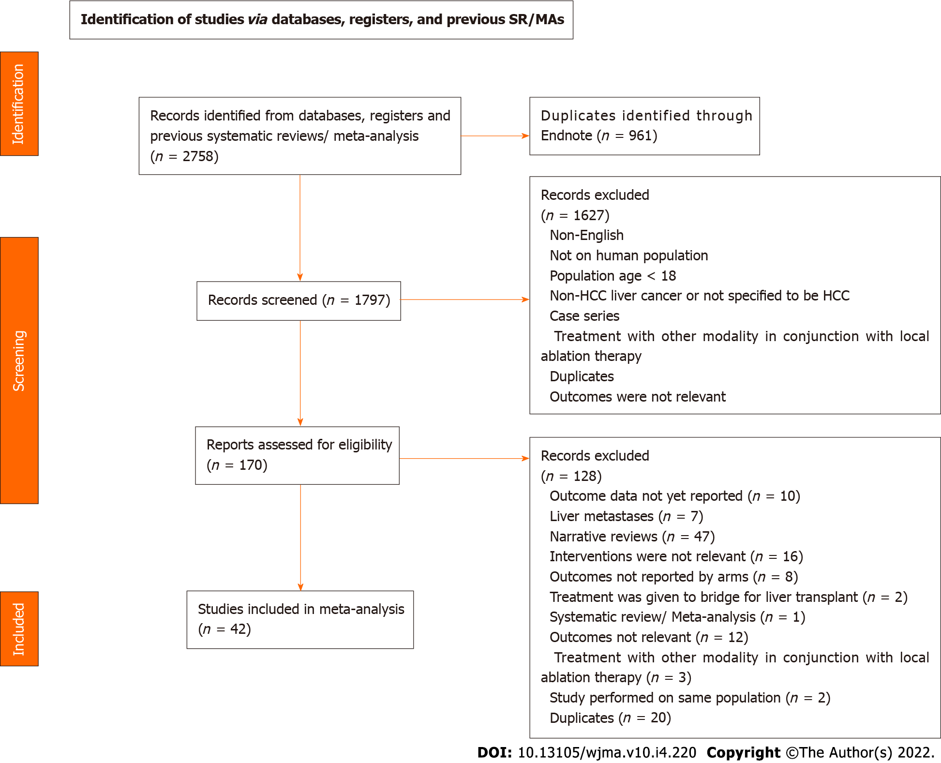
Figure 1 Flowchart of search strategy and article screening process.
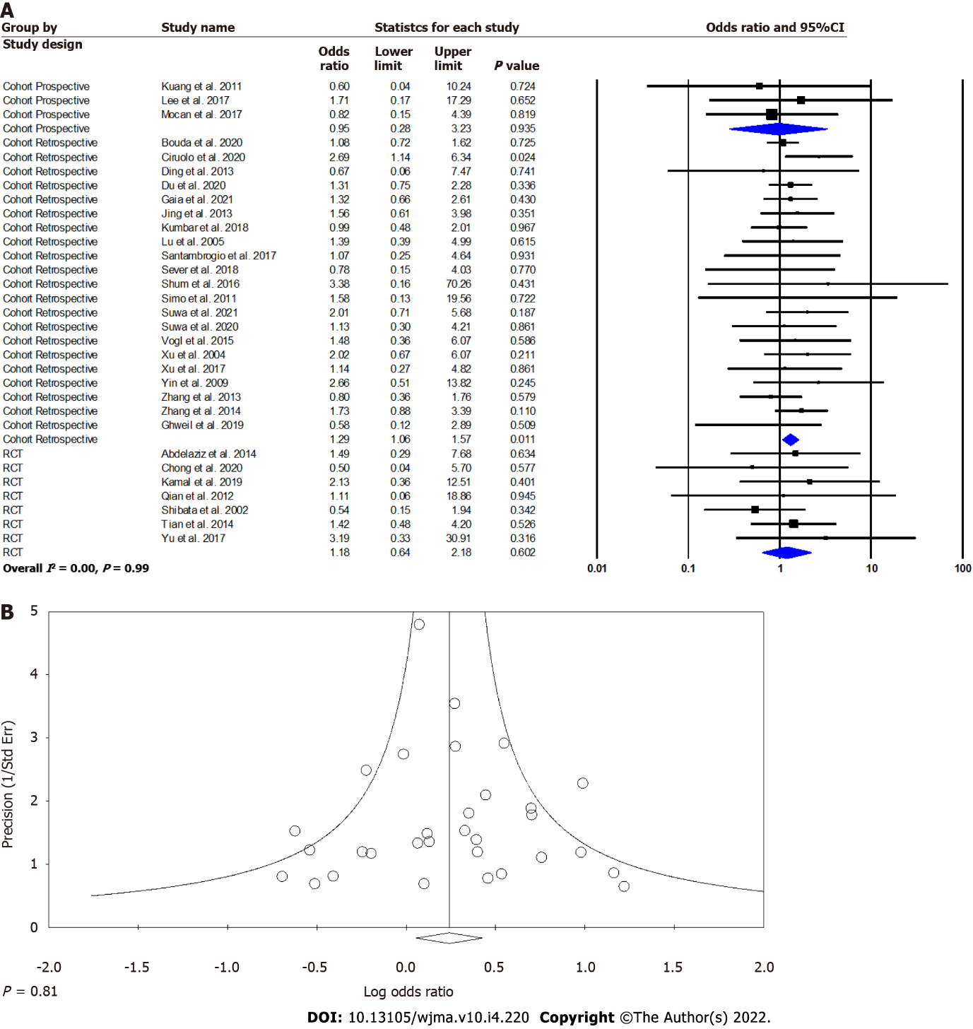
Figure 2 Forest plot and funnel plot. A: Microwave ablation versus radiofrequency ablation for intrahepatic hepatocellular carcinoma lesions. Forest plot for complete ablation; B: Microwave ablation versus radiofrequency ablation for intrahepatic hepatocellular carcinoma lesions: Funnel plot for publication bias.
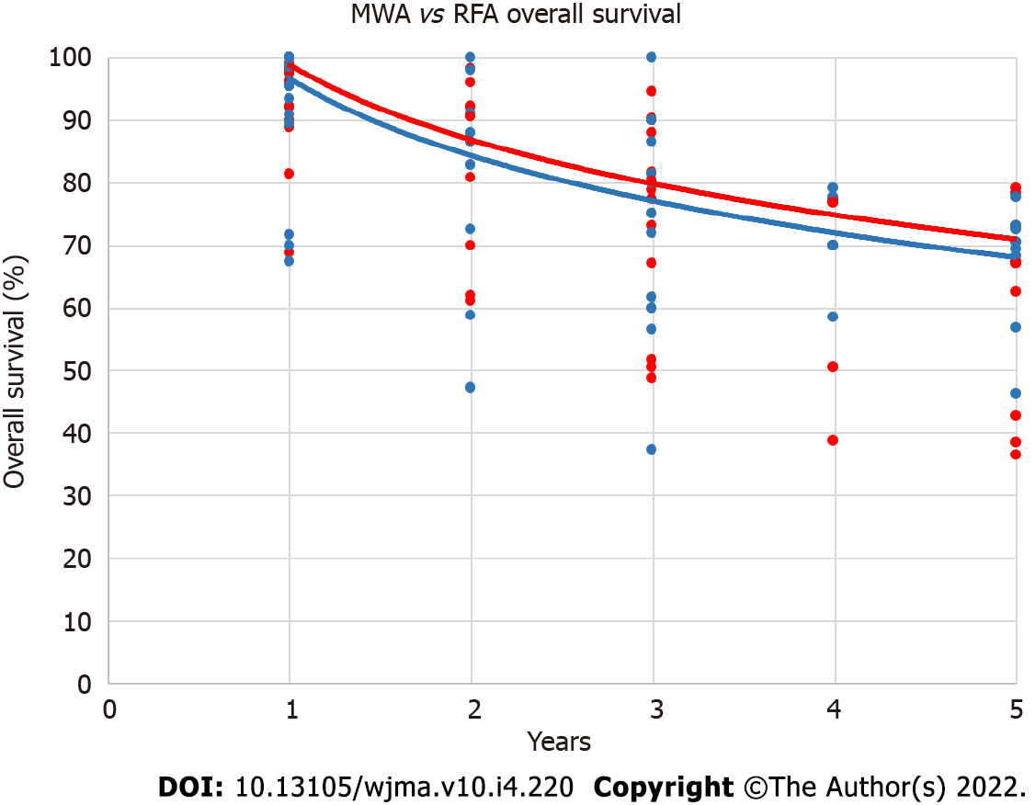
Figure 3 Dot plot of microwave ablation vs radiofrequency ablation overall survival rates over time. Trendlines are based on median survival. Microwave ablation is represented by red dots and red trendline while radiofrequency ablation is represented by blue dots and blue trendline. MWA: Microwave ablation; RFA: Radiofrequency ablation.
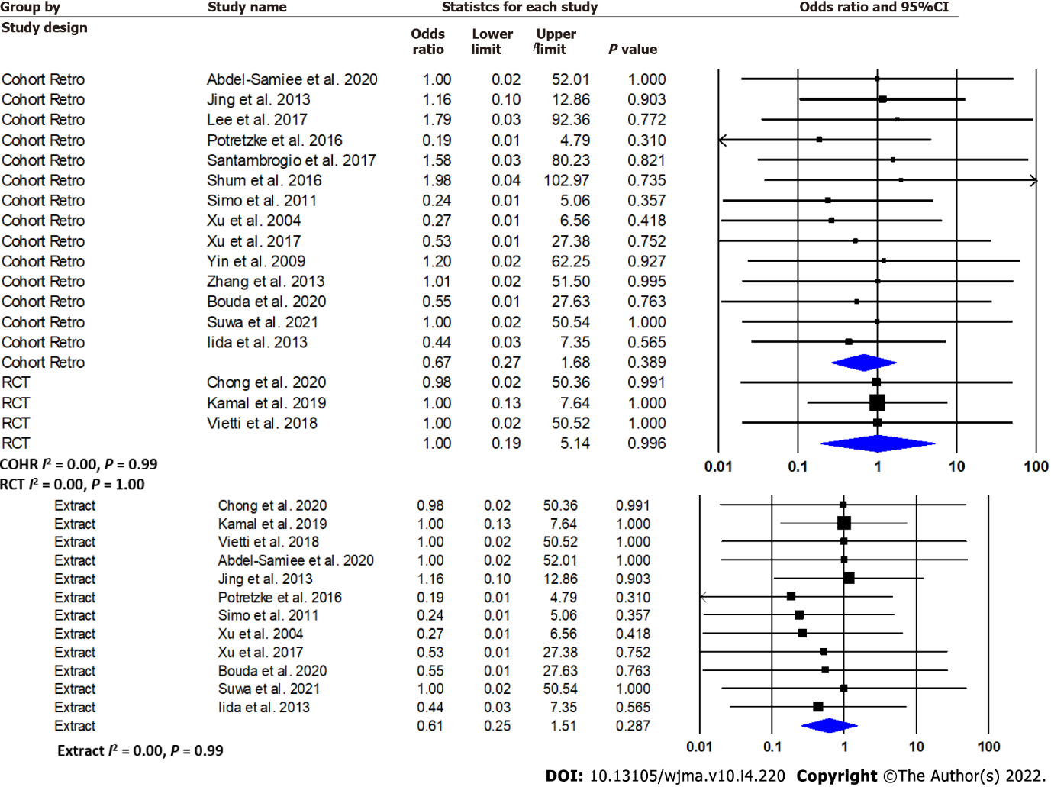
Figure 4 Microwave ablation versus radiofrequency ablation for intrahepatic hepatocellular carcinoma lesions: Forest plot for 30-d mortality.

Table 1 Summary of patient characteristics of included randomised controlled trials and cohort studies
Ref. | Design | Country | Year | Arms | NP | Age/yr | % males | NL | Tumour size, mean or median (range or SD)/mm | CPC (A/B/C) | F/U Duration/mo
Abdelaziz et al^{[72]}, 2014 | RCT | Egypt | 2009-2011 | MWA | 66 | 53.6 (48.6-58.6) | 72.7 | 76 | 29 (19.3-38.7) | 25/41/0 | NR
 |  |  |  | RFA | 45 | 56.8 (49.5-64.1) | 68.9 | 52 | 29.5 (19.2-39.8) | 24/21/0
Chong et al^{[34]}, 2020 | RCT | Hong Kong | 2011-2017 | MWA | 47 | 63 (50–80) | 63.8 | NR | 31 (20–45) | 39/7/1 | 38.3 (2.3–78.0)
 |  |  |  | RFA | 46 | 64.5 (42–5) | 82.6 |  | 28 (20–55) | 40/6/0 | 33.9 (4.9–72.7)
Kamal et al^{[35]}, 2019 | RCT | Egypt | 2017 | MWA | 28 | 55 (42-80) | 75 | 34 | 32.5 (23.3-41.7) | 22/6/0 | 12
 |  |  |  | RFA | 28 | 55 (42-80) | 78.6 | 34 | 32.8 (23.7-41.9) | 22/6/0 | 12
Qian et al^{[36]}, 2012 | RCT | China | 2009-2010 | MWA | 22 | 52 (43–75) | 90.9 | 22 | 21 (17-25) | 22/0/0 | 5.1 ± 1.3 (2.8-6.5)
 |  |  |  | RFA | 20 | 56 (43–76) | 95 | 20 | 20 (15-25) | 20/0/0 | 5.1 ± 1.3 (2.8-6.5)
Shibata et al^{[23]}, 2002 | RCT | Japan | 1999-2000 | MWA | 36 | 62.5 (52–74) | 66.7 | 46 | 22 (9–34) | 19/17/0 | 18 (6-27)
 |  |  |  | RFA | 36 | 63.6 (44–83) | 72.7 | 48 | 23 (10–37) | 21/15/0 | 18 (6-27)
Tian et al^{[37]}, 2014 | RCT | China | 2014 | MWA | 120 | NR | NR | 86 | 26 (13-39) | NR | NR
 |  |  |  | RFA |  |  |  | 79 | 22 (13-31)
Vietti et al^{[38]}, 2018 | RCT | France & Switzerland | 2011-2015 | MWA | 76 | NR | NR | 98 | NR | NR | 26 (18-29)
 |  |  |  | RFA | 76 |  |  | 104 |  |  | 25 (18-34)
Yu et al^{[22]}, 2017 | RCT | China | 2008-2015 | MWA | 203 | NR | NR | 265 | 27 (7– 50) | NR | 35.2 (2.0–81.9)
 |  |  |  | RFA | 200 |  |  | 251 | 26 (9–50) |  | 35.2 (2.0–81.9)
Abdel-Samiee et al^{[33]}, 2020 | Retro | Egypt | 2020 | MWA | 50 | NR | NR | NR | NR | NR | 36
 |  |  |  | RFA | 50 |  |  |  |  |  | 36
Bouda et al^{[39]}, 2020 | Retro | France | 2008-2016 | MWA | 79 | 62.8 (52.4-73.2) | 81 | 99 | 21.3 (13-29.6) | 71/8/0 | 34 (3–65)
 |  |  |  | RFA | 43 | 62.2 (50.3-74.1) | 76.7 | 52 | 23.0 (14.9-31.1) | 39/4/0 | 40 (5–126)
Chinnaratha et al^{[40]}, 2014 | Retro | Australia | 2006-2012 | MWA | 101 | 62.1 (51.7-72.5) | 98 | NR | 21.1 (10.9-31.3) | 92/23/2 | 36
 |  |  |  | RFA | 25 | 62.1 (51.7-72.5) | 98 |  | 21.1 (10.9-31.3) |  | 36
Cillo et al^{[41]}, 2014 | Pros/Retro | Italy | 2004-2010 | MWA | 42 | 64 (47–81) | 83 | 50 | NR |  | 24
 |  |  |  | RFA | 100 | 63 (34–81) | 83 | NR |  |  | 24
Ciruolo et al^{[42]}, 2020 | Retro | Italy | 2013-2019 | MWA | NR | 64 | 71.7 | 78 | NR | NR | NR
 |  |  |  | RFA |  |  |  | 172
Ding et al^{[43]}, 2013 | Retro | China | 2006-2010 | MWA | 113 | 59.06 (30–86) | 75.2 | 131 | 25.5 (8–50) | 75/38/0 | 18.3 (3–51.4)
 |  |  |  | RFA | 85 | 58.64 (40–77) | 80 | 98 | 23.8 (10–48) | 49/36/0 | 27.7 (4–60)
Du et al^{[44]}, 2020 | Retro | China | 2014-2016 | MWA | 218 | 56.3 (46.3-66.3) | 80 | 136 | 24 (13-35) | 107/8/0 | 28 (15-51)
 |  |  |  | RFA | 234 | 57.5 (48-67) | 76.5 | 137 | 26 (15-37) | 105/10/0
Gaia et al^{[45]}, 2021 | Retro | Italy | 2013-2019 | MWA | 81 | 67 (57–73) | 76.5 | 77 | 29 (20–35) | 71/10/0 | 20.4 (10.8-38.4)
 |  |  |  | RFA | 170 | 63 (56–72) | 69.4 | 169 | 20 (15–25) | 148/22/0 | 34.8 (19.2–51.6)
Ghweil et al^{[46]}, 2019 | Pros | Egypt | 2019 | MWA | 25 | NR | NR | NR | NR | NR | NR
 |  |  |  | RFA | 30
Iida et al^{[47]}, 2013 | Retro | Japan | 2001-2012 | MWA | 40 | 70.1 (63.5-76.7) | NR | NR | 20 (11-29) | NR | NR
 |  |  |  | RFA | 18 | 73.5 (69.5-77.5) |  |  | 21 (16-26)
Ding et al^{[48]}, 2013 | Retro | China | 2002-2011 | MWA | 556 | 58.4 (48.1-68.7) | 74.8 | 1090 | 23 (12-34) | 466/167/22 | (6-75)
 |  |  |  | RFA | 323 | 58 (47.8-68.3) | 79.8 | 562 | 22.8 (11.7-33.9) | 248/106/22 | (6-75)
Kuang et al^{[49]}, 2011 | Pros | China | 1997-2008 | MWA | 19 | 55 (27-74) | 94 | NR | NR | 77/4 /0 | 45 (24-155)
 |  |  |  | RFA | 31
Kumbar et al^{[50]}, 2018 | Retro | India | 2018 | MWA | 25 | (40-85) | 92 | 33 | NR | 13/8/4 | 15
 |  |  |  | RFA | 25 |  | 88 | 35 |  | 17/8/0
Lee et al^{[51]}, 2017 | Retro | Hong Kong | 2003-2011 | MWA | 26 | 62.5 (49 - 79) | 73.1 | 28 | 37.5 (20-60) | 23/3/0 | 47.5 (11.3-62.5)
 |  |  |  | RFA | 47 | 58 (43 - 77) | 85.1 | 52 | 31 (20-60) | 42/5/0 | 52.9 (3.6-121.8)
Liu et al^{[52]}, 2018 | Retro | China | 2002-2017 | MWA | 126 | 54 (45, 60) | 90.5 | 162 | 22.5 (17, 29) | NR | 36.8 (1-115)
 |  |  |  | RFA | 436 | 56 (46, 65) | 89.7 | 482 | 23.0 (18, 30) |  | 34.1 (1-171)
Loriaud et al^{[53]}, 2018 | Retro | France & Switzerland | 2007-2015 | MWA | NR | 69 (61–75) | 92.5 | 40 | 22.5 (10–47) | 40/0/0 | 28 (10-46)
 |  |  |  | RFA |  | 67 (58-74) | 85.8 | 120 | 21.3 (10-46) | 111/9/0
Lu et al^{[54]}, 2005 | Retro | China | 1997-2002 | MWA | 49 | 50.1 (24–74) | 89.8 | 98 | 25 (9–72) | 22/27/0 | 25.1 (2.0–50.6)
 |  |  |  | RFA | 53 | 54.5 (20–74) | 81.1 | 72 | 26 (10–61) | 47/6/0 | 24.8 (2.0–51.0)
Mocan et al^{[55]}, 2017 | Retro | Romania | 2010-2016 | MWA | NR | NR | NR | 22 | NR | NR | 12 (5.6-18.4)
 |  |  |  | RFA |  |  |  | 79 |  |  | 22.8 (7.8-37.4)
Nocerino et al^{[56]}, 2016 | Retro | Italy | 2016 | MWA | 106 | NR | NR | 134 | 20.4 (11-37) | NR | 12 (5.6-18.4)
 |  |  |  | RFA | 27 |  |  | 35 | 20.1 (7-34) |  | 22.8 (7.8-37.4)
Ohmoto et al^{[57]}, 2008 | Retro | Japan | 2002-2006 | MWA | 49 | 64 (38–75) | 83.7 | 56 | 17 (8–20) | 31/14/4 | 33.5 (9.8-57.2)
 |  |  |  | RFA | 34 | 67 (44–78) | 73.5 | 37 | 16 (7–20) | 20/11/3 | 25.9 (14.6-37.2)
Potretzke et al^{[58]}, 2016 | Retro | US | 2001-2013 | MWA | 99 | 61 (44–82) | 81.8 | 136 | 22 (20–23) | NR | 24
 |  |  |  | RFA | 55 | 62 (23–88) | 72.7 | 69 | 24 (22–26) |  | 31
Sakaguchi et al^{[59]}, 2009 | Pros | Japan | 2009 | MWA | 142 | NR | NR | NR | NR | NR | NR
 |  |  |  | RFA | 249
Santambrogio et al^{[60]}, 2017 | Retro | Italy | 2009-2015 | MWA | 60 | 70 (61.7-78.3) | 72 | NR | 21.5 (16.2-26.8) | 60/0/0 | 31 (15–46)
 |  |  |  | RFA | 94 | 69 (60-78) | 73 |  | 19.2 (14.2-24.2) | 94/0/0
Sever et al^{[61]}, 2018 | Retro | Turkey | 2012-2015 | MWA | 20 | 63.6 (57.3-69.9) | 65 | 37 | 28 (18-38) | 14/4/2 | 12 (1-40)
 |  |  |  | RFA | 20 | 64.3 (55.3-73.3) | 70 | 34 | 24 (13-35) | 11/4/5
Shum et al^{[62]}, 2016 | Retro | Hong Kong | 2014-2015 | MWA | 22 | NR | NR | NR | NR | NR | 19
 |  |  |  | RFA | 44 |  |  |  |  |  | 18
Simo et al^{[63]}, 2011 | Retro | US | 2006-2008 | MWA | 13 | 59.6 (49–72) | 54 | 15 | 23.1 (14–39) | 12/7/3 | 7 (2.5–10.5)
 |  |  |  | RFA | 22 | 58 (45–79) | 86 | 27 | 25.3 (12–44) | 7/6/0 | 19 (1.5–31)
Suwa et al^{[64]}, 2021 | Retro | Japan | 2014-2020 | MWA | 72 | 74.9 (66.5-83.3) | 65.3 | NR | 17.7 (10.9-24.5) | 58/14/0 | 12
 |  |  |  | RFA | 72 | 74.4 (65.2-83.6) | 68.1 | NR | 17.6 (11.3-23.9) | 61/11/0 | 37.8
Suwa et al^{[65]}, 2020 | Retro | Japan | 2016-2019 | MWA | 44 | 73.4 (65.7-81.1) | 68 | 52 | 17.2 (12.3-22.1) | 12/3/29 | NR
 |  |  |  | RFA | 55 | 73.4 (65.7-81.1) | 80 | 70 | 17.7 (11.3-24.1) | 16/8/31
Vogl et al^{[66]}, 2015 | Retro | Egypt | 2008-2010 | MWA | 28 | 60 (45-68) | 82.1 | 32 | 36 (9-50) | NR | NR
 |  |  |  | RFA | 25 | 57 (40-64) | 76 | 36 | 32 (8-45)
Xu et al^{[67]}, 2004 | Retro | China | 1997-2001 | MWA | 54 | 53.4 (24– 74) | 86.6 | 112 | 25 (15-36) | 53/33/11 | 27.4 (2–53)
 |  |  |  | RFA | 43 |  |  | 78 | 26 (12-40)
Xu et al^{[68]}, 2017 | Retro | China | 2007-2012 | MWA | 301 | 54.2 (43.2-65.2) | 78.1 | NR | 17 (14-20) | 278/23/0 | 53 (8–98)
 |  |  |  | RFA | 159 | 54.0 (43-65) | 83 |  | 17 (14-20) | 140/19/0 | 62 (6–102)
Yin et al^{[69]}, 2009 | Retro | China | 1997-2007 | MWA | 49 | 53 (41-65) | 87.2 | NR | 39 (31-47) | NR | 22 (2.2-93.5)
 |  |  |  | RFA | 59
Zhang et al^{[70]}, 2013 | Retro | China | 2006 | MWA | 77 | 54 (26–76) | 70.2 | 105 | NR | 77/0/0 | 24.5 (6–64)
 |  |  |  | RFA | 78 | 54 (30–80) | 82.1 | 93 |  | 78/0/0 | 26.3 (7–65.6)
Zhang et al^{[71]}, 2014 | Pros | China | 2014 | MWA | 45 | NR | NR | 60 | NR | NR | NR
 |  |  |  | RFA | 56 |  |  | 68
CPC: Child Pugh Score; MWA: Microwave ablation; NP: Number of patients; NL: Number of lesions, NR: Not reported; RFA: Radiofrequency ablation.

Table 2 Summary of the comparison of OS and local recurrence rates between microwave ablation versus radiofrequency ablation for intrahepatic hepatocellular lesions in both cohort studies and RCTs according to year of follow-up
Endpoint | Study design | No. of studies | OR | 95%CI | P for significance | I² | P for heterogeneity
Overall survival – OR
1Y | Prospective | 1 | 3.00 | 0.33-27.48 | 0.331 | - | -
 | Retrospective | 11 | 1.19 | 0.71-1.99 | 0.513 | 0 | 0.72
 | RCT | 4 | 1.95 | 0.71-5.34 | 0.194 | 35.5 | 0.20
2Y | Retrospective | 7 | 1.27 | 0.75-2.18 | 0.377 | 36.6 | 0.15
 | RCT | 1 | 1.84 | 0.54-6.28 | 0.333 | - | -
3Y | Prospective | 1 | 1.69 | 0.59-4.81 | 0.328 | - | -
 | Retrospective | 9 | 1.14 | 0.75-1.73 | 0.554 | 58.1 | 0.01
 | RCT | 2 | 0.98 | 0.62-1.54 | 0.929 | 0 | 0.62
4Y | Retrospective | 5 | 0.77 | 0.46-1.29 | 0.323 | 60.8 | 0.04
5Y | Prospective | 2 | 1.49 | 0.31-7.22 | 0.620 | 71.2 | 0.06
 | Retrospective | 5 | 0.86 | 0.62-1.19 | 0.357 | 34.8 | 0.19
 | RCT | 2 | 0.79 | 0.50-1.15 | 0.197 | 0 | 0.76
Unspecified | Retrospective | 4 | 1.54 | 1.15-2.05 | 0.004 | 0 | 0.50
 | RCT | 2 | 1.47 | 0.73-2.96 | 0.282 | 0 | 0.50
Local recurrence rate – OR
1Y | Retrospective | 4 | 0.78 | 0.29-2.11 | 0.619 | 62.8 | 0.04
 | RCT | 3 | 1.09 | 0.39-3.05 | 0.872 | 0 | 0.40
2Y | Retrospective | 4 | 1.00 | 0.40-2.45 | 0.992 | 76.2 | 0.06
 | RCT | 2 | 1.02 | 0.23-4.58 | 0.975 | 70.4 | 0.07
3Y | Retrospective | 2 | 0.80 | 0.11-5.97 | 0.826 | 84.8 | 0.01
 | RCT | 1 | 0.73 | 0.30-1.8 | 0.493 | - | -
4Y | Retrospective | 2 | 2.14 | 1.12-4.07 | 0.021 | 0 | 0.86
5Y | Prospective | 1 | 2.22 | 0.49-10.02 | 0.301 | - | -
 | RCT | 1 | 0.52 | 0.30-0.91 | 0.023 | - | -
Unspecified | Prospective | 3 | 0.60 | 0.25-1.39 | 0.233 | 0 | 0.44
 | Retrospective | 20 | 0.67 | 0.51-0.87 | 0.002 | 37.2 | 0.05
 |  | 1 | 0.26 | 0.06-1.07 | 0.063 | - | -
OS: Overall survival; OR: Odds ratio; CI: Confidence interval; RCT: Randomised controlled trial.
Table 3 Summary of the comparison of median and mean overall survival rates between microwave ablation versus radiofrequency ablation for intrahepatic hepatocellular carcinoma lesions in both cohort studies and randomised controlled trials
Year | MWA sample size | RFA sample size | Median OS |  | P value
 |  |  | MWA | RFA
1 | 1135 | 1623 | 96.2% | 95.4% | 0.31
2 | 651 | 789 | 90.7% | 88.0% | 0.10
3 | 1004 | 1480 | 80.5% | 75.3% | 0.002
4 | 421 | 464 | 76.8% | 70.0% | 0.02
5 | 764 | 1221 | 67.3% | 69.5% | 0.30
OS: Overall survival; MWA: Microwave ablation; RFA: Radiofrequency ablation.

Table 4 Summary of overall survival and local recurrence rate HRs
Endpoint | Study design | No. of studies | HR | 95%CI | P for significance | I² | P for heterogeneity
Overall survival – HR
Univariate | Retrospective | 2 | 1.17 | 0.75-1.83 | 0.497 | 17.5 | 0.27
Multivariate | Retrospective | 3 | 1.32 | 0.92-1.89 | 0.130 | 0.8 | 0.36
Unspecified | Prospective | 1 | 1.45 | 0.96-2.19 | 0.078 | - | -
 | Retrospective | 13 | 1.06 | 0.86-1.32 | 0.580 | 58.6 | 0.004
 | RCT | 4 | 1.34 | 0.97-1.86 | 0.079 | 0 | 0.58
Local recurrence rate – HR
Univariate | Retrospective | 3 | 1.77 | 0.81-3.88 | 0.151 | 63.9 | 0.06
Multivariate | Retrospective | 2 | 1.88 | 0.79-4.47 | 0.151 | 56.1 | 0.13
Cox proportional | Retrospective | 1 | 2.17 | 1.04-4.50 | 0.040 | - | -
Fine and gray | Retrospective | 1 | 2.07 | 0.95-4.26 | 0.070 | - | -
Unspecified | Retrospective | 1 | 2.00 | 0.50-8.00 | 0.326 | - | -
HR: Hazard ratio; CI: Confidence interval; RCT: Randomised controlled trial.

Table 5 Microwave ablation versus radiofrequency ablation for hepatocellular lesions: Meta-analysis of adverse events
Adverse event | No. of studies | OR | 95%CI | P for significance | I² |  | P for heterogeneity
Liver-related morbidity | 11 | 1.51 | 0.64-3.55 | 0.342 |  | 0 | 0.91
Postprocedural infections | 19 | 1.3 | 0.85-1.97 | 0.222 |  | 0 | 0.83
Postprocedural bleeding | 10 | 2.36 | 0.92-6.07 | 0.075 |  | 0 | 0.97
Bile duct injury | 5 | 1.88 | 0.57-6.23 | 0.299 |  | 0 | 0.99
Respiratory events | 14 | 1.99 | 1.07-3.71 | 0.03 |  | 0 | 0.87
Local events | 4 | 1.62 | 0.49-5.36 | 0.426 |  | 0 | 0.57
Liver related morbidity: Decompensation, jaundice, infarction, and portal vein thrombosis; Post-procedural infections: General, peritonitis, and liver abscess. Local events: Burns, pain, and wound complication; Respiratory events: Pleural effusion and pneumothorax. OR: Odds ratio; CI: Confidence interval.

Published by Baishideng Publishing Group Inc
7041 Koll Center Parkway, Suite 160, Pleasanton, CA 94566, USA
Telephone: +1-925-3991568
E-mail: bpgoffice@wjgnet.com
Help Desk: https://www.f6publishing.com/helpdesk
https://www.wjgnet.com

© 2022 Baishideng Publishing Group Inc. All rights reserved.

