Name of Journal: World Journal of Gastroenterology
Manuscript NO: 73237
Manuscript Type: REVIEW

Altered gut microbiota patterns in COVID-19: Markers for inflammation and disease severity

Chakraborty C et al. Gut microbiota in COVID-19 patients

Chiranjib Chakraborty, Ashish Ranjan Sharma, Manojit Bhattacharya, Kuldeep Dhama, Sang-Soo Lee

Chiranjib Chakraborty, School of Life Science and Biotechnology, Adamas University, Kolkata 700126, India

Ashish Ranjan Sharma, Institute for Skeletal Aging & Orthopaedic Surgery, Hallym University, Chuncheon-s 24252, South Korea

Manojit Bhattacharya, Department of Zoology, Fakir Mohan University, Balasore 756020, India

Kuldeep Dhama, Division of Pathology, Indian Council of Agricultural Research (ICAR)-Indian Veterinary Research Institute (IVRI), Bareilly 243122, Uttar Pradersh, India

Sang-Soo Lee, Institute for Skeletal Aging & Orthopedic Surgery, Hallym University, Chuncheon-si 200704, South Korea

Author contributions: Chakraborty C designed the research study and wrote the main manuscript draft; Sharma AR reviewed and edited the manuscript; Bhattacharya M developed the figures and tables; Dhama KD performed the English editing and validation; Lee SS did the funding acquisition; all authors have read and approved the final manuscript.

Corresponding author: Chiranjib Chakraborty, MSc, PhD, Associate Professor, Full Professor, School of Life Science and Biotechnology, Adamas University, Barasat-Barrackpore Rd, Kolkata 700126, India. drchiranjib@yahoo.com

Received: January 12, 2022
Revised: March 19, 2022
Accepted: May 13, 2022
Published online:

Abstract
The severe acute respiratory syndrome coronavirus 2 (SARS-CoV-2) infection leads to a severe respiratory illness and alters the gut microbiota, which dynamically interacts with the human immune system. Microbiota alterations include decreased levels of beneficial bacteria and augmentation of opportunistic pathogens. Here, we describe critical factors affecting the microbiota in coronavirus disease 2019 (COVID-19) patients. These include, such as gut microbiota imbalance and gastrointestinal symptoms, the pattern of altered gut microbiota composition in COVID-19 patients, and crosstalk between the microbiome and the gut-lung axis/gut-brain-lung axis. Moreover, we have illustrated the hypoxia state in COVID-19 associated gut microbiota alteration. The role of ACE2 in the digestive system, and control of its expression using the gut microbiota is discussed, highlighting the interactions between the lungs, the gut, and the brain during COVID-19 infection. Similarly, we address the gut microbiota in elderly or co-morbid patients as well as gut microbiota dysbiosis of in severe COVID-19. Several clinical trials to understand the role of probiotics in COVID-19 patients are listed in this review. Augmented inflammation is one of the major driving forces for COVID-19 symptoms and gut microbiome disruption and is associated with disease severity. However, understanding the role of the gut microbiota in immune modulation during SARS-CoV-2 infection may help improve therapeutic strategies for COVID-19 treatment.

Key Words: COVID-19; Inflammation; Gut microbiota; Therapeutic

Chakraborty C, Sharma AR, Bhattacharya M, Dhama K, Lee SS. Altered gut microbiota patterns in COVID-19: Markers for inflammation and disease severity. World J Gastroenterol 2022; In press

Core Tip: The gut microbiota of coronavirus disease 2019 (COVID-19) patients is altered compared to that of healthy individuals, with a reduction in the count of beneficial bacteria and an increase in the count of opportunistic fungi. In this review, we elucidate the components governing immune modulation. Additionally, we explore the effect of changes in the microbial ecosystem in COVID-19 patients, with an aim to help develop precise therapeutics and expand our knowledge regarding the pattern of changes in the gut microbiota of COVID-19 patients.

INTRODUCTION
The coronavirus disease 2019 (COVID-19) pandemic has stimulated research on several medical conditions and on individual patient variations during severe acute respiratory syndrome coronavirus 2 (SARS-CoV-2) infection to unfold underlying disease mechanisms. Scientists have determined the inflammatory response and cellular injury mediated by acute SARS-CoV-2 infection. Moreover, several studies have revealed the involvement of the gastrointestinal (GI) tract and its associated gut microbiome during COVID-19, motivating research in this field. Increasing evidence has surfaced confirming the association of the GI tract and COVID-19, including^{[1,2]} a severe state of gut dysbiosis in COVID-19 patients^{[3,4]}. Similarly, GI symptoms such as vomiting, abdominal pain, and diarrhea have been noted in many COVID-19 patients^{[5-7]}. Moreover, high expression of ACE2 receptor was reported in epithelial cells of the GI tract^{[8]}. SARS-CoV-2 RNA has been identified in rectal and anal swabs, as well as stool specimens^{[7,9,10]}. Finally, liver damage, loss of appetite, and irritable inflammatory diseases have been reported as post-COVID-19 illnesses^{[11]}. These all data strongly indicate a correlation between the GI including the gut microbiome, and COVID-19.
The gut microbiota plays an important role in controlling gut health and acts as a health modulator (Figure 1)^{[12]} aidings in different metabolic activities and extensively impacting health and disease^{[13,14]}. Ongoing research aims to better understand the gut microbiota and provide insights into the mechanistic conditions required to implement normal health functions. The gut microbiota controls specific functions in the host, such as drug and xenobiotic metabolism and nutrient metabolism^{[15]}. Simultaneously, it helps maintain the structural integrity of the gut mucosal barrier, protects against pathogens, and regulates immunomodulation, as well as health and disease conditions^{[16,17]}. Several other studies suggest a possible link between COVID-19 and gut microbiota composition^{[18,19]}. Additionally, an association has been shown between altered gut microbial composition and increased risk factors in COVID-19 patients (Figure 1)^{[20,21]}.
Inflammation is a major risk factor in COVID-19 patients^{[22-24]}. During uncontrolled inflammation, abnormal levels of cytokines such as interleukin-1 beta (IL-1β), IL-6, IL-8, IL-10, IL-12, granulocyte-macrophage colony-stimulating factor (GM-CSF), tumor necrosis factor-alpha (TNF-α), and interferon-gamma (IFN-γ) are found in the patients^{[23,25-27]}. Certain abnormal levels of cytokines are substantial related to the severity of COVID-19 and are probably responsible for the “cytokine storm” syndrome manifested during the disease^{[28-30]}. Research has correlated the inflammation during COVID-19 with GI and hepatic manifestations of the disease^{[31]}.
Interactions between the gut microbiota and the lungs, known as the gut-lung axis, have sparked interest for gastroenterology studies focusing on COVID-19 as these interactions affect disease severity. Changes in the gut microbiome certainly affect homeostasis and may lead to increased infections^{[32,33]}. Similarly, in addition to the gut, COVID-19 can also have a detrimental effect on the central nervous system (CNS) and the blood-brain barrier (BBB) and disrupt the gut-brain-lung axis. Studies have explored therapeutic options (nicotinic cholinergic agonists and vagus nerve stimulation) to minimize the damage caused to this axis^{[34]}.
Research is necessary to understand how the gut microbiome is altered during COVID-19 infection and the factors that influence the microbiome during mild to moderate and severe disease. Studies have been conducted to understand the GI symptoms during COVID-19 and to detect viral shedding using the fecal matter of SARS-CoV-2 patients. The gut microbiota of COVID-19 patients has been mapped to obtain evidence regarding inflammation, disease severity, and therapeutic development.
Using these studies, we explore the following critical factors: (1) The gut microbiota imbalance and GI symptoms in COVID-19 patients; (2) fecal viral shedding in COVID-19 patients and restoration of the gut microbiota; (3) the pattern of altered gut microbiota composition in COVID-19 patients; (4) alterations in gut biosynthesis during COVID-19 infection; (5) the role of ACE2 in the digestive system and the gut microbiome; (6) crosstalk between the microbiome and the gut-lung axis during COVID-19 infection; (7) crosstalk between the microbiome and the gut-brain-lung axis during COVID-19 infection; and (8) hypoxia during COVID-19 associated with altered gut microbiota. We also discuss how immune responses and inflammation due to COVID-19 drive the changes in the microbial ecosystem and summarize therapeutic options currently in development.

GI symptoms in COVID-19 patients
Along with respiratory symptoms and fever, GI symptoms have also been observed in COVID-19 patients (Table 1). A study by Redd et al^{[35]} reported abdominal pain (14.5%), nausea (26.4%), diarrhea (33.7%), and vomiting (15.4%) in patients from the United States. Three hundred and eighteen hospitalized COVID-19 patients were evaluated to understand their symptoms. In another study with 204 COVID-19 patients, 50.5% (103 patients) exhibited GI symptoms. Among these 103 patients, 78.6% showed a lack of appetite, 34% had diarrhea, 3.9% vomited, and 1.9% complained of abdominal pain. The authors correlated patients describing GI symptoms with other measurements such as prothrombin time, monocyte count, and liver enzyme levels. Patients with GI symptoms had elevated mean liver enzyme levels, extended prothrombin times, and lower monocyte counts^{[36]}. In a much larger cohort study involving 1099 COVID-19 patients from 552 different hospitals spread to over 30 provinces, only 3.8% of patients experienced diarrhea. The authors concluded that fever and cough are common symptoms, unlike diarrhea, among the COVID-19 patient population^{[37]}.
These findings suggest that the virus might be present for a period in the GI tract, which may cause a GI infection (Figure 2). Importantly, fecal viral shedding was noted after clearing SARS-CoV-2 from the respiratory tract, suggesting that the virus can persist for a long time in the GI tract, especially in patients who manifest GI symptoms. During COVID-19 infection, gut microbiota composition is altered, possibly explaining the GI imbalance and manifestations of the different GI symptoms such as abdominal pain, nausea, vomiting, and diarrhea, as described above. This change in the gut microbiota includes reduced levels of commensals microbes and is observed in patient samples even after 30 d of disease remission^{[38-40]}. Additional studies addressed the imbalance of the gut microbiota and its association with different GI-related aspects of COVID-19^{[41]}. The gut microbiota population in COVID-19 patients with low to moderate GI symptoms should also be analyzed. Evaluating these diverse patient populations will enable a thorough description of this phenomenon.

Fecal viral shedding in COVID-19 patients
Table 2 lists various cohort studies reporting fecal viral shedding by COVID-19 patients and detecting SARS-CoV-2 RNA in the fecal matter^{[42,43]}. SARS-CoV-2 RNA-positive fecal matter was detected in 66.67% of COVID-19 patients (42 patients) in China^{[43]}. Researchers attempted to evaluate the viral shedding period in stool samples, and noted viral shedding in asymptomatic patients. For example, SARS-CoV-2 RNA was detected from a stool sample of an asymptomatic child 17 d after viral exposure^{[9]}.
Certain studies have reported that virus separation from stool samples is difficult. For example, Wölfel et al^{[44]} detected viral RNA in stool samples but attempts to isolate the virus were unsuccessful, most likely due to the mild nature of the infection. A viral load below 10⁶ copies per milliliter often hampers viral isolation^{[36]}. The viral load also varies widely from one sample to another, including stool, serum, and respiratory samples^{[44-46]}. However, understanding the correlation between the altered gut microbiota and the viral load in patient samples is essential for advancing therapeutic strategies centered around restoring the microbiota.
Additionally, efforts should focus on determining the possible correlation between fecal viral shedding and altered gut microbiota composition at different stages the infection, i.e., mild to moderate or severe COVID-19.

Altered gut microbiota composition in COVID-19 patients
SARS-CoV-2 infections have led to changes in the ecology of the gut microbiota in patients (compared to that seen in controls). These changes are influenced by the immune responses elicited during COVID-19 (Table 3). Different studies have revealed the growth of unusual microorganisms and depletion of common gut microbes (bacterial, viral, and fungal populations) in COVID-19 patients (Figure 3).
To understand the severity of disease in COVID-19 patients, the gut microbiota composition of 100 COVID-19 patients was analyzed in two hospital cohorts. Stool samples were collected from 27 of the 100 patients. The gut microbiome compositions were characterized using total DNA extracted from stool samples. The authors demonstrated that the number of gut commensals and Bifidobacteria was low and correlated with several factors of disease severity, such as high concentrations of inflammatory cytokines and C-reactive protein (CRP). These data suggests that the composition of the microbiota is associated with disease severity^{[38]}. Another study carried out RNA and DNA profiling by sequencing of the virome using fecal matter from COVID-19 patients. The fecal matter of 98 COVID-19 patients was analyzed to understand COVID-19 severity and its association with the gut virome. The study showed that COVID-19 severity is inversely correlated with gut viruses, and older patients are more prone to severe COVID-19 outcomes^{[47]}. Alterations in fungal microbiomes during COVID-19 have also been investigated. Analysis of the fecal mycobiome using the deep shotgun method showed heterogeneous microbial profiles, with enrichment of fungal genera such as Aspergillus and Candida. Two species of Aspergillus (Aspergillus flavus and Aspergillus niger) were identified in fecal samples after clearance of SARS-CoV-2 from nasopharyngeal samples^{[48]}. Additionally, there is evidence of abundant symbionts among COVID-19 patients including Clostridium ramosum, Coprobacillus, and Clostridium hathewayi, which directly correlated with disease severity. Conversely, Faecalibacterium prausnitzii, which was also abundant among the patients, was inversely correlated with disease severity^{[49]}.
Similarly, in a study by Yeoh et al^{[38]}, stool samples from 27 patients were correlated with blood markers and inflammatory cytokines. The study concluded that the scale of COVID-19 severity might be associated with the gut microbiome and linked it to COVID-19 inflammation^{[46]}. In another study containing a greater number of African Americans, enriched genera (Campylobacter, Corynebacterium, and Peptoniphilus) were mapped in the COVID-19 patient population, the gut microbial composition was markedly different between positive and negative samples. However, the study did not identify any considerable association between COVID-19 severity and microbiome composition^{[50]}.
Certain studies even noted a reduction in fiber-utilizing bacteria such as Prevotella, Bacteroides plebius, and Faecalibacterium prausnitzii (F. prausnitzii), and a low Firmicute/Bacteroidetes ratio^{[51]}. Poor outcomes were noted in special populations, such as hypertensive, diabetic, and elderly patients^{[52,53]}. Research is still underway to ascertain the different types of gut microbial populations (pro-inflammatory, opportunistic, beneficial, or anti-inflammatory) present depending on COVID-19 severity (Figure 4).
These studies help us understand how gut microbiota composition affects patients with moderate to severe COVID-19 and how gut microbiota diversity might alter immunity in COVID-19 patients.

AlterationS in the biosynthesis of biological compounds in the gut during COVID-19 infection
Other than compositional changes in gut microbiota, functional changes during SARS-CoV-2 infection were observed in some patients. The gut microbiota aids in different biosynthetic pathways, such as amino acid biosynthesis, carbohydrate metabolism, nucleotide de novo biosynthesis, and glycolysis. This might be due to the abundance of bacterial components such as Collinsella tanakaei, Streptococcus infantis, Morganella morganii, and Collinsella aerofaciens, etc. Apart from these microbes, many short-chain fatty acid (SCFA) synthesis bacteria, such as Lachnospiraceae bacteria, Bacteroides stercoris, Alistipes onderdonkii, and Parabacteroides merdae were present in COVID-19 samples with mild symptoms and in non-COVID-19 samples^{[54]}. In a study using non-human primate models, β diversity analysis and 16S rRNA gene profiling were carried out to understand the gut microbiota composition during SARS-CoV-2 infection. The study revealed substantial changes in the gut microbiota composition and metabolism and a reduction in the concentration of SCFAs as well as a difference in the concentrations of bile acids. The study also found alterations in tryptophan metabolites during SARS-CoV-2 infection in the animal models^{[55]}.
Shotgun metagenomic sequencing using fecal samples has also been performed to profile the gut microbiome in SARS-CoV-2 infected patients. Researchers observed prolonged impairment of L-isoleucine biosynthesis and SCFAs due to alterations in the gut microbiome of patients with COVID-19^{[56]}.

RoLE OF ACE2 in the digestive system and the gut microbiome
The ACE2 (angiotensin-converting enzyme 2) receptor acts as a binding site by which SARS-CoV-2 enters host cells^{[57,58]}. A higher expression of ACE2 in the cell favors SARS-CoV-2 infection. Despite this, ACE2 deficiency can play a vital role in SARS-CoV-2 infection^{[59]}. Increased ACE2 expression is found in the epithelial cells of the respiratory tract (nasal mucosa, nasopharynx, and lungs), in different parts of the intestine, and in different types of epithelial cells, including nasal, corneal, and intestinal epithelial cells in humans^{[60]}. In addition, this protein is expressed in different parts of the digestive system, such as the small intestine, stomach, colon, and liver^{[61]}. However, ACE2 expression is controlled by distinct microbial communities in several body tissues. Mouse model studies suggest an association between certain microbial communities and overexpression of ACE2. This overexpression may prevent detrimental changes in hypoxia-induced gut pathophysiology and pulmonary pathophysiology^{[62]}. ACE2 expression is controlled in the GI and respiratory tract^{[63]}. Additionally, it can also be controlled by some bacterial species from important phyla. Downregulation of ACE2 expression was associated with the Bacteroidetes phylum. Among all species of this phylum, Bacteroides dorei has been shown to inhibit ACE2 expression in the colon, whereas the Firmicutes phylum plays a variable role in its modulation^{[20,49,64]}. These findings are supported by other studies describing the modulation of ACE2 expression in the gut by the microbiota^{[65,66]}.

Gut-lung axis crosstalk during COVID-19 infection
Several reports indicate that manipulation of the gut microbiota may be used to treat pulmonary diseases^{[67]}. Therefore, the gut-lung axis crosstalk can help to elucidate these respiratory and digestive system interactions (Figure 5). Dysbiosis occurs when there are detrimental changes in the microbial composition of the gut or respiratory tract. It often leads to altered immune responses and the development of diseases, such as COVID-19. Nonetheless, of gut dysbiosis can be manipulated for treatment purposes^{[32,67-69]}. Studies suggest that SARS-CoV-2 from the lungs travels to the gut via the lymphatic system leading to disrupted gut permeability^{[70,71]}. Furthermore, the extent of dysbiosis is associated with COVID-19 severity^{[4,72]}. Therefore, understanding the crosstalk between the microbiome and the gut-lung axis during COVID-19 infection may provide therapeutic approaches.

Gut-brain-lung axis crosstalk during COVID-19 infection
Like the gut-lung axis, crosstalk between the microbiome and the gut-brain axis has been recognized and remains the topic^{[73-75]}. Several studies have illustrated the role of the microbiome-gut-brain axis in different neurological disorders^{[76,77]}.
The interaction between the brain and the gut (also called the gut-brain axis) is bidirectional, with several pathways involved, including bacterial metabolites, neuroanatomical communications, neurotransmitters, and hormones^{[78]}. The vagus nerve is primarily involved in such communication, and these molecules (neurotransmitters/hormones) are produced in the GI tract. During communication between neurotransmitters and hormones, they might interact with the receptors on the vagus nerve, relaying information to the brain^{[78-81]}. Many hormones can cross the BBB and affect the CNS directly. Additionally, neuroendocrine pathways which operate via the hypothalamic-pituitary-adrenal (HPA) axis associated with stress also affect the BBB. The stress-HPA axis is associated with the release of glucocorticoids such as cortisol from the adrenal cortex. Cortisol, is associated with augmented intestinal permeability and GI motility, affecting the gut microbiota^{[78,82-84]}. The stress-HPA axis may also lead to inflammation and bacteria-derived impaired metabolite production, especially SCFAs^{[78,84]}. Therefore, a thorough understanding of the gut-brain axis can help the development of therapeutic approaches via modulation of the gut microbial composition.
The gut microbiota might play a distinct role in controlling the host immune system, and research is underway to uncover more in this field^{[85,86]}. The involvement of the lungs (gut-brain-lung axis) occurs when inflammation and neurodegeneration in the brain stem due to COVID-19 prevent cranial nerve signaling, disrupting anti-inflammatory pathways and normal respiratory and GI functions. Recently, the lungs have been associated in the crosstalk among the microbiota-gut-brain axis components, and this axis was also noted during COVID-19 (Figure 6)^{[34,78]}. Moreover, in COVID-19 patients, alterations in the gut microbiota have been shown to reduce live microbes (Bifidobacterium and Lactobacillus) during intestinal microbial dysbiosis^{[87]}.
The microbial translocation to the gut and its subsequent damage may play a vital role in inferior clinical outcomes for the disease. The gut-brain-lung axis during COVID-19 infection can also offer clues indicate viable directions for therapeutic development^{[34]}.

Hypoxia in COVID-19 and gut microbiota
Abnormal cytokine release (cytokine storms) and inflammatory responses may be associated with hypoxia during severe COVID-19. Viral replication in the lungs leads to a cytokine storm, destroying normal lung function and causing hypoxemia, i.e., low oxygen levels in the blood. Hypoxia-inducible factor-1α (HIF-1α) is a transcription factor that regulates cellular functions such as cell proliferation and angiogenesis. In hypoxic conditions, HIF-1α binds to the hypoxemic response element and induces the production of cytokines such as IL-6 and TNF-α, leading to hypoxia^{[88]}. There are other collective causes of hypoxia, including pulmonary infiltration and thrombosis. The COVID-19 virus induces pneumonia that causes atelectasis (collapsing of air sacs), leading to low oxygen levels in the body^{[89]}. Additionally, COVID-19 leads to mitochondrial damage, production of reactive oxygen species production and subsequently HIF-1α, further promoting viral infections and inflammation^{[90]}.
As part of its normal metabolic functions, the gut microbiota produces neurotropic metabolites, neurotransmitters, peptides, and SCFA, whose levels are disrupted due to COVID-19. SCFA such as butyrate confer neuroprotection. Modulation of gut microbes (responsible for such metabolite production) by SARS-CoV-2 alters hypoxia-sensing, negatively impacting the CNS^{[91]}. Therefore, an association between gut microbiota and hypoxia in COVID-19 patients can be speculated, and may be linked to the CNS (Figure 7).

Alteration of gut microbiota in COVID-19: EVIDENCE for inflammation OR DIEASE, severity?
Under normal conditions, colonization of the normal microbiota in the gut causes resistance to pathogen^{[92,93]}. Much of the normal gut microbiota belongs to Clostridia., which produces butyric acid. This SCFA is produced during dietary fiber fermentation along with acetic acid and propionic acid, which play a critical role in gut health (Figure 8A)^{[94,95]}. Butyric acid helps in maintain the integrity of the gut barrier by providing a vital energy resource for colonocytes. This SCFA also hinders histone deacetylase activity and inhibits the activation of the nuclear factor (NF)-κB signaling pathway activation. This phenomenon may activate the G protein-coupled receptor pair (GPR41 /GPR43). These events help exert an anti-inflammatory response in normal gut health and stimulate regulatory T cells (Treg cells)^{[96-100]}. Treg cells play a central role in suppressing inflammatory responses^{[97,101]}. However, in COVID-19 patients, typical microbiota dysbiosis causes an imbalance in all these events.
There is a distinct connection between dysbiosis of the gut microbiota and hyper-inflammatory responses, especially cytokine release, in some COVID-19 patients^{[102]} (Figure 8). Researchers noted that gut microbiota composition is related to the COVID-19 severity of and observed an association between altered cytokine levels and gut microbiota composition^{[38]}. Cytokines/inflammatory factors, such as IL-1β, IL-6, and TNF-α, are usually associated with inflammation during disease^{[103]}. In the case of severe COVID-19, the levels of certain cytokines, such as IL-6, IL-10, TNF-α, and IFN-are raised abnormally, and in some cases, cytokine storms are observed (Figure 8B)^{[23]}. In pilot study, the quality of gut microbial composition was associated with the severity COVID-19 in 15 patients at the time of hospitalization in Hong Kong. The study showed an abundance of microbes such as Clostridium hathewayi, Clostridium ramosum, and Coprobacillus in COVID-19 patients. Moreover, an anti-inflammatory bacteria, Faecalibacterium prausnitzii, was be inversely correlated with disease severity^{[49]}.
Nonetheless, more detailed studies are needed to understand the impaired gut health during COVID-19, especially in extreme forms of the disease. Another study confirmed microbiota dysbiosis in COVID-19 patients. This study found differential bacterial populations with a decrease in F. prausnitzii and Clostridium spp and an association of IL-21 in mild to severe COVID-19 patients^{[51]}.
A gut microbiota richness analysis in COVID-19 patients was conducted over through a six-month evaluation using 16S rDNA sequencing. This study showed that, patients with decreased post-convalescence richness in bacterial microbiota had high disease severity with increased CRP. Additionally, the authors observed increased incidence of intensive care unit admissions with worse pulmonary functions in these patients^{[104]}. The study suggested an association between the hyper-inflammatory response in COVID-19 and gut dysbiosis. However, a greater number of studies testing patients well after recovery are required to fully illustrate gut dysbiosis, associated factors, and the hyper-inflammatory response during COVID-19.

Gut microbiota IN elderly or co-morbid COVID-19 patients
Researchers have attempted to understand the role of the gut microbiota in elderly or co-morbid COVID-19 patients. A recent study evaluated the association of the gut microbiota and its modulation in COVID-19 patients. In this study, the cohort comprised approximately 200 severe COVID-19 patients hospitalized with pneumonia. Researchers considered elderly patients (age 62 years to 64 years) and their comorbidity. Patients in this study received two types of treatments: one group was treated with only the best available therapy (BAT), and the other group was treated with oral bacteriotherapy and BAT. Researchers found a decline in mortality and decreased progress in severe disease. Finally, researchers concluded that oral bacteriotherapy might be helpful in the management of hospitalized COVID-19 patients^{[105]}. Similarly, Rao et al^{[106]} noted that people with the comorbidities are more prone to COVID-19-related complications. In this case, immune system deregulation and deaths were also noted. However, researchers used-glucan to enhance the immune system in COVID-19 patients. This glucan was used to augment the activity of macrophages, natural killer cells, and IL-8, implicating that it might enhance the defense mechanisms to combat the virus^{[106]}.
Recently, Liu et al^{[1]} evaluated the role of the gut microbiota composition and its association with the post-acute COVID-19 syndrome (PACS). In this study, researchers considered the comorbidities and dietary patterns during patient selection compare gut microbiota compositions. However, no considerable differences were observed in age, comorbidities, gender, antibiotics, or antiviral drug use between patients with PACS or without PACS^{[1]}.
Therefore, in cases of elderly or co-morbid COVID-19 patients, the gut microbiota might play an important role in immune system deregulation, although further studies are required to validate the findings.

Gut microbiota based on antibiotic USAGE in COVID-19 patients
In COVID-19 patients, the use of antibiotics is relatively common. The frequently used antibiotics in COVID-19 patients are Azithromycin, Amoxicillin Clavulanate, Cephalosporin, Tetracycline^{[49,107]}, etc. The composition of the gut microbiota is hampered in COVID-19 patients due to the usage of antibiotics, occasionally causing antibiotic-associated diarrhea (AAD)^{[108]}. Antibiotics usages in COVID-19 patients were increased the number of opportunistic pathogens compared with that detected in an untreated control group. Zuo et al^{[49]} reported that the gut of COVID-19 patients, using antibiotics contains opportunistic bacterial pathogens such as Bacteroides nordii, Actinomyces viscosus, and Clostridium hathewayi. Additional studies also reported this phenomenon^{[22,109]}. An increase of opportunistic bacterial pathogens causes dysbiosis of the gut. Rafiqul Islam et al^{[110]} also noted that the abundance of opportunistic pathogens in COVID-19 patients in Bangladesh could cause dysbiosis, with 46 genera of opportunistic bacteria being identified patient GI samples. However, a study demonstrated that particular strains of probiotics may be useful for AAD^{[111]}. Scientists have shown that the administration of oral probiotics can recover gut health and have antiviral effects^{[112,53]}. For probiotic strain identification, Mak et al^{[113]} highlight the need for effective research to easily recognize the probiotic strains of therapeutic use. In this case, the probiotics should be specific for COVID-19, and help reduce the susceptibility to COVID-19 preventing severe COVID-19 disease.

gut microbiota Dysbiosis during COVID-19 and use of probiotics
Scientists identified an association between the gut microbiota dysbiosis and the severity of COVID-19. Magalhães et al^{[52]} noted that gut microbiota dysbiosis causes poor outcomes in elderly COVID-19 patients with hypertension and diabetes. Additionally, co-morbid elderly COVID-19 patients were prone to increased inflammatory situations due to the dysbiosis. The elevated amount of bacterial products in the gut might translocate into the blood due to the increased permeability across the intestinal epithelium. Bacterial toxin products, such as lipopolysaccharides (LPS), may accumulate in blood, aggravating TLR4 and subsequent downstream signaling. This could contribute to the “cytokine storm”, and result in complications in elderly COVID-19 patients^{[54]}. Researchers also found a different route of activation of toll-like receptor (TLR)4/TLR5 in COVID-19 patients^{[114-116]}. Hung et al^{[53]} also reported that gut microbiota dysbiosis increases COVID-19 severity in the elderly. However, the use of probiotics is a novel way to reduce COVID-19 severity in elderly populations.

Therapeutic implications and clinical trials to understand the role of the gut microbiota during COVID-19
A careful analysis of the microbiome-gut-lung axis during COVID-19 infection can direct research towards therapeutic options for restoring gut health. As an altered gut microbiota is strongly associated with COVID-19 and its severity, supplementation of bacterial metabolites or commensals and prebiotics to enrich the microbial ecosystem is a path toward effective therapeutic options.
However, very few studies have explored this. A randomized clinical trial with 300 registered participants assessed the effectiveness of combination therapy using Lactobacillus plantarum (L. plantarum) CECT 7484, L. plantarum CECT 30292, Pediococcus acidilactici (P. acidilactici) CECT 7483, and L. plantarum CECT 7485, in adult COVID-19 patients (ClinicalTrials.gov; Clinical trial no. NCT04517422). Nonetheless, a deficiency of well-established data calls for more studies of this nature^{[41]}. An open-label, randomized clinical trial with 350 participants conducted by Kaleido Biosciences sought to determine the effectiveness of a novel glycan molecule (KB109) in patients with mild to moderate COVID-19 (ClinicalTrials.gov; Clinical trial no. NCT04414124)^{[117]}. The synthetic glycan molecule reduced the number of acute care visits by COVID-19 patients. Additionally, disease resolution in patients with comorbidities was improved, compared to that in patients relying solely on supportive self-care.
A similar study attempted to evaluate the glycan molecule’s effectiveness (KB109) associated with gut microbiota function in COVID-19 patients. The same organization conducted the clinical study, an open-label, randomized clinical trial in 49 participants in the United States (ClinicalTrials.gov; Clinical trial no. NCT04486482)^{[118]}. There were no conclusive results; however, more studies are likely to be conducted in this sense. A complete list of the clinical trials initiated to understand the role of the gut microbiota in COVID-19 and its therapeutic implications are shown in Table 4.
As the pandemic persists, it is critical to assess the effect of next-generation probiotics, prebiotics, synbiotics, and increased fiber intake on changes in gut microbiota composition in patients with mild to moderate and severe COVID-19.

Future perspective
In several cases, complex pathophysiological and immunological responses are reported in the host due to SARS-CoV-2 infection. However, very little is known regarding the changes in gut virome in the COVID-19 patients, and this should be explored in future studies should explore it further. Moreover, the possible role of the gut microbiota in COVID-19 should be explored in future research. Likewise, population-based cohorts should be generated to illustrate the function of the altered gut microbiota during COVID-19 in different populations. This will enable the design of diagnostics and therapeutics for COVID-19 in different population types. Simultaneously, population-specific changes need to be described as this can help resolve severe conditions in COVID-19 patients. In the future, researchers should attempt to understand population-specific gut microbiota alteration during COVID-19 to design therapeutic interventions as required. Moreover, research could focus on the population specific changes in the immune response generated against the two altered gut microbiota during COVID-19.

CONCLUSION
Presently, abundant research has described the marked changes in the gut microbiomes of COVID-19 patients. Therefore, an apparent association exsists between the overall health of the gut microbiome and the progression of COVID-19^{[119]}. Furthermore, the altered gut microbiota has been shown to persist in patients even after several days of recovery from COVID-19.
However, poor outcome were observed in elderly or co-morbid patients^{[97,120]}. Recently, several studies discussed the factors associated with the modified gut microbiota in COVID-19 patients manifesting GI symptoms. According to some reports, increased inflammation may lead to a leaky gut, which enables the translocation of bacterial metabolites and toxins into the systemic circulation^{[97,120]}. This might cause further complications to the severe COVID-19 patients.
In this review, we have illustrated various GI aspects of COVID-19 patients including the gut microbiota imbalance and GI symptoms, the patterns of altered gut microbiota composition, the crosstalk between the microbiome and the gut-lung axis, the crosstalk between the microbiome and the gut-brain-lung axis, as well as hypoxia associated with altered gut microbiota. We also highlighted the association between the gut microbiota and elderly or co-morbid COVID-19 patients, as well as that of gut microbiota dysbiosis and COVID-19 severity. Additionally, we explored the correlation between, probiotics usage and the gut microbiota based on antibiotic usage in COVID-19 patients. Therefore, our review will provide a distinct outline for researchers working in the field. Also, it will provide valuable insight into the role of gut microbiomes in COVID-19 patients.
Currently, therapeutics are in development to combat COVID-19. In addition to antiviral therapeutics, probiotics might be effective for improving gut health through the gut-lung axis. Recently, several clinical trials have been initiated to understand the role of probiotics in COVID-19 patients. The ongoing clinical trials will elucidate the role of probiotic therapeutics or for COVID-19 patients, and offer new alternatives in COVID-19 treatment.

REFERENCES
1 Liu Q, Mak JWY, Su Q, Yeoh YK, Lui GC, Ng SSS, Zhang F, Li AYL, Lu W, Hui DS, Chan PK, Chan FKL, Ng SC. Gut microbiota dynamics in a prospective cohort of patients with post-acute COVID-19 syndrome. Gut 2022; 71: 544-552 [PMID: 35082169 DOI: 10.1136/gutjnl-2021-325989]
2 Troisi J, Venutolo G, Pujolassos Tanyà M, Delli Carri M, Landolfi A, Fasano A. COVID-19 and the gastrointestinal tract: Source of infection or merely a target of the inflammatory process following SARS-CoV-2 infection? World J Gastroenterol 2021; 27: 1406-1418 [PMID: 33911464 DOI: 10.3748/wjg.v27.i14.1406]
3 Al Kassaa I, El Omari S, Abbas N, Papon N, Drider D, Kassem II, Osman M. High association of COVID-19 severity with poor gut health score in Lebanese patients. PLoS One 2021; 16: e0258913 [PMID: 34673813 DOI: 10.1371/journal.pone.0258913]
4 Donati Zeppa S, Agostini D, Piccoli G, Stocchi V, Sestili P. Gut Microbiota Status in COVID-19: An Unrecognized Player? Front Cell Infect Microbiol 2020; 10: 576551 [PMID: 33324572 DOI: 10.3389/fcimb.2020.576551]
5 Gu J, Han B, Wang J. COVID-19: Gastrointestinal Manifestations and Potential Fecal-Oral Transmission. Gastroenterology 2020; 158: 1518-1519 [PMID: 32142785 DOI: 10.1053/j.gastro.2020.02.054]
6 Ramachandran P, Onukogu I, Ghanta S, Gajendran M, Perisetti A, Goyal H, Aggarwal A. Gastrointestinal Symptoms and Outcomes in Hospitalized Coronavirus Disease 2019 Patients. Dig Dis 2020; 38: 373-379 [PMID: 32599601 DOI: 10.1159/000509774]
7 Han C, Duan C, Zhang S, Spiegel B, Shi H, Wang W, Zhang L, Lin R, Liu J, Ding Z, Hou X. Digestive Symptoms in COVID-19 Patients With Mild Disease Severity: Clinical Presentation, Stool Viral RNA Testing, and Outcomes. Am J Gastroenterol 2020; 115: 916-923 [PMID: 32301761 DOI: 10.14309/ajg.0000000000000664]
8 Ng SC, Tilg H. COVID-19 and the gastrointestinal tract: more than meets the eye. Gut 2020; 69: 973-974 [PMID: 32273292 DOI: 10.1136/gutjnl-2020-321195]
9 Tang A, Tong ZD, Wang HL, Dai YX, Li KF, Liu JN, Wu WJ, Yuan C, Yu ML, Li P, Yan JB. Detection of Novel Coronavirus by RT-PCR in Stool Specimen from Asymptomatic Child, China. Emerg Infect Dis 2020; 26: 1337-1339 [PMID: 32150527 DOI: 10.3201/eid2606.200301]
10 Wong SH, Lui RN, Sung JJ. Covid-19 and the digestive system. J Gastroenterol Hepatol 2020; 35: 744-748 [PMID: 32215956 DOI: 10.1111/jgh.15047]
11 Mehandru S, Merad M. Pathological sequelae of long-haul COVID. Nat Immunol 2022; 23: 194-202 [PMID: 35105985 DOI: 10.1038/s41590-021-01104-y]
12 Holmes E, Li JV, Marchesi JR, Nicholson JK. Gut microbiota composition and activity in relation to host metabolic phenotype and disease risk. Cell Metab 2012; 16: 559-564 [PMID: 23140640 DOI: 10.1016/j.cmet.2012.10.007]
13 Nicholson JK, Holmes E, Kinross J, Burcelin R, Gibson G, Jia W, Pettersson S. Host-gut microbiota metabolic interactions. Science 2012; 336: 1262-1267 [PMID: 22674330 DOI: 10.1126/science.1223813]
14 Joyce SA, Gahan CG. The gut microbiota and the metabolic health of the host. Curr Opin Gastroenterol 2014; 30: 120-127 [PMID: 24468803 DOI: 10.1097/MOG.0000000000000039]
15 Jandhyala SM, Talukdar R, Subramanyam C, Vuyyuru H, Sasikala M, Nageshwar Reddy D. Role of the normal gut microbiota. World J Gastroenterol 2015; 21: 8787-8803 [PMID: 26269668 DOI: 10.3748/wjg.v21.i29.8787]
16 Corfield AP. The Interaction of the Gut Microbiota with the Mucus Barrier in Health and Disease in Human. Microorganisms 2018; 6 [PMID: 30072673 DOI: 10.3390/microorganisms6030078]
17 Tang WH, Kitai T, Hazen SL. Gut Microbiota in Cardiovascular Health and Disease. Circ Res 2017; 120: 1183-1196 [PMID: 28360349 DOI: 10.1161/CIRCRESAHA.117.309715]
18 Dhar D, Mohanty A. Gut microbiota and Covid-19-possible link and implications. Virus Res 2020; 285: 198018 [PMID: 32430279 DOI: 10.1016/j.virusres.2020.198018]
19 Zuo T, Wu X, Wen W, Lan P. Gut Microbiome Alterations in COVID-19. Genomics Proteomics Bioinformatics 2021 [PMID: 34560321 DOI: 10.1016/j.gpb.2021.09.004]
20 Chen J, Hall S, Vitetta L. Altered gut microbial metabolites could mediate the effects of risk factors in Covid-19. Rev Med Virol 2021; 31: 1-13 [PMID: 34546607 DOI: 10.1002/rmv.2211]
21 Yamamoto S, Saito M, Tamura A, Prawisuda D, Mizutani T, Yotsuyanagi H. The human microbiome and COVID-19: A systematic review. PLoS One 2021; 16: e0253293 [PMID: 34161373 DOI: 10.1371/journal.pone.0253293]
22 Chiappetta S, Sharma AM, Bottino V, Stier C. COVID-19 and the role of chronic inflammation in patients with obesity. Int J Obes (Lond) 2020; 44: 1790-1792 [PMID: 32409680 DOI: 10.1038/s41366-020-0597-4]
23 Del Valle DM, Kim-Schulze S, Huang HH, Beckmann ND, Nirenberg S, Wang B, Lavin Y, Swartz TH, Madduri D, Stock A, Marron TU, Xie H, Patel M, Tuballes K, Van Oekelen O, Rahman A, Kovatch P, Aberg JA, Schadt E, Jagannath S, Mazumdar M, Charney AW, Firpo-Betancourt A, Mendu DR, Jhang J, Reich D, Sigel K, Cordon-Cardo C, Feldmann M, Parekh S, Merad M, Gnjatic S. An inflammatory cytokine signature predicts COVID-19 severity and survival. Nat Med 2020; 26: 1636-1643 [PMID: 32839624 DOI: 10.1038/s41591-020-1051-9]
24 Chen L, Deng H, Cui H, Fang J, Zuo Z, Deng J, Li Y, Wang X, Zhao L. Inflammatory responses and inflammation-associated diseases in organs. Oncotarget 2018; 9: 7204-7218 [PMID: 29467962 DOI: 10.18632/oncotarget.23208]
25 Tang Y, Liu J, Zhang D, Xu Z, Ji J, Wen C. Cytokine Storm in COVID-19: The Current Evidence and Treatment Strategies. Front Immunol 2020; 11: 1708 [PMID: 32754163 DOI: 10.3389/fimmu.2020.01708]
26 Costela-Ruiz VJ, Illescas-Montes R, Puerta-Puerta JM, Ruiz C, Melguizo-Rodríguez L. SARS-CoV-2 infection: The role of cytokines in COVID-19 disease. Cytokine Growth Factor Rev 2020; 54: 62-75 [PMID: 32513566 DOI: 10.1016/j.cytogfr.2020.06.001]
27 García LF. Immune Response, Inflammation, and the Clinical Spectrum of COVID-19. Front Immunol 2020; 11: 1441 [PMID: 32612615 DOI: 10.3389/fimmu.2020.01441]
28 Mehta P, McAuley DF, Brown M, Sanchez E, Tattersall RS, Manson JJ; HLH Across Speciality Collaboration, UK. COVID-19: consider cytokine storm syndromes and immunosuppression. Lancet 2020; 395: 1033-1034 [PMID: 32192578 DOI: 10.1016/S0140-6736(20)30628-0]
29 Sinha P, Matthay MA, Calfee CS. Is a "Cytokine Storm" Relevant to COVID-19? JAMA Intern Med 2020; 180: 1152-1154 [PMID: 32602883 DOI: 10.1001/jamainternmed.2020.3313]
30 Ragab D, Salah Eldin H, Taeimah M, Khattab R, Salem R. The COVID-19 Cytokine Storm; What We Know So Far. Front Immunol 2020; 11: 1446 [PMID: 32612617 DOI: 10.3389/fimmu.2020.01446]
31 Perisetti A, Gajendran M, Mann R, Elhanafi S, Goyal H. COVID-19 extrapulmonary illness -special gastrointestinal and hepatic considerations. Dis Mon 2020; 66: 101064 [PMID: 32807535 DOI: 10.1016/j.disamonth.2020.101064]
32 de Oliveira GLV, Oliveira CNS, Pinzan CF, de Salis LVV, Cardoso CRB. Microbiota Modulation of the Gut-Lung Axis in COVID-19. Front Immunol 2021; 12: 635471 [PMID: 33717181 DOI: 10.3389/fimmu.2021.635471]
33 Zhou D, Wang Q, Liu H. Coronavirus disease 2019 and the gut-lung axis. Int J Infect Dis 2021; 113: 300-307 [PMID: 34517046 DOI: 10.1016/j.ijid.2021.09.013]
34 Johnson SD, Olwenyi OA, Bhyravbhatla N, Thurman M, Pandey K, Klug EA, Johnston M, Dyavar SR, Acharya A, Podany AT, Fletcher CV, Mohan M, Singh K, Byrareddy SN. Therapeutic implications of SARS-CoV-2 dysregulation of the gut-brain-lung axis. World J Gastroenterol 2021; 27: 4763-4783 [PMID: 34447225 DOI: 10.3748/wjg.v27.i29.4763]
35 Redd WD, Zhou JC, Hathorn KE, McCarty TR, Bazarbashi AN, Thompson CC, Shen L, Chan WW. Prevalence and Characteristics of Gastrointestinal Symptoms in Patients With Severe Acute Respiratory Syndrome Coronavirus 2 Infection in the United States: A Multicenter Cohort Study. Gastroenterology 2020; 159: 765-767.e2 [PMID: 32333911 DOI: 10.1053/j.gastro.2020.04.045]
36 Pan L, Mu M, Yang P, Sun Y, Wang R, Yan J, Li P, Hu B, Wang J, Hu C, Jin Y, Niu X, Ping R, Du Y, Li T, Xu G, Hu Q, Tu L. Clinical Characteristics of COVID-19 Patients With Digestive Symptoms in Hubei, China: A Descriptive, Cross-Sectional, Multicenter Study. Am J Gastroenterol 2020; 115: 766-773 [PMID: 32287140 DOI: 10.14309/ajg.0000000000000620]
37 Guan W-j, Ni Z-y, Hu Y, Liang W-h, Ou C-q, He J-x, Liu L, Shan H, Lei C-l, Hui DS. Clinical characteristics of coronavirus disease 2019 in China. New Engl J of Med 2020; 382 (18): 1708-1720
38 Yeoh YK, Zuo T, Lui GC, Zhang F, Liu Q, Li AY, Chung AC, Cheung CP, Tso EY, Fung KS, Chan V, Ling L, Joynt G, Hui DS, Chow KM, Ng SSS, Li TC, Ng RW, Yip TC, Wong GL, Chan FK, Wong CK, Chan PK, Ng SC. Gut microbiota composition reflects disease severity and dysfunctional immune responses in patients with COVID-19. Gut 2021; 70: 698-706 [PMID: 33431578 DOI: 10.1136/gutjnl-2020-323020]
39 Shi J, Sun J, Hu Y. Enteric involvement of SARS-CoV-2: Implications for the COVID-19 management, transmission, and infection control. Virulence 2020; 11: 941-944 [PMID: 32715925 DOI: 10.1080/21505594.2020.1794410]
40 Villapol S. Gastrointestinal symptoms associated with COVID-19: impact on the gut microbiome. Transl Res 2020; 226: 57-69 [PMID: 32827705 DOI: 10.1016/j.trsl.2020.08.004]
41 Kaźmierczak-Siedlecka K, Vitale E, Makarewicz W. COVID-19 -gastrointestinal and gut microbiota-related aspects. Eur Rev Med Pharmacol Sci 2020; 24: 10853-10859 [PMID: 33155247 DOI: 10.26355/eurrev_202010_23448]
42 Zhang T, Cui X, Zhao X, Wang J, Zheng J, Zheng G, Guo W, Cai C, He S, Xu Y. Detectable SARS-CoV-2 viral RNA in feces of three children during recovery period of COVID-19 pneumonia. J Med Virol 2020; 92: 909-914 [PMID: 32222992 DOI: 10.1002/jmv.25795]
43 Chen Y, Chen L, Deng Q, Zhang G, Wu K, Ni L, Yang Y, Liu B, Wang W, Wei C, Yang J, Ye G, Cheng Z. The presence of SARS-CoV-2 RNA in the feces of COVID-19 patients. J Med Virol 2020; 92: 833-840 [PMID: 32243607 DOI: 10.1002/jmv.25825]
44 Wölfel R, Corman VM, Guggemos W, Seilmaier M, Zange S, Müller MA, Niemeyer D, Jones TC, Vollmar P, Rothe C, Hoelscher M, Bleicker T, Brünink S, Schneider J, Ehmann R, Zwirglmaier K, Drosten C, Wendtner C. Virological assessment of hospitalized patients with COVID-2019. Nature 2020; 581: 465-469 [PMID: 32235945 DOI: 10.1038/s41586-020-2196-x]
45 Kevadiya BD, Machhi J, Herskovitz J, Oleynikov MD, Blomberg WR, Bajwa N, Soni D, Das S, Hasan M, Patel M, Senan AM, Gorantla S, McMillan J, Edagwa B, Eisenberg R, Gurumurthy CB, Reid SPM, Punyadeera C, Chang L, Gendelman HE. Diagnostics for SARS-CoV-2 infections. Nat Mater 2021; 20: 593-605 [PMID: 33589798 DOI: 10.1038/s41563-020-00906-z]
46 Huang C, Wang Y, Li X, Ren L, Zhao J, Hu Y, Zhang L, Fan G, Xu J, Gu X, Cheng Z, Yu T, Xia J, Wei Y, Wu W, Xie X, Yin W, Li H, Liu M, Xiao Y, Gao H, Guo L, Xie J, Wang G, Jiang R, Gao Z, Jin Q, Wang J, Cao B. Clinical features of patients infected with 2019 novel coronavirus in Wuhan, China. Lancet 2020; 395: 497-506 [PMID: 31986264 DOI: 10.1016/S0140-6736(20)30183-5]
47 Zuo T, Liu Q, Zhang F, Yeoh YK, Wan Y, Zhan H, Lui GCY, Chen Z, Li AYL, Cheung CP, Chen N, Lv W, Ng RWY, Tso EYK, Fung KSC, Chan V, Ling L, Joynt G, Hui DSC, Chan FKL, Chan PKS, Ng SC. Temporal landscape of human gut RNA and DNA virome in SARS-CoV-2 infection and severity. Microbiome 2021; 9: 91 [PMID: 33853691 DOI: 10.1186/s40168-021-01008-x]
48 Zuo T, Zhan H, Zhang F, Liu Q, Tso EYK, Lui GCY, Chen N, Li A, Lu W, Chan FKL, Chan PKS, Ng SC. Alterations in Fecal Fungal Microbiome of Patients With COVID-19 During Time of Hospitalization until Discharge. Gastroenterology 2020; 159: 1302-1310.e5 [PMID: 32598884 DOI: 10.1053/j.gastro.2020.06.048]
49 Zuo T, Zhang F, Lui GCY, Yeoh YK, Li AYL, Zhan H, Wan Y, Chung ACK, Cheung CP, Chen N, Lai CKC, Chen Z, Tso EYK, Fung KSC, Chan V, Ling L, Joynt G, Hui DSC, Chan FKL, Chan PKS, Ng SC. Alterations in Gut Microbiota of Patients With COVID-19 During Time of Hospitalization. Gastroenterology 2020; 159: 944-955.e8 [PMID: 32442562 DOI: 10.1053/j.gastro.2020.05.048]
50 Newsome RC, Gauthier J, Hernandez MC, Abraham GE, Robinson TO, Williams HB, Sloan M, Owings A, Laird H, Christian T, Pride Y, Wilson KJ, Hasan M, Parker A, Senitko M, Glover SC, Gharaibeh RZ, Jobin C. The gut microbiome of COVID-19 recovered patients returns to uninfected status in a minority-dominated United States cohort. Gut Microbes 2021; 13: 1-15 [PMID: 34100340 DOI: 10.1080/19490976.2021.1926840]
51 Khan M, Mathew BJ, Gupta P, Garg G, Khadanga S, Vyas AK, Singh AK. Gut Dysbiosis and IL-21 Response in Patients with Severe COVID-19. Microorganisms 2021; 9 [PMID: 34199203 DOI: 10.3390/microorganisms9061292]
52 Magalhães NS, Savino W, Silva PMR, Martins MA, Carvalho VF. Gut Microbiota Dysbiosis Is a Crucial Player for the Poor Outcomes for COVID-19 in Elderly, Diabetic and Hypertensive Patients. Front Med (Lausanne) 2021; 8: 644751 [PMID: 34458281 DOI: 10.3389/fmed.2021.644751]
53 Hung YP, Lee CC, Lee JC, Tsai PJ, Ko WC. Gut Dysbiosis during COVID-19 and Potential Effect of Probiotics. Microorganisms 2021; 9 [PMID: 34442684 DOI: 10.3390/microorganisms9081605]
54 Zuo T, Liu Q, Zhang F, Lui GC, Tso EY, Yeoh YK, Chen Z, Boon SS, Chan FK, Chan PK, Ng SC. Depicting SARS-CoV-2 faecal viral activity in association with gut microbiota composition in patients with COVID-19. Gut 2021; 70: 276-284 [PMID: 32690600 DOI: 10.1136/gutjnl-2020-322294]
55 Sokol H, Contreras V, Maisonnasse P, Desmons A, Delache B, Sencio V, Machelart A, Brisebarre A, Humbert L, Deryuter L, Gauliard E, Heumel S, Rainteau D, Dereuddre-Bosquet N, Menu E, Ho Tsong Fang R, Lamaziere A, Brot L, Wahl C, Oeuvray C, Rolhion N, Van Der Werf S, Ferreira S, Le Grand R, Trottein F. SARS-CoV-2 infection in nonhuman primates alters the composition and functional activity of the gut microbiota. Gut Microbes 2021; 13: 1-19 [PMID: 33685349 DOI: 10.1080/19490976.2021.1893113]
56 Zhang F, Wan Y, Zuo T, Yeoh YK, Liu Q, Zhang L, Zhan H, Lu W, Xu W, Lui GCY, Li AYL, Cheung CP, Wong CK, Chan PKS, Chan FKL, Ng SC. Prolonged Impairment of Short-Chain Fatty Acid and L-Isoleucine Biosynthesis in Gut Microbiome in Patients With COVID-19. Gastroenterology 2022; 162: 548-561.e4 [PMID: 34687739 DOI: 10.1053/j.gastro.2021.10.013]
57 Shang J, Ye G, Shi K, Wan Y, Luo C, Aihara H, Geng Q, Auerbach A, Li F. Structural basis of receptor recognition by SARS-CoV-2. Nature 2020; 581: 221-224 [PMID: 32225175 DOI: 10.1038/s41586-020-2179-y]
58 Chakraborty C, Sharma AR, Mallick B, Bhattacharya M, Sharma G, Lee SS. Evaluation of molecular interaction, physicochemical parameters and conserved pattern of SARS-CoV-2 Spike RBD and hACE2: in silico and molecular dynamics approach. Eur Rev Med Pharmacol Sci 2021; 25: 1708-1723 [PMID: 33629340 DOI: 10.26355/eurrev_202102_24881]
59 Verdecchia P, Cavallini C, Spanevello A, Angeli F. The pivotal link between ACE2 deficiency and SARS-CoV-2 infection. Eur J Intern Med 2020; 76: 14-20 [PMID: 32336612 DOI: 10.1016/j.ejim.2020.04.037]
60 Sungnak W, Huang N, Bécavin C, Berg M, Queen R, Litvinukova M, Talavera-López C, Maatz H, Reichart D, Sampaziotis F, Worlock KB, Yoshida M, Barnes JL; HCA Lung Biological Network. SARS-CoV-2 entry factors are highly expressed in nasal epithelial cells together with innate immune genes. Nat Med 2020; 26: 681-687 [PMID: 32327758 DOI: 10.1038/s41591-020-0868-6]
61 Hamming I, Timens W, Bulthuis ML, Lely AT, Navis G, van Goor H. Tissue distribution of ACE2 protein, the functional receptor for SARS coronavirus. A first step in understanding SARS pathogenesis. J Pathol 2004; 203: 631-637 [PMID: 15141377 DOI: 10.1002/path.1570]
62 Sharma RK, Oliveira AC, Yang T, Karas MM, Li J, Lobaton GO, Aquino VP, Robles-Vera I, de Kloet AD, Krause EG, Bryant AJ, Verma A, Li Q, Richards EM, Raizada MK. Gut Pathology and Its Rescue by ACE2 (Angiotensin-Converting Enzyme 2) in Hypoxia-Induced Pulmonary Hypertension. Hypertension 2020; 76: 206-216 [PMID: 32418496 DOI: 10.1161/HYPERTENSIONAHA.120.14931]
63 Koester ST, Li N, Lachance DM, Morella NM, Dey N. Variability in digestive and respiratory tract Ace2 expression is associated with the microbiome. PLoS One 2021; 16: e0248730 [PMID: 33725024 DOI: 10.1371/journal.pone.0248730]
64 Geva-Zatorsky N, Sefik E, Kua L, Pasman L, Tan TG, Ortiz-Lopez A, Yanortsang TB, Yang L, Jupp R, Mathis D, Benoist C, Kasper DL. Mining the Human Gut Microbiota for Immunomodulatory Organisms. Cell 2017; 168: 928-943.e11 [PMID: 28215708 DOI: 10.1016/j.cell.2017.01.022]
65 Penninger JM, Grant MB, Sung JJY. The Role of Angiotensin Converting Enzyme 2 in Modulating Gut Microbiota, Intestinal Inflammation, and Coronavirus Infection. Gastroenterology 2021; 160: 39-46 [PMID: 33130103 DOI: 10.1053/j.gastro.2020.07.067]
66 Viana SD, Nunes S, Reis F. ACE2 imbalance as a key player for the poor outcomes in COVID-19 patients with age-related comorbidities -Role of gut microbiota dysbiosis. Ageing Res Rev 2020; 62: 101123 [PMID: 32683039 DOI: 10.1016/j.arr.2020.101123]
67 Budden KF, Gellatly SL, Wood DL, Cooper MA, Morrison M, Hugenholtz P, Hansbro PM. Emerging pathogenic links between microbiota and the gut-lung axis. Nat Rev Microbiol 2017; 15: 55-63 [PMID: 27694885 DOI: 10.1038/nrmicro.2016.142]
68 Dumas A, Bernard L, Poquet Y, Lugo-Villarino G, Neyrolles O. The role of the lung microbiota and the gut-lung axis in respiratory infectious diseases. Cell Microbiol 2018; 20: e12966 [PMID: 30329198 DOI: 10.1111/cmi.12966]
69 Enaud R, Prevel R, Ciarlo E, Beaufils F, Wieërs G, Guery B, Delhaes L. The Gut-Lung Axis in Health and Respiratory Diseases: A Place for Inter-Organ and Inter-Kingdom Crosstalks. Front Cell Infect Microbiol 2020; 10: 9 [PMID: 32140452 DOI: 10.3389/fcimb.2020.00009]
70 S A, K G, A AM. Intermodulation of gut-lung axis microbiome and the implications of biotics to combat COVID-19. J Biomol Struct Dyn 2021: 1-17 [PMID: 34699326 DOI: 10.1080/07391102.2021.1994875]
71 Aktas B, Aslim B. Gut-lung axis and dysbiosis in COVID-19. Turk J Biol 2020; 44: 265-272 [PMID: 32595361 DOI: 10.3906/biy-2005-102]
72 Hernández-Terán A, Mejía-Nepomuceno F, Herrera MT, Barreto O, García E, Castillejos M, Boukadida C, Matias-Florentino M, Rincón-Rubio A, Avila-Rios S, Mújica-Sánchez M, Serna-Muñoz R, Becerril-Vargas E, Guadarrama-Pérez C, Ahumada-Topete VH, Rodríguez-Llamazares S, Martínez-Orozco JA, Salas-Hernández J, Pérez-Padilla R, Vázquez-Pérez JA. Dysbiosis and structural disruption of the respiratory microbiota in COVID-19 patients with severe and fatal outcomes. Sci Rep 2021; 11: 21297 [PMID: 34716394 DOI: 10.1038/s41598-021-00851-0]
73 Zhu X, Han Y, Du J, Liu R, Jin K, Yi W. Microbiota-gut-brain axis and the central nervous system. Oncotarget 2017; 8: 53829-53838 [PMID: 28881854 DOI: 10.18632/oncotarget.17754]
74 Morais LH, Schreiber HL 4th, Mazmanian SK. The gut microbiota-brain axis in behaviour and brain disorders. Nat Rev Microbiol 2021; 19: 241-255 [PMID: 33093662 DOI: 10.1038/s41579-020-00460-0]
75 Mayer EA. Gut feelings: the emerging biology of gut-brain communication. Nat Rev Neurosci 2011; 12: 453-466 [PMID: 21750565 DOI: 10.1038/nrn3071]
76 Taché Y, Saavedra JM. Introduction to the Special Issue "The Brain-Gut Axis". Cell Mol Neurobiol 2022; 42: 311-313 [PMID: 34652580 DOI: 10.1007/s10571-021-01155-7]
77 Dogra N, Mani RJ, Katare DP. The Gut-Brain Axis: Two Ways Signaling in Parkinson's Disease. Cell Mol Neurobiol 2022; 42: 315-332 [PMID: 33649989 DOI: 10.1007/s10571-021-01066-7]
78 Manosso LM, Arent CO, Borba LA, Ceretta LB, Quevedo J, Réus GZ. Microbiota-Gut-Brain Communication in the SARS-CoV-2 Infection. Cells 2021; 10 [PMID: 34440767 DOI: 10.3390/cells10081993]
79 Strandwitz P. Neurotransmitter modulation by the gut microbiota. Brain Res 2018; 1693: 128-133 [PMID: 29903615 DOI: 10.1016/j.brainres.2018.03.015]
80 O'Donnell MP, Fox BW, Chao PH, Schroeder FC, Sengupta P. A neurotransmitter produced by gut bacteria modulates host sensory behaviour. Nature 2020; 583: 415-420 [PMID: 32555456 DOI: 10.1038/s41586-020-2395-5]
81 Mittal R, Debs LH, Patel AP, Nguyen D, Patel K, O'Connor G, Grati M, Mittal J, Yan D, Eshraghi AA, Deo SK, Daunert S, Liu XZ. Neurotransmitters: The Critical Modulators Regulating Gut-Brain Axis. J Cell Physiol 2017; 232: 2359-2372 [PMID: 27512962 DOI: 10.1002/jcp.25518]
82 Konturek PC, Brzozowski T, Konturek SJ. Stress and the gut: pathophysiology, clinical consequences, diagnostic approach and treatment options. J Physiol Pharmacol 2011; 62: 591-599 [PMID: 22314561]
83 Vodička M, Ergang P, Hrnčíř T, Mikulecká A, Kvapilová P, Vagnerová K, Šestáková B, Fajstová A, Hermanová P, Hudcovic T, Kozáková H, Pácha J. Microbiota affects the expression of genes involved in HPA axis regulation and local metabolism of glucocorticoids in chronic psychosocial stress. Brain Behav Immun 2018; 73: 615-624 [PMID: 29990567 DOI: 10.1016/j.bbi.2018.07.007]
84 Ojeda J, Ávila A, Vidal PM. Gut Microbiota Interaction with the Central Nervous System throughout Life. J Clin Med 2021; 10 [PMID: 33801153 DOI: 10.3390/jcm10061299]
85 Zheng D, Liwinski T, Elinav E. Interaction between microbiota and immunity in health and disease. Cell Res 2020; 30: 492-506 [PMID: 32433595 DOI: 10.1038/s41422-020-0332-7]
86 Cerf-Bensussan N, Gaboriau-Routhiau V. The immune system and the gut microbiota: friends or foes? Nat Rev Immunol 2010; 10: 735-744 [PMID: 20865020 DOI: 10.1038/nri2850]
87 Xu K, Cai H, Shen Y, Ni Q, Chen Y, Hu S, Li J, Wang H, Yu L, Huang H, Qiu Y, Wei G, Fang Q, Zhou J, Sheng J, Liang T, Li L. [Management of COVID-19: the Zhejiang experience]. Zhejiang Da Xue Xue Bao Yi Xue Ban 2020; 49: 147-157 [PMID: 32391658 DOI: 10.3785/j.issn.1008-9292.2020.02.02]
88 Jahani M, Dokaneheifard S, Mansouri K. Hypoxia: A key feature of COVID-19 launching activation of HIF-1 and cytokine storm. J Inflamm (Lond) 2020; 17: 33 [PMID: 33139969 DOI: 10.1186/s12950-020-00263-3]
89 Rahman A, Tabassum T, Araf Y, Al Nahid A, Ullah MA, Hosen MJ. Silent hypoxia in COVID-19: pathomechanism and possible management strategy. Mol Biol Rep 2021; 48: 3863-3869 [PMID: 33891272 DOI: 10.1007/s11033-021-06358-1]
90 Tian M, Liu W, Li X, Zhao P, Shereen MA, Zhu C, Huang S, Liu S, Yu X, Yue M, Pan P, Wang W, Li Y, Chen X, Wu K, Luo Z, Zhang Q, Wu J. HIF-1α promotes SARS-CoV-2 infection and aggravates inflammatory responses to COVID-19. Signal Transduct Target Ther 2021; 6: 308 [PMID: 34408131 DOI: 10.1038/s41392-021-00726-w]
91 Gopal AB, Chakraborty S, Padhan PK, Barik A, Dixit P, Chakraborty D, Poirah I, Samal S, Sarkar A, Bhattacharyya A. Silent hypoxia in COVID-19: a gut microbiota connection. Curr Opin Physiol 2021; 23: 100456 [PMID: 34250324 DOI: 10.1016/j.cophys.2021.06.010]
92 Belkaid Y, Hand TW. Role of the microbiota in immunity and inflammation. Cell 2014; 157: 121-141 [PMID: 24679531 DOI: 10.1016/j.cell.2014.03.011]
93 von Rosenvinge EC, O'May GA, Macfarlane S, Macfarlane GT, Shirtliff ME. Microbial biofilms and gastrointestinal diseases. Pathog Dis 2013; 67: 25-38 [PMID: 23620117 DOI: 10.1111/2049-632X.12020]
94 Ríos-Covián D, Ruas-Madiedo P, Margolles A, Gueimonde M, de Los Reyes-Gavilán CG, Salazar N. Intestinal Short Chain Fatty Acids and their Link with Diet and Human Health. Front Microbiol 2016; 7: 185 [PMID: 26925050 DOI: 10.3389/fmicb.2016.00185]
95 Parada Venegas D, De la Fuente MK, Landskron G, González MJ, Quera R, Dijkstra G, Harmsen HJM, Faber KN, Hermoso MA. Short Chain Fatty Acids (SCFAs)-Mediated Gut Epithelial and Immune Regulation and Its Relevance for Inflammatory Bowel Diseases. Front Immunol 2019; 10: 277 [PMID: 30915065 DOI: 10.3389/fimmu.2019.00277]
96 Odenwald MA, Turner JR. The intestinal epithelial barrier: a therapeutic target? Nat Rev Gastroenterol Hepatol 2017; 14: 9-21 [PMID: 27848962 DOI: 10.1038/nrgastro.2016.169]
97 Kim HS. Do an Altered Gut Microbiota and an Associated Leaky Gut Affect COVID-19 Severity? mBio 2021; 12 [PMID: 33436436 DOI: 10.1128/mBio.03022-20]
98 Inan MS, Rasoulpour RJ, Yin L, Hubbard AK, Rosenberg DW, Giardina C. The luminal short-chain fatty acid butyrate modulates NF-kappaB activity in a human colonic epithelial cell line. Gastroenterology 2000; 118: 724-734 [PMID: 10734024 DOI: 10.1016/s0016-5085(00)70142-9]
99 Maslowski KM, Vieira AT, Ng A, Kranich J, Sierro F, Yu D, Schilter HC, Rolph MS, Mackay F, Artis D, Xavier RJ, Teixeira MM, Mackay CR. Regulation of inflammatory responses by gut microbiota and chemoattractant receptor GPR43. Nature 2009; 461: 1282-1286 [PMID: 19865172 DOI: 10.1038/nature08530]
100 Samuel BS, Shaito A, Motoike T, Rey FE, Backhed F, Manchester JK, Hammer RE, Williams SC, Crowley J, Yanagisawa M, Gordon JI. Effects of the gut microbiota on host adiposity are modulated by the short-chain fatty-acid binding G protein-coupled receptor, Gpr41. Proc Natl Acad Sci U S A 2008; 105: 16767-16772 [PMID: 18931303 DOI: 10.1073/pnas.0808567105]
101 Atarashi K, Tanoue T, Oshima K, Suda W, Nagano Y, Nishikawa H, Fukuda S, Saito T, Narushima S, Hase K, Kim S, Fritz JV, Wilmes P, Ueha S, Matsushima K, Ohno H, Olle B, Sakaguchi S, Taniguchi T, Morita H, Hattori M, Honda K. Treg induction by a rationally selected mixture of Clostridia strains from the human microbiota. Nature 2013; 500: 232-236 [PMID: 23842501 DOI: 10.1038/nature12331]
102 Chhibber-Goel J, Gopinathan S, Sharma A. Interplay between severities of COVID-19 and the gut microbiome: implications of bacterial co-infections? Gut Pathog 2021; 13: 14 [PMID: 33632296 DOI: 10.1186/s13099-021-00407-7]
103 Kany S, Vollrath JT, Relja B. Cytokines in Inflammatory Disease. Int J Mol Sci 2019; 20 [PMID: 31795299 DOI: 10.3390/ijms20236008]
104 Chen Y, Gu S, Chen Y, Lu H, Shi D, Guo J, Wu WR, Yang Y, Li Y, Xu KJ, Ding C, Luo R, Huang C, Yu L, Xu M, Yi P, Liu J, Tao JJ, Zhang H, Lv L, Wang B, Sheng J, Li L. Six-month follow-up of gut microbiota richness in patients with COVID-19. Gut 2022; 71: 222-225 [PMID: 33833065 DOI: 10.1136/gutjnl-2021-324090]
105 Ceccarelli G, Borrazzo C, Pinacchio C, Santinelli L, Innocenti GP, Cavallari EN, Celani L, Marazzato M, Alessandri F, Ruberto F, Pugliese F, Venditti M, Mastroianni CM, d'Ettorre G. Oral Bacteriotherapy in Patients With COVID-19: A Retrospective Cohort Study. Front Nutr 2020; 7: 613928 [PMID: 33505983 DOI: 10.3389/fnut.2020.613928]
106 Rao KS, Suryaprakash V, Senthilkumar R, Preethy S, Katoh S, Ikewaki N, Abraham SJK. Role of Immune Dysregulation in Increased Mortality Among a Specific Subset of COVID-19 Patients and Immune-Enhancement Strategies for Combatting Through Nutritional Supplements. Front Immunol 2020; 11: 1548 [PMID: 32733487 DOI: 10.3389/fimmu.2020.01548]
107 Al-Hadidi SH, Alhussain H, Abdel Hadi H, Johar A, Yassine HM, Al Thani AA, Eltai NO. The Spectrum of Antibiotic Prescribing During COVID-19 Pandemic: A Systematic Literature Review. Microb Drug Resist 2021; 27: 1705-1725 [PMID: 34077290 DOI: 10.1089/mdr.2020.0619]
108 Ramirez J, Guarner F, Bustos Fernandez L, Maruy A, Sdepanian VL, Cohen H. Antibiotics as Major Disruptors of Gut Microbiota. Front Cell Infect Microbiol 2020; 10: 572912 [PMID: 33330122 DOI: 10.3389/fcimb.2020.572912]
109 Chattopadhyay I, Shankar EM. SARS-CoV-2-Indigenous Microbiota Nexus: Does Gut Microbiota Contribute to Inflammation and Disease Severity in COVID-19? Front Cell Infect Microbiol 2021; 11: 590874 [PMID: 33791231 DOI: 10.3389/fcimb.2021.590874]
110 Rafiqul Islam SM, Foysal MJ, Hoque MN, Mehedi HMH, Rob MA, Salauddin A, Tanzina AY, Biswas S, Noyon SH, Siddiki AMAMZ, Tay A, Mannan A. Dysbiosis of Oral and Gut Microbiomes in SARS-CoV-2 Infected Patients in Bangladesh: Elucidating the Role of Opportunistic Gut Microbes. Front Med (Lausanne) 2022; 9: 821777 [PMID: 35237631 DOI: 10.3389/fmed.2022.821777]
111 Baud D, Dimopoulou Agri V, Gibson GR, Reid G, Giannoni E. Using Probiotics to Flatten the Curve of Coronavirus Disease COVID-2019 Pandemic. Front Public Health 2020; 8: 186 [PMID: 32574290 DOI: 10.3389/fpubh.2020.00186]
112 Xia Y, Cao J, Wang M, Lu M, Chen G, Gao F, Liu Z, Zhang D, Ke X, Yi M. Effects of Lactococcus lactis subsp. lactis JCM5805 on colonization dynamics of gut microbiota and regulation of immunity in early ontogenetic stages of tilapia. Fish Shellfish Immunol 2019; 86: 53-63 [PMID: 30428393 DOI: 10.1016/j.fsi.2018.11.022]
113 Mak JW, Chan FK, Ng SC. Probiotics and COVID-19-Authors’ reply. Lancet Gastroenterol Hepatol 2020; 5 (8): 722-723
114 Bhattacharya M, Sharma AR, Mallick B, Sharma G, Lee SS, Chakraborty C. Immunoinformatics approach to understand molecular interaction between multi-epitopic regions of SARS-CoV-2 spike-protein with TLR4/MD-2 complex. Infect Genet Evol 2020; 85: 104587 [PMID: 33039603 DOI: 10.1016/j.meegid.2020.104587]
115 Petruk G, Puthia M, Petrlova J, Samsudin F, Strömdahl AC, Cerps S, Uller L, Kjellström S, Bond PJ, Schmidtchen AA. SARS-CoV-2 spike protein binds to bacterial lipopolysaccharide and boosts proinflammatory activity. J Mol Cell Biol 2020; 12: 916-932 [PMID: 33295606 DOI: 10.1093/jmcb/mjaa067]
116 Chakraborty C, Sharma AR, Bhattacharya M, Sharma G, Lee SS, Agoramoorthy G. Consider TLR5 for new therapeutic development against COVID-19. J Med Virol 2020; 92: 2314-2315 [PMID: 32391920 DOI: 10.1002/jmv.25997]
117 Haran JP, Pinero JC, Zheng Y, Palma NA, Wingertzahn M. Virtualized clinical studies to assess the natural history and impact of gut microbiome modulation in non-hospitalized patients with mild to moderate COVID-19 a randomized, open-label, prospective study with a parallel group study evaluating the physiologic effects of KB109 on gut microbiota structure and function: a structured summary of a study protocol for a randomized controlled study. Trials 2021; 22: 245 [PMID: 33810796 DOI: 10.1186/s13063-021-05157-0]
118 van der Lelie D, Taghavi S. COVID-19 and the Gut Microbiome: More than a Gut Feeling. mSystems 2020; 5 [PMID: 32694127 DOI: 10.1128/mSystems.00453-20]
119 Buffie CG, Pamer EG. Microbiota-mediated colonization resistance against intestinal pathogens. Nat Rev Immunol 2013; 13: 790-801 [PMID: 24096337 DOI: 10.1038/nri3535]
120 Vignesh R, Swathirajan CR, Tun ZH, Rameshkumar MR, Solomon SS, Balakrishnan P. Could Perturbation of Gut Microbiota Possibly Exacerbate the Severity of COVID-19 via Cytokine Storm? Front Immunol 2020; 11: 607734 [PMID: 33569053 DOI: 10.3389/fimmu.2020.607734]
121 Zhou F, Yu T, Du R, Fan G, Liu Y, Liu Z, Xiang J, Wang Y, Song B, Gu X, Guan L, Wei Y, Li H, Wu X, Xu J, Tu S, Zhang Y, Chen H, Cao B. Clinical course and risk factors for mortality of adult inpatients with COVID-19 in Wuhan, China: a retrospective cohort study. Lancet 2020; 395: 1054-1062 [PMID: 32171076 DOI: 10.1016/S0140-6736(20)30566-3]
122 Lu X, Zhang L, Du H, Zhang J, Li YY, Qu J, Zhang W, Wang Y, Bao S, Li Y. SARS-CoV-2 infection in children. New Engl J of Med 2020; 382 (17): 1663-1665
123 Zhang JJ, Dong X, Cao YY, Yuan YD, Yang YB, Yan YQ, Akdis CA, Gao YD. Clinical characteristics of 140 patients infected with SARS-CoV-2 in Wuhan, China. Allergy 2020; 75: 1730-1741 [PMID: 32077115 DOI: 10.1111/all.14238]
124 Xiao F, Tang M, Zheng X, Liu Y, Li X, Shan H. Evidence for Gastrointestinal Infection of SARS-CoV-2. Gastroenterology 2020; 158: 1831-1833.e3 [PMID: 32142773 DOI: 10.1053/j.gastro.2020.02.055]
125 Yang X, Yu Y, Xu J, Shu H, Xia J, Liu H, Wu Y, Zhang L, Yu Z, Fang M, Yu T, Wang Y, Pan S, Zou X, Yuan S, Shang Y. Clinical course and outcomes of critically ill patients with SARS-CoV-2 pneumonia in Wuhan, China: a single-centered, retrospective, observational study. Lancet Respir Med 2020; 8: 475-481 [PMID: 32105632 DOI: 10.1016/S2213-2600(20)30079-5]
126 Wang D, Hu B, Hu C, Zhu F, Liu X, Zhang J, Wang B, Xiang H, Cheng Z, Xiong Y, Zhao Y, Li Y, Wang X, Peng Z. Clinical Characteristics of 138 Hospitalized Patients With 2019 Novel Coronavirus-Infected Pneumonia in Wuhan, China. JAMA 2020; 323: 1061-1069 [PMID: 32031570 DOI: 10.1001/jama.2020.1585]
127 Xu XW, Wu XX, Jiang XG, Xu KJ, Ying LJ, Ma CL, Li SB, Wang HY, Zhang S, Gao HN, Sheng JF, Cai HL, Qiu YQ, Li LJ. Clinical findings in a group of patients infected with the 2019 novel coronavirus (SARS-Cov-2) outside of Wuhan, China: retrospective case series. BMJ 2020; 368: m606 [PMID: 32075786 DOI: 10.1136/bmj.m606]
128 Liu K, Fang YY, Deng Y, Liu W, Wang MF, Ma JP, Xiao W, Wang YN, Zhong MH, Li CH, Li GC, Liu HG. Clinical characteristics of novel coronavirus cases in tertiary hospitals in Hubei Province. Chin Med J (Engl) 2020; 133: 1025-1031 [PMID: 32044814 DOI: 10.1097/CM9.0000000000000744]
129 Shi H, Han X, Jiang N, Cao Y, Alwalid O, Gu J, Fan Y, Zheng C. Radiological findings from 81 patients with COVID-19 pneumonia in Wuhan, China: a descriptive study. Lancet Infect Dis 2020; 20: 425-434 [PMID: 32105637 DOI: 10.1016/S1473-3099(20)30086-4]
130 Chen N, Zhou M, Dong X, Qu J, Gong F, Han Y, Qiu Y, Wang J, Liu Y, Wei Y, Xia J, Yu T, Zhang X, Zhang L. Epidemiological and clinical characteristics of 99 cases of 2019 novel coronavirus pneumonia in Wuhan, China: a descriptive study. Lancet 2020; 395: 507-513 [PMID: 32007143 DOI: 10.1016/S0140-6736(20)30211-7]
131 Wang W, Xu Y, Gao R, Lu R, Han K, Wu G, Tan W. Detection of SARS-CoV-2 in Different Types of Clinical Specimens. JAMA 2020; 323: 1843-1844 [PMID: 32159775 DOI: 10.1001/jama.2020.3786]
132 Zhang J, Wang S, Xue Y. Fecal specimen diagnosis 2019 novel coronavirus-infected pneumonia. J Med Virol 2020; 92: 680-682 [PMID: 32124995 DOI: 10.1002/jmv.25742]
133 Ling Y, Xu SB, Lin YX, Tian D, Zhu ZQ, Dai FH, Wu F, Song ZG, Huang W, Chen J, Hu BJ, Wang S, Mao EQ, Zhu L, Zhang WH, Lu HZ. Persistence and clearance of viral RNA in 2019 novel coronavirus disease rehabilitation patients. Chin Med J (Engl) 2020; 133: 1039-1043 [PMID: 32118639 DOI: 10.1097/CM9.0000000000000774]
134 Young BE, Ong SWX, Kalimuddin S, Low JG, Tan SY, Loh J, Ng OT, Marimuthu K, Ang LW, Mak TM, Lau SK, Anderson DE, Chan KS, Tan TY, Ng TY, Cui L, Said Z, Kurupatham L, Chen MI, Chan M, Vasoo S, Wang LF, Tan BH, Lin RTP, Lee VJM, Leo YS, Lye DC; Singapore 2019 Novel Coronavirus Outbreak Research Team. Epidemiologic Features and Clinical Course of Patients Infected With SARS-CoV-2 in Singapore. JAMA 2020; 323: 1488-1494 [PMID: 32125362 DOI: 10.1001/jama.2020.3204]
135 Wu Y, Guo C, Tang L, Hong Z, Zhou J, Dong X, Yin H, Xiao Q, Tang Y, Qu X, Kuang L, Fang X, Mishra N, Lu J, Shan H, Jiang G, Huang X. Prolonged presence of SARS-CoV-2 viral RNA in faecal samples. Lancet Gastroenterol Hepatol 2020; 5: 434-435 [PMID: 32199469 DOI: 10.1016/S2468-1253(20)30083-2]
136 Peng L, Liu J, Xu W, Luo Q, Chen D, Lei Z, Huang Z, Li X, Deng K, Lin B, Gao Z. SARS-CoV-2 can be detected in urine, blood, anal swabs, and oropharyngeal swabs specimens. J Med Virol 2020; 92: 1676-1680 [PMID: 32330305 DOI: 10.1002/jmv.25936]
137 Wu Y, Cheng X, Jiang G, Tang H, Ming S, Tang L, Lu J, Guo C, Shan H, Huang X. Altered oral and gut microbiota and its association with SARS-CoV-2 viral load in COVID-19 patients during hospitalization. NPJ Biofilms Microbiomes 2021; 7: 61 [PMID: 34294722 DOI: 10.1038/s41522-021-00232-5]

Footnotes
Conflict-of-interest statement: There are no conflicts of interest to report.

Open-Access: This article is an open-access article that was selected by an in-house editor and fully peer-reviewed by external reviewers. It is distributed in accordance with the Creative Commons Attribution Non Commercial (CC BY-NC 4.0) license, which permits others to distribute, remix, adapt, build upon this work non-commercially, and license their derivative works on different terms, provided the original work is properly cited and the use is non-commercial. See: https://creativecommons.org/Licenses/by-nc/4.0/

Provenance and peer review: Unsolicited article; Externally peer reviewed.
Peer-review model: Single blind

Peer-review started: January 12, 2022
First decision: March 10, 2022
Article in press:

Specialty type: Biotechnology and applied microbiology
Country/Territory of origin: India
Peer-review report’s scientific quality classification
Grade A (Excellent): A
Grade B (Very good): B, B
Grade C (Good): C, C
Grade D (Fair): 0
Grade E (Poor): 0

P-Reviewer: Gupta S, United States; Kamran M, Pakistan; Li S, China; Tan JK, Malaysia; Yu L, Singapore S-Editor: Chen YL L-Editor: A P-Editor:

Figure Legends
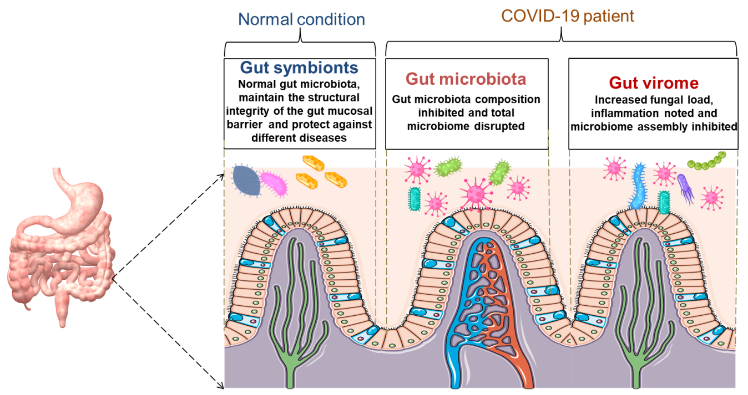
Figure 1 The schematic diagram shows normal healthy gut and the incidence in gut microbiota and gut virome in coronavirus disease 2019 patients. COVID-19: Coronavirus disease 2019.

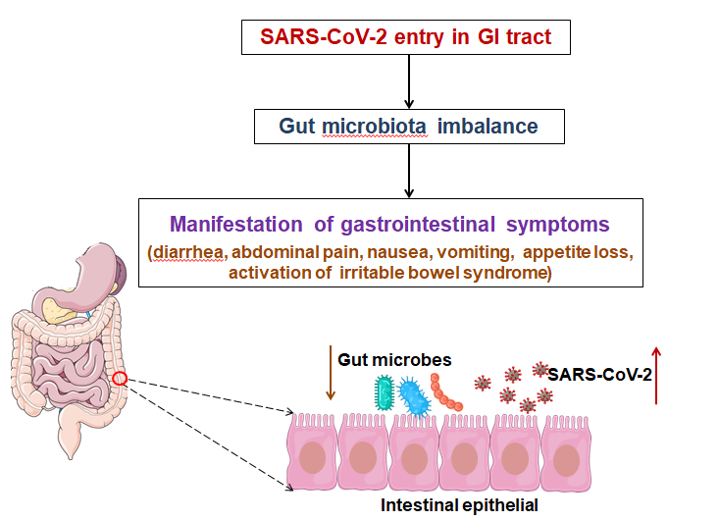
Figure 2 The schematic diagram illustrates the syndrome coronavirus 2 entry in the body, causes of gut microbiota imbalance which assists in manifesting the gastrointestinal symptoms in coronavirus disease 2019 patients. GI: Gastrointestinal; SARS-CoV-2: Syndrome coronavirus 2.

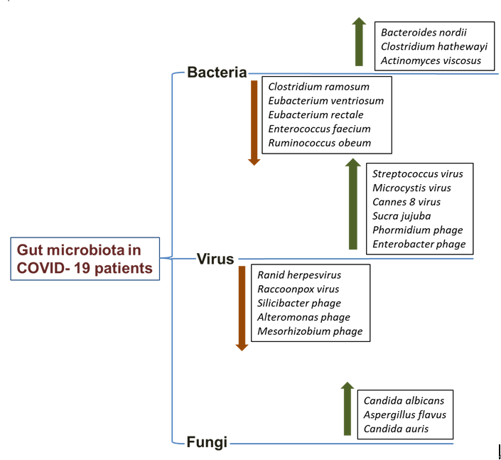

Figure 3 The diagram illustrates increased or decreased gut microbiota in coronavirus disease 2019 patients, including bacterial, viral, and fungal populations. COVID-19: Coronavirus disease 2019.

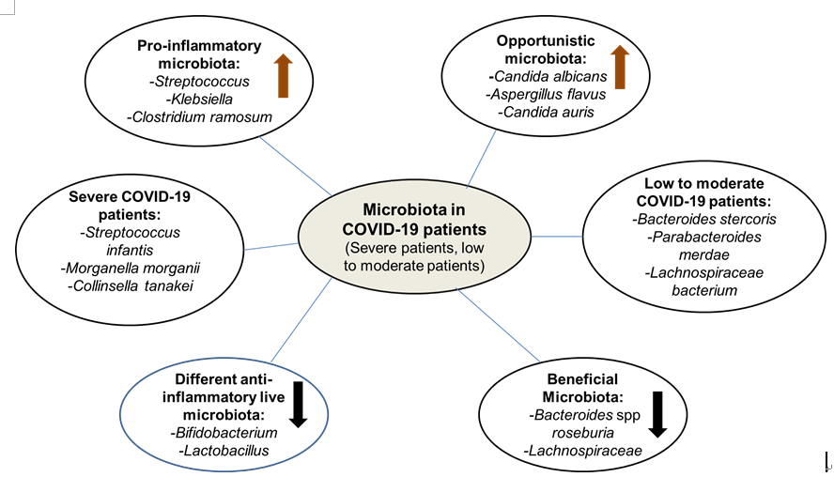
Figure 4 The diagram illustrates different types of mapped gut microbiota in coronavirus disease 2019 patients. Pro-inflammatory microbiota, opportunistic microbiota, the microbiome in severe coronavirus disease 2019 (COVID-19) patients, and the microbiome in low to moderate COVID-19 patients, anti-inflammatory microbiota, and beneficial microbiota. COVID-19: Coronavirus disease 2019.

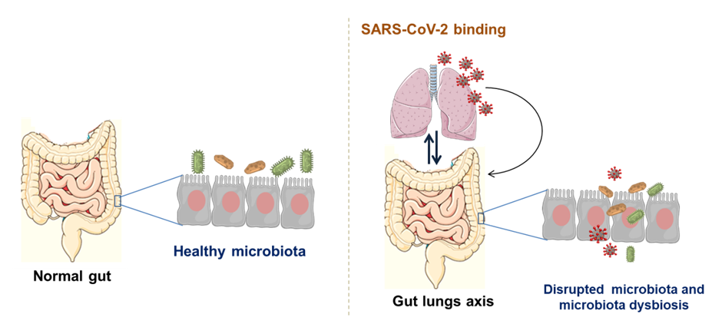

Figure 5 The diagram points out the normal gut and its microbial association. The figure also illustrates the crosstalk between the microbiome and gut-lung axis. SARS-CoV-2: Syndrome coronavirus 2.

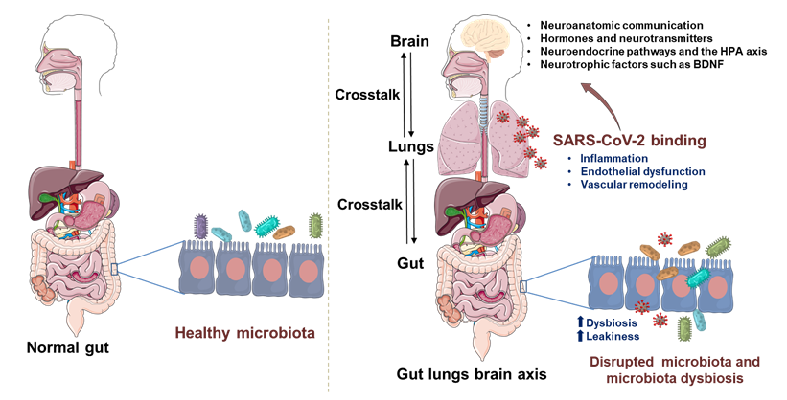
Figure 6 The diagram describes the normal gut and its microbial association. The figure also illustrates the crosstalk between the microbiome and gut-brain-lung axis. BDNF: Brain-derived neurotrophic factor; HPA: Hypothalamic-pituitary-adrenal; SARS-CoV-2: Syndrome coronavirus 2.
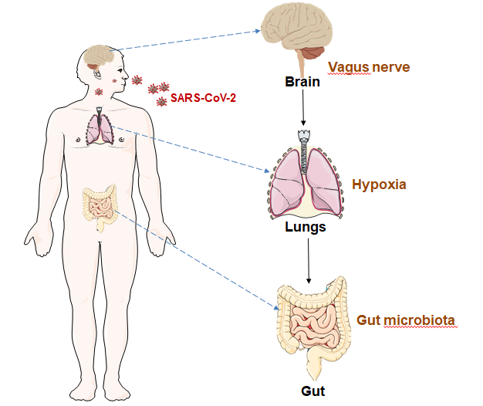
Figure 7 The figure illustrates an association between gut microbiota and hypoxia in coronavirus disease 2019 patients, and it is connected with central nervous system. SARS-CoV-2: Syndrome coronavirus 2.

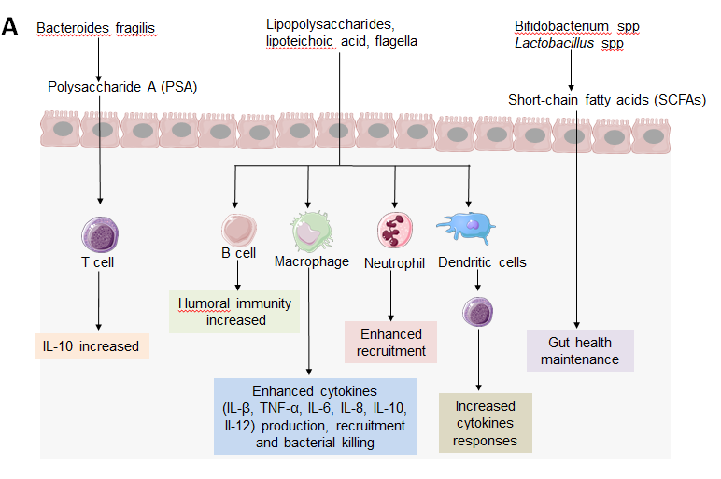
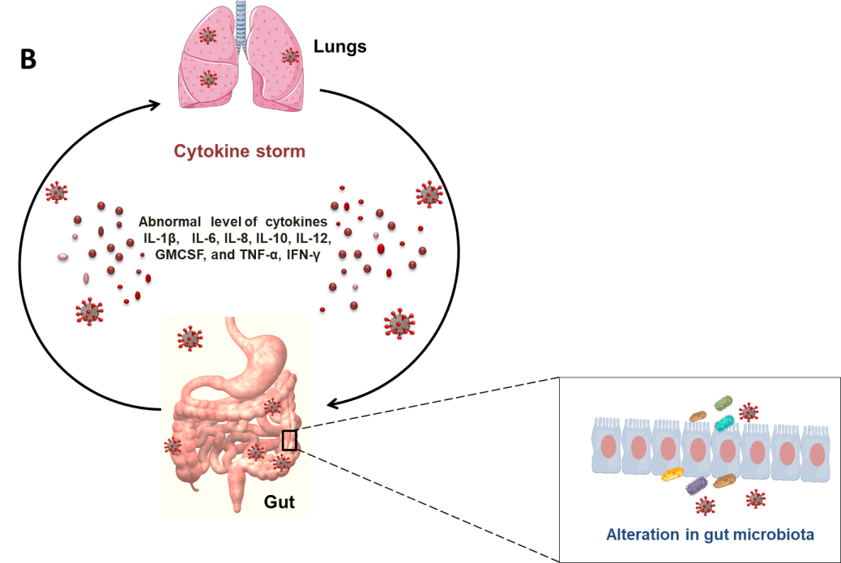
Figure 8 The figure illustrates normal gut microbiota and immunological consequences, and coronavirus disease 2019 related altered gut microbiota associated inflammation. A: Normal gut microbiota and immunological consequences for healthy gut; B: Coronavirus disease 2019 (COVID-19) related altered gut microbiota associated inflammation. The inflammatory condition in COVID-19 patients causes the abnormal release of different cytokines, such as interleukin-1 beta (IL-1β), IL-6, IL-8, IL-10, IL-12, granulocyte-macrophage colony-stimulating factor, tumor necrosis factor-alpha, and interferon-gamma. PSA: Polysaccharide A; SCFA: Short-chain fatty acid; IL-1β: Interleukin-1 beta; IL-6: Interleukin-6; GMCSF: Granulocyte-macrophage colony-stimulating factor; TNF-α: Tumor necrosis factor-alpha; IFN-γ: Interferon-gamma.

Table 1 Different gastrointestinal symptoms in coronavirus disease 2019 patients
S. No. | Total number of human subjects involved in study | Demographics of the study populations | Vomiting | Diarrhea | Nausea | Remarks/study summary | Reference
1 | 191 | Adults (46-67 years) hospitalised, Chinese peoples, 91 patients having comorbidity | 7 (3.7%) | 9 (4.7%) | 7 (3.7%) | Identification of several risk factors and a detailed clinical course of illness for mortality of COVID-19 patients | [121]
2 | 171 | Minor aged (1 d-15 years, hospitalised, Chinese children, no such comorbidity | 11 (6.4%) | 15 (8.8%) | NA | Report of a spectrum of illness from children infected with SARS-CoV-2 virus | [122]
3 | 1099 | Median age group (35-58 years), hospitalised, Chinese patients without any comorbidity | 55 (5.0%) | 42 (3.8%) | 55 (5.0%) | Identification and definition of clinical characteristics and disease severity of hospitalized COVID-19 patients | [37]
4 | 140 | Adults (25-87 year), hospitalised Chinese patients with high comorbidity | 7 (5.0%) | 18 (12.9%) | 24 (17.3%) | Report on hospitalized patients having COVID-19 with abnormal clinical manifestations (fever, fatigue, gastrointestinal symptoms, allergy) | [123]
5 | 73 | Adults hospitalised Chinese patients, comorbidity reported | NA | 26 (35.6%) | NA | Clinical significance of SARS-CoV-2 by examining viral RNA in feces of COVID-19 patients during hospitalizations | [124]
6 | 52 | Adults (mean age 59.7 year), critically ill ICU admitted Chinese patients, comorbidity reported | 2 (3.8%) | NA | NA | Retrospective, single-centered, observational study on critically ill, ICU-admitted adult COVID-19 patients | [125]
7 | 138 | Adult (median age 56 years), hospitalised Chinese patients with comorbidities | 5 (3.6%) | 14 (10.1%) | 14 (10.1%) | Clinical characteristics of COVID-19 patients in hospitalized conditions | [126]
8 | 41 | Middle age group (41-58 years) hospitalised Chinese patients with comorbidities | NA | 1 (2.6%) | NA | Epidemiological, laboratory, clinical, and radiological features and treatment with clinical outcomes of hospitalized COVID-19 patients | [46]
9 | 62 | Studied patients (median age 41 years) were hospitalised, Chinese ethnicity and comorbidity reported | NA | 3 (4.8%) | NA | Most common symptoms at onset of illness with clinical data in confirmed COVID-19 patients | [127]
10 | 137 | Studied patients ( mean age 57-55) ware Chinese and hospitalised, comorbidity was also noted | NA | 11 (8%) | NA | Investigation of epidemiological history, clinical characteristics, treatment, and prognosis of COVID-19 patients | [128]
11 | 81 | Chinese patients (mean age was 49.5 years), hospitalised with high comorbidities | 4 (4.9%) | 3 (3.7%) | NA | Report of confirmed COVID-19 patients with chest computer tomography imaging anomalies | [129]
12 | 99 | Hospitalised, Chinese patients (average age of the patients was 55.5 years), comorbidity was reported | 1 (1%) | 2 (2.0%) | 1 (1%) | Inclusive exploration of epidemiology and clinical features of COVID-19 patients | [130]
NA: Not available; ICU: Intensive care unit; COVID-19: Coronavirus disease 2019; SARS-CoV-2: Syndrome coronavirus 2.
Table 2 Fecal viral shedding in coronavirus disease 2019 patients
S. No. | Total number of human subjects in study | Demographics of the study populations | Gastrointestinal symptoms | Confirmed cases of fecal shedding | Remarks/study summary | Reference
1 | 205 | Patients (mean age of 44 years) were hospitalised, Chinese without any comorbidities | No symptoms | 44 | Evidence-based study for gastrointestinal infection of SARS-CoV-2 virus and its possible fecal-oral transmission route in humans | [131]
2 | 73 | Different age group (10 mo to 78 years old), hospitalised Chinese patients without report any comorbidities | Gastrointestinal bleeding, diarrhea | 39 | Description of epidemiological and clinical characteristics of COVID-19 patients | [124]
3 | 10 | Chinese patients have aged 19-40 years, hospitalised and no such comorbidity was reported | Hemoptysis, diarrhea, cough | 8 | Report of median aged COVID-19 confirmed patients in ICU | [127]
4 | 14 | Patients (18-87 years) were hospitalized, Chinese individuals without any comorbidities | No symptoms | 5 | Retrospective analysis of laboratory-confirmed COVID-19 cases in hospitalized conditions | [132]
5 | 66 | Chinese patients (median age of 44) were hospitalised, comorbidity was not reported | No symptoms | 11 | Viral RNA detection was performed from throat swabs, stool, urine, and serum samples in different clinical conditions in COVID-19 patients | [133]
6 | 18 | Adults patients (median age, 47 years) from Singapore were hospitalised and comorbidities was noted | No symptoms | 4 | COVID-19 patient case series using clinical, laboratory, and radiological data | [134]
7 | 74 | Studied paients belonged from China and were hospitalised with comorbidities | No symptoms | 41 | Analysis of respiratory and fecal samples to determine clinical symptoms and medical treatments of COVID-19 patients | [135]
8 | 9 | Adults Chinese patients were hospitalised without any comorbidities | Diarrhea and urinary irritation | 2 | Detection of SARS-CoV-2 RNA in urine and blood samples, and anal, oropharyngeal swabs of confirmed COVID-19 patients | [136]
ICU: Intensive care unit; COVID-19: Coronavirus disease 2019; SARS-CoV-2: Syndrome coronavirus 2.
Table 3 Analysis of gut microbiota in coronavirus disease 2019 patients in different cohorts
Sl. no | Cohort composition | No of Patients | Demographics of the study populations | Country | Significant gut microbiota found | Study conclusion | Reference
1 | A pilot study with 15 healthy individuals (controls) and 15 patients with COVID-19 | 15 | Study performed with hospitalised patients (median age 55), Chinese ethnicity and comorbidities were reported | Hong Kong | Abundance of Clostridium hathewayi, Clostridium ramosum, Coprobacillus, which are correlated with COVID-19 severity | Change in the fecal microbiome of COVID-19 patients during hospitalization, compared to healthy individuals (controls) | [48]
2 | The two-hospitals cohort, serial stool samples collected from 27 COVID-19 patients among 100 | 27 | Adults hospitalised Chinese patients, comorbidities were noted | Hong Kong | Faecalibacterium prausnitzii, Eubacteriumrectale and bifidobacteria | Gut microbiome involved in COVID-19 severity | [38]
3 | United States cohort (majority African American) | 50 | Studied patients (mean age 62.3 years) were hospitalised with comorbidities, American ethnicity | United States | Some of the significant genera (Corynebacterium Peptoniphilus, Campylobacter, etc.) | No significant associations found between the composition microbiome and disease severity from COVID-19 patient gut microbiota | [50]
4 | The study used 53 COVID-19 patients and 76 healthy individuals. 81 fecal samples collected during hospitalization | 53 | Adults Chinase hospitalised patients, no such comorbidities were noted | China | Elevated gut microbes such as Rothia mucilaginosa, Granulicatella spp, etc. | COVID-19 infection linked with change of the microbiome in COVID-19 patients | [137]
5 | 15 patients Cohort | 15 | Study performed adults hospitalised patients with comorbidities, Chinese ethnicity | Hong Kong | Elevated bacterial species Collinsella tanakaei ,Collinsella aerofaciens, Morganella morganii, Streptococcus infantis | The study found fecal viral (SARS-CoV-2) activity | [54]
6 | Two-hospital cohort with a total of 100 patients. Stool samples collected from 27 patients | 27 | Hospitalised adults patients were from China, comorbidities were noted | Hong Kong | Several gut microbiota such as Faecalibacterium prausnitzii, Eubacterium rectale, and bifidobacteria | Gut microbiota associated disease severity and inflammation in COVID-19 patients | [38]
7 | 98 COVID-19 patients (3 asymptomatic, 34 moderate, 53 mild, 3 critical, 5 severe), serial fecal samples collected from 37 COVID-19 patients | 37 | Adults (mean age 37) patients, hospitalised condition from Chinese ethnicity, comorbidities were reported | Hong Kong | A total of 10 virus species in fecal matter (9 DNA virus species and 1 RNA virus, pepper chlorotic spot virus) | Analysis of gut virome (RNA and DNA virome) in COVID-19 patients | [47]
8 | Study of fecal samples from 30 COVID-19 patients | 30 | Patients (mean age 46) were hospitalised from Chinese groups, comorbidities were noted | Hong Kong | Increased proportions of fungal pathogens (Candida albicans, Candida auris, Aspergillus flavus, Aspergillus niger) in fecal samples | Analysis of fecal fungal microbiome of COVID-19 patients | [48]
COVID-19: Coronavirus disease 2019.
Table 4 List of clinical trials initiated to understand the role of gut microbiota in coronavirus disease 2019 and its therapeutic implications
Sl No. | Objective of clinical trials | Clinical trials No. | Description of clinical trials | Remarks
1 | Evaluate the combination of probiotics (P. acidilactici and L. plantarum) to reduce the viral load of moderate or severe COVID-19 patients | NCT04517422 | It was a randomized controlled trial, 300 participants, treatment by dietary supplement (probiotics) | Observational study of adult and older adult, trial completed
2 | To explore the natural history of mild-to-moderate COVID-19 illness and safety of a novel glycan (KB109) and self-supportive care | NCT04414124 | It was a randomized, prospective, open-label, parallel-group controlled clinical study of 350 participants | Observational study of adults (both male and female), trial completed
3 | Investigate the physiologic effects of the novel glycan (KB109) on patients with COVID-19 illness on gut microbiota structure and function in the outpatient | NCT04486482 | It was a randomized, open-label clinical study of 49 participants | Observational study of adults patients with mild-to-moderate COVID-19 infections, trial completed
4 | Evaluate the clinical contribution of the gut microbiota and its diversity on the COVID-19 disease severity and the viral load | NCT05107245 | It was case-control, diagnostic study of 143 participants | Observational study on the diagnostic evaluation of the human intestinal microbiota, trial completed
5 | Studied the effects of Lactobacillus coryniformis K8 intake on the prevalence and severity of COVID-19 in health professional | NCT04366180 | A randomized, interventional study of 314 participants | Investigation of probiotic effects to healthcare personnel exposed to COVID-19 infection
6 | Investigate to exploring the role of nutritional support by probiotics to COVID-19 outpatients (adult) | NCT04907877 | Randomized, evidence based study of 300 participants | Used of probiotics as dietary supplement that enhance specific immune response of patients having COVID-19 respiratory infection
7 | Use of dietary supplement (Omni-Biotic® 10 AAD) can decrease the intestinal inflammation and improves dysbiosis for COVID-19 patients | NCT04420676 | It was a randomized Interventional study of 30 participants | This study performed as double blind, placebo-controlled study
8 | Evaluate the probiotics efficacy to decrease the COVID-19 infection symptoms and duration of COVID-19 positive patients | NCT04621071 | The double-blind, randomized, controlled trial of 17 participants | This study performed to explored the effects of dietary supplement: Probiotics (2 strains 10 × 10⁹ UFC), trial completed
9 | Impact analysis of probiotic strain L. reuteri DSM 17938 for specific Abs response against SARS-CoV-2 infection | NCT04734886 | It was control, randomized trial of 161 participants | To assess the upon and after COVID-19 infection in healthy adults, trial completed
10 | To evaluate the primary efficacy of live microbials (probiotics) for boosting up the immunity of SARS-CoV-2 infected persons (unvaccinated) | NCT04847349 | It was double-blind, randomized, controlled trial of 54 participants | Efficacy analysis of dietary supplement (combination of live microbials) as anti COVID-19 infection, trial completed
11 | Evaluate the follow -up of Symprove (probiotic) to COVID-19 positive patients | NCT04877704 | The randomized clinical trial was performed with 60 patients | Observational study to supervision of hospitalized COVID-19 patients
12 | Study was performed to evaluate the possible effect of a probiotic mixtures in the improvement of COVID-19 infection symptoms | NCT04390477 | It was randomized case control, clinical trial of 41 participants | Observational study of dietary supplement: Probiotic to COVID-19 patients
13 | The probiotic ( Omni-Biotic Pro Vi 5) use for investigate the side effect of post-COVID syndrome | NCT04813718 | It was a randomized trial of 20 participants | It was a therapeutic target study of probiotic for treatment of acute COVID-19 and prevention of post COVID infections
14 | To evaluate the effect of a probiotic strain on the occurrence and severity of COVID-19 in hospitalised elderly population | NCT04756466 | Randomized control trial of 201 participants | It was observational study, probiotic sued for improve the immune response of elderly patients
15 | This study assesses the beneficial effects of the nutritional supplementation (ABBC1) to individuals taken the COVID-10 vaccine | NCT04798677 | It was a double-blinded, placebo-controlled, randomized clinical study of 90 participants | Used as knowing the microbiome modulating properties, observational study
16 | To investigate the consequence of Ligilactobacillus salivarius MP101 to hospitalised elderly individuals | NCT04922918 | Non-randomised study of 25 participants | Observational study of aged patients having highly affected by COVID-19
17 | Study was performed to explored the effect of the probiotic Lactobacillus rhamnosus GG | NCT04399252 | It was a randomized double-blind, placebo-controlled trail of 182 participants | Observational study of individuals microbiome of household contacts exposed to COVID-19
18 | Treatment approaches by probiotics to human gut microbiome and growing the anti-inflammatory response for COVID-19 infected patients | NCT04854941 | It was a randomized controlled open-label study of 200 participants | The optimizing treatment approaches based observational study, trial completed
19 | To evaluate the capability of the novel nutritional supplement (probiotics and other vitamins) to COVID-19 infected and hospitalised patients | NCT04666116 | Randomized, single blind clinical trial of 96 participants | Used of dietary supplementation with probiotics aims to reduce the viral load
20 | Using of probiotics for COVID 19 transmission reduction to health care professionals | NCT04462627 | It was a non-randomized trial of 500 participants | Analysis and reduction of COVID-19 viral load to health care professionals
P. acidilactici: Pediococcus acidilactici; L. plantarum: Lactobacillus plantarum; COVID-19: Coronavirus disease 2019; SARS-CoV-2: Syndrome coronavirus 2.

