Name of Journal: World Journal of Clinical Cases
Manuscript NO: 71179
Manuscript Type: CASE REPORT

Cryptococcal antigen testing of lung tissue homogenate improves pulmonary cryptococcosis diagnosis: Two case reports

Wang WY et al. Cryptococcal antigen testing of lung tissue homogenate

Wei-Yi Wang, Yu-Lu Zheng, Li-Bin Jiang

Wei-Yi Wang, Li-Bin Jiang, Department of Respiratory Medicine, The First Affiliated Hospital of Zhejiang Chinese Medical University, Hangzhou 310006, Zhejiang Province, China

Yu-Lu Zheng, Department of Respiratory Medicine, The Third Affiliated Hospital of Zhejiang Chinese Medical University, Hangzhou 310000, Zhejiang Province, China

Author contributions: Jiang LB performed the postoperative evaluation and diagnosis; Wang WY and Zheng YL reviewed the literature and contributed to manuscript drafting; Wang WY collected the medical data; all authors issued final approval for the submitted version.

Corresponding author: Li-Bin Jiang, Doctor, MD, Chief Doctor, Department of Respiratory Medicine, The First Affiliated Hospital of Zhejiang Chinese Medical University, No. 54 Youdian Road, Hangzhou 310006, Zhejiang Province, China. jkzjuedu@163.com

Received: September 1, 2021
Revised: November 30, 2021
Accepted: March 7, 2022
Published online: April 26, 2022

Abstract
BACKGROUND
Pulmonary cryptococcosis (PC) is an opportunistic infectious disease of the respiratory system. Lung tissue biopsies, culture of respiratory samples (e.g., sputum, lung tissue, pleural fluid, and bronchoalveolar lavage fluid), and cryptococcal antigen (CrAg) testing are helpful for a definitive diagnosis. However, these tests are sometimes falsely negative. PC is often misdiagnosed or underdiagnosed owing to the absence of obvert symptoms, poor imaging specificity, and false-negative laboratory tests.

CASE SUMMARY
We report two female patients who underwent computed tomography-guided percutaneous needle pulmonary biopsy of a lung nodule for a confirmed diagnosis. In both patients, the CrAg test on the lung biopsy tissue homogenate was positive, while the serum CrAg test was negative. Combined with the lung tissue pathology, we made the diagnosis of PC. Antifungal therapy was effective in both patients.

CONCLUSION
Given the findings of our cases and the literature review, lung tissue homogenate CrAg testing can be helpful in improving the diagnosis of PC.

Key Words: Lung tissue homogenate; Cryptococcal antigen test; Pulmonary cryptococcosis; Lung biopsy; Diagnosis; Case report

©The Author(s) 2022. Published by Baishideng Publishing Group Inc. All rights reserved.

Citation: Wang WY, Zheng YL, Jiang LB. Cryptococcal antigen testing of lung tissue homogenate improves pulmonary cryptococcosis diagnosis: Two case reports. World J Clin Cases 2022; 10(12): 3893-3898
URL: https://www.wjgnet.com/2307-8960/full/v10/i12/3893.htm
DOI: https://dx.doi.org/10.12998/wjcc.v10.i12.3893

Core Tip: Pulmonary cryptococcosis (PC) is often misdiagnosed or underdiagnosed owing to the absence of obvert symptoms, poor imaging specificity, and false-negative laboratory tests. We presented two cases of PC wherein serum cryptococcal antigen (CrAg) tests were negative; however, CrAg tests using lung tissue homogenate were positive. Our report aims to highlight the dilemma in diagnosing PC, as well as a novel adjunct in the diagnostic work-up for PC–cryptococcal antigen tests on lung tissue homogenates.

INTRODUCTION
Cryptococcus neoformans, the aetiological cause of pulmonary cryptococcosis (PC), is globally prevalent and can cause a fatal, disseminated disease. As a potentially serious fungal infection, a timely and reliable diagnosis is very important for improving the prognosis of PC. The diagnosis of PC is based on a combination of clinical symptoms, radiological suspicion, and laboratory confirmation^{[1]}. Culture, histopathology, and serology are the main laboratory methods used for confirmation^{[2]}. However, PC may easily be misdiagnosed or underdiagnosed owing to the absence of clinical symptoms and false-negative laboratory results^{[2-6]}. Cryptococcal antigen (CrAg) testing is convenient, inexpensive, and effective in diagnosing PC^{[5,7]}. Serum, bronchoalveolar lavage fluid (BAFL), pleural effusion, percutaneous pulmonary aspirates, urine and cerebrospinal fluid have been used for CrAg testing^{[7-10]}, while lung tissue homogenate has not been reported thus far. The following cases highlight the usefulness and sensitivity of CrAg testing of lung tissue homogenate in the confirmation of PC.

CASE PRESENTATION
Chief complaints
Case 1: A 59-year-old female patient was admitted to the hospital for haemoptysis on August 21, 2017.
Case 2: A 57-year-old female patient complained of worsening cough for 4 mo and was admitted to the hospital on July 20, 2020.

History of present illness
Case 1: The patient complained of haemoptysis with no sputum. Chest computed tomography (CT) before admission revealed nodules in both lungs, and 7 d of antibacterial treatment was ineffective.
Case 2: The patient had a repeating cough with no fever or sputum.

History of past illness
Case 1: The patient had a 20-year history of immune thrombocytopenic purpura, 2-year history of secondary diabetes, and 1-month history of splenectomy. She had long-term steroid therapy indicated for systemic blood disease.
Case 2: The patient had no other medical history.

Personal and family history
Both patients had no remarkable personal or family history.

Physical examination
Case 1: Initial medical examination showed a respiratory rate (RR) of 17 breaths/min, heart rate (HR) of 85 beats/min, temperature of 37.2 °C, and blood pressure (BP) of 102/65 mmHg. No rales were detected in either lung.
Case 2: Physical examination showed an RR of 18 breaths/min, HR of 89 beats/min, temperature of 37.2 °C and BP of 139/79 mmHg. Normal sounds were heard on auscultation of the lungs.

Laboratory examinations
Case 1: The patient was HIV-negative. A CT-guided transthoracic needle lung biopsy (TNLB) of a nodule in the right lung was sent for evaluation 3 d after admission (Figure 1A). Her serum CrAg test was negative, while her lung biopsy revealed Cryptococcus neoformans infection. Lumbar puncture ruled out Cryptococcus infection of the nervous system. Therefore, she was investigated for PC, and antifungal therapy (fluconazole: 400 mg once daily for 3 mo and then voriconazole 200 mg twice daily for 9 mo) was initiated; however, her lung lesions did not resolve. A follow-up CT-guided TNLB on September 21, 2018 was positive for Cryptococcus neoformans on ink staining (Figure 1B). At that time, CrAg testing of lung biopsy tissue homogenate was performed, which yielded a positive result (Figure 1C). Her serum CrAg test and lung tissue culture remained negative.
Case 2: The patient was HIV-negative. She underwent CT-guided TNLB of a nodule in the lower lobe of the right lung 2 d after admission (Figure 2A). CrAg testing using lung biopsy tissue homogenate was positive (Figure 2B). Ink staining of her lung biopsy specimen was positive for Cryptococcus neoformans (Figure 2C). Lumbar puncture ruled out Cryptococcus infection of the nervous system.

Imaging examinations
Case 1: Chest CT revealed multiple nodules in both lungs (Figure 1A).
Case 2: CT scan of the chest showed a nodule in the right lung (Figure 2A).

FINAL DIAGNOSIS
The final diagnosis of both cases was PC.

TREATMENT
Case 1: Antifungal therapy (fluconazole: 400 mg once daily for 3 mo and then voriconazole 200 mg twice daily for 9 mo) was initiated.
Case 2: Antifungal therapy (fluconazole: 400 mg once daily for 3 mo) was initiated.

OUTCOME AND FOLLOW-UP
Case 1: Antifungal therapy had to be discontinued because of hepatic impairment. The lung lesions were stable without apparent respiratory symptoms for one year after antifungal therapy was discontinued (Figure 1A).
Case 2: Imaging follow-up after 3 mo of antifungal therapy revealed very good resolution of the nodule in the right lung seen previously (Figure 2A).

DISCUSSION
Early diagnosis of PC is crucial for timely and effective treatment. The diagnosis is based on a combination of clinical symptoms (e.g., cough, expectoration, chest tightness, chest pain, fever, and dyspnoea), suspicious radiological findings, and laboratory confirmation^{[1]}. PC may easily be misdiagnosed or underdiagnosed in the absence of clinical symptoms, especially for immunocompetent patients^{[6]}. Clustered or solitary pulmonary nodules are the most commonly seen lung abnormalities in PC^{[11]}. The radiographic similarities to pneumonia or neoplasms, however, can often confuse or delay the clinical diagnosis. Further diagnostic evaluation is often needed to rule out or confirm the diagnosis. The laboratory confirmation of PC is often the next step in evaluation and usually involves serology, histopathology, and/or mycological culture^{[2]}.
Lung tissue biopsies are an important method for a definitive diagnosis. Cryptococcus neoformans, an encapsulated organism, is a narrow-based budding yeast, as seen on histological staining with India ink, haematoxylin and eosin, Grocott-Gomori’s methenamine silver, or periodic acid-Schiff^{[1,12]}. However, in several previous studies, Cryptococcus in some samples did not have a typical polysaccharide capsule^{[13]}. In a previous study, the detection rate of Cryptococcus neoformans observed by electron microscopy was 89.5%^{[3]}. Samples obtained by CT-guided percutaneous lung biopsy may therefore not be adequate for staining and present a further diagnostic dilemma in confirming cryptococcosis.
The culture of respiratory samples has a complementary role in confirming PC. However, Cryptococcus cultures often take several days to grow, and many factors may influence the culture results of lung tissue, such as the number of pathogens, previous antifungal agents administered and duration of culture. A study reported a diagnostic rate of 70.8% for lung tissue culture^{[5]}.
Serum CrAg testing is a convenient, sensitive and rapid method for diagnosing PC^{[5]}. The overall sensitivity and specificity of CrAg testing in the diagnosis of cryptococcal infection were approximately 97.6% and 98.1%, respectively^{[7]}. However, in the two presented cases, the serum CrAg tests were all falsely negative. A false-negative CrAg test result may be due to a prozone reaction due to high antigen titres, low fungal load, samples transported in inappropriate vials, the presence of immunocomplexes preventing the release of glucuronoxylomannan antigen, or hypocapsular or acapsular strains of Cryptococcus spp^{[14]}. Patients with a single pulmonary nodule were less likely to have positive antigen testing than those with other radiographic presentations or concomitant extrapulmonary disease^{[4]}. For cases with a single pulmonary nodule, cryptococcal capsular antigen possibly only exists in the nodule and is not released into the blood. This might be the reason why lung tissue homogenate CrAg testing is more sensitive than serum testing in these cases.
However, there is a limitation of CrAg testing invasion in lung tissue homogenates. Since there are only two cases, this detection methodology deserves further study in a large sample.

CONCLUSION
Due to the potential risk of further dissemination of Cryptococcus infection and the long duration of antifungal therapy, it is necessary to combine multiple methods to improve the diagnostic certainty. According to our cases, lung tissue homogenate CrAg testing may help enhance the accuracy of the diagnosis, especially for serologically negative patients.

ACKNOWLEDGEMENTS
We acknowledge the contributions of Mr Jun-Min Cao and Mr Jian-Feng Wang for the research assistance.

REFERENCES
1 Setianingrum F, Rautemaa-Richardson R, Denning DW. Pulmonary cryptococcosis: A review of pathobiology and clinical aspects. Med Mycol 2019; 57: 133-150 [PMID: 30329097 DOI: 10.1093/mmy/myy086]
2 Gazzoni AF, Severo CB, Salles EF, Severo LC. Histopathology, serology and cultures in the diagnosis of cryptococcosis. Rev Inst Med Trop Sao Paulo 2009; 51: 255-259 [PMID: 19893977 DOI: 10.1590/s0036-46652009000500004]
3 Zeng Y, Wu X, Yi X, Luo B, Zhu M, Rui W, Zhu X, Li X, Li H. Clinicopathologic and ultrastructural study of non-HIV-related primary pulmonary cryptococcosis in China: report of 43 cases. Ultrastruct Pathol 2011; 35: 19-25 [PMID: 21214404 DOI: 10.3109/01913123.2010.521293]
4 Singh N, Alexander BD, Lortholary O, Dromer F, Gupta KL, John GT, del Busto R, Klintmalm GB, Somani J, Lyon GM, Pursell K, Stosor V, Muñoz P, Limaye AP, Kalil AC, Pruett TL, Garcia-Diaz J, Humar A, Houston S, House AA, Wray D, Orloff S, Dowdy LA, Fisher RA, Heitman J, Wagener MM, Husain S. Pulmonary cryptococcosis in solid organ transplant recipients: clinical relevance of serum cryptococcal antigen. Clin Infect Dis 2008; 46: e12-e18 [PMID: 18171241 DOI: 10.1086/524738]
5 Zhou Y, Lin PC, Ye JR, Su SS, Dong L, Wu Q, Xu HY, Xie YP, Li YP. The performance of serum cryptococcal capsular polysaccharide antigen test, histopathology and culture of the lung tissue for diagnosis of pulmonary cryptococcosis in patients without HIV infection. Infect Drug Resist 2018; 11: 2483-2490 [PMID: 30555247 DOI: 10.2147/IDR.S178391]
6 Xie X, Xu B, Yu C, Chen M, Yao D, Xu X, Cai X, Ding C, Wang L, Huang X. Clinical analysis of pulmonary cryptococcosis in non-HIV patients in south China. Int J Clin Exp Med 2015; 8: 3114-3119 [PMID: 26064200]
7 Huang HR, Fan LC, Rajbanshi B, Xu JF. Evaluation of a new cryptococcal antigen lateral flow immunoassay in serum, cerebrospinal fluid and urine for the diagnosis of cryptococcosis: a meta-analysis and systematic review. PLoS One 2015; 10: e0127117 [PMID: 25974018 DOI: 10.1371/journal.pone.0127117]
8 Zhang Y, Zhang SX, Trivedi J, Toll AD, Brahmer J, Hales R, Bonerigo S, Zeng M, Li H, Yung RC. Pleural fluid secondary to pulmonary cryptococcal infection: a case report and review of the literature. BMC Infect Dis 2019; 19: 710 [PMID: 31405376 DOI: 10.1186/s12879-019-4343-2]
9 Musabende M, Mukabatsinda C, Riviello ED, Ogbuagu O. Concurrent cryptococcal meningitis and disseminated tuberculosis occurring in an immunocompetent male. BMJ Case Rep 2016; 2016 [PMID: 26917794 DOI: 10.1136/bcr-2015-213380]
10 Liaw YS, Yang PC, Yu CJ, Chang DB, Wang HJ, Lee LN, Kuo SH, Luh KT. Direct determination of cryptococcal antigen in transthoracic needle aspirate for diagnosis of pulmonary cryptococcosis. J Clin Microbiol 1995; 33: 1588-1591 [PMID: 7650192 DOI: 10.1128/jcm.33.6.1588-1591.1995]
11 Hu Y, Ren SY, Xiao P, Yu FL, Liu WL. The clinical and radiological characteristics of pulmonary cryptococcosis in immunocompetent and immunocompromised patients. BMC Pulm Med 2021; 21: 262 [PMID: 34389002 DOI: 10.1186/s12890-021-01630-3]
12 Guarner J, Brandt ME. Histopathologic diagnosis of fungal infections in the 21st century. Clin Microbiol Rev 2011; 24: 247-280 [PMID: 21482725 DOI: 10.1128/CMR.00053-10]
13 Casadevall A, Coelho C, Cordero RJB, Dragotakes Q, Jung E, Vij R, Wear MP. The capsule of Cryptococcus neoformans. Virulence 2019; 10: 822-831 [PMID: 29436899 DOI: 10.1080/21505594.2018.1431087]
14 Chastain DB, Guarner J, Franco-Paredes C. Cryptococcal antigen negative meningoencephalitis in HIV/AIDS. Diagn Microbiol Infect Dis 2017; 89: 143-145 [PMID: 28784461 DOI: 10.1016/j.diagmicrobio.2017.06.016]

Footnotes
Informed consent statement: Informed written consent was obtained from the patient for publication of this report and any accompanying images.

Conflict-of-interest statement: The authors declare that they have no conflicts of interest.

CARE Checklist (2016) statement: The authors have read the CARE Checklist (2016), and the manuscript was prepared and revised according to the CARE Checklist (2016).

Open-Access: This article is an open-access article that was selected by an in-house editor and fully peer-reviewed by external reviewers. It is distributed in accordance with the Creative Commons Attribution NonCommercial (CC BY-NC 4.0) license, which permits others to distribute, remix, adapt, build upon this work non-commercially, and license their derivative works on different terms, provided the original work is properly cited and the use is non-commercial. See: https://creativecommons.org/Licenses/by-nc/4.0/

Provenance and peer review: Unsolicited article; Externally peer reviewed.
Peer-review model: Single blind

Peer-review started: September 1, 2021
First decision: November 22, 2021
Article in press: March 7, 2022

Specialty type: Respiratory system
Country/Territory of origin: China
Peer-review report’s scientific quality classification
Grade A (Excellent): 0
Grade B (Very good): B
Grade C (Good): C, C
Grade D (Fair): 0
Grade E (Poor): 0

P-Reviewer: Darbari A, India; Nabil A, Japan S-Editor: Liu JH L-Editor: A P-Editor: Liu JH
Figure Legends
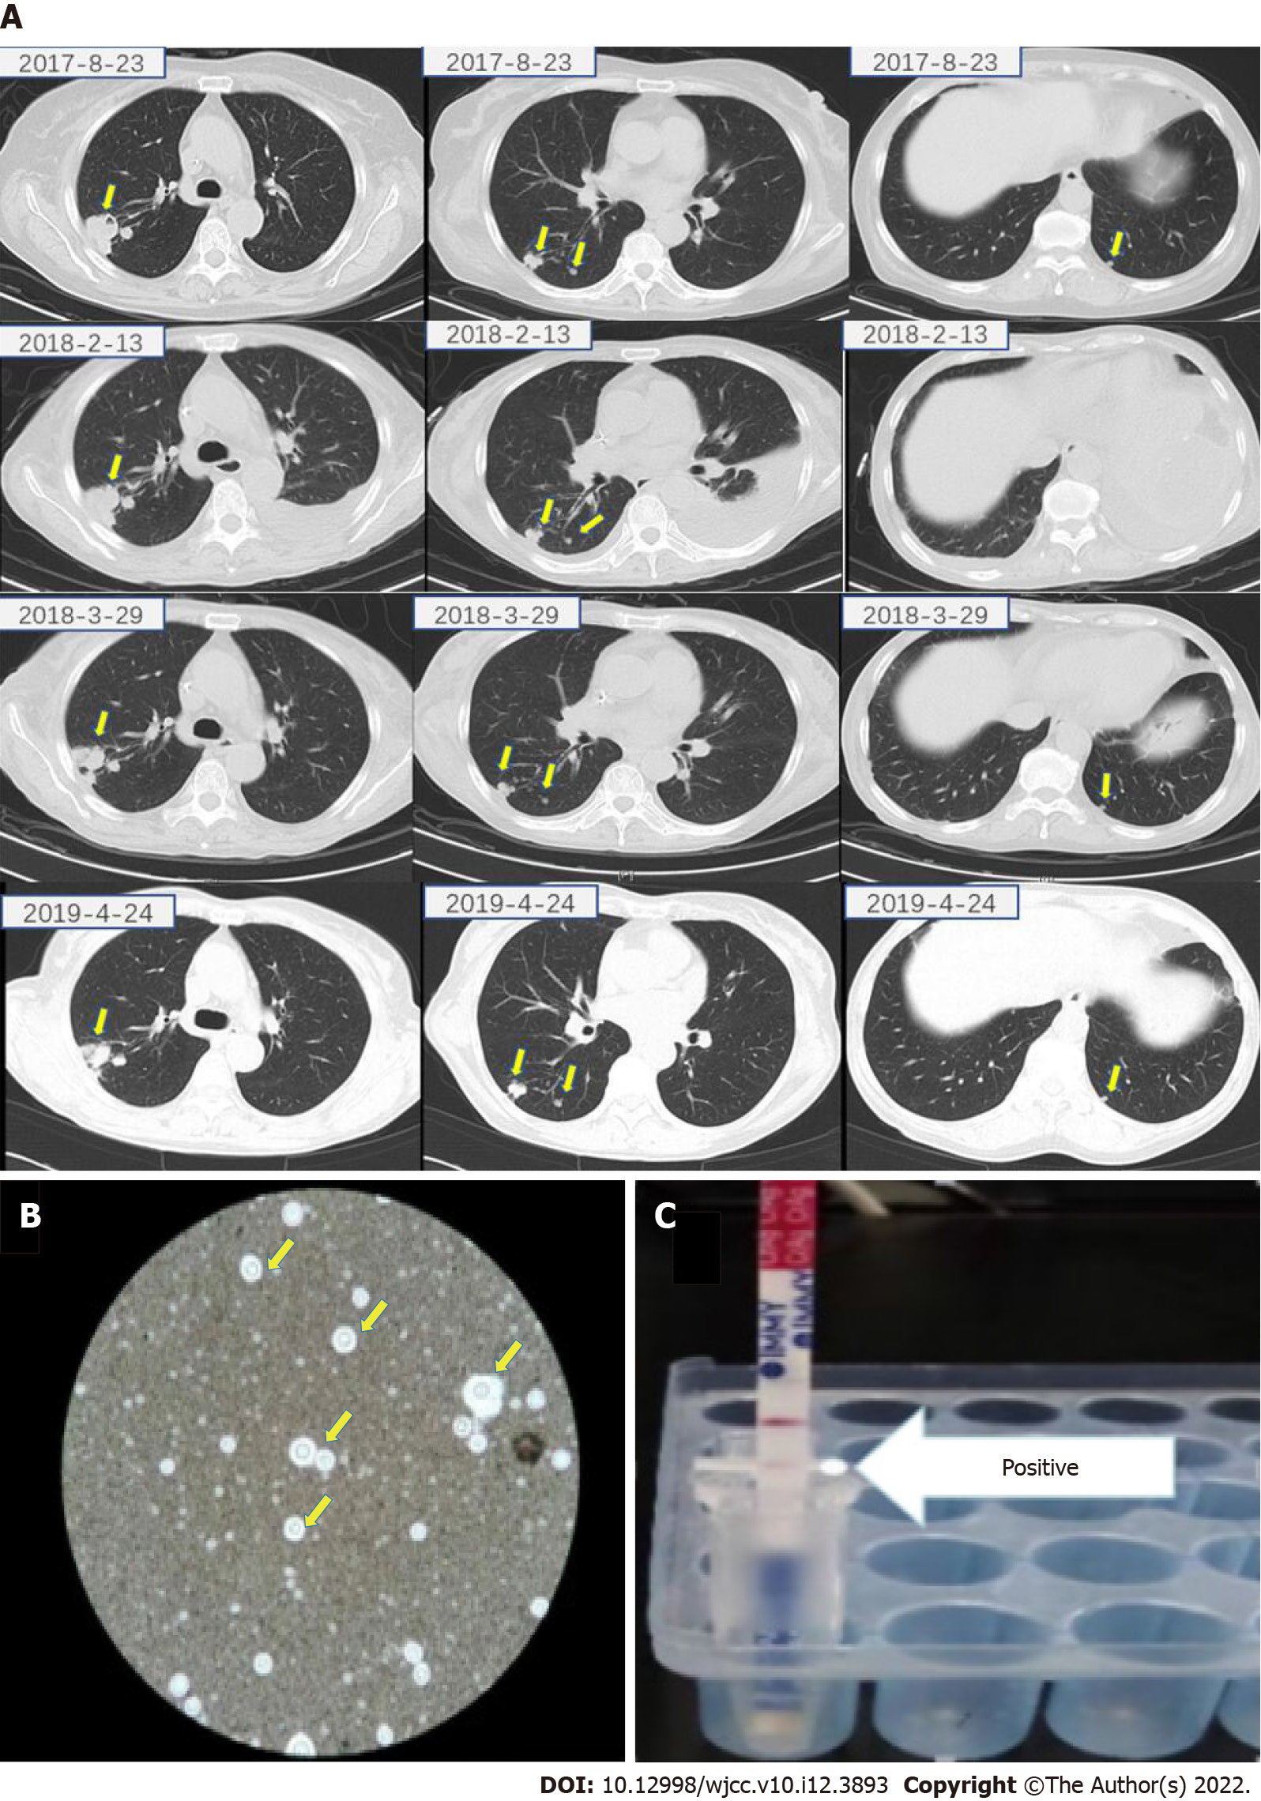
Figure 1 Imaging, pathology and cryptococcal antigen testing of lung tissue homogenate of case 1. A: Computed tomography scan of the chest showing multiple nodules in both lungs (arrow); B: Ink staining of lung biopsy specimen showing polysaccharide capsule that surrounds the cell body; C: Results of cryptococcal antigen lateral flow immunoassay of lung tissue homogenate.
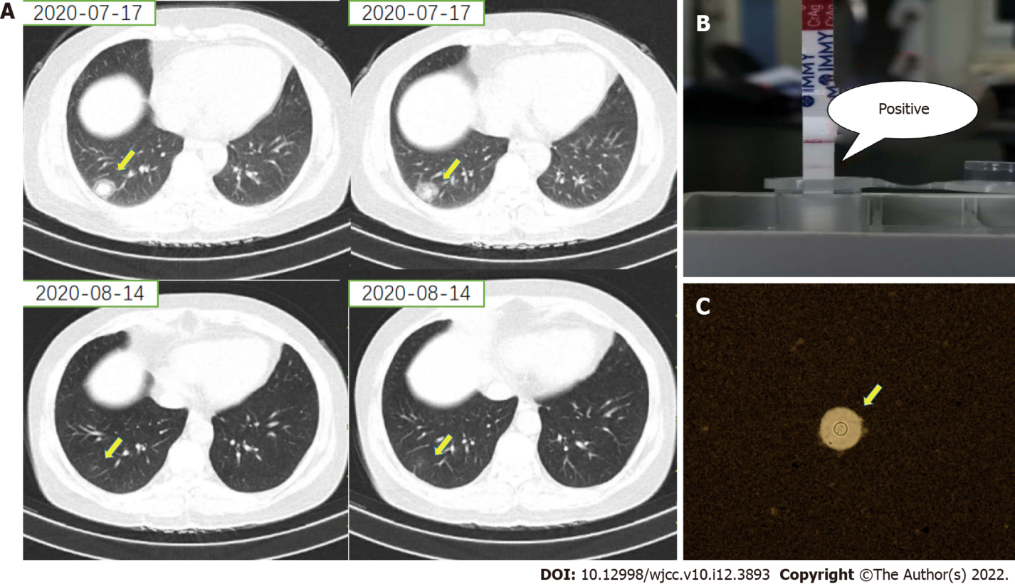
Figure 2 Imaging, pathology and cryptococcal antigen testing of lung tissue homogenate of case 2. A: Computed tomography scan of the chest showing a nodule in the right lung (arrow); B: Positive result for cryptococcal antigen in lateral flow immunoassay of lung tissue homogenate; C: Ink staining of lung biopsy specimen showing polysaccharide capsule that surrounds the cell body.

Published by Baishideng Publishing Group Inc
7041 Koll Center Parkway, Suite 160, Pleasanton, CA 94566, USA
Telephone: +1-925-3991568
E-mail: bpgoffice@wjgnet.com
Help Desk: https://www.f6publishing.com/helpdesk
https://www.wjgnet.com

© 2022 Baishideng Publishing Group Inc. All rights reserved.

