Name of Journal: World Journal of Biological Chemistry
Manuscript NO: 81331
Manuscript Type: MINIREVIEWS

Anticancer potential of Ferula assa-foetida and its constituents, a powerful plant for cancer therapy

Sirizi MAG et al. Anticancer potential of Ferula assa-foetida

Mohammad Amin Ghaffari Sirizi, Jalil Alizadeh Ghalenoei, Mohammad Allahtavakoli, Hasan Forouzanfar, Seyyed Majid Bagheri

Mohammad Amin Ghaffari Sirizi, Jalil Alizadeh Ghalenoei, Seyyed Majid Bagheri, Department of Physiology, Hematology-oncology Research Center, Shahid Sadoughi University of Medical Sciences, Yazd 8915173149, Iran

Mohammad Allahtavakoli, Department of Physiology and Pharmacology, School of Medicine, Rafsanjan University of Medical Sciences, Rafsanjan 8915173149, Iran

Hasan Forouzanfar, Department of Nursing, Tabas School of nursing, Birjand University of Medical Sciences, Birjand 8915173149, Iran

Author contributions: Bagheri SM and Allahtavakoli M designed the research study; Sirizi MAG and Alizadeh Ghalenoei J analyzed the data and wrote the manuscript; Forouzanfar H contributed new reagents and analytic tools; Bagheri SM Final review and editing; All authors have read and approve the final manuscript.

Corresponding author: Seyyed Majid Bagheri, PhD, Assistant Professor, Department of Physiology, Hematology-oncology Research Center, Shahid Sadoughi University of Medical Sciences, Yazd 8915173149, Iran. seyyedmajidbagheri@gmail.com

Received: November 10, 2022
Revised: January 24, 2023
Accepted: February 21, 2023
Published online: March 27, 2023

Abstract
Cancer is one of the main challenges of the health system around the world. This disease is increasing in developing countries and imposes heavy costs on patients and governments. On the other hand, despite various drugs, the death rate among cancer patients is still high and the current treatments have many harmful effects. In the traditional medicine of different countries, there are many medicinal plants that can be effective in the treatment of cancer. Ferula plants are traditionally used as spices and food or for medicinal purposes. Ferula assa-foetida is one of the famous plants of this genus, which has been used for the treatment of various diseases since ancient times. Among the main compounds of this plant, we can mention monoterpenes, sulfide compounds and polyphenols, which can show different therapeutic effects. This article has been compiled with the aim of collecting evidence and articles related to the anti-cancer effects of extracts, derived compounds, essential oils and nanoparticles containing Ferula assa-foetida. This review article was prepared by searching the terms Ferula assa-foetida and cancer, and relevant information was collected through searching electronic databases such as ISI Web of Knowledge, PubMed, and Google Scholar. Fortunately, the results of this review showed that relatively comprehensive studies have been conducted in this field and shown that Ferula assa-foetida can be very promising in the treatment of cancer.

Key Words: Ferula assa-foetida; Anticancer; Essential oil; Isolated components; Nano particle; Extract

©The Author(s) 2023. Published by Baishideng Publishing Group Inc. All rights reserved.

Citation: Sirizi MAG, Alizadeh Ghalenoei J, Allahtavakoli M, Forouzanfar H, Bagheri SM. Anticancer potential of Ferula assa-foetida and its constituents, a powerful plant for cancer therapy. World J Biol Chem 2023; 14(2): 28-39
URL: https://www.wjgnet.com/1949-8454 /full/v14/i2/28.htm
DOI: https://dx.doi.org/10.4331/wjbc.v14.i2.28

Core Tip: Finding new anti-cancer compounds is an important necessity in the treatment or prevention of this disease. Ferula assa-foetida has useful compounds for the prevention and treatment of cancer, which can be used in making new compounds. These compounds include sulphide compounds, flavonoids and terpene coumarins, which with new methods such as making emulsions and nanoparticles from these compounds can be of great help in reducing the costs of cancer patients and their life expectancy.

INTRODUCTION
Today, one of the main problems of the health community is cancer, which is currently known as the second leading cause of death in the world. The most common cancers are breast and lung cancer worldwide, accounting for 12.5% and 12.2% of all newly diagnosed cases, respectively^{[1]}. Common treatments include radiotherapy and chemotherapy that stop the cell cycle through apoptosis or non-apoptosis mechanisms such as necrosis^{[2]}. These therapies have a variety of side effects, including damage to healthy cells. Medicinal plants have therapeutic value due to their biologically active compounds such as terpenes, coumarins, phenolic and alkaloids^{[3]}. These natural compounds have shown promising insight into the treatment and prevention of cancer by restricting the division of tumor cells or inducing apoptosis with the advantage to reduce side effects^{[4]}. The genus Ferula includes 170 different species that are distributed all over the world and this genus belongs to the Apiaceae (Umbelliferae) family^{[5]}. Ferula assa-foetida, one of the famous species of Ferula that is used in Iranian traditional medicine for the treatment of digestive diseases, nervous problems and some reproductive system disorders such as decreased libido^{[6]}. Asafoetida or Anghouzeh (Traditional name in Persian), is an oleo gum resin which obtained from the root of Ferula assa-foetida and traditionally used as anthelmintic, anticonvulsant, sexual aphrodisiac and analgesic agent^{[7]}. New scientific reports have shown that asafoetida has antifungal^{[8]}, antidiabetic^{[9]}, antiinflammatory^{[10]}, antimutagenic^{[11]} antidementia^{[12]}, anticonvulsant^{[13]}, antiviral^{[14]}, anti-cancer^{[15]} and relaxant^{[16]} activities and also has preventive effect against cuprizone induced demyelination^{[17]}. There is not enough information available about the dosage and toxicity of asafoetida, but it is recommended not to consume more than 0.2 g per day ^{[18]}, and it has also been shown that long-term and high-dose administration (200 mg and above) causes liver damage^{[19]}. The main compounds that have been identified in the Ferula assa-foetida include glycoside compounds, various terpenoid, coumarin derivatives, and sulfide compounds^{[20,21]} which have been shown to have anti-cancer potential (Figures 1 and 2).
Some compounds isolated from Ferula assa-foetida have also been shown to have various pharmacological properties. For example, Ferulic acid is one of these compounds that has antioxidant and neuroprotective properties^{[22]}. Umbelliferon is a coumarin compound that has antioxidant and antidiabetic as well as antitumor effects^{[23]}. In recent years, many studies have been conducted on the anti-cancer effects of Ferula. The members of this genus have shown high anti-cancer potential, which can provide a good basis for finding new anti-cancer agents. Our focus on published studies on the impact of different extracts and compounds isolated from Ferula assa-foetida as anticancer agents. Due to the increase in cancer patients and significant findings on the anticancer effects of Ferula assa-foetida, this article is designed for help to researchers finding new anticancer compounds.

Method
This review article was prepared by searching the terms of Ferula assa-foetida and cancer. Information about Ferula assa-foetida and its anticancer effect was collected on electronic databases including ISI Web of Knowledge, Medline/PubMed, ScienceDirect, Embase, Scopus, Biological Abstract, Chemical Abstract and Google Scholar. To make the research easier to understand, the article is divided into different sections, including the anti-cancer effects of nanoparticles containing Ferula assa-foetida, essential oils, extracts, isolated compounds from Ferula assa-foetida, and preclinical and experimental studies (Table 1).

Anticancer effect of nanoparticles containing Ferula assa-foetida
Encapsulation of essential oils, extracts and plant derivatives can overcome their therapeutic limitations and lead to better stability, increased bioavailability and better efficacy^{[24]}. The use of nanoparticles in cancer treatment is a new method that can be used to target treatment. Ferula assa-foetida has various biological compounds that make it a suitable candidate for use in cancer treatment. Various studies have been conducted on the effect of different derivatives and extracts of this plant on different cell lines of cancer cells and generally positive results have been obtained. For example, use of silver nanoparticles and ethanol extract of asafoetida caused a decrease in the survival rate of L6 cancer cells, and the IC₅₀ value was calculated as 1 μg/mL^{[25]}. Some studies have shown that nanoemulsion containing Ferula assa-foetida essential oil can cause apoptosis by increasing BAX expression and decreasing BCL-2 in MCF7 cancer cells. The lethality of this nanoparticle has been calculated based on IC₅₀ equal to 64 μg/mL for MCF7 and 201 μg/mL for A2058. Also, a significant decrease in the expression of vascular endothelial growth factor (VEGF) at 32 μg/mL and vascular endothelial growth factor receptor (VEGFR) at 128 μg/mL was observed in MCF-7 cells treated with nanoemulsion. This nanoparticle was able to significantly reduce tumor indices in the murine model of induced breast cancer at a concentration of 100 mg/kg^{[26]}. Lipid nanoparticles containing Ferula assa-foetida seed oil on NT-2 human cancer stem cells had an IC₅₀ equal to 115.4 μg/mL. The morphometric results of blood vessels treated with these nanoparticles showed that the number of blood vessels was significantly reduced in concentrations of 250, 500 and 1000 μg/mL in a dose-dependent manner. Also, these nanoparticles increased the expression of TNF-α, P21, and Cas3^{[27]}. Synthesis of silver nanoparticles (AgNPs) with aqueous extract of asafoetida on MCF-7 cells caused cell death in a dose-dependent manner and its IC₅₀ was calculated as 2 μg/mL^{[28]}. By making zinc nanoparticles containing Ferula assa-foetida extract and investigating its effects on MCF7, MDA-MB231 and HT-29 cell lines, Boskabadi et al^{[29]} showed that this nanoparticle can significantly reduce the growth of cancer cells. The calculated IC₅₀ was equal to 23, 41.26 and 143 μg/mL after 72 h, respectively. In addition, the results showed that the nanoparticle has apoptotic properties and antioxidant activity with an IC₅₀ equal to 500 mg/mL. Expression of Bax and Bcl2 significantly up and down regulated respectively. Mokhtareeizadeh et al^{[30]} founded that nanoparticles containing Ferula assa-foetida essential oil can inhibit the growth of HepG2 and A2780 cells with IC₅₀ of 57 and 106.7 μg/mL respectively. These nanoparticles caused a significant decrease in angiogenesis in fertilized eggs at a dose of 125 μg/mL. Also it induced apoptosis and death of cancer tissue cells by regulating Caspase3 and 9, TNF-α, P53 and P21 in nude mice with breast cancer.

Anticancer effect of essential oil of Ferula assa-foetida
The main part used by Ferula assa-foetida is an oleo gum resin, which is obtained by shaving its root. This oleo gum resin contains many different compounds, the anti-cancer effects of some of these compounds have been investigated. The volatile part of oleo gum resin or its essential oil contains generally sulfur compounds that have a pungent and unpleasant smell. Some studies have shown that essential oil has strong anti-cancer effects. For example, Yatham et al^{[31]} found four main compounds in asafoetida essential oil, including (-)-E-2-butylpropenyl disulfide, (-)-Z-2-butylpropenyl disulfide, (-)-1-(methylthio) propyl (E)-1 -Propenyl disulfide, and (-)-1-(methylthio) propyl (Z)-1-propenyl disulfide were identified and investigated their potential to inhibit the growth of cancer cell lines SKOV3 (ovary) and A549 (lung). Meanwhile, trisulfide showed better activity against A549 and SKOV3 cell lines compared to disulfides. The analysis of Ferula assa-foetida seed essential oil showed that it contains compounds such as E-1-propenyl sec-butyl disulfide (13.13%) Z-1-propenyl sec-butyl disulfide (11.34%). This essential oil exerted its inhibitory effect on aerobic granular sludge gastric cancer cells near 100% in 10μl/mL in 72 h after incubation^{[32]}. The anti-proliferative and anti-apoptotic effects of asafoetida essential oil on liver cancer cell lines (HepG2 and SK-Hep1) as well as the expression of NFKB1, TGFB1, TNF, and caspase3 genes showed that the IC₅₀ of the oil for HepG2 and SK-Hep1 was 7.21 μg/mL and 8.0 μg/mL respectively. After EO treatment, the genes involved in metastasis and proliferation decreased and the genes involved in apoptosis showed a significant increase (casp3 and TNF). Analysis of the essential oil by GC showed the presence of 1, 2-dithiolane in the amount of 87.4%^{[33]}. Pavela et al^{[34]} evaluated the essential oils asafoetida and Ferula gummosa on T98G (human glioblastoma multiforme cell line), HCT116 (human colon cancer cell line). Ferula assa-foetida essential oil was more active on HCT116 with IC₅₀ value of 5.96 µg/mL and Ferula gummosa essential oil showed more activity on T98G with IC₅₀ value of 4.49 µg/mL. Essential oil of asafoetida (EOA) exposed MCF7 cells to different concentrations of EOA (2, 4, 6, 8, and 10 μl/mL) at 24, 48 and 72 h showed that EOA significantly decreased the viability of MCF7 cells in a time and concentration-dependent manner. The major constituents identified in EOA were E-1-propenyl sec-butyl disulfide (36.15) and Z-1-propeny sec-butyl disulfide (27.93%)^{[35]}

Anticancer effect of isolated constituents from Ferula assa-foetida
Several compounds are derived from Ferula assa-foetida, which include coumarins, sesquiterpene coumarins, flavonoids and phenolic constituents that have shown a number of pharmacological effects, including antibacterial, antifungal, cytotoxic, antioxidant and hormonal activities, as well as anticancer effects^{[36]}. Ferulic acid is one of the phenolic compounds in asafoetida, which has various therapeutic effects^{[37]}. Al-Mutairi et al^{[38]} have shown that when ineffective doses of ferulic acid were used with ineffective doses of thymoquinone, it was able to significantly reduce the death of MDA-MB- cells after 48 h. In another study, ferulic acid increased caspase 3 activity in the breast cancer cell line MDA-MB-231 and reduced the proliferation of the cancer cell line about 40% after 72 h at a concentration of 100 μM. Also, the anti-tumor potential of ferulic acid in a xenograft mouse model with MDA-MB-231 at a concentration of 100 mg/kg body weight could reduce tumor volume, weight and growth^{[39]}. Bagheri et al^{[40]}, showed that ferulic acid significantly reduced the growth of 4T1 mouse breast cancer cells at a dose of 500 μg/mL. Galbanic acid is a terpenes lactone derived from the gum of Ferula assa-foetida, which has also been identified in several other species of Ferula^{[41]}. Treatment of MDA-MB-231 and MCF-7 cells with galbanic acid showed that this compound leads to the inhibition of proliferation and induction of apoptosis with IC₅₀ of 48.7 and 56.6 μg/mL, respectively. Also, galbanic acid stimulated apoptosis through the up-regulation of Bax and caspase-3 and the down-regulation of bcl2 and increased the expression of superoxide dismutase, catalase and glutathione peroxidase genes^{[42]}. In confirmation of these results, in another study, the potential of galbanic acid in inhibiting four types of non- small lung cancer cells H460 and A549, PC-9 and HCC827 were proven after 24 h. Meanwhile, H460 cell line has the highest sensitivity to galbanic acid and showed an IC₅₀ of about 100 μM. It was also found that the expression levels of Bax and caspase 9 increased and Bcl-2, Bcl-xL and myeloid cell leukemia 1 (Mcl-1) decreased and cleaved poly (ADP-ribose) polymerase (PARP) in H460 cells^{[43]}. Androgen receptor (AR) signaling is crucial for the initiation and progression of prostate cancer (PCa). In a study, it was found that galbanic acid preferentially suppresses the growth of AR (+) PCa cells compared to AR (-) PCa cells. Galbanic acid induces apoptosis through G1 arrest associated with inhibition of cyclin/CDK4/6 pathway, especially cyclin D1^{[44]}. The anti-angiogenic activities of farnesiferol C (FC) in human umbilical vein endothelial cells showed that exposure to a concentration range of 10-40 μmol/L FC inhibited VEGF, migration, invasion cells and decrease the expression of matrix metalloproteinase 2. Furthermore, FC inhibited the angiogenesis of mouse aorta treated with VEGF in an experimental model. FC reduced the growth of mouse Lewis lung cancer by 60% and caused rapid inhibition of VEGFR1 autophosphorylation caused by VEGF without affecting VEGFR2. However, FC inhibited the phosphorylation of most VEGFR2 downstream kinases such as focal adhesion kinase, Src, extracellular signal-regulated kinase 1/2, p38 mitogen-activated protein kinase, and c-jun-NH2-kinase without affecting AKT^{[45]}. Sesquiterpene coumarins are a group of compounds found in the genus Ferula that have shown various therapeutic effects such as anticancer effects^{[21]}. Farnesiferol C obtained from the chloroform extract of Ferula assa-foetida, on MCF-7 cells, led to a decrease in cell viability after 24, 48 and 72h. (IC50 43, 20 and 14 µM, respectively). Farnesiferol C stopped the cell cycle in G0/G1 phase and induced apoptosis in MCF-7 cells. This compound increased cellular SOD, CAT MDA activities in 24 and 48 h and reduced activity of SOD and CAT and increased MDA level after 72 h exposure. It demonstrated that reactive oxygen species level increased 5.92%, 13.53% and 14.43% after 24, 48 and 72 h exposure, respectively^{[46]}. Treatment of K562, KBM5, U937 and HL-60 cancer cells with farnesiferol C showed that this substance has an IC₅₀ = 10 μM on K562 cells and 20μM on KBM5 cells and showed a significant effect only on these two types of cells. Also, cleaved PARP and caspase 3 and 9 decreased the expression of Bcl2 and stopped cells in G1, and farnesiferol C decreased the expression of Cyclin D1, Cyclin E, Cyclin B1 and histone deacetylase 1 and 2 in K562 and KBM52 cells^{[47]}. Investigation on anticancer potential of ten sesquiterpene coumarins include farnesiferol A, farnesiferol B, farnesiferol C, gummosin, samarkandin, umbelliprenin, badrakemine acetate, ferukrinone, kellerin and deacetyl kellerin derived from asafoetida showed that gummosin has highest cytotoxic activity among these sesquiterpene coumarins. It showed an IC₅₀ values of 30 and 32.1 μg/mL against PC-3 and MCF-7 cell lines respectively^{[48]}. Umbelliprenin is a prenylated coumarin compound found in Ferula species, also isolated from Ferula assa-foetida. This structure has various pharmacological effects such as cytotoxic activities and induction of apoptosis^{[49]}. Using the umbelliprenin isolated from Ferula assa-foetida on Jurkat T-CLL and Raji B-CLL cell lines showed that umbelliprenin induced apoptosis in a dose- and time-dependent manner (IC50, 16 h = 75 μM and 48 h = 25 μM respectively)^{[50]}. Farnesylation of the activated oncogenic ras product by Farnesyltransferase (FTase) is a critical step for its oncogenic function. Isolation of galbanic acid, karatavicinol, umbelliprenin, farnesiferol B, farnesiferol C from Ferula assa-foetida to inhibit FTase showed that galbanic acid has the highest enzyme inhibition potential and IC₅₀ was calculated as 2.5 μM. In addition, the calculated IC₅₀ value in reducing the proliferation of oncogenic ras-transformed NIH3T3/Hras-F cells by galbanic acid was 16.2 μM compared to the control group^{[51]}.

Different extractions of Ferula assa-foetida on cancer
Ferula assa-foetida ethanolic extract showed a significant effect on PC12 and MCF7 cells in reducing cell survival. The amount of IC₅₀s for 24, 48 and 72 h for MCF7 was 1.30, 1.284, 0.753 μM, respectively. Also, IC₅₀s for PC12 category at 24, 48 and 72 h were calculated as 2.84, 0.8 and 0.4 μM, respectively^{[52]}. The petroleum benzene, chloroform and methanol extract of asafoetida on MCF7 HepG2, A549, HT-29 and MDBK showed that the methanol fraction has an IC₅₀ of more than 100 μg/mL. Petroleum and chloroform extracts showed IC₅₀ values less than 52 μg/mL in four cell lines. Chloroform fraction showed IC₅₀ equal to 61.42 μg/mL in MCF7. The petroleum afraction showed an IC₅₀ of 45.73 μg/mL in MCF7^{[53]}. The hydroalcoholic extract of Ferula assa-foetida significantly reduce the mRNA expression level of epithelial-mesenchymal transition markers (vimentin, Snail1, Zeb1) and the anti-apoptotic marker Bcl-2, as well as the expression of stem cell marker CD44 and CD54^{[54]}. Ethanol extracts of Ferula assa-foetida and a number of its components (ferulic acid, vanillic acid, quercetin, ellagic acid, and p-coumaric acid) had cytotoxic effects on MCF-7 or MDA-MB-231 human breast cancer cells and 4T1 mouse cell line. Also, THP-1 peripheral blood monocytic leukemia cells can be polarized to M1 inflammatory phenotype by treatment with the extract and its components. Furthermore, this THP-1-dependent polarization of macrophages demonstrated an enhanced ability to damage MCF-7 or MDA-MB-231 cell monolayers in co-culture experiments. Therefore, treatment with Ferula assa-foetida extract can also indirectly cause the death of cancer cells through the activation of immune cells^{[55]}. The cytotoxic effects of the ethanolic extract of Ferula assa-foetida resin on HepG2 cell line in concentrations (10, 50, 100, 200 μg/mL) showed that this extract in doses of 50, 100 and 200 μg/mL decreased the viability of HepG2 cells but in doses of 100 and 200, it also changes the shape of normal L929 cells. Therefore, only a dose of 50 μg/mL can be considered as an effective and non-toxic dose^{[56]}. The investigation of methanolic and ethanolic extract of Ferula assa-foetida resin on osteosarcoma cell line showed that different concentrations of the extract in 24 and 48 h can reduce the survival of cancer cells. The highest effect rate corresponding to the concentration of 20 mg in 48 h for ethanolic and methanolic extract was calculated as 29.5 and 35.2, respectively. Also, the results showed that the ethanolic extract has a greater effect on the death of cancer cells^{[57]}.

Animal evidences from anti-tumor effect of Ferula assa foetida
Although animal evidence for the anticancer effect of Ferula assa-foetida is not much, several limited studies have shown that this plant has good anticancer potential. In a study, it was found that the use of 100 mg/kg asafoetida for 21 d against breast cancer caused by 4T1 cells in BALB/c mice can reduce tumor weight and tumor volume and increase the weight of treated mice. Also, asafoetida reduced lung, liver and kidney metastasis respectively. Asafoetida showed significant inhibitory activity against lipoxygenase as well as antioxidant activity^{[15]}. The use of food containing asafoetida (1.25 and 2.5%) showed that asafoetida significantly restored the level of the antioxidant system MNU (N-methyl-N-nitrosourea) induced mammary carcinogenesis in Sprague-Dawley rats. Furthermore, only in the MNU-control group, all animals had tumors with an average of 5.45 tumors per mouse (tumor burden) at the end of 18 wk, but the tumor burden in treated groups (1.25% and 2.5%) with asafoetida decreased to 3.6 and 2.3 tumor/mouse, respectively. The tumor volume in treated groups also decreased to 1.9cc (40%) and 1.3cc (59%), respectively, compared to 3.2cc in control group^{[58]}. The use of different doses of asafoetida (5, 10 and 20 mg/100 g body weight) on dimethylhydrazine-induced colon cancer in rats showed that body weight, tumor frequency, tumor incidence, tumor size, total serum sialic acid as well as the tissue structure of the colon improved in all groups treated with asafoetida and these effects was better at dose of 10 mg/ 100 g body weight than other doses^{[59]}.

Anticancer mechanisms
The results of this study show that extracts and compounds isolated from Ferula asafoetida can cause the death of cancer cells in different ways. These mechanisms are briefly shown in Figure 3. As can be seen from this diagram, by reducing angiogenesis, increasing apoptosis, inhibiting metastasis, affecting the oxidative system of cancer cells and disrupting the cycle of cancer cells, Ferula assa-foetida causes damage and death of these cells.

CONCLUSION
Cancer is one of the serious problems of human society, especially in developing countries. The costs of treating the disease are very high and the death rate caused by it is worrying. The healthcare system and the research community should find effective and low-cost treatment methods as soon as possible, especially for poor communities. Finding anti-cancer compounds of natural origin is one of these solutions. It is very encouraging to see the results of the anti-cancer effects of Ferula assa-foetida. These results show that asafoetida can be considered as a medicinal plant in cancer treatment. Many of the effective compounds found in plant gum have anti-cancer effects, which can be inspired by these compounds to create new drugs. The use of asafoetida as a seasoning in foods can also be effective in the follow-up of cancer. By taking advantage of new methods such as nanotechnology and biotechnology, we can imagine a better perspective in using this plant and its derivatives as an anti-cancer agent.

REFERENCES
1 Xia C, Dong X, Li H, Cao M, Sun D, He S, Yang F, Yan X, Zhang S, Li N, Chen W. Cancer statistics in China and United States, 2022: profiles, trends, and determinants. Chin Med J (Engl) 2022; 135: 584-590 [PMID: 35143424 DOI: 10.1097/CM9.0000000000002108]
2 Samadi P, Saki S, Dermani FK, Pourjafar M, Saidijam M. Emerging ways to treat breast cancer: will promises be met? Cell Oncol (Dordr) 2018; 41: 605-621 [PMID: 30259416 DOI: 10.1007/s13402-018-0409-1]
3 Roaa MH. A review article: The importance of the major groups of plants secondary metabolism phenols, alkaloids, and terpenes. Int J Res Appl Sci Biotechnol 2020; 7: 354–358 [DOI: 10.31033/ijrasb.7.5.47]
4 HemaIswarya S, Doble M. Potential synergism of natural products in the treatment of cancer. Phytother Res 2006; 20: 239-249 [PMID: 16557604 DOI: 10.1002/ptr.1841]
5 Gholami O, Shamsara J. Comparison of the cytotoxic effects of umbelliprenin and auraptene. Int J Pharm Pharm Sci 2016; 8: 1–4.
6 Iranshahy M, Iranshahi M. Traditional uses, phytochemistry and pharmacology of asafoetida (Ferula assa-foetida oleo-gum-resin)-a review. J Ethnopharmacol 2011; 134: 1-10 [PMID: 21130854 DOI: 10.1016/j.jep.2010.11.067]
7 Bagheri SM, Yadegari M, Zare-Mohazabiye F, Momeni-Asl H, Mirjalili A, Anvari M, Behpour M. Effect of Ferula assa-foetida oleo-gum-resin on gastric ulcer in indomethacin-ulcerated rats. J Curr Res Sci Med 2018; 4: 42 [DOI: 10.4103/jcrsm.jcrsm_48_17]
8 Angelini P, Pagiotti R, Venanzoni R, Granetti B. Antifungal and allelopathic effects of Asafoetida against Trichoderma harzianum and Pleurotus spp. Allelopath J 2009; 23: 357–368
9 Abu-Zaiton AS. Anti-diabetic activity of Ferula assafoetida extract in normal and alloxan-induced diabetic rats. Pak J Biol Sci 2010; 13: 97-100 [PMID: 20415145 DOI: 10.3923/pjbs.2010.97.100]
10 Bagheri SM, Hedesh ST, Mirjalili A, Dashti-R MH. Evaluation of Anti-inflammatory and Some Possible Mechanisms of Antinociceptive Effect of Ferula assa-foetida Oleo Gum Resin. J Evid Based Complementary Altern Med 2016; 21: 271-276 [PMID: 26427790 DOI: 10.1177/2156587215605903]
11 Soudamini KK, Unnikrishnan MC, Sukumaran K, Kuttan R. Mutagenicity and anti-mutagenicity of selected spices. Indian J Physiol Pharmacol 1995; 39: 347-353 [PMID: 8582746]
12 Bagheri SM, Dashti-R MH. Influence of asafoetida on prevention and treatment of memory impairment induced by d-galactose and NaNO2 in mice. Am J Alzheimers Dis Other Demen 2015; 30: 607-612 [PMID: 25788433 DOI: 10.1177/1533317515576388]
13 Bagheri SM, Rezvani ME, Vahidi AR, Esmaili M. Anticonvulsant effect of ferula assa-foetida oleo gum resin on chemical and amygdala-kindled rats. N Am J Med Sci 2014; 6: 408-412 [PMID: 25210675 DOI: 10.4103/1947-2714.139296]
14 Lee CL, Chiang LC, Cheng LH, Liaw CC, Abd El-Razek MH, Chang FR, Wu YC. Influenza A (H(1)N(1)) Antiviral and Cytotoxic Agents from Ferula assa-foetida. J Nat Prod 2009; 72: 1568-1572 [PMID: 19691312 DOI: 10.1021/np900158f]
15 Bagheri SM, Abdian-Asl A, Moghadam MT, Yadegari M, Mirjalili A, Zare-Mohazabieh F, Momeni H. Antitumor effect of Ferula assa-foetida oleo gum resin against breast cancer induced by 4T1 cells in BALB/c mice. J Ayurveda Integr Med 2017; 8: 152-158 [PMID: 28690055 DOI: 10.1016/j.jaim.2017.02.013]
16 Bagheri S, Hejazian Sh, Dashti-R M. The Relaxant Effect of Seed's Essential Oil and Oleo-Gum-Resin of Ferula Assa-Foetida on Isolated Rat's Ileum. Ann Med Health Sci Res 2014; 4: 238-241 [PMID: 24761245 DOI: 10.4103/2141-9248.129050]
17 Bagheri SM, Maghsoudi MJ, Yadegari M. Preventive Effect of Ferula asafoetida Oleo Gum Resin on Histopathology in Cuprizone-Induced Demyelination Mice. Int J Prev Med 2020; 11: 179 [PMID: 33456735 DOI: 10.4103/ijpvm.IJPVM_108_19]
18 Eigner D, Scholz D. Ferula asa-foetida and Curcuma longa in traditional medical treatment and diet in Nepal. J Ethnopharmacol 1999; 67: 1-6 [PMID: 10616954 DOI: 10.1016/S0378-8741(98)00234-7]
19 Bagheri SM, Yadegari M, Mirjalily A, Rezvani ME. Evaluation of Toxicity Effects of Asafetida on Biochemical, Hematological, and Histological Parameters in Male Wistar Rats. Toxicol Int 2015; 22: 61-65 [PMID: 26862262 DOI: 10.4103/0971-6580.172258]
20 Asghari J, Atabaki V, Baher E, Mazaheritehrani M. Identification of sesquiterpene coumarins of oleo-gum resin of Ferula assa-foetida L. from the Yasuj region. Nat Prod Res 2016; 30: 350-353 [PMID: 26134757 DOI: 10.1080/14786419.2015.1050669]
21 Nazari ZE, Iranshahi M. Biologically active sesquiterpene coumarins from Ferula species. Phytother Res 2011; 25: 315-323 [PMID: 21031633 DOI: 10.1002/ptr.3311]
22 Zhang SH, Liu D, Hu Q, Zhu J, Wang S, Zhou S. Ferulic acid ameliorates pentylenetetrazol-induced seizures by reducing neuron cell death. Epilepsy Res 2019; 156: 106183 [PMID: 31404716 DOI: 10.1016/j.eplepsyres.2019.106183]
23 Mazimba O. Umbelliferone: Sources, chemistry and bioactivities review. Bull Fac Pharmacy, Cairo Univ 2017; 55: 223–232 [DOI: 10.1016/j.bfopcu.2017.05.001]
24 El Asbahani A, Miladi K, Badri W, Sala M, Aït Addi EH, Casabianca H, El Mousadik A, Hartmann D, Jilale A, Renaud FN, Elaissari A. Essential oils: from extraction to encapsulation. Int J Pharm 2015; 483: 220-243 [PMID: 25683145 DOI: 10.1016/j.ijpharm.2014.12.069]
25 Subramaniam S, Kumarasamy S, Narayanan M, Ranganathan M, Rathinavel T, Chinnathambi A, Alahmadi TA, Karuppusamy I, Pugazhendhi A, Whangchai K. Spectral and structure characterization of Ferula assafoetida fabricated silver nanoparticles and evaluation of its cytotoxic, and photocatalytic competence. Environ Res 2022; 204: 111987 [PMID: 34474035 DOI: 10.1016/j.envres.2021.111987]
26 Azani H, Homayouni Tabrizi M, Neamati A, Khadem F, Khatamian N. The Ferula Assa-foetida Essential Oil Nanoemulsion (FAEO-NE) as the Selective, Apoptotic, and Anti-Angiogenic Anticancer Compound in Human MCF-7 Breast Cancer Cells and Murine Mammary Tumor Models. Nutr Cancer 2022; 74: 2196-2206 [PMID: 34607477 DOI: 10.1080/01635581.2021.1985533]
27 Sadat Khadem F, Es-Haghi A, Homayouni Tabrizi M, Shabestarian H. The loaded Ferula assa-foetida seed essential oil in Solid lipid nanoparticles (FSEO-SLN) as the strong apoptosis inducer agents in human NTERA-2 embryocarcinoma cells. Mater Technol 2021; 1–9 [DOI: 10.1080/10667857.2021.1924436]
28 Devanesan S, Ponmurugan K, AlSalhi MS, Al-Dhabi NA. Cytotoxic and Antimicrobial Efficacy of Silver Nanoparticles Synthesized Using a Traditional Phytoproduct, Asafoetida Gum. Int J Nanomedicine 2020; 15: 4351-4362 [PMID: 32606682 DOI: 10.2147/IJN.S258319]
29 Boskabadi SH, Balanezhad SZ, Neamati A, Tabrizi MH. The green-synthesized zinc oxide nanoparticle as a novel natural apoptosis inducer in human breast (MCF7 and MDA-MB231) and colon (HT-29) cancer cells. Inorg Nano-Metal Chem 2020; 51: 733–743 [DOI: 10.1080/24701556.2020.1808991]
30 Mokhtareeizadeh Z, Homayouni Tabrizi M. Optimisation of Ferula assa-foetida-Loaded PLGA Nanoparticles Synthesised and evaluation of putative mechanism for anticancer properties. Mater Technol 2021; 1–14 [DOI: 10.1080/10667857.2021.2016293]
31 Yatham P, Shukla D, Srivastava AK, Pragadheesh VS, Kumar D. Purification and identification of anticancer organosulfides from Ferula assa-foetida gum: integrative analysis employing GC/GC-MS/RP-HPLC/NMR. Nat Prod Res 2022; 36: 2869-2874 [PMID: 33960249 DOI: 10.1080/14786419.2021.1922903]
32 Bagheri SM, Shahmohamadi A. Anticancer Effect of Essential Oil of Seed of Ferula Assa-foetida on Adenocarcinoma Gastric Cell Line. Int J Clin Exp Physiol 2020; 7: 96–99 [DOI: 10.5530/ijcep.2020.7.3.24]
33 Verma S, Khambhala P, Joshi S, Kothari V, Patel T, Seshadri S. Evaluating the role of dithiolane rich fraction of Ferula asafoetida (apiaceae) for its antiproliferative and apoptotic properties: in vitro studies. Exp Oncol 2019; 41: 90-94 [PMID: 31262162 DOI: 10.32471/exp-oncology.2312-8852.vol-41-no-2.12989]
34 Pavela R, Morshedloo MR, Lupidi G, Carolla G, Barboni L, Quassinti L, Bramucci M, Vitali LA, Petrelli D, Kavallieratos NG, Boukouvala MC, Ntalli N, Kontodimas DC, Maggi F, Canale A, Benelli G. The volatile oils from the oleo-gum-resins of Ferula assa-foetida and Ferula gummosa: A comprehensive investigation of their insecticidal activity and eco-toxicological effects. Food Chem Toxicol 2020; 140: 111312 [PMID: 32247803 DOI: 10.1016/j.fct.2020.111312]
35 Bagheri S, Javidmehr D, Ghaffari M, Ghoderti-Shatori E. Chemical compositions and antiproliferative effect of essential oil of asafoetida on MCF7 human breast cancer cell line and female wistar rats. Cancer Transl Med 2020; 6: 34 [DOI: 10.4103/ctm.ctm_36_19]
36 Iranshahi M, Rezaee R, Najaf Najafi M, Haghbin A, Kasaian J. Cytotoxic activity of the genus Ferula (Apiaceae) and its bioactive constituents. Avicenna J Phytomed 2018; 8: 296-312 [PMID: 30377589]
37 Alam MA. Anti-hypertensive Effect of Cereal Antioxidant Ferulic Acid and Its Mechanism of Action. Front Nutr 2019; 6: 121 [PMID: 31448280 DOI: 10.3389/fnut.2019.00121]
38 Al-Mutairi A, Rahman A, Rao MS. Low Doses of Thymoquinone and Ferulic Acid in Combination Effectively Inhibit Proliferation of Cultured MDA-MB 231 Breast Adenocarcinoma Cells. Nutr Cancer 2021; 73: 282-289 [PMID: 32223348 DOI: 10.1080/01635581.2020.1743869]
39 Zhang X, Lin D, Jiang R, Li H, Wan J, Li H. Ferulic acid exerts antitumor activity and inhibits metastasis in breast cancer cells by regulating epithelial to mesenchymal transition. Oncol Rep 2016; 36: 271-278 [PMID: 27177074 DOI: 10.3892/or.2016.4804]
40 Bagheri SM, Asl AA, Shams A, Mirghanizadeh-Bafghi SA, Hafizibarjin Z. Evaluation of Cytotoxicity Effects of Oleo-Gum-Resin and Its Essential Oil of Ferula assa-foetida and Ferulic Acid on 4T1 Breast Cancer Cells. Indian J Med Paediatr Oncol 2017; 38: 116-120 [PMID: 28900317 DOI: 10.4103/ijmpo.ijmpo_60_16]
41 Kasaian J, Iranshahy M, Iranshahi M. Synthesis, biosynthesis and biological activities of galbanic acid - A review. Pharm Biol 2013 [PMID: 24328450 DOI: 10.3109/13880209.2013.846916]
42 Sajjadi M, Karimi E, Oskoueian E, Iranshahi M, Neamati A. Galbanic acid: Induced antiproliferation in estrogen receptor-negative breast cancer cells and enhanced cellular redox state in the human dermal fibroblasts. J Biochem Mol Toxicol 2019; 33: e22402 [PMID: 31576639 DOI: 10.1002/jbt.22402]
43 Oh BS, Shin EA, Jung JH, Jung DB, Kim B, Shim BS, Yazdi MC, Iranshahi M, Kim SH. Apoptotic Effect of Galbanic Acid via Activation of Caspases and Inhibition of Mcl-1 in H460 Non-Small Lung Carcinoma Cells. Phytother Res 2015; 29: 844-849 [PMID: 25753585 DOI: 10.1002/ptr.5320]
44 Zhang Y, Kim KH, Zhang W, Guo Y, Kim SH, Lü J. Galbanic acid decreases androgen receptor abundance and signaling and induces G1 arrest in prostate cancer cells. Int J Cancer 2012; 130: 200-212 [PMID: 21328348 DOI: 10.1002/ijc.25993]
45 Lee JH, Choi S, Lee Y, Lee HJ, Kim KH, Ahn KS, Bae H, Lee HJ, Lee EO, Ahn KS, Ryu SY, Lü J, Kim SH. Herbal compound farnesiferol C exerts antiangiogenic and antitumor activity and targets multiple aspects of VEGFR1 (Flt1) or VEGFR2 (Flk1) signaling cascades. Mol Cancer Ther 2010; 9: 389-399 [PMID: 20103598 DOI: 10.1158/1535-7163.MCT-09-0775]
46 Hasanzadeh D, Mahdavi M, Dehghan G, Charoudeh HN. Farnesiferol C induces cell cycle arrest and apoptosis mediated by oxidative stress in MCF-7 cell line. Toxicol Rep 2017; 4: 420-426 [PMID: 28959668 DOI: 10.1016/j.toxrep.2017.07.010]
47 Jung JH, Park JE, Sim DY, Im E, Park WY, Lee D, Shim BS, Kim SH. Farnesiferol C Induces Apoptosis in Chronic Myelogenous Leukemia Cells as an Imatinib Sensitizer via Caspase Activation and HDAC (Histone Deacetylase) Inactivation. Int J Mol Sci 2019; 20 [PMID: 31698777 DOI: 10.3390/ijms20225535]
48 Iranshahy M, Farhadi F, Paknejad B, Zareian P, Iranshahi M, Karami M, Abtahi SR. Gummosin, a sesquiterpene coumarin from Ferula assa-foetida is preferentially cytotoxic to human breast and prostate cancer cell lines. Avicenna J Phytomed 2019; 9: 446-453 [PMID: 31516858]
49 Ziai SA, Gholami O. Umbelliprenin, a bioactive constituent from the genus Ferula has cytotoxic and apoptotic activity in a dose- and time-dependent manner. Avicenna J Phytomed 2020; 10: 1-2 [PMID: 31921602]
50 Ziai SA, Gholami O, Iranshahi M, Zamani AH, Jeddi-Tehrani M. Umbelliprenin Induces Apoptosis in CLL Cell Lines. Iran J Pharm Res 2012; 11: 653-659 [PMID: 24250490]
51 Cha MR, Choi YH, Choi CW, Kim YS, Kim YK, Ryu SY, Kim YH, Choi SU. Galbanic acid, a cytotoxic sesquiterpene from the gum resin of Ferula asafoetida, blocks protein farnesyltransferase. Planta Med 2011; 77: 52-54 [PMID: 20560115 DOI: 10.1055/s-0030-1250049]
52 Abroudi M, Fard AG, Dadashizadeh G, Gholami O, Mahdian D. Antiproliferative effects of Ferula assa-foetida’s extract on PC12 and MCF7 cancer cells. Int J Biomed Engg Clin Sci 2020; 6: 60–67 [DOI: 10.11648/j.ijbecs.20200603.12]
53 Mosaddegh M, Esmaeili S, Hamzelomoghadam M, bagheri AA. In vitro cytotoxic assay of giant Fennel fractions. Res Pharm Sci 2012; 7: 113. Available from: http://rps.mui.ac.ir/index.php/jrps/article/download/432/416
54 Keyghobadi N, Bagheri V, Rahnamaii MS, Sarab GA. Evaluation of hydroalcoholic extract effects of Ferula assa-foetida on expression change of EMT and CD44-related genes in gastric cancer stem cell. Gene Reports 2022; 27: 101535. [DOI: 10.1016/j.genrep.2022.101535]
55 Alharbi A. Cellular effects of Ferula Assafoetida on breast cancer cells and inflammatory responses in cultured monocytes. 2021
56 Sadooghi SD, Nezhad Shahrokh Abadi K, Zafar Balanzhad S. Investigating the cytotoxic effects of ethanolic extract of Ferula assa-foetida resin on HepG2 cell line. KAUMS J 2013; 17: 323–330. Available from: https://www.semanticscholar.org/paper/Investigating-the-cytotoxic-effects-of-ethanolic-of-Sadooghi-Shahrokhabadi/886316bef7f13821856d4f0808c05234f587aa7d
57 Shafri MAM, Yusof FA, Zain AZM. In vitro cytotoxic activity of Ferula assafoetida on osteosarcoma cell line (HOS CRL). J Teknol 2015; 77. DOI: 10.11113/jt.v77.5994
58 Mallikarjuna GU, Dhanalakshmi S, Raisuddin S, Rao AR. Chemomodulatory influence of Ferula asafoetida on mammary epithelial differentiation, hepatic drug metabolizing enzymes, antioxidant profiles and N-methyl-N-nitrosourea-induced mammary carcinogenesis in rats. Breast Cancer Res Treat 2003; 81: 1-10 [PMID: 14531492 DOI: 10.1023/A:1025448620558]
59 Panwar R, Rana S, Dhawan DK, Prasad KK. Chemopreventive efficacy of different doses of Ferula asafoetida oleo-gum-resin against 1, 2-dimethylhydrazine (DMH) induced rat colon carcinogenesis. J Phytopharm 2015; 4: 282–286 [DOI: 10.31254/phyto.2015.4602]

Footnotes
Conflict-of-interest statement: All the author declare no conflict of interests for this article.

Open-Access: This article is an open-access article that was selected by an in-house editor and fully peer-reviewed by external reviewers. It is distributed in accordance with the Creative Commons Attribution NonCommercial (CC BY-NC 4.0) license, which permits others to distribute, remix, adapt, build upon this work non-commercially, and license their derivative works on different terms, provided the original work is properly cited and the use is non-commercial. See: https://creativecommons.org/Licenses/by-nc/4.0/

Provenance and peer review: Invited article; Externally peer reviewed.
Peer-review model: Single blind

Peer-review started: November 10, 2022
First decision: January 20, 2023
Article in press: February 21, 2023

Specialty type: Oncology
Country/Territory of origin: Iran
Peer-review report’s scientific quality classification
Grade A (Excellent): 0
Grade B (Very good): B
Grade C (Good): C
Grade D (Fair): 0
Grade E (Poor): 0

P-Reviewer: Sekhar P, India; Thongon N, Thailand S-Editor: Liu JH L-Editor: A P-Editor: Liu JH
Figure Legends
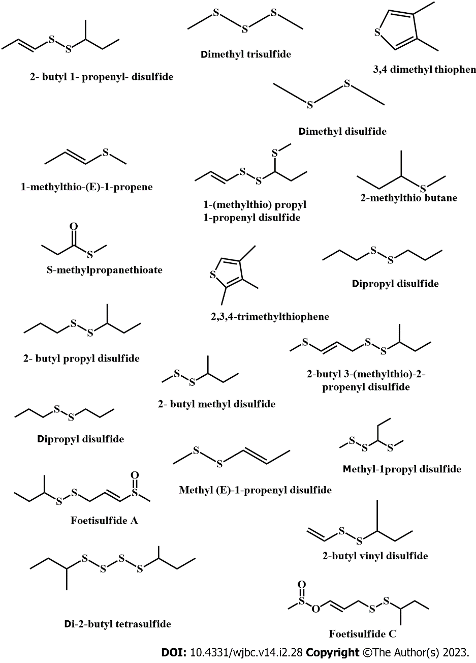
Figure 1 Chemical structure of some sulfide compounds derived from Ferula assa-foetida.

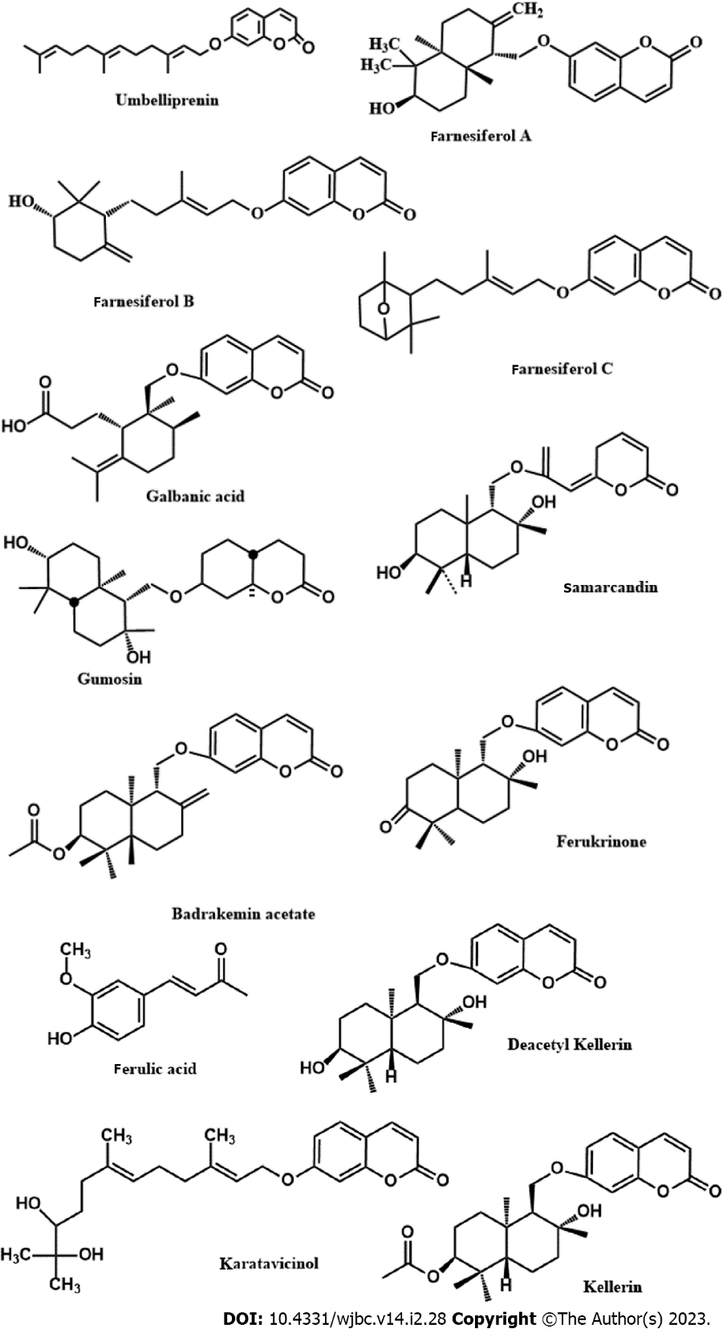
Figure 2 Chemical structure of isolated constituents from Ferula assa-foetida showed anticancer effect.
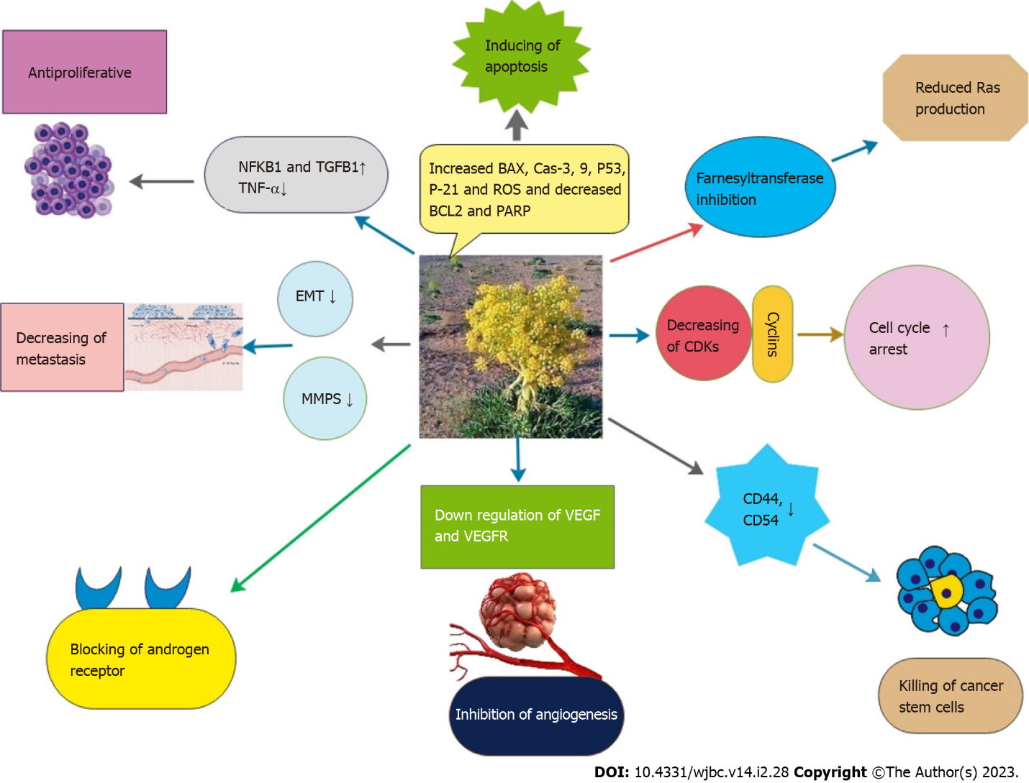
Figure 3 Investigated mechanisms by which Ferula assa-foetida exerts its anticancer effects. BCL2: B-cell lymphoma 2; CDKs: Cyclin-dependent kinases; EMT: Epithelial-mesenchymal transition; MMPS: Matrix metalloproteinases; VEGF: Vascular endothelial growth factor; VEGFR: Vascular endothelial growth factor receptor; ROS: Reactive oxygen species.
Table 1 An overview of anticancer effect of different parts of Ferula assa-foetida
 | Type/name | Cell line | Effects | Ref.
Nano particle | Silver nanoparticles and asafoetida ethanol extracts | L6 cancer cell line | IC50 was calculated 1 μg/mL | Subramaniam et al^{[25]}, 2021
 | Nano emulsion containing Ferula assa-foetida seed essential oil | MCF7 and A2058 cell line | Increased BAX and decreased BCL2 expression. IC50 = 64 μg/mL for MCF7 and 201 μg/mL for A2058. Also, decreased VEGF at 32 μg/mL and VEGFR at 128 μg/mL | Azani et al^{[26]}, 2021
 | Lipid nanoparticles containing Ferula assa foetida seed oil | NT-2 human cancer stem cells | IC50 = 115.4 μg/mL and the number of blood vessels reduced at 250, 500, and 1000 μg/mL | Sadat Khadem et al^{[27]}, 2021
 | Silver anoparticles (AgNPs) with aqueous extract of asafoetida | MCF-7 | IC50 was calculated 2 μg/mL | Devanesan et al^{[28]}, 2020
 | Zinc nanoparticles containing Ferula assa-foetida extract | MCF7, MDA-MB231 and HT-29 | IC50 was 23, 41.26 and 143 μg/mL after 72 h | Boskabadi et al^{[29]}, 2020
 | Ferula assa foetida essential oil on PLGA nanoparticles | HepG2 and A2780 | Inhibited HepG2 and A2780 with an IC50 of 57 μg/mL and 106.7 respectively. Reduction of vascular parametric factors at 125 μg/mL | Mokhtareeizadeh et al^{[30]}, 2021
Essential oil | (-)-E-2-butylpropenyl disulfide, (-)-Z-2-butylpropenyl disulfide, (-)-1-(methylthio) propyl (E)-1 -Propenyl disulfide, and (-)-1-(methylthio) propyl (Z)-1-propenyl disulfide | SKOV3 (ovary) and A549 (lung) cancer cell lines | Trisulfide showed better activity against A549 and SKOV3 cell lines compared to disulfides | Yatham et al^{[31]}, 2021
 | Seed of Ferula assa foetida essential oil | AGS gastric cancer cells | Inhibitory effect on AGS gastric cancer cells was near 100% at 10 μl/mL after 72 h incubation | Bagheri et al^{[32]}, 2020
 | Asafoetida essential oil | HepG2 and SK-Hep1 | IC50 for HepG2 and SK-Hep1 was 7.21 μg/mL and 8.0 μg/mL respectively | Verma et al^{[33]}, 2019
 | Essential oils asafoetida and | T98G and HCT116 | IC50 value for HCT116 was 5.96 µg/mL and for T98G was 4.49 µg/mL | Pavela et al^{[34]}, 2020
 | Essential oil of asafoetida | MCF7 cells | Decreased the viability of MCF7 cells in a time and concentration-dependent manner | Bagheri et al^{[35]}, 2020
Isolated components | Ferulic acid | MDA-MB-231 | Combination with 25 μM of thymoquinone and 250 μM of ferulic acid, decrease proliferation of MDA-MB-231 cells | Al-Mutairi et al^{[38]}, 2021
 | Ferulic acid | MDA-MB-231 | Increased caspase 3 and reduced the proliferation of cancer cells about 40% at 100 μM. 100 mg/kg significantly reduced tumor volume, weight and growth in mice | Zhang et al^{[39]}, 2016
 | Ferulic acid | 4T1 cells | Reduced the growth of cancer cells at 500 μg/mL | Bagheri et al^{[40]}, 2017
 | Galbanic acid | MDA-MB-231 and MCF-7 cells | IC50 was 48.7 and 56.6 μg/mL, respectively. Up-regulation of Bax and caspase-3 and down-regulation of bcl2 | Sajjadi et al^{[42]}, 2019
 | Galbanic acid | H460, A549, PC-9 and HCC827 | IC50 calculated 100 μM on H460 cell line. Bax and caspase 9 increased and Bcl-2, Bcl-xL and myeloid cell leukemia 1 (Mcl-1) decreased in H460 cells | Oh et al^{[43]}, 2015
 | Galbanic acid | AR+ PCa cells and AR- PCa cells | Suppresses the growth of AR (+) PCa cells. Inhibited cyclin/CDK4/6 pathway, specially cyclin D1 | Zhang et al^{[44]}, 2012
 | Farnesiferol C | HUVEC and mouse Lewis lung cancer cells | 10-40 μmol/L inhibited VEGF. Reduced the growth of mouse Lewis lung cancer by 60% | Lee et al^{[45]}, 2010
 | Sesquiterpene coumarins | PC-3 and MCF-7 | Gummosin showed highest cytotoxic activity. Also showed an IC50 values at 30 and 32.1 μg/mL against PC-3 and MCF-7 cell lines respectively | Iranshahy et al^{[48]}, 2019
 | Farnesiferol C | MCF-7 | Decrease cell viability after 24, 48 and 72 h. (IC50 43, 20 and 14 µM, respectively), and stopped the cell cycle in G0/G1 phase and induced apoptosis in MCF-7 cells | Hasanzadeh et al^{[46]}, 2017

AGS: Aerobic granular sludge; BCL2: B-cell lymphoma 2; EMT: Epithelial-mesenchymal transition; VEGF: Vascular endothelial growth factor; VEGFR: Vascular endothelial growth factor receptor.

Published by Baishideng Publishing Group Inc
7041 Koll Center Parkway, Suite 160, Pleasanton, CA 94566, USA
Telephone: +1-925-3991568
E-mail: bpgoffice@wjgnet.com
Help Desk: https://www.f6publishing.com/helpdesk
https://www.wjgnet.com

© 2023 Baishideng Publishing Group Inc. All rights reserved.

