Name of Journal: World Journal of Clinical Cases
Manuscript NO: 73269
Manuscript Type: META-ANALYSIS

Risk factors for hospital readmissions in pneumonia patients: A systematic review and meta-analysis

Fang YY et al. Hospital readmissions in pneumonia patients

Yuan-Yuan Fang, Jian-Chao Ni, Yin Wang, Jian-Hong Yu, Ling-Ling Fu

Yuan-Yuan Fang, Jian-Chao Ni, Jian-Hong Yu, Department of Geriatrics, Affiliated Hospital of Shaoxing University, Shaoxing 312000, Zhejiang Province, China

Yin Wang, Department of Internal Medicine, Yuecheng People’s Hospital, Shaoxing 312000, Zhejiang Province, China

Ling-Ling Fu, Department of Respiratory Medicine, Zhuji Affiliated Hospital of Shaoxing University, Zhuji 311800, Zhejiang Province, China

Author contributions: Fang YY and Ni JC conceived and designed the study; Wang Y and Yu JH were involved in literature search and data collection; Yu JH and Fu LL analyzed the data; Fang YY and Ni JC wrote the paper; Wang Y and Yu JH reviewed and edited the manuscript; all authors read and approved the final manuscript.

Corresponding author: Ling-Ling Fu, MD, Chief Doctor, Department of Respiratory Medicine, Zhuji Affiliated Hospital of Shaoxing University, No. 9 Jianmin Road, Zhuji 311800, Zhejiang Province, China. fu198609262021@sina.com

Received: November 16, 2021
Revised: January 25, 2022
Accepted: March 16, 2022
Published online:

Abstract
BACKGROUND
Factors that are associated with the short-term rehospitalization have been investigated previously in numerous studies. However, the majority of these studies have not produced any conclusive results because of their smaller sample sizes, differences in the definition of pneumonia, joint pooling of the in-hospital and post-discharge deaths and lower generalizability.

AIM
To estimate the effect of various risk factors on the rate of hospital readmissions in patients with pneumonia.

METHODS
Systematic search was conducted in PubMed Central, EMBASE, MEDLINE, Cochrane library, ScienceDirect and Google Scholar databases and search engines from inception until July 2021. We used the Newcastle Ottawa (NO) scale to assess the quality of published studies. A meta-analysis was carried out with random-effects model and reported pooled odds ratio (OR) with 95% confidence interval (CI).

RESULTS
In total, 17 studies with over 3 million participants were included. Majority of the studies had good to satisfactory quality as per NO scale. Male gender (pooled OR = 1.22; 95%CI: 1.16-1.27), cancer (pooled OR = 1.94; 95%CI: 1.61-2.34), heart failure (pooled OR = 1.28; 95%CI: 1.20-1.37), chronic respiratory disease (pooled OR = 1.37; 95%CI: 1.19-1.58), chronic kidney disease (pooled OR = 1.38; 95%CI: 1.23-1.54) and diabetes mellitus (pooled OR = 1.18; 95%CI: 1.08-1.28) had statistically significant association with the hospital readmission rate among pneumonia patients. Sensitivity analysis showed that there was no significant variation in the magnitude or direction of outcome, indicating lack of influence of a single study on the overall pooled estimate.

CONCLUSION
Male gender and specific chronic comorbid conditions were found to be significant risk factors for hospital readmission among pneumonia patients. These results may allow clinicians and policymakers to develop better intervention strategies for the patients.

Key Words: Hospital readmission; Meta-analysis; Pneumonia; Prediction; Systematic review

Fang YY, Ni JC, Wang Y, Yu JH, Fu LL. Risk factors for hospital readmissions in pneumonia patients: A systematic review and meta-analysis. World J Clin Cases 2022; In press

Core Tip: The main goal of this review is to estimate the effect of various risk factors on the rate of hospital readmissions in patients with pneumonia. In total, 17 studies with over 3 million participants were included. Most studies had good to satisfactory quality. Male gender and specific chronic comorbid conditions were found to be significant risk factors for hospital readmission among pneumonia patients. These results may allow clinicians and policymakers to develop better intervention strategies for the patients.

INTRODUCTION
The burden and incidence of acute infectious diseases, such as pneumonia, that have traditionally led to hospital admissions are expected to rise over the next few decades, mainly due to the increase in the population aged above 80 years^{[1,2]}. Older patients with pneumonia often require hospital admissions^{[3]}. The short-term rehospitalization and mortality rates are also found to be higher amongst those who survive the initial admission^{[3]}. Most elderly patients require special attention from health care professionals after discharge to reduce short-term rehospitalization and mortality rates.
Studies also show higher short-term rehospitalization and mortality rates in pneumonia patients, with 12% to 22% of the patients readmitted within 30 d after initial hospitalisation for pneumonia^{[3–5]}. Recent reports also show that rehospitalizations are associated with the increased risk of iatrogenic complications, resulting in additional financial burden on the health care system^{[6–8]}. As a results of the general trend of having short hospital stays, the main responsibility of caring for older pneumonia patients after the discharge falls on the primary health care providers^{[9]}.
Yet, there is still a limited knowledge of how to identify the pneumonia patients who are at higher risk of having short-term rehospitalization following discharge^{[10-12]}. Such knowledge is urgently required to ensure that the health care attention has been specifically given to the patients with the highest level of needs. Numerous studies attempted to investigate factors that are associated with the short-term rehospitalization^{[13-15]}. However, the majority of these studies were inconclusive due to small sample sizes, differences in the definition of pneumonia, joint pooling of the in-hospital and post-discharge deaths and lower generalizability^{[16–18]}.
To the best of our knowledge, there has been no systematic effort to pool data on the risk factors for hospital readmissions in patients with pneumonia. The purpose of the present review is to pool data from individual studies to identify risk factors for hospital readmissions in patients with pneumonia.

MATERIALS AND METHODS
Design and registration
The protocol of the current systematic review and meta-analysis of observational studies was registered in PROSPERO under the registration number (CRD42021260284). “Preferred Reporting Items for Systematic Reviews and Meta-Analyses (PRISMA) statement 2020” was utilized for reporting this systematic review incorporating the meta-analyses^{[19]}.

Eligibility criteria
Study design: Observational studies, irrespective of the study design (cross-sectional/case-control/cohort studies) reporting the relevant exposure and outcome were included. Only full-text publications were included while the studies published as conference abstracts/case reports/case series and unpublished data were excluded.

Participants: We have included the studies conducted among the adult pneumonia patients aged ≥ 18 years. Studies conducted among specific diseased population were excluded from the analysis.

Exposure: We have included studies assessing the association of any sociodemographic risk factors or comorbidity with hospital readmissions. At least three studies should have reported the particular risk factor to be eligible for inclusion in the review.

Outcome: Studies reporting the rate of hospital readmission across the different sociodemographic and comorbidity factors were included.

Search strategy
Systematic search of the literature was performed in the electronic databases such as PubMed Central, EMBASE, MEDLINE, and Cochrane library and search engines such as ScienceDirect and Google Scholar. Both medical subject headings (MeSH) and free-text words were used to search all these databases & search engines. The final search was carried out by combining the individual search results using appropriate Boolean operators (“OR” and “AND”) and narrowed down using the available filters on time period (from January 2010 to July 2021), language (published in English language only) and study design (observational studies). The detailed search strategy with search terms and results has been reported in the Supplementary material.

Study selection process
The selection of the relevant studies was performed by two independent investigators by screening the title, abstract and keywords of the manuscripts identified by the literature search. Full-text articles were retrieved for the studies shortlisted based on the eligibility criteria and screened by the same two investigators. Only studies that satisfy all the eligibility criteria with respect to design, participants, exposure and outcome were included. Disagreements between the investigators were resolved and final consensus on inclusion of studies was reached with the help of another investigator.

Data extraction process
Manual extraction of data was done using a pre-defined structured data extraction form. Data extracted using the form were as follows: Author, year of publication, information related to methods section such as design, setting, sample size, sampling strategy, study participants, eligibility criteria, exposure and outcome assessment method, quality related information, number of participants in exposed and non-exposed group and number of exposed and non-exposed participants with hospital readmission. Data were entered by the primary investigator and it was double-checked by secondary investigators for correct entry.

Risk of bias assessment
The risk of bias assessment was performed by two independent investigators using the Newcastle Ottawa (NO) Quality Assessment Form for observational studies under the Selection (maximum 4 stars), Comparability (maximum 2 stars) and Outcome domains (maximum 2 stars) with the following criteria: Representativeness, Sample size justification, Non-response, Ascertainment of exposure, Control for confounding, Assessment of outcome and Statistical tests. The total score ranges from 0 to 8 stars. Studies having 7 to 8 stars were considered of “good” quality, 5 to 6 stars indicated “satisfactory” quality, and 0 to 4 stars indicated “unsatisfactory” quality^{[20]}.

Statistical analysis
Meta-analysis was executed using the software Review Manager 5.4 (The Cochrane Collaboration, 2020). Since all the outcomes were dichotomous, number of events and participants in each group were entered to obtain the pooled effect estimate in terms of odds ratio (OR) and were graphically depicted by the forest plot. We used the random effects model with inverse variance method to calculate the weight of individual studies. Evidence of heterogeneity was assessed through chi square test and I² statistics to quantify the inconsistencies^{[21]}. We also performed sensitivity analysis to assess the robustness of results by removing the studies one by one and checking for any significant variation in the results. We have assessed publication bias through funnel plot for the outcomes with minimum of 10 included studies.

Quality of evidence
Two independent investigators assessed the risk of bias and quality of evidence for included studies using Grading of Recommendations Assessment, Development and Evaluation (GRADE) guidelines^{[21]}. GRADE approach consists of five components: (1) Risk of bias assessment: “Newcastle Ottawa Scale”; (2) Indirectness: Assessed in terms of population, exposure or outcomes; (3) Imprecision: To find how precise the estimate obtained–based on sample size and confidence interval; (4) Inconsistency: Evidence of heterogeneity using I² statistic and chi square test of heterogeneity; and (5) Publication bias: Egger’s test and funnel plot.
Finally, the quality of the included studies was classified as “Very Low”, “Low”, “Moderate” and “High” based on certainty of evidence.

RESULTS
Study selection
In total, 2421 records were retrieved through the literature search. Of them, 110 studies were eligible for the full-text retrieval, including four studies identified through the hand-search of references in the 106 retrieved articles from the primary screening. During the final stage of the screening, 17 studies with nearly 3 million participants were included (Figure 1)^{[11,12,22–36]}.

Characteristics of the included studies
Almost all the studies (16 out of 17 studies) were retrospective in nature. Majority of the included studies were conducted in the United States of America followed by European countries such as Italy, Denmark, United Kingdom, and Spain. The sample sizes of the included studies ranged from 771 to 1472070. Mean age of the participants ranged from 60 to 79 (Table 1). All the included studies had good to satisfactory quality (Table 2).

Predictors of hospital readmissions among pneumonia patients
Age and hospital readmissions: Three studies have reported on the risk of readmissions among elderly pneumonia patients aged 65+ years. The pooled OR was 0.90 (95%CI: 0.58-1.39; I² = 92%), indicating no difference in terms of hospital readmissions based on age group (Figure 2A). The quality of evidence was found to be very low as per GRADE approach.

Gender and hospital readmissions: A total of 13 studies looked at the risk of readmissions in male and female pneumonia patients. The pooled OR was 1.22 (95%CI: 1.16-1.27; I² = 79%), indicating that the males have 1.19 times higher odds of having hospital readmissions when compared to female pneumonia patients and this association was statistically significant (P < 0.001) (Figure 2B). The quality of evidence was found to be low as per GRADE approach.

Dementia and hospital readmissions: Nine studies compared risk of readmissions between dementia and non-dementia pneumonia patients. The pooled OR was 1.11 (95%CI: 0.96-1.29; I² = 99%), indicating that there was no between dementia and hospital readmissions among pneumonia patients (Figure 2C). The quality of evidence was found to be very low as per GRADE approach.

Diabetes mellitus and hospital readmissions: Seven studies have reported on the risk of readmissions between diabetes and non-diabetes pneumonia patients. The pooled OR was 1.18 (95%CI: 1.08-1.28; I² = 34%), indicating that the diabetes patients have 1.18 times higher odds of having hospital readmissions when compared to non-diabetes pneumonia patients (Figure 2D). The quality of evidence was found to be low as per GRADE approach.

Chronic respiratory disease and hospital readmissions: Ten studies showed the risk of readmissions in patients with and without chronic respiratory disease. The pooled OR was 1.37 (95%CI: 1.19-1.58; I² = 93%), indicating that the patients with chronic respiratory disease have significantly (1.37 times) higher odds of having hospital readmissions when compared to patients without chronic respiratory disease (P < 0.001) (Figure 2E). The quality of evidence was found to be low as per GRADE approach.

Chronic kidney disease and hospital readmissions: Seven studies have reported on the risk of readmissions between patients with and without chronic kidney disease. The pooled OR was 1.38 (95%CI: 1.23-1.54; I² = 47%), indicating that the patients with chronic kidney disease have 1.38 times higher odds of having hospital readmissions when compared to patients without chronic kidney disease (P < 0.001) (Figure 2F). The quality of evidence was found to be low as per GRADE approach.

Chronic liver disease and hospital readmissions: Five studies evaluated the risk of readmissions in patients with and without chronic liver disease and showed the pooled OR of 1.39 (95%CI: 0.98-1.98; I² = 75%), indicative of no significant association between chronic liver disease and readmission risk (Figure 2G). The quality of evidence was found to be very low as per GRADE approach.

Heart failure and hospital readmissions: Nine studies have reported on the risk of readmissions between patients with and without heart failure. The pooled OR was 1.28 (95%CI: 1.20-1.37; I² = 19%), indicating that the patients with heart failure have 1.28 times higher odds of having hospital readmissions when compared to patients without heart failure (Figure 2H). The quality of evidence was found to be low as per GRADE approach.

Ischaemic heart disease and hospital readmissions: A total of 4 studies evaluated the risk of readmissions in patients with and without ischaemic heart disease. The pooled OR was 1.15 (95%CI: 0.94-1.40; I² = 42%), indicating that there is no association between ischaemic heart disease and hospital readmissions (Figure 2I). The quality of evidence was found to be low as per GRADE approach.

Cerebrovascular disease and hospital readmissions: Five studies have reported on the risk of readmissions between patients with and without cerebrovascular disease. The pooled OR was 1.08 (95%CI: 0.85-1.38; I² = 71%), indicating there is no association between cerebrovascular disease and hospital readmissions (Figure 2J). The quality of evidence was found to be low as per GRADE approach.

Cancer and hospital readmissions: Risk of readmissions in patients with and without cancer was discussed in 10 studies. The pooled OR was 1.94 (95%CI: 1.61-2.34; I² = 96%), indicating that the patients with cancer have significantly higher (1.94 times) odds of having hospital readmissions when compared to patients without cancer (P < 0.001) (Figure 2K). The quality of evidence was found to be very low as per GRADE approach.

Intensive care units admission and hospital readmissions: Three studies have reported on the risk of readmissions between patients with and without intensive care units (ICU) admission during their hospital stay for primary diagnosis. The pooled OR was 1.21 (95%CI: 0.69-2.13; I² = 46%), indicating there is no association between ICU admission and hospital readmissions (Figure 2L). The quality of evidence was found to be low as per GRADE approach.

Mechanical ventilation and hospital readmissions: Four studies have reported on the risk of readmissions between patients with and without mechanical ventilation requirement during their hospital stay for primary diagnosis. The pooled OR was 1.36 (95%CI: 0.96-1.93; I² = 74%), indicating there is no association between mechanical ventilation and hospital readmissions (Figure 2M). The quality of evidence was found to be low as per GRADE approach.

Additional analysis
Sensitivity analysis has revealed that the estimates obtained for all the outcomes were robust to small study effects in terms of magnitude or direction of the outcomes. Funnel plot for the risk factors such as gender, cancer and chronic respiratory disease showed asymmetrical plot indicating the possibility of publication bias (Supplementary Figures 1-3).

DISCUSSION
Almost one in five pneumonia patients have to be readmitted to the hospital^{[37]}. Hospital readmissions following an episode of pneumonia are becoming a relatively frequent event, specifically among the older adults and patients with various co-morbidities^{[38]}. It is important, therefore, to identify the patients at high-risk of getting readmitted as early as possible and prevent the development of future complications. Despite its importance, the role of various risk factors on the hospital readmission rate among pneumonia patients remains unclear. The goal of this review was to study the association of various risk factors on hospital readmission rate among pneumonia patients.
We have found a total of 17 studies matching the eligibility criteria of the review. Most of these studies were conducted in American and European region. Though, almost all the studies were retrospective in nature, all of them were of good to satisfactory quality. We found that males had significantly higher odds of having hospital readmissions when compared to female pneumonia patients. Co-morbidities, such as diabetes mellitus, cancer, heart failure, chronic respiratory disease and chronic kidney disease were also significantly associated with the risk of readmissions among pneumonia patients. Sensitivity analysis revealed that there was no significant single-study effect on the magnitude or direction of association.
Although, there was no previous reviews to compare our study findings, the possible impact of various risk factors on hospital readmission rate among pneumonia patients has been explored using the previous literature. Studies show that in one in six patients pneumonia might fail to resolve completely in spite of appropriate treatment^{[39]}. Such patients might end up developing serious complications that require hospital readmissions^{[39]}. Our study showed that several host factors like gender, immunocompromising conditions (cancer, diabetes mellitus), heart failure, and chronic respiratory and kidney diseases are associated with the failure to resolve completely and increased risk of readmission.
Since the most frequent reason for the 30-d hospital readmission amongst pneumonia patients is the decompensation of the associated comorbid conditions^{[29,34]}, it is important to develop interventions that are aimed at reducing the all-cause readmission rates. This, in turn, would have a significant impact on the pneumonia readmission rate. Almost all the top five diagnoses of the potentially avoidable readmissions for each comorbidity were either a direct or an indirect complication of that comorbidity. For example, in patients with diabetes mellitus, atrial fibrillation, heart failure, ischemic heart disease, or chronic kidney disease, the most common cause and diagnosis of the potentially avoidable hospital readmission was the acute heart failure. Therefore, ensuring stability of comorbidities at the time of discharge in high risk patients with heart failure, kidney failure, cancer, etc., would impact not only the all-cause readmission rate but also the pneumonia readmission rate. Further research is required to explore potential interventions to evaluate and ensure clinical stability at the level of discharge, particularly in patients with the multiple and interrelated comorbidities.
In other cases, pneumonia readmissions may not be related to the initial pneumonia episode or the comorbidity decompensation, but rather to other causes, such as hospital-acquired infections, acute conditions, or trauma. With enhanced care, numbers of readmission due to hospital-acquired infections decreases. However, a significant number of these cases may remain as potentially unavoidable readmissions. Further studies are needed to assess how these factors may impact readmission rates in pneumonia patients, and to develop appropriate intervention plans.
The major strength of our review is the rigorous literature search and methodology used to provide reliable estimates. Additionally, this was the first review providing the association between sociodemographic and comorbid risk factors and hospital readmissions among pneumonia patients. Most studies included in our review were of higher quality and had a standard-criteria for defining hospital readmission (30-d hospital readmission), which might further enhance the generalisability of our study findings. Moreover, sensitivity analysis did not show any significant changes in magnitude and direction of association with respect to any of the exposure-outcome relationships.
However, our study has some limitations. There was a significant between-study variability that may limit the extrapolation of the study results. Most of the included studies were retrospective in nature, which makes it difficult to establish causation between the exposure and the disease. Hence, more longitudinal studies are needed to identify accurate and reliable effect estimates and make evidence-based recommendation for developing potential interventions in hospital setting.

CONCLUSION
Male gender and specific chronic comorbid conditions were found to be significant risk factors for hospital readmission among pneumonia patients. These results may allow clinicians and policymakers to develop better intervention strategies for the patients.

ARTICLE HIGHLIGHTS
Research background
Factors that are associated with the short-term rehospitalization have been investigated previously in numerous studies. However, the majority of these studies have not produced any conclusive results because of their smaller sample sizes, differences in the definition of pneumonia, joint pooling of the in-hospital and post-discharge deaths and lower generalizability.

Research motivation
To the best of our knowledge, there has been no systematic effort to pool data on the risk factors for hospital readmissions in patients with pneumonia.

Research objectives
To pool data from individual studies to identify risk factors for hospital readmissions in patients with pneumonia.

Research methods
Systematic search was conducted in PubMed Central, EMBASE, MEDLINE, Cochrane library, ScienceDirect and Google Scholar databases, and search engines from inception until July 2021.

Research results
In total, 17 studies with over 3 million participants were included. Majority of the studies had good to satisfactory quality as per Newcastle Ottawa scale. Male gender, cancer, heart failure, chronic respiratory disease, chronic kidney disease and diabetes mellitus had statistically significant association with the hospital readmission rate among pneumonia patients.

Research conclusions
Male gender and specific chronic comorbid conditions were found to be significant risk factors for hospital readmission among pneumonia patients. These results may allow clinicians and policymakers to develop better intervention strategies for the patients.

Research perspectives
More longitudinal studies are needed to identify accurate and reliable effect estimates and make evidence-based recommendation for developing potential interventions in hospital setting.

REFERENCES
1 Suzman R, Beard JR, Boerma T, Chatterji S. Health in an ageing world--what do we know? Lancet 2015; 385: 484-486 [PMID: 25468156 DOI: 10.1016/S0140-6736(14)61597-X]
2 Christensen K, Doblhammer G, Rau R, Vaupel JW. Ageing populations: the challenges ahead. Lancet 2009; 374: 1196-1208 [PMID: 19801098 DOI: 10.1016/S0140-6736(09)61460-4]
3 Li X, Blais JE, Wong ICK, Tam AWY, Cowling BJ, Hung IFN, Chan EWY. Population-based estimates of the burden of pneumonia hospitalizations in Hong Kong, 2011-2015. Eur J Clin Microbiol Infect Dis 2019; 38: 553-561 [PMID: 30684165 DOI: 10.1007/s10096-018-03459-x]
4 Klausen HH, Petersen J, Lindhardt T, Bandholm T, Hendriksen C, Kehlet H, Vestbo J, Andersen O. Outcomes in elderly Danish citizens admitted with community-acquired pneumonia. Regional differencties, in a public healthcare system. Respir Med 2012; 106: 1778-1787 [PMID: 22981322 DOI: 10.1016/j.rmed.2012.08.010]
5 Jain S, Self WH, Wunderink RG, Fakhran S, Balk R, Bramley AM, Reed C, Grijalva CG, Anderson EJ, Courtney DM, Chappell JD, Qi C, Hart EM, Carroll F, Trabue C, Donnelly HK, Williams DJ, Zhu Y, Arnold SR, Ampofo K, Waterer GW, Levine M, Lindstrom S, Winchell JM, Katz JM, Erdman D, Schneider E, Hicks LA, McCullers JA, Pavia AT, Edwards KM, Finelli L; CDC EPIC Study Team. Community-Acquired Pneumonia Requiring Hospitalization among U.S. Adults. N Engl J Med 2015; 373: 415-427 [PMID: 26172429 DOI: 10.1056/NEJMoa1500245]
6 Lefevre F, Feinglass J, Potts S, Soglin L, Yarnold P, Martin GJ, Webster JR. Iatrogenic complications in high-risk, elderly patients. Arch Intern Med 1992; 152: 2074-2080 [PMID: 1417381]
7 May CR, Eton DT, Boehmer K, Gallacher K, Hunt K, MacDonald S, Mair FS, May CM, Montori VM, Richardson A, Rogers AE, Shippee N. Rethinking the patient: using Burden of Treatment Theory to understand the changing dynamics of illness. BMC Health Serv Res 2014; 14: 281 [PMID: 24969758 DOI: 10.1186/1472-6963-14-281]
8 Jencks SF, Williams MV, Coleman EA. Rehospitalizations among patients in the Medicare fee-for-service program. N Engl J Med 2009; 360: 1418-1428 [PMID: 19339721 DOI: 10.1056/NEJMsa0803563]
9 Capelastegui A, España PP, Quintana JM, Gallarreta M, Gorordo I, Esteban C, Urrutia I, Bilbao A. Declining length of hospital stay for pneumonia and postdischarge outcomes. Am J Med 2008; 121: 845-852 [PMID: 18823851 DOI: 10.1016/j.amjmed.2008.05.010]
10 Adamuz J, Viasus D, Campreciós-Rodríguez P, Cañavate-Jurado O, Jiménez-Martínez E, Isla P, García-Vidal C, Carratalà J. A prospective cohort study of healthcare visits and rehospitalizations after discharge of patients with community-acquired pneumonia. Respirology 2011; 16: 1119-1126 [PMID: 21736665 DOI: 10.1111/j.1440-1843.2011.02017.x]
11 Mather JF, Fortunato GJ, Ash JL, Davis MJ, Kumar A. Prediction of pneumonia 30-day readmissions: a single-center attempt to increase model performance. Respir Care 2014; 59: 199-208 [PMID: 23942750 DOI: 10.4187/respcare.02563]
12 Shorr AF, Zilberberg MD, Reichley R, Kan J, Hoban A, Hoffman J, Micek ST, Kollef MH. Readmission following hospitalization for pneumonia: the impact of pneumonia type and its implication for hospitals. Clin Infect Dis 2013; 57: 362-367 [PMID: 23677872 DOI: 10.1093/cid/cit254]
13 Jasti H, Mortensen EM, Obrosky DS, Kapoor WN, Fine MJ. Causes and risk factors for rehospitalization of patients hospitalized with community-acquired pneumonia. Clin Infect Dis 2008; 46: 550-556 [PMID: 18194099 DOI: 10.1086/526526]
14 Capelastegui A, España Yandiola PP, Quintana JM, Bilbao A, Diez R, Pascual S, Pulido E, Egurrola M. Predictors of short-term rehospitalization following discharge of patients hospitalized with community-acquired pneumonia. Chest 2009; 136: 1079-1085 [PMID: 19395580 DOI: 10.1378/chest.08-2950]
15 Torner N, Izquierdo C, Soldevila N, Toledo D, Chamorro J, Espejo E, Fernández-Sierra A, Domínguez A; Project PI12/02079 Working Group. Factors associated with 30-day mortality in elderly inpatients with community acquired pneumonia during 2 influenza seasons. Hum Vaccin Immunother 2017; 13: 450-455 [PMID: 27924681 DOI: 10.1080/21645515.2017.1264782]
16 Lindenauer PK, Bernheim SM, Grady JN, Lin Z, Wang Y, Wang Y, Merrill AR, Han LF, Rapp MT, Drye EE, Normand SL, Krumholz HM. The performance of US hospitals as reflected in risk-standardized 30-day mortality and readmission rates for medicare beneficiaries with pneumonia. J Hosp Med 2010; 5: E12-E18 [PMID: 20665626 DOI: 10.1002/jhm.822]
17 Thomsen RW, Riis A, Nørgaard M, Jacobsen J, Christensen S, McDonald CJ, Sørensen HT. Rising incidence and persistently high mortality of hospitalized pneumonia: a 10-year population-based study in Denmark. J Intern Med 2006; 259: 410-417 [PMID: 16594909 DOI: 10.1111/j.1365-2796.2006.01629.x]
18 Tang VL, Halm EA, Fine MJ, Johnson CS, Anzueto A, Mortensen EM. Predictors of rehospitalization after admission for pneumonia in the veterans affairs healthcare system. J Hosp Med 2014; 9: 379-383 [PMID: 24648401 DOI: 10.1002/jhm.2184]
19 Page MJ, Moher D, Bossuyt PM, Boutron I, Hoffmann TC, Mulrow CD, Shamseer L, Tetzlaff JM, Akl EA, Brennan SE, Chou R, Glanville J, Grimshaw JM, Hróbjartsson A, Lalu MM, Li T, Loder EW, Mayo-Wilson E, McDonald S, McGuinness LA, Stewart LA, Thomas J, Tricco AC, Welch VA, Whiting P, McKenzie JE. PRISMA 2020 explanation and elaboration: updated guidance and exemplars for reporting systematic reviews. BMJ 2021; 372: n160 [PMID: 33781993 DOI: 10.1136/bmj.n160]
20 Wells G, Shea B, O’Connell D, Robertson J, Peterson J, Welch V, Losos M, Tugwell P. The Newcastle-Ottawa Scale (NOS) for Assessing the Quality of Nonrandomized Studies in Meta- Analysis. [cited 10 October 2021]. Available from: https://www.researchgate.net/publication/261773681_The_Newcastle-Ottawa_Scale_NOS_for_Assessing_the_Quality_of_Non-Randomized_Studies_in_Meta-Analysis
21 Higgins JP, Green S. Cochrane Handbook for Systematic Reviews of Interventions : Cochrane Book Series. [cited 10 October 2021]. Available from: https://www.researchgate.net/publication/229477301_Cochrane_Handbook_for_Systematic_Reviews_of_Interventions_Cochrane_Book_Series
22 Chakrabarti B, Lane S, Jenks T, Higgins J, Kanwar E, Allen M, Wotton D. Predictors of 30-day readmission following hospitalisation with community-acquired pneumonia. BMJ Open Respir Res 2021; 8 [PMID: 33771814 DOI: 10.1136/bmjresp-2021-000883]
23 Graversen SB, Pedersen HS, Sandbaek A, Foss CH, Ribe AR. Factors Associated With 30-Day Rehospitalization and Mortality in Older Patients After a Pneumonia Admission. J Am Med Dir Assoc 2020; 21: 1869-1878.e10 [PMID: 33036912 DOI: 10.1016/j.jamda.2020.08.025]
24 Graversen SB, Pedersen HS, Sandbaek A, Foss CH, Palmer VJ, Ribe AR. Dementia and the risk of short-term readmission and mortality after a pneumonia admission. PLoS One 2021; 16: e0246153 [PMID: 33507947 DOI: 10.1371/journal.pone.0246153]
25 Lee JE, Kim TH, Cho KH, Han KT, Park EC. The association between number of doctors per bed and readmission of elderly patients with pneumonia in South Korea. BMC Health Serv Res 2017; 17: 393 [PMID: 28595583 DOI: 10.1186/s12913-017-2352-7]
26 Toledo D, Soldevila N, Torner N, Pérez-Lozano MJ, Espejo E, Navarro G, Egurrola M, Domínguez Á; On-behalf of the Project FIS PI12/02079 Working Group. Factors associated with 30-day readmission after hospitalisation for community-acquired pneumonia in older patients: a cross-sectional study in seven Spanish regions. BMJ Open 2018; 8: e020243 [PMID: 29602852 DOI: 10.1136/bmjopen-2017-020243]
27 Nagasako EM, Reidhead M, Waterman B, Dunagan WC. Adding socioeconomic data to hospital readmissions calculations may produce more useful results. Health Aff (Millwood) 2014; 33: 786-791 [PMID: 24799575 DOI: 10.1377/hlthaff.2013.1148]
28 Shams I, Ajorlou S, Yang K. A predictive analytics approach to reducing 30-day avoidable readmissions among patients with heart failure, acute myocardial infarction, pneumonia, or COPD. Health Care Manag Sci 2015; 18: 19-34 [PMID: 24792081 DOI: 10.1007/s10729-014-9278-y]
29 Dharmarajan K, Hsieh AF, Lin Z, Bueno H, Ross JS, Horwitz LI, Barreto-Filho JA, Kim N, Bernheim SM, Suter LG, Drye EE, Krumholz HM. Diagnoses and timing of 30-day readmissions after hospitalization for heart failure, acute myocardial infarction, or pneumonia. JAMA 2013; 309: 355-363 [PMID: 23340637 DOI: 10.1001/jama.2012.216476]
30 Dong T, Cursio JF, Qadir S, Lindenauer PK, Ruhnke GW. Discharge disposition as an independent predictor of readmission among patients hospitalised for community-acquired pneumonia. Int J Clin Pract 2017; 71 [PMID: 28371024 DOI: 10.1111/ijcp.12935]
31 Faverio P, Compagnoni MM, Della Zoppa M, Pesci A, Cantarutti A, Merlino L, Luppi F, Corrao G. Rehospitalization for pneumonia after first pneumonia admission: Incidence and predictors in a population-based cohort study. PLoS One 2020; 15: e0235468 [PMID: 32603334 DOI: 10.1371/journal.pone.0235468]
32 Knox S. Pneumonia Readmissions in Older Adults With Dementia. Med Care 2019; 57: 766-772 [PMID: 31415343 DOI: 10.1097/MLR.0000000000001195]
33 Ahmedani BK, Solberg LI, Copeland LA, Fang-Hollingsworth Y, Stewart C, Hu J, Nerenz DR, Williams LK, Cassidy-Bushrow AE, Waxmonsky J, Lu CY, Waitzfelder BE, Owen-Smith AA, Coleman KJ, Lynch FL, Ahmed AT, Beck A, Rossom RC, Simon GE. Psychiatric comorbidity and 30-day readmissions after hospitalization for heart failure, AMI, and pneumonia. Psychiatr Serv 2015; 66: 134-140 [PMID: 25642610 DOI: 10.1176/appi.ps.201300518]
34 Jain S, Khera R, Mortensen EM, Weissler JC. Readmissions of adults within three age groups following hospitalization for pneumonia: Analysis from the Nationwide Readmissions Database. PLoS One 2018; 13: e0203375 [PMID: 30212485 DOI: 10.1371/journal.pone.0203375]
35 Jang JG, Ahn JH. Reasons and Risk Factors for Readmission Following Hospitalization for Community-acquired Pneumonia in South Korea. Tuberc Respir Dis (Seoul) 2020; 83: 147-156 [PMID: 32185918 DOI: 10.4046/trd.2019.0073]
36 Buja A, De Polo A, De Battisti E, Sperotto M, Baldovin T, Cocchio S, Furlan P, Saia M, Scapellato ML, Viel G, Baldo V, Bertoncello C, Ebell M. The importance of sex as a risk factor for hospital readmissions due to pulmonary diseases. BMC Public Health 2020; 20: 53 [PMID: 31937272 DOI: 10.1186/s12889-019-8138-6]
37 Epstein AM, Jha AK, Orav EJ. The relationship between hospital admission rates and rehospitalizations. N Engl J Med 2011; 365: 2287-2295 [PMID: 22168643 DOI: 10.1056/NEJMsa1101942]
38 De Alba I, Amin A. Pneumonia readmissions: risk factors and implications. Ochsner J 2014; 14: 649-654 [PMID: 25598730]
39 Allaudeen N, Vidyarthi A, Maselli J, Auerbach A. Redefining readmission risk factors for general medicine patients. J Hosp Med 2011; 6: 54-60 [PMID: 20945293 DOI: 10.1002/jhm.805]

Footnotes
Conflict-of-interest statement: The authors deny any conflict of interest.

PRISMA 2009 Checklist statement: The authors have read the PRISMA 2020 Checklist, and manuscript was prepared and revised according to the PRISMA 2020 Checklist.

Open-Access: This article is an open-access article that was selected by an in-house editor and fully peer-reviewed by external reviewers. It is distributed in accordance with the Creative Commons Attribution NonCommercial (CC BY-NC 4.0) license, which permits others to distribute, remix, adapt, build upon this work non-commercially, and license their derivative works on different terms, provided the original work is properly cited and the use is non-commercial. See: https://creativecommons.org/Licenses/by-nc/4.0/

Provenance and peer review: Unsolicited article; Externally peer reviewed.

Peer-review model: Single blind

Peer-review started: November 16, 2021
First decision: January 11, 2022
Article in press:

Specialty type: Medicine, research and experimental
Country/Territory of origin: China
Peer-review report’s scientific quality classification
Grade A (Excellent): A
Grade B (Very good): 0
Grade C (Good): C, C
Grade D (Fair): 0
Grade E (Poor): 0

P-Reviewer: Rakhshan V, Iran; Swai J, Canada S-Editor: Fan JR L-Editor: A P-Editor: Fan JR

Figure Legends
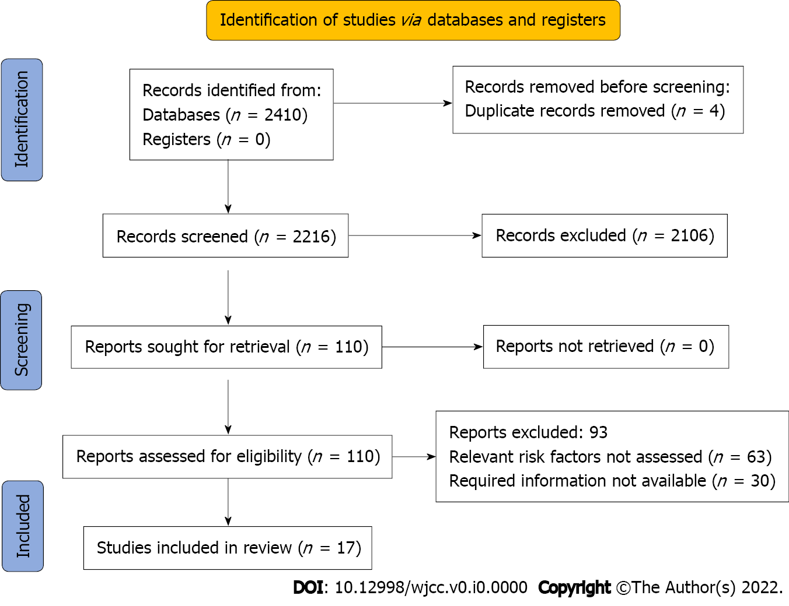
Figure 1 PRISMA flowchart.
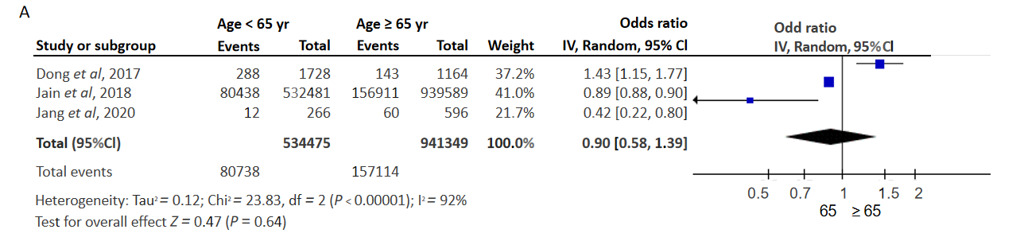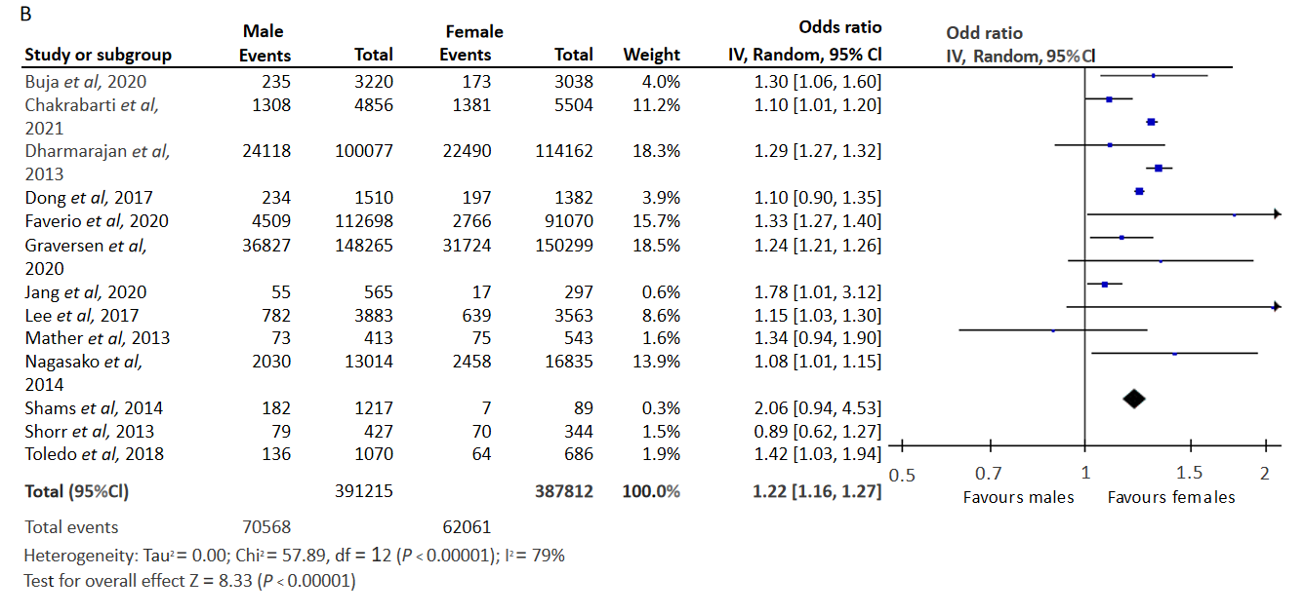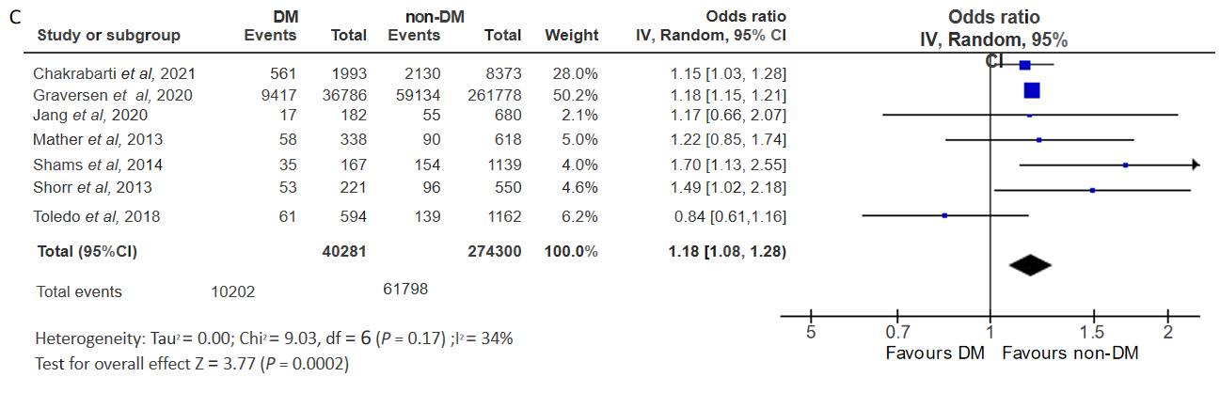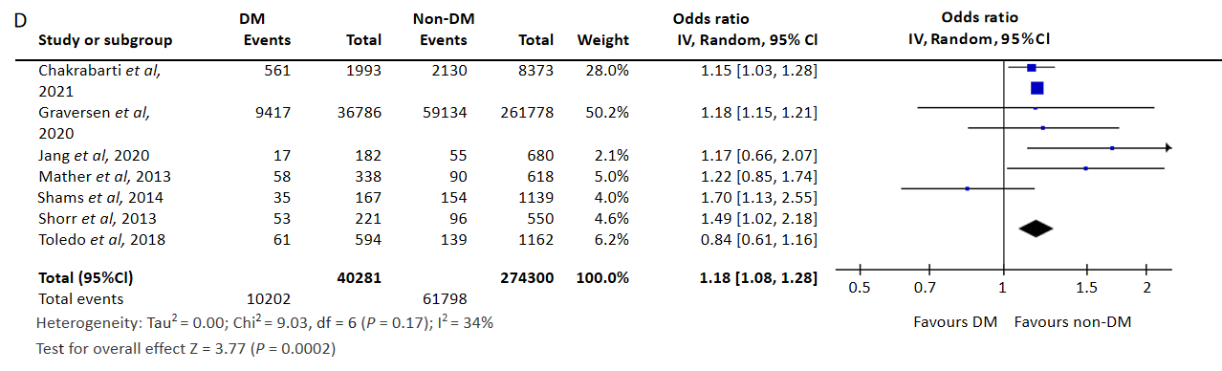
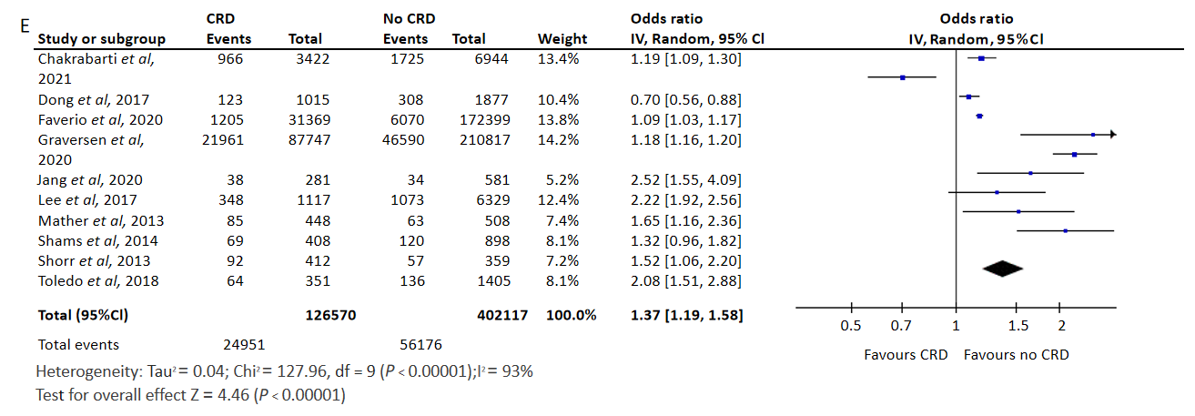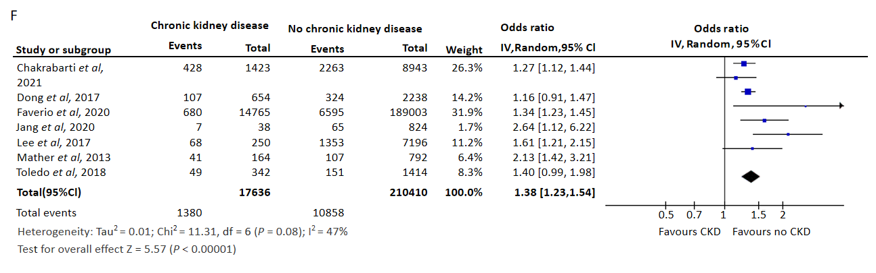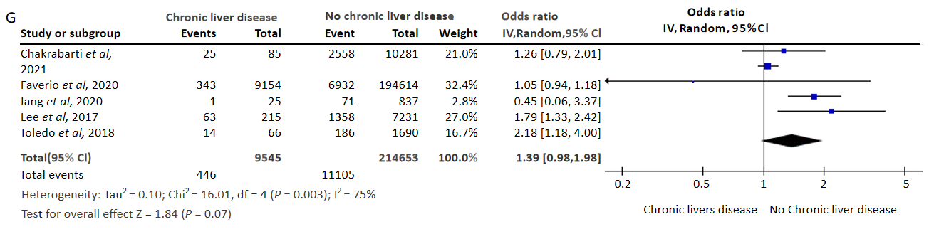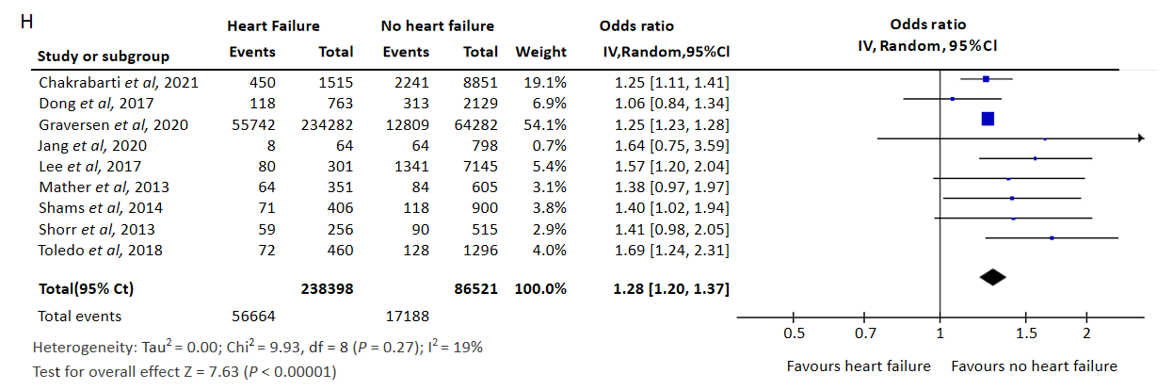
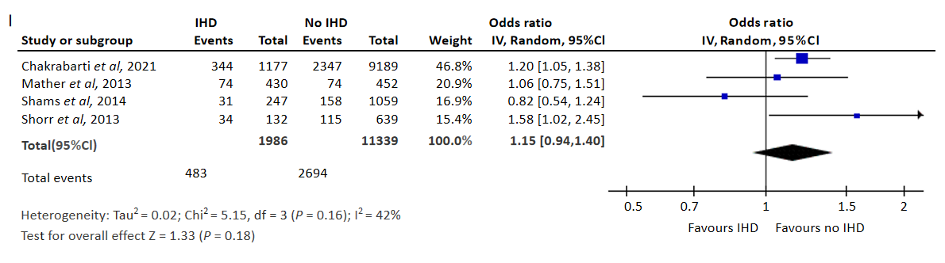
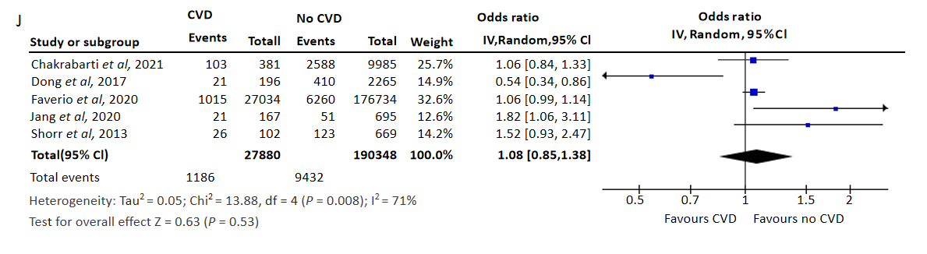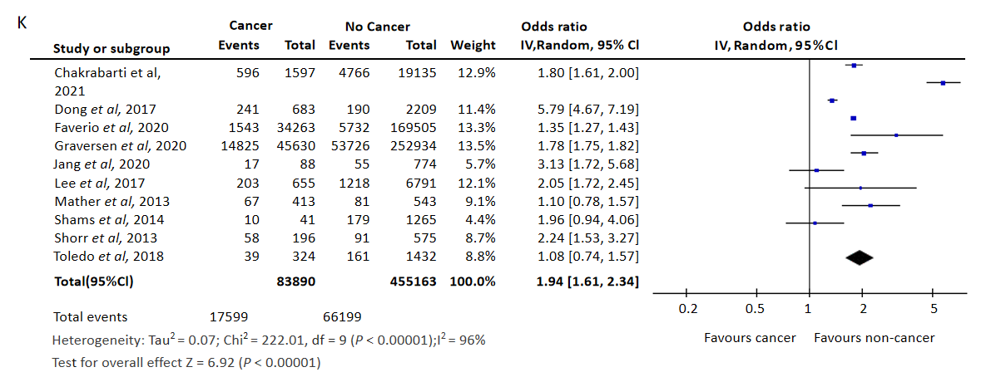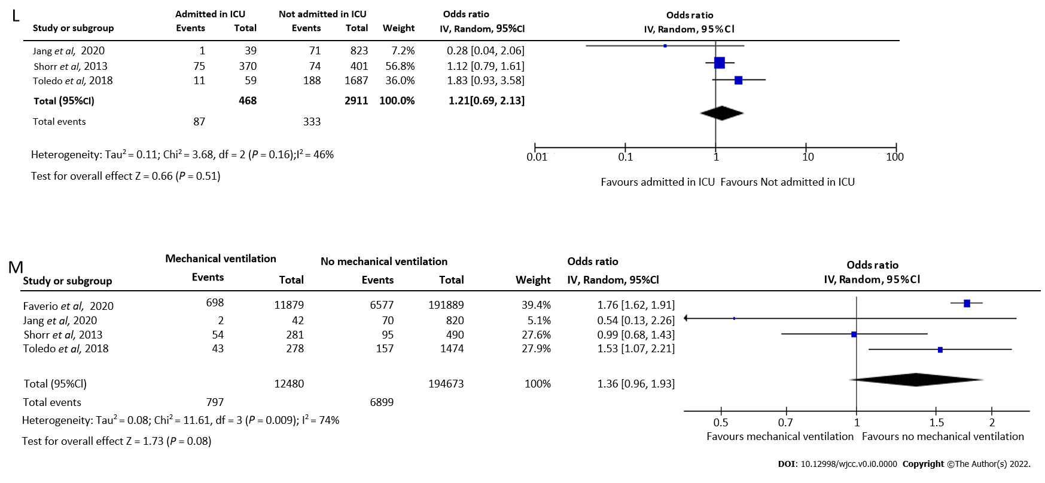
Figure 2 Forest plot showing the risk factors of hospital readmission rate among pneumonia patients. A: Age and hospital readmission; B: Gender and hospital readmission; C: Dementia and hospital readmission; D: Diabetes mellitus and hospital readmission; E: Chronic respiratory disease and hospital readmission; F: Chronic Kidney disease and hospital readmission; G: Chronic liver disease and hospital readmission; H: Heart failure and hospital readmission; I: Ischaemic heart disease and hospital readmission; J: Cerebrovascular disease and hospital readmission; K: Cancer and hospital readmission; L: ICU admission and hospital readmission; M: Mechanical Ventilation and hospital readmission.

Table 1 Characteristics of the studies included (n = 17)
No. | Ref. | Country | Study design | Sample size | Mean age (in years) | Study participants | Risk factors reported
1 | Ahmedani et al^{[33]}, 2015 | United States | Retrospective analysis of data | 72438 | NR | All health plan patients at the participating health systems with an index inpatient hospitalization for pneumonia between January 2009 and December 2011 | Dementia
2 | Buja et al^{[36]}, 2020 | Italy | Retrospective cohort study | 6258 | NR | Residents aged ≥ 65 yr with diagnosis related groups pneumonia (DRG 89 or 90) | Gender
3 | Chakrabarti et al^{[22]}, 2021 | United Kingdom | Retrospective analysis of data | 10366 | 73 | All community acquired pneumonia cases submitted by the nine participating hospitals in the AQ Pneumonia Programme between January 1, 2017 and March 31, 2019 | Gender, Dementia, Heart failure, Cancer, CRD, CKD, DM, IHD, Cerebrovascular disease
4 | Dharmarajan et al^{[29]}, 2013 | United States | Retrospective analysis of data | 214239 | NR | Hospitalizations among patients 65 yr or older with a complete claims history for 1 yr preceding admission | Gender
5 | Dong et al^{[30]}, 2017 | United States | Retrospective cohort study | 2892 | 61 | Medical records of all 2892 patients coded with a principal diagnosis of pneumonia admitted to the University of Chicago | Age, Gender, Cancer, Heart Failure, CKD, CRD, Cerebrovascular disease
6 | Faverio et al^{[31]}, 2020 | Italy | Retrospective cohort study | 203768 | 71.2 | NHS eligible residents in Lombardy who had experienced at least one hospital admission with pneumonia as primary or secondary diagnosis during the years 2003 to 2012 | Gender, Cancer, CKD, CRD, CLD, Cerebrovascular disease, Mechanical ventilation
7 | Graversen et al^{[23]}, 2020 | Denmark | Retrospective analysis of data | 298564 | NR | All Danish residents aged 65-99 yr, who had been discharged after a pneumonia-related hospital admission, referred to as index admission, during our study period | Gender, Dementia, Heart failure, Cancer, CRD, DM
8 | Graversen et al^{[24]}, 2021 | Denmark | Retrospective analysis of data | 298872 | NR | All Danish citizens aged 65–99 yr, who were discharged after a hospital admission (index admission) with a primary or secondary diagnosis of pneumonia as defined by the allocation of diagnostic codes (ICD-10: J12-J18, A709, or A481) | Dementia
9 | Jain et al^{[34]}, 2018 | United States of America | Retrospective analysis of data | 1472070 | 68.9 | All adults discharged alive after a hospitalization with the primary diagnosis of pneumonia | Age
10 | Jang et al^{[35]}, 2020 | Korea | Retrospective cohort | 862 | 68.5 | Patients with community acquired pneumonia hospitalized at Yeungnam University Hospital from March 2012 to February 2014 | Age, Gender, Dementia, Heart failure, Cancer, CRD, DM, CKD, CLD, Cerebrovascular disease, ICU admission, Mechanical ventilation
11 | Knox^{[32]}, 2019 | United States | Retrospective analysis of data | 389956 | 79 | Pneumonia patients ranging in age from 65 to 90 yr of age | Dementia
12 | Lee et al^{[25]}, 2017 | Republic of Korea | Retrospective cohort | 7446 | NR | Patients older than 65 yr who were hospitalized with pneumonia between 2003 and 2013 | Gender, Dementia, Heart failure, Cancer, CRD, CKD
13 | Mather et al^{[11]}, 2013 | United States | Retrospective cohort | 956 | NR | Adult patients admitted to Hartford Hospital from January 2009 to March 2012 with principal diagnosis of pneumonia (International Classification of Diseases, 9th Revision, Clinical Modification codes 480.XX, 481, 482.XX, 483.X, 485, 486, and 487.0) as potential index pneumonia admission | Gender, Dementia, Heart failure, Cancer, CRD, CKD, DM, IHD
14 | Nagasako et al^{[27]}, 2014 | United States | Retrospective analysis of data | 29849 | NR | Hospital readmissions for patients discharged from non-federal Missouri acute care or critical access hospitals between June 1, 2009 and May 31, 2012, with principal diagnoses of pneumonia | Gender
15 | Shams et al^{[28]}, 2014 | United States | Retrospective cohort | 1306 | 68.3 | Adult patients with principal (or secondary) discharge diagnoses of pneumonia | Gender, Cancer, Heart Failure, CRD, DM, IHD
16 | Shorr et al^{[12]}, 2013 | United States | Retrospective cohort | 771 | 60 | All adult subjects with bacterial pneumonia admitted to a single institution between January and December 2010 | Gender, Cancer, Dementia, Heart Failure, ICU admission, Mechanical ventilation, Cerebrovascular disease, CRD, DM, IHD
17 | Toledo et al^{[26]}, 2018 | Spain | Cross-sectional | 1756 | NR | Patients included were aged ≥ 65 yr admitted through the emergency department to any of the participating hospitals for ≥ 24 h with a chest X ray showing pulmonary infiltrate compatible with pneumonia and ≥ 1 of the following symptoms or signs of acute lower respiratory tract infection: Cough, pleural chest pain, dyspnoea, fever > 38 °C, hypothermia < 35 °C and abnormal auscultator respiratory sounds unexplained by other causes | Gender, Heart failure, Cancer, CRD, CKD, DM
NR: Not reported; CRD: Chronic respiratory diseases; CKD: Chronic kidney disease; CLD: Chronic liver disease; DM: Diabetes mellitus; IHD: Ischaemic heart disease; NHS: National Health Service.
Table 2 Quality assessment of the included studies (n = 17)
No. | Ref. | Representativeness | Sample size justification | Non-response | Ascertainment of exposure | Control for confounding | Assessment of outcome | Statistical tests | Overall quality
1 | Ahmedani et al^{[33]}, 2015 | 1 star | 0 star | 0 star | 1 star | 2 stars | 1 star | 1 star | Satisfactory
2 | Buja et al^{[36]}, 2020 | 1 star | 1 star | 1 star | 1 star | 2 stars | 1 star | 1 star | Good
3 | Chakrabarti et al^{[22]}, 2021 | 1 star | 0 star | 1 star | 1 star | 2 stars | 1 star | 1 star | Good
4 | Dharmarajan et al^{[29]}, 2013 | 1 star | 1 star | 0 star | 1 star | 2 stars | 1 star | 1 star | Good
5 | Dong et al^{[30]}, 2017 | 0 star | 0 star | 0 star | 1 star | 2 stars | 1 star | 1 star | Satisfactory
6 | Faverio et al^{[31]}, 2020 | 1 star | 0 star | 0 star | 1 star | 2 stars | 1 star | 1 star | Satisfactory
7 | Graversen et al^{[23]}, 2020 | 1 star | 1 star | 1 star | 1 star | 2 stars | 1 star | 1 star | Good
8 | Graversen et al^{[24]}, 2021 | 1 star | 0 star | 1 star | 1 star | 2 stars | 1 star | 1 star | Good
9 | Jain et al^{[34]}, 2018 | 1 star | 1 star | 0 star | 1 star | 2 stars | 1 star | 1 star | Good
10 | Jang et al^{[35]}, 2020 | 1 star | 1 star | 1 star | 1 star | 2 stars | 1 star | 1 star | Good
11 | Knox^{[32]}, 2019 | 0 star | 0 star | 0 star | 1 star | 0 star | 1 star | 0 star | Unsatisfactory
12 | Lee et al^{[25]}, 2017 | 1 star | 1 star | 1 star | 1 star | 2 stars | 1 star | 1 star | Good
13 | Mather et al^{[11]}, 2013 | 1 star | 0 star | 1 star | 1 star | 2 stars | 1 star | 1 star | Good
14 | Nagasako et al^{[27]}, 2014 | 0 star | 1 star | 0 star | 0 star | 0 star | 1 star | 1 star | Unsatisfactory
15 | Shams et al^{[28]}, 2014 | 0 star | 1 star | 0 star | 1 star | 0 star | 1 star | 0 star | Unsatisfactory
16 | Shorr et al^{[12]}, 2013 | 1 star | 1 star | 1 star | 1 star | 2 stars | 1 star | 1 star | Good
17 | Toledo et al^{[26]}, 2018 | 1 star | 0 star | 1 star | 1 star | 2 stars | 1 star | 1 star | Good

