Name of journal: World Journal of Gastroenterology
ESPS Manuscript No: 6615
Columns: TOPIC HIGHLIGHTS

WJG 20th Anniversary Special Issues (12): Nonalcoholic fatty liver disease

adv36 adipogenic adenovirus in human liver disease

Trovato FM et al. NAFLD and adipogenic adenoviruses

Francesca M Trovato, Daniela Catalano, Adriana Garozzo, G Fabio Martines, Clara Pirri, Guglielmo M Trovato

Francesca M Trovato, Daniela Catalano, G Fabio Martines, Clara Pirri, Guglielmo M Trovato, Department of Medical and Pediatric Sciences, Internal Medicine, University of Catania, 95100 Catania, Italy

Adriana Garozzo, Department of Biomedical Science, University of Catania, 95100 Catania, Italy

Author contributions: all Authors contributed equally to this work, based on preceding studies and articles; Trovato FM design and draft of the review; Garozzo A revised the virology aspects; Trovato GM final edit the paper.

Correspondence to: Guglielmo M Trovato, MD, Department of Medical and Pediatric Sciences, Internal Medicine, University of Catania, Policlinico, Ed. 4, 4th floor, Via Santa Sofia, 95100 Catania, Italy. guglielmotrovato@unict.it

Telephone: +39-95-3781533 Fax: +39-95-3781549
Received: October 25, 2013 Revised: April 3, 2014
Accepted: June 26, 2014

Published online:

Abstract
Obesity and liver steatosis are usually described as related diseases. Obesity is regarded as exclusive consequence of an imbalance between food intake and physical exercise, modulated by endocrine and genetic factors. Non-alcoholic fatty liver disease (NAFLD), is a condition whose natural history is related to, but not completely explained by over-nutrition, obesity and insulin resistance. There is evidence that environmental infections, and notably adipogenic Adenoviruses infections in humans, are associated not only with obesity, which is sufficiently established, but also with allied conditions, such as fatty liver. In order to elucidate the role, if any, of previous ADV36 infection in humans, we investigated association of ADV36-ADV37 seropositivity with obesity and fatty liver in humans. Moreover, the possibility that lifestyle-nutritional intervention in patients with NAFLD and different ADV36 seropositive status, achieves different clinical outcomes on ultrasound bright liver imaging, insulin resistance and obesity was challenged. ADV36 seropositive patients have a more consistent decrease in insulin resistance, fatty liver severity and body weight in comparison with ADV36 seronegative patients, indicating a greater responsiveness to nutritional intervention. These effects were not dependent on a greater pre-interventional body weight and older age. These results imply that no obvious disadvantage – and, seemingly, that some benefit – is linked to ADV36 seropositivity, at least in NAFLD. ADV36 previous infection can boost weight loss and recovery of insulin sensitivity under interventional treatment.

© 2014 Baishideng Publishing Group Inc. All rights reserved.

Key words: Non-alcoholic fatty liver disease; Human adenovirus 36 and 36; obesity; Insulin resistance; Mediterranean diet; Ultrasound

Core tip: There is evidence that environmental infections, and notably adipogenic Adenoviruses ADV36 /ADV37 infections in humans, are associated with obesity, being causative contributing factors of obesity in humans and animals. Lifestyle-nutritional intervention, in patients with different ADV36 seropositive status, achieves different clinical outcomes, i.e. a greater effect, on bright liver, insulin resistance and obesity is observed in comparison with ADV36 seronegative patients. These effects are not dependent on a greater pre-interventional body weight and older age. Adipogenic Adenovirus infections in humans are associated with obesity, but also with allied conditions, such as fatty liver, and can have different effects on the liver in humans and animals.

Trovato FM, Catalano D, Garozzo A, Martines GF, Pirri C, Trovato GM. adv36 adipogenic adenovirus in human liver disease. World J Gastroenterol 2014; In Press

OVERVIEW
Obesity and liver steatosis are generally associated^{[1,2]}. Nonetheless, some possible limitations of this so very definite statement have recently been reported and, even without clear-cut information, it is evident that lean individuals can actually have Non-alcoholic fatty liver disease (NAFLD) with a different clinical profile in comparison with overweight-obese individuals with NAFLD^{[3]}. The basis and background of our approach to obesity and obesity-related conditions, notably NAFLD, have been developed over more than 25 years, taking into account that fatty liver, even in absence of alcohol abuse, is probably a condition detrimental for the liver, or, at least, associated with some liver “injury”^{[4-6]}. NAFLD is currently recognized as subsequent to unhealthy lifestyle, moreover, adherence to Mediterranean Diet, which is a proxy of healthy nutritional profiles, is significantly decreasing even among healthy subjects^{[7]} and a parallel increase of NAFLD is conceivably ensuing. Adherence to Mediterranean Diet Score (AMDS) has decreased significantly over the past 15 recent years, suggesting a rapid loss of adherence to healthy nutritional habits even in the Mediterranean area. Several intervention strategies, especially in childhood and adolescence, are currently being applied or are envisaged^{[8]}, in an attempt to counteract more robust or subtle marketing strategies that tend to induce unfavorable nutritional habits; these last are sometimes definitely detrimental for the nutritional health of populations and increase the risk of cancer and cardiovascular and liver disease even in childhood. Nonetheless, national and international intervention planned and actuated were not sufficiently effective for the promotion of healthier lifestyles and did not succeed against unhealthy habits and foods. Genetic-hereditary factors are extensively studied in obesity^{[9-11]} but also epigenetic mechanisms could be operating^{[12-16]}. Environment can conceivably interfere in the etiopathogenesis of obesity and related conditions^{[17,18]}: the epidemiologic impact is not univocal, and, among other factors including climate, food availability and quality, pollution, urban mobility, physical exercise facilities, the role of bacterial and viral infections, also as individual microbiome must be considered. It can favor or reduce by different, opposite or concurrent mechanisms, body fat content, adipogenesis and fatty storage in several organs, notably the liver^{[19]}. In summary, the target of intervention in clinical research and practice is the decrease of excessive and lasting over-nutrition and the abandonment of sedentary life, both pursued facilitating psychological dispositions and early life behaviors, along with parental-social conditioning^{[17]}.
Behavioral counseling focused on physical exercise and self-efficacy enhances dietary adherence and weight loss in obesity^{[20,21]}. Increased adherence to a healthier diet profile and to greater physical exercise activity concurs and improves liver appearance and function in NAFLD patients^{[22,23]} as in other conditions^{[24-30]}. Also Hepatitis C virus (HCV) is associated with liver steatosis, but its persistence after virus eradication observed in several cases is considered, even conjecturally, the confirmation that different mechanisms are operating. Fat increase in liver by diets, sedentary life, genetics and environmental factors do not exclude that other viruses or the microbiome do not have a priori effects^{[19]}.

OBESITY
The investigations on the relationship between obesity and adenovirus are quite recent^{[31]}. Adenoviruses are medium sized, non-enveloped, icosahedral shaped double stranded linear DNA viruses. They are commonly used as vectors in gene delivery systems. ADV36 is one of 56 serotypes in 7 subgroups of human adenoviruses^{[32]}. It was observed that after ADV36 inoculation in either chickens or mice, body fat increased, visceral fat increased disproportionally to body fat, and serum lipids were paradoxically lower despite the obesity^{[31,33]}. ADV36 infection accelerates the differentiation of preadipocytes to adipocytes in 3T3-L1 cells and human preadipocytes^{[34]}. Moreover, ADV36 DNA was isolated from human adipose tissues of severe obese subjects^{[35]}. We began investigating in 2002, through pioneering studies in animals and humans^{[31-35]}, whether non-diabetic patients with previous ADV36 infection showed greater degrees of overweight-obesity, of insulin resistance, assessed by homeostasis model assessment (HOMA), and/or of other related factors^{[36]}. We considered carefully the need for excluding diabetes from an observational study, since addressing possible associations more than histology and virus identification in fat and liver cells, the need for excluding powerful confounding factors, as also B and C virus hepatitis, was necessary. Despite this relevant shortage of the population to be studied, we confirmed that a great prevalence of ADV36 seropositivity, 43%, in adults^{[36]} is present also in our population, in Italy. There are some gender-related differences: ADV36 seropositivity for neutralizing antibodies has a prevalence of 59% in women, and of 33% in men. This prevalence is comparable to the prevalence of seropositivity for ADV36 – around 50% in adults - neutralizing antibodies reported in the extensive international survey recently published^{[37]}. The core of our study showed that prevalence in obese subjects is significantly higher, 64.7%, in comparison with non-obese subjects, in which prevalence was 32.6%^{[36]}. The main possible bias of our contribution is that the population studied is not randomly chosen, but represents, within the exclusion criteria (severe acute and chronic disease, cancer, alcohol and diabetes), the current referrals to our diagnostic and therapeutic unit, i.e. includes patients seeking liver ultrasound (us) and nutritional assessment and advice for actual or perceived overweight-obesity. Fluctuation of body weight, from normal to overweight level, is a distinctive feature of most normal subjects: this could explain the relatively higher prevalence in our population group of ADV36 neutralizing antibodies seropositivity in comparison with other studies in younger population and even in children or adolescents, and to the fact that we are actually studying most subjects with an history of overweight-obesity. ADV36 seropositivity prevalence increases with ageing (20-29, 30-39, 40-49, 50-59, 60-69 and ≥ 70 years) considering consecutive adult age decades in our population (Figure 1).
ADV36 seropositive subjects also have an increased prevalence of essential hypertension (i.e. slightly “high-normal” diastolic blood pressure) and of greater insulin resistance (IR), in comparison with the control group of ADV seronegative subjects. In Figure 2 The Odds Ratios show an increased hazard of obesity associated with ADV36 seropositivity (OR = 6.879; 95%CI: 3.316–14.274), essential hypertension (OR = 2.977; 95%CI: 1.625–5.451) and IR (OR = 3.792; 95%CI: 2.052–7.006).
We suggested that ADV36 seropositive status could be also a hallmark of a clinical-metabolic profile possibly preceding obesity and diabetes in non-obese patients^{[36]}. By means of a multiple linear regression (MLR) model, aimed at reaching a synthetic representation of our results, we challenged the predictability of body mass index (BMI), used as a measurement of the grade of obesity, and the predictability of HOMA, used as a measurement of insulin resistance. HOMA variance, in our model, is explained significantly only by BMI and triglycerides, and not by ADV36 seropositivity (Table 1).
As a consequence, previous infection with ADV36 does not plausibly account for IR and the degrees of HOMA. Differently, ADV36 seropositivity is significantly present in the model to BMI and accounts reasonably and significantly for the BMI variance; in this model, a significant concurrent contribution of HOMA is also present in the mechanisms contributing to obesity.
The conclusion was that a direct pathophysiological mechanism on establishment and/or maintaining obesity could be operating, and could be related to an earlier ADV36 infection; ADV36 seropositivity does not account for different degrees of HOMA, and thereafter, any likely evidence of effects of ADV36 mediated by insulin resistance is missing. All models are weighted by age since ADV36 seropositivity prevalence increases with ageing.

LIVER
Obesity and liver steatosis are frequently described as related diseases, even with several exceptions, as indicated above^{[3]}. Non-alcoholic fatty liver disease, is a condition whose natural history is related to, but is not completely explained by, over-nutrition, obesity and insulin resistance. Aminotransferase levels may fluctuate and, among subjects with fatty liver at US, those with normal and abnormal alanine aminotransferase (ALT) levels show a similar or identical pattern^{[38]}. This finding provides indirect evidence that ALT does not differentiate various conditions or stages of the disease in NAFLD, and, obviously, is not associated with the actual fat content of liver cells. US bright liver pattern and its derived score (BLS) is one of the most comprehensive non-invasive diagnostic tools for bright/fatty liver assessment, with a satisfactory clinical consistency^{[38]}, confirmed also in our clinical experience^{[22]}. After on-site validation of the Mathiesen’s score (Bright Liver Score, i.e. BLS)^{[22]}, we used and use in our studies this non-invasive tool as a reliable substitute for the diagnosis and staging of fatty/bright liver: us NAFLD diagnosis has also a good intra-observer reliability. This score provides comprehensive information, and liver biopsy, by which sampling differences and/or errors can result in substantial misdiagnosis and staging inaccuracies in liver diffuse abnormalities, such as steatosis^{[39]}, is performed only for the definition of nodules or for investigating diffuse but scarcely defined lesions. Moreover, non-invasive us imaging allows a more complete visualization of the liver which, by liver biopsy, is reached in very limited and – hopefully – accurately chosen areas^{[39]}; this method perhaps does not provide a sufficiently comprehensive description of the liver as a whole. In our experience, by US-guided fine needle aspirate biopsy (FNAB, 20 Gauge), using echo-transducers with a central hole which allows the coaxial passage of the needle and the concurrent vision of the needle and the area to be reached, it is possible to get specimens of adequate length (2.5-5.0 cm) with a number of portal spaces sufficient to allow a reliable assessment of steatosis and fibrosis^{[38]}. The method is safer than other biopsy procedures, is repeatable and is currently done when double specimens are to be taken (intranodular biopsy plus nearby liver)^{[22,40]} if needed for diagnostic purposes. This is the case when non-invasive imaging is doubtful and there is the need of a differential diagnosis of Hepatocellular carcinoma, Cholangiocarcinoma, Metastasis, Lymphoma, or of other diffuse non-neoplastic disease. With this indication, the parallel biopsy of the seemingly non-tumoral liver tissue is carried out to obtain information on the associated liver disease, if there is any. In Figure 3 a convex US transducer with a central hole for allowing co-axial biopsy is shown, along with four different specimens of liver FNAB in fatty liver performed with 20 G needle.
The pathology of NAFLD, its impact on hepatic fibrosis, animal models and biomarkers, molecular mechanisms of lipotoxicity, diagnostic strategies, and associated conditions are among the most significant fields of clinical and translational research. Since healthier lifestyles, regarding correct hypercaloric- unbalanced diets, diminishing sedentary lifestyle, and alcohol abuse withdrawal, are the most effective therapeutic interventional strategies in liver steatosis as they are in obesity management, and because no special information can be obtained by liver biopsy in subjects with the lone imaging evidence of fatty liver, without any visible associated liver lesion, liver biopsy is not only not recommended for the diagnosis, but could be even misleading due to the limitations described above.

ADENOVIRUS ADV36
Obesity and fatty liver, notably NAFLD, can co-exist and can undergo exacerbation or remission independent of each other; concurrent straight, discrete and significant mutual linear relationships between insulin resistance, obesity and severity of fatty liver involvement are confirmed by previous studies^{[22]}. Both obesity and NAFLD are easily quantifiable and can be assessed non-invasively. In fact, they could be considered two facets of an allied condition. The acknowledgement that a third factor, beyond food intake and adiposity, could be contributing to obesity and NAFLD prompted the investigation of the adipogenic adenoviruses ADV36 seropositivity relationship with fatty liver. In these investigations, the number of confounding variants was limited; i.e. subjects with different dietary profiles, diabetes, cancer and hepatitis C virus-related liver disease were excluded^{[41]}. In this study we investigated prevalence of ADV36 seropositivity in NAFLD patients and observed a lower prevalence of ADV36 seropositivity (32.3%) in NAFLD patients in comparison with non-NAFLD subjects (46.5%), despite no difference of BMI, as averages, being observed in the two groups: 28.15 ± 5.97 vs 27.11±5.36.
By Odds Ratio, Figure 4, a higher risk of non-alcoholic fatty liver disease is associated with insulin resistance and obesity, and a lower NAFLD risk is associated with ADV36 seropositivity^{[41]}.
Considering all the NAFLD patients, the same grade of BLS, age, insulin resistance, cholesterol and triglycerides was observed, but a significant difference of BMI, greater in ADV36 positive subjects (30.58 ± 5.81 vs 26.99 ± 5.76) was present. This suggested the possibility of an anti-steatogenic effect of ADV36 implying a better metabolic profile in ADV36 non-diabetic infected subjects, compared to the uninfected subjects which show the same degree of obesity. Whereas, recent cross-sectional and longitudinal studies showed that ADV36 seropositivity is associated with better glycaemic control in humans^{[42-45]}.

ADENOVIRUS ADV37
Along the same line of research we investigated also whether non- diabetic patients with previous ADV37 infection, under uniform, appropriate, and reasonably healthy dietary proﬁle prescriptions, show different prevalence of overweight-obesity, insulin resistance, assessed by HOMA, and/or fatty liver^{[46]}. ADV37 seropositivity is not associated with a significant increase of prevalence and severity of obesity in comparison with ADV37 seronegative subjects but have a significantly greater prevalence of NAFLD, which is concurrently explained in a MLR model by ADC37 seropositivity and greater body weight (Table 2).
There is a greater relative hazard of fatty liver for ADV37 seropositive patients, as expressed by the Odds ratio. In Figure 5 Odds ratios show that an increased risk of obesity (top) is associated with greater insulin resistance, C-reactive protein (CRP), and ADV37 seropositivity (ADV37+), whereas higher high-density lipoprotein (HDL) cholesterol is associated with lower prevalence of obesity. A more consistent association of ADV37+, greater insulin resistance, CRP, and obesity was observed with NAFLD (bottom), whereas higher HDL cholesterol was associated with a lower prevalence of NAFLD. No sex difference was found. CRP indicates C-reactive protein; HDL, high-density lipoprotein; NAFLD, nonalcoholic fatty liver disease. This behavior is different, if not the opposite of, that of ADV36.

SOME REMARKS
These two adipogenetic Adenoviruses, ADV36 and ADV37, appear to be associated with different lipidogenic effects at least in two different organs, notably liver and fat cells. The need for additional longitudinal/prospective studies is obvious. Moreover, there are no data available regardingearly infection and subsequent seroconversion – no data are available for subjects shifting from a condition of seropositivity to seronegativity. Last but not least, no clear-cut information is currently available on the compound ADV36/ADV37 seropositivity. We observed that ADV36+ and ADV37+ compound seropositivity, independently by difference of nutritional profile, has no additive effect on obesity and insulin resistance^{[47]}.

NEED FOR AN INTERVENTION STUDY
Since correlation does not imply causation (cum hoc ergo propter hoc logical fallacy), and considering the ethical barriers against the proof of NAFLD induced by ADV36 inoculation in humans, we set out to discover, within our current lifestyle- nutritional interventions program, to seek to determine whether participants, NAFLD patients, achieve different clinical outcomes, and whether changes are blunted or enhanced according to ADV36 seropositivity status^{[48]}. This intervention study, within a homogeneous and established lifestyle-nutritional intervention program was carried out limiting possible confounding factors. Previous HCV infection is a recognized risk factor for development of liver steatosis and insulin resistance, particularly in patients with visceral obesity; also, in type-2 diabetic patients, NAFLD may develop and progress independent of the diabetes progression itself; both conditions were preliminarily excluded from the result of our study, in the attempt to minimize the number of confounding factors. The program of interventional health psychology is currently aimed, in our institution, at life-style modifications: the goal is a gradual weight loss of approximately 5% of the initial body weight within 6 months in obese overweight subjects. However, the key goal of the diet is to achieve an adequate nutritional status, with close reference to daily physical activity and to the degree of weight abnormality. Weight modifications through the prescribed diets are foreseen, but without the aim of reaching rapid effects both on weight and on liver steatosis. Diet was provided with daily recommendations derived also from the specific software used (DietosystemTM, Milan, Italy). ADV36 seropositive patients have a more consistent decrease in insulin resistance, fatty liver severity and body weight in comparison with ADV36 seronegative patients, indicating a greater responsiveness to nutritional intervention. These effects were not associated with a greater pre-interventional body weight and older age, which could be explaining factors. ADV36 seropositive status is associated significantly and independently with the reduction of bright liver and obesity. These results imply no obvious disadvantage and, seemingly, some benefit is linked to ADV36 seropositivity, at least in NAFLD. All patients, in both groups, had a satisfactory adherence to the prescription, including abstinence for alcoholics. After our interventional approach, ADV36 seropositive patients have a more consistent decrease of insulin resistance and body weight, indicating a greater responsiveness to the nutritional intervention. Figure 6A shows how, after a comprehensive nutritional and lifestyle intervention, the improvement is more relevant in ADV36 seropositive than in ADV36 seronegative NAFLD patients: a greater decrease of insulin resistance (HOMA) and of overweight (BMI) was achieved in ADV seropositive NAFLD patients.
This was not due to greater obesity of ADV36 seropositive NAFLD patients, since the subsequent multiple liner regression model, BMI adjusted for eliminating the difference of BMI as a potential confounding factor, confirms the relevance of ADV36 seropositivity, not dependent on a greater pre-interventional body weight. The model indicates that both fat mass decrease and ADV36 seropositive status account significantly and independently for the disappearance of bright liver (Table 3).
Figure 6B shows how, after a comprehensive nutritional and lifestyle intervention, the Odds of bright liver persistence is associated with lack of insulin resistance (HOMA) and body weight (BMI) decrease, while a relevant association with improvement, i.e. Bright Liver disappearance, is observed in ADV36 seropositive NAFLD patients.
Differently from our original hypothesis, bright liver disappearance seems to be not blunted by ADV36 positive serological status and is associated with a greater fat mass loss.

CURRENT HYPOTHESIS AND ENVISAGED MECHANISMS
ADV36 can modify the machinery of human cells by several mechanisms, and particularly the most direct one, i.e. the persistence of the virus in any tissue or organ, including fat cells and/or hepatocytes. ADV36 induces the synthesis of specific protein, E4orf1^{[43]}; this can be also a consequence of an epigenetic effect, i.e. the result of functionally relevant changes to the genome that do not involve a change in the nucleotide sequence nor any integration^{[49]}. Preadipocytes of the ADV36 DNA positive subjects showed about 8-fold greater ability to differentiate into fat cells, compared to that of the ADV36 DNA negative subjects. These findings are in agreement with the ability of ADV36 to induce adipogenic differentiation and lipid accumulation in adipocyte progenitors. Can it suggest a persistent replication of ADV36 in seropositive persons? In animal models, ADV36 appears to alleviate hyperglycemia by increasing glucose uptake by adipose tissue and skeletal muscle and by reducing hepatic glucose output, along with a robust upregulation of adiponectin and an attenuation of hepatic steatosis^{[50-53]}. A working model to explain the antidiabetic effect of ADV36 was developed^{[54]}. Overall in adipose tissue, skeletal muscle, and liver of mice, ADV36 downregulates insulin signaling yet upregulates the Ras-PI3K pathway, which upregulates Glut1 and Glut4 in skeletal muscle and adipose tissue and downregulates Glut2 in liver. Furthermore, ADV36 increases adiponectin, which may activate AMPK. Collectively, this leads to greater glucose uptake by adipose tissue and skeletal muscle and reduces hepatic glucose release, which may contribute to ADV36-induced improvement in systemic glycemic control (Figure 7).
ADV36 infection stimulated an inflammatory state by increasing the level of MCP-1 (monocyte chemoattractant protein-1) through the activation of nuclear factor κB, which in turn induces the infiltration of macrophages into adipocytes. Knockout (MCP-1(-/-)) mice are protected from ADV36-induced inflammation and obesity so that virus-induced inflammation could be the cellular mechanism underlying ADV36-induced obesity and MCP-1 may be a therapeutic target in preventing virus-induced obesity^{[55]}. Increase in glycemic control and adipogenesis can be uncoupled. The E4orf1 gene of ADV36 has been shown to be responsible for its adipogenic effect. E4orf1 protein of ADV36 was recently identified as the protein likely to mediate ADV36 induced improvements in glucose disposal^{[43]}. ADV36 E4orf1 may reduce glucose output in basal and gluconeogenic conditions, reduce de-novo lipogenesis, increase complete fatty acid oxidation and promote lipid transport. These mechanisms, collectively, may contribute to lower hepatic lipid accumulation and to a better glycemic control. Several alterations in hepatic lipid metabolism can result in insulin resistance and hepatic steatosis such as impaired suppression of glucose output under gluconeogenic conditions, impaired fatty acid oxidation, decreased lipid export, and increased de-novo lipogenesis. In vitro studies showed that E4orf1 protein is necessary and sufficient for ADV36 to increase cellular glucose uptake from adipocytes and myoblasts and to reduce glucose output from hepatocytes: E4orf1 also reduced DNL, and up-regulated ApoB secretion, which is indicative of lipid export. This action of E4orf1 may be sufficient to attenuate hepatic triglyceride accumulation, as observed in ADV36 infected C57BL/6J mice on high fat diet^{[43,56,57]}.

LIMITATIONS AND FUTURE PERSPECTIVES
We are aware that present evidence in not supported by evidence based on Koch's postulates and/or by the demonstration of the presence of ADV36 or of any of its component in the liver. Our observational investigation was merged within the current chosen approach for the management of fatty liver disease, in non-diabetics, without alcohol abuse and without viral hepatitis disease. In this subset the only clinical clue for fatty liver could be overweight-obesity. A bias was that patients were not randomly selected from a definite population, but were all subjects coming to our outpatient clinic for US assessment and nutritional evaluation and counseling, with or without presenting currently overweight or obesity. Most of the normal weight subjects, however, were overweight or obese in the preceding years. According to our knowledge and practice, we rely on lifestyle assessment and management of obesity and fatty liver, with a common approach. Despite this, we challenged the possibility that a factor, such as this infection with widespread human viruses with obesogenic effects in animals is, could have similar effect in humans. We tried to explain how these effects, if any, could be inter-related with the obesity-associated liver disease which, in its more “pure” form, is currently defined NAFLD.
The envisaged molecular mechanisms are the results of the studies of different investigators with different methodological approaches. E4orf1 is not a secretory protein, and therefore does not have a cell surface receptor for cell entry. Moreover, a long term delivery of E4orf1 may be required to influence metabolism in vivo. Therefore, a suitable delivery system such as a retrovirus or nano-particles that express E4orf1 is required to test the effects of E4orf1 in vivo. Nonetheless, E4orf1 may provide novel signaling targets to prevent NAFLD and insulin resistance even in the presence of a high fat diet^{[43,57,58]}.
More information of the effects of ADV36/37 on cultured human cells, i.e. adipocytes, hepatocytes and others are still needed, as too are additional longitudinal epidemiological studies. Prospective studies on seropositive subjects shifting from conditions of seropositivity to seronegativity could provide useful information. Assessment of combined ADV36/ADV37 seropositivity on liver and, notably, on liver fibrosis and steatosis, are a field of current investigation; we preliminary reported that compound ADV36/ADV37 seropositivity is associated with a risk profile more similar to ADV37 seropositivity (Figure 8), whose effect is not blunted by ADV36 seropositivity.
In this subset, a search for groups with early first infections and subsequent modality of seroconversion could provide useful information. The study of identical twins and the assessment of different susceptibility, if any, of patients with combined ADV36/ADV37 seropositivity would also be useful.
The availability of affordable predictive application tools will foster both epidemiological and preventive strategies and prospective intervention actions^{[19]}. The possibility of using a ADV36 vaccine in humans and the use of substances with inhibitory action on ADV36 replication and/or on its adipogenic effects are currently being investigated, despite its questionable usefulness according to our current knowledge.
Nonetheless, despite overweight-obesity being considered invariably ominous for health, under several conditions, also in this case of ADV36 associated obesity being overweight appears “protective” (obesity paradox), not only against renal and heart failure^{[59]}, but also against NAFLD^{[41,48]}. This issue is debated, but the core of the problem is that we still lack a good definition of the healthy overweight person, if any, and of his/her relationship with a healthy dietary profile and with appropriate physical exercise. Within this comprehensive frame, obesity is regarded as exclusive consequence of an imbalance between food intake and physical exercise, modulated by endocrine and genetic causes, and influenced by behavioral mechanisms which are conditioned by economic, societal and psychological factors. Economists and, obviously, epidemiologists mention the environment: but they skip the evidence that environmental infections, and notably adipogenic adenoviruses infections in humans, are associated with obesity, and allied conditions, such as fatty liver, and that these can be the factors influencing obesity and consequent disease in humans and animals^{[60]}, since obesity itself is a factor influencing the outcome in virus disease^{[61]}. Our contribution is hopefully a step towards enhancing a more comprehensive approach to NAFLD knowledge, assessment and treatment.

REFERENCES
1 Roden M. Mechanisms of Disease: hepatic steatosis in type 2 diabetes--pathogenesis and clinical relevance. Nat Clin Pract Endocrinol Metab 2006; 2: 335-348 [PMID: 16932311]
2 Petersen KF, Dufour S, Feng J, Befroy D, Dziura J, Dalla Man C, Cobelli C, Shulman GI. Increased prevalence of insulin resistance and nonalcoholic fatty liver disease in Asian-Indian men. Proc Natl Acad Sci USA 2006; 103: 18273-18277 [PMID: 17114290]
3 Younossi ZM, Stepanova M, Negro F, Hallaji S, Younossi Y, Lam B, Srishord M. Nonalcoholic fatty liver disease in lean individuals in the United States. Medicine (Baltimore) 2012; 91: 319-327 [PMID: 23117851 DOI: 10.1097/MD.0b013e3182779d49]
4 Petersen KF, Dufour S, Befroy D, Lehrke M, Hendler RE, Shulman GI. Reversal of nonalcoholic hepatic steatosis, hepatic insulin resistance, and hyperglycemia by moderate weight reduction in patients with type 2 diabetes. Diabetes 2005; 54: 603-608 [PMID: 15734833]
5 Yeh MM, Brunt EM. Pathology of nonalcoholic fatty liver disease. Am J Clin Pathol 2007; 128: 837-847 [PMID: 17951208]
6 Lim YS, Kim WR. The global impact of hepatic fibrosis and end-stage liver disease. Clin Liver Dis 2008; 12: 733-46, vii [PMID: 18984463 DOI: 10.1016/j.cld.2008.07.007]
7 Trovato GM, Martines GF, Catalano D. Mediterranean Diet adherence is decreasing in healthy subjects over the years 1996-2010 also in Mediterranean area. FASEB J 2012; 26: 1004
8 Trovato GM, Alonzo E, Cacciola S, Cannizzaro V, La Carrubba R, Pisana P, Purrello A, Raiti ME, Fardella M. The Spontaneous Plants' Recipes Project for enhancing Mediterranean Diet profile change: A sustainable strategy for obesity prevention in childhood, and for contributing to biodiversity maintenance. An intervention of the Italian Food and Nutrition Public Provincial Service. FASEB J 2013; 27: 617
9 Younossi ZM, Baranova A, Ziegler K, Del Giacco L, Schlauch K, Born TL, Elariny H, Gorreta F, VanMeter A, Younoszai A, Ong JP, Goodman Z, Chandhoke V. A genomic and proteomic study of the spectrum of nonalcoholic fatty liver disease. Hepatology 2005; 42: 665-674 [PMID: 16116632]
10 Bell LN, Theodorakis JL, Vuppalanchi R, Saxena R, Bemis KG, Wang M, Chalasani N. Serum proteomics and biomarker discovery across the spectrum of nonalcoholic fatty liver disease. Hepatology 2010; 51: 111-120 [PMID: 19885878 DOI: 10.1002/hep.23271]
11 Puri P, Wiest MM, Cheung O, Mirshahi F, Sargeant C, Min HK, Contos MJ, Sterling RK, Fuchs M, Zhou H, Watkins SM, Sanyal AJ. The plasma lipidomic signature of nonalcoholic steatohepatitis. Hepatology 2009; 50: 1827-1838 [PMID: 19937697 DOI: 10.1002/hep.23229]
12 Cordero P, Campion J, Milagro FI, Martinez JA. Transcriptomic and epigenetic changes in early liver steatosis associated to obesity: effect of dietary methyl donor supplementation. Mol Genet Metab 2013; 110: 388-395 [PMID: 24084163 DOI: 10.1016/j.ymgme.2013.08.022]
13 Sookoian S, Pirola CJ. Systems biology elucidates common pathogenic mechanisms between nonalcoholic and alcoholic-fatty liver disease. PLoS One 2013; 8: e58895 [PMID: 23516571 DOI: 10.1371/journal.pone.0058895]
14 Li YY. Genetic and epigenetic variants influencing the development of nonalcoholic fatty liver disease. World J Gastroenterol 2012; 18: 6546-6551 [PMID: 23236228 DOI: 10.3748/wjg.v18.i45.6546]
15 Pirola CJ, Gianotti TF, Burgueño AL, Rey-Funes M, Loidl CF, Mallardi P, Martino JS, Castaño GO, Sookoian S. Epigenetic modification of liver mitochondrial DNA is associated with histological severity of nonalcoholic fatty liver disease. Gut 2013; 62: 1356-1363 [PMID: 22879518 DOI: 10.1136/gutjnl-2012-302962]
16 Sanal MG. The blind men 'see' the elephant-the many faces of fatty liver disease. World J Gastroenterol 2008; 14: 831-844 [PMID: 18240340]
17 Trovato GM. Behavior, nutrition and lifestyle in a comprehensive health and disease paradigm: skills and knowledge for a predictive, preventive and personalized medicine. EPMA J 2012; 3: 8 [PMID: 22738244 DOI: 10.1007/s13167-012-0141-2]
18 Tan HH, Fiel MI, Sun Q, Guo J, Gordon RE, Chen LC, Friedman SL, Odin JA, Allina J. Kupffer cell activation by ambient air particulate matter exposure may exacerbate non-alcoholic fatty liver disease. J Immunotoxicol 2009; 6: 266-275 [PMID: 19908945 DOI: 10.1080/15476910903241704]
19 Dhurandhar NV, Geurts L, Atkinson RL, Casteilla L, Clement K, Gerard P, Vijay-Kumar M, Nam JH, Nieuwdorp M, Trovato G, Sørensen TI, Vidal-Puig A, Cani PD. Harnessing the beneficial properties of adipogenic microbes for improving human health. Obes Rev 2013; Epub ahead of print [PMID: 23663746 DOI: 10.1111/obr.12045]
20 Trovato GM, Catalano D, Pennisi A, Trovato FM, Pace P, Martines GF, Pirri C. NAFLD (Non-Alcoholic-Fatty-Liver--Disease) reversal by a comprehensive nutritional-physical exercise intervention. FASEB J 2012; 26: 819
21 Allison DB, Downey M, Atkinson RL, Billington CJ, Bray GA, Eckel RH, Finkelstein EA, Jensen MD, Tremblay A. Obesity as a disease: a white paper on evidence and arguments commissioned by the Council of the Obesity Society. Obesity (Silver Spring) 2008; 16: 1161-1177 [PMID: 18464753 DOI: 10.1038/oby.2008.231]
22 Catalano D, Trovato GM, Martines GF, Randazzo M, Tonzuso A. Bright liver, body composition and insulin resistance changes with nutritional intervention: a follow-up study. Liver Int 2008; 28: 1280-1287 [PMID: 18435716 DOI: 10.1111/j.1478-3231.2008.01742.x]
23 Trovato GM, Catalano D, Martines GF, Pirri C, Trovato FM. Western dietary pattern and sedentary life: independent effects of diet and physical exercise intensity on NAFLD. Am J Gastroenterol 2013; 108: 1932-1933 [PMID: 24300872 DOI: 10.1038/ajg.2013.356]
24 Trovato GM, Martines GF, Trovato FM, Catalano D. Re: "Relation of the traditional Mediterranean diet to cerebrovascular disease in a Mediterranean population". Am J Epidemiol 2013; 178: 661 [PMID: 23788673 DOI: 10.1093/aje/kwt125]
25 Catalano D, Trovato GM, Pace P, Martines GF, Trovato FM. Mediterranean diet and physical activity: an intervention study. Does olive oil exercise the body through the mind? Int J Cardiol 2013; 168: 4408-4409 [PMID: 23714600 DOI: 10.1016/j.ijcard.2013.05.034]
26 Trovato GM, Pace P, Martines GF, Trovato FM, Pirri C, Catalano D. Stress, abdominal obesity and intrarenal resistive index in essential hypertension. Clin Ter 2012; 163: 299-305 [PMID: 23007813]
27 Trovato GM, Pace P, Cangemi E, Martines GF, Trovato FM, Catalano D. Gender, lifestyles, illness perception and stress in stable atrial fibrillation. Clin Ter 2012; 163: 281-286 [PMID: 23007810]
28 Trovato GM, Martines GF, Trovato FM, Pirri C, Pace P, Catalano D. Renal resistive index and parathyroid hormone relationship with renal function in nondiabetic patients. Endocr Res 2012; 37: 47-58 [PMID: 22007967 DOI: 10.3109/07435800.2011.625513]
29 Catalano D, Trovato GM, Martines GF, Pirri C, Trovato FM. Renal function and severity of bright liver. Relationship with insulin resistance, intrarenal resistive index, and glomerular filtration rate. Hepatol Int 2011; 5: 822-829 [PMID: 21484130 DOI: 10.1007/s12072-011-9254-2]
30 Trovato GM, Pirri C, Martines GF, Tonzuso A, Trovato F, Catalano D. Lifestyle interventions, insulin resistance, and renal artery stiffness in essential hypertension. Clin Exp Hypertens 2010; 32: 262-269 [PMID: 20662726 DOI: 10.3109/10641960903265204]
31 Dhurandhar NV, Kulkarni P, Ajinkya SM, Sherikar A. Effect of adenovirus infection on adiposity in chicken. Vet Microbiol 1992; 31: 101-107 [PMID: 1320784]
32 Dhurandhar NV, Israel BA, Kolesar JM, Mayhew GF, Cook ME, Atkinson RL. Increased adiposity in animals due to a human virus. Int J Obes Relat Metab Disord 2000; 24: 989-996 [PMID: 10951537]
33 Vangipuram SD, Sheele J, Atkinson RL, Holland TC, Dhurandhar NV. A human adenovirus enhances preadipocyte differentiation. Obes Res 2004; 12: 770-777 [PMID: 15166297]
34 Atkinson RL, Dhurandhar NV, Allison DB, Bowen RL, Israel BA, Albu JB, Augustus AS. Human adenovirus-36 is associated with increased body weight and paradoxical reduction of serum lipids. Int J Obes (Lond) 2005; 29: 281-286 [PMID: 15611785]
35 Salehian B, Forman SJ, Kandeel FR, Bruner DE, He J, Atkinson RL. Adenovirus 36 DNA in adipose tissue of patient with unusual visceral obesity. Emerg Infect Dis 2010; 16: 850-852 [PMID: 20409382 DOI: 10.3201/eid1605.091271]
36 Trovato GM, Castro A, Tonzuso A, Garozzo A, Martines GF, Pirri C, Trovato F, Catalano D. Human obesity relationship with Ad36 adenovirus and insulin resistance. Int J Obes (Lond) 2009; 33: 1402-1409 [PMID: 19786969 DOI: 10.1038/ijo.2009.196]
37 Mast TC, Kierstead L, Gupta SB, Nikas AA, Kallas EG, Novitsky V, Mbewe B, Pitisuttithum P, Schechter M, Vardas E, Wolfe ND, Aste-Amezaga M, Casimiro DR, Coplan P, Straus WL, Shiver JW. International epidemiology of human pre-existing adenovirus (Ad) type-5, type-6, type-26 and type-36 neutralizing antibodies: correlates of high Ad5 titers and implications for potential HIV vaccine trials. Vaccine 2010; 28: 950-957 [PMID: 19925902 DOI: 10.1016/j.vaccine.2009.10.145]
38 Mathiesen UL, Franzén LE, Aselius H, Resjö M, Jacobsson L, Foberg U, Frydén A, Bodemar G. Increased liver echogenicity at ultrasound examination reflects degree of steatosis but not of fibrosis in asymptomatic patients with mild/moderate abnormalities of liver transaminases. Dig Liver Dis 2002; 34: 516-522 [PMID: 12236486]
39 Caturelli E, Pompili M, Bartolucci F, Siena DA, Sperandeo M, Andriulli A, Bisceglia M. Hemangioma-like lesions in chronic liver disease: diagnostic evaluation in patients. Radiology 2001; 220: 337-342 [PMID: 11477234]
40 Ratziu V, Charlotte F, Heurtier A, Gombert S, Giral P, Bruckert E, Grimaldi A, Capron F, Poynard T; LIDO Study Group. Sampling variability of liver biopsy in nonalcoholic fatty liver disease. Gastroenterology 2005; 128: 1898-1906 [PMID: 15940625]
41 Trovato GM, Martines GF, Garozzo A, Tonzuso A, Timpanaro R, Pirri C, Trovato FM, Catalano D. Ad36 adipogenic adenovirus in human non-alcoholic fatty liver disease. Liver Int 2010; 30: 184-190 [PMID: 19840251 DOI: 10.1111/j.1478-3231.2009.02127.x]
42 Atkinson RL. Human adenovirus-36 and non-alcoholic fatty liver disease. Liver Int 2010; 30: 164-165 [PMID: 20456035 DOI: 10.1111/j.1478-3231.2009.02190.x]
43 Dhurandhar EJ, Krishnapuram R, Hegde V, Dubuisson O, Tao R, Dong XC, Ye J, Dhurandhar NV. E4orf1 improves lipid and glucose metabolism in hepatocytes: a template to improve steatosis & amp; hyperglycemia. PLoS One 2012; 7: e47813 [PMID: 23110104 DOI: 10.1371/journal.pone.0047813]
44 Lin WY, Dubuisson O, Rubicz R, Liu N, Allison DB, Curran JE, Comuzzie AG, Blangero J, Leach CT, Göring H, Dhurandhar NV. Long-term changes in adiposity and glycemic control are associated with past adenovirus infection. Diabetes Care 2013; 36: 701-707 [PMID: 23160725 DOI: 10.2337/dc12-1089]
45 Trovato GM, Catalano D, Martines GF, Trovato FM. Comment on: Lin et al. Long-term changes in adiposity and glycemic control are associated with past adenovirus infection. Diabetes Care 2013; 36: 701-707. Diabetes Care 2013; 36: e184 [PMID: 24065857 DOI: 10.2337/dc13-0671]
46 Trovato GM, Martines GF, Pirri C, Trovato FM, Castro A, Garozzo A, Catalano D. Obesity-independent association of human adenovirus Ad37 seropositivity with nonalcoholic fatty liver disease. J Clin Gastroenterol 2012; 46: e46-e54 [PMID: 22476041 DOI: 10.1097/MCG.0b013e31824b225c]
47 Trovato GM, Catalano D, Martines GF, Trovato FM, Garozzo A, Pirri C, Tonzuso A. Compound Seropositivity of neutralizing antibodies against Adipogenic Adenoviruses (ADV36 and ADV 37): no additive effect on overweight-obesity and on Insulin Resistance (IRHOMA). The microbiome across the obesity and into the liver. FASEB J 2013; 27: 1056
48 Trovato GM, Martines GF, Trovato FM, Pirri C, Pace P, Garozzo A, Castro A, Catalano D. Adenovirus-36 seropositivity enhances effects of nutritional intervention on obesity, bright liver, and insulin resistance. Dig Dis Sci 2012; 57: 535-544 [PMID: 21953137 DOI: 10.1007/s10620-011-1903-8]
49 von Scholten BJ, Andresen EN, Sørensen TI, Jess T. Aetiological factors behind adipose tissue inflammation: an unexplored research area. Public Health Nutr 2013; 16: 27-35 [PMID: 22464010 DOI: 10.1017/S1368980012000894]
50 Rathod M, Vangipuram SD, Krishnan B, Heydari AR, Holland TC, Dhurandhar NV. Viral mRNA expression but not DNA replication is required for lipogenic effect of human adenovirus Ad-36 in preadipocytes. Int J Obes (Lond) 2007; 31: 78-86 [PMID: 16652125]
51 Vangipuram SD, Yu M, Tian J, Stanhope KL, Pasarica M, Havel PJ, Heydari AR, Dhurandhar NV. Adipogenic human adenovirus-36 reduces leptin expression and secretion and increases glucose uptake by fat cells. Int J Obes (Lond) 2007; 31: 87-96 [PMID: 16703005]
52 Pasarica M, Mashtalir N, McAllister EJ, Kilroy GE, Koska J, Permana P, de Courten B, Yu M, Ravussin E, Gimble JM, Dhurandhar NV. Adipogenic human adenovirus Ad-36 induces commitment, differentiation, and lipid accumulation in human adipose-derived stem cells. Stem Cells 2008; 26: 969-978 [PMID: 18203674 DOI: 10.1634/stemcells.2007-0868]
53 Rathod MA, Rogers PM, Vangipuram SD, McAllister EJ, Dhurandhar NV. Adipogenic cascade can be induced without adipogenic media by a human adenovirus. Obesity (Silver Spring) 2009; 17: 657-664 [PMID: 19165154 DOI: 10.1038/oby.2008.630]
54 Krishnapuram R, Dhurandhar EJ, Dubuisson O, Kirk-Ballard H, Bajpeyi S, Butte N, Sothern MS, Larsen-Meyer E, Chalew S, Bennett B, Gupta AK, Greenway FL, Johnson W, Brashear M, Reinhart G, Rankinen T, Bouchard C, Cefalu WT, Ye J, Javier R, Zuberi A, Dhurandhar NV. Template to improve glycemic control without reducing adiposity or dietary fat. Am J Physiol Endocrinol Metab 2011; 300: E779-E789 [PMID: 21266671 DOI: 10.1152/ajpendo.00703.2010]
55 Na HN, Nam JH. Adenovirus 36 as an obesity agent maintains the obesity state by increasing MCP-1 and inducing inflammation. J Infect Dis 2012; 205: 914-922 [PMID: 22275403 DOI: 10.1093/infdis/jir864]
56 Krishnapuram R, Dhurandhar EJ, Dubuisson O, Hegde V, Dhurandhar NV. Doxycycline-regulated 3T3-L1 preadipocyte cell line with inducible, stable expression of adenoviral E4orf1 gene: a cell model to study insulin-independent glucose disposal. PLoS One 2013; 8: e60651 [PMID: 23544159 DOI: 10.1371/journal.pone.0060651]
57 Dhurandhar NV. Insulin sparing action of adenovirus 36 and its E4orf1 protein. J Diabetes Complications 2013; 27: 191-199 [PMID: 23246247 DOI: 10.1016/j.jdiacomp.2012.09.006]
58 Dhurandhar EJ, Dubuisson O, Mashtalir N, Krishnapuram R, Hegde V, Dhurandhar NV. E4orf1: a novel ligand that improves glucose disposal in cell culture. PLoS One 2011; 6: e23394 [PMID: 21886789 DOI: 10.1371/journal.pone.0023394]
59 Greenberg JA. The obesity paradox in the US population. Am J Clin Nutr 2013; 97: 1195-1200 [PMID: 23636238 DOI: 10.3945/ajcn.112.045815]
60 Trovato GM, Catalano D, Trovato FM. The challenge of obesity: can we look to the moon instead of the finger? J Am Coll Cardiol 2013; 62: 1036 [PMID: 23643506 DOI: 10.1016/j.jacc.2013.03.066]
61 Fezeu L, Julia C, Henegar A, Bitu J, Hu FB, Grobbee DE, Kengne AP, Hercberg S, Czernichow S. Obesity is associated with higher risk of intensive care unit admission and death in influenza A (H1N1) patients: a systematic review and meta-analysis. Obes Rev 2011; 12: 653-659 [PMID: 21457180 DOI: 10.1111/j.1467-789X.2011.00864.x]

P-Reviewers: Guan YS, Su CQ S-Editor: Ma YJ L-Editor: E-Editor:

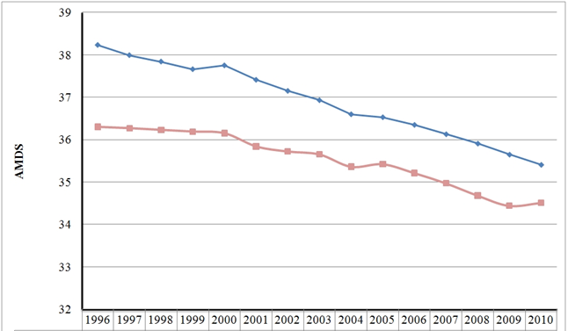
Figure 1 ADV36 seropositivity prevalence increases with ageing (20-29, 30-39, 40-49, 50-59, 60-69 and ≥ 70 years) considering consecutive adult age decades in our population.

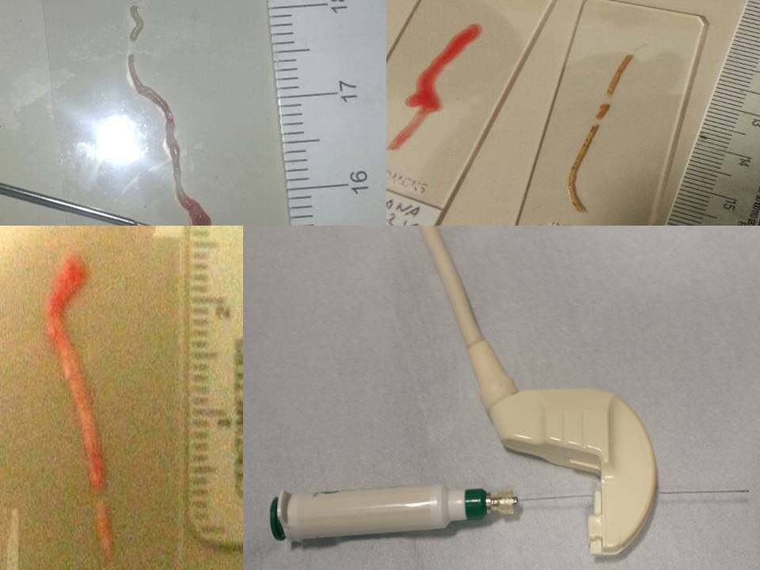
Figure 2 Odds ratios show an increased hazard of obesity associated with ADV36 seropositivity (OR = 6.879; 95%CI: 3.316–14.274), essential hypertension (OR = 2.977; 95%CI: 1.625–5.451) and insulin resistance (OR = 3.792; 95%CI: 2.052–7.006).

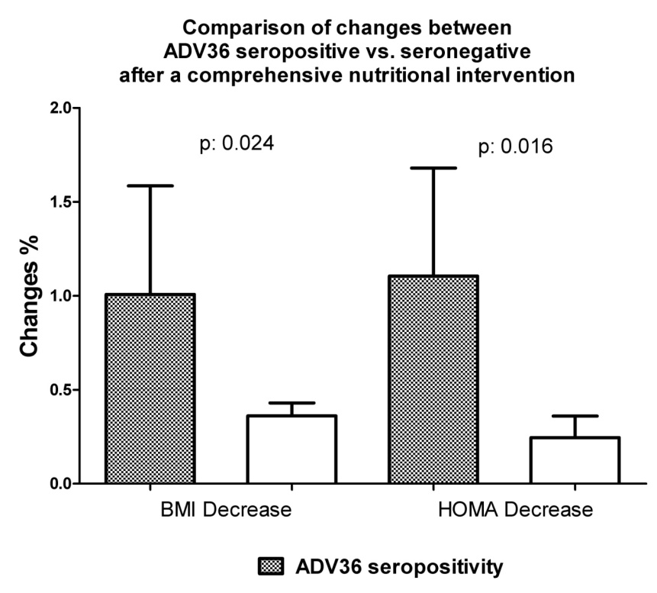
Figure 3 Convex ultrasound transducer with a central hole for allowing co-axial biopsy and four different specimens of liver fine needle aspirate biopsy in fatty liver performed with 20 G needle. BMI: body mass index; HOMA: homeostasis model assessment.

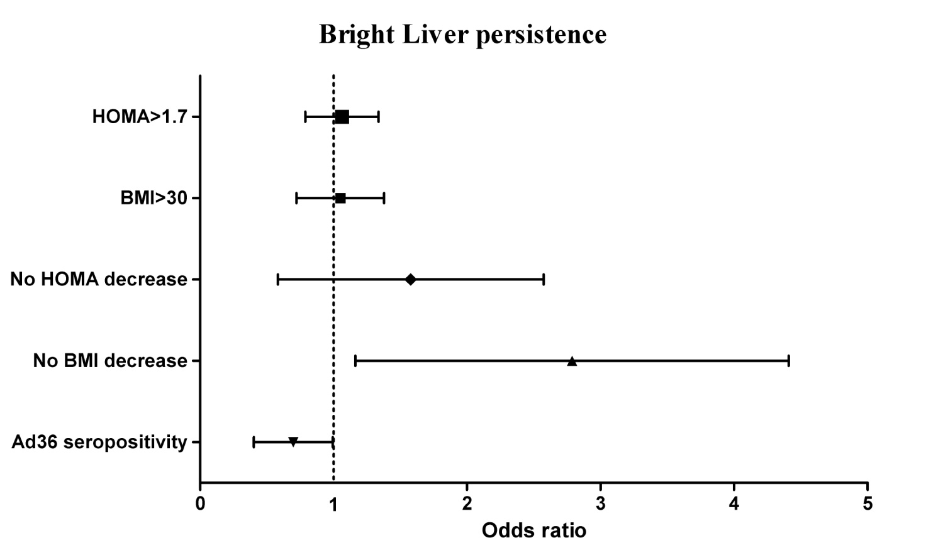
Figure 4 Odds ratio: higher hazard of non-alcoholic fatty liver disease is associated with insulin resistance and obesity, and a lower non-alcoholic fatty liver disease risk is associated with ADV36 seropositivity. BMI: body mass index; HOMA: homeostasis model assessment.

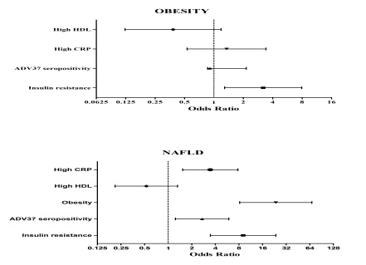
Figure 5 Odds ratio: Increased risk of obesity (top) is associated with greater insulin resistance, C-reactive protein, and ADV37 seropositivity (Ad37+), whereas higher high-density lipoprotein cholesterol is associated with lower prevalence of obesity. A more consistent association of ADV37+, greater insulin resistance, C-reactive protein (CRP), and obesity was observed with non-alcoholic fatty liver disease (NAFLD) (bottom), whereas higher high-density lipoprotein (HDL) cholesterol was associated with a lower prevalence of NAFLD. No sex difference was found. CRP indicates C-reactive protein; HDL, high-density lipoprotein; NAFLD, nonalcoholic fatty liver disease. This behavior is different, if not opposite, of that of ADV36.

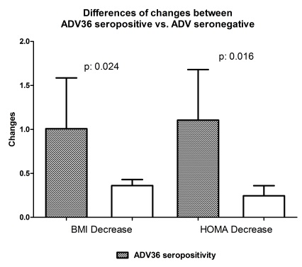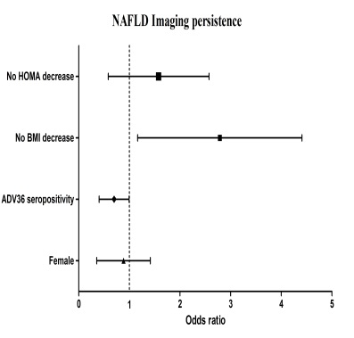
A B
Figure 6 After a comprehensive nutritional and lifestyle intervention, the improvement is more relevant in ADV36 seropositive than in ADV36 seronegative non-alcoholic fatty liver disease patients: a greater decrease of insulin resistance (homeostasis model assessment) and of overweight (body mass index) was achieved in ADV seropositive non-alcoholic fatty liver disease patients (A) and the odds of bright liver persistence is associated with lack of insulin resistance (homeostasis model assessment) and body weight (body mass index) decrease, while a relevant association with improvement, i.e. bright liver disappearance, is observed in ADV36 seropositive non-alcoholic fatty liver disease patients (b). BMI: Body mass index; HOMA: Homeostasis model assessment; nafld: Non-alcoholic fatty liver disease.

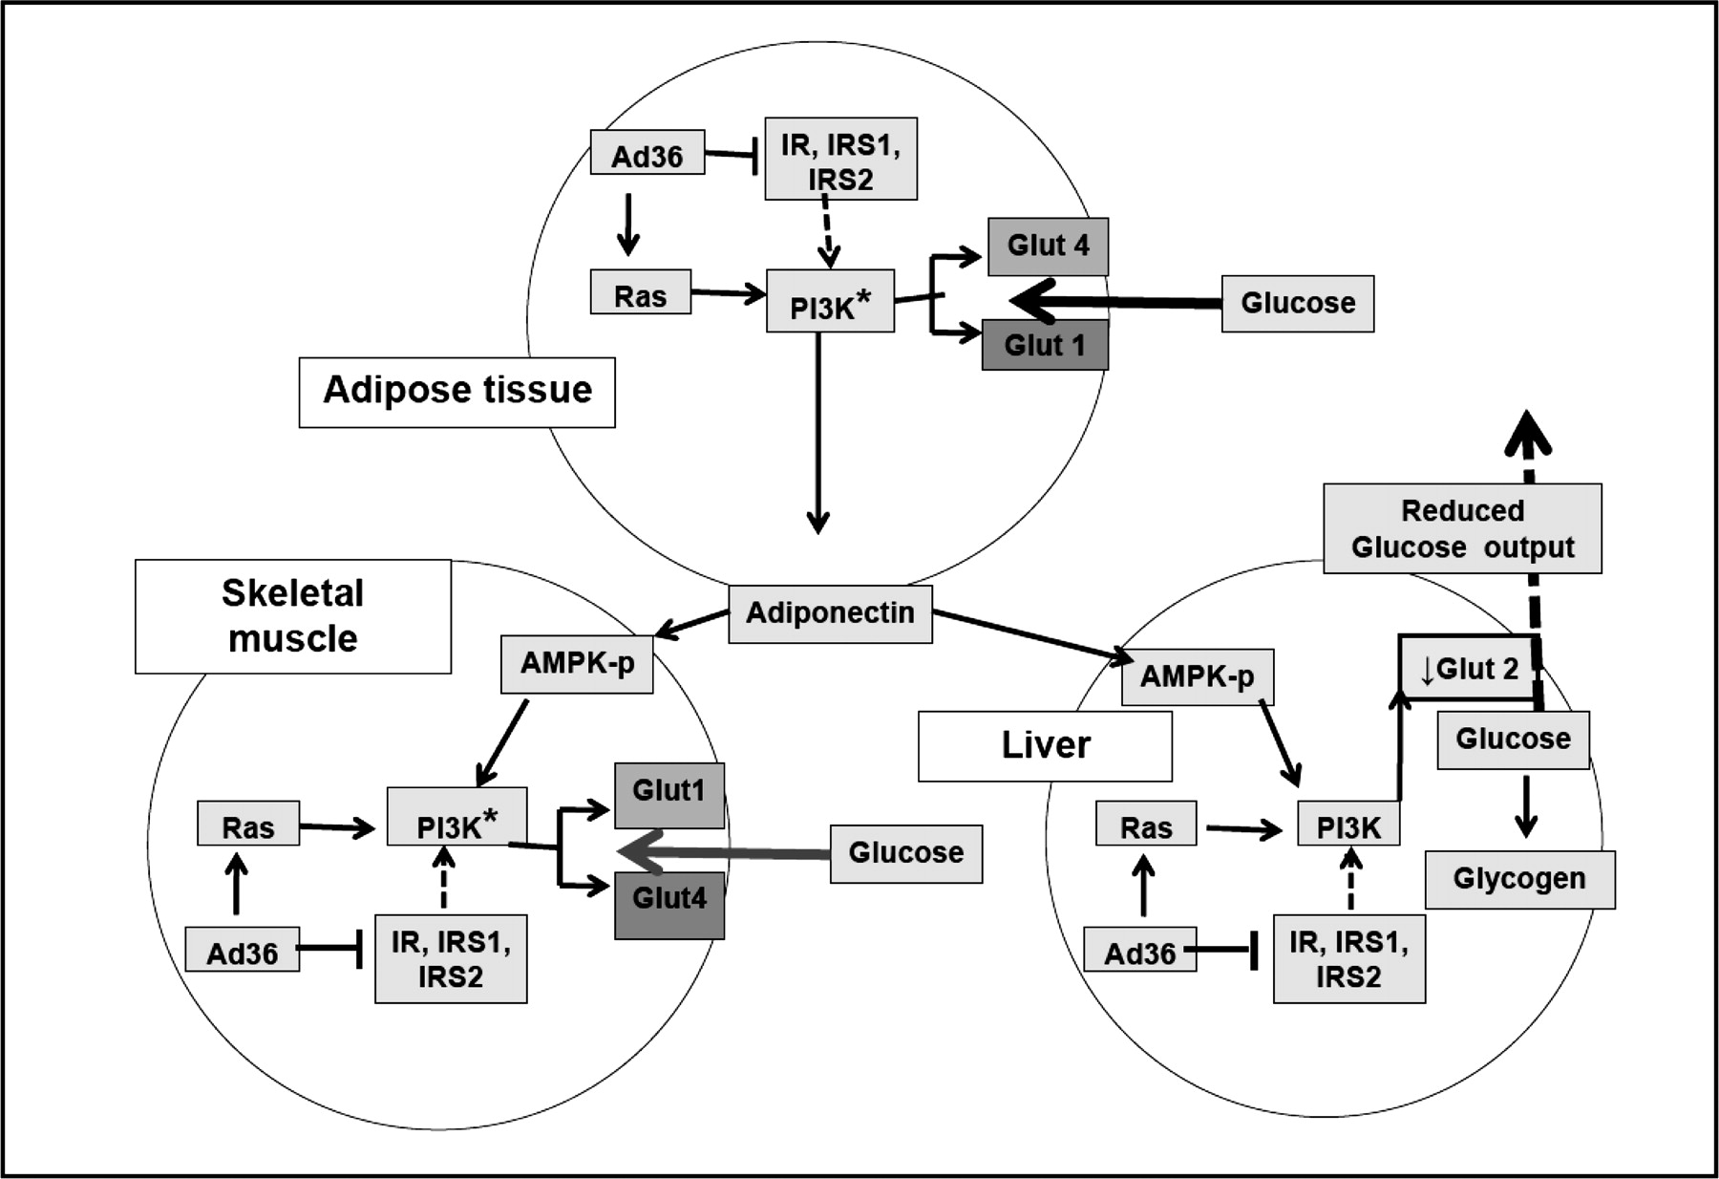
Figure 7 Working model to explain the antidiabetic effect of ADV36. Overall, data from suggest that, in adipose tissue, skeletal muscle, and liver of mice, ADV36 downregulates insulin signaling yet upregulates the Ras-PI3K pathway, which upregulates Glut1 and Glut4 in skeletal muscle and adipose tissue and downregulates Glut2 in liver. Furthermore, ADV36 increases adiponectin, which may activate AMPK. Collectively, this leads to greater glucose uptake by adipose tissue and skeletal muscle and reduces hepatic glucose release, which may contribute to ADV36-induced improvement in systemic glycemic control^{[53]}. Modified from Krishnapuram et al^{[54]}.

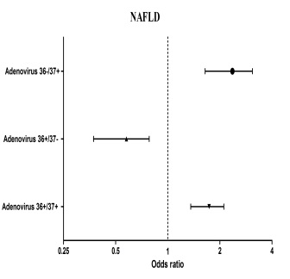
Figure 8 Compound ADV36/ADV37 seropositivity is associated with a risk profile more similar to ADV37 seropositivity, whose effect is not blunted by ADV36 seropositivity. nafld: Non-alcoholic fatty liver disease.

Table 1 Multiple linear regressions to body mass index and homeostasis model assessment
 | r | r² | r² change | F | sig | β | p-value
BMI
 | 0.667 | 0.445 | 0.445 | 17.842 | < 0.0001
Waist/hip ratio |  |  |  |  |  | -0.013 | 0.841
FM,% |  |  |  |  |  | 0.105 | 0.084
Total cholesterol, mg/dl |  |  |  |  |  | 0.148 | 0.039
HDL cholesterol, mg/dl |  |  |  |  |  | -0.088 | 0.259
Triglycerides, mg/dl |  |  |  |  |  | -0.103 | 0.184
HOMA |  |  |  |  |  | 0.564 | < 0.0001
ADV36 seropositivity |  |  |  |  |  | 0.182 | 0.004
HOMA
 | 0.671 | 0.451 | 0.451 | 18.285 | < 0.0001
Waist/hip ratio |  |  |  |  |  | -0.055 | 0.389
BMI, kg/m² |  |  |  |  |  | 0.558 | < 0.0001
FM, % |  |  |  |  |  | -0.032 | 0.598
Total cholesterol, mg/dl |  |  |  |  |  | 0.004 | 0.956
HDL cholesterol, mg/dl |  |  |  |  |  | -0.102 | 0.188
Triglycerides, mg/dl |  |  |  |  |  | 0.213 | 0.006
ADV36 seropositivity |  |  |  |  |  | 0.005 | 0.938
Weighted least squares regression - weighted by age. bold font indicates significant correlations. BMI: Body mass index; FM: Fat mass; HDL: High-density lipoprotein; LDL: Low-density lipoprotein.

Table 2 Multiple Linear regression to non-alcoholic fatty liver disease-ADV37 seropositivity
NAFLD
 | r | r² | F | sig | β | p-value
 | 0.632 | 0.400 | 18.789 | < 0.0001
ADV37 seropositivity |  |  |  |  | 0.222 | 0.001
HDL cholesterol, mg/dl |  |  |  |  | 0.097 | 0.190
Triglycerides, mg/dl |  |  |  |  | 0.133 | 0.073
HOMA |  |  |  |  | -0.052 | 0,572
BMI, kg/m² |  |  |  |  | -0.557 | < 0.0001
Bold font indicates significant correlations. BLS: Bright liver score; HDL: High-density lipoprotein; BMI: Body mass index.

Table 3 Multiple linear regression, body mass index balanced, to non-alcoholic fatty liver disease disappearance – effects of changes Δ
All patients (n = 62)
 | r | r² | F | sig | β | p-value
 | 0.635 | 0.403 | 2.701 | 0.029
ADV36 seropositivity |  |  |  |  | 0.408 | 0.013
Waist/hip Ratio |  |  |  |  | 0.018 | 0.907
ΔWeight, kg |  |  |  |  | 0.413 | 0.057
ΔFM,% |  |  |  |  | 0.433 | 0.012
ΔHOMA |  |  |  |  | 0.189 | 0.284
ΔALT, U/L |  |  |  |  | 0.279 | 0.095
ΔLongitudinal right liver (mm) |  |  |  |  | -0.154 | 0.386
Weighted least squares regression - weighted by BMI. Bold font indicates significant correlations. BMI: Body mass index; FM: Fat mass; ALT: Alanineaminotransferase.

