Name of Journal: World Journal of Clinical Cases
Manuscript NO: 60787
Manuscript Type: CASE REPORT

Complete pathological response in locally advanced non-small-cell lung cancer patient: A case report

Parisi E et al. Hypofractionation in LA-NSCLC

Elisabetta Parisi, Donatella Arpa, Giuglia Ghigi, Simona Micheletti, Elisa Neri, Luca Tontini, Martina Pieri, Antonino Romeo

Elisabetta Parisi, Donatella Arpa, Giulia Ghigi, Simona Micheletti, Elisa Neri, Luca Tontini, Martina Pieri, Antonino Romeo, Radiotherapy Unit, IRCCS Istituto Scientifico Romagnolo per lo Studio dei Tumori (IRST) "Dino Amadori", Meldola 47014, Italy

Author contributions: Parisi E conceived and designed the study, was involved in data collection, analyzed and interpreted the data, and drafted the manuscript; Arpa D conceived and designed the study and was involved in data collection; Ghigi G, Micheletti S, Neri E, Tontini L and Pieri M were responsible for data collection; Romeo A revised the manuscript for important intellectual content; all authors read and approved the final manuscript.

Corresponding author: Elisabetta Parisi, MD, Doctor, Radiotherapy Unit, IRCCS Istituto Scientifico Romagnolo per lo Studio dei Tumori (IRST) "Dino Amadori", Via P. Maroncelli 40, Meldola 47014, Italy. elisabetta.parisi@irst.emr.it

Received: January 27, 2021
Revised: February 22, 2021
Accepted: April 20, 2021
Published online:

Abstract
BACKGROUND
Chemotherapy and radiotherapy followed by durvalumab is currently the standard treatment for locally advanced node-positive non-small-cell lung cancer (NSCLC). We describe the case of a patient with locally advanced node-positive NSCLC (LA-NSCLC) treated in a phase II prospective protocol with chemotherapy, accelerated hypofractionated radiotherapy (AHRT) and surgery in the pre-immunotherapy era.

CASE SUMMARY
A 69-year-old male, ex-smoker (20 PY), with a Karnofsky performance status of 90, was diagnosed with locally advanced squamous cell lung carcinoma. He was staged by total body computed tomography (CT) scanning, and integrated ¹⁸F-fluorodeoxyglucose positron emission tomography/CT scan [cT4 cN3 cM0, stage IIIC according to TNM (tumor-node-metastasis) 8th edition] and received AHRT between chemotherapy cycles, in accordance with the study protocol (EudractCT registration 2008-006525-14). At the end of the study the patient underwent surgery, which was not part of the protocol, and showed a complete pathological response.

CONCLUSION
This case report confirms that AHRT can be used successfully to treat primary LA-NSCLC with bilateral mediastinal lymph node involvement. Our case is of particular interest because of the pathological response after AHRT and the lack of surgical complications. We hypothesize that this radiotherapeutic approach, with its proven efficacy, could be delivered as a short course reducing treatment costs, increasing patient compliance and reducing toxicity. We are currently investigating the possibility of combining hypofractionation, chemotherapy and immunotherapy for patients with LA-NSCLC.

Key Words: Locally advanced non-small-cell lung cancer; Hypofractionated radiotherapy; Chemoradiotherapy; Complete pathological response; Immunotherapy; Case report

Parisi E, Arpa D, Ghigi G, Micheletti S, Neri E, Tontini L, Pieri M, Romeo A. Complete pathological response in locally advanced non-small-cell lung cancer patient: A case report. World J Clin Cases 2021; In press

Core Tip: Non-small-cell lung cancer (NSCLC) represents the most common cause of death from cancer worldwide. The majority of patients present with locally advanced or metastatic disease at diagnosis. Concurrent chemoradiotherapy and immunotherapy is actually the gold standard treatment for this patient setting, with better long-term survival data than previously. As concurrent chemoradiotherapy is characterized by high-grade toxicity, a limited number of lung cancer patients is able to undergo or complete the treatment in clinical practice. We present a patient with NSCLC who was enrolled in a protocol using accelerated hypofractionated radiotherapy and who, after surgery, was staged as no residual oncological disease ypT0ypN0.
INTRODUCTION
Non-small-cell lung cancer (NSCLC) is a malignant tumor commonly and frequently diagnosed and represents an important cause of cancer death worldwide^{[1]}. The majority of patients initially present with advanced or metastatic stage disease^{[2]}. The current gold standard treatment for locally advanced NSCLC (LA-NSCLC) is chemotherapy, conventional fractionation radiotherapy (RT) and durvalumab for fit patients who have responded to definitive concurrent chemoradiotherapy (CRT)^{[3]}. The integration of chemotherapy and RT is characterized by a high rate of potential side-effects. Indeed, comparison studies of concomitant and sequential CRT have shown the advantages of the former, albeit concomitant treatment has an important rate of acute and late toxicity^{[4,5]}.
Radiobiological studies^{[6]} suggest that locoregional control is improved with higher radiation doses^{[7]}. Some authors have studied the efficacy of accelerated hypofractionated RT (AHRT), reporting interesting results in early-stage peripheral lung cancer^{[8]}. Hypofractionation with ablative doses is currently used for the stereotactic treatment of peripheral early-stage lung cancer thanks to improved imaging and RT technology. However, the scenario is completely different for LA-NSCLC in which dose fractionation has changed very little over the past 10 years^{[9]}. Despite this, improved survival rates have been registered for patients with LA-NSCLC. The most significant improvement in survival in this patient setting has been achieved through the addition of immunotherapy (IO).

CASE PRESENTATION
Chief complaints
A 69-year-old Caucasian male, ex-smoker (20 PY), with a Karnofsky performance status of 90 presented with a cough and fever.

History of present illness
He reported an unintentional 3 kg weight loss in 1 mo.

History of past illness
He had no significant past medical history or surgical history. He was not taking any medication.

Personal and family history
No family member had a history of cancer.

Physical examination
His temperature was 36.3°C, heart rate was 70 bpm, and SaO₂ was 97%. Thorax examination revealed decreased breath sounds in the left lung.

Laboratory examinations
Laboratory testing including complete blood count, were all within normal limits.

Imaging examinations
He was diagnosed in April 2009 with squamous cell lung carcinoma by endoscopic bronchial ultrasound and submitted to transbronchial nodal aspiration for suspected mediastinal node involvement (4 left and 2 right). Before RT, the patient underwent a lung function study, the results were in the normal range for FEV1 (forced expiratory volume in 1 s), FVC (forced vital capacity) and DLCO (diffusing lung capacity for carbon monoxide). The patient underwent staging by total body contrast-enhanced computed tomography (CT) scanning and ¹⁸F-fluorodeoxyglucose positron emission tomography/CT (PET-CT) scanning (Figure 1).

FINAL DIAGNOSIS
The final diagnosis was squamous cell lung carcinoma, cT4 cN3 cM0, stage IIIC according to TNM (tumor-node-metastasis) 8th edition.

TREATMENT
He was enrolled in a prospective phase II clinical trial of CRT using AHRT in helical TomoTherapy (TomoTherapy Inc., Madison, WI, United States) for patients with LA-NSCLC (EudractCT registration 2008-006525-14)^{[10]}.
From April 30 to July 29, 2009, the patient underwent chemotherapy according to the following scheme: cisplatin 75 mg/m² and docetaxel 75 mg/m² on day 1 every 21 d for two cycles. From the 15th to the 19th day after the second cycle of chemotherapy, he also underwent AHRT. The dose prescribed to the clinical target volume (CTV) was 30 Gy/5 daily fractions with an internal dose of up to 40 Gy in order to create a dose distribution^{[11,12]} similar to brachytherapy; 25 Gy/5 fractions were prescribed to the lymph node CTV, with an internal dose of up to 37.5 Gy. The aim of the internal dose to the CTV was to increase the heterogeneity of dose distribution as in stereotactic body radiotherapy. Fifteen days after RT, the patient underwent endoscopic ultrasonography, with no evidence of mediastinal nodes. He thus completed the protocol with the 2 remaining courses of CT with the same cisplatin dosage and reduced dosage of docetaxel, as per the study protocol.

Toxicity
After the first chemotherapy cycle, the patient showed grade 4 leukopenia and neutropenia according to National Cancer Institute common terminology criteria for adverse events version 3.0^{[13]}. He was hospitalized for treatment with antibiotics and granulocyte-colony stimulating factors. The 3 remaining chemotherapy cycles were administered with a dosage reduction. To plan RT, the patient underwent a multiphasic chest contrast-enhanced free-breathing CT scan to obtain the best definition of tumor and infiltration of organs at risk (OaR). Information on contouring and RT planning are reported in the protocol^{[10]} (Figure 2). Radiological evaluation, PET-CT and total body contrast-enhanced CT scan performed at the end of the protocol showed a reduction in the primary tumor mass, left parahilar mass (standardized uptake value, 4 vs 8.93 pre-RT), no evidence of radiological mediastinal nodes, and the appearance of pulmonary thickening in the lower left lobe. Bronchoscopy was repeated at the end of the treatment and a biopsy taken to check for left parahilar residual disease, the results were histologically negative.

OUTCOME AND FOLLOW-UP
The patient then started the follow-up program according to the protocol schedule. Three months after the end of treatment, approval was obtained for the patient to undergo surgery comprising left pneumonectomy and mediastinal lymphadenectomy. The histological referral was as follows: presence of numerous sections of peribronchial lung tissue with marked fibrosclerosis and chronic inflammation of giant cells compatible with iatrogenic origin, no neoplastic infiltrates. Twenty-four lymph nodes were disease-free. Bronchial slice tumor-free. The final histological evaluation was ypT0 ypN0 ypMx with no residual tumor. Follow-up continued until the end of 2016 when the patient died from complications of a lung infection.

DISCUSSION
In this report we presented the case of a patient with NSCLC, stage IIIC according to TNM 8th edition. The tumor was initially defined as inoperable and the patient was enrolled in a clinical study. The novelty in this case was the RT schedule, i.e., AHRT to the tumor site (cT4 for mediastinal involvement) and bilateral mediastinal lymph nodes (cN3). To the best of our knowledge, this was the first protocol in the pre-IO era to use AHRT in only 5 fractions plus chemotherapy to treat locally advanced NSCLC in terms of both the primary tumor and involved mediastinal nodes. Our patient unexpectedly obtained a complete pathological response after treatment. Although surgery was not indicated because of the baseline stage of disease, radiological response before surgical intervention is nonetheless considered as a partial response according to RECIST criteria 1.1. This was the case in our patient. However, a stereotactic study on lung cancer by Bradley et al^{[8]} reported the practicability of AHRT but potential late toxicity as the most important limit of its general clinical use. In their systematic review, Kaster et al^{[14]} underlined better outcomes in stage III NSCLC used concurrently with systematic chemotherapy. The authors analyzed RT dose schedules with a maximum dose per fraction of 3.5 Gy and a fraction range of 15-35, concluding that AHRT increases regional control by the use of a high biologically effective dose (BED) value. In this case report, the dose prescribed to the primary tumor ranged from 6 Gy to 8 Gy per fraction and the dose prescribed to the involved mediastinal nodes ranged from 5 Gy to 7.5 Gy per fraction. Despite a high dose per fraction to the mediastinum, our patient did not report any RT-related toxicity during the later years of follow-up. Some studies have reported that toxicity, in the majority of cases, is correlated with the dose to the OaR^{[14,15]}. Bradley et al^{[8]}, reported, in their protocol, the same grade toxicity for patients who underwent 60 Gy or 74 Gy of radiotherapy treatment but the death rate was different, and was higher in the 74 Gy arm. In a phase I study of AHRT, Cannon et al^{[16]} underlined that the fractionation used was well tolerated when strict normal tissue constraints were maintained. In our patient, we obtained two different OaR DVHs (dose-volume histograms), one in hypofractionation and the other with the conversion into 2 Gy equivalent dose. All dose constraints recommended were met^{[17]}. The use of intensity modulated arch therapy in TomoTherapy, of contrast-enhanced CT simulation, and of a daily megavoltage setup helped us to save the OaR. Furthermore, we applied non-isotropic expansion to the gross tumor volume. This aspect led to a reduction in the volume of irradiated lung.
Using BED₁₀ at the isocenter, the mean dose to the tumor resulted in 74 Gy and the mean dose to the involved mediastinum resulted in 54 Gy, as reported in the protocol.
Despite the improvements in RT in recent years, no advantages in survival have been reported from its concomitant use with chemotherapy in LA-NSCLC. Although the addition of durvalumab to radiochemotherapy has improved overall survival, this immunotherapeutic drug is reserved for fit patients who respond to CRT. The question thus remains: what hope can we offer in terms of treatment to elderly or unfit patients with IIIB-C NSCLC?

CONCLUSION
In conclusion, concomitant CRT followed by IO is the treatment choice for LA-NSCLC. Our experience, reported in the previous protocol, confirms that short course radiotherapy can decrease treatment costs and increase patient compliance. It is thus time to design studies that contemplate chemotherapy, AHRT and IO in this patient setting.

ACKNOWLEDGEMENTS
The authors thank Tierney G for editorial assistance.

REFERENCES
1 Ferlay J, Soerjomataram I, Dikshit R, Eser S, Mathers C, Rebelo M, Parkin DM, Forman D, Bray F. Cancer incidence and mortality worldwide: sources, methods and major patterns in GLOBOCAN 2012. Int J Cancer 2015; 136: E359-E386 [PMID: 25220842 DOI: 10.1002/ijc.29210]
2 Ishida K, Hirose T, Yokouchi J, Oki Y, Kusumoto S, Sugiyama T, Ishida H, Shirai T, Nakashima M, Yamaoka T, Ohnishi T, Ohmori T, Kagami Y. Phase II study of concurrent chemoradiotherapy with carboplatin and vinorelbine for locally advanced non-small-cell lung cancer. Mol Clin Oncol 2014; 2: 405-410 [PMID: 24772308 DOI: 10.3892/mco.2014.252]
3 Antonia SJ, Villegas A, Daniel D, Vicente D, Murakami S, Hui R, Kurata T, Chiappori A, Lee KH, de Wit M, Cho BC, Bourhaba M, Quantin X, Tokito T, Mekhail T, Planchard D, Kim YC, Karapetis CS, Hiret S, Ostoros G, Kubota K, Gray JE, Paz-Ares L, de Castro Carpeño J, Faivre-Finn C, Reck M, Vansteenkiste J, Spigel DR, Wadsworth C, Melillo G, Taboada M, Dennis PA, Özgüroğlu M; PACIFIC Investigators. Overall Survival with Durvalumab after Chemoradiotherapy in Stage III NSCLC. N Engl J Med 2018; 379: 2342-2350 [PMID: 30280658 DOI: 10.1056/NEJMoa1809697]
4 Curran WJ Jr, Paulus R, Langer CJ, Komaki R, Lee JS, Hauser S, Movsas B, Wasserman T, Rosenthal SA, Gore E, Machtay M, Sause W, Cox JD. Sequential vs. concurrent chemoradiation for stage III non-small cell lung cancer: randomized phase III trial RTOG 9410. J Natl Cancer Inst 2011; 103: 1452-1460 [PMID: 21903745 DOI: 10.1093/jnci/djr325]
5 Fournel P, Robinet G, Thomas P, Souquet PJ, Léna H, Vergnenégre A, Delhoume JY, Le Treut J, Silvani JA, Dansin E, Bozonnat MC, Daurés JP, Mornex F, Pérol M; Groupe Lyon-Saint-Etienne d'Oncologie Thoracique-Groupe Français de Pneumo-Cancérologie. Randomized phase III trial of sequential chemoradiotherapy compared with concurrent chemoradiotherapy in locally advanced non-small-cell lung cancer: Groupe Lyon-Saint-Etienne d'Oncologie Thoracique-Groupe Français de Pneumo-Cancérologie NPC 95-01 Study. J Clin Oncol 2005; 23: 5910-5917 [PMID: 16087956 DOI: 10.1200/JCO.2005.03.070]
6 Martel MK, Ten Haken RK, Hazuka MB, Kessler ML, Strawderman M, Turrisi AT, Lawrence TS, Fraass BA, Lichter AS. Estimation of tumor control probability model parameters from 3-D dose distributions of non-small cell lung cancer patients. Lung Cancer 1999; 24: 31-37 [PMID: 10403692 DOI: 10.1016/s0169-5002(99)00019-7]
7 Chemotherapy in non-small cell lung cancer: a meta-analysis using updated data on individual patients from 52 randomised clinical trials. Non-small Cell Lung Cancer Collaborative Group. BMJ 1995; 311: 899-909 [PMID: 7580546]
8 Bradley JD, Paulus R, Komaki R, Masters G, Blumenschein G, Schild S, Bogart J, Hu C, Forster K, Magliocco A, Kavadi V, Garces YI, Narayan S, Iyengar P, Robinson C, Wynn RB, Koprowski C, Meng J, Beitler J, Gaur R, Curran W Jr, Choy H. Standard-dose vs high-dose conformal radiotherapy with concurrent and consolidation carboplatin plus paclitaxel with or without cetuximab for patients with stage IIIA or IIIB non-small-cell lung cancer (RTOG 0617): a randomised, two-by-two factorial phase 3 study. Lancet Oncol 2015; 16: 187-199 [PMID: 25601342 DOI: 10.1016/S1470-2045(14)71207-0]
9 Perez CA, Stanley K, Rubin P, Kramer S, Brady L, Perez-Tamayo R, Brown GS, Concannon J, Rotman M, Seydel HG. A prospective randomized study of various irradiation doses and fractionation schedules in the treatment of inoperable non-oat-cell carcinoma of the lung. Preliminary report by the Radiation Therapy Oncology Group. Cancer 1980; 45: 2744-2753 [PMID: 6991092 DOI: 10.1002/1097-0142(19800601)45:11<2744::aid-cncr2820451108>3.0.co;2-u]
10 Parisi E, Genestreti G, Sarnelli A, Ghigi G, Arpa D, Burgio MA, Gavelli G, Rossi A, Scarpi E, Monti M, Tesei A, Polico R, Romeo A. Accelerated hypofractionated radiotherapy plus chemotherapy for inoperable locally advanced non-small-cell lung cancer: final results of a prospective phase-II trial with a long-term follow-up. Radiat Oncol 2019; 14: 112 [PMID: 31234868 DOI: 10.1186/s13014-019-1317-x]
11 Polico R, Stea L, Antonello M, Princivalli M, Marchetti C, Busetto M, Schiavon S, Pizzi G. [The polycentric multiple arc complanar technic, or telebrachytherapy. A 4-year experience (an innovative way for the local control of solid neoplasms)]. Radiol Med 1995; 90: 113-123 [PMID: 7569075]
12 Hennequin C, Tredaniel J, Chevret S, Durdux C, Dray M, Manoux D, Perret M, Bonnaud G, Homasson JP, Chotin G, Hirsch A, Maylin C. Predictive factors for late toxicity after endobronchial brachytherapy: a multivariate analysis. Int J Radiat Oncol Biol Phys 1998; 42: 21-27 [PMID: 9747815 DOI: 10.1016/s0360-3016(98)00032-7]
13 Cancer Therapy Evaluation Program. Common terminology criteria for adverse events, version 3.0, DCTD, NCI, NIH, DHHS, March 31 2003. [cited 9 August 2020]. In: Cancer Therapy Evaluation Program [Internet]. Available from: http://ctep.cancer.gov
14 Kaster TS, Yaremko B, Palma DA, Rodrigues GB. Radical-intent hypofractionated radiotherapy for locally advanced non-small-cell lung cancer: a systematic review of the literature. Clin Lung Cancer 2015; 16: 71-79 [PMID: 25450876 DOI: 10.1016/j.cllc.2014.08.002]
15 Wurstbauer K, Deutschmann H, Dagn K, Kopp P, Zehentmayr F, Lamprecht B, Porsch P, Wegleitner B, Studnicka M, Sedlmayer F. DART-bid (Dose-differentiated accelerated radiation therapy, 1.8 Gy twice daily)--a novel approach for non-resected NSCLC: final results of a prospective study, correlating radiation dose to tumor volume. Radiat Oncol 2013; 8: 49 [PMID: 23497555 DOI: 10.1186/1748-717X-8-49]
16 Cannon DM, Mehta MP, Adkison JB, Khuntia D, Traynor AM, Tomé WA, Chappell RJ, Tolakanahalli R, Mohindra P, Bentzen SM, Cannon GM. Dose-limiting toxicity after hypofractionated dose-escalated radiotherapy in non-small-cell lung cancer. J Clin Oncol 2013; 31: 4343-4348 [PMID: 24145340 DOI: 10.1200/JCO.2013.51.5353]
17 Grills IS, Yan D, Martinez AA, Vicini FA, Wong JW, Kestin LL. Potential for reduced toxicity and dose escalation in the treatment of inoperable non-small-cell lung cancer: a comparison of intensity-modulated radiation therapy (IMRT), 3D conformal radiation, and elective nodal irradiation. Int J Radiat Oncol Biol Phys 2003; 57: 875-890 [PMID: 14529795 DOI: 10.1016/s0360-3016(03)00743-0]

Footnotes
Informed consent statement: Written informed consent was obtained from the patient’s next of kin for inclusion in this report.

Conflict-of-interest statement: The authors declare that they have no conflict interests.

CARE Checklist (2016) statement: The authors have read the CARE Checklist (2016), and the manuscript was prepared and revised according the CARE Checklist (2016).

Open-Access: This article is an open-access article that was selected by an in-house editor and fully peer-reviewed by external reviewers. It is distributed in accordance with the Creative Commons Attribution NonCommercial (CC BY-NC 4.0) license, which permits others to distribute, remix, adapt, build upon this work non-commercially, and license their derivative works on different terms, provided the original work is properly cited and the use is non-commercial. See: http://creativecommons.org/Licenses/by-nc/4.0/

Manuscript source: Unsolicited manuscript

Peer-review started: January 27, 2021
First decision: February 11, 2021
Article in press:

Specialty type: Medicine, research and experimental
Country/Territory of origin: Italy
Peer-review report’s scientific quality classification
Grade A (Excellent): 0
Grade B (Very good): B
Grade C (Good): C
Grade D (Fair): 0
Grade E (Poor): 0

P-Reviewer: Fu T, Zeng Y S-Editor: Gao CC L-Editor: Webster JR P-Editor:
Figure Legends
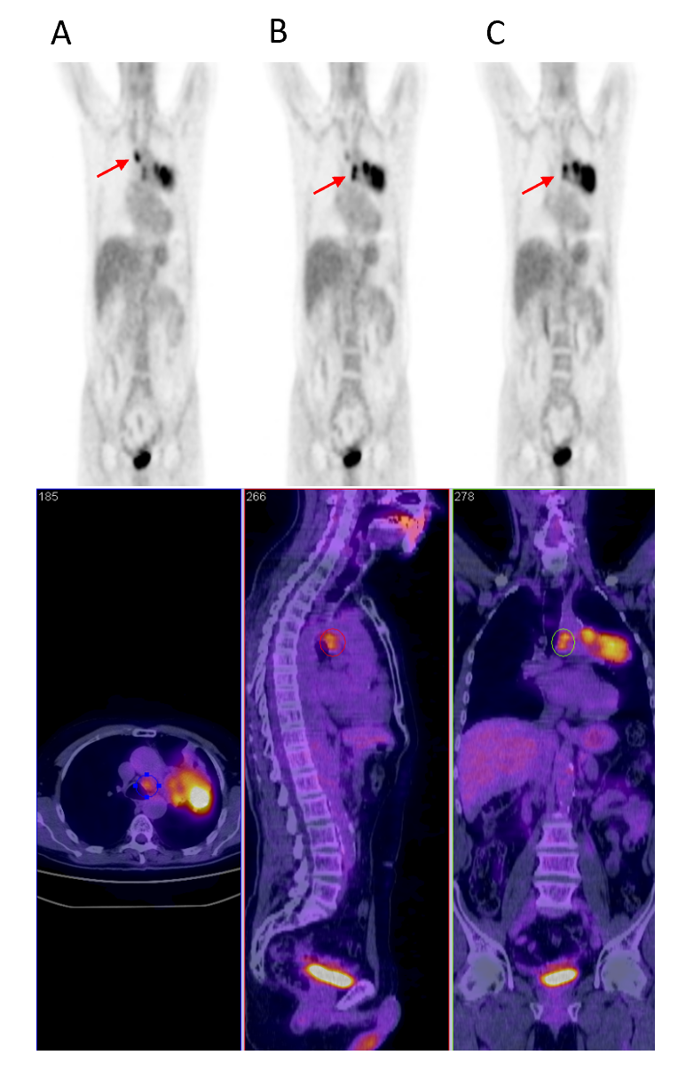
Figure 1 Positron emission tomography/computed tomography staging before the start of chemoradiotherapy treatment. A: The red arrow indicates the localization of the involved mediastinal lymph node in station 2R; B: The red arrow indicates the localization of the involved mediastinal lymph nodes in stations 7L and 4L; C: The red arrow indicates the localization of the primary tumor with mediastinal infiltration. Radiological staging was cT4 cN3 cM0.
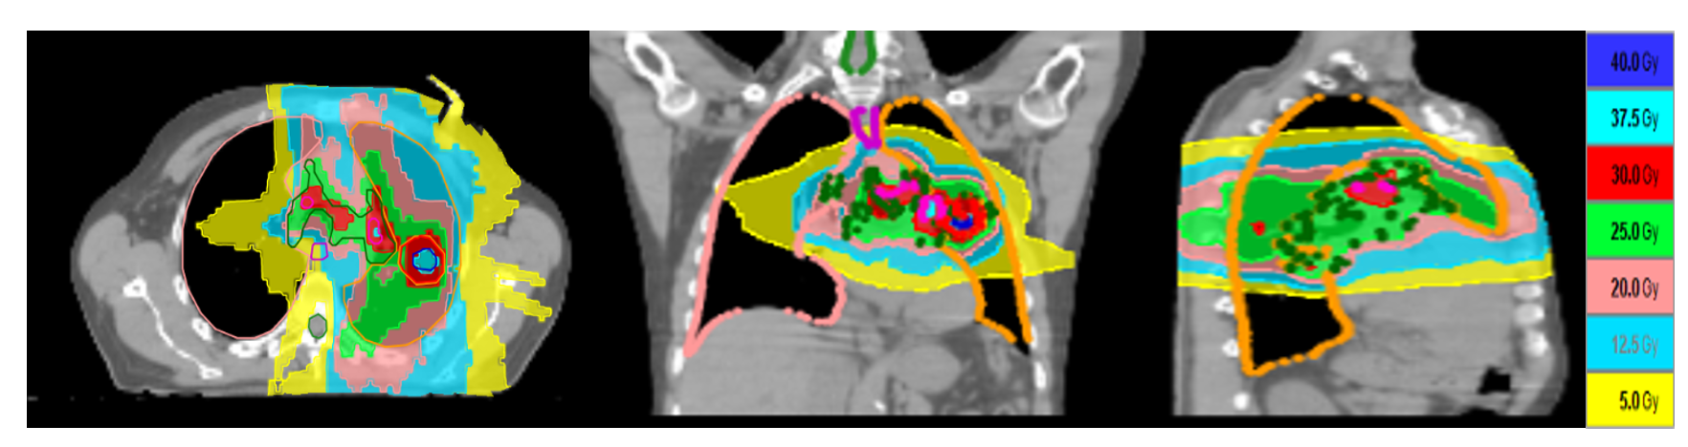
Figure 2 Dose distribution of the patient radiotherapy plan on computed tomography. The color legend dose-volume histograms in the column on the right illustrates the dose distribution. Prescription dose was 30 Gy/5 daily fractions with a heterogeneous dose escalation of up to 40 Gy inside the primary tumor to simulate brachytherapy dose distribution. Prescription dose was 25 Gy/5 daily fractions with a heterogeneous dose escalation of up to 37.5 Gy inside the nodal tumor. The different colors show the following isodoses: red, 30 Gy; deep blue, 40 Gy; aqua, 37.5 Gy; light blue, 12.5 Gy; green, 25 Gy; pink, 20 Gy; light blue, 12.5 Gy; yellow, 5 Gy.

