Name of journal: World Journal of Gastroenterology
ESPS Manuscript NO: 9103
Column: REVIEW

Treatment for superficial non-ampullary duodenal epithelial tumors

Kakushima N et al. Treatment for non-ampullary duodenal tumors

Naomi Kakushima, Hideyuki Kanemoto, Masaki Tanaka, Kohei Takizawa, Hiroyuki Ono

Naomi Kakushima, Masaki Tanaka, Kohei Takizawa, Hiroyuki Ono, Division of Endoscopy, Shizuoka Cancer Center, 1007 Shimonagakubo, Nagaizumi, Suntougun, Shizuoka 4118777, Japan

Hideyuki Kanemoto, Division of Hepato–Biliary–Pancreatic Surgery, Shizuoka Cancer Center, Shizuoka Cancer Center, 1007 Shimonagakubo, Nagaizumi, Suntougun, Shizuoka 4118777, Japan

Author contributions: Kakushima N, Kanemoto H, Tanaka M, Takizawa K and Ono H contributed to conception and design, acquisition of data, or analysis and interpretation of data; drafted the article or revised it critically for important intellectual content; and final approval of the version to be published.

Correspondence to: Naomi Kakushima, MD, PhD, Division of Endoscopy, Shizuoka Cancer Center, 1007 Shimonagakubo, Nagaizumi, Suntougun, Shizuoka, 4118777, Japan. kakushin-tky@umin.ac.jp
Telephone: +81-55-9895222 Fax: +81-55-9895692
Received: January 20, 2014 Revised: April 18, 2014
Accepted: May 19, 2014

Published online:

Abstract
Because of the low prevalence of non-ampullary duodenal epithelial tumors (NADETs), standardized clinical management of sporadic superficial NADETs, including diagnosis, treatment, and follow-up, has not yet been established. Retrospective studies have revealed certain endoscopic findings suggestive of malignancy. Duodenal adenoma with high-grade dysplasia and mucosal cancer are candidates for local resection by endoscopic or minimally invasive surgery. The use of endoscopic treatment including endoscopic mucosal resection (EMR) and endoscopic submucosal dissection (ESD), for the treatment for superficial NADETs is increasing. EMR requires multiple sessions to achieve complete remission and repetitive endoscopy is needed after resection. ESD provides an excellent complete resection rate, however it remains a challenging method, considering the high risk of intraoperative or delayed perforation. Minimally invasive surgery such as wedge resection and pancreas-sparing duodenectomy are beneficial for superficial NADETs that are technically difficult to remove by endoscopic treatment. Pancreaticoduodenectomy remains a standard surgical procedure for treatment of duodenal cancer with submucosal invasion, which presents a risk of lymph node metastasis. Endoscopic or surgical treatment outcomes of superficial NADETs without submucosal invasion are satisfactory. Establishing an endoscopic diagnostic tool to differentiate superficial NADETs between adenoma and cancer as well as between mucosal and submucosal cancer is required to select the most appropriate treatment.

© 2014 Baishideng Publishing Group Inc. All rights reserved.
Key words: Duodenal neoplasms; Duodenal cancer; Pancreaticoduodenectomy; Endoscopic surgery; Esophagogastroduodenoscopy
Core tip: Superficial non-ampullary duodenal epithelial tumors (NADETs) including adenoma and mucosal cancer are candidates for local resection regarding the nil risk of lymph node metastasis. Pancreaticoduodenectomy remains a standard surgical procedure for treatment of duodenal cancer with submucosal invasion. Preoperative diagnosis to differentiate superficial NADETs between adenoma and cancer as well as between mucosal and submucosal cancer is essential to select minimally invasive treatment such as endoscopic resection or minimally invasive surgery.

Kakushima N, Kanemoto H, Tanaka M, Takizawa K, Ono H. Treatment for superficial non-ampullary duodenal epithelial tumors. World J Gastroenterol 2014; In press

INTRODUCTION
The prevalence of non-ampullary primary duodenal tumors is extremely low among autopsy studies (0.02%–0.5%)^{[1-4]}. Benign tumors are generally predominant, comprising 60%–75% of autopsy series^{[5]}, and 90% of duodenal polyps identified by endoscopic biopsy^{[6]}, but they frequently do not produce symptoms. Primary non-ampullary duodenal cancer (NADC) accounts for only 0.5% of all gastrointestinal malignancies^{[7]}. A Japanese study reported that the incidence of non-ampullary duodenal epithelial tumors (NADETs) among patients who underwent screening or diagnostic esophagogastroduodenoscopy (EGD) over a 21-year period was 0.098% (52/53134)^{[8]}. A European study reported that the incidence of duodenal villous adenoma was 0.1–0.4% ^{[9,10]} among patients who underwent diagnostic or screening EGD.
The number of case studies related to the treatment of sporadic superficial NADETs has recently increased, possibly because of the use of EGD during regular medical check-ups and the standardized method of imaging the second portion of the duodenum during EGD. However, information regarding the biological behavior, treatment indication, and prognosis of NADETs is still lacking. In this review, the present status regarding the clinical management of sporadic superficial NADETs will be discussed.

MORPHOLOGY OF NADETs
The morphology of superficial NADETs is similar to that of epithelial tumors of the colorectum; protruding or elevated lesion types predominate. Therefore, several previous studies have classified the morphological type of superficial NADETs based on the classification criteria used for colorectal tumors^{[11-13]}. Macroscopic types based on endoscopic features include protruded pedunculated (Ip), protruded sessile (Is), semipedunculated type (Isp), superficial elevated type (IIa), flat type (IIb), and superficial shallow or depressed type (IIc)^{[14]}.

LOCATION OF NADETs
Both benign adenoma and cancer arise most frequently in the second portion of the duodenum, especially the periampullary area^{[15-17]}. Almost 90% of endoscopically treated lesions are reportedly located in the first or second portion of the duodenum^{[11,12]}. However, an accurate prognosis according to the location remains unknown for superficial NADETs, although tumors in the first or second portion are reportedly favorable factors for surgically treatable duodenal cancer^{[18]}.

DEFINITION OF EARLY NADC
There is no established definition of early NADC with respect to the depth of invasion and risk of lymph node metastasis. However, previous studies have followed the rules used for early colorectal^{[14]} or gastric cancer^{[19]}, i.e., tumor invasion to the lamina propria or muscularis mucosa (T1a) or the submucosa (T1b) regardless of lymph node metastasis^{[11,12,20]}. Based on a Japanese analysis of early NADCs that included pT1a or pT1b cancer, Nagatani et al^{[11]} reported no incidence of lymph node metastasis among 40 cases of pT1a cancers, and Fujisawa et al^{[12]} reported none among 166 cases of mucosal cancers. The incidence of lymph node metastasis among pT1b cancer is reported to range from 5.3% (2/37) to 5.4% (4/75)^{[11,12]}. The depth of pT1b cancer invasion has not been described in these reported cases; therefore, at present, pT1b NADC should be considered at risk of lymph node metastasis regardless of the depth of submucosal invasion.

TREATMENT STRATEGY FOR SUPERFICIAL NADETs
Types of NADETs to be treated
It is important to determine the type of sporadic superficial NADETs that should be removed to lower the risk of those that have a substantial possibility to progress to invasive cancer and to avoid overtreatment of those with less malignant potential^{[22]}. Small bowel adenomas, including duodenal adenomas, are reported to have a higher percentage of villous tumors than colorectal adenomas^{[5]}; thus, the possibility of harboring cancer is estimated to be higher^{[23,24]}. Patients with familial adenomatous polyposis (FAP) are known to have a high prevalence of duodenal adenomas, and prospective follow-up studies have demonstrated that such adenomas can slowly progress to cancer^{[24-26]}. Sporadic NADC may occur because of the adenoma carcinoma sequence, as in FAP patients^{[15,27]}, or de novo. However, the incidence of sporadic NADC is extremely rare; thus, endoscopic findings suggestive of cancer have not yet been established.

Pretreatment evaluation of cancerous lesions
Macroscopically, larger-sized lesions, those with a component of depression (IIa + IIc type or IIc type) and those with a red and ill-glistened surface, are reported to have a higher tendency to have a cancerous component^{[28,29]}. In contrast, there are also a few reports of large IIa type, so-called carpet-like adenomas that increase in size without cancerous components^{[8,28]}. In addition to the macroscopic features, findings of magnifying endoscopy with^{[30-32]} or without^{[33-35]} narrow-band imaging can offer information to distinguish potentially malignant lesions. Heterogeneous patterns of irregular or disappeared mucosal structures with irregular vascular patterns have been correlated with high-grade dysplasia (HGD) or mucosal cancer^{[30,33,34]}.

Issue of pretreatment biopsies
The necessity of obtaining biopsy specimens from superficial NADETs before treatment remains controversial. Because of the thinness of the duodenal wall, the biopsy procedure itself may induce unintended fibrosis associated with the lesion, which may complicate subsequent endoscopic resection (ER). In contrast, a histological proof of malignancy may be preferable before employing a treatment modality with a substantial risk of complication, such as ER or surgery. Discrepancy of endoscopic biopsy histology and that of resected specimens is sometimes experienced in gastric epithelial lesions^{[36]} and has also been reported in duodenal lesions^{[20,37-39]}. Post-treatment diagnosis may lead to an upgrade in pathology. In a previous study, comparisons between biopsy and resected specimens of 56 superficial NADETs revealed the same diagnosis in 59% patients, an upgrade in 36% patients, and a downgrade in 5% patients. Among the lesions with an upgrade in pathology, most had an upgrade from HGD to adenocarcinoma^{[42]}. In another study, T1a cancer was observed in 13.5% cases in which initial biopsies indicated simple adenomas^{[38]}. Therefore, lesions with a biopsy diagnosis of HGD should be considered for local treatment, and ER may present an improved diagnostic tool for borderline lesions.

Pretreatment evaluation between T1a and T1b NADC
It is difficult to differentiate T1a from T1b NADC by barium studies or endoscopy^{[11]}. Nagatani et al^{[11]} studied the macroscopic features of early NADC with little possibility of submucosal invasion and indicated the following lesions suggestive of T1a cancer: Ip type, ≤20 mm; Is type, ≤5 mm; IIa type, ≤10 mm; and carpet-like IIa type of any size. Endoscopic ultrasonography has been reported to be a promising tool for diagnosing and staging duodenal villous tumors^{[41,42]}. Non-lifting sign or lack of mobility when manipulated with a snare suggest submucosal invasion^{[43]}.

Endoscopic treatment and outcomes
Endoscopic treatment should be limited to lesions confined to the mucosa; however, endoscopic techniques to remove superficial NADETs have not yet been standardized^{[44,45]}. Although case reports of polypectomy^{[46,47]} and strip biopsy^{[48-50]} for protruded lesions have been reported, the results of endoscopic mucosal resection (EMR) for NADETs are based on several small case series^{[51,52]}. EMR often requires multiple sessions (piecemeal resection), and complete remission has been reported in 55%–100% cases^{[37,38,43,53-55]}. The local recurrence rate among these previous studies was 0%–37%, and recurrent lesions were endoscopically re-treated by a second EMR or endoscopic ablation^{[37,38,43,53-55]}. Reportedly, successful eradication by endoscopic treatment is dictated by the extent of the luminal circumference of the tumor^{[56]} and the possibility of en bloc resection^{[57]}. Complications after EMR include bleeding (0%–33%) and perforation (3%)^{[38,58]}.
Compared with EMR, there are fewer reports of endoscopic submucosal dissection (ESD) (Figure1) for superficial NADETs^{[59]}. Nevertheless, ESD has been reported to have a superior complete resection rate (86%–100%), with no incidence of recurrence^{[20,39,40,60-63]}. However, the complication rate of bleeding is 0%–7% and the perforation rate is higher at 6%–50%^{[20,39,40,60-63]}. A retrospective multicenter survey of 421 duodenal EMR and ESD cases showed that both intraoperative and delayed perforation occurred more frequently among ESD cases^{[64]}. In addition, there was no difference in the overall perforation rate between lesions located in the first or second portion of the duodenum; however, delayed perforation was mostly observed in the second portion^{[64]} or distal to Vater’s ampulla^{[65]}. Delayed perforation may occur even after successful ESD^{[61]}, and the high rate of delayed perforation may be because of the larger ulcer created by ESD, increased thermocoagulation effect induced by ESD, and presence of bile and pancreatic juices. To avoid the risk of delayed perforation, attempts have been made to completely close the mucosal defect after ESD with multiple endoclips^{[64,66]} or with an over-the-scope clip^{[67]}, or by applying polyglycolic acid sheets^{[68,69]}. Others have reported insertion of endoscopic nasobiliary drainage and nasopancreatic drainage tubes to avoid exposure of bile and pancreatic juices to the ESD ulcer^{[61]}.
Lienert et al^{[70]} reported the use of argon plasma coagulation (APC) for the treatment of duodenal adenoma in a cohort of 15 patients. Eradication was successful in 87%, no patients developed cancer during the study period of 40 months, and the local recurrence rate was 39%^{[70]}. However, APC treatment is inadequate to obtain a histological assessment of the entire lesion; therefore, it is risky to solely rely on APC for the treatment of superficial NADETs. Nonetheless, APC may be used as an adjunct to EMR to reduce local recurrence^{[71]} or for locally recurrent lesions after EMR.

Surgical treatment and outcomes
An optimal surgical treatment of sporadic superficial NADETs has not yet been established. Pancreaticoduodenectomy (PD), also known as the Whipple procedure, is a radical surgery performed for advanced disease and cases of early stage NADC with the aim to avoid tumor recurrence^{[72-75]}. Pancreatic fistula, anastomotic leakage, and pancreatitis are serious complications after PD. Although the morbidity and mortality rates following PD have decreased in recent years^{[76,77]}, the procedure still results in considerable intraoperative stress.
Transduodenal local excision^{[78,79]}, wedge resection (segmental, partial, and full-thickness)^{[78,80-83]}, and pancreas-sparing duodenectomy (PSD)^{[78,84,85]} are organ-preserving surgical procedures suitable for patients with premalignant or early malignant duodenal lesions. In a previous study, the recurrence rate of villous duodenal tumors after transduodenal local excision was reported to be 32% at 5 years, and 24% recurrences were cancer^{[78]}. However, the presence of cancer was not known before surgery, and the authors concluded that PD is appropriate for villous tumors with a malignant component^{[78]}. Jurisic et al^{[82]} reported local recurrence with nodal metastasis after local excision for cancer with submucosal invasion, suggesting the inadequacy of local excision for T1b NADC.
Wedge resection (segmental, partial, and full-thickness) has been associated with lower morbidity than PD^{[78,80,81,83,86,87]}. Tanigawa et al^{[81]} reported a good clinical course without recurrence after partial resection for T1a cancer. For early NADC located in the third and fourth portions of the duodenum, segmental resection is associated with negligible morbidity and mortality, while allowing for satisfactory clear margins during lymphadenectomy^{[83]}.
PSD was introduced as an alternative to PD for treatment of benign and premalignant duodenal disease and is reportedly a beneficial modality for treatment of patients with multiple lesions^{[78,84,85,88]}. For PSD, patients should have a preoperative diagnosis of no lymphadenopathy and sampling of the lymph node surrounding the tumor before resection should be obtained for intraoperative pathological examination to detect lymph node metastasis^{[85]}. Eisenberger et al^{[84]} recommended analysis of intraoperative fresh frozen sections to exclude malignant disease and to consider conversion of the procedure from PSD to PD after intraoperative diagnosis of malignant disease in the fresh frozen sections. The incidence of local recurrence is low, suggesting that PSD is an acceptable procedure for treatment of selected duodenal neoplasms, such as superficial NADETs confined to the mucosa.

PROGNOSIS OF SUPERICIAL NADETs
Because previous reports of surgical treatment for duodenal cancer included small numbers of patients with superficial NADETs, including adenoma or early NADC, little information is available regarding treatment success and treatment-related morbidity or mortality.
The most important prognostic factor is the depth of tumor invasion^{[80,89-93]}. With regard to the risk of nodal metastasis, superficial NADETs, including adenoma and T1a cancer, are treatable by local resection; however, the ability to achieve a negative margin may be a prerequisite to successful local resection. For adenoma or T1a cancer, ER presents the same distant survival rates as surgery^{[94]}. In contrast, T1b cancer should be resected with lymphadenectomy and PD appears to remain the treatment of choice. In a recent review of 67 patients, Barnes et al^{[95]} reported a 5-year survival rate of 100% in stage I duodenal cancer. Therefore, preoperative diagnosis of the presence of submucosal invasion is important to select the appropriate surgical method.

FOLLOW-UP AFTER TREATMENT
Considering that EMR is often performed piecemeal, repetitive endoscopy after resection is necessary. Ahmad et al^{[37]} suggested that 6 wk was a suitable interval to observe healing of the EMR site for lesions requiring multiple sessions to achieve and/or confirm complete remission. Others report that endoscopic surveillance every 3 mo is required initially. Subsequently, if no recurrence is observed, the surveillance should be reduced to every 6 mo or once a year^{[54,96]}. Annual checkups should be performed for at least 2 years after complete removal^{[55]}. For lesions with submucosal invasion, computed tomography and abdominal ultrasound should be performed to detect nodal or distant metastasis.
Recent studies of Western populations have suggested that patients with sporadic duodenal adenomas are at a higher risk for the development of colorectal neoplasia^{[97-100]}. The odds ratio of colorectal neoplasia among patients with sporadic duodenal adenomas is reportedly 2.4–3.6, and the incidence of colorectal cancer was significantly higher^{[97,98]}. Dietary risk factors correlated with cancer of the small intestine are similar to those correlated with colon cancer^{[101]}. Therefore, patients with sporadic duodenal adenomas should undergo routine colonoscopy screening to increase the detection rate of colorectal neoplasia.

FUTURE PERSPECTIVES
As with other malignancies, early detection is important for the treatment of sporadic superficial NADETs. Establishing an endoscopic diagnostic tool to differentiate the lesion between adenoma and cancer as well as between mucosal and submucosal cancer is required. For lesions confined to the mucosa, local resection is acceptable, and en bloc resection with negative margins is beneficial to lower the risk of local recurrence. The use of endoscopic treatment modalities, including EMR and ESD, for the treatment for superficial NADETs is increasing. However, ESD remains a challenging method, considering the high risk of intraoperative or delayed perforation. Therefore, primary closure of the endoscopically resected site, as a preventive measure, is preferable. The use of radical surgery for superficial NADETs has decreased with the introduction of minimally invasive surgery. Newer methods, such as the use of an over-the-scope clip^{[67-69]} or combined surgery of endoscopy and laparoscopy^{[86,102]}, have been reported. Further studies are warranted to improve the current diagnostic and treatment methods to both preserve curability and improve the quality of life.
REFERENCES
1 Darling RC, Welch CE. Tumors of the small intestine. N Engl J Med 1959; 260: 397-408 [PMID: 13632900 DOI: 10.1056/NEJM195902262600901]
2 Cortese AF, Cornell GN. Carcinoma of the duodenum. Cancer 1972; 29: 1010-1015 [PMID: 5017329 DOI: 10.1002/1097-0142(197204)29: 4<1010: : AID-CNCR2820290448>3.0.CO; 2-6]
3 Hoffman BP, Grayzel DM. Benign tumors of the duodenum. Am J Surg 1945; 70: 394-400 [PMID: 21005186]
4 Shukla SK, Elias EG. Primary neoplasms of the duodenum. Surg Gynecol Obstet 1976; 142: 858-860 [PMID: 936029]
5 Perzin KH, Bridge MF. Adenomas of the small intestine: a clinicopathologic review of 51 cases and a study of their relationship to carcinoma. Cancer 1981; 48: 799-819 [PMID: 7248908 DOI: 10.1002/1097-0142(19810801)48: ]
6 Höchter W, Weingart J, Seib HJ, Ottenjann R. [Duodenal polyps. Incidence, histologic substrate and significance]. Dtsch Med Wochenschr 1984; 109: 1183-1186 [PMID: 6745123 DOI: 10.1055/s-2008-1069345]
7 Alwmark A, Andersson A, Lasson A. Primary carcinoma of the duodenum. Ann Surg 1980; 191: 13-18 [PMID: 7352773]
8 Yokoyama T, Saito D, Kondo H, Kido M, Hosokawa K, Shirao K, Yokota T, Yamaguchi H, Oguro Y, Ishikawa T, Ushio K, Ochiai A, Hiroasi S, Yoshida S. Endoscopic diagnosis of malignant lesions of the duodenum. Stomach Intestine 1993; 28: 641-649
9 Batra SK, Schuman BM, Reddy RR. The endoscopic variety of duodenal villous adenoma - an experience with ten cases. Endoscopy 1983; 15: 89-92 [PMID: 6872969 DOI: 10.1055/s-2007-1021475]
10 Jepsen JM, Persson M, Jakobsen NO, Christiansen T, Skoubo-Kristensen E, Funch-Jensen P, Kruse A, Thommesen P. Prospective study of prevalence and endoscopic and histopathologic characteristics of duodenal polyps in patients submitted to upper endoscopy. Scand J Gastroenterol 1994; 29: 483-487 [PMID: 8079103]
11 Nagatani K, Takekoshi T, Baba Y, Kaku S, Koizumi K, Fujii A, Ogata E, Ohta H, Nishi M, Kato Y, Yanagisawa A. Indications for endoscopic treatment of early duodenal cancer based on cases reported in the literature (in Japanese). Endosc Digest 1993; 5: 969-976
12 Fujisawa T, Tomofuji Y, Kuroda N, Hagino H, Sakamoto N, Sakashita M, Maeda M, Kouno T, Matsuno Y. A case of early duodenal cancer with tubulo-villous adenoma: report of a case and clinicopathological review of Japanese literature. Gastroenterol Endosc 1995; 37: 2768-2775
13 Oka S, Tanaka S, Nagata S, Hiyama T, Ito M, Kitadai Y, Yoshihara M, Haruma K, Chayama K. Clinicopathologic features and endoscopic resection of early primary nonampullary duodenal carcinoma. J Clin Gastroenterol 2003; 37: 381-386 [PMID: 14564184]
14 Japanese Society for Cancer of the Colon and Rectum. Japanese classification of colorectal carcinoma. 8th ed. Tokyo, Kanehara Shuppan, 2013: 9-10
15 Sellner F. Investigations on the significance of the adenoma-carcinoma sequence in the small bowel. Cancer 1990; 66: 702-715 [PMID: 2167140 DOI: 10.1002/1097-0142(19900815)66: ]
16 Shimizu N, Tanaka S, Morikawa J, Yorioka S, Fukuda S, Yamashita S, Bamba M, Hattori T, Hosoda S. [Early duodenal cancer of the bulb--report of a case]. Gan No Rinsho 1989; 35: 100-106 [PMID: 2646464]
17 Schulten MF, Oyasu R, Beal JM. Villous adenoma of the duodenum. A case report and review of the literature. Am J Surg 1976; 132: 90-96 [PMID: 952341]
18 Sohn TA, Lillemoe KD, Cameron JL, Pitt HA, Kaufman HS, Hruban RH, Yeo CJ. Adenocarcinoma of the duodenum: factors influencing long-term survival. J Gastrointest Surg 1998; 2: 79-87 [PMID: 9841972 DOI: 10.1016/S1091-255X(98)80107-8]
19 Japanese Gastric Cancer Association. Japanese classification of gastric carcinoma. 14th ed. Tokyo, Kanehara Shuppan, 2010: 7-8
20 Takahashi T, Ando T, Kabeshima Y, Kawakubo H, Shito M, Sugiura H, Omori T. Borderline cases between benignancy and malignancy of the duodenum diagnosed successfully by endoscopic submucosal dissection. Scand J Gastroenterol 2009; 44: 1377-1383 [PMID: 19821793 DOI: 10.3109/00365520903287551]
21 Witteman BJ, Janssens AR, Griffioen G, Lamers CB. Villous tumours of the duodenum. An analysis of the literature with emphasis on malignant transformation. Neth J Med 1993; 42: 5-11 [PMID: 8446225]
22 Fujishiro M. Endoscopic treatment for nonampullary duodenal neoplasms. Endosc Digest 2011; 23: 135-139 (in Japanese)
23 Bail JP, Lozac'h P, Volant A, Charles JF. [Adenocarcinoma of the duodenum. Apropos of 2 cases: review of the literature]. J Chir (Paris) 1987; 124: 604-608 [PMID: 3323213]
24 Vasen HF, Möslein G, Alonso A, Aretz S, Bernstein I, Bertario L, Blanco I, Bülow S, Burn J, Capella G, Colas C, Engel C, Frayling I, Friedl W, Hes FJ, Hodgson S, Järvinen H, Mecklin JP, Møller P, Myrhøi T, Nagengast FM, Parc Y, Phillips R, Clark SK, de Leon MP, Renkonen-Sinisalo L, Sampson JR, Stormorken A, Tejpar S, Thomas HJ, Wijnen J. Guidelines for the clinical management of familial adenomatous polyposis (FAP). Gut 2008; 57: 704-713 [PMID: 18194984 DOI: 10.1136/gut.2007.136127]
25 Spigelman AD, Talbot IC, Penna C, Nugent KP, Phillips RK, Costello C, DeCosse JJ. Evidence for adenoma-carcinoma sequence in the duodenum of patients with familial adenomatous polyposis. The Leeds Castle Polyposis Group (Upper Gastrointestinal Committee). J Clin Pathol 1994; 47: 709-710 [PMID: 7962621 DOI: 10.1136/jcp.47.8.709]
26 Brosens LA, Keller JJ, Offerhaus GJ, Goggins M, Giardiello FM. Prevention and management of duodenal polyps in familial adenomatous polyposis. Gut 2005; 54: 1034-1043 [PMID: 15951555 DOI: 10.1136/gut.2004.053843.]
27 Maehata Y, Esaki M, Hirahashi M, Kitazono T, Matsumoto T. Duodenal adenomatosis in Japanese patients with familial adenomatous polyposis. Dig Endosc 2014; 26 Suppl 2: 30-34 [PMID: 24750145 DOI: 10.1111/den.12255]
28 Yamanaka T, Yamamichi N, Konishi F. Clinico-pathological study of duodenal adenoma (in Japanese with an English abstract). Gastroenterol Endosc 1987; 29: 3070-3079
29 Goda K, Kikuchi D, Yamamoto Y, Takimoto K, Kakushima N, Morita Y, Doyama H, Gotoda T, Maehata Y, Abe N. Endoscopic diagnosis of superficial non-ampullary duodenal epithelial tumors in Japan: Multicenter case series. Dig Endosc 2014; 26 Suppl 2: 23-29 [PMID: 24750144 DOI: 10.1111/den.12277]
30 Yoshimura N, Goda K, Tajiri H, Ikegami M, Nakayoshi T, Kaise M. Endoscopic features of nonampullary duodenal tumors with narrow-band imaging. Hepatogastroenterology 2010; 57: 462-467 [PMID: 20698209]
31 Kikuchi D, Hoteya S, Iizuka T, Kimura R, Kaise M. Diagnostic algorithm of magnifying endoscopy with narrow band imaging for superficial non-ampullary duodenal epithelial tumors. Dig Endosc 2014; 26 Suppl 2: 16-22 [PMID: 24750143 DOI: 10.1111/den.12282]
32 Inatsuchi S, Maeda Y. Magnifying endoscopy with narrow band imaging for diagnosis of nonampullary duodenal adenomas and early cancers (in Japanese with an English abstract). Stomach Intestine 2011; 46: 1604-1617
33 Tanaka K, Toyoda H, Inoue H, Hamada Y, Aoki M, Kosaka R, Takamura M, Imoto I. Depressed-type early duodenal carcinoma (carcinoma in situ) observed by enhanced magnification endoscopy. Endoscopy 2007; 39 Suppl 1: E125-E126 [PMID: 17440853 DOI: 10.1055/s-2007-966171]
34 Onozato Y, Kakizaki S, Ishihara H, Sohara N, Iizuka H, Okamura S, Mori M, Ogawa T, Itoh H. Magnifying endoscopic findings of early duodenal adenocarcinoma in relation to the pathological findings. Endoscopy 2008; 40 Suppl 2: E92-E93 [PMID: 18633892 DOI: 10.1055/s-2007-995573]
35 Tanaka M, Usuda M, Okura Y, Fujimori T, Ito H, Nanasawa H, Orihara M, Iwamoto S, Makimoto S, Shinagawa K, Bando T, Obi T, Nogami T, Miyazaki TG. Significance of magnifying endoscopy in diagnosis of duodenal elevated lesions (in Japanese with an English abstract). Stomach Intestine 2003; 38: 1709-1720
36 Takao M, Kakushima N, Takizawa K, Tanaka M, Yamaguchi Y, Matsubayashi H, Kusafuka K, Ono H. Discrepancies in histologic diagnoses of early gastric cancer between biopsy and endoscopic mucosal resection specimens. Gastric Cancer 2012; 15: 91-96 [PMID: 21814828 DOI: 10.1007/s10120-011-0075-8]
37 Ahmad NA, Kochman ML, Long WB, Furth EE, Ginsberg GG. Efficacy, safety, and clinical outcomes of endoscopic mucosal resection: a study of 101 cases. Gastrointest Endosc 2002; 55: 390-396 [PMID: 11868015]
38 Lépilliez V, Chemaly M, Ponchon T, Napoleon B, Saurin JC. Endoscopic resection of sporadic duodenal adenomas: an efficient technique with a substantial risk of delayed bleeding. Endoscopy 2008; 40: 806-810 [PMID: 18828076 DOI: 10.1055/s-2008-1077619]
39 Endo M, Abiko Y, Oana S, Kudara N, Chiba T, Suzuki K, Koizuka H, Uesugi N, Sugai T. Usefulness of endoscopic treatment for duodenal adenoma. Dig Endosc 2010; 22: 360-365 [PMID: 21175499 DOI: 10.1111/j.1443-1661.2010.01014.x.]
40 Kakushima N, Ono H, Takao T, Kanemoto H, Sasaki K. Method and timing of resection of superficial non-ampullary duodenal epithelial tumors. Dig Endosc 2014; 26 Suppl 2: 35-40 [PMID: 24750146 DOI: 10.1111/den.12259]
41 Tio TL, Sie LH, Verbeek PC, Dé Wit LT, Tytgat GN. Endosonography in diagnosing and staging duodenal villous adenoma. Gut 1992; 33: 567-568 [PMID: 1582606 DOI: 10.1136/gut.33.4.567]
42 Perez A, Saltzman JR, Carr-Locke DL, Brooks DC, Osteen RT, Zinner MJ, Ashley SW, Whang EE. Benign nonampullary duodenal neoplasms. J Gastrointest Surg 2003; 7: 536-541 [PMID: 12763412 DOI: 10.1016/S1091-255X(02)00146-4]
43 Alexander S, Bourke MJ, Williams SJ, Bailey A, Co J. EMR of large, sessile, sporadic nonampullary duodenal adenomas: technical aspects and long-term outcome (with videos). Gastrointest Endosc 2009; 69: 66-73 [PMID: 18725157 DOI: 10.1016/j.gie.2008.04.061]
44 Yoshino J, Inui K, Wakabayashi T, Okushima K, Kobayashi T, Miyoshi Y, Nakamura Y, Takada M, Kado R. Endoscopic therapy for small tumors or tumorous lesions in the duodenum (in Japanese with an English abstract). Stomach Intestine 2001; 36: 1541-1545
45 Sato Y, Inoue H, Kaga M, Hayashi T, Wakamura K, Wada Y, Inui M, Sugaya S, Odata N, Satodate H, Kudo S. EMR/ESD for nonampullary duodenal tumors (in Japanese). Clin Gastroenterol 2006; 9: 158-163
46 Tringali M, Crotta S, Bodrato C, Lolli R, Cerrato C, Cerrato G. Early primary duodenal carcinoma successfully treated by endoscopic polypectomy. Endoscopy 1994; 26: 709 [PMID: 7859685]
47 Friedrich-Rust M, Jaeger C, Gossner L, May A, Günter E, Stolte M, Ell C. [Early duodenal adenocarcinoma arising in gastric metaplasia treated by endoscopic resection]. Z Gastroenterol 2006; 44: 323-328 [PMID: 16625461 DOI: 10.1055/s-2006-926492]
48 Obata S, Suenaga M, Araki K, Fujioka Y, Kimura K, Maeda K, Miura K, Mizutani J. Use of strip biopsy in a case of early duodenal cancer. Endoscopy 1992; 24: 232-234 [PMID: 1587243 DOI: 10.1055/s-2007-1010470]
49 Nishida K, Nojiri I, Kato M, Higashijima M, Takagi K, Akashi R. [A case of early duodenal cancer resected by endoscopic polypectomy in the elderly]. Nihon Ronen Igakkai Zasshi 1993; 30: 705-708 [PMID: 8230785]
50 Sakaida I, Yoshida T, Okita K. Endoscopic resection of early duodenal cancer using a strip biopsy technique. Am J Gastroenterol 2000; 95: 1600-1601 [PMID: 10894618 DOI: 10.1111/j.1572-0241.2000.02114.x]
51 Kume K, Okubo Y, Ejiri Y, Abe H, Hakozaki H, Murata I, Yoshikawa I, Otsuki M. 1. Early duodenal carcinoma successfully treated by endoscopic mucosal resection. Digest Endosc 2000; 12: 177-180 [DOI: 10.1046/j.1443-1661.2000.00021.x]
52 Sanomura M, Tanaka S, Ito M, Chayama K. Depressed-type, early duodenal carcinoma (carcinoma in situ) treated by endoscopic mucosal resection. J Gastroenterol 2003; 38: 813-815 [PMID: 14505142 DOI: 10.1007/s00535-003-1152-5]
53 Hirasawa R, Iishi H, Tatsuta M, Ishiguro S. Clinicopathologic features and endoscopic resection of duodenal adenocarcinomas and adenomas with the submucosal saline injection technique. Gastrointest Endosc 1997; 46: 507-513 [PMID: 9434217]
54 Apel D, Jakobs R, Spiethoff A, Riemann JF. Follow-up after endoscopic snare resection of duodenal adenomas. Endoscopy 2005; 37: 444-448 [PMID: 15844023 DOI: 10.1055/s-2005-861287]
55 Abbass R, Rigaux J, Al-Kawas FH. Nonampullary duodenal polyps: characteristics and endoscopic management. Gastrointest Endosc 2010; 71: 754-759 [PMID: 20363416 DOI: 10.1016/j.gie.2009.11.043]
56 Kedia P, Brensinger C, Ginsberg G. Endoscopic predictors of successful endoluminal eradication in sporadic duodenal adenomas and its acute complications. Gastrointest Endosc 2010; 72: 1297-1301 [PMID: 20970793 DOI: 10.1016/j.gie.2010.07.039]
57 Kim HK, Chung WC, Lee BI, Cho YS. Efficacy and long-term outcome of endoscopic treatment of sporadic nonampullary duodenal adenoma. Gut Liver 2010; 4: 373-377 [PMID: 20981216 DOI: 10.5009/gnl.2010.4.3.373]
58 Eswaran SL, Sanders M, Bernadino KP, Ansari A, Lawrence C, Stefan A, Mattia A, Howell DA. Success and complications of endoscopic removal of giant duodenal and ampullary polyps: a comparative series. Gastrointest Endosc 2006; 64: 925-932 [PMID: 17140900]
59 Yamamoto Y, Yoshizawa N, Tomida H, Fujisaki J, Igarashi M. Therapeutic outcomes of endoscopic resection for superficial non-ampullary duodenal tumor. Dig Endosc 2014; 26 Suppl 2: 50-56 [PMID: 24750149 DOI: 10.1111/den.12273]
60 Takeuchi M, Kobayashi M, Shioji K, Togashi T, Hashimoto S, Sato Y, Narisawa R, Aoyagi Y. Prevention and management of complications in endoscopic resection for non-ampullary duodenal neoplasms (in Japanese with an English abstract). Endosc Digest 2010; 22: 1561-158
61 Jung JH, Choi KD, Ahn JY, Lee JH, Jung HY, Choi KS, Lee GH, Song HJ, Kim DH, Kim MY, Bae SE, Kim JH. Endoscopic submucosal dissection for sessile, nonampullary duodenal adenomas. Endoscopy 2013; 45: 133-135 [PMID: 23364841 DOI: 10.1055/s-0032-1326178]
62 Matsumoto S, Miyatani H, Yoshida Y. Endoscopic submucosal dissection for duodenal tumors: a single-center experience. Endoscopy 2013; 45: 136-137 [PMID: 22930172 DOI: 10.1055/s-0032-1310123]
63 Honda T, Yamamoto H, Osawa H, Yoshizawa M, Nakano H, Sunada K, Hanatsuka K, Sugano K. Endoscopic submucosal dissection for superficial duodenal neoplasms. Dig Endosc 2009; 21: 270-274 [PMID: 19961529 DOI: 10.1111/j.1443-1661.2009.00908.x]
64 Ono H, Nonaka S, Uedo N, Kaise M, Oyama T, Doyama H, Kokawa A, Kaneko K, Kodashima S, Tanabe S, Toyonaga T, Hirasawa T, Michida T. Clinical issues of duodenal EMR/ESD (in Japanese with an English abstract). Stomach Intestine 2011; 46: 1669-1677
65 Inoue T, Uedo N, Yamashina T, Yamamoto S, Hanaoka N, Takeuchi Y, Higashino K, Ishihara R, Iishi H, Tatsuta M, Takahashi H, Eguchi H, Ohigashi H. Delayed perforation: a hazardous complication of endoscopic resection for non-ampullary duodenal neoplasm. Dig Endosc 2014; 26: 220-227 [PMID: 23621427 DOI: 10.1111/den.12104]
66 Iizuka T, Kikuchi D, Hoteya S, Yamada A, Yamashita S, Fujimoto A, Nakamura M, Matsui A, Kuroki Y, Mitani T, Kaise M, Yahagi N. How to manage duodenal tumors with EMR or ESD (in Japanese with an English abstract). Gastroenterol Endosc 2011; 53: 87-94
67 Mori H, Shintaro F, Kobara H, Nishiyama N, Rafiq K, Kobayashi M, Nakatsu T, Miichi N, Suzuki Y, Masaki T. Successful closing of duodenal ulcer after endoscopic submucosal dissection with over-the-scope clip to prevent delayed perforation. Dig Endosc 2013; 25: 459-461 [PMID: 23368742 DOI: 10.1111/j.1443-1661.2012.01363.x]
68 Doyama H, Tominaga K, Yoshida N, Takemura K, Yamada S. Endoscopic tissue shielding with polyglycolic acid sheets, fibrin glue and clips to prevent delayed perforation after duodenal endoscopic resection. Dig Endosc 2014; 26 Suppl 2: 41-45 [PMID: 24750147 DOI: 10.1111/den.12253]
69 Takimoto K, Imai Y, Matsuyama K. Endoscopic tissue shielding method with polyglycolic acid sheets and fibrin glue to prevent delayed perforation after duodenal endoscopic submucosal dissection. Dig Endosc 2014; 26 Suppl 2: 46-49 [PMID: 24750148 DOI: 10.1111/den.12280]
70 Lienert A, Bagshaw PF. Treatment of duodenal adenomas with endoscopic argon plasma coagulation. ANZ J Surg 2007; 77: 371-373 [PMID: 17497979 DOI: 10.1111/j.1445-2197.2007.04063.x]
71 Basford PJ, Bhandari P. Endoscopic management of nonampullary duodenal polyps. Therap Adv Gastroenterol 2012; 5: 127-138 [PMID: 22423261 DOI: 10.1177/1756283X11429590]
72 Scott-Coombes DM, Williamson RC. Surgical treatment of primary duodenal carcinoma: a personal series. Br J Surg 1994; 81: 1472-1474 [PMID: 7820475]
73 Solej M, D'Amico S, Brondino G, Ferronato M, Nano M. Primary duodenal adenocarcinoma. Tumori 2008; 94: 779-786 [PMID: 19267092]
74 Han SL, Cheng J, Zhou HZ, Zeng QQ, Lan SH. The surgical treatment and outcome for primary duodenal adenocarcinoma. J Gastrointest Cancer 2010; 41: 243-247 [PMID: 20431961 DOI: 10.1007/s12029-010-9160-1]
75 Lang H, Nadalin S, Raab R, Jähne J. [Results of surgical therapy of primary adenocarcinoma of the duodenum]. Chirurg 1999; 70: 571-577 [PMID: 10412601 DOI: 10.1007/s001040050688]
76 Cameron JL, Riall TS, Coleman J, Belcher KA. One thousand consecutive pancreaticoduodenectomies. Ann Surg 2006; 244: 10-15 [PMID: 16794383 DOI: 10.1097/01.sla.0000217673.04165.ea]
77 Mukherjee S, Kocher HM, Hutchins RR, Bhattacharya S, Abraham AT. Impact of hospital volume on outcomes for pancreaticoduodenectomy: a single UK HPB centre experience. Eur J Surg Oncol 2009; 35: 734-738 [PMID: 18547780 DOI: 10.1016/j.ejso.2008.04.006]
78 Farnell MB, Sakorafas GH, Sarr MG, Rowland CM, Tsiotos GG, Farley DR, Nagorney DM. Villous tumors of the duodenum: reappraisal of local vs. extended resection. J Gastrointest Surg 2000; 4: 13-21, discussion 22-3 [PMID: 10631358]
79 Haglund U, Fork FT, Genell S, Rehnberg O. Villous adenomas in the duodenum. Br J Surg 1985; 72: 26-27 [PMID: 3967125]
80 Santoro E, Sacchi M, Scutari F, Carboni F, Graziano F. Primary adenocarcinoma of the duodenum: treatment and survival in 89 patients. Hepatogastroenterology 1997; 44: 1157-1163 [PMID: 9261617]
81 Tanigawa K, Akino K, Kajiwara Y, Ozeki K, Kanematsu T, Shibata H, Yamashita S. A small depressed early cancer of the second portion of duodenum: report of a case and review of Japanese literature. Chin Med J (Engl) 1996; 109: 810-813 [PMID: 9275361]
82 Jurisić D, Doko M, Glavan E, Rosko D, Vidović D, Tomić K. Local recurrence of primary non-ampullary adenocarcinoma of duodenum after surgical treatment--a case report and a literature review. Coll Antropol 2006; 30: 225-229 [PMID: 16617602]
83 Kaklamanos IG, Bathe OF, Franceschi D, Camarda C, Levi J, Livingstone AS. Extent of resection in the management of duodenal adenocarcinoma. Am J Surg 2000; 179: 37-41 [PMID: 10737576]
84 Eisenberger CF, Knoefel WT, Peiper M, Yekebas EF, Hosch SB, Busch C, Izbicki JR. Pancreas-sparing duodenectomy in duodenal pathology: indications and results. Hepatogastroenterology 2004; 51: 727-731 [PMID: 15143902]
85 Konishi M, Kinoshita T, Nakagohri T, Takahashi S, Gotohda N, Ryu M. Pancreas-sparing duodenectomy for duodenal neoplasms including malignancies. Hepatogastroenterology 2007; 54: 753-757 [PMID: 17591055]
86 Abe N, Suzuki Y, Masaki T, Mori T, Sugiyama M. Surgical management of superficial non-ampullary duodenal tumors. Dig Endosc 2014; 26 Suppl 2: 57-63 [PMID: 24750150 DOI: 10.1111/den.12272]
87 Tanaka Y, Tokunaga K, Katsuragawa K, Yoshiura K, Naitoh M, Kino K, Tsuru M, Matsumoto K, Fukazawa T, Kuroiwa K, Sakagawa K, Sawabe M, Takubo K, Esaki Y. Early carcinoma of the distal second part of the duodenum treated by wedge resection. J Clin Gastroenterol 1999; 28: 67-69 [PMID: 9916673]
88 Spalding DR, Isla AM, Thompson JN, Williamson RC. Pancreas-sparing distal duodenectomy for infrapapillary neoplasms. Ann R Coll Surg Engl 2007; 89: 130-135 [PMID: 17346405 DOI: 10.1308/003588407X155815]
89 Galandiuk S, Hermann RE, Jagelman DG, Fazio VW, Sivak MV. Villous tumors of the duodenum. Ann Surg 1988; 207: 234-239 [PMID: 3345110]
90 Friedrich-Rust M, Ell C. Early-stage small-bowel adenocarcinoma: a review of local endoscopic therapy. Endoscopy 2005; 37: 755-759 [PMID: 16032496 DOI: 10.1055/s-2005-870162]
91 Rose DM, Hochwald SN, Klimstra DS, Brennan MF. Primary duodenal adenocarcinoma: a ten-year experience with 79 patients. J Am Coll Surg 1996; 183: 89-96 [PMID: 8696551]
92 Bakaeen FG, Murr MM, Sarr MG, Thompson GB, Farnell MB, Nagorney DM, Farley DR, van Heerden JA, Wiersema LM, Schleck CD, Donohue JH. What prognostic factors are important in duodenal adenocarcinoma? Arch Surg 2000; 135: 635-641; discussion 641-2 [PMID: 10843358 DOI: 10.1001/archsurg.135.6.635]
93 Ryder NM, Ko CY, Hines OJ, Gloor B, Reber HA. Primary duodenal adenocarcinoma: a 40-year experience. Arch Surg 2000; 135: 1070-104; discussion 1070-104; [PMID: 10982512 DOI: 10.1001/archsurg.135.9.1070]
94 Seifert E, Schulte F, Stolte M. Adenoma and carcinoma of the duodenum and papilla of Vater: a clinicopathologic study. Am J Gastroenterol 1992; 87: 37-42 [PMID: 1728122]
95 Barnes G, Romero L, Hess KR, Curley SA. Primary adenocarcinoma of the duodenum: management and survival in 67 patients. Ann Surg Oncol 1994; 1: 73-78 [PMID: 7834432]
96 Kashida H, Inoue H, Yamamura F, Minami H, Sato Y, Kaga M, Kameda R, Kudo S. Treatment selection, prevention for complication and follow-up for duodenal tumors (in Japanese). Clin Gastroenterol 2008; 11: 260-265
97 Murray MA, Zimmerman MJ, Ee HC. Sporadic duodenal adenoma is associated with colorectal neoplasia. Gut 2004; 53: 261-265 [PMID: 14724161 DOI: 10.1136/gut.2003.025320]
98 Ramsoekh D, van Leerdam ME, Dekker E, Ouwendijk RT, van Dekken H, Kuipers EJ. Sporadic duodenal adenoma and the association with colorectal neoplasia: a case-control study. Am J Gastroenterol 2008; 103: 1505-1509 [PMID: 18510617 DOI: 10.1111/j.1572-0241.2007.01775.x]
99 Pequin P, Manfredi S, Quentin V, Heresbach D, Boyer J, Siproudhis L, Bretagne JF. Patients with sporadic duodenal adenoma are a high-risk group for advanced colorectal neoplasia: results of a case-control study. Aliment Pharmacol Ther 2007; 26: 277-282 [PMID: 17593073 DOI: 10.1111/j.1365-2036.2007.03359.x]
100 Adler DG, Qureshi W, Davila R, Gan SI, Lichtenstein D, Rajan E, Shen B, Zuckerman MJ, Fanelli RD, Van Guilder T, Baron TH. The role of endoscopy in ampullary and duodenal adenomas. Gastrointest Endosc 2006; 64: 849-854 [PMID: 17140885]
101 Negri E, Bosetti C, La Vecchia C, Fioretti F, Conti E, Franceschi S. Risk factors for adenocarcinoma of the small intestine. Int J Cancer 1999; 82: 171-174 [PMID: 10389747 DOI: 10.1002/(SICI)1097-0215(19990719)82: ]
102 Sakon M, Takata M, Seki H, Hayashi K, Munakata Y, Tateiwa N. A novel combined laparoscopic-endoscopic cooperative approach for duodenal lesions. J Laparoendosc Adv Surg Tech A 2010; 20: 555-558 [PMID: 20578925 DOI: 10.1089/lap.2009.0392]

P-Reviewers: Chang JH, Chung WC, Jeon SE S-Editor: Ma N L-Editor: E-Editor:

Figure legend
Figure 1 Images in the surgery. A: A superficial elevated type (IIa) lesion is observed in the second portion of the duodenum; B: Chromoendoscopy with indigocarmine was used to clarify the border of the tumor; C: After marking with argon plasma coagulation, submucosal injection was performed; D: Circumferential cutting was performed using an insulated-tipped knife (ITknife nano (KD-612); Olympus, Tokyo, Japan); E: Submucosal dissection was performed; F: The lesion was successfully removed en bloc without complications; G: Histopathological analysis revealed a mucosal adenocarcinoma of 16 mm in diameter (yellow lines).
A
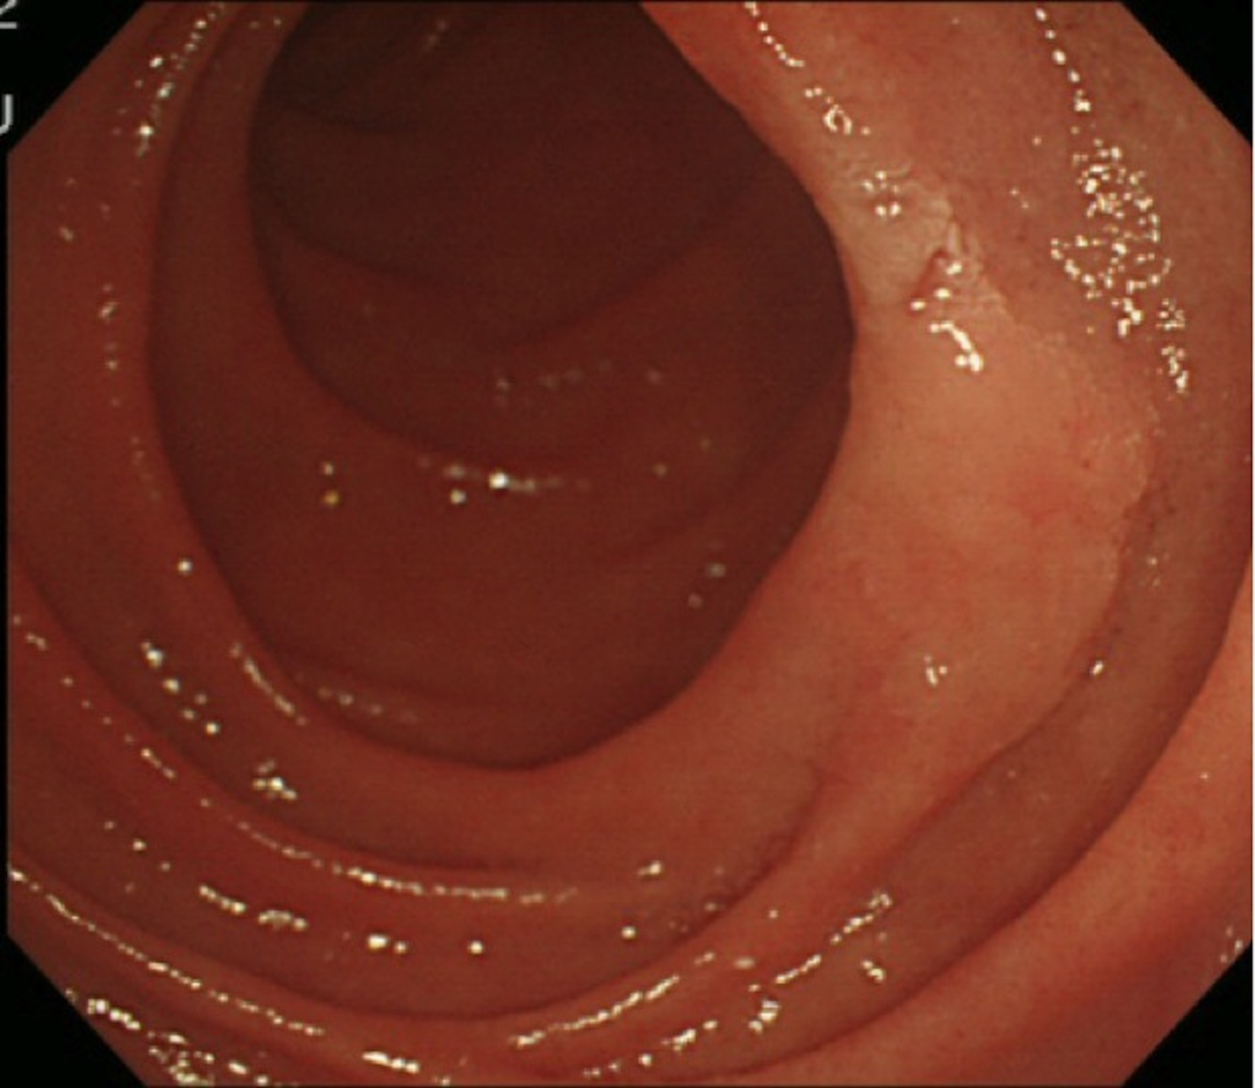
B
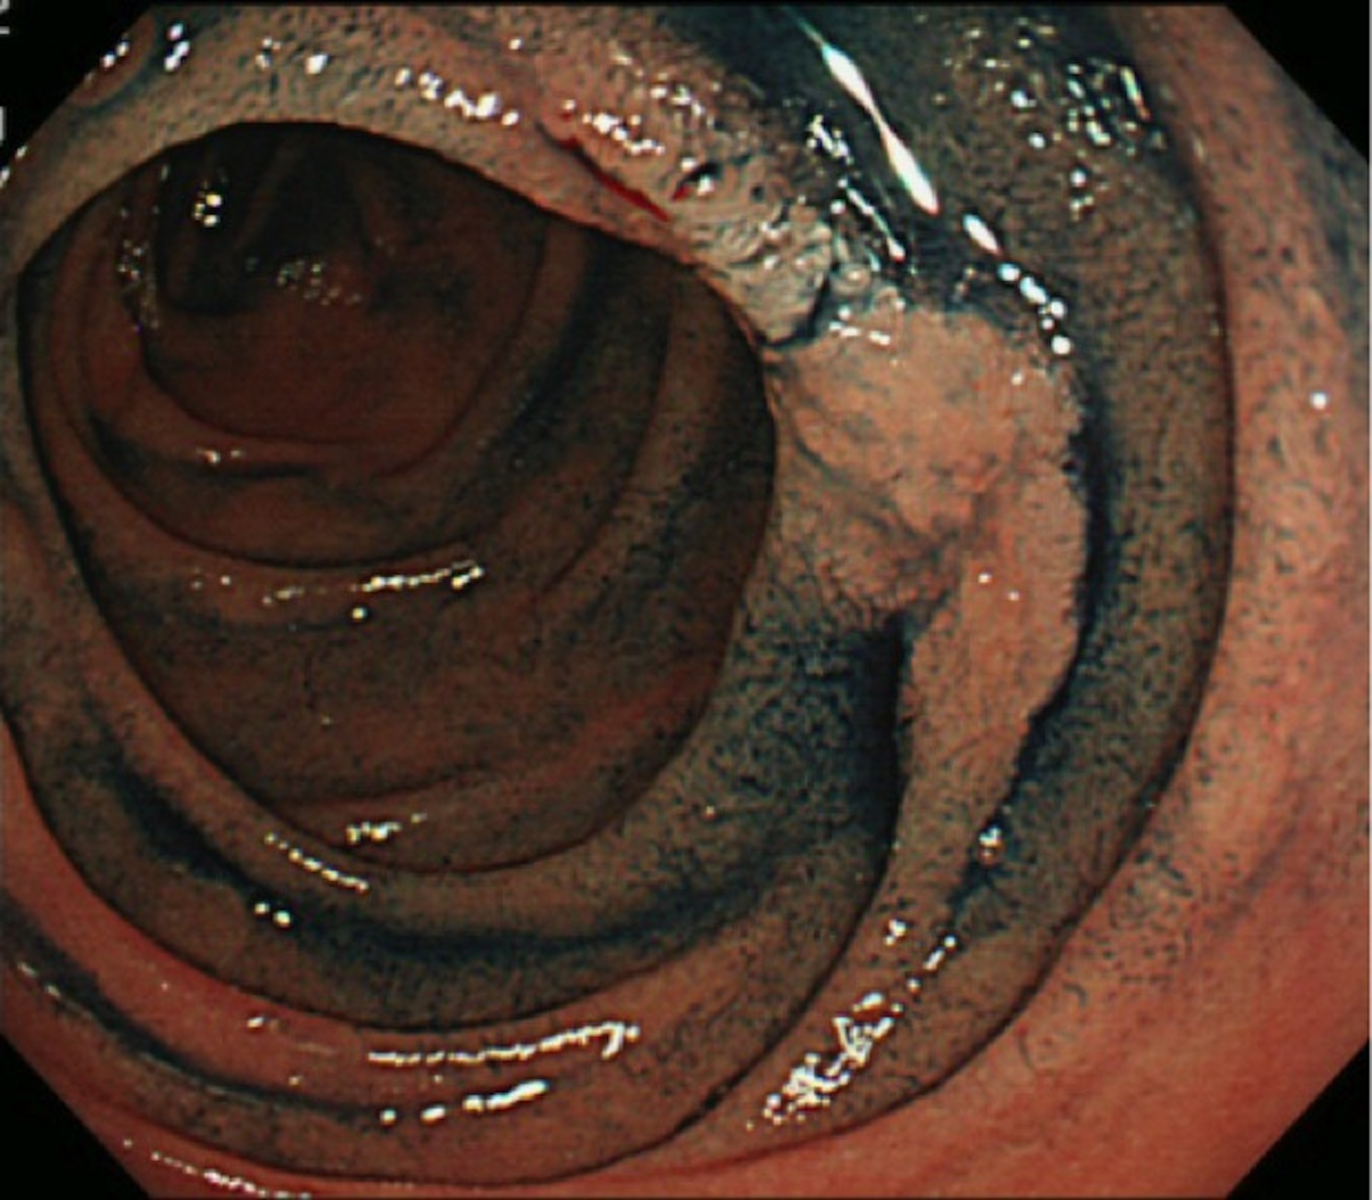
C
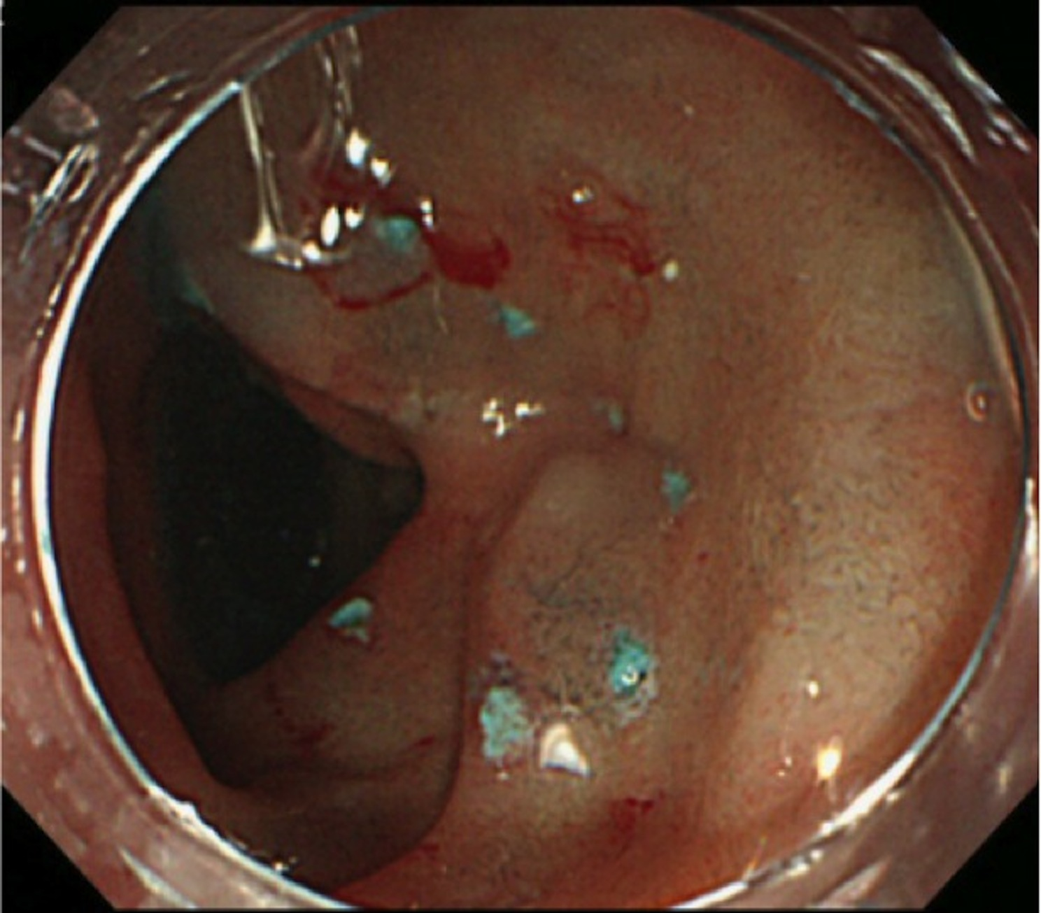
D
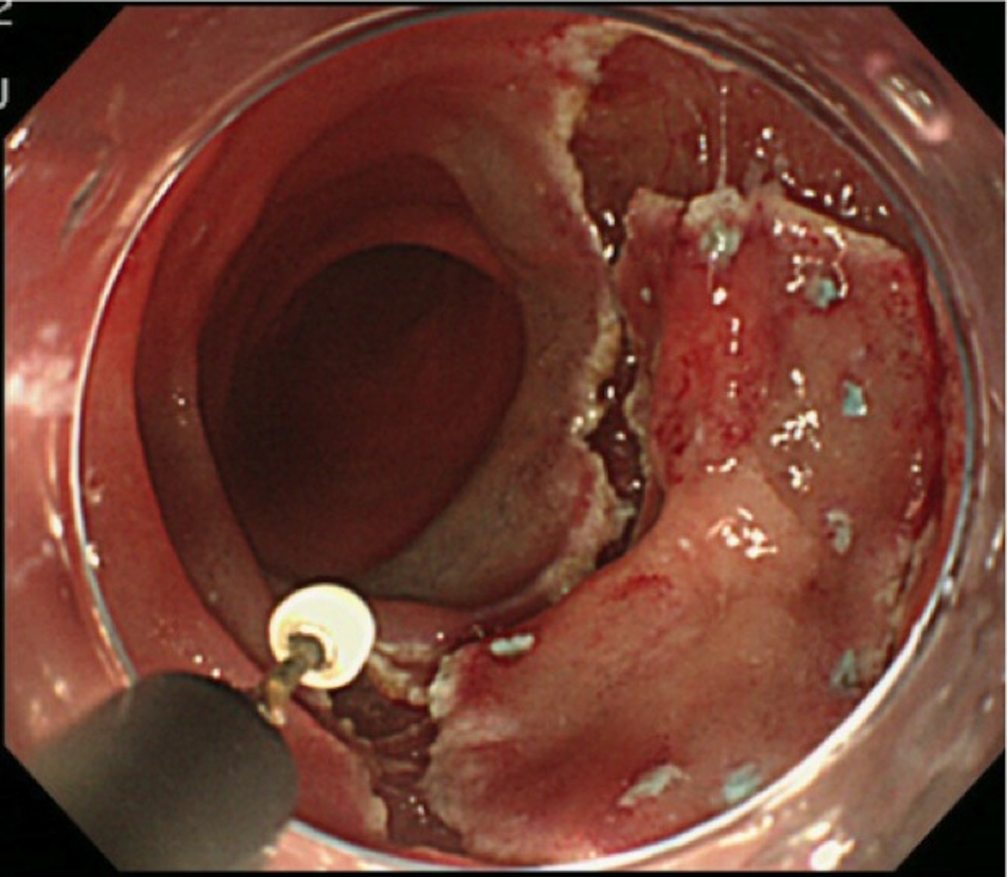
E
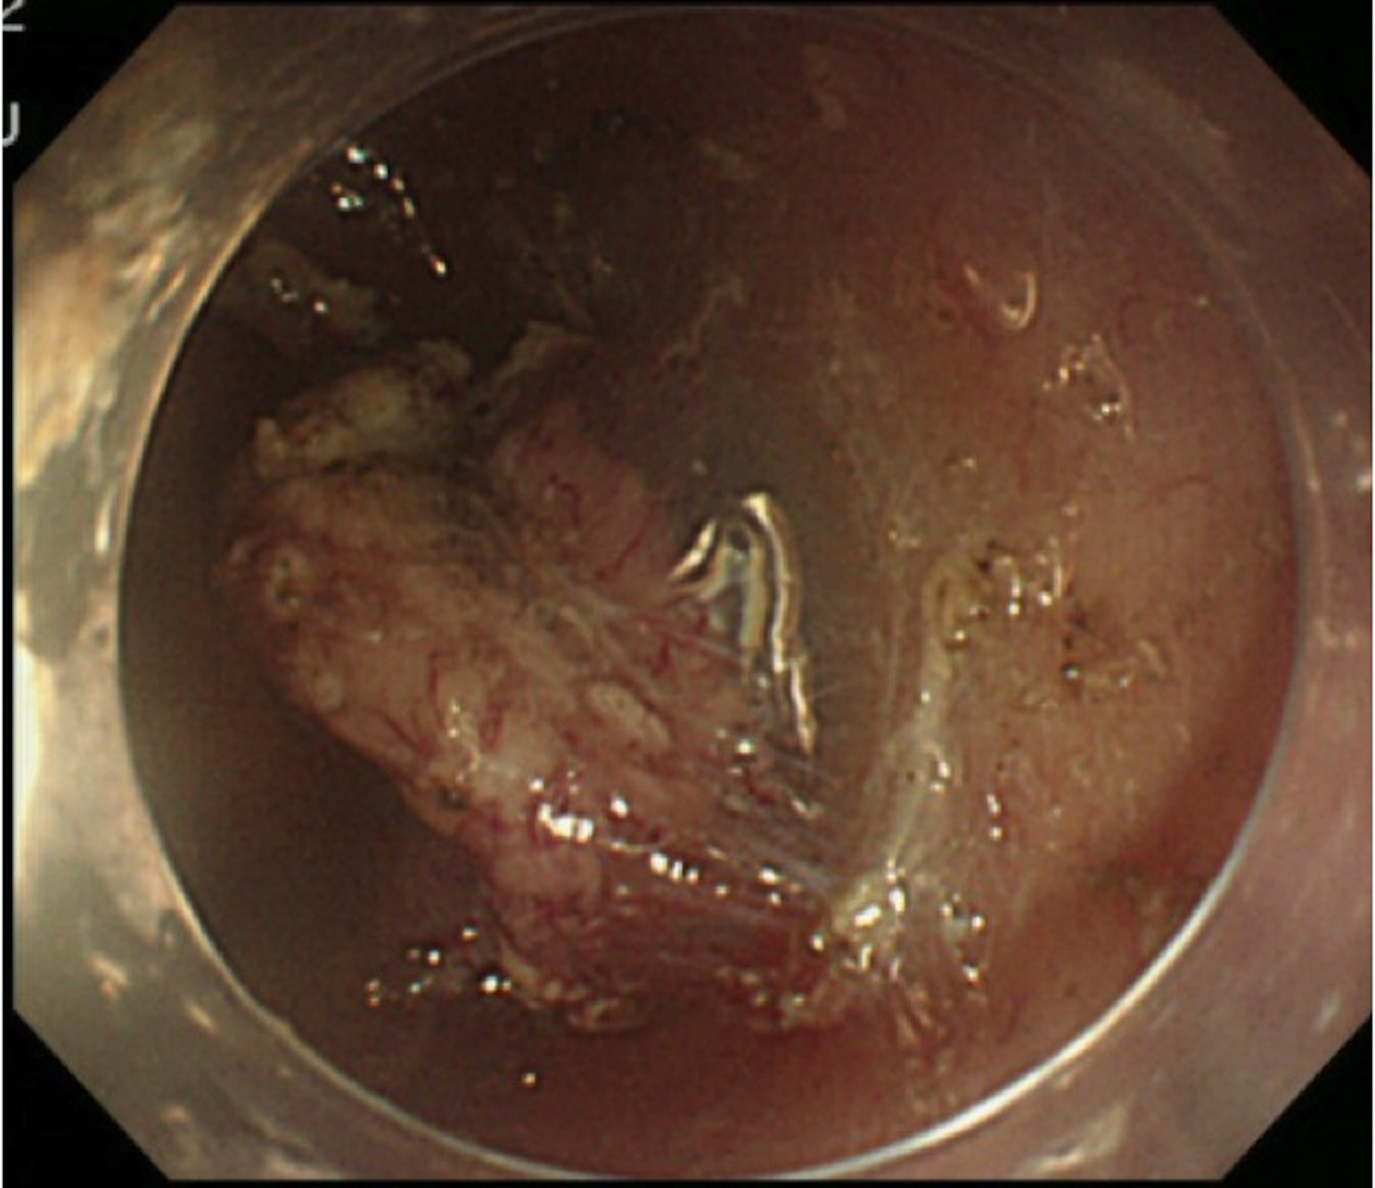
F
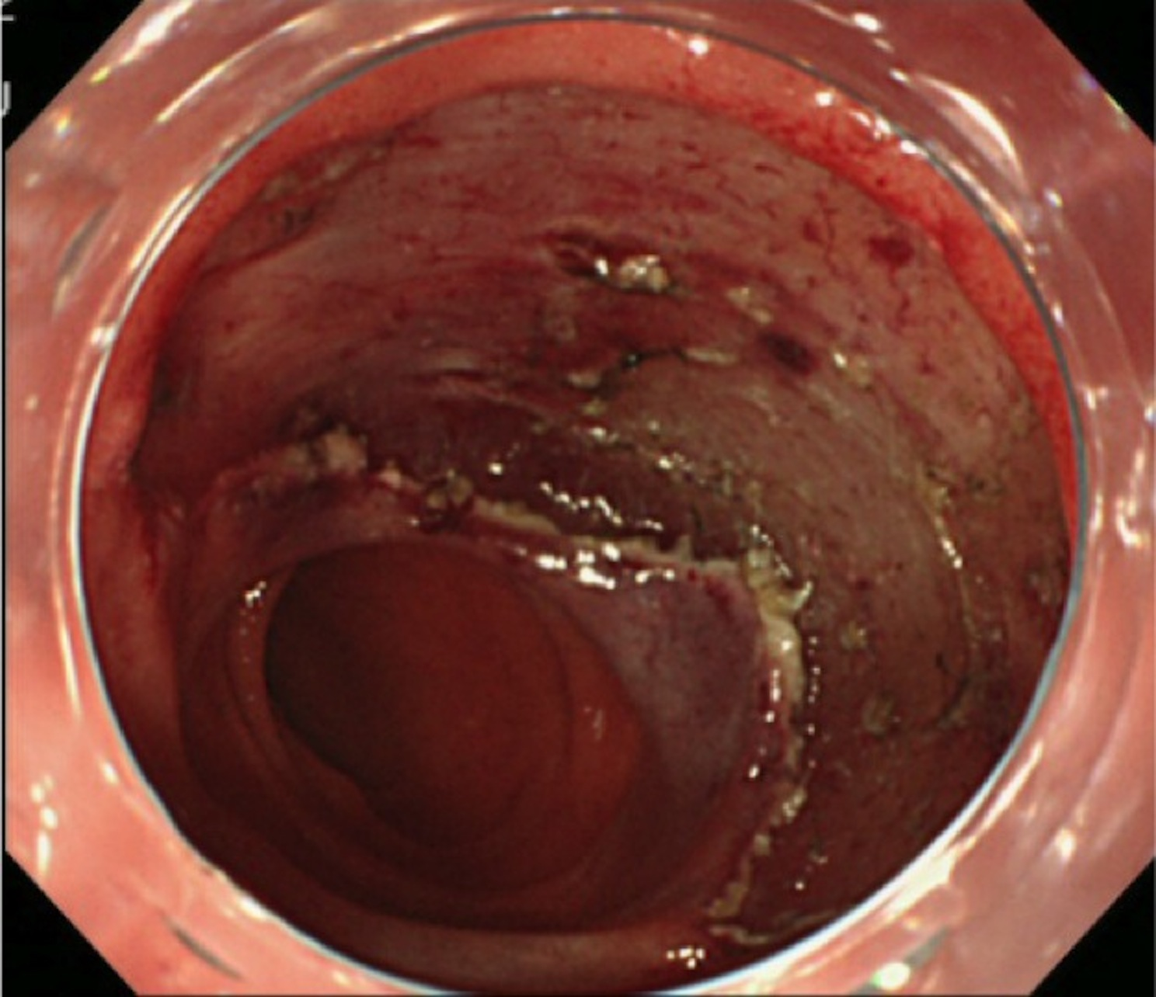
G
