Name of Journal: World Journal of Hepatology
Manuscript NO: 91430
Manuscript Type: EDITORIAL

Progress of mitochondrial and endoplasmic reticulum-associated signaling and its regulation of chronic liver disease by Chinese medicine

Zheng Y et al. Endoplasmic reticulum MAM and CLD

Yang Zheng, Yi-Hui Zheng, Jia-Hui Wang, Tie-Jian Zhao, Lei Wang, Tian-Jian Liang

Yang Zheng, Yi-Hui Zheng, Jia-Hui Wang, Tie-Jian Zhao, Lei Wang, Tian-Jian Liang, Department of Medicine, Faculty of Chinese Medicine Science, Guangxi University of Chinese Medicine, Nanning 530222, Guangxi Zhuang Autonomous Region, China

Co-first authors: Yang Zheng and Yi-Hui Zheng.

Author contributions: Zheng Y, Zheng YH, Wang JH, Zhao TJ, Wang L and Liang TJ designed the study; Zheng Y and Zheng YH wrote the first draft; Wang JH, Zhao TJ and Wang L were responsible for the production of the images; Zheng Y and Liang TJ revised the paper; All authors have read and approve the final manuscript.

Supported by the National Natural Science Foundation of China, No. 82204755, and No. 81960751; the Guangxi Natural Science Foundation Youth Project, No. 2023GXNSFBA026274; the Guangxi University of Traditional Chinese Medicine School-level Project Youth Fund, No. 2022QN008; and Faculty of Chinese Medicine Science Guangxi University of Chinese Medicine Research Project, No. 2022MS008 and No. 2022QJ001.

Corresponding author: Tian-Jian Liang, MD, Professor, Department of Medicine, Faculty of Chinese Medicine Science, Guangxi University of Chinese Medicine, No. 13 Wuhe Avenue, Qingxiu District, Nanning 530222, Guangxi Zhuang Autonomous Region, China. Zycc5@sina.com

Received: December 28, 2023
Revised: February 3, 2024
Accepted: March 25, 2024
Published online:

Abstract
Abstract: The endoplasmic reticulum (ER) is connected to mitochondria through mitochondria-associated ER membranes (MAMs). MAMs provide a framework for crosstalk between the ER and mitochondria, playing a crucial role in regulating cellular calcium balance, lipid metabolism, and cell death. Dysregulation of MAMs is involved in the development of chronic liver disease (CLD). In CLD, changes in MAMs structure and function occur due to factors such as cellular stress, inflammation, and oxidative stress, leading to abnormal interactions between mitochondria and the ER, resulting in liver cell injury, fibrosis, and impaired liver function. Traditional Chinese medicine has shown some research progress in regulating MAMs signaling and treating CLD. This paper reviews the literature on the association between mitochondria and the ER, as well as the intervention of traditional Chinese medicine in regulating CLD.

Key Words: Mitochondria; Endoplasmic reticulum; Mitochondria-associated ER membranes; Traditional Chinese medicine; Chronic liver disease

Zheng Y, Zheng YH, Wang JH, Zhao TJ, Wang L, Liang TJ. Progress of mitochondrial and endoplasmic reticulum-associated signaling and its regulation of chronic liver disease by Chinese medicine. World J Hepatol 2024; In press

Core Tip: Endoplasmic reticulum mitochondria-associated membranes (MAMs) play a very important role in the pathogenesis of chronic liver disease. MAMs play an important regulatory role in lipid accumulation, inflammatory response and apoptosis of cells, etc. Influencing the regulatory function of MAMs by targeting their structure can play a role in ameliorating chronic liver disease, which provides new perspectives and research directions for the development of new therapeutic approaches for chronic liver disease.

INTRODUCTION
Chronic liver disease (CLD) is a global health threat and a leading cause of human mortality, encompassing non-alcoholic fatty liver disease (NAFLD), alcoholic fatty liver disease, viral hepatitis, liver fibrosis, and hepatocellular carcinoma (HCC)^{[1]}. While early-stage CLD can be reversed, advanced liver cirrhosis and HCC severely impact patients' quality of life and even pose life-threatening risks. Mitochondria, known as the powerhouse of cells, are responsible for generating cellular energy through oxidative phosphorylation. Additionally, mitochondria play a role in calcium homeostasis, reactive oxygen species production, and cell apoptosis. Disruption of mitochondrial function is associated with the progression of CLD, including liver fibrosis, lipid degeneration, and hepatocyte injury. On the other hand, the endoplasmic reticulum (ER) is an interconnected membrane network involved in protein synthesis, folding, and transport. It also plays a crucial role in lipid metabolism, calcium signaling, and cellular stress response. Disturbance of ER homeostasis leads to the accumulation of misfolded proteins, triggering a cellular stress response known as ER stress. ER stress has emerged as a key factor in liver injury, inflammation, and the development of CLD. There is crosstalk between the ER and mitochondrial signaling pathways, with mitochondria-associated ER membranes (MAMs) connecting the ER and mitochondria in terms of structure and function. MAMs play important roles in cellular signaling and function, including calcium signaling, mitochondrial dynamics, energy metabolism, inflammation response, lipid transport, and cell apoptosis. Thus, they have a significant impact on the interplay and regulation of CLD^{[2]}. Given the interdependence and coordinated functions of mitochondria and the ER, understanding the potential mechanisms of mitochondria-ER signaling in CLD has become an area of in-depth research. Targeted therapeutic approaches may offer potential strategies to improve liver damage and prevent disease progression.

MITOCHONDRIA AND CLDS
Mitochondria, also known as the "powerhouses" of cells, play a crucial role in various metabolic processes^{[3]}. They serve as the site for cellular oxidative phosphorylation and adenosine triphosphate (ATP) synthesis, and are involved in a wide range of important biological functions, including energy conversion, the citric acid cycle, regulation of cellular calcium concentration, as well as being the primary source of reactive oxygen species (ROS) and a regulatory center for cell apoptosis^{[4]}.

Mitochondrial dysfunction and NAFLD
Research suggests that NAFLD is characterized by excessive accumulation of fat in liver cells, leading to abnormal fatty acid oxidation, significant increase in mitochondrial reactive ROS, and alterations in mitochondrial membrane lipids and proteins^{[5,6]}. Zeng et al^{[7]} found that fatty acid translocase (FAT/CD36) on the mitochondrial membrane is heavily glycosylated in NAFLD, reducing its ability to transport long-chain fatty acids into the mitochondria and inhibiting fatty acid oxidation. Additionally, the lipid composition of the mitochondrial membrane changes with the continuous accumulation of lipids^{[7]}. The increased electron transport chain (ETC) activity leads to excessive ROS production, which directly attacks biomolecules, reduces intracellular antioxidant enzyme levels, and causes oxidative damage to cells. This results in metabolic changes and ultimately leads to ETC dysfunction. The combination of increased rates of fatty acid beta-oxidation and elevated ROS levels leads to damage to the mitochondrial respiratory chain, insulin resistance, and inflammation^{[8]}, See Figure 1 for details.

Mitochondrial dysfunction and alcoholic liver disease
In AFLD, various changes occur in liver mitochondria, such as increased levels of reactive ROS, decreased mitochondrial membrane potential, abnormal fatty acid beta-oxidation, and mitotic abnormalities^{[9]}. Alcohol metabolism in the liver interferes with the oxidation of fatty acids, leading to the accumulation of triglycerides (TG). Simultaneously, alcohol metabolism generates a large amount of ROS, which causes oxidative damage to cells, resulting in metabolic changes, liver cell injury, and inflammation leading to the development of alcoholic liver disease (ALD)^{[10]}. Furthermore, alcohol-induced mitochondrial damage exacerbates liver injury and steatosis. Mitochondria undergo structural remodeling to enhance alcohol metabolism. Studies have shown that alcohol can damage mtDNA, impair cellular energy metabolism, and increase ROS production. Additionally, alcohol induces excessive accumulation of iron in the liver. Alcohol metabolism also reduces the levels of the antioxidant GSH in mitochondria, leading to increased ROS production, lipid peroxidation in liver cells, and iron-induced cell death^{[11]}, See Figure 1 for details.

Mitochondrial dysfunction and viral hepatitis
The incidence and contagiousness of viral hepatitis are high, with hepatitis B (HBV) and hepatitis C (HCV) being common forms of chronic hepatitis. Han et al^{[12]} demonstrated through their experiments that morphological and structural changes in mitochondria can typically be detected in patients with hepatitis B^{[13]}. HBV can induce perinuclear aggregation of mitochondria and trigger their translocation through phosphorylation of the core protein at Ser616, leading to mitochondrial division^{[14]}. Hsu et al^{[15]} found that the absence of BNIP3 promotes excessive accumulation of reactive ROS, inflammatory reactions, and the formation of fatty liver in liver tissue. The characteristic of HCV-related CLD is an increase in ROS, which causes metabolic disorders, resulting in insulin resistance, hepatic steatosis, and iron accumulation in the liver. Ezaki et al^{[16]} discovered that the HCV core protein NS5A can induce mitochondrial division, inhibit the translocation of Parkin to mitochondria, reduce autophagic activity, and maintain HCV-induced mitochondrial damage, See Figure 1 for details.

Mitochondrial dysfunction and liver fibrosis
Yong et al^{[17]} discovered that pathological factors can cause mitochondrial damage, leading to the release of mtDNA and triggering an inflammatory response through the cyclic GMP-AMP synthase (cGAS)-stimulator of interferon genes (STING) pathway. In their experiments, abnormal mitochondrial morphology was observed, and RT-PCR revealed an increase in mtDNA content in the cytoplasm, making mtDNA highly susceptible to ROS attack^{[18]}. Mutations in mtDNA can easily affect genes encoding important functional regions, leading to the occurrence of mitochondrial dysfunction-related diseases and inducing activation of the hepatic inflammatory signaling pathway^{[19]}. In the liver, the expression levels of NLRP3, caspase, and IL-1β are significantly increased, along with the expression levels of key molecules in the cGAS-STING signaling pathway, including cGAS, STING, IRF3, and downstream NF-κB nuclear translocation. This also leads to the accumulation of TDP-43 in liver cells, inducing mitochondrial damage. The release of mtDNA from mitochondrial damage can activate the cGAS-STING signaling pathway, collectively triggering an inflammatory response and promoting the formation of liver fibrosis. The progression of liver fibrosis is believed to be associated with iron overload, which promotes hepatocyte iron death through excessive induction of lipid peroxidation^{[20]}. Inhibition of hepatic stellate cell (HSC) activation and alleviation of liver fibrosis can be achieved by regulating iron death^{[21]}, See Figure 1 for details.

Mitochondrial dysfunction and HCC
Mitochondrial dysfunction-mediated accumulation of reactive ROS and damage to mitochondrial DNA may contribute to the development of liver cancer. Research has shown that mitochondrial fission promotes the survival of liver cancer cells by enhancing autophagy and suppressing mitochondria-dependent cell apoptosis, and inhibitors of mitochondrial fission significantly inhibit tumor growth^{[18]}. The characteristic feature of mitochondria in cancer cells is the excessive production of ROS, which promotes cancer development by inducing genomic instability, modifying gene expression, and participating in signaling pathways. The relative increase in ROS is due to a slowdown in electron transfer in the respiratory chain, leading to an absolute increase in ROS production, as well as a decrease in antioxidant enzyme activity. The decrease in cellular antioxidant enzyme levels leads to oxidative damage in cells and signaling transduction, resulting in corresponding metabolic changes^{[8]}. Mechanistic analysis has shown that mitochondrial fission leads to increased ROS production, mediates the activation of AKT, and synergistically interacts with the TP53 and NF-κB pathways to promote tumor progression^{[22]}, See Figure 1 for details.

ENDOPLASMIC RETICULUM AND CLD
The ER is a vital organelle involved in calcium storage, lipid metabolism, and synthesis of steroid hormones^{[23]}. External stimuli that disrupt protein folding or lipid homeostasis can trigger ER stress (ERS), activating the unfolded protein response (UPR) signaling pathway in cells. Research has shown that ERS is closely associated with the development of various diseases, including inflammation, dysregulation of glucose and lipid metabolism, liver fibrosis, and cancer.

Endoplasmic reticulum stress and NAFLD
ERS can contribute to the progression of NAFLD from simple steatosis to NASH, which is characterized by the development of inflammation and varying degrees of fibrosis^{[24]}. The "second-strike theory" suggests that the liver undergoes oxidative stress, resulting in increased cellular activity and a massive release of inflammatory cytokines, causing hepatocellular inflammation and the formation of NAFLD^{[25]}. In NAFLD, cytotoxic lipids modify the ER structure and directly activate the UPR, leading to dysregulation of protein homeostasis. Although hepatocytes can tolerate TG storage, saturated fatty acids and lysophosphatidylcholine cause lipotoxicity^{[26,27]}. Once taken up by hepatocytes, these lipids are stored in cytoplasmic droplets, and excess saturated fatty acids trigger hepatocyte ERS through various mechanisms^{[28]}. ERS and IR trigger NAFLD by acting on hepatocytes and causing massive intracellular lipid deposition, See Figure 2 for details.

Endoplasmic reticulum stress and ALD
Homocysteine is known to enhance the production of NF-κB, IL-1b, IL-6, and IL-8, induce endoplasmic ERS, and promote various cellular damage processes^{[29]}. Homocysteine can activate pathways such as GRP78, CHOP, IRE1α, sterol regulatory element-binding protein, and JNK^{[30]}. Long-term alcohol administration in animals leads to increased expression of cytochrome P450, which in turn enhances the expression of superoxide dismutase and activates nuclear factor erythroid 2-related factor 2, a key factor in the ESR response. Sun et al^{[31]} found that changes in gene expression in ALD are closely related to its pathogenesis. Gene ontology enrichment analysis revealed two main functional groups: angiogenesis and stress response. Abnormal angiogenesis is also observed in the progression of ALD and exacerbates alcohol-induced liver injury. Studies have shown that excessive ethanol intake can cause chronic inflammation in liver parenchyma, leading to liver fibrosis and pathological angiogenesis, See Figure 2 for details.

Endoplasmic reticulum stress and viral hepatitis
ERS plays a crucial role in the progression of viral hepatitis, particularly in cases of HBV infection. The HBV inflammatory surface antigen can activate the UPR, leading to hepatocyte apoptosis and precancerous phenotypic changes. Notably, elevated levels of GRP78, an ER chaperone protein, have been observed in HBV patients, suggesting its association with HBV infection^{[32]}. Additionally, research indicates that HCV-related liver cancer patients exhibit upregulation of vascular endothelial growth factor (VEGF) in tissue serum, leading to abnormal angiogenesis acceleration^{[33]}. Accumulation of misfolded proteins triggers ER stress and the expression of GRP78^{[34]}. GRP94, which binds to Ca²⁺, facilitates translocation and folding of newly synthesized polypeptides, participates in oligomer assembly and degradation, and inhibits the formation of misfolded proteins. Furthermore, GRP94 acts as an antigen-presenting cell, activating the UPR and initiating cellular self-regulation^{[35]}. XBP1 promotes the expression of molecular chaperones such as GRP78 and GRP94, enhancing the cell's ability to handle unfolded proteins and activating ER-associated degradation (ERAD) and other ER degradation pathway-related genes, See Figure 2 for details.

Endoplasmic reticulum stress and liver fibrosis
ERS is a cellular response to various stressors that disrupt protein folding in the endoplasmic ER. Three transmembrane proteins on the ER membrane, namely ATF6, PERK, and IRE1α, play crucial roles in releasing unfolded/misfolded proteins and initiating the UPR. During ERS, BiP dissociates from these transmembrane proteins and binds to unfolded/misfolded proteins, activating downstream signaling pathways^{[36]}. In liver cells, PERK-mediated ERS induces the upregulation of dual-specificity phosphatase 5, which reduces the phosphorylation levels of extracellular signal-regulated kinases and inhibits their activity. Additionally, PERK-mediated ERS increases the activation of caspase-3, leading to hepatocyte death and liver fibrosis^{[37]}. Overexpression of IRE1α in HSCs downregulates IRE1α, XBP1, PERK, and CHOP, preventing HSC activation and reducing liver injury and fibrosis. In PDGF-induced HSCs, the activation of the PI3K/AKT pathway disrupts calcium homeostasis, leading to the accumulation of misfolded proteins and the induction of ERS, ultimately promoting HSC activation, proliferation, and liver fibrosis^{[38]}, See Figure 2 for details.

Endoplasmic reticulum stress and HCC
ATF6 is a type II ER transmembrane protein that dissociates from BiP and undergoes cleavage when ER stress occurs^{[39]}. The cleaved form of ATF6α not only activates the transcription of XBP1u, but also induces genes related to protein folding and ERAD^{[40]}. The rapid proliferation of tumor cells is accompanied by a sharp increase in protein synthesis, inevitably leading to UPR activation, while miRNA imbalance exists in both hepatitis and HCC. Some studies have also shown that the endoribonuclease activity of IRE1 is not only responsible for cleaving XBP1, but also for cleaving and regulating miRNAs^{[41]}. Therefore, ER stress leads to miRNA imbalance in inflammation and cancer, promoting tumor development and progression. Tumor cells can transmit ER stress and UPR signals to neighboring macrophages, upregulating UPR target genes and pro-inflammatory factors, thereby promoting the pro-inflammatory effect of tumors and regulating the tumor microenvironment^{[42,43]}. VEGF, as an important regulator of angiogenesis, inhibits tumor growth by restricting blood vessel formation and reducing tumor blood supply when its levels decrease^{[44]}, See Figure 2 for details.

MITOCHONDRIAL AND ENDOPLASMIC RETICULUM ASSOCIATION SIGNALING AND CLD
There is crosstalk between ER and mitochondrial signaling pathways, and the opening of endoplasmic reticulum Insp3/Ca ion channels affects mitochondrial Ca²⁺ homeostasis, and disruption of mitochondrial Ca²⁺ homeostasis leads to alterations in mitochondrial membrane potential, permeability transition pore, and other alterations in mitochondria, which are one of the most important organelles in hepatocytes, providing the majority of the cell's energy^{[45]}. The ER is connected to the mitochondria by MAMs connected to the mitochondria, a dynamic structure that is highly sensitive to the cellular physiological environment and is mainly involved in the regulation of ERS, oxidative stress, apoptosis, cellular autophagy, changes in mitochondrial dynamics and inflammation^{[46]}.

MAMs and NAFLD
The molecular mediators of mitochondrial fusion are primarily Mfn1/2 (mitofusin1/2). Both Mfn1 and Mfn2 are located on the outer mitochondrial membrane, with Mfn2 also being localized on MAMs. Together, they regulate the structure and function of MAMs, inhibit the proximity of ER and mitochondria, and promote mitochondrial fusion^{[47]}. Reduced expression of Mfn2 has been observed in liver biopsies of NASH patients, and specific ablation of liver Mfn2 in vivo leads to inflammation, TG accumulation, fibrosis, and liver cancer. This suggests that Mfn2 binds to phosphatidylserine (PS) and can selectively extract PS into membrane domains, facilitating its transfer to mitochondria and the synthesis of mitochondrial phosphatidylethanolamine (PE). Therefore, the deficiency of Mfn2 in the liver reduces PS transfer and phospholipid synthesis, leading to ER stress and the development of NASH. Specifically, PS is mainly synthesized in the ER and enters mitochondria through transient membrane contacts between MAMs and the outer mitochondrial membrane. In mitochondria, PS is converted to PE, which then enters the endoplasmic reticulum to be converted to phosphatidylcholine (PC). Thus, MAMs play a crucial role in phospholipid synthesis and transport^{[48]}, See Figure 3 for details.

MAMs and ALD
Under the influence of alcohol, PERK, as a connecting protein of MAMs, mediates liver cell death through the regulation of MAMs. When PERK in MAMs is knocked out, cells exhibit abnormal ER morphology, as well as MAMs disruption and calcium imbalance^{[49]}. After passing through the gastrointestinal tract, alcohol is absorbed into the bloodstream and enters the liver for metabolism. Within liver cells, enzymes such as alcohol dehydrogenase and aldehyde dehydrogenase convert alcohol into acetic acid, which enters the tricarboxylic acid cycle (TCA), leading to a decrease in the NAD⁺/NADH ratio and further mitochondrial dysfunction. Damage to the mitochondria impairs the TCA, leading to disturbances in fatty acid metabolism and excessive fat deposition in liver cells, resulting in fatty liver. Additionally, alcohol can also cause damage to ER morphology and function in liver cells through various pathways. In alcohol-induced liver tissue with severe impairment of both mitochondrial and ER function and morphology, MAMs, as a functional platform where these two organelles interact, may be more sensitive to alcohol exposure^{[50]}, See Figure 3 for details.

MAMs and viral hepatitis
Our findings demonstrate that STING can bind to mitochondrial antiviral signaling protein at MAMs, thereby enhancing the interferon response to viral infections. Additionally, HCV proteins were found to localize to MAMs, potentially leading to increased mitochondrial ROS levels through Ca²⁺ manipulation. Furthermore, certain molecules present on the structure of MAMs, such as Ero1 and p66Shc, promote ROS production. Ero1, an important molecule involved in redox homeostasis, consists of two isoforms, Ero1-α and Ero1-β. The majority of Ero1-α is localized on MAMs, and its upregulation can result in increased ROS production. Notably, the dephosphorylation of the Ser36 site enables its transfer to MAMs, mediating ROS generation. This process facilitates the flow of Ca²⁺ from the endoplasmic ER to mitochondria through MAMs. Consequently, the accumulation of mitochondrial Ca²⁺ leads to mitochondrial depolarization and abnormalities in oxidative phosphorylation. As a result, the mitochondrial electron transport chain uncouples with respiratory complexes I and III, further augmenting ROS production. This process can be described by ERCa²⁺, which serves as the basis for mitochondrial ROS production. Importantly, the inhibition of ERCa²⁺ channels can effectively block this process^{[51,52]}, See Figure 3 for details.

MAMs and liver fibrosis
TMAMs can have an effect on mitochondrial function, including fusion/fission, mitophagy, and energy metabolism. MAMs play a dual role in maintaining cellular homeostasis by promoting mitochondrial division and mitophagy while also potentially causing pathological damage through excessive mitochondrial fission, calcium overload, or oxidative stress. Evidence suggests that MAMs are involved in PINK1/Parkin-mediated mitophagy, with core proteins associated with MAMs regulating their integrity and functionality^{[49]}. In vivo studies have demonstrated that liver-specific ablation of Mfn2, a protein involved in MAMs, leads to inflammation, triglyceride accumulation, fibrosis, and HCC. This suggests that Mfn2 binds to PS and selectively extracts it to membrane domains, facilitating PS transfer to mitochondria and mitochondrial phosphatidylethanolamine synthesis^{[53]}, See Figure 3 for details.

MAMs and HCC
Research has shown that enhancing the physical contact between the endoplasmic ER and mitochondria leads to mitochondrial calcium overload and cell apoptosis. Conversely, disrupting the ER-mitochondria contact points stimulates mitochondrial oxidative respiration and ATP production^{[54]}. Increased mitochondrial fission has been observed in liver cancer tissues, and it has been found that enhanced mitochondrial fission promotes the growth of liver cancer cells. Overexpression of Drp1 in liver cancer cells, followed by overexpression of Rab32, leads to a decrease in MAMs structure formation, a significant increase in mitochondrial calcium concentration, and subsequently promotes liver cancer cell apoptosis while inhibiting cell proliferation. Numerous studies have found that MAMs play important roles in both calcium signal transduction and the transfer of calcium from the ER to mitochondria^{[55]}. Excessive uptake of mitochondrial calcium can result in mitochondrial calcium overload, opening of the permeability transition pore, mitochondrial swelling, rupture of the outer mitochondrial membrane, and subsequently, release of cytochrome c and cell apoptosis^{[54]}, See Figure 3 for details.

TRADITIONAL CHINESE MEDICINE TARGETS MITOCHONDRIAL ENDOPLASMIC RETICULUM MODULATION TO INTERVENE IN CLD
The research on traditional Chinese medicine (TCM) in regulating MAMs signaling and treating CLDs has shown significant progress. Certain TCM components have been proven to have a reparative effect on the structure and function of MAMs, thereby improving the progression of CLDs. Additionally, some active ingredients in TCM exhibit antioxidant, anti-inflammatory, and insulin-sensitivity regulating properties, some of which may be related to their modulation of MAMs signaling. The modulation of MAMs signaling by TCM components is an important research direction for the treatment of CLDs. Current studies have demonstrated that certain TCM components can regulate MAMs signaling and improve liver pathological responses, providing new insights and approaches for the treatment of CLDs.

Silymarin
Silymarin is a novel flavonoid compound extracted from the seeds of Silybum marianum^{[56]}. This drug has been shown to protect the liver, promote liver cell regeneration, enhance liver metabolism, and reduce serum transaminase levels. It is suitable for adjunctive treatment of chronic hepatitis, cirrhosis, and other liver diseases. Animal experiments have shown that silymarin can increase the expression of superoxide dismutase (SOD) in lymphocytes of mice with CLD, thereby reducing the production of reactive ROS and protecting liver cell membranes^{[57]}. Silymarin can also stabilize endoplasmic ER function and exert anti-inflammatory and hepatoprotective effects by reducing the levels of TNF-α, IL-6, IL-8, and other inflammatory cytokines^{[58]}, See Figure 4 for details.

Tartaric acid
Tartaric acid can inhibit lipid peroxidation and clear ROS, effectively preventing the occurrence and development of liver fibrosis induced by carbon tetrachloride (CCl₄). Multiple studies have found that rhein can inhibit the chemotaxis and phagocytosis of neutrophils, as well as the activation of macrophage lipid inflammatory mediators, and suppress the activity of TNF-α and IL-1β^{[59,60]}. Rhein has the ability to clear ROS and inhibit lipid peroxidation^{[61]}. Research has shown that in animal models of CCl₄ and ethanol-induced liver fibrosis, rhein can significantly reduce malondialdehyde levels and increase SOD levels, thereby reducing the excessive generation of ROS in mitochondria, See Figure 4 for details.

Quercetin
Quercetin is a flavonoid compound. Recent studies have found that subcellular mechanisms related to calcium imbalance, endoplasmic ERS, and mitochondrial damage are closely related to the progression of CLD and the activation of NLRP3 inflammasomes. During metabolic-related fatty liver disease, the expression of NLRP3 inflammasomes increases, and the homeostasis of MAMs is disrupted. Quercetin intervention has been shown to effectively protect against liver damage and reverse changes in MAMs. The results suggest that quercetin may exert its protective effects through the MAMs-NLRP3 pathway, providing new insights for nutritional interventions in the treatment of metabolic-related fatty liver disease. Quercetin inhibits alcohol-induced hepatocyte ferroptosis by regulating the PERK-MAMs pathway, thereby alleviating alcohol-induced liver injury^{[62]}, See Figure 4 for details.

Vanillic acid
One such TCM component is vanillic acid (VA), an edible plant compound, which has been studied for its beneficial effects on calcium (Ca²⁺) complications induced by hyperinsulinemia (HI), intracellular homeostasis, MAM integrity, and liver metabolism under in vivo and in vitro conditions. VA has been found to possess various pharmacological effects, such as antioxidant, antidiabetic, and anti-inflammatory properties^{[63]}. The liver plays a crucial role in regulating lipid metabolism balance in the body, and excessive lipid accumulation in liver cells contributes to the occurrence and development of NAFLD. During the HI phase in HepG2 cells, distorted MAMs lead to insulin resistance (IR) and excessive lipid synthesis, accompanied by inflammation and oxidative stress. VA effectively protects ER and Ca²⁺ homeostasis during the HI phase^{[64]}, See Figure 4 for details.

Compound glycyrrhizin tablets
Compound glycyrrhizin tablets have a positive effect on the prevention and treatment of liver diseases, with glycyrrhizin, glycine, and cysteine hydrochloride as its main components^{[65]}. Animal experiments have shown that compound glycyrrhizin tablets can protect the liver by inhibiting the transduction of the NF-κB pro-inflammatory signaling pathway and the expression of downstream inflammatory molecules^{[66]}. Studies have found that glycyrrhizin not only inhibits the expression of IL-6 and IL-8, significantly increasing the activity of liver cells, but also promotes the expression of SOD and glutathione, and inhibits malondialdehyde synthesis, thereby alleviating oxidative stress-induced liver cell damage. Glycine can inhibit the generation of reactive ROS, reduce ROS and lipid peroxidation, and alleviate liver damage caused by oxidative stress reactions^{[67]}, See Figure4 for details.

CONCLUSION

The signaling crosstalk between mitochondria and ER, mainly mediated by ROS and calcium loading, influences each other's endoplasmic reticulum and mitochondrial function mechanisms to regulate CLD. The mechanisms of mitochondrial and ER dysfunction are complex and diverse, and they are interrelated and interact with each other. With the deepening of the basic theoretical research on the structure and function of mitochondria and ER, it is possible to combine the application of genomics, proteomics, metabolomics, and other modern technologies to explore in depth the signaling links between mitochondrial and ER function in various CLDs. In this paper, we elucidate the treatment of CLDs by TCM from traditional Chinese medicine to provide new ideas and means for the diagnosis and treatment of CLDs in the future. MAMs are the key factors linking the material and communication signals of mitochondria and ER. However, there are more methods for evaluating MAMs, and the accuracy of their detection varies in different studies, such as subjective judgment errors in techniques such as fluorescence localization. Under different pathologic conditions, the body's compensatory effects on MAMs proteins can vary. Therefore, future studies need to further define the criteria for judging the number of MAMs, such as the promotion of dynamic observation techniques at the cellular level, which will increase the credibility and rigor of the study.

REFERENCES
1 Zhang C, Zhao Y, Yu M, Qin J, Ye B, Wang Q. Mitochondrial Dysfunction and Chronic Liver Disease. Curr Issues Mol Biol 2022; 44: 3156-3165 [PMID: 35877442 DOI: 10.3390/cimb44070218]
2 Marchi S, Patergnani S, Missiroli S, Morciano G, Rimessi A, Wieckowski MR, Giorgi C, Pinton P. Mitochondrial and endoplasmic reticulum calcium homeostasis and cell death. Cell Calcium 2018; 69: 62-72[PMID: 28515000 DOI: 10.1016/j.ceca.2017.05.003]
3 Rodrigues T, Ferraz LS. Therapeutic potential of targeting mitochondrial dynamics in cancer. Biochem Pharmacol 2020; 182: 114282 [PMID: 33058754 DOI: 10.1016/j.bcp.2020.114282]
4 Yamada Y, Takano Y, Satrialdi, Abe J, Hibino M, Harashima H. Therapeutic Strategies for Regulating Mitochondrial Oxidative Stress. Biomolecules 2020; 10 [PMID: 31948035 DOI: 10.3390/biom10010083]
5 Prasun P, Ginevic I, Oishi K. Mitochondrial dysfunction in nonalcoholic fatty liver disease and alcohol related liver disease. Transl Gastroenterol Hepatol 2021; 6: 4 [PMID: 33437892 DOI: 10.21037/tgh-20-125]
6 Durand M, Coué M, Croyal M, Moyon T, Tesse A, Atger F, Ouguerram K, Jacobi D. Changes in Key Mitochondrial Lipids Accompany Mitochondrial Dysfunction and Oxidative Stress in NAFLD. Oxid Med Cell Longev 2021; 2021: 9986299 [PMID: 34257827 DOI: 10.1155/2021/9986299]
7 Zeng S, Wu F, Chen M, Li Y, You M, Zhang Y, Yang P, Wei L, Ruan XZ, Zhao L, Chen Y. Inhibition of Fatty Acid Translocase (FAT/CD36) Palmitoylation Enhances Hepatic Fatty Acid β-Oxidation by Increasing Its Localization to Mitochondria and Interaction with Long-Chain Acyl-CoA Synthetase 1. Antioxid Redox Signal 2022; 36: 1081-1100 [PMID: 35044230 DOI: 10.1089/ars.2021.0157]
8 Kharroubi W, Haj Ahmed S, Nury T, Andreoletti P, Sakly R, Hammami M, Lizard G. Mitochondrial dysfunction, oxidative stress and apoptotic induction in microglial BV-2 cells treated with sodium arsenate. J Environ Sci (China) 2017; 51: 44-51 [PMID: 28115150 DOI: 10.1016/j.jes.2016.08.028]
9 Buyco DG, Martin J, Jeon S, Hooks R, Lin C, Carr R. Experimental models of metabolic and alcoholic fatty liver disease. World J Gastroenterol 2021; 27: 1-18 [PMID: 33505147 DOI: 10.3748/wjg.v27.i1.1]
10 Xu W, Lu C, Yao L, Zhang F, Shao J, Zheng S. Dihydroartemisinin protects against alcoholic liver injury through alleviating hepatocyte steatosis in a farnesoid X receptor-dependent manner. Toxicol Appl Pharmacol 2017; 315: 23-34 [PMID: 27939985 DOI: 10.1016/j.taap.2016.12.001]
11 Ali N, Ferrao K, Mehta KJ. Liver Iron Loading in Alcohol-Associated Liver Disease. Am J Pathol 2023; 193: 1427-1439 [PMID: 36306827 DOI: 10.1016/j.ajpath.2022.08.010]
12 Han D, Johnson HS, Rao MP, Martin G, Sancheti H, Silkwood KH, Decker CW, Nguyen KT, Casian JG, Cadenas E, Kaplowitz N. Mitochondrial remodeling in the liver following chronic alcohol feeding to rats. Free Radic Biol Med 2017; 102: 100-110 [PMID: 27867097 DOI: 10.1016/j.freeradbiomed.2016.11.020]
13 Zai W, Hu K, Ye J, Ding J, Huang C, Li Y, Fang Z, Wu M, Wang C, Chen J, Yuan Z. Long-Term Hepatitis B Virus Infection Induces Cytopathic Effects in Primary Human Hepatocytes, and Can Be Partially Reversed by Antiviral Therapy. Microbiol Spectr 2022; 10: e0132821 [PMID: 35171034 DOI: 10.1128/spectrum.01328-21]
14 Kim SJ, Khan M, Quan J, Till A, Subramani S, Siddiqui A. Hepatitis B virus disrupts mitochondrial dynamics: induces fission and mitophagy to attenuate apoptosis. PLoS Pathog 2013; 9: e1003722 [PMID: 24339771 DOI: 10.1371/journal.ppat.1003722]
15 Hsu CC, Wu LC, Hsia CY, Yin PH, Chi CW, Yeh TS, Lee HC. Energy metabolism determines the sensitivity of human hepatocellular carcinoma cells to mitochondrial inhibitors and biguanide drugs. Oncol Rep 2015; 34: 1620-1628 [PMID: 26133123 DOI: 10.3892/or.2015.4092]
16 Ezaki J, Matsumoto N, Takeda-Ezaki M, Komatsu M, Takahashi K, Hiraoka Y, Taka H, Fujimura T, Takehana K, Yoshida M, Iwata J, Tanida I, Furuya N, Zheng DM, Tada N, Tanaka K, Kominami E, Ueno T. Liver autophagy contributes to the maintenance of blood glucose and amino acid levels. Autophagy 2011; 7: 727-736 [PMID: 21471734 DOI: 10.4161/auto.7.7.15371]
17 Yong H. The role of mitochondrial damage mediated by abnormal TDP-43 aggregation in CCl₄-induced liver fibrosis and its mechanism. Shandong University, 2022 [DOI: 10.27272/d.cnki.gshdu.2022.004748]
18 Ali SS, Medda N, Dutta SM, Patra R, Maiti S. Protection against Mitochondrial Oxidative-Stress by Flesh-Extract of Edible Freshwater Snail Bellamya bengalensis Prevents Arsenic Induced DNA and Tissue Damage. Anticancer Agents Med Chem 2020; 20: 1266-1273 [PMID: 32275495 DOI: 10.2174/1871520620666200410081535]
19 Niemann J, Johne C, Schröder S, Koch F, Ibrahim SM, Schultz J, Tiedge M, Baltrusch S. An mtDNA mutation accelerates liver aging by interfering with the ROS response and mitochondrial life cycle. Free Radic Biol Med 2017; 102: 174-187 [PMID: 27890640 DOI: 10.1016/j.freeradbiomed.2016.11.035]
20 Wu A, Feng B, Yu J, Yan L, Che L, Zhuo Y, Luo Y, Yu B, Wu D, Chen D. Fibroblast growth factor 21 attenuates iron overload-induced liver injury and fibrosis by inhibiting ferroptosis. Redox Biol 2021; 46: 102131 [PMID: 34530349 DOI: 10.1016/j.redox.2021.102131]
21 Zhang Z, Guo M, Shen M, Kong D, Zhang F, Shao J, Tan S, Wang S, Chen A, Cao P, Zheng S. The BRD7-P53-SLC25A28 axis regulates ferroptosis in hepatic stellate cells. Redox Biol 2020; 36: 101619 [PMID: 32863216 DOI: 10.1016/j.redox.2020.101619]
22 Ren T, Zhang H, Wang J, Zhu J, Jin M, Wu Y, Guo X, Ji L, Huang Q, Zhang H, Yang H, Xing J. MCU-dependent mitochondrial Ca(2+) inhibits NAD(+)/SIRT3/SOD2 pathway to promote ROS production and metastasis of HCC cells. Oncogene 2017; 36: 5897-5909 [PMID: 28650465 DOI: 10.1038/onc.2017.167]
23 Yu HY, Song YH, Zhao L, Liu TQ, Bao XQ. Research progress on endoplasmic reticulum stress and alcoholic liver disease. Huagong Shikan 2021; 35: 32-36 [DOI: 10.16597/j.cnki.issn.1002-154x.2021.10.009]
24 Lebeaupin C, Vallée D, Hazari Y, Hetz C, Chevet E, Bailly-Maitre B. Endoplasmic reticulum stress signalling and the pathogenesis of non-alcoholic fatty liver disease. J Hepatol 2018; 69: 927-947 [PMID: 29940269 DOI: 10.1016/j.jhep.2018.06.008]
25 Day CP, James OF. Steatohepatitis: a tale of two "hits"? Gastroenterology 1998; 114: 842-845 [PMID: 9547102 DOI: 10.1016/s0016-5085(98)70599-2]
26 Song MJ, Malhi H. The unfolded protein response and hepatic lipid metabolism in non alcoholic fatty liver disease. Pharmacol Ther 2019; 203: 107401 [PMID: 31419516 DOI: 10.1016/j.pharmthera.2019.107401]
27 Mota M, Banini BA, Cazanave SC, Sanyal AJ. Molecular mechanisms of lipotoxicity and glucotoxicity in nonalcoholic fatty liver disease. Metabolism 2016; 65: 1049-1061 [PMID: 26997538 DOI: 10.1016/j.metabol.2016.02.014]
28 Flessa CM, Kyrou I, Nasiri-Ansari N, Kaltsas G, Papavassiliou AG, Kassi E, Randeva HS. Endoplasmic Reticulum Stress and Autophagy in the Pathogenesis of Non-alcoholic Fatty Liver Disease (NAFLD): Current Evidence and Perspectives. Curr Obes Rep 2021; 10: 134-161 [PMID: 33751456 DOI: 10.1007/s13679-021-00431-3]
29 Ji C, Kaplowitz N. Betaine decreases hyperhomocysteinemia, endoplasmic reticulum stress, and liver injury in alcohol-fed mice. Gastroenterology 2003; 124: 1488-1499 [PMID: 12730887 DOI: 10.1016/s0016-5085(03)00276-2]
30 Esfandiari F, Villanueva JA, Wong DH, French SW, Halsted CH. Chronic ethanol feeding and folate deficiency activate hepatic endoplasmic reticulum stress pathway in micropigs. Am J Physiol Gastrointest Liver Physiol 2005; 289: G54-G63 [PMID: 15705656 DOI: 10.1152/ajpgi.00542.2004]
31 Sun J, Li B, Sun A, Zhao K, Ma Y, Zhao J, Pan H, Song Q, Wang Y, Yu C, Wang C, Zhang H, Zhang W, Kong C. Comprehensive analysis of aberrantly expressed profiles of messenger RNA in alcoholic liver disease. J Cell Biochem 2019; 120: 4248-4254 [PMID: 30294942 DOI: 10.1002/jcb.27710]
32 Jäger R, Bertrand MJ, Gorman AM, Vandenabeele P, Samali A. The unfolded protein response at the crossroads of cellular life and death during endoplasmic reticulum stress. Biol Cell 2012; 104: 259-270 [PMID: 22268789 DOI: 10.1111/boc.201100055]
33 Yvamoto EY, Ferreira RF, Nogueira V, Pinhe MA, Tenani GD, Andrade JG, Baitello ME, Gregório ML, Fucuta PS, Silva RF, Souza DR, Silva RC. Influence of vascular endothelial growth factor and alpha-fetoprotein on hepatocellular carcinoma. Genet Mol Res 2015; 14: 17453-17462 [PMID: 26782388 DOI: 10.4238/2015.December.21.16]
34 Xia C, Liu Y, Chen Z, Zheng M. Involvement of Interleukin 6 in Hepatitis B Viral Infection. Cell Physiol Biochem 2015; 37: 677-686 [PMID: 26343270 DOI: 10.1159/000430386]
35 Chen WT, Tseng CC, Pfaffenbach K, Kanel G, Luo B, Stiles BL, Lee AS. Liver-specific knockout of GRP94 in mice disrupts cell adhesion, activates liver progenitor cells, and accelerates liver tumorigenesis. Hepatology 2014; 59: 947-957 [PMID: 24027047 DOI: 10.1002/hep.26711]
36 Kropski JA, Blackwell TS. Endoplasmic reticulum stress in the pathogenesis of fibrotic disease. J Clin Invest 2018; 128: 64-73 [PMID: 29293089 DOI: 10.1172/JCI93560]
37 Jo HJ, Yang JW, Park JH, Choi ES, Lim CS, Lee S, Han CY. Endoplasmic Reticulum Stress Increases DUSP5 Expression via PERK-CHOP Pathway, Leading to Hepatocyte Death. Int J Mol Sci 2019; 20 [PMID: 31491992 DOI: 10.3390/ijms20184369]
38 Zuo L, Zhu Y, Hu L, Liu Y, Wang Y, Hu Y, Wang H, Pan X, Li K, Du N, Huang Y. PI3-kinase/Akt pathway-regulated membrane transportation of acid-sensing ion channel 1a/Calcium ion influx/endoplasmic reticulum stress activation on PDGF-induced HSC Activation. J Cell Mol Med 2019; 23: 3940-3950 [PMID: 30938088 DOI: 10.1111/jcmm.14275]
39 Haze K, Yoshida H, Yanagi H, Yura T, Mori K. Mammalian transcription factor ATF6 is synthesized as a transmembrane protein and activated by proteolysis in response to endoplasmic reticulum stress. Mol Biol Cell 1999; 10: 3787-3799 [PMID: 10564271 DOI: 10.1091/mbc.10.11.3787]
40 Yamamoto K, Sato T, Matsui T, Sato M, Okada T, Yoshida H, Harada A, Mori K. Transcriptional induction of mammalian ER quality control proteins is mediated by single or combined action of ATF6alpha and XBP1. Dev Cell 2007; 13: 365-376 [PMID: 17765680 DOI: 10.1016/j.devcel.2007.07.018]
41 Khaled J, Kopsida M, Lennernäs H, Heindryckx F. Drug Resistance and Endoplasmic Reticulum Stress in Hepatocellular Carcinoma. Cells 2022; 11 [PMID: 35203283 DOI: 10.3390/cells11040632]
42 Friedl P, Locker J, Sahai E, Segall JE. Classifying collective cancer cell invasion. Nat Cell Biol 2012; 14: 777-783 [PMID: 22854810 DOI: 10.1038/ncb2548]
43 Talmadge JE, Fidler IJ. AACR centennial series: the biology of cancer metastasis: historical perspective. Cancer Res 2010; 70: 5649-5669 [PMID: 20610625 DOI: 10.1158/0008-5472.CAN-10-1040]
44 Gao LY, Liang BY, Jin C, Li YJ, Wang XY, Zhang F, Zheng SZ. Advances in the role of neovascularization in the development of liver diseases. Shengli Kexue Jinzhan 2020; 51: 193-197 [DOI: 10.3969/j.issn.0559-7765.2020.03.008]
45 Wang WD, Chen DF. Endoplasmic reticulum stress mitochondrial dysfunction and nonalcoholic fatty liver disease. Chongqing Yixue 2009; 38: 2 [DOI: 10.3969/j.issn.1671-8348.2009.04.020]
46 Agrawal RR, Larrea D, Xu Y, Shi L, Zirpoli H, Cummins LG, Emmanuele V, Song D, Yun TD, Macaluso FP, Min W, Kernie SG, Deckelbaum RJ, Area-Gomez E. Alzheimer's-Associated Upregulation of Mitochondria-Associated ER Membranes After Traumatic Brain Injury. Cell Mol Neurobiol 2023; 43: 2219-2241 [PMID: 36571634 DOI: 10.1007/s10571-022-01299-0]
47 Hernández-Alvarez MI, Sebastián D, Vives S, Ivanova S, Bartoccioni P, Kakimoto P, Plana N, Veiga SR, Hernández V, Vasconcelos N, Peddinti G, Adrover A, Jové M, Pamplona R, Gordaliza-Alaguero I, Calvo E, Cabré N, Castro R, Kuzmanic A, Boutant M, Sala D, Hyotylainen T, Orešič M, Fort J, Errasti-Murugarren E, Rodrígues CMP, Orozco M, Joven J, Cantó C, Palacin M, Fernández-Veledo S, Vendrell J, Zorzano A. Deficient Endoplasmic Reticulum-Mitochondrial Phosphatidylserine Transfer Causes Liver Disease. Cell 2019; 177: 881-895.e17 [PMID: 31051106 DOI: 10.1016/j.cell.2019.04.010]
48 Filadi R, Greotti E, Turacchio G, Luini A, Pozzan T, Pizzo P. Mitofusin 2 ablation increases endoplasmic reticulum-mitochondria coupling. Proc Natl Acad Sci U S A 2015; 112: E2174-E2181 [PMID: 25870285 DOI: 10.1073/pnas.1504880112]
49 Doghman-Bouguerra M, Granatiero V, Sbiera S, Sbiera I, Lacas-Gervais S, Brau F, Fassnacht M, Rizzuto R, Lalli E. FATE1 antagonizes calcium- and drug-induced apoptosis by uncoupling ER and mitochondria. EMBO Rep 2016; 17: 1264-1280 [PMID: 27402544 DOI: 10.15252/embr.201541504]
50 Cao Y, Chen Z, Hu J, Feng J, Zhu Z, Fan Y, Lin Q, Ding G. Mfn2 Regulates High Glucose-Induced MAMs Dysfunction and Apoptosis in Podocytes via PERK Pathway. Front Cell Dev Biol 2021; 9: 769213 [PMID: 34988075 DOI: 10.3389/fcell.2021.769213]
51 Broggini-Tenzer A, Sharma A, Nytko KJ, Bender S, Vuong V, Orlowski K, Hug D, O'Reilly T, Pruschy M. Combined treatment strategies for microtubule stabilizing agent-resistant tumors. J Natl Cancer Inst 2015; 107 [PMID: 25694444 DOI: 10.1093/jnci/dju504]
52 Gilady SY, Bui M, Lynes EM, Benson MD, Watts R, Vance JE, Simmen T. Ero1alpha requires oxidizing and normoxic conditions to localize to the mitochondria-associated membrane (MAM). Cell Stress Chaperones 2010; 15: 619-629 [PMID: 20186508 DOI: 10.1007/s12192-010-0174-1]
53 Voelker DR. Reconstitution of phosphatidylserine import into rat liver mitochondria. J Biol Chem 1989; 264: 8019-8025 [PMID: 2542259]
54 Doghman-Bouguerra M, Lalli E. ER-mitochondria interactions: Both strength and weakness within cancer cells. Biochim Biophys Acta Mol Cell Res 2019; 1866: 650-662 [PMID: 30668969 DOI: 10.1016/j.bbamcr.2019.01.009]
55 Huang Q, Zhan L, Cao H, Li J, Lyu Y, Guo X, Zhang J, Ji L, Ren T, An J, Liu B, Nie Y, Xing J. Increased mitochondrial fission promotes autophagy and hepatocellular carcinoma cell survival through the ROS-modulated coordinated regulation of the NFKB and TP53 pathways. Autophagy 2016; 12: 999-1014 [PMID: 27124102 DOI: 10.1080/15548627.2016.1166318]
56 Zhao H, Lv FF, San RX, Wang XZ, Li ZH, Xie W. Clinical efficacy of silymarin capsule in the treatment of drug-induced liver injury. Gansu Yiyao 2021; 40: 490-493 [DOI: 10.15975/j.cnki.gsyy.2021.06.003]
57 Gillessen A, Schmidt HH. Silymarin as Supportive Treatment in Liver Diseases: A Narrative Review. Adv Ther 2020; 37: 1279-1301 [PMID: 32065376 DOI: 10.1007/s12325-020-01251-y]
58 Federico A, Dallio M, Loguercio C. Silymarin/Silybin and Chronic Liver Disease: A Marriage of Many Years. Molecules 2017; 22 [PMID: 28125040 DOI: 10.3390/molecules22020191]
59 Liu S, Yin R, Yang Z, Wei F, Hu J. The effects of rhein on D-GalN/LPS-induced acute liver injury in mice: Results from gut microbiome-metabolomics and host transcriptome analysis. Front Immunol 2022; 13: 971409 [PMID: 36389730 DOI: 10.3389/fimmu.2022.971409]
60 Wang A, Jiang H, Liu Y, Chen J, Zhou X, Zhao C, Chen X, Lin M. Rhein induces liver cancer cells apoptosis via activating ROS-dependent JNK/Jun/caspase-3 signaling pathway. J Cancer 2020; 11: 500-507 [PMID: 31897245 DOI: 10.7150/jca.30381]
61 Malterud KE, Farbrot TL, Huse AE, Sund RB. Antioxidant and radical scavenging effects of anthraquinones and anthrones. Pharmacology 1993; 47 Suppl 1: 77-85 [PMID: 8234446 DOI: 10.1159/000139846]
62 Mei GB, Chen L, Jiang CJ, Yao P. Protection of quercetin against metabolism-related fatty liver injury in T2DM mice. Huazhong Keji Daxue Xuebao 2021; 50: 561-565, 573 [DOI: 10.3870/j.issn.1672-0741.2021.05.002]
63 Grattagliano I, de Bari O, Bernardo TC, Oliveira PJ, Wang DQ, Portincasa P. Role of mitochondria in nonalcoholic fatty liver disease--from origin to propagation. Clin Biochem 2012; 45: 610-618 [PMID: 22484459 DOI: 10.1016/j.clinbiochem.2012.03.024]
64 Kumar P, Liu C, Suliburk J, Hsu JW, Muthupillai R, Jahoor F, Minard CG, Taffet GE, Sekhar RV. Supplementing Glycine and N-Acetylcysteine (GlyNAC) in Older Adults Improves Glutathione Deficiency, Oxidative Stress, Mitochondrial Dysfunction, Inflammation, Physical Function, and Aging Hallmarks: A Randomized Clinical Trial. J Gerontol A Biol Sci Med Sci 2023; 78: 75-89 [PMID: 35975308 DOI: 10.1093/gerona/glac135]
65 Lian H, Zhou T, Hu L, Zhang HQ. Clinical efficacy of triple therapy with bitter yellow injection, compound glycyrrhizin and adefovir in the treatment of HBeAg-positive chronic hepatitis B and its effect on patients' immune function. Xiandai Zhongxiyi Jiehe Zazhi 2017; 26: 1314-1316 [DOI: 10.3969/j.issn.1008-8849.2017.12.020]
66 Qiu HP. Study on the mechanism of glycyrrhizin affecting acute liver injury in mice through NF-κB pathway. Chongqing Yixue 2016; 45: 3 [DOI: 10.3969/j.issn.1671-8348.2016.30.011]
67 Yang XY, Su XL. Pathway mechanism of action of hepatoprotective efficacy of glycyrrhizic acid. Zhongguo Zuzhi HuaXue Yu Xibao Huaxue Zazhi 2019; 28: 5 [DOI: 10.16705/j.cnki.1004-1850.2019.01.012]

Footnotes
Conflict-of-interest statement: The authors declare that there are no financial conflicts of interest.

Open-Access: This article is an open-access article that was selected by an in-house editor and fully peer-reviewed by external reviewers. It is distributed in accordance with the Creative Commons Attribution NonCommercial (CC BY-NC 4.0) license, which permits others to distribute, remix, adapt, build upon this work non-commercially, and license their derivative works on different terms, provided the original work is properly cited and the use is non-commercial. See: https://creativecommons.org/Licenses/by-nc/4.0/

Provenance and peer review: Invited article; Externally peer reviewed.
Peer-review model: Single blind

Peer-review started: December 28, 2023
First decision: January 27, 2024
Article in press:

Specialty type: Biology
Country/Territory of origin: China
Peer-review report’s scientific quality classification
Grade A (Excellent): 0
Grade B (Very good): B
Grade C (Good): 0
Grade D (Fair): 0
Grade E (Poor): 0

P-Reviewer: Juneja D, India S-Editor: Gong ZM L-Editor: A P-Editor:

Figure Legends
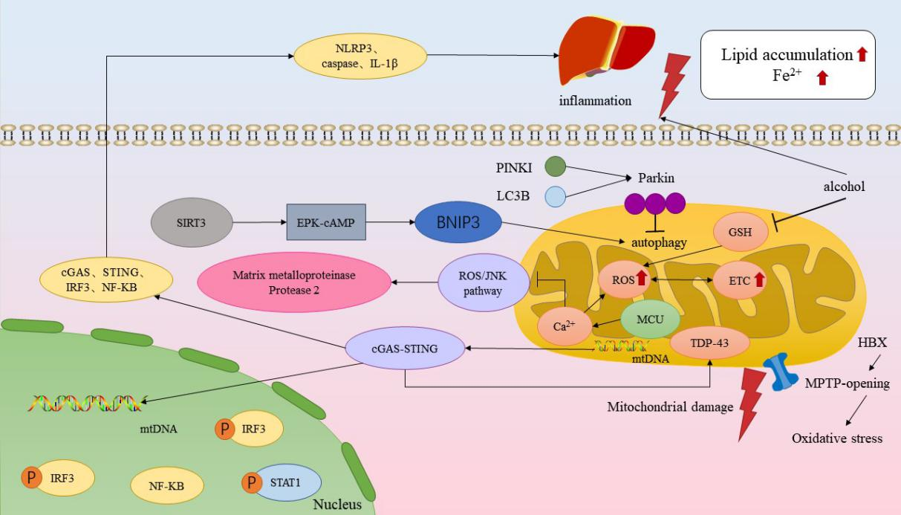
Figure 1 Molecular mechanism of mitochondrial dysfunction modulating the relationship between chronic liver disease. Increasing electron transport chain (ETC) leads to excess reactive oxygen species (ROS), causing corresponding metabolic changes and ultimately ETC dysfunction. Alcohol metabolism, which decreases GSH levels in mitochondria, increases ROS production and causes iron death. Interfering with autophagy by silencing Parkin led to enhanced apoptotic signaling, while SIRT3 increased BNIP3 expression in hepatocytes via the ERK-cAMP pathway, promoting BNIP3-mediated mitochondrial autophagy. Mitochondrial injury can lead to mtDNA leakage, which triggers an inflammatory response through the cGAS-String pathway. cGAS-STRING signaling pathway key molecules, cGAS, STING, and IRF3 expression levels, as well as the downstream NF-κB nuclear translocation, were significantly increased, and at the same time, it caused the accumulation of TDP-43 in the mitochondria of hepatocytes, which induced mitochondrial damage. Inflammatory response significantly increased the expression levels of NLRP3, caspasel and IL-1β in the liver, resulting in iron accumulation and lipid accumulation. ETC: Electron transport chain; ROS: Reactive oxygen species.
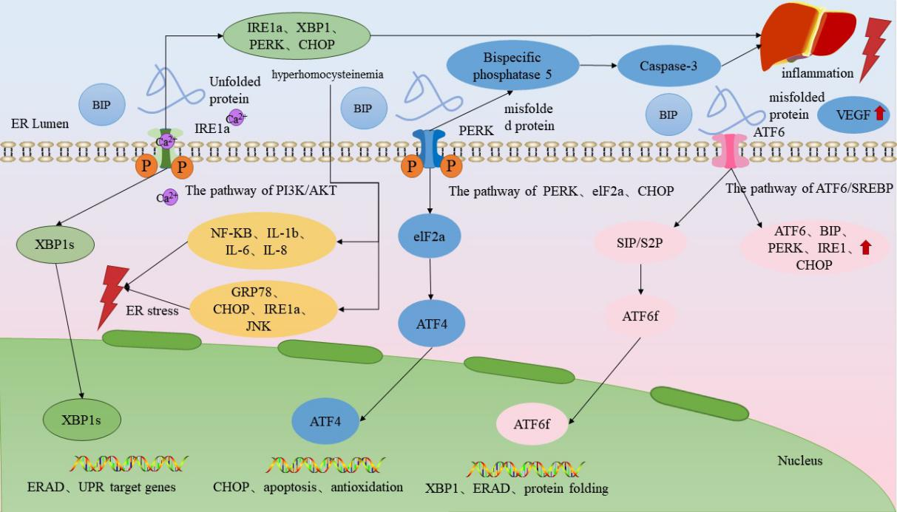
Figure 2 Endoplasmic reticulum dysfunction modulates chronic liver disease. Upon occurrence of endoplasmic reticulum stress (ERS), BiP dissociates from the three ER transmembrane proteins and binds to unfolded proteins with high affinity, and the dissociated transmembrane proteins shift to an active state and activate downstream signaling. Upon dissociation from BiP upon ERS, PERK endoplasmic reticulum stress increases the expression of bispecific phosphatase 5 in hepatocytes through the PERK/eIF2α/CHOP pathway as a means of raising the intracellular activated caspase-3 levels, which ultimately induces hepatocyte death. ATF6 is cleaved upon dissociation from BiP during ERS onset, and cleaved ATF6α activates the transcription of XBP1u.IRE1α is activated and translocates to the cell membrane via the PI3K/AKT pathway, leading to extracellular Ca²⁺ inward flow, which disrupts the intracellular calcium homeostasis and triggers ERS, so that IRE1 α, XBP1, PERK and CHOP upregulation, which ultimately leads to hepatic stellate cell activation and proliferation and promotes liver fibrosis. ER: Endoplasmic reticulum; VEGF: Vascular endothelial growth factor.
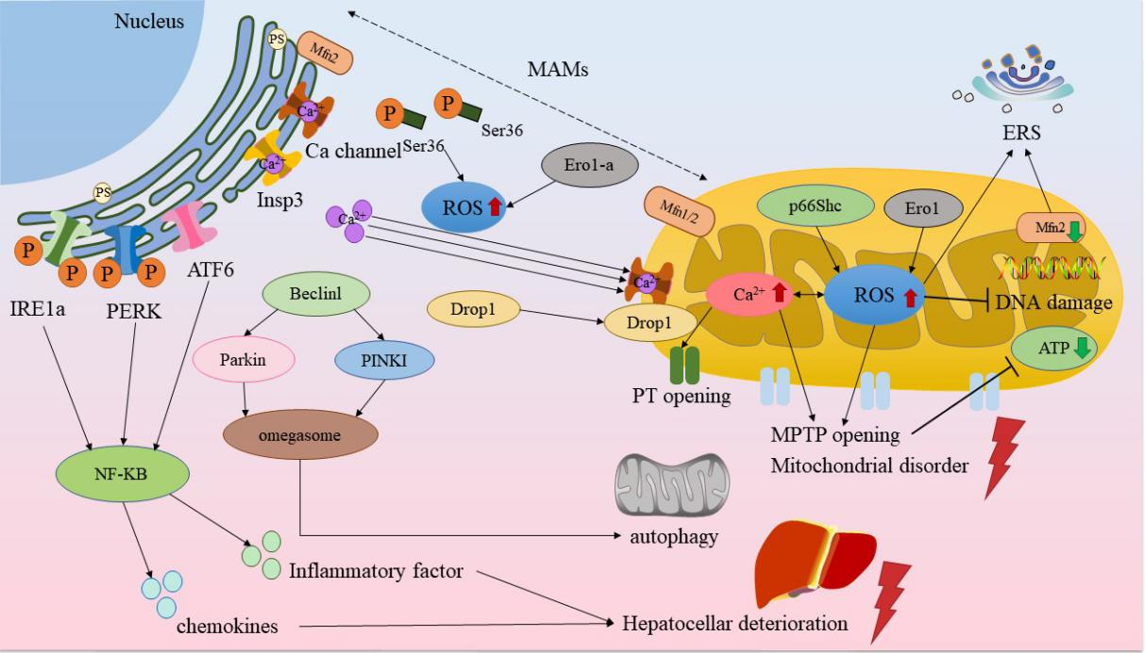
Figure 3 Mitochondrial and endoplasmic reticulum-associated signaling regulates the molecular mechanism of chronic liver disease. Reactive oxygen species (ROS) in the endoplasmic reticulum (ER) initiates Ca²⁺ efflux from Insp3 and Ca ion channels, and the Ser36 site is dephosphorylated and can be transferred to mitochondria-associated ER membranes (MAMs) to mediate ROS production. ROS promotes Ca²⁺ in the ER to flow to the mitochondria through the MAMs and increases mitochondrial ROS production, and conversely, the increase in ROS affects Ca²⁺ and initiates the opening of permeability transition pores, and the swelling of the mitochondria causes the rupture of the outer membrane, which can lead to oxidative damage to DNA and cause adenosine triphosphate depletion. Beclinl and PINK1/Parkin mediate mitochondrial autophagy, and together with PINKI, promote an increase in MAMs and omegasome formation. Excessive accumulation of ROS leads to endoplasmic reticulum stress, activation of the ATF6, IRE1, and PERK, the three unfolded protein response pathways, and the up-regulation of NF-κB activity, promoting the secretion of hepatocyte inflammatory factors and chemokines, leading to functional deterioration of hepatocytes. MAMs: Mitochondria-associated ER membranes; ERS: Endoplasmic reticulum stress; ATP: Adenosine triphosphate.
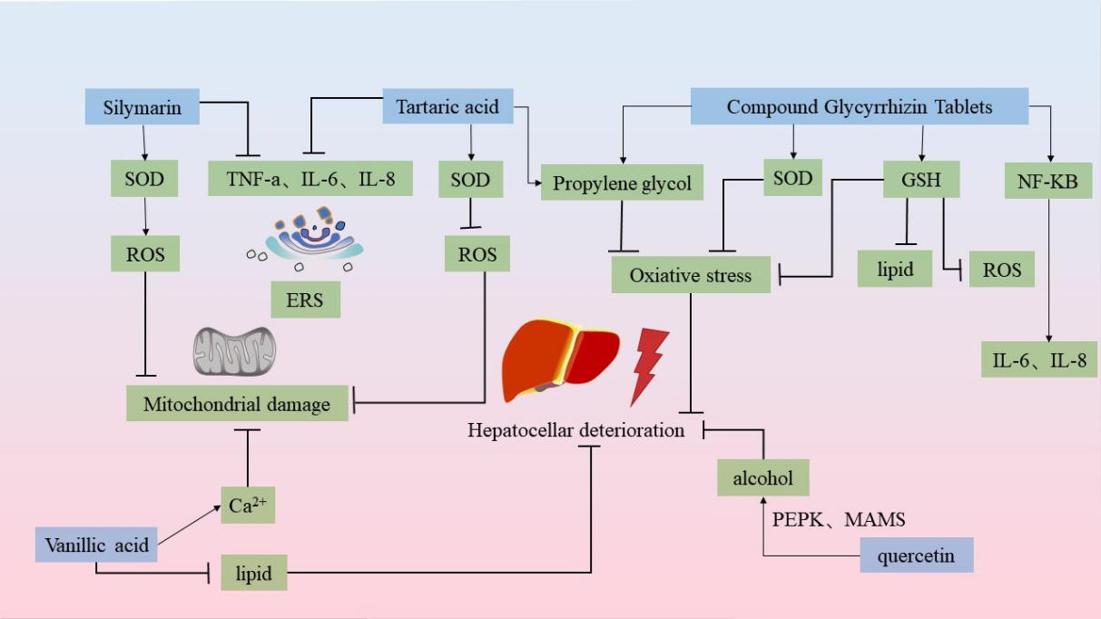
Figure 4 Molecular mechanism of Chinese medicines regulating the treatment of chronic liver disease. Silymarin increases the expression of superoxide dismutase (SOD) to reduce the levels of reactive oxygen species (ROS) and TNF-α, IL-6, IL-8, etc. to stabilize the endoplasmic reticulum (ER). Rhein is capable of anti-lipid peroxidation and scavenging of ROS, and inhibits the activities of TNF-a and IL-1β to stabilize the ER. vA significantly reduces malondialdehyde and elevates the levels of SOD to reduce ROS in mitochondria. vA has the ability to reduce lipid accumulation in hepatocytes and protect ER and Ca²⁺ homeostasis. quercetin inhibits alcohol and Ca²⁺ homeostasis through the regulation of PERK-MAMs pathway. VA has the ability to reduce intracellular lipid accumulation in hepatocytes and effectively protect ER and Ca²⁺ homeostasis. quercetin inhibits alcohol-induced iron death in hepatocytes and alleviates alcoholic liver injury through the regulation of the PERK-MAMs pathway. Composite glycyrrhizin tablets inhibit NF-κB pro-inflammatory signaling and IL-6 and IL-1β activities by inhibiting NF-κB pro-inflammatory signaling and IL-6 and IL-1β activities. transduction and IL-6 and IL-8 expression to inhibit hepatic injury, and also by promoting SOD and GSH expression as well as inhibiting malondialdehyde synthesis, induced hepatocellular injury. GSH passages inhibit ROS generation and attenuate hepatic injury caused by oxidative stress. ROS: Reactive oxygen species; ERS: Endoplasmic reticulum stress; SOD: Superoxide dismutase.

