Name of Journal: World Journal of Gastroenterology
Manuscript NO: 59172
Manuscript Type: ORIGINAL ARTICLE

Clinical and Translational Research
Quantitative multiparametric magnetic resonance imaging can aid non-alcoholic steatohepatitis diagnosis in a Japanese cohort

Imajo K et al. Quantitative MRI for NASH

Kento Imajo, Louise Tetlow, Andrea Dennis, Elizabeth Shumbayawonda, Sofia Mouchti, Timothy J Kendall, Eve Fryer, Shogi Yamanaka, Yasushi Honda, Takaomi Kessoku, Yuji Ogawa, Masato Yoneda, Satoru Saito, Catherine Kelly, Matt D Kelly, Rajarshi Banerjee, Atsushi Nakajima

Kento Imajo, Yasushi Honda, Takaomi Kessoku, Yuji Ogawa, Satoru Saito, Atsushi Nakajima, Department of Gastroenterology and Hepatology, Yokohama City University School of Medicine, Yokohama 236-0004, Japan

Louise Tetlow, Andrea Dennis, Elizabeth Shumbayawonda, Sofia Mouchti, Catherine Kelly, Matt D Kelly, Rajarshi Banerjee, Innovation, Perspectum, Oxford OX4 2LL, United Kingdom

Timothy J Kendall, Centre for Inflammation Research, University of Edinburgh, Edinburgh, United Kingdom, Edinburgh EH16 4TJ, United Kingdom

Eve Fryer, Department of Cellular Pathology, Oxford University Hospitals NHS Foundation Trust, Oxford OX3 9DU, United Kingdom

Shogi Yamanaka, Anatomic and Clinical Pathology Department, Yokohoma City University Hospital, Yokohoma 236-0004, Japan

Masato Yoneda, Department of Gastroenterology, Yokohama City University Graduate School of Medicine, Yokohama 236-0004, Japan

Author contributions: Imajo K and Nakajima A developed the study concept, protocols and initiated the project; Kelly MD and Banerjee R assisted in the further development of the protocol and drafting the clinical study protocol; Imajo K, Nakajima A, Fryer E, Kendall TJ, Yamanaka S, Honda Y, Kessoku T, Ogawa Y, Yoneda M and Saito S contributed to the data collection; Tetlow L, Dennis AM, Shumbayawonda E to the data analysis; Imajo K, Tetlow L, Nakajima A, Dennis AM, Shumbayawonda E, Kelly C, Kelly MD and Banerjee R drafted and completed the manuscript. All authors contributed to the final manuscript.

Corresponding author: Andrea Dennis, PhD, Research Scientist, Innovation, Perspectum, Gemini One, 5520 John Smith Drive, Oxford OX4 2LL, United Kingdom. andrea.dennis@perspectum.com

Received: August 28, 2020
Revised: November 17, 2020
Accepted: December 28, 2020
Published online: January 21, 2021

Abstract
BACKGROUND
Non-invasive assessment of non-alcoholic steatohepatitis (NASH) is increasing in desirability due to the invasive nature and costs associated with the current form of assessment; liver biopsy. Quantitative multiparametric magnetic resonance imaging (mpMRI) to measure liver fat (proton density fat fraction) and fibroinflammatory disease [iron-corrected T1 (cT1)], as well as elastography techniques [vibration-controlled transient elastography (VCTE) liver stiffness measure], magnetic resonance elastography (MRE) and 2D Shear-Wave elastography (SWE) to measure stiffness and fat (controlled attenuated parameter) are emerging alternatives which could be utilised as a safe surrogates to liver biopsy.

AIM
To evaluate the agreement of non-invasive imaging modalities with liver biopsy, and their subsequent diagnostic accuracy for identifying NASH patients.

METHODS
From January 2019 to February 2020, Japanese patients suspected of NASH were recruited onto a prospective, observational study and were screened using non-invasive imaging techniques; mpMRI with LiverMultiScan®, VCTE, MRE and 2D-SWE. Patients were subsequently biopsied, and samples were scored by three independent pathologists. The diagnostic performances of the non-invasive imaging modalities were assessed using area under receiver operating characteristic (AUC) with the median of the histology scores. Concordance between all three independent pathologists was further explored using Krippendorff’s alpha (a) from weighted kappa statistics.

RESULTS
N = 145 patients with mean age of 60 (SD: 13 years.), 39% females, and 40% with body mass index ≥ 30 kg.m⁻² were included in the analysis. For identifying patients with NASH, MR liver fat and cT1 were the strongest performing individual measures (AUC: 0.80 and 0.74 respectively), and the combined mpMRI metrics (cT1 and MR liver fat) were the overall best non-invasive (AUC: 0.83). For identifying fibrosis ≥ 1, MRE performed best (AUC: 0.97), compared to VCTE-liver stiffness measure (AUC: 0.94) and 2D-SWE (AUC: 0.94). For assessment of steatosis ≥ 1, MR liver fat was the best performing non-invasive (AUC: 0.92), compared to controlled attenuated parameter (AUC: 0.75). Assessment of the agreement between pathologists showed that concordance was best for steatosis (a = 0.58), moderate for ballooning (a = 0.40) and fibrosis (a = 0.40), and worst for lobular inflammation (a = 0.12).

CONCLUSION
Quantitative mpMRI is an effective alternative to liver biopsy for diagnosing NASH and non-alcoholic fatty liver, and thus may offer clinical utility in patient management.

Key Words: Corrected T1; Fibro-inflammation; Non-invasive imaging; Non-alcoholic steatohepatitis; Multiparametric magnetic resonance imaging; Non-alcoholic fatty liver disease

Imajo K, Tetlow L, Dennis A, Shumbayawonda E, Mouchti S, Kendall TJ, Fryer E, Yamanaka S, Honda Y, Kessoku T, Ogawa Y, Yoneda M, Saito S, Kelly C, Kelly MD, Banerjee R, Nakajima A. Quantitative multiparametric magnetic resonance imaging can aid non-alcoholic steatohepatitis diagnosis in a Japanese cohort. World J Gastroenterol 2021; 27(3): 0000-0000 URL: https://www.wjgnet.com/1007-9327/full/v27/i3/0000.htm DOI: https://dx.doi.org/10.3748/wjg.v27.i3.0000

Core Tip: There is growing interest in the utility of non-invasive tests in the management of non-alcoholic steatohepatitis (NASH). We explored how magnetic resonance imaging technology can stratify patients with simple fatty liver disease from those with NASH. Our results showed that quantitative magnetic resonance imaging derived metrics showed the strongest correlations to the histological pathological components of NASH with very few technical failures. We also observed very high levels of inter-reader disagreement in histopathological biopsy reads, highlighting the pressing need for alternative diagnostic tests for NASH. Our work therefore supports the use of this non-invasive technology in day-to-day practice.
INTRODUCTION
Non-alcoholic fatty liver disease (NAFLD) is the most common cause of chronic liver disease, affecting approximately 25% of the general population worldwide^{[1]} and up to 30% of the general population in Japan^{[2]}. Additionally, up to 19% of individuals in south east Asia with body mass index (BMI) ≤ 25 kg/m² have “lean” or “non-obese” NAFLD^{[3,4]}. The scope of disease aetiologies within NAFLD differ in both clinical significance and prognosis^{[1,5–7]} on a continuum that encompasses “simple steatosis” or NAFL (hepatic steatosis without inflammation), to non-alcoholic steatohepatitis (NASH) and NASH cirrhosis. NASH results when fat accumulation in the liver triggers inflammatory signals and reactive oxygen species that can amplify liver injury and stimulate fibrosis^{[8]}. NASH is predicted to become the leading cause of liver transplant over the coming decade^{[1]} as NASH patients have a greater tendency to develop advanced liver fibrosis, cirrhosis, and hepatocellular carcinoma^{[9–11]}.
Liver biopsy is the current gold standard for differentiating simple steatosis from NASH as well as staging the severity of fibrosis in patients with NAFLD^{[12]}. However, due to the limitations associated with biopsy^{[13]}, high procedure costs, high levels of discordance between readers, and poor acceptability by patients, there has been an increase in the use of non-invasive imaging biomarkers to diagnose and monitor the disease.
Vendor-neutral and scalable multiparametric magnetic resonance imaging (mpMRI) measurements of liver fat proton density fat fraction with IDEAL and iron corrected T1-mapping (cT1) are emerging as promising quantitative imaging biomarkers for NASH. MRI liver fat correlates strongly with histologically graded steatosis across the clinical range seen in NASH^{[14]} and has high diagnostic accuracy in stratifying all grades of liver steatosis^{[15-17]}, cT1 has been shown to correlate with ballooning^{[18]}, and has been shown to predict clinical outcomes in patients with chronic liver disease^{[19,20]}. Both metrics have good technical validity with high repeatability and reproducibility across MRI manufacturers and field strength^{[21]}. Additionally, due to their sensitivity to subtle changes in hepatic fat and fibro-inflammation, mpMRI techniques are increasingly used as inclusion criteria endpoints in NASH clinical trials and are included in the FDA Biomarker Qualification Program.
Magnetic resonance elastography (MRE) is an alternative MR based approach that can be used to stage fibrosis. MRE has shown utility in identifying patients with NASH from those with simple steatosis^{[22]} whilst also being able to detect the presence of advanced fibrosis in patients with chronic liver disease^{[23]}. However, MRE has not demonstrated sufficient utility for the longitudinal monitoring of fibrosis progression or regression^{[14,24]}.
Ultrasound based methods such as vibration-controlled transient elastography (VCTE) liver stiffness measure (VCTE-LSM) have shown good utility in identifying patients with advanced fibrosis^{[25,26]}, however may be less reliable in patients who are morbidly obese; a high-risk group for NASH^{[25]}. VCTE controlled-attenuation parameter (CAP) has been shown to be sensitive to early changes in liver fat albeit with a low ability to differentiate steatosis levels.
The aim of this study was to evaluate the diagnostic performance of quantitative mpMRI, MRE, and transient elastography (VCTE and 2D shear-wave elastography) to identify patients with suspected NASH and to report on the correlations between these non-invasive technologies and histology.

MATERIALS AND METHODS
This was an observational trial conducted and sponsored by the Yokohoma City University Hospital between January 2019 and February 2020. N = 151 adult participants who underwent a liver biopsy for suspected NASH were included in this interim analysis. Participants were invited to undergo core liver biopsy if there was evidence of steatosis (Proton density fat fraction ≥ 5.2% or CAP ≥ 236)^{[16]}. Patients were excluded if there was contraindication to MRI, history of alcoholism, or evidence of other chronic liver disease (Figure 1). The study was conducted in accordance with the ethical principles of the Declaration of Helsinki 2013, was approved by the Ethics Committee of Yokohama City University Hospital and was registered as a clinical trial (UMIN Clinical Trials Registry: UMIN000026145).

Histopathological evaluations
Liver biopsy samples were obtained using a 16-gauge needle biopsy kit with an adequate liver biopsy defined as being ≥ 20 mm in length and/or with ≥ 10 portal tracts. Biopsy samples were assessed independently by three histopathologists, one at YCUH at the time of collection and then later by a further two pathologists using digitalised biopsy slides. Histological scoring of fibrosis, steatosis, lobular inflammation, and hepatocyte ballooning was performed by all pathologists, and overall disease activity was graded according to the NAFLD activity score [NASH Clinical Research Network (NAS)]. NASH was defined as NAS ≥ 4, ballooning ≥ 1 and inflammation ≥ 1 as described in AASLD guidelines^{[12]}. All scores were taken from the median score for each component from the three pathologists.

Non-invasive biomarkers
MR liver fat and cT1 measurements were made using the non-contrast LiverMultiScan® mpMRI protocol (Perspectum, Oxford, United Kingdom), performed with the patient in the supine position using a 3 Tesla GE Discovery 750W scanner system (GE Healthcare, Milwaukee, WI, United States). The average scan time for this protocol was 10 min. Four single transverse slices were captured through the liver centered on the porta hepatis. Anonymised mpMRI data were analysed off-site by image analysts trained in abdominal anatomy and artefact detection, who were blinded to the clinical data and risk grouping. For liver fat, three 15 mm diameter circular regions of interest (ROIs) were selected on the transverse maps to cover a representative sample of the liver parenchyma. For cT1 (ms), three ROIs were placed on the central slice within the typical percutaneous biopsy region. Median values from all pixels within the ROIs were calculated and used as the representative score.
MRE examinations were performed using the same MRI scanner and following a 2-dimensional MRE protocol^{[27]}. Interpretation of MRE images to obtain stiffness values was performed by abdominal radiologists^{[22]}. VCTE-LSMs were obtained by one operator using either 3.5 MHz M-probe and/or 2.5 MHz XL-probe dependent upon suitability (waste-hip circumference and BMI) and through use of the automatic probe selection tool embedded within the FibroScan operating software^{[28]}. VCTE-LSM measures with at least 10 valid shots and a success rate of ≥ 60% were considered reliable and used for statistical analysis. Hepatic steatosis was assessed using the CAP value provided by the device. 2D shear-wave elastography (2D-SWE) measurements were obtained using a Logiq S8 system (GE Healthcare)^{[29]}. Example images are shown in Figure 2 for all methods.

Statistical analysis
Descriptive statistics were used to summarise baseline participant characteristics. Continuous variables were reported as mean and standard deviation, categorical variables were reported as frequency and percentage, and confidence intervals (CI) were reported at the 95% level. Mean difference in biomarker values between those with NAFL and those with NASH were compared using independent t-tests or Wilcoxon signed-rank tests, depending on distribution. Diagnostic performance of non-invasive biomarkers was assessed using area under receiver operator characteristic curve (AUC) with multivariate logistic regressions utilised to assess performance of combined biomarkers. Correlations between median scores from the 3 pathology reads and image-derived markers (liver fat, cT1, MRE, VCTE-LSM and CAP) were assessed using Spearman’s rank correlation coefficient.
Inter-rater variability analysis between the pathology scores given by the 3 pathologists were performed using tri-variate weighted kappa statistic, with the overall variability seen for each of the histological metrics assessed by Krippendorff’s alpha. Agreement between pathologists was determined utilising guidelines for hierarchical kappa-type statistics^{[30]}.
Statistical analysis was performed using R software version 3.6.1 with P < 0.05 considered to be statistically significant. Case-wise deletion was employed to include only complete cases for MR metrics, VCTE-LSM and CAP for each analyses as appropriate rather than imputing any missing values.

RESULTS
Of the initial 151 patients who underwent liver biopsy, 145 were eligible for the study. The average age was 60 (± 13) years, 61% patients were male, 40% BMI ≥ 30 kg.m⁻² and 60% of patients had NASH (NAS ≥ 4 with ballooning ≥ 1 and inflammation ≥ 1; Table 1). There was a broad range of histology scores across all aspects of the key histopathological hallmarks of NASH (Table 2). From the entire cohort, one had missing MRE data, two had missing LiverMultiScan® data, 28 missing or uninterpretable Fibroscan data, and 61 had missing or uninterpretable 2D-SWE data. Investigation into potential causes of failure for the ultrasound based methods revealed BMI to be significantly higher in the cases in which VCTE-LSM was unreported (31.7 kg.m⁻² vs 28.1 kg.m⁻², P < 0.05), and similarly was elevated in those with missing 2D-SWE (29.5 kg.m⁻² vs 27.9 kg.m⁻²).

Diagnostic accuracy of non-invasive imaging markers for differentiation of disease activity

Steatosis (NAFL): MR Liver fat [AUC: 0.92 (CI: 0.87-0.98)], and CAP [AUC: 0.75 (CI: 0.58-0.92)] both discriminated between steatosis ≥ 1, while the other imaging markers were unable to [cT1 AUC: 0.64 (CI: 0.46-0.82), MRE AUC: 0.53 (CI: 0.33-0.72), VCTE-LSM AUC: 0.60 (CI: 0.37-0.82), 2D-SWE AUC: 0.53 (CI: 0.22-0.84)]. For steatosis ≥ 2, MR liver fat again showed the best performance [MR liver fat: AUC: 0.86 (CI: 0.80-0.93); vs CAP AUC: 0.68 (CI: 0.59-0.78)]. 7 patients had CAP technical failure and 10 patients were not able to gain reliable results.

NASH: To diagnose steatohepatitis (NAS ≥ 4 with at least one in both ballooning and inflammation), MR liver fat [AUC: 0.80 (CI: 0.73-0.87)], cT1 [AUC: 0.75 (CI: 0.67-0.84)], and CAP [AUC: 0.71 (CI: 0.62-0.80)] all had good discriminatory performance, while VCTE-LSM [AUC: 0.56 (CI: 0.45-0.66)], MRE [AUC: 0.57 (CI: 0.47-0.67)] and 2D-SWE [AUC: 0.58 (CI: 0.45-0.71)] were not as effective (Figure 3). Multivariate analysis to explore the potential for increased diagnostic performance of biomarkers used in combination for identifying those with NASH, revealed the combination of cT1 and MR liver fat [AUC: 0.83 (CI: 0.76-0.90)] was superior to the individual markers and to that of VCTE-LSM and CAP in combination [AUC: 0.71 (CI: 0.66-0.8)] (Figure 4).

Fibrosis: To measure fibrosis alone, MRE [AUC: 0.97 (CI: 0.94-1.0)], VCTE-LSM [AUC: 0.94 (CI: 0.9-0.99)] and 2D-SWE [AUC: 0.94 (CI: 0.86-1.0)] were all excellent at discriminating for any fibrosis (≥ 1) whilst MR liver fat [AUC: 0.68 (CI: 0.44-0.92)], cT1 [AUC: 0.63 (CI: 0.3-0.97)] and CAP [AUC: 0.6 (CI: 0.39-0.81)] were not as effective. These performances were maintained for discriminating those with more advanced fibrosis (≥ 2): MRE [AUC: 0.92 (CI: 0.87-0.97)]; VCTE-LSM [AUC: 0.88 (CI: 0.81-0.95)]; 2D-SWE [AUC: 0.87 (CI: 0.76-0.99)] compared to cT1 [AUC: 0.62 (CI: 0.49-0.74)] MR liver fat [AUC: 0.60 (CI: 0.48-0.72)] and CAP [AUC: 0.57 (CI: 0.45-0.70)]. VCTE-LSM, and to an even greater extent 2D-SWE, however both had high levels of missing data (20% and 42% respectively) likely related to elevated obesity.

Advanced NASH: To identify those with NASH and advanced fibrosis (NAS ≥ 4 with F ≥ 2), both cT1 [AUC: 0.74 (CI: 0.66-0.82)] and MR liver fat [AUC: 0.71 (CI: 0.63-0.80)] outperformed the other measures; MRE [AUC 0.66 (CI: 0.57-0.75)], VCTE-LSM [AUC: 0.64 (CI: 0.54-0.74)], CAP [AUC: 0.68 (CI: 0.59-0.78)], and 2D-SWE [AUC: 0.62 (CI: 0.49-0.75)]. Combining cT1 and MR liver fat improved the performance [AUC: 0.76 (CI: 0.69-0.84)] and was superior to the combination of VCTE-LSM and CAP [AUC: 0.70 (CI: 0.61-0.79)], (Figure 4).

Correlations between image derived biomarkers and histological markers of disease
MRI cT1 correlated significantly with all key aspects of histology [fibrosis, steatosis, ballooning and lobular inflammation (r_{s} = 0.24, r_{s} = 0.29, r_{s} = 0.39, r_{s} = 0.31, respectively)] and with overall NAS (r_{s} = 0.58). MR liver fat was positively correlated with steatosis (r_{s} = 0.70), and with inflammation (r_{s} = 0.28), ballooning (r_{s} = 0.29) and overall NAS (r_{s} = 0.64) but was negatively correlated with fibrosis (r_{s} = -0.25). MRE was significantly correlated with fibrosis (r_{s} = 0.75) and ballooning and lobular inflammation (r_{s} = 0.32, r_{s} = 0.16 respectively) and negatively correlated with steatosis (r_{s} = -0.23). VCTE-LSM correlated significantly with fibrosis (r_{s} = 0.69) and ballooning (r_{s} = 0.29), and CAP with steatosis (r_{s} = 0.39), inflammation (r_{s} = 0.26), ballooning (r_{s} = 0.33) and NAS (r_{s} = 0.49). 2D shear-wave elastography was positively correlated with fibrosis (r_{s} = 0.72) and ballooning (r_{s} = 0.34; Table 3).

Concordance between pathologists
Assessment of the overall agreement (Krippendorff’s alpha) of the pathologists for each histological marker showed that there was moderate agreement for indicators of steatosis and NAS (a = 0.58 and a = 0.42 respectively), fair agreement for ballooning and fibrosis (a = 0.40 for both), and none to slight agreement on lobular inflammation (a = 0.11). Assessment of the trivariate weighted kappa scores from individual pathologists for each metric showed no reoccurring pattern of agreement between any two pathologists (Table 4).

DISCUSSION
The diagnosis of NASH is important as it provides prognostic information indicating an increased risk of fibrosis progression and liver-related mortality but has hitherto been limited because of the need for histological verification. In clinical practice, distinguishing between NAFL, NASH, and NASH with fibrosis is highly desirable for risk stratification. Patients with steatosis can be educated about future cardiovascular risk, and lifestyle measures to prevent them, while those with NASH, or NASH and fibrosis, can be monitored and treated (pioglitazone, cevoglitazar) to reduce the risk of cardiovascular and liver clinical complications. In this study, we were able to identify and differentiate patients with steatosis, NASH, and NASH with fibrosis with good diagnostic performance using non-invasive technologies which characterise liver tissue accurately.
The diagnosis of NASH is based, at present, on the histological presence of steatosis and either lobular inflammation or ballooning, with the presence of fibrosis highlighting disease progression. Currently, the only biomarkers shown to predict outcomes in patients are histological fibrosis and cT1^{[19,20,31]}. However, cT1 is sensitive to ballooning, inflammation, steatosis as well as fibrosis, and so cannot be considered a pure fibrosis biomarker. When measuring just fibrosis, MRE had greater correlations to histology and greater sensitivity than other methods but could not by itself distinguish NAFL from NASH or NASH with fibrosis. Whilst ultrasound methods are also effective for staging advanced fibrosis, in line with reported literature^{[32–35]}, they can be less reliable in patients with obesity as seen in the higher BMI observed in this cohort with missing VCTE and 2D-SWE data. In contrast BMI has not been shown to systematically affect the failure rate for MRE^{[23]} or of mpMRI^{[36,37]}, except for the very unusual conditions when a participant is simply too large to fit into the scanner. All elastography measures however have been shown to be confounded by iron, steatosis and inflammation^{[38]} in the measure of fibrosis.
The assessment of steatosis is important as the accumulation of liver fat is linked with the progression of hepatocyte injury that can ultimately result in fibrosis^{[39]}; the downstream consequence of NASH which is linked to poor clinical outcomes^{[31]}. In this study, MR liver fat demonstrated better performance than CAP for the detection and differentiation of steatosis grades. As a result, this makes MR liver fat a good marker of NAFL and NASH. Where cT1 appears to have an advantage over MR liver fat as a non-invasive biomarker for NASH is in the detection and diagnosis of patients with both NASH and fibrosis. Both cT1, and uncorrected T1 have been reported to be elevated in those with advanced liver fibrosis^{[40–43]}. A key limitation of MR liver fat as a solo biomarker of NASH is that patients with advanced fibrosis and cirrhosis have lower acclimations of liver fat than those at earlier stages of disease^{[44,45]}. Our results, in line with those reported in the literature, demonstrate a negative association between MR liver fat and advanced fibrosis^{[44,45]}. This is an important consideration when using MR liver fat as a biomarker for those with NASH with fibrosis, and is reflected in the superior diagnostic accuracy of cT1 when compared to MR liver fat for identifying those with NASH and fibrosis ≥ 2.
In this study assessing the ability of different non-invasive biomarkers to detect NASH, MR liver fat and cT1 were superior to the other metrics investigated. Crucially however, the composite marker of cT1 and MR liver fat showed the greatest diagnostic accuracy. Furthermore, when the contribution from steatosis was reduced due to the increase in fibrosis, the correlation between inflammation and MR liver fat disappeared, whilst the correlation with cT1 remained, suggesting an independent association between cT1 and inflammation. The relationship between inflammation and cT1 in the absence of steatosis has also been observed in patients with hepatitis C, where cT1 was positively correlated with inflammation^{[19]}.
New diagnostic tools are evaluated by comparison to histological measures. Recent studies on the reproducibility of histology^{[46]} have established that biopsy as the de facto benchmark is not perfect. We also observed discordance between different pathologists across the four cardinal pathological features (steatosis, ballooning, lobular inflammation and fibrosis), with no common pattern of concordance seen between any two pathologists. Previous literature discusses the subjective nature of histological grading systems^{[47]} which is evident in these findings, demonstrating that subjectivity as well as potential sampling and human error can affect results^{[48–50]}. This analysis highlights the need for more robust endpoints with which to evaluate the performance of non-invasive diagnostics. The gold standard would be a tool that predicts clinical outcomes and can thus provide prognosis. Whilst such studies are both time-consuming and costly in order to generate the necessary evidence, encouragingly, initial work in this space has demonstrated potential for cT1 to predict clinical outcomes in patients with chronic liver disease^{[19,20]}. It is hoped that further validation of these observations in patients with NASH specifically will aid in the development of a clinical pathway that does not rely on invasive liver biopsy.
This study was not without its limitations, with the pre-screening step prior to liver biopsy likely truncating the correlations that would be observed across the full disease spectrum. While this may also impact the diagnostic accuracy evaluated, this pre-screening approach is representative of clinical practice. Observed failure rates for the ultrasound-based methods also have the potential to skew the results given its dependence on BMI, with patients with high BMI less likely to be included in the study. In practice this has a bearing on the value proposition of such technologies for screening and monitoring as failed measurements will result in necessary further clinical tests for patients.

CONCLUSION
In summary, this study demonstrates the clinical utility of mpMRI for the stratification of NAFLD, and encourages mpMRI use as a non-invasive alternative to biopsy in the clinical care pathway. Quantitative mpMRI metrics showed the strongest overall correlations to the histological components of NASH with fewer technical failures. mpMRI also out-performed MRE and ultrasound-based elastography methods in the identification of patients with NASH and fibrosis. The ability to risk stratify patients in a single non-invasive test is a particular strength of mpMRI, offering a safe and cost-effective alternative to liver biopsy.

ARTICLE HIGHLIGHTS
Research background
Non-alcoholic fatty liver disease affects 25% of the population worldwide and up to 30% in the Japanese population, and in some can progress to non-alcoholic steatohepatitis (NASH), a leading cause of liver transplant due to its strong propensity to develop into cirrhosis and hepatocellular carcinoma.

Research motivation
Liver biopsy is the current reference standard for a clinical diagnosis of NASH, a method that is expensive, invasive and suffers from great observer variability. Non-invasive and scalable alternatives are required in order to meet the burgeoning demands of the disease on clinical caseloads across the globe.

Research objectives
The main objectives of the study were to evaluate the diagnostic performance of non-invasive, image derived metrics to identify patients with suspected NASH. The metrics under investigation included two quantitative multi-parametric magnetic resonance imaging (MRI) measures, iron corrected T1 mapping [(cT1), a marker of fibro-inflammation] and proton density liver fat fraction (a marker of liver fat), magnetic resonance elastography and ultrasound based transient elastography (vibration-controlled transient elastography and 2D shear-wave elastography), both markers of liver stiffness.

Research methods
In an observational study of patients who were being screened clinically on suspicion of NASH, n = 145 individuals underwent liver biopsy and concomitant imaging measures of liver health. Diagnosis of NASH was based on histology, graded using the NAS- Clinical Research Network scoring system and diagnostic accuracy of the image-derived metrics assessed using area under receiver operator characteristic curve. In addition, the biopsy slides were read by 2 further pathologists and comparisons made to explore the level of agreement on diagnosis between individual doctors.

Research results
In this study assessing the ability of different non-invasive biomarkers to detect NASH, MR liver fat and cT1 were superior to the other metrics investigated. Crucially however, the composite marker of cT1 and MR liver fat showed the greatest diagnostic accuracy for identifying those with NASH and also those with NASH with fibrosis. These measures also had very few technical failures. This is the first assessment and direct comparison of these technologies in a Japanese cohort. We also observed discordance between different pathologists across the four cardinal pathological features (steatosis, ballooning, lobular inflammation and fibrosis), with no common pattern of agreement seen between any two pathologists.

Research conclusions
These results demonstrate the clinical utility of quantitative multiparametric magnetic resonance imaging (mpMRI) for the identification and stratification of patients with NASH from those with evidence of NAFLD and encourages mpMRI use as a non-invasive alternative to biopsy in the clinical care pathway. Quantitative mpMRI metrics showed the strongest correlation to the histological components of NASH with fewer technical failures. mpMRI also out-performed magnetic resonance elastography and ultrasound-based elastography methods in the identification of patients with NASH and fibrosis. Liver biopsy suffered from high levels of inter-reading disagreement, highlighting the pressing need for alternative diagnostic tests for NASH.

Research perspectives
The ability to risk stratify patients in a single non-invasive test is a particular strength of mpMRI, offering a safe and cost-effective alternative to liver biopsy. Future work should be focused on validating these findings further and on longer term outcomes studies to investigate the prognostic natures of these measurements in a Japanese population.

REFERENCES
1 Younossi Z, Anstee QM, Marietti M, Hardy T, Henry L, Eslam M, George J, Bugianesi E. Global burden of NAFLD and NASH: trends, predictions, risk factors and prevention. Nat Rev Gastroenterol Hepatol 2018; 15: 11-20 [PMID: 28930295 DOI: 10.1038/nrgastro.2017.109]
2 Fan JG, Kim SU, Wong VW. New trends on obesity and NAFLD in Asia. J Hepatol 2017; 67: 862-873 [PMID: 28642059 DOI: 10.1016/j.jhep.2017.06.003]
3 Albhaisi S, Chowdhury A, Sanyal AJ. Non-alcoholic fatty liver disease in lean individuals. JHEP Rep 2019; 1: 329-341 [PMID: 32039383 DOI: 10.1016/j.jhepr.2019.08.002]
4 Younes R, Bugianesi E. NASH in Lean Individuals. Semin Liver Dis 2019; 39: 86-95 [PMID: 30654392 DOI: 10.1055/s-0038-1677517]
5 Angulo P. Long-term mortality in nonalcoholic fatty liver disease: is liver histology of any prognostic significance? Hepatology 2010; 51: 373-375 [PMID: 20101746 DOI: 10.1002/hep.23521]
6 Singh S, Allen AM, Wang Z, Prokop LJ, Murad MH, Loomba R. Fibrosis progression in nonalcoholic fatty liver vs nonalcoholic steatohepatitis: a systematic review and meta-analysis of paired-biopsy studies. Clin Gastroenterol Hepatol 2015; 13: 643-54.e1-9; quiz e39-40 [PMID: 24768810 DOI: 10.1016/j.cgh.2014.04.014]
7 Seki Y, Kakizaki S, Horiguchi N, Hashizume H, Tojima H, Yamazaki Y, Sato K, Kusano M, Yamada M, Kasama K. Prevalence of nonalcoholic steatohepatitis in Japanese patients with morbid obesity undergoing bariatric surgery. J Gastroenterol 2016; 51: 281-289 [PMID: 26314837 DOI: 10.1007/s00535-015-1114-8]
8 Marra F, Lotersztajn S. Pathophysiology of NASH: perspectives for a targeted treatment. Curr Pharm Des 2013; 19: 5250-5269 [PMID: 23394092 DOI: 10.2174/13816128113199990344]
9 Wong SW, Ting YW, Chan WK. Epidemiology of non-alcoholic fatty liver disease-related hepatocellular carcinoma and its implications. JGH Open 2018; 2: 235-241 [PMID: 30483595 DOI: 10.1002/jgh3.12070]
10 Angulo P, Keach JC, Batts KP, Lindor KD. Independent predictors of liver fibrosis in patients with nonalcoholic steatohepatitis. Hepatology 1999; 30: 1356-1362 [PMID: 10573511 DOI: 10.1002/hep.510300604]
11 Ekstedt M, Nasr P, Kechagias S. Natural History of NAFLD/NASH. Curr Hepatol Rep 2017; 16: 391-397 [PMID: 29984130 DOI: 10.1007/s11901-017-0378-2]
12 Chalasani N, Younossi Z, Lavine JE, Charlton M, Cusi K, Rinella M, Harrison SA, Brunt EM, Sanyal AJ. The diagnosis and management of nonalcoholic fatty liver disease: Practice guidance from the American Association for the Study of Liver Diseases. Hepatology 2018; 67: 328-357 [PMID: 28714183 DOI: 10.1002/hep.29367]
13 Piccinino F, Sagnelli E, Pasquale G, Giusti G. Complications following percutaneous liver biopsy. A multicentre retrospective study on 68,276 biopsies. J Hepatol 1986; 2: 165-173 [PMID: 3958472 DOI: 10.1016/s0168-8278(86)80075-7]
14 Harrison SA, Dennis A, Fiore MM, Kelly MD, Kelly CJ, Paredes AH, Whitehead JM, Neubauer S, Traber PG, Banerjee R. Utility and variability of three non-invasive liver fibrosis imaging modalities to evaluate efficacy of GR-MD-02 in subjects with NASH and bridging fibrosis during a phase-2 randomized clinical trial. PLoS One 2018; 13: e0203054 [PMID: 30192782 DOI: 10.1371/journal.pone.0203054]
15 Caussy C, Reeder SB, Sirlin CB, Loomba R. Noninvasive, Quantitative Assessment of Liver Fat by MRI-PDFF as an Endpoint in NASH Trials. Hepatology 2018; 68: 763-772 [PMID: 29356032 DOI: 10.1002/hep.29797]
16 Imajo K, Kessoku T, Honda Y, Tomeno W, Ogawa Y, Mawatari H, Fujita K, Yoneda M, Taguri M, Hyogo H, Sumida Y, Ono M, Eguchi Y, Inoue T, Yamanaka T, Wada K, Saito S, Nakajima A. Magnetic Resonance Imaging More Accurately Classifies Steatosis and Fibrosis in Patients With Nonalcoholic Fatty Liver Disease Than Transient Elastography. Gastroenterology 2016; 150: 626-637.e7 [PMID: 26677985 DOI: 10.1053/j.gastro.2015.11.048]
17 Jayakumar S, Middleton MS, Lawitz EJ, Mantry PS, Caldwell SH, Arnold H, Mae Diehl A, Ghalib R, Elkhashab M, Abdelmalek MF, Kowdley KV, Stephen Djedjos C, Xu R, Han L, Mani Subramanian G, Myers RP, Goodman ZD, Afdhal NH, Charlton MR, Sirlin CB, Loomba R. Longitudinal correlations between MRE, MRI-PDFF, and liver histology in patients with non-alcoholic steatohepatitis: Analysis of data from a phase II trial of selonsertib. J Hepatol 2019; 70: 133-141 [PMID: 30291868 DOI: 10.1016/j.jhep.2018.09.024]
18 Eddowes PJ, McDonald N, Davies N, Semple SIK, Kendall TJ, Hodson J, Newsome PN, Flintham RB, Wesolowski R, Blake L, Duarte RV, Kelly CJ, Herlihy AH, Kelly MD, Olliff SP, Hübscher SG, Fallowfield JA, Hirschfield GM. Utility and cost evaluation of multiparametric magnetic resonance imaging for the assessment of non-alcoholic fatty liver disease. Aliment Pharmacol Ther 2018; 47: 631-644 [PMID: 29271504 DOI: 10.1111/apt.14469]
19 Jayaswal ANA, Levick C, Selvaraj EA, Dennis A, Booth JC, Collier J, Cobbold J, Tunnicliffe EM, Kelly M, Barnes E, Neubauer S, Banerjee R, Pavlides M. Prognostic value of multiparametric magnetic resonance imaging, transient elastography and blood-based fibrosis markers in patients with chronic liver disease. Liver Int 2020 [PMID: 32730664 DOI: 10.1111/Liv.14625]
20 Pavlides M, Banerjee R, Sellwood J, Kelly CJ, Robson MD, Booth JC, Collier J, Neubauer S, Barnes E. Multiparametric magnetic resonance imaging predicts clinical outcomes in patients with chronic liver disease. J Hepatol 2016; 64: 308-315 [PMID: 26471505 DOI: 10.1016/j.jhep.2015.10.009]
21 Bachtiar V, Kelly MD, Wilman HR, Jacobs J, Newbould R, Kelly CJ, Gyngell ML, Groves KE, McKay A, Herlihy AH, Fernandes CC, Halberstadt M, Maguire M, Jayaratne N, Linden S, Neubauer S, Banerjee R. Repeatability and reproducibility of multiparametric magnetic resonance imaging of the liver. PLoS One 2019; 14: e0214921 [PMID: 30970039 DOI: 10.1371/journal.pone.0214921]
22 Chen J, Talwalkar JA, Yin M, Glaser KJ, Sanderson SO, Ehman RL. Early detection of nonalcoholic steatohepatitis in patients with nonalcoholic fatty liver disease by using MR elastography. Radiology 2011; 259: 749-756 [PMID: 21460032 DOI: 10.1148/radiol.11101942]
23 Singh S, Venkatesh SK, Wang Z, Miller FH, Motosugi U, Low RN, Hassanein T, Asbach P, Godfrey EM, Yin M, Chen J, Keaveny AP, Bridges M, Bohte A, Murad MH, Lomas DJ, Talwalkar JA, Ehman RL. Diagnostic performance of magnetic resonance elastography in staging liver fibrosis: a systematic review and meta-analysis of individual participant data. Clin Gastroenterol Hepatol 2015; 13: 440-451.e6 [PMID: 25305349 DOI: 10.1016/j.cgh.2014.09.046]
24 Castera L, Friedrich-Rust M, Loomba R. Noninvasive Assessment of Liver Disease in Patients With Nonalcoholic Fatty Liver Disease. Gastroenterology 2019; 156: 1264-1281.e4 [PMID: 30660725 DOI: 10.1053/j.gastro.2018.12.036]
25 Kwok R, Tse YK, Wong GL, Ha Y, Lee AU, Ngu MC, Chan HL, Wong VW. Systematic review with meta-analysis: non-invasive assessment of non-alcoholic fatty liver disease--the role of transient elastography and plasma cytokeratin-18 fragments. Aliment Pharmacol Ther 2014; 39: 254-269 [PMID: 24308774 DOI: 10.1111/apt.12569]
26 Cosyns B, Lancellotti P. Normal reference values for echocardiography: a call for comparison between ethnicities. Eur Heart J Cardiovasc Imaging 2016; 17: 523-524 [PMID: 26976356 DOI: 10.1093/ehjci/jev353]
27 Yin M, Talwalkar JA, Glaser KJ, Manduca A, Grimm RC, Rossman PJ, Fidler JL, Ehman RL. Assessment of hepatic fibrosis with magnetic resonance elastography. Clin Gastroenterol Hepatol 2007; 5: 1207-1213.e2 [PMID: 17916548 DOI: 10.1016/j.cgh.2007.06.012]
28 Sandrin L, Fourquet B, Hasquenoph JM, Yon S, Fournier C, Mal F, Christidis C, Ziol M, Poulet B, Kazemi F, Beaugrand M, Palau R. Transient elastography: a new noninvasive method for assessment of hepatic fibrosis. Ultrasound Med Biol 2003; 29: 1705-1713 [PMID: 14698338 DOI: 10.1016/j.ultrasmedbio.2003.07.001]
29 Ferraioli G, Tinelli C, Lissandrin R, Zicchetti M, Dal Bello B, Filice G, Filice C. Point shear wave elastography method for assessing liver stiffness. World J Gastroenterol 2014; 20: 4787-4796 [PMID: 24782633 DOI: 10.3748/wjg.v20.i16.4787]
30 Landis JR, Koch GG. An application of hierarchical kappa-type statistics in the assessment of majority agreement among multiple observers. Biometrics 1977; 33: 363-374 [PMID: 884196 DOI: 10.2307/2529786]
31 Angulo P, Kleiner DE, Dam-Larsen S, Adams LA, Bjornsson ES, Charatcharoenwitthaya P, Mills PR, Keach JC, Lafferty HD, Stahler A, Haflidadottir S, Bendtsen F. Liver Fibrosis, but No Other Histologic Features, Is Associated With Long-term Outcomes of Patients With Nonalcoholic Fatty Liver Disease. Gastroenterology 2015; 149: 389-97.e10 [PMID: 25935633 DOI: 10.1053/j.gastro.2015.04.043]
32 Castéra L, Foucher J, Bernard PH, Carvalho F, Allaix D, Merrouche W, Couzigou P, de Lédinghen V. Pitfalls of liver stiffness measurement: a 5-year prospective study of 13,369 examinations. Hepatology 2010; 51: 828-835 [PMID: 20063276 DOI: 10.1002/hep.23425]
33 Petta S, Di Marco V, Cammà C, Butera G, Cabibi D, Craxì A. Reliability of liver stiffness measurement in non-alcoholic fatty liver disease: the effects of body mass index. Aliment Pharmacol Ther 2011; 33: 1350-1360 [PMID: 21517924 DOI: 10.1111/j.1365-2036.2011.04668.x]
34 Tapper EB, Lok AS. Use of Liver Imaging and Biopsy in Clinical Practice. N Engl J Med 2017; 377: 756-768 [PMID: 28834467 DOI: 10.1056/NEJMra1610570]
35 Cassinotto C, Boursier J, de Lédinghen V, Lebigot J, Lapuyade B, Cales P, Hiriart JB, Michalak S, Bail BL, Cartier V, Mouries A, Oberti F, Fouchard-Hubert I, Vergniol J, Aubé C. Liver stiffness in nonalcoholic fatty liver disease: A comparison of supersonic shear imaging, FibroScan, and ARFI with liver biopsy. Hepatology 2016; 63: 1817-1827 [PMID: 26659452 DOI: 10.1002/hep.28394]
36 Mojtahed A, Kelly CJ, Herlihy AH, Kin S, Wilman HR, McKay A, Kelly M, Milanesi M, Neubauer S, Thomas EL, Bell JD, Banerjee R, Harisinghani M. Reference range of liver corrected T1 values in a population at low risk for fatty liver disease-a UK Biobank sub-study, with an appendix of interesting cases. Abdom Radiol (NY) 2019; 44: 72-84 [PMID: 30032383 DOI: 10.1007/s00261-018-1701-2]
37 Wilman HR, Kelly M, Garratt S, Matthews PM, Milanesi M, Herlihy A, Gyngell M, Neubauer S, Bell JD, Banerjee R, Thomas EL. Characterisation of liver fat in the UK Biobank cohort. PLoS One 2017; 12: e0172921 [PMID: 28241076 DOI: 10.1371/journal.pone.0172921]
38 Thomaides-Brears HB, Lepe R, Banerjee R, Duncker C. Multiparametric MR mapping in clinical decision-making for diffuse liver disease. Abdom Radiol (NY) 2020; 45: 3507-3522 [PMID: 32761254 DOI: 10.1007/s00261-020-02684-3]
39 Kleiner DE, Brunt EM. Nonalcoholic fatty liver disease: pathologic patterns and biopsy evaluation in clinical research. Semin Liver Dis 2012; 32: 3-13 [PMID: 22418883 DOI: 10.1055/s-0032-1306421]
40 Heye T, Yang SR, Bock M, Brost S, Weigand K, Longerich T, Kauczor HU, Hosch W. MR relaxometry of the liver: significant elevation of T1 relaxation time in patients with liver cirrhosis. Eur Radiol 2012; 22: 1224-1232 [PMID: 22302503 DOI: 10.1007/s00330-012-2378-5]
41 Thomsen C, Christoffersen P, Henriksen O, Juhl E. Prolonged T1 in patients with liver cirrhosis: an in vivo MRI study. Magn Reson Imaging 1990; 8: 599-604 [PMID: 2082130 DOI: 10.1016/0730-725x(90)90137-q]
42 Bradley CR, Cox EF, Scott RA, James MW, Kaye P, Aithal GP, Francis ST, Guha IN. Multi-organ assessment of compensated cirrhosis patients using quantitative magnetic resonance imaging. J Hepatol 2018; 69: 1015-1024 [PMID: 29886155 DOI: 10.1016/j.jhep.2018.05.037]
43 Banerjee R, Pavlides M, Tunnicliffe EM, Piechnik SK, Sarania N, Philips R, Collier JD, Booth JC, Schneider JE, Wang LM, Delaney DW, Fleming KA, Robson MD, Barnes E, Neubauer S. Multiparametric magnetic resonance for the non-invasive diagnosis of liver disease. J Hepatol 2014; 60: 69-77 [PMID: 24036007 DOI: 10.1016/j.jhep.2013.09.002]
44 Permutt Z, Le TA, Peterson MR, Seki E, Brenner DA, Sirlin C, Loomba R. Correlation between liver histology and novel magnetic resonance imaging in adult patients with non-alcoholic fatty liver disease - MRI accurately quantifies hepatic steatosis in NAFLD. Aliment Pharmacol Ther 2012; 36: 22-29 [PMID: 22554256 DOI: 10.1111/j.1365-2036.2012.05121.x]
45 Wildman-Tobriner B, Middleton MM, Moylan CA, Rossi S, Flores O, Chang ZA, Abdelmalek MF, Sirlin CB, Bashir MR. Association Between Magnetic Resonance Imaging-Proton Density Fat Fraction and Liver Histology Features in Patients With Nonalcoholic Fatty Liver Disease or Nonalcoholic Steatohepatitis. Gastroenterology 2018; 155: 1428-1435.e2 [PMID: 30031769 DOI: 10.1053/j.gastro.2018.07.018]
46 Davison BA, Harrison SA, Cotter G, Alkhouri N, Sanyal A, Edwards C, Colca JR, Iwashita J, Koch GG, Dittrich HC. Suboptimal reliability of liver biopsy evaluation has implications for randomized clinical trials. J Hepatol 2020; 73: 1322-1332 [PMID: 32610115 DOI: 10.1016/j.jhep.2020.06.025]
47 Sanai FM, Keeffe EB. Liver biopsy for histological assessment: The case against. Saudi J Gastroenterol 2010; 16: 124-132 [PMID: 20339187 DOI: 10.4103/1319-3767.61244]
48 Kleiner DE, Brunt EM, Van Natta M, Behling C, Contos MJ, Cummings OW, Ferrell LD, Liu YC, Torbenson MS, Unalp-Arida A, Yeh M, McCullough AJ, Sanyal AJ; Nonalcoholic Steatohepatitis Clinical Research Network. Design and validation of a histological scoring system for nonalcoholic fatty liver disease. Hepatology 2005; 41: 1313-1321 [PMID: 15915461 DOI: 10.1002/hep.20701]
49 Merriman RB, Ferrell LD, Patti MG, Weston SR, Pabst MS, Aouizerat BE, Bass NM. Correlation of paired liver biopsies in morbidly obese patients with suspected nonalcoholic fatty liver disease. Hepatology 2006; 44: 874-880 [PMID: 17006934 DOI: 10.1002/hep.21346]
50 Pournik O, Alavian SM, Ghalichi L, Seifizarei B, Mehrnoush L, Aslani A, Anjarani S, Eslami S. Inter-observer and Intra-observer Agreement in Pathological Evaluation of Non-alcoholic Fatty Liver Disease Suspected Liver Biopsies. Hepat Mon 2014; 14: e15167 [PMID: 24497882 DOI: 10.5812/hepatmon.15167]

Footnotes
Institutional review board statement: The study was conducted in accordance with the ethical principles of the Declaration of Helsinki 2013, was approved by the Ethics Committee of Yokohama City University Hospital and was registered as a clinical trial (UMIN Clinical Trials Registry: UMIN000026145).

Conflict-of-interest statement: Perspectum Ltd is a privately funded commercial enterprise that develops medical devices to address unmet clinical needs, including LiverMultiScan®. LT, ES, AD, MK are all employees of Perspectum. RB is CEO of Perspectum. KI, and AN have no relevant disclosures to this study. TK and EF undertake consultancy work for Perspectum.

Data sharing statement: No additional data are available.

Open-Access: This article is an open-access article that was selected by an in-house editor and fully peer-reviewed by external reviewers. It is distributed in accordance with the Creative Commons Attribution NonCommercial (CC BY-NC 4.0) license, which permits others to distribute, remix, adapt, build upon this work non-commercially, and license their derivative works on different terms, provided the original work is properly cited and the use is non-commercial. See: http://creativecommons.org/Licenses/by-nc/4.0/

Manuscript source: Unsolicited manuscript

Peer-review started: August 28, 2020
First decision: November 3, 2020
Article in press: December 28, 2020

Specialty type: Gastroenterology and hepatology
Country/Territory of origin: Japan
Peer-review report’s scientific quality classification
Grade A (Excellent): A
Grade B (Very good): B
Grade C (Good): C
Grade D (Fair): 0
Grade E (Poor): 0

P-Reviewer: Lei YC, Xu CF, Wu B S-Editor: Zhang H L-Editor: A P-Editor: Wang LL

Figure Legends
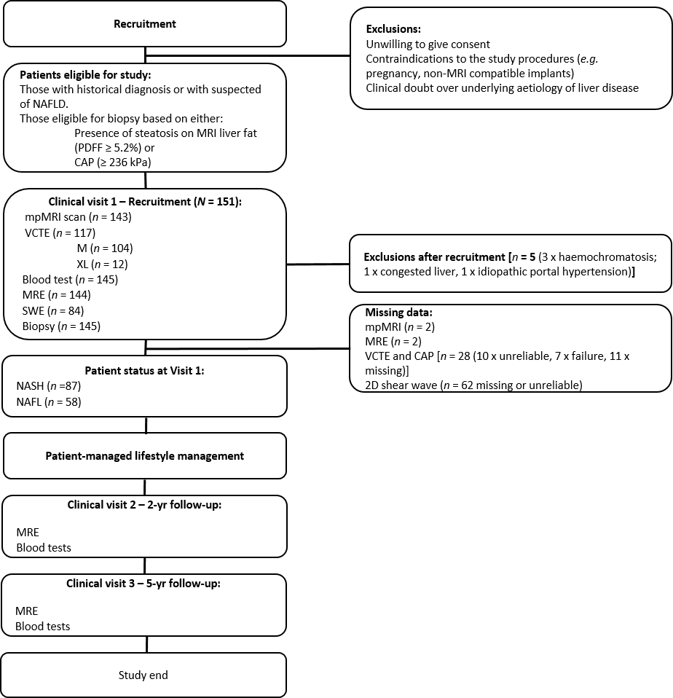
Figure 1 CONSORT diagram of patient pathway and inclusion into the study. mpMRI: Quantitative multiparametric magnetic resonance imaging; CAP: Controlled-attenuation parameter; MRE: Magnetic resonance elastography; NASH: Non-alcoholic steatohepatitis; NAFLD: Non-alcoholic fatty liver disease’; VCTE: Vibration-controlled transient elastography.

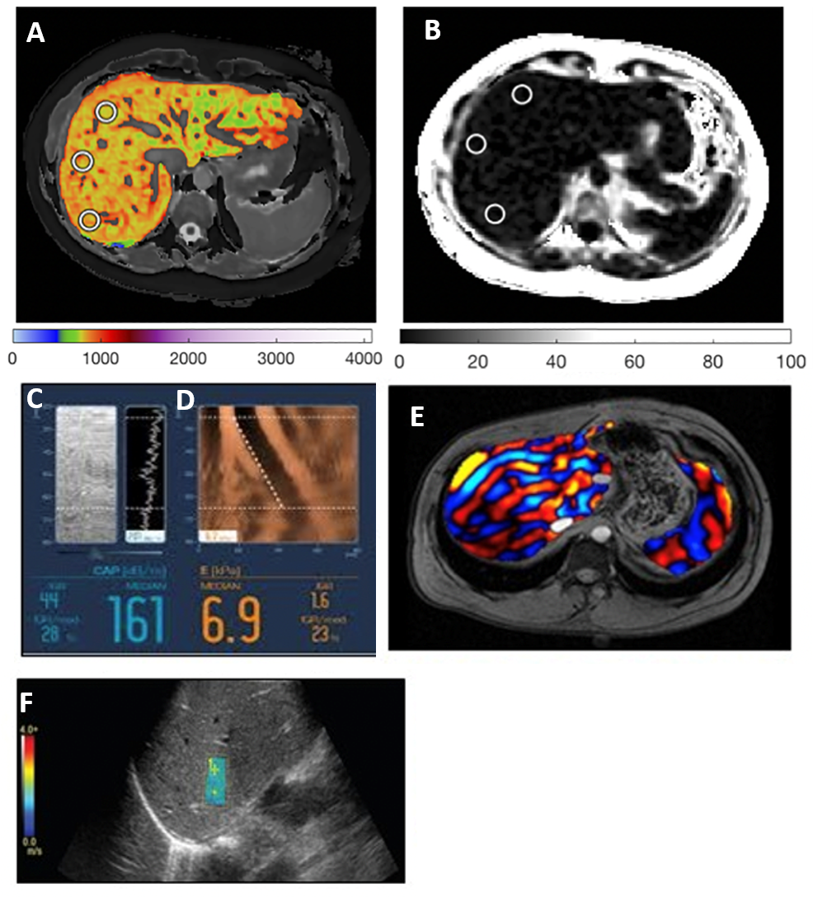
Figure 2 Example images from each technology. A: Corrected T1 map; B: Magnetic resonance liver fat map; C: Fibroscan controlled-attenuation parameter; D: Fibroscan Liver Stiffness; E: magnetic resonance elastography liver stiffness map; and F: 2D Shear-wave elastography.

Figure 3 Receiver operator characteristic curves for discriminating those with non-alcoholic steatohepatitis (NAS ≥ 4 and ballooning > 1 or inflammation > 1) from those without. Area under the curve and confidence intervals displayed in the legend for each non-invasive measure. MRE: Magnetic resonance elastography; CAP: Controlled-attenuation parameter; cT1: Corrected T1; LSM: Liver stiffness measure; PDFF: Proton density fat fraction.

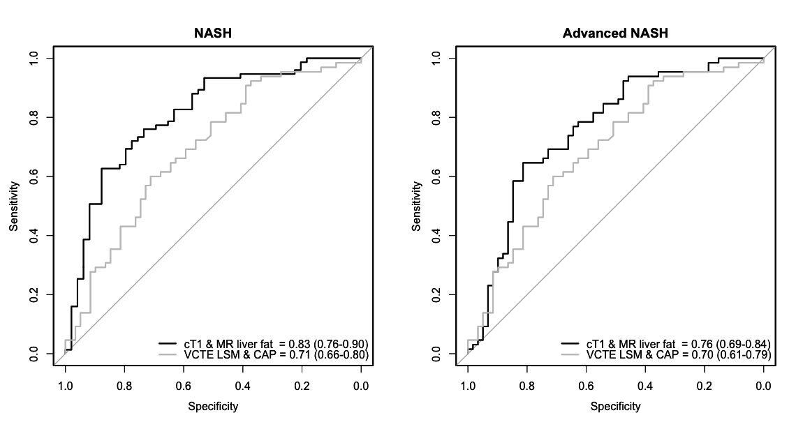
Figure 4 Receiver operator characteristic curves for discriminating those with non-alcoholic steatohepatitis (left) and those with non-alcoholic steatohepatitis with fibrosis (right). Area under the curve and confidence intervals displayed in the legend for each non-invasive measure. CAP: Controlled-attenuation parameter; VCTE: Vibration-controlled transient elastography; cT1: Corrected T1; NASH: Non-alcoholic steatohepatitis.

Table 1 Participant demographics
 | Total (n = 145), mean ± SD (% of cohort) | NASH | NAFL
Total cohort (n) | 145 | 87 | 58
Sex (male) | 88 (60.7%) | 46 | 42ª
Age | 60.2 ± 13.1 | 60.9 ± 13.2 | 59 ± 12.9
BMI average | 28.8 ± 4.7 | 29.9 ± 4.4 | 27.1 ± 4.8^{c}
Normal BMI (≥ 18.5 ≤ 22.9) | n = 17, 21.4 ± 1.6 | 6 | 12
Overweight (≥ 23.0 ≤ 27.9) | n = 43, 25.6 ± 1.1 | 26 | 26
Obese (≥ 27.5) | n = 82, 32.1 ± 3.2 | 55 | 20
Blood serum tests
AST (IU/L) | 47.8 ± 27.5 | 56.4 ± 29.8 | 34.8 ± 17.1^{c}
ALT (IU/L) | 59.8 ± 49.3 | 71.3 ± 51.5 | 42.6 ± 41.4^{c}
GGT | 85.9 ± 78.4 | 97.8 ± 85.8 | 69.3 ± 62.9^{b}
Total bilirubin (mg/dL) | 0.86 ± 0.4 | 0.8 ± 0.3 | 0.9 ± 0.4
Platelets (× 10⁴/μL) | 19.4 ± 7.3 | 19.9 ± 7.5 | 18.8 ± 7
HbA1C (%) | 6.5 ± 1.1 | 6.6 ± 1.0 | 6.5 ± 1.1
Fasting insulin (mU/mL) | 20 ± 14.2 | 20.6 ± 11.6 | 19 ± 17.4
Fasting blood glucose (mg/dL) | 124 ± 34.7 | 126.1 ± 32.5 | 120.8 ± 37.8
Albumin (g/dL) | 4.3 ± 0.5 | 4.3 ± 0.4 | 4.2 ± 0.5
Non-invasive test
cT1 | n = 143, 871 ± 102 | n = 88, 907 ± 90 | n = 56, 817 ± 96^{c}
MR liver fat | n = 143, 11.4 ± 6.1 | n = 88, 13.6 ± 5.8 | n = 56, 8.1 ± 5.1^{c}
CAP | n = 117, 294.3 ± 47.4 | n = 74, 309.1 ± 37.1 | n = 43, 268.9 ± 52.7^{c}
VCTE-LSM | n = 117, 12.8 ± 9.5 | n = 74, 13 ± 8.4 | n = 43, 12.5 ± 11.1
MRE | n = 144, 4.2 ± 1.7 | n = 88, 4.3 ± 1.5 | n = 56, 4.1 ± 1.9
SE | n = 84, 9.3 ± 2.7 | n = 50, 9.6 ± 2.4 | n = 33, 8.8 ± 3.1
Reported pre-existing conditions
Hypertensive | n = 71 | n = 45 | n = 26
Dyslipidaemic | n = 111 | n = 72 | n = 39
Reported as diabetic | n = 97 | n = 59 | n = 38
Non-alcoholic steatohepatitis (NASH) were patients with NASH clinical research network ≥ 4 with ballooning ≥ 1. Stars denote significance difference between those with NASH and non-alcoholic fatty liver these levels: ªP < 0.05, ^{b}P < 0.01, ^{c}P < 0.001. MRE: Magnetic resonance elastography; CAP: Controlled-attenuation parameter; VCTE: Vibration-controlled transient elastography; cT1: Corrected T1; BMI: Body mass index; NASH: Non-alcoholic steatohepatitis; NAFL: Non-alcoholic fatty liver.

Table 2 Range of histology scores reported across the entire cohort
Histology scores from biopsy (n = 144)
 | Score | Total | NASH | NAFL
Steatosis (Brunt) | 0 | 13 | 0 | 13
 | 1 | 74 | 36 | 37
 | 2 | 35 | 30 | 5
 | 3 | 21 | 20 | 1
Lobular inflammation | 0 | 13 | 0 | 1
 | 1 | 91 | 48 | 51
 | 2 | 35 | 35 | 9
 | 3 | 4 | 3 | 0
Ballooning | 0 | 39 | 0 | 39
 | 1 | 72 | 55 | 16
 | 2 | 32 | 31 | 1
 | 3 | 0 | 0 | 0
Fibrosis (Kleiner) | 0 | 5 | 1 | 0
 | 1 | 24 | 10 | 14
 | 2 | 27 | 16 | 11
 | 3 | 55 | 39 | 15
 | 4 | 31 | 19 | 12
NAS | 0 | 0 | 0 | 0
 | 1 | 5 | 0 | 5
 | 2 | 23 | 0 | 22
 | 3 | 26 | 0 | 26
 | 4 | 25 | 25 | 1
 | 5 | 37 | 35 | 2
 | 6 | 16 | 16 | 0
 | 7 | 8 | 8 | 0
 | 8 | 2 | 2 | 0
NASH: Non-alcoholic steatohepatitis; NAFL: Non-alcoholic fatty liver.
Table 3 Spearman's correlation coefficients for all variables
 | cT1, (n = 143) | MR liver fat (n = 143) | MRE (n = 144) | VCTE-LSM (n = 117) | CAP (n = 117) | 2D SWE (n = 84)
Fibrosis | 0.24, p < 0.01 | -0.25, p <0.01 | 0.75, p < 0.001 | 0.69, p < 0.001 | 0.05, p = 0.58 | 0.72, p < 0.001
Steatosis | 0.29, p < 0.001 | 0.70, p < 0.001 | -0.23, p < 0.01 | -0.09, p = 0.23 | 0.39, p < 0.001 | -0.07, p = 0.53
Lobular inflammation | 0.31, P < 0.001 | 0.28, P < 0.001 | 0.16, p < 0.01 | 0.15, p = 0.10 | 0.26, p < 0.01 | 0.16, p = 0.15
Ballooning | 0.39, P < 0.001 | 0.29, P < 0.001 | 0.32, P < 0.01 | 0.29, P < 0.01 | 0.33, P < 0.001 | 0.34, P < 0.001
NAS | 0.58, P < 0.001 | 0.64, P < 0.001 | 0.06, P = 0.44 | 0.13, P = 0.13 | 0.49, P < 0.001 | 0.16, P = 0.13
Correlations with statistical significance P < 0.05 are in bold. MRE: Magnetic resonance elastography; CAP: Controlled-attenuation parameter; VCTE: Vibration-controlled transient elastography; cT1: Corrected T1; SWE: Shear-Wave elastography; NASH: Non-alcoholic steatohepatitis; LSM: Liver stiffness measure.

Table 4 Inter-rater variability between the three pathologists for each histology metric
Histological metric | Pathologists | Kappa weighted | Lower CI | Upper CI | ASE | P value | Overall inter-rater variability (Krippendorff’s alpha)
Steatosis | 1 vs 2 | 0.609 | 0.517 | 0.7 | 0.0467 | < 0.0001 | 0.584
 | 1 vs 3 | 0.483 | 0.388 | 0.579 | 0.0489 | < 0.0001
 | 2 vs 3 | 0.585 | 0.485 | 0.686 | 0.0513 | < 0.0001
Lobular inflammation | 1 vs 2 | 0.118 | 0.0631 | 0.173 | 0.0281 | < 0.0001 | 0.109
 | 1 vs 3 | 0.0376 | 0.00574 | 0.0695 | 0.0163 | 0.02
 | 2 vs 3 | 0.179 | 0.0699 | 0.288 | 0.0556 | 0.001
Ballooning | 1 vs 2 | 0.297 | 0.205 | 0.389 | 0..047 | < 0.0001 | 0.398
 | 1 vs 3 | 0.459 | 0.344 | 0.573 | 0.0583 | < 0.0001
 | 2 vs 3 | 0.27 | 0.18 | 0.36 | 0.0453 | < 0.0001
Fibrosis | 1 vs 2 | 0.719 | 0.65 | 0.788 | 0.0353 | < 0.0001 | 0.398
 | 1 vs 3 | 0.571 | 0.496 | 0.647 | 0.0386 | < 0.0001
 | 2 vs 3 | 0.597 | 0.521 | 0.672 | 0.0385 | < 0.0001
NAS | 1 vs 2 | 0.279 | 0.202 | 0.357 | 0.0398 | < 0.0001 | 0.421
 | 1 vs 3 | 0.244 | 0.172 | 0.316 | 0.0366 | < 0.0001
 | 2 vs 3 | 0.434 | 0.35 | 0.518 | 0.043 | < 0.0001

