Name of Journal: World Journal of Orthopedics
Manuscript NO: 80791
Manuscript Type: MINIREVIEWS

Two-stage revision in periprosthetic knee joint infections

Alrayes MM et al. Two-stage revision in periprosthetic knee infections

Majd M Alrayes, Mohamed Sukeik

Majd M Alrayes, Department of Orthopedics, Imam Abdulrahman bin Faisal University, Khobar 34423, Saudi Arabia

Mohamed Sukeik, Department of Trauma & Orthopaedics, Dr. Sulaiman Al-Habib Hospital – Al Khobar, Al Khobar 34423, Al Khobar, Saudi Arabia

Author contributions: Alrayes M contributed to manuscript writing and literature search; Sukeik M contributed to project supervision, scientific content, and manuscript revision.

Corresponding author: Mohamed Sukeik, FRCS (Ed), MD, Surgeon, Department of Trauma & Orthopaedics, Dr. Sulaiman Al-Habib Hospital – Al Khobar, King Salman Bin Abdulaziz Rd, Al Bandariyah, Kingdom of Saudi Arabia, Al Khobar 34423, Saudi Arabia. msukeik@hotmail.com

Received: October 12, 2022
Revised: December 20, 2022
Accepted: January 10, 2023
Published online:

Abstract
Periprosthetic joint infection (PJI) following total knee arthroplasty is one of the most catastrophic and costly complications that carries significant patient wellness as well as economic burdens. The road to efficiently diagnosing and treating PJI is challenging, as there is still no gold standard method to reach the diagnosis as early as desired. There are also international controversies with respect to the best approach to manage PJI cases. In this review, we highlight recent advances in managing PJI following knee arthroplasty surgery and discuss in depth the two-stage revision method.

Key Words: Periprosthetic joint infection; Knee arthroplasty; Two-stage revision; Spacer; Reimplantation

Alrayes MM, Sukeik M. Two-stage revision in periprosthetic knee joint infections. World J Orthop 2022; In press

Core Tip: Two-stage revision for management of periprosthetic joint infection (PJI) following total knee arthroplasty has been widely used with satisfactory outcomes. In this review, we provide comprehensive discussion of the treatment of knee PJI with the two-stage revision method.

INTRODUCTION
Owing to recent advancements in medicine, the life expectancy of the general population has increased. With changes in modern lifestyle, there is an increased expectation for retention of physical activity and mobility; therefore, the number of joint replacement surgeries has surged ^{[1,2]}. Around 1 million knee and hip arthroplasty procedures are performed annually in the United States, and this number is anticipated to double by 2030^{[3]}. In addition to this increase in the number of surgeries, the incidence of PJI also continues to rise ^{[2]}. Currently PJI occurs in 1% to 2% of primary and 4% of revision arthroplasties ^{[1,2,4,5]}. Kurtz et al^{[1]} suggest that there will be over 260,000 revision total knee arthroplasties (TKAs) performed in the United States by 2030. Compared to hip arthroplasty, the risk of PJI is higher after knee arthroplasty^{[6,7]}. For example, the rate of PJI reported after TKA varies from 0.5%-2%, while a range of 0.5%-1.0% is reported after total hip arthroplasty. A higher risk of PJI following TKA may be attributed to less protective soft tissue coverage and higher joint mobility in the knee ^{[8,9]}. Delanois et al^{[10]} report that PJI alone accounted for 20.4% of all revisions after TKA, and this is considered the most common etiology leading to revision surgery. A number of risk factors are associated with developing PJI including the operative setting, patient comorbidities, and implant-related factors^{[2]}. Additionally, the longer the implanted prosthesis is expected to last, the greater the cumulative risk is for developing infection. Diagnosing PJI early can reduce the significant physical and emotional burden on the patient and the financial pressures on society. However, early diagnosis is still challenging due to the lack of tests that are highly sensitive and specific for this complication. However, early clinical suspicion in parallel to the use of existing serological markers, radiological examination, joint aspirate evaluation, and biopsy continues to be the mainstay for diagnosing PJI^{[11,12]}. The management of PJI remains controversial and requires a complex therapeutic approach, prolonged antimicrobial therapy, and the use of a variety of surgical techniques. Selecting the optimal treatment strategy to eradicate the infection requires proper diagnosis of the infecting microorganisms and identification of their antibiotic susceptibilities. When PJI is missed or inadequately treated, the patient will likely need to endure several operations due to the persistence of infection, negatively impacting function and quality of life^{[13]}. An interdisciplinary approach is crucial to reaching the best patient outcome, and this requires the involvement of orthopedic and plastic surgeons, infectious disease physicians, and microbiologists^{[2,14]}. The greatest difficulty in managing PJI is the formation of the so-called biofilm, which enables the responsible pathogens to remain on the implant surface, making them resistant to most systemic intravenous antibiotics. Understanding this phenomenon helps in diagnosing and treating PJI^{[2]}. For example, the use of modern diagnostic methods such as sonication for biofilm detection increases the sensitivity for diagnosing PJI, especially in chronic infections caused by low-virulence pathogens^{[2]}.
In this review, we provide an updated summary of the current concepts surrounding the two-stage revision procedure in the management of periprosthetic knee joint infections.

DEFINITION & CLASSIFICATION OF PJI
As there currently exists no single test that is capable of diagnosing PJI with complete accuracy, this surgical complication continues to be extremely challenging to tackle^{[15-17]}. The Musculoskeletal Infection Society (MSIS) and the Infectious Diseases Society (IDSA) have proposed criteria to help physicians diagnose PJI^{[18,19]}. In 2018, a second consensus meeting validated the MSIS definition of PJI, but made a few minor modifications^{[20]}. Whilst the major criteria for PJI are the same across all definitions, the minor criteria and supporting evidence are less universally agreed upon. Lately, new tests and biomarkers have evolved and become increasingly available^{[21-23]}, including serum D-dimer^{[24]}, synovial leukocyte esterase^{[25]}, synovial alpha-defensin^{[26]}, synovial C-reactive protein (CRP)^{[27]}, and molecular techniques such as next-generation sequencing^{[28]}. However, recent research has demonstrated the variability in the sensitivity and specificity of these tests^{[29]}. Therefore, such advancements in PJI diagnosis demanded revision of the existing diagnostic criteria to incorporate the new testing and take into account the relative importance of the different tests included. Thus, a multi-institutional study was published in 2018 in the Journal of Arthroplasty and included new diagnostic criteria^{[17]}. This new PJI scoring system outperformed the IDSA and MSIS criteria in terms of sensitivity and specificity.
The timing in which infection occurs can aid the identification of the infecting organism. Toms et al^{[30]} propose a classification consisting of four modes of presentation of PJI: Stage 1 - acute infections occurring within 6 wk; Stage 2 - late onset with chronic indolent infection; Stage 3: sudden-onset in an otherwise well-functioning prosthesis with an acute presentation of infection secondary to hematogenous spread; Stage 4 ( proposed by Tsukayama, Estrada, and Gustilo^{[31]}) - positive culture at the time of surgery without previous evidence of infection.

PATHOPHYSIOLOGY OF PERIPROSTHETIC JOINT INFECTION
Most PJI cases are iatrogenic due to inoculation of microorganisms intraoperatively^{[13]}. Based on the virulence of the infecting microorganisms, PJI could either have an early presentation (during the 1st 4-6 wk postoperative) or be delayed (usually 3 mo to 3 years). Early infection usually presents with distinct local and systemic signs of inflammation and is typically caused by highly virulent microorganisms (e.g., Staphylococcus aureus, Streptococci spp., Enterococci spp.). On the other hand, less virulent organisms (e.g., coagulase-negative Staphylococci or Cutibacterium spp.) are the culprits of most delayed infections, which usually present with milder signs and symptoms^{[2,13]} (Figure 1). The presence of foreign bodies such as orthopedic implants increases the infection risk, largely owing to the establishment of the so-called biofilm on prosthetic surfaces^{[32]}. The biofilm formation process consists of several steps: (1) adherence of the microorganisms to the implant; (2) multiplication and elaboration of exopolysaccharides ("glycocalyx"); and (3) coalescence of microcolonies encased in the glycocalyx to form a film^{[33]}. Near the biofilm's surface, microorganisms are generally metabolically active and have free access to nutrients. However, deep within the biofilm, microorganisms have less nutrient access and become metabolically inactive or exist in different states of dormancy, making them more immune to host defenses^{[34]}. Hence, the success of antimicrobial therapy may be negatively impacted by the microenvironment within a biofilm, as diffusion of drugs through the biofilm may be limited^{[33]}. Furthermore, due to the high vascularity of periprosthetic tissue, all implants are at high risk of hematogenous seeding from a distant primary focus. While the risk of this is high during the life of the implant, the highest risk of hematogenous infection occurs in the first few years after implantation^{[2,35]}.

TREATMENT PLAN
The management of PJI remains controversial; therefore treatment plans should be tailored for each patient individually. Eradication of the infection, reduction of pain, and restoration of joint function are the primary goals of treatment^{[12]}. In general, management of PJI consists of antimicrobial therapy alone or antimicrobial therapy combined with single or staged surgeries. The approach depends on several factors, including the timing and microbiology of infection, condition of the joint and implant, and the individual patient circumstance. Surgical options include debridement and retention of the prosthesis, resection arthroplasty with reimplantation in a single or staged procedure, resection arthroplasty alone, or in extreme cases, amputation^{[36]}. Two-stage revision remains the favorite surgical option, with overall higher rates of eradicating PJI in comparison to single-stage revision. For example, Elson et al^{[37]} report 3.5% failure rates with two-stage revision vs 12.4% using a single-stage strategy. Similarly, Garvin et al^{[38]} report a failure rate of 5.6% vs 10.1%, respectively. For the purposes of this review article, we will focus mainly on the two-stage revision method.

TWO-STAGE REVISION
The two-stage revision procedure is considered to be the gold standard for the management of PJI^{[12]}. This method was described in 1983 by Insall et al^{[39]} and in 1995, Garvin et al^{[40]} conducted a literature review that highlighted the success associated with this approach. The first stage of the procedure includes the removal of the in-situ prosthesis, thorough debridement of the infected bone and soft tissue, and the implantation of antibiotic-loaded cement (ALC) spacers for temporary fixation. The interim period between the two stages includes administration of intravenous antibiotics and close monitoring of the patient clinically and serologically for resolution of infection. Once the infection has resolved, the second stage, which comprises the use of antibiotic-loaded cement for reimplantation of the definitive prosthesis^{[12,41]}. The time between stages can range from 6 wk to several months. Both stages necessitate aggressive debridement of all infected and necrotic tissue^{[41]}. The following are indications for using a two-stage rather than a single-stage revision procedure^{[12]}: (1) Systemic infection (sepsis) with signs of infection but an unidentified causative microorganism; (2) Antibiotic-resistant microorganisms identified by preoperative cultures; (3) Presence of a sinus tract; and (4) Insufficient soft tissue coverage to allow a single-stage procedure.

1st stage
The first stage of the procedure entails a thorough and vigorous debridement of the whole effective joint space after the removal of all implanted materials and cement^{[41]} (Figure 2). Whenever possible, the use of antibiotics is postponed until all microbiological samples have been collected. To increase the likelihood of arriving at a conclusive diagnosis, it is recommended to obtain both aerobic and anaerobic cultures; at least three and as many as six intraoperative periprosthetic tissue samples or the explanted prosthesis itself may be sent for testing^{[42]}. The sensitivity, specificity, positive predictive value, and negative predictive value with a minimum of two positive samples have been reported to be 94%, 97%, 77%, and 99.9%, respectively^{[43]}. It is advised to excise the old scar and the sinus tract if present. Sending the prosthetic parts for sonification is an option, but this should be planned prior to surgery as it requires special packaging^{[41]}. It is crucial to remove any cement, even if it is firmly affixed to the underlying bone, in addition to any soft tissue that is grossly involved by the infection^{[44]}. Osteotomes, specialized chisels, drills, and taps, as well as various methods that make use of ultrasound-based extraction instruments, can all be used to remove the cement^{[45]}. During this stage, the surgeon must proceed cautiously, since iatrogenic bone injury is possible^{[44]} (Figure 3A). It is important to perform extensive lavage with a high-pressure pulsatile lavage system using at least 6 L of fluid. Normal saline is usually favored, and lavage provides a significant mechanical action that eliminates sequestra, necrotic tissue, and microorganisms. Several studies have investigated adding antibiotics to the normal saline, but no therapeutic advantage over plain lavage solution has been shown^{[41]}. Following the removal of the implants and thorough debridement, new sterile drapes are applied followed by a spacer with ALC (Figures 3B and C). Spacers are either static or dynamic, prefabricated or handcrafted and hemiarthroplasty spacers can replace both sides of the joint. Preoperative culture and sensitivity testing of the infecting microorganisms helps to decide the best antibiotics to be added preoperatively to the cement used for construction of the spacer. A discussion with a microbiologist is also necessary to agree on the best choice of antibiotics^{[41]}.

Interim period
At this point, antibiotic therapy is the cornerstone and should be tailored depending on the microorganism's antimicrobial sensitivity. With the help of a microbiologist, empiric therapy should be started if the organism or sensitivities are unknown. To identify an organism, all reasonable efforts should be made^{[41]}. The most popular regimen is intravenous antibiotics for 4-6 wk followed by discontinuation of the antibiotics for a period of 2-8 wk prior to the second stage, as this results in a high rate of infection control^{[46,47]}. The best results are usually obtained when the infecting microorganism is sensitive and systemic antibiotics are used in the interim period^{[48,49]}. Prolonging the interim period has been linked with suboptimal infection control rates and poor function restoration^{[12]}. However, a single study concluded that there were no differences in functional outcome in patients who had undergone a two-stage revision with an interim period of less than 6 mo vs those with more than 6 mo between resection and reimplantation^{[12,19]}. Deciding to move forward with prosthesis reimplantation depends on clinical, serological testing, and joint aspirate assessment. Residual infection requires further debridement and a new spacer insertion^{[41]}. Normalization of the CRP and erythrocyte sedimentation rate (ESR) alone does not guarantee eradication of the infection, especially in coagulase-negative staphylococcal infections, as these may not trigger a significant inflammatory response^{[12]}. Kusuma et al^{[50]} reported that synovial white blood cell (WBC) count is the most reliable predictor of infection control, and a decision to proceed to the second stage depends on attaining a WBC count of less than 3000/µL with less than 80% polymorphonuclear cells from the joint aspirate. Negative intraoperative frozen sections and tissues grossly appearing noninfected are other criteria which are utilized in the second stage to support the decision of proceeding with reimplantation, as there is a high risk of false positive or false negative preoperative cultures. The joint aspirate is mainly used for cell count assessment^{[50]}.

Spacer
Spacers are categorized as articulating (dynamic) or non-articulating (static). Between staged procedures, dynamic spacers maintain ambulation and joint range of motion, which protect against muscle wasting; evidence has shown them to be as or more effective at eliminating infection as static spacers^{[51]}. Being able to maintain a range of motion also prevents against the formation of soft tissue and muscle contractures, which facilitates the reimplantation procedure^{[12,52,53]}. Brunnekreef et al^{[54]} found a better and quicker recovery of knee function with dynamic spacers, resulting in shorter operation times. Furthermore, compared to static spacers, the use of a dynamic spacer appears to increase the rate of infection eradication (91.2% vs 87%)^{[55]}. Moreover, using a static spacer may result in bone loss due to migration of the spacer^{[56,57]}. Despite the above, static spacers may be preferrable in certain circumstances, such as massive bony and soft tissues loss, ligament laxity in the knee, and deficiency of the abductor muscles of the hips^{[41,44]}. Prosthesis with Antibiotic-Loaded Acrylic Cement (PROSTALAC) is an example of an articulating spacer that delivers high concentration of broad-spectrum antibiotics locally. A common regimen used with PROSTALACs is the inclusion of 3 g of vancomycin and 2 g of gentamicin in each sachet of Palacos R cement (Schering Plough Ltd, Labo nv, Belgium). However, antibiotics in spacers may also be prepared according to the sensitivities of the infecting micro-organisms if detected preoperatively^{[12]}. Spacers are usually augmented with a post-operative course of intravenous antibiotics until the definitive antibiotic sensitivities of the infective micro-organisms are detected from the intraoperative cultures taken at the first stage procedure^{[12]}. However, spacers are not complication-free. Faschingbauer et al^{[58]} reported that out of 138 patients, 27 (19.6%) developed complications, including spacer fractures in 12 cases (8.7%), dislocation in 12 cases (8.7%), 1 case of a periprosthetic femoral fracture with a spacer in situ, 1 case of a dislocation with simultaneous spacer fracture, and 1 case of protrusion into the pelvis.

2nd stage
The second stage consists of removal of the spacer, further debridement, and collection of tissue samples followed by definitive reimplantation of a new prosthesis (Figure 4). The decision to proceed with the definitive reimplantation must be made after the resolution of all infection-related symptoms and signs and improvement of laboratory results (a declining trend of CRP and ESR may be accepted as opposed to complete normalization of the values as stated earlier)^{[41,44]}. During the second stage, the existing scar is usually utilized to approach the joint^{[59]}. Once the joint is appropriately exposed, further samples are obtained for cultures. It is crucial to remove the cement spacer with the pseudo-synovial cavity that develops around the spacer without compromising the surrounding bone. Necrotic tissue is removed, and pulse lavage is used for extensive irrigation of the joint. This ensures the removal of any residual cement debris, which potentially can cause third body wear if left at the spacer site. If necessary, bone allografts may be utilized at this point to reconstruct any bony deficiencies followed by reimplantation of the definitive prosthesis in accordance with the preoperative plan. The use of bone allografts in revision surgery after PJI has drawn some controversy in the past^{[60]}. Latest evidence, however, has not been able to demonstrate a substantial difference in the rate of reinfection following the use of allografts in this context. Therefore, when there is considerable bone loss, bone grafts may still be used safely^{[61]}. Both cemented and uncemented prostheses may be utilized for the definitive implant. Modern antibiotic delivery methods like defensive antibacterial coating may also be utilized at this stage^{[62]}. Similar reinfection rates and aseptic loosening have been reported when using cemented or uncemented prostheses in TKA revisions for infection^{[63]}. Following surgery, antibiotics may be administered until the bacteriology results are revealed^{[12]}. If any suspicion remains regarding infection during the second stage, a synovial leukocyte esterase strip test, synovial alpha-defensin test, or a frozen section intraoperative tissue analysis may be used to confirm. If the tests are suggestive of residual infection, aggressive debridement followed by a cemented spacer reimplantation (a repetition of the first stage) is necessary^{[41,44]} (Figure 5).

CONCLUSION
PJI is challenging to manage, but recent advancements in laboratory testing have helped to facilitate early diagnosis when used collectively under the internationally agreed upon definition of this surgical complication. A multidisciplinary team approach is crucial when dealing with such cases. Efforts should be made to diagnose the causative microorganism as early as possible in order to start appropriate antimicrobial therapy and plan surgical intervention accordingly. In terms of surgical options, the two-stage revision procedure remains the gold standard approach in chronic cases and yields the highest PJI eradication rates.

REFERENCES
1 Kurtz S, Ong K, Lau E, Mowat F, Halpern M. Projections of primary and revision hip and knee arthroplasty in the United States from 2005 to 2030. J Bone Joint Surg Am 2007; 89: 780-785 [PMID: 17403800 DOI: 10.2106/JBJS.F.00222]
2 Izakovicova P, Borens O, Trampuz A. Periprosthetic joint infection: current concepts and outlook. EFORT Open Rev 2019; 4: 482-494 [PMID: 31423332 DOI: 10.1302/2058-5241.4.180092]
3 Sloan M, Premkumar A, Sheth NP. Projected Volume of Primary Total Joint Arthroplasty in the U.S., 2014 to 2030. J Bone Joint Surg Am 2018; 100: 1455-1460 [PMID: 30180053 DOI: 10.2106/JBJS.17.01617]
4 Corvec S, Portillo ME, Pasticci BM, Borens O, Trampuz A. Epidemiology and new developments in the diagnosis of prosthetic joint infection. Int J Artif Organs 2012; 35: 923-934 [PMID: 23138706 DOI: 10.5301/ijao.5000168]
5 Ong KL, Kurtz SM, Lau E, Bozic KJ, Berry DJ, Parvizi J. Prosthetic joint infection risk after total hip arthroplasty in the Medicare population. J Arthroplasty 2009; 24: 105-109 [PMID: 19493644 DOI: 10.1016/j.arth.2009.04.027]
6 Beam E, Osmon D. Prosthetic Joint Infection Update. Infect Dis Clin North Am 2018; 32: 843-859 [PMID: 30241717 DOI: 10.1016/j.idc.2018.06.005]
7 Koh CK, Zeng I, Ravi S, Zhu M, Vince KG, Young SW. Periprosthetic Joint Infection Is the Main Cause of Failure for Modern Knee Arthroplasty: An Analysis of 11,134 Knees. Clin Orthop Relat Res 2017; 475: 2194-2201 [PMID: 28573549 DOI: 10.1007/s11999-017-5396-4]
8 Namba RS, Inacio MC, Paxton EW. Risk factors associated with deep surgical site infections after primary total knee arthroplasty: an analysis of 56,216 knees. J Bone Joint Surg Am 2013; 95: 775-782 [PMID: 23636183 DOI: 10.2106/JBJS.L.00211]
9 Edwards JR, Peterson KD, Mu Y, Banerjee S, Allen-Bridson K, Morrell G, Dudeck MA, Pollock DA, Horan TC. National Healthcare Safety Network (NHSN) report: data summary for 2006 through 2008, issued December 2009. Am J Infect Control 2009; 37: 783-805 [PMID: 20004811 DOI: 10.1016/j.ajic.2009.10.001]
10 Delanois RE, Mistry JB, Gwam CU, Mohamed NS, Choksi US, Mont MA. Current Epidemiology of Revision Total Knee Arthroplasty in the United States. J Arthroplasty 2017; 32: 2663-2668 [PMID: 28456561 DOI: 10.1016/j.arth.2017.03.066]
11 Della Valle CJ, Zuckerman JD, Di Cesare PE. Periprosthetic sepsis. Clin Orthop Relat Res 2004: 26-31 [PMID: 15057075 DOI: 10.1097/00003086-200403000-00005]
12 Kini SG, Gabr A, Das R, Sukeik M, Haddad FS. Two-stage Revision for Periprosthetic Hip and Knee Joint Infections. Open Orthop J 2016; 10: 579-588 [PMID: 28144371 DOI: 10.2174/1874325001610010579]
13 Zimmerli W, Trampuz A, Ochsner PE. Prosthetic-joint infections. N Engl J Med 2004; 351: 1645-1654 [PMID: 15483283 DOI: 10.1056/NEJMra040181]
14 Karczewski D, Winkler T, Renz N, Trampuz A, Lieb E, Perka C, Müller M. A standardized interdisciplinary algorithm for the treatment of prosthetic joint infections. Bone Joint J 2019; 101-B: 132-139 [PMID: 30700114 DOI: 10.1302/0301-620X.101B2.BJJ-2018-1056.R1]
15 Fernández-Sampedro M, Fariñas-Alvarez C, Garces-Zarzalejo C, Alonso-Aguirre MA, Salas-Venero C, Martínez-Martínez L, Fariñas MC. Accuracy of different diagnostic tests for early, delayed and late prosthetic joint infection. BMC Infect Dis 2017; 17: 592 [PMID: 28841913 DOI: 10.1186/s12879-017-2693-1]
16 Ahmad SS, Shaker A, Saffarini M, Chen AF, Hirschmann MT, Kohl S. Accuracy of diagnostic tests for prosthetic joint infection: a systematic review. Knee Surg Sports Traumatol Arthrosc 2016; 24: 3064-3074 [PMID: 27377905 DOI: 10.1007/s00167-016-4230-y]
17 Parvizi J, Tan TL, Goswami K, Higuera C, Della Valle C, Chen AF, Shohat N. The 2018 Definition of Periprosthetic Hip and Knee Infection: An Evidence-Based and Validated Criteria. J Arthroplasty 2018; 33: 1309-1314.e2 [PMID: 29551303 DOI: 10.1016/j.arth.2018.02.078]
18 Parvizi J. Reply to the Letter to the Editor: New Definition for Periprosthetic Joint Infection: From the Workgroup of the Musculoskeletal Infection Society. Clin Orthop Relat Res 2017; 475: 291 [PMID: 27798789 DOI: 10.1007/s11999-016-5088-5]
19 Osmon DR, Berbari EF, Berendt AR, Lew D, Zimmerli W, Steckelberg JM, Rao N, Hanssen A, Wilson WR; Infectious Diseases Society of America. Executive summary: diagnosis and management of prosthetic joint infection: clinical practice guidelines by the Infectious Diseases Society of America. Clin Infect Dis 2013; 56: 1-10 [PMID: 23230301 DOI: 10.1093/cid/cis966]
20 Shohat N, Bauer T, Buttaro M, Budhiparama N, Cashman J, Della Valle CJ, Drago L, Gehrke T, Marcelino Gomes LS, Goswami K, Hailer NP, Han SB, Higuera CA, Inaba Y, Jenny JY, Kjaersgaard-Andersen P, Lee M, Llinás A, Malizos K, Mont MA, Jones RM, Parvizi J, Peel T, Rivero-Boschert S, Segreti J, Soriano A, Sousa R, Spangehl M, Tan TL, Tikhilov R, Tuncay I, Winkler H, Witso E, Wouthuyzen-Bakker M, Young S, Zhang X, Zhou Y, Zimmerli W. Hip and Knee Section, What is the Definition of a Periprosthetic Joint Infection (PJI) of the Knee and the Hip? Can the Same Criteria be Used for Both Joints?: Proceedings of International Consensus on Orthopedic Infections. J Arthroplasty 2019; 34: S325-S327 [PMID: 30343971 DOI: 10.1016/j.arth.2018.09.045]
21 Deirmengian C, Kardos K, Kilmartin P, Cameron A, Schiller K, Parvizi J. Diagnosing periprosthetic joint infection: has the era of the biomarker arrived? Clin Orthop Relat Res 2014; 472: 3254-3262 [PMID: 24590839 DOI: 10.1007/s11999-014-3543-8]
22 Patel R, Alijanipour P, Parvizi J. Advancements in Diagnosing Periprosthetic Joint Infections after Total Hip and Knee Arthroplasty. Open Orthop J 2016; 10: 654-661 [PMID: 28144375 DOI: 10.2174/1874325001610010654]
23 Lee YS, Koo KH, Kim HJ, Tian S, Kim TY, Maltenfort MG, Chen AF. Synovial Fluid Biomarkers for the Diagnosis of Periprosthetic Joint Infection: A Systematic Review and Meta-Analysis. J Bone Joint Surg Am 2017; 99: 2077-2084 [PMID: 29257013 DOI: 10.2106/JBJS.17.00123]
24 Shahi A, Kheir MM, Tarabichi M, Hosseinzadeh HRS, Tan TL, Parvizi J. Serum D-Dimer Test Is Promising for the Diagnosis of Periprosthetic Joint Infection and Timing of Reimplantation. J Bone Joint Surg Am 2017; 99: 1419-1427 [PMID: 28872523 DOI: 10.2106/JBJS.16.01395]
25 Wyatt MC, Beswick AD, Kunutsor SK, Wilson MJ, Whitehouse MR, Blom AW. The Alpha-Defensin Immunoassay and Leukocyte Esterase Colorimetric Strip Test for the Diagnosis of Periprosthetic Infection: A Systematic Review and Meta-Analysis. J Bone Joint Surg Am 2016; 98: 992-1000 [PMID: 27307359 DOI: 10.2106/JBJS.15.01142]
26 Deirmengian C, Kardos K, Kilmartin P, Cameron A, Schiller K, Parvizi J. Combined measurement of synovial fluid α-Defensin and C-reactive protein levels: highly accurate for diagnosing periprosthetic joint infection. J Bone Joint Surg Am 2014; 96: 1439-1445 [PMID: 25187582 DOI: 10.2106/JBJS.M.01316]
27 Tetreault MW, Wetters NG, Moric M, Gross CE, Della Valle CJ. Is synovial C-reactive protein a useful marker for periprosthetic joint infection? Clin Orthop Relat Res 2014; 472: 3997-4003 [PMID: 25070920 DOI: 10.1007/s11999-014-3828-y]
28 Tarabichi M, Shohat N, Goswami K, Alvand A, Silibovsky R, Belden K, Parvizi J. Diagnosis of Periprosthetic Joint Infection: The Potential of Next-Generation Sequencing. J Bone Joint Surg Am 2018; 100: 147-154 [PMID: 29342065 DOI: 10.2106/JBJS.17.00434]
29 Shahi A, Tan TL, Kheir MM, Tan DD, Parvizi J. Diagnosing Periprosthetic Joint Infection: And the Winner Is? J Arthroplasty 2017; 32: S232-S235 [PMID: 28712799 DOI: 10.1016/j.arth.2017.06.005]
30 Toms AD, Davidson D, Masri BA, Duncan CP. The management of peri-prosthetic infection in total joint arthroplasty. J Bone Joint Surg Br 2006; 88: 149-155 [PMID: 16434514 DOI: 10.1302/0301-620X.88B2.17058]
31 Tsukayama DT, Estrada R, Gustilo RB. Infection after total hip arthroplasty. A study of the treatment of one hundred and six infections. J Bone Joint Surg Am 1996; 78: 512-523 [PMID: 8609130 DOI: 10.2106/00004623-199604000-00005]
32 Zimmerli W, Waldvogel FA, Vaudaux P, Nydegger UE. Pathogenesis of foreign body infection: description and characteristics of an animal model. J Infect Dis 1982; 146: 487-497 [PMID: 7119479 DOI: 10.1093/infdis/146.4.487]
33 Donlan RM. Biofilm formation: a clinically relevant microbiological process. Clin Infect Dis 2001; 33: 1387-1392 [PMID: 11565080 DOI: 10.1086/322972]
34 Costerton JW, Stewart PS, Greenberg EP. Bacterial biofilms: a common cause of persistent infections. Science 1999; 284: 1318-1322 [PMID: 10334980 DOI: 10.1126/science.284.5418.1318]
35 Rakow A, Perka C, Trampuz A, Renz N. Origin and characteristics of haematogenous periprosthetic joint infection. Clin Microbiol Infect 2019; 25: 845-850 [PMID: 30678837 DOI: 10.1016/j.cmi.2018.10.010]
36 Osmon DR, Berbari EF, Berendt AR, Lew D, Zimmerli W, Steckelberg JM, Rao N, Hanssen A, Wilson WR; Infectious Diseases Society of America. Diagnosis and management of prosthetic joint infection: clinical practice guidelines by the Infectious Diseases Society of America. Clin Infect Dis 2013; 56: e1-e25 [PMID: 23223583 DOI: 10.1093/cid/cis803]
37 Elson RA. Exchange arthroplasty for infection. Perspectives from the United Kingdom. Orthop Clin North Am 1993; 24: 761-767 [PMID: 8414442 DOI: 10.1016/S0030-5898(20)31856-3]
38 Garvin KL, Fitzgerald RH Jr, Salvati EA, Brause BD, Nercessian OA, Wallrichs SL, Ilstrup DM. Reconstruction of the infected total hip and knee arthroplasty with gentamicin-impregnated Palacos bone cement. Instr Course Lect 1993; 42: 293-302 [PMID: 8463677]
39 Insall JN, Thompson FM, Brause BD. Two-stage reimplantation for the salvage of infected total knee arthroplasty. J Bone Joint Surg Am 1983; 65: 1087-1098 [PMID: 6630253]
40 Garvin KL, Hanssen AD. Infection after total hip arthroplasty. Past, present, and future. J Bone Joint Surg Am 1995; 77: 1576-1588 [PMID: 7593069 DOI: 10.2106/00004623-199510000-00015]
41 Franceschini M, Pedretti L, Cerbone V, Sandiford NA. Two stage revision: indications, techniques and results. Ann Jt 2022; 7 [DOI: 10.21037/aoj-20-84]
42 Sukeik MTS, Haddad FS. (vi) Management of periprosthetic infection in total hip arthroplasty. Orthop Trauma. 2009; 23 [DOI:10.1016/j.mporth.2009.08.009]
43 Spangehl MJ, Masri BA, O'Connell JX, Duncan CP. Prospective analysis of preoperative and intraoperative investigations for the diagnosis of infection at the sites of two hundred and two revision total hip arthroplasties. J Bone Joint Surg Am 1999; 81: 672-683 [PMID: 10360695 DOI: 10.2106/00004623-199905000-00008]
44 Parvizi J, Gehrke T, Mont MA, Callaghan JJ. Introduction: Proceedings of International Consensus on Orthopedic Infections. J Arthroplasty 2019; 34: S1-S2 [PMID: 30343969 DOI: 10.1016/j.arth.2018.09.038]
45 de Steiger R. Commentary on: Ultrasonic cement removal in cement-in-cement revision total hip arthroplasty: What is the effect on the final cement-in-cement bond? Bone Joint Res 2019; 8: 253-254 [PMID: 31346453 DOI: 10.1302/2046-3758.86.BJR-2019-0097]
46 Hanssen AD, Rand JA, Osmon DR. Treatment of the infected total knee arthroplasty with insertion of another prosthesis. The effect of antibiotic-impregnated bone cement. Clin Orthop Relat Res 1994: 44-55 [PMID: 7994976]
47 Brandt CM, Duffy MC, Berbari EF, Hanssen AD, Steckelberg JM, Osmon DR. Staphylococcus aureus prosthetic joint infection treated with prosthesis removal and delayed reimplantation arthroplasty. Mayo Clin Proc 1999; 74: 553-558 [PMID: 10377928 DOI: 10.4065/74.6.553]
48 Segawa H, Tsukayama DT, Kyle RF, Becker DA, Gustilo RB. Infection after total knee arthroplasty. A retrospective study of the treatment of eighty-one infections. J Bone Joint Surg Am 1999; 81: 1434-1445 [PMID: 10535593 DOI: 10.2106/00004623-199910000-00008]
49 Westrich GH, Walcott-Sapp S, Bornstein LJ, Bostrom MP, Windsor RE, Brause BD. Modern treatment of infected total knee arthroplasty with a 2-stage reimplantation protocol. J Arthroplasty 2010; 25: 1015-1021, 1021.e1-1021.e2 [PMID: 20888545 DOI: 10.1016/j.arth.2009.07.017]
50 Kusuma SK, Ward J, Jacofsky M, Sporer SM, Della Valle CJ. What is the role of serological testing between stages of two-stage reconstruction of the infected prosthetic knee? Clin Orthop Relat Res 2011; 469: 1002-1008 [PMID: 20941647 DOI: 10.1007/s11999-010-1619-7]
51 Charette RS, Melnic CM. Two-Stage Revision Arthroplasty for the Treatment of Prosthetic Joint Infection. Curr Rev Musculoskelet Med 2018; 11: 332-340 [PMID: 29948954 DOI: 10.1007/s12178-018-9495-y]
52 Freeman MG, Fehring TK, Odum SM, Fehring K, Griffin WL, Mason JB. Functional advantage of articulating versus static spacers in 2-stage revision for total knee arthroplasty infection. J Arthroplasty 2007; 22: 1116-1121 [PMID: 18078879 DOI: 10.1016/j.arth.2007.04.009]
53 Van Thiel GS, Berend KR, Klein GR, Gordon AC, Lombardi AV, Della Valle CJ. Intraoperative molds to create an articulating spacer for the infected knee arthroplasty. Clin Orthop Relat Res 2011; 469: 994-1001 [PMID: 21042896 DOI: 10.1007/s11999-010-1644-6]
54 Brunnekreef J, Hannink G, Malefijt Mde W. Recovery of knee mobility after a static or mobile spacer in total knee infection. Acta Orthop Belg 2013; 79: 83-89 [PMID: 23547521]
55 Bonanzinga T, Tanzi G, Iacono F, Ferrari MC, Marcacci M. Periprosthetic knee infection: two stage revision surgery. Acta Biomed 2017; 88: 114-119 [PMID: 29083362 DOI: 10.23750/abm.v88i4-S.6802]
56 Fehring TK, Odum S, Calton TF, Mason JB. Articulating versus static spacers in revision total knee arthroplasty for sepsis. The Ranawat Award. Clin Orthop Relat Res 2000: 9-16 [PMID: 11064968 DOI: 10.1097/00003086-200011000-00003]
57 Hanssen AD. Managing the infected knee: as good as it gets. J Arthroplasty 2002; 17: 98-101 [PMID: 12068416 DOI: 10.1054/arth.2002.32458]
58 Faschingbauer M, Reichel H, Bieger R, Kappe T. Mechanical complications with one hundred and thirty eight (antibiotic-laden) cement spacers in the treatment of periprosthetic infection after total hip arthroplasty. Int Orthop 2015; 39: 989-994 [PMID: 25582658 DOI: 10.1007/s00264-014-2636-z]
59 Haddad FS, Rayan F. The role of impaction grafting: the when and how. Orthopedics 2009; 32 [PMID: 19751009 DOI: 10.3928/01477447-20090728-19]
60 English H, Timperley AJ, Dunlop D, Gie G. Impaction grafting of the femur in two-stage revision for infected total hip replacement. J Bone Joint Surg Br 2002; 84: 700-705 [PMID: 12188488 DOI: 10.1302/0301-620x.84b5.12504]
61 Ammon P, Stockley I. Allograft bone in two-stage revision of the hip for infection. Is it safe? J Bone Joint Surg Br 2004; 86: 962-965 [PMID: 15446518 DOI: 10.1302/0301-620X.86B7.14292]
62 Zagra L, Gallazzi E, Romanò D, Scarponi S, Romanò C. Two-stage cementless hip revision for peri-prosthetic infection with an antibacterial hydrogel coating: results of a comparative series. Int Orthop 2019; 43: 111-115 [PMID: 30374639 DOI: 10.1007/s00264-018-4206-2]
63 Edwards PK, Fehring TK, Hamilton WG, Perricelli B, Beaver WB, Odum SM. Are cementless stems more durable than cemented stems in two-stage revisions of infected total knee arthroplasties? Clin Orthop Relat Res 2014; 472: 206-211 [PMID: 23817757 DOI: 10.1007/s11999-013-3139-8]

Footnotes
Conflict-of-interest statement: All the authors declare having no conflict of interests for this article.

Open-Access: This article is an open-access article that was selected by an in-house editor and fully peer-reviewed by external reviewers. It is distributed in accordance with the Creative Commons Attribution NonCommercial (CC BY-NC 4.0) license, which permits others to distribute, remix, adapt, build upon this work non-commercially, and license their derivative works on different terms, provided the original work is properly cited and the use is non-commercial. See: https://creativecommons.org/Licenses/by-nc/4.0/

Provenance and peer review: Invited article; Externally peer reviewed.
Peer-review model: Single blind

Peer-review started: October 12, 2022
First decision: December 13, 2022
Article in press:

Specialty type: Orthopedics
Country/Territory of origin: Saudi Arabia
Peer-review report’s scientific quality classification
Grade A (Excellent): 0
Grade B (Very good): B, B
Grade C (Good): 0
Grade D (Fair): 0
Grade E (Poor): 0

P-Reviewer: Donadono C, Italy; Torres RM, Portugal S-Editor: Liu JH L-Editor: Filipodia P-Editor: Liu JH
Figure Legends
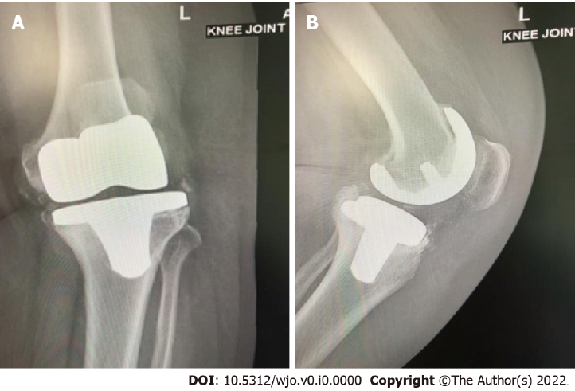
Figure 1 Anteroposterior and lateral plain radiographs showing septic loosening of a left total knee arthroplasty in a 65-year-old female patient who underwent the primary procedure 5 years previously. A: Anteroposterior view; B: Lateral view. Preoperative aspiration confirmed Staphylococcus aureus infection and serum and synovial fluid inflammatory markers were elevated.
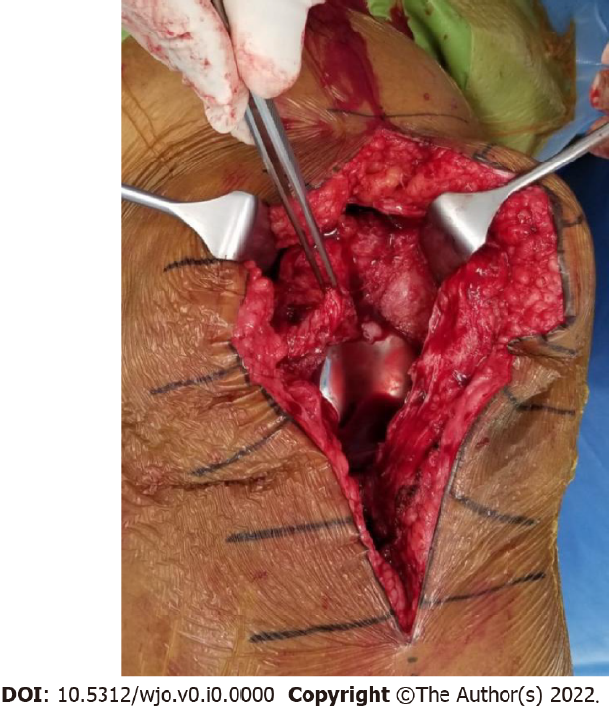
Figure 2 First stage revision of the case shown in Figure 1. Synovial tissue surrounds the prosthesis. Total synovectomy was performed and samples sent for culture confirmed the growth of Staphylococcus aureus.
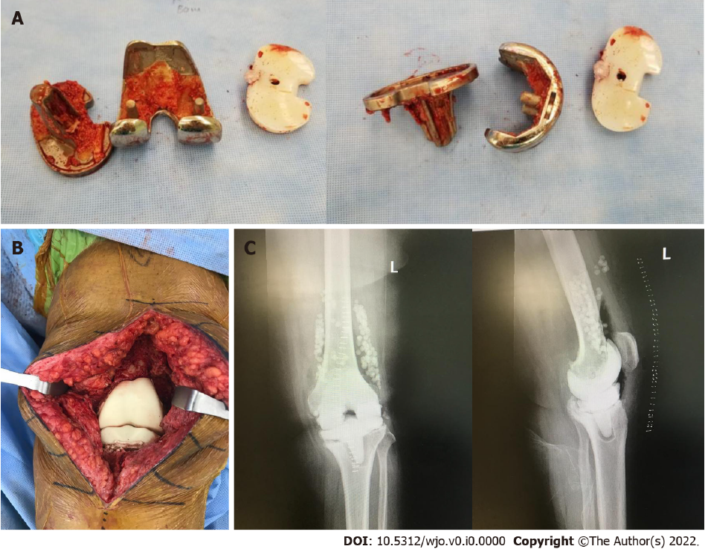
Figure 3 First stage revision. A: Explanted prosthesis with minimal bone loss; B: Articulating spacer implantation at the end of the procedure containing vancomycin and tobramycin; C: Anteroposterior and lateral plain radiographs of the left knee after the first stage showing the spacer in situ with antibiotic beads.
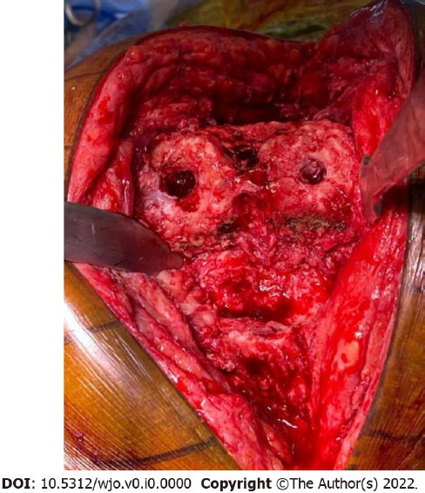
Figure 4 Second stage revision. After the removal of the spacer, the joint is prepared for reimplantation of the prosthesis. This joint shows minimal bone loss.
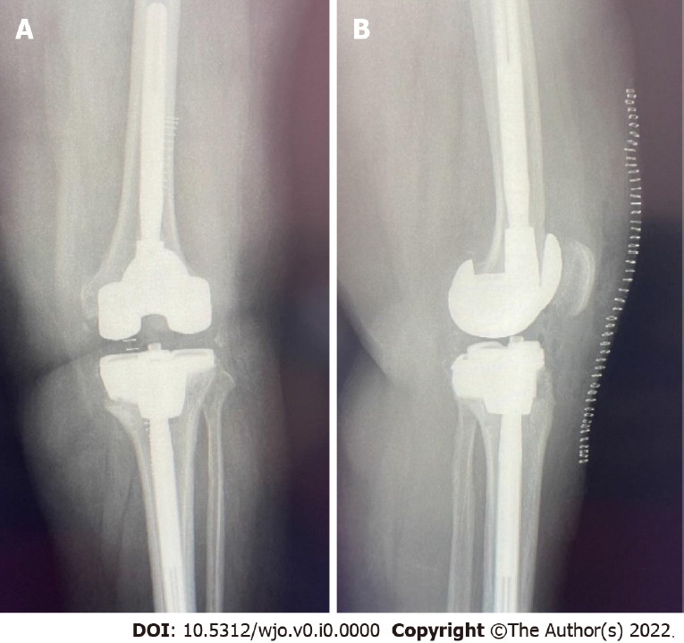
Figure 5 Postoperative anteroposterior and lateral plain radiographs. A: Postoperative anteroposterior view of the left knee after completion of the second stage revision; B: Lateral view of the left knee after completion of the second stage revision.

