Name of Journal: World Journal of Clinical Cases
Manuscript NO: 60360
Manuscript Type: CASE REPORT

Primary mesonephric adenocarcinoma of the fallopian tube: A case report

Xie C et al. MNAC of the fallopian tube

Chuan Xie, Yang-Mei Shen, Qiu-He Chen, Ce Bian

Chuan Xie, Qiu-He Chen, Ce Bian, Department of Gynecology and Obstetrics, Key Laboratory of Birth Defects and Related Diseases of Women and Children, Ministry of Education, West China Second University Hospital, Sichuan University, Chengdu 610041, Sichuan Province, China

Yang-Mei Shen, Department of Pathology, Key Laboratory of Birth Defects and Related Diseases of Women and Children, Ministry of Education, West China Second University Hospital, Sichuan University, Chengdu 610041, Sichuan Province, China

Author contributions: Xie C performed the data collection and manuscript writing; Shen YM performed the data collection and figure preparation; Chen QH performed the figure preparation; Bian C performed the manuscript writing and editing; all authors have read and approved the manuscript.

Corresponding author: Ce Bian, MD, PhD, Department of Gynecology and Obstetrics, Key Laboratory of Birth Defects and Related Diseases of Women and Children, Ministry of Education, West China Second University Hospital, Sichuan University, No. 20 Section Three, South Renmin Road, Chengdu 610041, Sichuan Province, China. terrybian@163.com

Received: October 27, 2020
Revised: April 21, 2021
Accepted: April 29, 2021
Published online:

Abstract
BACKGROUND
Mesonephric adenocarcinoma (MNAC) is an extremely rare malignancy in the female genital tract. Only a few cases have been reported in the literature, and most of them occurred in the cervix, with extremely rare cases in the uterine body and ovary. MNAC has never been reported to arise in the fallopian tube.

CASE SUMMARY
A 45-year-old woman was referred to our institution with a history of abdominal pain. Ultrasound revealed a cystic and solid mass in left adnexal region. The patient underwent complete staging surgery when intraoperative pathological examination demonstrated that the mass was malignant. The final histological and immunohistochemical results confirmed the diagnosis of MNAC originating from the fallopian tube. Then she received four cycles of combination chemotherapy with carboplatin plus paclitaxel. The tumor recurred with hepatic metastases 4 mo after initial surgery, and second resection of the tumors in the liver plus partial hepatectomy was performed. She was supplemented with five courses of a new combination chemotherapy with gemcitabine plus carboplatin, and there was no evidence of recurrence within the 22-mo follow-up period after the second surgery.

CONCLUSION
MNAC originating from the fallopian tube is an extremely rare and high malignancy with a poor prognosis. It can be very aggressive, even at early stage. Little is known about the clinical characteristics, pathological diagnosis, prognosis, and optimal management strategy of MNAC originating from the fallopian tube. Herein we report the first case of primary MNAC deriving from the fallopian tube.

Key Words: Mesonephric adenocarcinoma; Mesonephric-like adenocarcinoma; Fallopian tube; Surgery; Chemotherapy; Case report

Xie C, Shen YM, Chen QH, Bian C. Primary mesonephric adenocarcinoma of the fallopian tube: A case report. World J Clin Cases 2021; In press

Core Tip: We present the first case of primary mesonephric adenocarcinoma (MNAC) deriving from the fallopian tube without sign of relapse or metastasis after second excision of recurrent lesions until now, which demonstrated a satisfactory response to combination chemotherapy of gemcitabine and carboplatin. MNAC originating from the fallopian tube can be very aggressive, even at early stage. Because of its sensitivity to the chemotherapy regimen, it is reasonable that combination chemotherapy of gemcitabine and carboplatin plays an important role in treatment of recurrent MNAC deriving from the fallopian tube. However, further research is needed to determine the effectiveness of this chemotherapy regimen and provide better therapeutic regimen.

INTRODUCTION
Mesonephric adenocarcinoma (MNAC) has only rarely been reported to occur in the uterine body; however, it has never been reported to arise in the fallopian tube. Ovarian adenocarcinomas that share immunophenotypic, morphologic, and molecular features with MNACs but lack association with mesonephric hyperplasia or remnants have been reported, therefore mesonephric-like adenocarcinomas (MLAs) are recently recommended to describe these neoplasms^{[1-3]}. However, neither MNACs nor MLAs have been reported to arise in the fallopian tube up to now. Here we report the first case of primary fallopian tube MNAC (FT-MNAC) with distant recurrence after complete staging surgery combined with systemic chemotherapy, but there is no evidence of recurrence after the second resection of metastatic lesions followed by a new chemotherapy combination with gemcitabine plus carboplatin till now.

CASE PRESENTATION
Chief complaints
A 45-year-old woman presented to our institution with a 3-mo history of lower abdominal pain.

Physical examination
Vaginal examination revealed a palpable mass about 6 cm in diameter in the left adnexal area, and other physical examinations showed no abnormalities.

Laboratory examinations
Laboratory examinations including the serum tumor markers were all within normal range.

Imaging examinations
Transvaginal ultrasound revealed a cystic and solid mass measuring 6.8 cm × 4.6 cm in diameter in left adnexal area.
Surgical treatment and intraoperative findings
A laparotomy was performed and the intraoperative frozen section revealed a diagnosis of malignancy. Therefore, the patient underwent a complete staging surgery. Intraoperative findings revealed that there was a solid and cystic mass measuring 7 cm in maximum diameter with irregular and friable surface, arising from the left fallopian tube. The capsule of the tumor mass was intact. The left ovary and the right adnexa were normal and not infiltrated by the tumor. No obvious tumor implants were observed in the pelvic and abdominal peritoneum, and other organ surfaces, including the liver, diaphragm, stomach, and omentum.

Postoperative pathology and immunohistochemistry
Gross examination of the excised specimen showed a mass measuring 7 cm in maximum diameter arising from the left fallopian tube wall. Histologic examination revealed that the tumor originated from the fallopian tube wall and the tumor cell involved the mucosa and serosal membrane of the fallopian tube (Figure 1A and B). Vestiges of mesonephric hyperplasia (Figure 1C) and hyperplasia into cancerous nests (Figure 1D) were histologically found. Immunohistochemical staining revealed that PAX8 expression was strong and diffuse (Figure 2A). The staining for GATA3 was weak and diffuse (Figure 2B) and CD10 revealed cytoplasmic and luminal staining (Figure 2C). The expression of thyroid transcription factor-1 was diffuse and strong (Figure 2D), but the tumors were totally negative for Calretinin (Figure 2E), Wilms' tumour-1 (Figure 2F), estrogen receptor (Figure 3A), progesterone receptor (Figure 3B), and CA125 (Figure 3C). Positive staining for P16 (Figure 3D) and P53 (Figure 3E) was detected. The positive rate of Ki-67 expression was 60%-70% (Figure 3F).

FINAL DIAGNOSIS
The final histological and immunohistochemical results confirmed the diagnosis of FT-MNAC. The tumor was staged as International Federation of Gynecology and Obstetrics (FIGO) stage IA.

TREATMENT
Chemotherapy after first surgery
The patient received adjuvant chemotherapy with four courses of paclitaxel (175 mg/m²) and carboplatin (300 mg/m²) after the first surgery.

Recurrence of the disease and second surgical treatment
Abdominal computed tomography detected low-density nodules under the liver capsule (Figure 4A and B) 4 mo after initial surgery. Then the second resection of tumors in the liver plus partial hepatectomy (Figure 4C and D) was performed and the postoperative pathological examination indicated that the hepatic tumors were metastatic MNAC.

Chemotherapy after the second surgery
Five courses of a new combination chemotherapy with carboplatin (300 mg/m²) and gemcitabine (1000 mg/m²) were administered to the patient.

OUTCOME AND FOLLOW-UP
There was no evidence of recurrence within a 22 mo follow-up period after the second surgery.

DISCUSSION
MNAC is an extremely rare and highly malignant tumor in the female reproductive system. It is believed to be originated from remnant of the regressed mesonephric duct (also called Wolffian duct)^{[1,4]}. Due to the lack of information on the treatment of this rare disease, there are currently no established guidelines about standard therapy of FT-MNAC. However, a radical surgery may be the initial choice for localized disease. Comprehensive staging surgery including hysterectomy, bilateral salpingo-oophorectomy, omentectomy, and para-aortic plus pelvic lymphadenectomy was performed in most of the reported MNAC patients. In this case, the woman was a perimenopausal patient who had already given birth, therefore she received complete staging surgery. Initial radical surgery is considered to be the standard treatment, but there is little evidence about the efficacy of the treatment with chemotherapy or radiotherapy after surgery. Because of its high malignancy, postoperative chemotherapy may be an important and necessary adjuvant treatment method for FT-MNAC to prevent or delay tumor recurrence like any other MNAC or fallopian tube cancer.
MNACs can be very aggressive, even at early stage. A review of the literature including 31 cases of MNAC reported that 82% of the patients had FIGO stage IB disease at initial diagnosis, but one third of the patients with FIGO stage I disease developed recurrence even after radical surgery. Distant metastases and local recurrence were frequent findings in this study, and the median time to recurrence was 2.1 years^{[5]}. In another study, a recurrence rate of 32% was reported among patients with FIGO stage I MNAC^{[6]}. Distant metastases at initial diagnosis were found in less than 5% of MNAC cases, but a malignant clinical course has been reported in about 40% of patients^{[7,8]}. In our case, no distant metastasis was detected at the time of initial diagnosis. Although complete staging surgery combined with systemic chemotherapy was performed, the patient still developed tumor recurrence 4 mo after initial surgery, which indicated that FT-MNAC is very aggressive.
There are no specific recommendations about the treatment of recurrent MNAC especially FT-MNAC, due to limited number of reported cases. However, excision of locally recurrent lesions followed by systemic chemotherapy is still the optimal treatment for patients with recurrent MNAC. By the time being, there has been very little research about which chemotherapy regimen is effective for recurrent MNAC. A recent study reported a recurrent MNAC patient with good response to combination chemotherapy of paclitaxel and carboplatin^{[9]}. However, this patient, who had been given chemotherapy with carboplatin plus paclitaxel after initial surgery, rapidly developed a distant relapse. Hence, a new combination chemotherapy with gemcitabine and carboplatin was administered to treat the present patient, and she had no evidence of disease recurrence within a 22 mo follow-up period, indicating that combination chemotherapy with carboplatin plus gemcitabine may be effective for treating FT-MNAC.

CONCLUSION
We present the first case of primary FT-MNAC without sign of relapse or metastasis after second excision of recurrent lesions until now, which demonstrated a satisfactory response to combination chemotherapy of gemcitabine and carboplatin. FT-MNAC can be very aggressive, even at early stage. Because of its sensitivity to the chemotherapy regimen, it is reasonable that combination chemotherapy of gemcitabine and carboplatin plays an important role in the treatment of recurrent FT-MNAC. However, further research is needed to determine the effectiveness of this chemotherapy regimen and provide better therapeutic regimen.

REFERENCES
1 Howitt BE, Nucci MR. Mesonephric proliferations of the female genital tract. Pathology 2018; 50: 141-150 [PMID: 29269124 DOI: 10.1016/j.pathol.2017.11.084]
2 McCluggage WG, Vosmikova H, Laco J. Ovarian Combined Low-grade Serous and Mesonephric-like Adenocarcinoma: Further Evidence for A Mullerian Origin of Mesonephric-like Adenocarcinoma. Int J Gynecol Pathol 2020; 39: 84-92 [PMID: 30575604 DOI: 10.1097/PGP.0000000000000573]
3 McFarland M, Quick CM, McCluggage WG. Hormone receptor-negative, thyroid transcription factor 1-positive uterine and ovarian adenocarcinomas: report of a series of mesonephric-like adenocarcinomas. Histopathology 2016; 68: 1013-1020 [PMID: 26484981 DOI: 10.1111/his.12895]
4 Pors J, Cheng A, Leo JM, Kinloch MA, Gilks B, Hoang L. A Comparison of GATA3, TTF1, CD10, and Calretinin in Identifying Mesonephric and Mesonephric-like Carcinomas of the Gynecologic Tract. Am J Surg Pathol 2018; 42: 1596-1606 [PMID: 30148742 DOI: 10.1097/PAS.0000000000001142]
5 Yap OW, Hendrickson MR, Teng NN, Kapp DS. Mesonephric adenocarcinoma of the cervix: a case report and review of the literature. Gynecol Oncol 2006; 103: 1155-1158 [PMID: 17023031 DOI: 10.1016/j.ygyno.2006.08.031]
6 Dierickx A, Göker M, Braems G, Tummers P, Van den Broecke R. Mesonephric adenocarcinoma of the cervix: Case report and literature review. Gynecol Oncol Rep 2016; 17: 7-11 [PMID: 27354991 DOI: 10.1016/j.gore.2016.05.002]
7 Montalvo N, Redrobán L, Galarza D. Mesonephric adenocarcinoma of the cervix: a case report with a three-year follow-up, lung metastases, and next-generation sequencing analysis. Diagn Pathol 2019; 14: 71 [PMID: 31266530 DOI: 10.1186/s13000-019-0847-8]
8 Na K, Kim HS. Clinicopathologic and Molecular Characteristics of Mesonephric Adenocarcinoma Arising From the Uterine Body. Am J Surg Pathol 2019; 43: 12-25 [PMID: 29189288 DOI: 10.1097/PAS.0000000000000991]
9 Montagut C, Mármol M, Rey V, Ordi J, Pahissa J, Rovirosa A, Gascón P, Mellado B. Activity of chemotherapy with carboplatin plus paclitaxel in a recurrent mesonephric adenocarcinoma of the uterine corpus. Gynecol Oncol 2003; 90: 458-461 [PMID: 12893219 DOI: 10.1016/s0090-8258(03)00228-2]

Footnotes
Informed consent statement: Written consent to publish this information was obtained from the patient.

Conflict-of-interest statement: The authors declare no conflict of interest/competing interests in publishing the present manuscript.

CARE Checklist (2016) statement: The authors have read the CARE Checklist (2016), and the manuscript was prepared and revised according to the CARE Checklist (2016).

Open-Access: This article is an open-access article that was selected by an in-house editor and fully peer-reviewed by external reviewers. It is distributed in accordance with the Creative Commons Attribution NonCommercial (CC BY-NC 4.0) license, which permits others to distribute, remix, adapt, build upon this work non-commercially, and license their derivative works on different terms, provided the original work is properly cited and the use is non-commercial. See: http://creativecommons.org/Licenses/by-nc/4.0/

Manuscript source: Unsolicited manuscript

Peer-review started: October 27, 2020
First decision: January 17, 2021
Article in press:

Specialty type: Medicine, research and experimental
Country/Territory of origin: China
Peer-review report’s scientific quality classification
Grade A (Excellent): 0
Grade B (Very good): B
Grade C (Good): 0
Grade D (Fair): 0
Grade E (Poor): 0

P-Reviewer: Tanabe S S-Editor: Fan JR L-Editor: Wang TQ P-Editor:
Figure Legends
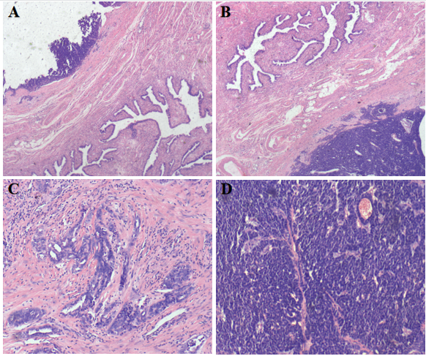
Figure 1 Histologic features of fallopian tube-mesonephric adenocarcinoma. A and B: Pathological finding revealed that the tumor originated from the fallopian tube wall and involved the mucosa and serosal membrane of the fallopian tube; C and D: Vestiges of mesonephric hyperplasia (C) and hyperplasia into cancerous nests (D) were histologically found. The histologic patterns of the tumor were mainly solid.
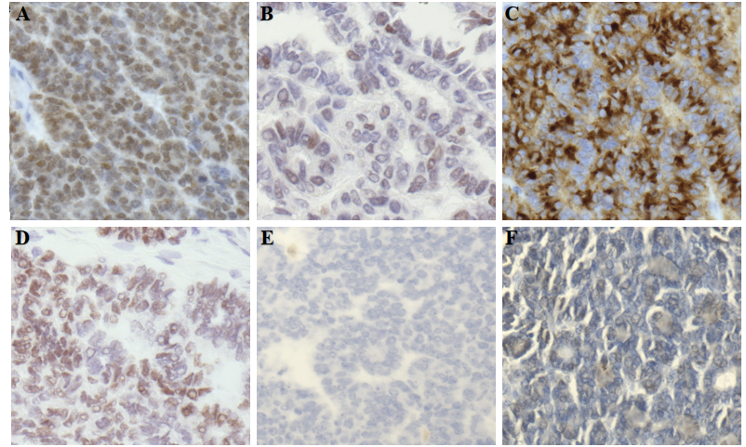
Figure 2 Immunohistochemical staining of fallopian tube-mesonephric adenocarcinoma. A: PAX8 expression in this case was strong and diffuse, indicating that the tumor arose from the female genital tract; B: GATA3 positivity is helpful in confirming the diagnosis of mesonephric carcinoma, but the staining may be weak and focal. In the present case, the staining for GATA3 was weak and diffuse; C: CD10 revealed cytoplasmic and luminal staining; D: Immunohistochemical staining for thyroid transcription factor-1 was strong and diffuse; E and F: Immunohistochemistry showed totally negative staining for Calretinin (E) and Wilms' tumour-1 (F).
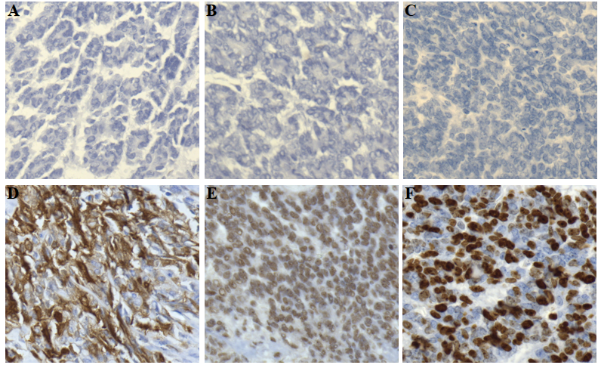
Figure 3 Immunohistochemical staining of fallopian tube-mesonephric adenocarcinoma. A-C: Immunohistochemistry demonstrated totally negative staining for estrogen receptor (A), progesterone receptor (B), and CA125 (C); D and E: Positive staining for P16 (D) and P53 (E) was detected; F: The positive rate of Ki-67 expression was 60%-70%.
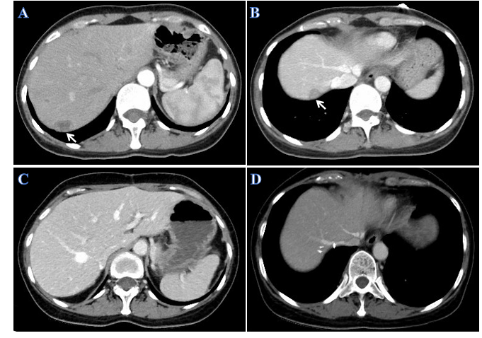
Figure 4 Computed tomography images of the patient with hepatic recurrence. A and B: Abdominal computed tomography (CT) scan detected low-density nodules under the liver capsule. The arrows indicate metastatic nodules in the liver, and the diameters of the metastatic lesions ranged from 1.5-2.5 cm; C and D: CT appearances of the liver after second resection of tumors in the liver plus partial hepatectomy.

