Name of Journal: World Journal of Gastroenterology
Manuscript NO: 40292
Manuscript Type: CASE REPORT

Novel methionyl-tRNA synthetase gene variants/phenotypes in interstitial lung and liver disease: A case report and review of the literature

Abuduxikuer K et al. Novel MARS variants and phenotypes in ILLD

Kuerbanjiang Abuduxikuer, Jia-Yan Feng, Yi Lu, Xin-Bao Xie, Lian Chen, Jian-She Wang

Kuerbanjiang Abuduxikuer, Yi Lu, Xin-Bao Xie, Jian-She Wang, Department of Hepatology, Children's Hospital of Fudan University, Shanghai 201102, China

Jia-Yan Feng, Lian Chen, Department of Pathology, Children's Hospital of Fudan University, Shanghai 201102, China

Jian-She Wang, Department of Pediatrics, Jinshan Hospital of Fudan University, Shanghai 201508, China

ORCID number: Kuerbanjiang Abuduxikuer (0000-0003-0298-3269); Jia-Yan Feng (0000-0002-6651-4675); Yi Lu (0000-0002-3311-4501); Xin-Bao Xie (0000-0002-3692-7356); Lian Chen (0000-0002-0545-2108); Jian-She Wang (0000-0003-0823-586X).

Author contributions: Wang JS designed the report and approved the final submission; Abuduxikuer K collected data, analyzed relevant information, and wrote the manuscript; Wang JS, Lu Y, Xie XB, and Abuduxikuer K clinically managed the patient; Feng JY, Chen L analyzed liver biopsy samples.

Supported by the National Natural Science Foundation of China, No. 81570468.

Informed consent statement: Informed consent was obtained from the parents.

Conflict-of-interest statement: The authors declare that they have no conflicts of interest.

CARE Checklist (2013) statement: The authors have read the CARE Checklist (2013), and the manuscript was prepared and revised according to the CARE Checklist (2013).
Open-Access: This article is an open-access article which was selected by an in-house editor and fully peer-reviewed by external reviewers. It is distributed in accordance with the Creative Commons Attribution Non Commercial (CC BY-NC 4.0) license, which permits others to distribute, remix, adapt, build upon this work non-commercially, and license their derivative works on different terms, provided the original work is properly cited and the use is non-commercial. See: http://creativecommons.org/licenses/by-nc/4.0/

Manuscript source: Unsolicited manuscript

Correspondence to: Jian-She Wang, MD, PhD, Professor, Department of Hepatology, Children's Hospital of Fudan University, 399 Wanyuan Road, Shanghai 201102, China. jshwang@shmu.edu.cn
Telephone: +86-21-64931171
Fax: +86-21-64931171

Received: June 21, 2018
Peer-review started: June 22, 2018
First decision: July 31, 2018
Revised: August 2, 2018
Accepted: August 24, 2018
Article in press:
Published online:

Abstract
Interstitial lung and liver disease (ILLD) is caused by biallelic mutations in the methionyl-tRNA synthetase (MARS) gene. To date, no genetic changes other than missense variants were reported in the literature. Here we report a five-month-old female infant with typical ILLD (failure to thrive, developmental delay, jaundice, diffuse interstitial lung disease, hepatomegaly with severe steatosis, anemia, and thrombocytosis) having novel phenotypes such as kidney stone, acetabular dysplasia, prolonged fever, and extreme leukocytosis. Whole exome sequencing revealed a novel truncating variant (c.2158C>T/p.Gln720Stop) together with a novel tri-nucleotide insertion (c.893_894insTCG that caused the insertion of an arginine on the amino acid position of 299) in MARS gene.

Key words: Interstitial lung and liver disease; Methionyl-trna synthetase gene; Methionyl-tRNA synthetase; Infant; Kidney stone; Hip dysplasia; Leukocytosis

© The Author(s) 2018. Published by Baishideng Publishing Group Inc. All rights reserved.

Core tip: Previously reported cases of interstitial lung and liver disease (ILLD) were associated with biallelic missense mutations in the methionyl-tRNA synthetase (MARS) gene. Here we report a Chinese infant with typical ILLD (failure to thrive, developmental delay, interstitial lung disease, cholestasis, hepatomegaly, steatosis, anemia, and thrombocytosis) with novel phenotypes, such as kidney stone, acetabular dysplasia, prolonged fever, and extreme leukocytosis. Whole exome sequencing revealed a novel truncating variant (c.2158C>T/p.Gln720Stop), and a novel tri-nucleotide insertion (c.893_894insTCG) in MARS gene. Despite resolution of cholestasis, this patient died of respiratory failure at the age of 11 mo.

Abuduxikuer K, Feng JY, Lu Y, Xie XB, Chen L, Wang JS. Novel methionyl-tRNA synthetase gene variants/phenotypes in interstitial lung and liver disease: A case report and review of the literature. World J Gastroenterol 2018; In press

INTRODUCTION
methionyl-tRNA synthetase (MARS) gene encodes cytoplasmic methionyl-tRNA synthetase (MetRS) responsible for catalyzing ligation of methionine to tRNA^{[1]}. MetRS belongs to a family of aminoacyl-tRNA synthetases that play critical roles in protein biosynthesis by charging tRNAs with their cognate amino acids^{[2]}. Interstitial lung and liver disease (ILLD) (OMIM#615486) is caused by homozygous or compound heterozygous mutations in the MARS gene (156560) on chromosome 12q13^{[3-5]}. Heterozygous MARS mutations has been reported to be associated with autosomal dominant Charcot-Marie-Tooth disease (CMT)^{[6-9]}. Same MARS mutation may cause both ILLD and CMT^{[10]}. MARS is also a candidate gene for hereditary spastic paraplegias (HSPs), a neuro-degenerative motor neuron disorder^{[11]}. To date, no genetic changes other than missense variants were reported in the literature. Here we report a Chinese infant with lethal ILLD having novel phenotypes such as kidney stone, acetabular dysplasia, prolonged fever, and extreme leukocytosis. Whole exome sequencing revealed a novel truncating variant together with a novel tri-nucleotide insertion in MARS gene.

CASE REPORT
A five-month-old female infant was presented with failure to thrive, developmental delay, jaundice, and dark urine. She was born full-term with normal birth weight (3100 g) after an uncomplicated first pregnancy and vaginal delivery. Weight gain and developmental milestones were normal until three-months of age (weighted 6000 g), then she failed to thrive with a body weight of 5700 g at the age of 5-mo without the ability of rolling over.
At in-patient admission, this patient was 5.2-mo-old with a body weight of 5500 g (2nd percentile by WHO standards), length of 55 cm (lower than the 1st percentile), and head circumference of 39 cm (2nd percentile). This infant had prolonged low-grade fever, pulmonary effusion, diffuse interstitial lung disease, significant leukocytosis, high procalcitonin (PCT)/CRP levels, and required nasal oxygen therapy. Serial chest X-rays showed some improvement of pulmonary effusion, but no improvement of interstitial lung involvement (Figure 1A). After serial antibiotic treatments (ceftriaxone, cefoperazone + slubactam, meropenem, norvancomycin, and fluconazole), body temperature was able to be normalized, oxygen therapy was no longer needed, leukocytosis improved, but interstitial lung disease stayed the same. After treated with ursodeoxycholic acid and fat soluble vitamins, cholestasis improved significantly (Table 1).
Patient was discharged with normal oxygen saturation on room-air without apparent respiratory distress or cough. Liver function test and complete blood count was normal at a 9.5-mo follow-up. However, the infant was admitted to a provincial level pediatric intensive care unit for acute respiratory distress at 11-mo of age, and received mechanical ventilation. Despite treatment, she died of respiratory failure and hypoxic encephalopathy.
Genetic cause was suspected due to multiple system involvement, but liver panel consisting of 41 genes (Table 2) related to liver diseases came back negative. Lysosomal storage disease was considered, but an enzyme panel for screening of common lysosomal storage diseases was normal, as was the urine acidoglycoprotein level. This patient was enrolled for undiagnosed disease patient program in our hospital, and whole exome sequencing was ordered. Compound heterozygous MARS gene variants, c.2158C>T/p.Gln720Stop and c.893_894insTCG/p.Arg299dup, were detected. Presence of these mutations was confirmed with Sanger sequencing, and parental origins were ascertained. Both variants were not reported in the dbSNP137 (http://www. ncbi.nlm.nih.gov/snp/), 1000 Genome Database (http://www.1000genomes.org/), and Exome Variant Server (http://evs.gs.washington.edu/EVS/). The c.2158C>T mutation was inherited from the healthy mother, caused the change of glutamine amino acid in the position of 720 to a stop codon, and predicted to be disease causing by MutationTaster (http://www.mutationtaster.org). The tri-nucleotide insertion (c.893_894insTCG) inherited from her healthy father caused the insertion of a single amino acid (arginine) on the position of 299, and predicted to be disease causing by MutationTaster (Figure 2A). Details of genetic testing results and secondary findings were provided in Table 2.
Liver biopsy results showed severe steatosis of hepatic cells with ballooning, lobular disarray, and cholestasis. Mild changes, such as fibrosis, lymphocyte infiltration, and bile duct proliferation, were seen within the portal region. Hepatic iron deposition was seen after iron staining, but copper staining was negative (Figure 1C). Sinosoids, and Kupffer cells seemed normal. Immunohistochemical staining for hepatitis B surface antigen, core antigen, Epstein-Barr virus, and langerin cells were negative. Immunohistochemical staining for cholestasis related proteins, such as BSEP, MDR3, MRP2, TJP2, and MYO5B, were all normal. After the genetic diagnosis, we used rabbit anti-MARS monoclonial antibody (purchased from http://www.abcam.cn, product code: ab180497) to perform immunohistochemical staining on paraffin embedded liver biopsy samples. When compared to a normal liver sample (donated for liver transplantation), coarsely granular pigments within cytoplasm were seen in the index patient.
Ultrasound examination revealed marked hepatomegaly (liver 4 cm below the right costal margin, and 5 cm below the xiphoid process), and reduced hepatic echogenicity. Hyper-echoic lesions consistent with stone formation were seen on both kidneys. Abdominal computed tomography (CT) scan showed hepatic steatosis, and hyper-echoic lesions suggestive of kidney stone in the left kidney but not in the right kidney (Figure 1B). X-ray imaging of skull was normal, as were long bones on both arms and legs. X-ray imaging also picked up abnormally shallow hip sockets on both sides that is suggestive of acetabular dysplasia or congenital hip dysplasia (Figure 1B). Other diagnostic evaluations were provided in Table 3.

DISCUSSION
MetRS is one of 20 ubiquitously expressed enzymes essential for protein biosynthesis, and covalently links methionine with its cognate tRNA. Since initial reports of MARS gene mutation causing ILLD^{[3]} and CMT^{[6]} in 2013, total of 34 cases of ILLD^{[4,5,10]}, and 8 cases of CMT^{[7-10]} have been reported so far.
Similar to previous reports, our case had failure to thrive, developmental delay, interstitial lung disease, liver involvement (hepatomegaly, cholestasis, hepatic steatosis, fibrosis, and iron deposition), anemia, and thrombocytosis. Active proliferation of bone marrow cells has been reported by Sun et al^{[5]}. Our patient had marked leukocytosis (white blood cell count up to 71.7 × 10⁹/L), and bone marrow biopsy showed extreme proliferation of bone marrow cells with few hemophagocytic cells. MetRS is also a component of a cytoplasmic multiaminoacyl-tRNA synthetase complex with multiple roles in immune response, inflammation, and tumor genesis^{[12,13]}. Prolonged low grade fever, leukocytosis, thrombocytosis, and elevated c-reactive protein in this patient responded to intensive antibiotic treatment, and could be viewed as exaggerated inflammatory or immune response to infection. Unlike previous reports of arrest in red blood cell maturity^{[3,5]}, bone marrow biopsy in this patient showed marked proliferation of normal erythrocyte precursors.
Aminoaciduria have been reported^{[3]}, but kidney stones has never been reported to be associated with MARS mutation. No evidence of urinary tract infection, proteinuria, or organic aciduria was found in our case, and serum electrolytes with urea and creatinine were essentially normal. Evaluation of urinary citrate, calcium, 24-h urine output in future ILLD cases might be needed in order to rule out factors predisposing renal stone formation^{[14]}. Mutation in gene encoding mitochondrial seryl-tRNA synthetase has been reported to cause renal damage^{[15,16]}, but no association of cytoplasmic aminoacyl-tRNA synthetas including MARS have been reported. Since previously reported mutations were all non-synonymous in nature, severe mutations (such as truncating and single amino-acid insertion in our case) may have caused some renal impairment leading to stone formation.
No skeletal abnormality has been reported except for 2 cases of ILLD with delayed bone age^{[5]}. Our case had marked acetabular dysplasia consistent with developmental hip dysplasia. Other than being female, this infant did not have other risk factors^{[17]} such as breach presentation on delivery, local infection, or trauma. Whole exome sequencing did not find abnormalities in previously reported susceptible genes such as GDF5, TBX4, ASPN, IL-6, TGF-b1, and PAPPA2^{[18]}. Hip dysplasia is associated with CMT^{[19]}, and prevalence of hip dysplasia among children with CMT ranged from 6% to 8.1%^{[20]}. Novarino et al^{[11]} reported 4 cases of HSPs with compound heterozygous variant of MARS gene in a family with infantile onset delayed motor milestones and disability on crawling/walking. Two cases had bilateral Achilles contracture, one had scoliosis, but none had hip-joint abnormalities. A recent report of ILLD case^{[10]} carried the p.Arg618Cys variant that also associated with CMT in a previous report^{[6]}, indicating ILLD and CMT may share a same disease causing mechanism. All reported cases of CMT, ILLD, and HSPs associated with MARS gene had missense mutations. Our case had a truncating mutation and an insertion of a single amino-acid. Severe mutations may have been responsible for hip dysplasia that could be an early manifestation of CMT in this patient.
The c.2158C>T/p.Gln720Stop, which was inherited from the mother, caused the glutamine amino acid change in the position of 720 leading to stop codon at well conserved the α-helix bundle domain (anti-codon binding domain) of methionyl-tRNA synthetase protein.
The tri-nucleotide insertion (c.893_894insTCG) from paternal origin caused the insertion of a single amino acid (arginine) on the position of 299 in the Rossmann fold domain (catalysis center). Nine out of 12 ILLD variants reported so far affected amino acid on the Rossmann fold domain (Figure 2B), and Arg299 is adjacent to the active methionine binding site of human MetRS surrounded by amino acid residues of Arg12, Leu13, Pro14, Thr257, Gly259, Tyr260, Asn297, and His301^{[21]}.
All eight mutations from European ILLD cases were located in the Rossmann fold of MARS protein. However, only one out of four mutations from Chinese cases carried mutation in the Rossmann fold domain, and significantly different from European ILLD case (Fisher's exact = 0.018) (Figure 2B). Our case also suggested that, severe mutations may lead to more organ/system involvement and severe outcome.
In vivo yeast complementation assay was used to predict effects of MARS variants including 1852C>T/p.Arg618Cys^{[6]}, c.920A>G/p.Tyr307Cys^{[10]}, and 1852C>T/p.Arg618Cys^{[10]}. In vitro aminoacylation assay with HEK293 cell was used to confirm effects of c.1108T>C/p.Phe370Leu, and c.1568T>C/p.Ile523Thr MARS varians^{[3]}. Effects of c.1031A>G/p.Tyr344Cys, c.1177G>A/p.Ala393Thr, c.1700C>T/p.Ser567Leu, and c.1814A>T/p.Asp605Val were studied with in vitro yeast aminoacylation assay^{[4]}, and later by Comisso et al^{[22]} using E. Coli based aminoacylation assay. Further functional studies were needed to confirm effects of variants in our case, as well as variants reported by others (c.2398C>A/p.Pro800Thr^{[7]}; c.433G>A/p.Asp145Asn, and c.2405T>C/p.Phe802Ser^{[5]}). Beside previously used methods, one may consider animal models utilized to predict pathogenicity of other aminoacyl-tRNA synthetase mutations such as Drosophila, and C. elegans^{[23]}.
Currently, there is no cure for ILLD, and treatment is supportive. Given that in vitro enzyme activity may partly be restored by increasing methionine^{[22]}, methionine supplementation could be considered in studies of animal models, or even in humans. However, plasma levels of methionine, and its toxic product, homocyteine, should be closely monitored.
In conclusion, truncating and insertion variants in MARS gene may cause ILLD, and phenotypes of ILLD may also include kidney stone, acetabular dysplasia, prolonged fever, and extreme leukocytosis.

ARTICLE HIGHLIGHTS
Case characteristics
A five-month-old female infant presented with failure to thrive, developmental delay, jaundice, and dark urine.

Clinical diagnosis
Typical clinical findings and whole exome sequencing results led to a diagnosis of interstitial lung and liver disease (ILLD).

Differential diagnosis
Genetic cause was suspected due to multiple system involvement, but liver panel consisting of 41 genes related to liver diseases came back negative. Lysosomal storage disease was considered, but enzyme panel for screening of common lysosomal storage diseases were normal, as was the urine acidoglycoprotein level.

Laboratory diagnosis
Laboratory findings were Cholestasis, anemia, abnormal blood coagulation profiled, thrombocytosis, and extreme leukocytosis. Whole exome sequencing revealed a novel truncating variant (c.2158C>T/p.Gln720Stop), and a novel tri-nucleotide insertion (c.893_894insTCG) in methionyl-tRNA synthetase (MARS) gene.

Imaging diagnosis
X-ray, computed tomography scan, and ultrasound imaging revealed interstitial lung disease, hepatomegaly, kidney stone, and acetabular dysplasia.

Pathological diagnosis
Liver biopsy results showed severe hepatic steatosis, hepatic cells ballooning, lobular disarray, cholestasis, iron deposition, and mild fibrosis/lymphocyte infiltration/bile duct proliferation within the portal region.

Treatment
Ursodeoxycholic acid, fat soluble vitamins, antibiotics, oxygen therapy, and supportive treatment.

Related reports
Previously reports ILLD were associated with biallelic missense mutations in the MARS gene. Phenotypes, such as kidney stone, acetabular dysplasia, prolonged fever, and extreme leukocytosis, have never been reported to be associated with ILLD.

Term explanation
ILLD is interstitial lung and liver disease caused by homozygous or compound heterozygous mutations in the MARS gene. Typical findings in ILLD include failure to thrive, developmental delay, interstitial lung disease, liver involvement (hepatomegaly, cholestasis, hepatic steatosis, fibrosis, and iron deposition), anemia, and thrombocytosis.

Experiences and lessons
Regardless of race or ethnicity, ILLD should be considered in all patients with chronic liver diseases with progressive interstitial lung involvement. Severe mutations may lead to more organ/system involvement and severe outcome.

REFERENCES
1 Deniziak MA, Barciszewski J. Methionyl-tRNA synthetase. Acta Biochim Pol 2001; 48: 337-350 [PMID: 11732605]
2 Ibba M, Soll D. Aminoacyl-tRNA synthesis. Annu Rev Biochem 2000; 69: 617-650 [PMID: 10966471 DOI: 10.1146/annurev.biochem.69.1.617]
3 van Meel E, Wegner DJ, Cliften P, Willing MC, White FV, Kornfeld S, Cole FS. Rare recessive loss-of-function methionyl-tRNA synthetase mutations presenting as a multi-organ phenotype. BMC Med Genet 2013; 14: 106 [PMID: 24103465 DOI: 10.1186/1471-2350-14-106]
4 Hadchouel A, Wieland T, Griese M, Baruffini E, Lorenz-Depiereux B, Enaud L, Graf E, Dubus JC, Halioui-Louhaichi S, Coulomb A, Delacourt C, Eckstein G, Zarbock R, Schwarzmayr T, Cartault F, Meitinger T, Lodi T, de Blic J, Strom TM. Biallelic Mutations of Methionyl-tRNA Synthetase Cause a Specific Type of Pulmonary Alveolar Proteinosis Prevalent on Réunion Island. Am J Hum Genet 2015; 96: 826-831 [PMID: 25913036 DOI: 10.1016/j.ajhg.2015.03.010]
5 Sun Y, Hu G, Luo J, Fang D, Yu Y, Wang X, Chen J, Qiu W. Mutations in methionyl-tRNA synthetase gene in a Chinese family with interstitial lung and liver disease, postnatal growth failure and anemia. J Hum Genet 2017; 62: 647-651 [PMID: 28148924 DOI: 10.1038/jhg.2017.10]
6 Gonzalez M, McLaughlin H, Houlden H, Guo M, Yo-Tsen L, Hadjivassilious M, Speziani F, Yang XL, Antonellis A, Reilly MM, Züchner S; Inherited Neuropathy Consortium. Exome sequencing identifies a significant variant in methionyl-tRNA synthetase (MARS) in a family with late-onset CMT2. J Neurol Neurosurg Psychiatry 2013; 84: 1247-1249 [PMID: 23729695 DOI: 10.1136/jnnp-2013-305049]
7 Hyun YS, Park HJ, Heo SH, Yoon BR, Nam SH, Kim SB, Park CI, Choi BO, Chung KW. Rare variants in methionyl- and tyrosyl-tRNA synthetase genes in late-onset autosomal dominant Charcot-Marie-Tooth neuropathy. Clin Genet 2014; 86: 592-594 [PMID: 24354524 DOI: 10.1111/cge.12327]
8 Nam SH, Hong YB, Hyun YS, Nam da E, Kwak G, Hwang SH, Choi BO, Chung KW. Identification of Genetic Causes of Inherited Peripheral Neuropathies by Targeted Gene Panel Sequencing. Mol Cells 2016; 39: 382-388 [PMID: 27025386 DOI: 10.14348/molcells.2016.2288]
9 Hirano M, Oka N, Hashiguchi A, Ueno S, Sakamoto H, Takashima H, Higuchi Y, Kusunoki S, Nakamura Y. Histopathological features of a patient with Charcot-Marie-Tooth disease type 2U/AD-CMTax-MARS. J Peripher Nerv Syst 2016; 21: 370-374 [PMID: 27717217 DOI: 10.1111/jns.12193]
10 Rips J, Meyer-Schuman R, Breuer O, Tsabari R, Shaag A, Revel-Vilk S, Reif S, Elpeleg O, Antonellis A, Harel T. MARS variant associated with both recessive interstitial lung and liver disease and dominant Charcot-Marie-Tooth disease. Eur J Med Genet 2018 [PMID: 29655802 DOI: 10.1016/j.ejmg.2018.04.005]
11 Novarino G, Fenstermaker AG, Zaki MS, Hofree M, Silhavy JL, Heiberg AD, Abdellateef M, Rosti B, Scott E, Mansour L, Masri A, Kayserili H, Al-Aama JY, Abdel-Salam GMH, Karminejad A, Kara M, Kara B, Bozorgmehri B, Ben-Omran T, Mojahedi F, El Din Mahmoud IG, Bouslam N, Bouhouche A, Benomar A, Hanein S, Raymond L, Forlani S, Mascaro M, Selim L, Shehata N, Al-Allawi N, Bindu PS, Azam M, Gunel M, Caglayan A, Bilguvar K, Tolun A, Issa MY, Schroth J, Spencer EG, Rosti RO, Akizu N, Vaux KK, Johansen A, Koh AA, Megahed H, Durr A, Brice A, Stevanin G, Gabriel SB, Ideker T, Gleeson JG. Exome sequencing links corticospinal motor neuron disease to common neurodegenerative disorders. Science 2014; 343: 506-511 [PMID: 24482476 DOI: 10.1126/science.1247363]
12 Guo M, Schimmel P. Essential nontranslational functions of tRNA synthetases. Nat Chem Biol 2013; 9: 145-153 [PMID: 23416400 DOI: 10.1038/nchembio.1158]
13 Yao P, Fox PL. Aminoacyl-tRNA synthetases in medicine and disease. EMBO Mol Med 2013; 5: 332-343 [PMID: 23427196 DOI: 10.1002/emmm.201100626]
14 Bevill M, Kattula A, Cooper CS, Storm DW. The Modern Metabolic Stone Evaluation in Children. Urology 2017; 101: 15-20 [PMID: 27838366 DOI: 10.1016/j.urology.2016.09.058]
15 Rivera H, Martín-Hernández E, Delmiro A, García-Silva MT, Quijada-Fraile P, Muley R, Arenas J, Martín MA, Martínez-Azorín F. A new mutation in the gene encoding mitochondrial seryl-tRNA synthetase as a cause of HUPRA syndrome. BMC Nephrol 2013; 14: 195 [PMID: 24034276 DOI: 10.1186/1471-2369-14-195]
16 Belostotsky R, Ben-Shalom E, Rinat C, Becker-Cohen R, Feinstein S, Zeligson S, Segel R, Elpeleg O, Nassar S, Frishberg Y. Mutations in the mitochondrial seryl-tRNA synthetase cause hyperuricemia, pulmonary hypertension, renal failure in infancy and alkalosis, HUPRA syndrome. Am J Hum Genet 2011; 88: 193-200 [PMID: 21255763 DOI: 10.1016/j.ajhg.2010.12.010]
17 Shaw BA, Segal LS; SECTION ON ORTHOPAEDICS. Evaluation and Referral for Developmental Dysplasia of the Hip in Infants. Pediatrics 2016; 138: [PMID: 27940740 DOI: 10.1542/peds.2016-3107]
18 Shi D, Dai J, Ikegawa S, Jiang Q. Genetic study on developmental dysplasia of the hip. Eur J Clin Invest 2012; 42: 1121-1125 [PMID: 22594447 DOI: 10.1111/j.1365-2362.2012.02682.x]
19 Novais EN, Bixby SD, Rennick J, Carry PM, Kim YJ, Millis MB. Hip dysplasia is more severe in Charcot-Marie-Tooth disease than in developmental dysplasia of the hip. Clin Orthop Relat Res 2014; 472: 665-673 [PMID: 23943527 DOI: 10.1007/s11999-013-3127-z]
20 Walker JL, Nelson KR, Heavilon JA, Stevens DB, Lubicky JP, Ogden JA, VandenBrink KA. Hip abnormalities in children with Charcot-Marie-Tooth disease. J Pediatr Orthop 1994; 14: 54-59 [PMID: 8113373]
21 Nadarajan SP, Mathew S, Deepankumar K, Yun H. An in silico approach to evaluate the polyspecificity of methionyl-tRNA synthetases. J Mol Graph Model 2013; 39: 79-86 [PMID: 23228618 DOI: 10.1016/j.jmgm.2012.11.005]
22 Comisso M, Hadchouel A, de Blic J, Mirande M. Mutations in MARS identified in a specific type of pulmonary alveolar proteinosis alter methionyl-tRNA synthetase activity. FEBS J 2018 [PMID: 29775242 DOI: 10.1111/febs.14510]
23 Oprescu SN, Griffin LB, Beg AA, Antonellis A. Predicting the pathogenicity of aminoacyl-tRNA synthetase mutations. Methods 2017; 113: 139-151 [PMID: 27876679 DOI: 10.1016/j.ymeth.2016.11.013]

P-Reviewer: Al-Haggar M, Arslan N, Hamaguchi M S-Editor: Wang XJ
L-Editor: E-Editor:

Specialty type: Gastroenterology and hepatology
Country of origin: China
Peer-review report classification
Grade A (Excellent): 0
Grade B (Very good): B, B
Grade C (Good): 0
Grade D (Fair): D
Grade E (Poor): 0

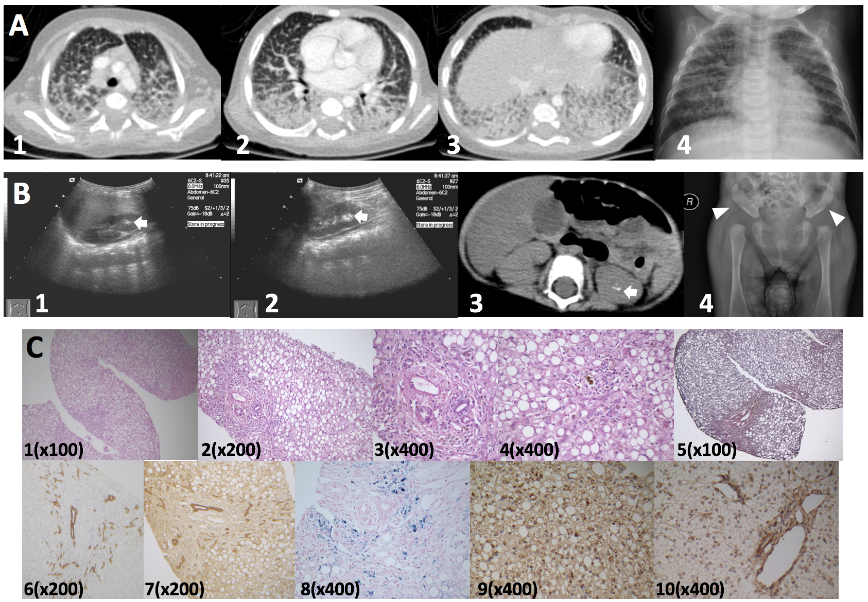
Figure 1 Imaging and histopathological features. A: Contrast enhanced pulmonary CT scan (1-3), and chest X-ray (4) showed pulmonary effusion with marked interstitial lung involvement; B: Hyper-echoic lesions consistent with stone formation on ultrasonography (arrows; 1, right kidney; 2, left kidney) and non-contrast abdominal computed tomography scan (arrow, 3). Acetabular dysplasia (4, arrowhead showing abnormally shallow hip socket); C: Liver biopsy (all originally magnified principal images): Severe steatosis of hepatic cells with ballooning, lobular disarray, and cholestasis (1-4), mild fibrosis (5), mild lymphocyte infiltration (4), bile duct proliferation (6 CK-7, 7 CK-19), and hepatic iron deposition (8). MARS immunohistochemistry staining, coarsely granular pigments within cytoplasms in the index patient (9), but not in samples of a healthy control (10). MARS: methionyl-tRNA synthetase gene.

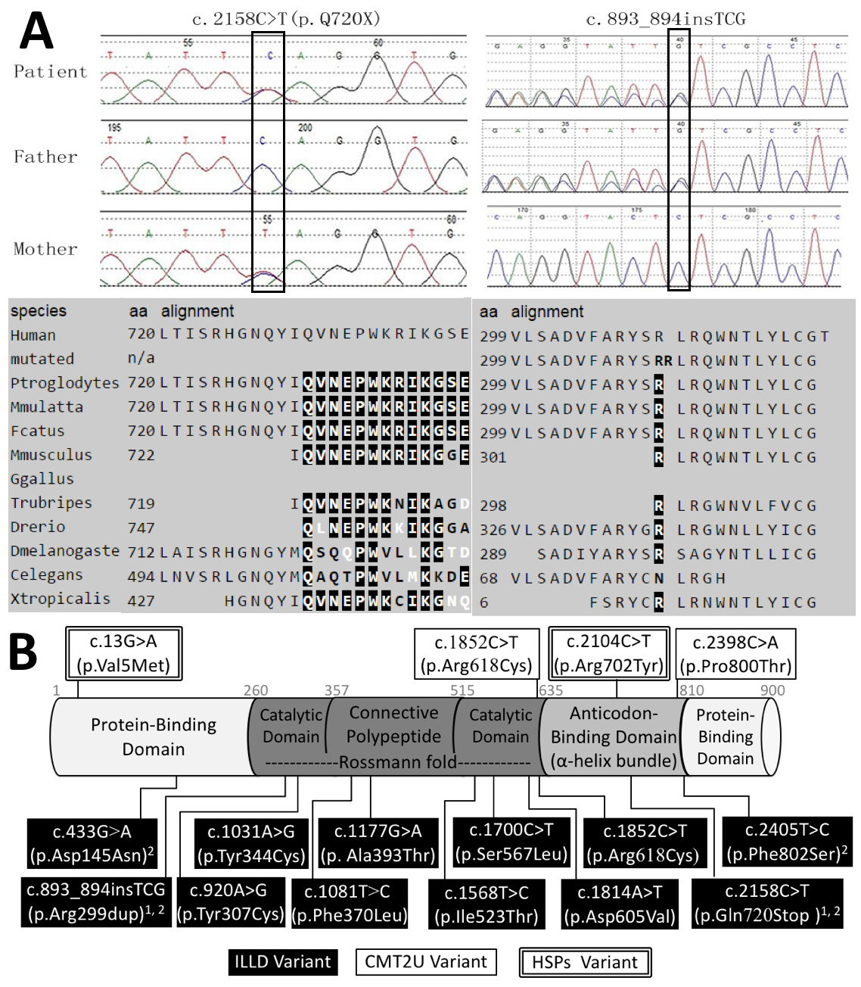
Figure 2 Genetic testing results, protein features, and distribution of reported variants within the methionyl-tRNA synthetase protein. A: Sanger sequencing confirmation of the index case and parents, both variants affect highly conserved amino-acid residues of MetRS protein; B: Illustration of MetRS protein domains, location of amino-acid changes of reported variants so far. ¹Variants from our report; ²Variants from Chinese ILLD cases. MetRS: methionyl-tRNA synthetase; ILLD: Interstitial lung and liver disease.

Table 1 Changes in complete blood count, procalcitonin, serum biochemistry, and blood coagulation profiles
Age in months (¹in-patient admission; ²discharge to out-patient follow-up) |  | 5.1 | 5.6¹ | 6.0 | 6.2 | 6.5 | 6.8 | 7 | 7.2² | 9.5
Complete blood count (reference range) | White Blood Cell (4-10¹ 10⁹/L) | 16.9 | 21.1 | 71.7 | 26.4 | 33.7 | 45.8 | 30.3 | 24.3 | 14.3
 | Neutrophil (20%-50%) | 58.1 | 39.8 | 58.0 | 63.1 | 62.0 | 63.0 | 62.7 | 64.4 | 38.9
 | Lymphocyte (45%-75%) | 36.2 | 53.1 | 31.1 | 28.7 | 28.9 | 15.0 | 29.5 | 27.8 | 51.4
 | Abnormal lymphocytes (0) | NA | 0.0 | 0.0 | NA | 0.0 | 17.0 | 0.0 | 0.0 | NA
 | Platelet count (100-300¹ 10⁹/L) | 764.0 | 513.0 | 993.0 | 464.0 | 387.0 | 494.0 | 279.0 | 397.0 | 386.0
 | hemoglobin (110-160 g/L) | 78.0 | 85.2 | 78.2 | 60.1 | 64.0 | 65.2 | 90.0 | 88.0 | 122.0
 | Red Blood Cell Count(4.0-5.5¹ 10¹² /L) | 3.5 | 3.1 | 2.8 | 2.0 | 2.0 | 2.2 | 2.9 | 2.9 | 4.3
 | Reticulocyte (0.5%-1.5%) | NA | 2.9 | 6.7 | NA | 6.3 | 7.8 | 3.3 | 6.8 | 1.0
 | C-Reactive Protein (< 8 mg/L) | 1.0 | 8.0 | 90.0 | 32.0 | 43.0 | 37.0 | 45.0 | 8.0 | 8.0
Procalcitonin (< 0.05 ng/mL) |  | NA | 4.6 | 17.4 | 7.7 | 13.4 | NA | NA | NA | NA
Serum biochemistry (reference range) | Albumin (35-55 g/L) | 29.0 | 34.6 | 27.3 | 30.8 | 32.3 | 28.7 | 38.5 | 39.1 | 43.0
 | Alanine aminotransferase (0-40 IU/L) | 41.0 | 45.0 | 17.0 | 13.0 | 4.0 | 50.0 | 49.0 | 38.0 | 29.0
 | Aspartate aminotransferase (0-40 IU/L) | 100.0 | 104.0 | 46.0 | 37.0 | 66.0 | 98.0 | 70.0 | 62.0 | 41.0
 | Total bilirubin (5.1-17.1 µmol/L) | 68.0 | 120.4 | 133.0 | 132.9 | 126.8 | 110.6 | 90.1 | 42.9 | 8.1
 | Direct bilirubin (0-6 µmol/L) | 53.0 | 76.9 | 93.7 | 96.1 | 86.6 | 70.4 | 61.8 | 29.8 | 4.4
 | γ-glutamyl transferase (7-50 IU/L) | 73.0 | 61.0 | 76.0 | 58.0 | 54.0 | 57.0 | 107.0 | 230.0 | 122.0
 | Total bile acid (0-10 µmol/L) | NA | 182.8 | 123.3 | 152.4 | 137.2 | 157.4 | 311.7 | 282.3 | 34.6
 | Alkaline phosphatase (42-383 IU/L) | 307.0 | 137.0 | 149.0 | 119.0 | 122.0 | 148.0 | 178.0 | 214.0 | 378.0
 | Blood glucose (3.9-5.8 mmol/L) | NA | 1.2 | 1.6 | 8.4 | 1.1 | NA | NA | 3.6 | NA
 | Lactic acid (0-2 mmol/L) | NA | 3.9 | NA | 3.6 | 3.6 | NA | NA | NA | NA
 | Ammonia (10-47 µmol/L) | NA | 88.0 | NA | NA | NA | NA | NA | 55.0 | NA
 | Total cholesterol (3.1-5.2 mmol/L) | 3.1 | 2.0 | NA | 2.3 | 2.5 | NA | 2.8 | 4.4 | 3.1
 | LDL-cholesterol (1.30-3.90 mmol/L) | NA | NA | NA | 1.0 | NA | NA | NA | NA | NA
 | HDL-cholesterol (0.91-2.05 mmol/L) | NA | NA | NA | 0.3 | NA | NA | NA | NA | NA
 | Triglyceride (0.56-1.70 mmol/L) | NA | 2.0 | NA | 2.7 | 2.1 | NA | 2.1 | 1.8 | 1.5
Blood coagulation profiles | Activated partial thromboplastin time (28.0-44.5 s) | NA | 48.1 | NA | 57.5 | 56.4 | 53.9 | 47.7 | 42.3 | 43.8
 | D-dimer (0-0.3 mg/L) | NA | 0.94 | NA | 2.06 | 1.15 | 0.97 | 0.7 | 0.51 | NA
 | Fibrinogen (2-4 g/L) | NA | 1.45 | NA | 1.82 | 2.29 | 2.54 | 3.03 | 3.46 | 3.44
 | Fibrinogen degradation products (0-5 µg/ML) | NA | 1.31 | NA | 5.22 | 2.35 | 2.78 | 1.47 | 1.16 | NA
 | Thrombin time (14-21 s) | NA | 20.4 | NA | 19.1 | 19.9 | 19.9 | 15.8 | 18.4 | 15.2
 | International normalized ratio (0.8-1.2) | NA | NA | NA | 1.29 | 1.26 | 1.35 | 1.3 | 1.03 | 0.99
 | Prothrombin time (12.0-14.8 s) | NA | NA | NA | 16 | 15.7 | 16.5 | 16.1 | 13.5 | 13.1
 | Prothrombin time activity (80%-100%) | NA | NA | NA | 67 | 69 | 63 | 66 | 95 | 103
NA: Not available.

Table 2 Genetic testing results
Genetic Tests | Gene | Transcript ID | Associated conditions (Inheritance patterns) in OMIM | Variant | Amino-acid change | Hom/Het | Parental origin | Prediction of pathogenicity
 |  |  |  |  |  |  |  | Mutation taster | SIFT | Provean | Polyphen2
Liver Panel¹ | ATP8B1 | NM _005603 | Cholestasis, benign recurrent, intrahepatic (AR); cholestasis, intrahepatic, of pregnancy, 1 (AD); cholestasis, progressive familial intrahepatic 1 (AR) | c.234C> G | p.His78Gln | Het | NA | Polymorphism | Tolerated | Neutral | Benign
 |  |  |  | c.1729A>G | p.Ile577Val | Het | NA | Polymorphism | Tolerated | Neutral | Possibly damaging
 |  |  |  | c.2021T>C | p. Met674Thr | Het | NA | Polymorphism | Tolerated | Neutral | Benign
 |  |  |  | c.3477C>T | Synonymous | Het | NA | Polymorphism | Tolerated | Neutral | NA
 |  |  |  | c.3744C>A | Synonymous | Het | NA | Polymorphism | Tolerated | Neutral | NA
Whole exome sequencing | MARS | NM_004990 | Charcot-Marie-Tooth disease, axonal, type 2U (AD); Interstitial lung and liver disease (AR) | c.2158C>T | p.Gln720Stop | Het | Maternal | Disease causing | NA | NA | NA
 |  |  |  | c.893_894insTCG | p.Arg299dup | Het | Paternal | Disease causing | NA | Deleterious | NA
 | ATP8B1 | NM_005603 | Cholestasis, benign recurrent, intrahepatic (AR); cholestasis, intrahepatic, of pregnancy, 1 (AD); cholestasis, progressive familial intrahepatic 1 (AR) | c.2021T>C | p. Met674Thr | Het | Paternal | polymorphism | Tolerated | Neutral | Benign
 | CPT1A | NM_001876 | CPT deficiency, hepatic, type IA (AR) | c.1163+5G>A | - | Het | Maternal | Disease causing | NA | NA | NA
 | LRPPRC | NM_133259 | Leigh syndrome, French-Canadian type (AR) | c.2965C>T | p.Arg989Cys | Het | Maternal | Disease causing | Damaging | Deleterious | Probably damaging
 | FLG | NM_002106 | Ichthyosis vulgaris (AD); (Dermatitis, atopic, susceptibility to, 2) | c.5841G>A | p.Trp1947Stop | Het | Maternal | Disease causing | NA | NA | NA
 | G6PD | NM_00104251 | Hemolytic anemia, G6PD deficient (favism) (XLD); (Resistance to malaria due to G6PD deficiency) | c.241C>T | p.Arg81Cys | Het | Maternal | Disease causing | Damaging | Deleterious | Benign
 | POMGNT1 | NM_017739 | Muscular dystrophy-dystroglycanopathy (congenital with brain and eye anomalies), type A, 3 (AR); Muscular dystrophy-dystroglycanopathy (congenital with mental retardation), type B, 3 (AR); Muscular dystrophy-dystroglycanopathy (limb-girdle), type C, 3 (AR); Retinitis pigmentosa 76 (AR) | c.794G>A | p.Arg265His | Het | Maternal | Disease causing | Damaging | Deleterious | Probably damaging
 | SERPINC1 | NM_000488 | Thrombophilia due to antithrombin III deficiency (AD/AR) | c.719A>G | p.Asn240Ser | Het | Maternal | Polymorphism | Tolerated | Neutral | Benign
 | TG | NM_003235 | Thyroid dyshormonogenesis 3 (AR); (autoimmune thyroid disease, susceptibility to, 3) | c.5791A>G | p.Ile1931Val | Het | Paternal | Polymorphism | Tolerated | Neutral | Benign
 | USH2A | NM_206933 | Retinitis pigmentosa 39; Usher syndrome type 2A (AR) | c.8559-2A>G | - | Het | Paternal | Disease causing | NA | NA | NA
¹Genes included in liver panel: ATP8B1, ABCB11, ABCB4, TJP2, BAAT, CLDN1, HSD3B7, AKR1D1, CYP7B1, AMACR, CYP27A1, DHCR7, JAG1, NOTCH2, SLC25A13, DGUOK, MPV17, FAH, ABCC2, UGT1A1, NPC1, NPC2, GALT, GALE, ALDOA, ALDOB, KRT18, KRT8, CIRH1A, CFTR, GFDM1, EARS2, HSD17B4, LIPA, PEX1, PEX5, POU1F1, HESX1, SERPINA1, VIPAS39, and VPS33B. NA: Not available.

Table 3 Diagnostic evaluation of the patient with methionyl-tRNA synthetase mutation
Etiological assessment | Investigations performed (normal unless otherwise indicated)
Infections | Serum procalcitonin levels (significantly elevated, Table 1);  Serology for Hepatitis B, C, HIV, syphilis, EBV, CMV, HSV, toxoplasmin, and rubella virus;  PCR for CMV; beta-d-glucan assay; galactomannan assay; T-Spot.TB test;  Cerebrospinal fluid analysis for white blood cell count, protein, and glucose level;  Complete blood count: anemia, elevated WBC and C-reactive protein (Table 1);  Culture for blood, urine, sputum, alveolar lavage fluid, and cerebrospinal fluid;  Sputum and alveolar lavage fluid for mycoplasma/chlamydia DNA detection;  Sputum and alveolar lavage fluid for detection of respiratory syncytial virus, adenovirus, influenza virus, and para-influenza virus antigens;  Alveolar lavage fluid smear for fungus detection
Radiology, endoscopy, and histopathology | Multiple chest X-rays and a contrast-enhanced computed tomography scan of the lung (alveolar effusions with severe interstitial lung disease) (Figure 1);  Abdominal ultrasonography and CT scan (hepatomegaly, liver steatosis, kidney stones) (Figure 1);  Bronchoscopy (chronic inflammatory changes in bronchiolar mucosa);  X-ray imaging of the skull; CT scan of adrenal gland;  X-ray imaging of long bones: (abnormally shallow hip socket that is suggestive of acetabular dysplasia or congenital hip dysplasia) (Figure 1);  Liver biopsy (severe steatosis of hepatic cells with ballooning, lobular disarrays; mild changes, such as cholestasis, fibrosis, lymphocyte infiltration, Iron deposition, and bile duct proliferation);  Bone marrow aspirate (extreme proliferation of bone marrow cells with few hemophagocytic cells); peripheral blood smear
Immunology | Immunoglobulin levels (after IVIG therapy at local hospital): elevated IgG (20.2 g/L, normal range 3.7-8.3 g/L), IgM (1.47 g/L, normal range 0.33-1.25 g/L), and IgA (0.63 g/L, normal range 014-0.5) levels; normal IgE, complement 4, and complement 3 levels;  Neutrophil oxidative burst activity, and lymphocyte subpopulations;  Autoimmune anti-bodies
Biochemical, metabolic and endocrine profiling | Glucose profiling (hypoglycemia); slightly elevated serum lactate (Table 1);  Liver function test: cholestasis, hypoalbuminemia, abnormal blood coagulation profiles (Table 1);  Creatine kinase, lactate dehydrogenase;  Serum amino acids (proline 1803 µmol/L, normal range: 165-700 µmol/L; threonine 171uM, normal range: 17-90 µmol/L) and acyl-carnitine profile; urine organic acids (including succinylacetone); Urine acidoglycoprotein (51.98mg/mmol creatinine, normal range: 59.70-78.52 mg/mmol creatinine).  Low levels of total serum cholesterol, HDL and LDL cholesterol (Table 1).  Serum cortisol level; thyroid function test (total triiodothyronine 52.6 ng/dL, normal range: 70-220 ng/dL)  Ophthalmology, electrocardiology, and echocardiogram (patent foramen ovale, 2.6mm)
Genetic disorders | White blood cell lysosomal enzyme screening for GM1 gangliosidosis, GM2 gangliosidosis, Sandhoff disease, Krabbe leukodystrophy, Gaucher disease, Fabry disease, Pompe disease, metachromatic leukodystrophy, Nieman-Pick disease, neuronal ceroid lipofuscinoses (1 and 2), mucopolysaccharidosis (type I-VII, IX), muculipidosis (type II and III).  Liver panel including 41 genes known to cause liver diseases, and trio whole exome sequencing (Table 2).

