Name of Journal: World Journal of Clinical Cases
Manuscript NO: 88717
Manuscript Type: CASE REPORT

Changes in macrophage infiltration and podocyte injury in lupus nephritis patients with repeated renal biopsy: Report of three cases

Liu SY et al. Changes in LN patients with repeated renal biopsy

Shi-Yuan Liu, Hao Chen, Li-Jia He, Chun-Kai Huang, Pu Wang, Zhang-Ru Rui, Jue Wu, Yang Yuan, Yue Zhang, Wen-Ju Wang, Xiao-Dan Wang

Shi-Yuan Liu, Li-Jia He, Chun-Kai Huang, Pu Wang, Wen-Ju Wang, Xiao-Dan Wang, Central Laboratory, Key Laboratory of Tumor Immunological Prevention and Treatment of Yunnan Province, Yan'an Hospital Affiliated to Kunming Medical University, Kunming 650051, Yunnan Province, China

Hao Chen, Zhang-Ru Rui, Jue Wu, Yang Yuan, Yue Zhang, Department of Nephropathy, Yan'an Hospital Affiliated to Kunming Medical University, Kunming 650051, Yunnan Province, China

Co-first authors: Shi-Yuan Liu and Hao Chen.

Co-corresponding authors: Xiao-Dan Wang and Wen-Ju Wang.

Author contributions: Wang XD and Wang WJ contributed equally to this work; Liu SY and Chen H contributed equally to this work; Wang XD and Wang WJ designed the research study; Liu SY and Chen H performed the research; Liu SY, He LJ, Huang CK, and Wang P analyzed the data and wrote the manuscript; Rui ZR, Wu J, Yuan Y, and Zhang Y contributed medical records; Wang XD made critical revisions related to important intellectual content of the manuscript; all authors have read and approved the final manuscript.

Supported by National Natural Science Foundation of China, No. 81960136; the Science and Technology Department of Yunnan Province, No. 202101AT070243.

Corresponding author: Xiao-Dan Wang, MD, Associate Chief Physician, Central Laboratory, Key Laboratory of Tumor Immunological Prevention and Treatment of Yunnan Province, Yan'an Hospital Affiliated to Kunming Medical University, No. 245 Renmin East Road, Kunming 650051, Yunnan Province, China. wxdky001@163.com

Received: October 11, 2023
Revised: December 5, 2023
Accepted: December 13, 2023
Published online:

Abstract
BACKGROUND
In this study, we retrospectively analysed macrophage infiltration and podocyte injury in three patients with diffuse proliferative lupus nephritis (LN) who underwent repeated renal biopsy.

CASE SUMMARY
Clinical data of three diffuse proliferative LN patients with different pathological characteristics (case 1 was LN IV-G (A), case 2 was LN IV-G (A)+V, and case 3 was LN IV-G (A) + thrombotic microangiopathy) were reviewed. All patients underwent repeated renal biopsies 6 mo later, and renal biopsy specimens were studied. Macrophage infiltration was assessed by CD68 expression detected by immunohistochemical staining, and an immunofluorescence assay was used to detect podocin expression to assess podocyte damage. After treatment, Case 1 changed to LN III-(A), Case 2 remained as type V LN lesions, and Case 3, which changed to LN IV-S (A), had the worst prognosis. We observed reduced macrophage infiltration after therapy. However, two of the patients with active lesions after treatment still showed macrophage infiltration in the renal interstitium. Before treatment, the three patients showed discontinuous expression of podocin. Notably, the integrity of podocin was restored after treatment in Case 1

CONCLUSION
It may be possible to reverse podocyte damage and decrease the infiltrating macrophages in LN patients through effective treatment.

Key Words: Lupus nephritis; Macrophage; Podocyte; Repeat renal biopsy; Thrombotic Microangiopathy; Case report

Liu SY, Chen H, He LJ, Huang CK, Wang P, Rui ZR, Wu J, Yuan Y, Zhang Y, Wang WJ, Wang XD. Changes in macrophage infiltration and podocyte injury in lupus nephritis patients with repeated renal biopsy: Report of three cases. World J Clin Cases 2023; In press

Core Tip: In this study, we retrospectively analysed the clinical and pathological data of three patients who underwent repeated renal biopsies after treatment for diffuse proliferative lupus nephritis (LN) with different pathological characteristics. Immunohistochemistry and immunofluorescence tests were used to assess the podocyte damage and infiltration of macrophages. Diffuse proliferative LN with different pathological features has different prognoses, and the prognosis of LN with thrombotic microangiopathy is relatively poor. Podocyte injury and macrophage infiltration may be involved in the pathogenesis of LN. It may be possible to reverse podocyte damage and decrease the infiltrating macrophages in LN patients through effective treatment.

INTRODUCTION
Diffuse proliferative lupus nephritis (LN) is the most common pathological type of LN, accounting for approximately 50% of all LN cases. Type IV LN is often severe, and pathological examination of renal biopsy often shows obvious proliferative lesions and a large amount of immune complex deposition^{[1]}. Many studies have found that renal resident cells and infiltrating inflammatory cells are involved in the tissue damage process of LN^{[2]}. The injured podocytes activate inflammatory cells through the expression of Toll-like receptors and activate T cells through major histocompatibility complexes and CD86, thereby participating in the local immune response and the formation of crescents in coordination with parietal epithelial cells in LN^{[3,4]}. The accumulation of infiltrating macrophages in the kidney with a proinflammatory phenotype correlated with the degree of glomerulosclerosis and interstitial fibrosis by producing inflammatory cytokines and chemokines in LN^{[5]}. However, few studies have compared macrophage infiltration and podocyte injury in repeated LN renal biopsy specimens before and after treatment. In this study, we retrospectively analysed the clinical and pathological data of three patients who underwent repeated renal biopsies after treatment for diffuse proliferative LN with different pathological characteristics [case 1 was LN IV-G (A), case 2 was LN IV-G (A) + V, and case 3 was LN IV-G (A) + thrombotic microangiopathy (TMA)]. Immunohistochemistry and immunofluorescence tests were used to assess the podocyte damage and infiltration of macrophages to provide guidance for clinical practice.

CASE PRESENTATION
Chief complaints
Case 1: A 35-year-old woman was hospitalized because of oedema.

Case 2: A 34-year-old woman was hospitalized because of oedema.

Case 3: A 22-year-old woman was hospitalized because of oedema, with accompanying oliguria.

History of present illness
Case 1: Facial erythema for nearly 2 mo and oedema for 5 d.

Case 2: Oedema for 20 d.

Case 3: Diarrhea and oedema for 5 d accompanied by reduced urine volume.

History of past illness
Cases 1 and 2: The patients had no history of past illness.

Case 3: The patient had a history of kidney disease.

Personal and family history
All the three cases had no remarkable personal or family history.

Physical examination
Case 1: The patient had erythema of the cheeks, and mild oedema of the face and both lower limbs.

Case 2: The patient had mild ankle oedema of both lower limbs.

Case 3: The patient had oedema of both lower limbs.

Laboratory examinations
Case 1: Routine blood test showed white blood cells 2.76 × 10⁹/L, hemoglobin 100 g/L, and albumin 29.3 g/L, and routine urine test showed urine protein (++++).

Case 2: Routine blood test showed albumin 23.6 g/L, and routine urine test showed urine protein (++++) and urine red blood cells 15/high power field.

Case 3: Routine blood test showed albumin 15.5 g/L, low-value platelets 51 × 10⁹/L, hemoglobin 61 g/L, and serum creatinine 3.57 mg/dL, and routine urine test showed urine protein (++++).

Imaging examinations
No abnormalities were detected in the physical examination in all the three cases.

Clinical and pathological data of three patients
Pathological images of renal biopsies from the three patients are shown in Figure 1 (periodic acid-silver methenamine staining, 200 × magnification). The clinical and pathological characteristics of the three patients are summarized in Table 1.

Immunohistochemical staining for CD68
Immunohistochemical staining for CD68 was used to evaluate macrophage infiltration in the glomeruli and renal interstitium (Figure 2). Before therapy, a large number of CD68-positive cells were observed in the glomeruli and renal interstitium. In the second renal biopsy specimen, the number of CD68-positive macrophages in the glomeruli of the three patients were significantly reduced; notably, Case 2 had no obvious active disease after treatment. However, some CD68-positive cells could still be observed in the renal interstitium in Case 1 and Case 3 with active disease. It is suggested that infiltrated macrophages in the kidney may be associated with disease activity in LN.

Immunofluorescence staining for podocin
Immunofluorescence staining was used to determine the expression of podocin, which is a specific protein in podocytes (Figure 3). Before treatment, all the three patients showed discontinuous and reduced expression of podocin. However, after treatment, the expression of podocin in Case 1 became significantly continuous and complete, which suggests that podocyte injury was reversible. Although increased podocin expression was noticed in Case 2, there was still discontinuous expression, which was indicative of podocyte injury in membranous LN. In Case 3, the expression of podocin was not significantly improved.

FINAL DIAGNOSIS
Case 1
The patient was diagnosed with LN IV-G (A) by the first renal biopsy.

Case 2
The patient was diagnosed with LN IV-G (A) + V by the first renal biopsy.

Case 3
The patient was diagnosed with LN IV-G (A) + TMA by the first renal biopsy.

TREATMENT
Case 1
The patient was given 0.5 g intravenous methylprednisolone (MP) for 3 d, and the treatment was repeated after 1 mo. During this period, 48 mg of MP tablets and 0.2 g of hydroxychloroquine were orally administered once a day, and 0.8 g of cyclophosphamide (CTX) was intravenously administered every month (total CTX ≤ 12 g). In the sixth month, the patient underwent repeated renal biopsy, which revealed that the pathological type had changed to LN III (A). However, it still showed active lesions and six small fibrocellular crescents (a total of 20 glomeruli). The treatment was switched to intravenous infusion of MP 0.5 mg for 3 d.

Case 2
The patient was given 0.5 g intravenous MP for 3 d, and the treatment was repeated after 1 mo. During this period, 55 mg of prednisone tablets and 0.3 g of hydroxychloroquine were administered orally once a day, and 0.5 g CTX was intravenously administered once a month (total CTX ≤ 12 g). In the sixth month, repeated renal biopsy revealed that the pathological type had changed to LN V type, and no obvious active disease was observed. Prednisone tablets were tapered gradually.

Case 3
The patient was immediately given intravenous MP 0.25 g for 3 d. After 1 wk, 0.5 g of MP was intravenously administered for 3 d. For the next 2 mo, she was given an intravenous infusion of 0.25 g of MP for 3 d. At the same time, haemodialysis and gamma-globulin treatment were conducted, and plasma exchange was performed. During this period, 40 mg of MP tablets were given orally once a day, and 0.5 g of mycophenolate mofetil (MMF) was administered twice a day. She was intravenously administered with 0.4 g CTX every month (total CTX ≤ 12 g). In the sixth month, repeated renal biopsy revealed that the pathological type had changed to LN IV-S (A). Although TMA had improved, the disease was still active. She was given an intravenous infusion of MP 0.25 mg for 3 d. During the follow-up, the patient's renal function deteriorated, end-stage renal disease developed, and maintenance haemodialysis was adopted. After 1 year of follow-up, the glucocorticoid and immunosuppressive agents were stopped due to repeated infections.

OUTCOME AND FOLLOW-UP
Case 1
The patient achieved complete remission and no recurrence was observed after 6 years of follow-up.

Case 2
The patient achieved complete remission and she had no recurrence after 5 years of follow-up.

Case 3
The patient had been on haemodialysis for 4 years.

DISCUSSION
The severity of clinical manifestations of LN is not parallel to pathological changes in the kidney. Therefore, renal biopsy plays an indispensable role in the diagnosis and management of LN patients. In this study, repeated renal biopsy after 6 mo revealed that Case 1 had changed to LN III (A), and there were still active lesions and crescents. The ratio of crescent cells to fibroblasts is an independent risk factor for poor renal survival^{[6]}. Thus, MP pulse therapy was continued. In Case 2, the active LN lesions were significantly improved, and the pathological type remained type V LN. In Case 3, improvement in TMA was found, but proliferative active lesions of LN were still present. Therefore, MP pulse therapy was continued. The relevance of repeated kidney biopsy in patients with LN is controversial. However, there are no doubts that repeated renal biopsy represents a useful tool in difficult cases to evaluate the response to therapy to modulate the intensity of treatment^{[7,8]}.
There have been reports that infiltration of macrophages plays an important role in the pathogenesis of LN^{[9]}. In this study, we observed reduced macrophage infiltration after therapy. Especially, the infiltrating macrophages in the glomerulus disappeared sooner than those in the renal interstitium. Two patients with active lesions after treatment still showed macrophage infiltration in the renal interstitium, which suggested that macrophage infiltration in the kidney was related to disease activity. Some studies have also found that interstitial macrophages may be the major effectors of chronic injury that correlated with proteinuria and poor renal prognosis in patients with LN^{[10]}.
In recent years, a large amount of renal biopsy data has revealed glomerular podocyte damage in LN^{[11]}. It was also observed in this study that the integrity of podocin expression was restored after treatment in Case 1, which was not mentioned in other reports. In addition, in Case 3, there was no significant improvement in immune damage, while the expression of podocin was still deficient. We suspect that podocyte damage in type IV LN may be mainly due to immune damage.

CONCLUSION
Diffuse proliferative LN with different pathological features has different prognoses, and the prognosis of LN with TMA is relatively poor. Podocyte injury and macrophage infiltration may be involved in the pathogenesis of LN. By comparing pathological changes before and after treatment, we found that it may be possible to reverse podocyte damage and decrease the infiltrating macrophages in diffuse proliferative LN patients through effective treatment.

REFERENCES
1 Yu C, Li P, Dang X, Zhang X, Mao Y, Chen X. Lupus nephritis: new progress in diagnosis and treatment. J Autoimmun 2022; 132: 102871 [PMID: 35999111 DOI: 10.1016/j.jaut.2022.102871]
2 Richoz N, Tuong ZK, Loudon KW, Patiño-Martínez E, Ferdinand JR, Portet A, Bashant KR, Thevenon E, Rucci F, Hoyler T, Junt T, Kaplan MJ, Siegel RM, Clatworthy MR. Distinct pathogenic roles for resident and monocyte-derived macrophages in lupus nephritis. JCI Insight 2022; 7 [PMID: 36345939 DOI: 10.1172/jci.insight.159751]
3 Bhargava R, Li H, Tsokos GC. Pathogenesis of lupus nephritis: the contribution of immune and kidney resident cells. Curr Opin Rheumatol 2023; 35: 107-116 [PMID: 35797522 DOI: 10.1097/BOR.0000000000000887]
4 Liu R, Wen X, Peng X, Zhao M, Mi L, Lei J, Xu K. Immune podocytes in the immune microenvironment of lupus nephritis (Review). Mol Med Rep 2023; 28 [PMID: 37711069 DOI: 10.3892/mmr.2023.13091]
5 Kwant LE, Vegting Y, Tsang-A-Sjoe MWP, Kwakernaak AJ, Vogt L, Voskuyl AE, van Vollenhoven RF, de Winther MPJ, Bemelman FJ, Anders HJ, Hilhorst ML. Macrophages in Lupus Nephritis: Exploring a potential new therapeutic avenue. Autoimmun Rev 2022; 21: 103211 [PMID: 36252930 DOI: 10.1016/j.autrev.2022.103211]
6 Cai F, Han F, Wang H, Han H, Le J, Lan L, Xu Y, Chen J. The Crescentic Implication of Renal Outcomes in Proliferative Lupus Nephritis. J Rheumatol 2018; 45: 513-520 [PMID: 29449502 DOI: 10.3899/jrheum.170553]
7 Haładyj E, Cervera R. Repeat renal biopsy in lupus nephritis - unnecessary harm and risk of complications or important diagnostic tool with clinical consequences? Reumatologia 2016; 54: 49-50 [PMID: 27407278 DOI: 10.5114/reum.2016.60211]
8 Moroni G, Depetri F, Ponticelli C. Lupus nephritis: When and how often to biopsy and what does it mean? J Autoimmun 2016; 74: 27-40 [PMID: 27349351 DOI: 10.1016/j.jaut.2016.06.006]
9 Dias CB, Malafronte P, Lee J, Resende A, Jorge L, Pinheiro CC, Malheiros D, Woronik V. Role of renal expression of CD68 in the long-term prognosis of proliferative lupus nephritis. J Nephrol 2017; 30: 87-94 [PMID: 26621103 DOI: 10.1007/s40620-015-0252-7]
10 Tsai CY, Li KJ, Shen CY, Lu CH, Lee HT, Wu TH, Ng YY, Tsao YP, Hsieh SC, Yu CL. Decipher the Immunopathological Mechanisms and Set Up Potential Therapeutic Strategies for Patients with Lupus Nephritis. Int J Mol Sci 2023; 24 [PMID: 37373215 DOI: 10.3390/ijms241210066]
11 Zhou XJ, Klionsky DJ, Zhang H. Podocytes and autophagy: a potential therapeutic target in lupus nephritis. Autophagy 2019; 15: 908-912 [PMID: 30755075 DOI: 10.1080/15548627.2019.1580512]

Footnotes
Informed consent statement: All three patients provided written informed consent for renal biopsy.

Conflict-of-interest statement: All the authors have no conflicts of interest to disclose.

CARE Checklist (2016) statement: The authors have read the CARE Checklist (2016), and the manuscript was prepared and revised according to the CARE Checklist (2016).

Open-Access: This article is an open-access article that was selected by an in-house editor and fully peer-reviewed by external reviewers. It is distributed in accordance with the Creative Commons Attribution NonCommercial (CC BY-NC 4.0) license, which permits others to distribute, remix, adapt, build upon this work non-commercially, and license their derivative works on different terms, provided the original work is properly cited and the use is non-commercial. See: https://creativecommons.org/Licenses/by-nc/4.0/

Provenance and peer review: Unsolicited article; Externally peer reviewed.
Peer-review model: Single blind

Peer-review started: October 11, 2023
First decision: November 22, 2023
Article in press:

Specialty type: Pathology
Country/Territory of origin: China
Peer-review report’s scientific quality classification
Grade A (Excellent): 0
Grade B (Very good): B
Grade C (Good): 0
Grade D (Fair): 0
Grade E (Poor): 0

P-Reviewer: Salvadori M, Italy S-Editor: Liu JH L-Editor: Wang TQ P-Editor:
Figure Legends
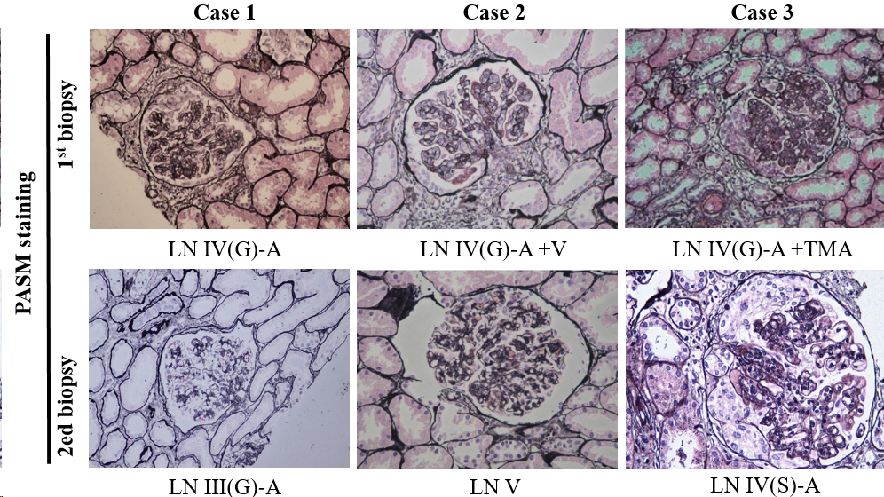
Figure 1 Pathological images of renal biopsy from the three patients (periodic acid-silver methenamine staining, 200 × magnification). PASM: Periodic acid-silver methenamine; LN: Lupus nephritis; TMA: Thrombotic microangiopathy; G: Global; A: Active; S: Segmental.
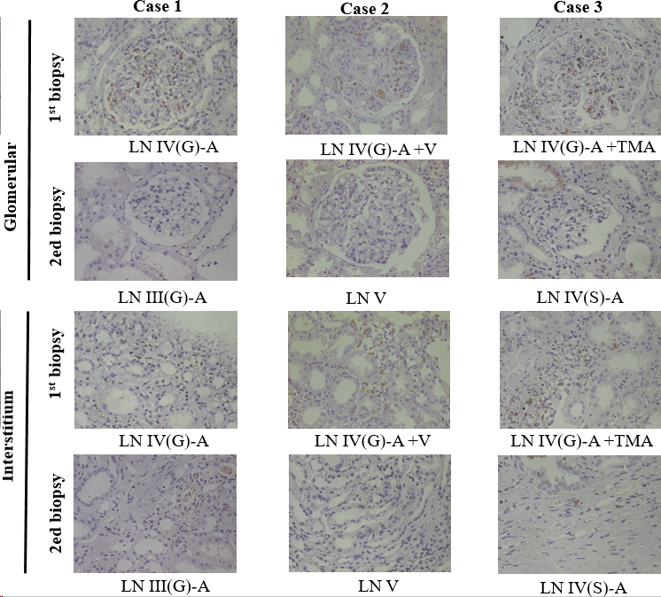
Figure 2 Immunohistochemical staining for CD68-positive macrophages in the glomerulus and renal interstitium. LN: Lupus nephritis; TMA: Thrombotic microangiopathy; G: Global; A: Active; S: Segmental.
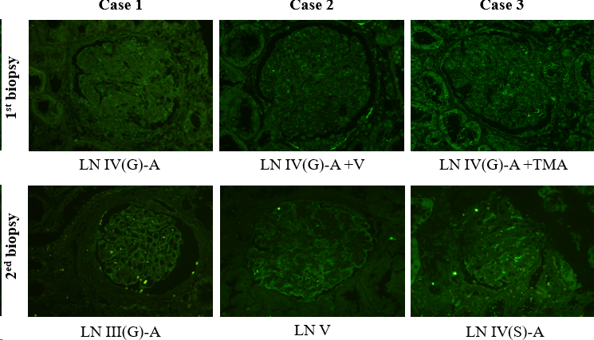
Figure 3 Podocin expression in the glomerulus. LN: Lupus nephritis; TMA: Thrombotic microangiopathy; G: Global; A: Active; S: Segmental.

Table 1 Clinical and pathological comparison of repeated renal biopsy in the three patients
Item | Case 1 |  | Case 2 |  | Case 3
 | First renal biopsy | Repeated renal biopsy | First renal biopsy | Repeated renal biopsy | First renal biopsy | Repeated renal biopsy
Pathological type | LN IV-G (A) | LN III (A) | LN IV-G (A)+V | LN V | LN IV-G (A)+TMA | LN IV-S (A)
AI | 12 | 7 | 13 | 4 | 16 | 13
CI | 1 | 4 | 0 | 2 | 2 | 2
SLEDAI | 18 | 6 | 18 | 4 | 24 | 14
Change of treatment | MP and CTX pulse therapy | MP pulse therapy | MP and CTX pulse therapy | Reduce glucocorticoids | MP and CTX pulse therapy, plasma exchange | MP pulse therapy, hemodialysis
Prognosis | - | Well | - | Well | - | Maintenance haemodialysis
Podocin expression | Visual reduction | Complete and continuous | Visual reduction | Increased expression | Visual reduction | Visual reduction
Infiltrating monocytes | Many monocytes infiltrated in the glomerulus and renal interstitium | Monocytes infiltrated in the renal interstitium | Many monocytes infiltrated in the glomerulus and renal interstitium | No obvious infiltration | Many monocytes infiltrated in the glomerulus and renal interstitium | Monocytes infiltrated in the renal interstitium
LN: Lupus nephritis; TMA: Thrombotic microangiopathy; AI: Acute Index; CI: Chronic Index; SLEDAI: Systemic Lupus Erythematosus Disease Activity Index; MP: Methylprednisolone; CTX: Cyclophosphamide; ESRD: End stage renal disease.

