Name of Journal: World Journal of Orthopedics
Manuscript NO: 90261
Manuscript Type: CASE REPORT

New method of local adjuvant therapy with bicarbonate Ringer’s solution for tumoral calcinosis: A case report

Noguchi T et al. Bicarbonate solution for tumoral calcinosis treatment

Takashi Noguchi, Akio Sakamoto, Kensaku Kakehi, Shuichi Matsuda

Takashi Noguchi, Akio Sakamoto, Kensaku Kakehi, Shuichi Matsuda, Department of Orthopaedic Surgery, Graduate School of Medicine, Kyoto University, Kyoto 606-8507, Japan

Co-corresponding authors: Takeshi Noguchi and Akio Sakamoto.

Author contributions: Noguchi T, Sakamoto A, Kakehi K and Matsuda S were participated in the treatment; Sakamoto A drafted the manuscript; All authors reviewed the manuscript and approved the final version of the manuscript. Noguchi T and Sakamoto A contributed equally to this work as co-corresponding authors. This invention was achieved through the cooperation of Noguchi T and Sakamoto A, they contributed efforts of equal substance throughout the research process, the designation of co-corresponding authorship accurately reflects our team's collaborative spirit and equal contributions.

Corresponding author: Akio Sakamoto, MD, PhD, Associate Professor, Department of Orthopaedic Surgery, Graduate School of Medicine, Kyoto University, Shogoin, Kawahara-cho 54, Sakyo-ku, Kyoto 606-8507, Japan. akiosaka@kuhp.kyoto-u.ac.jp

Received: December 3, 2023
Revised: January 6, 2024
Accepted: January 24, 2024
Published online:

Abstract
BACKGROUND
Tumoral calcinosis is a condition characterized by deposits of calcium phosphate crystals in extra-articular soft tissues, occurring in hemodialysis patients. Calcium phosphate crystals are mainly composed of hydroxyapatite, which is highly infiltrative to tissues, thus making complete resection difficult. An adjuvant method to remove or resolve the residual crystals during the operation is necessary.

CASE SUMMARY
A bicarbonate Ringer’s solution with bicarbonate ions (28 mEq/L) was used as the adjuvant. After resecting calcium phosphate deposits of tumoral calcinosis as much as possible, while filling with the solution, residual calcium phosphate deposits at the pseudocyst wall can be gently scraped by fingers or gauze in the operative field. A 49-year-old female undergoing hemodialysis for 15 years had swelling with calcium deposition for 2 years in the shoulders, bilateral hip joints, and the right foot. A shoulder lesion was resected, but the calcification remained and early re-deposition was observed. Considering the difficulty of a complete rection, we devised a bicarbonate dissolution method and excised the foot lesion. After resection of the calcified material, the residual calcified material was washed away with bicarbonate Ringer’s solution.

CONCLUSION
The bicarbonate dissolution method is a new, simple, and effective treatment for tumoral calcinosis in hemodialysis patients.

Key Words: Tumoral calcinosis; Adjuvant therapy; Bicarbonate; Ringer’s solution; Surgery; Case report

Noguchi T, Sakamoto A, Kakehi K, Matsuda S. New method of local adjuvant therapy with bicarbonate Ringer’s solution for tumoral calcinosis: A case report. World J Orthop 2024; In press

Core Tip: Tumoral calcinosis, which occurs in 2%-3% of hemodialysis patients, involves calcium phosphate deposits, thus making surgical resection challenging. Hydroxyapatite, the main component of tumoral calcinosis, infiltrates tissues extensively. A bicarbonate Ringer’s solution is used post-resection. A 49-year-old hemodialysis patient with calcified shoulder, hip, and foot lesions underwent the bicarbonate dissolution method. After resection, the operative field was washed with the solution. This simple and effective treatment offers a novel approach for managing tumoral calcinosis in hemodialysis patients.

INTRODUCTION
Tumoral calcinosis is a condition characterized by solitary or multifocal calcium phosphate deposits in extra-articular soft tissues. The joints of the hips, shoulders, and elbows are most often involved; the hands, feet, and knees are less often involved. Tumoral calcinosis often presents as painful tumor-like masses that limit joint range of motion; cosmetic problems also occur^{[1-5]}.
Tumoral calcinosis has a primary type with no associated disease, which is due to a genetic abnormality, and a secondary type that is associated with other disorders, especially chronic renal failure^{[1,6]}. The prevalence of tumoral calcinosis has been reported to range from 0.5%-3% among dialysis patients^{[7-9]}. The exact mechanisms underlying tumoral calcinosis are unclear. The role of repeated joint microtrauma has been suggested to cause tumoral calcinosis^{[10]}. Previous studies have reported that elevated calcium phosphate production is closely associated with soft tissue calcification^{[11,12]}. Regardless of the etiology, hyperphosphatemia is associated with tumoral calcinosis. Medical treatment for tumoral calcinosis in hemodialysis patients includes dietary phosphorus restriction, calcium-free phosphate binders, and frequent dialysis with low-calcium dialysis solutions; however, these treatments are usually ineffective^{[7,13,14]}.
Surgical resection is only used when these treatments are insufficient^{[15]}. Surgical resection of tumoral calcinosis lesions has been the primary treatment^{[13]} but surgical resection is not curative. In contrast, it has been reported that tumoral calcinosis is reduced or resolved with improved systemic symptoms following parathyroidectomy^{[16-18]}. Parathyroidectomy is effective for tumoral calcinosis patients, especially patients with secondary hyperparathyroidism^{[5]}. Following a parathyroidectomy, calcified tissue is significantly resorbed; however, bone renewal is reduced following parathyroidectomy because of lower parathyroid hormone (PTH) levels, resulting in increased circulating calcium and promotion of vessel and soft tissue calcification^{[19,20]}.
Calcium phosphate deposits in tumoral calcinosis have been shown to be comprised of hydroxyapatite [Ca₁₀(PO₄)₆(OH)₂]^{[21]}. Experimentally, hydroxyapatite is known to be insoluble; however, hydroxyapatite is easily dissolved by blowing carbon dioxide (CO₂) into a hydroxyapatite suspension, in which the dissolution amount is 200 times that found without CO₂. Calcium carbonate (CaCO₃) is an insoluble calcium salt. Hydroxyapatite co-exists with CO₂; CaCO₃ changes into the highly-soluble calcium hydrogen carbonate [Ca(HCO₃)₂]^{[22,23]}. We therefore assumed that hydroxyapatite in tumoral calcinosis could be soluble with co-existing CO₂ or HCO₃⁻.
A bicarbonate Ringer’s solution was used. The solution had a pH of 7.0 and an osmotic pressure of approximately 1.0. The solution contained HCO₃⁻ (28 mEq/L) (Tables 1-3). After resecting calcium phosphate deposits of tumoral calcinosis as much as possible, while filling with bicarbonate Ringer’s solution, residual calcium phosphate deposits at the pseudocyst wall are gently scraped with fingers or gauze in the operative field. Because the concentration of HCO₃⁻ (28 mEq/L) is normal in vivo, the amount to be used is not restricted, but we use approximately 1000 mL of the solution for 1 operation. The use of the solution as a washing solution is explained to the patients and consent is obtained.
Herein we report the successful treatment of a patient with tumoral calcinosis by local adjuvant therapy with bicarbonate Ringer’s solution. The procedure, chemical background, and safety are discussed.

CASE PRESENTATION
Chief complaints
The patient is a 49-year-old woman with a diagnosis of tumoral calcinosis.

History of present illness
She had noticed swelling in her right shoulder 2 years before the initial assessment. Nine months later, there was bilateral hip and right foot swelling. The size of the right shoulder swelling had increased to be from the supraclavicular fossa to the maxilla, and the size of the swelling was > 20 cm in diameter.

History of past illness
She has a history of hemodialysis for 15 years.

Personal and family history
There was no specific personal or family history.

Physical examination
The size of the bilateral hip swelling was > 20 cm in diameter and that of the sole of the foot was 3 cm. Each mass was elastic and soft with fluid palpitation.

Laboratory examinations
The leukocyte count was normal [7140/mm³ (normal range, 3300-8600/mm³)]. The differential was as follows: neutrophils, 68.8% (normal range, 46%-62%); lymphocytes, 22.4% (normal range, 30%-40%); monocytes, 6.7% (normal range, 4%-7%); eosinophils, 1.7% (normal range, 3%-5%); and basophils, 0.4% (normal range, < 1%). Laboratory data showed the following: corrected Ca²⁺, 9.7 mg/dL (normal range, 8.8-10.1 mg/dL); inorganic phosphorus, 5.5 mg/dL (normal range, 2.7-4.6 mg/dL); creatinine, 5.16 mg/dL (normal range, 0.16-0.79 mg/dL); estimated glomerular filtration rate, 7.8 mL/min/1.73 m² (normal range, < 90 mL/min/1.73 m²), and PTH-intact, 1110 pg/mL (reference value, 10-65 pg/mL). The serum phosphorus level was elevated, even after medical treatment. The serum PTH level was also elevated, suggesting secondary hyperparathyroidism.

Imaging examinations
Plain radiographs and computed tomography (CT) showed that the lesions were multilocular, opaque, and homogeneous. Axial CT showed various densities of calcium crystals and a liquid level within an elementary formation related to the sedimentation of calcium crystals with a serous supernatant (sedimentation sign)^{[4,10]} (Figure 1). In the right shoulder lesion, erosions of the bone cortex of the clavicle were noted. Magnetic resonance imaging showed that the cystic lesions had a homogenous low-signal intensity on T1-weighted images and high-signal intensity at the top of the cyst and low-signal intensity at the bottom of the cyst on T2-weighted images. Brachial plexus and vessels were located between the cyst and chest wall (Figure 2).

FINAL DIAGNOSIS
The diagnosis was based on the clinical course and the imaging findings were tumoral calcinosis associated with hemodialysis.

TREATMENT
Because growth of the lesion after medical treatment with low-calcium dialysis failed, surgical intervention was considered. The right shoulder lesion was not acceptable esthetically and the foot lesion caused discomfort when walking. Although a parathyroidectomy was an option, given the side effects, surgical resection was selected.
Under general anesthesia, an incision was made from the supraclavicular region to the axilla. A pseudofibrous capsule was noted and white fluid and muddy material extended to the subcutaneous tissue. The fluid material was removed. A solid white material was entrapped in the fibrous wall and the fibrous wall was removed as much as possible. The fibrous wall was continuous with the surrounding tissue without a clear border. Because the brachial plexus and vessels were located between the cyst and chest wall, complete resection was not possible. A curettage was performed for the calcified tissue in the fibrous wall and a massive, calcified lesion was removed. The operative field was routinely washed with normal saline to reduce the possibility of infection. A postoperative plain radiograph showed a diffuse, calcified intensity in the operative field (Figure 2). The fluid collection at the right shoulder gradually increased, and the swelling returned to the preoperative size within 2 months.
Because of the unsatisfactory results of the resected shoulder lesion, adjuvant therapy was added to the foot lesion resection. Under general anesthesia, a tourniquet was used. The calcified lesion was located on the sole and an incision was made at the lateral side of the sole. Muddy material with the same appearance as the shoulder lesion was removed. A cystic fibrous wall had formed, but was smaller than the shoulder lesion. The fibrous cystic wall was preserved, but calcified materials embedded in the cystic wall were removed as much as possible. Particles of calcified tissue at the fibrous wall were observed, even after resection of the calcified material (Figure 3). After filling with a total of 1000 mL of bicarbonate Ringer’s solution, a significant decrease in calcareous deposits was observed by the naked eye and fluoroscopy during the operation (Figure 3). Intra- and post-operative examinations showed no abnormalities in pH or base excess values. The postoperative course was uneventful. No fluid collection was observed 6 months postoperatively.

OUTCOME AND FOLLOW-UP
The resected materials of tumoral calcinosis were soaked with saline or bicarbonate at the side of the operation theatre. The calcified materials soaked with saline did not change, while the calcified materials soaked with bicarbonate Ringer solution became turbid immediately.

DISCUSSION
The current case was a typical presentation of tumoral calcinosis associated with hemodialysis. According to the literature, the average time of appearance of the mass after the start of dialysis ranges from a few months to several years^{[10]}. Clinically, the lesions present as masses of slow evolution, up to 20 or 30 cm in diameter^{[10]}. The location of the tumoral calcinosis was also typical, and is most often located in the vicinity of the large joints (hips, shoulders, and elbows)^{[10]}.
Histologically, tumoral calcinosis has a nodular architecture with fibrous septa coursing between nodules. The fibrous wall shows calcification surrounded by macrophages, osteoclast-like multinucleated giant cells, fibroblasts, and chronic inflammatory cells. Calcified materials are entrapped into the fibrous wall^{[24,25]}. Surgical resection of the lesions is not considered in accordance with the recommendations in the literature. The unsatisfactory results of surgical resection are due to these trapped calcified lesions in the fibrous wall. Calcium phosphate deposits in tumoral calcinosis have been shown to be Ca₁₀(PO₄)₆(OH)₂^{[21]}. We have developed a method to dissolve hydroxyapatite as an adjuvant therapy in surgical resection.
Hydroxyapatite has very low solubility. Hydroxyapatite is easily dissolved by blowing CO₂ into the hydroxyapatite suspension. The dissolution amount was 200 times that found without CO₂ blowing^{[22,23]}. Ca₁₀(PO₄)₆(OH)₂ reacts with CO₂ as soluble Ca(HCO₃)₂ and liquid phosphoric acid (H₃PO₄) [Ca₁₀(PO₄)₆(OH)₂ + 20CO₂ + 18H₂O → 10Ca(HCO₃)₂ + 6H₃PO₄]^{[26]}. CO₂ reacts with H₂O to form carbonic acid (H₂CO₃). Then, H₂CO₃ further dissociates into HCO₃⁻ and a H⁺. Therefore, CO₂ and HCO₃⁻ have the same chemical reaction in solution. CaCO₃ is a calcium salt with the same insolubility, but dissolves easily in solutions containing CO₂. Hydroxyapatite co-existing with CO₂ or CaCO₃ changes into the highly soluble Ca(HCO₃)₂^{[22,23]}. The bicarbonate Ringer’s solution had HCO₃- 28 mEq/L. The bicarbonate Ringer’s solution was used in emergency cases as well as in liver transplantation for compensation of extracellular fluid and correct metabolic acidosis. A bicarbonate Ringer’s solution is used in the current new method to dissolve hydroxyapatite in tumoral calcinosis.
Use of bicarbonate of Ringer’s solution was shown to be safe. The value of HCO₃- (28 mEq/L) was within normal limits in vivo, the solution had a pH of 7.0, and the osmotic pressure was approximately 1.0. In a previous report, critical alkalosis occurred in a patient who was irrigated with 1000 mL of 7% sodium bicarbonate solution intraperitoneally as adjuvant therapy for pseudomyxoma peritonei. The peritoneal capillary vessels easily absorb sodium bicarbonate in the abdominal cavity by diffusion, such as in peritoneal dialysis, and the peritoneal surface area is equal to the body surface area. The predicted amount of absorbed sodium bicarbonate was estimated to be approximately 30% of the entire irrigation volume^{[27]}. The 7% sodium bicarbonate solution was 833 mEq/L, which is much greater than the 28 mEq/L in the solution used in our case. Alkalosis was not reported in a patient who was twice-irrigated with 200 mL of 7% sodium bicarbonate solution for 2 min (total volume = 400 mL; estimated absorbed volume = 85 mL), even for intraperitoneal irrigation for adjuvant therapy for pseudomyxoma peritonei^{[27]}.

CONCLUSION
In conclusion, bicarbonate Ringer’s solution was used as an adjuvant therapy for tumoral calcinosis, which is a common complication in hemodialysis patients. Bicarbonate Ringer’s solution has a role in dissolving Ca₁₀(PO₄)₆(OH)₂. The bicarbonate dissolution method is a new, simple, and effective treatment for tumoral calcinosis in hemodialysis patients. The dissolution mechanism needs to be chemically verified in a corollary study.

REFERENCES
1 Kadowaki M, Naito K, Tobita M, Kumahashi N, Kono M, Takao M. A case of symptomatic tumoral calcinosis on the great toe and review of the literature. Arch Orthop Trauma Surg 2008; 128: 551-554 [PMID: 17372747 DOI: 10.1007/s00402-007-0310-2]
2 Farzan M, Farhoud AR. Tumoral calcinosis: what is the treatment? Report of two cases of different types and review of the literature. Am J Orthop (Belle Mead NJ) 2011; 40: E170-E176 [PMID: 22022679]
3 Chu HY, Chu P, Lin YF, Chou HK, Lin SH. Uremic tumoral calcinosis in patients on peritoneal dialysis: clinical, radiologic, and laboratory features. Perit Dial Int 2011; 31: 430-439 [PMID: 21357938 DOI: 10.3747/pdi.2009.00250]
4 Olsen KM, Chew FS. Tumoral calcinosis: pearls, polemics, and alternative possibilities. Radiographics 2006; 26: 871-885 [PMID: 16702460 DOI: 10.1148/rg.263055099]
5 Fathi I, Sakr M. Review of tumoral calcinosis: A rare clinico-pathological entity. World J Clin Cases 2014; 2: 409-414 [PMID: 25232542 DOI: 10.12998/wjcc.v2.i9.409]
6 Ovali GY, Tarhan S, Serter S, Bayindir P, Okcu G, Demireli P, Pabuscu Y. A rare disorder: idiopathic tumoral calcinosis. Clin Rheumatol2007; 26: 1142-1144 [PMID: 16565889 DOI: 10.1007/s10067-006-0269-3]
7 Ke G, Li S, Cui Y, Chen X, Che H, Dou C, Lian Z, Zhang L, Li Z, Ma J, Feng Z, Yang J, Hu Y, Wang Y, Zhang H, Huang H, Su H, Guo J, He C, Liang X, Shi W, Ge P, Liu S. Treatment of Uremic Tumoral Calcinosis in Maintenance Hemodialysis Patients. Blood Purif 2020; 49: 658-664 [PMID: 32289781 DOI: 10.1159/000506115]
8 Hamada J, Tamai K, Ono W, Saotome K. Uremic tumoral calcinosis in hemodialysis patients: clinicopathological findings and identification of calcific deposits. J Rheumatol 2006; 33: 119-126 [PMID: 16395759]
9 Cofan F, García S, Combalia A, Campistol JM, Oppenheimer F, Ramón R. Uremic tumoral calcinosis in patients receiving longterm hemodialysis therapy. J Rheumatol 1999; 26: 379-385 [PMID: 9972973]
10 Sakhy Y, Taoussi R, Ndayishimiye V, Sabiri M, Labied M, Lembarki G, El Manjra S, Lezar S, Essodegui F. Tumoral calcinosis of unusual location in a chronic hemodialysis patient. BJR Case Rep 2023; 9: 20220083 [PMID: 36998340 DOI: 10.1259/bjrcr.20220083]
11 Sabeel A, Al-Homrany M. Complete resorption of massive soft tissue calcification in a hemodialysis patient after parathyroidectomy. Am J Nephrol 2000; 20: 421-424 [PMID: 11093003 DOI: 10.1159/000013630]
12 Rodríguez-Ortiz ME, Pendón-Ruiz de Mier MV, Rodríguez M. Parathyroidectomy in dialysis patients: Indications, methods, and consequences. Semin Dial 2019; 32: 444-451 [PMID: 30656752 DOI: 10.1111/sdi.12772]
13 Shen X, Chen W, Wang X, Chen J. Uremic tumoral calcinosis in a patient on hemodialysis. Intern Med 2012; 51: 1443 [PMID: 22687862 DOI: 10.2169/internalmedicine.51.7218]
14 Kim Y, Hwang E, Park S. Resolution of uremic tumoral calcinosis in a patient on peritoneal dialysis with long-term low-calcium dialysate treatment. Kidney Res Clin Pract 2014; 33: 226-228 [PMID: 26885482 DOI: 10.1016/j.krcp.2014.09.002]
15 Aristizabal-Alzate A, Nieto-Ríos JF, Trujillo-Agudelo D, Cadavid-Aljure D, Serna-Higuita LM, Zuluaga-Valencia G. Uremic tumoral calcinosis with atypical manifestation. Case report. Nefrologia (Engl Ed) 2020 [PMID: 33234321 DOI: 10.1016/j.nefro.2020.07.010]
16 Niemann KE, Kröpil F, Hoffmann MF, Coulibaly MO, Schildhauer TA. A 23-year-old patient with secondary tumoral calcinosis: Regression after subtotal parathyroidectomy: A case report. Int J Surg Case Rep 2016; 23: 56-60 [PMID: 27088846 DOI: 10.1016/j.ijscr.2016.04.011]
17 Younes M, Belghali S, Zrour-Hassen S, Béjia I, Touzi M, Bergaoui N. Complete reversal of tumoral calcinosis after subtotal parathyroidectomy in a hemodialysis patient. Joint Bone Spine 2008; 75: 606-609 [PMID: 18693124 DOI: 10.1016/j.jbspin.2007.08.012]
18 Sunder S, Verma H, Venkataramanan K. Cervical tumoral calcinosis with secondary hyperparathyroidism in a chronic hemodialysis patient. Hemodial Int 2013; 17: 458-462 [PMID: 23072397 DOI: 10.1111/j.1542-4758.2012.00760.x]
19 Li J, Li X, Dong X, Ma L, Guo Z, Chen X. Different outcomes following parathyroidectomy in patients with uremic tumoral calcinosis: two case reports. BMC Nephrol 2023; 24: 55 [PMID: 36922797 DOI: 10.1186/s12882-023-03107-3]
20 Kakani E, Sloan D, Sawaya BP, El-Husseini A, Malluche HH, Rao M. Long-term outcomes and management considerations after parathyroidectomy in the dialysis patient. Semin Dial 2019; 32: 541-552 [PMID: 31313380 DOI: 10.1111/sdi.12833]
21 Hatori M, Oomamiuda K, Kokubun S. Hydroxyapatite crystals in tumoral calcinosis: a case report. Tohoku J Exp Med 1996; 180: 359-364 [PMID: 9130374 DOI: 10.1620/tjem.180.359]
22 Segnit ER, Holland HD, Biscardi CJ. The solubility of calcite in aqueous solutions—I The solubility of calcite in water between 75° and 200° at CO2 pressures up to 60 atm. Geochim Cosmochim Acta 1962; 26: 1301-1331 [DOI: 10.1016/0016-7037(62)90057-1]
23 Langmuir D. Stability of calcite based on aqueous solubility measurements. Geochim Cosmochim Acta 1968; 32: 835-851 [DOI: 10.1016/0016-7037(68)90099-9]
24 McKee PH, Liomba NG, Hutt MS. Tumoral calcinosis: a pathological study of fifty-six cases. Br J Dermatol 1982; 107: 669-674 [PMID: 7171486 DOI: 10.1111/j.1365-2133.1982.tb00526.x]
25 Slavin RE, Wen J, Barmada A. Tumoral calcinosis--a pathogenetic overview: a histological and ultrastructural study with a report of two new cases, one in infancy. Int J Surg Pathol 2012; 20: 462-473 [PMID: 22614164 DOI: 10.1177/1066896912444925]
26 Toyama T, Nakajima H, Kojima Y, Nishimiya N. Preparation of high-concentration hydroxyapatite solution by carbon dioxide blowing for morphological control of hydroxyapatite. Phosphorus Res Bull 2012; 26: 91-94 [DOI: 10.3363/prb.26.91]
27 Shirasawa Y, Orita H, Ishida K, Morimoto Y, Matsumoto M, Sakabe T. Critical alkalosis following intraperitoneal irrigation with sodium bicarbonate in a patient with pseudomyxoma peritonei. J Anesth 2008; 22: 278-281 [PMID: 18685934 DOI: 10.1007/s00540-008-0612-8]

Footnotes
Informed consent statement: The analysis used anonymous clinical data that were obtained after each patient had been notified at the Kyoto University home page that the data could be used for a clinical study.

Conflict-of-interest statement: The authors declare no conflict of interest.

CARE Checklist (2016) statement: The authors have read the CARE Checklist (2016), and the manuscript was prepared and revised according to the CARE Checklist (2016).

Open-Access: This article is an open-access article that was selected by an in-house editor and fully peer-reviewed by external reviewers. It is distributed in accordance with the Creative Commons Attribution NonCommercial (CC BY-NC 4.0) license, which permits others to distribute, remix, adapt, build upon this work non-commercially, and license their derivative works on different terms, provided the original work is properly cited and the use is non-commercial. See: https://creativecommons.org/Licenses/by-nc/4.0/

Provenance and peer review: Unsolicited article; Externally peer reviewed.
Peer-review model: Single blind

Peer-review started: December 3, 2023
First decision: December 28, 2023
Article in press:

Specialty type: Orthopedics
Country/Territory of origin: Japan
Peer-review report’s scientific quality classification
Grade A (Excellent): 0
Grade B (Very good): B
Grade C (Good): 0
Grade D (Fair): 0
Grade E (Poor): 0

P-Reviewer: Sanayeh EB, United States S-Editor: Zhang H L-Editor: A P-Editor:

Figure Legends
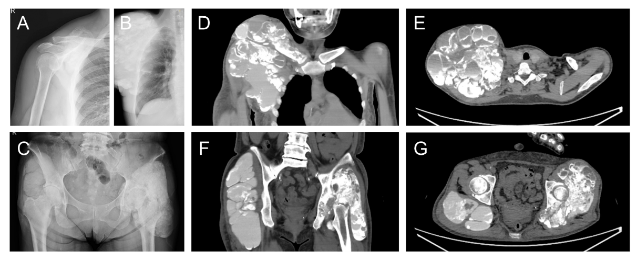
Figure 1 Plain radiograph and computed tomography of tumoral calcinosis. A-C: The images have an opaque and nodular appearance in the right shoulder 12 months (A) and 3 months before the operation (B) and the bilateral hips (C); D-G: Computed tomography (CT) shows calcified multi-cystic lesions in the right shoulder (D and E) and the bilateral hips (F and G); E and G: Axial CT shows each cyst has fluid-fluid level with a dense CT value at the bottom.
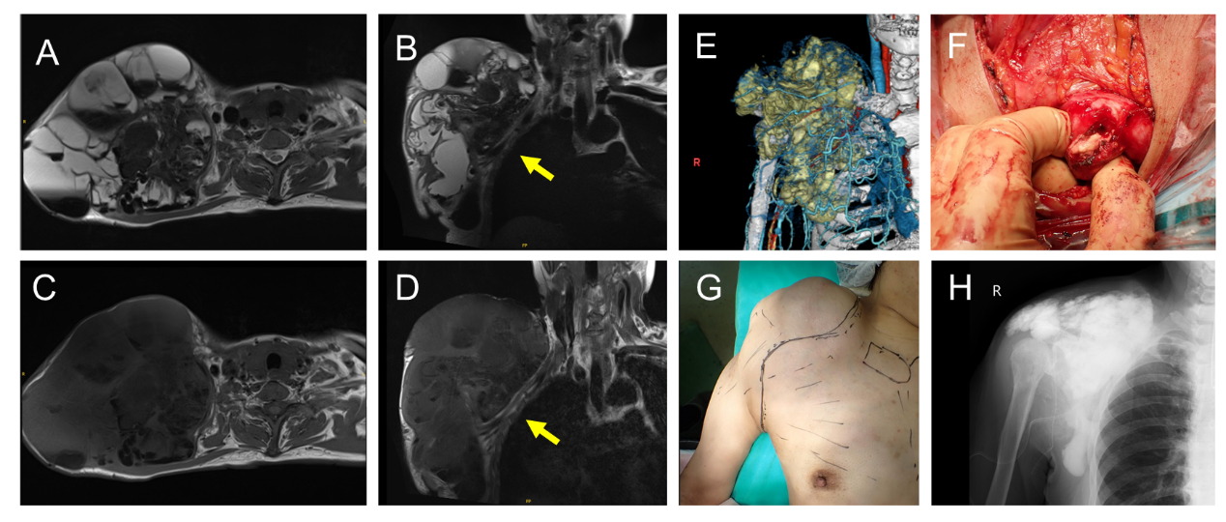
Figure 2 Magnetic resonance imaging and perioperative images. A-D: The magnetic resonance (MR) images reveal multi-cystic lesions with low-to-high signal intensity on T2- (A and B) and T1-weighted images (C and D); A: Axial T2-weighted image shows a fluid-fluid level with a high signal at the top and a low signal at the bottom; B and D: Coronal MR images show brachial plexus and subclavian vessels between the lesion and the chest wall (yellow arrows); E: Three-dimension computed tomography shows the extension of the calcified lesion; F: The operation field shows solid calcified lesion trapped in the fibrous wall; G: A photograph shows swelling and planned incision line; H: After the resection, the plain radiograph shows residual calcified fluid and the materials over the operative field.
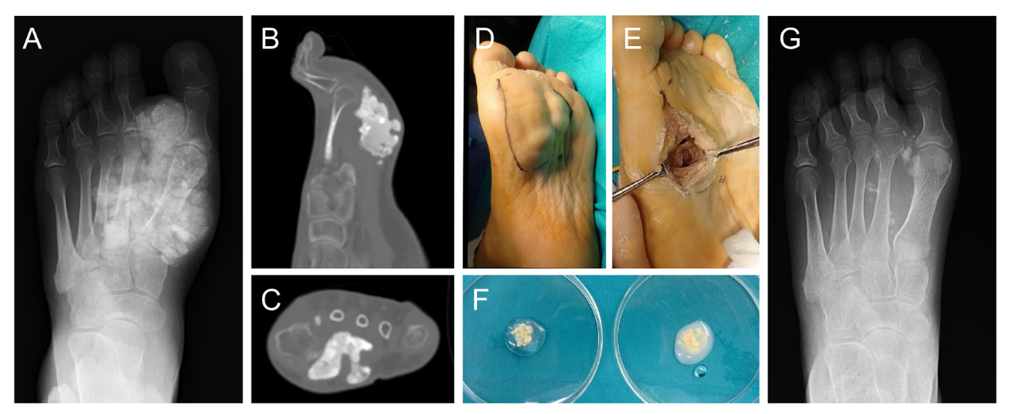
Figure 3 Tumoral calcinosis in the foot. A-C: A plain radiograph (A) and computed tomography (B and C) shows a calcified lesion of the foot; D: A photograph shows swelling and the planned incision line; E: Calcified lesion deposits at the wall after the calcified lesion were removed with suction and curettage; F: The resected calcified material had no reaction in saline (left), but became turbid and dissolved in bicarbonate Ringer’s solution (right); G: The calcified lesion was almost removed and no additional deposition was noted 6 months postoperatively.
Table 1 Composition bicarbonate solution
Ion | mEq/L
Na⁺ | 130
K⁺ | 4
Mg²⁺ | 2
Ca²⁺ | 3
Cl⁻ | 109
HCO₃⁻ | 28
Citrate³⁻ | 4
Table 2 Property of bicarbonate solution
Bicarbonate solution
Appearance | Colorless and transparent
pH | 6.8-7.8
Osmotic pressure | Apraxia 1

Table 3 Component of bicarbonate solution
Component |  | 500 mL | 1000 mL
Sodium chloride | NaCl | 2.92 g | 5.84 g
Potassium chloride | KCl | 0.15 g | 0.30 g
Calcium chloride hydrate | CaCl₂·2H₂O | 0.11 g | 0.22 g
Magnesium chloride | MgCl₂ | 0.10 g | 0.20 g
Sodium bicarbonate | NaHCO₃ | 1.175 g | 2.35 g
Sodium citrate hydrate | C₆H₉Na₃O₉ | 0.10 g | 0.20 g
Citric acid hydrate moderation | HOC(COOH)(CH₂COOH)₂·H₂O | Moderate | Moderate

