Name of Journal: World Journal of Clinical Cases
Manuscript NO: 78924
Manuscript Type: ORIGINAL ARTICLE

Observational Study
Comparison of the prevalence of sarcopenia in geriatric patients in Xining based on three different diagnostic criteria

Pan SQ et al. Comparison of the prevalence of sarcopenia

Shi-Qin Pan, Xiao-Fang Li, Ming-Qin Luo, Yue-Mei Li

Shi-Qin Pan, Xiao-Fang Li, Ming-Qin Luo, Yue-Mei Li, Department of Nuring, Qinghai Provincial People’s Hospital, Xining 810000, Qinghai Province, China

Author contributions: Pan SQ and Li XF designed and performed the research; Luo MQ and Li YM contributed new reagents and analytic tools; Pan SQ analyzed the data; Pan SQ wrote the paper.

Supported by the Chinese Academy of Medical Sciences, Peking Union Medical College Hospital, No. 2018PT33001.

Corresponding author: Yue-Mei Li, PhD, Chief Nurse, Department of Nursing, Qinghai Provincial People’s Hospital, No. 2 Gonghe Road, Xining 810000, Qinghai Province, China. lym64913@126.com

Received: July 22, 2022
Revised: October 18, 2022
Accepted: October 31, 2022
Published online:

Abstract
BACKGROUND
Sarcopenia is an age-related decline in skeletal muscle mass, which depends on an assessment of muscle strength and muscle mass. The diagnostic definition of sarcopenia varies by region.

AIM
To determine the optimal diagnostic criteria for sarcopenia in a plateau population. Cut off values for the components of diagnostic algorithms for sarcopenia in plateau populations should consider altitude.

METHODS
One hundred and fifty subjects aged > 60 years attending a tertiary comprehensive hospital in the city of Xining (elevation: 2260 m) between October and December 2018 were enrolled. Handgrip strength, muscle mass, and physical performance were measured. Sarcopenia was diagnosed according to the Asian Working Group for Sarcopenia (AWGS) 2019 criteria, Beijing criteria, and Lasha criteria.

RESULTS
Across diagnostic criteria, there were significant differences in the prevalence of sarcopenia in the overall population and stratified by gender. The prevalence of sarcopenia measured by the AWGS 2019 or Lasha criteria was significantly higher in female compared to male subjects. In males, the prevalence of sarcopenia measured by the Beijing criteria was significantly higher in subjects who identified as Han compared to Minority. In females, there were no significant differences in the prevalence of sarcopenia by ethnicity according to any criteria.

CONCLUSION
The Lasha criteria provided a lower prevalence of sarcopenia (males, 8.7%; females, 22.41%; overall, 14%) and were able to differentiate between males and females. The Lasha criteria are likely most appropriate for detection of sarcopenia in this plateau population. We recommend the Lasha criteria for detection of sarcopenia in Xining.

Key Words: Ethnic; Diagnostic criteria; Sarcopenia; Prevalence; Plateau

Pan SQ, Li XF, Luo MQ, Li YM. Comparison of the prevalence of sarcopenia in geriatric patients in Xining based on three different diagnostic criteria. World J Clin Cases 2022; In press

Core Tip: Cutoff values for the components of diagnostic algorithms for sarcopenia in plateau populations should consider altitude. We found the Lasha criteria provided a lower prevalence of sarcopenia (males, 8.7%; females, 22.41%; overall, 14%) and were able to differentiate between males and females. The Lasha criteria are likely most appropriate for detection of sarcopenia in this plateau population. We recommend the Lasha criteria for detection of sarcopenia in Xining.

INTRODUCTION
Sarcopenia was first defined in 1988 by Rosenberg, representing an age-related loss of skeletal muscle mass and strength^{[1]}. Sarcopenia affects approximately 10% of individuals aged > 60 years worldwide, and an estimated 10.5%-28.8% of elderly individuals in China^{[2-5]}. Sarcopenia is associated with an increased risk of falling, osteoporosis, fracture, disability, insulin-resistance, and all-cause mortality^{[6]}. Globally, sarcopenia is gaining importance as a major public health issue in an aging society, and there is an unmet need for detection, prevention, and treatment of sarcopenia through early and systematic screening^{[2]}.
The diagnostic definition of sarcopenia varies by region. In 2009, the European Working Group on Sarcopenia in Older People (EWGSOP) defined sarcopenia according to three parameters: Muscle mass, muscle strength and physical performance^{[7]}. In 2014, the Asian Working Group for Sarcopenia (AWGS) updated the definition of sarcopenia proposed by the EWGSOP to an “age-related loss of muscle mass, plus low muscle strength, and/or low physical performance,” and specified a sarcopenia diagnostic algorithm with cutoffs for each component^{[8]}. In 2018 and 2019, respectively, the EWGSOP and AWGS consensus on the definition and diagnosis of sarcopenia were updated^{[7,9]}. The EWGSOP2 definition focused on muscle strength as the main parameter for diagnosing sarcopenia, while AWGS 2019 retained the previous definition of sarcopenia, but revised the diagnostic algorithm, protocols, and some criteria^{[10]}.
According to the AWGS, cutoffs for each component of the sarcopenia diagnostic algorithm vary by ethnicity, body size, lifestyle, and cultural background^{[9]}. After adjusting for ethnicity, the diagnosis of sarcopenia may also be influenced by local sociodemographic, health-related, and lifestyle factors^{[11,12]}. As estimates of the prevalence of sarcopenia in different populations can be affected by the sarcopenia diagnostic criteria used, some regions in China have developed their own diagnostic criteria for sarcopenia^{[11,13,14]}.
The city of Xining in Qinghai Province is the only point of access to the Qinghai-Tibet plateau. A previous study showed that diagnostic reference values for sarcopenia suggested by the AWGS, EWGSOP and Bejing criteria were higher than those for Tibetans in Lhasa and Shigatse^{[13]}. In Lasha and Shigatse, the diagnostic reference values were < 6.53 kg/m² each for men and < 5.62 kg/m² and < 6.0 kg/m² for women, respectively, for the skeletal muscle mass index (SMI); and < 26.7 kg and < 13.3 kg for men and < 15.8 kg and < 8.9 kg for women, respectively, for handgrip strength.
The mass and function of skeletal muscle may be influenced by hypoxia at high altitudes. Hypoxia can lead to a decrease in muscle mass and strength by inhibiting protein synthesis and enhancing protein breakdown^{[15]}. Therefore, cutoff values for the components of a diagnostic algorithm for sarcopenia should consider altitude^{[13]}. Xining has an average elevation of 2260 m, which is lower than Lasha (3600 m) and Shigatse (4200 m). It is unclear whether the Lhasa criteria for sarcopenia are suitable for Xining. The objective of this study was to determine optimal diagnostic reference values for sarcopenia in residents of Xining, and provide evidence-based clinical practice guidelines for sarcopenia screening in Xining.

MATERIALS AND METHODS
Study design
The protocol for this observational study was reviewed by the Medical Ethics Committee of Qinghai Provincial People’s Hospital. The study was conducted according to the World Medical Association Declaration of Helsinki.

Study participants
Subjects attending a tertiary comprehensive hospital in the city of Xining, Qinghai, China between October and December 2018 were eligible for this study. Inclusion criteria were: (1) Aged > 60 years; (2) Residents of Xining City for > 10 years; and (3) Voluntary participation after providing written informed consent. Exclusion criteria were: (1) Cognitive impairment; (2) Caregivers unable to provide relevant information, if needed; (3) Mobility difficulties; (4) Metal implants (e.g., pacemakers and heart stents); or (5) Unable to complete the handgrip strength test.

Data collection
Subject demographics: Subject demographics, including gender, age, ethnicity, height, and weight were recorded.

Handgrip strength: Handgrip strength was measured with a CAMRY-EH101 hand grip dynamometer (Shenzhen Tengfei Yu Technology). The handle of the dynamometer was adjusted to 0 kg. Subjects stood with their arms by their sides and held the device in their dominant hand with the digital readout visible. Researchers verbally encouraged subjects to squeeze the dynamometer with their maximum isometric effort for 5 s. Grip strength was measured 3 times with 1-min intervals between tests. The highest value was used in the analyses.

Muscle mass: Muscle mass was measured with an InBody 720 Bioelectrical Impedance Analyzer (BIA). Subjects stood on the foot electrodes barefoot and grasped the hand electrodes with their fingers and thumbs. Subjects remained still with their shoulder joints slightly abducted and a 15° angle between the trunk and upper limbs for approximately 30 sec.

Physical performance: Physical performance was assessed by estimating gait speed (GS). Subjects walked in a straight line for 10 meters at their usual speed, using walking aids if needed. GS for the middle 6-meters of the course was calculated. The test was performed twice, and the shortest time was used in the analyses.

Diagnostic criteria for sarcopenia: Sarcopenia was diagnosed according to the AWGS 2019 criteria, Beijing criteria, and Lasha criteria^{[4,11,13]}.

Statistical analysis
Data analysis was performed with SPSS 22.0 (IBM, Armonk, NY, United States). Demographics and measured variables were characterized using descriptive statistics (i.e., mean ± SD and proportions). Differences in continuous variables were evaluated using the independent-sample t-test and chi-squared test. P < 0.05 was considered significant.

RESULTS
Study subjects
Overall, 150 subjects aged > 60 years were enrolled in this study. Subjects resided at middle and high elevations in different parts of Qinghai: 83 subjects resided at an altitude of 1500-2499 m, 45 subjects resided at an altitude of 2500-3499 m, and 21 subjects resided at an altitude of > 3500 m (Table 1). The demographic and clinical characteristics of subjects are summarized in Table 2.

Sarcopenia diagnostic criteria and prevalence stratified by gender
Across the diagnostic criteria, there were significant differences in the prevalence of sarcopenia in the overall population (AWGS 2019: 19.33% vs Beijing: 49.14% vs Lasha: 14%; χ² = 46.77; P < 0.001) and stratified by gender (male, AWGS 2019: 14.13% vs Beijing: 42.39% vs Lasha: 8.70%; χ² = 27.47; P< 0.001; female: AWGS 2019: 27.59%vs. Beijing: 56.25% vs Lasha: 22.4%; χ² = 15.09; P = 0.001).
The prevalence of sarcopenia measured by the AWGS 2019 (χ² = 4.13, P = 0.042) or Lasha (χ² = 5.56, P = 0.018) criteria was significantly higher in female subjects compared to male subjects, but there was no significant difference in the prevalence of sarcopenia by gender according to the Beijing criteria (χ² = 0.25, P = 0.617) (Figure 1A).

Sarcopenia diagnostic criteria and prevalence stratified by ethnicity
In male subjects, across the diagnostic criteria, there were significant differences in the prevalence of sarcopenia stratified by ethnicity (Han, AWGS 2019: 17.65% vs Beijing: 48.53% vs Lasha: 11.76%; χ² = 27.58; P < 0.001; Minority, AWGS 2019: 4.17% vs Beijing: 25.00% vs Lasha 0%; χ² = 9.81; P = 0.007). The prevalence of sarcopenia measured by the Beijing criteria (χ² = 4.02, P = 0.045) was significantly higher in subjects who identified as Han compared to subjects who identified as Minority, but there were no significant differences in the prevalence of sarcopenia by ethnicity according to the AWGS 2019 (χ² = 2.66, P = 0.103) or Lasha (χ² = 3.09, P = 0.079) criteria (Figure 1B).
In female subjects, across the diagnostic criteria, there were no significant differences in the prevalence of sarcopenia stratified by ethnicity (Han, AWGS 2019: 26.67% vs Beijing: 42.22% vs Lasha: 20.00%; χ² = 5.61; P = 0.06; Minority: AWGS 2019: 38.46% vs Beijing: 61.53% vs Lasha: 30.77%; χ² = 2.71; P = 0.258). There were no significant differences in the prevalence of sarcopenia by ethnicity according to the AWGS 2019 (χ² = 0.67; P = 0.411), Beijing (χ² = 1.51; P = 0.219) or Lasha (χ² = 0.67; P = 0.412) criteria (Figure 1C).

DISCUSSION
The objective of this study was to determine optimal diagnostic reference values for sarcopenia in residents of Xining, which is located on the Qinghai-Tibet Plateau at an average elevation of 2260 m. Sarcopenia diagnostic criteria are based on muscle mass, muscle strength and physical function, but may vary due to ethnicity, body size, and lifestyle and cultural factors. As chronic exposure to hypoxia at high altitudes can induce muscle atrophy and decrease physical performance, there is an unmet need to establish specific cut-off values for sarcopenia diagnostic criteria in plateau populations^{[16,17]}.
Consistent with other studies, among residents of Xining aged > 60 years, there were statistically significant differences in handgrip strength between males and females and in muscle mass between subjects who identified as Han or Minority ethnicities^{[5,18]}. According to AWGS 2019 and Beijing criteria, in Xining, there was a high prevalence of sarcopenia in males (14.13%/42.39%), females (27.59%/56.25%) and overall (19.33%/49.14%). As the Lasha criteria provided a lower prevalence of sarcopenia (males, 8.7%; females, 22.41%; overall, 14%) and were able to differentiate between males and females, they are likely more appropriate for detection of sarcopenia in this plateau population.
China is a multi-ethnic country, and the prevalence of sarcopenia varies among different ethnic groups and across cultures^{[5]}. In the present study, across the AWGS 2019, Beijing, or Lasha criteria, there were significant differences in the prevalence of sarcopenia stratified by ethnicity (Han and Minority) in male subjects. However, in male subjects, there were no significant differences in the prevalence of sarcopenia by ethnicity according to the AWGS 2019 criteria, and in female subjects, there were no significant differences in the prevalence of sarcopenia by ethnicity according to the AWGS 2019, Beijing or Lasha criteria. This may be explained by the following: First, in this study, subjects who identified as the Minority included the Hui, Zang, Sarah, and Mongols. These populations generally have a high protein diet, which may be preventative for sarcopenia^{[19]}. Second, the Hui and Sarah dance actively in church each day. Exercise can improve muscle health as it may induce autophagy, which regulates the fate of stem cells and satellite cell differentiation into muscle fibers^{[20-22]}.
This study was associated with some limitations. First, the sample size was small, especially for female subjects and those who identified as Minority. Second, the sample was recruited from a single site, which limits the generalizability of our findings. Future research will explore diagnostic cut-off values for sarcopenia in Xining based on data collected from a larger number of hospitalized and community-dwelling subjects. A comparison of the values with the Lasha criteria will help explain the effectiveness of the three diagnostic criteria (Asia/ Beijing/ Lasha) for sarcopenia in this population.

CONCLUSION
The prevalence of sarcopenia in subjects aged > 60 years in Xining differed across three diagnostic criteria. We recommend the Lasha criteria are the most appropriate for detection of sarcopenia in Xining.

ARTICLE HIGHLIGHTS
Research background
Sarcopenia is an age-related decline in skeletal muscle mass, which depends on an assessment of muscle strength and muscle mass. The diagnostic definition of sarcopenia varies by region.

Research motivation
The mass and function of skeletal muscle may be influenced by hypoxia at high altitudes. It is unclear whether the Lhasa criteria for sarcopenia are suitable for Xining.

Research objectives
To determine the optimal diagnostic criteria for sarcopenia in a plateau population.

Research methods
Handgrip strength, muscle mass, and physical performance were measured. Sarcopenia was diagnosed according to the Asian Working Group for Sarcopenia (AWGS) 2019 criteria, Beijing criteria, and Lasha criteria.

Research results
Across diagnostic criteria, there were significant differences in the prevalence of sarcopenia in the overall population and stratified by gender. The prevalence of sarcopenia measured by the AWGS 2019 or Lasha criteria was significantly higher in female compared to male subjects. In males, the prevalence of sarcopenia measured by the Beijing criteria was significantly higher in subjects who identified as Han compared to Minority. In females, there were no significant differences in the prevalence of sarcopenia by ethnicity according to any criteria.

Research conclusions
The Lasha criteria are likely most appropriate for detection of sarcopenia in this plateau population. We recommend the Lasha criteria for detection of sarcopenia in Xining.

Research perspectives
Future research will explore diagnostic cut-off values for sarcopenia in Xining based on data collected from a larger number of hospitalized and community-dwelling subjects.

REFERENCES
1 Rosenberg IH. Sarcopenia: origins and clinical relevance. J Nutr 1997; 127: 990S-991S [PMID: 9164280 DOI: 10.1093/jn/127.5.990S]
2 Shafiee G, Keshtkar A, Soltani A, Ahadi Z, Larijani B, Heshmat R. Prevalence of sarcopenia in the world: a systematic review and meta- analysis of general population studies. J Diabetes Metab Disord 2017; 16: 21 [PMID: 28523252 DOI: 10.1186/s40200-017-0302-x]
3 Wang H, Hai S, Liu Y, Liu YX, Zhou JH, Yang Y, Dong BR, Yue JR. Prevalence of Sarcopenia and Associated Factors in Community-dwelling Elderly Populations in Chengdu China. Sichuandaxue Xuebao Yixueban 2019; 50: 224-228 [PMID: 31106544]
4 Yang LJ, Wu GH, Yang YL, Wu YH, Zhang L, Wang MH, Mo LY, Xue G, Wang CZ, Weng XF. Nutrition, Physical Exercise, and the Prevalence of Sarcopenia in Elderly Residents in Nursing Homes in China. Med Sci Monit 2019; 25: 4390-4399 [PMID: 31189870 DOI: 10.12659/MSM.914031]
5 Liu X, Hao Q, Hou L, Xia X, Zhao W, Zhang Y, Ge M, Liu Y, Zuo Z, Yue J, Dong B. Ethnic Groups Differences in the Prevalence of Sarcopenia Using the AWGS Criteria. J Nutr Health Aging 2020; 24: 665-671 [PMID: 32510121 DOI: 10.1007/s12603-020-1381-9]
6 Bruyère O, Beaudart C, Ethgen O, Reginster JY, Locquet M. The health economics burden of sarcopenia: a systematic review. Maturitas 2019; 119: 61-69 [PMID: 30502752 DOI: 10.1016/j.maturitas.2018.11.003]
7 Cruz-Jentoft AJ, Bahat G, Bauer J, Boirie Y, Bruyère O, Cederholm T, Cooper C, Landi F, Rolland Y, Sayer AA, Schneider SM, Sieber CC, Topinkova E, Vandewoude M, Visser M, Zamboni M; Writing Group for the European Working Group on Sarcopenia in Older People 2 (EWGSOP2), and the Extended Group for EWGSOP2. Sarcopenia: revised European consensus on definition and diagnosis. Age Ageing 2019; 48: 16-31 [PMID: 30312372 DOI: 10.1093/ageing/afy169]
8 Chen LK, Liu LK, Woo J, Assantachai P, Auyeung TW, Bahyah KS, Chou MY, Chen LY, Hsu PS, Krairit O, Lee JS, Lee WJ, Lee Y, Liang CK, Limpawattana P, Lin CS, Peng LN, Satake S, Suzuki T, Won CW, Wu CH, Wu SN, Zhang T, Zeng P, Akishita M, Arai H. Sarcopenia in Asia: consensus report of the Asian Working Group for Sarcopenia. J Am Med Dir Assoc 2014; 15: 95-101 [PMID: 24461239 DOI: 10.1016/j.jamda.2013.11.025]
9 Chen LK, Woo J, Assantachai P, Auyeung TW, Chou MY, Iijima K, Jang HC, Kang L, Kim M, Kim S, Kojima T, Kuzuya M, Lee JSW, Lee SY, Lee WJ, Lee Y, Liang CK, Lim JY, Lim WS, Peng LN, Sugimoto K, Tanaka T, Won CW, Yamada M, Zhang T, Akishita M, Arai H. Asian Working Group for Sarcopenia: 2019 Consensus Update on Sarcopenia Diagnosis and Treatment. J Am Med Dir Assoc 2020; 21: 300-307.e2 [PMID: 32033882 DOI: 10.1016/j.jamda.2019.12.012]
10 Chiles Shaffer N, Simonsick EM, Thorpe RJ, Studenski SA. The Roles of Body Composition and Specific Strength in the Relationship Between Race and Physical Performance in Older Adults. J Gerontol A Biol Sci Med Sci 2020; 75: 784-791 [PMID: 31825084 DOI: 10.1093/gerona/glz103]
11 Zeng P, Wu S, Han Y, Liu J, Zhang Y, Zhang E, Zhang Y, Gong H, Pang J, Tang Z, Liu H, Zheng X, Zhang T. Differences in body composition and physical functions associated with sarcopenia in Chinese elderly: reference values and prevalence. Arch Gerontol Geriatr 2015; 60: 118-123 [PMID: 25440136 DOI: 10.1016/j.archger.2014.08.010]
12 Woo J, Arai H, Ng TP. Ethnic and geographic variations in muscle mass, muscle strength and physical performance measures. Eur Geriatr Med 2014; 5: 155-164 [DOI: 10.1016/j.eurger.2014.04.003]
13 Ye L, Wen Y, Chen Y, Yao J, Li X, Liu Y, Song J, Sun Z. Diagnostic reference values for sarcopenia in Tibetans in China. Sci Rep 2020; 10: 3067 [PMID: 32080301 DOI: 10.1038/s41598-020-60027-0]
14 Woo J, Leung J. Anthropometric Cut Points for Definition of Sarcopenia Based on Incident Mobility and Physical Limitation in Older Chinese People. J Gerontol A Biol Sci Med Sci 2016; 71: 935-940 [PMID: 26519945 DOI: 10.1093/gerona/glv197]
15 Panahi A, Malekmohammad M, Soleymani F, Hashemian SM. The Prevalence and Outcome of Intensive Care Unit Acquired Weakness (ICUAW). Tanaffos 2020; 19: 250-255 [PMID: 33815546]
16 Pasiakos SM, Berryman CE, Carbone JW, Murphy NE, Carrigan CT, Bamman MM, Ferrando AA, Young AJ, Margolis LM. Muscle Fn14 gene expression is associated with fat-free mass retention during energy deficit at high altitude. Physiol Rep 2018; 6: e13801 [PMID: 30009538 DOI: 10.14814/phy2.13801]
17 Chaudhary P, Sharma YK, Sharma S, Singh SN, Suryakumar G. High altitude mediated skeletal muscle atrophy: Protective role of curcumin. Biochimie 2019; 156: 138-147 [PMID: 30347230 DOI: 10.1016/j.biochi.2018.10.012]
18 Zhang Q, Lu H, Pan S, Lin Y, Zhou K, Wang L. 6MWT Performance and its Correlations with VO₂ and Handgrip Strength in Home-Dwelling Mid-Aged and Older Chinese. Int J Environ Res Public Health 2017; 14 [PMID: 28468260 DOI: 10.3390/ijerph14050473]
19 Pan SQ, Li YM, Li XF, Xiong R. Sarcopenia in geriatric patients from the plateau region of Qinghai-Tibet: A cross-sectional study. World J Clin Cases 2021; 9: 5092-5101 [PMID: 34307560 DOI: 10.12998/wjcc.v9.i19.5092]
20 de Mello RGB, Dalla Corte RR, Gioscia J, Moriguchi EH. Effects of Physical Exercise Programs on Sarcopenia Management, Dynapenia, and Physical Performance in the Elderly: A Systematic Review of Randomized Clinical Trials. J Aging Res 2019; 2019: 1959486 [PMID: 31827927 DOI: 10.1155/2019/1959486]
21 Kalantar-Zadeh K, Moore LW. Improving Muscle Strength and Preventing Sarcopenia and Cachexia in Chronic Kidney Disease and Transplanted Patients by Physical Activity and Exercise. J Ren Nutr 2019; 29: 465-466 [PMID: 31676147 DOI: 10.1053/j.jrn.2019.09.005]
22 Park SS, Seo YK, Kwon KS. Sarcopenia targeting with autophagy mechanism by exercise. BMB Rep 2019; 52: 64-69 [PMID: 30526769 DOI: 10.5483/BMBRep.2019.52.1.292]

Footnotes
Institutional review board statement: This study was approved by the ethics committee of Qinghai Provincial People’s Hospital. All procedures performed in studies involving human participants were in accordance with the ethical standards of the institutional and/or national research committee and with the 1964 Helsinki declaration and its later amendments or comparable ethical standards.

Informed consent statement: All study participants, or their legal guardian, provided informed written consent prior to study enrollment.

Conflict-of-interest statement: All authors declare that they have no conflict of interest.

Data sharing statement: No additional data are available.

STROBE statement: The authors have read the STROBE Statement—checklist of items, and the manuscript was prepared and revised according to the STROBE Statement—checklist of items.

Open-Access: This article is an open-access article that was selected by an in-house editor and fully peer-reviewed by external reviewers. It is distributed in accordance with the Creative Commons Attribution NonCommercial (CC BY-NC 4.0) license, which permits others to distribute, remix, adapt, build upon this work non-commercially, and license their derivative works on different terms, provided the original work is properly cited and the use is non-commercial. See: https://creativecommons.org/Licenses/by-nc/4.0/

Provenance and peer review: Unsolicited article; Externally peer reviewed.
Peer-review model: Single blind
Corresponding Author's Membership in Professional Societies: This research received funding from the Chinese Academy of Medical Sciences, Peking Union Medical College Hospital, .

Peer-review started: July 22, 2022
First decision: September 25, 2022
Article in press:

Specialty type: Geriatrics and Gerontology
Country/Territory of origin: China
Peer-review report’s scientific quality classification
Grade A (Excellent): 0
Grade B (Very good): B
Grade C (Good): 0
Grade D (Fair): D
Grade E (Poor): 0

P-Reviewer: Dauyey K, Kazakhstan; Wang D, Thailand S-Editor: Wang LL L-Editor: A P-Editor: Wang LL

Figure Legends
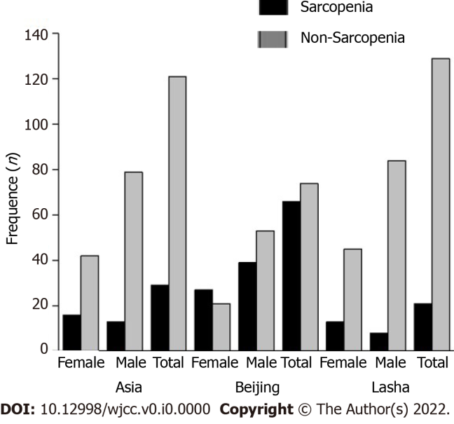
A

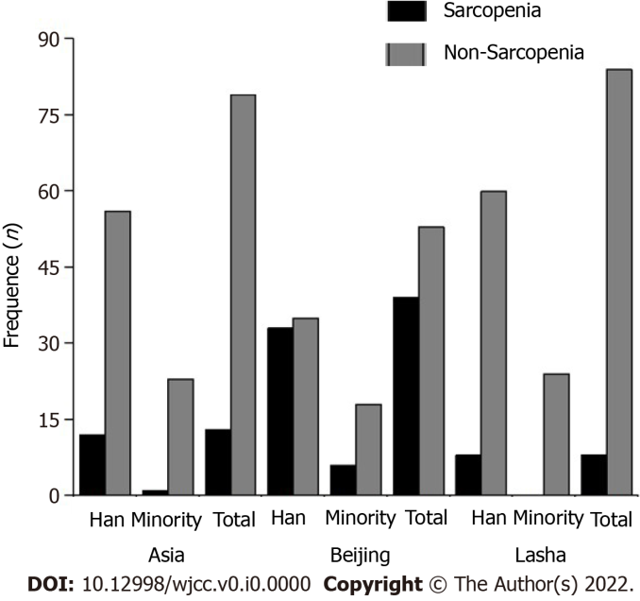

B
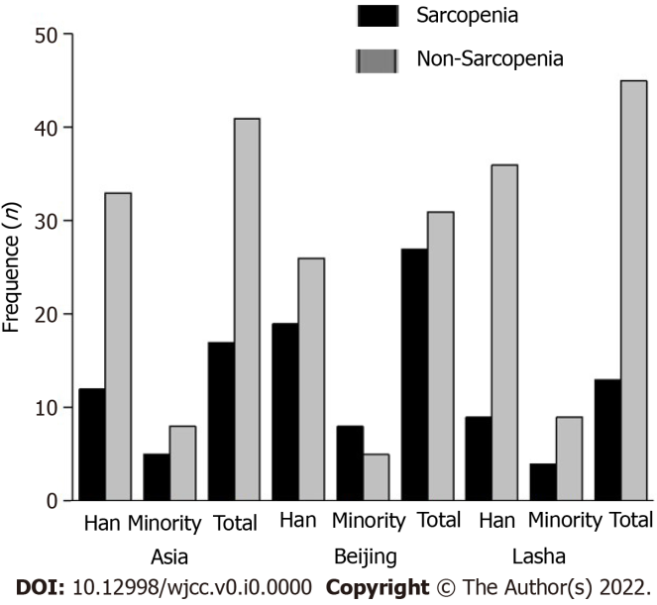

C
Figure 1 Sarcopenia diagnostic criteria and prevalence. A: Stratified by gender; B: stratified by ethnicity in male subjects; C: Stratified by ethnicity in female subjects.

Table 1 Sarcopenia diagnostic criteria
Variable |  | AWGS 2019 | Beijing | Lasha
Muscle Strength | Male | < 28 kg | < 27 kg | < 26.7 kg
 | Female | < 18 kg | < 16 kg | < 15.8 kg
Muscle mass (BIA) | Male | < 7.0 kg/m² | < 7.61 kg/m² | < 6.53 kg/m²
 | Female | < 5.7 kg/m² | < 6.43 kg/m² | < 5.62 kg/m²
Performance | Male | < 1.0 m/s | < 0.98 m/s | < 0.87 m/s
 | Female |  | < 0.88 m/s
AWGS: Asian Working Group for Sarcopenia; BIA: Bioelectrical Impedance Analyzer.

Table 2 Subjects demographic and clinical characteristics stratified by gender and ethnicity (n = 150)
Variable | Gender |  | Ethnicity
 | Male (n = 92) | Female (n = 58) | Han (n = 113) | Minority (n = 37)
Age (yr) | 72.93 ± 5.86 | 71.59 ± 5.21 | 72.37 ± 5.69 | 72.54 ± 5.55
Height (m) | 1.69 ± 0.06ª | 1.57 ± 0.06 | 1.64 ± 0.08 | 1.64 ± 0.09
Weight (kg) | 68.99 ± 12.54ª | 59.14 ± 9.57 | 63.90 ± 10.99 | 69.22 ± 15.51ª
BMI (kg/m2) | 24.25 ± 3.97 | 23.88 ± 3.65 | 23.66 ± 3.59 | 25.48 ± 4.29ª
Handgrip (kg) | 28.52 ± 9.39ª | 19.24 ± 6.32 | 25.26 ± 9.83 | 23.93 ± 8.29
Muscle mass (kg/m²) | 7.51 ± 0.97ª | 6.08 ± 0.78 | 6.84 ± 1.04 | 7.29 ± 1.37ª
6-meter gait speed (m) | 0.94 ± 0.23 | 0.87 ± 0.24 | 0.93 ± 0.25 | 0.86 ± 0.18
ªP < 0.05.

