Name of Journal: World Journal of Clinical Cases
Manuscript NO: 47117
Manuscript Type: CASE REPORT

Clear cell sarcoma of soft tissue in the pleural cavity: A case report

Chen YT et al. CCS of soft tissue

Yang-Tian Chen, Zhi Yang, Huan Li, Chen-Hui Ni

Yang-Tian Chen, Huan Li, Chen-Hui Ni, Department of Thoracic Surgery, The Affiliated People Hospital of Fujian University of Traditional Chinese Medicine, Fuzhou 350004, Fujian Province, China

Zhi Yang, Department of Pathology, The Affiliated People Hospital of Fujian University of Traditional Chinese Medicine, Fuzhou 350004, Fujian Province, China

ORCID number: Yang-Tian Chen (0000-0002-8615-7441); Zhi Yang (0000-0001-7880-5253); Huan Li (0000-0003-2800-9683); Chen-Hui Ni (0000-0003-1153-3235).

Author contributions: Chen YT, Li H, and Ni CH were the patient’s thoracic surgeons, reviewed the literature, and contributed to manuscript drafting; Yang Z performed the pathologic analyses and interpretation; Chen YT and Ni CH were responsible for revising the manuscript for important intellectual content; All authors issued final approval for the version to be submitted.

Informed consent statement: Informed written consent was obtained from the patient for publication of this report and any accompanying images.

Conflict-of-interest statement: The authors declare that they have no conflicts of interest.

CARE Checklist (2016) statement: The authors have read the CARE Checklist (2013), and the manuscript was prepared and revised according to the CARE Checklist (2016).

Open-Access: This article is an open-access article that was selected by an in-house editor and fully peer-reviewed by external reviewers. It is distributed in accordance with the Creative Commons Attribution Non Commercial (CC BY-NC 4.0) license, which permits others to distribute, remix, adapt, build upon this work non-commercially, and license their derivative works on different terms, provided the original work is properly cited and the use is non-commercial. See: http://creativecommons.org/licenses/by-nc/4.0/

Manuscript source: Unsolicited manuscript

Corresponding author: Yang-Tian Chen, MD, PhD, Associate Professor, Consultant Cardiac Surgeon, Department of Thoracic Surgery, The Affiliated People’s Hospital of Fujian University of Traditional Chinese Medicine, 602 Eight-One-Seven Middle Road, Fuzhou 350004, Fujian Province, China. chenyt1976@163.com
Telephone: +86-591-86250214

Received: March 14, 2019
Peer-review started: March 15, 2019
First decision: July 30, 2019
Revised: August 20, 2019
Accepted: August 25, 2019
Article in press:
Published online:

Abstract
BACKGROUND
Clear cell sarcoma (CCS) of soft tissue is a rare malignant soft tissue sarcoma usually located at the distal end of extremities and rarely at the trunk. Herein, we report a case of CCS in the pleural cavity.

CASE SUMMARY
A 31-year-old male was admitted for an uncertain mass in the left pleural cavity in routine physical examination without any symptoms. Video-assisted thoracoscopic surgery was performed to remove the tumor. The pathological finding displayed a cystic mass of 6.5 cm at the longest diameter, dark red sections, and cysts that could be found locally. Strong expression of soluble protein-100, human melanoma black-45, and vimentin was detected by immunohistochemical staining, which was inclined to the diagnosis of CCS of soft tissue. The patient refused chemotherapy, radiotherapy, and targeted therapy because of the personal financial situation. Follow-up computed tomography scans were done on the 90th and 180th postoperative days, and no obvious sign of recurrence was found until now.

CONCLUSION
CCS of soft tissue can be found in the pleural cavity, although with an extremely rare incidence. Radical resection is useful to improve the prognosis.

Key words: Sarcoma; Clear cell sarcoma; Clear cell sarcoma of soft tissue; Treatment; Case report

© The Author(s) 2019. Published by Baishideng Publishing Group Inc. All rights reserved.

Core tip: Clear cell sarcoma is a rare malignant tumor of soft tissue usually arising from the extremities. Here, we report a case of clear cell sarcoma located on the chest cavity, confirmed by positive staining of human melanoma black-45, and soluble protein-100 markers by immunohistochemistry. Radical resection of the tumor was performed and the short-term outcome was good.

Chen YT, Yang Z, Li H, Ni CH. Clear cell sarcoma of soft tissue in pleural cavity: A case report. World J Clin Cases 2019; In press

INTRODUCTION
Clear cell sarcoma (CCS) of soft tissue is a rare malignant soft tissue sarcoma that represents about 1% of all sarcomas^{[1]}. The true origination of CCS is still uncertain; it might be one type of synovial sarcoma because SSC usually arises in association with tendons and aponeuroses and has the same bidirectional differentiation ability as synovial sarcoma. However, on account of sharing a similar morphology with malignant melanoma, SSC is more likely derived from neural crest cells, which typically produce melanin and stain positive for human melanoma black-45 (HMB-45) and soluble protein-100 (S-100) markers by immunohistochemistry^{[2]}. CCS is usually located at the distal end of extremities and rarely at the trunk^{[3]}. According to the literature review, to date, there has been no report of CCS in the pleural cavity.

CASE PRESENTATION
Chief complaints
A 31-year-old male was admitted to our hospital for an uncertain mass in the left pleural cavity in routine physical examination without any symptoms.

History of past illness
His past history was unremarkable.

Personal and family history
His family history was unremarkable.

Physical examination upon admission
His physical examination was normal.

Laboratory examinations
Routine blood parameters were within the normal range. Tumor marker measurement results were as follows: carcinoembryonic antigen, 0.64 ng/mL; alpha-fetoprotein, 1.77 ng/mL; and carbohydrate antigen 19-9, 5.80 U/mL. Enhanced thoracic computed tomography (CT) demonstrated a posterior mediastinal mass about 6 cm diameter in the left pleural cavity, near the 9th and 10th thoracic vertebrae beside the thoracic descending aorta, with uneven enhancement (Figure 1). A neurologic tumor was suspected as the first diagnosis.
Video-assisted thoracoscopic surgery was performed to remove the mass. During the operation, the patient was placed in a right lateral decubitus position at 70 degrees with unilateral ventilation under general anesthesia. Three trocars were placed at the 3th, 4th, and 8th intercostal space. Under endoscopy, there was no obvious effusion in the pleural cavity. A spherical mass with broad base was found on the posterior chest wall, just left of the 9th thoracic vertebra, close to the aorta while no obvious adhesion was found between the tumor and aorta or vertebra. Careful dissection was done with electrocautery and harmonic scalpel in turn. A feeding branch from the intercostal artery and a draining vein to the hemiazygos vein were ligated and cut. Finally, the mass was removed under en bloc excision with a relatively clear margin. Furthermore, the base plane on local chest wall was managed with electrocoagulation to ensure no residual tumor (Figure 2). The drain tube was placed and the chest wall wound was closed routinely. The chest tube was removed on the 1st postoperative day and the patient was discharged on the 5th postoperative day with no events.

FINAL DIAGNOSIS
The pathological finding displayed a cystic mass of 6.5 cm at the longest diameter, dark red sections, and cysts that could be found locally. Strong expression of S-100, HMB-45, and vimentin was detected by immunohistochemical staining (Figure 3), which was inclined to the diagnosis of CCS of soft tissue^{[2,3]}.

TREATMENT
Video-assisted thoracoscopic surgery was performed to dissect the tumor. After surgery, the patient refused the suggestion of all following treatments such as chemotherapy, radiotherapy, and targeted therapy because of the personal financial situation.

OUTCOME AND FOLLOW-UP
Meanwhile, two postoperative follow-up CT scans were done on the 90th postoperative day and the 180th postoperative day, and no obvious sign of recurrence was found until now.

DISCUSSION
CCS is a rare malignant tumor of soft tissue with uncertain origination, which seems most likely to be diagnosed in adolescents and middle-aged people. The diagnosis of CCS always seems to be a challenge if there is a lack of pathologic immunohistochemical results. Although CCS has a similar morphologic appearance with malignant melanoma, it is possible for pathologists to distinguish them correctly by the difference of histopathologic and cytogenetic features between them^{[2]}. CCS is usually located in the deep soft tissue or under the deep fascia, in close relation to tendons and aponeuroses at the distal end of extremities such as the foot and knee, rarely at the trunk, with no epidermal involvement^{[4-9]} Differential diagnosis from other sarcomas should be made including epithelioid sarcoma, synovial sarcoma, epithelioid malignant peripheral nerve sheath tumor, alveolar soft part sarcoma, and so on^{[3]}.
Radical resection of the tumor might be the most effective way to treat CCS. Before the operation, magnetic resonance imaging of thoracic vertebra is done to exclude possible invasion of the tumor to the vertebra. The intraoperative exploration also ensures that there is no obvious adhesion between the spine and the tumor. If the vertebra or posterior ribs are invaded by tumor, the nearby vertebra and ribs should be removed with the tumor under en bloc excision and reconstruction of the chest wall should be done.
Adjuvant radiotherapy or chemotherapy might not be necessary for the poor evidence of therapeutic effect on SCC^{[10]}. However, radiation therapy is recommended if there is possible residual tumor after surgery to achieve a better outcome^{[11].}. Targeted therapy seems to be a good treatment for SSC with some encouraging evidence on malignant melanoma, but there is still a long way to go^{[12]}. Regular follow-up including CT scan or magnetic resonance imaging should be made every 3 mo postoperatively on account of the high risk of early metastases and recurrence of SSC^{[13]}.

CONCLUSION
CCS of soft tissue can be found in the pleural cavity, although with an extremely rare incidence. Radical resection is useful to improve the prognosis.

REFERENCES
1 Ibrahim RM, Steenstrup Jensen S, Juel J. Clear cell sarcoma-A review. J Orthop 2018; 15: 963-966 [PMID: 30210202 DOI: 10.1016/j.jor.2018.08.039]
2 Yang L, Chen Y, Cui T, Knösel T, Zhang Q, Geier C, Katenkamp D, Petersen I. Identification of biomarkers to distinguish clear cell sarcoma from malignant melanoma. Hum Pathol 2012; 43: 1463-1470 [PMID: 22406360 DOI: 10.1016/j.humpath.2011.10.022]
3 James AW, Dry SM. Diagnostically Challenging Epithelioid Soft Tissue Tumors. Surg Pathol Clin 2015; 8: 309-329 [PMID: 26297059 DOI: 10.1016/j.path.2015.05.002]
4 Kindblom LG, Lodding P, Angervall L. Clear-cell sarcoma of tendons and aponeuroses. An immunohistochemical and electron microscopic analysis indicating neural crest origin. Virchows Arch A Pathol Anat Histopathol 1983; 401: 109-128 [PMID: 6412444]
5 Kawai A, Hosono A, Nakayama R, Matsumine A, Matsumoto S, Ueda T, Tsuchiya H, Beppu Y, Morioka H, Yabe H; Japanese Musculoskeletal Oncology Group. Clear cell sarcoma of tendons and aponeuroses: a study of 75 patients. Cancer 2007; 109: 109-116 [PMID: 17133413 DOI: 10.1002/cncr.22380]
6 Juel J, Ibrahim RM. A case of clear cell sarcoma-A rare malignancy. Int J Surg Case Rep 2017; 36: 151-154 [PMID: 28587971 DOI: 10.1016/j.ijscr.2017.05.034]
7 Baus A, Culie D, Duong LT, Ben Lakhdar A, Schaff JB, Janot F, Kolb F. Primary clear cell sarcoma of the tongue and surgical reconstruction: About a rare case report. Ann Chir Plast Esthet 2019; 64: 98-105 [PMID: 30262251 DOI: 10.1016/j.anplas.2018.09.001]
8 Zhang X, Hu C, Cai L. A giant clear cell sarcoma on right scapular: A case report. Acta Orthop Traumatol Turc 2016; 50: 473-476 [PMID: 27452744 DOI: 10.1016/j.aott.2016.07.004]
9 Rocco G, de Chiara AR, Fazioli F, Scognamiglio F, La Rocca A, Apice G, Riva C. Primary giant clear cell sarcoma (soft tissue malignant melanoma) of the sternum. Ann Thorac Surg 2009; 87: 1927-1928 [PMID: 19463625 DOI: 10.1016/j.athoracsur.2008.10.077]
10 Hatcher H, Benson C, Ajithkumar T. Systemic Treatments in Soft Tissue Sarcomas. Clin Oncol (R Coll Radiol) 2017; 29: 507-515 [PMID: 28552518 DOI: 10.1016/j.clon.2017.05.002]
11 Al-Absi E, Farrokhyar F, Sharma R, Whelan K, Corbett T, Patel M, Ghert M. A systematic review and meta-analysis of oncologic outcomes of pre- versus postoperative radiation in localized resectable soft-tissue sarcoma. Ann Surg Oncol 2010; 17: 1367-1374 [PMID: 20217260 DOI: 10.1245/s10434-009-0885-7]
12 Stacchiotti S, Marrari A, Dei Tos AP, Casali PG. Targeted therapies in rare sarcomas: IMT, ASPS, SFT, PEComa, and CCS. Hematol Oncol Clin North Am 2013; 27: 1049-1061 [PMID: 24093175 DOI: 10.1016/j.hoc.2013.07.009]
13 Bianchi G, Charoenlap C, Cocchi S, Rani N, Campagnoni S, Righi A, Frisoni T, Donati DM. Clear cell sarcoma of soft tissue: a retrospective review and analysis of 31 cases treated at Istituto Ortopedico Rizzoli. Eur J Surg Oncol 2014; 40: 505-510 [PMID: 24560887 DOI: 10.1016/j.ejso.2014.01.016]

P-Reviewer: Kutlubay Z, Petrucciani N, Simone G S-Editor: Dou Y L-Editor: Filipodia E-Editor:

Specialty type: Medicine, Research and Experimental
Country of origin: China
Peer-review report classification
Grade A (Excellent): 0
Grade B (Very good): B
Grade C (Good): C
Grade D (Fair): D
Grade E (Poor): 0

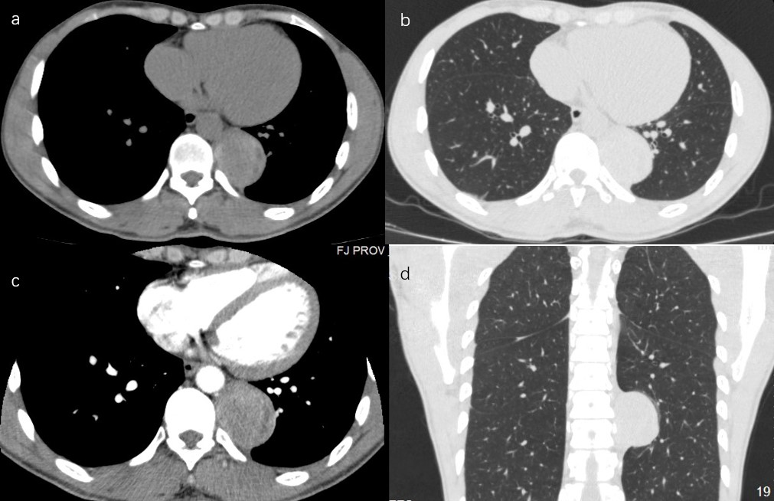
Figure 1 The CT scan indicates a paravertebral mass close to the thoracic aorta. A: Transverse view in mediastinal window of the normal CT scan; B: Transverse view in lung window of the normal CT scan; C: Transverse view in mediastinal window of the enhanced CT scan; D: Horizontal view in lung window of the normal CT scan. CT: Computed tomography.

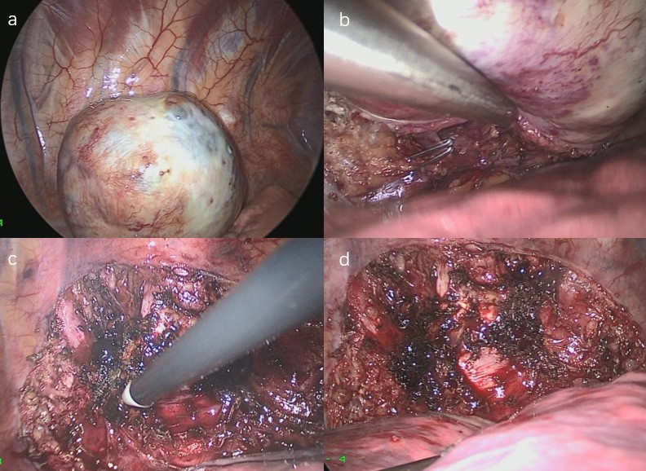
Figure 2 Video-assisted thoracoscopic surgery was performed to remove the mass. A: The tumor was located on the posterior chest wall near the 9th thoracic vertebra; B: The drain vein to the hemiazygos vein was ligated by hemoclips; C: The tumor was dissected carefully by electrocautery and harmonic scalpel in turn; D: The base plane on the chest wall was managed by electrocoagulation.
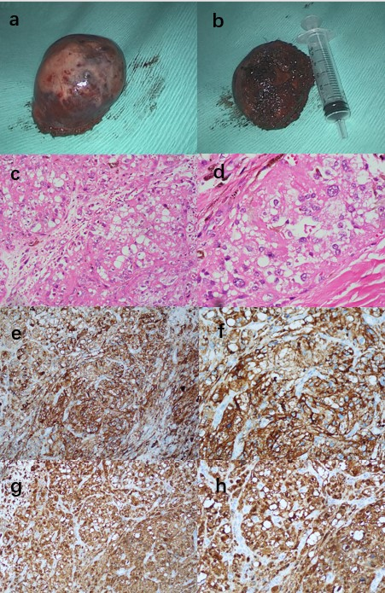
Figure 3 Cystic mass and immunohistochemical staining. A, B: The tumor was removed under en bloc dissection with a relative clear margin; C, D: Hematoxylin-eosin stain: Neoplastic cells were arranged in irregular nests separated by fibrous septa. Cells were round or oval in shape with regular vesicular nuclei and prominent nucleoli, moderate to abundant eosinophilic or clear cytoplasm; E, F: Neoplastic cells showed strong immunohistochemical expression of melanocytic marker S-100 (+); G, H: Neoplastic cells showed strong immunohistochemical expression of the melanocytic marker HMB-45 (+).

