Name of Journal: World Journal of Gastrointestinal Endoscopy
Manuscript NO: 65867
Manuscript Type: MINIREVIEWS

Endoscopic ultrasound-guided biliary drainage: Are we there yet?

Pawa R et al. EUS-biliary drainage

Rishi Pawa, Troy Pleasant, Chloe Tom, Swati Pawa

Rishi Pawa, Troy Pleasant, Swati Pawa, Department of Internal Medicine, Section of Gastroenterology and Hepatology, Wake Forest Baptist Medical Center, Winston-Salem, NC 27157, United States

Chloe Tom, Department of Medicine, Wake Forest School of Medicine, Winston-Salem, NC 27101, United States

Author contributions: Pawa R provided topic outlining, literature review, expertise, graphics, original draft preparation and manuscript editing; Pleasant T and Tom C performed original draft preparation; Pawa S performed the expertise and manuscript editing; Pleasant T, Tom C, and Pawa S performed topic outlining, literature review.

Corresponding author: Rishi Pawa, MBBS, Doctor, Department of Internal Medicine, Section of Gastroenterology and Hepatology, Wake Forest Baptist Medical Center, Medical Center Blvd, Winston-Salem, NC 27157, United States. rpawa@wakehealth.edu

Received: March 17, 2021
Revised: May 14, 2021
Accepted: July 14, 2021
Published online:

Abstract
Endoscopic retrograde cholangiopancreatography (ERCP) is the mainstay procedure of choice for management of obstructive biliary disease. While ERCP is widely performed with high success rates, the procedure is not feasible in every patient such as cases of non-accessible papilla. In the setting of unsuccessful ERCP, endoscopic ultrasound-guided biliary drainage (EUS-BD) has become a promising alternative to surgical bypass and percutaneous biliary drainage (PTBD). A variety of different forms of EUS-BD have been described, allowing for both intrahepatic and extrahepatic approaches. Recent studies have reported high success rates utilizing EUS-BD for both transpapillary and transluminal drainage, with fewer adverse events when compared to PTBD. Advancements in novel technologies designed specifically for EUS-BD have led to increased success rates as well as improved safety profile for the procedure. The techniques of EUS-BD are yet to be fully standardized and are currently performed by highly trained advanced endoscopists. The aim of our review is to highlight the different EUS-guided interventions for achieving biliary drainage and to both assess the progress that has been made in the field as well as consider what the future may hold.

Key Words: Endoscopic ultrasound-guided biliary drainage; Endoscopic ultrasound-guided rendezvous; Endoscopic ultrasound-guided choledochoduodenostomy; Endoscopic ultrasound-guided hepaticogastrostomy; Endoscopic ultrasound-guided gallbladder drainage; Endoscopic ultrasound-directed transgastric endoscopic retrograde cholangiopancreatography

Pawa R, Pleasant T, Tom C, Pawa S. Endoscopic ultrasound-guided biliary drainage: Are we there yet? World J Gastrointest Endosc 2021; In press

Core Tip: Endoscopic ultrasound-guided biliary drainage (EUS-BD) has emerged as a promising procedure for the management of obstructive biliary disease following failed endoscopic retrograde cholangiography. A number of different techniques have been described, with both intrahepatic and extrahepatic approaches. Using EUS-BD, either transpapillary or transluminal biliary decompression can be attained. Increased experience in these techniques along with introduction of novel devices and stents has led to improved outcomes when performing EUS-BD.

INTRODUCTION
For decades, endoscopic retrograde cholangiopancreatography (ERCP) has remained the gold standard procedure for management of biliary obstruction. The success rate of this procedure in achieving deep cannulation of the desired duct ranges from 89%-92% using conventional techniques^{[1-3]}. Advanced techniques to achieve biliary or pancreatic access have shown to improve cannulation up to 97%^{[4]}. Common causes of ERCP failure include distortion of the ampulla secondary to malignant infiltration or periampullary diverticulum. In addition, non-accessible papilla secondary to surgically altered gastrointestinal (GI) anatomy or gastric outlet obstruction (GOO) secondary to benign or malignant diseases can also result in failure^{[5]}. Conventionally, percutaneous transhepatic biliary drainage (PTBD) was the rescue therapy in the setting of ERCP failure. While PTBD has a high success rate, drainage complications including tube occlusion or dislodgement and cholangitis continue to be a major problem along with significantly reduced quality of life^{[6,7]}.
The use of endoscopic ultrasound (EUS) for performing cholangiopancreatography was first reported by Wiersema et al^{[8]} in 1996. In 2001, Giovannini et al^{[9]} first described the use of EUS for biliary drainage (EUS-BD)^{[9]}. Since that time, a number of studies have compared EUS-BD to PTBD, finding similarly high rates of technical success, but lower rates of procedure-related complications as well as need for re-intervention with EUS-BD^{[10-12]}. Recent meta-analyses and systematic reviews have offered the same conclusion, recommending EUS-BD over PTBD in the setting of ERCP failure due to higher rates of clinical success, fewer adverse events, and better quality of life^{[13,14]}.
The aim of this review is to describe recent advancements in EUS-BD with up-to-date techniques for achieving biliary access and drainage in patients with benign and malignant biliary obstruction where standard ERCP cannot be performed (Table 1).

EUS-Guided Rendezvous
EUS-guided rendezvous (EUS-RV) as a salvage technique after unsuccessful ERCP was first described by Mallery et al^{[15]} in 2004. This technique is used when the papilla is accessible, but deep cannulation cannot be achieved during ERCP. EUS-RV can be performed using a transhepatic or extrahepatic approach. For the transhepatic approach, the linear echoendoscope is placed in the stomach and a dilated segment II or segment III biliary branch is punctured with a 19-gauge needle. Following cholangiogram, a long (450 cm) 0.025 inch or 0.035 inch guidewire is advanced downstream into the duodenum. The extrahepatic approach involves puncture of the common bile duct (CBD) from the duodenal bulb (D1) or second portion of the duodenum (D2) followed by guidewire manipulation past the ampulla into the small bowel. Biliary cannulation is then re-attempted using a standard duodenoscope along the EUS-placed guidewire or the distal end of the guidewire is grasped with a forceps or snare and withdrawn via the accessory channel in the scope followed by a conventional ERCP^{[16]}.
Different standardized algorithms have been proposed, often recommending initial approach from the D2 position if possible, followed by the D1 position and eventually transhepatic (via the stomach) if needed^{[16,17]}. This recommendation is based on a number of factors including distance from puncture to ampulla and direction of needle position. A transhepatic approach requires a longer path to the papilla but requires less manipulation and steering of the guidewire compared to the extrahepatic approach. A study that compared extrahepatic vs transhepatic approach found similar success rates (100% vs 94.1%)in the two groups, but higher rates of post-procedure pain (5.5% vs 41.7%, P = 0.017), longer procedure times (25.7 min vs 34.4 min, P = 0.0004) and longer duration of hospitalization (2.52 d vs 0.17 d; P = 0.0015) in the transhepatic group^{[18]}.
One advantage of a transhepatic approach is the ability to perform EUS-guided antegrade therapy (EUS-AG) in patients following failed ERCP and inaccessible papilla. The technique can be performed in patients with surgically altered GI anatomy in which conventional EUS-RV is not feasible. Similar to the steps of EUS-RV, a guidewire is placed into the biliary system and advanced through the bile duct into the duodenum. This is followed by dilation of the fistulous tract if required. Subsequent biliary interventions such as stricture dilation, stone removal and transpapillary stent placement are then performed in an antegrade fashion without switching to a duodenoscope.
Iwashita et al^{[19]} performed EUS-AG stenting in 20 patients with surgically altered GI anatomy who presented with malignant biliary obstructions (MBO)^{[19]}. Technical and clinical success was achieved in 95% (19/20) of patients. The authors observed that approaching via the segment II intrahepatic allowed for a straighter approach course through the papilla. In a study using EUS-AG for management of biliary stones in patients with surgically altered GI anatomy, successful stone removal was performed in 72% (21/29) patients^{[20]}. One major limitation of EUS-AG is the difficulty of reintervention if needed. In these cases, repeat EUS-AG or EUS-hepaticogastrostomy may need be performed.
Guidewire manipulation through the ampulla into the duodenum proves to be a difficult step in EUS-RV and is a common cause of failure. Angled tip guidewires have allowed endoscopists more maneuverability when adjusting trajectory in the biliary tree. Shearing of the guidewire has been documented as a potential complication following intense manipulation^{[21]}. Martínez et al^{[22]} reported good procedural success (80.6%) using a 22-gauge needle and 0.018 inch guidewire in cases with benign pathology and non-dilated ducts, where use of a 19-gauge needle often proves difficult^{[22]}. More recently a steerable access system (Beacon EUS Access System; Covidien/Medtronic, Inc, Dublin, Ireland) has been designed allowing better control of the direction of wire through the biliary system. In a study by Ryou et al^{[23]} using this steerable access device for EUS-BD, guidewire advancement in the intended direction was successful in 100% cases without any reported cases of wire shearing^{[23]}.
EUS-RV has been used as an alternative to precut papillotomy for achieving biliary access following ERCP failure. A retrospective study comparing precut papillotomy to EUS-RV showed higher success rate in achieving biliary access in the EUS-RV group (98.3 vs 90.3%, P = 0.038) with similar degree of adverse events in both groups (3.4% in EUS vs 6.9% in precut)^{[24]}. In a later study, Lee et al^{[25]} compared two groups of patients failing standard ERCP. Following failed cannulation, patients in group one underwent precut papillotomy and/or EUS-BD, while patients in group two only had precut papillotomy available. It was observed that group one patients had a significantly lower ERCP failure rate compared to group two patients (1% vs 3.6%). Additionally, patients who underwent EUS-BD had higher success rates overall when compared with patients undergoing precut papillotomy alone (95.1% vs 75.3%)^{[25]}. Despite these findings, precut papillotomy is often used as a first line salvage therapy in patients with failed biliary cannulation due to high success rate with experienced endoscopists, and lack of widespread availability of EUS expertise and equipment^{[26]}.
One of the limitations for EUS-RV is difficultly in advancing the guidewire through a malignant stricture and past the ampulla for performing ERCP. Given the lower success rates of EUS-RV compared to other forms of EUS-BD in malignant biliary disease, EUS-RV is preferred for managing patients with benign conditions such as choledocholithiasis and post-cholecystectomy bile leak^{[27]}.

EUS-Guided Choledochoduodenostomy
EUS-guided choledochoduodenostomy (EUS-CDS) is a transluminal technique that results in formation of a fistula connecting the duodenum and the dilated CBD^{[28]}. It is commonly used in patients with distal MBO following failed cannulation.
This technique involves using a linear echoendoscope to identify the CBD from the duodenal bulb. The bile duct is then punctured using a 19-gauge needle and the needle position is confirmed by aspiration of bile and injection of contrast to perform a cholangiogram. A guidewire is then advanced through the needle towards the main biliary confluence, following which the needle is removed and the tract dilated (balloon dilators, cystotomes, needle knives, or graduated dilation catheters). Following dilation of the fistulous tract, a stent is placed across the choledochoduodenostomy site into the extrahepatic bile duct^{[29]}. The first report on EUS-CDS was published in 2001 with placement of a 10 Fr plastic stent between the duodenum and CBD^{[9]}. Further case reports described success with this technique, noting specific benefits including the ability to access the bile duct in a safe and stable manner, away from an obstructive tumor causing distal MBO^{[30,31]}.
Plastic stents (PS) were initially used for biliary drainage in EUS-CDS; however, high rates of complications were noted with these stents^{[32]}. In a 2011 review on stent selection for EUS-BD, the authors observed shorter patency along with increased risk of bile leak, migration and dislocation with PS when compared with self-expanding metal stents (SEMS)^{[33]}. Hara et al^{[34,35]} conducted two clinical studies, one using PS and one fully covered (FC)-SEMS, for EUS-CDS and found a higher stent occlusion rate associated with PS (53% patients) compared to FC-SEMS (11% patients)^{[34,35]}. Similar results were observed in a 2016 study by Khashab et al^{[36]}, where significantly more adverse events were seen in patients undergoing plastic stenting (42.86%) compared to patients treated with metal stents (13.08%)^{[36]}. Uncovered SEMS (UC-SEMS) are generally avoided as the initial stent in EUS-CDS as there is not a formed tract between the bile duct and the intestine, leading to a risk of bile leak.
A prospective study of 34 patients with unresectable MBO who underwent EUS-CDS with covered metal stent reported high technical (97%) and functional success (100%)^{[37]}. However non-tumor related recurrent biliary obstruction (RBO) was seen in 29% patients secondary to stent migration (18%), sludge/food impaction (9%) and duodenal wall impaction (3%). The median cumulative time to RBO was 11.3 mo (95%CI: 7.4–NA). Despite achieving high success rates of EUS-CDS with FC-SEMS, stent migration following placement was a worrisome complication, likely attributed to their large size, tubular shape and rigid properties^{[38-40]}. At times, endoscopists chose to first place an UC-SEMS to decrease the likelihood of stent migration, followed by FC-SEMS placement into the existing stent to prevent bile leakage^{[33]}.
The high rate of complications observed with plastic and tubular metal stents led to the use of a novel, fully covered lumen-apposing self-expanding metal stent (LAMS) for EUS-CDS. This stent was originally designed for drainage of pancreatic fluid collections. The AXIOS LAMS (AXIOS, Boston Scientific, Marlborough, MA, United States) has bilateral flanged ends which provide anchorage across non-adherent luminal structures, thereby decreasing the risk of stent displacement, bile leak and preventing tissue ingrowth^{[41,42]}. Further advancements were made with the introduction of the electrocautery (EC)-enhanced delivery system which merged puncture and release of the stent in a single step^{[43]}. This system removes the need for separate needle puncture, tract dilation and multiple guidewire exchanges which in turn may reduce risk of complications as well as procedure duration. The delivery system also allows the endoscopist to release the bilateral flanges independent of one another, preventing premature deployment of the proximal flange. The stent is available in different diameters and lengths (6 mm × 8 mm, 8 mm × 8 mm, 10 mm × 10 mm, 15 mm × 10 mm, and 20 mm × 10 mm) and is delivered through a 9 Fr or 10.8 Fr catheter. For purposes of EUS-CDS, LAMS with smaller diameters (6 mm, 8 mm, or 10 mm) are preferred, though the 6 mm and 8 mm diameter stents are not currently available in the United States (Figure 1). However, these stents are expensive when compared with plastic and tubular SEMS and may result in complications secondary to inadvertent deployment of the stent by an inexperienced user.
The first successful case of EUS-CDS using LAMS was described by Itoi and Binmoeller^{[44]} in 2014. In 2018, a prospective multicenter study evaluated the long term outcomes of using LAMS for EUS-CDS in 19 patients with unresectable MBO^{[45]}. Successful stent placement was performed in 100% patients and clinical success was achieved in 95%. During the follow up period (median 184 d), 95% of stents remained in good position without migration. RBO was noted in five patients (26%) due to food impaction (n = 2), kinking (n = 1), tumor ingrowth (n = 1) and stent dislodgement (n = 1), with four patients requiring reintervention. The risk of stent clogging was attributed to 6mm and 8mm diameter stents used in the study with the authors speculating that a larger stent diameter may reduce this complication. In 2019, a multi-center trial evaluated 67 patients undergoing EUS-CDS with 10 mm diameter EC-LAMS^{[46]}. The technical success rate was 95.5% while early adverse event rate was 6.3%. Clinical success (> 50% decrease in bilirubin) was 100% (40/40) in patients who followed up at four weeks, though 17.4% (7/40) later developed RBO requiring reintervention. The high clinical success observed in this study was probably influenced by limited follow-up, with 27 patients having a follow-up duration of < 4 wk. These patients were not evaluated in terms of clinical success and need for biliary re-intervention.
A systematic review and meta-analysis of thirteen studies and 572 patients who underwent EUS-CDS with PS, SEMS or LAMS showed an overall technical and clinical success rate of 91.9% and an adverse event rate of 14.5%^{[47]}. The most common adverse events were cholangitis, bleeding, bile leak and perforation. Though a trend was observed for improved safety with LAMS over other stents, it did not reach statistical significance. The safety and efficacy of EUS-CDS using EC-LAMS was further evaluated in a subgroup meta-analysis of five studies and 201 patients demonstrating a technical success of 93.8%, clinical success rate of 95.9% and post procedure adverse events rate of 5.6%^{[48]}. The lower rates of adverse events in more recent studies can be attributed to recent advances in EUS technology and growing experience with EUS-BD.
Despite the high technical and clinical success associated with EUS-CDS for distal MBO, the technique was generally reserved for palliative management due to concerns about potential stent inference in patients undergoing curative resection. In 2019, Fabbri et al^{[49]} reported five cases of resectable distal MBO where EUS-CDS was utilized as a bridge to surgery following failed ERCP^{[49]}. All five patients underwent successful EUS-CDS, and each subsequently underwent successful pylorus-preserving pancreaticoduodenectomy. The transduodenal LAMS did not impede surgery thereby suggesting that EUS-CDS can be performed even in patients with resectable malignancy. Additionally, in patients with both duodenal and distal biliary obstruction, a one-step procedure with successful EUS-CDS and duodenal stenting has been described^{[50]}. In this case series, a duodenal SEMS was placed during the same procedure as EUS-CDS without need the need to switch the echoendoscope with a duodenoscope or forward viewing endoscope.
EUS-CDS provides a viable alternative for biliary drainage (after unsuccessful ERCP) in patients presenting with distal MBO. However, this procedure cannot be performed in patients with a proximal obstruction. Additionally, GOO inhibiting endoscopic access to the duodenal bulb can be a limiting factor. In such cases, an intrahepatic approach is more often feasible.

EUS-Guided Hepaticogastrostomy
EUS-guided hepaticogastrostomy (EUS-HGS) is a feasible treatment option in patients when transpapillary or transduodenal forms of biliary drainage are not possible. This includes patients with GOO and surgically altered GI anatomy. The technique was first described in 2003 in a patient with a partial gastrectomy with Billroth II reconstruction, in which a transgastric plastic stent was successfully placed into a dilated left intrahepatic duct^{[51]}.
With the echoendoscope positioned in the stomach, a dilated left intrahepatic bile duct (segment III) is identified and punctured with a 19-gauge fine-needle aspiration (FNA) needle. After confirmation of needle placement into the duct by aspiration of bile and cholangiogram, a guidewire is advanced downstream into the distal bile duct, followed by tract dilation and stent placement through the fistulous tract with the distal end of the stent in the intrahepatic bile duct and the proximal end in the stomach^{[52,53]}. In 2017 Oh et al^{[54]} set out to determine the ideal biliary access point for successful EUS-HGS^{[54]}. In the study of 129 patients, technical success was achieved in 93% and functional success in 81.4%, while adverse event rate was 24.8%. From data analysis, authors concluded the intrahepatic bile duct diameter at point of puncture should be > 5 mm. Additionally, it was suggested a hepatic portion length (distance from mural wall to punctured bile duct) of 1 to £ 3 cm may facilitate successful EUS-HGS.
Despite the high technical success rates associated with this procedure, adverse events with EUS-HGS are not infrequent. These include stent migration with bile peritonitis, bleeding and pneumoperitoneum. Ogura and Higuchi^{[55]} described increased risk of mediastinitis associated with puncture of the segment II radical from the esophagus^{[55]}. Similar to EUS-RV, guidewire manipulation through the intrahepatic bile ducts is a difficult step of the procedure and can result in wire shearing. A “liver impaction technique” has been described in which, after the guidewire is pushed adequately into the peripheral bile duct, the FNA needle is pulled back into the hepatic parenchyma^{[56]}. Authors noted that because the tip of the FNA needle is now within the hepatic parenchyma, shearing while manipulating the guidewire within the biliary system becomes less likely.
Numerous studies have demonstrated increased risk of bleeding with the use of non-coaxial electrocautery for tract dilation. In a prospective study by Park et al^{[57]}, post procedure adverse events with tract dilation using needle-knife were significantly higher when compared to graded dilation (33% vs 7%, P = 0.02)^{[57]}. Similar results were seen by Honjo et al^{[58]} when comparing dilation with ultra-tapered mechanical dilators vs electrocautery dilator^{[58]} Though the procedure duration was shorter in the electrocautery group, the risk of bleeding was significantly higher. In a 2016 study by Khashab et al^{[36]}, coaxial and non-coaxial electrocautery for achieving tract dilation were separately analyzed, with increased risk of adverse events associated with non-coaxial electrocautery (OR 3.95, P = 0.03)^{[36]}.
Choice of stent for EUS-HGS plays an important role in procedural success and safety. As with EUS-CDS, PS have several disadvantages when compared to metal stents including increased risk of clogging (due to smaller diameter) as well as bile leak and bleeding (due to lack of tamponade effect)^{[33,36,53]}. For these reasons, tubular metal stents are favored in EUS-HGS. However, stent migration following EUS-HGS is noted to be a major, and at times fatal, adverse event with the use of FC-SEMS^{[59,60]}. One technique utilized by endoscopists to prevent stent migration is placement of a double pigtail plastic stent inside the metal stent, allowing the pigtails to function as anchors^{[61]}. An intra-scope channel release technique has also been described to prevent this complication^{[62]}. In this method the SEMS is released within the scope channel to minimize the stent length in the abdominal cavity. In a study directly comparing outcomes in patients undergoing EUS-HGS using either intra-scope (n = 21) or extra-scope (n = 20) channel release technique, it was observed that the intra-scope group had significantly shorter distance between the hepatic parenchyma and the stomach wall (0.66 ± 1.25 vs 2.52 ± 0.97, P < 0.05) following stent placement^{[63]}. Adverse events, including stent migration, were only noted in the extra-scope channel group, and the authors concluded the intra-scope release technique was useful for prevention of stent migration. LAMS, while appropriate for use in EUS-CDS, are not suitable for transhepatic drainage.
The use of tubular FC-SEMS for EUS-HGS can result in segmental cholangitis or liver abscess secondary to obstruction of peripheral bile ducts. A prospective preliminary feasibility study by Umeda et al^{[64]} in 2015 evaluated the outcomes of a newly designed 8 Fr single pigtail plastic stent for EUS-HGS^{[64]}. The stent had a tapered distal tip, with four flanges and pigtail anchor to prevent proximal and distal stent migration. There were no apertures in the middle part of the stent, thereby decreasing risk of bile leak into the peritoneal cavity. Twenty-three cases were performed using this stent with high technical (100%) and clinical (100%) success reported. Adverse events were noted in 17.4% (comparable to conventional PS), and re-occlusion rate was 13.7% after a median follow-up of 5 mo.
In an effort to minimize the risk of bile leak following fistula dilation, Park et al^{[65]} performed a randomized control trial to evaluate the feasibility and safety of a novel dedicated device for one-step EUS-BD^{[65]}. Sixteen patients underwent EUS-BD using a dedicated stent introducer with a modified hybrid metal stent (DH group). The stent introducer (DEUS, Standard Sci Tech, Seoul, South Korea) had a 3 Fr catheter with a 4 Fr tapered metal tip for the puncture of the intestine and liver without the need for tract dilation. The outer sheath of the delivery catheter was 7 Fr. A modified hybrid metal stent with an UC proximal end and covered distal portion was preloaded into the catheter. A conventional 8.5 Fr biliary metal stent introducer with a fully covered metal stent was used in the remaining 16 patients (FC group). Though the procedure duration was significantly shorter in the DH group, the rate of adverse events between the two groups did not reach statistical significance.
In 2017 Cho et al^{[66]} reported long term outcomes of a novel hybrid metal stent used to perform EUS-HGS in 21 patients^{[66]}. This hybrid metal stent (Standard Sci Tech Inc., Seoul, South Korea) had a distal covered portion (3.5 cm in length) to prevent bile leak and a proximal UC portion (1.5 to 6.5 cm in length) to decrease the likelihood of cholangitis from intrahepatic biliary obstruction. The proximal and distal anchoring flaps on the covered portion prevented stent migration. The hybrid stents used in this study measured 8 mm or 10 mm in diameter and ranged from 5 cm to 10 cm in length. High technical (100%) and clinical (85.7%) success was reported, with an early adverse event rate of 19%. Stent migration was not observed in the follow-up period, though stent occlusion requiring reintervention occurred in 10 (47.6%) patients after a median of 53.5 d. A retrospective study of 110 patients who underwent EUS-HGS with a long, partially covered (30% UC, 70% covered) metal stent was published by Nakai el al^{[67]} in 2020^{[67]}. The authors reported high technical (100%) and functional (94%) success with no reported cases of stent migration. However, 33% of patients eventually suffered RBO requiring re-intervention due to the hyperplastic ingrowth of the UC flange. In this study a shorter stent was associated with shorter time until RBO, and the authors recommended a 10 cm or longer metal stent to prolong stent patency.
In 2015 Ogura et al^{[68]} performed a retrospective study to examine potential predictors of stent patency^{[68]}. EUS-HGS using a metal stent (of varying lengths) was performed in 51 patients, with each patient undergoing computed tomography imaging the following day to measure the stent length in the stomach. It was noted that patients with intraluminal stent length < 3 cm had a shorter stent patency compared to patients in whom the stent length was > 3 cm (mean 52 d in < 3 cm vs mean 195 d in > 3 cm). In an effort to prolong stent patency, some endoscopists have utilized a technique combining EUS-HGS with EUS-AG stent placement^{[69]}. Imai et al^{[70]} performed a retrospective study comparing outcomes in patients with MBO treated with EUS-HGS alone (Group A, n = 42) versus combined EUS-HGS and EUS-AG (Group B, n = 37)^{[70]}. Technical success was higher in Group A (97.6% vs 83.8%) while clinical success was equal in both groups (90.2% vs 90.3%). Though there were no significant differences noted in duration of stent patency and number of reinterventions between the two groups, group A patients had a higher rate of adverse events (26.1 vs 10.8%, P = 0.03). Of note, bile leak was noted in seven patients in group A, and only one patient in group B.
In addition to achieving biliary drainage in the setting of MBO, EUS-HGS can also be used to manage benign biliary diseases (such as choledocholithiasis, hepatolithiasis and biliary stricture) in patients with inaccessible papilla^{[71,72]} (Figure 2). In 2018 James et al^{[73]} performed a retrospective review of 20 patients with surgically altered GI anatomy who underwent EUS-hepaticoenterostomy (EUS-HE) for management for benign biliary disease^{[73]}. Indications included CBD stones (n = 8), biliary stricture (n = 11) and bile leak (n = 1). Technical success was achieved in 100% patients, with 90% (18/20) then undergoing antegrade biliary therapy for stone clearance or treatment of biliary stricture. Patients underwent a mean of 2.7 procedures until resolution of their condition, with successful removal of the EUS-HE stent in 17/20 patients after a mean of 91 d.
A complete hilar biliary obstruction (HBO) presents a limitation for EUS-HGS, as drainage from the left intrahepatic duct does not necessarily relieve a right sided obstruction. In 2013 Park et al^{[74]} described a technique of direct puncture of the right hepatic duct from the bulb of the duodenum with transluminal stent placement, forming a hepaticoduodenostomy^{[74]}. Ogura et al^{[75]} reported success using a novel “bridge” technique which involves placement of a stent across the HBO, thus connecting the right and left intrahepatic, followed by EUS-HGS^{[75]}. Both techniques are challenging and only a small number of cases performed in referral centers have been reported to date^{[76]}. In addition, EUS-HGS may be contraindicated in patients with large abdominal ascites (preventing fistula formation with increased risk of stent migration) and unresectable gastric cancer.

EUS-CDS vs EUS-HGS
EUS-CDS and EUS-HGS are both effective in management of biliary obstruction following ERCP failure. EUS-HGS however, may be associated with a slightly higher rate of adverse events, likely due to a number of factors including the precise puncture of smaller caliber intrahepatic bile ducts through the liver parenchyma as well as increased risk of pneumoperitoneum and bile leakage in the peritoneal cavity.
A retrospective study directly comparing EUS-CDS and EUS-HGS in 121 patients (60 CDS and 61 HGS) showed a high technical (93.3% CDS and 91.8% HGS) and clinical (85.5% CDS and 82.1% HGS) success with both techniques, with a similar rate of adverse events (13.3% CDS vs 19.67% HGS, P = 0.37) in both groups^{[36]}. The stent patency duration between the two groups was not statistically significant (P = 0.228). Similar results were seen in a meta-analysis of 434 patients (208 HGS and 226 CDS) with comparable technical success (93.7% HGS and 94.1 CDS), clinical success (84.5% HGS and 88.5% CDS) and adverse events (OR = 0.97, 95%CI: 0.60-1.56) in both groups^{[77]}. However, in a separate meta-analysis of 686 patients (283 CDS and 403 HGS) adverse events were noted to be significantly higher in the EUS-HGS group (29% HGS and 20% CDS, P = 0.01)^{[78]}.
In the end, the choice between EUS-CDS or EUS-HGS often comes down to a patient-by-patient basis, with a decision based on patient anatomy, site of obstructing lesion, operator expertise and location of biliary dilation. EUS-CDS is most suitable in patients with distal MBO. However, it is not feasible in patients with proximal MBO. EUS-HGS can be utilized in such patients, as well as those with surgically altered GI anatomy. Nevertheless, if intrahepatic ductal dilation is not present, EUS-HGS is not a practical option.

EUS-guided Gallbladder Drainage
EUS-guided gallbladder drainage (EUS-GBD) allows for direct internal decompression of the gallbladder in patients presenting with acute cholecystitis who are poor surgical candidates. The technique was first described by Baron and Topazian^{[79]} in 2007. Since then, numerous studies have demonstrated success with this technique using both transgastric and transduodenal approaches^{[80,81]}.
In 2013, Itoi et al^{[82]} performed EUS-GBD using LAMS for management of obstructive jaundice secondary to distal MBO^{[82]}. Following this, Imai et al^{[83]} published a case series of 12 patients with unresectable distal MBO who underwent EUS-GBD following failed ERCP with high technical (100%) and functional (91.7%) success^{[83]}. Adverse events were noted in 16.7% patients, with stent dysfunction occurring in 8%. A recent multicenter retrospective study of 28 patients undergoing EUS-GBD for distal MBO reported similar high technical (100%) and clinical (93%) success rates^{[84]}. Delayed adverse events requiring reintervention occurred in 17.9% (5/28) patients. These included three patients with food impaction leading to acute cholecystitis and two patients with delayed bleeding. No perforation or stent migration was observed in this study.
In summary, EUS-GBD can be utilized in management of patients with distal MBO when standard ERCP and other forms of EUS-BD (EUS-CDS, EUS-HGS and EUS-RV) are not technically feasible. Cystic duct patency should always be evaluated prior to performing this procedure for biliary drainage. The biliary obstruction should be distal to the cystic duct takeoff to allow for proper biliary decompression^{[85]} (Figure 3).

EUS-directed Transgastric ERCP
EUS-directed transgastric ERCP (EDGE) is a valuable alternative to enteroscopy-assisted ERCP (e-ERCP) and laparoscopy-assisted ERCP (LA-ERCP) in patients with roux-en-Y gastric bypass (RYGB) anatomy requiring pancreatobiliary intervention. Under EUS guidance, the excluded stomach can be identified from the remnant gastric pouch or jejunum. Following puncture with a 19-gauge needle, a guidewire is advanced in the excluded stomach, followed by LAMS placement over the guidewire to create a gastrogastric or jejunogastric fistula. A duodenoscope is then passed through the LAMS and advanced to the major papilla to perform standard ERCP. Intervention can be performed during the index procedure or in a subsequent session. Once access to the duodenum and papilla is no longer required, the LAMS can be removed, and fistula closed using argon plasma coagulation, endoscopic clips, or endoscopic sutures (Figure 4).
The EDGE procedure was first described by Kedia el al^{[86]} in 2014^{[86]}. In 2017, a multicenter study on 16 patients undergoing EDGE procedure reported a high technical (100%) and clinical (91%) success, with stent dislodgement occurring in 19% patients^{[87]}. A recent multicenter retrospective study by Runge et al^{[88]} reported long-term outcomes in 178 patients following EDGE procedure^{[88]}. Technical success was achieved in 98% cases with adverse events occurring in 28 (15.7%) patients. The most common adverse events noted were LAMS misdeployment or migration (n = 13) and perforation (n = 6). Follow up endoscopy or upper GI imaging was completed in 90 patients (following stent removal) with nine patients (10%) showing persistent fistula. Fistula closure was successful in all five patients who then returned for follow up.
A 2018 study by Bukhari et al^{[89]} compared outcomes of EDGE vs e-ERCP^{[89]}. Technical success was higher in patients undergoing EDGE procedure (100% EDGE vs 60% e-ERCP) with a significantly shorter procedure time noted in this group (49.8 min EDGE vs 90.7 min e-ERCP, P < 0.001). Adverse events were similar in both groups. Outcomes of EDGE and LA-ERCP were compared in a 2019 study by Kedia et al^{[90]} with similar success rates (96.5% EDGE and 97.7% LA-ERCP) and adverse events (24% EDGE and 19% LA-ERCP) in both groups^{[90]}. However, shorter procedure times (P < 0.00001) and lengths of hospital stay (P < 0.00008) were noted in the EDGE group.
LAMS dislodgement during ERCP is a major adverse event which can result in perforation if the fistula tract has not yet matured. To avoid this, some endoscopists recommend performing EDGE in two steps, allowing fistula maturation following LAMS placement prior to performing ERCP^{[89]}. Alternatively, a single-stage EDGE can be performed by securing LAMS with an endoscopic stitch or over-the-scope clip^{[91]}. Persistent fistula between the gastric remnant and excluded stomach and subsequent weight gain is a worrisome complication of the EDGE procedure. However, most major studies have not shown any significant weight gain associated with the procedure^{[88-90]}. Given the reported safety profile and high success rate of the EDGE procedure, it can be used as a first line therapy in RYGB patients requiring biliary interventions.

CONCLUSION
Over the past two decades, EUS-BD has continued to evolve and is more frequently utilized in managing patients with benign and malignant biliary diseases at tertiary care centers with EUS expertise (Figure 5). The procedure has a high success rate and fewer complications than other forms of biliary drainage including PTBD and surgical bypass, making it a preferred alternative following failed ERCP. However, a significant learning curve is associated with this procedure, with literature suggesting experienced endoscopists requiring over 30 cases to become efficient and nearly 100 cases before mastering these techniques^{[92]}. In addition, there is insufficient evidence on the route of choice, and patients with biliary obstruction should be evaluated on a case-by-case basis by an experienced therapeutic endoscopist backed by a multidisciplinary team. The development of novel LAMS has led to improved outcomes in patients undergoing EUS-CDS. Further innovations in the development of EUS-BD specific tools coupled with standardization of techniques will likely lead to improved safety. Future prospective clinical trials are needed to better evaluate outcomes and further advance this rapidly evolving field of interventional EUS.

REFERENCES
1 Enochsson L, Swahn F, Arnelo U, Nilsson M, Löhr M, Persson G. Nationwide, population-based data from 11,074 ERCP procedures from the Swedish Registry for Gallstone Surgery and ERCP. Gastrointest Endosc 2010; 72: 1175-1184, 1184.e1-1184.e3 [PMID: 20970787 DOI: 10.1016/j.gie.2010.07.047]
2 DeBenedet AT, Elmunzer BJ, McCarthy ST, Elta GH, Schoenfeld PS. Intraprocedural quality in endoscopic retrograde cholangiopancreatography: a meta-analysis. Am J Gastroenterol 2013; 108: 1696-704; quiz 1705 [PMID: 23877349 DOI: 10.1038/ajg.2013.217]
3 Peng C, Nietert PJ, Cotton PB, Lackland DT, Romagnuolo J. Predicting native papilla biliary cannulation success using a multinational Endoscopic Retrograde Cholangiopancreatography (ERCP) Quality Network. BMC Gastroenterol 2013; 13: 147 [PMID: 24112846 DOI: 10.1186/1471-230X-13-147]
4 Huang C, Kung J, Liu Y, Tse A, Datta A, Singh I, Eysselein VE, Reicher S. Use of double wire-guided technique and transpancreatic papillary septotomy in difficult ERCP: 4-year experience. Endosc Int Open 2016; 4: E1107-E1110 [PMID: 27747287 DOI: 10.1055/s-0042-115407]
5 Balik E, Eren T, Keskin M, Ziyade S, Bulut T, Buyukuncu Y, Yamaner S. Parameters That May Be Used for Predicting Failure during Endoscopic Retrograde Cholangiopancreatography. J Oncol 2013; 2013: 201681 [PMID: 23861683 DOI: 10.1155/2013/201681]
6 Nennstiel S, Weber A, Frick G, Haller B, Meining A, Schmid RM, Neu B. Drainage-related Complications in Percutaneous Transhepatic Biliary Drainage: An Analysis Over 10 Years. J Clin Gastroenterol 2015; 49: 764-770 [PMID: 25518004 DOI: 10.1097/MCG.0000000000000275]
7 Baniya R, Upadhaya S, Madala S, Subedi SC, Shaik Mohammed T, Bachuwa G. Endoscopic ultrasound-guided biliary drainage versus percutaneous transhepatic biliary drainage after failed endoscopic retrograde cholangiopancreatography: a meta-analysis. Clin Exp Gastroenterol 2017; 10: 67-74 [PMID: 28408850 DOI: 10.2147/CEG.S132004]
8 Wiersema MJ, Sandusky D, Carr R, Wiersema LM, Erdel WC, Frederick PK. Endosonography-guided cholangiopancreatography. Gastrointest Endosc 1996; 43: 102-106 [PMID: 8635700 DOI: 10.1016/s0016-5107(06)80108-2]
9 Giovannini M, Moutardier V, Pesenti C, Bories E, Lelong B, Delpero JR. Endoscopic ultrasound-guided bilioduodenal anastomosis: a new technique for biliary drainage. Endoscopy 2001; 33: 898-900 [PMID: 11571690 DOI: 10.1055/s-2001-17324]
10 Bapaye A, Dubale N, Aher A. Comparison of endosonography-guided vs. percutaneous biliary stenting when papilla is inaccessible for ERCP. United European Gastroenterol J 2013; 1: 285-293 [PMID: 24917973 DOI: 10.1177/2050640613490928]
11 Khashab MA, Valeshabad AK, Afghani E, Singh VK, Kumbhari V, Messallam A, Saxena P, El Zein M, Lennon AM, Canto MI, Kalloo AN. A comparative evaluation of EUS-guided biliary drainage and percutaneous drainage in patients with distal malignant biliary obstruction and failed ERCP. Dig Dis Sci 2015; 60: 557-565 [PMID: 25081224 DOI: 10.1007/s10620-014-3300-6]
12 Lee TH, Choi JH, Park do H, Song TJ, Kim DU, Paik WH, Hwangbo Y, Lee SS, Seo DW, Lee SK, Kim MH. Similar Efficacies of Endoscopic Ultrasound-guided Transmural and Percutaneous Drainage for Malignant Distal Biliary Obstruction. Clin Gastroenterol Hepatol 2016; 14: 1011-1019.e3 [PMID: 26748220 DOI: 10.1016/j.cgh.2015.12.032]
13 Moole H, Bechtold ML, Forcione D, Puli SR. A meta-analysis and systematic review: Success of endoscopic ultrasound guided biliary stenting in patients with inoperable malignant biliary strictures and a failed ERCP. Medicine (Baltimore) 2017; 96: e5154 [PMID: 28099327 DOI: 10.1097/MD.0000000000005154]
14 Sharaiha RZ, Khan MA, Kamal F, Tyberg A, Tombazzi CR, Ali B, Tombazzi C, Kahaleh M. Efficacy and safety of EUS-guided biliary drainage in comparison with percutaneous biliary drainage when ERCP fails: a systematic review and meta-analysis. Gastrointest Endosc 2017; 85: 904-914 [PMID: 28063840 DOI: 10.1016/j.gie.2016.12.023]
15 Mallery S, Matlock J, Freeman ML. EUS-guided rendezvous drainage of obstructed biliary and pancreatic ducts: Report of 6 cases. Gastrointest Endosc 2004; 59: 100-107 [PMID: 14722561 DOI: 10.1016/s0016-5107(03)02300-9]
16 Matsubara S, Nakagawa K, Suda K, Otsuka T, Isayama H, Nakai Y, Oka M, Nagoshi S. A Proposed Algorithm for Endoscopic Ultrasound-Guided Rendezvous Technique in Failed Biliary Cannulation. J Clin Med 2020; 9 [PMID: 33260305 DOI: 10.3390/jcm9123879]
17 Iwashita T, Yasuda I, Mukai T, Iwata K, Ando N, Doi S, Nakashima M, Uemura S, Mabuchi M, Shimizu M. EUS-guided rendezvous for difficult biliary cannulation using a standardized algorithm: a multicenter prospective pilot study (with videos). Gastrointest Endosc 2016; 83: 394-400 [PMID: 26089103 DOI: 10.1016/j.gie.2015.04.043]
18 Dhir V, Bhandari S, Bapat M, Joshi N, Vivekanandarajah S, Maydeo A. Comparison of transhepatic and extrahepatic routes for EUS-guided rendezvous procedure for distal CBD obstruction. United European Gastroenterol J 2013; 1: 103-108 [PMID: 24917947 DOI: 10.1177/2050640613480145]
19 Iwashita T, Yasuda I, Mukai T, Iwata K, Doi S, Uemura S, Mabuchi M, Okuno M, Shimizu M. Endoscopic ultrasound-guided antegrade biliary stenting for unresectable malignant biliary obstruction in patients with surgically altered anatomy: Single-center prospective pilot study. Dig Endosc 2017; 29: 362-368 [PMID: 28066983 DOI: 10.1111/den.12800]
20 Iwashita T, Nakai Y, Hara K, Isayama H, Itoi T, Park DH. Endoscopic ultrasound-guided antegrade treatment of bile duct stone in patients with surgically altered anatomy: a multicenter retrospective cohort study. J Hepatobiliary Pancreat Sci 2016; 23: 227-233 [PMID: 26849099 DOI: 10.1002/jhbp.329]
21 Sharma M, Toshniwal J, Vashistha C, Wani ZA. Shearing of the sheath of the guide wire: a complication of endoscopic ultrasound-guided rendezvous procedure. Endosc Ultrasound 2013; 2: 171-172 [PMID: 24949390 DOI: 10.7178/eus.06.0013]
22 Martínez B, Martínez J, Casellas JA, Aparicio JR. Endoscopic ultrasound-guided rendezvous in benign biliary or pancreatic disorders with a 22-gauge needle and a 0.018-inch guidewire. Endosc Int Open 2019; 7: E1038-E1043 [PMID: 31404452 DOI: 10.1055/a-0918-5931]
23 Ryou M, Benias PC, Kumbhari V. Initial clinical experience of a steerable access device for EUS-guided biliary drainage. Gastrointest Endosc 2020; 91: 178-184 [PMID: 31408653 DOI: 10.1016/j.gie.2019.07.035]
24 Dhir V, Bhandari S, Bapat M, Maydeo A. Comparison of EUS-guided rendezvous and precut papillotomy techniques for biliary access (with videos). Gastrointest Endosc 2012; 75: 354-359 [PMID: 22248603 DOI: 10.1016/j.gie.2011.07.075]
25 Lee A, Aditi A, Bhat YM, Binmoeller KF, Hamerski C, Sendino O, Kane S, Cello JP, Day LW, Mohamadnejad M, Muthusamy VR, Watson R, Klapman JB, Komanduri S, Wani S, Shah JN. Endoscopic ultrasound-guided biliary access versus precut papillotomy in patients with failed biliary cannulation: a retrospective study. Endoscopy 2017; 49: 146-153 [PMID: 28107764 DOI: 10.1055/s-0042-120995]
26 Ustundag Y, Alper E, Parlak E. EUS-guided rendezvous instead of precut techniques as a rescue measure when selective biliary cannulation fails: is it replacement or misplacement? Gastrointest Endosc 2012; 76: 466-7; author reply 467 [PMID: 22817802 DOI: 10.1016/j.gie.2012.02.013]
27 Hara K, Yamao K, Mizuno N, Hijioka S, Imaoka H, Tajika M, Tanaka T, Ishihara M, Okuno N, Hieda N, Yoshida T, Niwa Y. Endoscopic ultrasonography-guided biliary drainage: Who, when, which, and how? World J Gastroenterol 2016; 22: 1297-1303 [PMID: 26811666 DOI: 10.3748/wjg.v22.i3.1297]
28 Artifon ELA, Visconti TAC, Brunaldi VO. Choledochoduodenostomy: Outcomes and limitations. Endosc Ultrasound 2019; 8: S72-S78 [PMID: 31897383 DOI: 10.4103/eus.eus_62_19]
29 Artifon EL, Perez-Miranda M. EUS-guided choledochoduodenostomy for malignant distal biliary obstruction palliation: an article review. Endosc Ultrasound 2012; 1: 2-7 [PMID: 24949329 DOI: 10.7178/eus.01.002]
30 Yamao K, Sawaki A, Takahashi K, Imaoka H, Ashida R, Mizuno N. EUS-guided choledochoduodenostomy for palliative biliary drainage in case of papillary obstruction: report of 2 cases. Gastrointest Endosc 2006; 64: 663-667 [PMID: 16996372 DOI: 10.1016/j.gie.2006.07.003]
31 Itoi T, Itokawa F, Sofuni A, Kurihara T, Tsuchiya T, Ishii K, Tsuji S, Ikeuchi N, Moriyasu F. Endoscopic ultrasound-guided choledochoduodenostomy in patients with failed endoscopic retrograde cholangiopancreatography. World J Gastroenterol 2008; 14: 6078-6082 [PMID: 18932289 DOI: 10.3748/wjg.14.6078]
32 Matsumoto S, Hara K, Mizuno N, Kuwahara T, Okuno N, Obata M, Kurita Y, Koda H, Tajika M, Tanaka T, Hirayama Y, Onishi S, Toriyama K, Niwa Y. Risk factor analysis for adverse events and stent dysfunction of endoscopic ultrasound-guided choledochoduodenostomy. Dig Endosc 2020; 32: 957-966 [PMID: 31883405 DOI: 10.1111/den.13620]
33 Itoi T, Isayama H, Sofuni A, Itokawa F, Kurihara T, Tsuchiya T, Tsuji S, Ishii K, Ikeuchi N, Tanaka R, Umeda J, Moriyasu F, Kawakami H. Stent selection and tips on placement technique of EUS-guided biliary drainage: transduodenal and transgastric stenting. J Hepatobiliary Pancreat Sci 2011; 18: 664-672 [PMID: 21688214 DOI: 10.1007/s00534-011-0410-9]
34 Hara K, Yamao K, Hijioka S, Mizuno N, Imaoka H, Tajika M, Kondo S, Tanaka T, Haba S, Takeshi O, Nagashio Y, Obayashi T, Shinagawa A, Bhatia V, Shimizu Y, Goto H, Niwa Y. Prospective clinical study of endoscopic ultrasound-guided choledochoduodenostomy with direct metallic stent placement using a forward-viewing echoendoscope. Endoscopy 2013; 45: 392-396 [PMID: 23338620 DOI: 10.1055/s-0032-1326076]
35 Hara K, Yamao K, Niwa Y, Sawaki A, Mizuno N, Hijioka S, Tajika M, Kawai H, Kondo S, Kobayashi Y, Matumoto K, Bhatia V, Shimizu Y, Ito A, Hirooka Y, Goto H. Prospective clinical study of EUS-guided choledochoduodenostomy for malignant lower biliary tract obstruction. Am J Gastroenterol 2011; 106: 1239-1245 [PMID: 21448148 DOI: 10.1038/ajg.2011.84]
36 Khashab MA, Messallam AA, Penas I, Nakai Y, Modayil RJ, De la Serna C, Hara K, El Zein M, Stavropoulos SN, Perez-Miranda M, Kumbhari V, Ngamruengphong S, Dhir VK, Park DH. International multicenter comparative trial of transluminal EUS-guided biliary drainage via hepatogastrostomy vs. choledochoduodenostomy approaches. Endosc Int Open 2016; 4: E175-E181 [PMID: 26878045 DOI: 10.1055/s-0041-109083]
37 Nakai Y, Isayama H, Kawakami H, Ishiwatari H, Kitano M, Ito Y, Yasuda I, Kato H, Matsubara S, Irisawa A, Itoi T. Prospective multicenter study of primary EUS-guided choledochoduodenostomy using a covered metal stent. Endosc Ultrasound 2019; 8: 111-117 [PMID: 30168480 DOI: 10.4103/eus.eus_17_18]
38 Leung Ki EL, Napoleon B. EUS-specific stents: Available designs and probable lacunae. Endosc Ultrasound 2019; 8: S17-S27 [PMID: 31897375 DOI: 10.4103/eus.eus_50_19]
39 Song TJ, Hyun YS, Lee SS, Park DH, Seo DW, Lee SK, Kim MH. Endoscopic ultrasound-guided choledochoduodenostomies with fully covered self-expandable metallic stents. World J Gastroenterol 2012; 18: 4435-4440 [PMID: 22969210 DOI: 10.3748/wjg.v18.i32.4435]
40 Jain D, Shah M, Patel U, Sharma A, Singhal S. Endoscopic Ultrasound Guided Choledocho-Enterostomy by Using Lumen Apposing Metal Stent in Patients with Failed Endoscopic Retrograde Cholangiopancreatography: A Literature Review. Digestion 2018; 98: 1-10 [PMID: 29672294 DOI: 10.1159/000487185]
41 Mussetto A, Fugazza A, Fuccio L, Triossi O, Repici A, Anderloni A. Current uses and outcomes of lumen-apposing metal stents. Ann Gastroenterol 2018; 31: 535-540 [PMID: 30174389 DOI: 10.20524/aog.2018.0287]
42 Binmoeller KF, Shah J. A novel lumen-apposing stent for transluminal drainage of nonadherent extraintestinal fluid collections. Endoscopy 2011; 43: 337-342 [PMID: 21264800 DOI: 10.1055/s-0030-1256127]
43 Jacques J, Privat J, Pinard F, Fumex F, Valats JC, Chaoui A, Cholet F, Godard B, Grandval P, Legros R, Kerever S, Napoleon B. Endoscopic ultrasound-guided choledochoduodenostomy with electrocautery-enhanced lumen-apposing stents: a retrospective analysis. Endoscopy 2019; 51: 540-547 [PMID: 30347424 DOI: 10.1055/a-0735-9137]
44 Itoi T, Binmoeller KF. EUS-guided choledochoduodenostomy by using a biflanged lumen-apposing metal stent. Gastrointest Endosc 2014; 79: 715 [PMID: 24424399 DOI: 10.1016/j.gie.2013.11.021]
45 Tsuchiya T, Teoh AYB, Itoi T, Yamao K, Hara K, Nakai Y, Isayama H, Kitano M. Long-term outcomes of EUS-guided choledochoduodenostomy using a lumen-apposing metal stent for malignant distal biliary obstruction: a prospective multicenter study. Gastrointest Endosc 2018; 87: 1138-1146 [PMID: 28843583 DOI: 10.1016/j.gie.2017.08.017]
46 El Chafic AH, Shah JN, Hamerski C, Binmoeller KF, Irani S, James TW, Baron TH, Nieto J, Romero RV, Evans JA, Kahaleh M. EUS-Guided Choledochoduodenostomy for Distal Malignant Biliary Obstruction Using Electrocautery-Enhanced Lumen-Apposing Metal Stents: First US, Multicenter Experience. Dig Dis Sci 2019; 64: 3321-3327 [PMID: 31175495 DOI: 10.1007/s10620-019-05688-2]
47 Mohan BP, Shakhatreh M, Garg R, Ponnada S, Navaneethan U, Adler DG. Efficacy and Safety of Endoscopic Ultrasound-guided Choledochoduodenostomy: A Systematic Review and Meta-Analysis. J Clin Gastroenterol 2019; 53: 243-250 [PMID: 30681639 DOI: 10.1097/MCG.0000000000001167]
48 Krishnamoorthi R, Dasari CS, Thoguluva Chandrasekar V, Priyan H, Jayaraj M, Law J, Larsen M, Kozarek R, Ross A, Irani S. Effectiveness and safety of EUS-guided choledochoduodenostomy using lumen-apposing metal stents (LAMS): a systematic review and meta-analysis. Surg Endosc 2020; 34: 2866-2877 [PMID: 32140862 DOI: 10.1007/s00464-020-07484-w]
49 Fabbri C, Fugazza A, Binda C, Zerbi A, Jovine E, Cennamo V, Repici A, Anderloni A. Beyond palliation: using EUS-guided choledochoduodenostomy with a lumen-apposing metal stent as a bridge to surgery. a case series. J Gastrointestin Liver Dis 2019; 28: 125-128 [PMID: 30851182 DOI: 10.15403/jgld.2014.1121.281.eus]
50 Rebello C, Bordini A, Yoshida A, Viana B, Ramos PE, Otoch JP, Cirino LM, Artifon EL. A One-step Procedure by Using Linear Echoendoscope to Perform EUS-guided Choledochoduodenostomy and Duodenal Stenting in Patients with Irresectable Periampullary Cancer. Endosc Ultrasound 2012; 1: 156-161 [PMID: 24949354 DOI: 10.7178/eus.03.007]
51 Burmester E, Niehaus J, Leineweber T, Huetteroth T. EUS-cholangio-drainage of the bile duct: report of 4 cases. Gastrointest Endosc 2003; 57: 246-251 [PMID: 12556796 DOI: 10.1067/mge.2003.85]
52 Giovannini M. EUS-guided hepaticogastrostomy. Endosc Ultrasound 2019; 8: S35-S39 [PMID: 31897377 DOI: 10.4103/eus.eus_47_19]
53 Ogura T, Higuchi K. Endoscopic Ultrasound-Guided Hepaticogastrostomy: Technical Review and Tips to Prevent Adverse Events. Gut Liver 2021; 15: 196-205 [PMID: 32694240 DOI: 10.5009/gnl20096]
54 Oh D, Park DH, Song TJ, Lee SS, Seo DW, Lee SK, Kim MH. Optimal biliary access point and learning curve for endoscopic ultrasound-guided hepaticogastrostomy with transmural stenting. Therap Adv Gastroenterol 2017; 10: 42-53 [PMID: 28286558 DOI: 10.1177/1756283X16671671]
55 Ogura T, Higuchi K. Technical tips for endoscopic ultrasound-guided hepaticogastrostomy. World J Gastroenterol 2016; 22: 3945-3951 [PMID: 27099437 DOI: 10.3748/wjg.v22.i15.3945]
56 Ogura T, Masuda D, Takeuchi T, Fukunishi S, Higuchi K. Liver impaction technique to prevent shearing of the guidewire during endoscopic ultrasound-guided hepaticogastrostomy. Endoscopy 2015; 47: E583-E584 [PMID: 26649471 DOI: 10.1055/s-0034-1393381]
57 Park DH, Jang JW, Lee SS, Seo DW, Lee SK, Kim MH. EUS-guided biliary drainage with transluminal stenting after failed ERCP: predictors of adverse events and long-term results. Gastrointest Endosc 2011; 74: 1276-1284 [PMID: 21963067 DOI: 10.1016/j.gie.2011.07.054]
58 Honjo M, Itoi T, Tsuchiya T, Tanaka R, Tonozuka R, Mukai S, Sofuni A, Nagakawa Y, Iwasaki H, Kanai T. Safety and efficacy of ultra-tapered mechanical dilator for EUS-guided hepaticogastrostomy and pancreatic duct drainage compared with electrocautery dilator (with video). Endosc Ultrasound 2018; 7: 376-382 [PMID: 29882518 DOI: 10.4103/eus.eus_2_18]
59 Martins FP, Rossini LG, Ferrari AP. Migration of a covered metallic stent following endoscopic ultrasound-guided hepaticogastrostomy: fatal complication. Endoscopy 2010; 42 Suppl 2: E126-E127 [PMID: 20405376 DOI: 10.1055/s-0029-1243911]
60 Okuno N, Hara K, Mizuno N, Hijioka S, Imaoka H, Yamao K. Stent migration into the peritoneal cavity following endoscopic ultrasound-guided hepaticogastrostomy. Endoscopy 2015; 47 Suppl 1 UCTN: E311 [PMID: 26115390 DOI: 10.1055/s-0034-1392314]
61 Sarkaria S, Lee HS, Gaidhane M, Kahaleh M. Advances in endoscopic ultrasound-guided biliary drainage: a comprehensive review. Gut Liver 2013; 7: 129-136 [PMID: 23560147 DOI: 10.5009/gnl.2013.7.2.129]
62 Uchida D, Kawamoto H, Kato H, Goto D, Tomoda T, Matsumoto K, Yamamoto N, Horiguchi S, Tsutsumi K, Okada H. The intra-conduit release method is useful for avoiding migration of metallic stents during EUS-guided hepaticogastrostomy (with video). J Med Ultrason (2001) 2018; 45: 399-403 [PMID: 29235065 DOI: 10.1007/s10396-017-0846-x]
63 Miyano A, Ogura T, Yamamoto K, Okuda A, Nishioka N, Higuchi K. Clinical Impact of the Intra-scope Channel Stent Release Technique in Preventing Stent Migration During EUS-Guided Hepaticogastrostomy. J Gastrointest Surg 2018; 22: 1312-1318 [PMID: 29667091 DOI: 10.1007/s11605-018-3758-1]
64 Umeda J, Itoi T, Tsuchiya T, Sofuni A, Itokawa F, Ishii K, Tsuji S, Ikeuchi N, Kamada K, Tanaka R, Tonozuka R, Honjo M, Mukai S, Fujita M, Moriyasu F. A newly designed plastic stent for EUS-guided hepaticogastrostomy: a prospective preliminary feasibility study (with videos). Gastrointest Endosc 2015; 82: 390-396.e2 [PMID: 25936451 DOI: 10.1016/j.gie.2015.02.041]
65 Park DH, Lee TH, Paik WH, Choi JH, Song TJ, Lee SS, Seo DW, Lee SK, Kim MH. Feasibility and safety of a novel dedicated device for one-step EUS-guided biliary drainage: A randomized trial. J Gastroenterol Hepatol 2015; 30: 1461-1466 [PMID: 26146796 DOI: 10.1111/jgh.13027]
66 Cho DH, Lee SS, Oh D, Song TJ, Park DH, Seo DW, Lee SK, Kim MH. Long-term outcomes of a newly developed hybrid metal stent for EUS-guided biliary drainage (with videos). Gastrointest Endosc 2017; 85: 1067-1075 [PMID: 27650270 DOI: 10.1016/j.gie.2016.09.010]
67 Nakai Y, Sato T, Hakuta R, Ishigaki K, Saito K, Saito T, Takahara N, Hamada T, Mizuno S, Kogure H, Nogchi K, Ito Y, Isayama H, Koike K. Long-term outcomes of a long, partially covered metal stent for EUS-guided hepaticogastrostomy in patients with malignant biliary obstruction (with video). Gastrointest Endosc 2020; 92: 623-631.e1 [PMID: 32278705 DOI: 10.1016/j.gie.2020.03.3856]
68 Ogura T, Yamamoto K, Sano T, Onda S, Imoto A, Masuda D, Takagi W, Fukunishi S, Higuchi K. Stent length is impact factor associated with stent patency in endoscopic ultrasound-guided hepaticogastrostomy. J Gastroenterol Hepatol 2015; 30: 1748-1752 [PMID: 26083496 DOI: 10.1111/jgh.13021]
69 Ogura T, Kitano M, Takenaka M, Okuda A, Minaga K, Yamao K, Yamashita Y, Hatamaru K, Noguchi C, Gotoh Y, Kuroda T, Yokota T, Nishikiori H, Sagami R, Higuchi K, Chiba Y. Multicenter prospective evaluation study of endoscopic ultrasound-guided hepaticogastrostomy combined with antegrade stenting (with video). Dig Endosc 2018; 30: 252-259 [PMID: 29055054 DOI: 10.1111/den.12976]
70 Imai H, Takenaka M, Omoto S, Kamata K, Miyata T, Minaga K, Yamao K, Sakurai T, Nishida N, Watanabe T, Kitano M, Kudo M. Utility of Endoscopic Ultrasound-Guided Hepaticogastrostomy with Antegrade Stenting for Malignant Biliary Obstruction after Failed Endoscopic Retrograde Cholangiopancreatography. Oncology 2017; 93 Suppl 1: 69-75 [PMID: 29258066 DOI: 10.1159/000481233]
71 Dorrell R, Madigan K, Pawa S, Pawa R. Antegrade Therapy for Management of Choledocholithiasis through Endoscopic Ultrasound-Guided Hepaticogastrostomy in a Patient with Surgically Altered Gastrointestinal Anatomy. Case Rep Gastrointest Med 2020; 2020: 8866899 [PMID: 33274087 DOI: 10.1155/2020/8866899]
72 Dorrell R, Barash E, Pawa R. Endoscopic ultrasound-guided hepaticogastrostomy as a salvage procedure for management of distal bile duct stricture, migrated self-expandable metal stent, and hepatolithiasis in a patient with surgically altered gastrointestinal anatomy. Dig Endosc 2021; 33: 204 [PMID: 32996150 DOI: 10.1111/den.13851]
73 James TW, Fan YC, Baron TH. EUS-guided hepaticoenterostomy as a portal to allow definitive antegrade treatment of benign biliary diseases in patients with surgically altered anatomy. Gastrointest Endosc 2018; 88: 547-554 [PMID: 29729226 DOI: 10.1016/j.gie.2018.04.2353]
74 Park SJ, Choi JH, Park DH, Choi JH, Lee SS, Seo DW, Lee SK, Kim MH. Expanding indication: EUS-guided hepaticoduodenostomy for isolated right intrahepatic duct obstruction (with video). Gastrointest Endosc 2013; 78: 374-380 [PMID: 23711555 DOI: 10.1016/j.gie.2013.04.183]
75 Ogura T, Masuda D, Imoto A, Umegaki E, Higuchi K. EUS-guided hepaticogastrostomy for hepatic hilar obstruction. Endoscopy 2014; 46 Suppl 1 UCTN: E32-E33 [PMID: 24523169 DOI: 10.1055/s-0033-1359133]
76 Caillol F, Rouy M, Pesenti C, Ratone JP, Giovannini M. Drainage of the right liver using EUS guidance. Endosc Ultrasound 2019; 8: S50-S56 [PMID: 31897380 DOI: 10.4103/eus.eus_52_19]
77 Uemura RS, Khan MA, Otoch JP, Kahaleh M, Montero EF, Artifon ELA. EUS-guided Choledochoduodenostomy Versus Hepaticogastrostomy: A Systematic Review and Meta-analysis. J Clin Gastroenterol 2018; 52: 123-130 [PMID: 29095426 DOI: 10.1097/MCG.0000000000000948]
78 Hedjoudje A, Sportes A, Grabar S, Zhang A, Koch S, Vuitton L, Prat F. Outcomes of endoscopic ultrasound-guided biliary drainage: A systematic review and meta-analysis. United European Gastroenterol J 2019; 7: 60-68 [PMID: 30788117 DOI: 10.1177/2050640618808147]
79 Baron TH, Topazian MD. Endoscopic transduodenal drainage of the gallbladder: implications for endoluminal treatment of gallbladder disease. Gastrointest Endosc 2007; 65: 735-737 [PMID: 17141230 DOI: 10.1016/j.gie.2006.07.041]
80 Song TJ, Park DH, Eum JB, Moon SH, Lee SS, Seo DW, Lee SK, Kim MH. EUS-guided cholecystoenterostomy with single-step placement of a 7F double-pigtail plastic stent in patients who are unsuitable for cholecystectomy: a pilot study (with video). Gastrointest Endosc 2010; 71: 634-640 [PMID: 20189528 DOI: 10.1016/j.gie.2009.11.024]
81 Itoi T, Itokawa F, Kurihara T. Endoscopic ultrasonography-guided gallbladder drainage: actual technical presentations and review of the literature (with videos). J Hepatobiliary Pancreat Sci 2011; 18: 282-286 [PMID: 20652716 DOI: 10.1007/s00534-010-0310-4]
82 Itoi T, Binmoeller K, Itokawa F, Umeda J, Tanaka R. Endoscopic ultrasonography-guided cholecystogastrostomy using a lumen-apposing metal stent as an alternative to extrahepatic bile duct drainage in pancreatic cancer with duodenal invasion. Dig Endosc 2013; 25 Suppl 2: 137-141 [PMID: 23617665 DOI: 10.1111/den.12084]
83 Imai H, Kitano M, Omoto S, Kadosaka K, Kamata K, Miyata T, Yamao K, Sakamoto H, Harwani Y, Kudo M. EUS-guided gallbladder drainage for rescue treatment of malignant distal biliary obstruction after unsuccessful ERCP. Gastrointest Endosc 2016; 84: 147-151 [PMID: 26764194 DOI: 10.1016/j.gie.2015.12.024]
84 Issa D, Irani S, Law R, Shah S, Bhalla S, Mahadev S, Hajifathalian K, Sampath K, Mukewar S, Carr-Locke DL, Khashab MA, Sharaiha RZ. Endoscopic ultrasound-guided gallbladder drainage as a rescue therapy for unresectable malignant biliary obstruction: a multicenter experience. Endoscopy 2020 [PMID: 32898918 DOI: 10.1055/a-1259-0349]
85 Sobani ZA, Ling C, Rustagi T. Endoscopic Ultrasound-Guided Gallbladder Drainage. Dig Dis Sci 2021; 66: 2154-2161 [PMID: 32749635 DOI: 10.1007/s10620-020-06520-y]
86 Kedia P, Sharaiha RZ, Kumta NA, Kahaleh M. Internal EUS-directed transgastric ERCP (EDGE): game over. Gastroenterology 2014; 147: 566-568 [PMID: 24975458 DOI: 10.1053/j.gastro.2014.05.045]
87 Tyberg A, Nieto J, Salgado S, Weaver K, Kedia P, Sharaiha RZ, Gaidhane M, Kahaleh M. Endoscopic Ultrasound (EUS)-Directed Transgastric Endoscopic Retrograde Cholangiopancreatography or EUS: Mid-Term Analysis of an Emerging Procedure. Clin Endosc 2017; 50: 185-190 [PMID: 27642849 DOI: 10.5946/ce.2016.030]
88 Runge TM, Chiang AL, Kowalski TE, James TW, Baron TH, Nieto J, Diehl DL, Krafft MR, Nasr JY, Kumar V, Khara HS, Irani S, Patel A, Law RJ, Loren DE, Schlachterman A, Hsueh W, Confer BD, Stevens TK, Chahal P, Al-Haddad MA, Mir FF, Pleskow DK, Huggett MT, Paranandi B, Trindade AJ, Brewer-Gutierrez OI, Ichkhanian Y, Dbouk M, Kumbhari V, Khashab MA. Endoscopic ultrasound-directed transgastric ERCP (EDGE): a retrospective multicenter study. Endoscopy 2021; 53: 611-618 [PMID: 32882722 DOI: 10.1055/a-1254-3942]
89 Bukhari M, Kowalski T, Nieto J, Kunda R, Ahuja NK, Irani S, Shah A, Loren D, Brewer O, Sanaei O, Chen YI, Ngamruengphong S, Kumbhari V, Singh V, Aridi HD, Khashab MA. An international, multicenter, comparative trial of EUS-guided gastrogastrostomy-assisted ERCP versus enteroscopy-assisted ERCP in patients with Roux-en-Y gastric bypass anatomy. Gastrointest Endosc 2018; 88: 486-494 [PMID: 29730228 DOI: 10.1016/j.gie.2018.04.2356]
90 Kedia P, Tarnasky PR, Nieto J, Steele SL, Siddiqui A, Xu MM, Tyberg A, Gaidhane M, Kahaleh M. EUS-directed Transgastric ERCP (EDGE) Versus Laparoscopy-assisted ERCP (LA-ERCP) for Roux-en-Y Gastric Bypass (RYGB) Anatomy: A Multicenter Early Comparative Experience of Clinical Outcomes. J Clin Gastroenterol 2019; 53: 304-308 [PMID: 29668560 DOI: 10.1097/MCG.0000000000001037]
91 Irani S, Yang J, Khashab MA. Mitigating lumen-apposing metal stent dislodgment and allowing safe, single-stage EUS-directed transgastric ERCP. VideoGIE 2018; 3: 322-324 [PMID: 30276356 DOI: 10.1016/j.vgie.2018.07.008]
92 Tyberg A, Mishra A, Cheung M, Kedia P, Gaidhane M, Craig C, Tarnasky PR, Ardengh JC, Kahaleh M. Learning curve for EUS-guided biliary drainage: What have we learned? Endosc Ultrasound 2020; 9: 392-396 [PMID: 32687074 DOI: 10.4103/eus.eus_42_20]

Footnotes
Conflict-of-interest statement: None of the authors have any conflict of interests.

Open-Access: This article is an open-access article that was selected by an in-house editor and fully peer-reviewed by external reviewers. It is distributed in accordance with the Creative Commons Attribution NonCommercial (CC BY-NC 4.0) license, which permits others to distribute, remix, adapt, build upon this work non-commercially, and license their derivative works on different terms, provided the original work is properly cited and the use is non-commercial. See: http://creativecommons.org/Licenses/by-nc/4.0/

Manuscript source: Invited manuscript

Corresponding Author's Membership in Professional Societies: American Society for Gastrointestinal Endoscopy.

Peer-review started: March 17, 2021
First decision: May 4, 2021
Article in press:

Specialty type: Gastroenterology and hepatology
Country/Territory of origin: United States
Peer-review report’s scientific quality classification
Grade A (Excellent): A
Grade B (Very good): 0
Grade C (Good): C, C, C
Grade D (Fair): D
Grade E (Poor): 0

P-Reviewer: Aparicio JR, Kuraoka N, Miyabe K, Scimeca D, Siripun A S-Editor: Fan JR L-Editor: P-Editor:
Figure Legends
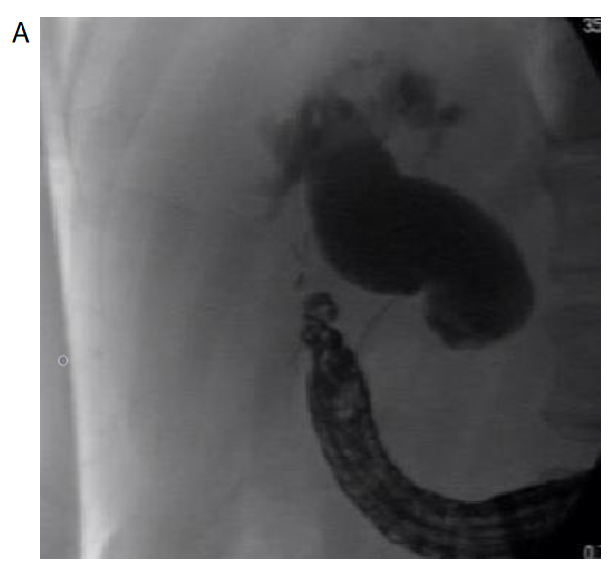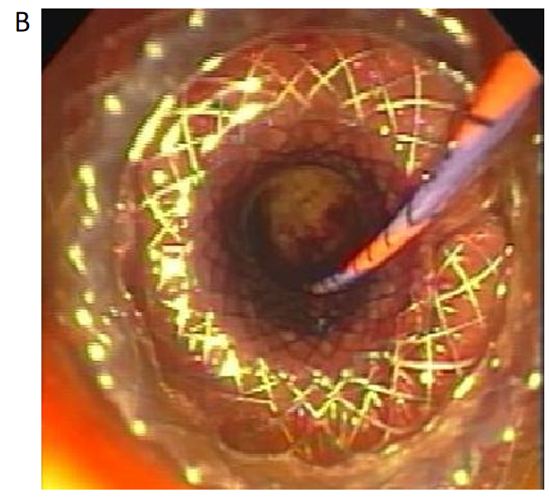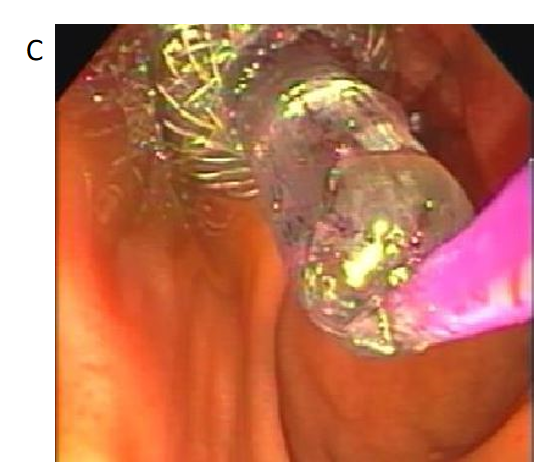
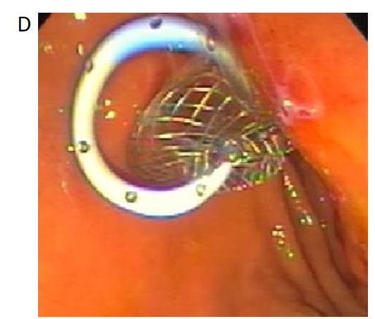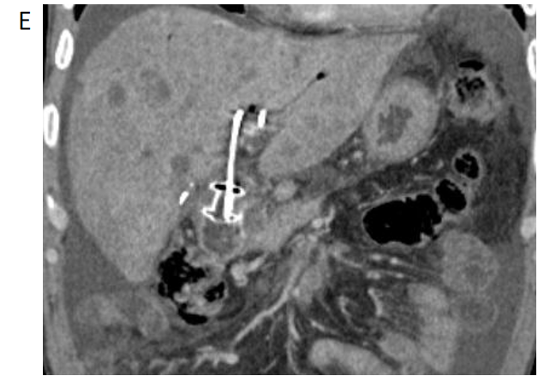
Figure 1 Endoscopic ultrasound-guided choledochoduodenostomy for distal malignant biliary obstruction using an electrocautery-enhanced lumen apposing metal stent A: Fluoroscopic image showing a dilated bile duct with distal biliary stricture secondary to pancreas head mass; B: Endoscopic image following lumen-apposing self-expanding metal stent (LAMS) deployment in the common bile duct; C: Balloon dilation of LAMS using a wire-guided balloon; D: Endoscopic image with double pigtail stent through the LAMS in the duodenal bulb; E: Computed tomography coronal image showing choledochoduodenostomy with a double pigtail stent through the LAMS. The proximal end of the double pigtail plastic stent is in the left intrahepatic duct.
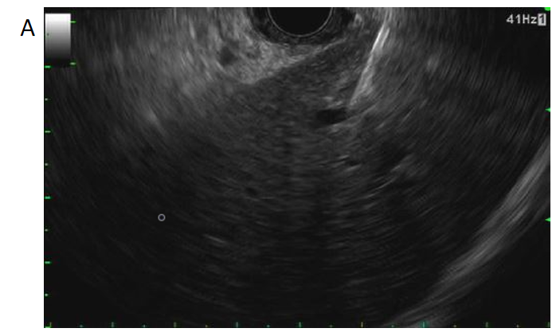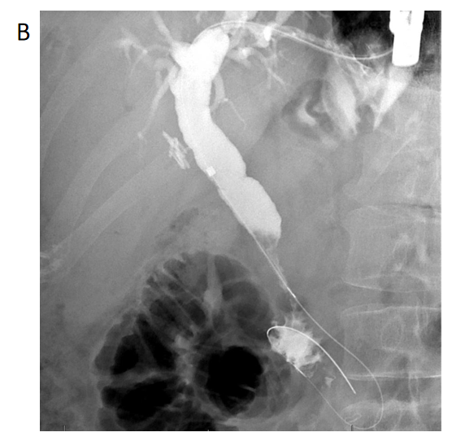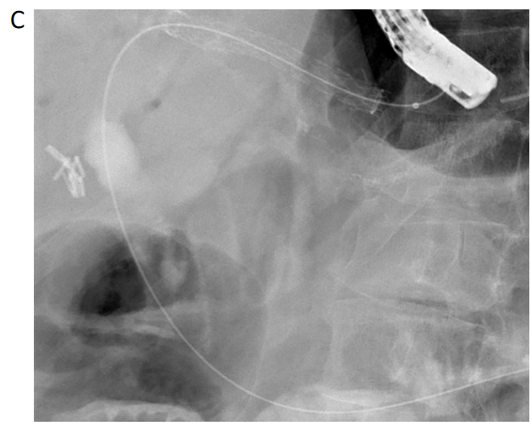
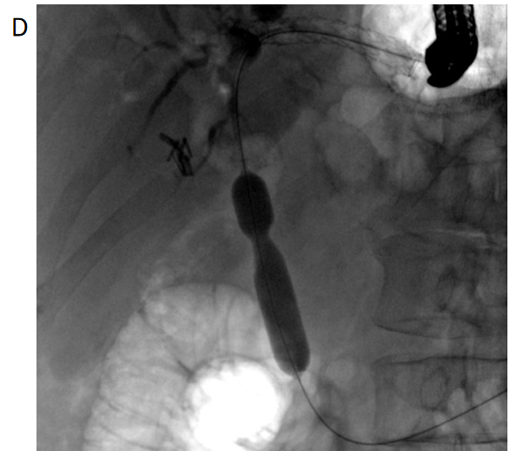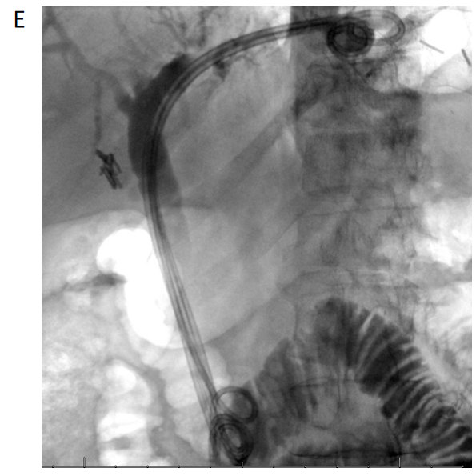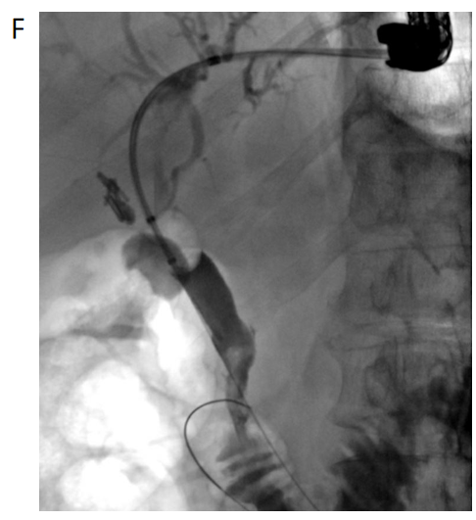
Figure 2 Endoscopic ultrasound-guided hepaticogastrostomy for benign distal biliary stricture in a patient with history of roux-en-Y gastric bypass surgery. A: Endoscopic ultrasound-guided puncture of a dilated B3 radical with a 19-gauge needle; B: Fluoroscopic image showing a dilated bile duct with distal biliary stricture; C: Fluoroscopic image showing placement of a fully covered hepaticogastrostomy metal stent; D: Antegrade balloon dilation of the distal bile duct stricture using a wire-guided balloon; E: Successful placement of four 7 Fr × 18 cm double pigtail biliary stents with the distal end past the ampulla in the small bowel and the proximal end in the stomach; F: Occlusion cholangiogram following removal of plastic hepaticogastrostomy stents showing resolution of distal bile duct stricture with free flow of contrast into the small bowel.
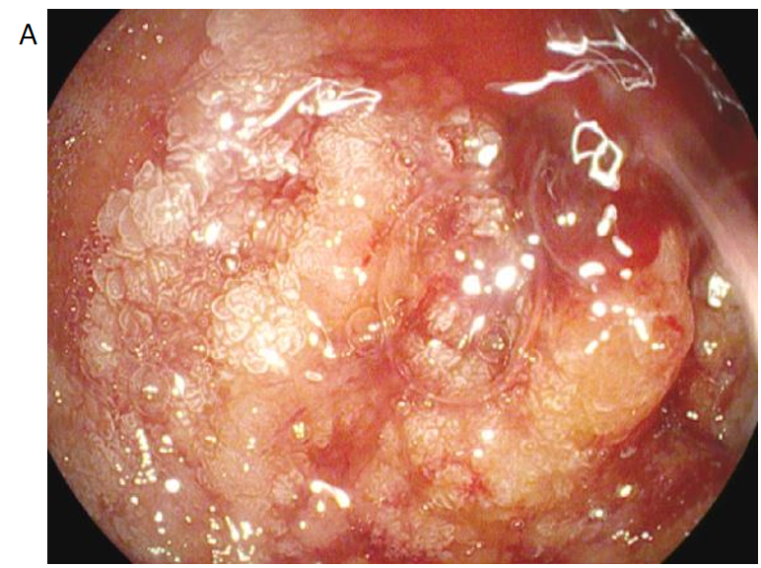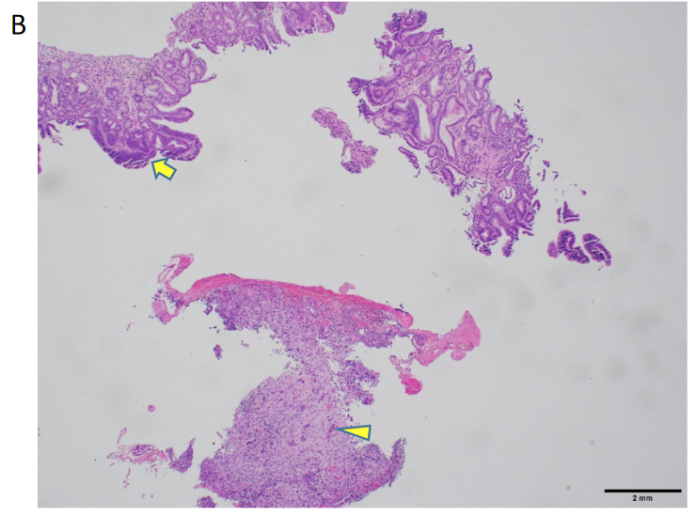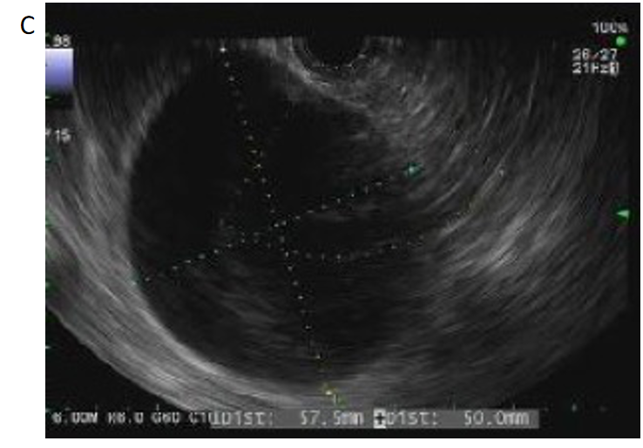
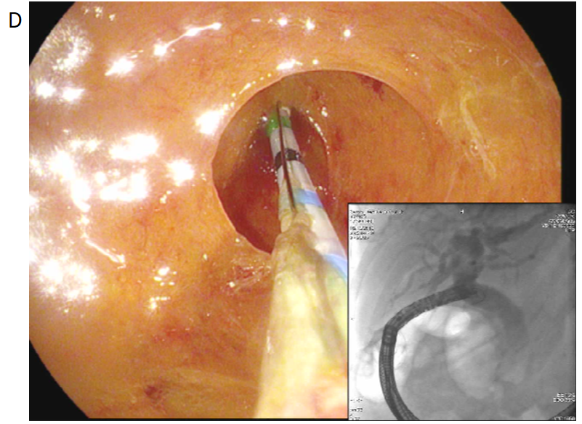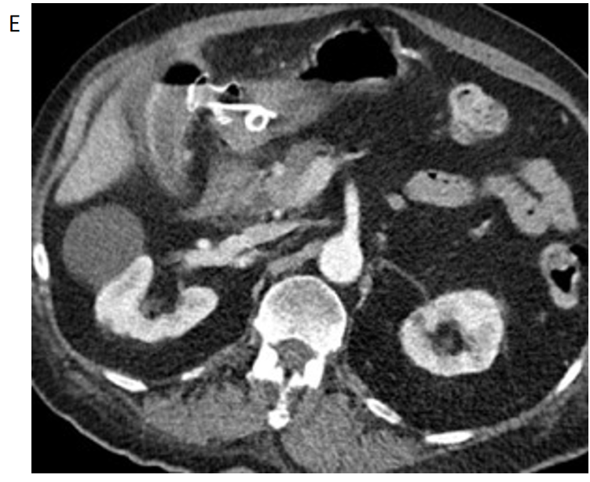
Figure 3 Endoscopic ultrasound-guided gallbladder drainage for distal malignant biliary obstruction secondary to duodenal adenocarcinoma using an electrocautery-enhanced lumen apposing metal stent A: Duodenal adenocarcinoma involving the duodenal sweep causing luminal narrowing; B: Adenocarcinoma (arrow heads) arising in a background of adenoma (arrow) with focal high-grade dysplasia (H&E stain); C: Endoscopic ultrasound image displaying distended gallbladder; D: Cholecystoscopy [post lumen-apposing self-expanding metal stent (LAMS) placement] with contrast injection via cystic duct opening opacifying the biliary tree showing a patent cystic duct; E: Post-procedural computed tomography scan displaying double pigtail stent and LAMS in place between gastric antrum and gallbladder.
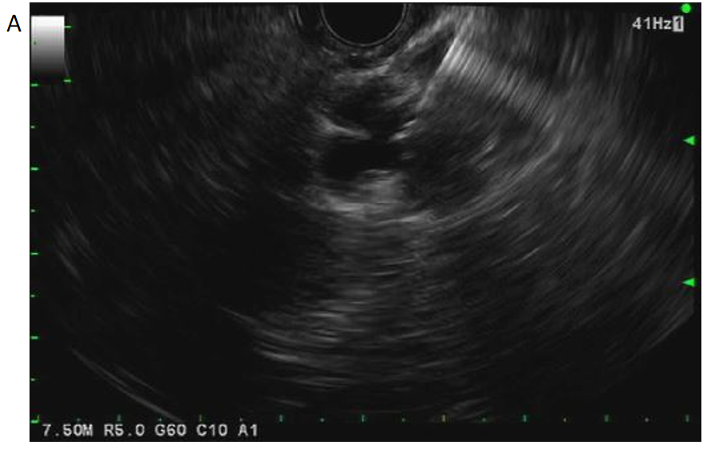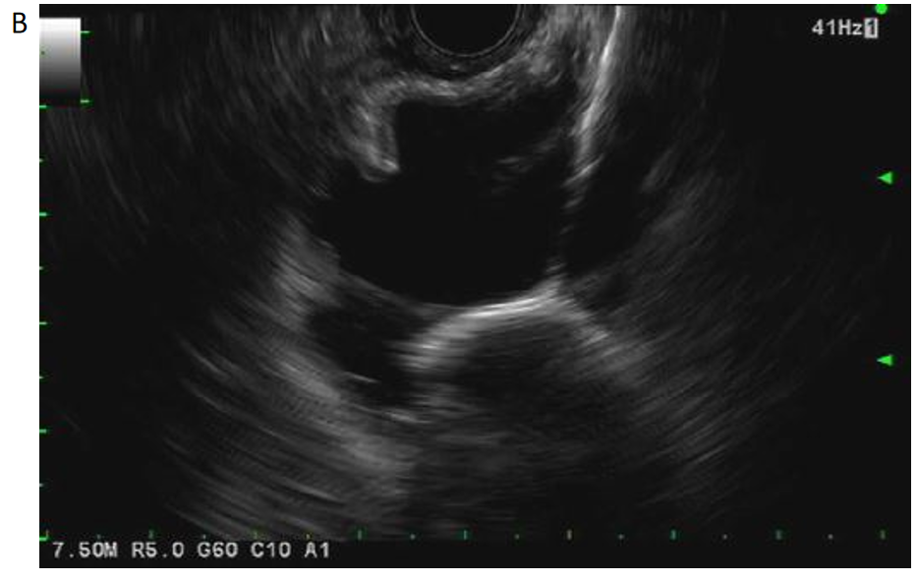
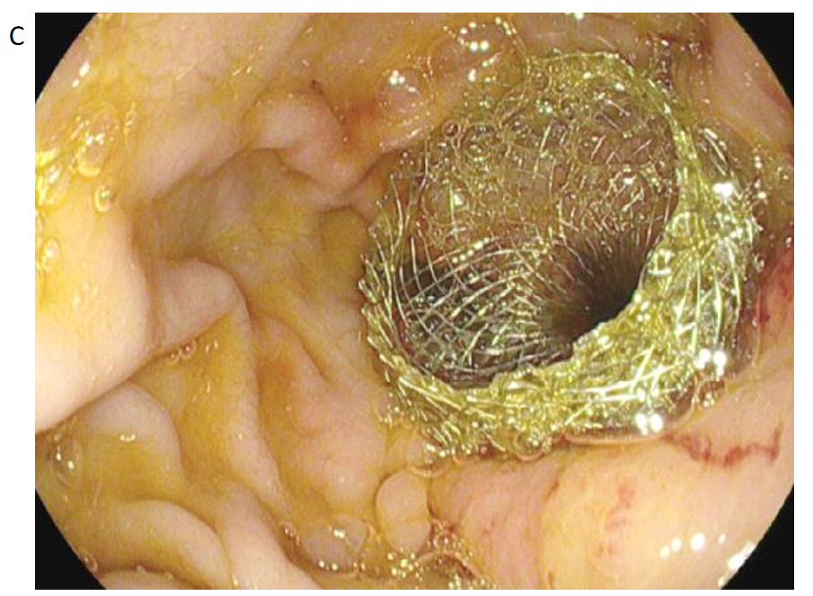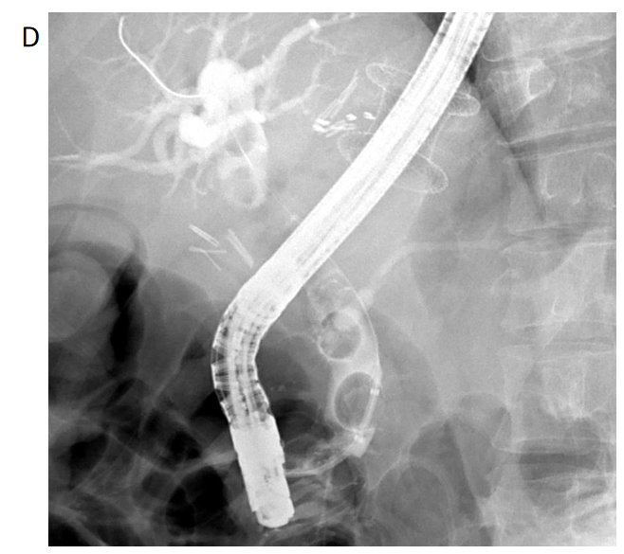
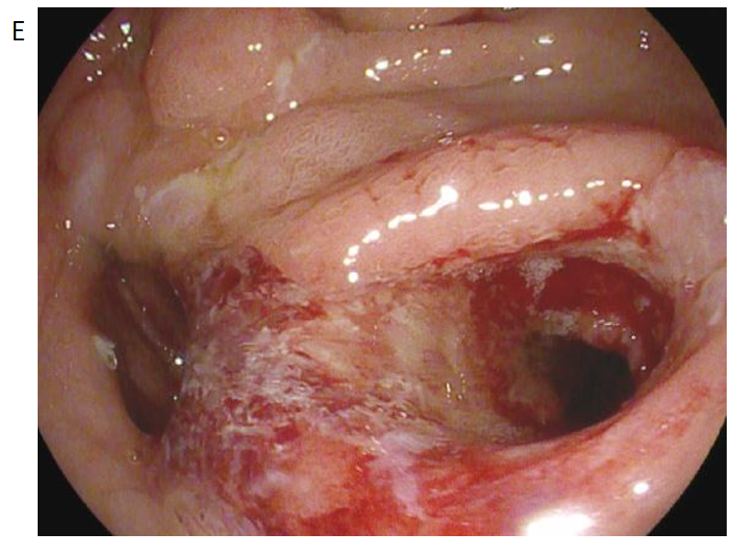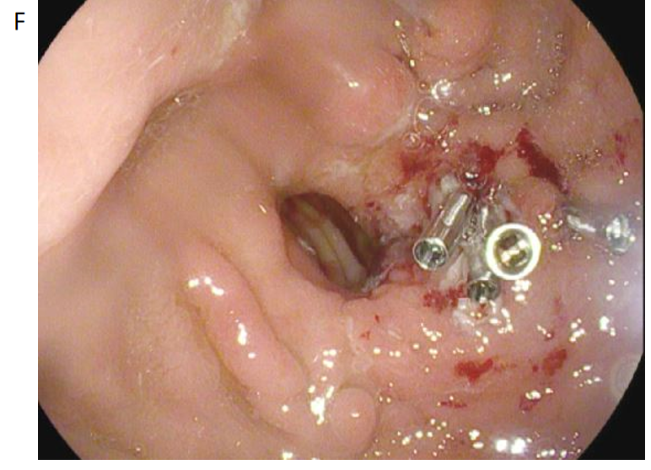
Figure 4 Endoscopic ultrasound-directed transgastric endoscopic retrograde cholangiography for choledocholithiasis in a patient with history of roux-en-Y gastric bypass surgery A: Endoscopic ultrasound-guided puncture of excluded stomach using a 19-gauge needle; B: Endoscopic ultrasound showing deployment of proximal flange of lumen-apposing self-expanding metal stent (LAMS) in the excluded stomach; C: Endoscopic image showing distal flange of LAMS in the gastric pouch; D: Fluoroscopic image of endoscopic retrograde cholangiopancreatography through LAMS showing multiple stones in the common bile duct; E: Gastrogastric fistula seen following LAMS removal; F: Successful closure of gastrogastric fistula using argon plasma coagulation and clips.
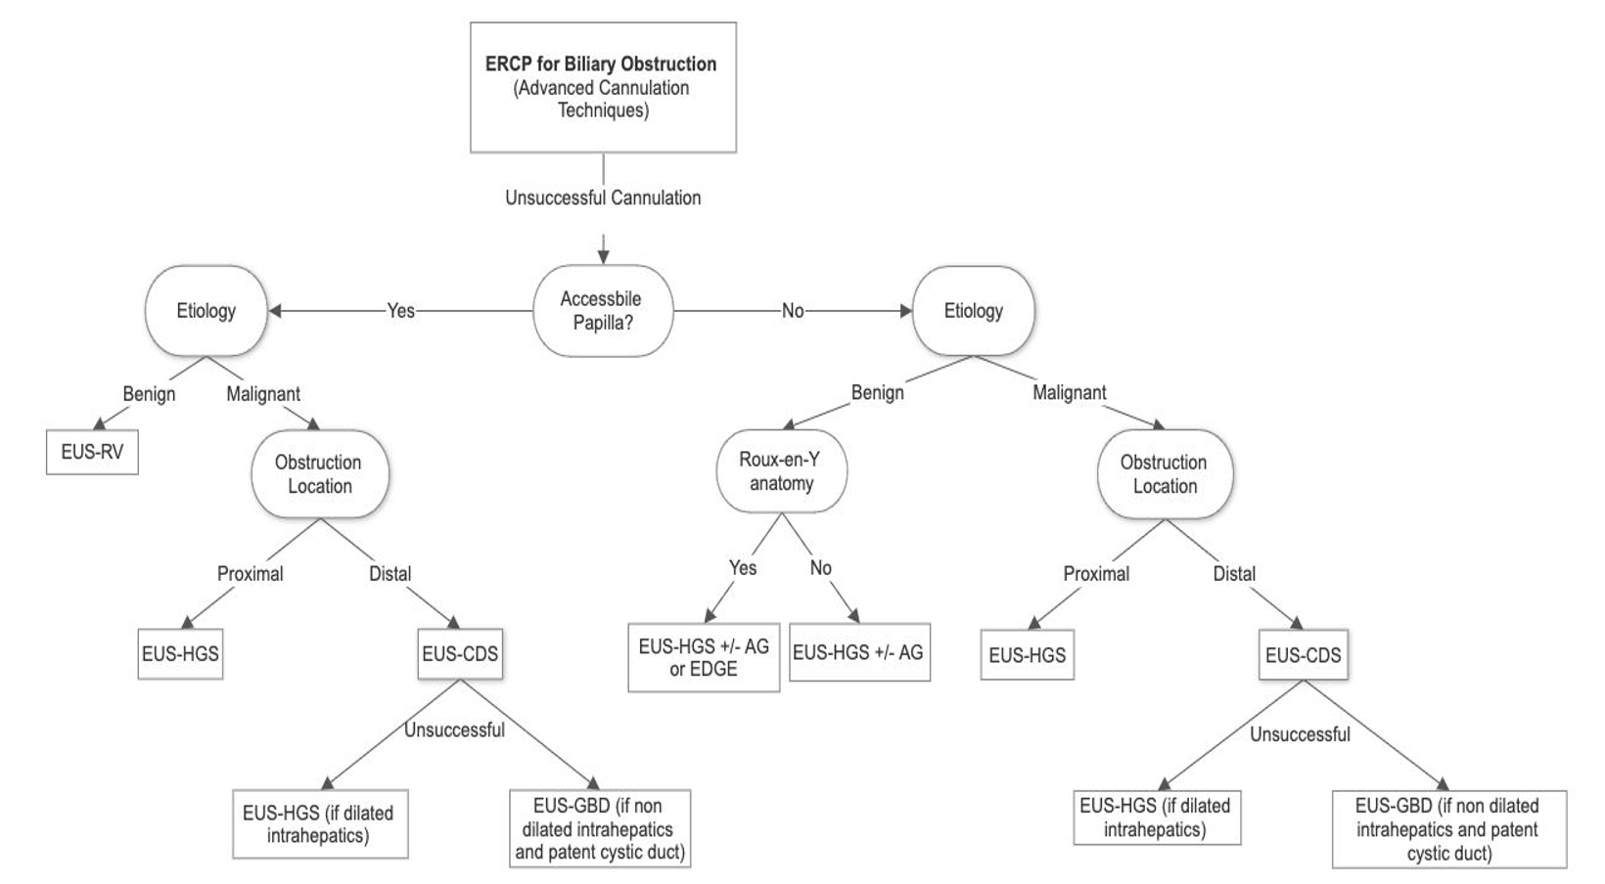
Figure 5 Proposed algorithm for endoscopic ultrasound-guided biliary drainage for biliary obstruction following failed endoscopic retrograde cholangiopancreatography. EUS: Endoscopic ultrasound; HGS: Hepaticogastrostomy; CDS: Choledochoduodenostomy; ERCP: Endoscopic retrograde cholangiopancreatography; EDGE: EUS-directed transgastric ERCP; GBD: Gallbladder drainage; RV: Rendezvous.
Table 1 Endoscopic ultrasound-guided biliary drainage procedures
 | EUS-BD procedures
1 | EUS-guided rendezvous
2 | EUS-guided choledochoduodenostomy
3 | EUS-guided hepaticogastrostomy
4 | EUS-guided gallbladder drainage
5 | EUS-directed transgastric ERCP
EUS: Endoscopic ultrasound; ERCP: Endoscopic retrograde cholangiopancreatography; BD: Biliary drainage.

