Name of Journal: World Journal of Gastrointestinal Endoscopy
Manuscript NO: 67333
Manuscript Type: MINIREVIEWS

Tips and tricks for the diagnosis and management of biliary stenosis-state of the art review

Del Vecchio Blanco G et al. Biliary stenosis diagnostic workup

Giovanna Del Vecchio Blanco, Michelangela Mossa, Edoardo Troncone, Renato Argirò, Andrea Anderloni, Alessandro Repici, Omero Alessandro Paoluzi, Giovanni Monteleone

Giovanna Del Vecchio Blanco, Michelangela Mossa, Edoardo Troncone, Giovanni Monteleone, Omero Alessandro Paoluzi, Department of Systems Medicine, Gastroenterology Unit, University of Rome Tor Vergata, Rome 00133, Italy

Renato Argirò, Department of Interventional Radiology, University of Rome Tor Vergata, Rome 00133, Italy

Andrea Anderloni, Alessandro Repici, Digestive Endoscopy Unit, Division of Gastroenterology, Humanitas Research Hospital & Humanitas University, Rozzano 20093, Italy

Author contributions: Del Vecchio Blanco G designed and wrote the manuscript; Mossa M and Argirò R contributed in the writing of the manuscript; Troncone E, Anderloni A, and Repici A contributed to critical revision of the manuscript; Paoluzi OA contributed in the writing and revision of the manuscript; Monteleone G contributed to direct supervision.

Corresponding author: Giovanna Del Vecchio Blanco, MD, Assistant Professor, Department of Systems Medicine, Gastroenterology Unit, University of Rome Tor Vergata, via Montpellier 1, Rome 00133, Italy. giovanna.del.vecchio.blanco@uniroma2.it

Received: April 30, 2021
Revised: June 24, 2021
Accepted: August 17, 2021
Published online:

Abstract
Biliary stenosis may represent a diagnostic and therapeutic challenge resulting in a delay in diagnosis and initiation of therapy due to the frequent difficulty in distinguishing a benign from a malignant stricture. In such cases, the diagnostic flowchart includes the sequential execution of imaging techniques, such as magnetic resonance, magnetic resonance cholangiopancreatography, and endoscopic ultrasound, while endoscopic retrograde cholangiopancreatography is performed to collect tissue for histopathological/cytological diagnosis or to treat the stenosis by insertion of stent. The execution of percutaneous transhepatic drainage with subsequent biopsy has been shown to increase the possibility of tissue diagnosis after failure of the above techniques. Although the diagnostic yield of histopathology and imaging has increased with improvements in endoscopic ultrasound and peroral cholangioscopy, differential diagnosis between malignant and benign stenosis may not be easy in some patients, and strictures are classified as indeterminate. In these cases, a multidisciplinary workup including biochemical marker assays and advanced technologies available may speed up a diagnosis of malignancy or avoid unnecessary surgery in the event of a benign stricture. Here, we review recent advancements in the diagnosis and management of biliary strictures and describe tips and tricks to increase diagnostic yields in clinical routine.

Key Words: Biliary stenosis; Cholangioscopy; Metal stent; Endoscopic ultrasound; Endoscopic ultrasound-guided fine needle aspiration; Biliary stenosis treatment

Del Vecchio Blanco G, Mossa M, Troncone E, Argirò R, Anderloni A, Repici A, Paoluzi OA, Monteleone G. Tips and tricks for the diagnosis and management of biliary stenosis-state of the art review. World J Gastrointest Endosc 2021; In press

Core Tip: Biliary stenosis remains a diagnostic and therapeutic challenge due to the difficulty in obtaining a tissue diagnosis to differentiate a malignant from a benign stricture. The diagnostic and therapeutic workup of patients with a suspected malignant biliary stricture should be discussed at a multidisciplinary team meeting in a tertiary center. The use of all available diagnostic tools such as magnetic resonance cholangiopancreatography, endoscopic retrograde cholangiopancreatography, endoscopic ultrasound-fine needle aspiration, and cholangioscopy should be evaluated to avoid unnecessary surgery or a delay in diagnosis. Here, we focus on the most recently published findings regarding the diagnosis and therapy of biliary stricture.

INTRODUCTION
A biliary stricture (BS) is a narrowing of the biliary tree caused by benign or malignant conditions. Differential diagnosis between the different forms of BS can be challenging, as the etiology may remain indeterminate even after carrying out complete laboratory, imaging, and tissue-based diagnostic investigations^{[1]}. Despite improvements in endoscopic techniques and a greater knowledge of the underlying causes of the condition acquired over the last decade, about 15%-20% of patients with indeterminate BS undergoing surgery are found to have a benign disease, with high postoperative mortality (10%) reported in many Western referral centers^{[1-4]}. Patients with indeterminate BS or a diagnosis of indeterminate dysplasia at histopathological evaluation require a multidisciplinary approach involving gastroenterologists, surgeons, radiologists, and oncologists for diagnosis and appropriate treatment.

Etiology
Most cases of BS are malignant BS (MBS) due to pancreatic adenocarcinoma, cholangiocarcinoma (CC), liver metastases, hepatocellular carcinoma, ampullary carcinoma, or gallbladder carcinoma. Rare causes of MBS are lymphoma and metastases to regional lymph node (RLN)s. Benign BS (BBS) accounts for up to 30% of all BS and may have a different etiology, although most are iatrogenic caused by biliary damage during surgery (e.g., post-laparoscopic cholecystectomy) or after liver transplantation (stenosis of biliary anastomosis). Chronic pancreatitis and autoimmune pancreatic/biliary disease can also induce BBS^{[4]} (Table 1).

Diagnostic workup
The choice of the most appropriate diagnostic and therapeutic pathway is based on the localization of the stricture in the biliary tract. The commonly used Bismuth-Corlette classification^{[5]} distinguishes five types of BS: type I – limited to the common hepatic duct, below the level of the confluence of the right and left hepatic ducts; type II – involving the confluence of the right and left hepatic ducts; type III – (1) Extending to the bifurcation of the right hepatic duct; or (2) Extending to the bifurcation of the left hepatic duct; type IV – extending to the bifurcations of both right and left hepatic ducts or with multifocal involvement; type V – a stricture at the junction of the common bile duct and cystic duct.

First step: Clinical presentation and biochemical parameters
Patients with BS are rarely asymptomatic; the most common clinical presentation is jaundice. Weight loss, fever, nausea, vomiting, pruritus, dark urine, discolored stool, and anorexia can also be present. Clinical history and symptoms are only in part useful for differential diagnosis as they may be similar in both benign and malignant forms of BS.
Biochemical parameters are not unequivocally indicative of the nature of BS, although increased levels of bilirubin, alkaline phosphatase, and alanine transaminase are considered strong predictors of malignancy^{[3,6]}. Normal bilirubin associated with increased transaminases may also be suggestive of malignant disease, while normal bilirubin levels and normal liver function tests are unlikely to be indicative of primary biliopancreatic neoplasia^{[7]}. Elevated levels of alkaline phosphatase, gamma glutamyl transpeptidase, carbohydrate antigen 19-9 (CA19-9), and carcinoembryonic antigen were associated with MBS in a multivariate analysis^{[8]}.
Among serum biomarkers, CA19-9 is the most common and validated tumor marker, showing high sensitivity and specificity for the diagnostic assessment of pancreatic cancer and seems to be useful in the early detection of this disease^{[9-11]}. Diagnostic accuracy of CA19-9 in the diagnosis of pancreatic neoplasia is increased when associated with the assessment of CA242, which displays a high sensitivity (89%, 95% confidence interval (CI): 80%-95%) without impairing specificity (75%, 95%CI: 67%-82%)^{[10]}. In CC, the sensitivity and specificity of CA19-9 are 72% and 84%, respectively^{[12]}. CA19-9 showed variable diagnostic power among European, Asian, and American populations, possibly related to different genetic factors, cut-off value range, and assay method in the different studies^{[12]}. However, it should be remembered that Lewis negative blood type patients (5%-10% of the Caucasian population), who cannot synthesize CA19-9, may have false-negative results^{[11]}. False-positive cases may be due to other medical conditions, both benign and malignant, responsible for increased CA19-9 levels, such as acute diabetes, cholangitis, pancreatitis, obstructive jaundice, liver cirrhosis, and hepatocellular, ovarian, bronchial, colon, and gastric cancers^{[11]}.
New biomarkers, including glypican-1, microRNA, macrophage inhibitory cytokine 1, and osteopontin, have been studied for their diagnostic, predictive, and prognostic potential, but none have as yet been sufficiently validated for use in routine clinical settings^{[1,11,13]}.

Tips: Liquid biopsy
As a non-invasive molecular diagnostic tool, liquid biopsy has been attracting increasing attention for its promising application in cancer patients. This technique is based on the analysis of circulating free DNA, circulating tumor cells, circulating cell-free RNA, and circulating tumor DNA (ctDNA) and is expected to have a major impact on cancer diagnosis and management. Although available data regarding circulating tumor DNA analysis in biliary tract tumors are limited, the evaluation of circulating tumor DNA may prove to have considerable application in diagnosis, monitoring of response to chemotherapy, and possible target therapy^{[14]}. Liquid biopsy of bile is emerging as a promising option for the molecular diagnosis of MBS, as several bile biomarkers including proteins, metabolites, and microRNAs have been described. Selected reaction monitoring is a flexible high-throughput analytical approach based on targeted mass spectrometry used to quantify cancer biomarkers in human bile. The selected reaction monitoring assay was able to simultaneously quantify 31 peptides in human bile, indicating that the evaluation of cancer-related bile protein allows differentiation between MBS and BBS. The use of bile biomarkers in combination with serum CA19-9 was found to be highly accurate for the diagnosis of MBS and was proposed as an adjunctive technique in clinical practice^{[15]}.

Second step: Imaging and histopathological assessment
Cross-sectional imaging: Transabdominal ultrasound is a highly sensitive (> 90%) first-level technique able to detect indirect signs of BS, such as dilation of the distal tract and the intrahepatic branches. Transabdominal ultrasound is very useful as a screening test in the case of suspected biliary obstruction but has very low sensitivity in detecting strictures or masses^{[3,4,16]}.
Other non-invasive imaging techniques available to define the extension of and differentiate between BBS and MBS are multidetector computed tomography (MDCT), magnetic resonance imaging (MRI), magnetic resonance cholangiopancreatography (MRCP), and positron emission tomography (PET). The diagnostic flowchart currently used in the differential diagnosis of BS includes MDCT and/or MRI plus MRCP, and occasionally PET as the standard imaging methods for preoperative assessment of suspected MBS. The choice of specific imaging techniques for evaluating and staging MBS depends on tumor localization (distal or intrahepatic biliary tract) and origin (primitive biliary or pancreatic). Since there is no single ideal imaging modality, a multimodality approach is frequently adopted in potential candidates for surgery^{[17-19]} (Figure 1).
MDCT is a routine imaging investigation for the preoperative assessment of intrahepatic and extrahepatic stenosis. MDCT provides a comprehensive evaluation of the primary tumor and adjacent structures, such as hepatic artery or portal and superior mesenteric vein as well as of the whole abdomen, to exclude potential metastasis. Diagnostic accuracy in characterizing stricture extent is low, ranging from 75% to 90%. Recently, intraprocedural cone-beam computed tomography (CT) has proven to be effective in the three-dimensional characterization of BS. The pre-contrast phase is useful for detecting possible intraductal stones as cause of obstruction and in differentiating stones from tumors^{[16,18]}. The arterial and venous post-contrast phase is able to identify the inflammatory/benign process of the suspected lesion and allows for an evaluation of the location and aspect of enhancement. In addition, delayed phases (usually 3-5 min after contrast medium injection) are helpful for the differential diagnosis of intrahepatic CC, which shows delayed phase enhancement due to its abundant fibrous stroma^{[18]}. In a recent meta-analysis, MDCT demonstrated a pooled sensitivity of 89% and specificity of 92% for the detection of portal vein and hepatic artery involvement in perihilar CC^{[19]}. The diagnostic accuracy of MDCT is 75%-92% for the longitudinal tumor extent of perihilar CC and 60%-88% for resectability due to underestimation of the proximal extent of the tumor. CT cholangiography imaging obtained with multiplanar reconstruction and minimum intensity projections was recently proposed as an alternative to MRCP for BS assessment, especially in patients with contraindication to MRI^{[20]}.
Due to the lack of associated ionizing radiation and the possibility of obtaining high-quality imaging of the biliary tract, MRI and MRCP are the techniques of choice in the diagnosis of BS, with high sensitivity in detecting the precise site and length of the stenosis but low sensitivity in differentiating malignant from benign strictures. The use of hepatocyte-specific MRI agents and diffusion-weighted imaging proved useful in tumor characterization^{[19]}. MRI with MRCP is the method of choice in the case of suspected perihilar CC. MRCP has a high sensitivity in detecting BS (up to 98%), with a reported sensitivity and specificity in differentiating between malignant and benign forms ranging from 38% to 90% and from 70% to 85%, respectively. In addition, MRCP has high accuracy (88%-96%) in predicting the extent of bile duct involvement in MBS^{[4,16-19]}. MRI can include two-dimensional and three-dimensional MRCP. Two-dimensional MRCP is performed in a single section of 4-8 cm thickness during breath holds and is less affected by motion artifacts, as it allows rapid acquisition. However, it may not reveal intraductal lesions due to the partial volume averaging artifact. In contrast, three- dimensional MRCP provides an excellent overall visualization of the biliary tree and an enhanced delineation of fine anatomical structures and small pathological features. Acquisition time is long, however, making it more susceptible to motion artifacts^{[19]}.
PET/CT is useful in the case of suspected distant metastasis or nodal metastases. In patients with resectable MBS, PET may help in the selection of candidates for surgery^{[19-21]}. Dual-time-point fluorine-18 fludeoxyglucose integrated with PET/CT scan (18F- FDG PET/CT) was found to be effective in differentiating between BBS and MBS^{[20]}, although inflammation of the biliary tract or the presence of mucinous CC may cause false-positive and false-negative results^{[19]}. The diagnostic power of 18F-FDG PET/CT for the diagnosis of primary tumor, lymph node invasion, and distant metastases was evaluated in a systematic review and meta-analysis of 2125 patients^{[22]}. The study confirmed 18F-FDG PET/CT as a useful diagnostic tool in selected cases, as it provides valuable information in patients with indeterminate BS. 18F-FDG PET/CT changed the treatment plan in almost 20% of previously defined resectable MBS, avoiding unnecessary non-curative resection^{[22]}. However, the routine use of 18F-FDG PET/CT as an imaging tool in tumor diagnosis remains controversial due to its low specificity (51%).

Tips: PET/MRI
Whole-body 18F-FDG-PET/MRI seems to hold great promise because of its ability to diagnose and stage potentially resectable MBS, providing in a single examination both MRI and PET information^{[19]}.

Tricks: Differential diagnosis using contrast-enhanced CT or MRI
The length of the involved biliary tract and contrast-enhanced morphological features are useful to differentiate BBS from MBS. Segmental involvement > 12 mm and thickening > 1.5 mm associated with luminal irregularity, asymmetry, and incremental enhancement may indicate the presence of MBS^{[18]}.

Endoscopic/radiological imaging
Endoscopic retrograde cholangiopancreatography (ERCP) is the standard technique used to evaluate BS, as it combines the radiological imaging of cholangiography and the possibility of obtaining a histopathological diagnosis by multimodal sampling (guided brushing, biopsy, or bile aspiration). ERCP generates high-resolution fluoroscopic images that provide information regarding stricture site, length, and presence of irregularity of the biliary wall. Although fluoroscopic imaging has an accuracy of 80% in distinguishing a benign from a malignant stricture, tissue sampling by biliary brushing or endoluminal biopsy is required to histologically confirm the differential diagnosis.
Brush cytology is a simple tool with minimal adverse events but with very low sensitivity. Endoluminal forceps biopsy (Figure 2) requires sphincterotomy, which may be challenging to perform especially in the case of strictures above the bifurcation of the common bile duct. Standard ERCP with brushing has a 26%-73% sensitivity in the detection of malignancy^{[23]}. The overall diagnostic yield of histopathological diagnosis ranges from 6% to 70%^{[24,25]}. In a systematic review and meta-analysis, the pooled sensitivity reported for brush cytology and forceps biopsy was 45.0% and 48.1%, respectively; combining the two methods increased sensitivity up to 59.4%^{[23]}. To improve the diagnostic accuracy of histological/cytological sampling during ERCP, Lee et al^{[24]} evaluated aspiration cytology plus brush cytology or brush cytology plus biopsy or aspiration cytology plus biopsy. In terms of cancer type (CC vs non-CC), diagnostic sensitivity was higher for CC in the brush cytology plus biopsy or aspiration cytology plus biopsy group than in the aspiration cytology plus brush cytology group (100% vs 69.4%, respectively; P < 0.001) but not for non-CC (57.1% vs 57.1%, respectively)^{[24]}.
False-negative samples may be attributable to histopathological interpretation, tumor characteristics, and procedural factors. The combination of transpapillary tissue sampling followed by brushing and bile aspiration by nasobiliary drainage seems to increase sensitivity up to 72% in the diagnosis of MBS^{[26]}.
Pneumatic dilatation of the stenotic tract before tissue sampling with large biopsy forceps was found in a retrospective study to improve sensitivity from 40% to 71% and diagnostic accuracy from 55% to 87% compared to biopsy sampling without dilatation, with no difference in complication rate between the two procedures^{[27]}. Fluorescence in situ hybridization (FISH) is used to analyze brush cytology specimens for chromosomal abnormalities in malignant cells. Although FISH is able to detect chromosomal changes in 80% of malignant biliary neoplasia, the combination of cytology and FISH revealed a sensitivity for malignancy of only 50%-60% in BS. A triple modality approach combining brush cytology, forceps biopsy, and FISH resulted in a marked increase in sensitivity for the diagnosis of CC compared with single modality testing and should be considered in the evaluation of indeterminate BS^{[26]}.

Tricks
Tube-assisted biopsy: Following biliary cannulation, a 10 Fr Soehendra biliary dilatation catheter is advanced over a guidewire in the stenosis in the left biliary tree. The tube is then placed as close as possible to the stricture area and the guidewire removed. Conventional endobiliary biopsy forceps are inserted through the tube into the area of the stricture for tissue collection^{[28]}.

Endoscopic transpapillary biopsy using the “tunnel” technique: This technique consists of the use of an 11.5 Fr biliary dilatation catheter as a tunnel for biopsy forceps after cutting the tapered tip. Following biliary cannulation, the catheter is advanced over a 0.035-inch guidewire and a 6 Fr catheter in the left biliary duct, where the previously identified stenosis is located. Next, the guidewire and 6 Fr catheter are removed, and 7 Fr biopsy forceps inserted in the 11.5 Fr catheter to collect tissue^{[29]}.

Endoscopic transpapillary biopsy using the “zipline” technique: A looped nylon thread is added to one cup of a pair of forceps with 2 mm-wide cups; the loop is then inserted over a guidewire and the forceps are advanced into the right bile duct^{[30]}.

Tips: How to improve ERCP histological results
Perform at least 10 brush passes under continuous fluoroscopy after meticulously preparing everything required for fixing the tissue sample in order to avoid contamination or air-drying artifacts. Combine different sampling methods and, if confident, perform brush and biopsy before and after stricture dilatation. Take at least four biopsy samples and work closely with the pathologist^{[31]}.

Cholangioscopy
Direct visualization of the biliary tract by SpyGlass peroral cholangioscopy (POCS) system (Boston Scientific, Marlborough, Massachusetts) introduced in 2007^{[32]} enhances
the diagnostic power of ERCP in patients with indeterminate BS by providing intraductal imaging of the stenotic duct or of the lesion suggestive of malignancy. Over the past two decades, three types of cholangioscopy platforms have become available. The most recently introduced is a digital single-operator cholangioscopy (D-SOC) ultra-slim endoscope inserted into the bile duct through the working channel of a duodenoscope and advanced into the papilla, providing excellent image quality achieved by image- enhanced endoscopy. Several studies demonstrated its high performance in the diagnosis of BS, with a > 70% sensitivity but < 50% specificity^{[33-35]}. In a recent systematic review of published studies evaluating the diagnostic performance of any type of POCS, the sensitivity, specificity, and diagnostic accuracy of POCS for diagnosing MBS ranged from 38%-100%, 49%-100%, and 50%-100%, respectively, with a technical success rate of 82%-100%^{[34]}.
Although D-SOC allows viewing of the biliary tract from the inside, its use is limited by the high cost of the equipment and the lack of standardization in the interpretation of visual features of the biliary ducts. Endoscopic features defined as suggestive of MBS at cholangioscopy are nodular or papillary masses with irregular surface, fragile mucosa, and dilated and tortuous vessels (Figure 3). Kim et al^{[35]} reported an association between the detection of tortuous vessels and malignancy with a sensitivity of 61% and specificity of 100%^{[35]}. A recent meta-analysis on D-SOC in the visual interpretation of indeterminate BS reported a 94% sensitivity and 95% specificity, a diagnostic accuracy of 94%, a positive predictive value of 93%, and a negative predictive value of 98% in the diagnosis of MBS^{[36]}.
In a prospective study on 289 patients with indeterminate BS enrolled in 20 centers in Asia, the Middle East, and Africa, the use of two POCS systems (SpyGlass Legacy and SpyGlass DS digital system) was able to detect stricture/filling or bile duct defect in 98.6% of patients, providing a visual diagnostic impression in 87.2% and adequate biopsies in 92.9% of cases, with low rate of complication (1.7%)^{[37]}. A limitation of this study was that it did not investigate patients with primary biliary disease. In two other recent studies from the United States and the Netherlands, which included patients with primary sclerosing cholangitis in their populations, POCS did not increase diagnostic sensitivity for CC over that of ERCP with brush cytology^{[38,39]}. The lack of a standardized classification of image findings detected during cholangioscopy still causes problems of interpretation and may be responsible for unsatisfactory diagnostic accuracy^{[38,39]}.
To overcome this limit, Robles-Medranda et al^{[40]} proposed in 2018 a classification system based on neoplastic and non-neoplastic findings including villous, polypoid, inflammatory, ulcerated, flat, or honeycomb patterns, which revealed an outstanding 96% sensitivity, 92% specificity, 96% negative predictive value, and an interobserver agreement up to 90%^{[40]}. Similar results were found by Gerges et al^{[41]}, who reported a sensitivity of visualization of 95.5%^{[41]}. In 2020, the Monaco classification was proposed for indeterminate BS based on eight visual criteria: presence of stricture, lesion (mass, nodule, or polypoid appearance), mucosal features, papillary projections, ulceration, abnormal vessels, scarring, and pronounced pit pattern. Final diagnostic accuracy based only on visual impression was 70%, with a high interobserver agreement for presumptive diagnosis (k = 0.31)^{[42]}.
The diagnostic accuracy of D-SOC is further improved by D-SOC-guided biopsy, which allows precise tissue sampling of the detected lesions. In a meta-analysis by Wen et al^{[43]}, SpyBite (Boston Scientific) biopsy showed a pooled sensitivity, specificity, positive likelihood ratio, negative likelihood ratio, and diagnostic odds ratio of 0.74 (95%CI: 0.67-0.80), 0.98 (95%CI: 0.95-1.00), 10.52 (95%CI: 5.45-20.32), 0.31 (95%CI: 0.23-0.41), and 65.18 (95%CI: 26.79-158.61), with a lower complication rate mainly ERCP-related. Acute cholangitis was the most common complication with a rate of 1.8%^{[43]}.
A point of great debate is the number of biopsies needed to obtain adequate tissue for a diagnostic histopathological assessment. Based on currently available studies, the number of biopsies is not defined with any certainty, but more than two biopsies are required to reach a sensitivity > 70%^{[23,43]}. In a randomized multicenter investigation, an average of six biopsy specimens were taken during POCS, achieving a sensitivity of 68.2%, which increased up to 95.5% if visual impression at cholangioscopy was added to biopsy forceps performance^{[41]}.
The possible increase in diagnostic power using rapid on-site evaluation of D-SOC microbiopsy was recently assessed in a single-center prospective randomized trial among patients with indeterminate BS^{[44]}. The authors concluded that there were no significant differences between the off-site and on-site groups in terms of diagnostic accuracy (90% vs 87.5%), sensitivity (76.9% vs 75%), and specificity (100% vs 100%). However, a greater number of biopsies was necessary to obtain a diagnosis in the off-site cohort (n = 3-4) than in the on-site cohort (n = 1)^{[44]}.
A precise evaluation of the extension of the neoplasia along the biliary wall in surgical candidate patients is of key importance in ensuring curative resection. D-SOC visualization of the biliary ducts allows the evaluation of intraductal cancer extension, not evident with diagnostic methods previously used and may guide the choice of surgical treatment, avoiding unnecessary surgery in the case of locally advanced neoplasia. In a retrospective study investigating the use of D-SOC for preoperative evaluation of extrahepatic biliary tumor, the visual impression accuracy of SpyGlass and SpyBite was 95.0% and 80.5%, respectively. D-SOC modified a previous classification of perihilar CC in 42% of patients and changed surgical management in 21% of cases^{[45]}. Despite its high diagnostic accuracy, cholangioscopy is an expensive and difficult-to- handle technique that requires extensive experience in the performance of ERCP and adequate training in the interpretation of digital images and technique of execution. Several complications may occur during cholangioscopy, and the rate of serious adverse events ranges from 1% to 7%, with estimated rates of pancreatitis, cholangitis, and perforation of 2%, 4%, and 1%, respectively^{[46]}. Cholangitis was reported in 8% of patients undergoing D-SOC; the administration of antibiotics during or immediately after the procedure seems to reduce the risk of this complication^{[47]}.
A cost-benefit analysis of D-SOC compared to conventional ERCP in the diagnosis of BS, based on data from two of the largest Belgian hospitals performing cholangioscopy, revealed that the adoption of D-SOC led to a 31% reduction in the number of procedures needed to obtain a diagnosis and saved about 5% of the allocated budget^{[48]}.

Endoscopic ultrasound
Endoscopic ultrasound (EUS) is a diagnostic tool based on double endoscopic and ultrasonographic vision thanks to a high-frequency transducer placed on the tip of the endoscope. Due to the ease in identifying the biliary tract from the stomach and the duodenum, EUS may be considered a first-level procedure in identifying the cause of obstructive jaundice or in the diagnostic assessment of distal BS or unresectable intrahepatic CC (Figure 4).
The biliary examination usually starts from the stomach by identifying the biliary duct from the liver hilum and continues from the duodenal bulb to the second portion of the duodenum, studying the entire extrahepatic duct until the intrapancreatic portion. An endoscopic and ultrasonographic assessment of the ampulla and the gallbladder may also be performed to complete the investigation.
EUS has a diagnostic accuracy > 95% in identifying biliary thickening suggestive of malignancy compared to MRCP^{[48]} (Figure 5). Given its high diagnostic accuracy in excluding a pathological thickening of the biliary wall, if performed at the beginning of the diagnostic process, EUS can avoid having to carry out an invasive procedure such as ERCP and any related complications^{[49]}.
The possibility of obtaining tissue from a clear mass by guided-EUS fine needle aspiration (EUS-FNA) increases the diagnostic power of EUS (Figures 6 and 7). EUS-FNA has a pooled sensitivity and specificity of 80% and 97%, respectively, in the diagnosis of malignancy in the biliary tract^{[50]}. The advantage of performing EUS-FNA and ERCP in a single session should not be understated, as it reduces the duration of diagnostic workup in patients with BS and allows the selection of patients requiring therapeutic ERCP, thus avoiding an invasive procedure in absence of clear pathological thickening of the biliary tract (Figure 8). Zaheer et al^{[51]} reported that EUS changed the diagnosis in 36% of patients from malignant to benign^{[51]}.
The combination of EUS-FNA and ERCP-based tissue sampling in the same session has a diagnostic yield of up to 85%, whereas the overall accuracy of EUS-FNA tissue sampling is significantly higher than that of ERCP in the differential diagnosis of MBS (76% vs 58%)^{[52]}. An additional advantage offered by EUS-FNA is the possibility of obtaining histological samples from an extraductal lesion not reachable by ERCP. In a retrospective multicenter study on 263 patients with suspected MBS, EUS, and ERCP were carried out in the same session and the diagnostic power of samples collected from BS by EUS-FNA and intraductal biopsy, cytology via nasobiliary drainage, or brushing by ERCP was compared^{[53]}. This study found an overall sensitivity and diagnostic accuracy of 73.6% and 76.1% for EUS-FNA, 56.5% and 60.5% for ERCP-based tissue sampling, and 85.8% and 87.1% for the combination of both tissue-sampling methods^{[53]}.
As the therapeutic options for CC are surgical resection or liver transplantation, a precise definition of the tumor extension is crucial in guiding the treatment choice. RLN metastasis and margin status are the most important predictors of post-surgical outcome^{[54]}. In this context, EUS-FNA proved to be the preferred technique in the identification and sampling of lymph nodes. In a retrospective study of consecutive patients with CC undergoing EUS staging with EUS-FNA of RLN, EUS identified positive RLN in 86% of patients and detected a higher percentage of positive RLN than cross-sectional imaging (83% vs 50%); EUS-FNA revealed metastatic RLN in 17% of patients^{[55]}. According to the authors, preoperative staging with EUS and EUS-FNA of RLN should be considered in patients with any type of CC^{[56]}.

Tips
The choice of endoscopic technique to obtain a tissue-based differential diagnosis of BS should be tailored according to the stricture location. In patients where ERCP transpapillary forceps biopsy resulted non-diagnostic, POCS-guided forceps biopsy should be preferred in proximal BS, whereas EUS-FNA biopsy may be more appropriate for distal BS^{[55]}.

Intraductal ultrasound
Intraductal ultrasound (IDUS) involves a 2-mm high-frequency radial probe (12-20 MHz) introduced through the working channel of a duodenoscope. On IDUS visualization, the normal wall of the bile duct appears as three layers: an inner hyperechoic layer corresponding to mucosa, a middle hypoechoic layer corresponding to smooth muscle fibers, and an outer hyperechoic layer corresponding to connective tissue^{[57]}. IDUS could be particularly effective in the assessment of CC, especially where no mass is detected, and may be used to distinguish BBS from MBS. Sonographic features associated with MBS are hypoechoic or heterogeneous echo-poor infiltrating tissue with irregular borders breaking the normal sonographic pattern of the bile duct wall, eccentric and irregular wall thickening, sessile mass, invasion of surrounding tissues, and presence of enlarged lymph nodes^{[58]}.
In a retrospective study by Chen et al^{[59]}, IDUS showed a sensitivity, specificity, positive predictive value, negative predictive value, and accuracy rate of 96.9%, 79.0%, 82.0%, 96.2%, and 88.0%, respectively, in distinguishing MBS from BBS. Combining IDUS and ERCP-guided tissue sampling improved the accuracy rate from 88.0% to 96.8% and specificity from 79.0% to 96.8%. A length > 20 mm and a wall thickness > 7 mm has a positive predictive value > 90% for malignancy^{[59]}. A recent prospective study confirmed an > 80% accuracy of IDUS in detecting malignancy in patients with negative ERCP cytology and histology and corroborated its usefulness in targeting biopsy sampling with improvement in diagnostic accuracy^{[60]}. However, this technique is not routinely performed, and its use is progressively decreasing in favor of D-SOC.

Third step: Endoscopic treatment of biliary stenosis
Endoscopic treatment of BS, both benign and malignant, is well documented and widely accepted. The European Society of Gastrointestinal Endoscopy guidelines defined the correct choice of stent according to the location and etiology of the stenosis^{[61]}. In BS related to liver transplantation, chronic pancreatitis, or post-cholecystectomy strictures, the treatment of choice is temporary insertion of multiple plastic stents or a fully covered self-expandible metal stent (FC-SEMS) depending on the etiology and location of the stricture, diameter of the common bile duct, and operator expertise. With FC-SEMS insertion, the possibility of stent migration (9% of cases reported) with consequential failure of stricture resolution should be kept in mind^{[62]}. A recent review by Larghi et al^{[63]} described different strategies used to treat anastomotic BS after liver transplantation, comparing the advantages and disadvantages of plastic multi-stenting treatment vs placement of a metal stent reported in the literature, including four randomized controlled trials (Figure 9). The authors concluded that insufficient data are currently available to define which type of treatment is better than another, suggesting the need for a multicenter international randomized trial to draw definitive conclusions. Even less conclusive results are available for the treatment of refractory strictures, especially for hilar anastomotic strictures after liver transplants and hepaticojejunostomies. A recent single-center study aimed at evaluating the use of FC-SEMS for hilar BBS recently reported that temporary placement of an FC-SEMS is feasible and effective for refractory BBS, with a technical success rate of 100%, stricture resolution rate of 96.6%, and complication rate of 12.0%^{[64]}.
For MBS, the European Society of Gastrointestinal Endoscopy recommendations advise against routine preoperative biliary drainage in patients with surgical indication in absence of cholangitis, severe symptomatic jaundice, delayed surgery, or in the case of neoadjuvant therapy. A 10 mm-diameter SEMS is recommended for extrahepatic MBS before surgery. Palliative biliary drainage should be performed by ERCP with FC-SEMS or partially covered SEMS insertion. Surgical biliodigestive anastomosis and percutaneous biliary drainage should be indicated in selected cases where ERCP cannot be performed due to its high rate of complications and impact on the patient’s quality of life^{[65,66]}.
Described for the first time in 2001, endoscopic ultrasound biliary drainage (EUS-BD) is an emerging technique useful in patients in whom ERCP biliary drainage failed or is not technically feasible due to duodenal stenosis or unreachable papilla^{[67,68]}. A meta-analysis comparing EUS-BD vs percutaneous transhepatic biliary drainage in 312 patients demonstrated that clinical success was similar for both techniques, but complications were less frequent with EUS-BD^{[69]}. Despite the apparently high cost of the device, reintervention rates and costs were found to be lower with EUS-BD in a retrospective expertise-based study^{[70]}. In a systematic review and meta-analysis, Dhindsa et al^{[71]} evaluated the technical success, clinical outcome, and rate of adverse events of EUS-BD reported in 23 studies published in peer-reviewed journals. The pooled rate of clinical success was 87.0%, technical success 91.5%, reintervention 6.5%, and adverse events 17.9%. The most common adverse events were biliary leaks and infection or stent migration, although a precise evaluation of the incidence of complication was hampered by the variability of adverse event rates, the heterogeneity of EUS-BD, performed via hepatogastrostomy, cholecystostomy, or choledochoduodenostomy, and the different techniques of drainage, such as plastic stents, metal stents, lumen-apposing metal stents (LAMS), nasobiliary drainage tubes, or a combination of these, used in the different studies^{[71]}.
The use of devices designed for EUS-guided drainage, such as LAMS (Boston Scientific, Marlborough, Massachusetts, United States), was first reported in 2011 and significantly contributed to improving the technical success and safety of EUS-BD. Nevertheless, this type of procedure requires an operator expert in interventional EUS and should be performed in a tertiary care referral center after a multidisciplinary discussion of the clinical case^{[72]}.
In a recent study by Anderloni et al^{[73]} involving 46 consecutive patients with malignant distal biliary duct obstruction over a 3-year period, choledochoduodenostomy using LAMS showed a technical success rate of 93.5% and a clinical success rate of 97.7%, with an incidence of complication of 11.6%. The most serious complication was fatal bleeding, occurring in one case after 17 d from stent placement, while the remaining were food impaction in the stent and one migration of the stent^{[73]}. In line with these results, a French multicenter study reported a technical and clinical success rate of 98.5% and 97.1%, respectively, with a short-term adverse event rate of 1.6% and a 6-mo stent patency rate of 91.4%^{[74]}. Of note, in this French study the procedures were performed by 12 operators in 10 different centers. Each operator had experience of routine diagnostic EUS, including FNA and ERCP in the previous 5 years, and only four operators had previously performed > 20 EUS-BD. No difference in terms of technical success between operators was reported^{[74]}. Despite these findings, data regarding the efficacy of EUS-BD by LAMS and the precise timing of intervention need to be confirmed in a randomized controlled trial.

Future treatment for BS
Radiofrequency ablation was recently proposed for the treatment of endobiliary malignancy, ablation of intraductal extension of ampullary adenomas, and recanalization of occluded metal stents^{[75]}. The use of radiofrequency ablation in hilar BS was evaluated by Inoue et al^{[76]} in a retrospective study of patients with unresectable malignant hilar biliary obstruction treated with radiofrequency ablation followed by biliary drainage with SEMS. The recurrence rate of biliary obstruction was 38.5% within a median time of 230 d. The findings of this study open up new therapeutic perspectives in patients with unresectable hilar BS, but further investigations are necessary to optimize the technique and determine its indication.

CONCLUSION
The management of BS can be complicated due to the difficulty in obtaining a correct differential tissue diagnosis between benign and malignant stenosis, especially in cases of hilar stenosis and when the tumor grows along the wall of the biliary tract. A shared multidisciplinary management approach to patients with BS is therefore necessary in order to exploit all the diagnostic techniques currently available and to select the most suitable therapy based on recent findings in the scientific literature.

REFERENCES
1 Bowlus CL, Olson KA, Gershwin ME. Evaluation of indeterminate biliary strictures. Nat Rev Gastroenterol Hepatol 2016; 13: 28-37 [PMID: 26526122 DOI: 10.1038/nrgastro.2015.182]
2 Singh A, Gelrud A, Agarwal B. Biliary strictures: diagnostic considerations and approach. Gastroenterol Rep (Oxf) 2015; 3: 22-31 [PMID: 25355800 DOI: 10.1093/gastro/gou072]
3 Fernandez Y Viesca M, Arvanitakis M. Early Diagnosis And Management Of Malignant Distal Biliary Obstruction: A Review On Current Recommendations And Guidelines. Clin Exp Gastroenterol 2019; 12: 415-432 [PMID: 31807048 DOI: 10.2147/CEG.S195714]
4 Tummala P, Munigala S, Eloubeidi MA, Agarwal B. Patients with obstructive jaundice and biliary stricture ± mass lesion on imaging: prevalence of malignancy and potential role of EUS-FNA. J Clin Gastroenterol 2013; 47: 532-537 [PMID: 23340062 DOI: 10.1097/MCG.0b013e3182745d9f]
5 Bismuth H, Corlette MB. Intrahepatic cholangioenteric anastomosis in carcinoma of the hilus of the liver. Surg Gynecol Obstet 1975; 140: 170-178 [PMID: 1079096]
6 Garcea G, Ngu W, Neal CP, Dennison AR, Berry DP. Bilirubin levels predict malignancy in patients with obstructive jaundice. HPB (Oxford) 2011; 13: 426-430 [PMID: 21609376 DOI: 10.1111/j.1477-2574.2011.00312.x]
7 Thomasset SC, Saunders D, Holland A, Dennison AR, Garcea G. Malignant biliary strictures in patients with a normal bilirubin and/or normal liver enzymes. HPB (Oxford) 2015; 17: 969-974 [PMID: 26256123 DOI: 10.1111/hpb.12468]
8 Park JY, Jeon TJ. Factors Associated with Malignant Biliary Strictures in Patients with Atypical or Suspicious Cells on Brush Cytology. Clin Endosc 2019; 52: 168-174 [PMID: 30625267 DOI: 10.5946/ce.2018.105]
9 Xing H, Wang J, Wang Y, Tong M, Hu H, Huang C, Li D. Diagnostic Value of CA 19-9 and Carcinoembryonic Antigen for Pancreatic Cancer: A Meta-Analysis. Gastroenterol Res Pract 2018; 2018: 8704751 [PMID: 30584422 DOI: 10.1155/2018/8704751]
10 Zhang Y, Yang J, Li H, Wu Y, Zhang H, Chen W. Tumor markers CA19-9, CA242 and CEA in the diagnosis of pancreatic cancer: a meta-analysis. Int J Clin Exp Med 2015; 8: 11683-11691 [PMID: 26380005]
11 Hasan S, Jacob R, Manne U, Paluri R. Advances in pancreatic cancer biomarkers. Oncol Rev 2019; 13: 410 [PMID: 31044028 DOI: 10.4081/oncol.2019.410]
12 Liang B, Zhong L, He Q, Wang S, Pan Z, Wang T, Zhao Y. Diagnostic Accuracy of Serum CA19-9 in Patients with Cholangiocarcinoma: A Systematic Review and Meta-Analysis. Med Sci Monit 2015; 21: 3555-3563 [PMID: 26576628 DOI: 10.12659/msm.895040]
13 Lourdusamy V, Tharian B, Navaneethan U. Biomarkers in bile-complementing advanced endoscopic imaging in the diagnosis of indeterminate biliary strictures. World J Gastrointest Endosc 2015; 7: 308-317 [PMID: 25901209 DOI: 10.4253/wjge.v7.i4.308]
14 Rizzo A, Ricci AD, Tavolari S, Brandi G. Circulating Tumor DNA in Biliary Tract Cancer: Current Evidence and Future Perspectives. Cancer Genomics Proteomics 2020; 17: 441-452 [PMID: 32859625 DOI: 10.21873/cgp.20203]
15 Adrait A, Dumonceau JM, Delhaye M, Annessi-Ramseyer I, Frossard JL, Couté Y, Farina A. Liquid Biopsy of Bile based on Targeted Mass Spectrometry for the Diagnosis of Malignant Biliary Strictures. Clin Transl Sci 2021; 14: 148-152 [PMID: 33048472 DOI: 10.1111/cts.12890]
16 Kapoor BS, Mauri G, Lorenz JM. Management of Biliary Strictures: State-of-the-Art Review. Radiology 2018; 289: 590-603 [PMID: 30351249 DOI: 10.1148/radiol.2018172424]
17 NCCN. NCCN clinical practice guidelines in oncology. Hepatobiliary cancers. Version 5.2020. [cited 20 March 2021]. Available from: https://www.nccn.org/
18 Joo I, Lee JM, Yoon JH. Imaging Diagnosis of Intrahepatic and Perihilar Cholangiocarcinoma: Recent Advances and Challenges. Radiology 2018; 288: 7-13 [PMID: 29869969 DOI: 10.1148/radiol.2018171187]
19 Ruys AT, van Beem BE, Engelbrecht MR, Bipat S, Stoker J, Van Gulik TM. Radiological staging in patients with hilar cholangiocarcinoma: a systematic review and meta-analysis. Br J Radiol 2012; 85: 1255-1262 [PMID: 22919007 DOI: 10.1259/bjr/88405305]
20 Rizzo S, De Piano F, Buscarino V, Pagan E, Bagnardi V, Zanagnolo V, Colombo N, Maggioni A, Del Grande M, Del Grande F, Bellomi M, Aletti G. Pre-operative evaluation of epithelial ovarian cancer patients: Role of whole body diffusion weighted imaging MR and CT scans in the selection of patients suitable for primary debulking surgery. A single-centre study. Eur J Radiol 2020; 123: 108786 [PMID: 31862634 DOI: 10.1016/j.ejrad.2019.108786]
21 Choi EK, Yoo IeR, Kim SH, O JH, Choi WH, Na SJ, Park SY. The clinical value of dual-time point 18F-FDG PET/CT for differentiating extrahepatic cholangiocarcinoma from benign disease. Clin Nucl Med 2013; 38: e106-e111 [PMID: 23354026 DOI: 10.1097/RLU.0b013e318266f402]
22 Lamarca A, Barriuso J, Chander A, McNamara MG, Hubner RA, ÓReilly D, Manoharan P, Valle JW. ¹⁸F-fluorodeoxyglucose positron emission tomography (¹⁸FDG-PET) for patients with biliary tract cancer: Systematic review and meta-analysis. J Hepatol 2019; 71: 115-129 [PMID: 30797051 DOI: 10.1016/j.jhep.2019.01.038]
23 Navaneethan U, Njei B, Lourdusamy V, Konjeti R, Vargo JJ, Parsi MA. Comparative effectiveness of biliary brush cytology and intraductal biopsy for detection of malignant biliary strictures: a systematic review and meta-analysis. Gastrointest Endosc 2015; 81: 168-176 [PMID: 25440678 DOI: 10.1016/j.gie.2014.09.017]
24 Lee SJ, Lee YS, Lee MG, Lee SH, Shin E, Hwang JH. Triple-tissue sampling during endoscopic retrograde cholangiopancreatography increases the overall diagnostic sensitivity for cholangiocarcinoma. Gut Liver 2014; 8: 669-673 [PMID: 25368755 DOI: 10.5009/gnl13292]
25 Tanaka H, Matsusaki S, Baba Y, Isono Y, Sase T, Okano H, Saito T, Mukai K, Murata T, Taoka H. Usefulness of Endoscopic Transpapillary Tissue Sampling for Malignant Biliary Strictures and Predictive Factors of Diagnostic Accuracy. Clin Endosc 2018; 51: 174-180 [PMID: 28854772 DOI: 10.5946/ce.2017.082]
26 Nanda A, Brown JM, Berger SH, Lewis MM, Barr Fritcher EG, Gores GJ, Keilin SA, Woods KE, Cai Q, Willingham FF. Triple modality testing by endoscopic retrograde cholangiopancreatography for the diagnosis of cholangiocarcinoma. Therap Adv Gastroenterol 2015; 8: 56-65 [PMID: 25729431 DOI: 10.1177/1756283X14564674]
27 Pörner D, Kaczmarek DJ, Heling D, Hausen A, Mohr R, Hüneburg R, Matthaei H, Glowka TR, Manekeller S, Fischer HP, Toma M, Nattermann J, Strassburg CP, Gonzalez-Carmona MA, Weismüller TJ. Transpapillary tissue sampling of biliary strictures: balloon dilatation prior to forceps biopsy improves sensitivity and accuracy. Sci Rep 2020; 10: 17423 [PMID: 33060723 DOI: 10.1038/s41598-020-74451-9]
28 Ko SW, Lee SS, So H, Hwang JS, Song TJ, Lee SK, Kim MH. A novel method of biopsy for indeterminate pancreaticobiliary strictures: tube-assisted biopsy. Endoscopy 2020; 52: 589-594 [PMID: 32219796 DOI: 10.1055/a-1127-3265]
29 Perri V, Orlandini B, Tringali A, Boškoski I, Costamagna G. Endoscopic transpapillary biopsy using a self-assembled device: the tunnel technique. Endoscopy 2020; 52: 616-617 [PMID: 31995827 DOI: 10.1055/a-1089-7315]
30 Hamada T, Takahara N, Nakai Y, Kanai S, Saito T, Koike K. The "zipline" technique for endoscopic transpapillary biliary biopsy. Endoscopy 2020; 52: 236-237 [PMID: 31593988 DOI: 10.1055/a-1015-6609]
31 Dumonceau JM, Delhaye M, Charette N, Farina A. Challenging biliary strictures: pathophysiological features, differential diagnosis, diagnostic algorithms, and new clinically relevant biomarkers - part 1. Therap Adv Gastroenterol 2020; 13: 1756284820927292 [PMID: 32595761 DOI: 10.1177/1756284820927292]
32 Chen YK. Preclinical characterization of the Spyglass peroral cholangiopancreatoscopy system for direct access, visualization, and biopsy. Gastrointest Endosc 2007; 65: 303-311 [PMID: 17258991 DOI: 10.1016/j.gie.2006.07.048]
33 Navaneethan U, Hasan MK, Kommaraju K, Zhu X, Hebert-Magee S, Hawes RH, Vargo JJ, Varadarajulu S, Parsi MA. Digital, single-operator cholangiopancreatoscopy in the diagnosis and management of pancreatobiliary disorders: a multicenter clinical experience (with video). Gastrointest Endosc 2016; 84: 649-655 [PMID: 26995690 DOI: 10.1016/j.gie.2016.03.789]
34 Kulpatcharapong S, Pittayanon R, J Kerr S, Rerknimitr R. Diagnostic performance of different cholangioscopes in patients with biliary strictures: a systematic review. Endoscopy 2020; 52: 174-185 [PMID: 31923922 DOI: 10.1055/a-1083-6105]
35 Kim HJ, Kim MH, Lee SK, Yoo KS, Seo DW, Min YI. Tumor vessel: a valuable cholangioscopic clue of malignant biliary stricture. Gastrointest Endosc 2000; 52: 635-638 [PMID: 11060188 DOI: 10.1067/mge.2000.108969]
36 de Oliveira PVAG, de Moura DTH, Ribeiro IB, Bazarbashi AN, Franzini TAP, Dos Santos MEL, Bernardo WM, de Moura EGH. Efficacy of digital single-operator cholangioscopy in the visual interpretation of indeterminate biliary strictures: a systematic review and meta-analysis. Surg Endosc 2020; 34: 3321-3329 [PMID: 32342216 DOI: 10.1007/s00464-020-07583-8]
37 Almadi MA, Itoi T, Moon JH, Goenka MK, Seo DW, Rerknimitr R, Lau JY, Maydeo AP, Lee JK, Nguyen NQ, Niaz SK, Sud R, Ang TL, Aljebreen A, Devereaux BM, Kochhar R, Reichenberger J, Yasuda I, Kaffes AJ, Kitano M, Peetermans J, Goswamy PG, Rousseau MJ, Reddy DN, Lakhtakia S, Lee YN, Rai VK, Kamada K, Tanaka R, Tonozuka R, Tsuchida A, Song TJ, Ramchandani MK; SpyGlass AMEA Registry Group. Using single-operator cholangioscopy for endoscopic evaluation of indeterminate biliary strictures: results from a large multinational registry. Endoscopy 2020; 52: 574-582 [PMID: 32289852 DOI: 10.1055/a-1135-8980]
38 Kaura K, Sawas T, Bazerbachi F, Storm AC, Martin JA, Gores GJ, Abu Dayyeh BK, Topazian MD, Levy MJ, Petersen BT, Chandrasekhara V. Cholangioscopy Biopsies Improve Detection of Cholangiocarcinoma When Combined with Cytology and FISH, but Not in Patients with PSC. Dig Dis Sci 2020; 65: 1471-1478 [PMID: 31571103 DOI: 10.1007/s10620-019-05866-2]
39 de Vries AB, van der Heide F, Ter Steege RWF, Koornstra JJ, Buddingh KT, Gouw ASH, Weersma RK. Limited diagnostic accuracy and clinical impact of single-operator peroral cholangioscopy for indeterminate biliary strictures. Endoscopy 2020; 52: 107-114 [PMID: 31858509 DOI: 10.1055/a-1061-7067]
40 Robles-Medranda C, Valero M, Soria-Alcivar M, Puga-Tejada M, Oleas R, Ospina-Arboleda J, Alvarado-Escobar H, Baquerizo-Burgos J, Robles-Jara C, Pitanga-Lukashok H. Reliability and accuracy of a novel classification system using peroral cholangioscopy for the diagnosis of bile duct lesions. Endoscopy 2018; 50: 1059-1070 [PMID: 29954008 DOI: 10.1055/a-0607-2534]
41 Gerges C, Beyna T, Tang RSY, Bahin F, Lau JYW, van Geenen E, Neuhaus H, Nageshwar Reddy D, Ramchandani M. Digital single-operator peroral cholangioscopy-guided biopsy sampling vs ERCP-guided brushing for indeterminate biliary strictures: a prospective, randomized, multicenter trial (with video). Gastrointest Endosc 2020; 91: 1105-1113 [PMID: 31778656 DOI: 10.1016/j.gie.2019.11.025]
42 Sethi A, Tyberg A, Slivka A, Adler DG, Desai AP, Sejpal DV, Pleskow DK, Bertani H, Gan SI, Shah R, Arnelo U, Tarnasky PR, Banerjee S, Itoi T, Moon JH, Kim DC, Gaidhane M, Raijman I, Peterson BT, Gress FG, Kahaleh M. Digital Single-operator Cholangioscopy (DSOC) Improves Interobserver Agreement (IOA) and Accuracy for Evaluation of Indeterminate Biliary Strictures: The Monaco Classification. J Clin Gastroenterol 2020 [PMID: 32040050 DOI: 10.1097/MCG.0000000000001321]
43 Wen LJ, Chen JH, Xu HJ, Yu Q, Liu K. Efficacy and Safety of Digital Single-Operator Cholangioscopy in the Diagnosis of Indeterminate Biliary Strictures by Targeted Biopsies: A Systematic Review and Meta-Analysis. Diagnostics (Basel) 2020; 10 [PMID: 32887436 DOI: 10.3390/diagnostics10090666]
44 Bang JY, Navaneethan U, Hasan M, Sutton B, Hawes R, Varadarajulu S. Optimizing Outcomes of Single-Operator Cholangioscopy-Guided Biopsies Based on a Randomized Trial. Clin Gastroenterol Hepatol 2020; 18: 441-448.e1 [PMID: 31351135 DOI: 10.1016/j.cgh.2019.07.035]
45 Pereira P, Santos S, Morais R, Gaspar R, Rodrigues-Pinto E, Vilas-Boas F, Macedo G. Role of Peroral Cholangioscopy for Diagnosis and Staging of Biliary Tumors. Dig Dis 2020; 38: 431-440 [PMID: 31940612 DOI: 10.1159/000504910]
46 ASGE Technology Committee., Komanduri S, Thosani N, Abu Dayyeh BK, Aslanian HR, Enestvedt BK, Manfredi M, Maple JT, Navaneethan U, Pannala R, Parsi MA, Smith ZL, Sullivan SA, Banerjee S. Cholangiopancreatoscopy. Gastrointest Endosc 2016; 84: 209-221 [PMID: 27236413 DOI: 10.1016/j.gie.2016.03.013]
47 Turowski F, Hügle U, Dormann A, Bechtler M, Jakobs R, Gottschalk U, Nötzel E, Hartmann D, Lorenz A, Kolligs F, Veltzke-Schlieker W, Adler A, Becker O, Wiedenmann B, Bürgel N, Tröger H, Schumann M, Daum S, Siegmund B, Bojarski C. Diagnostic and therapeutic single-operator cholangiopancreatoscopy with SpyGlassDS™: results of a multicenter retrospective cohort study. Surg Endosc 2018; 32: 3981-3988 [PMID: 29532224 DOI: 10.1007/s00464-018-6141-0]
48 Deprez PH, Garces Duran R, Moreels T, Furneri G, Demma F, Verbeke L, Van der Merwe SW, Laleman W. The economic impact of using single-operator cholangioscopy for the treatment of difficult bile duct stones and diagnosis of indeterminate bile duct strictures. Endoscopy 2018; 50: 109-118 [PMID: 29172216 DOI: 10.1055/s-0043-121268]
49 Scheiman JM, Carlos RC, Barnett JL, Elta GH, Nostrant TT, Chey WD, Francis IR, Nandi PS. Can endoscopic ultrasound or magnetic resonance cholangiopancreatography replace ERCP in patients with suspected biliary disease? A prospective trial and cost analysis. Am J Gastroenterol 2001; 96: 2900-2904 [PMID: 11693324 DOI: 10.1111/j.1572-0241.2001.04245.x]
50 Sadeghi A, Mohamadnejad M, Islami F, Keshtkar A, Biglari M, Malekzadeh R, Eloubeidi MA. Diagnostic yield of EUS-guided FNA for malignant biliary stricture: a systematic review and meta-analysis. Gastrointest Endosc 2016; 83: 290-8.e1 [PMID: 26422979 DOI: 10.1016/j.gie.2015.09.024]
51 Zaheer A, Anwar MM, Donohoe C, O'Keeffe S, Mushtaq H, Kelleher B, Clarke E, Kirca M, McKiernan S, Mahmud N, Keeling N, MacMathuna P, O'Toole D. The diagnostic accuracy of endoscopic ultrasound in suspected biliary obstruction and its impact on endoscopic retrograde cholangiopancreatography burden in real clinical practice: a consecutive analysis. Eur J Gastroenterol Hepatol 2013; 25: 850-857 [PMID: 23411866 DOI: 10.1097/MEG.0b013e32835ee5d0]
52 de Moura DTH, Ryou M, de Moura EGH, Ribeiro IB, Bernardo WM, Thompson CC. Endoscopic Ultrasound-Guided Fine Needle Aspiration and Endoscopic Retrograde Cholangiopancreatography-Based Tissue Sampling in Suspected Malignant Biliary Strictures: A Meta-Analysis of Same-Session Procedures. Clin Endosc 2020; 53: 417-428 [PMID: 31684700 DOI: 10.5946/ce.2019.053]
53 Jo JH, Cho CM, Jun JH, Chung MJ, Kim TH, Seo DW, Kim J, Park DH; Research Group for Endoscopic Ultrasonography in KSGE. Same-session endoscopic ultrasound-guided fine needle aspiration and endoscopic retrograde cholangiopancreatography-based tissue sampling in suspected malignant biliary obstruction: A multicenter experience. J Gastroenterol Hepatol 2019; 34: 799-805 [PMID: 30378169 DOI: 10.1111/jgh.14528]
54 Nakagawa T, Kamiyama T, Kurauchi N, Matsushita M, Nakanishi K, Kamachi H, Kudo T, Todo S. Number of lymph node metastases is a significant prognostic factor in intrahepatic cholangiocarcinoma. World J Surg 2005; 29: 728-733 [PMID: 15880276 DOI: 10.1007/s00268-005-7761-9]
55 Lee YN, Moon JH, Choi HJ, Kim HK, Lee HW, Lee TH, Choi MH, Cha SW, Cho YD, Park SH. Tissue acquisition for diagnosis of biliary strictures using peroral cholangioscopy or endoscopic ultrasound-guided fine-needle aspiration. Endoscopy 2019; 51: 50-59 [PMID: 30184609 DOI: 10.1055/a-0645-1395]
56 Malikowski T, Levy MJ, Gleeson FC, Storm AC, Vargas EJ, Topazian MD, Abu Dayyeh BK, Iyer PG, Rajan E, Gores GJ, Roberts LR, Chandrasekhara V. Endoscopic Ultrasound/Fine Needle Aspiration Is Effective for Lymph Node Staging in Patients With Cholangiocarcinoma. Hepatology 2020; 72: 940-948 [PMID: 31860935 DOI: 10.1002/hep.31077]
57 Tabibian JH, Visrodia KH, Levy MJ, Gostout CJ. Advanced endoscopic imaging of indeterminate biliary strictures. World J Gastrointest Endosc 2015; 7: 1268-1278 [PMID: 26675379 DOI: 10.4253/wjge.v7.i18.1268]
58 Sun B, Hu B. The role of intraductal ultrasonography in pancreatobiliary diseases. Endosc Ultrasound 2016; 5: 291-299 [PMID: 27803901 DOI: 10.4103/2303-9027.191607]
59 Chen L, Lu Y, Wu JC, Bie L, Xia L, Gong B. Diagnostic Utility of Endoscopic Retrograde Cholangiography/Intraductal Ultrasound (ERC/IDUS) in Distinguishing Malignant from Benign Bile Duct Obstruction. Dig Dis Sci 2016; 61: 610-617 [PMID: 26423079 DOI: 10.1007/s10620-015-3896-1]
60 Kim HS, Moon JH, Lee YN, Choi HJ, Lee HW, Kim HK, Lee TH, Choi MH, Cha SW, Cho YD, Park SH. Prospective Comparison of Intraductal Ultrasonography-Guided Transpapillary Biopsy and Conventional Biopsy on Fluoroscopy in Suspected Malignant Biliary Strictures. Gut Liver 2018; 12: 463-470 [PMID: 29409305 DOI: 10.5009/gnl17205]
61 Dumonceau JM, Tringali A, Papanikolaou IS, Blero D, Mangiavillano B, Schmidt A, Vanbiervliet G, Costamagna G, Devière J, García-Cano J, Gyökeres T, Hassan C, Prat F, Siersema PD, van Hooft JE. Endoscopic biliary stenting: indications, choice of stents, and results: European Society of Gastrointestinal Endoscopy (ESGE) Clinical Guideline - Updated October 2017. Endoscopy 2018; 50: 910-930 [PMID: 30086596 DOI: 10.1055/a-0659-9864]
62 Zheng X, Wu J, Sun B, Wu YC, Bo ZY, Wan W, Gao DJ, Hu B. Clinical outcome of endoscopic covered metal stenting for resolution of benign biliary stricture: Systematic review and meta-analysis. Dig Endosc 2017; 29: 198-210 [PMID: 27681297 DOI: 10.1111/den.12742]
63 Larghi A, Tringali A, Rimbaş M, Barbaro F, Perri V, Rizzatti G, Gasbarrini A, Costamagna G. Endoscopic Management of Benign Biliary Strictures After Liver Transplantation. Liver Transpl 2019; 25: 323-335 [PMID: 30329213 DOI: 10.1002/lt.25358]
64 Sato T, Kogure H, Nakai Y, Ishigaki K, Hakuta R, Saito K, Saito T, Takahara N, Hamada T, Mizuno S, Tada M, Isayama H, Koike K. A prospective study of fully covered metal stents for different types of refractory benign biliary strictures. Endoscopy 2020; 52: 368-376 [PMID: 32092770 DOI: 10.1055/a-1111-8666]
65 Stark A, Hines OJ. Endoscopic and operative palliation strategies for pancreatic ductal adenocarcinoma. Semin Oncol 2015; 42: 163-176 [PMID: 25726060 DOI: 10.1053/j.seminoncol.2014.12.014]
66 Nennstiel S, Weber A, Frick G, Haller B, Meining A, Schmid RM, Neu B. Drainage-related Complications in Percutaneous Transhepatic Biliary Drainage: An Analysis Over 10 Years. J Clin Gastroenterol 2015; 49: 764-770 [PMID: 25518004 DOI: 10.1097/MCG.0000000000000275]
67 Giovannini M, Moutardier V, Pesenti C, Bories E, Lelong B, Delpero JR. Endoscopic ultrasound-guided bilioduodenal anastomosis: a new technique for biliary drainage. Endoscopy 2001; 33: 898-900 [PMID: 11571690 DOI: 10.1055/s-2001-17324]
68 Kunda R, Pérez-Miranda M, Will U, Ullrich S, Brenke D, Dollhopf M, Meier M, Larghi A. EUS-guided choledochoduodenostomy for malignant distal biliary obstruction using a lumen-apposing fully covered metal stent after failed ERCP. Surg Endosc 2016; 30: 5002-5008 [PMID: 26969661 DOI: 10.1007/s00464-016-4845-6]
69 Baniya R, Upadhaya S, Madala S, Subedi SC, Shaik Mohammed T, Bachuwa G. Endoscopic ultrasound-guided biliary drainage vs percutaneous transhepatic biliary drainage after failed endoscopic retrograde cholangiopancreatography: a meta-analysis. Clin Exp Gastroenterol 2017; 10: 67-74 [PMID: 28408850 DOI: 10.2147/CEG.S132004]
70 Sportes A, Camus M, Greget M, Leblanc S, Coriat R, Hochberger J, Chaussade S, Grabar S, Prat F. Endoscopic ultrasound-guided hepaticogastrostomy versus percutaneous transhepatic drainage for malignant biliary obstruction after failed endoscopic retrograde cholangiopancreatography: a retrospective expertise-based study from two centers. Therap Adv Gastroenterol 2017; 10: 483-493 [PMID: 28567118 DOI: 10.1177/1756283X17702096]
71 Dhindsa BS, Mashiana HS, Dhaliwal A, Mohan BP, Jayaraj M, Sayles H, Singh S, Ohning G, Bhat I, Adler DG. EUS-guided biliary drainage: A systematic review and meta-analysis. Endosc Ultrasound 2020; 9: 101-109 [PMID: 32295967 DOI: 10.4103/eus.eus_80_19]
72 Binmoeller KF, Shah J. A novel lumen-apposing stent for transluminal drainage of nonadherent extraintestinal fluid collections. Endoscopy 2011; 43: 337-342 [PMID: 21264800 DOI: 10.1055/s-0030-1256127]
73 Anderloni A, Fugazza A, Troncone E, Auriemma F, Carrara S, Semeraro R, Maselli R, Di Leo M, D'Amico F, Sethi A, Repici A. Single-stage EUS-guided choledochoduodenostomy using a lumen-apposing metal stent for malignant distal biliary obstruction. Gastrointest Endosc 2019; 89: 69-76 [PMID: 30189198 DOI: 10.1016/j.gie.2018.08.047]
74 Jacques J, Privat J, Pinard F, Fumex F, Chaput U, Valats JC, Cholet F, Jezequel J, Grandval P, Legros R, Lepetit H, Albouys J, Napoleon B. EUS-guided choledochoduodenostomy by use of electrocautery-enhanced lumen-apposing metal stents: a French multicenter study after implementation of the technique (with video). Gastrointest Endosc 2020; 92: 134-141 [PMID: 32084411 DOI: 10.1016/j.gie.2020.01.055]
75 Larghi A, Rimbaș M, Tringali A, Boškoski I, Rizzatti G, Costamagna G. Endoscopic radiofrequency biliary ablation treatment: A comprehensive review. Dig Endosc 2019; 31: 245-255 [PMID: 30444547 DOI: 10.1111/den.13298]
76 Inoue T, Ibusuki M, Kitano R, Kobayashi Y, Ohashi T, Nakade Y, Sumida Y, Ito K, Yoneda M. Endobiliary radiofrequency ablation combined with bilateral metal stent placement for malignant hilar biliary obstruction. Endoscopy 2020; 52: 595-599 [PMID: 32208498 DOI: 10.1055/a-1133-4448]

Footnotes
Conflict-of-interest statement: All authors declare that they have no conflict of interest.

Open-Access: This article is an open-access article that was selected by an in-house editor and fully peer-reviewed by external reviewers. It is distributed in accordance with the Creative Commons Attribution NonCommercial (CC BY-NC 4.0) license, which permits others to distribute, remix, adapt, build upon this work non-commercially, and license their derivative works on different terms, provided the original work is properly cited and the use is non-commercial. See: http://creativecommons.org/Licenses/by-nc/4.0/

Manuscript source: Invited manuscript

Peer-review started: April 30, 2021
First decision: June 17, 2021
Article in press:

Specialty type: Gastroenterology and hepatology
Country/Territory of origin: Italy
Peer-review report’s scientific quality classification
Grade A (Excellent): 0
Grade B (Very good): B
Grade C (Good): C
Grade D (Fair): 0
Grade E (Poor): 0

P-Reviewer: Tadros M, Tomizawa M S-Editor: Fan JR L-Editor: Filipodia P-Editor:
Figure Legends
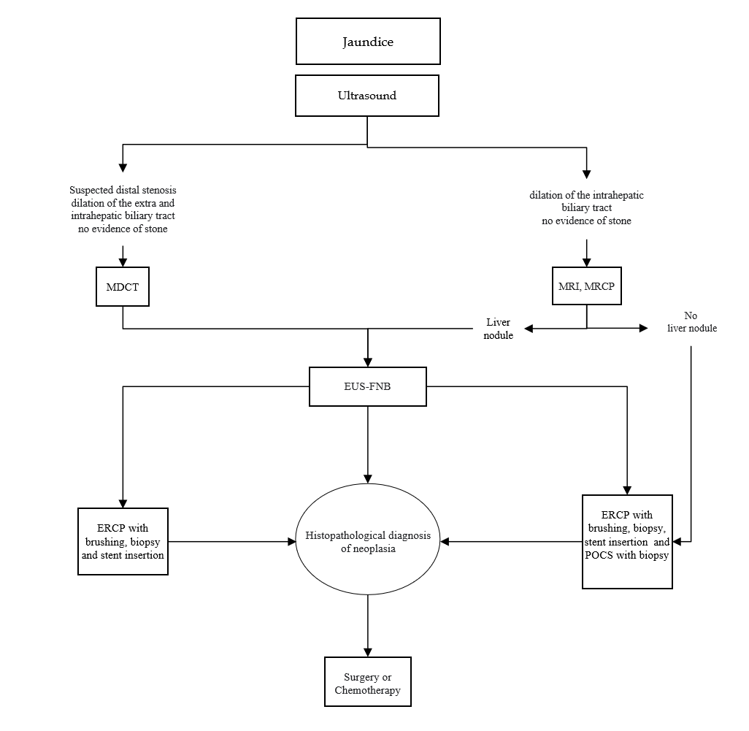
Figure 1 Algorithm of imaging investigations in biliary stenosis. MDCT: Multidetector computed tomography; MRI: Magnetic resonance imaging; MRCP: Magnetic resonance cholangiopancreatography; EUS-FNA: Endoscopic ultrasound-fine needle aspiration; ERCP: Endoscopic retrograde cholangiopancreatography; POCS: Peroral cholangioscopy.
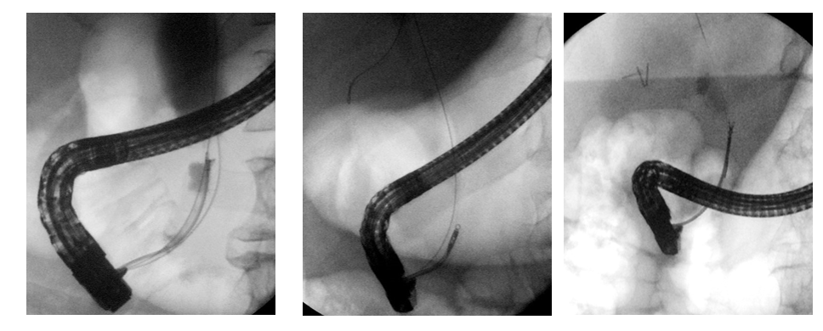
Figure 2 Three cases of patients with distal stenosis in which the diagnosis of cholangiocarcinoma was made by forceps biopsy during endoscopic retrograde cholangiopancreatography.
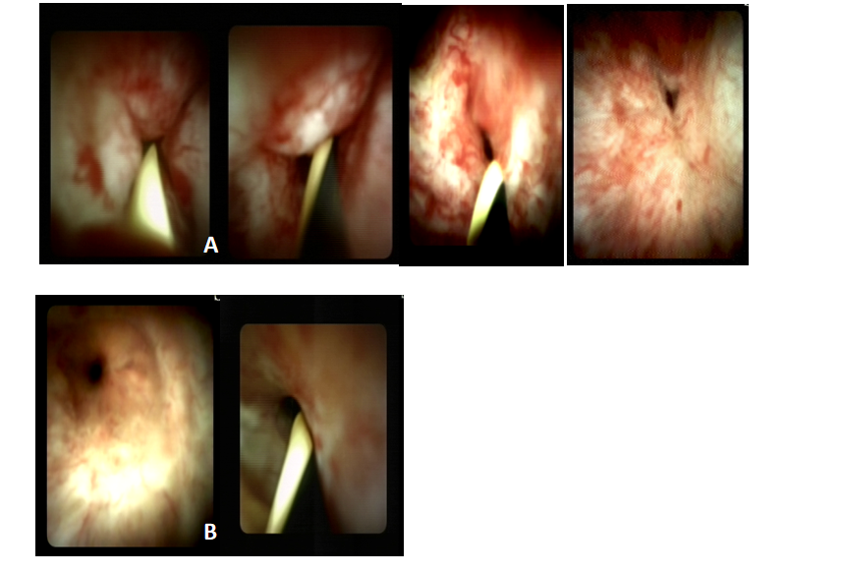
Figure 3 Digital (SpyGlass) cholangioscopy images. A: Cholangiocarcinoma; B: Benign stenosis.
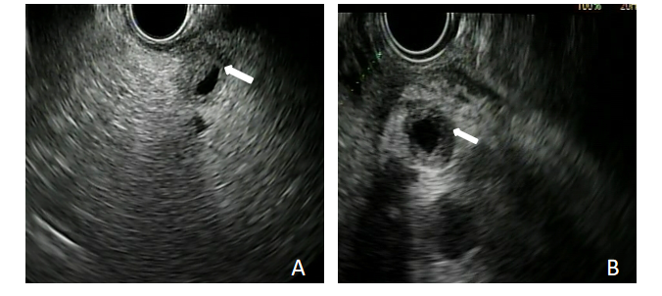
Figure 4 Two cases of cholangiocarcinoma evaluated with endoscopic ultrasound. A: Distal stenosis of the main biliary tract; B: Stenosis of the proximal-middle tract of the main biliary duct. Arrows indicate the stenotic tract.
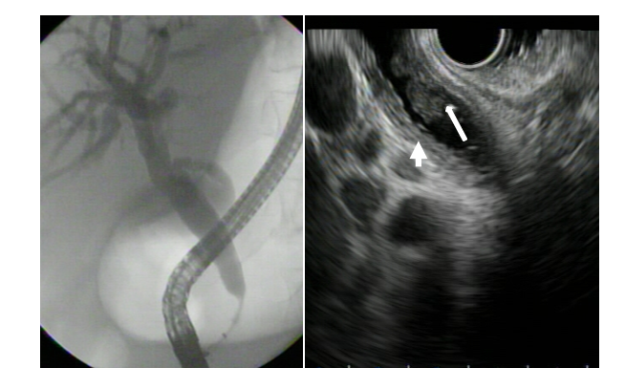
Figure 5 Endoscopic retrograde cholangiopancreatography and endoscopic ultrasound image of a stenotic tract of the distal biliary duct. In the endoscopic ultrasound image, the nodule inside the main biliary tract (large arrow) and thickening of the bile duct wall (small arrow) are visible.
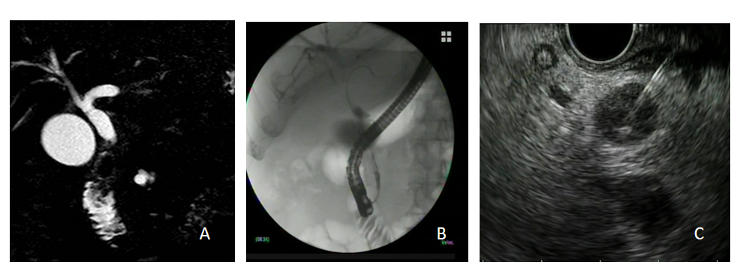
Figure 6 Adenocarcinoma of the main biliary tract. A: Magnetic resonance image of suspected neoplastic stenosis; B: Endoscopic retrograde cholangiopancreatography image confirming the stenosis; C: Endoscopic ultrasound-guided fine needle aspiration of the stenotic tract for tissue diagnosis.
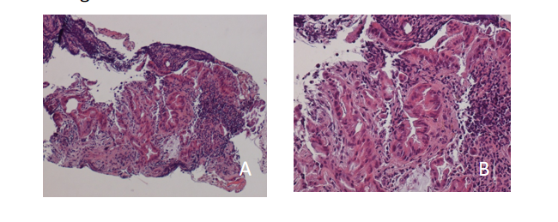
Figure 7 Histology of specimen collected by endoscopic ultrasound-fine needle aspiration from cholangiocarcinoma in a hepatic nodule. A: Hematoxylin and eosin staining, magnification × 40; B: Hematoxylin and eosin staining, magnification × 100.
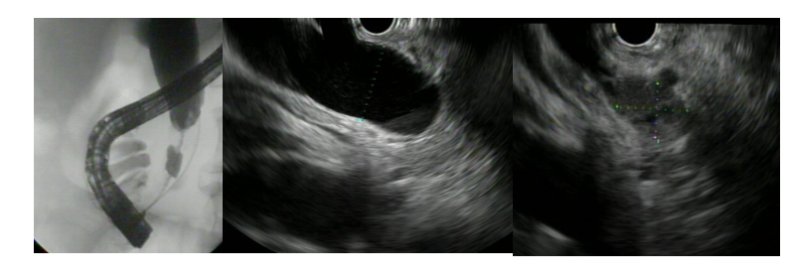
Figure 8 Diagnosis of cholangiocarcinoma of the distal tract of the main biliary duct, obtained in a single session by biopsy during endoscopic retrograde cholangiopancreatography and endoscopic ultrasound-guided fine needle aspiration. Endoscopic ultrasound images show dilation of the common bile duct and stenosis of the distal tract due to a neoplastic nodule.
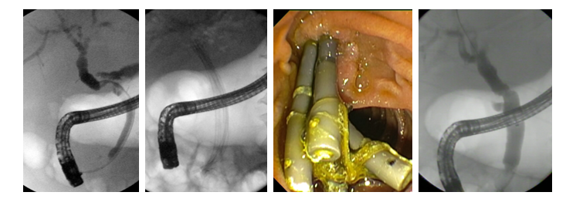
Figure 9 Multi-stenting treatment of anastomotic stenosis after liver transplantation. The image on the far right shows complete resolution of the stenosis.
Table 1 Etiology of benign biliary stenosis
Iatrogenic | Post-cholecystectomy
 | Post-liver transplantation (anastomotic, non-anastomotic)
 | Hepaticojejunostomy anastomotic strictures
Autoimmune disease | Primary or secondary sclerosing cholangitis
 | Autoimmune cholangitis (IgG4-related)
 | Autoimmune pancreatitis
Chronic disease | Pancreatitis
 | Choledocholithiasis
 | Sarcoidosis
Infectious disease | Recurrent cholangitis, HIV cholangiopathy, tuberculosis
Ischemic disease
Abdominal trauma
HIV: Human immunodeficiency virus; IgG: Immunoglobulin G.

