Name of Journal: World Journal of Gastroenterology
Manuscript NO: 48768
Manuscript Type: ORIGINAL ARTICLE

Basic Study
Integrative analysis of the inverse expression patterns in pancreas development and cancer progression

Zang HL et al. Inverse expression patterns in pancreas cancer

Hong-Liang Zang, Guo-Min Huang, Hai-Ying Ju, Xiao-Feng Tian

Hong-Liang Zang, Xiao-Feng Tian, Guo-Min Huang, Department of Hepatobiliary and Pancreatic Surgery, China-Japan Union Hospital of Jilin University, Changchun 130033, Jilin Province, China

Hai-Ying Ju, Department of Hematology, Jilin Province Blood Center, Changchun 130000, Jilin Province, China

ORCID number: Hong-Liang Zang (0000-0002-9570-6158); Guo-Min Huang (0000-0002-7473-7780); Hai-Ying Ju (0000-0001-6428-803X); Xiao-Feng Tian (0000-0001-7146-5313).

Author contributions: Zang HL performed the majority of experiments and analyzed the data; Huang GM performed the molecular investigations; Ju HY designed and coordinated the research; Tian XF wrote the paper.

Conflict-of-interest statement: The authors declare no conflict of interest.

Data sharing statement: No additional data are available.

Open-Access: This article is an open-access article that was selected by an in-house editor and fully peer-reviewed by external reviewers. It is distributed in accordance with the Creative Commons Attribution Non Commercial (CC BY-NC 4.0) license, which permits others to distribute, remix, adapt, build upon this work non-commercially, and license their derivative works on different terms, provided the original work is properly cited and the use is non-commercial. See: http://creativecommons.org/licenses/by-nc/4.0/

Manuscript source: Unsolicited manuscript

Corresponding author: Xiao-Feng Tian, MSc, Attending Doctor, Department of Hepatobiliary and Pancreatic Surgery, China-Japan Union Hospital of Jilin University, No.126 Sendai Street, Changchun 130033, Jilin Province, China. chuie03755@163.com
Telephone: +86-431-84995999

Received: May 5, 2019
Peer-review started: May 5, 2019
First decision: June 10, 2019
Revised: July 5, 2019
Accepted: July 19, 2019
Article in press:
Published online:

Abstract
BACKGROUND
As a malignant tumor, pancreatic cancer with a meager 5-year survival rate has been widely concerning. However, the molecular mechanisms that result in malignant transformation of pancreatic cells remain elusive.

AIM
To investigate the gene expression profiles in normal or malignant transformed pancreas development.

METHODS
MaSigPro and analysis of variance were performed on two pancreas development datasets downloaded from the Gene Expression Omnibus database. Six pancreatic cancer datasets collected from The Cancer Genome Atlas database were used to establish differentially expressed genes related to pancreas development and pancreatic cancer. Moreover, gene clusters with highly similar interpretation patterns between pancreas development and pancreatic cancer progression were established by self-organizing map and singular value decomposition. Additionally, the hypergeometric test was performed to compare the corresponding interpretation patterns. Abnormal regions of metabolic pathway were analyzed using the Subpathway-GM method.

RESULTS
This study established the continuously upregulated and downregulated genes at different stages in pancreas development and progression of pancreatic cancer. Through analysis of the differentially expressed genes, we established inverse and consistent direction development-cancer pattern associations. Based on the application of Subpathway-GM analysis, we established 17 significant metabolic subpathways that were closely associated with pancreatic cancer. Of note, the most significant metabolite subpathway was related to glycerophospholipid metabolism.

CONCLUSION
Inverse and consistent direction development-cancer pattern associations were established. There was a significant correlation in the inverse patterns, but no consistent direction patterns.

Key words: Pancreatic cancer; Pancreas development; Inverse pattern; Metabolites subpathway

© The Author(s) 2019. Published by Baishideng Publishing Group Inc. All rights reserved.

Core tip: We analyzed the differentially expressed genes during pancreas development and pancreatic cancer progression. We found that genes upregulated in tumorigenesis were conversely suppressed in the development of pancreas. Reciprocally, upregulated gene expression pattern during pancreas development was negatively correlated with pancreatic cancer progression. Additionally, 17 significant metabolic subpathways, especially glycerophospholipid metabolism, were identified, which were highly correlated with pancreas cancer development.

Zang HL, Huang GM, Ju HY, Tian XF. Integrative analysis of the inverse expression patterns in pancreas development and cancer progression. World J Gastroenterol 2019; In press

Introduction
As one of the most malignant tumors, pancreatic cancer results in more than 0.4 million deaths per year^{[1]}. Generally, it refers to pancreatic adenocarcinoma, which is the most common and devastating of all types of pancreatic cancer. According to the Union for International Cancer Control classification criteria, patients with pancreatic cancer can be divided into four main stages, including stage I, II, III, and IV^{[2]}. The overall 5-year survival rate of pancreatic cancer is less than 5% and the median survival period is 6 mo after diagnosis, which is the lowest survival rate among all types of cancers^{[3,4]}. Early diagnosis of biomarkers and effective treatments will help researchers effectively conduct pancreatic cancer research.
Similar to tumor progression, organ development can also be divided into several stages in a time-dependent manner^{[5]}. Moreover, development is strictly controlled by multiple signaling pathways and transcription factors^{[6]}. Some researchers believe that cancer is the problem of developmental biology. It has been reported that several genes and pathways affect normal or malignant transformed pancreas development^{[7]}. Pancreatic and duodenal homeobox 1 (PDX1), which is exclusively expressed in the pancreas, is essential for pancreas development. Recent research has shown that the dysfunction of PDX1 also promotes pancreatic cancer development and progression^{[8,9]}.
We therefore investigated the relationship between pancreas development and pancreatic cancer progression by analyzing two datasets related with pancreas development and six datasets related with pancreatic cancer. Through bioinformatics analysis, we established differentially gene expression profiles and multiple patterns that were consistent/inverse in the development-cancer patterns. Moreover, we found that there was a significant negative correlation between inverse development and cancer. Of note, we identified 17 metabolic subpathways that were highly related with pancreatic cancer development.

Materials and Methods

Pancreas development datasets
To further understand pancreas development, we analyzed two databases (accession: GSE42094, GSE96697) obtained from the Gene Expression Omnibus (GEO) database. Data from 16 samples in six development stages were obtained from GSE42094, including undifferentiated human embryonic stem cells, stage 1 (S1), S2, S3, S4, and S5. In the GSE96697 database, according to glycoprotein 2 and cadherin-1 (CDH1) interpretation, we classified 7-wk pancreas development data into three stages including early, middle, and late stages. We established that high interpretation of glycoprotein 2 was early stage, while low interpretation was the middle stage. Additionally, low interpretation of CDH1 was established as late stage.

Pancreatic cancer datasets
To further understand the development and progression of pancreatic cancer, we analyzed five pancreatic cancer datasets obtained from TCGA (https://portal.gdc.cancer.gov/), ICGC (https://icgc.org/), and GEO databases^{[10-12]}. All of these datasets contained five or six clinical stages and available clinical information. The accession numbers in the GEO database are GSE62452, GSE79668, and GSE102238. Detailed information on the datasets is listed in Table 1.

Metabolite highly related to pancreatic cancer
According to previous studies, we established differentially abundant metabolites and converted them to KEGG compound IDs^{[13-16]}. These metabolites were obtained from differentially abundant between control and pancreatic cancer. A total of 60 pancreatic cancer-associated differentially abundant metabolites were established.

Identification of differentially expressed genes in time-course datasets
We found the gene expression profile with significant differences between experimental groups in time course datasets using maSigPro approach. MaSigPro was applied to establish experimental groups using the dummy variables with a two-regression step, and it is an R package for significance analysis time-course microarray experiments. Briefly, after adjusting, a global-scale regression model with all defined variables and differently expressed genes was established. We applied a variable selection strategy to investigate the virtual difference between groups to establish the different profiles. According to the patient’s clinical stages, we could establish the pancreatic cancer interpretation profiles as “time-series” datasets. We selected 0.05 as false discovery rate (FDR) significance threshold for the analysis in this study without a special request. In the GSE96697 dataset, due to the fewer development stage, we used analysis of variance (ANOVA) method to obtain differentially expressed genes (DEGs).

Identification of gene cluster with consistent expression patterns
To investigate the pancreas development and pancreatic cancer development and progression-associated interpretation patterns, we performed initial screening on the interpretation matrix of DEGs. We pre-processed the DEGs using a self-organizing map (SOM) strategy and performed the pattern recognition using the singular value decomposition (SVD) strategy. We conducted comprehensive SOM-SVD analysis under the guidance of http://www.cs.bris.ac.uk/Bhfang/TPSC/somsvd.html as previously described (paper). Briefly, the analysis can be summarized in three steps. Initially, we conducted SOM transformation. Second, SOM output was decomposed using the SVD strategy. FDR, which is used for significant neuron assessment, was set at 0.10 to select the pancreas development and pancreatic cancer progression pattern genes. The identified genes were analyzed using component plane presentation-integrated SOM for gene clustering. The highly similar expression pattern clusters were used for pancreas development and pancreatic cancer progression integrative analysis.

Function for Geneset enrichment analysis
In our study, we annotated the identified interpretation patterns using the Database for Annotation, Visualization and Integrated Discovery, which are comprehensive sets of functional annotation tools. The identified interpretation patterns were clustered into more than 40 Gene Ontology-Biological Process terms. R package iSubpathwayMiner was applied for subpathway enrichment analysis.

Comparison of gene expression pattern between development and cancer
We identified the upregulated interpretation patterns and downregulated interpretation patterns in the pancreas development as dev-Up and dev-Dw. To analyze the associations between pancreas development and pancreatic progression, we used the hypergeometric test in our study, as previously described^{[17]}. Briefly, we compared the dev-Up versus can-Up, dev-Up versus can-Dw, dev-Dw versus can-Up, and dev-Dw versus can-Up to generate the development and cancer dataset pairs. Moreover, we considered that P < 0.05 was a significant correlation between pancreas development and pancreatic cancer progression. The P-value was calculated according to the following formula:
$$P=1-\sum_{x=0}^{k-1}{\frac{\left(\begin{matrix}N_{cancer} \\ x\end{matrix}\right)\left(\begin{matrix}M-N_{cancer} \\ N_{development}\end{matrix}\right)}{\left(\begin{matrix}M \\ N_{development}\end{matrix}\right)}}$$

In this formula, N-development and N-cancer indicate the number of pancreas development and pancreatic cancer regulation genes, respectively. M indicates the whole genome number, while k indicates the number of common genes.

Results

Identification of genes differentially expressed in pancreas development
To investigate the transcriptional pattern during pancreas development, we evaluated the interpretation patterns in GSE42094 and GSE96697, which are the datasets of pancreas development. Using the maSigPro method, we identified 3069 DEGs at different time points of pancreas development in GSE42094 dataset. We then employed SOM-SVD strategy to select the topology-preserving DEGs, according to interpretation matrices (Figure 1A). Reciprocally, the selected genes in a topology-preserving selection further confirmed the alteration in “time-series” processes. All genes were automatically selected in this method. Then the matrices with 1257 genes, which were obtained from SOM-SVD analysis, were clustered into four gene clusters (clusters 1–4). As shown in Figure 1A, cluster 2 and cluster 4 contained genes that were transiently upregulated in the early stage of development, then decreased gradually along with development. We therefore named these gene sets as continuous downregulated expression patterns. In contrast, genes with a low expression level and increased gradually in the latter stage of development were observed in cluster 1 and cluster 3. They were thus identified as continuously upregulated expression patterns.
For the GSE96697 dataset, we used the ANOVA method to analyze the expression data set and identified 3078 differential expressed genes. The K-means clustering method was used to establish patterns of interpretation of DEG sets, and we established six clusters. Similar to the previous continuous adjustment pattern recognition, we found that cluster 4 and cluster 6 were the interpretation modes of downregulation, and cluster 2 was the interpretation mode of upregulation (Figure 2). From this analysis, we found that 641 and 616 genes in the GSE42094 and GSE96697 datasets were continuously upregulated, while 1059 and 1052 genes were continuously downregulated. To investigate the biological characteristics of genes related with pancreatic development, functional enrichment analysis was used to aggregate genes in a consistent upregulation or downregulation model. We found that “lipid digestion” and “cholesterol homeostasis” were enriched during pancreas development and continued to upregulate the mode of interpretation. “Cell proliferation” and “mitotic nuclear division” were annotated in an interpretive pattern that was continuously downregulated (Figure 1B).

Exploration of genes that continuously regulated in pancreatic cancer progression
To measure the status of genes related with pancreas development in the progression of pancreatic cancer, we analyzed six pancreatic cancer data sets described in Materials and Methods. We considered each clinical stage of pancreatic cancer as the point in time to determine progression patterns, similar to pancreatic developmental analysis. Thus, we could determine the various interpretation patterns in these pancreatic cancer data sets (Figure 3A). Comparative analysis was used to study the mode of interpretation of continuous regulation between pancreatic development and pancreatic cancer progression. We established the interpretation mode of the upregulation of the tumor and the interpretation mode of the downregulation according to the following criteria: exceeding [(n-1)/ 2 + 1] the interpretation level of the adjacent stage changes with the same trend, n repeats the number of stages in each data set. The absolute slope was more significant than 0.05. We established six gene clusters in the upregulated pattern and six of the downregulated patterns (Figure 3B).

Comparative analysis of gene expression between pancreas development and pancreatic cancer progression
To investigate the relationship between pancreatic development and pancreatic cancer progression, we performed a hypergeometric test. As shown in Figure 4A, retro-pancreatic development and pancreatic cancer patterns included dev-Up versus can-Dw and dev-Dw versus can-Up. On the other hand, we found a weak relationship between inconsistent development and cancer patterns. Specifically, we did not find any significant correlation between any two dev-Dw and can-Dw datasets. The inverse interpretation patterns were clustered into Gene Ontology-Biological Process terms to analyze biological function including dev-Up versus can-Dw and Dev-Dw versus can-Up patterns (Figure 4B). The results showed that 141 genes with dev-Up versus can-Dw were mainly associated with immune-related BP terms including “T Cell Proliferation” and “Innate Immune Response In Mucosa.” Furthermore, 202 genes with dev-Dw versus can-Up were exclusively involved in proliferation-related BP terms including “Cell Division” and “DNA Replication Initiation.” Collectively, cell proliferation activity, as one of the essential characteristics in the malignant tumor, was gradually enhanced along with cancer progression, which was consistent with previous studies.

Identification of metabolic subpathways associated with pancreatic cancer
A total of 343 genes were established in the inverse interpretation patterns. To further establish pancreatic cancer associated with metabolic subpathways, we found 60 unique differentially abundant metabolites, which might be associated with pancreatic cancer progression. After integrating the analysis of 343 genes and 60 metabolites, Subpathway-GM strategy was employed to establish the critical, abnormal regions identified in each metabolic pathway. Subsequently, we set FDR < 0.01 as a threshold for further analysis of 343 genes and 60 differential metabolite pathways and identified 17 significant metabolic sub-avenues (Table 2). Among these established subpathways, the most significant was "Glycerophospholipid metabolism," (path:00564_1) which was critical for lipid metabolism. Our data thus demonstrate that activation of metabolite pathways, especially lipid metabolism, is crucial for pancreatic cancer development.

Discussion
Accumulative studies have indicated that metabolism is important for cancer initiation and progression. Alterations of genes related to metabolism in tumors provide increased energy for cancer cell proliferation, even under nutrient-deficient or hypoxic conditions^{[18]}. Integrative analysis of metabolic pathway and metabolites facilitates a better understanding of the underlying mechanism and potential drug targets of pancreatic cancer^{[13,19]}.
Following analysis of the pancreas development database and pancreatic cancer database, we established 202 genes with dev-Dw and can-Up, which were mainly associated with cell proliferation. Consistent with previous studies, our results confirmed that the uncontrolled proliferative activity of cancer cells is the most remarkable hallmark of carcinogenesis, along with tumor progression^{[22]}. Conversely, the proliferative capacity is decreased along with normal pancreas development^{[20-22]}. DNA replication is accompanied by cell proliferation. Due to the infinite hyperplasia of cancer cells, DNA replication is continuously upregulated in pancreatic cancer^{[23,24]}. Due to the limited proliferation of healthy organs, DNA replication continuously downregulates pancreatic development^{[25]}. We established 141 genes with dev-Up, can-Dw including “T Cell Proliferation” and “Innate Immune Response In Mucosa.” As a dynamic process, carcinogenesis is associated with immunoediting^{[26]}. Along with cancer progression, the host immunosurveillance is suppressed, which in turn leads to cancer immune escape. Interestingly, though analysis of metabolism pathways, we found that genes related to steroid hormone biosynthesis were dysregulated during cancer development. Steroid can elicit immunosuppressive effects and restrict T cell-mediated cancer eradication^{[27]}. We therefore hypothesized that enhanced steroid production was the primary cause for cancer immunoediting.
After analysis of the pancreas development database and pancreatic cancer database, we established that glycerophospholipid metabolism, as an essential subpathway in lipid metabolism, was the most significant subpathway. Many pieces of research have shown that lipid metabolism is strongly linked to pancreas cancer. The pancreatic lipase, as a lipolytic enzyme, is thought to be one of the predictors for prognosis and cancer-specific mortality in pancreas cancer^{[13]}. Pancreatic lipase 1 and 2 is a significant lipase for lipid hydrolysis in pancreatic cancer patients, which is significantly reduced compared to healthy controls. Additionally, inversed expressed genes and metabolites in glycerophospholipid metabolism are associated with pancreatic cancer. SLC44A4, closely associated with acetylcholine synthesis and transport, is markedly upregulated in advanced and undifferentiated epithelial tumors, especially in prostate and pancreatic cancer^{[28,29]}. Choline can decrease the risk of developing pancreatic cancer^{[29]}. Besides, choline and phosphocholine reportedly associate with other cancers including breast and ovarian cancers^{[30-31]}. Some researchers believe that increased choline and phosphocholine are the critical aspects of tumor metabolism and tumor cell migration^{[32]}. Besides lipid metabolism, recent studies have also revealed that activation of glycolysis and citrate cycle pathway promotes cancer development^{[33]}.
In summary, here we identified a series of genes related to metabolism via bioinformatics analysis, which are crucial for cancer development. We believe that our findings may provide potential targets for the treatment or prognosis of pancreatic cancer.

ARTICLE HIGHLIGHTS
Research background
Pancreatic disease remains one of the most feared and clinically challenging diseases to treat despite continual improvements in therapies.

Research motivation
To develop targeted drugs for killing cancer cells.

Research objectives
To explore the molecular interpretation patterns of pancreas development and cancer progression.

Research methods
This study used the ANOVA method, self-organizing map-singular value decomposition analysis, enrichment analysis, and hypergeometric test.

Research results
The results investigated continuously dysregulated interpretation patterns in pancreas development and pancreatic cancer.

Research conclusions
Integrative analysis of continuously dysregulated interpretation patterns to establish the inverse interpretation in metabolites and gene levels. Through integrating the genes with metabolites, some key abnormal regions of metabolic pathways were established.

Research perspectives
With the increase in human disease databases, a larger-scale integrative analysis is needed for the correlation with pancreas development and cancer. We believe the more convince underlying mechanism and potential drug development targets could be supposed by larger-scale development and integrative cancer analysis in future studies. This method could also be used for the investigation of other diseases.

Acknowledgments
We appreciate Dr. Xi Huang for support in editing the manuscript.

REFERENCES
1 GBD 2015 Mortality and Causes of Death Collaborators.. Global, regional, and national life expectancy, all-cause mortality, and cause-specific mortality for 249 causes of death, 1980-2015: A systematic analysis for the Global Burden of Disease Study 2015. Lancet 2016; 388: 1459-1544 [PMID: 27733281 DOI: 10.1016/S0140-6736(16)31012-1]
2 Cascinu S, Falconi M, Valentini V, Jelic S; ESMO Guidelines Working Group. Pancreatic cancer: ESMO Clinical Practice Guidelines for diagnosis, treatment and follow-up. Ann Oncol 2010; 21: v55-v58 [PMID: 20555103 DOI: 10.1093/annonc/mdq165]
3 Hidalgo M. Pancreatic cancer. N Engl J Med 2010; 362: 1605-1617 [PMID: 20427809 DOI: 10.1056/NEJMra0901557]
4 Bond-Smith G, Banga N, Hammond TM, Imber CJ. Pancreatic adenocarcinoma. BMJ 2012; 344: e2476 [PMID: 22592847 DOI: 10.1136/bmj.e2476]
5 Jennings RE, Berry AA, Strutt JP, Gerrard DT, Hanley NA. Human pancreas development. Development 2015; 142: 3126-3137 [PMID: 26395141 DOI: 10.1242/dev.120063]
6 Quilichini E, Haumaitre C. Implication of epigenetics in pancreas development and disease. Best Pract Res Clin Endocrinol Metab 2015; 29: 883-898 [PMID: 26696517 DOI: 10.1016/j.beem.2015.10.010]
7 Fleming AK, Storz P. Protein kinase C isoforms in the normal pancreas and in pancreatic disease. Cell Signal 2017; 40: 1-9 [PMID: 28826907 DOI: 10.1016/j.cellsig.2017.08.005]
8 Vinogradova TV, Sverdlov ED. PDX1: A Unique Pancreatic Master Regulator Constantly Changes Its Functions during Embryonic Development and Progression of Pancreatic Cancer. Biochemistry (Mosc) 2017; 82: 887-893 [PMID: 28941456 DOI: 10.1134/S000629791708003X]
9 Roy N, Takeuchi KK, Ruggeri JM, Bailey P, Chang D, Li J, Leonhardt L, Puri S, Hoffman MT, Gao S, Halbrook CJ, Song Y, Ljungman M, Malik S, Wright CV, Dawson DW, Biankin AV, Hebrok M, Crawford HC. PDX1 dynamically regulates pancreatic ductal adenocarcinoma initiation and maintenance. Genes Dev 2016; 30: 2669-2683 [PMID: 28087712 DOI: 10.1101/gad.291021.116]
10 Yang S, He P, Wang J, Schetter A, Tang W, Funamizu N, Yanaga K, Uwagawa T, Satoskar AR, Gaedcke J, Bernhardt M, Ghadimi BM, Gaida MM, Bergmann F, Werner J, Ried T, Hanna N, Alexander HR, Hussain SP. A Novel MIF Signaling Pathway Drives the Malignant Character of Pancreatic Cancer by Targeting NR3C2. Cancer Res 2016; 76: 3838-3850 [PMID: 27197190 DOI: 10.1158/0008-5472.CAN-15-2841]
11 Kirby MK, Ramaker RC, Gertz J, Davis NS, Johnston BE, Oliver PG, Sexton KC, Greeno EW, Christein JD, Heslin MJ, Posey JA, Grizzle WE, Vickers SM, Buchsbaum DJ, Cooper SJ, Myers RM. RNA sequencing of pancreatic adenocarcinoma tumors yields novel expression patterns associated with long-term survival and reveals a role for ANGPTL4. Mol Oncol 2016; 10: 1169-1182 [PMID: 27282075 DOI: 10.1016/j.molonc.2016.05.004]
12 He W, Wu J, Shi J, Huo YM, Dai W, Geng J, Lu P, Yang MW, Fang Y, Wang W, Zhang ZG, Habtezion A, Sun YW, Xue J. IL22RA1/STAT3 Signaling Promotes Stemness and Tumorigenicity in Pancreatic Cancer. Cancer Res 2018; 78: 3293-3305 [PMID: 29572224 DOI: 10.1158/0008-5472.CAN-17-3131]
13 Zhang G, He P, Tan H, Budhu A, Gaedcke J, Ghadimi BM, Ried T, Yfantis HG, Lee DH, Maitra A, Hanna N, Alexander HR, Hussain SP. Integration of metabolomics and transcriptomics revealed a fatty acid network exerting growth inhibitory effects in human pancreatic cancer. Clin Cancer Res 2013; 19: 4983-4993 [PMID: 23918603 DOI: 10.1158/1078-0432.CCR-13-0209]
14 Budhu A, Terunuma A, Zhang G, Hussain SP, Ambs S, Wang XW. Metabolic profiles are principally different between cancers of the liver, pancreas and breast. Int J Biol Sci 2014; 10: 966-972 [PMID: 25210494 DOI: 10.7150/ijbs.9810]
15 Battini S, Faitot F, Imperiale A, Cicek AE, Heimburger C, Averous G, Bachellier P, Namer IJ. Metabolomics approaches in pancreatic adenocarcinoma: Tumor metabolism profiling predicts clinical outcome of patients. BMC Med 2017; 15: 56 [PMID: 28298227 DOI: 10.1186/s12916-017-0810-z]
16 An Y, Cai H, Yang Y, Zhang Y, Liu S, Wu X, Duan Y, Sun D, Chen X. Identification of ENTPD8 and cytidine in pancreatic cancer by metabolomic and transcriptomic conjoint analysis. Cancer Sci 2018; 109: 2811-2821 [PMID: 29987902 DOI: 10.1111/cas.13733]
17 Zhang C, Li C, Xu Y, Feng L, Shang D, Yang X, Han J, Sun Z, Li Y, Li X. Integrative analysis of lung development-cancer expression associations reveals the roles of signatures with inverse expression patterns. Mol Biosyst 2015; 11: 1271-1284 [PMID: 25720795 DOI: 10.1039/c5mb00061k]
18 Le A, Rajeshkumar NV, Maitra A, Dang CV. Conceptual framework for cutting the pancreatic cancer fuel supply. Clin Cancer Res 2012; 18: 4285-4290 [PMID: 22896695 DOI: 10.1158/1078-0432.CCR-12-0041]
19 Hanahan D, Weinberg RA. Hallmarks of cancer: The next generation. Cell 2011; 144: 646-674 [PMID: 21376230 DOI: 10.1016/j.cell.2011.02.013]
20 Ames BN, Shigenaga MK, Gold LS. DNA lesions, inducible DNA repair, and cell division: Three key factors in mutagenesis and carcinogenesis. Environ Health Perspect 1993; 101: 35-44 [PMID: 8013423 DOI: 10.1289/ehp.93101s535]
21 Fürthauer M, González-Gaitán M. Endocytosis, asymmetric cell division, stem cells and cancer: Unus pro omnibus, omnes pro uno. Mol Oncol 2009; 3: 339-353 [PMID: 19581131 DOI: 10.1016/j.molonc.2009.05.006]
22 Knudsen ES, Balaji U, Mannakee B, Vail P, Eslinger C, Moxom C, Mansour J, Witkiewicz AK. Pancreatic cancer cell lines as patient-derived avatars: Genetic characterisation and functional utility. Gut 2018; 67: 508-520 [PMID: 28073890 DOI: 10.1136/gutjnl-2016-313133]
23 Cancer Genome Atlas Research Network. Electronic address: andrew_aguirre@dfci.harvard.edu.; Cancer Genome Atlas Research Network. Integrated Genomic Characterization of Pancreatic Ductal Adenocarcinoma. Cancer Cell 2017; 32: 185-203.e13 [PMID: 28810144 DOI: 10.1016/j.ccell.2017.07.007]
24 Cicenas J, Kvederaviciute K, Meskinyte I, Meskinyte-Kausiliene E, Skeberdyte A, Cicenas J. KRAS, TP53, CDKN2A, SMAD4, BRCA1, and BRCA2 Mutations in Pancreatic Cancer. Cancers (Basel) 2017; 9: pii: E42 [PMID: 28452926 DOI: 10.3390/cancers9050042]
25 Anderson RM, Bosch JA, Goll MG, Hesselson D, Dong PD, Shin D, Chi NC, Shin CH, Schlegel A, Halpern M, Stainier DY. Loss of Dnmt1 catalytic activity reveals multiple roles for DNA methylation during pancreas development and regeneration. Dev Biol 2009; 334: 213-223 [PMID: 19631206 DOI: 10.1016/j.ydbio.2009.07.017]
26 Aroldi F, Zaniboni A. Immunotherapy for pancreatic cancer: Present and future. Immunotherapy 2017; 9: 607-616 [PMID: 28595517 DOI: 10.2217/imt-2016-0142]
27 Patel S, Choudhary M, Chandra RK, Bhardwaj AK, Tripathi MK. Sex steroids exert a suppressive effect on innate and cell mediated immune responses in fresh water teleost, Channa punctatus. Dev Comp Immunol 2019; 100: 103415 [PMID: 31202893 DOI: 10.1016/j.dci.2019.103415]
28 Mattie M, Raitano A, Morrison K, Morrison K, An Z, Capo L, Verlinsky A, Leavitt M, Ou J, Nadell R, Aviña H, Guevara C, Malik F, Moser R, Duniho S, Coleman J, Li Y, Pereira DS, Doñate F, Joseph IB, Challita-Eid P, Benjamin D, Stover DR. The Discovery and Preclinical Development of ASG-5ME, an Antibody-Drug Conjugate Targeting SLC44A4-Positive Epithelial Tumors Including Pancreatic and Prostate Cancer. Mol Cancer Ther 2016; 15: 2679-2687 [PMID: 27550944 DOI: 10.1158/1535-7163.MCT-16-0225]
29 Song P, Rekow SS, Singleton CA, Sekhon HS, Dissen GA, Zhou M, Campling B, Lindstrom J, Spindel ER. Choline transporter-like protein 4 (CTL4) links to non-neuronal acetylcholine synthesis. J Neurochem 2013; 126: 451-461 [PMID: 23651124 DOI: 10.1111/jnc.12298]
30 Aboagye EO, Bhujwalla ZM. Malignant transformation alters membrane choline phospholipid metabolism of human mammary epithelial cells. Cancer Res 1999; 59: 80-84 [PMID: 9892190]
31 Ackerstaff E, Glunde K, Bhujwalla ZM. Choline phospholipid metabolism: A target in cancer cells? J Cell Biochem 2003; 90: 525-533 [PMID: 14523987 DOI: 10.1002/jcb.10659]
32 Zhan B, Wen S, Lu J, Shen G, Lin X, Feng J, Huang H. Identification and causes of metabonomic difference between orthotopic and subcutaneous xenograft of pancreatic cancer. Oncotarget 2017; 8: 61264-61281 [PMID: 28977862 DOI: 10.18632/oncotarget.18057]
33 Ren JG, Seth P, Ye H, Guo K, Hanai JI, Husain Z, Sukhatme VP. Citrate Suppresses Tumor Growth in Multiple Models through Inhibition of Glycolysis, the Tricarboxylic Acid Cycle and the IGF-1R Pathway. Sci Rep 2017; 7: 4537 [PMID: 28674429 DOI: 10.1038/s41598-017-04626-4]
P-Reviewer: Ahmad Z, Bolshakova GB, Löhr JM, Misiakos EP, Zavras N
S-Editor: Yan JP
L-Editor: Filipodia E-Editor:
Specialty type: Gastroenterology and hepatology
Country of origin: China
Peer-review report classification
Grade A (Excellent): A
Grade B (Very good): B, B
Grade C (Good): C, C
Grade D (Fair): 0
Grade E (Poor): 0

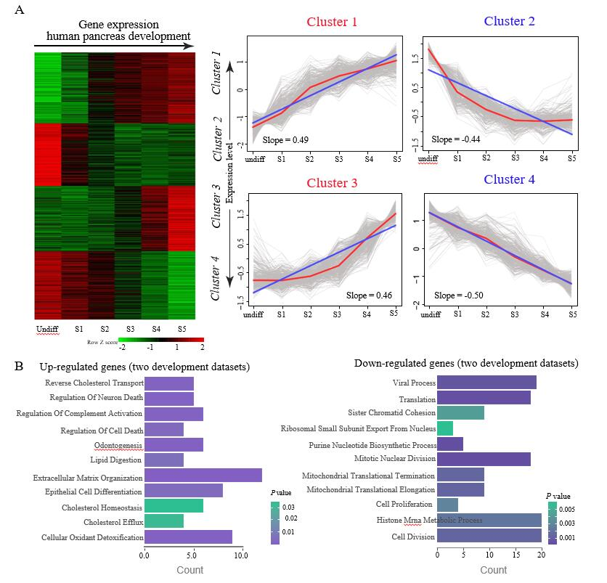
Figure 1 Continuous differential expression patterns in pancreas development. A: Clustering of human pancreas development genes. In the heat map, green indicates downregulated and red indicates upregulated. In the line graphs, lines represent the tendency of the cluster changes; B: Gene Ontology-Biological Process annotations of the continuously upregulated and downregulated genes.

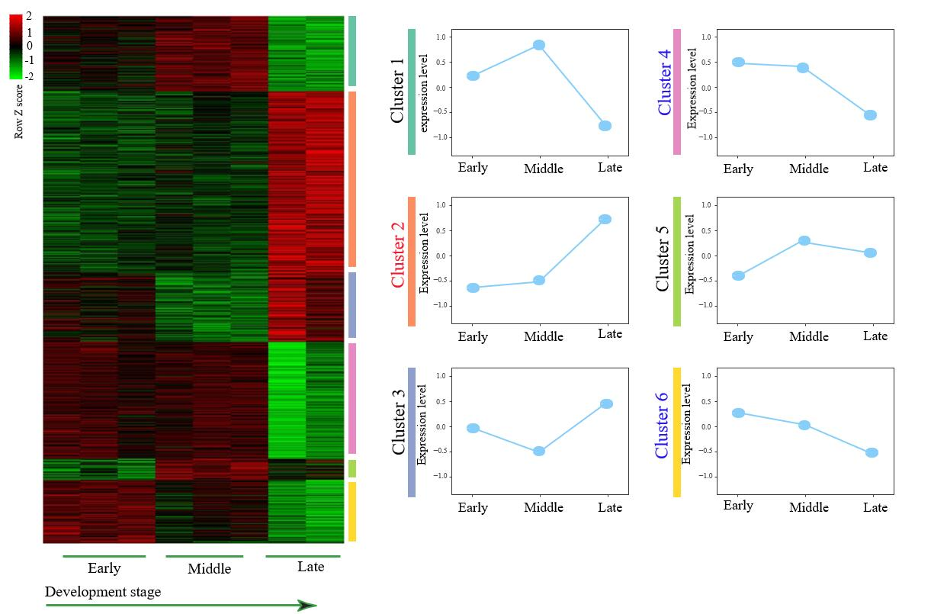
Figure 2 Expression patterns identified from GSE96697. Among these results, upregulated and downregulated patterns (red, green color labeled) were defined and further analyzed in our study.

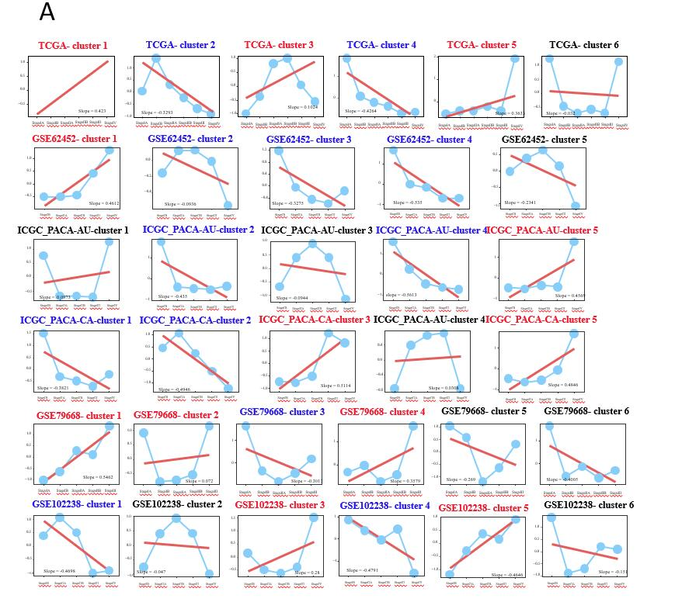
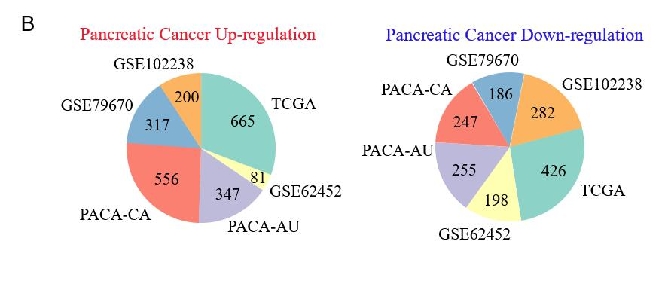
Figure 3 Expression patterns identified from six pancreatic cancer datasets. A: Among these results, upregulated and downregulated patterns (red, blue color labeled) were defined and further analyzed in our study; B: Pie diagram showed the upregulated and downregulated genes in each pancreatic cancer dataset.

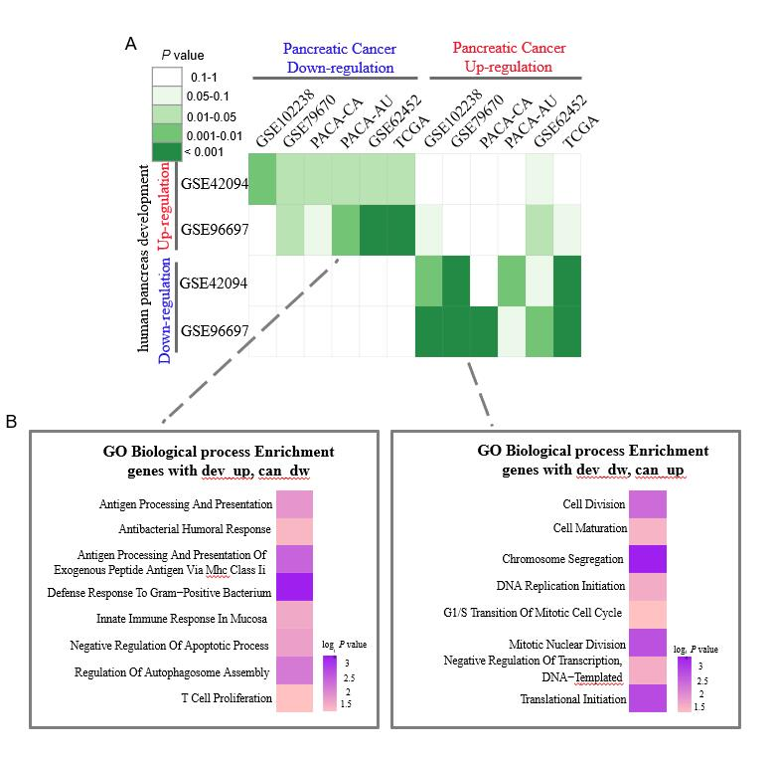
Figure 4 Integrated analysis of expression patterns in pancreas development and pancreatic cancer progression. A: Comparison of interpretation patterns between pancreas development and cancer progression. Color in each cell indicates the P-value; B: Gene Ontology-Biological Process annotations of the inverse interpretation patterns including dev-up versus can-dw and dev-dw versus can-up.

Table 1 Information on the pancreatic cancer datasets
Dataset name | TCGA | GSE62452 | PACA-AU (ICGC) | PACA-CA (ICGC) | GSE79670 | GSE102238
Histological type | PDAC | PDAC | PDAC | PDAC | PDAC | PDAC
Samples | 145 | 69 | 89 | 202 | 50 | 48
Gender Female, Male | 68, 77 | 31, 38 | 41, 48 | 94, 108 | 19, 31 | 21, 27
Stage I (IA, IB) | 3, 9 | 0, 4 | 0, 6 | 0, 11 | 3, 6 | 0, 8
Stage II (IIA, IIB) | 23, 104 | 10, 36 | 20, 47 | 28, 155 | 4, 31 | 19, 15
Stage III | 3 | 13 | 9 | 5 | 6 | 3
Stage IV | 3 | 6 | 7 | 3 | 0 | 3
Platform | RNA-seq | Affymetrix | RNA-seq | RNA-seq | RNA-seq | Agilent
PDAC: Pancreatic adenocarcinoma.

Table 2 Seventeen significant metabolic subpathways in pancreatic cancer
Pathway ID | Pathway name | Ann molecule ratio | Ann Bg ratio | P value | FDR
path:00564_1 | Glycerophospholipid metabolism | 9/378 | 47/25051 | 3.03E-08 | 5.15E-07
path:00330_1 | Arginine and proline metabolism | 5/378 | 18/25051 | 5.55E-06 | 4.72E-05
path:00020_1 | Citrate cycle (TCA cycle) | 3/378 | 9/25051 | 0.000267613 | 0.001516472
path:00630_1 | Glyoxylate and dicarboxylate metabolism | 3/378 | 11/25051 | 0.000513985 | 0.002184435
path:00140_4 | Steroid hormone biosynthesis | 4/378 | 32/25051 | 0.001313707 | 0.003783719
path:00430_1 | Taurine and hypotaurine metabolism | 2/378 | 4/25051 | 0.00133543 | 0.003783719
path:00061_3 | Fatty acid biosynthesis | 2/378 | 5/25051 | 0.002203499 | 0.004682436
path:00650_1 | Butanoate metabolism | 2/378 | 5/25051 | 0.002203499 | 0.004682436
path:00565_3 | Ether lipid metabolism | 3/378 | 21/25051 | 0.003704522 | 0.00699743
path:00260_2 | Glycine, serine and threonine metabolism | 2/378 | 7/25051 | 0.004535597 | 0.007455604
path:00140_7 | Steroid hormone biosynthesis | 3/378 | 23/25051 | 0.004824214 | 0.007455604
path:00230_1 | Purine metabolism | 4/378 | 58/25051 | 0.011412618 | 0.016167876
path:00480_1 | Glutathione metabolism | 3/378 | 38/25051 | 0.019466435 | 0.025456107
path:00230_2 | Purine metabolism | 3/378 | 43/25051 | 0.026957207 | 0.032733751
path:00071_1 | Fatty acid metabolism | 2/378 | 19/25051 | 0.032785866 | 0.037157315
path:00240_1 | Pyrimidine metabolism | 2/378 | 48/25051 | 0.163441722 | 0.17365683
path:00310_1 | Lysine degradation | 1/378 | 21/25051 | 0.27342756 | 0.27342756
FDR: False discovery rate.

