Name of Journal: World Journal of Stem Cells
Manuscript NO: 85023
Manuscript Type: ORIGINAL ARTICLE

Basic Study
Zinc enhances the cell adhesion, migration, and self-renewal potential of human umbilical cord derived mesenchymal stem cells

Sahibdad I et al. Zn promote MSCs growth

Iqra Sahibdad, Shumaila Khalid, G Rasul Chaudhry, Asmat Salim, Sumreen Begum, Irfan Khan

Iqra Sahibdad, Shumaila Khalid, Asmat Salim, Irfan Khan, Dr. Panjwani Center for Molecular Medicine and Drug Research, International Center for Chemical and Biological Sciences, University of Karachi, Karachi 75270, Sindh, Pakistan

G Rasul Chaudhry, Department of Biological Sciences, Oakland University, Rochester, MI 48309, United States

Sumreen Begum, Stem Cell Research Laboratory (SCRL), Sindh Institute of Urology and Transplantation (SIUT), Karachi 75200, Sindh, Pakistan

Author contributions: Sahibdad I performed experiments and wrote the original manuscript; Khalid S helped in experimentation and writing; Chaudhry GR evaluated and analyzed the data, and reviewed and edited the manuscript; Salim A evaluated and analyzed the data and reviewed the manuscript; Begum S evaluated and analyzed the data; Khan I conceived and designed the studies, evaluated and analyzed the data, and finalized the manuscript.

Supported by Higher Education Commission, Pakistan indigenous fellowship, No. 520-149004-2MD6-75 (to Ms. Iqra Sahibdad) and No. 520-165117-2BS6-21 (to Ms. Shumaila Khalid).

Corresponding author: Irfan Khan, PhD, Assistant Professor, Dr. Panjwani Center for Molecular Medicine and Drug Research, International Center for Chemical and Biological Sciences, University of Karachi, University Road, Karachi 75270, Sindh, Pakistan. khan@iccs.edu

Received: April 8, 2023
Revised: May 15, 2023
Accepted: June 6, 2023
Published online:

Abstract
BACKGROUND
Zinc (Zn) is the second most abundant trace element after Fe, present in the human body. It is frequently reported in association with cell growth and proliferation, and its deficiency is considered to be a major disease contributing factor.

AIM
To determine the effect of Zn on in vitro growth and proliferation of human umbilical cord (hUC)-derived mesenchymal stem cells (MSCs).

METHODS
hUC-MSCs were isolated from human umbilical cord tissue and characterized based on immunocytochemistry, immunophenotyping, and tri-lineage differentiation. The impact of Zn on cytotoxicity and proliferation was determined by MTT and Alamar blue assay. To determine the effect of Zn on population doubling time (PDT), hUC-MSCs were cultured in media with and without Zn for several passages. An in vitro scratch assay was performed to analyze the effect of Zn on the wound healing and migration capability of hUC-MSCs. A cell adhesion assay was used to test the surface adhesiveness of hUC-MSCs. Transcriptional analysis of genes involved in the cell cycle, proliferation, migration, and self-renewal of hUC-MSCs was performed by quantitative real-time polymerase chain reaction. The protein expression of Lin28, a pluripotency marker, was analyzed by immunocytochemistry.

RESULTS
Zn at lower concentrations enhanced the rate of proliferation but at higher concentrations (> 100 µM), showed concentration dependent cytotoxicity in hUC-MSCs. hUC-MSCs treated with Zn exhibited a significantly greater healing and migration rate compared to untreated cells. Zn also increased the cell adhesion rate, and colony forming efficiency (CFE). In addition, Zn upregulated the expression of genes involved in the cell cycle (CDC20, CDK1, CCNA2, CDCA2), proliferation (transforming growth factor β1, GDF5, hypoxia-inducible factor 1α), (CXCR4, VCAM1, VEGF-A), and self-renewal (OCT4, SOX2, NANOG) of hUC-MSCs. Expression of Lin28 protein was significantly increased in cells treated with Zn.

CONCLUSION
Our findings suggest that zinc enhances the proliferation rate of hUC-MSCs decreasing the PDT, and maintaining the CFE. Zn also enhances the cell adhesion, migration, and self-renewal of hUC-MSCs. These results highlight the essential role of Zn in cell growth and development.

Key Words: Human umbilical cord; Mesenchymal stem cells; Zinc; Cell proliferation; In vitro expansion

Sahibdad I, Khalid S, Chaudhry GR, Salim A, Begum S, Khan I. Zinc enhances the cell adhesion, migration, and self-renewal potential of human umbilical cord derived mesenchymal stem cells. World J Stem Cells 2023; In press

Core Tip: Zinc (Zn) efficiently increased the proliferation of mesenchymal stem cells (MSCs) with a significant increase in the rate of population doublings, and at higher concentrations, it was cytotoxic. MSCs of the test group maintained a higher frequency of mesenchymal progenitors. Upregulation of genes involved in cell cycle, proliferation, pluripotency, and migration, was also observed in test groups. Zn increased the migration capability of MSCs and cell adhesion ability of MSCs. Overall, the results showed that Zn at lower concentrations supported cell growth, division, and proliferation of MSCs while maintaining the MSC-specific characteristics, including pluripotency, migration, and cell adhesion.

INTRODUCTION
Preclinical and clinical research supports regenerative medicine as a promising therapeutic approach to address degenerative disorders, including cardiovascular diseases, dermal wounds, rheumatic diseases, traumas, immune system diseases, neuronal diseases, and cancers^{[1,2]}. Cell-based therapy approach in regenerative medicine utilizes undifferentiated stem cells and possesses the potential to proliferate clonally and differentiate into other types of cells^{[3–5]}. Among these stem cells, mesenchymal stem cells (MSCs) are the multipotent stem cells that act as immune modulators, lack HLA-DR, and down-regulate the antigen-presenting and co-stimulatory molecules^{[6]}. These immune privilege properties make MSCs a potential candidate in regenerative medicine^{[7–9]}. Currently, more than 1000 registered clinical studies involve MSCs for the regeneration of tissues and organs^{[10]}.
MSCs from perinatal sources, such as umbilical cord tissue, umbilical cord blood, and amniotic fluid, are highly proliferative with a sustained tendency of differentiation^{[11–13]}. Though MSCs can be isolated from various body tissues, their low number has created a need for in vitro expansion. Clinically, 20 to 100 × 10⁶ MSCs are required for a single therapeutic dose, which minimally takes 4 to 8 wk for in vitro expansion^{[13]}. The expansion period and the quality of MSCs depend on the isolation and cell culture protocols. In addition, the biological properties of MSCs are influenced by the patient’s clinical history, including age and genetic makeup^{[14]}. Non-physiological conditions, including cell density, oxygen level, passage number, culture medium ingredients, and senescence are also being reported to alter biological characteristics of MSC like stemness, morphological features, migration, and proliferative potential^{[13]}.
Zinc (Zn) is a trace element that is widely reported for its role in growth and proliferation of cells, namely osteoblasts (MC3T3-E1 cells)^{[15]}, endothelial cells^{[16]}, smooth muscle cells^{[17]}, CD8+T cells^{[18,19]}. Its deficiency is directly proportional to stem cell proliferation^{[20]}. Plasma contains more than 1% of the total Zn^{[21]}. Biologically, Zn is involved in cell catalytic, structural, and regulatory functions^{[22]}. It acts as a cofactor of more than 300 enzymes^{[23]}.
Based on the role of Zn in cell growth and proliferation, we hypothesized that the addition of Zn in the growth medium would significantly increase the growth and proliferation rate of MSCs, which will be helpful in their in vitro expansion for therapeutic purposes. To the best of our knowledge, no study has addressed the effects of Zn on human umbilical cord (hUC)-MSCs. Thus, for the first time, we anticipate the potential role of Zn in the proliferation, migration, morphology, doubling time, and gene expression profile of hUC-MSCs.

MATERIALS AND METHODS
Collection, Processing, and Culturing of Human Umbilical Cord Tissue Samples
Human umbilical cord tissue samples were collected during elective C-sections of healthy donors under formal consent from Zainab Panjwani Memorial Hospital, Karachi. The independent ethical committee of PCMD, ICCBS, University of Karachi, for human subjects has approved the protocol (IEC-009-UCB-2015). The samples were collected in phosphate buffer saline (PBS) containing 0.5% EDTA as an anticoagulant, and processed as reported previously^{[24,25]}. The cord tissue was washed with PBS to remove blood clots and debris. After washing, the tissue was chopped into 3 mm³ pieces or explants and transferred into T75 culture flask containing 10-12 mL Dulbecco’s Modified Eagle’s Medium (DMEM) supplemented with 10% fetal bovine serum, 1% penicillin-streptomycin, and 1 mmol/L sodium pyruvate. The flask was incubated at 37 °C in a humidified incubator set at 5% CO₂. The culture medium was changed at the interval of three days. After 10-15 days, an outgrowth of cells was noted from the explants, that was allowed to grow and proliferate. hUC-MSCs up to passage 5 were used in the experiments.

Characterization of MSCs
MSCs were characterized based on tri-lineage differentiation, immunophenotyping, and immunocytochemistry.

Tri-lineage differentiation: For differentiation towards adipogenic, chondrogenic, and osteogenic lineages, the cells at passage P3 were cultured in a 6-well plate and grown in DMEM until they achieved 60%-70% confluency. Subsequently, DMEM was replaced with an adipogenic induction medium (200 µM indomethacin, 1 µM dexamethasone, and 10 µM insulin), osteogenic induction medium (10 µM beta glycerophosphate, 50 µM ascorbic phosphate, and 0.1 µM dexamethasone), and chondrogenic induction medium [20 ng transforming growth factor β1 (TGFβ1), 10 ng insulin, 100 µM ascorbic acid, and 1 µM dexamethasone]. Cells in induction media were incubated for three weeks. After incubation, cells were fixed with 4% Paraformaldehyde (PFA) and stained with Oil red O, Alcian blue, and Alizarin red S stain to detect oil droplets, glycosaminoglycan content, and calcium deposited in induced adipocytes, chondrocytes, and osteocytes, respectively. Images were captured under a bright field microscope with a CCD camera (Ti2, Nikon, Japan).

Immunophenotyping: Immunophenotyping was performed for cell surface markers CD73, Vimentin, CD105, and CD45 (Cat No. 562245, BD Bioscience). MSCs were incubated in blocking solution with primary antibodies at recommended dilutions for 2 h at 37 °C, and finally with secondary antibody Alexa Flour 546 of 1:200 dilution for 1 h. Cells were analyzed on a flow cytometer (BD FACS Celesta, Becton Dickson, United States).

Immunocytochemistry: MSCs were cultured in a chamber slide with a density of 5000 cells per well. Cells were fixed with 4% PFA for 10 min at room temperature (RT) and then permeabilized with 0.1% Triton X-100. Blocking was performed with 2% bovine serum albumin for 20 min at RT. Primary antibodies for MSC antigens CD73 (550256, BD Pharmingen, United States), CD117 (32-9000, Zymed Laboratories, Inc., United States), CD29 (MAB-1981, Chemicon International, United States), CD105 (560839, BD Pharmingen, United States), Stro1 (14-6688-82, Molecular Probes, Invitrogen, United States), Vimentin (V6389, Sigma-Aldrich, Inc., United States), Lin28 (PA1-096, Molecular Probes, Invitrogen, United States), and CD45 (CBL415, BD Pharmingen, United States) were added at recommended dilutions and kept at 4 °C overnight. Following PBS washing, cells were incubated with Alexa fluor-546 secondary antibody having 1:200 dilutions for 1 h at 37 °C. Nuclei were stained with DAPI for 15 min. Finally, cells were mounted and visualized under a fluorescent microscope (NiE, Nikon, Japan).

MTT Assay
MTT assay was performed, taking different concentrations of ZnCl₂ in complete DMEM to determine minimal toxic concentration. MSCs (2000 cells) per well were seeded in a 96-well plate with 200 µL complete DMEM. The medium was aspired, and cells were incubated with 5 µM, 10 µM, 20 µM, 30 µM, 50 µM, 100 µM, 250 µM, and 500 µM concentrations of ZnCl₂ for overnight. The next day, the medium was removed, and cells were incubated with 200 µL of MTT dye (0.5 gm/mL stock) for 4 h and incubated at 37 °C with 5% CO₂. Then, the MTT solution was discarded, and 200 µL of DMSO was added to dissolve formazan crystals formed by metabolically active cells. The plate was kept on an orbital shaker for 5 min at RT, and absorbance was measured at 570 nm by spectrophotometer (SpectraMax, United States).

Alamar blue assay for hUC-MSC proliferation kinetics
To analyze MSC proliferation, 2000 cells per well were seeded in a 96-well plate and incubated with different concentrations of ZnCl₂ for 24 h, 48 h, and 72 h. After each time point, the medium was removed, and 0.02% Alamar blue solution was added to each well. Fluorescence intensity was measured using a fluorescence spectrophotometer with excitation at 560nm and emission at 600nm (Varioskan LUX, Thermo Scientific). The relative fluorescence unit (RFU) was calculated by the given formula given below:
Difference between treated and untreated (%) = (RFU of treated groups/RFU of untreated group) × 100

Proliferation rate of hUC-MSCs
To analyze the proliferation rate of hUC-MSCs, 10000 cells per well were seeded in a 24-well plate and incubated with 20 µM ZnCl₂. When cells attained 70%-80% confluency, they were detached and counted by hemocytometer for the number of population doubling (NPD), and population doubling time (PDT) by the formulae given below:
NPD = 3.33 × log (N_{t}/N_{i})
PDT = t × log (2)/[log (N_{t}) – log (Ni)]
Where, N_{i} = no. of cells plated; N_{t} = no. of cells harvested; t_{i} = initial day (0 d) and t (harvesting day).

Colony forming unit assay
MSCs were seeded at 500 cells per cm² in a T25 culture flask. After two weeks of incubation, cells were fixed with 4% PFA, followed by incubation with 0.5% crystal violet prepared in 10% methanol. Cells were washed with distilled water, and colonies were visualized at 40 × magnification under bright field microscope. A cluster of 100 cells was considered a colony. Results were analyzed by SPSS software.

Transcriptional profile of genes involved in cell cycle, proliferation, pluripotency, and migration
Cells were harvested for RNA isolation, 1 mL Trizol reagent (15596026, Invitrogen) was added, followed by the addition of 500 µL chloroform for phase separation and centrifugation at 12000 rpm. The aqueous layer was collected and incubated with 1 mL absolute ethanol for 2 h at -80 °C. The suspension was centrifuged, and the pellet was rinsed with 70% ethanol. Finally, the pellet was reconstituted in 15 µL nuclease-free water, quantified by nanodrop spectrophotometer, and stored at -20 °C. cDNA was synthesized using 1 μg RNA by RevertAid first-strand cDNA synthesis kit (K1622, Thermo Scientific, United States). All the primers were designed by http://www.ncbi.nlm.nih.gov/tool/primerblast and synthesized commercially. quantitative real-time polymerase chain reaction (qPCR) amplification was performed in a triplicate manner using qPCR master mix (A600A, Promega, Madison, WI, United States) for the genes mentioned in Table 1.

Scratch assay
For cell migration, 4000 cells per well were seeded in a 24-well plate containing DMEM and incubated for 24 h. After monolayer formation, the scratch was developed using a 100 µL pipette tip, and cells were incubated with 20 µM ZnCl_{2.} Migration of cells was observed at 2 h, 4 h, 6 h, 8 h, and 24 h of scratch development. Images were captured at different time points under a phase-contrast microscope (Eclipse Ts2, Nikon, Japan) and migration was measured in percentage with the help of the following formula:
% of MSCs migration = [ (hi − Δh) ÷ hi] × 100%
Where, hi = the area of scratch measured immediately after scratching, and Δh = is the area of scratch measured at 2, 4, 6, 8, and 24 h.

Cell adhesion assay
To analyze cell adherence in control and test groups, MSCs were harvested, seeded in a culture flask, and cell adhesion was determined by observing MSCs at different time points, i.e., at 0 min (immediately after seeding), after 15 min, 30 min, 1 h, and 2 h. Cell adhesion was evaluated by the given formula:
%Percentage = no. of cells adhered on the flask surface/no. of floating cells in media.

Pluripotency retention of hUC-MSCs
To analyze the pluripotency marker after 20 µM ZnCl₂ treatment, MSCs were incubated with the primary antibody of Lin28 at 1:100 dilution and kept at 4 °C overnight. After PBS washing, cells were incubated with Alexa fluor-546 secondary antibody of 1:200 dilutions for 1 h at 37 °C. Nuclei were stained with DAPI for 15 min and then visualized under a fluorescent microscope (NiE, Nikon, Japan).

RESULTS
Human Umbilical Cord Processing and Culturing
MSCs were isolated from human umbilical cord tissue by the explant method (Figure 1A). Human umbilical cord tissue comprises one vein, two arteries, and Wharton's jelly (Figure 1B). MSCs started to outgrow the cord tissue after 10-15 d of cord processing. At this stage, cells adhered to the flask surface and appeared as trigonal shape (Figure 1C and D). After approximately 25 d, cells were observed to be interconnected with each other by their extensions, formed colonies, and exhibited elongated fibroblast-like morphology, which was termed P₀ (passage zero) MSCs (Figure 1E and F).

Characterization of hUC-MSCs
Cells isolated from the umbilical cord possessed adhesive properties and exhibited fibroblast-like morphology (Figure 2A). The isolated population of cells showed positive expression for MSCs specific markers, including CD73, CD117, CD29, CD105, Stro1, Vimentin, and Lin28, while negative for CD45, which is a hematopoietic marker (Figure 2B). Immunophenotypic analysis showed positive expression for CD73 (90%), vimentin (98%), and CD105 (80%), and less than 4% population was positive for CD45 (Figure 2C). The isolated cells successfully differentiated into adipogenic, osteogenic, and chondrogenic lineages as confirmed by Oil red O, Alizarine red S, and Alcine blue staining (Figure 2D).

Cytotoxicity analysis and proliferation kinetics of hUC-MSCs
ZnCl₂ concentrations ranging from 5 µM-100 µM did not show any cytotoxic effect on cells (Figure 3A and B). ZnCl₂ was found to be significantly cytotoxic above 100 µM concentration, and its cytotoxicity was found to be higher in a concentration-dependent manner. The IC₅₀ of ZnCl₂ was found at 250 µM concentration (Figure 3A). For proliferation analysis, MSCs were treated with 5-50 µM ZnCl₂ for 24, 48, and 72 h. Fluorescence intensity was measured for each group at the respective time after incubating with Alamar blue for 4 h. Results of each temporal group were analyzed by one-way ANOVA between control and test groups. All test groups observed significantly increased proliferation after 48 and 72 h (Figure 4A and B). MSCs in passage 5 were analyzed for NPD and PDT. After 10 d, MSCs of the control and treated group (20 µM ZnCl₂), were counted, and significantly higher NPD was observed in 20 µM ZnCl₂ treated group (Figure 3C), while PDT reduced significantly in the treated group in contrast to the control group (Figure 3D).

Colony forming unit assay and transcriptional analysis of cell cycle and proliferation genes
To analyze the presence of mesenchymal progenitors, colony forming unit (CFU) assay was performed. Colonies of hUC-MSCs were observed after 2 wk of cell seeding. The test group supplemented with 20 µM ZnCl₂, exhibited a significantly higher number of colonies than the control group (Figure 4A and B). To analyze the transcriptional changes of 20 µM ZnCl₂ treated MSCs to the untreated MSCs, fold change regulation (2^{-ΔΔCt}) of cell cycle and proliferation genes was analyzed at 12, 24, 48, and 72 h. Expression of cell cycle genes, i.e., CDC20, CCNA2, and CDCA2, was comparatively increased in all temporal groups of 20µM ZnCl₂, while CDK1 was upregulated after 24, 48, and 72 h (Figure 4C). Among proliferation genes, expression of TGFβ1 and GDF5 was significantly increased in all temporal groups of 20 µM ZnCl₂, whereas hypoxia-inducible factor 1α (HIF-1α) exhibited a significant upregulation after 24, 48, and 72 h (Figure 4D).

Cell migration assay and transcriptional analysis of genes involved in cell migration
ZnCl₂ was also found to facilitate the migration of hUC-MSCs (Figure 5A) and significantly increased (^{b}P ≤ 0.01) migration was observed in 20 µM ZnCl₂ treated groups for 2-8 h, while scratch was completely healed after 24 h in both groups, i.e., control and ZnCl₂ treated groups. The percentage of area healed is plotted against time (Figure 5B). Gene expression analysis of migration factors showed upregulation of CXCR-4 at all the time points, i.e., 24, 48, and 72 h, while V-CAM1, VEGF-A was significantly upregulated after 48 and 72 h. MMP-2 was found to be upregulated after 24 and 72 h (Figure 5C).

Cell adhesion assay
To analyze the effect of ZnCl₂ on the adhesiveness of hUC-MSCs, in vitro cell adhesion assay, was performed. A significant increase in the cell adhesion rate of hUC-MSCs in the 20 µM ZnCl₂ treated group was noted at 15 min, 30 min,1 h, and 2 h, compared to the control group (Figure 6A). Cell adhesion rate (%) is plotted against time (Figure 6B).

Retention of pluripotency markers
Immunostaining: Immunostaining of 20 µM ZnCl₂ treated MSCs showed positive expression of pluripotency marker Lin28 at all the time points (Figure 7A). The quantified mean fluorescence intensity showed a significant increase in expression at 24 h (Figure 7B).

Gene expression analysis: Genes expression analysis showed that OCT4 was significantly upregulated in all temporal groups (12, 24, 48, and 72 h), of 20 µM ZnCl₂. In contrast, the expression of SOX2 and NANOG was significantly higher in temporal groups of 24 and 48 h and then fell to the level of control in 72 h (Figure 7C).

DISCUSSION
Zn is among the essential trace elements that is ubiquitously found in the human body. According to prior investigations, it is one of the trace elements that is majorly involved in cell growth and proliferation^{[16,17,26]}. It stimulates cell division and proliferation by regulating enzymes such as deoxythymidine kinase and/or by regulating hormones including insulin-like growth factor-I (IGF-I) and nerve growth factors^{[23,27]}. Zn acts as a signal molecule for both extracellular and intracellular pathways. It upregulates PI3 kinase pathway which activates AKT in fibroblast cells and transactivates EGF receptor by Src pathway in epithelial cells of the airway. It also regulates the ERK1/2 pathway with the induction of p21 (CiP/WAF1), and cyclin D1 in colonocytes^{[21]}. Studies reported the role of Zn on the proliferation of adipose derived MSCs^{[23,26]}. A recent study reported the effect of Zn on human umbilical cord derived MSCs and showed its importance in MSC survival and differentiation properties. The study suggested that Zn could enhance antioxidative properties of MSCs by regulating Nrf2/Sirt3 signaling pathway^{[28]}. In the present study, we analyzed the effect of ZnCl₂ on hUC-MSCs in the context of its proliferation and growth, pluripotency, migration, and cell adhesion properties.
ZnCl₂ is reported to have a biphasic effect on the viability and proliferation of the cells and exhibited dose-dependent response, which varies for different cell lines^{[29]}. Most of the studies found ZnCl₂ cytotoxic above 100 µM in different dividing cells, including coronary artery endothelial cells, vascular smooth muscle cells, and even MSCs^{[16,17,23]}. Our findings showed cytotoxicity of ZnCl₂ above 100 µM, which is in line with the previous study^{[23]}. The proliferation profile of MSCs reported by previous studies gave a bell shape biphasic curve whose peaks vary for ZnCl₂ concentrations for different cells. We also obtained a bell shape biphasic curve representing an increase in MSC proliferation with increase of ZnCl₂ concentration up to 30 µM, and then gradually decreasing upon further increase. However, up to 100 µM concentration of ZnCl₂ gave significantly increased proliferation of MSCs in test groups as compared to control. Increased population doublings (NPD) and reduced PDT were observed in the treatment group in contrast to control MSCs.
MSCs are the progenitor cells that proliferate rapidly^{[30,31]}. MSCs retain their multipotent ability, but the expanded cultured population of MSCs shows heterogeneous morphology of cells with variations in the frequency of early progenitor cells^{[30]}. It is reported that human umbilical cord-derived MSCs exhibit the highest percentage of colony-forming units in contrast to the MSCs derived from bone marrow, adipose tissue, and dental pulp^{[32]}. By CFU assay, we analyzed the impact of Zn on the colony-forming potential of MSCs derived from the human umbilical cord. Our results revealed that ZnCl₂ maintains a high pool of early progenitor cells in the MSC population, as many colonies were found in the treated group. ZnCl₂ treated group also exhibited denser colonies with spindle-shaped morphology which represented the rapidly self-replicating cells^{[30]}. MSCs of the control group showed broad morphology with less dense colonies, which reflected slow self-replicating cells^{[30]}.
Gene expression analysis of treated MSCs exhibited a significant increase in cell cycle genes, including CDK1, CDC20, CCNA2, and CACD2. The level of CDK1 remains constant in entire cell division, but its activity depends on cyclins that are synthesized at different cell cycle stages^{[33]}. CCNA2 or cyclin A2 is important for G1/S and G2/M transition, thus responsible for cell cycle progression^{[34]}. CDK1 and CDC20 are the key mitotic regulators^{[35,36]}. CDC20 is a cofactor of CPC/C (anaphase-promoting complex/Cyclosome), by activating CPC/C, CDC20 regulates the activity of CDK1 and promotes chromosome segregation by degrading securin, thus responsible for anaphase transition^{[36]}. Whereas CDCA2 is essential for retaining chromatin structure in post-mitotic nuclei and regulates DNA damage responses for mitotic to interphase transition^{[37]}. Upregulation of these genes required at different stages of the cell cycle showed progression of the cell cycle in the test group.
Few growth factors are pleiotropic and are found to be involved in multiple biological functions. For instance, TGFβ is one of them, and previous studies have reported the role of TGFβ in MSCs proliferation^{[38,39]}, and differentiation towards chondrogenic lineage; however, it inhibits terminal differentiation^{[39]}. TGFβ1 is found to promote hUC-MSCs proliferation without affecting the phenotype of MSCs^{[38]}. Hence, our results are in the context of these findings as the ZnCl₂ treated group showed a significant increase in TGFβ1 expression and stemness markers like OCT4, SOX2, and NANOG.
Few studies have reported the effect of Zinc on the expression of HIF1-α, but there is inconsistency, as some studies on cancer cells proved down-regulation of HIF1-α caused by Zinc^{[40,41]}, while in keratinocytes and prostate cells, Zinc is found to stabilize HIF1-α expression^{[41,42]}. Our findings showed enhanced expression of HIF1-α in ZnCl₂ treatment group which is in agreement with later studies^{[41,42]}. Overall, the significantly increased expression of TGFβ1, GDF5, and HIF1-α suggested the increased proliferation and multipotency of MSCs in the test group.
Migration is an important factor that should be considered for better therapeutic effects of MSCs in regeneration and cell therapy. Studies reported that Zn enhances the migratory capability of cells^{[16,17,23,43]}. For example, endothelial cells and smooth muscle exhibited enhanced migration and cell adhesion when treated with ZnCl_{2.} These cells showed upregulation of focal adhesion molecules, including integrin, vinculin, actin, ICAM1, and VEGFA^{[16,17]}. We analyzed the effect of Zn on the migration ability of MSCs by in vitro scratch assay, which showed a significant increase in MSC migration after ZnCl₂ treatment. These results were further confirmed by gene expression analysis of migration factors, including CXCR-4, V-CAM1, VEGF-A, and MMP2. These are involved in chemotaxis, cell rolling, and cell invasion and play their role in different phases of cell migration^{[44]}. CXCR-4 and VEGF-A are the early migration markers, where CXCR-4 is a chemokine receptor, and VEGF is a growth factor, and both are involved in chemotaxis and trafficking of cells. V-CAM1 is a cell adhesion molecule, whereas MMP2 is required for cell invasion^{[44]}. Here we analyzed these genes to estimate the migration ability of MSCs after ZnCl₂ treatment, and we found that after 12 h, only VEGF-A showed high expression as compared to control, and after 24 h, all four migration markers exhibited significantly increased expression. After 48 h, CXCR-4, V-CAM1, and VEGF-A showed significantly increased expression, and after 72 h all of these genes showed significantly high expression, whereas MMP2 showed the highest expression. Overall, up-regulation of these genes suggested that Zn also enhanced the expression of migration markers and promoted MSC migration, where fluctuations in their regulation may relate to their role at different stages of cell migration^{[44]}. Studies reported that Zn promotes cell adhesion at lower concentrations in different cell types. Endothelial cells of coronary artery and smooth muscle cells exhibited increased cell adhesion ability when cultured in a ZnCl₂ supplemented medium^{[16,17]}. We also found a considerably enhanced cell adhesion rate of MSCs when treated with 20 µM ZnCl₂.
Lin28, a pluripotency marker, was analyzed for its protein expression. It is an RNA binding protein that was first characterized in C.elegans as a heterochronic gene and was found to control developmental timing. In mammals, two homologs, including Lin28a and Lin28b are present in the cytoplasm as well as in the nucleus^{[45]}. Structurally, Lin28 comprises the N-terminal cold shock domain and two zinc-binding motifs (CCHCx2) located at C-terminal. Lin28 is highly expressed in ESCs, while upon differentiation, its expression is suppressed by miRNAs, namely Let-7 and Lin-4^{[45]}. It is involved in post-translational modifications of specific subsets of mRNAs. In skeletal muscles, it binds to IGF-2 mRNA^{[46]}, while in mouse ESCs it is reported to bind with mRNAs of cell cycle-specific genes^{[47,48]}. OCT4 mRNA is also reported as one of the targets of Lin28 for post-translational modifications^{[49]}. Our results showed positive expression of Lin28 in all temporal groups, however, its expression exhibited fluctuations, i.e., after 24 h of treatment, it was significantly enhanced, and then at later time points, the expression decreased gradually and became approximately similar to control group. It might be because of its post-translational role. That is why it showed higher expression before, i.e., after 24 h than other pluripotency genes that exhibited their higher expression mainly after 48 and 72 h. Altogether, these factors make regulatory circuitry which is regulated through feed-forward loop and autoregulatory mechanism^{[49]}, and the fluctuations in their expression at time points may reflect this regulatory circuitry.
OCT4, SOX2, and NANOG, are the transcription factors that are conserved across mammalian species^{[50]}. All three are highly expressed in ESCs and are responsible for the pluripotency and self-renewal of ESCs^{[51]}. These transcription factors regulate gene expression in a highly cooperative fashion^{[52]}. OCT4 and SOX2 form heterodimers and bind to specific promoters on DNA^{[53]}. NANOG is a homeobox family gene that also forms heterodimer and regulates other pluripotency genes in feedback mechanism^{[53]}. These are also found to have similar role in adult stem cells, including MSCs^{[11,50,54]}. A study carried out by Hu et al^{[55]}, 2016, saw a significant increase in the expression of OCT4, SOX2, and NANOG in mouse ESCs when treated with ZnCl₂ for 48 h. The study further reported that as ESCs in humans and mice share the same key regulators, i.e., OCT4, SOX2, NANOG^{[55]}, Zn might exert similar effects regarding the acquaintance and maintenance of the pluripotency in human stem cells. Mnatsakanyan et al^{[56]}, 2019 also showed significantly increased expression of SOX2 in mouse ESC after long-term treatment, i.e., 30 days with ZnCl₂^{[56]}. In our study, gene expression analysis of all three genes OCT4, SOX2, NANOG showed a significant increase in the test group after 24 and 48 h. After 12 and 72 h of treatment, SOX2 and NANOG did not exhibit any significant difference compared to the control, while OCT4 represented a significant increase in all temporal groups.
Limitations of this study is that growth kinetics is analyzed by treating cells up to three days with zinc. Further temporal study is required to evaluate the long term effects of zinc. Also the signaling pathways that zinc utilizes to produce its effects are needed to be explored via protein quantification. An in vivo experimental evaluation is also needed to further support the in vitro findings.

CONCLUSION
At lower concentrations, Zn efficiently increased the proliferation of MSCs with a significant increase in the rate of population doublings, and at higher concentrations, it was cytotoxic. MSCs of the test group maintained a higher frequency of mesenchymal progenitors. Upregulation of genes involved in cell cycle, proliferation, pluripotency, and migration, was also observed in test groups. Zn increased the migration capability of MSCs and cell adhesion ability of MSCs. Overall, the results showed that Zn at lower concentrations supported cell growth, division, and proliferation of MSCs while maintaining the MSC-specific characteristics, including pluripotency, migration, and cell adhesion. Hence, Zinc could be a suitable constituent for cell culture medium that would help to enhance the quantity, quality, and rate of in vitro proliferation of MSCs for clinical and industrial-scale production. Though fewer studies are reported on Zinc effects on MSCs, further investigations are required to understand the mechanism that Zn utilizes to induce its effects.

ARTICLE HIGHLIGHTS
Research background
Zinc (Zn) is the second most abundant trace element after Fe, present in the human body. It is frequently reported in association with cell growth and proliferation, and its deficiency is considered to be a major disease contributing factor.

Research motivation
Trace elements are required to be supplemented in culturing media that will help to promote proliferation, cell division, and cellular growth, which will result in in vitro expansion of mesenchymal stem cells (MSCs) to achieve a desired number of cells for therapeutic dose.

Research objectives
In the present study, we aimed to determine the effect of Zn on in vitro growth and proliferation of human umbilical cord (hUC)-derived MSCs.

Research methods
hUC-MSCs were isolated from human umbilical cord tissue and characterized based on immunocytochemistry, immunophenotyping, and tri-lineage differentiation. The impact of Zn on cytotoxicity and proliferation was determined by MTT and Alamar blue assay. To determine the effect of Zn on population doubling time (PDT), hUC-MSCs were cultured in media with and without Zn for several passages. An in vitro scratch assay was performed to analyze the effect of Zn on the wound healing and migration capability of hUC-MSCs. A cell adhesion assay was used to test the surface adhesiveness of hUC-MSCs. Transcriptional analysis of genes involved in the cell cycle, proliferation, migration, and self-renewal of hUC-MSCs was performed by quantitative real-time polymerase chain reaction. The protein expression of Lin28, a pluripotency marker, was analyzed by immunocytochemistry.

Research results
Zn at lower concentrations enhanced the rate of proliferation but at higher concentrations (> 100 µM), showed concentration dependent cytotoxicity in hUC-MSCs. hUC-MSCs treated with Zn exhibited a significantly greater healing and migration rate compared to untreated cells. Zn also increased the cell adhesion rate, and colony forming efficiency (CFE). In addition, Zn upregulated the expression of genes involved in the cell cycle (CDC20, CDK1, CCNA2, CDCA2), proliferation (TGFβ1, GDF5, hypoxia-inducible factor 1α), (CXCR4, VCAM1, VEGF-A), and self-renewal (OCT4, SOX2, NANOG) of hUC-MSCs. Expression of Lin28 protein was significantly increased in cells treated with Zn.

Research conclusions
Our findings suggest that zinc enhances the proliferation rate of hUC-MSCs decreasing the PDT, and maintaining the CFE. Zn also enhances the cell adhesion, migration, and self-renewal of hUC-MSCs. These results highlight the essential role of Zn in cell growth and development.

Research perspectives
Zinc at lower concentrations supported cell growth, division, and proliferation of MSCs while maintaining the MSC-specific characteristics, including pluripotency, migration, and cell adhesion. This will lead to produce large number of MSCs required for in vivo implanation in shorter period of time.

REFERENCES
1 Mao AS, Mooney DJ. Regenerative medicine: Current therapies and future directions. Proc Natl Acad Sci USA 2015; 112: 14452-14459 [PMID: 26598661 DOI: 10.1073/pnas.1508520112]
2 Trohatou O, Roubelakis MG. Mesenchymal Stem/Stromal Cells in Regenerative Medicine: Past, Present, and Future. Cell Reprogram 2017; 19: 217-224 [PMID: 28520465 DOI: 10.1089/cell.2016.0062]
3 Ejtehadifar M, Shamsasenjan K, Movassaghpour A, Akbarzadehlaleh P, Dehdilani N, Abbasi P, Molaeipour Z, Saleh M. The Effect of Hypoxia on Mesenchymal Stem Cell Biology. Adv Pharm Bull 2015; 5: 141-149 [PMID: 26236651 DOI: 10.15171/apb.2015.021]
4 Fathi, E.; Farahzadi, R. Isolation, Culturing, Characterization and Aging of Adipose Tissue-Derived Mesenchymal Stem Cells: A Brief Overview. Brazilian Arch. Biol. Technol. 2016, 59 [DOI:10.1590/1678-4324-2016150383]
5 Rajabzadeh N, Fathi E, Farahzadi R. Stem cell-based regenerative medicine. Stem Cell Investig 2019; 6: 19 [PMID: 31463312 DOI: 10.21037/sci.2019.06.04]
6 Jiang W, Xu J. Immune modulation by mesenchymal stem cells. Cell Prolif 2020; 53: e12712 [PMID: 31730279 DOI: 10.1111/cpr.12712]
7 Dominici M, Le Blanc K, Mueller I, Slaper-Cortenbach I, Marini F, Krause D, Deans R, Keating A, Prockop Dj, Horwitz E. Minimal criteria for defining multipotent mesenchymal stromal cells. The International Society for Cellular Therapy position statement. Cytotherapy 2006; 8: 315-317 [PMID: 16923606 DOI: 10.1080/14653240600855905]
8 Mohammadian M, Shamsasenjan K, Lotfi Nezhad P, Talebi M, Jahedi M, Nickkhah H, Minayi N, Movassagh Pour A. Mesenchymal stem cells: new aspect in cell-based regenerative therapy. Adv Pharm Bull 2013; 3: 433-437 [PMID: 24312873 DOI: 10.5681/apb.2013.070]
9 Brown C, McKee C, Bakshi S, Walker K, Hakman E, Halassy S, Svinarich D, Dodds R, Govind CK, Chaudhry GR. Mesenchymal stem cells: Cell therapy and regeneration potential. J Tissue Eng Regen Med 2019; 13: 1738-1755 [PMID: 31216380 DOI: 10.1002/term.2914]
10 Merimi M, El-Majzoub R, Lagneaux L, Moussa Agha D, Bouhtit F, Meuleman N, Fahmi H, Lewalle P, Fayyad-Kazan M, Najar M. The Therapeutic Potential of Mesenchymal Stromal Cells for Regenerative Medicine: Current Knowledge and Future Understandings. Front Cell Dev Biol 2021; 9: 661532 [PMID: 34490235 DOI: 10.3389/fcell.2021.661532]
11 Kang CM, Kim H, Song JS, Choi BJ, Kim SO, Jung HS, Moon SJ, Choi HJ. Genetic Comparison of Stemness of Human Umbilical Cord and Dental Pulp. Stem Cells Int 2016; 2016: 3453890 [PMID: 27087814 DOI: 10.1155/2016/3453890]
12 Donders R, Bogie JFJ, Ravanidis S, Gervois P, Vanheusden M, Marée R, Schrynemackers M, Smeets HJM, Pinxteren J, Gijbels K, Walbers S, Mays RW, Deans R, Van Den Bosch L, Stinissen P, Lambrichts I, Gyselaers W, Hellings N. Human Wharton's Jelly-Derived Stem Cells Display a Distinct Immunomodulatory and Proregenerative Transcriptional Signature Compared to Bone Marrow-Derived Stem Cells. Stem Cells Dev 2018; 27: 65-84 [PMID: 29267140 DOI: 10.1089/scd.2017.0029]
13 Drela K, Stanaszek L, Nowakowski A, Kuczynska Z, Lukomska B. Experimental Strategies of Mesenchymal Stem Cell Propagation: Adverse Events and Potential Risk of Functional Changes. Stem Cells Int 2019; 2019: 7012692 [PMID: 30956673 DOI: 10.1155/2019/7012692]
14 Estrada JC, Torres Y, Benguría A, Dopazo A, Roche E, Carrera-Quintanar L, Pérez RA, Enríquez JA, Torres R, Ramírez JC, Samper E, Bernad A. Human mesenchymal stem cell-replicative senescence and oxidative stress are closely linked to aneuploidy. Cell Death Dis 2013; 4: e691 [PMID: 23807220 DOI: 10.1038/cddis.2013.211]
15 Seo HJ, Cho YE, Kim T, Shin HI, Kwun IS. Zinc may increase bone formation through stimulating cell proliferation, alkaline phosphatase activity and collagen synthesis in osteoblastic MC3T3-E1 cells. Nutr Res Pract 2010; 4: 356-361 [PMID: 21103080 DOI: 10.4162/nrp.2010.4.5.356]
16 Ma J, Zhao N, Zhu D. Endothelial Cellular Responses to Biodegradable Metal Zinc. ACS Biomater Sci Eng 2015; 1: 1174-1182 [PMID: 27689136 DOI: 10.1021/acsbiomaterials.5b00319]
17 Ma J, Zhao N, Zhu D. Bioabsorbable zinc ion induced biphasic cellular responses in vascular smooth muscle cells. Sci Rep 2016; 6: 26661 [PMID: 27248371 DOI: 10.1038/srep26661]
18 Ibs KH, Rink L. Zinc-altered immune function. J Nutr 2003; 133: 1452S-1456S [PMID: 12730441 DOI: 10.1093/jn/133.5.1452S]
19 Barnett JB, Dao MC, Hamer DH, Kandel R, Brandeis G, Wu D, Dallal GE, Jacques PF, Schreiber R, Kong E, Meydani SN. Effect of zinc supplementation on serum zinc concentration and T cell proliferation in nursing home elderly: a randomized, double-blind, placebo-controlled trial. Am J Clin Nutr 2016; 103: 942-951 [PMID: 26817502 DOI: 10.3945/ajcn.115.115188]
20 Levenson CW, Morris D. Zinc and neurogenesis: making new neurons from development to adulthood. Adv Nutr 2011; 2: 96-100 [PMID: 22332038 DOI: 10.3945/an.110.000174]
21 Hara T, Takeda TA, Takagishi T, Fukue K, Kambe T, Fukada T. Physiological roles of zinc transporters: molecular and genetic importance in zinc homeostasis. J Physiol Sci 2017; 67: 283-301 [PMID: 28130681 DOI: 10.1007/s12576-017-0521-4]
22 Roohani N, Hurrell R, Kelishadi R, Schulin R. Zinc and its importance for human health: An integrative review. J Res Med Sci 2013; 18: 144-157 [PMID: 23914218]
23 Moon MY, Kim HJ, Choi BY, Sohn M, Chung TN, Suh SW. Zinc Promotes Adipose-Derived Mesenchymal Stem Cell Proliferation and Differentiation towards a Neuronal Fate. Stem Cells Int 2018; 2018: 5736535 [PMID: 29765417 DOI: 10.1155/2018/5736535]
24 Aslam S, Khan I, Jameel F, Zaidi MB, Salim A. Umbilical cord-derived mesenchymal stem cells preconditioned with isorhamnetin: potential therapy for burn wounds. World J Stem Cells 2020; 12: 1652-1666 [PMID: 33505606 DOI: 10.4252/wjsc.v12.i12.1652]
25 Khalid S, Ekram S, Ramzan F, Salim A, Khan I. Co-regulation of Sox9 and TGFβ1 transcription factors in mesenchymal stem cells regenerated the intervertebral disc degeneration. Front Med (Lausanne) 2023; 10: 1127303 [PMID: 37007782 DOI: 10.3389/fmed.2023.1127303]
26 Fathi E, Farahzadi R. Zinc Sulphate Mediates the Stimulation of Cell Proliferation of Rat Adipose Tissue-Derived Mesenchymal Stem Cells Under High Intensity of EMF Exposure. Biol Trace Elem Res 2018; 184: 529-535 [PMID: 29189996 DOI: 10.1007/s12011-017-1199-4]
27 MacDonald RS. The role of zinc in growth and cell proliferation. J Nutr 2000; 130: 1500S-1508S [PMID: 10801966 DOI: 10.1093/jn/130.5.1500S]
28 Lu XD, Lin YF, Lin XY, Zhang Q, Wang ZH, Mi XG, Wang RB, Zhang XF, Luan X, Liu Y, Li B, Tan Y, Fang YQ. Anti-Oxidative Effect of Zinc in Human Umbilical Cord Mesenchymal Stem Cells. Biophys. Reports, 2021, 2: 142-151 2021, 7: 142-151 [DOI:10.52601/bpr.2021.200046]
29 Salesa B, Sabater I Serra R, Serrano-Aroca Á. Zinc Chloride: Time-Dependent Cytotoxicity, Proliferation and Promotion of Glycoprotein Synthesis and Antioxidant Gene Expression in Human Keratinocytes. Biology (Basel) 2021; 10 [PMID: 34827065 DOI: 10.3390/biology10111072]
30 Pochampally R. Colony forming unit assays for MSCs. Methods Mol Biol 2008; 449: 83-91 [PMID: 18370085 DOI: 10.1007/978-1-60327-169-1_6]
31 Bertolo A, Capossela S, Fränkl G, Baur M, Pötzel T, Stoyanov J. Oxidative status predicts quality in human mesenchymal stem cells. Stem Cell Res Ther 2017; 8: 3 [PMID: 28061861 DOI: 10.1186/s13287-016-0452-7]
32 Fabre H, Ducret M, Degoul O, Rodriguez J, Perrier-Groult E, Aubert-Foucher E, Pasdeloup M, Auxenfans C, McGuckin C, Forraz N, Mallein-Gerin F. Characterization of Different Sources of Human MSCs Expanded in Serum-Free Conditions with Quantification of Chondrogenic Induction in 3D. Stem Cells Int 2019; 2019: 2186728 [PMID: 31320905 DOI: 10.1155/2019/2186728]
33 Mendenhall MD, Hodge AE. Regulation of Cdc28 cyclin-dependent protein kinase activity during the cell cycle of the yeast Saccharomyces cerevisiae. Microbiol Mol Biol Rev 1998; 62: 1191-1243 [PMID: 9841670 DOI: 10.1128/MMBR.62.4.1191-1243.1998]
34 Müller GA, Engeland K. The central role of CDE/CHR promoter elements in the regulation of cell cycle-dependent gene transcription. FEBS J 2010; 277: 877-893 [PMID: 20015071 DOI: 10.1111/j.1742-4658.2009.07508.x]
35 Hein JB, Nilsson J. Interphase APC/C-Cdc20 inhibition by cyclin A2-Cdk2 ensures efficient mitotic entry. Nat Commun 2016; 7: 10975 [PMID: 26960431 DOI: 10.1038/ncomms10975]
36 Qiao R, Weissmann F, Yamaguchi M, Brown NG, VanderLinden R, Imre R, Jarvis MA, Brunner MR, Davidson IF, Litos G, Haselbach D, Mechtler K, Stark H, Schulman BA, Peters JM. Mechanism of APC/CCDC20 activation by mitotic phosphorylation. Proc Natl Acad Sci USA 2016; 113: E2570-E2578 [PMID: 27114510 DOI: 10.1073/pnas.1604929113]
37 Feng Y, Qian W, Zhang Y, Peng W, Li J, Gu Q, Ji D, Zhang Z, Wang Q, Zhang D, Sun Y. CDCA2 promotes the proliferation of colorectal cancer cells by activating the AKT/CCND1 pathway in vitro and in vivo. BMC Cancer 2019; 19: 576 [PMID: 31196027 DOI: 10.1186/s12885-019-5793-z]
38 Li D, Liu Q, Qi L, Dai X, Liu H, Wang Y. Low levels of TGF-β1 enhance human umbilical cord-derived mesenchymal stem cell fibronectin production and extend survival time in a rat model of lipopolysaccharide-induced acute lung injury. Mol Med Rep 2016; 14: 1681-1692 [PMID: 27357811 DOI: 10.3892/mmr.2016.5416]
39 Rodrigues M, Griffith LG, Wells A. Growth factor regulation of proliferation and survival of multipotential stromal cells. Stem Cell Res Ther 2010; 1: 32 [PMID: 20977782 DOI: 10.1186/scrt32]
40 Nardinocchi L, Pantisano V, Puca R, Porru M, Aiello A, Grasselli A, Leonetti C, Safran M, Rechavi G, Givol D, Farsetti A, D'Orazi G. Zinc downregulates HIF-1α and inhibits its activity in tumor cells in vitro and in vivo. PLoS One 2010; 5: e15048 [PMID: 21179202 DOI: 10.1371/journal.pone.0015048]
41 Pan R, Chen C, Liu WL, Liu KJ. Zinc promotes the death of hypoxic astrocytes by upregulating hypoxia-induced hypoxia-inducible factor-1alpha expression via poly(ADP-ribose) polymerase-1. CNS Neurosci Ther 2013; 19: 511-520 [PMID: 23582235 DOI: 10.1111/cns.12098]
42 Yun YJ, Li SH, Cho YS, Park JW, Chun YS. Survivin mediates prostate cell protection by HIF-1alpha against zinc toxicity. Prostate 2010; 70: 1179-1188 [PMID: 20564420 DOI: 10.1002/pros.21152]
43 Ninsontia C, Phiboonchaiyanan PP, Chanvorachote P. Zinc induces epithelial to mesenchymal transition in human lung cancer H460 cells via superoxide anion-dependent mechanism. Cancer Cell Int 2016; 16: 48 [PMID: 27330411 DOI: 10.1186/s12935-016-0323-4]
44 Shojaeian A, Mehri-Ghahfarrokhi A, Banitalebi-Dehkordi M. Migration Gene Expression of Human Umbilical Cord Mesenchymal Stem Cells: A Comparison between Monophosphoryl Lipid A and Supernatant of Lactobacillus acidophilus. Int J Mol Cell Med 2019; 8: 154-160 [PMID: 32215266 DOI: 10.22088/IJMCM.BUMS.8.2.154]
45 Ma F, Zhou Z, Li N, Zheng L, Wu C, Niu B, Tang F, He X, Li G, Hua J. Lin28a promotes self-renewal and proliferation of dairy goat spermatogonial stem cells (SSCs) through regulation of mTOR and PI3K/AKT. Sci Rep 2016; 6: 38805 [PMID: 27941834 DOI: 10.1038/srep38805]
46 Polesskaya A, Cuvellier S, Naguibneva I, Duquet A, Moss EG, Harel-Bellan A. Lin-28 binds IGF-2 mRNA and participates in skeletal myogenesis by increasing translation efficiency. Genes Dev 2007; 21: 1125-1138 [PMID: 17473174 DOI: 10.1101/gad.415007]
47 Xu B, Huang Y. Histone H2a mRNA interacts with Lin28 and contains a Lin28-dependent posttranscriptional regulatory element. Nucleic Acids Res 2009; 37: 4256-4263 [PMID: 19443445 DOI: 10.1093/nar/gkp372]
48 Xu B, Zhang K, Huang Y. Lin28 modulates cell growth and associates with a subset of cell cycle regulator mRNAs in mouse embryonic stem cells. RNA 2009; 15: 357-361 [PMID: 19147696 DOI: 10.1261/rna.1368009]
49 Qiu C, Ma Y, Wang J, Peng S, Huang Y. Lin28-mediated post-transcriptional regulation of Oct4 expression in human embryonic stem cells. Nucleic Acids Res 2010; 38: 1240-1248 [PMID: 19966271 DOI: 10.1093/nar/gkp1071]
50 Carlin R, Davis D, Weiss M, Schultz B, Troyer D. Expression of early transcription factors Oct-4, Sox-2 and Nanog by porcine umbilical cord (PUC) matrix cells. Reprod Biol Endocrinol 2006; 4: 8 [PMID: 16460563 DOI: 10.1186/1477-7827-4-8]
51 Pierantozzi E, Gava B, Manini I, Roviello F, Marotta G, Chiavarelli M, Sorrentino V. Pluripotency regulators in human mesenchymal stem cells: expression of NANOG but not of OCT-4 and SOX-2. Stem Cells Dev 2011; 20: 915-923 [PMID: 20879854 DOI: 10.1089/scd.2010.0353]
52 Boyer LA, Lee TI, Cole MF, Johnstone SE, Levine SS, Zucker JP, Guenther MG, Kumar RM, Murray HL, Jenner RG, Gifford DK, Melton DA, Jaenisch R, Young RA. Core transcriptional regulatory circuitry in human embryonic stem cells. Cell 2005; 122: 947-956 [PMID: 16153702 DOI: 10.1016/j.cell.2005.08.020]
53 Shariati F, Favaedi R, Ramazanali F, Ghoraeian P, Afsharian P, Aflatoonian B, Aflatoonian R, Shahhoseini M. Increased expression of stemness genes REX-1, OCT-4, NANOG, and SOX-2 in women with ovarian endometriosis vs normal endometrium: A case-control study. Int J Reprod Biomed 2018; 16 [PMID: 31417979 DOI: 10.18502/ijrm.v16i12.3684]
54 Ruiz G, Valencia-González HA, Pérez-Montiel D, Muñoz F, Ocadiz-Delgado R, Fernández-Retana J, Pérez-Plasencia C, Reséndis-Antonio O, Gariglio P, García-Carrancá A. Genes Involved in the Transcriptional Regulation of Pluripotency Are Expressed in Malignant Tumors of the Uterine Cervix and Can Induce Tumorigenic Capacity in a Nontumorigenic Cell Line. Stem Cells Int 2019; 2019: 7683817 [PMID: 31885625 DOI: 10.1155/2019/7683817]
55 Hu J, Yang Z, Wang J, Yu J, Guo J, Liu S, Qian C, Song L, Wu Y, Cheng J. Zinc Chloride Transiently Maintains Mouse Embryonic Stem Cell Pluripotency by Activating Stat3 Signaling. PLoS One 2016; 11: e0148994 [PMID: 26910359 DOI: 10.1371/journal.pone.0148994]
56 Mnatsakanyan H, Sabater I Serra R, Salmeron-Sanchez M, Rico P. Zinc Maintains Embryonic Stem Cell Pluripotency and Multilineage Differentiation Potential via AKT Activation. Front Cell Dev Biol 2019; 7: 180 [PMID: 31544103 DOI: 10.3389/fcell.2019.00180]

Footnotes
Institutional review board statement: The independent ethical committee of PCMD, ICCBS, University of Karachi, for human subjects has approved the protocol, No. IEC-009-UCB-2015.

Informed consent statement: Informed consent was obtained from the donor.

Conflict-of-interest statement: All the authors report no relevant conflicts of interest for this article.

Data sharing statement: No additional data to share.

Open-Access: This article is an open-access article that was selected by an in-house editor and fully peer-reviewed by external reviewers. It is distributed in accordance with the Creative Commons Attribution NonCommercial (CC BY-NC 4.0) license, which permits others to distribute, remix, adapt, build upon this work non-commercially, and license their derivative works on different terms, provided the original work is properly cited and the use is non-commercial. See: https://creativecommons.org/Licenses/by-nc/4.0/

Provenance and peer review: Invited article; Externally peer reviewed.

Peer-review model: Single blind

Peer-review started: April 8, 2023
First decision: April 25, 2023
Article in press:

Specialty type: Cell and tissue engineering
Country/Territory of origin: Pakistan
Peer-review report’s scientific quality classification
Grade A (Excellent): 0
Grade B (Very good): B, B
Grade C (Good): 0
Grade D (Fair): 0
Grade E (Poor): 0

P-Reviewer: Ahmadabad HN, Iran; Shen Y, China S-Editor: Li L L-Editor: A P-Editor:
Figure Legends
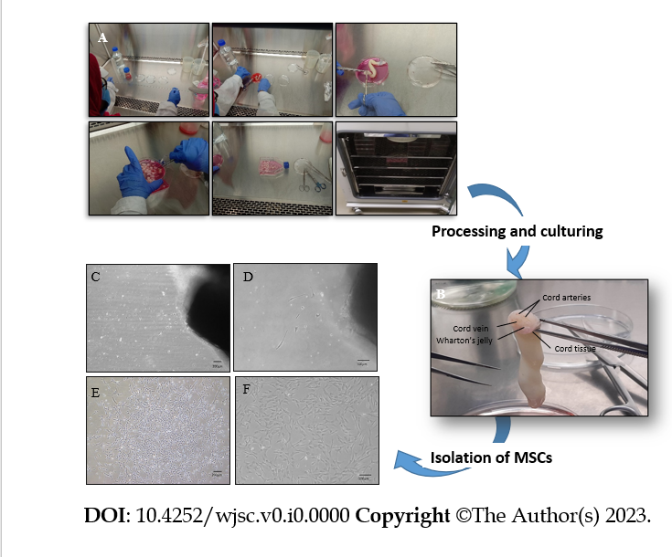
Figure 1 Processing and culturing of human umbilical cord tissue: A: Demonstration of the pictographic representation of human umbilical cord processing; B: Show cord tissue comprises one vein and two arteries surrounded by Wharton's jelly; C-F: Shows fibroblast-like morphology of mesenchymal stem cells at 4 × and 10 × magnifications at P₀ (C and D), while P₀ at a later stage shows elongated fibroblast-like morphology, which is interconnected with their extensions and is arranged in colonies (E and F).

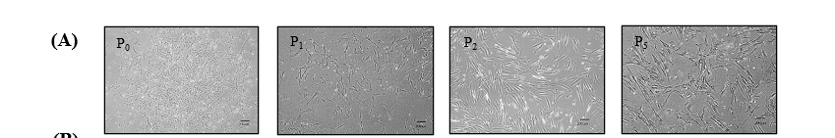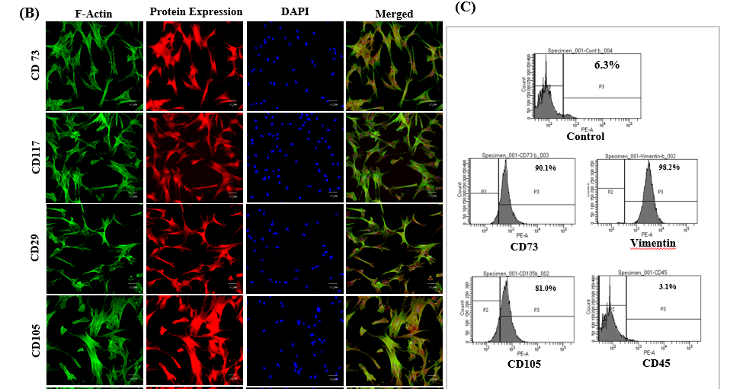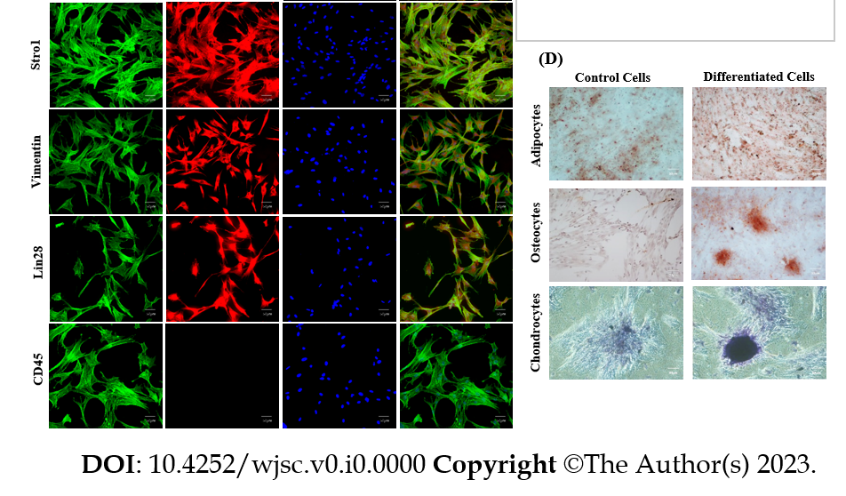
Figure 2 Characterization of human umbilical cord-derived mesenchymal stem cells. A: Isolated human umbilical cord-derived mesenchymal stem cells appeared as elongated, fibroblast-like cells which were slightly trigonal at P₀ and then gradually became elongated in latter passages (P₁, P₂, P₅); B: These cells positively expressed CD73, CD117, CD29, CD105, Stro1, Vimentin, and Lin28 while exhibiting negative expression of CD45; C: Cell surface analysis by flowcytometry showed that more than 80% of the cell population was positive for CD73, vimentin, and CD105 while less than 4% were positive for hematopoietic marker i.e. CD45; D: The cells were successfully differentiated into adipocytes, osteocytes, and chondrocytes. Oil red O stain, alizarin red S stain, and Alcian blue stain confirmed the presence of lipids vacuoles, calcium deposits, and glycosaminoglycan in adipocytes, osteocytes, and chondrocytes, respectively.

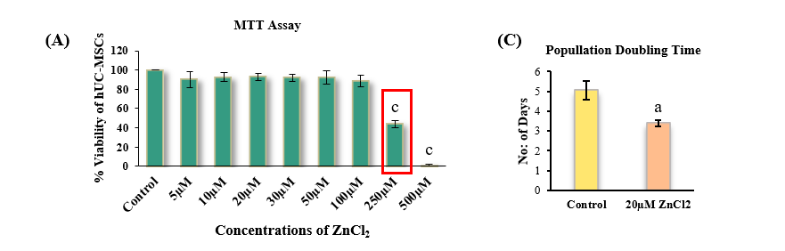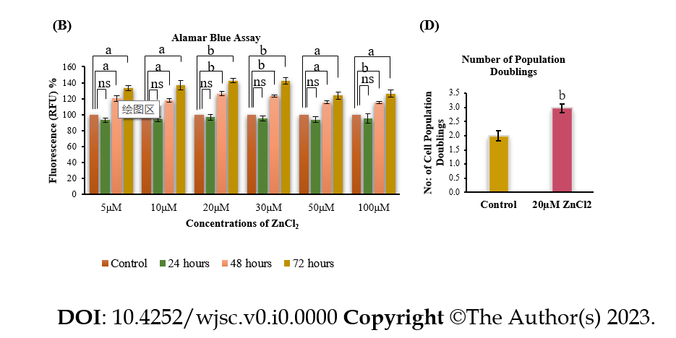
Figure 3 Cytotoxic analysis of ZnCl₂ for human umbilical cord-derived mesenchymal stem cells. A: Concentrations of ZnCl₂ 5 µM, 10 µM, 20 µM, 30 µM, 50 µM, 100 µM, 250 µM, and 500 µM, were analyzed for their cytotoxicity by MTT assay. Concentrations from 5 µM to 100 µM did not show any significant decrease in viability (Percent) of human umbilical cord (hUC)-derived mesenchymal stem cells (MSCs) compared to control. 250 µM reflected IC₅₀ value of ZnCl_{2,} and both 250 µM and 500 µM concentrations were found to be significantly (^{c}P ≤ 0.001) cytotoxic. Results were analyzed by performing one-way ANOVA and Post-Hoc Bonferroni test; B: Alamar blue assay analysis of hUC-MSCs after 24 h after ZnCl₂ did not exhibit any significant difference between control and test groups. But after 48 and 72 h, the proliferation of MSCs was significantly increased (ªP ≤ 0.05, ^{b}P ≤ 0.01) in all test groups. For further experiments, 20 µM of ZnCl₂ was selected as the test group concentration. C: Test group 20 µM ZnCl₂ exhibited significantly higher (^{b}P ≤ 0.01) NPD i.e., 2.9 ± 0.14, as compared to the control group, which showed 1.9 ± 0.18. Significantly reduced (ªP ≤ 0.05) D: PDT was observed in the test group i.e., approximately 3 d ± 0.16 in contrast to the control group having population doubling time of 5 ± 0.46 d. Results were analyzed by independent sample t-Test. Data is presented as mean ± SD (n = 3) where the significance level is ªP ≤ 0.05.
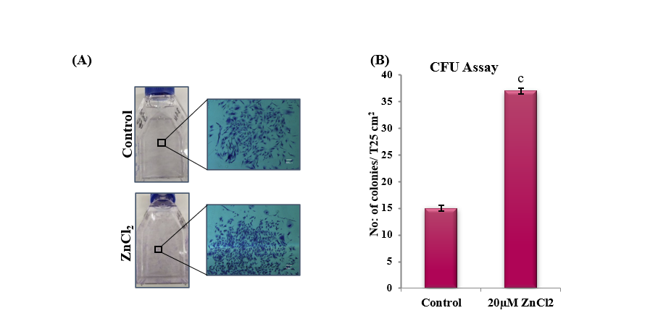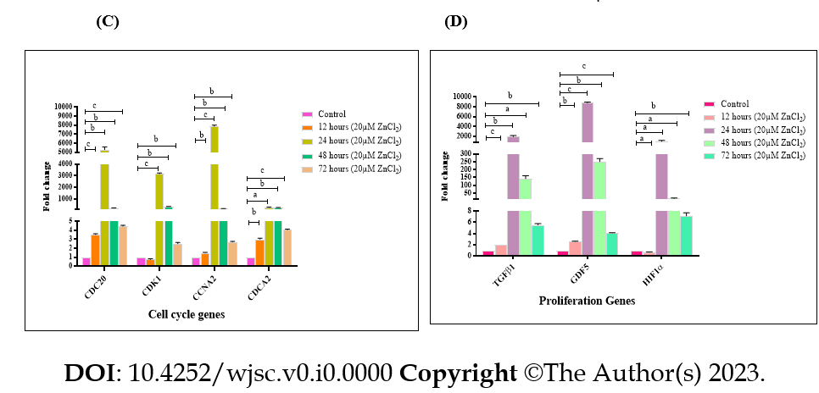
Figure 4 Colony forming unit Assay and transcriptional analysis of cell cycle and proliferation genes. A: Colonies after crystal violet staining in control and test groups. Denser colonies were observed in ZnCl₂ treated group. Images were captured at 4 × magnification; B: A significantly higher number (^{c}P ≤ 0.001) of colonies was observed in ZnCl₂ treated group with a mean number of 37 ± 0.57 colonies per T25 flask as compared to control i.e., 15 ± 0.57 colonies per T25 flask. Results were analyzed by SPSS, performing an independent sample t-Test. C: Gene expression of cell cycle genes CDC20, CCNA2, CDCA2 was significantly increased in the test group after 12, 24, 48, and 72 h of treatment with 20 µM ZnCl₂. No significant difference was found in CDK1 gene expression after 12, but it was significantly enhanced after 24, 48, and 72 h. This fold change (2^{-ΔΔCt}) increase in genes expression was highest in the 24-h group. D: Gene expression of proliferation genes transforming growth factor β1 and GDF5 were significantly increased in all temporal groups i.e. 12, 24, 48, and 72 h, of 20 µM ZnCl₂. HIF1α significantly decreased after 12 h but then significantly increased after 24, 48, and 72 h. Results were analyzed by SPSS, performing an independent sample t-Test. Data was represented as mean ± SD (n = 3) where significance level ªP ≤ 0.05 (ªP ≤ 0.05, ^{b}P ≤ 0.01, ^{c}P ≤ 0.001).
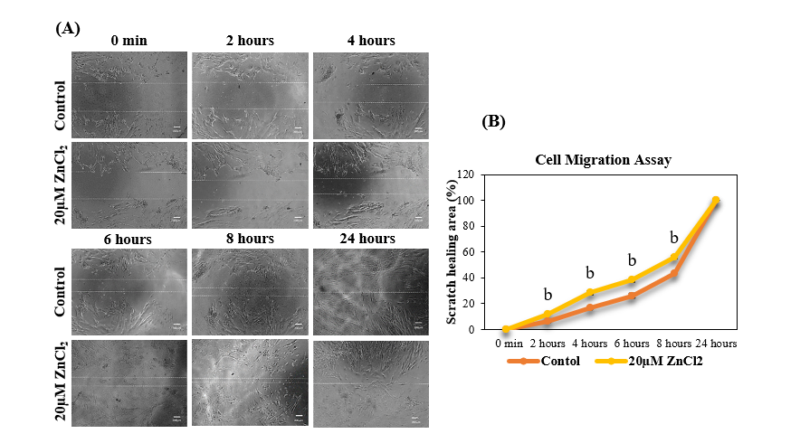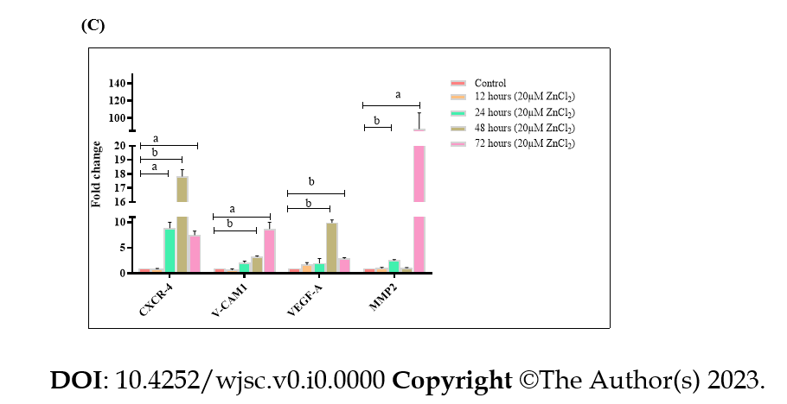
Figure 5 Effect of ZnCl₂ on the migration potential of human umbilical cord-derived mesenchymal stem cells. A: Microscopic examination of human umbilical cord (hUC)-derived mesenchymal stem cells (MSCs) immediately after the scratch was given, i.e., 0 h, and after 2 h, 4 h, 6 h, 8 h, and 24 h. MSCs of the test group (20 µM ZnCl₂) exhibited faster migration as compared to control at all time points up to 8 h, and the scratch was completely healed after 24 h in both groups; B: Percentage of the area of scratch healed at time points, i.e., 0 min, 2 h, 4 h, 6 h, 8 h, and 24 h, analyzed by independent sample t-test. MSCs exhibited a significantly (^{b}P ≤ 0.01) increased migration (Percent) in the test group (20 µM ZnCl₂). C: Gene expression analysis of migration factors CXCR-4, V-CAM 1, VEGF-A, and MMP2, after 12, 24, 48, and 72 h of 20 µM ZnCl₂ treatment. CRCR-4 exhibited significantly increased expression after 24 h, 48 h, and 72 h of treatment. V-CAM1, and VEGF-A showed significantly higher expression after 48 and 72 h of treatment. MMP2 showed enhanced expression after 24 and 72 h. Results were analyzed by independent sample t-Test. Data was analyzed as mean ± SD (n = 3) where significance level ªP ≤ 0.05 (ªP ≤ 0.05, ^{b}P ≤ 0.01, ^{c}P ≤ 0.001).
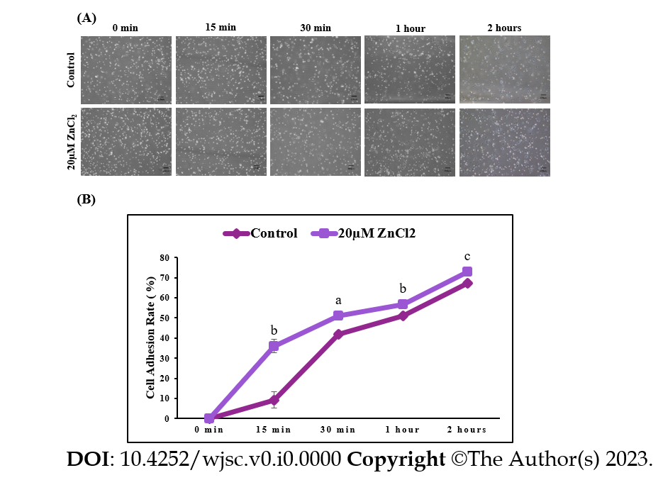
Figure 6 Effect ZnCl₂ on adhesion ability of human umbilical cord-derived mesenchymal stem cells. A: Images of human umbilical cord (hUC)-derived mesenchymal stem cells (MSCs) of the control group and 20 µM ZnCl₂ treated groups at 0 min, 15 min, 30 min, 1 h, and 2 h of cell seeding. Bright, rounded, and freely floating cells represent unadhered cells while dark cells represent adhered cells; B: Significant increase was observed in the adhesion ability of hUC-MSCs of the treated group after 15 min (^{b}P ≤ 0.01), 30 min (ªP ≤ 0.05),1 h (^{b}P ≤ 0.01), and 2 h (^{c}P ≤ 0.001). An independent sample t-test was performed to analyze results, and data were represented as mean ± SD (n = 3).
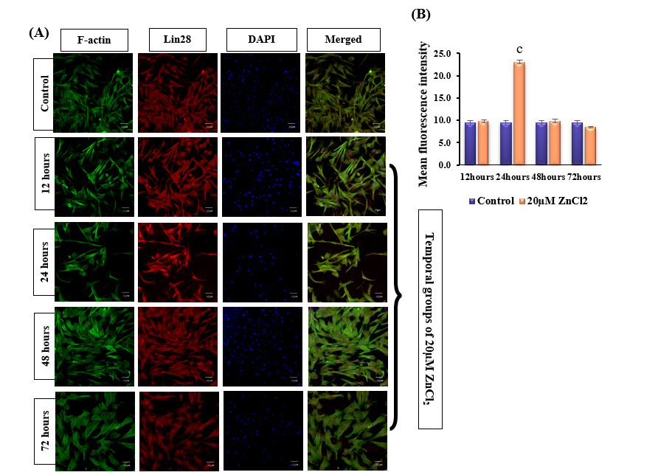

Figure 7 Protein expression of Lin28 and transcriptional analysis of pluripotency genes. A: Positive expression of mesenchymal stem cells (MSCs) specific marker Lin28 was observed after 12 h, 24 h,48 h, and 72 h of 20 µM ZnCl₂ treatment, as visualized by immunocytochemical staining; B: Quantified fluorescent intensities showed that 20 µM ZnCl₂ treated MSCs expressed Lin28 protein (^{c}P ≤ 0.001); C: Quantitative real-time polymerase chain reaction analysis of pluripotency genes OCT4, SOX2, and NANOG, exhibited significantly increased (ªP ≤ 0.05) expression of OCT4 at 12, 24, 48, and 72 h, while SOX2, and NANOG showed significantly increased expression at 24 and 48 h (ªP ≤ 0.05, ^{b}p ≤ 0.01). Results were analyzed by SPSS, performing an independent sample t-test. Data were analyzed as mean ± SD (n = 3) where significance level ªP ≤ 0.05.

Table 1 Primers for cell cycle and proliferation genes
S. No | Genes | Primer sequence (5’-3’) | Annealing temperature (ºC)
1 | GAPDH | (F) CCAGAACATCATCCCTGCCT | 58
 |  | (R) CCTGCTTCACCACCTTCTTG
2 | CDC20 | (F) TCCTGAGTCTGACCATGAGC | 58
 |  | (R) CTGAGGTGATGGGTTGGTCT
3 | CDK1 | (F) GGGGTCAGCTCGTTACTCAA | 58
 |  | (R) CACTTCTGGCCACACTTCAT
4 | CCNA2 | (F) CCAGGAGAATATCAACCCGGA | 58
 |  | (R) GGAACGGTGACATGCTCATC
5 | CDCA2 | (F) TCTGGGAGTAAGCCTGTCTG | 58
 |  | (R) AGGAGGTAATTCGGCATGCT
6 | TGFβ1 | (F) CAAGGCACAGGGGACCAG | 58
 |  | (R) CAGGTTCCTGGTGGGCAG
7 | GDF5 | (F) CACATCCCAAGAGCCCCTTC | 58
 |  | (R) GCCCAGGTGAGGAGAAATGG
8 | HIF1α | (F) CTCGAGATGCAGCCAGATCT | 58
 |  | (R) CCAGAAGTTTCCTCACACGC
9 | 45203 | (F) GATGTCAGGGCTCTTTGTCCA | 54
 |  | (R) TACTCTCCCCAGCTTGCTTTG
10 | SOX-2 | (F) CCCTGCAGTACAACTCCATGAC | 54
 |  | (R) GGTAGTGCTGGGACATGTGAAG
11 | NANOG | (F) AAGGCAAACAACCCACTTCTG | 54
 |  | (R) CCAGTTGTTTTTCTGCCACCT
12 | CXCR 4 | (F) ACTGAGAAGCATGACGGACA | 54
 |  | (R) TCATCTGCCTCACTGACGTT
13 | VCAM1 | (F) CCTGGGAAGATGGTCGTGAT | 54
 |  | (R) AGATGTGGTCCCCTCATTCG
14 | VEGF-A | (F) AGCGCAAGAAATCCCGGT | 54
 |  | (R) CCCTCCGGACCCAAAGTG
15 | MMP2 | (F) TTGACGGTAAGGACGGACTC | 54
 |  | (R) AGCGGAATGGAAACTTGCAG
Housekeeping gene: GAPDH (Glyceraldehyde-3 Phosphate Dehydrogenase); cell cycle genes: CDC20 (Cell-Division Cycle Protein 20), CDK1 (Cyclin-Dependent Kinase 1), CCNA2 (Cyclin-A2), CDCA2 (Cell Division Cycle Associated 2); proliferation genes: TGFβ (Transforming Growth Factor β1), 1, GDF5 (Growth Differentiation Factor 5), HIF1α (Hypoxia-Inducible Factor 1α); pluripotency genes: OCT-4 (Octamer-Binding Transcription Factor-4), SOX2 (SRY-box 2), NANOG; migration genes: CXCR 4 (Chemokine Receptor Type 4), VCAM1 (Vascular Cell Adhesion Molecule1), VEGF-A (Vascular Endothelial Growth Factor-A), MMP2 (Matrix Metallopeptidase 2).

