Name of Journal: World Journal of Clinical Cases
Manuscript NO: 42307
Manuscript Type: CASE REPORT

Ureteral double J stent displaced into vena cava and management with laparoscopy: A case report and review of the literature

Mao XW et al. Stent displaced into vena cava and laparoscopy

Xia-Wa Mao, Gang Xu, Jia-Quan Xiao, Hui-Feng Wu

Xia-Wa Mao, Gang Xu, Jia-Quan Xiao , Hui-Feng Wu, Department of Urology, The Second Affiliated Hospital of Zhejiang University School of Medicine, Hangzhou 310009, Zhejiang Province, China

ORCID number: Xia-Wa Mao (0000-0001-9882-5366); Gang Xu (0000-0002-8837-3498); Jia-Quan Xiao (0000-0002-7311-3212); Hui-Feng Wu (0000-0001-9874-7599).

Author contributions: Mao XW designed the research; Mao XW, Xu G and Xiao JQ performed the research; Mao XW and Wu HF analyzed the data; Mao XW wrote the paper.

Supported by the Program of Medical and Health Technology Development in Zhejiang Province, No. 2016147031.

Informed consent statement: All involved persons gave their written informed consent prior to study inclusion.

Conflict-of-interest statement: The authors declare that they have no conflicts of interest.
CARE Checklist (2016) statement: The authors have read the CARE Checklist (2016) and the manuscript was prepared and revised according to the CARE Checklist (2016).

Open-Access: This article is an open-access article which was selected by an in-house editor and fully peer-reviewed by external reviewers. It is distributed in accordance with the Creative Commons Attribution Non Commercial (CC BY-NC 4.0) license, which permits others to distribute, remix, adapt, build upon this work non-commercially, and license their derivative works on different terms, provided the original work is properly cited and the use is non-commercial. See: http://creativecommons.org/licenses/by-nc/4.0/

Manuscript source: Unsolicited manuscript

Correspondence to: Xia-Wa Mao, MD, Surgeon, Department of Urology, The Second Affiliated Hospital of Zhejiang University School of Medicine, 88 Jiefang Road, Hangzhou 310009, Zhejiang Province, China. evevev96@hotmail.com
Telephone: +86-571-87783777
Fax: +86-571-87783777

Received: September 30, 2018
Peer-review started: September 30, 2018
First decision: October 12, 2018
Revised: October 15, 2018
Accepted: October 23, 2018
Article in press:
Published online:

Abstract
We reported displacement of a ureteral double J stent into the vena cava and laparoscopic management in a 69-year-old patient with a history of ureteral stent placement. Preoperative computed tomography and plain X-rays showed malposition of the double J stent and displacement into the inferior vena cava. The characteristics of stent misplacement precluded endovascular procedures and explorative laparoscopic surgery was performed. The intra- and postoperative period was uneventful. Postoperative imaging demonstrated the new double J stent in the right position. The patient was discharged 7 d after operation and was symptom free at 4-mo follow-up.

Key words: Double J stent; Displacement; Inferior vena cava; Laparoscopy

© The Author(s) 2018. Published by Baishideng Publishing Group Inc. All rights reserved.

Core tip: Ureteral double J stent displacement into the vena cava is a rare complication in urology. Only six cases have been reported in the literature and all stents were removed by various methods except laparoscopy. Here, we report our experience of such a case.

Mao XW, Xu G, Xiao JQ, Wu HF. Ureteral double J stent displaced into vena cava and management with laparoscopy: A case report and review of the literature. World J Clin Cases 2018; In press

INTRODUCTION
Ureteral double J stent is usually used for maintaining urine flow from the kidney to the bladder, preventing stenosis, and surgery of ureteral injuries^{[1]}. Traditionally, the procedure is performed under cystoscopic guidance with or without the aid of X-rays. Unavoidably, the double J stent will cause complications including encrustation, fragmentation, distal and proximal migration, and lower urinary tract symptoms^{[2]}. Most of them are mild and self-limited and can be alleviated by conservative interventions. However, the double J stent is rarely displaced into the vena cava through the ureter. Stent displacement can be managed by percutaneous removal, or open surgery combined with vascular surgery^{[3-8]}. We here present a case of double J stent displacement into the vena cava and successful laparoscopic removal.

CASE REPORT
A 69-year-old patient with recurrent left flank pain and vomiting for 15 d was admitted to our hospital. He had a history of urinary stones and received extracorporeal shock wave lithotripsy for a left ureteral stone 8 and 3 years ago. Bilateral ureteral double J stents were placed due to anuria 1 d before the patient was referred to us. Postoperative X-rays demonstrated malposition of the left ureteral double J stent (Figure 1). Caval migration was highly suspected. Computed tomography (CT) showed that the left double J stent penetrated the bladder, then into the left common iliac vein, and finally into the inferior vena cava (IVC) (Figure 2). The upper end of the double J stent was at the level of the right renal vessels and not the heart, which made the case more complicated^{[8]}.
We planned to remove the migrated catheter laparoscopically based on the following factors. First, it was likely that the catheter had migrated into the vena cava from a small vessel, indicating that it would be feasible to perform the surgery laparoscopically. Second, the surgeon had performed a large number of laparoscopic operations and had experienced several similar cases, although not entirely the same. Our surgical plan was divided into four main steps: removing the catheter, repairing the vessel, repairing the ureter, and replacing the stent. Laparoscopic surgery was performed through three ports: optical access at a site 1 cm left of the umbilicus; 5-mm operative accesses on the lesion side; and one 10-mm access at the intersection of the umbilicus and anterior axillary line. After incising the peritoneum and reflecting the left colon, the ureter was identified. We noted by laparoscopic touch that the stent was not inside the ureter. Therefore, we opened the bladder and pulled the stent from the inside. A slight movement of one small vein near the bladder was observed. The vein, which proved to be the vena obturatoria, was thoroughly dissected and the stent was found inside the vein (Figure 3). The double J stent was removed from the vein from inside the bladder, and one Hem-o-lok clip was placed in the distal vein. Meanwhile, a minor ureteral injury was detected and repaired with 5/0 vicryl sutures. A new 6F double J stent was introduced into the ureter. The bladder was closed with 2/0 vicryl sutures. Finally, a small drain was inserted via the 5-mm port.
Postoperatively, the patient was started on anticoagulation therapy for 3 d and had an uneventful recovery. Postoperative X-rays confirmed that the new double J stent was in the right position. The patient was discharged 7 d after the operation. The new double J stent was removed cystoscopically 4 wk after surgery. The patient was followed for 3 mo, and 1 year after surgery, no sequelae were found with CT and ultrasound.

DISCUSSION
Ureteral stent placement, either antegrade or retrograde, is a prevalent intervention procedure. It causes various complications including encrustation, fracture, and migration proximally and distally. Rare complications include stent knotting and vascular migration (Table 1)^{[3,6,7,9]}. The presence of the stent within a ureter adjacent to a pulsating vascular structure, either a normal vessel or graft, appears to be favorable for erosion to occur^{[10]}. Michalopoulos et al^{[4]} first reported a case of intravascular migration of a stent placed intraoperatively in the right ureter that migrated into the venous circulation.
In our patient, due to ureteral twisting or fragile bladder mucosa, the surgeon might have had difficulty placing the guidewire, which possibly penetrated directly out of the lower part of the ureter, and then into the adjacent vessel. If so, this would have caused gross hematuria and poor surgical vision. Subsequently, a ureteral stent was introduced through the guidewire and displaced into the IVC ultimately. It should be noted that the procedure has to be performed under X-ray monitoring, which may detect such a complication. Accordingly, it would be possible for the surgeon to correct it during the operation. However, it was unusual in our case that displacement into the circulation did not cause severe bleeding but rather moderate gross hematuria, so it seemed that the procedure was uneventful. The diagnosis of stent displacement can be established by postoperative plain abdominal radiography and CT imaging.
Endovascular management of arterioureteral fistula has been previously described^{[11-14]}. It seems to be an ideal treatment in such a situation. Nevertheless, to make it clear we decided to perform laparoscopic exploration because the lower end of the stent was still inside the bladder. Furthermore, the bladder should be explored to confirm its integrity. As stent migration did not cause severe bleeding, we believed that the operation could be attempted by laparoscopy. During the procedure, we observed that the stent went into the left common iliac vein through the vena obturatoria, which is a small vein. Undoubtedly, if the stent had penetrated directly into the adjacent major vein, open surgery would have been more feasible and safer.
In conclusion, the displacement of ureteral stents into the vascular system is a rare complication in urology. The key to prevention includes scopic guidance with X-ray monitoring, high degree of suspicion, and early intervention. The treatment options include endovascular, percutaneous or open surgery, as well as laparoscopy.

ARTICLE HIGHLIGHTS
Case characteristics
A rare case with ureteral stent displacement into vena cava.

Clinical diagnosis
After admission, kidney, ureter, bladder X-ray (KUB) combined with computed tomography (CT) scan confirmed that the left ureteral stent was in the inferior vena cava (IVC).

Differential diagnosis
Theoretically, ureteral stent malposition or placed outside of the ureter is not a rare complication. However, stent displacement into the IVC makes the case more complex and dangerous. CT scan can confirm the diagnosis.

Laboratory diagnosis
The laboratory tests showed normal plasma levels of hemoglobin (115 g/L, normal range 110–150 g/L) and minor gross hematuria (RBC⁺⁺⁺).

Imaging diagnosis
CT reconstruction combined with KUB showed the left ureteral stent in the IVC. The upper pole of the stent was at the kidney level and the lower pole was inside the bladder.

Pathological diagnosis
Pathological examination was not necessary in this case.

Treatment
Based on previous experiences, we performed the operation laparoscopically and removed the stent successfully.

Term explanation
Ureteral stent displacement is defined as the stent not being in the right position but somewhere outside the ureter. Usually the stent may only be placed in the nearby fat tissue and does not cause severe complications and sequelae.

Experiences and lessons
The ureteral stent has to be placed under X-ray guidance. Displacement of the stent should be suspected when unusual or unexpected bleeding occurs after endoscopic surgery.

REFERENCES
1 Brotherhood H, Lange D, Chew BH. Advances in ureteral stents. Transl Androl Urol 2014; 3: 314-319 [PMID: 26816785 DOI: 10.3978/j.issn.2223-4683.2014.06.06]
2 Ahallal Y, Khallouk A, El Fassi MJ, Farih MH. Risk factor analysis and management of ureteral double-j stent complications. Rev Urol 2010; 12: e147-e151 [PMID: 20811552]
3 Falahatkar S, Hemmati H, Gholamjani Moghaddam K. Intracaval migration: an uncommon complication of ureteral Double-J stent placement. J Endourol 2012; 26: 119-121 [PMID: 22192115 DOI: 10.1089/end.2011.0469]
4 Michalopoulos AS, Tzoufi MJ, Theodorakis G, Mentzelopoulos SD. Acute postoperative pulmonary thromboembolism as a result of intravascular migration of a pigtail ureteral stent. Anesth Analg 2002; 95: 1185-1188 [PMID: 12401589 DOI: 10.1097/00000539-200211000-00011]
5 Garrido Abad P, Fernández Arjona M, Fernández González I, Santos Arrontes D, Pereira Sanz I. [Proximal migration of a Double J catheter: case report and review of the literature]. Arch Esp Urol 2008; 61: 428-431 [PMID: 18581681 DOI: 10.4321/S0004-06142008000300010]
6 Ioannou CV, Velegrakis J, Kostas T, Georgakarakos E, Touloupakis E, Anezinis P, Katsamouris AN. Caval migration of a ureteral J-stent after simultaneous ureter and iliac vein perforation during its placement for obstructive pyelonephritis. Int Angiol 2009; 28: 421-424 [PMID: 19935599]
7 Sabnis RB, Ganpule AP, Ganpule SA. Migration of double J stent into the inferior vena cava and the right atrium. Indian J Urol 2013; 29: 353-354 [PMID: 24235801 DOI: 10.4103/0970-1591.120125]
8 Hastaoglu IO, Tokoz H, Kavlak E, Bilgen F. Double J ureteral stent displaced through the right ventricle. Interact Cardiovasc Thorac Surg 2014; 18: 853-854 [PMID: 24632423 DOI: 10.1093/icvts/ivu037]
9 Sighinolfi MC, De Stefani S, Micali S, Mofferdin A, Baisi B, Celia A, Bianchi G. A knotted multi-length ureteral stent: a rare complication. Urol Res 2005; 33: 70-71 [PMID: 15625611 DOI: 10.1007/s00240-004-0441-7]
10 Bergqvist D, Pärsson H, Sherif A. Arterio-ureteral fistula--a systematic review. Eur J Vasc Endovasc Surg 2001; 22: 191-196 [PMID: 11506509 DOI: 10.1053/ejvs.2001.1432]
11 Asham EH, Walsh M, Adiseshiah M. An unusual case of haematuria treated by endoluminal repair. Eur J Vasc Endovasc Surg 1999; 17: 89-90 [PMID: 10071625 DOI: 10.1053/ejvs.1998.0673]
12 el Khader K. [Complications of double J ureteral stents]. J Urol (Paris) 1996; 102: 173-175 [PMID: 9091568]
13 Gibbons M, O'Donnell S, Lukens M, Meglin A, Costabile RA. Treatment of a ureteroiliac artery fistula with an intraluminal endovascular graft. J Urol 1998; 159: 2083-2084 [PMID: 9598529 DOI: 10.1016/S0022-5347(01)63260-9]
14 Vandersteen DR, Saxon RR, Fuchs E, Keller FS, Taylor LM Jr, Barry JM. Diagnosis and management of ureteroiliac artery fistula: value of provocative arteriography followed by common iliac artery embolization and extraanatomic arterial bypass grafting. J Urol 1997; 158: 754-758 [PMID: 9258074 DOI: 10.1097/00005392-199709000-00015]
P-Reviewer: Desai DJ, Mazaris E S-Editor: Wang JL L-Editor: E-Editor:

Specialty type: Medicine, research and experimental
Country of origin: China
Peer-review report classification
Grade A (Excellent): 0
Grade B (Very good): B
Grade C (Good): C
Grade D (Fair): 0
Grade E (Poor): 0

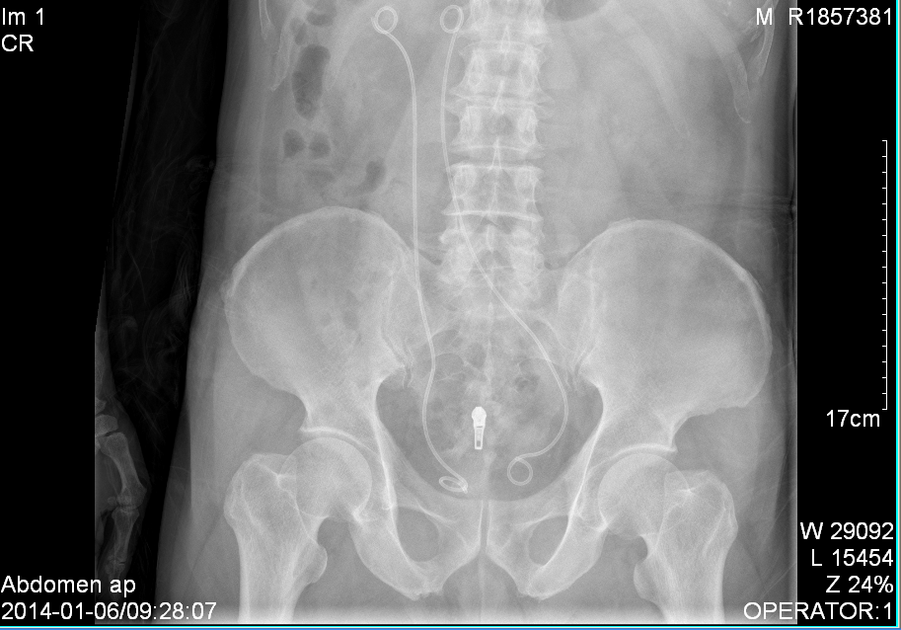
Figure 1 Plain kidney, ureter, and bladder X-ray showing the left ureteral stent in malposition.

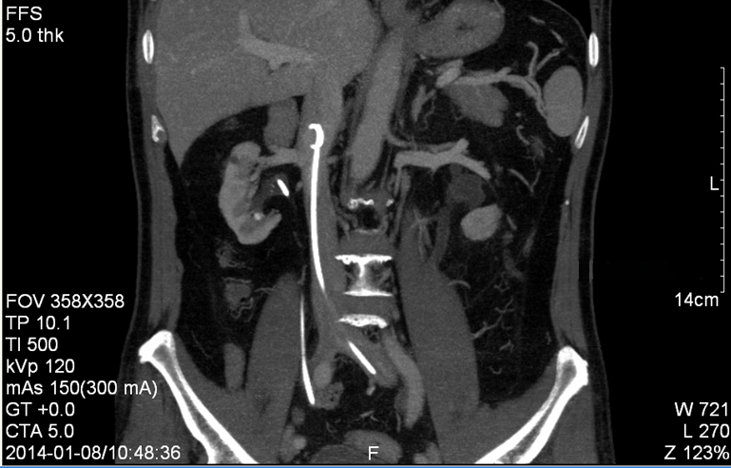
Figure 2 Computed tomography reconstruction of the abdomen confirmed the left ureteral stent in the inferior vena cava.

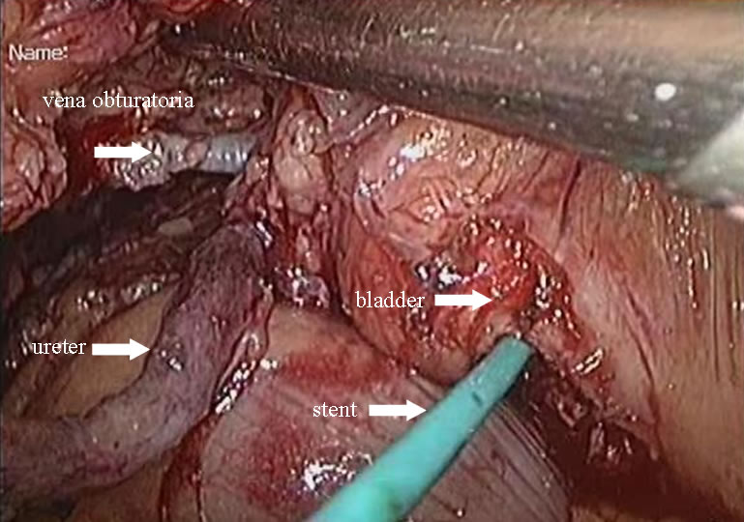
Figure 3 Surgical video screen capture demonstrated the corresponding anatomy.

Table 1 Published literature on the management of double J stent displacement into inferior vena cava
First author | Year of publication | No. of patients | Clinical manifestation | Management | Upper end of stent | Primary disease
Michalopoulos et al^{[4]} | 2002 | 1 | Pulmonary thromboembolism | Percutaneous removal through right femoral vein | IVC | Renal stone operation
Garrido et al^{[5]} | 2008 | 1 | Loin pain and fever | Removal through percutaneous nephrostomy | IVC | Gynecologic surgery
Ioannou et al^{[6]} | 2009 | 1 | Microscopic hematuria | Open surgery through left retroperitoneal approach | IVC | Obstructive pyelonephritis
Falahatkar et al^{[3]} | 2012 | 1 | Urinary incontinence | Percutaneous removal through left femoral vein | Right atrium | Hysterectomy
Sabnis et al^{[7]} | 2013 | 1 | History of ureteroscopy | Exploration  through Gibson’s incision | Right atrium | Ureteral stone operation
Hastaoglu et al^{[8]} | 2014 | 1 | Hematuria | Open surgery under cardiopulmonary  bypass | Right ventricle | Ureteral stone operation
IVC: Inferior vena cava.

