Name of Journal: World Journal of Gastrointestinal Surgery
Manuscript NO: 84958
Manuscript Type: ORIGINAL ARTICLE

Retrospective Study
Regional differences in islet amyloid deposition in the residual pancreas with new-onset diabetes secondary to pancreatic ductal adenocarcinoma

Wang R et al. IAPP in NOD secondary to PDAC

Rui Wang, Ya Liu, Yan Liang, Li Zhou, Mao-Jia Chen, Xu-Bao Liu, Chun-Lu Tan, Yong-Hua Chen

Rui Wang, Xu-Bao Liu, Chun-Lu Tan, Yong-Hua Chen, Division of Pancreatic Surgery, Department of General Surgery, West China Hospital, Sichuan University, Chengdu 610041, Sichuan Province, China

Ya Liu, Department of General Surgery, Chengdu Second People's Hospital, Chengdu 610041, Sichuan Province, China

Yan Liang, Li Zhou, Core Facilities, West China Hospital, Sichuan University, Chengdu 610041, Sichuan Province, China

Mao-Jia Chen, Animal Experimental Center, West China Hospital, Sichuan University, Chengdu 610041, Sichuan Province, China

Author contributions: Chen YH and Tan CL contributed equally to this work; Chen YH, Tan CL and Liu XB conceived and designed the research; Wang R, Liu Y, Liang Y, Zhou L and Chen MJ collected the data and conducted the research; Wang R, Liu Y, Liang Y, Zhou L and Chen MJ analysed and interpreted the data; Wang R and Liu Y wrote the initial paper; Chen YH and Tan CL revised the paper; all authors contributed to the article and approved the submitted version.

Supported by the Key Research and Development Projects in Sichuan Province, No. 2019YFS0043; and 1·3·5 Project for Disciplines of Excellence, West China Hospital, Sichuan University, No. ZY2017302-1.3.5.

Corresponding author: Yong-Hua Chen, MD, PhD, Associate Professor, Division of Pancreatic Surgery, Department of General Surgery, West China Hospital, Sichuan University, No. 37 Guoxue Alley, Wuhou District, Chengdu 610041, Sichuan Province, China. chenyonghua2007@163.com

Received: April 5, 2023
Revised: May 16, 2023
Accepted: June 6, 2023
Published online: August 27, 2023

Abstract
BACKGROUND
Islet amyloid deposition and reduced β-cell mass are pathological hallmarks in type 2 diabetes mellitus subjects. To date, the pathological features of the islets in diabetes secondary to pancreatic ductal adenocarcinoma (PDAC) have not been specifically addressed.

AIM
To provide further insight into the relationship between islet amyloid deposition of the residual pancreas in PDAC patients and to explore whether regional differences (proximal vs distal residual pancreas) are associated with islet amyloid deposition.

METHODS
We retrospectively collected clinical information and pancreatic tissue removed from tumors of 45 PDAC patients, including 14 patients with normal glucose tolerance (NGT), 16 patients with prediabetes and 15 new-onset diabetes (NOD) patients diagnosed before surgery by an oral glucose tolerance test at West China Hospital from July 2017 to June 2020. Pancreatic volume was calculated by multiplying the estimated area of pancreatic tissue on each image slice by the interval between slices based on abdominal computer tomography scans. Several sections of paraffin-embedded pancreas specimens from both the proximal and/or distal regions remote from the tumor were stained as follows: (1) Hematoxylin and eosin for general histological appearance; (2) hematoxylin and insulin for the determination of fractional β-cell area (immunohistochemistry); and (3) quadruple insulin, glucagon, thioflavin T and DAPI staining for the determination of β-cell area, α-cell area and amyloid deposits.

RESULTS
Screening for pancreatic histologic features revealed that duct obstruction with islet amyloid deposition, fibrosis and marked acinar atrophy were robust in the distal pancreatic regions but much less robust in the proximal regions, especially in the prediabetes and NOD groups. Consistent with this finding, the remnant pancreatic volume was markedly decreased in the NOD group by nearly one-half compared with that in the NGT group (37.35 ± 12.16 cm³ vs 69.79 ± 18.17 cm³, P < 0.001). As expected, islets that stained positive for amyloid (islet amyloid density) were found in the majority of PDAC cases. The proportion of amyloid/islet area (severity of amyloid deposition) was significantly higher in both prediabetes and NOD patients than in NGT patients (P = 0.002; P < 0.0001, respectively). We further examined the regional differences in islet amyloid deposits. Islet amyloid deposit density was robustly increased by approximately 8-fold in the distal regions compared with that in the proximal regions in the prediabetes and NOD groups (3.98% ± 3.39% vs 0.50% ± 0.72%, P = 0.01; 12.03% vs 1.51%, P = 0.001, respectively).

CONCLUSION
In conclusion, these findings suggest that robust alterations of the distal pancreas due to tumors can disturb islet function and structure with islet amyloid formation, which may be associated with the pathogenesis of NOD secondary to PDAC.

Key Words: Pancreatic ductal adenocarcinoma; Diabetes; Amyloid deposits; Islet amyloid polypeptide; Residual pancreas

©The Author(s) 2023. Published by Baishideng Publishing Group Inc. All rights reserved.

Citation: Wang R, Liu Y, Liang Y, Zhou L, Chen MJ, Liu XB, Tan CL, Chen YH. Regional differences in islet amyloid deposition in the residual pancreas with new-onset diabetes secondary to pancreatic ductal adenocarcinoma. World J Gastrointest Surg 2023; 15(8): 1703-1711
URL: https://www.wjgnet.com/1948-9366/full/v15/i8/1703.htm
DOI: https://dx.doi.org/10.4240/wjgs.v15.i8.1703

Core Tip: This retrospective study investigated the relationship between islet amyloid deposition of the residual pancreas in 45 pancreatic ductal adenocarcinoma (PDAC) patients with different glycemic status and to explore whether regional differences (proximal vs. distal residual pancreas) are associated with islet amyloid deposition. Our findings suggest that robust alterations of the distal pancreas due to tumors can disturb islet function and structure with islet amyloid formation, which may be associated with the pathogenesis of new-onset diabetes secondary to PDAC.

INTRODUCTION
Type 3c (pancreatogenic) diabetes mellitus (T3cDM) occurs due to inherited or acquired pancreatic disease or resection^{[1]} and accounts for 5%-10% of patients with diabetes in Western countries^{[2]}. Although it is similar to the more prevalent type 1 diabetes mellitus and type 2 diabetes mellitus (T2DM), T3cDM has a unique pattern of metabolic and hormonal characteristics and a high incidence of pancreatic tumors in the majority of patients^{[3]}. Moreover, longstanding T2DM has been recognized as a modest risk factor for pancreatic ductal adenocarcinoma (PDAC)^{[4]}. In turn, there is increasing evidence that PDAC is a markedly diabetogenic state and can cause new-onset diabetes (NOD)^{[3,5]}.
The formation of islet amyloid occurs by aggregation of islet amyloid polypeptide (IAPP, or amylin), which is normally cosecreted with insulin by β cells and has a regulatory effect on metabolism^{[6,7]}. Islet amyloid deposition and reduced β-cell mass are pathological hallmarks in T2DM subjects^{[8,9]}. Although islet amyloid deposits occur in the majority of patients with diabetes, they have also been reported in a small proportion of subjects who are apparently nondiabetic, especially in elderly individuals^{[10]}. A recent study reported that islet amyloid deposits are not restricted to patients with T2DM alone but also occur at similar abundancies in patients with diabetes due to exocrine pancreatic disorders^{[11]}. In addition, in patients with diabetes secondary to PDAC, insulin secretion is often diminished despite the presence of insulin resistance^{[12]}. Thus, the etiologies and pathophysiological hallmarks of T2DM and diabetes secondary to PDAC appear to be largely different from each other.
To date, the pathological features of the islets in diabetes secondary to PDAC have not been specifically addressed. In the present study, we sought to provide further insight into the relationship between islet amyloid deposition in the residual pancreas in PDAC patients and hyperglycemia and to explore, for the first time, whether regional differences (proximal vs. distal residual pancreas) are associated with islet amyloid deposition and/or reduced β-cell area.

MATERIALS AND METHODS
Subjects
In the present study, we retrospectively collected pancreatic tissue from 45 PDAC patients, including 14 patients with normal glucose tolerance (NGT), 16 patients with prediabetes and 15 NOD patients diagnosed before surgery by oral glucose tolerance test (OGTT)^{[13]} at West China Hospital from July 2017 to June 2020. Subjects were excluded if the patients’ history indicated a diagnosis of DM before the diagnosis of PDAC. A 2 h OGTT was performed on the day before the operation. After an overnight fast of at least 8 h, a 75-g OGTT was performed in all subjects at 8:00 AM. Blood samples were drawn at baseline and 120 min as collection information of fasting plasma glucose (FPG) and 2 h plasma glucose. Diabetes and prediabetes were diagnosed and classified based on glucose tolerance according to World Health Organization (WHO) recommendations^{[13]}. Accordingly, individuals were classified as normoglycemia (FPG < 6.1 mmol/L and 2 h plasma glucose < 7.8 mmol/L), prediabetes (FPG = 6.1-6.9 mmol/L and/or 2 h plasma glucose = 7.8-11 mmol/L) or diabetes (FPG ≥ 7.0 mmol/L and/or 2 h plasma glucose ≥ 11.1 mmol/L). The study was approved by the Biomedical Research Ethics Committee of West China Hospital, Sichuan University (2014No.37). Informed consent was acquired from all individual participants and/or guardians included in the study.

Determination of remnant pancreatic volume
To determine the remnant pancreatic volume of the PDAC patients, abdominal computed tomography scans were analyzed as described in our previous study. Using all slices involving pancreatic tissue, the pancreatic tissue contours were annotated by freehand to generate the area of the pancreas for each slice. In the next step, the estimated area of pancreatic tissue on each image slice was multiplied by the interval between slices to derive the volume of the entire pancreas.

Tissue preparation and histological assessments
Specimens were routinely sampled from both the head and distal regions adjacent to the tumor site and fixed in 10% buffered formalin. Only tumor-distant tissue (at least 0.5 cm distant from the tumor margin) was analyzed. Several consecutive 4 mm thick sections of paraffin-embedded pancreas specimens from both the proximal and/or distal regions remote from the tumor were stained as follows^{[11,14]}: (1) Hematoxylin and eosin for general histological appearance; (2) hematoxylin and insulin for the determination of fractional β-cell area (immunohistochemistry); and (3) quadruple insulin, glucagon, thioflavin T and DAPI staining for the determination of β-cell area, α-cell area and amyloid deposits (Thioflavin T#T1892-25G and DAPI#28718-90-3, Sigma; insulin#EM80714 and glucagon#ET1702-20; Huabio). Together with conventional microscopic observations, morphometric analysis of the islet and islet endocrine cells was conducted on immunostained sections.

Image acquisition and analysis
Quadruple-stained tissue slices were scanned with a laser-scanning confocal microscope, and images were acquired with NIS-Elements Viewer software (Nikon, Japan). The extent of islet amyloid deposits was expressed as the average percentage of amyloid-positive area relative to total islet area^{[11]}. As in previous studies in the field of β-cell research^{[11,15]}, one tissue section was examined per patient. Quadruple-stained tissue slices were imaged at 200-fold magnification, and 20 islets larger than four cells were studied in detail from each individual. The ratio of α- to β-cell area (α/β) was digitally measured using NIS-Elements Viewer software (Nikon, Japan) as previously reported^{[16]}. Our primary outcome was a comparison of the islet amyloid deposition of the proximal and distal regions of the residual pancreas in patients with NOD secondary to PDAC.

Statistical analysis
All the data were analyzed by SPSS version 26.0 (IBM, New York, NY, United States). Data are presented as frequencies for categorical variables and mean ± SD for continuous variables. Differences between groups were analyzed using the Wilcoxon signed-rank test or independent samples t test for continuous data and Pearson’s chi-square test for categorical data. A two-sided P value less than 0.05 indicated a statistically significant difference.

RESULTS
Clinical data
As shown in Table 1, the major clinical profiles were comparable among the three groups. The average body mass index (BMI) and age were comparable among all groups. No statistically significant differences were detected in the plasma lipid, serum creatinine and CA19-9 concentrations among all groups. The surgical method and the TNM stage were comparable among the three groups.

Pathological features and remnant pancreatic volume
Screening for pancreatic histologic features revealed that duct obstruction with islet amyloid deposition, fibrosis and marked acinar atrophy were robust in the distal pancreatic regions but much less robust in the proximal regions, especially in the prediabetes and NOD groups (Figures 1 and 2). Consistent with this finding, the remnant pancreatic volume was markedly decreased in the NOD group by nearly one-half compared with that in the NGT group (37.35 ± 12.16 cm³ vs 69.79 ± 18.17 cm³, P < 0.001). The remnant pancreatic volume was decreased in the prediabetic group, and the average was smaller than that in the NGT group (51.99 ± 15.63 cm³ vs 69.79 ± 18.17 cm³, P = 0.003).

Islet amyloid deposits in the remnant pancreas
None of the specimens that were stained positive for amyloid were related to malignant tumors of the pancreas. As expected, islets that stained positive for amyloid (islet amyloid density) were found in the majority of prediabetes and NOD cases but not in NGT cases (93.75% and 93.33% vs 50%). The proportion of amyloid/islet area (severity of amyloid deposition) was significantly higher in both prediabetes and NOD patients than in NGT patients (P = 0.002; P < 0.0001, respectively). The proportion of the islet occupied by amyloid was 3.63 ± 3.17% in pre-DM and 10.45 ± 6.78% in DM (P = 0.006). One case (6.25%) in NOD and one case (6.67%) in pre-DM were completely free from amyloid. Among 14 cases of NGT, seven (50%) showed minimal amyloid deposition, and the other 7 cases were completely free from amyloid.

Regional differences in islet amyloid deposits
We further examined the regional differences in islet amyloid deposits (10 cases per group). The comparison of islet amyloid density in the head and distal regions is shown in Table 1. Interestingly, islet amyloid deposit density was robustly increased approximately 8-fold in the distal regions compared with the proximal regions in the prediabetes and NOD groups. In the NOD cases, the mean islet amyloid density was 12.03% in the distal regions vs 1.51% in the proximal regions (P = 0.001). Furthermore, a similar increase in islet amyloid density was observed in patients with prediabetes between the proximal and distal regions (0.50 ± 0.72% and 3.98 ± 3.39%, respectively, P = 0.01). In the NGT cases, there was a proportionate increase in islet amyloid density in the distal regions compared to the proximal regions (0.006 ± 0.013% and 0.37 ± 0.43%, respectively, P = 0.026).

DISCUSSION
In the present study, to the best of our knowledge, we characterized for the first time the regional heterogeneity of islet amyloid deposition in the remnant pancreas of patients with NOD secondary to PDAC. We also revealed the differences between the distal and proximal pancreas in NOD patients, which was characterized by ductal lesions and pancreas atrophy accompanied by islet amyloid deposition. In the NOD groups, the islet amyloid deposit density in the distal regions was approximately 8-fold higher than that in the proximal regions. Consistent with this finding, the remnant pancreatic volume was markedly decreased in the NOD group by nearly one-half compared with that in the normoglycemia groups.
The pathophysiology of diabetes is generally divided into insulin resistance and pancreatic islet dysfunction. In particular, the loss of endocrine cells due to islet amyloid deposits is an important pathological change in T2DM patients^{[17,18]}. Intraislet capillary density was linearly correlated with the severity of islet amyloid deposits, which might be both a cause and a consequence of islet amyloid and T2DM^{[19]}. In addition, pathological changes in the islets may be different in each individual with T2DM and reflect each pathophysiology^{[8]}. Amyloid aggregation and deposition have an influence on diabetic pathology and may be drivers of the pathogenesis of diabetes^{[20,21]}. Islet amyloid was more common with severe β-cell loss and high BMI and associated with macrophage infiltration in Japanese patients with T2DM^{[15]}. Interestingly, detection of circulating cell-free DNA, including IAPP, by sera is valuable in identifying type 2 diabetes and healthy individuals^{[22]}. In addition, endoplasmic reticulum stress is a mechanism of IAPP-induced β-cell apoptosis that is characteristic of β-cells in humans with type 2 diabetes^{[23]}.
One of the main pathologic features of PDAC is the obstruction of the pancreatic ducts due to tumors with distal exocrine atrophy, inflammation and fibrosis. In turn, autodestruction and inflammation of exocrine acinar tissue may cause islet destruction and amyloid deposition and likely combine to suppress the ability of β-cells to exhibit normal insulin secretory dynamics in NOD, resulting in the onset of diabetes. Rivera et al^{[24]} indicated that autophagy/Lysosomal degradation can defend β cells against proteotoxicity induced by oligomerization-prone human IAPP. In fact, NOD caused by PDAC is associated with proinflammatory alterations, insulin resistance, and perturbations in β-cell functions that lead to loss of glucose homeostasis^{[25]}. Recent research has suggested that transdifferentiation and dedifferentiation are involved in the decrease in β-cell volume in patients with PDAC and that β-cell volume might change dynamically depending on the glucose metabolic state^{[12]}. Our finding is consistent with prior research on the occurrence of amyloid deposits in both diabetes secondary to pancreatic disorders and T2DM^{[11]}. Therefore, islet amyloid deposition may be associated with the pathogenesis of NOD secondary to PDAC.
In the human pancreas, islet cellular composition and structure are similar throughout the pancreas, and there is no difference in insulin secretion stimulated by glucose in islets isolated from different regions^{[26]}. In diabetic cats, there was no difference in the amount of amyloid between the left limb middle segment and right limb of the pancreas^{[27]}. However, Wang et al^{[26]} revealed distinct characteristics of the human pancreas in that there was preferential loss of large islets in the head region in patients with T2DM. In the present study, the abundance of amyloid deposits in the distal pancreas, not the proximal pancreas, of PDAC patients was a novel finding, and we noted various disruptions in distal pancreas morphology, with pancreatic atrophy and massive fibrosis accompanied by amyloid deposition. Consistent with this finding, the remnant pancreatic volume was markedly decreased in the NOD group by nearly one-half compared with that in the normoglycemia groups. In one study, patients with Type 1 Diabetes had a 26% reduction in pancreatic volume within a few months after diagnosis, suggesting that pancreatic atrophy occurs before the onset of clinical disease^{[28]}. Together, pancreatic atrophy may be a risk factor for the development of NOD secondary to PDAC in patients.
Some limitations of the present study should be acknowledged. Most importantly, the clinical correlations cannot establish a causal relationship between amyloid deposition and NOD caused by PDAC. Furthermore, the number of pancreatic tissue specimens included in this study was relatively limited. Third, to minimize the confounding effects of concomitant T2DM, patients diagnosed before PDAC were not included in the present study.

CONCLUSION
These findings suggest that robust alterations in the distal pancreas due to tumors can disturb islet function and structure with islet amyloid formation, which may be associated with the pathogenesis of NOD secondary to PDAC.

ARTICLE HIGHLIGHTS
Research background
Islet amyloid deposition and reduced β-cell mass are pathological hallmarks in type 2 diabetes mellitus subjects.

Research motivation
To date, the pathological features of the islets in diabetes secondary to pancreatic ductal adenocarcinoma (PDAC) have not been specifically addressed.

Research objectives
This study aimed to provide further insight into the relationship between islet amyloid deposition of the residual pancreas in PDAC patients and to explore whether regional differences (proximal vs distal residual pancreas) are associated with islet amyloid deposition.

Research methods
This retrospectively collected pancreatic tissue removed from tumors from 45 PDAC patients, including 14 patients with normal glucose tolerance (NGT), 16 patients with prediabetes and 15 new-onset diabetes (NOD) patients. Pancreatic volume was calculated by multiplying the estimated area of pancreatic tissue on each image slice by the interval between slices based on abdominal computer tomography scans. Several sections of paraffin-embedded pancreas specimens from both the proximal and/or distal regions remote from the tumor were stained and analyzed.

Research results
Screening for pancreatic histologic features revealed that duct obstruction with islet amyloid deposition, fibrosis and marked acinar atrophy were robust in the distal pancreatic regions but much less robust in the proximal regions, especially in the prediabetes and NOD groups. Consistent with this finding, the remnant pancreatic volume was markedly decreased in the NOD group by nearly one-half compared with that in the NGT group (37.35 ± 12.16 cm³ vs 69.79 ± 18.17 cm³, P < 0.001). As expected, islets that stained positive for amyloid (islet amyloid density) were found in the majority of PDAC cases. The proportion of amyloid/islet area (severity of amyloid deposition) was significantly higher in both prediabetes and NOD patients than in NGT patients (P = 0.002; P < 0.0001, respectively). We further examined the regional differences in islet amyloid deposits. Islet amyloid deposit density was robustly increased by approximately 8-fold in the distal regions compared with that in the proximal regions in the prediabetes and NOD groups (3.98 ± 3.39% vs 0.50 ± 0.72%, P = 0.01; 12.03% vs 1.51%, P = 0.001, respectively).

Research conclusions
In conclusion, these findings suggest that robust alterations of the distal pancreas due to tumors can disturb islet function and structure with islet amyloid formation.

Research perspectives
Future studies to evaluate the role of islet amyloid deposition in the pathogenesis of NOD secondary to PDAC may be justified.

REFERENCES
1 American Diabetes Association. Diagnosis and classification of diabetes mellitus. Diabetes Care 2014; 37 Suppl 1: S81-S90 [PMID: 24357215 DOI: 10.2337/dc14-S081]
2 Cui Y, Andersen DK. Pancreatogenic diabetes: special considerations for management. Pancreatology 2011; 11: 279-294 [PMID: 21757968 DOI: 10.1159/000329188]
3 Hart PA, Bellin MD, Andersen DK, Bradley D, Cruz-Monserrate Z, Forsmark CE, Goodarzi MO, Habtezion A, Korc M, Kudva YC, Pandol SJ, Yadav D, Chari ST; Consortium for the Study of Chronic Pancreatitis, Diabetes, and Pancreatic Cancer(CPDPC). Type 3c (pancreatogenic) diabetes mellitus secondary to chronic pancreatitis and pancreatic cancer. Lancet Gastroenterol Hepatol 2016; 1: 226-237 [PMID: 28404095 DOI: 10.1016/S2468-1253(16)30106-6]
4 Huang BZ, Pandol SJ, Jeon CY, Chari ST, Sugar CA, Chao CR, Zhang ZF, Wu BU, Setiawan VW. New-Onset Diabetes, Longitudinal Trends in Metabolic Markers, and Risk of Pancreatic Cancer in a Heterogeneous Population. Clin Gastroenterol Hepatol 2020; 18: 1812-1821.e7 [PMID: 31809917 DOI: 10.1016/j.cgh.2019.11.043]
5 Saito E, Goto A, Kanehara R, Ohashi K, Noda M, Matsuda T, Katanoda K. Prevalence of diabetes in Japanese patients with cancer. J Diabetes Investig 2020; 11: 1159-1162 [PMID: 32022988 DOI: 10.1111/jdi.13231]
6 Boyle CN, Zheng Y, Lutz TA. Mediators of Amylin Action in Metabolic Control. J Clin Med 2022; 11 [PMID: 35456307 DOI: 10.3390/jcm11082207]
7 Raimundo AF, Ferreira S, Pobre V, Lopes-da-Silva M, Brito JA, Dos Santos DJVA, Saraiva N, Dos Santos CN, Menezes R. Urolithin B: Two-way attack on IAPP proteotoxicity with implications for diabetes. Front Endocrinol (Lausanne) 2022; 13: 1008418 [PMID: 36589826 DOI: 10.3389/fendo.2022.1008418]
8 Mizukami H, Kudoh K. Diversity of pathophysiology in type 2 diabetes shown by islet pathology. J Diabetes Investig 2022; 13: 6-13 [PMID: 34562302 DOI: 10.1111/jdi.13679]
9 Milardi D, Sciacca MF, Randazzo L, Raudino A, La Rosa C. The role of calcium, lipid membranes and islet amyloid polypeptide in the onset of type 2 diabetes: innocent bystanders or partners in a crime? Front Endocrinol (Lausanne) 2014; 5: 216 [PMID: 25566188 DOI: 10.3389/fendo.2014.00216]
10 Xin A, Mizukami H, Inaba W, Yoshida T, Takeuchi YK, Yagihashi S. Pancreas Atrophy and Islet Amyloid Deposition in Patients With Elderly-Onset Type 2 Diabetes. J Clin Endocrinol Metab 2017; 102: 3162-3171 [PMID: 28505316 DOI: 10.1210/jc.2016-3735]
11 Ueberberg S, Nauck MA, Uhl W, Montemurro C, Tannapfel A, Clark A, Meier JJ. Islet Amyloid in Patients With Diabetes Due to Exocrine Pancreatic Disorders, Type 2 Diabetes, and Nondiabetic Patients. J Clin Endocrinol Metab 2020; 105 [PMID: 32271378 DOI: 10.1210/clinem/dgaa176]
12 Wang Y, Ni Q, Sun J, Xu M, Xie J, Zhang J, Fang Y, Ning G, Wang Q. Paraneoplastic β Cell Dedifferentiation in Nondiabetic Patients with Pancreatic Cancer. J Clin Endocrinol Metab 2020; 105 [PMID: 31781763 DOI: 10.1210/clinem/dgz224]
13 Alberti KG, Zimmet PZ. Definition, diagnosis and classification of diabetes mellitus and its complications. Part 1: diagnosis and classification of diabetes mellitus provisional report of a WHO consultation. Diabet Med 1998; 15: 539-553 [PMID: 9686693 DOI: 10.1002/(SICI)1096-9136(199807)15:7<539::AID-DIA668>3.0.CO;2-S]
14 Potter KJ, Abedini A, Marek P, Klimek AM, Butterworth S, Driscoll M, Baker R, Nilsson MR, Warnock GL, Oberholzer J, Bertera S, Trucco M, Korbutt GS, Fraser PE, Raleigh DP, Verchere CB. Islet amyloid deposition limits the viability of human islet grafts but not porcine islet grafts. Proc Natl Acad Sci U S A 2010; 107: 4305-4310 [PMID: 20160085 DOI: 10.1073/pnas.0909024107]
15 Kamata K, Mizukami H, Inaba W, Tsuboi K, Tateishi Y, Yoshida T, Yagihashi S. Islet amyloid with macrophage migration correlates with augmented β-cell deficits in type 2 diabetic patients. Amyloid 2014; 21: 191-201 [PMID: 25007035 DOI: 10.3109/13506129.2014.937857]
16 Fujita Y, Kozawa J, Iwahashi H, Yoneda S, Uno S, Eguchi H, Nagano H, Imagawa A, Shimomura I. Human pancreatic α- to β-cell area ratio increases after type 2 diabetes onset. J Diabetes Investig 2018; 9: 1270-1282 [PMID: 29570955 DOI: 10.1111/jdi.12841]
17 Jurgens CA, Toukatly MN, Fligner CL, Udayasankar J, Subramanian SL, Zraika S, Aston-Mourney K, Carr DB, Westermark P, Westermark GT, Kahn SE, Hull RL. β-cell loss and β-cell apoptosis in human type 2 diabetes are related to islet amyloid deposition. Am J Pathol 2011; 178: 2632-2640 [PMID: 21641386 DOI: 10.1016/j.ajpath.2011.02.036]
18 Westermark P, Andersson A, Westermark GT. Islet amyloid polypeptide, islet amyloid, and diabetes mellitus. Physiol Rev 2011; 91: 795-826 [PMID: 21742788 DOI: 10.1152/physrev.00042.2009]
19 Ling W, Huang Y, Huang YM, Shen J, Wang SH, Zhao HL. Pancreatic Angiopathy Associated With Islet Amyloid and Type 2 Diabetes Mellitus. Pancreas 2020; 49: 1232-1239 [PMID: 33003086 DOI: 10.1097/MPA.0000000000001664]
20 Stanciu GD, Bild V, Ababei DC, Rusu RN, Cobzaru A, Paduraru L, Bulea D. Link Between Diabetes and Alzheimer's Disease due to the Shared Amyloid Aggregation and Deposition Involving both Neurodegenerative Changes and Neurovascular Damages. J Clin Med 2020; 9 [PMID: 32503113 DOI: 10.3390/jcm9061713]
21 Krishnamurthy PK, Rajamohamedsait HB, Gonzalez V, Rajamohamedsait WJ, Ahmed N, Krishnaswamy S, Sigurdsson EM. Sex and Immunogen-Specific Benefits of Immunotherapy Targeting Islet Amyloid Polypeptide in Transgenic and Wild-Type Mice. Front Endocrinol (Lausanne) 2016; 7: 62 [PMID: 27379014 DOI: 10.3389/fendo.2016.00062]
22 Karaglani M, Panagopoulou M, Cheimonidi C, Tsamardinos I, Maltezos E, Papanas N, Papazoglou D, Mastorakos G, Chatzaki E. Liquid Biopsy in Type 2 Diabetes Mellitus Management: Building Specific Biosignatures via Machine Learning. J Clin Med 2022; 11 [PMID: 35207316 DOI: 10.3390/jcm11041045]
23 Huang CJ, Lin CY, Haataja L, Gurlo T, Butler AE, Rizza RA, Butler PC. High expression rates of human islet amyloid polypeptide induce endoplasmic reticulum stress mediated beta-cell apoptosis, a characteristic of humans with type 2 but not type 1 diabetes. Diabetes 2007; 56: 2016-2027 [PMID: 17475933 DOI: 10.2337/db07-0197]
24 Rivera JF, Costes S, Gurlo T, Glabe CG, Butler PC. Autophagy defends pancreatic β cells from human islet amyloid polypeptide-induced toxicity. J Clin Invest 2014; 124: 3489-3500 [PMID: 25036708 DOI: 10.1172/JCI71981]
25 Wei Q, Qi L, Lin H, Liu D, Zhu X, Dai Y, Waldron RT, Lugea A, Goodarzi MO, Pandol SJ, Li L. Pathological Mechanisms in Diabetes of the Exocrine Pancreas: What's Known and What's to Know. Front Physiol 2020; 11: 570276 [PMID: 33250773 DOI: 10.3389/fphys.2020.570276]
26 Wang X, Misawa R, Zielinski MC, Cowen P, Jo J, Periwal V, Ricordi C, Khan A, Szust J, Shen J, Millis JM, Witkowski P, Hara M. Regional differences in islet distribution in the human pancreas--preferential beta-cell loss in the head region in patients with type 2 diabetes. PLoS One 2013; 8: e67454 [PMID: 23826303 DOI: 10.1371/journal.pone.0067454]
27 Lutz TA, Rand JS. Detection of amyloid deposition in various regions of the feline pancreas by different staining techniques. J Comp Pathol 1997; 116: 157-170 [PMID: 9131431 DOI: 10.1016/s0021-9975(97)80073-4]
28 Williams AJ, Thrower SL, Sequeiros IM, Ward A, Bickerton AS, Triay JM, Callaway MP, Dayan CM. Pancreatic volume is reduced in adult patients with recently diagnosed type 1 diabetes. J Clin Endocrinol Metab 2012; 97: E2109-E2113 [PMID: 22879632 DOI: 10.1210/jc.2012-1815]

Footnotes
Institutional review board statement: The study was approved by the Biomedical Research Ethics Committee of West China Hospital, Sichuan University (2014No.37).

Informed consent statement: All study participants or their legal guardians provided informed written consent about personal and medical data collection prior to study enrollment.

Conflict-of-interest statement: All authors report no relevant conflict of interest for this article.

Data sharing statement: No additional data are available.

Open-Access: This article is an open-access article that was selected by an in-house editor and fully peer-reviewed by external reviewers. It is distributed in accordance with the Creative Commons Attribution NonCommercial (CC BY-NC 4.0) license, which permits others to distribute, remix, adapt, build upon this work non-commercially, and license their derivative works on different terms, provided the original work is properly cited and the use is non-commercial. See: https://creativecommons.org/Licenses/by-nc/4.0/

Provenance and peer review: Invited article; Externally peer reviewed.
Peer-review model: Single blind

Peer-review started: April 5, 2023
First decision: May 12, 2023
Article in press: June 6, 2023

Specialty type: Nutrition and dietetics
Country/Territory of origin: China
Peer-review report’s scientific quality classification
Grade A (Excellent): A
Grade B (Very good): B
Grade C (Good): C, C
Grade D (Fair): 0
Grade E (Poor): 0

P-Reviewer: Dilek ON, Turkey; Isaji S, Japan S-Editor: Yan JP L-Editor: A P-Editor: Yan JP
Figure Legends
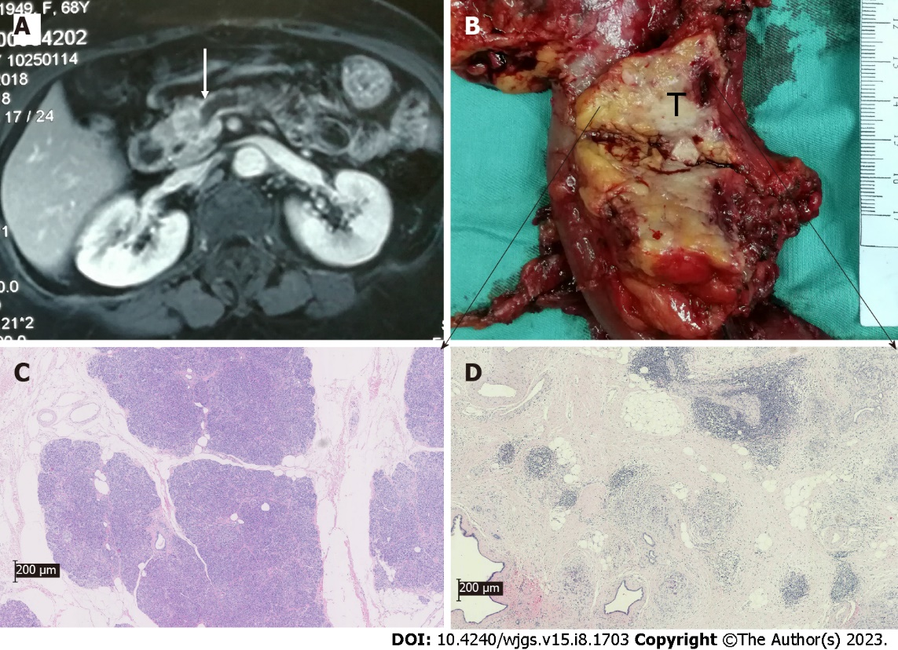

Figure 1 Preoperative magnetic resonance imaging image and histopathologic image of the surgical resection of pancreatic specimens of pancreatic ductal adenocarcinoma patients with new-onset diabetes. A and B: Magnetic resonance imaging images (A) and images of surgical specimens (B) from pancreatic ductal adenocarcinoma patients showed pancreatic head tumor invading the main pancreatic duct, leading to dilation of the pancreatic duct and atrophy of the body and tail of the pancreas; C and D: Representative images of hematoxylin and eosin staining from the proximal (C) or distal (D) pancreas.

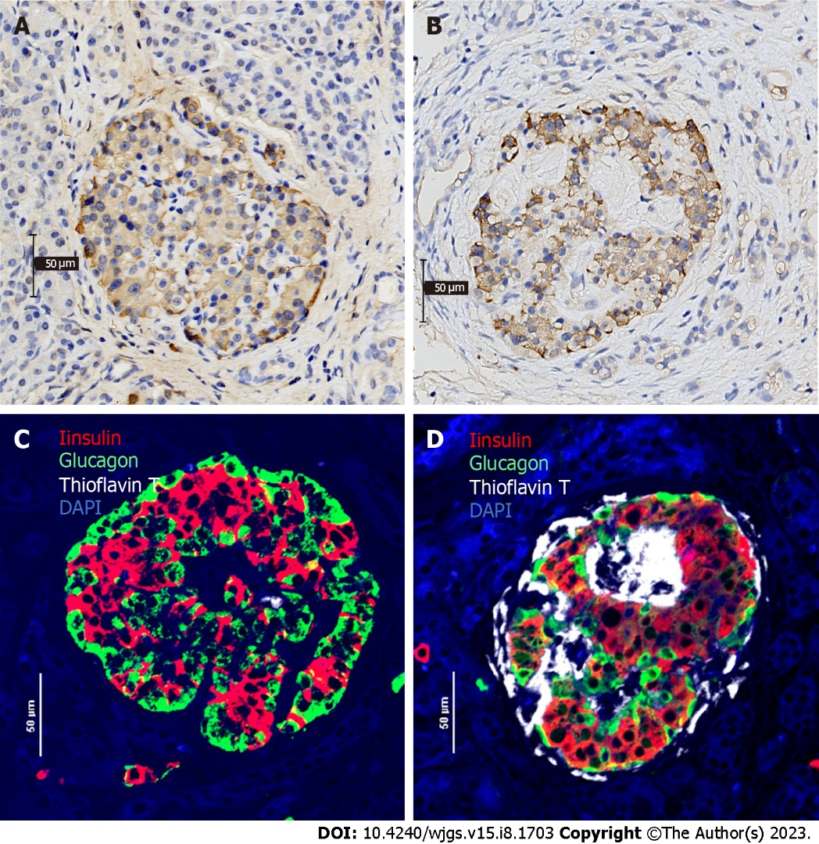
Figure 2 Islet immunohistochemical and immunofluorescent analysis of the proximal/distal pancreas of pancreatic ductal adenocarcinoma patients with new-onset diabetes. A and B: Representative images of immunohistochemical staining for insulin from the proximal (A) or distal (B) pancreas; C and D: Representative quadruple insulin (red), glucagon (green), thioflavin T (white) and DAPI (blue) staining from the proximal (C) or distal (D) pancreas for the determination of β-cell area, α-cell area and amyloid deposits.

Table 1 Clinical summary and islet amyloid deposits of investigated subjects
Parameter | Normal glucose tolerance (n = 14) | Prediabetes (n = 16) | Diabetes (n = 15)
Sex (female/male) | 7/7 | 4/12 | 8/7
Age, yr | 59.86 ± 12.01 | 61.36 ± 10.56 | 63.13 ± 11.34
Body-mass-index, kg/m² | 22.23 ± 2.44 | 21.76 ± 2.55 | 22.43 ± 3.44
Fasting glucose, mmol/L | 5.02 ± 0.39 | 5.48 ± 0.83 | 7.57 ± 1.93e
2 h glucose (OGTT), mmol/L | 6.41 ± 0.81 | 9.12 ± 1.16^{c} | 15.84 ± 4.08^{f}
HbA1c, % | 5.33 ± 0.73 | 5.88 ± 0.59 | 7.42 ± 1.66e
CA19-9 | 247.53 ± 338.37 | 412.15 ± 391.46 | 492.39 ± 441.24
Serum creatinine | 62.21 ± 11.17 | 67.75 ± 15.16 | 64.80 ± 19.59
Triglycerides | 1.23 ± 0.56 | 1.22 ± 0.45 | 1.97 ± 1.68
Cholesterol | 4.67 ± 2.51 | 4.29 ± 1.19 | 4.34 ± 1.30
High density lipoprotein | 1.21 ± 0.50 | 1.21 ± 0.35 | 0.93 ± 0.56
Low-density lipoprotein | 2.26 ± 0.52 | 2.56 ± 0.98 | 2.08 ± 0.83
Operation
Pancreaticoduodenectomy | 10 | 8 | 9
Distal pancreas resection | 3 | 8 | 6
Total pancreatectomy | 1 | 0 | 0
TNM stage
IA and IB | 5 | 8 | 6
IIA | 2 | 1 | 2
IIB | 7 | 4 | 5
III | 0 | 3 | 2
Gross tumor volume (cm³) | 15.59 ± 12.54 | 12.35 ± 11.07 | 13.75 ± 10.15
Remnant pancreatic volume (cm³) | 69.79 ± 18.17 | 51.99 ± 15.63^{b} | 37.35 ± 12.16^{d}
Islet amyloid density, % | 0.27 ± 0.40 | 3.63 ± 3.17^{b} | 10.45 ± 6.78^{f}
Head regions¹ | 0.006 ± 0.013 | 0.50 ± 0.72 | 1.51 ± 2.51
Distal regions¹ | 0.37 ± 0.43^{g} | 3.98 ± 3.39^{h} | 12.03 ± 7.29^{i}

¹10 cases per group.

P ≤ 0.05 vs normal glucose tolerance subjects.

^{b}P ≤ 0.01.

^{c}P ≤ 0.001.

^{d}P ≤ 0.05 vs prediabetes subjects.

^{e}P ≤ 0.01.

^{f}P ≤ 0.001.

^{g}P ≤ 0.05 vs head regions.

^{h}P ≤ 0.01.

^{i}P ≤ 0.001.

OGTT: Oral glucose tolerance test; HbA1c: Hemoglobin A1c; CA19-9: Carbohydrate antigen 19-9; TNM: Tumor-node-metastasis.

Published by Baishideng Publishing Group Inc
7041 Koll Center Parkway, Suite 160, Pleasanton, CA 94566, USA
Telephone: +1-925-3991568
E-mail: bpgoffice@wjgnet.com
Help Desk: https://www.f6publishing.com/helpdesk
https://www.wjgnet.com

© 2023 Baishideng Publishing Group Inc. All rights reserved.

