Name of Journal: World Journal of Clinical Cases
Manuscript NO: 70824
Manuscript Type: CASE REPORT

Immunoglobulin G4-related disease involving multiple systems: A case report

An YQ et al. A case report of IgG4-RD

Yu-Qiong An, Ning Ma, Yong Liu

Yu-Qiong An, Ning Ma, Heart Center, Beijing Children’s Hospital, Capital Medical University, National Center for Children’s Health, Beijing 100045, China

Yong Liu, Department of Ultrasound, Beijing-Shijitan Hospital, Capital Medical University, Beijing 100038, China

Author contributions: An YQ reviewed the literatures and contributed to manuscript drafting; Liu Y analyzed and interpreted the imaging findings; Liu Y and Ma N were responsible for the revision of the important intellectual contents; all authors issued the final approval for the submitted version.

Supported by Beijing Hospitals Authority Clinical Medicine Development of special funding support, No. XMLX202113; Beijing Municipal Science &Technology Commission, No. Z191100006619051; Special Fund for Open Topics of Lymph Surgery in Beijing Shijitan Hospital Affiliated to Capital Medical University, No. 2019-LB03; and Beijing Natural Science Foundation, No. 7192062.

Corresponding author: Yong Liu, MD, PhD, Chief Doctor, Professor, Department of Ultrasound, Beijing-Shijitan Hospital, Capital Medical University, Tieyi Road, Yangfangdian, Beijing 100038, China. liuy@bjsjth.cn

Received: August 16, 2021
Revised: November 16, 2021
Accepted: January 27, 2022
Published online: March 16, 2022

Abstract
BACKGROUND
IgG4-related disease (IgG4-RD), an immune-mediated chronic progressive fibroinflammatory disease, can affect the functions of several organs. Some common characteristics can be observed in different IgG4-RDs, such as higher prevalence in middle-aged and elderly male patients, raised serum IgG4 levels, abundant infiltration of IgG4-positive cells and fibrosis, diffuse or localized swelling of the affected organs, and good response to glucocorticoids treatment.

CASE SUMMARY
A 72-year-old man complained of left upper abdominal pain 3 mo ago, and he was diagnosed with acute onset of chronic cholecystitis and acute pancreatitis in the local hospital. Pain improved after relevant treatment. Several days ago, his abdominal pain worsened, and he was admitted to our hospital for further treatment. Doppler ultrasound showed that the pancreas presented with sausage-like swelling and the parenchymal echo was diffusely reduced. Gallbladder volume was increased, while the wall was rough and thickened with bilateral signs. Furthermore, the left submandibular gland was enlarged, accompanied with significantly increased blood flow signals. Finally, we found that the adventitia of the abdominal aorta and right iliac artery was thickened locally. Serum IgG4 was elevated to 12600 mg/L. Therefore, the patient was diagnosed with IgG4-RD. After treatment with methylprednisolone, he had an uneventful course and was discharged in good condition.

CONCLUSION
IgG4-RD can involve almost any organs. Ultrasound has a significant role in timely and accurately diagnosis.

Key Words: Immunoglobulin G4; Autoimmune pancreatitis; Cholecystitis; Arteritis; Ultrasound; Case report

©The Author(s) 2022. Published by Baishideng Publishing Group Inc. All rights reserved.

Citation: An YQ, Ma N, Liu Y. Immunoglobulin G4-related disease involving multiple systems: A case report. World J Clin Cases 2021; 10(8): 2543-2549
URL: https://www.wjgnet.com/2307-8960/full/v10/i8/2543.htm
DOI: https://dx.doi.org/10.12998/wjcc.v10.i8. 2543

Core Tip: Immunoglobulin G4-related disease (IgG4-RD) can involve multiple organs and sites, such as the glands and ductal tissues. However, it is rare that a patient with more than three organs are involved at the same time, as well as the arterial lesions. In our case, we report a patient with the autoimmune inflammation, his four organs and tissues are involved, they are the aorta, pancreas, gallbladder, and submandibular gland. Meanwhile, the involved abdominal aorta and iliac artery presented as IgG4-related periarteritis. Finally, we made a comprehensive diagnosis according to the clinical histology, imaging, serology, and the response to the therapy.

INTRODUCTION
IgG4-related disease (IgG4-RD) is an immune-mediated chronic progressive fibroinflammatory disease, which can involve multiple organs or tissues, such as pancreas, biliary tract, salivary glands, lacrimal glands, lung, kidney, and retroperitoneum^{[1-4]}. IgG4-RD has a higher prevalence in male patients with age over 50 years^{[5,6]} and it is easily confused with malignant tumor, infection, and other autoimmune diseases. Histopathology plays a key role in the diagnosis of IgG4-RD, and the typical pathological manifestations include lymphoplasmacytic infiltration, storiform fibrosis, and obliterative phlebitis^{[7,8]}. The affected organs present as localized or diffused swelling, while the serum IgG4 concentration is often significantly elevated^{[9]}. A comprehensive diagnostic criterion was established by the Japan College of Rheumatology in 2011^{[9]} and the corelative classification criteria for IgG4-RD was also developed by the American College of Rheumatology/European League Against in 2019^{[10]}. Besides, most patients have a good response to the steroids or rituximab therapy within a short time, but it is common for this disease to recur.
Although IgG4-RD can involve multiple organs and sites, it is still rare that a patient with more than three organs are involved at the same time and most of the affected sites are glands and ductal tissues. Meanwhile, the arterial lesions are less common in IgG4-RD. In our case, the autoimmune inflammation involved four organs and tissues, including the aorta, pancreas, gallbladder, submandibular gland, and the abdominal aorta and iliac artery presented with IgG4-related periarteritis. Finally, a comprehensive diagnosis is made, according to the clinical histology, imaging, serology, the appearance of the affected organs, and response to therapy.

CASE PRESENTATION
Chief complaints
A 72-year-old man was admitted to the gastroenterology department with pain in the left upper quadrant for 3 mo.

History of present illness
The patient had left upper abdominal pain 3 mo ago, accompanying with symptoms of anorexia, yellow urine, chills, nausea, vomiting, abdominal distention, and diarrhea, but no cough, expectoration, hemoptysis and other lung symptoms. Thus, he was referred to the local hospital. After the relevant laboratory and imaging examinations, the patient was diagnosed with acute onset of chronic cholecystitis and acute pancreatitis. The pain symptom improved after liver protective and anti-infective treatment, resolving tetany, pain relief, and fluid rehydration. Three days ago, his abdominal pain worsened and he was admitted to the Department of Gastroenterology in our hospital for further treatment.

History of past illness
He has a history of chronic hepatitis B > 30 years and hypertension for 10 years treated with nifedipine. He underwent excision of the right mandible mass 5 mo ago, and pathological results showed massive lymphocyte infiltration with fibrous tissue hyperplasia.

Personal and family history
His father and daughter are both carriers of hepatitis B virus.

Physical examination
There was tenderness in the upper abdomen, no rebound pain and muscle tension, and no mass was touched in the whole abdomen. A surgical scar of 3-4 cm was seen in his right mandible. The others showed no obvious abnormality.

Laboratory examinations
Biochemical examinations showed that ESR was 25 mm/h (normal range 0-15 mm/h). Tumor marker carbohydrate antigen 15-3 was 24.3 U/L. Hepatitis B surface antigen (HBsAg) was 1.06 IU/mL, hepatitis Be antigen (HBeAg) was 0.02 S/CO, hepatitis B core antibody (HBcAg) was 10.07 S/CO. Finally, serum IgG4 was elevated to 12600 mg/L. The routine urine tests and renal function tests were all normal.

Imaging examinations
Abdominal ultrasound revealed that the pancreas was diffusely enlarged and sausage-shaped, in which the anteroposterior diameters of the pancreatic head, body and tail were 3.1 cm, 2.7 cm and 2.2 cm, respectively. The pancreatic parenchyma echo was diffusely reduced and the boundary was not clear (Figure 1A). The gallbladder volume was enlarged, and the wall was rough and thickened with bilateral signs. Silt-like deposits were found in the gallbladder with a range of 5.6 cm × 2.0 cm (Figure 1B). Contrast-enhanced ultrasound (CEUS) revealed that the pancreatic lesions were uniformly enhanced in the arterial phase (Figure 1C). Computed tomography scan indicated that the pancreas was enlarged, and its head had spotty, high-density foci. The gallbladder was enlarged and the cyst wall was thickened (Figure 1D). Furthermore, there were no obvious abnormalities in the lung and kidneys. Thus, autoimmune pancreatitis with gallbladder involvement was considered.
Salivary gland ultrasound showed that the right submandibular gland was almost completely removed, and the left submandibular gland was enlarged with a size of 2.5 cm × 1.4 cm. We found that the parenchymal echo was not uniform, and companied with reticular separation and scattered flake-like hypoecho (Figure 2A). Color doppler flow imaging suggested that the blood flow signal was significantly increased (Figure 2B). There was no obvious abnormality in the bilateral parotid and sublingual glands.
Abdominal arterial ultrasound showed that the adventitia of the abdominal aorta and right iliac artery was locally thickened with a maximum up to 5.0 mm (Figure 3A and B). CEUS demonstrated that extensive new blood vessels were distributed in the adventitia, while the intensity of imaging was evaluated to grade III (Figure 3D). These results were similar to the inflammatory activity of periarteritis. Multiple strong echogenic plaques were seen on the arterial wall, suggesting atherosclerosis of the abdominal aorta and iliac artery. Additionally, ulceration was observed in the plaque of the posterior wall of the abdominal aorta (Figure 3C).

FINAL DIAGNOSIS
Combined with the clinical manifestations, pathological results, laboratory examinations, and imaging results, IgG4-RD simultaneously affects the pancreas (autoimmune pancreatitis), gallbladder (cholecystitis), salivary gland (submandibular adenitis), and aorta (pancreatitis).

TREATMENT
After excluding the relative contraindications for glucocorticoids, such as tumors and tuberculosis, the patient was injected intravenously with methylprednisolone and supplemented with antihypertensive and hypoglycemic treatment, gastric mucosa protection, liver protection and other treatments.

OUTCOME AND FOLLOW-UP
The patient had an uneventful course and was discharged in good general condition. The patient was instructed to take prednisolone on time and closely monitor blood pressure and blood glucose. One month later, there was no obvious abnormality when re-examined by the ultrasound and biochemical tests.

DISCUSSION
IgG4-RD is a rare disease that can involve multiple organs at the same time^{[1,11,12]}, which is similar to many malignant, infectious, and inflammatory diseases^{[13]}. The epidemiological data of IgG4-RD have not been completely established due to rarity and misdiagnosis^{[14,15]}. The clinical manifestations of IgG4-RD mainly depend on the affected organs and lack specificity, which is challengeable for making correct diagnosis^{[16]}. According to the comprehensive diagnostic criteria published in 2012^{[9]}, IgG4-RD patients must have (1) A compatible clinical presentation (swelling or masses in single/multiple organs); (2) Serum IgG4 concentration > 135 mg/dL; and (3) Histopathological evidence of marked lymphocytic and plasmocytic infiltration (IgG4-plasma cells/high-power field > 10 with IgG4/IgG-positive cell ratio > 40%). The patient in our case initially presented with epigastric pain similar to pancreatitis and was misdiagnosed with acute pancreatitis in another hospital. However, it was later found that the lesions involved multiple sites, and the volume of the affected organs, such as the pancreas, gallbladder, and submandibular gland increased significantly, and serum IgG4 increased to 12600 mg/L (> 1.35 g/L). The pathological results of the previous operation on the submandibular gland suggested that lymphocyte infiltration was accompanied by fibrous tissue hyperplasia. Our case fulfilled all the comprehensive diagnostic criteria, so we made the diagnosis of multisystem IgG4-RD.
If patients present with any typical clinical, serological or radiographic results, the clinical diagnosis sometimes can be made without pathological biopsy examinations^{[17]}. If the patient has typical imaging findings of IgG4-RD, such as sausage-shaped pancreas^{[3,18]} and periarteritis affecting the aorta below the renal artery, combined with relevant clinical manifestations and serological data, clinical diagnosis of IgG4-RD should be considered^{[10]}. For our patient, most of the characteristic manifestations of IgG4-RD were found (such as the lesion involved the pancreas and salivary gland), along with typical imaging findings (such as sausage-shaped swollen pancreas). In addition, periarteritis affecting the abdominal aorta and iliac artery, with inflammatory thickening of the arterial wall, supported the diagnosis of IgG4-RD^{[19]}.
The 72-year-old patient presented with multiple sclerotic plaques in the abdominal aorta and iliac artery. There was ulceration on the surface of the sclerotic plaque. At that time, we suspected that the autoimmune inflammation stimulated the arterial wall for a long time and IgG4-RD caused the sclerotic plaques to rupture and ulcerate. It has been shown that IgG4-RD retroperitoneal fibrosis usually occurs around the aorta, suggesting that the adventitia of the arterial vessels may also be a target of this disease^{[20]}. Doppler ultrasound and CEUS revealed that the adventitia of the abdominal aorta and iliac artery were thickened with multiple neovascularization, which also suggested that IgG4-RD mainly involved the adventitia. It has also been reported that IgG4-RD arteritis can lead to aneurysm formation^{[20]}, suggesting that inflammation may stimulate diffuse thickening of the arterial wall, narrow the arterial lumen, and cause aneurysm formation^{[19]}. Therefore, if the multisite lesion does not respond to conventional treatments, IgG4-RD should be considered. More attention should be paid to the lesions involving large vessels and aneurysm formation.
Glucocorticoid therapy is the best choice after diagnosis of IgG4-RD^{[21]}, while the surgery, radiotherapy and chemotherapy should be avoided as far as possible. Before using glucocorticoids, contraindications to corticosteroids (such as tuberculosis and tumor) should be excluded^{[22]}. For patients with the arteritis, it is important to be aware of the risk of the artery wall becoming thinner or even rupturing during glucocorticoid therapy, which requires real-time monitoring and appropriate intervention.

CONCLUSION
In our case, IgG4-RD involved several anatomical sites and multiple tissues and organs. A comprehensive diagnosis of IgG4-RD, including clinical history, imaging results, and pathological features, should be made. Doppler ultrasound as a noninvasive and convenient method plays an important role in the diagnosis of IgG4-RD. Timely and effective diagnosis could prevent serious organ injury, tissue fibrosis, and even death.

REFERENCES
1 Okazaki K, Uchida K. Current perspectives on autoimmune pancreatitis and IgG4-related disease. Proc Jpn Acad Ser B Phys Biol Sci 2018; 94: 412-427 [PMID: 30541967 DOI: 10.2183/pjab.94.027]
2 Miyabe K, Zen Y, Cornell LD, Rajagopalan G, Chowdhary VR, Roberts LR, Chari ST. Gastrointestinal and Extra-Intestinal Manifestations of IgG4-Related Disease. Gastroenterology 2018; 155: 990-1003.e1 [PMID: 30012334 DOI: 10.1053/j.gastro.2018.06.082]
3 Chen JH, Deshpande V. IgG4-related Disease and the Liver. Gastroenterol Clin North Am 2017; 46: 195-216 [PMID: 28506361 DOI: 10.1016/j.gtc.2017.01.001]
4 Zhang Z, Guan W, Lin Q, Yu W. Thoracic paravertebral involvement in patients with IgG4-related disease: CT and MR imaging findings. Rheumatology (Oxford) 2020; 59: 3878-3885 [PMID: 32556185 DOI: 10.1093/rheumatology/keaa254]
5 Masamune A, Kikuta K, Hamada S, Tsuji I, Takeyama Y, Shimosegawa T, Okazaki K; Collaborators. Nationwide epidemiological survey of autoimmune pancreatitis in Japan in 2016. J Gastroenterol 2020; 55: 462-470 [PMID: 31872350 DOI: 10.1007/s00535-019-01658-7]
6 Stone JH, Zen Y, Deshpande V. IgG4-related disease. N Engl J Med 2012; 366: 539-551 [PMID: 22316447 DOI: 10.1056/NEJMra1104650]
7 Kamisawa T, Zen Y, Pillai S, Stone JH. IgG4-related disease. Lancet 2015; 385: 1460-1471 [PMID: 25481618 DOI: 10.1016/S0140-6736(14)60720-0]
8 Okazaki K. Autoimmune Pancreatitis and IgG4-Related Disease: The Storiform Discovery to Treatment. Dig Dis Sci 2019; 64: 2385-2394 [PMID: 31363956 DOI: 10.1007/s10620-019-05746-9]
9 Umehara H, Okazaki K, Masaki Y, Kawano M, Yamamoto M, Saeki T, Matsui S, Yoshino T, Nakamura S, Kawa S, Hamano H, Kamisawa T, Shimosegawa T, Shimatsu A, Nakamura S, Ito T, Notohara K, Sumida T, Tanaka Y, Mimori T, Chiba T, Mishima M, Hibi T, Tsubouchi H, Inui K, Ohara H. Comprehensive diagnostic criteria for IgG4-related disease (IgG4-RD), 2011. Mod Rheumatol 2012; 22: 21-30 [PMID: 22218969 DOI: 10.1007/s10165-011-0571-z]
10 Wallace ZS, Naden RP, Chari S, Choi HK, Della-Torre E, Dicaire JF, Hart PA, Inoue D, Kawano M, Khosroshahi A, Lanzillotta M, Okazaki K, Perugino CA, Sharma A, Saeki T, Schleinitz N, Takahashi N, Umehara H, Zen Y, Stone JH; Members of the ACR/EULAR IgG4-RD Classification Criteria Working Group. The 2019 American College of Rheumatology/European League Against Rheumatism classification criteria for IgG4-related disease. Ann Rheum Dis 2020; 79: 77-87 [PMID: 31796497 DOI: 10.1136/annrheumdis-2019-216561]
11 Sanges S, Jeanpierre E, Lopez B, Russick J, Delignat S, Carpentier B, Dubois R, Dubucquoi S, Guerrier T, Hachulla É, Hatron PY, Paris C, Susen S, Launay D, Lacroix-Desmazes S, Terriou L. Acquired Hemophilia A in IgG4-Related Disease: Case Report, Immunopathogenic Study, and Review of the Literature. Front Immunol 2020; 11: 558811 [PMID: 33424828 DOI: 10.3389/fimmu.2020.558811]
12 Mahajan VS, Mattoo H, Deshpande V, Pillai SS, Stone JH. IgG4-related disease. Annu Rev Pathol 2014; 9: 315-347 [PMID: 24111912 DOI: 10.1146/annurev-pathol-012513-104708]
13 Roos E, Hubers LM, Coelen RJS, Doorenspleet ME, de Vries N, Verheij J, Beuers U, van Gulik TM. IgG4-Associated Cholangitis in Patients Resected for Presumed Perihilar Cholangiocarcinoma: a 30-Year Tertiary Care Experience. Am J Gastroenterol 2018; 113: 765-772 [PMID: 29549357 DOI: 10.1038/s41395-018-0036-5]
14 AbdelRazek MA, Venna N, Stone JH. IgG4-related disease of the central and peripheral nervous systems. Lancet Neurol 2018; 17: 183-192 [PMID: 29413316 DOI: 10.1016/S1474-4422(17)30471-4]
15 Chen LYC, Mattman A, Seidman MA, Carruthers MN. IgG4-related disease: what a hematologist needs to know. Haematologica 2019; 104: 444-455 [PMID: 30705099 DOI: 10.3324/haematol.2018.205526]
16 Wallace ZS, Zhang Y, Perugino CA, Naden R, Choi HK, Stone JH; ACR/EULAR IgG4-RD Classification Criteria Committee. Clinical phenotypes of IgG4-related disease: an analysis of two international cross-sectional cohorts. Ann Rheum Dis 2019; 78: 406-412 [PMID: 30612117 DOI: 10.1136/annrheumdis-2018-214603]
17 Sánchez-Oro R, Alonso-Muñoz EM, Martí Romero L. Review of IgG4-related disease. Gastroenterol Hepatol 2019; 42: 638-647 [PMID: 31722794 DOI: 10.1016/j.gastrohep.2019.08.009]
18 Thompson A, Whyte A. Imaging of IgG4-related disease of the head and neck. Clin Radiol 2018; 73: 106-120 [PMID: 28501095 DOI: 10.1016/j.crad.2017.04.004]
19 Akiyama M, Kaneko Y, Takeuchi T. Characteristics and prognosis of IgG4-related periaortitis/periarteritis: A systematic literature review. Autoimmun Rev 2019; 18: 102354 [PMID: 31323364 DOI: 10.1016/j.autrev.2019.102354]
20 Matsumoto Y, Kasashima S, Kawashima A, Sasaki H, Endo M, Kawakami K, Zen Y, Nakanuma Y. A case of multiple immunoglobulin G4-related periarteritis: a tumorous lesion of the coronary artery and abdominal aortic aneurysm. Hum Pathol 2008; 39: 975-980 [PMID: 18430457 DOI: 10.1016/j.humpath.2007.10.023]
21 Zhang YJ, Chen Y, Zhao X, Chang X, Guan S, Tian J, Xia BY, Qu X. Coronary Arteritis and Periaortitis in IgG4-Related Disease. Can J Cardiol 2020; 36: 589.e5-589.e7 [PMID: 32220388 DOI: 10.1016/j.cjca.2019.11.028]
22 Melenotte C, Seguier J, Ebbo M, Kaphan E, Bernit E, Saillier L, Audoin B, Feyeux D, Daniel L, Roche PH, Graillon T, Dufour H, Boutière C, Girard N, Closs-Prophette F, Guillaud C, Tieulié N, Regent A, Harlé JR, Hamidou M, Mekinian A, Grados A, Schleinitz N. Clinical presentation, treatment and outcome of IgG4-related pachymeningitis: From a national case registry and literature review. Semin Arthritis Rheum 2019; 49: 430-437 [PMID: 31155444 DOI: 10.1016/j.semarthrit.2019.05.003]

Footnotes
Informed consent statement: Informed written consent was obtained from the patient for publication of this report and any accompanying images.

Conflict-of-interest statement: The authors declare that they have no conflict of interest.

CARE Checklist (2016) statement: The authors have read the CARE Checklist (2016), and the manuscript was prepared and revised according to the CARE Checklist (2016).

Open-Access: This article is an open-access article that was selected by an in-house editor and fully peer-reviewed by external reviewers. It is distributed in accordance with the Creative Commons Attribution NonCommercial (CC BY-NC 4.0) license, which permits others to distribute, remix, adapt, build upon this work non-commercially, and license their derivative works on different terms, provided the original work is properly cited and the use is non-commercial. See: https://creativecommons.org/Licenses/by-nc/4.0/

Provenance and peer review: Unsolicited article; Externally peer reviewed.
Peer-review model: Single blind

Peer-review started: August 16, 2021
First decision: November 6, 2021
Article in press: January 27, 2022

Specialty type: Immunology
Country/Territory of origin: China
Peer-review report’s scientific quality classification
Grade A (Excellent): 0
Grade B (Very good): 0
Grade C (Good): C
Grade D (Fair): 0
Grade E (Poor): 0

P-Reviewer: Shao Q S-Editor: Wu YXJ L-Editor: A P-Editor: Wu YXJ

Figure Legends
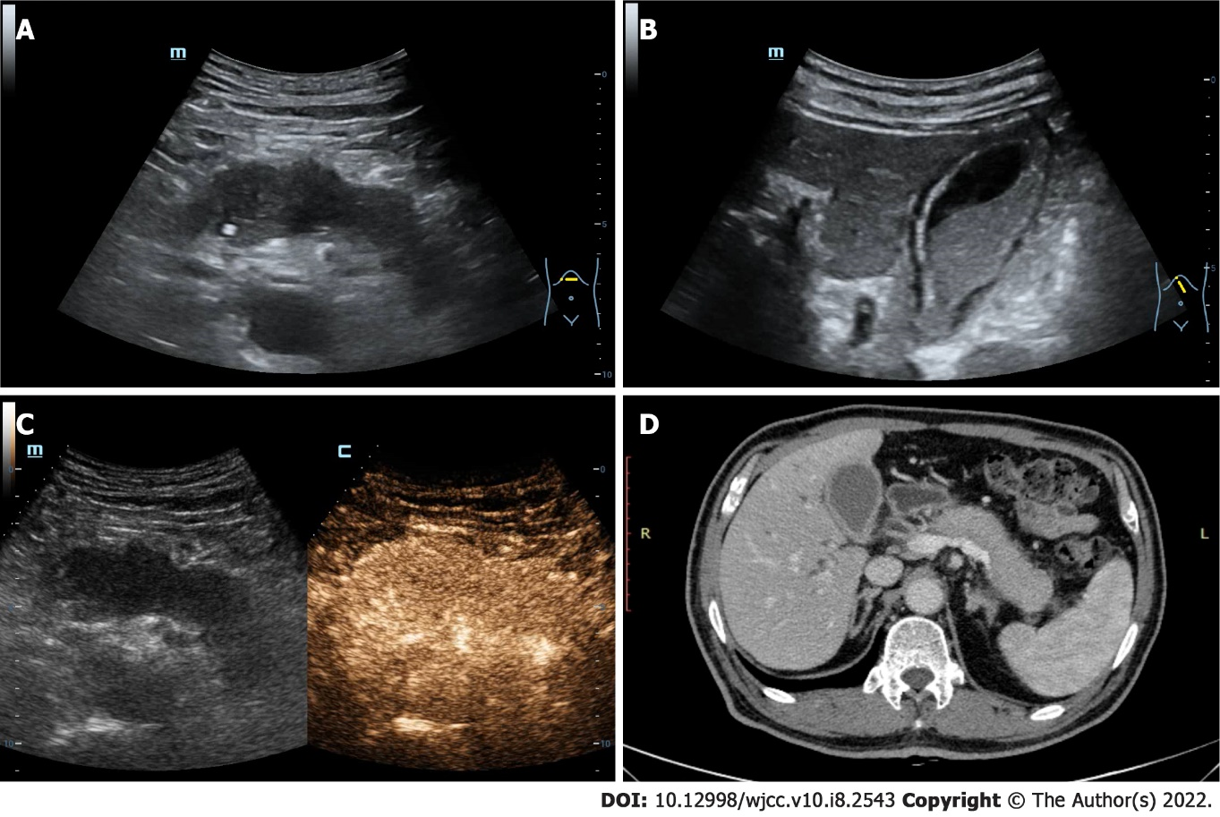
Figure 1 The ultrasound and computed tomography images of pancreas and gallbladder. A: The pancreas is diffusely enlarged with unclear boundary and the parenchyma echo is reduced; B: The gallbladder volume is enlarged and the wall is rough, accompanying with the silt-like deposits; C: The pancreatic lesions area is uniformly enhanced in arterial phase after the intravenous ultrasound contrast-enhanced; D: Contrast-enhanced computed tomography image revealing that both the pancreas and gallbladder are enlarged and the gallbladder wall is thickened, which are consistent with the ultrasound results.

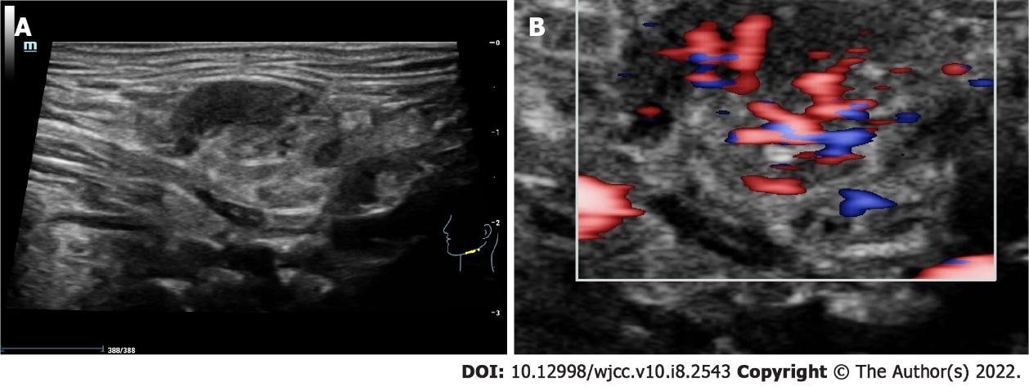
Figure 2 The ultrasound image of the left submandibular gland. A: The submandibular gland is enlarged and its parenchyma echo is not uniform; B: Color doppler flow imaging suggesting that the blood flow signal is significantly increased.

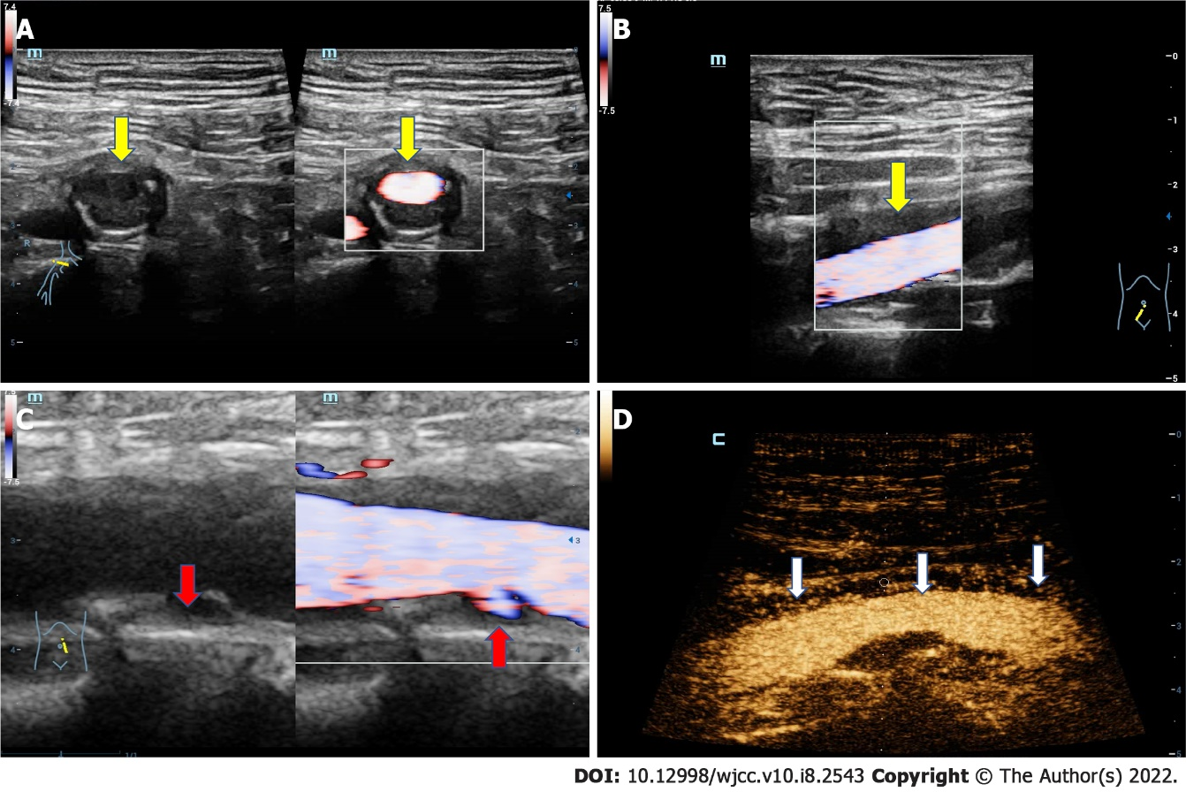
Figure 3 The ultrasound images of the artery. A: The transverse ultrasound image of iliac artery shows that the adventitia is obviously thickened; B: The longitudinal ultrasound image of iliac artery shows that the adventitia is obviously thickened (yellow arrow); C: The longitudinal section of iliac artery, in which multiple plaques can be clearly seen on the arterial wall, and there is an ulceration in the plaque of the posterior wall (red arrow); D: Contrast-enhanced ultrasound demonstrates that extensive new blood vessels in the adventitia (white arrow).

Published by Baishideng Publishing Group Inc
7041 Koll Center Parkway, Suite 160, Pleasanton, CA 94566, USA
Telephone: +1-925-3991568
E-mail: bpgoffice@wjgnet.com
Help Desk: https://www.f6publishing.com/helpdesk
https://www.wjgnet.com

© 2022 Baishideng Publishing Group Inc. All rights reserved.

