Name of Journal: World Journal of Clinical Oncology
ESPS Manuscript NO: 21247
Manuscript Type: Review

Estrogen receptor alpha amplification in breast cancer: 25 years of debate

Holst F. ESR1 amplification review

Frederik Holst

Frederik Holst, Dana-Farber Cancer Institute, Dana-Farber/Harvard Cancer Center, Boston, MA 02215, United States

Author contributions: Holst F wrote this review.

Conflict-of-interest statement: Holst F has royalty interest associated with intellectual property of ZytoVision GmbH concerning patent US8101352B2 “Detection of ESR1 Amplification in Breast Cancer” and according EU patent application.

Open-Access: This article is an open-access article which was selected by an in-house editor and fully peer-reviewed by external reviewers. It is distributed in accordance with the Creative Commons Attribution Non Commercial (CC BY-NC 4.0) license, which permits others to distribute, remix, adapt, build upon this work non-commercially, and license their derivative works on different terms, provided the original work is properly cited and the use is non-commercial. See: http://creativecommons.org/licenses/by-nc/4.0/

Correspondence to: Frederik Holst, PhD, Dana-Farber Cancer Institute, Dana-Farber/Harvard Cancer Center, 450 Brookline Avenue, Boston, MA 02215, United States. frederik_holst@dfci.harvard.edu
Telephone: +1-617-6324515

Received: July 2, 2015
Peer-review started: July 7, 2015
First decision: September 18, 2015
Revised: January 5, 2016
Accepted: February 14, 2016
Article in press:
Published online:

Abstract
Twenty-five years ago, Nembrot and colleagues reported amplification of the estrogen receptor alpha (ESR1) gene in breast cancer, initiating a broad and still ongoing scientific debate on the prevalence and clinical significance of this genetic aberration that affects one of the most important genes in breast cancer. Since then, a multitude of studies on this topic has been published, covering a wide range of divergent results and arguments. Two major issues related to ESR1 amplification have not been conclusively addressed to date: (1) The reported prevalence of this alteration in breast cancer ranges from 0% to 75%, suggesting that ESR1 copy number analysis is hampered by technical and interpreter issues. In this context, the extent to which abundant amounts of messenger RNA can mimic amplification in standard fluorescence in situ hybridization (FISH) assays in the analysis of strongly expressed genes like ESR1; (2) the clinical relevance of ESR1 amplification: such relevance is strongly disputed, with data showing predictive value for response as well as resistance of the cancer to anti-estrogen therapies, or for subsequent development of cancers in the case of precursor lesions that display amplification of ESR1. Here I provide a comprehensive summary of the various views on ESR1 amplification, and highlight explanations for the contradictions and conflicting data that could inform future ESR1 research.

Key words: Estrogen receptor alpha; Gene amplification; Breast cancer; Tamoxifen; Methodology

© The Author(s) 2016. Published by Baishideng Publishing Group Inc. All rights reserved.

Core tip: The estrogen receptor alpha gene (ESR1) is one of the most important genes in breast cancer, but the prevalence of ESR1 amplification is matter of ongoing debate. A number of studies suggest that technical issues and lack of standards contribute to the discrepant findings. Future studies should focus on the potential clinical relevance of this phenomenon.

Holst F. Estrogen receptor alpha amplification in breast cancer: 25 years of debate. World J Clin Oncol 2016; In press

INTRODUCTION
When Nembrot et al^{[1]} published the discovery of estrogen receptor alpha encoding gene (ESR1) amplification in breast cancer in 1990, it was not possible to foresee that, two and a half decades later, conflicting data on the prevalence and possible clinical significance of this alteration would lead to an ongoing debate^{[2,3]}. The controversy results from the importance of the gene for the treatment of breast cancer. ESR1 encodes the estrogen receptor alpha (ERα), which is a cellular receptor for the steroid hormone estrogen, a key molecule that regulates the growth and differentiation of the mammary gland^{[4-8]}. ERα is activated by estrogen and drives cell proliferation in breast cancer^{[9-11]}. About two thirds of breast cancers express ERα at the time of diagnosis, making the ERα-protein the most frequently applied clinical biomarker and molecular therapy target for this tumor type^{[9,12-15]}.
Gene amplification is a critical mechanism for oncogenic activation of a gene^{[16,17]}, and is believed to be a marker for oncogene addiction^{[18,19]}. The success of Herceptin® in treating breast and gastric cancers with amplification of the ERBB2 gene [that encodes the human epidermal growth factor 2 (HER2)] has impressively demonstrated the clinical value of gene amplification^{[20,21]}. The report of frequent ESR1 amplification as a candidate marker for optimal response to anti-estrogen treatment of breast cancer patients with Tamoxifen^{[22,23]} thus attracted considerable attention in the scientific community.
However, reports of ESR1 amplification were challenged from the outset. Watts et al^{[24]} used the same method as Nembrot et al^{[1]} but reported an unexpected lower incidence of copy number increase in 1991. This already suggested that differences in laboratory protocols, interpretation of results, and tissue sampling may represent major challenges in the analysis of ESR1 amplification. To date, articles that present a wide range of diverging data and arguments^{[15,22]}, continue to be published, and debate or address the topic of ESR1 amplification. In particular, an intense dialog flared up following the reports that frequent ESR1 amplification were detected in a large series of breast cancer patients, and of clinical data that suggested potential clinical benefit for endocrine treatment^{[25-36]}. This was especially evident in response to the suggestion that pre-mRNA artifacts could explain conflicting results reported in a 2012 FISH study on ESR1 amplification^{[3,22,23,37,38]}, what appeared like a self-fulfilling prophecy concerning mRNA artifacts initially discussed already in 2008^{[28]}. Other conclusions ranged from there being no ESR1 amplification in breast cancer^{[32]} and that earlier reports of amplification were “fictional”^{[37]}, to claims of frequent prevalence, with predictive significance for response or resistance to anti-estrogen therapy^{[25,33,36,38,39]}. In addition, whether amplification of ESR1 is an early or late event, and whether it can be implemented as a potential marker for prophylactic anti-estrogen treatment^{[3,40]}, has also been debated.

PREVALENCE OF ESR1 AMPLIFICATION
Definitions and references
To date, various studies have been published reporting ESR1 amplification frequencies ranging from 0% to 75 % (Figure 1), depending on methods used, sample cohorts, and threshold definitions^{[15]}. The amplification has been described as typically occurring in a mosaic pattern, indicating heterogeneous and low level increases in copy number. Amplified cells often showed only few additional gene copies in tight clusters of the homogeneously staining region (HSR) type^{[38]} (Figure 2).
This pattern of amplification is of particular relevance for understanding the scientific debate on ESR1 amplification in breast cancer. Determining the prevalence of gene amplification requires first that the term be defined. In general, “gene amplification” is defined as an increase in the gene copy number in a cell; independent of the ratio of gene copy number to centromere copy number^{[41,42]}. However, as testing for human epidermal growth factor receptor 2 (ERBB2 or HER2) testing was done more frequently, the term “gene amplification” was reserved for amplifications with an average gene to centromere ratio of ≥ 2.0 or ≥ 2.2 (or > 6 copies per nucleus), simply because the threshold being able to predict the response to therapy was determined at this level^{[43-45]}. As a consequence, low level gene amplification with a ratio less than 2.0 but greater than 1.0 was neglected. However, for studies in which low copy number increases associated with gene amplification were investigated, the exclusion of amplifications with these low ratios^{[46]} can have major consequences with respect to the prevalence of the genetic alteration and can decrease it to significantly lower frequencies in study cohorts, as shown in Figure 1.
Low-level gene copy number alterations like ESR1 amplifications often present as a continuum of one-to-several additional ESR1 copies, and minor changes of the threshold cut off value can have a major impact on study outcome. For example, using a cut off of > 2.0 instead of ≥ 2.0 for amplification calling, or a ratio 2.2 instead of 1.8, can change the amplification frequency by almost 50%^{[22,47,48]}. In a recent study done with use of next-generation sequencing (NGS), the threshold of ≥ 6 average copies (as recommended for HER2 testing^{[44]}) in tissue samples with tumor purity of > 20%^{[49]} resulted in only 0.8% ESR1 amplification.
The low level and heterogeneous character of ESR1 amplification suggests that “classical HER2” thresholds may not be optimal for ESR1 analysis^{[36,38]}: This is even more true when non-morphologic methods are applied for analyzing isolated DNA, wherein the choice of normalization references has a critical impact on analysis outcome. Indeed, several investigators employing qPCR have demonstrated that the prevalence of ESR1 amplification depends massively on the choice of the reference genes or sequences^{[26,28,38]}, and have suggested that variable deletion frequencies of reference genes are responsible for this phenomenon^{[26,28]}.
In fact, use of some assays with reference genes that have a lower frequency of deletion in breast cancer (18% vs 30%) - according to The Cancer Genome Atlas (TCGA)^{[50]} – also led to the detection of lower frequencies of ESR1 amplification (ASXL2, EIF5B and PVR vs ESR2). Note, however, that when reference genes such as PIEZO2 (FAM38B) are used, which have higher deletion frequencies (30%), the frequency of ESR1 amplification remains low^{[28]}, suggesting that factors other than reference gene alterations may also contribute to the outcome of qPCR studies. This is also exemplified in cases when two qPCR assays lead to different ESR1 amplification results, even though the different reference genes (ESR2 and SOD2) used had similar deletion frequencies (30%) according to TCGA. These assays highlight a huge difference (approximately a dimension) in the dynamic range for the same samples, suggesting that technical issues, in addition to the status of the reference gene, can impact study outcome^{[51]} (Table 1 and Figures 1-4).

Heterogeneity and counting
Over the last few years, tumor heterogeneity and plasticity has been increasingly recognized as a common property of cancer^{[52-60]} that makes molecular diagnosis difficult^{[22,34,38,55,56,61,62]}. Heterogeneity is an obvious issue in the analyses of isolated DNA, where mixtures of cells with normal copy numbers and low level amplification may easily result in an “average” copy number that ranges below the definition threshold for the amplification status^{[38]}. In the case of heterogeneous cancers analyzed with use of in situ analysis (such as FISH), the choice of the tumor area(s) for analysis is of the utmost importance^{[38]}. Accordingly, approaches that classify the tumor gene status based on a minimum of successful hybridized tumor cells^{[63]} might fail to detect aberrations that are only present only in a minor portion of the cancer bulk.

Signals and copies
Besides the purity and analyzability of tumor cells, the interpretation of FISH signals also contributes to analysis outcome. For example, automated FISH scoring systems are limited in their ability to count individual signals in tight clusters, and instead measure the ratio of fluorescence intensities^{[64]}. But because fluorescence intensities and signal numbers can vary due to various technical issues that are independent of copy number, automated analysis may be considerably less sensitive than the human eye. This may be particularly true in the case of the low-level clusters that are typical of ESR1^{[15,26]}, because identification of individual gene copies is highly dependent on the interpretation of signal patterns. A major challenge in determining low level gene copy numbers that are also heterogeneously distributed is the identification of FISH signals that represent a single gene copy. For example, it is difficult to distinguish dense clusters of multiple gene copies (which often appear as one large signal) from true single gene copies; and additionally it is virtually impossible to detect tandem gene duplications (which occur commonly in breast cancer genomes^{[65]}) with established FISH scoring criteria that recommend interpreting “doublets” (i.e., two tightly adjacent signals) as a single gene copy.
Such a FISH signal-counting recommendation is often applied, based on the American Food and Drug Administration (FDA)-approved interpretation guidelines for HER2 FISH testing^{[66]}. However, the recommendation to count two adjacent signals as one is based on studies that determine numerical chromosome aberrations, not focal changes in gene copy number^{[67,68]}. For chromosome enumeration using probes that do not hybridize within the centromere region, this approach is warranted: following the s-phase of the cell cycle, chromosomes consist of two chromatids, each of which contains one gene copy. Accordingly, FISH analysis displays two signals nearby for these two gene copies^{[69]} (Figure 3), even though chromosome number is not pathologically increased in these cases and such signals should be counted as one.
In contrast to chromosome enumeration, the increased number of gene copies on one chromatid or chromosome is relevant for determining gene copy number: in this case, signal doublets should be considered to represent two gene copies. Studies that combine FISH and gene chip or Southern blot technologies show that FISH signal doublets represent two gene copies on one chromosome, and as such constitute gene amplification^{[70-73]} (Figure 3).

Challenges with use of chips
Gene chip technology and Next Generation Sequencing (NGS) are powerful techniques for detecting genomic alterations with high accuracy and objectivity, compared to morphologic methods that evaluate results based on the interpretation of individual observers. Nevertheless, there are serious pitfalls associated with use of these methods. In 2008, a published summary of gene chip analyses listed a huge range of amplification frequencies reported in different studies and different tumor populations, ranging from 7% to 35%, even for ERBB2^{[27]}. Over the years, various limitations have led to a reconsideration of these methods. Most importantly, we now take into account if the isolated DNA was analyzed as an average of many different cells, and also consider methodological limitations due to technology related background of measurement. We acknowledge for instance that the quality of the gene chip hybridization (call rates) limits the sensitivity for detecting alterations in gene copy number^{[22,30,34,38,74]}. The large amount of data involved in these studies also makes these methods strongly dependent on the specific computational approaches and algorithms that are used^{[74-76]}.
The general impact of the normalization reference and the computational method used to analyze raw data played a key role in the rediscovery of ESR1 amplification, based on the analysis of 22 breast cancers with use of Affymetrix 10K SNP GeneChips^{[25,77]}. This is illustrated in supplementary figures and the supporting supplementary optical dataset S1 as well as in a video documentation (supporting supplementary video clips S1+S2).
TCGA^{[78,79]} provides the largest and most advanced GeneChip copy number database for isolated DNA from tumor samples. A meta-analysis of TCGA dataset offers new insights into ESR1 copy number alterations beyond the published FISH studies. For example, two tumor entities with the most frequently reported ESR1 amplification (by FISH analysis), i.e., breast and endometrial cancers^{[25,80]}, are top ranked also by Genomic Identification of Significant Targets in Cancer (GISTIC) analysis (2016-06-01 stddata_2015-04-02 regular peel off)^{[50]}. GISTIC analysis demonstrates that ESR1 copy numbers significantly (threshold q=0.25) exceed the genome-wide average (Q = 0.096), and reveals overall, focal (< half of 6q) and high level ESR1 amplification in 15.6%, 5.9% and 1.9%, respectively (for a threshold of fold changes relative to the genome-wide average = 0.1)^{[50,81]}. TCGA also confirms the existence of very small amplifications, with ESR1 and CCDC170 being the only genes in the GISTIC peak^{[50]} (Figure 4): although some peaks are due to structural alterations that involve only part of the ESR1 gene, others are limited specifically to the ESR1 gene and its flanking regions (Figure 4)^{[82,83]}, providing additional strong support for a clonal selection process that targets the ESR1 locus^{[81]}. Amplifications that were limited to ESR1 - but included parts of CCDC170 - were also found in another SNP GeneChip study^{[77]} (supporting Figures 1 and 5) and by Next Generation Sequencing (NGS), in a breast tumor that was sensitive to estradiol treatment^{[82-84]} (Figure 5). Obviously, novel and publicly available databases such as TCGA collection^{[50]} were not available at the time when the debate on ESR1 amplification started, but the latest upgrade is still not considered in all publications to date^{[85]}.

Fact or phantom
FISH may detect pre-mRNA transcripts of ESR1, and such hybridization could mimic DNA hybridization signals. They may argue for ESR1 amplification calling to be false positive in cases with small FISH-detected amplifications that are limited to the ESR1 gene^{[25]}. Such artifacts may also explain the lower rates of amplification found by other methods^{[37]}. The significance of this phenomenon is, however, not yet fully evaluated, and some reports indicate that it does not have a major impact: these include cases with ESR1 amplifications whose extensions have been mapped (by FISH) to the gene locus only^{[25]}. For example, FISH amplification signals are detectable even after RNase treatment of the tissue section prior to the FISH analysis, indicating that DNA is targeted^{[38]}.
Also, in at least 50% of tested cancers, ESR1 amplification identified by FISH can be confirmed by multiplex ligation-dependent probe amplification (MLPA) PCR^{[38]}, and additionally, a qPCR could show that tumors with ESR1 amplification (determined by FISH) average significantly higher ESR1 copy numbers than do tumors without ESR1 amplification (also detected by FISH) (Table 1 and Figures 1-4)^{[51]}.
It is important to understand that failed validation of FISH-determined ESR1 amplifications by qPCR or GeneChip analysis may be due to tumor purity and heterogeneity. Quantitative analysis of DNA isolated from tissue samples is always prone to underestimation of gene copy numbers - this is due to the fact that, because of non-cancerous cells present in a tumor sample, cancer cell purity typically ranges between 20%-80% in breast cancer, and is often overestimated in histological analyses^{[86]}. The “contaminating” non-cancerous tissues inevitably “dilutes” the tumor DNA, and leads to underestimation of changes in gene copy number^{[22,34,38,50,86]}. Clearly this dilution effect is even higher if low-level and heterogeneous alterations (e.g., the ESR1 amplification) are analyzed^{[50,60,82]}.

CLINICAL SIGNIFICANCE OF ESR1 AMPLIFICATION
Gains for expression
A causal relationship between ESR1 copy numbers and increased expression of ERα protein, which drives cell proliferation^{[9-11]}, provides the molecular underpinning of the potential clinical relevance of ESR1 amplification. Expression of the ERα-protein itself has been used for decades as a biomarker for initiating anti-estrogen treatment in breast cancer^{[9]}. However, regardless of the prevalence of gene amplification across a tumor type, the increase in copy number for a given gene is a well-known mechanism to increase its expression^{[16,17,42,87,88]}. Accordingly, gene amplification is assumed to be a marker for a tumor’s addiction to the expression of the amplified gene^{[18,19]}.
Several reports, including those that use DNA-specific methods for ESR1 copy number determination, have documented a significant correlation between ESR1 gene amplification and ERα protein expression^{[25,33,35,48,63,88-92]} (Table 1).
Nevertheless, it is important to keep in mind that other mechanisms in addition to amplification also regulate a gene’s transcription, and its translation into protein. In fact, some studies^{[1,28,37,93,94]} challenge the correlation between ESR1 copy number and expression levels (Table 1). Nonetheless, it is clear that here, too, the majority of discrepant findings are likely due to technical and methodological reasons. These could include a low number of cases analyzed, false negative ERα expression test results, or lack of statistical power due to low frequencies of tumors with ESR1 copy number alterations detected. However, ESR1 amplification has been described in ERα-protein negative breast cancers with poor survival^{[94]} and it is perceivable that general genetic instability drives ERα-independent 6q amplification in these tumors. Accordingly, such cases are unlikely to be associated with ERα-protein expression and could contribute to findings challenging the correlation between ESR1 copy number and ERα expression levels.

Response or resistance
The controversy about the relevance of ESR1 amplification in breast cancer derives from claims that this genetic aberration is a potential predictive marker for optimal response to endocrine therapy. Three studies used FISH for gene copy number determination, and report that breast cancer patients that were treated with Tamoxifen, and which showed ESR1 amplification in their tumors, had a better disease-specific survival than did patients without this alteration. These studies also include a retrospective analysis of the Tamoxifen-only arm of the prospective randomized ABCSG-06 trial (Figure 6)^{[25,33,39]}. Additionally, a qPCR study found the worst outcome for patients whose tumors are ERα-negative and have ESR1 amplification, while there was no association between survival in ERα-positive cancers that received Tamoxifen treatment^{[94]}. In contrast, another study suggested that ESR1 amplification predicts resistance to Tamoxifen therapy^{[36]}, although the results were not reproduced in a follow-up study of the randomized Danish cohort of the BIG-98 trial^{[95]}.
These discrepant results can be explained by differences in the kinds and mechanisms of amplification. For example, gene amplification driven by general genetic instability may be a marker for aggressive tumors^{[96]} with unfavorable prognosis, less likely responding to any therapy. Such amplifications, with lack of ERα protein expression^{[94]}, would dominate the results of survival analysis in aggressive tumor subsets^{[36]}. Other tumors might amplify a gene specifically driven by the tumors addiction to the respective pathway^{[19]}. Indeed, this mechanism has been suggested in two independent studies that observed focal ESR1 amplifications of low-level copy number change in long-term estrogen-deprived (LTED) MCF7 breast cancer cell lines, with use of DNA-specific GeneChips and qPCR for ESR1 copy number determination. And another experimental study showed that breast-cancer-derived xenografts respond to estrogen treatment of tumor cells that harbor ESR1 amplification, as determined by NGS^{[84,97]}.
Furthermore, in one clinical phase II study for evaluating anti-estrogen treatment, a focal ESR1 amplification appeared after therapy in one out of 49 tumors analyzed by NGS^{[98]}. These functional studies provide strong evidence for the potential clinical relevance of ESR1 amplification as a mechanism of ERα pathway regulation. And one additional study used LTED MCF7 cells to show a change of ESR1 gene status detectable by FISH; however, the FISH signals were RNase-sensitive and no ESR1 copy number increase was detectable by ESR1 qPCR, suggesting that the FISH results may have been due to probe hybridization to abundant mRNA^{[99]}.
Gene amplifications in human cancers are markers of the tumor’s dependence on the encoded protein, and point to a potential target of therapy^{[18,20,21,43-45,100,101]}. However, the effects of therapy depend on effective target neutralization, and indicate that target levels must be relevant for effective inactivation by antagonistic drugs. In other words, the success of therapy might depend on the fold change in the amplified gene’s copy number.
Accordingly, gene amplification is a well-known mechanism that underlies drug resistance^{[102-109]}. Even in case of HER2 (ERBB2), the mechanism of “receptor overcrowding” (and thus the level of receptor gene expression) was believed to be responsible for turning a marker for response into one for resistance depending on the level of gene expression^{[109]}.
And while the threshold for therapy response was determined at a doubled gene dose in the case of ERBB2, amplifications of other genes (e.g., EGFR, ERBB3 (HER3), and PIK3CA in lung cancer) might be relevant at lower levels^{[38,69,110-119]}. This and even a tumor’s heterogeneity regarding the amplification status of a gene, should be taken into account when considering gene amplification as a maker for therapy response or resistance.

Early or late
There is growing evidence that low-level gene copy number amplifications represent an adaptation by tissues to selective pressures^{[84,97]}, even in normal (non-transformed) cells^{[60]}. It is obvious that such alterations in growth-regulating pathways can increase the risk for cancerous outgrowth^{[10,88]}. The appearance of ESR1 amplification in precancerous lesions and their increased frequency during neoplastic transformation suggests that such amplification is an early event that is potentially cancer-initiating and that drives cell proliferation^{[3,25,40,120,121]}; what is not as clear is whether ESR1 amplification alone is sufficient to transform cells. Nevertheless, detection of ESR1 amplification in breast cancer precursor lesions might help to identify patients at high cancer risk, and it has thus been suggested that such patients could benefit from prophylactic anti-ER treatment^{[3]}.

FUTURE DIRECTIONS AND CHALLENGES
Rat runs and maps of malignancy
The debate on ESR1 amplification in breast cancer is mainly based on methodological issues, including technical limitations, quality of application, and interpretation of results using the standard methods that are available today. The controversy on the frequency of low level ESR1 amplifications in particular, highlights the need for methodically advanced and sensitive approaches that will allow consistent findings.
The power of high throughput screening methods for a bird’s eye perspective of the schematic landscapes has enabled us to draw integrated maps of malignancy. But cancer is not yet vanquished, and zooming in to details of these landscapes could open new dimensions of insights into hidden and undiscovered molecular pathways (rat runs) of malignancy that might be missed from a bird’s eye perspective.
A future perspective could comprise a combination of the existing cancer landscapes and detailed information derived from sensitive targeted approaches that will enable us to develop eagles eyes. Use of established morphological imaging methods such as FISH, as well as newly developed NGS-based approaches, could combine the objectivity of computational analysis algorithms with the resolution of single-cell analyses. These methods could integrate spatial and morphological, objective and high resolution measurement within tissues^{[122]}, and are in the process of being developed. Initial results have been published with use of Single-Nucleus Sequencing (SNS)^{[54,59,123]}, but challenges of using NGS data processing and Whole Genome Amplification (WGA) still remain to be tackled^{[75,76,124]}.

Gnosis and medicine's 5 sigma
Studies that use methods with limited power produce results of limited significance. While the established FISH method is suggested to be a valuable approach for studying the clinical relevance of ESR1 amplification or gene status in breast cancer^{[3,25,33,36,38,39,48,91]} (Figure 6), there is no established consensus on how the interpretation of signal patterns or of gene status classification thresholds. As such, the nature of the ESR1 gene status on the level of nucleic acids (DNA or RNA) might appear to be of secondary importance when considering a reproducible phenomenon that has an established standard diagnostic method and that is potentially applicable as a clinical marker^{[3]}. In contrast, studies on the potential clinical significance of detectable phenomena seem to be rather reasonable. In this context, the robustness and predictive power of a clinically applicable marker may be more important than its molecular properties.
Richard Horton recently commented that “Much of the scientific literature, perhaps half, may simply be untrue”, pointing to the recent p-values of “5 sigma” set in particle physics. And the idea, that, regarding scientific publications, “something has gone fundamentally wrong with one of our greatest human creations”, highlights the need for publishing critical reviews and debates in science^{[30]}. However, scientific debates will be rewarded when, besides the P-values and technical methodology, we do not lose sight of the goals of medical research.

REFERENCES
1 Nembrot M, Quintana B, Mordoh J. Estrogen receptor gene amplification is found in some estrogen receptor-positive human breast tumors. Biochem Biophys Res Commun 1990; 166: 601-607 [PMID: 2302226 DOI: 10.1016/0006-291X(90)90851-D]
2 Chen JR, Hsieh TY, Chen HY, Yeh KY, Chen KS, ChangChien YC, Pintye M, Chang LC, Hwang CC, Chien HP, Hsu YC. Absence of estrogen receptor alpha (ESR1) gene amplification in a series of breast cancers in Taiwan. Virchows Arch 2014; 464: 689-699 [PMID: 24756215 DOI: 10.1007/s00428-014-1576-8]
3 Soysal SD, Kilic IB, Regenbrecht CR, Schneider S, Muenst S, Kilic N, Güth U, Dietel M, Terracciano LM, Kilic E. Status of estrogen receptor 1 (ESR1) gene in mastopathy predicts subsequent development of breast cancer. Breast Cancer Res Treat 2015; 151: 709-715 [PMID: 25981900 DOI: 10.1007/s10549-015-3427-y]
4 Russo J, Russo IH. Differentiation and breast cancer. Medicina (B Aires) 1997; 57 Suppl 2: 81-91 [PMID: 9567346]
5 Prall OW, Rogan EM, Sutherland RL. Estrogen regulation of cell cycle progression in breast cancer cells. J Steroid Biochem Mol Biol 1998; 65: 169-174 [PMID: 9699870 DOI: 10.1016/S0960-0760(98)00021-1]
6 Russo J, Hu YF, Yang X, Russo IH. Developmental, cellular, and molecular basis of human breast cancer. J Natl Cancer Inst Monogr 2000; (27): 17-37 [PMID: 10963618 DOI: 10.1093/oxfordjournals.jncimonographs.a024241]
7 Russo J, Hu YF, Silva ID, Russo IH. Cancer risk related to mammary gland structure and development. Microsc Res Tech 2001; 52: 204-223 [PMID: 11169868 DOI: 10.1002/1097-0029(20010115)52: 2<204:: AID-JEMT1006>3.0.CO; 2-F]
8 Brisken C, O'Malley B. Hormone action in the mammary gland. Cold Spring Harb Perspect Biol 2010; 2: a003178 [PMID: 20739412 DOI: 10.1101/cshperspect.a003178]
9 Allred DC. Issues and updates: evaluating estrogen receptor-alpha, progesterone receptor, and HER2 in breast cancer. Mod Pathol 2010; 23 Suppl 2: S52-S59 [PMID: 20436503 DOI: 10.1038/modpathol.2010.55]
10 Yue W, Yager JD, Wang JP, Jupe ER, Santen RJ. Estrogen receptor-dependent and independent mechanisms of breast cancer carcinogenesis. Steroids 2013; 78: 161-170 [PMID: 23178278 DOI: 10.1016/j.steroids.2012.11.001]
11 Zabransky DJ, Park BH. Estrogen receptor and receptor tyrosine kinase signaling: use of combinatorial hormone and epidermal growth factor receptor/human epidermal growth factor receptor 2-targeted therapies for breast cancer. J Clin Oncol 2014; 32: 1084-1086 [PMID: 24590645 DOI: 10.1200/JCO.2013.53.5070]
12 Sunderland MC, Osborne CK. Tamoxifen in premenopausal patients with metastatic breast cancer: a review. J Clin Oncol 1991; 9: 1283-1297 [PMID: 2045868]
13 Stierer M, Rosen H, Weber R, Hanak H, Spona J, Tüchler H. Immunohistochemical and biochemical measurement of estrogen and progesterone receptors in primary breast cancer. Correlation of histopathology and prognostic factors. Ann Surg 1993; 218: 13-21 [PMID: 8328824 DOI: 10.1097/00000658-199307000-00004]
14 Silverberg SG, Kurman RJ, Nogales F, Mutter GL, Kubik-Huch RA, Tavassoli FA. Tumours of the uterine corpus: Epithelial tumors and related lesions. In: Tavassoli FA, Devilee P, editors. Pathology and Genetics of Tumours of the Breast and Female Genital Organs. Lyon: IARC Press, 2003: 221-249
15 Burstein HJ, Temin S, Anderson H, Buchholz TA, Davidson NE, Gelmon KE, Giordano SH, Hudis CA, Rowden D, Solky AJ, Stearns V, Winer EP, Griggs JJ. Adjuvant endocrine therapy for women with hormone receptor-positive breast cancer: american society of clinical oncology clinical practice guideline focused update. J Clin Oncol 2014; 32: 2255-2269 [PMID: 24868023 DOI: 10.1200/JCO.2013.54.2258]
16 Stratton MR, Campbell PJ, Futreal PA. The cancer genome. Nature 2009; 458: 719-724 [PMID: 19360079 DOI: 10.1038/nature07943]
17 Santarius T, Shipley J, Brewer D, Stratton MR, Cooper CS. A census of amplified and overexpressed human cancer genes. Nat Rev Cancer 2010; 10: 59-64 [PMID: 20029424 DOI: 10.1038/nrc2771]
18 Sharma SV, Settleman J. Oncogene addiction: setting the stage for molecularly targeted cancer therapy. Genes Dev 2007; 21: 3214-3231 [PMID: 18079171 DOI: 10.1101/gad.1609907]
19 Comoglio PM, Giordano S, Trusolino L. Drug development of MET inhibitors: targeting oncogene addiction and expedience. Nat Rev Drug Discov 2008; 7: 504-516 [PMID: 18511928 DOI: 10.1038/nrd2530]
20 Slamon DJ, Clark GM, Wong SG, Levin WJ, Ullrich A, McGuire WL. Human breast cancer: correlation of relapse and survival with amplification of the HER-2/neu oncogene. Science 1987; 235: 177-182 [PMID: 3798106]
21 Slamon DJ, Leyland-Jones B, Shak S, Fuchs H, Paton V, Bajamonde A, Fleming T, Eiermann W, Wolter J, Pegram M, Baselga J, Norton L. Use of chemotherapy plus a monoclonal antibody against HER2 for metastatic breast cancer that overexpresses HER2. N Engl J Med 2001; 344: 783-792 [PMID: 11248153 DOI: 10.1056/NEJM200103153441101]
22 Holst F, Moelans CB, Filipits M, Singer CF, Simon R, van Diest PJ. On the evidence for ESR1 amplification in breast cancer. Nat Rev Cancer 2012; 12: 149 [PMID: 22270954 DOI: 10.1038/nrc3093-c3]
23 Albertson DG. ESR1 amplification in breast cancer: controversy resolved? J Pathol 2012; 227: 1-3 [PMID: 22322671 DOI: 10.1002/path.3999]
24 Watts CK, Handel ML, King RJ, Sutherland RL. Oestrogen receptor gene structure and function in breast cancer. J Steroid Biochem Mol Biol 1992; 41: 529-536 [PMID: 1562523]
25 Holst F, Stahl PR, Ruiz C, Hellwinkel O, Jehan Z, Wendland M, Lebeau A, Terracciano L, Al-Kuraya K, Jänicke F, Sauter G, Simon R. Estrogen receptor alpha (ESR1) gene amplification is frequent in breast cancer. Nat Genet 2007; 39: 655-660 [PMID: 17417639 DOI: 10.1038/ng2006]
26 Brown LA, Hoog J, Chin SF, Tao Y, Zayed AA, Chin K, Teschendorff AE, Quackenbush JF, Marioni JC, Leung S, Perou CM, Neilsen TO, Ellis M, Gray JW, Bernard PS, Huntsman DG, Caldas C. ESR1 gene amplification in breast cancer: a common phenomenon? Nat Genet 2008; 40: 806-87; author reply 806-87; [PMID: 18583964 DOI: 10.1038/ng0708-806]
27 Horlings HM, Bergamaschi A, Nordgard SH, Kim YH, Han W, Noh DY, Salari K, Joosse SA, Reyal F, Lingjaerde OC, Kristensen VN, Børresen-Dale AL, Pollack J, van de Vijver MJ. ESR1 gene amplification in breast cancer: a common phenomenon? Nat Genet 2008; 40: 807-88; author reply 807-88; [PMID: 18583965 DOI: 10.1038/ng0708-807]
28 Reis-Filho JS, Drury S, Lambros MB, Marchio C, Johnson N, Natrajan R, Salter J, Levey P, Fletcher O, Peto J, Ashworth A, Dowsett M. ESR1 gene amplification in breast cancer: a common phenomenon? Nat Genet 2008; 40: 809-10; author reply 810-2 [PMID: 18583966 DOI: 10.1038/ng0708-809b]
29 Vincent-Salomon A, Raynal V, Lucchesi C, Gruel N, Delattre O. ESR1 gene amplification in breast cancer: a common phenomenon? Nat Genet 2008; 40: 809; author reply 810-812 [PMID: 18583967 DOI: 10.1038/ng0708-809a]
30 Horton R. Offline: What is medicine's 5 sigma? The Lancet 2015; 385: 1380 [DOI: 10.1016/S0140-6736(15)60696-1]
31 Albertson DG. Conflicting evidence on the frequency of ESR1 amplification in breast cancer. Nat Genet 2008; 40: 821-822 [PMID: 18583976 DOI: 10.1038/ng0708-821]
32 Adélaïde J, Finetti P, Charafe-Jauffret E, Wicinski J, Jacquemier J, Sotiriou C, Bertucci F, Birnbaum D, Chaffanet M. Absence of ESR1 amplification in a series of breast cancers. Int J Cancer 2008; 123: 2970-2972 [PMID: 18816632 DOI: 10.1002/ijc.23786]
33 Tomita S, Zhang Z, Nakano M, Ibusuki M, Kawazoe T, Yamamoto Y, Iwase H. Estrogen receptor alpha gene ESR1 amplification may predict endocrine therapy responsiveness in breast cancer patients. Cancer Sci 2009; 100: 1012-1017 [PMID: 19320640 DOI: 10.1111/j.1349-7006.2009.01145.x]
34 Holst F, Simon R, Tennstedt P. Estrogen Receptor (ESR1) Amplification in Breast Cancer: A Current Review. Connection 2009; 13: 44-49
35 Moelans CB, Monsuur HN, de Pinth JH, Radersma RD, de Weger RA, van Diest PJ. ESR1 amplification is rare in breast cancer and is associated with high grade and high proliferation: a multiplex ligation-dependent probe amplification study. Anal Cell Pathol (Amst) 2010; 33: 13-18 [PMID: 20966540 DOI: 10.3233/clo-2010-0527]
36 Nielsen KV, Ejlertsen B, Müller S, Møller S, Rasmussen BB, Balslev E, Lænkholm AV, Christiansen P, Mouridsen HT. Amplification of ESR1 may predict resistance to adjuvant tamoxifen in postmenopausal patients with hormone receptor positive breast cancer. Breast Cancer Res Treat 2011; 127: 345-355 [PMID: 20556506 DOI: 10.1007/s10549-010-0984-y]
37 Ooi A, Inokuchi M, Harada S, Inazawa J, Tajiri R, Kitamura SS, Ikeda H, Kawashima H, Dobashi Y. Gene amplification of ESR1 in breast cancers--fact or fiction? A fluorescence in situ hybridization and multiplex ligation-dependent probe amplification study. J Pathol 2012; 227: 8-16 [PMID: 22170254 DOI: 10.1002/path.3974]
38 Moelans CB, Holst F, Hellwinkel O, Simon R, van Diest PJ. ESR1 amplification in breast cancer by optimized RNase FISH: frequent but low-level and heterogeneous. PLoS One 2013; 8: e84189 [PMID: 24367641 DOI: 10.1371/journal.pone.0084189]
39 Singer CF, Holst F, Steurer S, Burandt E, Samonigg H, Lax S, Jakesz R, Rudas M, Stöger H, Greil R, Dietze O, Sauter G, Filipits M, Simon R, Gnant M. Estrogen receptor alpha (ESR1) gene amplification status and clinical outcome in tamoxifen-treated postmenopausal patients with endocrine-responsive early breast cancer: An analysis of the prospective ABCSG-6 trial. J Clin Oncol 2012; 30 suppl: abstr 10501
40 Verschuur-Maes AH, Moelans CB, de Bruin PC, van Diest PJ. Analysis of gene copy number alterations by multiplex ligation-dependent probe amplification in columnar cell lesions of the breast. Cell Oncol (Dordr) 2014; 37: 147-154 [PMID: 24692099 DOI: 10.1007/s13402-014-0170-z]
41 The American Heritage Science Dictionary. Boston: Houghton Mifflin Harcourt, 2005
42 Bizari L, Silva AE, Tajara EH. Gene amplification in carcinogenesis. Genetics and Molecular Biology 2006; 29: 1-7 [DOI: 10.1590/S1415-47572006000100001]
43 Kallioniemi OP, Kallioniemi A, Kurisu W, Thor A, Chen LC, Smith HS, Waldman FM, Pinkel D, Gray JW. ERBB2 amplification in breast cancer analyzed by fluorescence in situ hybridization. Proc Natl Acad Sci USA 1992; 89: 5321-5325 [PMID: 1351679]
44 Wolff AC, Hammond ME, Schwartz JN, Hagerty KL, Allred DC, Cote RJ, Dowsett M, Fitzgibbons PL, Hanna WM, Langer A, McShane LM, Paik S, Pegram MD, Perez EA, Press MF, Rhodes A, Sturgeon C, Taube SE, Tubbs R, Vance GH, van de Vijver M, Wheeler TM, Hayes DF. American Society of Clinical Oncology/College of American Pathologists guideline recommendations for human epidermal growth factor receptor 2 testing in breast cancer. J Clin Oncol 2007; 25: 118-145 [PMID: 17159189 DOI: 10.1200/JCO.2006.09.2775]
45 Sauter G, Lee J, Bartlett JM, Slamon DJ, Press MF. Guidelines for human epidermal growth factor receptor 2 testing: biologic and methodologic considerations. J Clin Oncol 2009; 27: 1323-1333 [PMID: 19204209 DOI: 10.1200/JCO.2007.14.8197]
46 Tabarestani S, Ghaderian SM, Rezvani H. Detection of Gene Amplification by Multiplex Ligation- Dependent Probe Amplification in Comparison with In Situ Hybridization and Immunohistochemistry. Asian Pac J Cancer Prev 2015; 16: 7997-8002 [PMID: 26625832]
47 Nessling M, Richter K, Schwaenen C, Roerig P, Wrobel G, Wessendorf S, Fritz B, Bentz M, Sinn HP, Radlwimmer B, Lichter P. Candidate genes in breast cancer revealed by microarray-based comparative genomic hybridization of archived tissue. Cancer Res 2005; 65: 439-447 [PMID: 15695385]
48 Tsiambas E, Georgiannos SN, Salemis N, Alexopoulou D, Lambropoulou S, Dimo B, Ioannidis I, Kravvaritis C, Karameris A, Patsouris E, Dourakis S. Significance of estrogen receptor 1 (ESR-1) gene imbalances in colon and hepatocellular carcinomas based on tissue microarrays analysis. Med Oncol 2011; 28: 934-940 [PMID: 20458558 DOI: 10.1007/s12032-010-9554-8]
49 Jeselsohn R, Yelensky R, Buchwalter G, Frampton G, Meric-Bernstam F, Gonzalez-Angulo AM, Ferrer-Lozano J, Perez-Fidalgo JA, Cristofanilli M, Gómez H, Arteaga CL, Giltnane J, Balko JM, Cronin MT, Jarosz M, Sun J, Hawryluk M, Lipson D, Otto G, Ross JS, Dvir A, Soussan-Gutman L, Wolf I, Rubinek T, Gilmore L, Schnitt S, Come SE, Pusztai L, Stephens P, Brown M, Miller VA. Emergence of constitutively active estrogen receptor-α mutations in pretreated advanced estrogen receptor-positive breast cancer. Clin Cancer Res 2014; 20: 1757-1767 [PMID: 24398047 DOI: 10.1158/1078-0432.CCR-13-2332]
50 The Cancer Genome Atlas. TCGA Copy Number Portal, 2015
51 Holst F. ESR1-Amplifikationen in humanen gynäkologischen Tumoren. Department of Biology. Hamburg: University of Hamburg, 2012
52 Liu W, Laitinen S, Khan S, Vihinen M, Kowalski J, Yu G, Chen L, Ewing CM, Eisenberger MA, Carducci MA, Nelson WG, Yegnasubramanian S, Luo J, Wang Y, Xu J, Isaacs WB, Visakorpi T, Bova GS. Copy number analysis indicates monoclonal origin of lethal metastatic prostate cancer. Nat Med 2009; 15: 559-565 [PMID: 19363497 DOI: 10.1038/nm.1944]
53 Navin N, Krasnitz A, Rodgers L, Cook K, Meth J, Kendall J, Riggs M, Eberling Y, Troge J, Grubor V, Levy D, Lundin P, Månér S, Zetterberg A, Hicks J, Wigler M. Inferring tumor progression from genomic heterogeneity. Genome Res 2010; 20: 68-80 [PMID: 19903760 DOI: 10.1101/gr.099622.109]
54 Navin N, Kendall J, Troge J, Andrews P, Rodgers L, McIndoo J, Cook K, Stepansky A, Levy D, Esposito D, Muthuswamy L, Krasnitz A, McCombie WR, Hicks J, Wigler M. Tumour evolution inferred by single-cell sequencing. Nature 2011; 472: 90-94 [PMID: 21399628 DOI: 10.1038/nature09807]
55 Yap TA, Gerlinger M, Futreal PA, Pusztai L, Swanton C. Intratumor heterogeneity: seeing the wood for the trees. Sci Transl Med 2012; 4: 127ps10 [PMID: 22461637 DOI: 10.1126/scitranslmed.3003854]
56 Marusyk A, Almendro V, Polyak K. Intra-tumour heterogeneity: a looking glass for cancer? Nat Rev Cancer 2012; 12: 323-334 [PMID: 22513401 DOI: 10.1038/nrc3261]
57 Gerlinger M, Rowan AJ, Horswell S, Larkin J, Endesfelder D, Gronroos E, Martinez P, Matthews N, Stewart A, Tarpey P, Varela I, Phillimore B, Begum S, McDonald NQ, Butler A, Jones D, Raine K, Latimer C, Santos CR, Nohadani M, Eklund AC, Spencer-Dene B, Clark G, Pickering L, Stamp G, Gore M, Szallasi Z, Downward J, Futreal PA, Swanton C. Intratumor heterogeneity and branched evolution revealed by multiregion sequencing. N Engl J Med 2012; 366: 883-892 [PMID: 22397650 DOI: 10.1056/NEJMoa1113205]
58 Meacham CE, Morrison SJ. Tumour heterogeneity and cancer cell plasticity. Nature 2013; 501: 328-337 [PMID: 24048065 DOI: 10.1038/nature12624]
59 Francis JM, Zhang CZ, Maire CL, Jung J, Manzo VE, Adalsteinsson VA, Homer H, Haidar S, Blumenstiel B, Pedamallu CS, Ligon AH, Love JC, Meyerson M, Ligon KL. EGFR variant heterogeneity in glioblastoma resolved through single-nucleus sequencing. Cancer Discov 2014; 4: 956-971 [PMID: 24893890 DOI: 10.1158/2159-8290.CD-13-0879]
60 Black JC, Atabakhsh E, Kim J, Biette KM, Van Rechem C, Ladd B, Burrowes PD, Donado C, Mattoo H, Kleinstiver BP, Song B, Andriani G, Joung JK, Iliopoulos O, Montagna C, Pillai S, Getz G, Whetstine JR. Hypoxia drives transient site-specific copy gain and drug-resistant gene expression. Genes Dev 2015; 29: 1018-1031 [PMID: 25995187 DOI: 10.1101/gad.259796.115]
61 Tan DS, Lambros MB, Marchiò C, Reis-Filho JS. ESR1 amplification in endometrial carcinomas: hope or hyperbole? J Pathol 2008; 216: 271-274 [PMID: 18788074 DOI: 10.1002/path.2432]
62 Janiszewska M, Liu L, Almendro V, Kuang Y, Paweletz C, Sakr RA, Weigelt B, Hanker AB, Chandarlapaty S, King TA, Reis-Filho JS, Arteaga CL, Park SY, Michor F, Polyak K. In situ single-cell analysis identifies heterogeneity for PIK3CA mutation and HER2 amplification in HER2-positive breast cancer. Nat Genet 2015; 47: 1212-1219 [PMID: 26301495 DOI: 10.1038/ng.3391]
63 Lin CH, Liu JM, Lu YS, Lan C, Lee WC, Kuo KT, Wang CC, Chang DY, Huang CS, Cheng AL. Clinical significance of ESR1 gene copy number changes in breast cancer as measured by fluorescence in situ hybridisation. J Clin Pathol 2013; 66: 140-145 [PMID: 23268322 DOI: 10.1136/jclinpath-2012-200929]
64 Furrer D, Jacob S, Caron C, Sanschagrin F, Provencher L, Diorio C. Validation of a new classifier for the automated analysis of the human epidermal growth factor receptor 2 (HER2) gene amplification in breast cancer specimens. Diagn Pathol 2013; 8: 17 [PMID: 23379971 DOI: 10.1186/1746-1596-8-17]
65 McBride DJ, Etemadmoghadam D, Cooke SL, Alsop K, George J, Butler A, Cho J, Galappaththige D, Greenman C, Howarth KD, Lau KW, Ng CK, Raine K, Teague J, Wedge DC, Cancer Study Group AO, Caubit X, Stratton MR, Brenton JD, Campbell PJ, Futreal PA, Bowtell DD. Tandem duplication of chromosomal segments is common in ovarian and breast cancer genomes. J Pathol 2012; 227: 446-455 [PMID: 22514011 DOI: 10.1002/path.4042]
66 Dako D. HER2 FISH pharmDxTM Interpretation Guide - Breast Cancer, 2010
67 Hopman AH, Ramaekers FC, Raap AK, Beck JL, Devilee P, van der Ploeg M, Vooijs GP. In situ hybridization as a tool to study numerical chromosome aberrations in solid bladder tumors. Histochemistry 1988; 89: 307-316 [PMID: 3410743 DOI: 10.1007/BF00500631]
68 Hopman AH, Poddighe PJ, Smeets AW, Moesker O, Beck JL, Vooijs GP, Ramaekers FC. Detection of numerical chromosome aberrations in bladder cancer by in situ hybridization. Am J Pathol 1989; 135: 1105-1117 [PMID: 2688431]
69 Martin V, Mazzucchelli L, Frattini M. An overview of the epidermal growth factor receptor fluorescence in situ hybridisation challenge in tumour pathology. J Clin Pathol 2009; 62: 314-324 [PMID: 19052028 DOI: 10.1136/jcp.2008.059592]
70 Lupski JR, de Oca-Luna RM, Slaugenhaupt S, Pentao L, Guzzetta V, Trask BJ, Saucedo-Cardenas O, Barker DF, Killian JM, Garcia CA, Chakravarti A, Patel PI. DNA duplication associated with Charcot-Marie-Tooth disease type 1A. Cell 1991; 66: 219-232 [PMID: 1677316]
71 Fortna A, Kim Y, MacLaren E, Marshall K, Hahn G, Meltesen L, Brenton M, Hink R, Burgers S, Hernandez-Boussard T, Karimpour-Fard A, Glueck D, McGavran L, Berry R, Pollack J, Sikela JM. Lineage-specific gene duplication and loss in human and great ape evolution. PLoS Biol 2004; 2: E207 [PMID: 15252450 DOI: 10.1371/journal.pbio.0020207]
72 Braude I, Vukovic B, Prasad M, Marrano P, Turley S, Barber D, Zielenska M, Squire JA. Large scale copy number variation (CNV) at 14q12 is associated with the presence of genomic abnormalities in neoplasia. BMC Genomics 2006; 7: 138 [PMID: 16756668 DOI: 10.1186/1471-2164-7-138]
73 Moles KJ, Gowans GC, Gedela S, Beversdorf D, Yu A, Seaver LH, Schultz RA, Rosenfeld JA, Torchia BS, Shaffer LG. NF1 microduplications: identification of seven nonrelated individuals provides further characterization of the phenotype. Genet Med 2012; 14: 508-514 [PMID: 22241097 DOI: 10.1038/gim.2011.46]
74 Koike A, Nishida N, Yamashita D, Tokunaga K. Comparative analysis of copy number variation detection methods and database construction. BMC Genet 2011; 12: 29 [PMID: 21385384 DOI: 10.1186/1471-2156-12-29]
75 Teo SM, Pawitan Y, Ku CS, Chia KS, Salim A. Statistical challenges associated with detecting copy number variations with next-generation sequencing. Bioinformatics 2012; 28: 2711-2718 [PMID: 22942022 DOI: 10.1093/bioinformatics/bts535]
76 Treangen TJ, Salzberg SL. Repetitive DNA and next-generation sequencing: computational challenges and solutions. Nat Rev Genet 2012; 13: 36-46 [PMID: 22124482 DOI: 10.1038/nrg3117]
77 Ruiz C. Identification and validation of amplification target genes in breast cancer. Philosophisch-Naturwissenschaftliche Fakultät. Basel: Universität Basel, 2006
78 The Cancer Genome Atlas. TCGA Copy Number Portal, 2014
79 Zack TI, Schumacher SE, Carter SL, Cherniack AD, Saksena G, Tabak B, Lawrence MS, Zhsng CZ, Wala J, Mermel CH, Sougnez C, Gabriel SB, Hernandez B, Shen H, Laird PW, Getz G, Meyerson M, Beroukhim R. Pan-cancer patterns of somatic copy number alteration. Nat Genet 2013; 45: 1134-1140 [PMID: 24071852 DOI: 10.1038/ng.2760]
80 Lebeau A, Grob T, Holst F, Seyedi-Fazlollahi N, Moch H, Terracciano L, Turzynski A, Choschzick M, Sauter G, Simon R. Oestrogen receptor gene (ESR1) amplification is frequent in endometrial carcinoma and its precursor lesions. J Pathol 2008; 216: 151-157 [PMID: 18720455 DOI: 10.1002/path.2405]
81 Mermel CH, Schumacher SE, Hill B, Meyerson ML, Beroukhim R, Getz G. GISTIC2.0 facilitates sensitive and confident localization of the targets of focal somatic copy-number alteration in human cancers. Genome Biol 2011; 12: R41 [PMID: 21527027 DOI: 10.1186/gb-2011-12-4-r41]
82 Veeraraghavan J, Tan Y, Cao XX, Kim JA, Wang X, Chamness GC, Maiti SN, Cooper LJ, Edwards DP, Contreras A, Hilsenbeck SG, Chang EC, Schiff R, Wang XS. Recurrent ESR1-CCDC170 rearrangements in an aggressive subset of oestrogen receptor-positive breast cancers. Nat Commun 2014; 5: 4577 [PMID: 25099679 DOI: 10.1038/ncomms5577]
83 The Cancer Genome Atlas. TCGA Copy Number Portal, 2013
84 Li S, Shen D, Shao J, Crowder R, Liu W, Prat A, He X, Liu S, Hoog J, Lu C, Ding L, Griffith OL, Miller C, Larson D, Fulton RS, Harrison M, Mooney T, McMichael JF, Luo J, Tao Y, Goncalves R, Schlosberg C, Hiken JF, Saied L, Sanchez C, Giuntoli T, Bumb C, Cooper C, Kitchens RT, Lin A, Phommaly C, Davies SR, Zhang J, Kavuri MS, McEachern D, Dong YY, Ma C, Pluard T, Naughton M, Bose R, Suresh R, McDowell R, Michel L, Aft R, Gillanders W, DeSchryver K, Wilson RK, Wang S, Mills GB, Gonzalez-Angulo A, Edwards JR, Maher C, Perou CM, Mardis ER, Ellis MJ. Endocrine-therapy-resistant ESR1 variants revealed by genomic characterization of breast-cancer-derived xenografts. Cell Rep 2013; 4: 1116-1130 [PMID: 24055055 DOI: 10.1016/j.celrep.2013.08.022]
85 Thomas C, Gustafsson JÅ. Estrogen receptor mutations and functional consequences for breast cancer. Trends Endocrinol Metab 2015; 26: 467-476 [PMID: 26183887 DOI: 10.1016/j.tem.2015.06.007]
86 Carter SL, Cibulskis K, Helman E, McKenna A, Shen H, Zack T, Laird PW, Onofrio RC, Winckler W, Weir BA, Beroukhim R, Pellman D, Levine DA, Lander ES, Meyerson M, Getz G. Absolute quantification of somatic DNA alterations in human cancer. Nat Biotechnol 2012; 30: 413-421 [PMID: 22544022 DOI: 10.1038/nbt.2203]
87 Claycomb JM, Orr-Weaver TL. Developmental gene amplification: insights into DNA replication and gene expression. Trends Genet 2005; 21: 149-162 [PMID: 15734574 DOI: 10.1016/j.tig.2005.01.009]
88 Li Q, Seo JH, Stranger B, McKenna A, Pe'er I, Laframboise T, Brown M, Tyekucheva S, Freedman ML. Integrative eQTL-based analyses reveal the biology of breast cancer risk loci. Cell 2013; 152: 633-641 [PMID: 23374354 DOI: 10.1016/j.cell.2012.12.034]
89 Schuur ER, Weigel RJ. Monoallelic amplification of estrogen receptor-alpha expression in breast cancer. Cancer Res 2000; 60: 2598-2601 [PMID: 10825128]
90 Dunbier AK, Anderson H, Ghazoui Z, Lopez-Knowles E, Pancholi S, Ribas R, Drury S, Sidhu K, Leary A, Martin LA, Dowsett M. ESR1 is co-expressed with closely adjacent uncharacterised genes spanning a breast cancer susceptibility locus at 6q25.1. PLoS Genet 2011; 7: e1001382 [PMID: 21552322 DOI: 10.1371/journal.pgen.1001382]
91 Laenkholm AV, Knoop A, Ejlertsen B, Rudbeck T, Jensen MB, Müller S, Lykkesfeldt AE, Rasmussen BB, Nielsen KV. ESR1 gene status correlates with estrogen receptor protein levels measured by ligand binding assay and immunohistochemistry. Mol Oncol 2012; 6: 428-436 [PMID: 22626971 DOI: 10.1016/j.molonc.2012.04.003]
92 Pentheroudakis G, Kotoula V, Eleftheraki AG, Tsolaki E, Wirtz RM, Kalogeras KT, Batistatou A, Bobos M, Dimopoulos MA, Timotheadou E, Gogas H, Christodoulou C, Papadopoulou K, Efstratiou I, Scopa CD, Papaspyrou I, Vlachodimitropoulos D, Linardou H, Samantas E, Pectasides D, Pavlidis N, Fountzilas G. Prognostic significance of ESR1 gene amplification, mRNA/protein expression and functional profiles in high-risk early breast cancer: a translational study of the Hellenic Cooperative Oncology Group (HeCOG). PLoS One 2013; 8: e70634 [PMID: 23923010 DOI: 10.1371/journal.pone.0070634]
93 Thomas C, Gustafsson JA. Not enough evidence to include ESR1 amplification. Nat Rev Cancer 2011; 11: 823
94 Markiewicz A, Wełnicka-Jaśkiewicz M, Skokowski J, Jaśkiewicz J, Szade J, Jassem J, Zaczek AJ. Prognostic significance of ESR1 amplification and ESR1 PvuII, CYP2C19*2, UGT2B15*2 polymorphisms in breast cancer patients. PLoS One 2013; 8: e72219 [PMID: 23951298 DOI: 10.1371/journal.pone.0072219]
95 Ejlertsen B, Aldridge J, Nielsen KV, Regan MM, Henriksen KL, Lykkesfeldt AE, Müller S, Gelber RD, Price KN, Rasmussen BB, Viale G, Mouridsen H. Prognostic and predictive role of ESR1 status for postmenopausal patients with endocrine-responsive early breast cancer in the Danish cohort of the BIG 1-98 trial. Ann Oncol 2012; 23: 1138-1144 [PMID: 21986093 DOI: 10.1093/annonc/mdr438]
96 Kandoth C, Schultz N, Cherniack AD, Akbani R, Liu Y, Shen H, Robertson AG, Pashtan I, Shen R, Benz CC, Yau C, Laird PW, Ding L, Zhang W, Mills GB, Kucherlapati R, Mardis ER, Levine DA. Integrated genomic characterization of endometrial carcinoma. Nature 2013; 497: 67-73 [PMID: 23636398 DOI: 10.1038/nature12113]
97 Aguilar H, Solé X, Bonifaci N, Serra-Musach J, Islam A, López-Bigas N, Méndez-Pertuz M, Beijersbergen RL, Lázaro C, Urruticoechea A, Pujana MA. Biological reprogramming in acquired resistance to endocrine therapy of breast cancer. Oncogene 2010; 29: 6071-6083 [PMID: 20711236 DOI: 10.1038/onc.2010.333]
98 Quenel-Tueux N, Debled M, Rudewicz J, MacGrogan G, Pulido M, Mauriac L, Dalenc F, Bachelot T, Lortal B, Breton-Callu C, Madranges N, de Lara CT, Fournier M, Bonnefoi H, Soueidan H, Nikolski M, Gros A, Daly C, Wood H, Rabbitts P, Iggo R. Clinical and genomic analysis of a randomised phase II study evaluating anastrozole and fulvestrant in postmenopausal patients treated for large operable or locally advanced hormone-receptor-positive breast cancer. Br J Cancer 2015; 113: 585-594 [PMID: 26171933 DOI: 10.1038/bjc.2015.247]
99 Tomita S, Abdalla MO, Fujiwara S, Matsumori H, Maehara K, Ohkawa Y, Iwase H, Saitoh N, Nakao M. A cluster of noncoding RNAs activates the ESR1 locus during breast cancer adaptation. Nat Commun 2015; 6: 6966 [PMID: 25923108 DOI: 10.1038/ncomms7966]
100 Albanell J, Baselga J. Trastuzumab, a humanized anti-HER2 monoclonal antibody, for the treatment of breast cancer. Drugs Today (Barc) 1999; 35: 931-946 [PMID: 12973420]
101 Pegram M, Slamon D. Biological rationale for HER2/neu (c-erbB2) as a target for monoclonal antibody therapy. Semin Oncol 2000; 27: 13-19 [PMID: 11049052]
102 Stark GR, Wahl GM. Gene amplification. Annu Rev Biochem 1984; 53: 447-491 [PMID: 6383198 DOI: 10.1146/annurev.bi.53.070184.002311]
103 Visakorpi T, Hyytinen E, Koivisto P, Tanner M, Keinänen R, Palmberg C, Palotie A, Tammela T, Isola J, Kallioniemi OP. In vivo amplification of the androgen receptor gene and progression of human prostate cancer. Nat Genet 1995; 9: 401-406 [PMID: 7795646 DOI: 10.1038/ng0495-401]
104 Koivisto P, Visakorpi T, Kallioniemi OP. Androgen receptor gene amplification: a novel molecular mechanism for endocrine therapy resistance in human prostate cancer. Scand J Clin Lab Invest Suppl 1996; 226: 57-63 [PMID: 8981668]
105 Smith KA, Chernova OB, Groves RP, Stark MB, Martínez JL, Davidson JN, Trent JM, Patterson TE, Agarwal A, Duncan P, Agarwal ML, Stark GR. Multiple mechanisms of N-phosphonacetyl-L-aspartate resistance in human cell lines: carbamyl-P synthetase/aspartate transcarbamylase/dihydro-orotase gene amplification is frequent only when chromosome 2 is rearranged. Proc Natl Acad Sci USA 1997; 94: 1816-1821 [PMID: 9050862]
106 Koivisto P, Kononen J, Palmberg C, Tammela T, Hyytinen E, Isola J, Trapman J, Cleutjens K, Noordzij A, Visakorpi T, Kallioniemi OP. Androgen receptor gene amplification: a possible molecular mechanism for androgen deprivation therapy failure in prostate cancer. Cancer Res 1997; 57: 314-319 [PMID: 9000575]
107 Koivisto P, Kolmer M, Visakorpi T, Kallioniemi OP. Androgen receptor gene and hormonal therapy failure of prostate cancer. Am J Pathol 1998; 152: 1-9 [PMID: 9422516]
108 Bubendorf L, Kolmer M, Kononen J, Koivisto P, Mousses S, Chen Y, Mahlamäki E, Schraml P, Moch H, Willi N, Elkahloun AG, Pretlow TG, Gasser TC, Mihatsch MJ, Sauter G, Kallioniemi OP. Hormone therapy failure in human prostate cancer: analysis by complementary DNA and tissue microarrays. J Natl Cancer Inst 1999; 91: 1758-1764 [PMID: 10528027]
109 Bates M, Sperinde J, Köstler WJ, Ali SM, Leitzel K, Fuchs EM, Paquet A, Lie Y, Sherwood T, Horvat R, Singer CF, Winslow J, Weidler JM, Huang W, Lipton A. Identification of a subpopulation of metastatic breast cancer patients with very high HER2 expression levels and possible resistance to trastuzumab. Ann Oncol 2011; 22: 2014-2020 [PMID: 21289364 DOI: 10.1093/annonc/mdq706]
110 Cappuzzo F, Hirsch FR, Rossi E, Bartolini S, Ceresoli GL, Bemis L, Haney J, Witta S, Danenberg K, Domenichini I, Ludovini V, Magrini E, Gregorc V, Doglioni C, Sidoni A, Tonato M, Franklin WA, Crino L, Bunn PA, Varella-Garcia M. Epidermal growth factor receptor gene and protein and gefitinib sensitivity in non-small-cell lung cancer. J Natl Cancer Inst 2005; 97: 643-655 [PMID: 15870435 DOI: 10.1093/jnci/dji112]
111 Cappuzzo F, Toschi L, Domenichini I, Bartolini S, Ceresoli GL, Rossi E, Ludovini V, Cancellieri A, Magrini E, Bemis L, Franklin WA, Crino L, Bunn PA, Hirsch FR, Varella-Garcia M. HER3 genomic gain and sensitivity to gefitinib in advanced non-small-cell lung cancer patients. Br J Cancer 2005; 93: 1334-1340 [PMID: 16288303 DOI: 10.1038/sj.bjc.6602865]
112 Cappuzzo F, Varella-Garcia M, Shigematsu H, Domenichini I, Bartolini S, Ceresoli GL, Rossi E, Ludovini V, Gregorc V, Toschi L, Franklin WA, Crino L, Gazdar AF, Bunn PA, Hirsch FR. Increased HER2 gene copy number is associated with response to gefitinib therapy in epidermal growth factor receptor-positive non-small-cell lung cancer patients. J Clin Oncol 2005; 23: 5007-5018 [PMID: 16051952 DOI: 10.1200/JCO.2005.09.111]
113 Ribeiro FR, Henrique R, Martins AT, Jerónimo C, Teixeira MR. Relative copy number gain of MYC in diagnostic needle biopsies is an independent prognostic factor for prostate cancer patients. Eur Urol 2007; 52: 116-125 [PMID: 17070983 DOI: 10.1016/j.eururo.2006.09.018]
114 Jensen KC, Turbin DA, Leung S, Miller MA, Johnson K, Norris B, Hastie T, McKinney S, Nielsen TO, Huntsman DG, Gilks CB, West RB. New cutpoints to identify increased HER2 copy number: analysis of a large, population-based cohort with long-term follow-up. Breast Cancer Res Treat 2008; 112: 453-459 [PMID: 18193353 DOI: 10.1007/s10549-007-9887-y]
115 Dahabreh IJ, Linardou H, Siannis F, Kosmidis P, Bafaloukos D, Murray S. Somatic EGFR mutation and gene copy gain as predictive biomarkers for response to tyrosine kinase inhibitors in non-small cell lung cancer. Clin Cancer Res 2010; 16: 291-303 [PMID: 20028749 DOI: 10.1158/1078-0432.CCR-09-1660]
116 Ålgars A, Lintunen M, Carpén O, Ristamäki R, Sundström J. EGFR gene copy number assessment from areas with highest EGFR expression predicts response to anti-EGFR therapy in colorectal cancer. Br J Cancer 2011; 105: 255-262 [PMID: 21694725 DOI: 10.1038/bjc.2011.223]
117 Dahabreh IJ, Linardou H, Kosmidis P, Bafaloukos D, Murray S. EGFR gene copy number as a predictive biomarker for patients receiving tyrosine kinase inhibitor treatment: a systematic review and meta-analysis in non-small-cell lung cancer. Ann Oncol 2011; 22: 545-552 [PMID: 20826716 DOI: 10.1093/annonc/mdq432]
118 Fidler MJ, Morrison LE, Basu S, Buckingham L, Walters K, Batus M, Jacobson KK, Jewell SS, Coon J, Bonomi PD. PTEN and PIK3CA gene copy numbers and poor outcomes in non-small cell lung cancer patients with gefitinib therapy. Br J Cancer 2011; 105: 1920-1926 [PMID: 22095222 DOI: 10.1038/bjc.2011.494]
119 Woelber L, Hess S, Bohlken H, Tennstedt P, Eulenburg C, Simon R, Gieseking F, Jaenicke F, Mahner S, Choschzick M. EGFR gene copy number increase in vulvar carcinomas is linked with poor clinical outcome. J Clin Pathol 2012; 65: 133-139 [PMID: 22128196 DOI: 10.1136/jcp-2010-079806]
120 Burkhardt L, Grob TJ, Hermann I, Burandt E, Choschzick M, Jänicke F, Müller V, Bokemeyer C, Simon R, Sauter G, Wilczak W, Lebeau A. Gene amplification in ductal carcinoma in situ of the breast. Breast Cancer Res Treat 2010; 123: 757-765 [PMID: 20033484 DOI: 10.1007/s10549-009-0675-8]
121 Moelans CB, de Weger RA, Monsuur HN, Maes AH, van Diest PJ. Molecular differences between ductal carcinoma in situ and adjacent invasive breast carcinoma: a multiplex ligation-dependent probe amplification study. Anal Cell Pathol (Amst) 2010; 33: 165-173 [PMID: 20978320 DOI: 10.3233/ACP-CLO-2010-0546]
122 Kalisky T, Blainey P, Quake SR. Genomic analysis at the single-cell level. Annu Rev Genet 2011; 45: 431-445 [PMID: 21942365 DOI: 10.1146/annurev-genet-102209-163607]
123 Shapiro E, Biezuner T, Linnarsson S. Single-cell sequencing-based technologies will revolutionize whole-organism science. Nat Rev Genet 2013; 14: 618-630 [PMID: 23897237 DOI: 10.1038/nrg3542]
124 Ning L, Liu G, Li G, Hou Y, Tong Y, He J. Current Challenges in Bioinformatics of Single Cell Genomics. Frontiers in Oncology 2014; 4: 7 [DOI: 10.3389/fonc.2014.00007]

P-Reviewer: Nayak BS, Shao R, Sheu JJC, Wang L, Vaclav V
S-Editor: Qiu S L-Editor: E-Editor:

Table 1 Published studies testing interrelations of ESR1 amplification with ESR1/ERα expression over cases. Studies are separated for test results by correlation or association and no correlation or association found
Correlation or association found | Ref. | Patients (n) | ESR1 CNI (%) | ERα-negative CNI (%) | Method for CNI  detection
1 | Nembrot et al^{[1]} | 22 | 27.3 | 0.0 | Western Blot
2 | Holst et al^{[25]} | 1652 | 36.1 | 1.3 | FISH
3 | Tomita et al^{[33]} | 133 | 33.8 | 0.0 | FISH
4 | Moelans et al^{[35]} | 135 | 8.1 | 27.3 | MLPA
5 | Tsiambas et al^{[48]} | 60 | 21.6 | - | FISH
6 | Dunbier et al^{[90]} | 44 | 20.5 | 0.0 | Gene Chip
7 | Laenkholm et al^{[91]} | 220 | 42.4 | 8.8 | FISH
8 | Singer et al^{[39]} | 394 | 47.5 | 1.0 | FISH
9 | Lin et al^{[63]} | 150 | 12.7 | 5.9 | FISH
10 | Pentheroudakis et al^{[92]} | 1010 | 58.8 | 12.5 | FISH
11 | Li et al^{[88]} | 219 | - | - | Gene Chip
12 | Soysal et al^{[3]} | 58 | 15.5 | 0.0 | FISH
Correlation or association not found

1 | Watts et al^{[24]} | 37 | 2.7 | 0.0 | Western Blot
2 | Reis-Filho et al^{[28]} | 70 | 11.4 | 25.0 | Gene Chip
3 | Vincent-Salomon et al^{[29]} | 341 | 0.9 | 66.7% | Gene Chip
4 | Moelans, Weger et al^{[35]} | 39 | ~20 | - | MLPA
5 | Ooi et al^{[37]} | 51 | 5.9 | 0.0 | FISH/MLPA
6 | Markiewicz et al^{[94]} | 281 | 11.7 | 66.7 | qPCR
7 | Chen et al^{[2]} | 301 | 8.6 | 46.2 | FISH
Frequency of ESR1 copy number increase (CNI), size (n) of study cohort and proportions of ERα negative (ERα-) tumors within cases with ESR1 CNI are given if available.

A

B

Figure 1 Frequencies of ESR1 amplification in literature. Shown are percent of cases analyzed (y-axis) over studies published (x-axis). Prevalence of cases with ESR1 amplifications using HER2 testing definitions for amplification status (A) and a combined frequency of cases with HER2 criteria amplifications and cases with gene copy number gains (B). For study references see Appendix A-D.

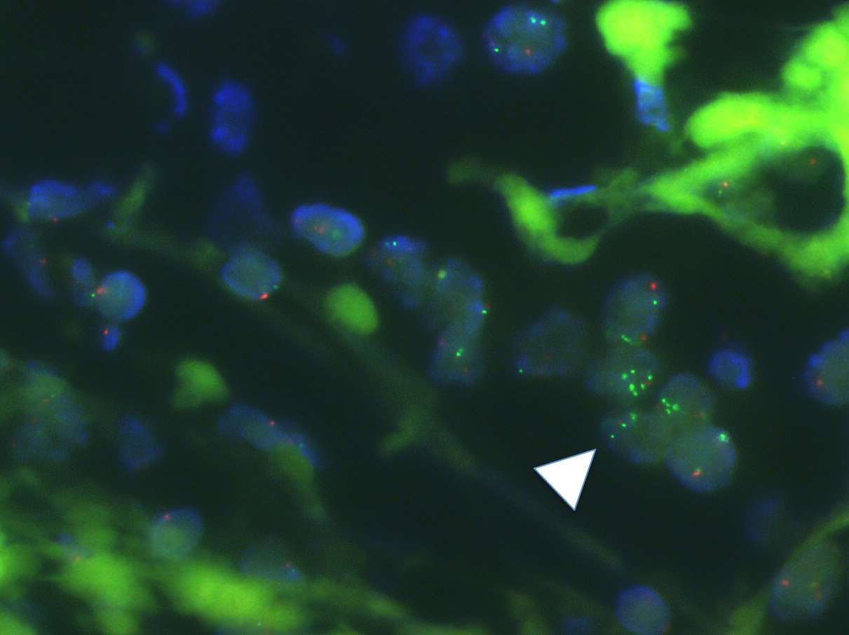

Figure 2 Supposed ESR1 amplification of mosaic pattern heterogeneous appearance by fluorescence in situ hybridization (FISH) analysis. Green and red spots represent ESR1 gene probe and centromere 6 probe, respectively. White arrowhead indicates a cluster of nuclei (blue) displaying increased number of ESR1 FISH signals within a cell population without additional ESR1 copies visible^{[38]}.

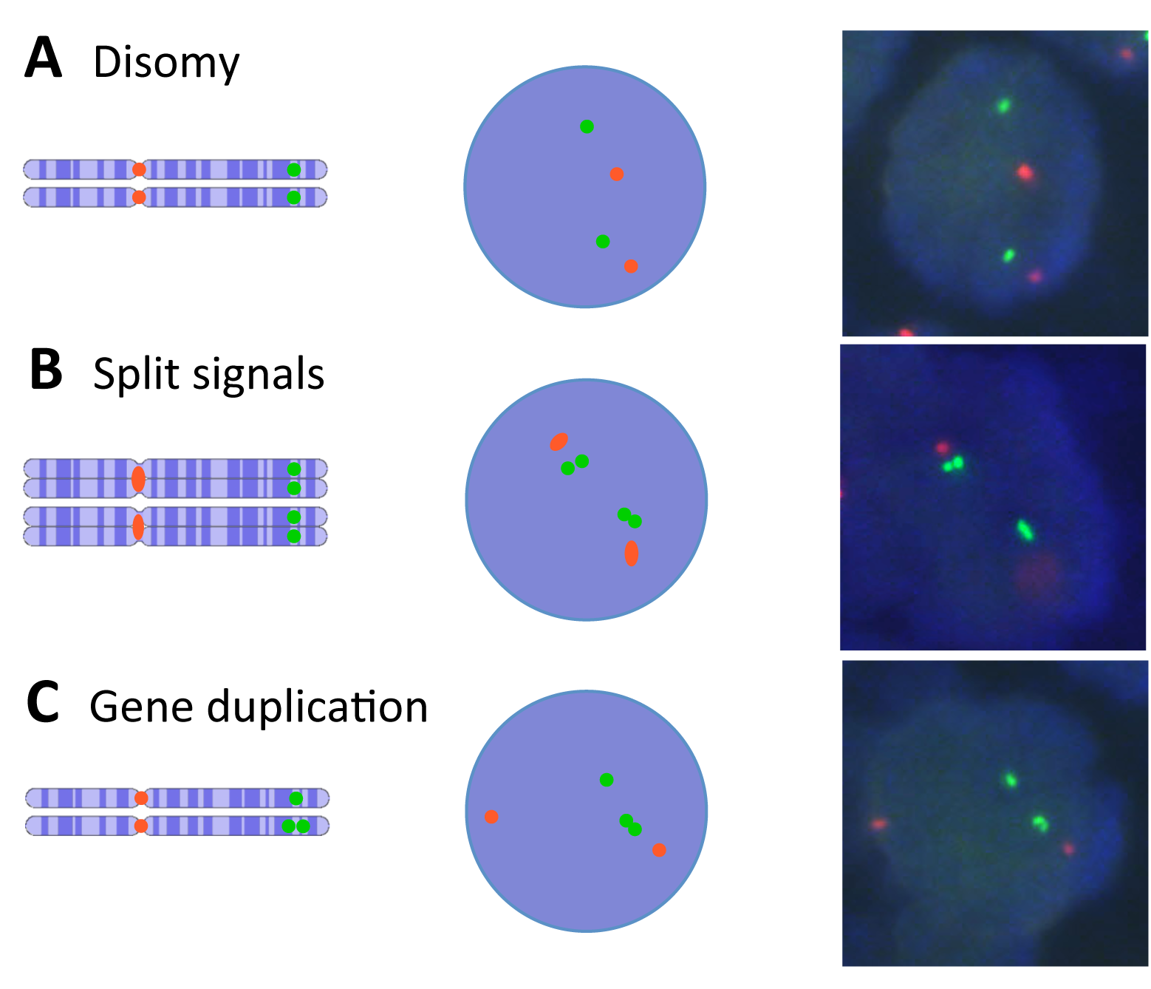
Figure 3 ESR1 single and split signal patterns and their supposed appearance by fluorescence in situ hybridization (FISH). Green and red spots represent ESR1 gene probe and centromere 6 probe, respectively. (A) Normal disomy with two chromosomes and two gene copies. (B) Normal disomy after s-phase with four chromatids and four gene copies. (C) Disomy harboring mono allelic gene duplication with two chromosomes and three gene copies^{[38]}.

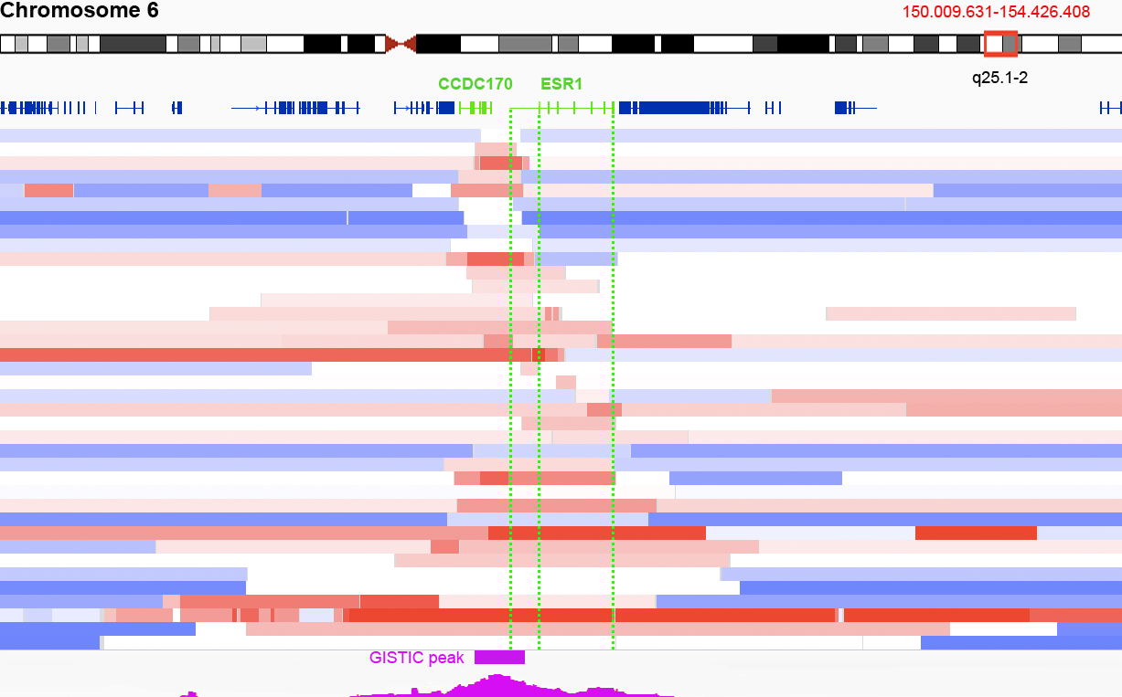Figure 4 Most focal ESR1 amplifications in the cancer genome atlas. Segmented log2 copy number fold changes relative to the genome wide average in 38 TCGA breast cancers illustrated in horizontal bars (red: increased, white: neutral/normal, blue: decreased/deleted). Focal amplifications smaller than the region 2 Mb up and downstream of ESR1 (150.009.631-154.426.408 bp) harboring any ESR1 sequences in relation to their flanking regions are shown. Upper 15 cases exhibit such amplifications harboring CCDC170 sequences and only parts of ESR1 in their peak. The lower 22 cases harbor either full ESR1 or no CCDC170 sequences in their peak. Positions of genes are indicated in dark blue and ESR1 as well as CCDC170 are highlighted in green color. GISTIC score peak is indicated in magenta color. The position of the significant (Q < 0.25) GISTIC peak region is indicated as a separate magenta colored bar (95%CI)^{[50,79,81]}. TCGA: The cancer genome atlas.

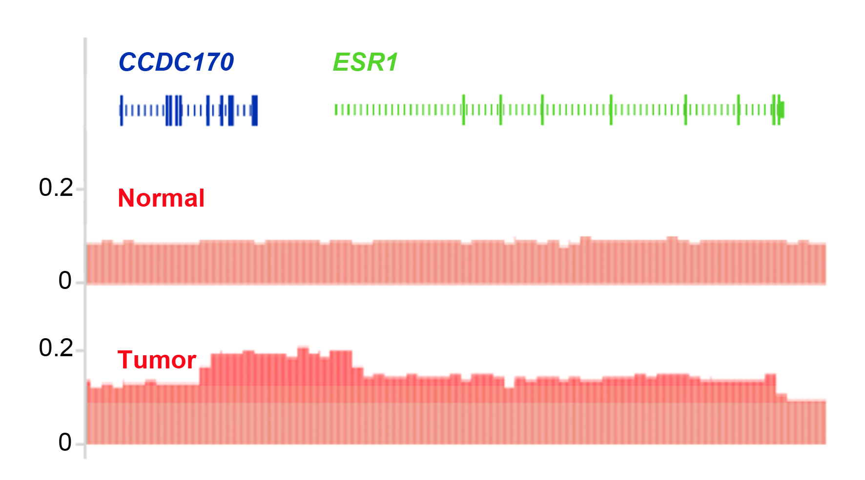
Figure 5 ESR1 amplification in a breast cancer tumor responding to estradiol treatment. DNA copy number profiles (red) in relation to the genomic position of CCDC170 (blue) and ESR1 (green) in normal and a breast cancer tumor tissue that harbors amplification of the ESR1 gene. The amplified DNA sequence extends from CCDC170 throughout the promoter region and the coding sequence of ESR1. The mapping of amplification was performed using read counts obtained during whole genome sequencing. Read counts above normal and max reads including ESR1 are indicated in increased darker red shading^{[84]}.

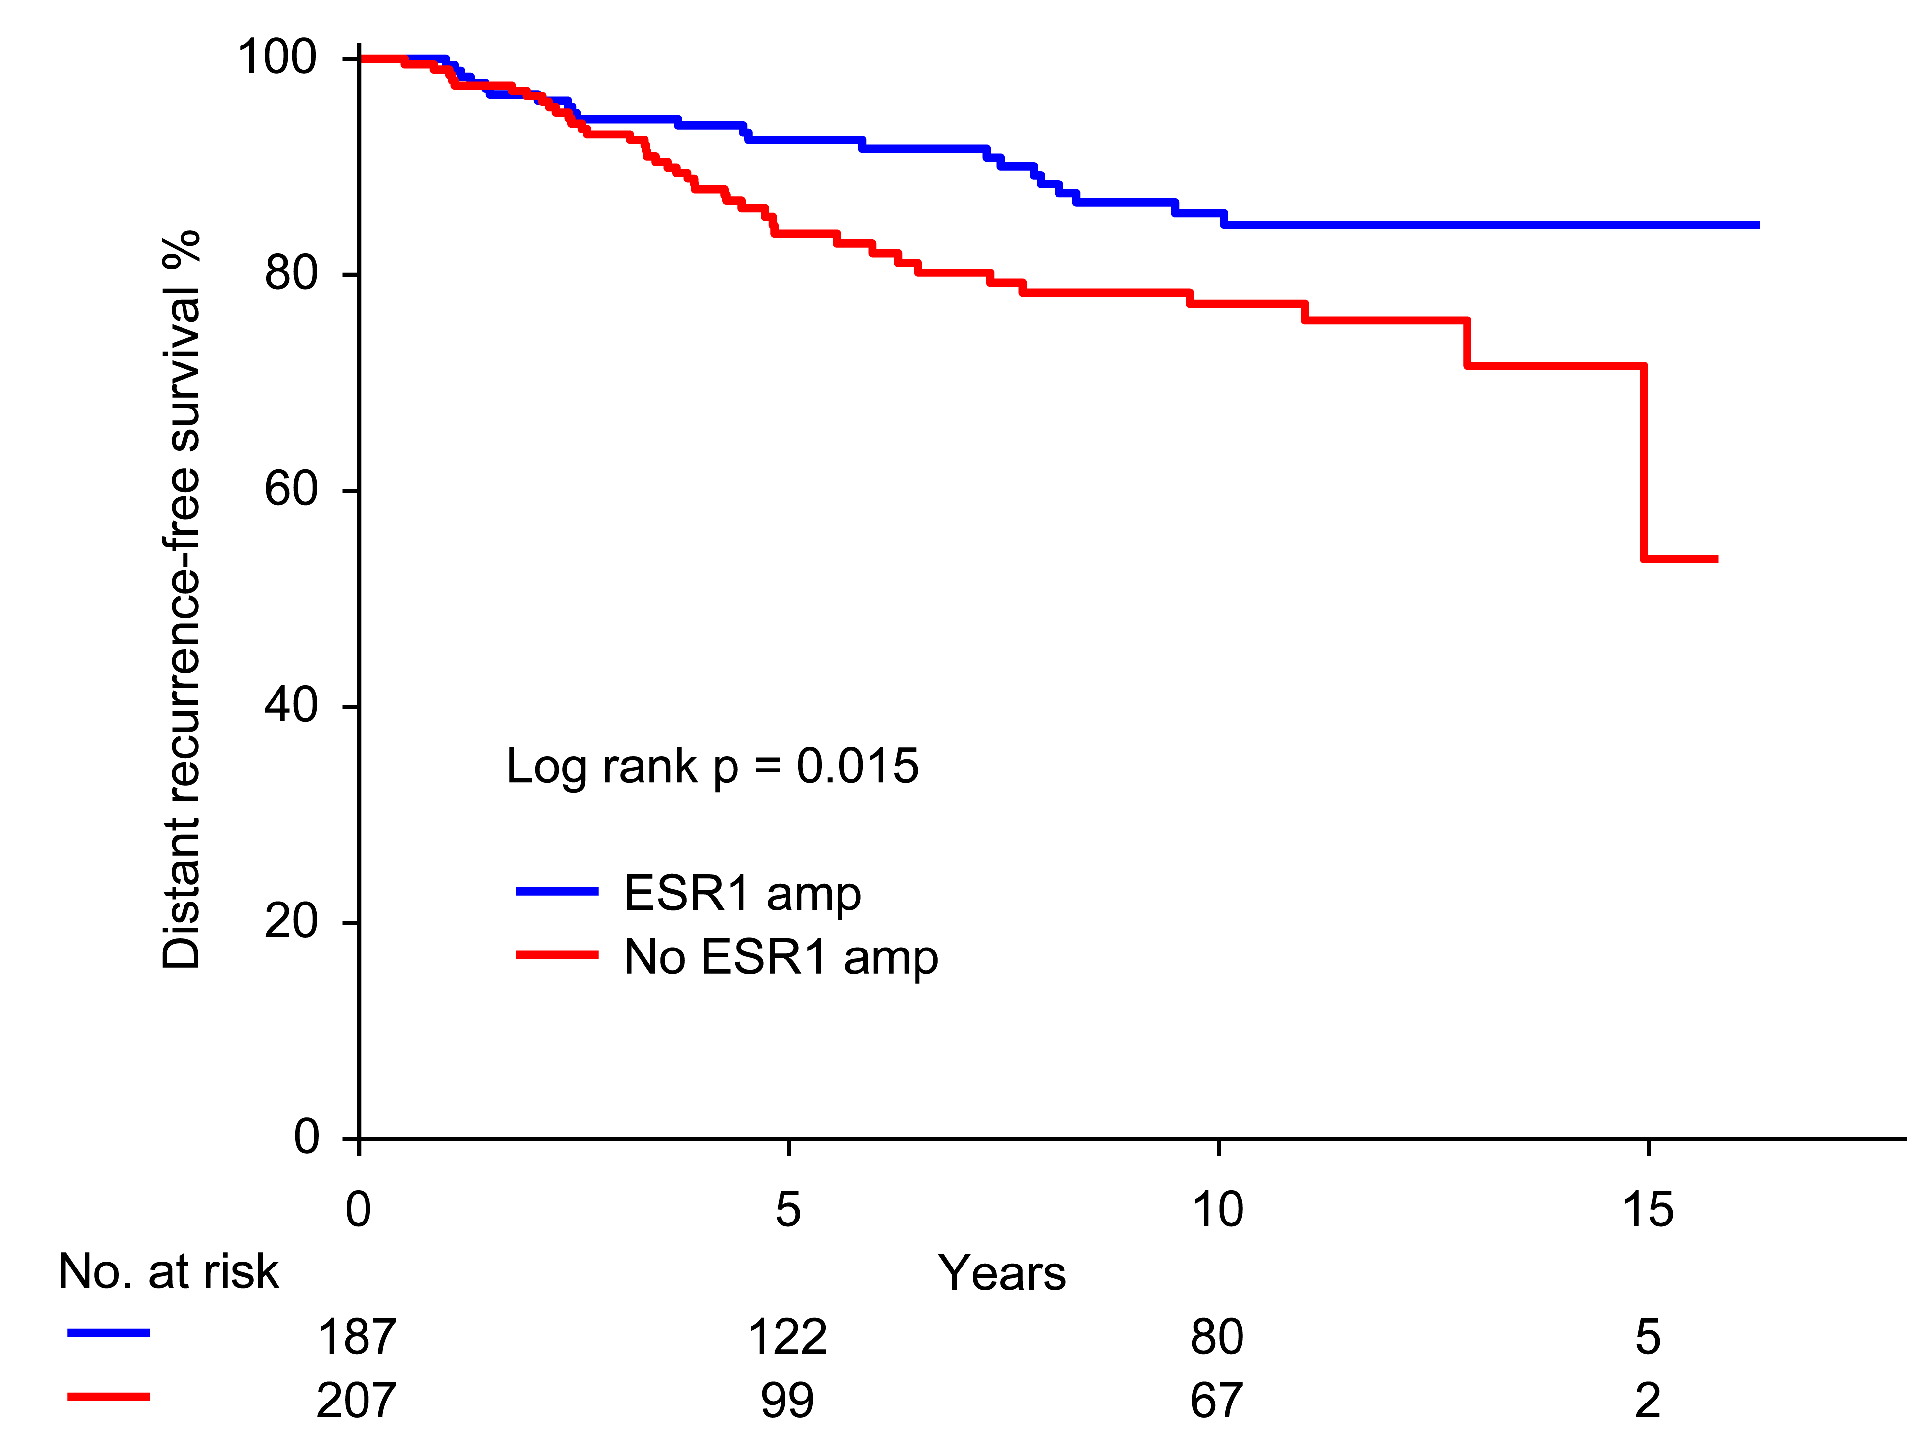Figure 6 Kaplan-Meier plot for distant recurrence-free survival of 394 breast cancer patients treated with Tamoxifen. Patients with (blue) and without (red) ESR1 amplification in primary tumor^{[39]}.

