Format for ANSWERING REVIEWERS

March 6, 2012

Dear Editor,

Please find enclosed the edited manuscript in Word format (file name: 2370-edited-6-3-2013).

Title: Teledermatology update: Mobile teledermatology

Author: Feroze Kaliyadan

Name of Journal: World Journal of Dermatology

ESPS Manuscript NO: 2370

The manuscript has been improved according to the suggestions of reviewers:
1 Format has been updated
2. Comments from reviewer 1:
Dear author, your article represents a description of teledermatology and in particular is centered on the application of mobile technology. English requires a review by a native speaker to be acceptable. I think that a greater emphasis on aspects that you considered to be innovative can be useful to do not seem to be a mere repetition of what has already been described in the literature. A description about a your own experience, if present, could be useful. Sincerely
Reply to reviewer 1
Thank you for your valuable comments. I have been working in a English based instructional set up for more than 30 years and am myself a reviewer for English language quality for various journal submissions and textbooks. It is not clear which part of the manuscript the review feels a need for review of language. It would have been useful if the reviewer could give examples of what exactly requires improvement. Anyway have modified language and syntax a bit and I sincerely feel that it suffices for English language quality.
I have a added a bit more stress on the innovative aspects of mobile teldermatology and also added a bit more on my own experience.

Comments from Reviewer 2:
The manuscript is well written and has clear messages. The only point to be corrected is to delete the internet links of references.
Reply to reviewer 2
Thanks a lot for the comments. The internet links of the references have been corrected.

Comments from Reviewer 3:
This is a well-written, easy-to-read article on mobile teledermatology. The authors give a brief overview on the current applications of mobile dermatology along with its challenges. Future directions are provided. However, expanding the discussions on the challenges and future research would make the article more interesting.
Reply to reviewer 3
Thanks a lot for the comments. I have expanded the discussion on the challenges and future research aspects as suggested.

3 References have been corrected.

Thank you again for considering publishing our manuscript in the World Journal of Dermatology

Sincerely yours,
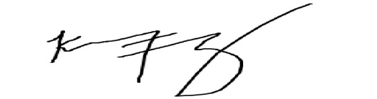

Feroze Kaliyadan
Department of Dermatology
College of Medicine
King Faisal University
Hofuf
Saudi Arabia -31982

