Name of Journal: World Journal of gastroenterology
Manuscript NO: 52372
Manuscript Type: CASE REPORT

Malignant glomus tumor of the intestinal ileum with multiorgan metastases: a case report and review of literature

Chen JH et al. Malignant glomus tumor of intestinal ileum

Jian-hong Chen, Lin Lin, Kui-liang Liu, Hui Su, Ling-ling Wang, Peng-peng Ding, Quan Zhou, Hong Liu, Jing Wu

Jian-hong Chen, Lin Lin, Kui-liang Liu, Hui Su, Peng-peng Ding, Hong Liu, Department of Gastroenterology, Beijing Shijitan Hospital, Capital Medical University, Beijing 100038, China

Ling-ling Wang, Quan Zhou, Department of Pathology, Beijing Shijitan Hospital, Capital Medical University, Beijing 100038, China

Jing Wu, Department of Gastroenterology, Beijing Friendship Hospital, Capital Medical University, Beijing 100050, China

Author contributions: Chen JH, Lin L, Liu KL, and Wu J designed this report; Su H performed the capsule endoscopy examination for the patient; Wang LL and Zhou Q performed the histopathological and immunohistochemical analyses; Chen JH, Lin L, Liu KL, and Ding PP followed the patient and recorded his medical information; Chen JH wrote the paper.

Supported by the National Natural Science Foundation of China, No. 81900505.

Corresponding author: Jing Wu, MD, PhD, Professor, Department of Gastroenterology, Beijing Friendship Hospital, Capital Medical University, No. 95 Yongan road, Xicheng district, Beijing 100050, China. wujing36@163.com

Received: November 25, 2019
Revised: January 8, 2020
Accepted: January 15, 2020
Published online: February 21, 2020

Abstract
BACKGROUND
Glomus tumors (GTs) are rare mesenchymal neoplastic lesions derived from cells of the glomus body. GTs rarely occurs in the visceral organs, where there may be few or no glomus bodies, and the majority of GTs are benign, rarely demonstrating aggressive or malignant behavior and histological features.

CASE SUMMARY
We report a patient with malignant GTs of the intestinal ileum with multiorgan metastases who was admitted due to moderate anemia. Capsule endoscopy revealed a bleeding mass in the intestinal ileum, and the patient underwent segmental ileal resection through laparoscopic surgery. The histopathological and immunohistochemical diagnoses were consistent with malignant GT. Long-term follow-up showed that the GT had metastasized to multiple organs such as the colon, brain, and possibly the lung.

CONCLUSION
This case was characterized by the highest degree of malignancy and by multiorgan metastases, and it was the first case of intestinal GT uncovered by capsule endoscopy.

Key words: Malignant glomus tumor; Intestine; Metastases; Capsule endoscopy; Diagnosis; Case report

Citation: Chen Jh, Lin L, Liu Kl, Su H, Wang Ll, Ding Pp, Zhou Q, Liu H, Wu J. Malignant glomus tumor of the intestinal ileum with multiorgan metastases: a case report and review of literature. World J Gastroenterol 2020; 26(7): 770-776
URL: https://www.wjgnet.com/1007-9327/full/v26/i7/770.htm
DOI: https://dx.doi.org/10.3748/wjg.v26.i7.770

Core tip: We report a patient with malignant glomus tumors of the intestinal ileum characterized by the highest degree of malignancy and multiorgan metastases, and it was the first case of intestinal glomus tumor uncovered by capsule endoscopy. We further reviewed the literature on the clinicopathologic features, diagnosis, and treatment of intestinal glomus tumors.

INTRODUCTION
Glomus tumors (GTs) are mesenchymal neoplastic lesions derived from cells of the neuromyoarterial glomus or glomus body^{[1,2]}. GTs are extremely rare, accounting for approximately 2% of all soft tissue neoplasms, and most often occur in the subungual region of the extremities^{[1,3]}. The majority of GTs are benign and rarely demonstrate aggressive or malignant behavior and histological features^{[4,5]}. GTs rarely occur in the gastrointestinal tract, where there may be few or no glomus bodies. Among the rarely reported gastrointestinal GTs, the gastric antrum is the most frequent region involved, and GTs that occur in the intestinal tract are extremely rare^{[5]}.
Here, we report a patient with malignant GTs of the intestinal ileum with multiorgan metastases and review the literature on the clinicopathologic features, diagnosis, and treatment of intestinal GTs.

CASE PRESENTATION
Chief complaints
A 73-year-old woman was admitted with the main complaint of dizziness for 3 mo.

History of present illness
Patient’s dizziness symptoms started 3 mo ago with weakness, which had worsened over the past 1 wk.

History of past illness
The patient received modified radical mastectomy of the left breast 5 years ago.

Physical examination
The patient’s temperature was 36.5 °C, heart rate was 78 bpm, respiratory rate was 18 breaths per min, and blood pressure was 125/75 mmHg. There were no significant positive signs other than anemic conjunctivae and anemic appearance.

Laboratory examinations and imaging examinations
Blood routine examination showed that her hemoglobin level was 6.3 g/dl and the fecal occult blood test was positive. Contrast computed tomography (CT), upper gastrointestinal endoscopy, and colonoscopy did not reveal any significant findings. Then the patient underwent a capsule endoscopy examination, which revealed a bleeding mass in the intestinal ileum (Figure 1).

MULTIDISCIPLINARY EXPERT CONSULTATION
Hong Gao, MD, PhD, Professor and Chief, Department of colorectal surgery, Beijing Shijitan Hospital Affiliated to the Capital Medical University.
It was recommended that the patient undergo segmental ileum resection through laparoscopic surgery.

TREATMENT
The patient underwent segmental ileum resection through laparoscopic surgery. The tumor measured 2.0 cm × 2.8 cm × 1.2 cm.

FINAL DIAGNOSIS
The histological examination revealed that the tumor cells were spindle-shaped and surrounded by branched or dilated vessels (Figure 2A), with vascular invasion and focal necrosis, and extended to the muscularis propria. The mitotic activity was ≥ 5/per high-power field (HPF) (× 200) with marked nuclear atypia (Figure 2B and C). Immunohistochemical staining showed that the tumor cells were positive for smooth muscle actin (SMA), vimentin, caldesmon, cluster of differentiation 34 (CD34), and Ki-67 (80%+) and were negative for CD117, desmin, dog-1, s100, leukocyte common antigen and cytokeratin (commonly referred to as CK) (Figure 3). The histopathologic examination and immunohistochemistry results were consistent with a malignant GT.

OUTCOME AND FOLLOW-UP
At 10 mo after surgery, the patient was re-hospitalized for dizziness and left leg weakness. Cranial magnetic resonance imaging showed the presence of a lesion measuring approximately 2.0 cm in the right frontal lobe that was considered a metastatic tumor. Postoperative pathological examination demonstrated that the lesion had similar histopathological and immunohistochemical features to the primary intestinal GT. Further follow-up showed multiorgan metastases of the GT to the transverse and sigmoid colon (the patient underwent hemicolectomy by laparoscopy), abdominal wall (the patient underwent the resection of the abdominal tumor, enterodialysis, and partial enterectomy by laparotomy), left temporal lobe (the patient underwent two tumor resections by craniotomy), and possibly the lung (contrast CT showed a slightly enlarged mass in the inferior lobe of the right lung, and the patient and her family refused further examinations). Eventually, the patient died from multiple organ failure caused by GT metastases. Informed consent was obtained from the patient and her family.

DISCUSSION
GTs most commonly occur in the dermis or subcutis of the extremities, and the vast majority of GTs are benign; malignant cases account for less than 1% of all GTs^{[6,7]}. GTs have been occasionally reported in other locations, including the gastrointestinal tract, where the stomach has been the most frequent site of occurrence. GTs arising from the intestine are extremely rare.
To date, only 20 primary intestinal GTs have been described in the literature, including 9 cases reported by Russian investigators before 1988, for which we could not uncover detailed information^{[8-16]}. The clinicopathologic features of the other 11 documented intestinal GTs are summarized in Table 1. The 11 patients ranged from 29-years-old to 82-years-old, and there was a significant male predominance, with 8 males (72.7%), 2 females, and 1 case of unknown sex, while previous data showed a nearly equal sex distribution^{[17]}. Intestinal GTs presented with diverse clinical symptoms, the most common of which were melena, vomiting, abdominal pain, and anemic symptoms.
Intestinal GTs can occur in any part of the intestine, and the tumor size ranges from 0.6 cm to 12.8 cm at the longest diameter. The endoscopic appearance of intestinal GTs includes submucosal lesions with either normal mucosa or ulceration. Histologically, intestinal GTs are composed of multiple cellular nodules separated by smooth muscle cells and vascular forms in which numerous dilated blood vessels without GT elements are seen in the tumor periphery. Intestinal GTs can involve mucosa, muscularis, and the whole wall of the intestine, and 54.5% (6/11) of 11 of the previously reported cases involved serosa and even perienteric adipose tissue. Immunohistochemical analyses demonstrated that most intestinal GTs were positive for SMA, caldesmon, calponin, and vimentin and were negative for CD117, desmin, and S-100^{[7,17]}.
The diagnosis of malignant GTs should consider the tumor size, infiltrative growth, growth pattern, cellularity, nuclear grade, mitotic activity, atypical mitotic figures, vascular involvement, and necrosis. Folpe et al^{[7]} studied the features of 52 unusual GTs and proposed the following criteria for the diagnosis of malignant GTs: tumors with deep locations, more than 2 cm, atypical mitotic figures, moderate to high nuclear grades and a mitotic activity of ≥ 5/50 HPFs (400×). World Health Organization classification of soft tissue tumors (2013) recommended that tumors with a deep location and a size of more than 2 cm in the absence of nuclear atypia were classified as glomus tumors of “uncertain malignant potential.” According to these criteria, two cases with serosal invasion, large tumor sizes (maximum diameters of 2.5 cm and 12.8 cm), and increased mitotic activity (19/50 HPFs and 4-5/50 HPFs) met the diagnostic criteria for malignant GTs^{[5,18]}.
The major differential diagnoses for intestinal GTs were gastrointestinal stromal tumors (GISTs) and gastrointestinal neurogenic tumors. Markku et al^{[17]} summarized the differences in immunohistochemical findings between gastrointestinal GTs and GISTs. GISTs stained positively for CD117 (100%) and CD34 (69%). In contrast, GTs were generally negative for CD117 (100%), and only a few cases were positive for CD34 (20%). Gastrointestinal neurogenic tumors had substantial positive staining for S-100 (paragangliomas and neurilemmomas), CK (carcinoid tumors), and the neuroendocrine markers chromogranin A, neuron-specific enolase, synaptophysin, and CD56 and were negative for SMA and CD117^{[1]}.
Complete surgical resection of the tumor is an effective radical treatment for atypical GTs. Markku et al^{[17]} performed long-term follow-up for 32 atypical gastrointestinal GTs (one intestinal case) after primary surgery and found that one patient died of metastatic disease at 50 mo and that the original tumor had mild atypia and vascular invasion. Malignant GTs were highly invasive, with high rates of recurrence and metastases. Previous studies have shown that 62.5% (10/16) of malignant GTs derived from the trachea, bronchus, or lung were distant metastases, and six patients died during the 60-mo follow-up. Surgical resection is still an effective treatment for malignant GTs, and some patients receive postoperative adjuvant chemotherapy with poor responses to treatment^{[19]}. These 11 documented intestinal GT patients that included two malignant cases, underwent laparoscopy or laparotomy, and no recurrence or metastases were reported. Due to the extremely low incidence of intestinal GTs and incomplete clinical information, it is difficult to identify an effective treatment for malignant GTs of the intestine.
Our patient had a malignant intestinal GT with several important and interesting features. (1) This patient had the highest degree of malignancy: among 11 reported intestinal GTs, 81.8% (9/11) of the cases were benign, and the only two cases that were malignant had increased mitotic activity. Our case exhibited the highest degree of malignancy with extremely high mitotic activity and proliferation capacity (Ki-67, 80% +). (2) This patient had multiorgan metastases: no distant metastases and postoperative recurrence were observed in the two malignant GTs that were previously reported^{[5,18]}, while our patient had multiorgan metastases to the transverse colon, sigmoid colon, abdominal wall, left temporal lobe and possibly the lung. This is the first reported case of malignant intestinal GT with multiorgan metastases. And (3) This patient was diagnosed by capsule endoscopy: the tumor occurred in the intestinal ileum, and contrast CT did not show marked enhancement; in addition, upper gastrointestinal endoscopy and colonoscopy could not reach the lesion site. This is the first case of GT identified by capsule endoscopy, and our study added GT to the range of intestinal diseases that can be identified by capsule endoscopy.

CONCLUSION
We reported a malignant intestinal GT with the highest degree of malignancy and multiorgan metastases, and this patient was the first GT patient to be diagnosed by capsule endoscopy. Intestinal GTs are extremely rare; most cases are benign, while a few cases demonstrate aggressive or malignant clinical and histological features. The clinical manifestations, imaging and endoscopic features of malignant intestinal GTs lack specificity, and careful histological examinations and immunostaining for appropriate markers are essential for accurate diagnoses. Complete surgical resection is an effective radical treatment for intestinal GTs.

References
1 Dong LL, Chen EG, Sheikh IS, Jiang ZN, Huang AH, Ying KJ. Malignant glomus tumor of the lung with multiorgan metastases: case report and literature review. Onco Targets Ther 2015; 8: 1909-1914 [PMID: 26251614 DOI: 10.2147/OTT.S89396]
2 Namikawa T, Tsuda S, Fujisawa K, Iwabu J, Uemura S, Tsujii S, Maeda H, Kitagawa H, Kobayashi M, Hanazaki K. Glomus tumor of the stomach treated by laparoscopic distal gastrectomy: A case report. Oncol Lett 2019; 17: 514-517 [PMID: 30655795 DOI: 10.3892/ol.2018.9621]
3 Tsuneyoshi M, Enjoji M. Glomus tumor: a clinicopathologic and electron microscopic study. Cancer 1982; 50: 1601-1607 [PMID: 6288219 DOI: 10.1002/1097-0142(19821015)50:8<1601::aid-cncr2820500823>3.0.co;2-5]
4 Lee HW, Lee JJ, Yang DH, Lee BH. A clinicopathologic study of glomus tumor of the stomach. J Clin Gastroenterol 2006; 40: 717-720 [PMID: 16940885 DOI: 10.1097/00004836-200609000-00011]
5 Abu-Zaid A, Azzam A, Amin T, Mohammed S. Malignant glomus tumor (glomangiosarcoma) of intestinal ileum: a rare case report. Case Rep Pathol 2013; 2013: 305321 [PMID: 23691399 DOI: 10.1155/2013/305321]
6 Yoshida H, Asada M, Marusawa H. Gastrointestinal: Glomus tumor: A rare submucosal tumor of the stomach. J Gastroenterol Hepatol 2019; 34: 815 [PMID: 30665269 DOI: 10.1111/jgh.14594]
7 Folpe AL, Fanburg-Smith JC, Miettinen M, Weiss SW. Atypical and malignant glomus tumors: analysis of 52 cases, with a proposal for the reclassification of glomus tumors. Am J Surg Pathol 2001; 25: 1-12 [PMID: 11145243 DOI: 10.1097/00000478-200101000-00001]
8 Mamedov KB, Mamedbekova LG, Abdullaev IG. [Glomus tumor as a cause of multiple profuse intestinal hemorrhages]. Khirurgiia (Mosk) 1987; (9): 81-83 [PMID: 2826871]
9 Portnoĭ LM, Gracheva KP, Kriuchkova GS, Maĭskiĭ VB. [Glomic tumor of the duodenum]. Arkh Patol 1975; 37: 73-74 [PMID: 170896]
10 Lenskaia MA, Treshchan OIa. [Glomus tumor of the small intestine]. Khirurgiia (Mosk) 1976; (4): 127-128 [PMID: 181636]
11 Rykov VA. [Malignant glomus tumor of the jejunum with distant metastases]. Arkh Patol 1977; 39: 64-66 [PMID: 199144]
12 Leĭkina MA, Averbakh AM. [Malignant glomic tumor of the duodenum]. Arkh Patol 1984; 46: 81-84 [PMID: 6095795]
13 Pomelov VS, Nudnov NV, Savvina TV. [Malignant glomic tumor of the duodenum]. Sov Med 1981; (10): 120-123 [PMID: 6274046]
14 Penin VA, Ignatov SV, Malinov OA. [Cavernous glomus tumor of the small intestine]. Khirurgiia (Mosk) 1988; (12): 128-129 [PMID: 2853245]
15 Dasaev AN, Stepanov VA. [Glomus tumor of the small intestine with metastasis to the liver]. Klin Med (Mosk) 1985; 63: 110-111 [PMID: 2987610]
16 Vaza AM, Kaem RI, Chikunova BZ. [Glomic tumor of the ileum with perforation and hemorrhage]. Klin Med (Mosk) 1974; 52: 129-130 [PMID: 4371251]
17 Miettinen M, Paal E, Lasota J, Sobin LH. Gastrointestinal glomus tumors: a clinicopathologic, immunohistochemical, and molecular genetic study of 32 cases. Am J Surg Pathol 2002; 26: 301-311 [PMID: 11859201 DOI: 10.1097/00000478-200203000-00003]
18 Tan TJ, Hayes MM, Radigan JP, Munk PL. Glomus tumour of the colon: dynamic contrast-enhanced CT findings and review of the literature. Clin Imaging 2015; 39: 714-716 [PMID: 25770905 DOI: 10.1016/j.clinimag.2015.02.015]
19 Huang B, Chen FG, Zhuang J, Zheng WC, Zhu WY, Zhang QC, Wang SH, Guo CM, Xie CM. [Primary tracheal malignant glomus tumor with lung metastasis diagnosed by pathological analysis: a case report and literature review]. Zhonghua Jie He He Hu Xi Za Zhi 2017; 49: 697-702 [PMID: 28910916 DOI: 10.3760/cma.j.issn.1001-0939.2017.09.016]
20 Bennett S, Lam M, Wasserman J, Carver D, Saloojee N, Moyana T, Auer RA, Lorimer J. A case series of two glomus tumors of the gastrointestinal tract. J Surg Case Rep 2015; 2015: pii: rju144 [PMID: 25576168 DOI: 10.1093/jscr/rju144]
21 Campana JP, Goransky J, Mullen EG, Palavecino EM. Intestinal benign glomus tumor: description and review of the literature. Dig Dis Sci 2014; 59: 2594-2596 [PMID: 24795037 DOI: 10.1007/s10620-014-3172-9]
22 Oliphant R, Gardiner S, Reid R, McPeake J, Porteous C. Glomus tumour of the ascending colon. J Clin Pathol 2007; 60: 846 [PMID: 17596555 DOI: 10.1136/jcp.2006.041590]
23 Barua R. Glomus tumor of the colon. First reported case. Dis Colon Rectum 1988; 31: 138-140 [PMID: 2827970 DOI: 10.1007/bf02562647]
24 Geraghty JM, Everitt NJ, Blundell JW. Glomus tumour of the small bowel. Histopathology 1991; 19: 287-289 [PMID: 1655616 DOI: 10.1111/j.1365-2559.1991.tb00040.x]
25 Hamilton CW, Shelburne JD, Bossen EH, Lowe JE. A glomus tumor of the jejunum masquerading as a carcinoid tumor. Hum Pathol 1982; 13: 859-861 [PMID: 6286460 DOI: 10.1016/s0046-8177(82)80082-8]
26 Knackstedt C, Wasmuth H, Donner A, Trautwein C, Winograd R. Diagnosis of an unusual tumor in the duodenum. Endoscopy 2007; 39 Suppl 1: E94 [PMID: 17440867 DOI: 10.1055/s-2007-966456]
27 Tuluc M, Horn A, Inniss S, Thomas R, Zhang PJ, Khurana JS. Case report: glomus tumor of the colon. Ann Clin Lab Sci 2005; 35: 97-99 [PMID: 15830716]

Footnotes
Informed consent statement: Informed written consent was obtained from the patient for publication of this report.

Conflict-of-interest statement: The authors declare that they have no competing interests.

CARE Checklist (2016) statement: The authors have read the CARE Checklist (2016), and the manuscript was prepared and revised according to the CARE Checklist (2016).

Open-Access: This article is an open-access article that was selected by an in-house editor and fully peer-reviewed by external reviewers. It is distributed in accordance with the Creative Commons Attribution Non Commercial (CC BY-NC 4.0) license, which permits others to distribute, remix, adapt, build upon this work non-commercially, and license their derivative works on different terms, provided the original work is properly cited and the use is non-commercial. See: http://creativecommons.org/licenses/by-nc/4.0/

Manuscript source: Invited manuscript

Peer-review started: November 25, 2019
First decision: December 12, 2019
Article in press: January 15, 2020

Specialty type: Gastroenterology and hepatology
Country of origin: China
Peer-review report classification
Grade A (Excellent): 0
Grade B (Very good): B, B, B
Grade C (Good): C
Grade D (Fair): 0
Grade E (Poor): 0

P-Reviewer: Chisthi MM, Sacchetti F, Thanindratarn P, Huang CF S-Editor: Gong ZM L-Editor: Filipodia E-Editor: Ma YJ

Figure Legends
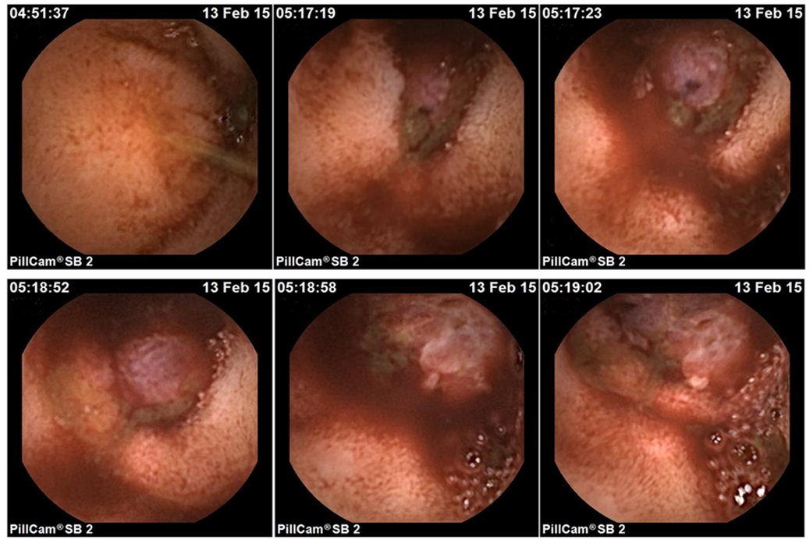
Figure 1 Capsule endoscopic characteristics of the intestinal glomus tumor from different perspectives.

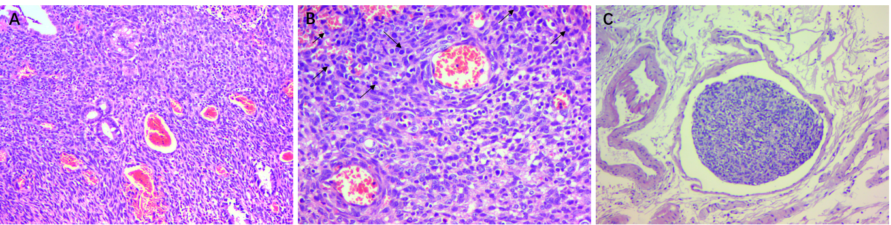
Figure 2 Histological characteristics of the malignant glomus tumor in ileum. A: Spindled tumor cells with branched or dilated vessels surrounded [hematoxylin and eosin (H&E) stain, 100 ×]; B: Spindled cells with high mitotic activity and nuclear atypia marked with arrows (H&E stain, 200 ×); and C: Tumor cells with vascular invasion (H&E stain, 100 ×).

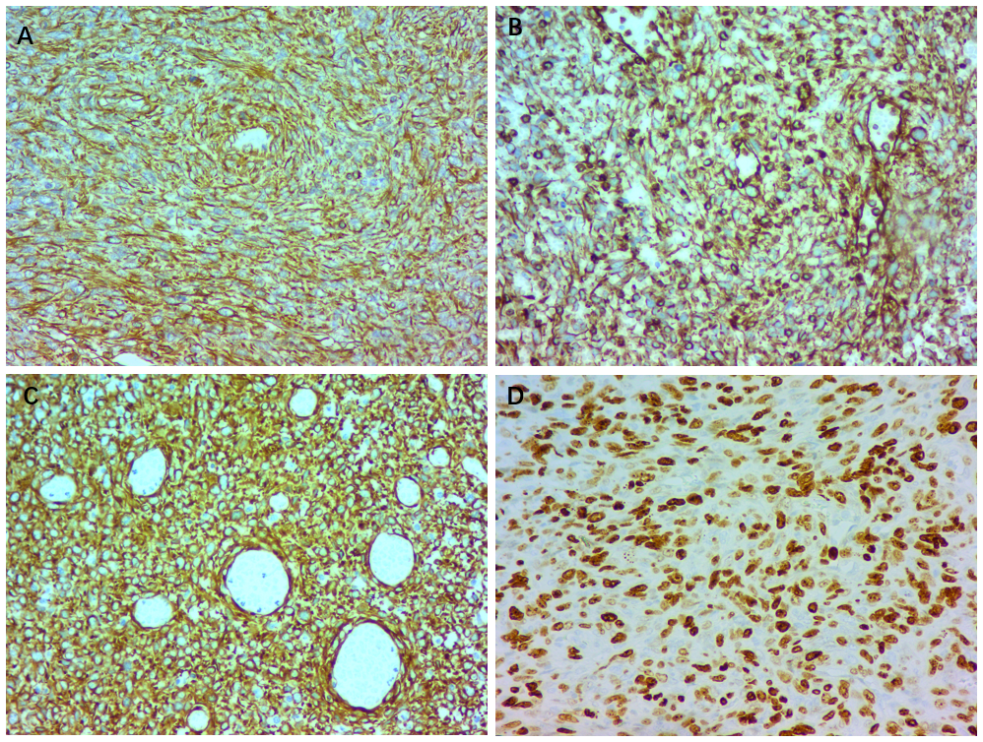
Figure 3 Immunohistochemical staining characteristics of the malignant glomus tumor in ileum. A: Smooth muscle actin; B: Vimentin; C: Caldesmon; and D: Ki-67.

Table 1 Clinicopathological characteristics of documented intestinal glomus tumors
Ref. | Age/sex | Symptoms | Location/size in cm | Invasion | Mitotic activity | Follow up
Abu-Zaid et al^{[5]}, 2013 | 29/female | constipation vomiting, melena | Ileum  12.8 × 10.2 × 13.1 | serosa | 4-5/50 HPFs | 6 mo NETR
Tan et al^{[18]}, 2015 | 74/male | vomiting abdominal pain | Splenic flexure  2.5 | serosa | 19/50 HPFs | 6 mo NETR
Bennett et al^{[20]}, 2015 | 70/male | light headedness, melena | Ascending colon  2.3 × 1.6 | muscularis propria | 1/50 HPFs | NA
Campana et al^{[21]}, 2014 | 51/male | melena, orthostasis | Ileum  3.7 | muscularis propria | < 5/50 HPFs | 2 yr NETR
Oliphant et al^{[22]}, 2007 | 37/male | abdominal pain, altered bowel habit | Ascending colon  3.0 × 2.0 | pericolic fat | 0/50 HPFs | NA
Barua et al^{[23]}, 1988 | 60/NA | NA | Colon  0.8 × 0.6 | pericolic fat | NA | NA
Miettinen et al^{[17]}, 2002 | 34/female | appendicitis-like symptoms | Cecum  7.0 × 6.0 | NA | 1/50 HPFs | NA
Geraghty et al^{[24]}, 1991 | 60/male | abdominal pain, diarrhea | Ileum  0.6 | serosa | 0/50 HPFs | Died¹
Hamilton et al^{[25]}, 1982 | 82/male | abdominal pain, anorexia, nausea | Jejunum  1.0 × 1.5 | serosa | NA | 6 mo NETR
Knackstedt et al^{[26]}, 2007 | 65/male | vomiting | Duodenum  NA | submucosa | 0/50 HPFs | NA
Tuluc et al^{[27]}, 2005 | 40/male | rectal bleeding | Colon  diminutive | mucosa | 0/50 HPFs | > 1 yr NETR
¹The patient died 5 d post-operatively from a presumed pulmonary embolus; NA: not available; NETR: no evidence of tumor recurrence; HPFs: High power fields, 400 ×.

