Name of Journal: World Journal of Clinical Cases
Manuscript NO: 41429
Manuscript Type: CASE REPORT

Follicular dendritic cell sarcoma detected in hepatogastric ligament: A case report and review of literature

Yan WX et al. Follicular dendritic cell sarcoma in hepatogastric ligament

Wen-Xin Yan, You-Xi Yu, Ping Zhang, Xing-Kai Liu, Yan Li

Wen-Xin Yan, You-Xi Yu, Ping Zhang, Xing-Kai Liu, Department of Hepatobiliary and Pancreatic Surgery, the First Hospital of Jilin University, Changchun 130021, Jilin Province, China

Yan Li, Department of Surgery, School of Medicine, University of Louisville, Louisville, KY 40202, United States

ORCID number: Wen-Xin Yan (0000-0002-5821-5907); You-Xi Yu (0000-0003-4542-5363); Ping Zhang (0000-0003-4944-2937); Xing-Kai Liu (0000-0001-7856-3899); Yan Li (0000-0002-9403-9533).

Author contributions: Yan WX and Yu YY contributed to data collection and analysis, and manuscript drafting; Zhang P contributed to clinical consultant and case interpretation; Liu XK contributed to manuscript design and editing; Li Y contributed to English modification and coordinated with a native English speaker to check English grammar.

Informed consent statement: Informed consent was obtained from patients regarding the use of specimens for case report.

Conflict-of-interest statement: All authors declare to have no conflict of interest.

CARE Checklist (2016) statement: The guidelines of the CARE Checklist (2016) have been adopted.

Open-Access: This article is an open-access article which was selected by an in-house editor and fully peer-reviewed by external reviewers. It is distributed in accordance with the Creative Commons Attribution Non Commercial (CC BY-NC 4.0) license, which permits others to distribute, remix, adapt, build upon this work non-commercially, and license their derivative works on different terms, provided the original work is properly cited and the use is non-commercial. See: http://creativecommons.org/licenses/by-nc/4.0/

Manuscript source: Unsolicited manuscript

Correspondence to: Xing-Kai Liu, MD, PhD, Assistant Professor, Department of Hepatobiliary and Pancreatic Surgery, the First Hospital of Jilin University, No. 71 Xinmin Street, Changchun 130021, Jilin Province, China. xingkailiu@foxmail.com
Telephone: +86-431-88782222
Fax: +86-431-88782222

Received: August 24, 2018
Peer-review started: August 24, 2018
First decision: October 8, 2018
Revised: October 15, 2018
Accepted: October 23, 2018
Article in press:
Published online:

Abstract
The most common organ where follicular dendritic cell sarcoma (FDCS) occurs is in cervical lymph nodes, while few cases are found in extranodal organs such as liver, spleen, and soft tissue. This is a case report that FDCS occurs at hepatogastric ligament. To our knowledge, there is no such case being reported previously. A 47-year-old male patient was found an intraabdominal mass during an annual physical examination. Computed tomography showed a 4.2 cm × 4.1 cm mass located at lesser curvature of stomach, above pancreas. During operation, a tumor mass was found at hepatogastric ligament and a radical resection was performed. The tumor is diagnosed as FDCS by pathology and immunohistochemical test. The patient has a favorable recovery, and no obvious abnormality is found 3 months post-operation.

Key words: Follicular dendritic cell sarcoma; Hepatogastric ligament; Pathology; Immunohistochemistry; Computed tomography; Case report

© The Author(s) 2018. Published by Baishideng Publishing Group Inc. All rights reserved.

Core tip: Follicular dendritic cell sarcoma (FDCS) is a rare malignant tumor which is derived from hyperplasia dendritic cells. There is no case was reported previously that FDCS located in hepatogastric ligament. It is a very rare localization of FDCS and with the necessity of the case presentation to call clinician’s attention to the case of abdominal occupying mass possible from FDCS patients.

Yan WX, Yu YX, Zhang P, Liu XK, Li Y. Follicular dendritic cell sarcoma detected in hepatogastric ligament: A case report and review of literature. World J Clin Cases 2018; In press

INTRODUCTION
Follicular dendritic cell sarcoma (FDCS) is a rare malignant tumor which is derived from hyperplasia dendritic cells. The FDCS cases were firstly reported and discussed by Monda et al^{[1]} in 1986. Unlike normal dendritic cells, the follicular dendritic cells have no ability to present any antigens^{[2]}. FDCS, derived from hyperplastic dendritic cells, usually occurs in lymph node, especially in the cervical lymph node. Few cases occur in extranodal organs such as liver and spleen, and soft tissue^{[3]}. Most FDCS patients are young adults with no difference of gender^{[4]}. Surgery is the main therapeutics strategy at present. Although more than 200 cases were found by searching PubMed databases from 1986 to present using “follicular dendritic cell sarcoma” as key word, no case was reported previously that FDCS located in hepatogastric ligament. To our knowledge, it is a very rare localization of FDCS and with the necessity of case presentation to call clinician’s attention to the case of abdominal occupying mass possible from FDCS patients.

CASE REPORT
A 47-year-old male patient was found an enterocoelic mass during an annual physical exam. There were no any gastrointestinal symptoms when the patient was admitted to our hospital. Relevant past medical history included a long time of outdoor work, irregular eating time, smoking and alcohol abuse about thirty years. Computed tomography (CT) scan showed a 4.2 cm × 4.1 cm mass located at lesser curvature of the stomach, above pancreas (Figure 1). The clinical diagnosis was abdominal occupying mass. During operation, the tumor mass was found located at hepatogastric ligament next to lesser curvature of the stomach and cardia. A radical resection was performed and tumor size was measured 4.5 cm × 5.5 cm × 3 cm, with appearance of smooth surface, brown color, abundant blood supply and firm texture (Figure 2).
The pathological reports are the following: (1) Marginal sinus, non-expanded vessels, vestigial lymphoid follicles and vestigial reticular cells, tumor tissues are surrounded by adipose tissue and incrassated fiber capsule; (2) The spindle or oval tumor cells are arranged in a whirlpool or woven pattern; (3) Cells show abundant cytoplasm but no clear boundary between cells; and (4) Other pathological features include nealy-circular cell nucleus, slender chromatin, and few mitosis (Figure 2). The immunohistochemical test results are the followings: CD21(+), CD23(+), CD35(+), S-100(partial+), BC12(+), BC16(+), CDε(T+), CD5(+), CD20(B+), CD38(little+), CD43(T+), Cyclind1(+), Ki67(20%+), Mum(partial+), CD10(-), Pax5(-), EBER(-). The representative immunohistochemical tests of positive staining and negative staining are showed in Figure 3. In summary, the pathological diagnosis is FDCS. Post-operation, the patient has a favorable recovery without complications. After the operation, the patient has no obvious abnormality for follow-up consultations in the first month and third month.

DISCUSSION
FDCS is a low-moderate malignant tumor but with a higher rate of relapse and metastasis^{[5]}. The carcinogenic mechanisms of FDCS initiation and progression are largely unknown. About 10%-20% of patients usually suffer from hyaline-vascular Castleman disease (HVCD)^{[6]}. Because the FDCS with HVCD has increased expression of vascular endothelial growth factor (VEGF), it is speculated that FDCS may be derives from hyperplasia dendritic cells being stimulated by VEGF^{[7,8]}. As a lymphatic system malignant tumor, no evidence shows that FDCS has any relationship with Epsteim-Barr virus and Epstein-Barr-Encoded-RNA which is usually used as negative control for diagnosis^{[9]}.
There are about 200 cases of FDCS reported after Monda^{[1]}’s first report in 1986. The incidence of morbidity crowd is young adults with median age of 43-year-old, but no gender difference. FDCS usually is detected in lymph node, especially the cervical lymph node. FDCS is also found occurred in other lymph nodes such as mediastinum, retroperitoneum, mesentery, and tonsillar^{[10]}. FDCS may occur in extronodal glands, including liver, stomach, spleen, pancreas, intestine, muscle, and skin. Because the clinical manifestation of FDCS has no specificity, it is hard to find out or to make an accurate diagnosis just by general clinical examination. FDCS occurring in lymph gland is generally in chronic processing, with painless swollen lymph node. FDCS occurring in intraabdominal may be easy to metastasize to other organs such as liver and lung.
Diagnosis of FDCS is mainly based on microscopical findings of cytological features and immunohistochemical tests. In low-power field, the cytological features are characterized by spindle to ovoid or fusiform cell forming fascicles, whorle, diffuse sheet or nodular with lymphocytes infiltration^{[11,12]}. In high-power field, cytoplasm shows thin eosinophilic. Tumor-cells have symplasma with non-clear boundary. Cell nucleus is circle or oval with clear nuclear envelope. The chromatin usually occurs vacuolization or stipping shape. Mitochondrions may be seen occasionally in the nucleus. The finding of a large area of coagulative necrosis is usually with a poor prognosis^{[13]}.
The feature of FDCS in electron microscope shows long villus cells being linked together by desmosome junctions^{[12]}. The characteristics of immunohistochemistry for FDCS shows positive staining of CD21, CD23 and CD35, which are the main diagnostic markers to differentiate the other diseases, including dendritic sarcoma, soft tissue sarcoma, lymphoma, especially interdigitating dendritic cell sarcoma (IDCS). There are other non-specific positive immunohistochemistry biomarkers including CD68, S-100, CD1a, D2-40, and Ki-67. Positive Ki-67 expression is an important index of prognosis^{[11]}.
The possible misdiagnosis of FDCS includes histiocytic sarcoma (HS), Langerhans cell sarcoma (LCS), and IDCS. The immunohistochemical biomarkers being used most often for these 4 diseases (FDCS, HS, LCS and IDCS) are CD68, CD1a, CD21, CD23, LYS and S-100. According to previous report^{[13]}, the expression profile is the following: HS: CD68 (100%), CD1a (0%), CD21/CD35 (0%), LYS (94%), S100 (33%); LCS: CD68 (96%), CD1a (100%), CD21/CD35 (0%), LYS (42%), S100 (100%); IDCS: CD68 (50%), CD1a (0%), CD21/CD35 (0%), LYS (25%), S100 (100%); FDCS: CD68 (54%), CD1a (0%), CD21/CD35 (100%), LYS (8%), S-100 (16%). In addition, the diagnosis of FDCS also needs to be distinguished from ectopic thymoma, malignant melanoma, lymphoepithelioma like carcinoma and malignant peripheral nerve sheath tumor. Immunohistochemical tests of CD21, CD23 and CD35 are the most accurate indicators to distinguish FDCS from those non-FDCS diseases.
Currently, there is no a valid therapeutic strategy for FDCS. Cytoxan, Hydroxyrubicin, Oncovin and Prednisone (CHOP) program is generally used for malignant lymphoma or soft tissue sarcoma. Report indicates that CHOP program has no satisfactory effect, but doxorubicin (DXR), etoposide, methylprednisolone, cisplatin, and cytarabine (ESHAP) are recommended^{[2]}. Due to lack of enough data for a statistics and effective follow-up work, there is no affirmative answer to the curative effects. Radiotherapy and chemotherapy may be appropriated to those patients who have no chance to receive an operation. However, we can’t treat the patient by standard radiotherapy or chemotherapy regimens because FDCS is not diagnosed before surgery. The first choice for us is radical resection. For prognosis, it is reported that age (< 40-year-old), large tumor size (> 6 cm), mitotic counts (> 5/10 high-power field), positive Ki-67, large area of coagulative necrosis are the indicators of a poor prognosis^{[2]}. In addition, intra-abdominal FDCS, metastasis and recurrence are more common leading to a poor prognosis.

ARTICLE HIGHLIGHTS
Case characteristics
No any obvious or special clinical symptoms, an enterocoelic mass is found by computed tomography (CT) scan during an annual physical examination.

Clinical diagnosis
An enterocoelic mass is found by CT.

Differential diagnosis
Using different methods (location, imageology, histopathology) to distinguish it with other tumour.

Laboratory diagnosis
Diagnosis of follicular dendritic cell sarcoma (FDCS) is mainly based on microscopical findings of cytological features and immunohistochemical results.

Imaging diagnosis
CT can find an occupying mass.

Pathological diagnosis
Immunohistochemical detection of CD21, CD23 and CD35 are the most accurate indicators to distinguish FDCS from those non-FDCS diseases.

Treatment
Radical resection to remove the tumor.

Term explanation
FDCS: Follicular dendritic cell sarcoma.

Experiences and lessons
FDCS is still an uncommon disease and it is needed to find more effective diagnostic indicators and better treatment strategies.

REFERENCES
1 Monda L, Warnke R, Rosai J. A primary lymph node malignancy with features suggestive of dendritic reticulum cell differentiation. A report of 4 cases. Am J Pathol 1986; 122: 562-572 [PMID: 2420185]
2 Sasaki M, Izumi H, Yokoyama T, Kojima M, Hosono A. Follicular dendritic cell sarcoma treated with a variety of chemotherapy. Hematol Oncol 2017; 35: 905-908 [PMID: 27734516 DOI: 10.1002/hon.2364]
3 Sahay A, Bal M, Patil A, Kane S, Pai P. Follicular Dendritic Cell Sarcoma of the Larynx: Apropos a Rare Case with Review of the Literature. Turk Patoloji Derg 2017 [PMID: 28984342 DOI: 10.5146/tjpath.2017.01408]
4 Swerdlow SH, Campo E, Pileri SA, Harris NL, Stein H, Siebert R, Advani R, Ghielmini M, Salles GA, Zelenetz AD, Jaffe ES. The 2016 revision of the World Health Organization classification of lymphoid neoplasms. Blood 2016; 127: 2375-2390 [PMID: 26980727 DOI: 10.1182/blood-2016-01-643569]
5 Lu H, WJ. Extranodal follicular dendritic cell sarcoma in small intestinal mesentery. J Clin Exp Pathol 2003; 19: 22-26
6 Ruco LP, Gearing AJ, Pigott R, Pomponi D, Burgio VL, Cafolla A, Baiocchini A, Baroni CD. Expression of ICAM-1, VCAM-1 and ELAM-1 in angiofollicular lymph node hyperplasia (Castleman's disease): evidence for dysplasia of follicular dendritic reticulum cells. Histopathology 1991; 19: 523-528 [PMID: 1723957 DOI: 10.1111/j.1365-2559.1991.tb01500.x]
7 Chang YC, Chau IY, Yeh YC, Chau GY. Small intestine follicular dendritic cell sarcoma with liver metastasis: A case report. Medicine (Baltimore) 2017; 96: e7261 [PMID: 28767565 DOI: 10.1097/MD.0000000000007261]
8 Cheuk W, Chan JK, Shek TW, Chang JH, Tsou MH, Yuen NW, Ng WF, Chan AC, Prat J. Inflammatory pseudotumor-like follicular dendritic cell tumor: a distinctive low-grade malignant intra-abdominal neoplasm with consistent Epstein-Barr virus association. Am J Surg Pathol 2001; 25: 721-731 [PMID: 11395549 DOI: 10.1097/00000478-200106000-00003]
9 Bai LY, Kwang WK, Chiang IP, Chen PM. Follicular dendritic cell tumor of the liver associated with Epstein-Barr virus. Jpn J Clin Oncol 2006; 36: 249-253 [PMID: 16533803 DOI: 10.1093/jjco/hyl001]
10 Shen SC, Wu CC, Ng KF, Wu RC, Chen HM, Chen TC. Follicular dendritic cell sarcoma mimicking giant cell carcinoma of the pancreas. Pathol Int 2006; 56: 466-470 [PMID: 16872443 DOI: 10.1111/j.1440-1827.2006.01991.x]
11 Li L, Shi YH, Guo ZJ, Qiu T, Guo L, Yang HY, Zhang X, Zhao XM, Su Q. Clinicopathological features and prognosis assessment of extranodal follicular dendritic cell sarcoma. World J Gastroenterol 2010; 16: 2504-2519 [PMID: 20503450 DOI: 10.3748/wjg.v16.i20.2504]
12 Wang Q, An L, Cui N, Sha J, Zhu D. [Follicular dendritic cell sarcoma: a case report and review of literature]. Linchung Erbiyan Houtoujing Waike Zazhi 2011; 25: 100-102 [PMID: 21553518]
13 Pileri SA, Grogan TM, Harris NL, Banks P, Campo E, Chan JK, Favera RD, Delsol G, De Wolf-Peeters C, Falini B, Gascoyne RD, Gaulard P, Gatter KC, Isaacson PG, Jaffe ES, Kluin P, Knowles DM, Mason DY, Mori S, Müller-Hermelink HK, Piris MA, Ralfkiaer E, Stein H, Su IJ, Warnke RA, Weiss LM. Tumours of histiocytes and accessory dendritic cells: an immunohistochemical approach to classification from the International Lymphoma Study Group based on 61 cases. Histopathology 2002; 41: 1-29 [PMID: 12121233 DOI: 10.1046/j.1365-2559.2002.01418.x]

P-Reviewer: Aghakhani A, Aykan NF, De Silva AP S-Editor: Ji FF L-Editor: E-Editor:

Specialty type: Medicine, research and experimental
Country of origin: China
Peer-review report classification
Grade A (Excellent): O
Grade B (Very good): O
Grade C (Good): C, C, C
Grade D (Fair): 0
Grade E (Poor): 0

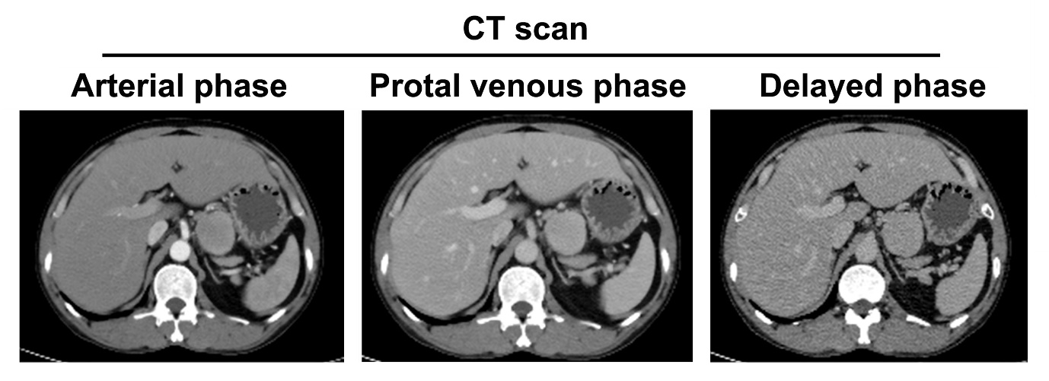Figure 1 Computed tomography scan images of the tumor.

A B C
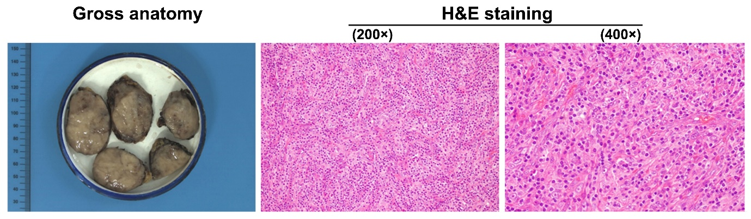
Figure 2 Appearance of gross anatomy of spited tumor and histology. A: Gross anatomy of tumor, spited specimens; B: Histology by H and E staining showed the mild shape of follicular dendritic cell sarcoma comprised of fascicular oval and spindle cell and infiltration of small lymphocyte into the tumor (200 × magnification); C: The high power field of histology by H and E staining showed that cytoplasm is abundant and eosinophilic. Cell nucleus in oval or long spindle shape with small and clear nucleus (400 × magnification).
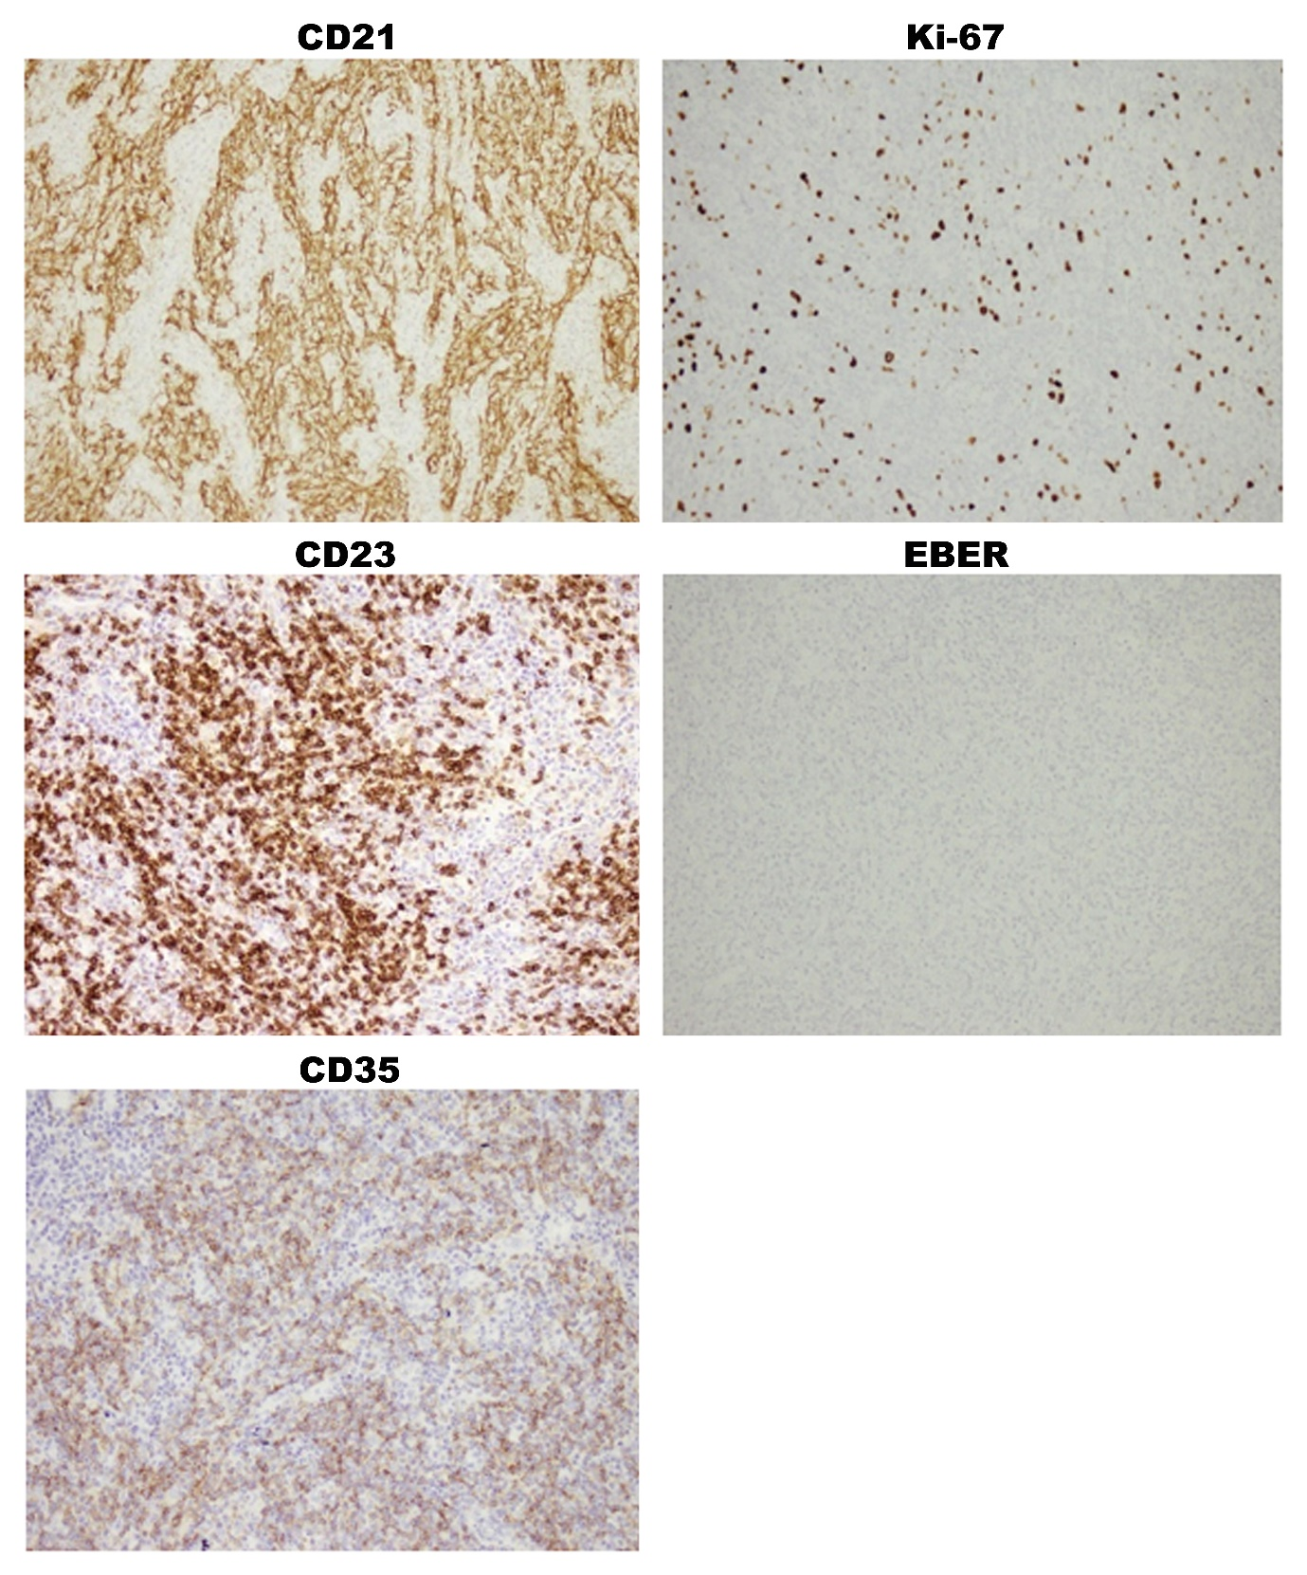
Figure 3 Immunohistochemical staining of tumor tissues. Immunohistochemical images showed a positive staining for CD21, CD23 and CD35, which were the specific biomarkers of diagnosis of follicular dendritic cell sarcoma. Ki-67 staining showed 20% positive cells, while Epstein-Barr-Encoded-RNA was negative stained. 200 × magnification for all images.

