Name of Journal: World Journal of Gastroenterology
Manuscript NO: 54521
Manuscript Type: META-ANALYSIS

Computed tomography vs liver stiffness measurement and magnetic resonance imaging in evaluating esophageal varices in cirrhotic patients: A systematic review and meta-analysis

Li Y et al. Noninvasive methods for evaluation of EV

Yue Li, Lei Li, Hong-Lei Weng, Roman Liebe, Hui-Guo Ding

Yue Li, Lei Li, Hui-Guo Ding, Department of Gastroenterology and Hepatology, Beijing You’an Hospital Affiliated with Capital Medical University, Beijing 100069, China

Hong-Lei Weng, Department of Medicine II, Section Molecular Hepatology, Medical Faculty Mannheim, Heidelberg University, Mannheim 68167, Germany

Roman Liebe, Department of Medicine II, Saarland University Medical Center, Homburg 66424, Germany

Author contributions: Li Y and Li L contributed equally to collecting the data and writing the manuscript; Ding HG designed the project and was in charge of the manuscript; Weng HL and Liebe R performed the language editing; all authors have read and approved the manuscript.

Supported by the State Key Projects Specialized on Infectious Diseases, No. 2017ZX10203202–004; Beijing Municipal Administration of Hospitals Clinical Medicine Development of Special Funding, No. ZYLX201610; Beijing Municipal Administration of Hospitals’ Ascent Plan, No. DFL20151602; and Digestive Medical Coordinated Development Center of Beijing Hospitals Authority, No. XXT24.

Corresponding author: Hui-Guo Ding, MD, PhD, Chief Doctor, Chief Physician, Professor, Department of Gastroenterology and Hepatology, Beijing You’an Hospital affiliated with Capital Medical University, 8 Xitoutiao, Youanmenwai, Fengtai District, Beijing 100069, China. dinghuiguo@ccmu.edu.cn

Received: February 13, 2020
Revised: March 19, 2020
Accepted: April 24, 2020
Published online:
Abstract
BACKGROUND
Computed tomography (CT), liver stiffness measurement (LSM), and magnetic resonance imaging (MRI) are non-invasive diagnostic methods for esophageal varices (EV) and for the prediction of high-bleeding-risk EV (HREV) in cirrhotic patients. However, the clinical use of these methods is controversial.

AIM
To evaluate the accuracy of LSM, CT, and MRI in diagnosing EV and predicting HREV in cirrhotic patients.

Methods
We performed literature searches in multiple databases, including PubMed, Embase, Cochrane, CNKI, and Wanfang databases, for articles that evaluated the accuracy of LSM, CT, and MRI as candidates for the diagnosis of EV and prediction of HREV in cirrhotic patients. Summary sensitivity and specificity, positive likelihood ratio and negative likelihood ratio, diagnostic odds ratio, and the areas under the summary receiver operating characteristic curves were analyzed. The quality of the articles was assessed using the quality assessment of diagnostic accuracy studies-2 tool. Heterogeneity was examined by Q-statistic test and I² index, and sources of heterogeneity were explored using meta-regression and subgroup analysis. Publication bias was evaluated using Deek’s funnel plot. All statistical analyses were conducted using Stata12.0, MetaDisc1.4, and RevMan5.3.

Results
Overall, 18, 17, and 7 relevant articles on the accuracy of LSM, CT, and MRI in evaluating EV and HREV were retrieved. A significant heterogeneity was observed in all analyses (P < 0.05). The areas under the summary receiver operating characteristic curves of LSM, CT, and MRI in diagnosing EV and predicting HREV were 0.86 (95% confidence interval [CI]: 0.83-0.89), 0.91 (95%CI: 0.88-0.93), and 0.86 (95%CI: 0.83-0.89), and 0.85 (95%CI: 0.81-0.88), 0.94 (95%CI: 0.91-0.96), and 0.83 (95%CI: 0.79-0.86), respectively, with sensitivities of 0.84 (95%CI: 0.78-0.89), 0.91 (95%CI: 0.87-0.94), and 0.81 (95%CI: 0.76-0.86), and 0.81 (95%CI: 0.75-0.86), 0.88 (95%CI: 0.82-0.92), and 0.80 (95%CI: 0.72-0.86), and specificities of 0.71 (95%CI: 0.60-0.80), 0.75 (95%CI: 0.68-0.82), and 0.82 (95%CI: 0.70-0.89), and 0.73 (95%CI: 0.66-0.80), 0.87 (95%CI: 0.81-0.92), and 0.72 (95%CI: 0.62-0.80), respectively. The corresponding positive likelihood ratios were 2.91, 3.67, and 4.44, and 3.04, 6.90, and2.83; the negative likelihood ratios were 0.22, 0.12, and 0.23, and 0.26, 0.14, and 0.28; the diagnostic odds ratios were 13.01, 30.98, and 19.58, and 11.93, 49.99, and 10.00. CT scanner is the source of heterogeneity. There was no significant difference in diagnostic threshold effects (P > 0.05) or publication bias (P > 0.05).

Conclusion
Based on the meta-analysis of observational studies, it is suggested that CT imaging, a non-invasive diagnostic method, is the best choice for the diagnosis of EV and prediction of HREV in cirrhotic patients compared with LSM and MRI.

Key words: Multidetector computed tomography imaging; Magnetic resonance imaging; Liver stiffness measurement; Liver cirrhosis; Esophageal varices; Meta-analysis

Li Y, Li L, Weng HL, Liebe R, Ding HG. Computed tomography vs liver stiffness measurement and magnetic resonance imaging in evaluating esophageal varices in cirrhotic patients: A systematic review and meta-analysis. World J Gastroenterol 2020; In press

Core tip: To date, endoscopy is regarded as the “gold standard” for diagnosis of esophageal varices (EV) and prediction of high-bleeding-risk EV (HREV) in cirrhotic patients. This study came into the conclusion that computed tomography has higher accuracy in diagnosing EV and predicting HREV than liver stiffness measurement and magnetic resonance imaging in cirrhotic patients. It is suggested that computed tomography, a non-invasive diagnostic method, is the best choice for diagnosing EV and predicting HREV in cirrhotic patients compared with liver stiffness measurement and magnetic resonance imaging. However, in future, the head-to-head comparisons of these imaging tools in the same series of patients are required to confirm the predictive value, especially by using artificial intelligence technique.
INTRODUCTION
Globally, liver cirrhosis is the most common liver disease and the 11th leading cause of death. Approximately two million people die from liver disease every year and 50% of them die from complications of cirrhosis^{[1]}. Portal hypertension (PH) with esophageal varices (EV) and the following lethal variceal hemorrhage is the most serious and common complication of cirrhosis. The incidence of EV in cirrhotic patients is 7% per year and the five-year cumulative incidence rate reaches 21%^{[2]}. Although the treatment of variceal hemorrhage has been improved over the past two decades, the 6-wk mortality is 10%-20%^{[3]}. The confirmation of varices and the most suitable treatment in the early phase is crucial in order to reduce the mortality. To date, endoscopy is regarded as the “gold standard” for diagnosing the presence of varices and predicting bleeding risk. Baveno VI recommends that compensated cirrhotic patients without varices whose etiological factor has been removed should receive endoscopy every 3 years^{[4]}. Endoscopy, however, is invasive and uncomfortable. In addition to endoscopy, hepatic vein pressure gradient (HVPG) is considered as a “gold standard” in estimating PH and for risk stratification of liver cirrhosis. HVPG is superior to liver biopsy in predicting the occurrence of complications in cirrhotic patients, including EV and variceal hemorrhage^{[5]}. It is promising that with the aid of HVPG-guided precise treatment, physicians can diagnose and treat PH similarly to “high blood pressure”^{[6]}. However, HVPG measurement is also invasive and expensive. Therefore, non-invasive and easy-to-perform diagnostic techniques to predict complications in cirrhotic patients with PH are required in clinical practice.
So far, several models and parameters based on serum markers^{[7,8]} have been proposed. However, poor reliability has prevented their use in clinical practice. Recently, multiple studies evaluated the accuracy of liver stiffness measurement (LSM), computed tomography (CT), and magnetic resonance imaging (MRI) in the diagnosis of EV and prediction of high-bleeding-risk EV (HREV) in cirrhotic patients. There have, however, been controversies regarding the use of LSM, CT, and MRI as non-invasive diagnostic methods for EV and prediction of HREV in cirrhotic patients. Therefore, the aim of this meta-analysis was to evaluate the value of the imaging methods for the diagnosis of EV and prediction of HREV in clinical practice.

MATERIALS AND METHODS
This systematic review and meta-analysis was conducted following the Preferred Reporting Items for Systematic Reviews and Meta-Analyses guidelines^{[9]}, and the protocol is registered at PROSPERO (CRD42019126278).

Literature search
A systematic literature research based on PubMed, Embase, Cochrane, CNKI, and Wanfang databases using various combinations of Medical Subject Headings and non-Medical Subject Headings terms was performed independently by two reviewers. The search was limited to original full text articles published in English and Chinese.
The articles reporting the diagnostic value of LSM were searched using key words “LS,” “liver stiffness,” “FibroScan,” “esophageal varices”, and “cirrhosis”, and those reporting the diagnostic value of CT and MRI were searched based on key words “CT,” “computed tomography,” “esophageal varices”, and “cirrhosis” and “MR,” “magnetic resonance,” “esophageal varices”, and “cirrhosis”, respectively.
The last search was performed on April 26, 2019.

Eligibility criteria: The inclusion criteria were: (1) Patients were diagnosed with liver cirrhosis; (2) endoscopy was performed to confirm the presence and/or grade of EV; (3) relevant examinations, such as LSM, CT, or MRI, were performed; and (4) the diagnostic accuracy was compared between reference and LSM, CT, or MRI. The exclusion criteria were: (1) Duplicate articles; (2) reviews; (3) case reports; (4) noncirrhotic patients; (5) patients in whom the presence of varices evaluated was not evaluated by endoscopy; and (6) lack of accuracy assessment.

Data extraction: The primary data were extracted by two reviewers independently. The study characteristics contained country, study design, age, gender, and etiology of liver cirrhosis. The data included patient number, cut-off value, and the sensitivity and specificity in the diagnosis of EV or HREV. The criteria for HREV based on endoscopy were any of the following^{[10-12]}: (1) Varices diameter ≥ 5 mm and snakelike varices with red color signs; and (2) large varices (diameter ≥ 10 mm) and nodular and tumor-shaped varices with or without red color signs.

Quality assessment
Two reviewers independently assessed the study quality using the Quality Assessment of Diagnostic Accuracy Studies-2 in RevMan5.3. They calculated the risk of bias as high, low, or unclear with regard to the following aspects: Patient selection, index test, reference standard, and flow and timing. Discrepancies were resolved by discussion between the two reviewers. Each question was judged as “yes”, “no”, or “unclear”.

Statistical analysis
First, true positive (TP) value, false positive (FP) value, false negative (FN) value, and true negative (TN) value were extracted from the original articles. Data analyses were conducted using Stata12.0, MetaDisc1.4, and RevMan5.3.
Second, the heterogeneity of all tested parameters was examined by Q-statistic test and I² index. Heterogeneity was considered significant if P < 0.05 (Q-statistic test) or I² ≥ 50%^{[13]}. When heterogeneity was tested, we further evaluated the threshold effects by calculating the Spearman’s correlation coefficient. Threshold effects were considered significant if P < 0.05. If no threshold effects existed, sources of heterogeneity were analyzed by meta-regression according to study characteristics. Besides, we performed subgroup analysis according to the results of meta-regression.
The analysis was performed using the fixed-effects model or random-effects model if heterogeneity was considered significant. The diagnostic accuracy was evaluated by the area under the summary receiver operating characteristic curve (AUSROC) with 95% confidence interval (CI), summary sensitivity and specificity with 95%CI, summary positive likelihood ratio (PLR) and negative likelihood ratio (NLR) with 95%CI, and summary diagnostic odds ratio (DOR).
Finally, publication bias was evaluated using Deek’s funnel plot, with P < 0.05 as having significant publication bias^{[14]}.

RESULTS
Literature identification
All analyzed cirrhotic patients were diagnosed by histopathology and/or typical clinical symptoms and laboratory and imaging findings. The etiologies of liver cirrhosis included hepatitis B virus, hepatitis C virus, alcohol, autoimmune hepatitis, nonalcoholic steatohepatitis, and miscellaneous.

LSM: According to the aforementioned search strategy, 898 articles relevant to LSM and cirrhosis were identified. Eighteen best-matched articles were chosen for final meta-analysis^{[15-32]}. The selection process is presented in Figure 1A. Fifteen out of eighteen selected publications^{[15-17,19-25,27-29,31,32]} studied the diagnostic value for EV in 1836 patients. These studies were performed in Asia (n = 6), Europe (n = 7), and Africa (n = 2). In addition, 13^{[15-18,20-23,26,27,30-32]} articles reported the predictive value of HREV in 2388 patients. These studies were performed in Asia (n = 5), Europe (n = 6), and Africa (n = 2), respectively.

CT: According to the search strategy, 17 out of 2192 articles relevant to CT imaging and cirrhosis were chosen for meta-analysis^{[33-49]} (Figure 1B). Sixteen articles^{[33-38,40-49]} enrolled 3327 patients (31 groups) and examined the diagnostic value of CT for EV. These studies were performed in Asia (n = 9), North America (n = 3), and Africa (n = 4) (Table 1). Besides, 10^{[34-36,39-43,45,47]} articles reported the predictive value of HREV in 2686 patients (23 groups). These studies were performed in Asia (n = 5), North America (n = 3), and Africa (n = 2) (Table 2).

MRI: According to the search strategy, 7 out of 601 articles that evaluated MRI in liver cirrhosis were included in the meta-analysis^{[50-56]} (Figure 1C). Four manuscripts reported the diagnostic value of MRI for EV, which included 750 patients (7 groups)^{[50-52,54]}. These studies were performed in Asia (n = 3) and Africa (n = 1). Besides, 4 articles comprising 9 groups and 1053 patients studied the predictive value of HREV^{[53-56]}, which were performed in Asia (n = 3) and Europe (n = 1).
The quality of the eligible articles is shown in Figure 2.

Meta-analysis
The results of meta-analysis are shown in Table 3. Significant heterogeneity was observed in all analyses (P < 0.05), except summary sensitivity in diagnosing EV and summary NLR in evaluating both EV and HREV using MRI (P > 0.05). Therefore, the random-effects model was used to combine effect quantity. Threshold effects were not found in all analyses (P > 0.05). CT had the highest AUSROC for the evaluation of EV and HREV (Figure 3A and B).

LSM: Using LSM to diagnose EV, the AUSROC was 0.86 (95%CI: 0.83-0.89, I² = 97.43%, Figure 3C), with a summary sensitivity of 0.84 (95%CI: 0.78-0.89, I² =82.63%; Figure 4A) and summary specificity was 0.71 (95%CI: 0.60-0.80, I² = 86.56%; Figure 4B). The summary PLR, NLR, and DOR were 2.91 (95%CI: 2.08-4.06, I² = 82.66%), 0.22 (95%CI: 0.16-0.30, I² = 79.49%), and 13.01 (95%CI: 7.83-21.64; Table 3), respectively.
As for the predictive value of LSM for HREV, the AUSROC was 0.85 (95%CI: 0.81-0.88, I² = 97.13%; Figure 3D), with a summary sensitivity of 0.81 (95%CI: 0.75-0.86, I² = 70.93%; Figure 4C) and summary specificity of 0.73 (95%CI: 0.66-0.80, I² = 91.65%; Figure 4D). The summary PLR, NLR, and DOR were 3.04 (95%CI: 2.38-3.89, I² = 85.63%), 0.26 (95%CI: 0.19-0.34, I² = 68.30%), and 11.93 (95%CI: 7.89-18.03; Table 3), respectively.

CT: The AUSROC of CT in the diagnosis of EV was 0.91 (95%CI: 0.88-0.93, I² = 97.17%; Figure 3E), with a summary sensitivity of 0.91 (95%CI: 0.87-0.94, I² = 88.46%) and specificity of 0.75 (95%CI: 0.68-0.82, I² = 80.58%; Figure 5A and B). The summary PLR, NLR, and DOR were 3.67 (95%CI: 2.73-4.94, I² = 83.81%), 0.12 (95%CI: 0.08-0.18, I² = 88.94%), and 30.98 (95%CI: 16.02-59.91; Table 3), respectively.
The AUSROC of CT in the prediction of HREV was 0.94 (95%CI: 0.91-0.96, I² = 98.30%; Figure 3F), with a summary sensitivity of 0.88 (95%CI: 0.82-0.92, I² = 87.06%) and specificity of 0.87 (95%CI: 0.81-0.92, I² = 93.26%; Figure 5C and D). The summary PLR, NLR, and DOR were 6.90 (95%CI: 4.54-10.49, I² = 91.04%), 0.14 (95%CI: 0.09-0.21, I² = 91.10%), and 49.99 (95%CI: 25.38-98.43; Table 3), respectively.

MRI: The AUSROC of MRI in the diagnosis of EV was 0.86 (95%CI: 0.83-0.89, I² = 86.41%; Figure 3G), with a summary sensitivity of 0.81 (95%CI: 0.76-0.86, I² = 33.57%) and specificity of 0.82 (95%CI: 0.70-0.89, I² = 74.53%; Figure 6A and B). The summary PLR, NLR, and DOR were 4.44 (95%CI: 2.74-7.21, I² = 31.66%), 0.23 (95%CI: 0.18-0.28, I² < 0.01%), and 19.58 (95%CI: 11.36-33.66; Table 3), respectively.
As for the prediction of HREV by MRI, the AUSROC was 0.83 (95%CI: 0.79-0.86, I² = 91.64%; Figure 3H), with a summary sensitivity of 0.80 (95%CI: 0.72-0.86, I² = 67.03%) and specificity of 0.72 (95%CI: 0.62-0.80, I² = 83.17%; Figure 6C and D). The summary PLR, NLR, and DOR were 2.83 (95%CI: 2.11-3.80, I² = 51.94%), 0.28 (95%CI: 0.21-0.38, I² = 43.01%), and 10.00 (95%CI: 6.63-15.09; Table 3), respectively.
Based on this meta-analysis, CT had higher accuracy in evaluating the presence of both EV and HREV with an AUSROC of 0.91 and 0.94, respectively.

Meta-regression
Based on the above results, we further focused on CT for diagnosis of EV and prediction of HREV. We performed meta-regression for CT to examine the source of heterogeneity and found that the accuracy of CT in the diagnosis EV was affected by CT scanner (P < 0.05).

CT subgroup analysis
64-slice scanner vs 16-slice scanner in diagnosis of EV: CT performed with a 64-slice scanner showed better accuracy in EV compared with imaging performed with a 16-slice scanner [AUSROC: 0.98 (95%CI: 0.97-0.99, I² < 0.01%) vs 0.94 (95%CI: 0.92-0.96, I² < 0.01%); summary sensitivity: 0.98 (95%CI: 0.91-1.00, I² = 92.01%) vs 0.94 (95%CI: 0.88-0.97, I² = 73.98%); summary specificity: 0.94 (95%CI: 0.82-0.98, I² = 64.69%) vs 0.78 (95%CI: 0.65-0.87, I² = 76.48%); and summary DOR: 904.11 (95%CI: 74.85-11000) vs 50.75 (95%CI: 16.21-158.911)]. I²-values decreased and indicated that there was no significant heterogeneity.

16-slice scanner in prediction of HREV: Based on the diameter of EV, the AUSROC for prediction of HREV using 16-slice CT scanner was 0.96 (95%CI: 0.93-0.97, I² = 40.73%). The summary sensitivity, specificity, and DOR were 0.93 (95%CI: 0.89-0.96, I² = 17.26%), 0.94 (95%CI: 0.87-0.97, I² = 78.08%), and 192.47 (95%CI: 71.03-521.49), respectively. There was no statistically significant heterogeneity.

Publication bias
According to Deeks’ funnel plot, there was no evidence of significant publication bias (P > 0.05).

DISCUSSION
Esophageal variceal hemorrhage is a catastrophic and fatal complication of PH with cirrhosis. The current “gold standard” for the diagnosis of EV and HREV is endoscopy in clinical practice. However, periodic endoscopy is expensive and uncomfortable, and therefore not easily accepted by most patients. The advantages of non-invasive diagnostic tools for evaluating EV and HREV are repeatability and better patient acceptance. We therefore performed a meta-analysis to compare the accuracy of evaluating EV and HREV by three non-invasive diagnostic methods: CT, MRI, and LSM.
In this meta-analysis, we identified 18, 17, and 7 articles evaluating the accuracy of LSM, CT, and MRI for diagnosing EV and predicting HREV, respectively. The analysis showed that CT had the highest accuracy for both EV and HREV. The AUSROC was 0.91 and 0.94, and DOR was 30.98 and 49.99 for evaluating the presence of EV and HREV. Baveno VI consensus recommends that patients with a liver stiffness < 20 kPa on transient elastography and with a platelet count > 150 × 10⁹/L have a very low risk of having varices requiring treatment, and can avoid screening endoscopy. In studies that validate the criteria, up to 100% of patients who met the criteria had an ultimately negative endoscopy, but it showed a relatively low specificity of 61.5%^{[57]}. Rosman et al^{[58]} investigated the utility of incorporating the CT or MR findings of portosystemic collateral vessels to predict HREV in patients who did not meet Baveno VI criteria. The presence of portosystemic collateral vessels to predict HREV yielded a sensitivity of 0.95 and specificity of 0.36 in these patients. Therefore, the use of additional portosystemic collateral vessels from CT or MRI can further help identify patients with compensatory cirrhosis who do not require endoscopy. The weakness of LSM using transient elastography is decreased applicability in obese patients and patients with ascites. Lipp et al^{[43]} evaluated the ability of CT and MRI to detect EV and found that CT is a superior imaging modality to MRI. According to a meta-analysis performed by Deng et al^{[7]}, Lok score had the highest AUSROC of 0.79, followed by FIB-4, Forns, aspartate aminotransferase-to-alanine aminotransferase ratio, and aspartate aminotransferase-to-platelet ratio, for the diagnosis of EV. Aspartate aminotransferase-to-alanine aminotransferase ratio had the highest AUSROC of 0.74, followed by aspartate aminotransferase-to-platelet ratio, Lok, FIB-4, and Forns scores for the prediction of HREV. A significant heterogeneity (I² ranged from 86.41% to 98.30%) was found in their meta-analysis. The CT scanner was significantly associated with heterogeneity in diagnosing EV. Subgroup analysis suggested that the accuracy of CT scanner with more slices was critical for diagnosing EV.
Compared with endoscopy, contrast-enhanced CT or MRI can clearly show the portal vein system and collateral circulation^{[59,60]}. In addition to EV, they can be used for the diagnosis of other complications including hepatocellular carcinoma^{[61,62]}. There is no doubt that endoscopy is irreplaceable. It can diagnose esophageal and gastric varices as well as other lesions that cause upper gastrointestinal bleeding, such as peptic ulcer. Combined with the ultrasound probe, it was applied to probe the blood vessels around the wall of the esophagus. Zheng et al^{[63]} evaluated endoscopic ultrasound probe examinations for the prediction of recurrence of EV after endoscopic therapies by detecting peri-esophageal collateral veins, perforating veins, and para-esophageal collateral veins. The result showed that peri-esophageal collateral veins can predict 1-year variceal recurrence with a sensitivity of 45% and specificity of 86% when using a diameter of 3.5 mm as cut-off value.
There are several limitations of our analysis that should be taken into consideration. First, we searched the databases for articles only written in English and Chinese, which may miss some articles written in other languages. Second, though the Deek’s funnel plot asymmetry test showed no evidence of significant publication bias, there are probably studies of negative outcomes which have not been published. These research results may be missed. Third, the included articles had different definitions or cut-off values of HREV. Thus, no standard diagnostic thresholds for CT, MRI, and LSM were defined. Finally, we regarded endoscopy currently as the “gold standard” for diagnosing EV and HREV, nevertheless, there was no head-to-head controlled study of the above-mentioned non-invasive diagnostic methods in the same series of patients. This indirect comparison brought to a statistical bias, thus might attribute to study heterogeneity. Despite the limitations, new analysis techniques of radiomics are likely to improve diagnostic and predictive accuracy of many diseases. Choi et al^{[64]} developed a deep learning system for accurate staging of liver fibrosis using CT. These promising results should initiate further studies on CT using artificial intelligence and machine learning technology to reduce the need for endoscopy.
In conclusion, based on this meta-analysis, CT has higher accuracy for evaluating both EV and HREV in cirrhotic patients. However, further head-to-head comparisons of these noninvasive diagnostic tools are required to confirm the predictive value in EV and HREV, particularly in view of the future use of artificial intelligence technology.

ARTICLE HIGHLIGHTS
Research background
The non-invasive and easy-to-perform diagnostic techniques to predict complications in cirrhotic patients are required in clinical practice. Up to now, the clinical use of liver stiffness measurement (LSM), computed tomography (CT), and magnetic resonance imaging (MRI), as non-invasive diagnostic methods to diagnose esophageal varices (EV) and to predict high-bleeding-risk EV (HREV) in cirrhotic patients, is controversial.

Research motivation
The LSM, CT, and MRI for the diagnosis of EV and prediction of HREV, promising non-invasive diagnostic methods to predict complications in cirrhotic patients, are required in clinical practice. However, the accuracy, sensitivity, and specificity varied in different studies. The overall accuracy, sensitivity, and specificity of LSM, CT, and MRI in the diagnosis of EV and prediction of HREV in cirrhotic patients have not stated.

Research objectives
This is a very important and interesting systematic review and meta-analysis aimed to determine the overall accuracy and sensitivity of three non-invasive methods to diagnose EV and predict the risk of bleeding in patients with liver cirrhosis.

Research methods
We performed literature searches by using selected keywords in PubMed, Embase, Cochrane, CNKI, and Wanfang databases for full-text articles published in English and Chinese. All statistical analyses were conducted using Stata12.0, MetaDisc1.4, and RevMan5.3. Summary sensitivity and specificity, positive likelihood ratio and negative likelihood ratio, diagnostic odds ratio, and the area under the summary receiver operating characteristic curves that evaluated the accuracy of LSM, CT, and MRI as candidates for diagnosing EV and predicting HREV in cirrhotic patients were analyzed. The random-effects model was used to combine effect quantity. The quality of the articles was assessed using the quality assessment of diagnostic accuracy studies-2 tool. Heterogeneity was examined by Q-statistic test and I² index, and sources of heterogeneity were explored using meta-regression and subgroup analysis. Publication bias was evaluated using Deek’s funnel plot.

Research results
Overall, 18, 17, and 7 relevant articles on the accuracy of LSM, CT, and MRI in diagnosing EV and predicting HREV were retrieved. CT had higher accuracy than LSM and MRI in diagnosing EV and predicting HREV with areas under the summary receiver operating characteristic curves of 0.91 (95%CI: 0.88-0.93) and 0.94 (95%CI: 0.91-0.96), respectively. The sensitivities of LSM, CT, and MRI in diagnosing EV and predicting HREV were 0.84 (95%CI: 0.78-0.89), 0.91 (95%CI: 0.87-0.94), and 0.81 (95%CI: 0.76-0.86), and 0.81 (95%CI: 0.75-0.86), 0.88 (95%CI: 0.82-0.92), and 0.80 (95%CI: 0.72-0.86), respectively. The specificities were 0.71 (95%CI: 0.60-0.80), 0.75 (95%CI: 0.68-0.82), and 0.82 (95%CI: 0.70-0.89), and 0.73 (95%CI: 0.66-0.80), 0.87 (95%CI: 0.81-0.92), and 0.72 (95%CI: 0.62-0.80) , respectively. The positive likelihood ratios were 2.91, 3.67, and 4.44, and 3.04, 6.90, and 2.83, respectively. The negative likelihood ratios were 0.22, 0.12, and 0.23, and 0.26, 0.14, and 0.28, respectively. The diagnostic odds ratios were 13.01, 30.98, and 19.58, and 11.93, 49.99, and 10.00, respectively. A significant heterogeneity was observed in all analyses (P < 0.05). CT scanner was identified to be the source of heterogeneity. There was no significant difference in diagnostic threshold effects (P > 0.05) or publication bias (P > 0.05). To determine the risk for bleeding of EV using a non-invasive method might have important clinical applications in daily practice. The study gives an overall view of the problem, and for sure does give clinical details which could be useful in making decisions in everyday practice.

Research conclusions
Based on the meta-analysis of observational studies, CT has higher accuracy in evaluating EV and HREV than LSM and MRI in cirrhotic patients. It is suggested that CT, a non-invasive diagnostic method, is the best choice for the diagnosis of EV and prediction of HREV in cirrhotic patients compared with LSM and MRI.

Research perspectives
The results are very important with significant applications for clinicians in making decisions in daily practice for treatment of cirrhotic patients with portal hypertension. In future, the head-to-head or direct comparisons of these non-invasive methods in the same series of patients are required to confirm the predictive value, especially by using artificial intelligence technique.

ACKNOWLEDGEMENTS
We acknowledge the support in statistical methods review provided by Xiang-Yu Yan, PhD, Capital Medical University School of Public Health, Beijing, China.

REFERENCES
1 Asrani SK, Devarbhavi H, Eaton J, Kamath PS. Burden of liver diseases in the world. J Hepatol 2019; 70: 151-171 [PMID: 30266282 DOI: 10.1016/j.jhep.2018.09.014]
2 Pateu E, Oberti F, Calès P. The noninvasive diagnosis of esophageal varices and its application in clinical practice. Clin Res Hepatol Gastroenterol 2018; 42: 6-16 [PMID: 28870440 DOI: 10.1016/j.clinre.2017.07.006]
3 Buechter M, Kahraman A, Manka P, Gerken G, Jochum C, Canbay A, Dechêne A. Spleen and Liver Stiffness Is Positively Correlated with the Risk of Esophageal Variceal Bleeding. Digestion 2016; 94: 138-144 [PMID: 27756066 DOI: 10.1159/000450704]
4 de Franchis R; Baveno VI Faculty. Expanding consensus in portal hypertension: Report of the Baveno VI Consensus Workshop: Stratifying risk and individualizing care for portal hypertension. J Hepatol 2015; 63: 743-752 [PMID: 26047908 DOI: 10.1016/j.jhep.2015.05.022]
5 Garcia-Tsao G, Abraldes JG, Berzigotti A, Bosch J. Portal hypertensive bleeding in cirrhosis: Risk stratification, diagnosis, and management: 2016 practice guidance by the American Association for the study of liver diseases. Hepatology 2017; 65: 310-335 [PMID: 27786365 DOI: 10.1002/hep.28906]
6 Li Y, Li P, Zhang YN, Ding HG. [Strategy for diagnosis and precise treatment of portal hypertension with hepatic venous pressure gradient: a dream or a reality?] Zhonghua Gan Zang Bing Za Zhi 2018; 26: 254-258 [PMID: 29996334 DOI: 10.3760/cma.j.issn.1007-3418.2018.04.004]
7 Deng H, Qi X, Guo X. Diagnostic Accuracy of APRI, AAR, FIB-4, FI, King, Lok, Forns, and FibroIndex Scores in Predicting the Presence of Esophageal Varices in Liver Cirrhosis: A Systematic Review and Meta-Analysis. Medicine (Baltimore) 2015; 94: e1795 [PMID: 26496312 DOI: 10.1097/MD.0000000000001795]
8 Wasfy E, Elkassas G, Elnawasany S, Elkasrawy K, Abd-Elsalam S, Soliman S, Badawi R. Predicting Esophageal Varices in Cirrhotic Hepatitis C Virus Patients Using Noninvasive Measurement of Insulin Resistance Variables. Endocr Metab Immune Disord Drug Targets 2018; 18: 573-580 [PMID: 30073932 DOI: 10.2174/1871530318666180803120428]
9 Moher D, Liberati A, Tetzlaff J, Altman DG; PRISMA Group. Preferred reporting items for systematic reviews and meta-analyses: the PRISMA statement. PLoS Med 2009; 6: e1000097 [PMID: 19621072 DOI: 10.1371/journal.pmed.1000097]
10 Chinese Society of Gastroenterology, Chinese Society of Hepatology and Chinese Society of Endoscopy, Chinese Medical Association. Consensus on prevention and treatment for gastroesophageal varices and variceal hemorrhage in liver cirrhosis. Zhonghua Gan Zang Bing Za Zhi 2008; 16: 564–570 [DOI: 10.3321/j.issn:1007-3418.2008.08.002]
11 Idezuki Y. General rules for recording endoscopic findings of esophagogastric varices (1991). Japanese Society for Portal Hypertension. World J Surg 1995; 19: 420-2; discussion 423 [PMID: 7638999 DOI: 10.1007/bf00299178]
12 Garcia-Tsao G, Sanyal AJ, Grace ND, Carey W; Practice Guidelines Committee of the American Association for the Study of Liver Diseases; Practice Parameters Committee of the American College of Gastroenterology. Prevention and management of gastroesophageal varices and variceal hemorrhage in cirrhosis. Hepatology 2007; 46: 922-938 [PMID: 17879356 DOI: 10.1002/hep.21907]
13 Higgins JP, Thompson SG, Deeks JJ, Altman DG. Measuring inconsistency in meta-analyses. BMJ 2003; 327: 557-560 [PMID: 12958120 DOI: 10.1136/bmj.327.7414.557]
14 Deeks JJ, Macaskill P, Irwig L. The performance of tests of publication bias and other sample size effects in systematic reviews of diagnostic test accuracy was assessed. J Clin Epidemiol 2005; 58: 882-893 [PMID: 16085191 DOI: 10.1016/j.jclinepi.2005.01.016]
15 Bintintan A, Chira RI, Bintintan VV, Nagy GA, Manzat-Saplacan MR, Lupsor-Platon M, Stefanescu H, Duma MM, Valean SD, Mircea PA. Value of hepatic elastography and Doppler indexes for predictions of esophageal varices in liver cirrhosis. Med Ultrason 2015; 17: 5-11 [PMID: 25745650 DOI: 10.11152/mu.2013.2066.171.abric]
16 Calvaruso V, Bronte F, Conte E, Simone F, Craxì A, Di Marco V. Modified spleen stiffness measurement by transient elastography is associated with presence of large oesophageal varices in patients with compensated hepatitis C virus cirrhosis. J Viral Hepat 2013; 20: 867-874 [PMID: 24304456 DOI: 10.1111/jvh.12114]
17 Castéra L, Le Bail B, Roudot-Thoraval F, Bernard PH, Foucher J, Merrouche W, Couzigou P, de Lédinghen V. Early detection in routine clinical practice of cirrhosis and oesophageal varices in chronic hepatitis C: comparison of transient elastography (FibroScan) with standard laboratory tests and non-invasive scores. J Hepatol 2009; 50: 59-68 [PMID: 19013661 DOI: 10.1016/j.jhep.2008.08.018]
18 Chen YP, Zhang Q, Dai L, Liang XE, Peng J, Hou JL. Is transient elastography valuable for high-risk esophageal varices prediction in patients with hepatitis-B-related cirrhosis? J Gastroenterol Hepatol 2012; 27: 533-539 [PMID: 21871027 DOI: 10.1111/j.1440-1746.2011.06889.x]
19 Colecchia A, Montrone L, Scaioli E, Bacchi-Reggiani ML, Colli A, Casazza G, Schiumerini R, Turco L, Di Biase AR, Mazzella G, Marzi L, Arena U, Pinzani M, Festi D. Measurement of spleen stiffness to evaluate portal hypertension and the presence of esophageal varices in patients with HCV-related cirrhosis. Gastroenterology 2012; 143: 646-654 [PMID: 22643348 DOI: 10.1053/j.gastro.2012.05.035]
20 Hassan EM, Omran DA, El Beshlawey ML, Abdo M, El Askary A. Can transient elastography, Fib-4, Forns Index, and Lok Score predict esophageal varices in HCV-related cirrhotic patients? Gastroenterol Hepatol 2014; 37: 58-65 [PMID: 24365388 DOI: 10.1016/j.gastrohep.2013.09.008]
21 Hu Z, Li Y, Li C, Huang C, Ou Z, Guo J, Luo H, Tang X. Using Ultrasonic Transient Elastometry (FibroScan) to Predict Esophageal Varices in Patients with Viral Liver Cirrhosis. Ultrasound Med Biol 2015; 41: 1530-1537 [PMID: 25817781 DOI: 10.1016/j.ultrasmedbio.2015.02.005]
22 Kazemi F, Kettaneh A, N'kontchou G, Pinto E, Ganne-Carrie N, Trinchet JC, Beaugrand M. Liver stiffness measurement selects patients with cirrhosis at risk of bearing large oesophageal varices. J Hepatol 2006; 45: 230-235 [PMID: 16797100 DOI: 10.1016/j.jhep.2006.04.006]
23 Li F, Yan T, Shao Q, Ji D, Li B, Li Z, Chen G. [Clinical study of FibroScan efficiency for diagnosing size of oesophageal varices in liver cirrhosis patients]. Zhonghua Gan Zang Bing Za Zhi 2014; 22: 600-603 [PMID: 25243961 DOI: 10.3760/cma.j.issn.1007-3418.2014.08.010]
24 Lin X, Shang G, Qi C, Chang X, Wei M, Chen W. Measurement of liver and spleen stiffness by transient elastography and its relationship with esophageal varices. Zhonghua Xiao Hua Za Zhi 2018; 38: 129-131 [DOI: 10.3760/cma.j.issn.0254-1432.2018.02.014]
25 Liu F, Li TH, Han T, Xiang HL, Zhang HS. [Non-invasive assessment of portal hypertension in patients with liver cirrhosis using FibroScan transient elastography]. Zhonghua Gan Zang Bing Za Zhi 2013; 21: 840-844 [PMID: 24331694 DOI: 10.3760/cma.j.issn.1007-3418.2013.11.010]
26 Nguyen-Khac E, Saint-Leger P, Tramier B, Coevoet H, Capron D, Dupas JL. Noninvasive diagnosis of large esophageal varices by FibroScan: strong influence of the cirrhosis etiology. Alcohol Clin Exp Res 2010; 34: 1146-1153 [DOI: 10.1111/j.1530-0277.2010.01191.x]
27 Saad Y, Said M, Idris MO, Rabee A, Zakaria S. Liver stiffness measurement by fibroscan predicts the presence and size of esophageal varices in egyptian patients with HCV related liver cirrhosis. J Clin Diagn Res 2013; 7: 2253-2257 [PMID: 24298490 DOI: 10.7860/JCDR/2013/6026.3484]
28 Salzl P, Reiberger T, Ferlitsch M, Payer BA, Schwengerer B, Trauner M, Peck-Radosavljevic M, Ferlitsch A. Evaluation of portal hypertension and varices by acoustic radiation force impulse imaging of the liver compared to transient elastography and AST to platelet ratio index. Ultraschall Med 2014; 35: 528-533 [PMID: 24871695 DOI: 10.1055/s-0034-1366506]
29 Sharma P, Kirnake V, Tyagi P, Bansal N, Singla V, Kumar A, Arora A. Spleen stiffness in patients with cirrhosis in predicting esophageal varices. Am J Gastroenterol 2013; 108: 1101-1107 [PMID: 23629600 DOI: 10.1038/ajg.2013.119]
30 Sporea I, Raţiu I, Bota S, Şirli R, Jurchiş A. Are different cut-off values of liver stiffness assessed by transient elastography according to the etiology of liver cirrhosis for predicting significant esophageal varices? Med Ultrason 2013; 15: 111-115 [PMID: 23702500 DOI: 10.11152/mu.2013.2066.152.is1ir2]
31 Stefanescu H, Grigorescu M, Lupsor M, Maniu A, Crisan D, Procopet B, Feier D, Badea R. A new and simple algorithm for the noninvasive assessment of esophageal varices in cirrhotic patients using serum fibrosis markers and transient elastography. J Gastrointestin Liver Dis 2011; 20: 57-64 [PMID: 21451799]
32 Wang JH, Chuah SK, Lu SN, Hung CH, Chen CH, Kee KM, Chang KC, Tai WC, Hu TH. Transient elastography and simple blood markers in the diagnosis of esophageal varices for compensated patients with hepatitis B virus-related cirrhosis. J Gastroenterol Hepatol 2012; 27: 1213-1218 [PMID: 22432969 DOI: 10.1111/j.1440-1746.2012.07132.x]
33 Cansu A, Ahmetoglu A, Kul S, Yukunc G, Fidan S, Arslan M, Topbas M. Diagnostic performance of using effervescent powder for detection and grading of esophageal varices by multi-detector computed tomography. Eur J Radiol 2014; 83: 497-502 [PMID: 24355657 DOI: 10.1016/j.ejrad.2013.11.014]
34 Deng H, Qi X, Zhang Y, Peng Y, Li J, Guo X. Diagnostic accuracy of contrast-enhanced computed tomography for esophageal varices in liver cirrhosis: a retrospective observational study. J Evid Based Med 2017; 10: 46-52 [PMID: 27792276 DOI: 10.1111/jebm.12226]
35 Dessouky BA, Abdel Aal el SM. Multidetector CT oesophagography: an alternative screening method for endoscopic diagnosis of oesophageal varices and bleeding risk. Arab J Gastroenterol 2013; 14: 99-108 [PMID: 24206737 DOI: 10.1016/j.ajg.2013.08.006]
36 Elalfy H, Elsherbiny W, Abdel Rahman A, Elhammady D, Shaltout SW, Elsamanoudy AZ, El Deek B. Diagnostic non-invasive model of large risky esophageal varices in cirrhotic hepatitis C virus patients. World J Hepatol 2016; 8: 1028-1037 [PMID: 27648155 DOI: 10.4254/wjh.v8.i24.1028]
37 Elkammash T, Elfiky I, Zaiton F, Khorshed SE. Diagnostic performance of multidetector computed tomography in the evaluation of esoph ageal varices. Egypt J Radiol Nucl Med 2016; 47: 43-51 [DOI: 10.1016/j.ejrnm.2015.11.003]
38 Jiang BT, Su Y, Li RH, Tao Y, Zhou Z, Xin GQ, Zhang P, Yan YT, Hu ZX. Study on gastroscopy and multi-slice spiral CT for the value of clinical diagnosis and treatment in cirrhotic esophageal and gastric varices. Zhonghua Xiao Hua Bing Yu Ying Xiang Za Zhi 2015; 5: 25-27
39 Kim H, Choi D, Gwak GY, Lee JH, Lee SJ, Kim SH, Lee JY, Park Y, Chang I, Lim HK. High-risk esophageal varices in patients treated with locoregional therapies for hepatocellular carcinoma: evaluation with regular follow-up liver CT. Dig Dis Sci 2009; 54: 2247-2252 [PMID: 19051016 DOI: 10.1007/s10620-008-0606-2]
40 Kim H, Choi D, Gwak GY, Lee JH, Park MK, Lee HIe, Kim SH, Nam S, Yoo EY, Do YS. Evaluation of esophageal varices on liver computed tomography: receiver operating characteristic analyses of the performance of radiologists and endoscopists. J Gastroenterol Hepatol 2009; 24: 1534-1540 [PMID: 19486446 DOI: 10.1111/j.1440-1746.2009.05849.x]
41 Kim SH, Kim YJ, Lee JM, Choi KD, Chung YJ, Han JK, Lee JY, Lee MW, Han CJ, Choi JI, Shin KS, Choi BI. Esophageal varices in patients with cirrhosis: multidetector CT esophagography--comparison with endoscopy. Radiology 2007; 242: 759-768 [PMID: 17229872 DOI: 10.1148/radiol.2423050784]
42 Kim YJ, Raman SS, Yu NC, To'o KJ, Jutabha R, Lu DS. Esophageal varices in cirrhotic patients: evaluation with liver CT. AJR Am J Roentgenol 2007; 188: 139-144 [PMID: 17179356 DOI: 10.2214/AJR.05.1737]
43 Lipp MJ, Broder A, Hudesman D, Suwandhi P, Okon SA, Horowitz M, Clain DJ, Friedmann P, Min AD. Detection of esophageal varices using CT and MRI. Dig Dis Sci 2011; 56: 2696-2700 [PMID: 21380758 DOI: 10.1007/s10620-011-1660-8]
44 Moftah SG, Kamal S, Hanna ATK. CT esophagography: non invasive screening and grading of esophageal varices in cirrhosis. Egypt J Radiol Nucl Med 2014; 45: 263-270 [DOI: 10.1016/j.ejrnm.2014.03.004]
45 Perri RE, Chiorean MV, Fidler JL, Fletcher JG, Talwalkar JA, Stadheim L, Shah ND, Kamath PS. A prospective evaluation of computerized tomographic (CT) scanning as a screening modality for esophageal varices. Hepatology 2008; 47: 1587-1594 [PMID: 18393388 DOI: 10.1002/hep.22219]
46 Wu L, Fan ZP, Gu HY, Feng Q. Value of multislice spiral CT in detecting and grading of esophageal varices in cirrhotic patients. Weichang Bing Xue 2009; 14: 12-15 [DOI: 10.3969/j.issn.1008-7125.2009.01.005]
47 Yu NC, Margolis D, Hsu M, Raman SS, Lu DS. Detection and grading of esophageal varices on liver CT: comparison of standard and thin-section multiplanar reconstructions in diagnostic accuracy. AJR Am J Roentgenol 2011; 197: 643-649 [PMID: 21862806 DOI: 10.2214/AJR.10.5458]
48 Zhao SF, Feng K, Qu QY,Cui M, Wang Y, Tan J, Song M. Application of CT portography in esophagogastric varices in cirrhotic patients. Weichang Bing Xue 2016; 21: 615-619 [DOI: 10.3969/j.issn.1008-7125.2016.10.008]
49 Zhu K, Meng X, Pang P, Qian J, Shen M, Hu B, Shan H. Gastric varices in patients with portal hypertension: evaluation with multidetector row CT. J Clin Gastroenterol 2010; 44: e108-e115 [PMID: 19904219 DOI: 10.1097/MCG.0b013e3181c115c6]
50 Chu CQ, Li BC. Clinical value of enhanced T1 high resolution isotropic volume examination series of magnetic resonance imaging in collateral vessels of esophageal gastric varices. Zhonghua Xiao Hua Bing Yu Ying Xiang Za Zhi 2012; 2: 14-17 [DOI: 10.3877/cma.j.issn.2095-2015.2012.06.004]
51 Li H, Chen TW, Li ZL, Zhang XM, Li CJ, Chen XL, Chen GW, Hu JN, Ye YQ. Albumin and magnetic resonance imaging-liver volume to identify hepatitis B-related cirrhosis and esophageal varices. World J Gastroenterol 2015; 21: 988-996 [PMID: 25624735 DOI: 10.3748/wjg.v21.i3.988]
52 Razek AA, Massoud SM, Azziz MR, El-Bendary MM, Zalata K, Motawea EM. Prediction of esophageal varices in cirrhotic patients with apparent diffusion coefficient of the spleen. Abdom Imaging 2015; 40: 1465-1469 [PMID: 25732406 DOI: 10.1007/s00261-015-0391-2]
53 Ronot M, Lambert S, Elkrief L, Doblas S, Rautou PE, Castera L, Vilgrain V, Sinkus R, Van Beers BE, Garteiser P. Assessment of portal hypertension and high-risk oesophageal varices with liver and spleen three-dimensional multifrequency MR elastography in liver cirrhosis. Eur Radiol 2014; 24: 1394-1402 [PMID: 24626745 DOI: 10.1007/s00330-014-3124-y]
54 Shin SU, Lee JM, Yu MH, Yoon JH, Han JK, Choi BI, Glaser KJ, Ehman RL. Prediction of esophageal varices in patients with cirrhosis: usefulness of three-dimensional MR elastography with echo-planar imaging technique. Radiology 2014; 272: 143-153 [PMID: 24620910 DOI: 10.1148/radiol.14130916]
55 Sun HY, Lee JM, Han JK, Choi BI. Usefulness of MR elastography for predicting esophageal varices in cirrhotic patients. J Magn Reson Imaging 2014; 39: 559-566 [PMID: 24115368 DOI: 10.1002/jmri.24186]
56 Zhou HY, Chen TW, Zhang XM, Zeng NL, Zhou L, Tang HJ, Wang D, Jian S, Liao J, Xiang JY, Hu J, Zhang Z. Diameters of left gastric vein and its originating vein on magnetic resonance imaging in liver cirrhosis patients with hepatitis B: Association with endoscopic grades of esophageal varices. Hepatol Res 2014; 44: E110-E117 [PMID: 24107109 DOI: 10.1111/hepr.12246]
57 Sousa M, Fernandes S, Proença L, Silva AP, Leite S, Silva J, Ponte A, Rodrigues J, Silva JC, Carvalho J. The Baveno VI criteria for predicting esophageal varices: validation in real life practice. Rev Esp Enferm Dig 2017; 109: 704-707 [PMID: 28776387 DOI: 10.17235/reed.2017.5052/2017]
58 Rosman M, Aneke-Nash C, Whitsett M, Jacobson I M. The utility of radiographic evidence of portosystemic collateral vessels to improve the Baveno VI consensus recommendations in the non-invasive prediction of esophageal varices. Gastroenterology 2019; 156: 1334 [DOI: 10.1016/S0016-5085(19)40352-1]
59 Palaniyappan N, Cox E, Bradley C, Scott R, Austin A, O'Neill R, Ramjas G, Travis S, White H, Singh R, Thurley P, Guha IN, Francis S, Aithal GP. Non-invasive assessment of portal hypertension using quantitative magnetic resonance imaging. J Hepatol 2016; 65: 1131-1139 [PMID: 27475617 DOI: 10.1016/j.jhep.2016.07.021]
60 Januszewicz MM, Hałaburda-Rola M, Pruszyńska-Włodarczyk I, Czachór-Zielińska A, Rowiński O. Computed tomography evaluation of patent paraumbilical vein and its aneurysm in relation to other portosystemic collateral channels in patients with liver cirrhosis and portal hypertension. Pol J Radiol 2019; 84: e112-e117 [PMID: 31019603 DOI: 10.5114/pjr.2019.83135]
61 Kim SY, An J, Lim YS, Han S, Lee JY, Byun JH, Won HJ, Lee SJ, Lee HC, Lee YS. MRI With Liver-Specific Contrast for Surveillance of Patients With Cirrhosis at High Risk of Hepatocellular Carcinoma. JAMA Oncol 2017; 3: 456-463 [PMID: 27657493 DOI: 10.1001/jamaoncol.2016.3147]
62 Li JP, Feng GL, Li DQ, Wang HB, Zhao DL, Wan Y, Jiang HJ. Detection and differentiation of early hepatocellular carcinoma from cirrhosis using CT perfusion in a rat liver model. Hepatobiliary Pancreat Dis Int 2016; 15: 612-618 [PMID: 27919850 DOI: 10.1016/s1499-3872(16)60148-0]
63 Zheng J, Zhang Y, Li P, Zhang S, Li Y, Li L, Ding H. The endoscopic ultrasound probe findings in prediction of esophageal variceal recurrence after endoscopic variceal eradication therapies in cirrhotic patients: a cohort prospective study. BMC Gastroenterol 2019; 19: 32 [PMID: 30782139 DOI: 10.1186/s12876-019-0943-y]
64 Choi KJ, Jang JK, Lee SS, Sung YS, Shim WH, Kim HS, Yun J, Choi JY, Lee Y, Kang BK, Kim JH, Kim SY, Yu ES. Development and Validation of a Deep Learning System for Staging Liver Fibrosis by Using Contrast Agent-enhanced CT Images in the Liver. Radiology 2018; 289: 688-697 [PMID: 30179104 DOI: 10.1148/radiol.2018180763]

Footnotes
Conflict-of-interest statement: The authors deny any conflict of interest.

PRISMA 2009 Checklist statement: The authors have read the PRISMA 2009 Checklist, and the manuscript was prepared and revised according to the PRISMA 2009 Checklist.

Open-Access: This article is an open-access article that was selected by an in-house editor and fully peer-reviewed by external reviewers. It is distributed in accordance with the Creative Commons Attribution NonCommercial (CC BY-NC 4.0) license, which permits others to distribute, remix, adapt, build upon this work non-commercially, and license their derivative works on different terms, provided the original work is properly cited and the use is non-commercial. See: http://creativecommons.org/licenses/by-nc/4.0/

Manuscript source: Unsolicited manuscript

Peer-review started: February 13, 2020
First decision: March 15, 2020
Article in press:

Specialty type: Gastroenterology and hepatology
Country/Territory of origin: China
Peer-review report’s scientific quality classification
Grade A (Excellent): 0
Grade B (Very good): 0
Grade C (Good): C, C
Grade D (Fair): 0
Grade E (Poor): 0

P-Reviewer: Manenti A, Sterpetti AV S-Editor: Dou Y L-Editor: Wang TQ E-Editor:
Figure Legends
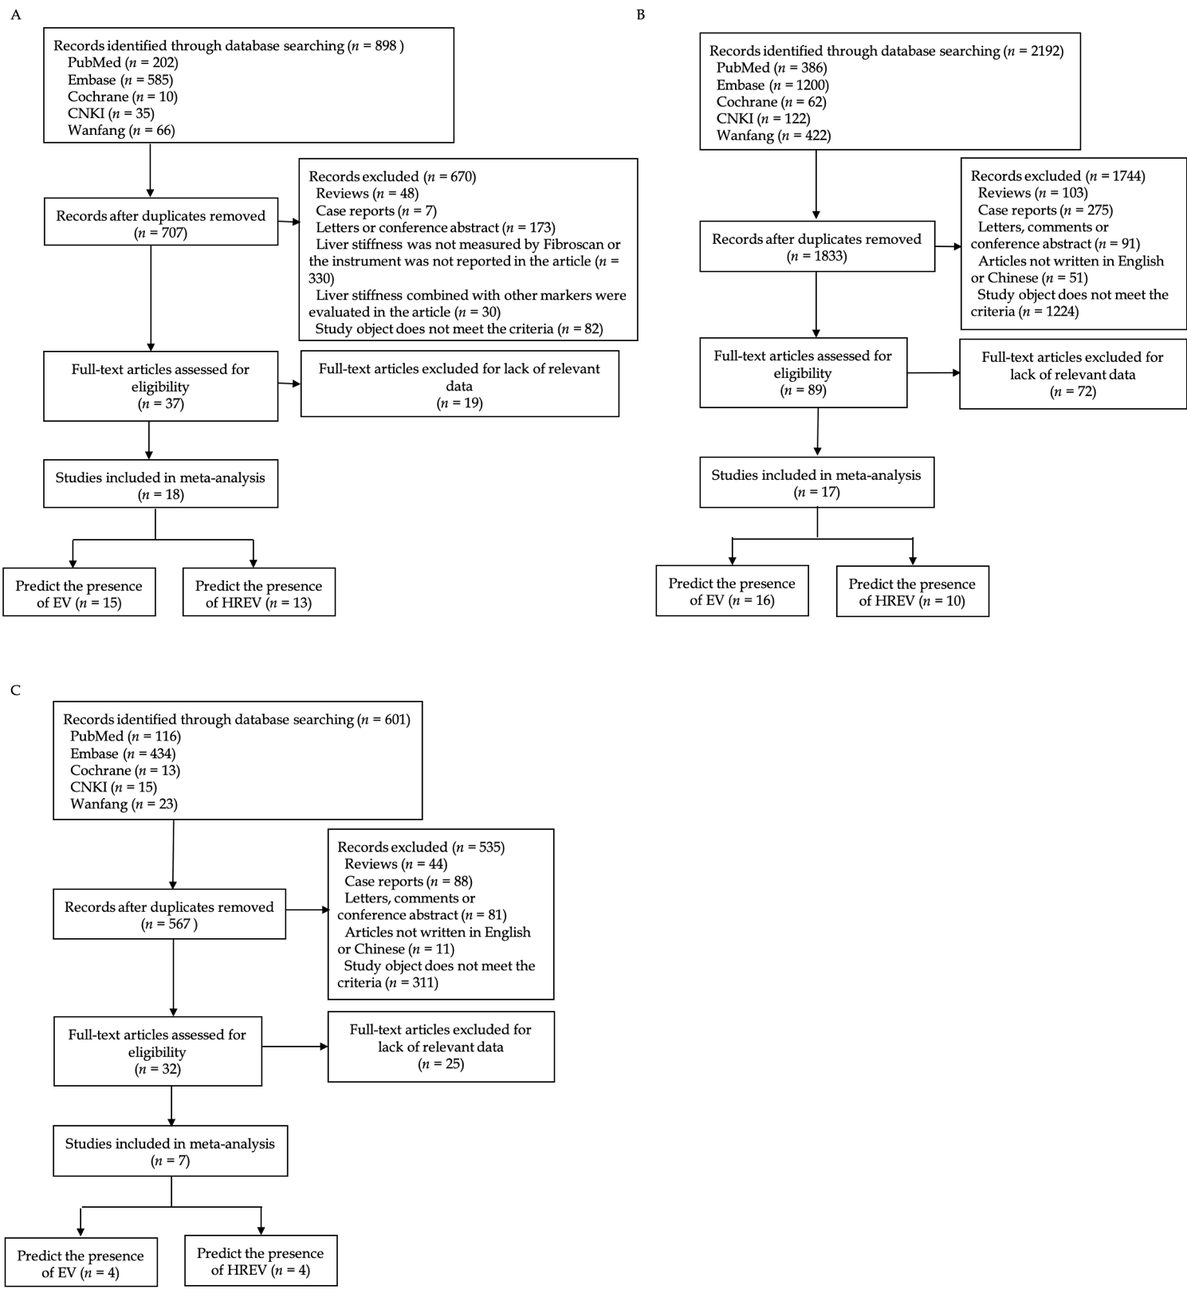Figure 1 Flow chart of the search and selection of articles. A: Flow chart of the search and selection of articles about liver stiffness measurement; B: Flow chart of the search and selection of articles about computed tomography; C: Flow chart of the search and selection of articles about magnetic resonance imaging.
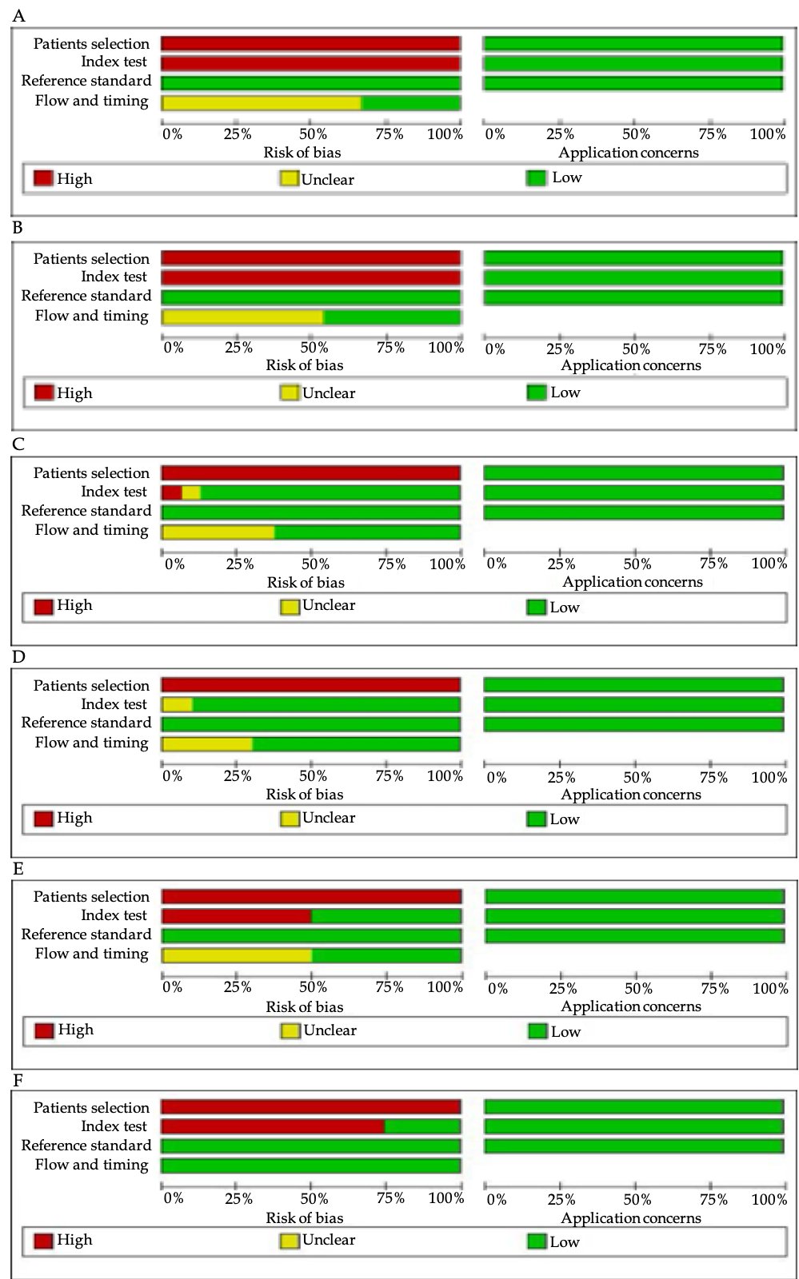
Figure 2 Methodological evaluation according to Quality Assessment of Diagnostic Accuracy Studies-2 of the included articles. A, C, and E: Diagnosis of esophageal varices using liver stiffness measurement, computed tomography, and magnetic resonance imaging, respectively; B, D, and F: Prediction of high-bleeding-risk esophageal varices using liver stiffness measurement, computed tomography, and magnetic resonance imaging, respectively. Articles were identified as having a potential bias risk for patient selection and index text.
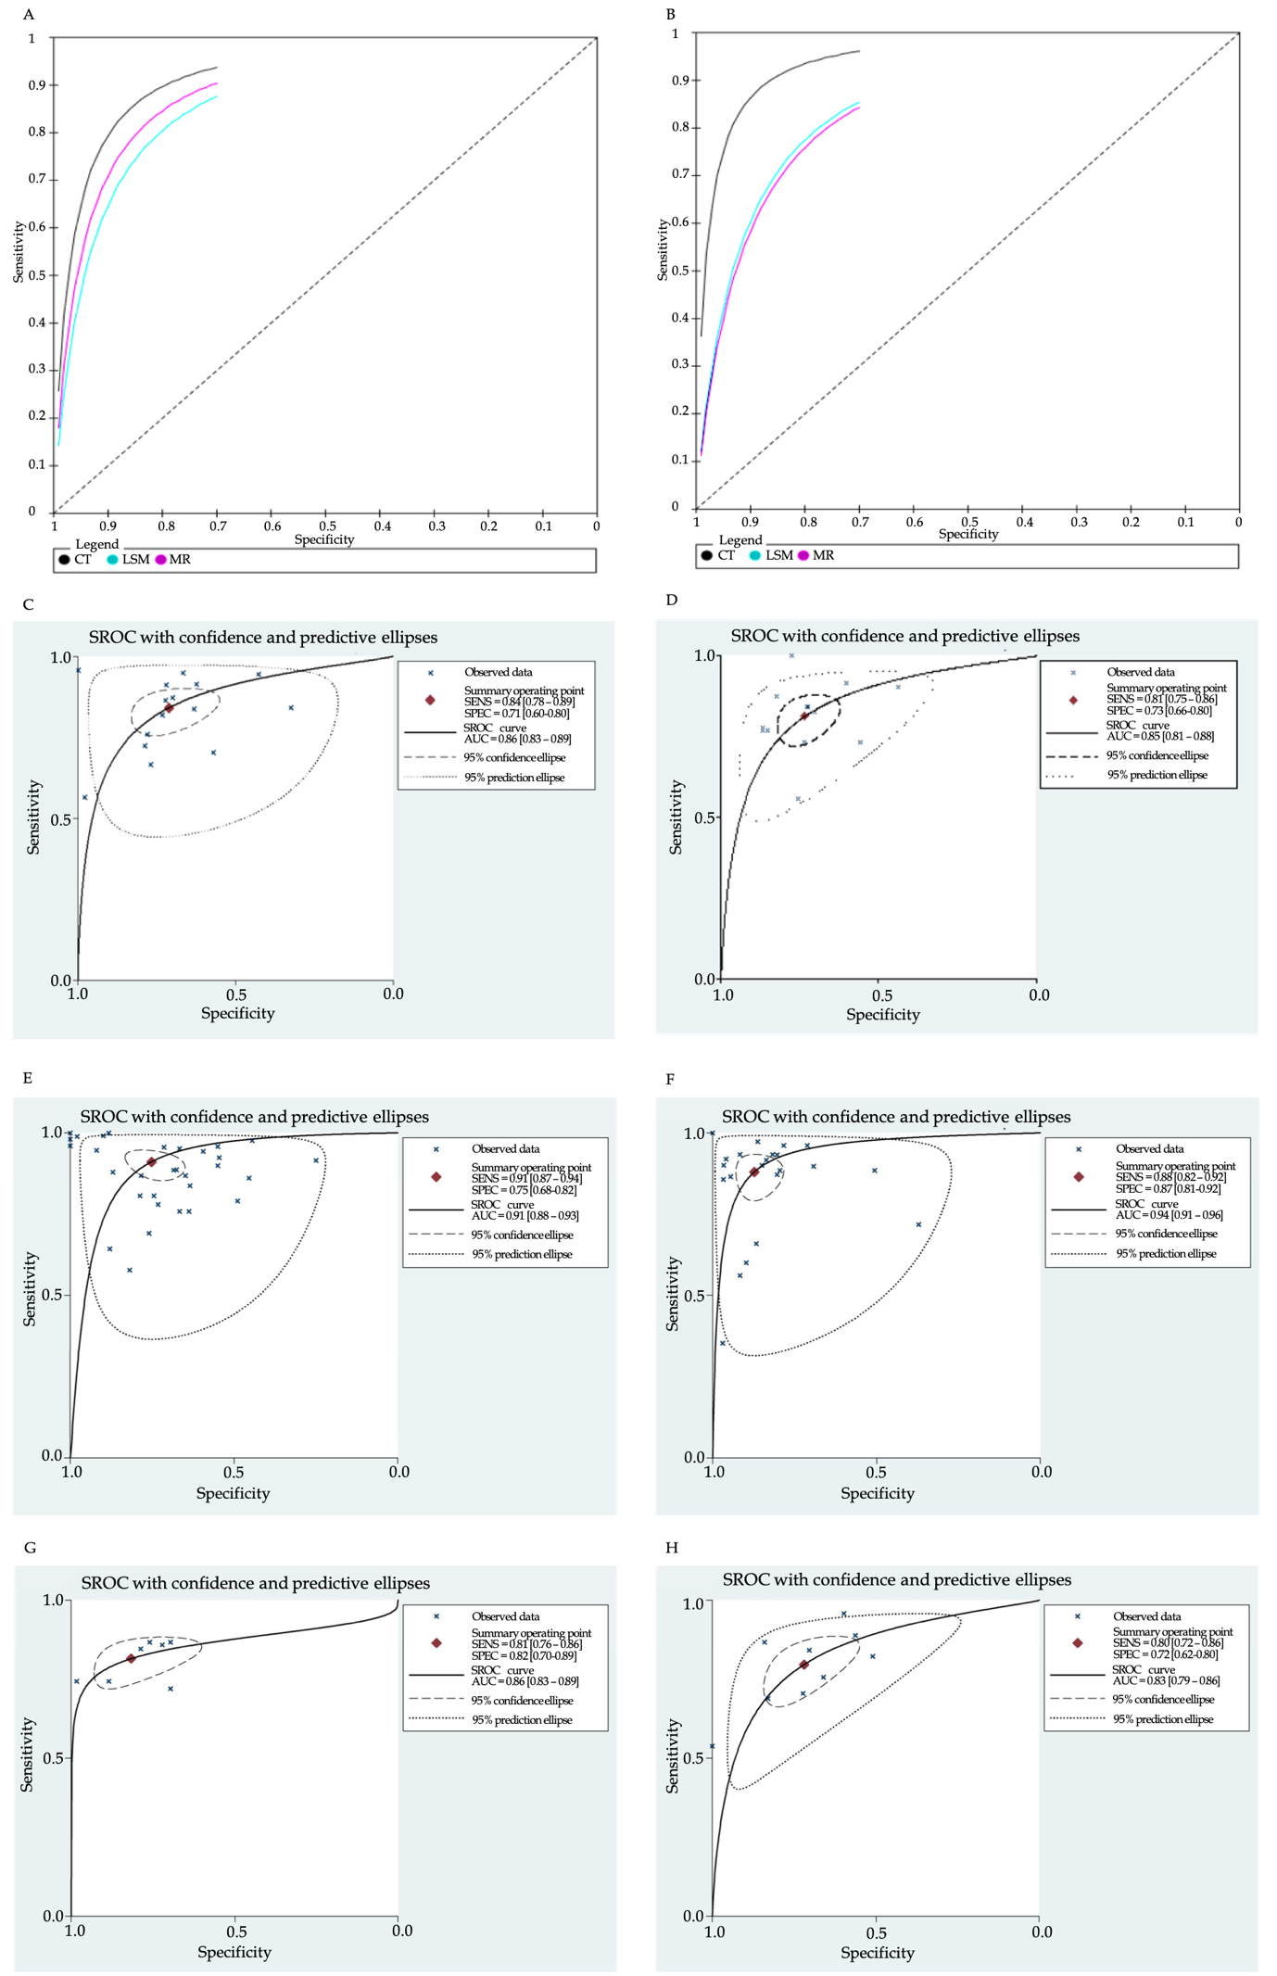
Figure 3 Summary receiver operating characteristic curves. A and B: Summary receiver operating characteristic (SROC) curves of liver stiffness measurement, computed tomography, and magnetic resonance imaging for the diagnosis of esophageal varices (EV) and prediction of high-bleeding-risk EV (HREV); C and D: SROC curves of liver stiffness measurement for the diagnosis of EV and prediction of HREV; E and F: SROC curves of computed tomography for the diagnosis of EV and prediction of HREV; G and H: SROC curves of magnetic resonance imaging for the diagnosis of EV and prediction of HREV.

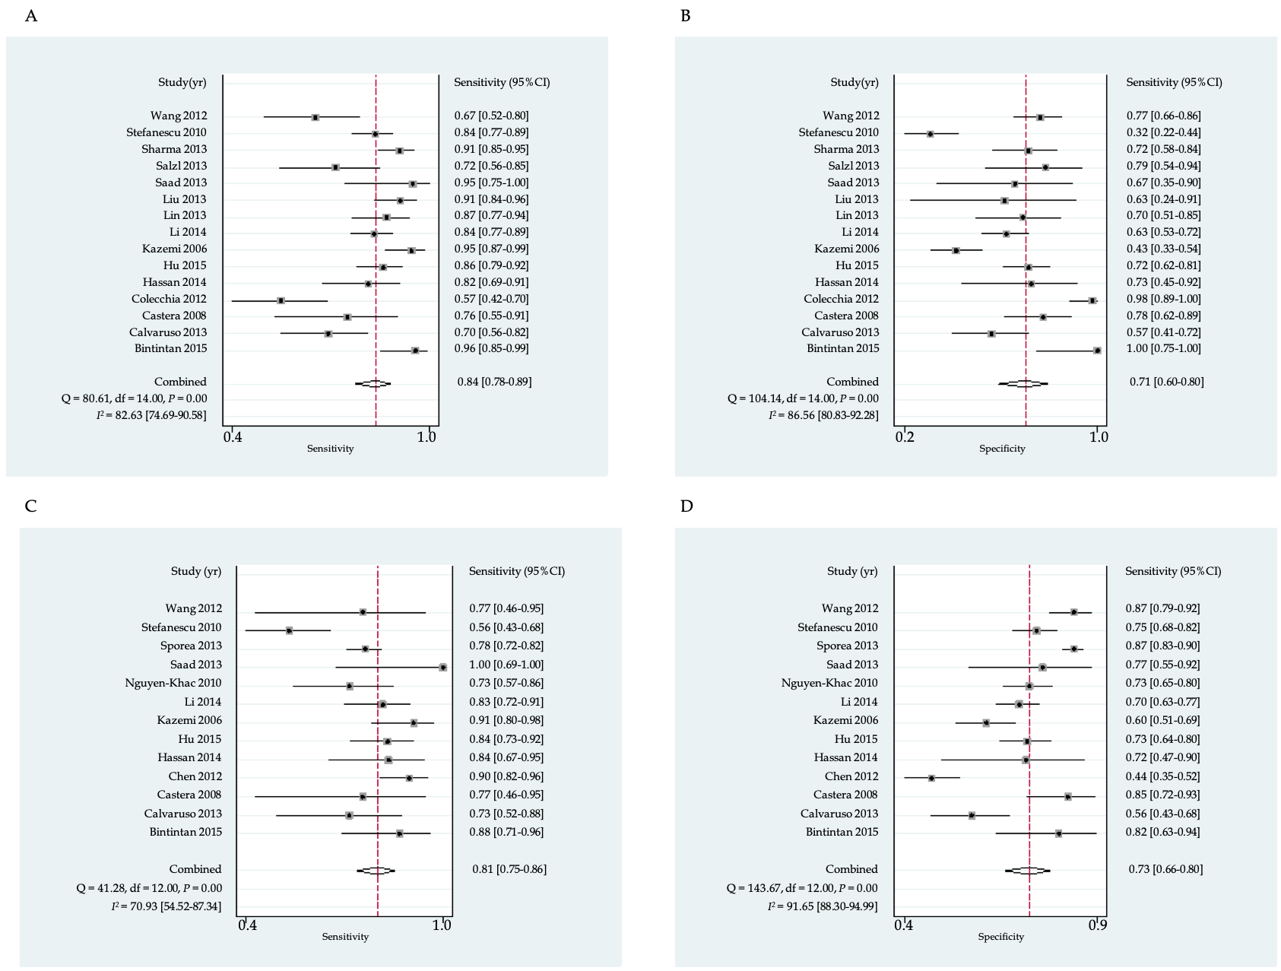
Figure 4 Summary sensitivity and specificity of liver stiffness measurement. A and B: Summary sensitivity and specificity of liver stiffness measurement for the diagnosis of esophageal varices; C and D: Summary sensitivity and specificity of liver stiffness measurement for the prediction of high-bleeding-risk esophageal varices.
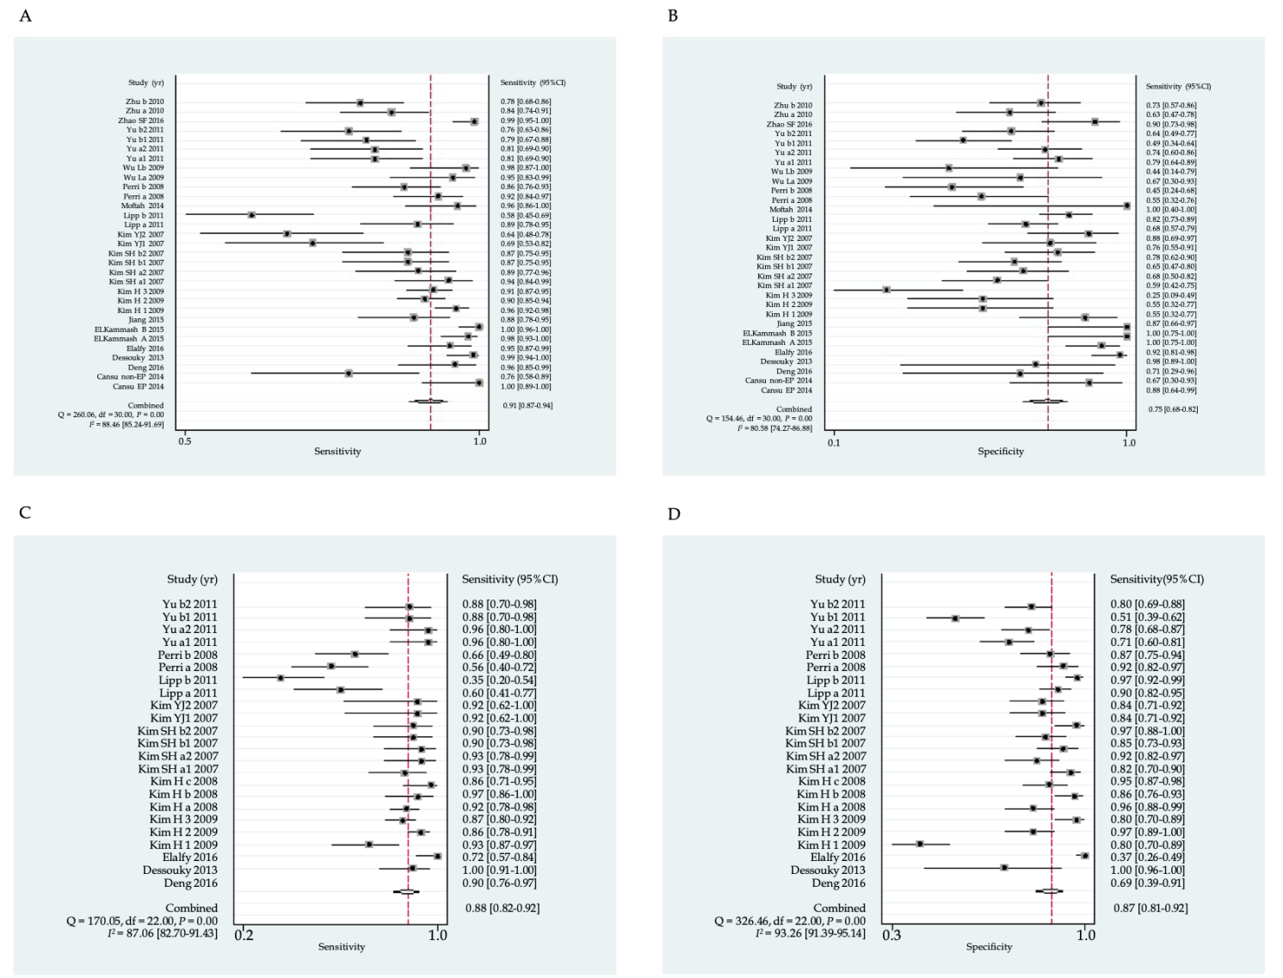
Figure 5 Summary sensitivity and specificity of computed tomography imaging. A and B: Summary sensitivity and specificity of computed tomography for the diagnosis of esophageal varices; C and D: Summary sensitivity and specificity of computed tomography imaging for the prediction of high-bleeding-risk esophageal varices.
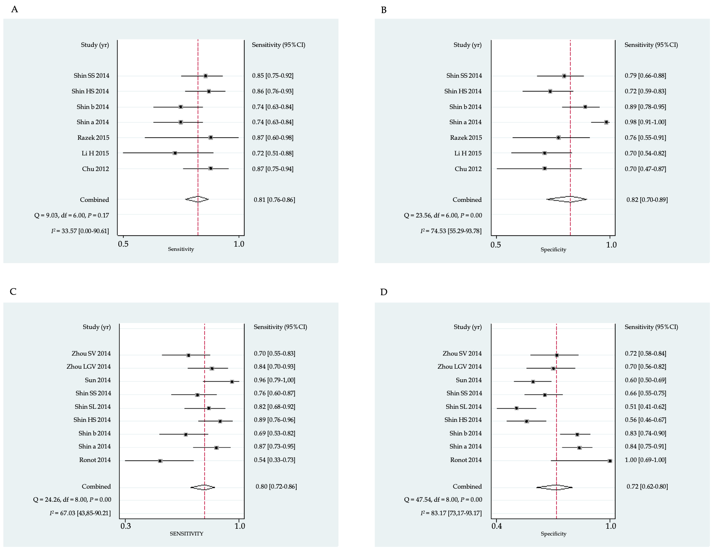
Figure 6 Summary sensitivity and specificity of magnetic resonance imaging. A and B: Summary sensitivity and specificity of magnetic resonance imaging for the diagnosis of esophageal varices; C and D: Summary sensitivity and specificity of magnetic resonance imaging for the prediction of high-bleeding-risk esophageal varices.
Table 1 Characteristics of articles using computed tomography imaging to diagnose esophageal varices
Ref. | Study design | Total patients | Mean age (yr) | Male (%) | Etiology (%) | Child-Pugh class (%) | CT scanner | Interval between CT and endoscopy | Presence of EV
 |  |  |  |  |  |  |  |  | TP | FP | FN | TN
Cansu et al^{[33]}, 2014 | Prospective | 50 | 56.8 | 54 | HBV (40.0); HCV (30.0); Biliary (6.0); HBV + HCV (4.0); Alcohol (4.0%); Others (16.0) | A (52.0); B (36.0); C (12.0) | 16-slice | Within 4 wk | 33 | 2 | 0 | 15
 | Prospective | 42 | 56.2 | 69 | HBV (45.2); HCV (23.8); Alcohol (4.8); HBV + HCV (2.4); Biliary (2.4); Others (21.4) | A (38.1); B (31.0); C (31.0) | 16-slice | Within 4 wk | 25 | 3 | 8 | 6
Deng et al^{[34]}, 2016 | Retrospective | 52 | 55.4 | 63.5 | Alcohol (30.8); HBV (25.0); HBV + Alcohol (9.6); HCV (3.8); HBV + HCV (1.9); Others (28.9) | A (49.0); B (39.2); C (11.8) | NR | NR | 43 | 2 | 2 | 5
Dessouky et al^{[35]}, 2013 | Prospective | 137 | 58.7 | 53.3 | HCV (67.9); HBV (19.7); HBV + HCV (10.2); Steatohepatitis (2.2) | A (55); B (31); C (14) | 16-slice | Within 24 h | 89 | 1 | 1 | 46
Elalfy et al^{[36]}, 2016 | Retrospective | 124 | 56.5 | 52 | HCV (100) | A (62.9); B (37.1) | 16-slice | NR | 70 | 4 | 4 | 46
Elkammash et al^{[37]}, 2015 | NR | 112 | 51.4 | 68.8 | HBV (46); HCV (44); Schistosomiasis (10) | NR | 64-slice | Within 2 wk | 97 | 0 | 2 | 13
 |  |  |  |  |  |  |  |  | 99 | 0 | 0 | 13
Jiang et al^{[38]}, 2015 | NR | 89 | 57 | 64 | HBV (71.9); Alcohol (11.2); HCV (7.9); Biliary (5.6); Drug (1.1); Unknown (2.3) | NR | 64-slice | NR | 58 | 3 | 8 | 20
Kim et al^{[40]}, 2020 | Retrospective | 104 | 59 | 74 | HBV (72.1); HCV (12.5); Alcohol (6.7); Others (8.7) | A (41.3); B (30.8); C (27.9) | 16 or 64-slice | Within 4 wk | 180 | 9 | 8 | 11
 |  |  |  |  |  |  |  |  | 169 | 9 | 19 | 11
 |  |  |  |  |  |  |  |  | 172 | 15 | 16 | 5
Kim et al^{[41]}, 2007 | Prospective | 90 | 54.8 | 72.2 | HBV (73.3); HCV (21.1); Alcohol (2.2); Others (3.3) | A (81.1); B (18.9) | 16-slice | Within 4 h | 50 | 15 | 3 | 22
 |  |  |  |  |  |  |  |  | 47 | 12 | 6 | 25
 |  |  |  |  |  |  |  |  | 46 | 13 | 7 | 24
 |  |  |  |  |  |  |  |  | 46 | 8 | 7 | 29
Kim et al^{[42]}, 2007 | Retrospective | 67 | 56.2 | 58.2 | HCV (35.8); HBV (22.4); Alcohol (22.4); HBV + HCV (9.0); Others (10.4) | A (23.9); B (37.3); C (38.8) | NR | Within 4 wk | 29 | 6 | 13 | 19
 |  |  |  |  |  |  |  |  | 27 | 3 | 15 | 22
Lipp et al^{[43]}, 2011 | Retrospective | 299 | 55.2 | 64.9 | NR | NR | 4 or 16 or 64-slice | Within 12 wk | 54 | 24 | 7 | 52
 |  |  |  |  |  |  |  |  | 41 | 17 | 30 | 77
Moftah et al^{[44]}, 2014 | NR | 54 | 56.8 | 74.1 | NR | NR | 8-slice | NR | 48 | 0 | 2 | 4
Perri et al^{[45]}, 2008 | Retrospective | 101 | NR | 63.4 | Viral (21.8); Alcohol (18.8); Biliary (17.8); NASH (14.9); Others (26.7) | A (44.6); B (39.6); C (15.8) | 4-slice or higher | 2 d¹ | 73 | 10 | 6 | 12
 |  |  |  |  |  |  |  |  | 68 | 12 | 11 | 10
Wu et al^{[46]}, 2009 | Prospective | 50 | 57.7 | 60 | HBV (76); Autoimmune (2); Others (22) | A (26.0); B (62.0); C (12.0) | 16-slice | Within 4 wk | 39 | 3 | 2 | 6
 |  |  |  |  |  |  |  |  | 40 | 5 | 1 | 4
Yu et al^{[47]}, 2011 | Retrospective | 109 | 55.9 | 55 | HCV (46.8); Alcohol (17.4); HBV (6.4); Others (29.4) | NR | 16 or 64-slice | NR | 50 | 10 | 12 | 37
 |  |  |  |  |  |  |  |  | 50 | 12 | 12 | 35
 |  |  |  |  |  |  |  |  | 49 | 24 | 13 | 23
 |  |  |  |  |  |  |  |  | 47 | 17 | 15 | 30
Zhao et al^{[48]}, 2016 | Retrospective | 143 | 52.39 | 67.1 | HBV (70.6); Alcohol (11.2); Autoimmune (4.9); HCV (3.5); Biliary (3.5); Others (6.3) | A (37.8); B (33.6); C (28.7) | 64-slice | 3.4 d² | 11 | 3 | 1 | 27
 |  |  |  |  |  |  |  |  | 2
Zhu et al^{[49]}, 2009 | Retrospective | 127 | 45.2 | 75.6 | HBV (74.8); Alcohol (10.2); HCV (4.7); Others (10.2) | A (37.8); B (37.0); C (25.2) | 4-slice | Within 4 wk | 72 | 15 | 14 | 26
 |  |  |  |  |  |  |  |  | 67 | 11 | 19 | 30
¹Median. ²Mean. NR: Not reported; HBV: Hepatitis B virus; HCV: Hepatitis C virus; NASH: Nonalcoholic steatohepatitis; CT: Computed tomography; EV: Esophageal varices; TP: True positive; FP: False positive; FN: False negative; TN: True negative.
Table 2 Characteristics of articles using computed tomography imaging to predict HREV
Ref. | Study design | Total patients | Mean age (yr) | Male (%) | Etiology (%) | Child-Pugh class (%) | CT scanner | Cut-off value (mm) | Interval between CT and endoscopy | Presence of HREV
 |  |  |  |  |  |  |  |  |  | TP | FP | FN | TN
Deng et al^{[34]}, 2016 | Retrospective | 52 | 55.4 | 64 | Alcohol (30.8); HBV (25.0); HBV + Alcohol (9.6); HCV (3.8); HBV + HCV (1.9); Others (28.9) | A (49.0); B (39.2); C (11.8) | NR | EVD 3.9 | NR | 35 | 4 | 4 | 9
Dessouky et al^{[35]}, 2013 | Prospective | 137 | 58.7 | 53 | HCV (67.9); HBV (19.7); HBV + HCV (10.2); Steatohepatitis (2.2) | A (55); B (31); C (14) | 16-slice | EVD 3.0 | Within 24 h | 38 | 0 | 0 | 99
Elalfy et al^{[36]}, 2016 | Retrospective | 124 | 56.5 | 52 | HCV (100) | A (62.9); B (37.1) | 16-slice | PVD 12.5 | NR | 33 | 49 | 13 | 29
Kim et al^{[39]}, 2008 | Retrospective | 110 | 61 | 74 | HBV (60.9); HCV (29.1) Alcohol (6.4); HBV + HCV (1.8); Others (1.8) | A (63.6); B (26.4); C (10.0) | 16-slice | EVD 2.0 | 8.2 d¹ | 123 | 15 | 9 | 61
 |  |  |  |  |  |  |  |  |  | 113 | 2 | 19 | 59
 |  |  |  |  |  |  |  |  |  | 115 | 15 | 17 | 61
Kim et al^{[40]}, 2020 | Retrospective | 104 | 59 | 74 | HBV (72.1); HCV (12.5); Alcohol (6.7); Others (8.7) | A (41.3); B (30.8); C (27.9) | 16 or 64-slice | EVD 2.0 | Within 4 wk | 34 | 3 | 3 | 70
 |  |  |  |  |  |  |  |  |  | 36 | 10 | 1 | 63
 |  |  |  |  |  |  |  |  |  | 32 | 4 | 5 | 69
Kim et al^{[41]}, 2007 | Prospective | 90 | 54.8 | 72 | HBV (73.3); HCV (21.1); Alcohol (2.2); Others (3.3) | A (81.1); B (18.9) | 16-slice | Grade 2 and Grade 3³ | Within 4 h | 28 | 11 | 2 | 49
 |  |  |  |  |  |  |  |  |  | 28 | 5 | 2 | 55
 |  |  |  |  |  |  |  |  |  | 27 | 9 | 3 | 51
 |  |  |  |  |  |  |  |  |  | 27 | 2 | 3 | 58
Kim et al^{[42]}, 2007 | Retrospective | 67 | 56.2 | 58 | HCV (35.8); HBV (22.4); Alcohol (22.4); HBV + HCV (9.0); Others (10.4) | A (23.9); B (37.3); C (38.8) | NR | EVD 3.0 | Within 4 wk | 11 | 9 | 1 | 46
 |  |  |  |  |  |  |  |  |  | 11 | 9 | 1 | 46
Lipp et al^{[43]}, 2011 | Retrospective | 299 | 55.2 | 65 | NR | NR | 4 or 16 or 64-slice | EVD 4.0 | Within 12 wk | 18 | 11 | 12 | 96
 |  |  |  |  |  |  |  |  |  | 12 | 4 | 22 | 127
Perri et al^{[45]}, 2008 | Prospective | 101 | NR | 63 | Viral (21.8); Alcohol (18.8); Biliary (17.8); NASH (14.9); Others (26.7) | A (44.6); B (39.6); C (15.8) | 4-slice or higher | EVD 5.0 | 2 d² | 23 | 5 | 18 | 55
 |  |  |  |  |  |  |  |  |  | 27 | 8 | 14 | 52
Yu et al^{[47]}, 2011 | Retrospective | 109 | 55.9 | 55 | HCV (46.8); Alcohol (17.4); HBV (6.4); Others (29.4) | NR | 16 or 64-slice | EVD 2.0 | NR | 25 | 24 | 1 | 59
 |  |  |  |  |  |  |  |  |  | 25 | 18 | 1 | 65
 |  |  |  |  |  |  |  |  |  | 23 | 41 | 3 | 42
 |  |  |  |  |  |  |  |  |  | 23 | 17 | 3 | 66
¹Mean. ²Median. ³Grade 2: Varices show beaded appearance; Grade 3: Varices run in oblique course and are tortuous with tumorlike appearance. EVD: Esophageal varices diameter; NR: Not reported; PVD: Portal vein diameter; HBV: Hepatitis B virus; HCV: Hepatitis C virus; NASH: Nonalcoholic steatohepatitis; CT: Computed tomography; HREV: High-bleeding-risk esophageal varices; TP: True positive; FP: False positive; FN: False negative; TN: True negative.

Table 3 Overview of results of meta-analysis
Group | LSM for presence of EV | LSM for presence of HREV | CT for presence of EV | CT for presence of HREV | MRI for presence of EV | MRI for presence of HREV
Diagnostic threshold
Spearman correlation coefficient | 0.36 | 0.21 | -0.2 | 0.12 | 0.27 | 0.57
P value | 0.19 | 0.5 | 0.27 | 0.58 | 0.56 | 0.11
SROC
AUSROC (95%CI) | 0.86 (0.83-0.89) | 0.85 (0.81-0.88) | 0.91 (0.88-0.93) | 0.94 (0.91-0.96) | 0.86 (0.83-0.89) | 0.83 (0.79-0.86)
I² | 97.43% | 97.13% | 97.17% | 98.30% | 86.41% | 91.64%
P value | < 0.01 | < 0.01 | < 0.01 | < 0.01 | < 0.01 | < 0.01
Sensitivity
Summary sensitivity (95%CI) | 0.84 (0.78-0.89) | 0.81 (0.75-0.86) | 0.91 (0.87-0.94) | 0.88 (0.82-0.92) | 0.81 (0.76-0.86) | 0.80 (0.72-0.86)
I² | 82.63% | 70.93% | 88.46% | 87.06% | 33.57% | 67.03%
P value | < 0.01 | < 0.01 | < 0.01 | < 0.01 | 0.17 | < 0.01
Specificity
Summary specificity (95%CI) | 0.71 (0.60-0.80) | 0.73 (0.66-0.80) | 0.75 (0.68-0.82) | 0.87 (0.81-0.92) | 0.82 (0.70-0.89) | 0.72 (0.62-0.80)
I² | 86.56% | 91.65% | 80.58% | 93.26% | 74.53% | 83.17%
P value | < 0.01 | < 0.01 | < 0.01 | < 0.01 | < 0.01 | < 0.01
PLR
Summary PLR (95%CI) | 2.91 (2.08-4.06) | 3.04 (2.38-3.89) | 3.67 (2.73-4.94) | 6.90 (4.54-10.49) | 4.44 (2.74-7.21) | 2.83 (2.11-3.80)
I² | 82.66% | 85.63% | 83.81% | 91.04% | 31.66% | 51.94%
P value | < 0.01 | < 0.01 | < 0.01 | < 0.01 | 0.01 | < 0.01
NLR
Summary NLR (95%CI) | 0.22 (0.16-0.30) | 0.26 (0.19-0.34) | 0.12 (0.08-0.18) | 0.14 (0.09-0.21) | 0.23 (0.18-0.28) | 0.28 (0.21-0.38)
I² | 79.49% | 68.30% | 88.94% | 91.10% | <0.01% | 43.01%
P value | < 0.01 | < 0.01 | < 0.01 | < 0.01 | 0.53 | 0.08
Summary DOR (95%CI) | 13.01 (7.83-21.64) | 11.93 (7.89-18.03) | 30.98 (16.02-59.91) | 49.99 (25.38-98.43) | 19.58 (11.39-33.66) | 10.00 (6.63-15.09)
A significant heterogeneity was found in all analyses. There were no threshold effects in all analyses (P > 0.05). CT had the largest area under the summary receiver operating characteristic curves in both of the diagnosis of EV and prediction of HREV. SROC: Summary receiver operating characteristic curves; CT: Computed tomography; EV: Esophageal varices; HREV: High bleeding risk esophageal varices; MRI: Magnetic resonance imaging; LSM: Liver stiffness measurement; PLR: Positive likelihood ratio; NLR: Negative likelihood ratio; DOR: Diagnostic odds ratio; AUSROC: Area under the summary receiver operating characteristic curves.

