Name of journal: World Journal of Biological Chemistry
ESPS Manuscript NO: 15450
Manuscript Type: Original Article

Basic Study
DNA microarray unravels rapid changes in transcriptome of MK-801 treated rat brain

Kobayashi Y et al. MK-801 triggered rat brain transcriptome

Yuka Kobayashi, Sofya P Kulikova, Junko Shibato, Randeep Rakwal, Hiroyuki Satoh, Didier Pinault, Yoshinori Masuo

Yuka Kobayashi, Hiroyuki Satoh, Department of Biomolecular Science, Faculty of Science, Toho University, Chiba 274-8510, Japan

Yuka Kobayashi, Junko Shibato, Randeep Rakwal, Yoshinori Masuo, Health Technology Research Center (HTRC), National Institute of Advanced Industrial Science and Technology (AIST), Tsukuba 305-8569, Ibaraki, Japan

Sofya P Kulikova, Didier Pinault, INSERM U1114, Neuropsychologie Cognitive et Physiopathologie de la Schizophrénie, FMTS (Fédération de Médecine Translationnelle de Strasbourg), Faculté de Médecine, Université de Strasbourg, 67400 Strasbourg, France

Junko Shibato, Randeep Rakwal, Department of Anatomy, School of Medicine, Showa University, Shinagawa, Tokyo 142-8555, Japan

Junko Shibato, Laboratory of Exercise Biochemistry and Neuroendrocrinology, Institute of Health and Sport Sciences, University of Tsukuba, Tsukuba 305-8574, Ibaraki, Japan

Junko Shibato, Randeep Rakwal, Global Research Center for Innovative Life Science, Peptide Drug Innovation, School of Pharmacy and Pharmaceutical Sciences, Hoshi University, Shinagawa, Tokyo 142-8501, Japan

Randeep Rakwal, Organization for Educational Initiatives, University of Tsukuba, Tsukuba 305-8577, Ibaraki, Japan

Randeep Rakwal, Faculty of Health and Sport Sciences and Tsukuba International Academy for Sport Studies (TIAS), University of Tsukuba, Tsukuba 305-8574, Ibaraki, Japan

Yoshinori Masuo, Laboratory of Neuroscience, Department of Biology, Faculty of Science, Toho University, Funabashi, Chiba 274-8510, Japan

Author contributions: Yuka Kobayashi, Yoshinori Masuo, Junko Shibato and Randeep Rakwal performed the majority of experiments; Sofya P Kulikova and Didier Pinault performed the electrophysiology experiments and contributed to the design and the writing and revision; Yoshinori Masuo and Hiroyuki Satoh co-ordinated and provided financial support for this work; Yuka Kobayashi, Yoshinori Masuo, Junko Shibato and Randeep Rakwal designed the study and wrote and edited/revised the manuscript.

Institutional animal care and use committee statement: All animal care procedures were achieved in accordance with European Union Guidelines (Directive 2010/63/EU) and with CREMEAS, the National and Regional Ethics Committee. The experiments were also conducted in accordance with the Guidelines for the Care and Use of Laboratory Animals at the National Institute of Advanced Industrial Science and Technology (AIST), Japan.

Conflict-of-interest statement: The authors declare no conflict of interest.

Data sharing statement: The obtained gene expression data deposited at the NCBI, Gene Expression Omnibus (GEO) site (accession number GSE63639) is freely available to the scientific community (http://www.ncbi.nlm.nih.gov/geo/).

Open-access: This article is an open-access article which selected by an in-house editor and fully peer-reviewed by external reviewers. It distributed in accordance with the Creative Commons Attribution Non Commercial (CC BY-NC 4.0) license, which permits others to distribute, remix, adapt, build upon this work non-commercially, and license their derivative works on different terms, provided the original work is properly cited and the use is non-commercial. See: http://creativecommons.org/licenses/by-nc/4.0/

Correspondence to: Dr. Randeep Rakwal, Professor, Faculty of Health and Sport Sciences and Tsukuba International Academy for Sport Studies (TIAS), University of Tsukuba, 1-1-1 Tennoudai, Tsukuba 305-8574, Ibaraki, Japan. plantproteomics@gmail.com
Telephone: +81-90-18537875

Received: November 26, 2014
Peer-review started: November 29, 2014
First decision: December 26, 2014
Revised: July 21, 2015
Accepted: August 30, 2015
Article in press:
Published online:

Abstract
AIM: To investigate the impact of MK-801 on gene expression patterns genome wide in rat brain regions.

METHODS: Rats were treated with an intraperitoneal injection of MK-801 [0.08 (low-dose) and 0.16 (high-dose) mg/kg] or NaCl (vehicle control). In a first series of experiment, the frontoparietal electrocorticogram was recorded 15 min before and 60 min after injection. In a second series of experiments, the whole brain of each animal was rapidly removed at 40 min post-injection, and different regions were separated: amygdala, cerebral cortex, hippocampus, hypothalamus, midbrain and ventral striatum on ice followed by DNA microarray (4 × 44 K whole rat genome chip) analysis.

RESULTS: Spectral analysis revealed that a single systemic injection of MK-801 significantly and selectively augmented the power of baseline gamma frequency (30-80 Hz) oscillations. DNA microarray analysis showed the largest number (up- and down- regulations) of gene expressions in the cerebral cortex (378), midbrain (376), hippocampus (375), ventral striatum (353), amygdala (301), and hypothalamus (201) under low-dose (0.08 mg/kg) of MK-801. Under high-dose (0.16 mg/kg), ventral striatum (811) showed the largest number of gene expression changes. Gene expression changes were functionally categorized to reveal expression of genes and function varies with each brain region.

CONCLUSION: Acute MK-801 treatment increases synchrony of baseline gamma oscillations, and causes very early changes in gene expressions in six individual rat brain regions, a first report.

Key words: Dizocilpine; Dye-swap; Gene expression; Microarray; MK801; N-Methyl-D-aspartate receptors

© The Author(s) 2015. Published by Baishideng Publishing Group Inc. All rights reserved.

Core tip: N-Methyl-D-aspartate receptors (NMDAr) are involved in multiple physiological functions and neuropsychiatric disorders. Dizocilpine (commonly referred to as MK-801) is a well-known non-competitive NMDAr antagonist with psychotomimetic properties. A combination of electrophysiological and molecular analyses reveals not only the synchrony of baseline oscillations by MK-801, but also more importantly new insight into differential gene expressions in the cerebral cortex, midbrain, hippocampus, ventral striatum, amygdala, and hypothalamus regions after acute low-dose (0.08 mg/kg) MK-801 treatment; only the ventral striatum showed increased gene expression at a high dose (0.16 mg/kg) of MK-801. We believe that our present study will contribute in the understanding of the pathogenic mechanisms of neuropsychiatric disorders.

Kobayashi Y, Kulikova SP, Shibato J, Rakwal R, Satoh H, Pinault D, Masuo Y. DNA microarray unravels rapid changes in transcriptome of MK-801 treated rat brain. World J Biol Chem 2015; In press
INTRODUCTION
N-Methyl-D-aspartate receptor (NMDAr) is an ionotropic subtype of glutamate receptors, one of the excitatory amino acids, forming high calcium (Ca²⁺)-permeable cation channels that specifically accept NMDA as a selective agonist^{[1]}. The NMDAr is a tetramer, composed of assemblies of NMDAR1 (NR1) and NMDAR2 (NR2) subunits^{[2]}. NMDAr integrates chemical and electrical stimuli into a Ca²⁺ signal, and plays crucial roles in synaptic plasticity, which may be involved in learning, memory, and motion. Dysfunction of NMDAr has been suggested to be involved in stroke, Parkinson’s disease, and schizophrenia^{[3-6]}. Decreased Ca²⁺ influx in the response to glutamate activation leads to the impairment of NMDAr function, disrupting intra- and extracellular communication. Impaired NMDAr function in the prefrontal cortex causes injury to learning and memory formation, probably causing impulsivity, hyperactivity, and attention deficit, seen in attention-deficit hyperactivity disorder (ADHD)^{[7]}. The state of NMDAr inhibition is also similar to the schizophrenia model^{[8,9]}.
It has been demonstrated that NMDAr play potential roles in nociceptive (the neural processes of encoding and processing noxious stimuli) transmission, particularly in the spinal cord^{[10]}. NMDAr antagonists reduced the successive increase in response to repetitive stimuli, namely wind-up, in dorsal and ventral horn neurons^{[11]}. Because of the psychotomimetic action of NMDAr antagonists, it was suggested that human psychosis and NMDAr blockade are correlated^{[12]}. The drugs that non-competitively block NMDAr simulate schizophrenic psychopathology in healthy humans^{[13]}. Of importance, using fMRI it has recently been demonstrated that acute ketamine administration in healthy subjects increases global brain functional connectivity^{[14]}, creating a state resembling that recorded in patients during the early stages of schizophrenia but not that recorded in patients with chronic (since several years) schizophrenia^{[15]}. The acute ketamine effects are quick and reversible. These findings are consistent with preclinical studies demonstrating that in rodent’s ketamine or MK-801 transiently increases the power of baseline gamma oscillations in cortical and subcortical structures^{[16,17]}. Furthermore, there is proof that NMDAr antagonists induce a broad range of symptoms, behaviors, and cognitive deficits that resemble aspects of endogenous psychoses, particularly schizophrenia and dissociative states^{[9]}.
Phencyclidine (PCP), a well-known NMDAr antagonist, is one of the most effective psychotropic drugs. The PCP-elicited psychosis symptoms closely resemble schizophrenia such as positive/negative symptoms and cognitive deficits^{[8,18,19]}. It should be noted that the glutamate hypothesis is one of few hypotheses of etiology and/or pathophysiology of schizophrenia. Javitt hypothesized that hypofunction of NMDAr is involved in the pathogenic mechanism of schizophrenia^{[4]}. As part of that evidence, it was reported that there is a (1) decrease in the phosphorylation level of NR1 subunit in post-mortem brains of schizophrenia patients^{[20]}; and (2) occurrence of abnormal behavior similar to schizophrenia symptom in the NR2A subunit (GRIN2A) lacking mice^{[21,22]}. Other than PCP, dizocilpine (commonly referred to as MK-801) is another well-known non-competitive NMDAr antagonist. These molecules have psychotomimetic properties. Intraperitoneal (ip) injection of MK-801 induces hyperlocomotion, ataxia, abducted hindlimbs, flat body posture, and stereotyped behavior such as head weaving in rat^{[23]}. It should be emphasized that these conditions are also included in the ADHD symptoms. It has been proposed that ADHD-like symptoms can be produced by stopping development of the dopaminergic neuron^{[24]}. Moreover, it has been demonstrated that NMDAr expression was enhanced in the striatum in ADHD model animals, where activities of the dopaminergic neurons were inhibited^{[25]}.
MK-801 has been used in studies of NMDAr in schizophrenia and psychosis^{[26-28]}. Systemic administration of MK-801 causes dysfunction of learning and memory^{[29]}. Acute ip injection of MK-801-induced transient behavior, and which correlated with schizophreniform psychosis in the rat. MK-801-treated animals progressed to an acute episode involving abnormal behavior reminiscent of symptoms of schizophrenia^{[16,17,30]}. Furthermore, significant reproducible behavior was found, such as increased locomotion, stereotyped sniffing and ataxia^{[31,32]}. These behavioral changes are dose-dependent, varied with age and sex, and represents a rat EAA hypofunction model of psychosis^{[33]}.
The overall goal of the present study was to identify gene expression patterns along rat chromosomes in different brain regions after a single injection of MK-801, which exerts a longer acute effect than ketamine on ongoing brain activities^{[16]}. The brain regions (amygdala, cerebral cortex, hippocampus, hypothalamus, midbrain and ventral striatum) of MK-801-treated rats were subjected to a genome-wide transcriptome mapping analysis (4 × 44 K). The present study should contribute in the understanding of the pathogenic mechanisms of neuropsychiatric disorders. To note, a previous study in 2004, was the first study on uncovering gene expressions using rat model to investigate the effects of both memantine and MK-801 in adult rat brain^{[34]}. In that study, a cDNA-based microarray chip carrying 1090 well-characterized transcripts was used to profile gene expression changes in the posterior cingulate and anterior retrosplenial cortices of the rat brain following 5 to 50 mg/kg memantine and 1 mg/kg MK-801 brain^{[34]}, but which is different from our study in that six brain regions were sampled following low-dose (0.08 mg/kg) and high-dose (0.16 mg/kg) single injection of MK-801.

MATERIALS AND METHODS
Ethics
In this study, all animal care procedures were achieved in accordance with European Union Guidelines (Directive 2010/63/EU) and with CREMEAS, the National and Regional Ethics Committee. The second part of the study (for genome-wide analysis experiment) was conducted in accordance with the Guidelines for the Care and Use of Laboratory Animals at the National Institute of Advanced Industrial Science and Technology (AIST), Japan.

Animals, MK-801 injection, and electrophysiology
Four adult (3-6 months old) male Wistar rats (280-380 g body weight, BW) were used for the electrophysiology experiment performed in the French laboratory. All animal care procedures were achieved in accordance with European Union Guidelines (Directive 2010/63/EU) and with CREMEAS, the National and Regional Ethics Committee. Rats were implanted under deep anesthesia in a stereotaxic frame. For bilateral recordings two stainless steel screws were implanted extradurally over the left and right frontoparietal cortices (from bregma: 1 mm posterior and 2 mm lateral). Two other screws were fixed: in the frontal bone for ground connection and in the bone covering the cerebellum for reference. The screws were connected to a subminiature connector fixed to the skull with dental acrylic. Following the surgery, the rats were housed in separate cages with food and water ad libitum. Recording sessions began after 1 week of recovery. Every rat had a 15-min habituation period before the recording session. It was gently stimulated to ensure it did not fall asleep. During this habituation period, each rat was injected with vehicle (NaCl, 0.9%, 1 mL/kg,) and MK-801 (0.08 mg/kg, intraperitoneal, ip; low-dose) and the recordings were carried out about 60 min after injection^{[16]}. The electrocorticogram (ECoG) signals were processed with a bandpass of 0.1-800 Hz and digitized at 10 kHz. Spectral analysis of ongoing spontaneously occurring activity was done with Fast Fourier Transformation (FFT). The total power was the sum of all FFT values computed between 30 and 80 Hz (resolution 2.4 Hz).

Animals, treatment with MK-801, dissection of brain, and preparation of fine brain tissue sample powders
This part of the experiment was conducted in accordance with the Guidelines for the Care and Use of Laboratory Animals at the National Institute of Advanced Industrial Science and Technology (AIST), Japan. Nine male 10-wk-old Wistar rats (300-350 g BW) were housed in acrylic cages (3 per cage) at 24 ℃ and given access to tap water and laboratory chow ad libitum. The rats were divided into two groups, and each group rats received ip injection of 0.08 (low-dose) and 0.16 (high-dose) mg/kg of MK-801, respectively. Three rats were treated with saline as sham (vehicle control group) using the same method (see the experimental strategy in Figure 1). After 40 min post-injection, the whole brain of each animal was rapidly removed and put on ice, and brain regions were separated according to the method of Glowinski and Iversen (1996)^{[35]}, with minor modifications^{[36,37]}. Each brain region was placed in a sterile 2 mL Eppendorf microtube, quickly immersed in liquid nitrogen before being stored in -80 ℃ prior to further analysis. The deep frozen brain regions (amygdala, cerebral cortex, hippocampus, hypothalamus, midbrain and ventral striatum) were transferred to a pre-chilled (in liquid nitrogen) mortar and pestle and ground to a very fine powder (for details see protocol by Masuo et al^{[38,39]}). The powdered samples (aliquots of 70 mg) were transferred to sterile 2 mL Eppendorf microtubes (pre-chilled in liquid nitrogen) and stored at -80 ℃ till used for extraction of total RNA.

Total RNA extraction, cDNA synthesis, and reverse transcription-polymerase chain reaction
Total RNA was extracted from about 70 mg sample powder using the QIAGEN RNeasy Mini Kit (QIAGEN, Maryland, United States). To verify the quality of this RNA, the yield and purity were determined spectrophotometrically (NanoDrop, Wilmington, DE, United States) and visually confirmed using formaldehyde-agarose gel electrophoresis. To validate the total RNA quality and subsequently synthesized cDNA, reverse transcription-polymerase chain reaction (RT-PCR) was carried out using two commonly used house-keeping genes glyceraldehyde 3-phosphate dehydrogenase (GAPDH) and β-actin as positive controls^{[40,41]}. The 3’-UTR gene-specific primers were designed in-house and are listed in Table 1.
Briefly, total RNA samples were first DNase-treated with RNase-free DNase (Stratagene, La Jolla, CA, United States). First-strand cDNA was then synthesized in a 20 μL reaction mixture with an AffinityScript QPCR cDNA Synthesis Kit (Stratagene, Agilent Technologies, La Jolla, United States) according to the protocol provided by the manufacturer, using 1 μg total RNA isolated from each control and treated samples. The reaction conditions were: 25 ℃ for 5 min, 42 ℃ for 5 min, 55 ℃ for 40 min and 95 ℃ for 5 min. The synthesized cDNA was mixed up to a volume of 50 μL with sterile water supplied in the kit. The reaction mixture contained 0.6 μL of the first-strand cDNA, 7 pmols of each primer set and 6.0 μL of the Emerald Amp PCR Master Mix (2X premix) (TaKaRa Shuzo, Shiga, Japan) in a total volume of 12 μL with sterile water supplied in the kit. Thermal-cycling (S1000 Thermal Cycler, Bio-Rad, Tokyo, Japan) parameters were as follows: after an initial denaturation at 97 ℃ for 5 m, samples were subjected to a cycling regime of 20 to 40 cycles at 95 ℃ for 45 s, 55 ℃ for 45 s, and 72 ℃ for 1 min. At the end of the final cycle, an additional extension step was carried out for 10 min at 72 ℃. After completion of the PCR the total reaction mixture was spin down and mixed (3 μL) was loaded into wells of a 1.8% agarose [Agarose (fine powder) Cat no. 02468-95, Nacalai Tesque, Kyoto, Japan] gel. Electrophoresis was then performed for about 22 min at 100 Volts in 1X TAE buffer using a Mupid-ex electrophoresis system (ADVANCE, Tokyo, Japan). The gels were stained (8 μL of 10 mg/mL ethidium bromide (EtBr) in 200 mL 1X TAE buffer) for about 7 min and the stained bands were visualized and quantified using an UV-transilluminator (ATTO, Tokyo, Japan). Each gene expression analysis was performed at least twice as independent PCR reactions and electrophoresis on gel, and one of the images was presented as a representative data for each gene in the respective figures (Figures 2 and 3) for no change or up- and down-regulated expressions.

Rat whole genome DNA microarray analysis
A rat 4 × 44K whole genome oligo DNA microarray chip (G4131F, Agilent Technologies, Palo Alto, CA, United States) was used for global gene expression analysis. Total RNA (800 ng) was labeled with either Cy3 or Cy5 dye using an Agilent Low RNA Input Fluorescent Linear Amplification Kit (Agilent). Fluorescently labeled targets of control as well as treated samples were hybridized to the same microarray slide with 60-mer probes. A flip labeling (dye-swap or reverse labeling with Cy3 and Cy5 dyes) procedure was followed to nullify the dye bias associated with unequal incorporation of the two Cy dyes into cRNA^{[41-45]}. Briefly, the same total RNA (800 ng) samples were labeled twice with Cy3 or Cy5: a Cy5-labeled treatment (T^{Cy5}) and a Cy3-labeled control (C^{Cy3}) were hybridized on a slide and then a Cy3-labeled treatment (T^{Cy3}) and a Cy5-labeled control (C^{Cy5}) were reversely hybridized on another slide. Hybridization and wash processes were performed according to the manufacturer’s instructions, and hybridized microarrays were scanned using an Agilent Microarray scanner G2565BA. For the detection of significantly differentially expressed genes between control and treated samples each slide image was processed by Agilent Feature Extraction software (version 9.5.3.1). This program measures Cy3 and Cy5 signal intensities of whole probes. Dye-bias tends to be signal intensity dependent therefore, the software selected probes using a set by rank consistency filter for dye-normalization. Said normalization was performed by LOWESS (locally weighted linear regression) which calculates the log ratio of dye-normalized Cy3- and Cy5-signals, as well as the final error of log ratio. The significance (P) value based on the propagate error and universal error models (Agilent). In this analysis, the threshold of significant differentially expressed genes was < 0.01 (for the confidence that the feature was not differentially expressed). In addition, erroneous data generated due to artifacts were eliminated before data analysis using the software. The differentially expressed gene lists (up- and down-regulated genes) were generated and annotated using the GeneSpring version GX 10 (Agilent). The outputs of microarray analysis used in this study are available under the series number GSE63639, at the NCBI Gene Expression Omnibus (GEO) public functional genomics data repository (http://www.ncbi.nlm.nih.gov/geo/query/acc.cgi?acc=GSE63639).
To validate the microarray data, RT-PCR analysis was performed on two selected up- and down-regulated genes using 3`-UTR specific gene primers (see Table 1).

RESULTS
MK-801 increases the power of spontaneously-occurring gamma oscillations
To examine the neurophysiological impact of MK-801, we conducted bilateral high-resolution ECoG recordings in free-moving awake rats during the resting state. Spectral analysis revealed that a single subcutaneous administration of MK-801 at a low (0.08 mg/kg) or higher (0.16 mg/kg) dose significantly and dose-dependently augmented the power of baseline gamma oscillations (Figure 4). The MK-801 effects lasted more than one hour and were transient^{[16]}. It is worth mentioning that a single injection of a psychotomimetic dose of a non-competitive NMDAr antagonist (MK-801 or ketamine) transiently induces persistent aberrant gamma oscillations in multiple cortical and subcortical structures, including the prefrontal cortex, accumbens, amygdala, basalis, hippocampus, striatum and thalamus^{[17]}.

Quality of total RNA and expression level of GAPDH and β-actin genes in the brain regions
To investigate global changes in gene expression in the brain regions, the quantity and quality of the total RNA is a critical factor in further downstream analyses, and was confirmed as described in Methods and Materials section. The quantity and quality of total RNA was shown in Figure 2. This RNA was then used for synthesizing cDNA. Prior to DNA microarray analysis, we examined the expression of two commonly used house-keeping genes, namely GAPDH and β-actin in all the six brain regions. We used these two genes as positive controls rather than simply loading or using internal controls^{[40]}. This simple test of gene expression showed that the mRNAs for GAPDH and β-actin were expressed almost uniformly across regions and conditions (Figure 2C). Following this preliminary but extremely important analysis of sample quantity and quality, we proceeded to conduct a DNA microarray analysis.

Genome-wide transcriptome analysis reveals numerous and early changes in gene expression
The differentially expressed genes in each brain region, amygdala, cerebral cortex, hippocampus, hypothalamus, midbrain, and ventral striatum were analyzed based on their up- or down-regulations. Genes were up-regulated if they displayed a fold-change ratio greater than or equal to 1.5, whereas genes were down-regulated if they showed a fold-change ration less than or equal to 0.75 in both the chips carrying different Cy3 and Cy5 labels; i.e., dye-swap experiment^{[41-45]}. Each brain region showed different patterns and numbers of changed gene expressions, reflecting the different responses of the brain regions to MK-801 treatment. Moreover, differential gene expression was also observed with the dose of applied MK-801, suggesting a clear dose-dependent effect of the antagonist. In Figures 5A and B, the numbers of changed genes in each region under low- and high- doses of MK-801, respectively, are shown. Results show that under low-dose of MK-801, the largest number (up- and down-regulations) of gene expressions was affected in the cerebral cortex (378) followed by midbrain (376), hippocampus (375), ventral striatum (353), amygdala (301) and hypothalamus (201) (Figure 5A). Results showed that under high-dose of MK-801, the largest number (up- and down-regulations) of gene expressions were affected in the ventral striatum (811) followed by midbrain (689), hippocampus (443), cerebral cortex (341), hypothalamus (325) and amygdala (269) (Figure 5B). The common genes between regions were numbered and indicated over the lined arrows (Figure 5A and B).
As the only other study available to date was the 2004 report by Marvanova et al^{[34]} who showed gene expression changes post-MK-801 injection in adult rat brain, we compared those genes (34) with our gene inventory for all the six brain regions. Two genes were found to be in common, namely C-fos or Fos (NM_022197, FBJ osteosarcoma oncogene; an immediate early gene encoding a nuclear protein involved in signal transduction: http://www.ncbi.nlm.nih.gov/nuccore/NM_022197), and RL/IF-1 or Nfkbia (NM_001105720, nuclear factor of kappa light polypeptide gene enhancer in B-cells inhibitor, alpha; inhibitor of NF-kappa-B/binds NF kappa B and retains it in the cytoplasm: http://www.ncbi.nlm.nih.gov/nuccore/NM_001105720). The Fos gene was found to be up-regulated in the cerebral cortex (1.7 fold), amygdala (1.87 fold), and hippocampus (1.55 fold) whereas Nfkbia gene was up-regulated in midbrain (1.79 fold), and only under high dose (0.16 mg/kg) MK-801. Although the Nfkbia gene expression may be a generalized response to the MK-801injection as also suggested by Marvanova et al^{[34]}, the up-expression of the Fos gene may have some meaning in the brain, as it is also a marker of neuronal activation. A recently published study showed significant increase in the c-Fos protein in amygdala, hippocampus and thalamus, after local injection of MK-801 leading those authors to suggest that local blockade of NMDA receptors in the medial prefrontal cortex could lead to the activation of diverse downstream structure^{[46]}. These low commonalities of gene expressions between the two studies are ascribed to: (1) use of posterior cingulate and anterior retrosplenial cortices of the rat brain over six distinct regions used in our study; (2) 1090 cDNA probes versus 41090 gene probes used here; and (3) 1 mg/kg MK-801 dose administration compared to low-dose (0.08 mg/kg) and high-dose (0.16 mg/kg) MK-801 used in our study. Nevertheless, the 2004 study contributed to the identification of 34 (and 28 following memantine injection) well characterized transcripts to delineate molecular pharmacologic effects of NMDA/glutamate receptor antagonists in the rat brain^{[34]}.

Confirmatory RT-PCR on two candidate genes
To confirm alterations in gene expression observed by DNA microarray, we selected two genes expressed differentially among brain regions and doses, namely the up-regulated gene (Cyr61) and the down-regulated gene (Amy1) (Table 1 lists the gene-specific primers used for these two genes). The results of the RT-PCR analysis of these two genes, Cyr61 and Amy1 are presented in Figure 3 as both EtBr-stained PCR gene products and as a graph for clarity. Results from RT-PCR revealed that the intensity of bands were higher than control in all regions under both low- and high- dose, especially under high-dose for the Cyr61 gene. For Amy1, the intensity of bands was lower than control in all regions under high-dose. These results imply that the microarray data can be re-confirmed using appropriate primer design followed by RT-PCR. The possible function of these two genes in context of MK-801 action is discussed below under up- and down-regulated genes.

Functional categorization of differential gene expressions
As a next step, all the genes in each region (low- and high- doses) were functionally characterized based on the GO, and are presented in Figures 6 to 11. These genes were divided into 38 functional categories in total. We selected some remarkably differentially expressed genes showing up-/down-regulations in all regions examined in this study, along with some genes with very high-/low-fold values and those with having characteristic functional annotations related to this study. The functional categories were annotated by NCBI database or Rat Genome Database (RGD, http://rgd.mcw.edu/). These genes are discussed below in up-regulated and down-regulated categories, respectively.

Up-regulated genes
Cyr61: Cysteine-rich, angiogenic inducer 61; an extracellular heparin binding protein involved in supporting smooth muscle cell (SMC) adhesion, promoting cell migration and enhancing growth factor-stimulated mitogenesis; NM_031327. The expression of this gene was found to be up-regulated in all regions [amygdala (30.92 fold), cerebral cortex (22.85 fold), ventral striatum (20.89 fold), hippocampus (13.41 fold), hypothalamus (4.61 fold) and midbrain (2.04 fold)] with high-dose of MK-801. Under low-dose, the expression was up-regulated in five regions [cerebral cortex (16.84 fold), ventral striatum (7.98 fold), amygdala (4.78 fold), hippocampus (2.88 fold) and hypothalamus (1.85 fold)]. Cyr61 is prominent in extracellular matrix binding (molecular function, MF), cell adhesion (biological process, BP) and extracellular region (cellular component, CC) categories. This gene induced angiogenesis and vascular SMC chemotaxis; increased protein levels were detected after balloon angioplasty^{[47]}. Ito et al^{[48]} confirm that subcutaneously (s.c.) injection of PCP induced remarkable up-regulation of this gene expression after 60 min in the neocortex of the rats at post-natal day 56. MK-801 also caused a prominent up-regulation of neocortical expression of this gene in adult rats. It has been suggested that this gene or protein could be implicated in a molecular cascade associated with the age-dependent onset of schizophrenia. Our data indicate that up-regulation of Cyr61 expression by the injection of NMDA receptor antagonist is induced rapidly in the adult rat brain. This gene may act as a chemotactic factor that influences neurite outgrowth in response to a stimulating acetylcholine signal^{[49]}. Thus, the up-regulated Cyr61 expression might be related to neurodegenerative diseases.

Verge: The synonym of Apold1, apolipoprotein L domain containing 1; may regulate endothelial cell differentiation, activation and signaling; NM_001003403. The expression of this gene was found to be up-regulated in all regions [cerebral cortex (10.47 fold), hippocampus (6.63 fold), amygdala (6.31 fold), ventral striatum (5.11 fold), hypothalamus (2.90 fold) and midbrain (2.35 fold)] with high-dose of MK-801. Under low-dose, the expression was up-regulated in four regions [cerebral cortex (6.59 fold), ventral striatum (2.45 fold), amygdala (2.34 fold) and hippocampus (2.11 fold)]. This gene mainly belongs to lipid binding (MF), angiogenesis (BP) and extracellular region (CC) categories. The Verge mRNA and protein are induced selectively in the endothelium of adult vasculature by chemical seizures. Further, this gene may function as a dynamic regulator of endothelial cell signaling and vascular function^{[50]}. Thus, MK-801 treatment may have an effect on the signaling related to angiogenesis.

Ccl2: C-C motif (chemokine) ligand 2; a chemokine involved in leukocyte taxis and inflammation; associated with many diseases; NM_031530. The expression of this gene was found to be up-regulated in the cerebral cortex (3.80/7.06 fold), with both low- and high-dose of MK-801. Under high-dose, the expression was up-regulated in four regions [amygdala (4.28 fold), ventral striatum (4.10 fold), hippocampus (3.94 fold) and midbrain (2.02 fold)]. Ccl2 mainly functions in CCR2 chemokine receptor binding, G-protein-coupled receptor binding, chemokine activity, immune response, inflammatory response (BP), cell soma, cytoplasm, extracellular region and extracellular space (CC) and brain injuries, brain ischemia, and bipolar disorder (pathway) categories. Drexhage et al^{[51]} reported that increased serum Ccl2 levels in the schizophrenia patients are significantly higher than in healthy adult human. Independent of the use of anti-psychotic medication, both regarding the class of drug and the individual drug Ccl2 is associated with divergent diseases, including schizophrenia. In the brain, the change of Ccl2 expression in the cerebral cortex during early stage of schizophrenia was seen. Application of Ccl2 on dopaminergic neurons increases their excitability, dopamine release and related locomotor activity^{[52]}. Therefore, characteristic function of this gene may be related to increased locomotor activity which is included in the positive symptoms in schizophrenia.

Klf4: Kruppel-like factor 4 (gut); a transcription factor that works with Sp1 to activate the Laminin gamma1 chain gene; NM_053713. The expression of this gene was found to be up-regulated in the cerebral cortex (3.09/4.22 fold), with both low- and high-dose of MK-801. In other regions, the expression was up-regulated under low-dose in the ventral striatum (1.93 fold), under high-dose in four regions [amygdala (3.11 fold), ventral striatum (3.03 fold), hippocampus (2.82 fold) and hypothalamus (1.87 fold)]. This gene belongs to RNA polymerase II transcription factor activity (MF), cell differentiation (BP) and chromatin (CC) categories. Zhu et al^{[53]} suggested that this gene can be up-regulated by activation of NMDA receptors and such up-regulation is dependent on calcium. MK-801 completely abolished NMDA-induced Klf4 expression in their experiment. From these results, it is implied that NMDA-induced Klf4 mRNA expression is dependent on Ca²⁺ influx, and is completely blocked by MK-801. Thus, this gene can be suggested to be related to NMDA receptor function in the episode of schizophrenia. Coming back to the study of Zhu et al^{[53]}, it is difficult to compare those data obtained from cultured neurons and brain slices, with our present study, and also whether the MK-801 concentration used (20 μmol/L) is equivalent to the amount of MK-801 available in brain tissue following a low- of high-dose of MK-801 administered ip. However, in the study of Zhu et al^{[53]} it seems that the concentration of MK-801 is appropriate for measuring glutamate excitotoxicity with excessive Ca²⁺ influx. The up-regulation of the Klf4 found in the present study might reflect a hyperglutamatergic state that would be induced following GABAergic disinhibition (at least of pyramidal neurons) subsequent to NMDAr blockade on GABAergic interneurons^{[54,55]}. On the basis of an in vitro investigation and biophysical stimulation of a hippocampal disynaptic recurrent inhibitory circuit, it is generally thought that the blockade or hypofunction of NMDAr by ketamine or MK-801 or PCP would initially attenuate the excitation of PV+GABAergic interneurons, which are strongly excited by NMDAr activation^{[56]} and which are more sensitive to NMDAr antagonists than glutamatergic neurons^{[57]}. This difference might be due to a difference in NMDAr subunit assembly between local GABAergic interneurons and projection glutamatergic neurons.

Adamts1: ADAM metallopeptidase with thrombospondin type 1 motif, 1; disintegrin and metalloprotease that may be necessary for normal kidney morphology and function; NM_024400. The expression of this gene was found to be up-regulated in three regions [cerebral cortex (5.26/3.53 fold), amygdala (3.92/1.81 fold) and ventral striatum (3.33/1.58 fold)] with both low- and high-dose of MK-801. Under high-dose, the expression was up-regulated in two regions [hippocampus (2.21 fold) and hypothalamus (1.55 fold)]. The functional categories are heparin binding, metal ion binding, metalloendopeptidase activity and peptidase activity (MF), proteolysis (BP) and extracellular matrix and extracellular region (CC). It is reported that the expression of Adamts1 gene increases during a physical or toxic injury^{[58,59]} and in neurological diseases, such as Alzheimer’s disease and Parkinson disease^{[60]}. It seems that the changed gene expressions associated with models of neurodegenerative disorders may be a sensitive molecular response to the pathological circumstances of the brain areas^{[61]}. In that study, Adamts1 expression was up-regulated dose-dependently in three regions. These results suggest that Adamts1 gene expression might be modulated in response to cranial nerve diseases.

Zfp36: Zinc finger protein 36; acts as a transcriptional activator; NM_133290. The expression of this gene was found to be up-regulated in the cerebral cortex (2.35/3.50 fold), with both low- and high-dose of MK-801. In other regions, the expression was up-regulated under high-dose in the amygdala (1.52 fold), under low-dose in the ventral striatum (2.09 fold). The functional categories are AU-rich element binding (MF), mRNA catabolic process (BP) and cytoplasm, cytosol and nucleus (CC). Itokawa et al^{[21]} determined that a microsatellite repeat in the promoter region of the GRIN2A gene suppresses transcriptional activity and correlates with the symptom severity in chronic schizophrenia patients. Furthermore, mice lacking the GRIN2A are known to show abnormal behavior similar to symptoms in schizophrenia. A 2001 study on schizophrenia drug-gene interactions revealed some bridge genes that included GRIN2A, GRIN3B, GRIN2C, and GRIN2B^{[62]}. Therefore, Zfp36 may act as a transcriptional activator in the schizophrenia patients. Of note, in our study, we also identified a Grin3b gene that was slightly down-regulated in the hippocampus and only under low-dose MK-801 treatment.

LOC685106: Similar to ribosomal protein L6; XM_001062312. The expression of this gene was found to be up-regulated in all regions [hypothalamus (13.25 fold), hippocampus (12.90 fold), amygdala (10.82 fold), cerebral cortex (9.40 fold), ventral striatum (8.54 fold) and midbrain (7.67 fold)] with low-dose of MK-801. Under high-dose, the expression was not changed. It functions as a structural constituent of ribosome (FC), translation (BP) and ribosome (CC), and is therefore related to protein synthesis. Thus, MK-801 treatment might cause enhanced protein synthesis due to increased gene expression.

Down-regulated genes
Amy1: The synonym of Amy1a, amylase, alpha 1A (salivary); key enzyme in the digestion of starches and glycogen; NM_00101970. The expression of this gene was found to be down-regulated in all regions [ventral striatum (0.12 fold), cerebral cortex (0.28 fold), midbrain (0.48 fold), amygdala (0.53 fold), hippocampus (0.63 fold) and hypothalamus (0.65 fold)] with high-dose of MK-801. Under low-dose, the expression was down-regulated in the cerebral cortex (0.56 fold). This gene shows alpha-amylase activity (MF), carbohydrate metabolic process (BP), extracellular space (CC) and starch and sucrose metabolic pathway (pathway) functions. The Amy1 gene function in the brain remains unknown, but it may be involved in glycogen degradation under normal conditions, and therefore affected by treatment with MK-801.

Avp: Arginine vasopressin; a neuropeptide hormone involved in the regulation of natriuresis, vasoconstriction, cell growth and proliferation, and various behaviors; associated with hypertension, diabetes, and epilepsy; NM_016992. The expression of this gene was found to be down-regulated in the amygdala (0.13/0.19 fold) with both low- and high-dose of MK-801. In the ventral striatum, the expression was up-regulated under high-dose (1.80 fold). Avp shows V1A vasopressin receptor binding, V1B vasopressin receptor binding and V2 vasopressin receptor binding (MF), G-protein coupled receptor protein signaling pathway (BP), dendrite, extracellular region, extracellular space and secretory granule (CC), cerebrovascular accident, dehydration, dementia (disease) and abnormal anxiety-related response, abnormal coping response, abnormal depression-related behavior, abnormal emotion/affect behavior, hyperactivity (phenotype) and vasopressin signaling pathway (pathway) functions. The Avp was shown to be involved in the regulation of brain water content and cerebral edema^{[63]}. The Avp protein is synthesized in and secreted by the suprachiasmatic nucleus (SCN) in a circadian pattern and is expressed in the inner medulla^{[64]}. The Avp gene expression in the SCN is mediated by MAPK signaling pathway^{[64]}. Further, Avp activated by the protein kinase C activator, phorbol 12-myristate 13-acetate, and sodium channel blocker of Avp, tetrodotoxin (TTX), greatly decreases heteronuclear RNA levels and suppresses rhythmicity. Matsuoka et al^{[65]} reported that Avp expression was down-regulated in the amygdala of MK-801 treated rats. Their results match our present data obtained from DNA microarray analysis. Furthermore, it was also proposed that Avp is related to water intoxication which is a symptom in schizophrenia patients^{[66]}. It has been suggested that Avp receptors, V1a and V1b, may be implicated in the psychiatric disorders associated with dysfunction of social behavior such as schizophrenia and autism^{[67]}. The result of this study was consistent with the previous reports. We believe that the Avp expression is rapidly affected in the amygdala by MK-801, and therefore might be an important factor in neurodegenerative disorders such as schizophrenia and autism.

Sostdc1: Sclerostin domain containing 1; may be involved in the onset of endometrial receptivity for implantation/sensitization.; NM_153737. The expression of this gene was found to be down-regulated in the hippocampus (0.20/0.19 fold) with both low- and high-dose of MK-801. In other regions, the expression was up-regulated under both low- and high-dose in the amygdala (1.50/3.18 fold), and down-regulated under high-dose in the hypothalamus (0.40 fold). The major functional categories for Sostdc1 are protein binding (MF), Wnt receptor signaling pathway and negative regulation of bone morphogenetic protein (BMP) signaling pathway (BP) and extracellular region and extracellular space (CC). Sostdc1 belongs to a family of bone morphogenetic protein (BMP) antagonists and encodes a secretory protein called uterine sensitization-associated gene-1 or ectodin^{[68]}. Interestingly, a recent study on altered brain gene expression profiles associated with the pathogenesis of phenylketonuria (PKU) in a mouse model revealed its up-regulation in the PKU mouse than in the wild-type^{[69]}. It was proposed that the further study of this gene may provide new insights into the mechanisms involved in neurological damage in the PKU brain. The function of this gene in respect to MK-801 treatment remains unknown, but will also benefit from further studies.

Kcnj13: Potassium inwardly-rectifying channel, subfamily J, member 13; inwardly rectifying K+ for the Na+,K(+)-ATPase; NM_053608. The expression of this gene was found to be down-regulated in the hippocampus (0.08/0.15 fold) with both low- and high-dose of MK-801. In other regions, the expression was up-regulated under high-dose in two regions [midbrain (2.21 fold) and amygdala (1.86 fold)], and down-regulated under low-dose in three regions [cerebral cortex (0.32 fold), midbrain (0.55 fold) and vent (0.74 fold)], under high-dose in the hypothalamus (0.25 fold). It mainly shows inward rectifier potassium channel activity, potassium ion binding and voltage-gated ion channel activity (MF), ion transport, potassium ion transport (BP) and integral to membrane and membrane (CC) functions. The Kcnj13 was found to be expressed in thyroid, intestine and choroid plexus^{[70]}. MK-801 is an open channel blocker, which inhibits only the ion channel site which is opened by ligand binding. Thus this gene with function of voltage-gated ion channel activity, also responded to MK-801 in this study.

Ttr: Transthyretin; binds thyroxine (T4) and 3,5,3' triiodothyronine (T3); plays a role in thyroid hormone transport in serum; NM_012681. The expression of this gene was found to be down-regulated in the hippocampus (0.18/0.24 fold) with both low- and high-dose of MK-801. In other regions, the expression was up-regulated under high-dose in two regions [amygdala (2.79 fold) and ventral striatum (2.31 fold)], and down-regulated under high-dose in the hypothalamus (0.28 fold), under low-dose in the midbrain (0.46 fold). The functional categories are hormone activity, hormone binding and thyroid hormone transmembrane transporter activity (MF), thyroid hormone metabolic process and transport (BP), extracellular region and extracellular space (CC) and Alzheimer’s disease, amyloid neuropathies and brain ischemia (disease). It has been reported that Ttr protein expression in cerebrospinal fluid (CSF) of schizophrenia patients was down-regulated in contrast to that in plasma. Ttr tetramer is a retinoid transporter, and the dysfunction of retinoid may be involved in pathology of schizophrenia^{[71]}. It was confirmed that Ttr expression, which is specifically expressed in the choroid plexus in that study, was completely decreased in the brain of adult rat treated with maternal separation during the neonatal period used as a model of depression^{[72]}. Tsai et al^{[73]} also suggested that the change in the expression level of this gene is correlated with the pathogenesis of the Alzheimer’s disease. Thus, it is suggested that this gene may related to the psychiatric disorders. In this study, Ttr gene expression was also down-regulated in hippocampus, hypothalamus (high-dose) and midbrain (low-dose). Taken together with previous reports, Ttr may be involved in the etiology of schizophrenia in the intracerebral substances. To note, in the present study we find the Ttr gene down-regulation after acute MK-801 treatment, which is a model of first stages of schizophrenia, in contrast to its up-regulation after chronic MK-801 treatment, which is a model from chronic schizophrenia^{[65]}. Interestingly, a recent study on altered brain gene expression profiles associated with the pathogenesis of PKU in a mouse model revealed up-regulation of Ttr in the PKU mouse than in the wild-type^{[69]}. The authors suggested that this might be due to dopamine deficiency.

Pmch: Pro-melanin-concentrating hormone; cyclic neuropeptide; induces hippocampal synaptic transmission; NM_012625. The expression of this gene was found to be down-regulated in the hypothalamus (0.12/0.28 fold) with both low- and high-dose of MK-801. Major functional categories are melanin-concentrating hormone activity and type 1 melanin-concentrating hormone receptor binding (MF), regulation of neuronal synaptic plasticity (BP) and extracellular region and extracellular space, nucleus (CC). The Pmch regulates appetite, and it activates Y1 receptor which in turn mediates Npy^{[74]}. Pmch may play a role in retrograde facilitation on the inhibitory avoidance^{[75]}. It plays a role in regulation of feeding behavior^{[76]}. The Pmch gene is expressed in the lateral hypothalamus and zona incerta of the central nervous system^{[76]} and is found in the brain lateral hypothalamic area^{[74]}. In schizophrenia patients treated with antipsychotic agents, the symptom weight gain is observed. It is suggested that increased Pmch is associated with weight gain^{[77-79]}. However, in this study, Pmch expression was down-regulated in the hypothalamus. The Pmch expression may be down-regulated in schizophrenia patients without treatment, whereas it may be up-regulated by treatment with antipsychotic agents, where it is involved in weight gain.

Slc6a3: Solute carrier family 6 (neurotransmitter transporter, dopamine), member3; acts as a sodium-dependent dopamine transporter; may play a role in regulation of dopamine metabolism and signaling; NM_012694. The expression of this gene was found to be down-regulated in the hypothalamus (0.01/0.09 fold) with both low- and high-dose of MK-801. It belongs to multiple functional categories of dopamine binding, dopamine transmembrane transporter activity and dopamine: sodium symporter activity (MF), dopamine biosynthetic and catabolic processes (BP), integral to plasma membrane, plasma membrane and synaptosome (CC), Parkinsonian disorders (disease), abnormal movement/ locomotion, abnormal spatial learning, hyperactivity (phenotype), ADHD (behavior) and dopamine signaling pathway (pathway). Slc6a3 is sodium-dependent dopamine transporter^{[80-82]}. Slc6a3 is expressed in substantia nigra and ventral tegmental area^{[80]}. Saiz et al^{[83]} reported that their study provides evidence that possible interaction between dopamine-3 receptor (DRD3) and Slc6a3 genes are associated with schizophrenia. It was also reported previously that the variations at Slc6a3 are important determinants of schizophrenia susceptibility, with additional risk due to some variant genes. These genes encode proteins that regulate synaptic dopamine concentrations^{[84]}. It has been proposed that the hyperenhancement of the dopamine function is involved in the positive symptom of schizophrenia. Adriani et al^{[85]} found that the dopamine transporter overexpressing rats showed increased impulsivity in the absence of general locomotor effects. In this study, the expression of Slc6a3, one of the genes encode proteins that regulate synaptic dopamine concentrations, was down-regulated in the hypothalamus by the injection of MK-801. Therefore, the dopamine function might have been hyper-enhanced. Thereby, dopamine would modulate the excitability of neurons, for instance via its action on GABAergic neurons^{[86,87]}. This dopaminergic action would interfere with MK-801 action since GABAergic neurons are thought to be the first target of NMDAr antagonists^{[88]}.

Lect1: Leukocyte cell derived chemotaxin 1; cartilage-specific angiostatic factor; stimulates growth of chondrocytes and inhibits tube formation of endothelial cells; NM_030854. The expression of this gene was found to be highly down-regulated in the midbrain (0.09 fold) with low-dose of MK-801. Under high-dose, the expression was up-regulated in the hypothalamus (2.26 fold). The functional categories are cartilage development, cell differentiation, multicellular organismal development, negative regulation of angiogenesis and negative regulation of vascular endothelial growth factor receptor signaling pathway (BP) and extracellular region and integral to membrane and membrane (CC). In this study, the expression of genes having the function of positive regulation of angiogenesis, Cyr61 and Verge, were up-regulated. While this gene (Lect1), having the function of negative regulation of angiogenesis, was found to be down-regulated. Therefore, it can be suggested that MK-801 treatment leads to a signaling related to angiogenesis (see Verge).

DISSCUSSION
Our study provides an exhaustive inventory of gene expressions, and shows that MK-801 is highly effective in causing large number of gene expressions as early as 40 min after treatment in rat brain. Using a high-throughput DNA microarray screening approach, in the core of this study we compare and provide, for the first time, transcriptome profiles in six brain regions, namely amygdala, cerebral cortex, hippocampus, hypothalamus, midbrain and ventral striatum, after MK-801 treatment using rat model. It should be mentioned that one of the goals of the study was also to identify potential biomarkers closely associated with neurological damage in rat brain after MK-801 treatment. Our investigation has provided not only new insight into the differential genes expressed upon MK-801 treatment but also has identified several genes which are related to psychiatric disorders, such as schizophrenia or depression. This is interesting since the NMDAr antagonist ketamine has not only psychotomimetic but also antidepressant effects^{[89]}. Moreover, as we pooled brain samples to decrease inter-animal variation during DNA microarray analysis, this may have decreased the specificity of the potential biomarkers. However, the approach used here has allowed us to present these candidate biomarkers to the scientific community, and undoubtedly, further functional analysis will be needed to determine their importance. Finally, detailed bioinformatics analysis, such as utilizing the Ingenuity Pathway Analysis (IPA, Ingenuity® Systems, www.ingenuity.com) tool, will be essential to reveal predominant pathways and networks of genes affected by MK-801 providing new meaning to this vast gene resource presented in this study.

ACKNOWLEDGMENTS
RR and JS appreciate the kind support of Professor Seiji Shioda and Dr. Tetsuo Ogawa (Department of Anatomy I, Showa University-School of Medicine) and Professor Hideaki Soya (University of Tsukuba) for unselfish encouragement and promoting cross-laboratory research and study. RR is also very grateful to Professors Yoshihiro Shiraiwa (Provost, Faculty of Life and Environmental Sciences) and Koji Nomura (Organization for Educational Initiatives) of University of Tsukuba for their encouragement, and promoting multi-disciplinary research and study. DP was supported by The French Institute of health and Medical Research (Inserm), Université de Strasbourg and Neurex. The authors reported no biomedical financial interests or potential conflicts of interest.

COMMENTS
Background
N-Methyl-D-aspartate receptor (NMDAr) hypofunction is thought to be involved in various neuropsychiatric disorders, including schizophrenia. Non-competitive NMDAr antagonists, like PCP, ketamine and MK-801 (or dizocilpine), are suitable pharmacological tools used to understand the pathogenesis of psychosis, as they disturb – in both humans and rodents - behavior, brain connectivity and oscillations, cognition and sensory-perceptual processes which, together, resemble aspects of schizophreniform psychoses.

Research frontiers
Combining pharmacological, electrophysiological and DNA microarray approaches is a great challenge to understand the initial genetic-to-molecular mechanisms and gene-gene interactions responsible for the NMDAr hypofunction thought to underlie the pathogenesis of neurobiological disorders.

Innovations and breakthroughs
The present study used two low doses (0.08 and 0.16 mg/kg) of MK-801, which increases in a dose-dependent manner the power of spontaneously occurring gamma (30-80 Hz) and higher frequency oscillations in the adult rat cortex and subcortical structures. Using genome DNA chip (4 × 44 K), it provides, from MK-801-treated rats, a detailed gene inventory and resource from six brain regions (amygdala, cerebral cortex, hippocampus, hypothalamus, midbrain and ventral striatum). The present study reveals several genes identified as being potential biomarker candidates for schizophrenia and depression.

Applications
As this study primarily provides a gene resource, the outputs of microarray analysis are freely available to the public scientific community under the series number GSE63639, at the NCBI Gene Expression Omnibus (GEO) public functional genomics data repository (http://www.ncbi.nlm.nih.gov/geo/query/acc.cgi?acc=GSE63639). These data can be downloaded and analysed for further bioinformatics and targeted functional analysis.

Terminology
Genome-wide transcriptome analysis is the analysis of the total set of transcripts present in a cell, tissue or organism, usually by DNA microarray technique. The mRNA abundance or expression of genes could be unraveled in the brain regions examined at the set point of 40-minute post-injection MK-801.

Peer-review
This study and analysis of genes genome wide, in particular could help in the potential identification of biomarkers associated with neurological and neuropsychiatric illnesses.
REFERENCES
1 Mayer ML, Westbrook GL. The physiology of excitatory amino acids in the vertebrate central nervous system. Prog Neurobiol 1987; 28: 197-276 [PMID: 2883706 DOI: 10.1016/0301-0082(87)90011-6]
2 Liu L, Wong TP, Pozza MF, Lingenhoehl K, Wang Y, Sheng M, Auberson YP, Wang YT. Role of NMDA receptor subtypes in governing the direction of hippocampal synaptic plasticity. Science 2004; 304: 1021-1024 [PMID: 15143284 DOI: 10.1126/science.1096615]
3 Hallett PJ, Standaert DG. Rationale for and use of NMDA receptor antagonists in Parkinson's disease. Pharmacol Ther 2004; 102: 155-174 [PMID: 15163596 DOI: 10.1016/j.pharmthera.2004.04.001]
4 Javitt DC. Glutamate and schizophrenia: phencyclidine, N-methyl-D-aspartate receptors, and dopamine-glutamate interactions. Int Rev Neurobiol 2007; 78: 69-108 [PMID: 17349858 DOI: 10.1016/S0074-7742(06)78003-5]
5 Lau CG, Zukin RS. NMDA receptor trafficking in synaptic plasticity and neuropsychiatric disorders. Nat Rev Neurosci 2007; 8: 413-426 [PMID: 17514195 DOI: 10.1038/nrn2153]
6 Lai TW, Shyu WC, Wang YT. Stroke intervention pathways: NMDA receptors and beyond. Trends Mol Med 2011; 17: 266-275 [PMID: 21310659 DOI: 10.1016/j.molmed.2010.12.008]
7 Lehohla M, Kellaway L, Russell VA. NMDA receptor function in the prefrontal cortex of a rat model for attention-deficit hyperactivity disorder. Metab Brain Dis 2004; 19: 35-42 [PMID: 15214504 DOI: 10.1023/B: MEBR.0000027415.75432.ad]
8 Javitt DC, Zukin SR. Recent advances in the phencyclidine model of schizophrenia. Am J Psychiatry 1991; 148: 1301-1308 [PMID: 1654746 DOI: 10.1176/ajp.148.10.1301]
9 Krystal JH, Karper LP, Seibyl JP, Freeman GK, Delaney R, Bremner JD, Heninger GR, Bowers MB, Charney DS. Subanesthetic effects of the noncompetitive NMDA antagonist, ketamine, in humans. Psychotomimetic, perceptual, cognitive, and neuroendocrine responses. Arch Gen Psychiatry 1994; 51: 199-214 [PMID: 8122957 DOI: 10.1001/archpsyc.1994.03950030035004]
10 Dickenson AH. A cure for wind up: NMDA receptor antagonists as potential analgesics. Trends Pharmacol Sci 1990; 11: 307-309 [PMID: 2168102 DOI: 10.1016/0165-6147(90)90228-Z]
11 Xu XJ, Zhang X, Hökfelt T, Wiesenfeld-Hallin Z. Plasticity in spinal nociception after peripheral nerve section: reduced effectiveness of the NMDA receptor antagonist MK-801 in blocking wind-up and central sensitization of the flexor reflex. Brain Res 1995; 670: 342-346 [PMID: 7743203 DOI: 10.1016/0006-8993(94)01360-T]
12 Tamminga CA. Schizophrenia and glutamatergic transmission. Crit Rev Neurobiol 1998; 12: 21-36 [PMID: 9444480 DOI: 10.1615/CritRevNeurobiol.v12.i1-2.20]
13 Jentsch JD, Roth RH. The neuropsychopharmacology of phencyclidine: from NMDA receptor hypofunction to the dopamine hypothesis of schizophrenia. Neuropsychopharmacology 1999; 20: 201-225 [PMID: 10063482 DOI: 10.1016/S0893-133X(98)00060-8]
14 Driesen NR, McCarthy G, Bhagwagar Z, Bloch M, Calhoun V, D'Souza DC, Gueorguieva R, He G, Ramachandran R, Suckow RF, Anticevic A, Morgan PT, Krystal JH. Relationship of resting brain hyperconnectivity and schizophrenia-like symptoms produced by the NMDA receptor antagonist ketamine in humans. Mol Psychiatry 2013; 18: 1199-1204 [PMID: 23337947 DOI: 10.1038/mp.2012.194]
15 Anticevic A, Corlett PR, Cole MW, Savic A, Gancsos M, Tang Y, Repovs G, Murray JD, Driesen NR, Morgan PT, Xu K, Wang F, Krystal JH. N-methyl-D-aspartate receptor antagonist effects on prefrontal cortical connectivity better model early than chronic schizophrenia. Biol Psychiatry 2015; 77: 569-580 [PMID: 25281999 DOI: 10.1016/j.biopsych.2014.07.022]
16 Pinault D. N-methyl d-aspartate receptor antagonists ketamine and MK-801 induce wake-related aberrant gamma oscillations in the rat neocortex. Biol Psychiatry 2008; 63: 730-735 [PMID: 18022604 DOI: 10.1016/j.biopsych.2007.10.006]
17 Hakami T, Jones NC, Tolmacheva EA, Gaudias J, Chaumont J, Salzberg M, O'Brien TJ, Pinault D. NMDA receptor hypofunction leads to generalized and persistent aberrant gamma oscillations independent of hyperlocomotion and the state of consciousness. PLoS One 2009; 4: e6755 [PMID: 19707548 DOI: 10.1371/journal.pone.0006755]
18 Snyder SH. Phencyclidine. Nature 1980; 285: 355-356 [PMID: 7189825 DOI: 10.1038/285355a0]
19 Luby ED, Cohen BD, Rosenbaum G, Gottlieb JS, Kelley R. Study of a new schizophrenomimetic drug; sernyl. AMA Arch Neurol Psychiatry 1959; 81: 363-369 [PMID: 13626287 DOI: 10.1001/archneurpsyc.1959.02340150095011]
20 Emamian ES, Karayiorgou M, Gogos JA. Decreased phosphorylation of NMDA receptor type 1 at serine 897 in brains of patients with Schizophrenia. J Neurosci 2004; 24: 1561-1564 [PMID: 14973229 DOI: 10.1523/JNEUROSCI.4650-03.2004]
21 Itokawa M, Yamada K, Yoshitsugu K, Toyota T, Suga T, Ohba H, Watanabe A, Hattori E, Shimizu H, Kumakura T, Ebihara M, Meerabux JM, Toru M, Yoshikawa T. A microsatellite repeat in the promoter of the N-methyl-D-aspartate receptor 2A subunit (GRIN2A) gene suppresses transcriptional activity and correlates with chronic outcome in schizophrenia. Pharmacogenetics 2003; 13: 271-278 [PMID: 12724619 DOI: 10.1097/01.fpc.0000054082.64000.63]
22 Mouri A, Noda Y, Mizoguchi H, Nabeshima T. [Dysfunction of glutamatergic systems and potential animal models of schizophrenia]. Nihon Yakurigaku Zasshi 2006; 127: 4-8 [PMID: 16508216 DOI: 10.1254/fpj.127.4]
23 Löscher W, Hönack D. Anticonvulsant and behavioral effects of two novel competitive N-methyl-D-aspartic acid receptor antagonists, CGP 37849 and CGP 39551, in the kindling model of epilepsy. Comparison with MK-801 and carbamazepine. J Pharmacol Exp Ther 1991; 256: 432-440 [PMID: 1671593]
24 Miller FE, Heffner TG, Kotake C, Seiden LS. Magnitude and duration of hyperactivity following neonatal 6-hydroxydopamine is related to the extent of brain dopamine depletion. Brain Res 1981; 229: 123-132 [PMID: 6796194 DOI: 10.1016/0006-8993(81)90750-2]
25 Masuo Y, Ishido M, Morita M, Oka S, Niki E. Motor activity and gene expression in rats with neonatal 6-hydroxydopamine lesions. J Neurochem 2004; 91: 9-19 [PMID: 15379882 DOI: 10.1111/j.1471-4159.2004.02615.x]
26 Wong EH, Kemp JA, Priestley T, Knight AR, Woodruff GN, Iversen LL. The anticonvulsant MK-801 is a potent N-methyl-D-aspartate antagonist. Proc Natl Acad Sci U S A 1986; 83: 7104-7108 [PMID: 3529096]
27 Woodruff GN, Foster AC, Gill R, Kemp JA, Wong EH, Iversen LL. The interaction between MK-801 and receptors for N-methyl-D-aspartate: functional consequences. Neuropharmacology 1987; 26: 903-909 [PMID: 2821432]
28 de Olmos S, Bender C, de Olmos JS, Lorenzo A. Neurodegeneration and prolonged immediate early gene expression throughout cortical areas of the rat brain following acute administration of dizocilpine. Neuroscience 2009; 164: 1347-1359 [PMID: 19772897 DOI: 10.1016/j.neuroscience.2009.09.022]
29 Ahlander M, Misane I, Schött PA, Ogren SO. A behavioral analysis of the spatial learning deficit induced by the NMDA receptor antagonist MK-801 (dizocilpine) in the rat. Neuropsychopharmacology 1999; 21: 414-426 [PMID: 10457539 DOI: 10.1016/S0893-133X(98)00116-X]
30 Manahan-Vaughan D, von Haebler D, Winter C, Juckel G, Heinemann U. A single application of MK801 causes symptoms of acute psychosis, deficits in spatial memory, and impairment of synaptic plasticity in rats. Hippocampus 2008; 18: 125-134 [PMID: 17924525 DOI: 10.1002/hipo.20367]
31 Koek W, Woods JH, Winger GD. MK-801, a proposed noncompetitive antagonist of excitatory amino acid neurotransmission, produces phencyclidine-like behavioral effects in pigeons, rats and rhesus monkeys. J Pharmacol Exp Ther 1988; 245: 969-974 [PMID: 2838610]
32 Tiedtke PI, Bischoff C, Schmidt WJ. MK-801-induced stereotypy and its antagonism by neuroleptic drugs. J Neural Transm Gen Sect 1990; 81: 173-182 [PMID: 1975747 DOI: 10.1007/BF01245040]
33 Andiné P, Widermark N, Axelsson R, Nyberg G, Olofsson U, Mårtensson E, Sandberg M. Characterization of MK-801-induced behavior as a putative rat model of psychosis. J Pharmacol Exp Ther 1999; 290: 1393-1408 [PMID: 10454519]
34 Marvanová M, Lakso M, Wong G. Identification of genes regulated by memantine and MK-801 in adult rat brain by cDNA microarray analysis. Neuropsychopharmacology 2004; 29: 1070-1079 [PMID: 14970830 DOI: 10.1038/sj.npp.1300398]
35 Glowinski J, Iversen LL. Regional studies of catecholamines in the rat brain. I. The disposition of [3H]norepinephrine, [3H]dopamine and [3H]dopa in various regions of the brain. J Neurochem 1966; 13: 655-669 [PMID: 5950056]
36 Hirano M, Rakwal R, Shibato J, Agrawal GK, Jwa NS, Iwahashi H, Masuo Y. New protein extraction/solubilization protocol for gel-based proteomics of rat (female) whole brain and brain regions. Mol Cells 2006; 22: 119-125 [PMID: 16951559]
37 Hirano M, Rakwal R, Kouyama N, Katayama Y, Hayashi M, Shibato J, Ogawa Y, Yoshida Y, Iwahashi H, Masuo Y. Gel-based proteomics of unilateral irradiated striatum after gamma knife surgery. J Proteome Res 2007; 6: 2656-2668 [PMID: 17564426 DOI: 10.1021/pr070093k]
38 Masuo Y, Hirano M, Shibato J, Nam HW, Fournier I, Mériaux C, Wisztorski M, Salzet M, Soya H, Agrawal GK, Ogawa T, Shioda S, Rakwal R. Brain proteomics: Sample preparation techniques for the analysis of rat brain samples using mass spectrometry. In: Ivanov AR, Lazarev AV, editors. Sample Preparation in Biological Mass Spectrometry. Dordrecht Heidelberg London, New York: Springer, 2011: 171-195 [DOI: 10.1007/978-94-007-0828-0_11]
39 Masuo Y, Shibato J, Rakwal R. ADHD animal model characterization: transcriptomics and proteomics analyses. Methods Mol Biol 2012; 829: 505-530 [PMID: 22231835 DOI: 10.1007/978-1-61779-458-2_32]
40 Suzuki T, Higgins PJ, Crawford DR. Control selection for RNA quantitation. Biotechniques 2000; 29: 332-337 [PMID: 10948434]
41 Hori M, Nakamachi T, Rakwal R, Shibato J, Nakamura K, Wada Y, Tsuchikawa D, Yoshikawa A, Tamaki K, Shioda S. Unraveling the ischemic brain transcriptome in a permanent middle cerebral artery occlusion mouse model by DNA microarray analysis. Dis Model Mech 2012; 5: 270-283 [PMID: 22015461 DOI: 10.1242/dmm.008276]
42 Martin-Magniette ML, Aubert J, Cabannes E, Daudin JJ. Evaluation of the gene-specific dye bias in cDNA microarray experiments. Bioinformatics 2005; 21: 1995-2000 [PMID: 15691855 DOI: 10.1093/bioinformatics/bti302]
43 Hirano M, Rakwal R, Shibato J, Sawa H, Nagashima K, Ogawa Y, Yoshida Y, Iwahashi H, Niki E, Masuo Y. Proteomics- and transcriptomics-based screening of differentially expressed proteins and genes in brain of Wig rat: a model for attention deficit hyperactivity disorder (ADHD) research. J Proteome Res 2008; 7: 2471-2489 [PMID: 18457438 DOI: 10.1021/pr800025t]
44 Ogawa T, Rakwal R, Shibato J, Sawa C, Saito T, Murayama A, Kuwagata M, Kageyama H, Yagi M, Satoh K, Shioda S. Seeking gene candidates responsible for developmental origins of health and disease. Congenit Anom (Kyoto) 2011; 51: 110-125 [PMID: 21848995 DOI: 10.1111/j.1741-4520.2011.00315.x]
45 Lee MC, Rakwal R, Shibato J, Inoue K, Chang H, Soya H. DNA microarray-based analysis of voluntary resistance wheel running reveals novel transcriptome leading robust hippocampal plasticity. Physiol Rep 2014; 2: pii: e12206 [PMID: 25413326 DOI: 10.14814/phy2.12206]
46 Nowak K, Meyza K, Nikolaev E, Hunt MJ, Kasicki S. Local blockade of NMDA receptors in the rat prefrontal cortex increases c-Fos expression in multiple subcortical regions. Acta Neurobiol Exp (Wars) 2012; 72: 207-218 [PMID: 23093008]
47 Grzeszkiewicz TM, Lindner V, Chen N, Lam SC, Lau LF. The angiogenic factor cysteine-rich 61 (CYR61, CCN1) supports vascular smooth muscle cell adhesion and stimulates chemotaxis through integrin alpha(6)beta(1) and cell surface heparan sulfate proteoglycans. Endocrinology 2002; 143: 1441-1450 [PMID: 11897702 DOI: 10.1210/endo.143.4.8731]
48 Ito T, Hiraoka S, Kuroda Y, Ishii S, Umino A, Kashiwa A, Yamamoto N, Kurumaji A, Nishikawa T. Effects of schizophrenomimetics on the expression of the CCN1 (CYR 61) gene encoding a matricellular protein in the infant and adult neocortex of the mouse and rat. Int J Neuropsychopharmacol 2007; 10: 717-725 [PMID: 17608974 DOI: 10.1017/S1461145707007882]
49 Albrecht C, von Der Kammer H, Mayhaus M, Klaudiny J, Schweizer M, Nitsch RM. Muscarinic acetylcholine receptors induce the expression of the immediate early growth regulatory gene CYR61. J Biol Chem 2000; 275: 28929-28936 [PMID: 10852911 DOI: 10.1074/jbc.M003053200]
50 Regard JB, Scheek S, Borbiev T, Lanahan AA, Schneider A, Demetriades AM, Hiemisch H, Barnes CA, Verin AD, Worley PF. Verge: a novel vascular early response gene. J Neurosci 2004; 24: 4092-4103 [PMID: 15102925 DOI: 10.1523/JNEUROSCI.4252-03.2004]
51 Drexhage RC, Padmos RC, de Wit H, Versnel MA, Hooijkaas H, van der Lely AJ, van Beveren N, deRijk RH, Cohen D. Patients with schizophrenia show raised serum levels of the pro-inflammatory chemokine CCL2: association with the metabolic syndrome in patients? Schizophr Res 2008; 102: 352-355 [PMID: 18486454 DOI: 10.1016/j.schres.2008.03.018]
52 Guyon A, Skrzydelski D, De Giry I, Rovère C, Conductier G, Trocello JM, Daugé V, Kitabgi P, Rostène W, Nahon JL, Mélik Parsadaniantz S. Long term exposure to the chemokine CCL2 activates the nigrostriatal dopamine system: a novel mechanism for the control of dopamine release. Neuroscience 2009; 162: 1072-1080 [PMID: 19477239 DOI: 10.1016/j.neuroscience.2009.05.048]
53 Zhu S, Tai C, MacVicar BA, Jia W, Cynader MS. Glutamatergic stimulation triggers rapid Krüpple-like factor 4 expression in neurons and the overexpression of KLF4 sensitizes neurons to NMDA-induced caspase-3 activity. Brain Res 2009; 1250: 49-62 [PMID: 19041854 DOI: 10.1016/j.brainres.2008.11.013]
54 Adams BW, Moghaddam B. Effect of clozapine, haloperidol, or M100907 on phencyclidine-activated glutamate efflux in the prefrontal cortex. Biol Psychiatry 2001; 50: 750-757 [PMID: 11720693 DOI: 10.1016/S0006-3223(01)01195-7]
55 Anand A, Charney DS, Oren DA, Berman RM, Hu XS, Cappiello A, Krystal JH. Attenuation of the neuropsychiatric effects of ketamine with lamotrigine: support for hyperglutamatergic effects of N-methyl-D-aspartate receptor antagonists. Arch Gen Psychiatry 2000; 57: 270-276 [PMID: 10711913 DOI: 10.1001/archpsyc.57.3.270]
56 Jones RS, Bühl EH. Basket-like interneurones in layer II of the entorhinal cortex exhibit a powerful NMDA-mediated synaptic excitation. Neurosci Lett 1993; 149: 35-39 [PMID: 8469376 DOI: 10.1016/0304-3940(93)90341-H]
57 Grunze HC, Rainnie DG, Hasselmo ME, Barkai E, Hearn EF, McCarley RW, Greene RW. NMDA-dependent modulation of CA1 local circuit inhibition. J Neurosci 1996; 16: 2034-2043 [PMID: 8604048]
58 Sasaki M, Seo-Kiryu S, Kato R, Kita S, Kiyama H. A disintegrin and metalloprotease with thrombospondin type1 motifs (ADAMTS-1) and IL-1 receptor type 1 mRNAs are simultaneously induced in nerve injured motor neurons. Brain Res Mol Brain Res 2001; 89: 158-163 [PMID: 11311987 DOI: 10.1016/S0169-328X(01)00046-8]
59 Cross AK, Haddock G, Stock CJ, Allan S, Surr J, Bunning RA, Buttle DJ, Woodroofe MN. ADAMTS-1 and -4 are up-regulated following transient middle cerebral artery occlusion in the rat and their expression is modulated by TNF in cultured astrocytes. Brain Res 2006; 1088: 19-30 [PMID: 16630594 DOI: 10.1016/j.brainres.2006.02.136]
60 Miguel RF, Pollak A, Lubec G. Metalloproteinase ADAMTS-1 but not ADAMTS-5 is manifold overexpressed in neurodegenerative disorders as Down syndrome, Alzheimer's and Pick's disease. Brain Res Mol Brain Res 2005; 133: 1-5 [PMID: 15661359 DOI: 10.1016/j.molbrainres.2004.09.008]
61 Kurumaji A, Ito T, Ishii S, Nishikawa T. Effects of FG7142 and immobilization stress on the gene expression in the neocortex of mice. Neurosci Res 2008; 62: 155-159 [PMID: 18771696 DOI: 10.1016/j.neures.2008.08.001]
62 Putnam DK, Sun J, Zhao Z. Exploring schizophrenia drug-gene interactions through molecular network and pathway modeling. AMIA Annu Symp Proc 2011; 2011: 1127-1133 [PMID: 22195173]
63 Zemo DA, McCabe JT. Salt-loading increases vasopressin and vasopressin 1b receptor mRNA in the hypothalamus and choroid plexus. Neuropeptides 2001; 35: 181-188 [PMID: 11884209 DOI: 10.1054/npep.2001.0864]
64 Mori T, Dickhout JG, Cowley AW. Vasopressin increases intracellular NO concentration via Ca(2+) signaling in inner medullary collecting duct. Hypertension 2002; 39: 465-469 [PMID: 11882591 DOI: 10.1161/hy02t2.102908]
65 Matsuoka T, Tsunoda M, Sumiyoshi T, Takasaki I, Tabuchi Y, Seo T, Tanaka K, Uehara T, Itoh H, Suzuki M, Kurachi M. Effect of MK-801 on gene expressions in the amygdala of rats. Synapse 2008; 62: 1-7 [PMID: 17948890 DOI: 10.1002/syn.20455]
66 Kishimoto T, Hirai M, Ohsawa H, Terada M, Matsuoka I, Ikawa G. Manners of arginine vasopressin secretion in schizophrenic patients--with reference to the mechanism of water intoxication. Jpn J Psychiatry Neurol 1989; 43: 161-169 [PMID: 2796026 DOI: 10.1111/j.1440-1819.1989.tb02565.x]
67 Egashira N, Tanoue A, Tsujimoto G, Mishima K, Takano Y, Iwasaki K, Fujiwara M. [Vasopressin receptor knockout mice as an animal model of psychiatric disorders]. Nihon Shinkei Seishin Yakurigaku Zasshi 2006; 26: 101-105 [PMID: 16722468]
68 Simmons DG, Kennedy TG. Uterine sensitization-associated gene-1: a novel gene induced within the rat endometrium at the time of uterine receptivity/sensitization for the decidual cell reaction. Biol Reprod 2002; 67: 1638-1645 [PMID: 12390898 DOI: 10.1095/biolreprod.102.006858]
69 Park JW, Park ES, Choi EN, Park HY, Jung SC. Altered brain gene expression profiles associated with the pathogenesis of phenylketonuria in a mouse model. Clin Chim Acta 2009; 401: 90-99 [PMID: 19073163 DOI: 10.1016/j.cca.2008.11.019]
70 Nakamura N, Suzuki Y, Sakuta H, Ookata K, Kawahara K, Hirose S. Inwardly rectifying K+ channel Kir7.1 is highly expressed in thyroid follicular cells, intestinal epithelial cells and choroid plexus epithelial cells: implication for a functional coupling with Na+,K+-ATPase. Biochem J 1999; 342 (Pt 2): 329-336 [PMID: 10455019]
71 Wan C, Yang Y, Li H, La Y, Zhu H, Jiang L, Chen Y, Feng G, He L. Dysregulation of retinoid transporters expression in body fluids of schizophrenia patients. J Proteome Res 2006; 5: 3213-3216 [PMID: 17081074 DOI: 10.1021/pr060176l]
72 Kohda K, Jinde S, Iwamoto K, Bundo M, Kato N, Kato T. Maternal separation stress drastically decreases expression of transthyretin in the brains of adult rat offspring. Int J Neuropsychopharmacol 2006; 9: 201-208 [PMID: 16079023 DOI: 10.1017/S1461145705005857]
73 Tsai KJ, Yang CH, Lee PC, Wang WT, Chiu MJ, Shen CK. Asymmetric expression patterns of brain transthyretin in normal mice and a transgenic mouse model of Alzheimer's disease. Neuroscience 2009; 159: 638-646 [PMID: 19167467 DOI: 10.1016/j.neuroscience.2008.12.045]
74 Chaffer CL, Morris MJ. The feeding response to melanin-concentrating hormone is attenuated by antagonism of the NPY Y(1)-receptor in the rat. Endocrinology 2002; 143: 191-197 [PMID: 11751609 DOI: 10.1210/endo.143.1.8569]
75 Varas M, Pérez M, Ramírez O, de Barioglio SR. Melanin concentrating hormone increase hippocampal synaptic transmission in the rat. Peptides 2002; 23: 151-155 [PMID: 11814630 DOI: 10.1016/S0196-9781(01)00591-5]
76 Saito Y, Tetsuka M, Yue L, Kawamura Y, Maruyama K. Functional role of N-linked glycosylation on the rat melanin-concentrating hormone receptor 1. FEBS Lett 2003; 533: 29-34 [PMID: 12505154 DOI: 10.1016/S0014-5793(02)03744-4]
77 Müller DJ, Kennedy JL. Genetics of antipsychotic treatment emergent weight gain in schizophrenia. Pharmacogenomics 2006; 7: 863-887 [PMID: 16981847 DOI: 10.2217/14622416.7.6.863]
78 Chagnon YC, Bureau A, Gendron D, Bouchard RH, Mérette C, Roy MA, Maziade M. Possible association of the pro-melanin-concentrating hormone gene with a greater body mass index as a side effect of the antipsychotic olanzapine. Am J Med Genet B Neuropsychiatr Genet 2007; 144B: 1063-1069 [PMID: 17541984 DOI: 10.1002/ajmg.b.30554]
79 Fatemi SH, Reutiman TJ, Folsom TD, Sidwell RW. The role of cerebellar genes in pathology of autism and schizophrenia. Cerebellum 2008; 7: 279-294 [PMID: 18418686 DOI: 10.1007/s12311-008-0017-0]
80 Giros B, el Mestikawy S, Bertrand L, Caron MG. Cloning and functional characterization of a cocaine-sensitive dopamine transporter. FEBS Lett 1991; 295: 149-154 [PMID: 1765147 DOI: 10.1016/0014-5793(91)81406-X]
81 Kilty JE, Lorang D, Amara SG. Cloning and expression of a cocaine-sensitive rat dopamine transporter. Science 1991; 254: 578-579 [PMID: 1948035 DOI: 10.1126/science.1948035]
82 Shimada S, Kitayama S, Lin CL, Patel A, Nanthakumar E, Gregor P, Kuhar M, Uhl G. Cloning and expression of a cocaine-sensitive dopamine transporter complementary DNA. Science 1991; 254: 576-578 [PMID: 1948034 DOI: 10.1126/science.1948034]
83 Sáiz PA, García-Portilla MP, Arango C, Morales B, Arias B, Corcoran P, Fernández JM, Alvarez V, Coto E, Bascarán MT, Bousoño M, Fañanas L, Bobes J. Genetic polymorphisms in the dopamine-2 receptor (DRD2), dopamine-3 receptor (DRD3), and dopamine transporter (SLC6A3) genes in schizophrenia: Data from an association study. Prog Neuropsychopharmacol Biol Psychiatry 2010; 34: 26-31 [PMID: 19766158 DOI: 10.1016/j.pnpbp.2009.09.008]
84 Talkowski ME, Kirov G, Bamne M, Georgieva L, Torres G, Mansour H, Chowdari KV, Milanova V, Wood J, McClain L, Prasad K, Shirts B, Zhang J, O’Donovan MC, Owen MJ, Devlin B, Nimgaonkar VL. A network of dopaminergic gene variations implicated as risk factors for schizophrenia. Hum Mol Genet 2008; 17: 747-758 [PMID: 18045777 DOI: 10.1093/hmg/ddm347]
85 Adriani W, Boyer F, Gioiosa L, Macrì S, Dreyer JL, Laviola G. Increased impulsive behavior and risk proneness following lentivirus-mediated dopamine transporter over-expression in rats' nucleus accumbens. Neuroscience 2009; 159: 47-58 [PMID: 19135135 DOI: 10.1016/j.neuroscience.2008.11.042]
86 Kröner S, Krimer LS, Lewis DA, Barrionuevo G. Dopamine increases inhibition in the monkey dorsolateral prefrontal cortex through cell type-specific modulation of interneurons. Cereb Cortex 2007; 17: 1020-1032 [PMID: 16772311 DOI: 10.1093/cercor/bhl012]
87 Seamans JK, Gorelova N, Durstewitz D, Yang CR. Bidirectional dopamine modulation of GABAergic inhibition in prefrontal cortical pyramidal neurons. J Neurosci 2001; 21: 3628-3638 [PMID: 11331392]
88 Moghaddam B, Adams B, Verma A, Daly D. Activation of glutamatergic neurotransmission by ketamine: a novel step in the pathway from NMDA receptor blockade to dopaminergic and cognitive disruptions associated with the prefrontal cortex. J Neurosci 1997; 17: 2921-2927 [PMID: 9092613]
89 Zarate CA, Singh JB, Carlson PJ, Brutsche NE, Ameli R, Luckenbaugh DA, Charney DS, Manji HK. A randomized trial of an N-methyl-D-aspartate antagonist in treatment-resistant major depression. Arch Gen Psychiatry 2006; 63: 856-864 [PMID: 16894061 DOI: 10.1001/archpsyc.63.8.856]
P-Reviewer: Frade JM, Montecucco A S-Editor: Tian YL
L-Editor: E-Editor:

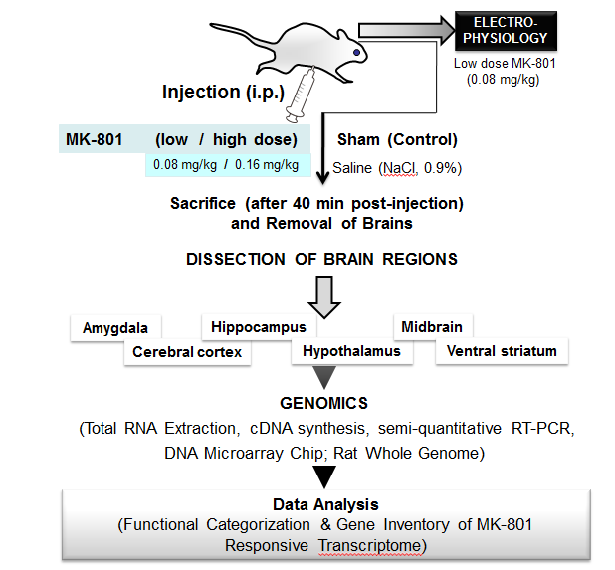
Figure 1 Experimental strategy and design to investigate the MK-801 effects on rat brain. Details are mentioned in the Methods and Materials section.

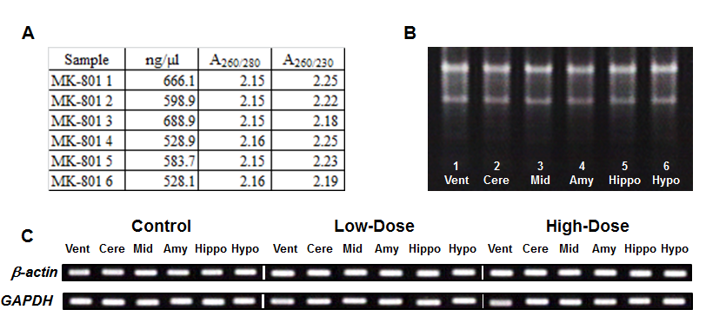
Figure 2 Total RNA quality and quantity check, and RT-PCR. Total RNA quality was confirmed spectrophotometrically (A) and by formaldehyde agarose-gel electrophoresis (B). Stable expression levels of GAPDH and β-actin genes are shown (C). For further details, see the Methods and Materials section.
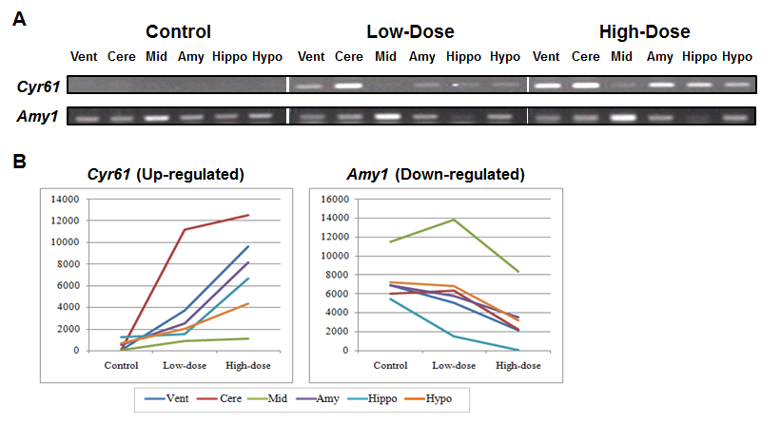
Figure 3 RT-PCR analyses of Cyr61 and Amy1 genes that are differentially expressed in the 6 brain regions by MK-801 treatment. For the stable expression levels of GAPDH and β-actin genes, please see Figure 2C. For further details, see the Methods and Materials section.
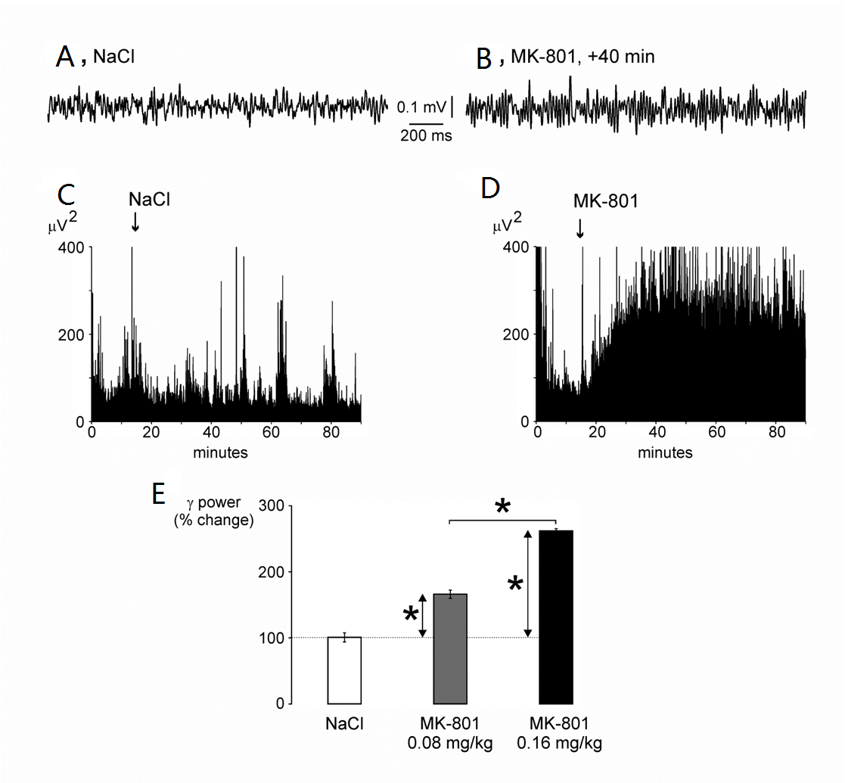
Figure 4 MK-801 increases the power of spontaneously-occurring (30-80 Hz) oscillations. A-B: Typical 2-s bouts of frontoparietal electrocorticogram (bandpass: 20-80 Hz) recorded in a free-moving awake rat under control (vehicle: NaCl, 0.9%, 1 mL/kg, A) and MK-801 (about 40 min after injection, 0.08 mg/kg, B) conditions; C-D: Each chart shows the total power (resolution: 2.4 Hz; average of 8 x 2.5-s epochs) of oscillations during a 90-min recording session, during which the rat received an injection [NaCl (C) or MK-801 (D)] at 15 min (arrow). Note that MK-801 induces a dramatic increase in power, which is still present at the end of the recording session; E: The histogram shows that MK-801 significantly (t-test, stars, P < 0.001) and in a dose-dependent manner increases the power during the 30 to 40 minutes post-injection period. All values are means ± SEM (5 rats, > 100 values/rat, spectral analysis 2.5-s epochs).

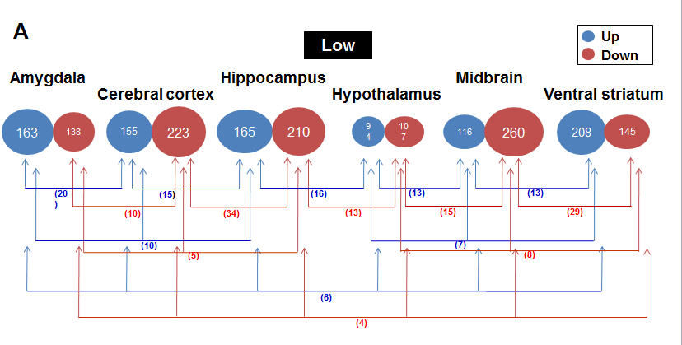
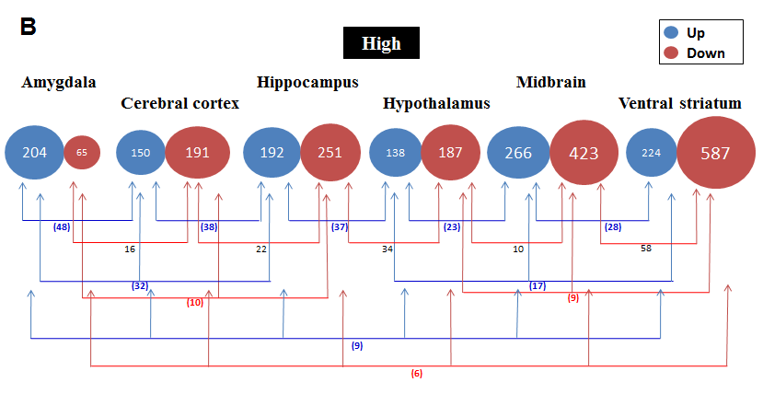
Figure 5 Number of changed genes in each brain region and the number of common genes among each region. A: Low-dose of MK-801; B: High-dose of MK-801.

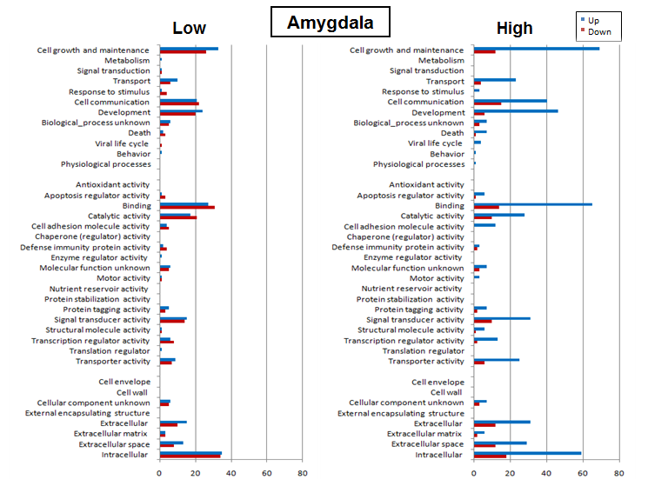
Figure 6 Functional categorization of the differentially expressed amygdala genes based on Gene Ontology. Changed genes divided into 38 function categories in the amygdala.
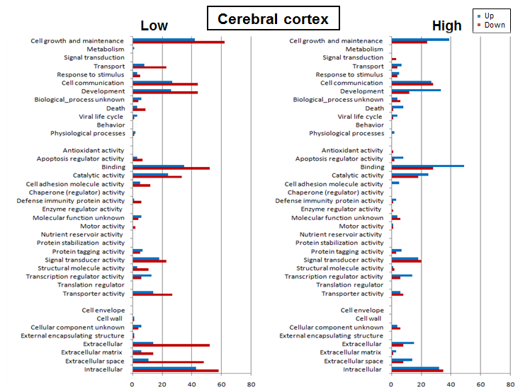
Figure 7 Functional categorization of the differentially expressed cerebral cortex genes based on GO. Changed genes divided into 38 function categories in the cerebral cortex.
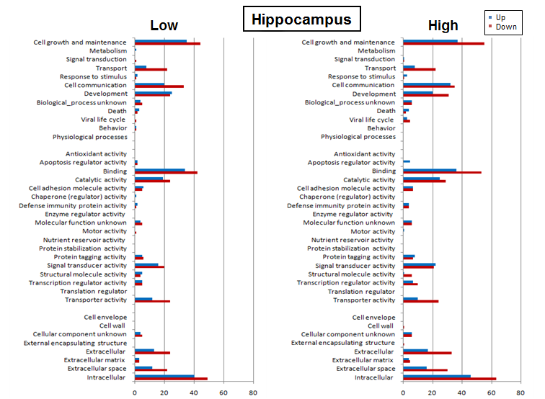
Figure 8 Functional categorization of the differentially expressed hippocampus genes based on GO. Changed genes divided into 38 function categories in the hippocampus.
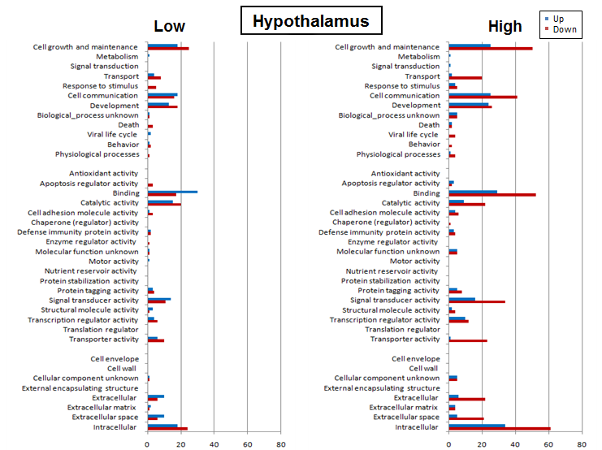
Figure 9 Functional categorization of the differentially expressed hypothalamus genes based on GO. Changed genes divided into 38 function categories in the hypothalamus.
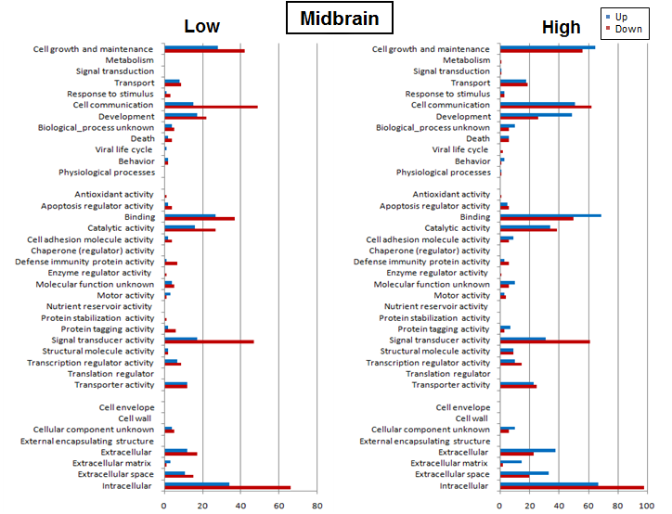
Figure 10 Functional categorization of the differentially expressed midbrain genes based on GO. Changed genes divided into 38 function categories in the midbrain.
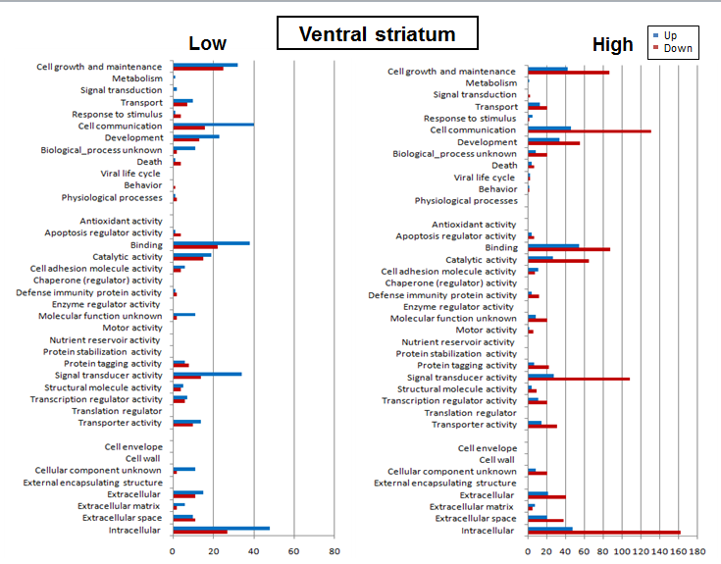
Figure 11 Functional categorization of the differentially expressed ventral striatum genes based on GO. Changed genes divided into 38 function categories in the ventral striatum.
Table 1 Primer design for reverse transcription-polymerase chain reaction validation experiment
Accession (Gene) | Gene Symbol | Description | Nucleotide Sequence (5'-3'): Left |  | Nucleotide Sequence (5'-3'): Right |  | Product Size (bp)
X02231 X00972 | Gapdh | Glyceraldehyde-3-phosphate dehydrogenase |  | tccctcaagattgtcagcaa |  | agatccacaacggatacatt |  | 308
NM031144 | β-actin | β-actin |  | cctgtatgcctctggtcgta |  | ccatctcttgctcgaagtct |  | 260
NM_031327 | Cyr61 | Cysteine rich protein 61 |  | gtccttgtggacaaccagtgta |  | cctttagtccctgaacttgtgg |  | 341
NM_001010970 | Amy1a | Amylase, alpha 1A (salivary) |  | cttctgacagagcccttgtctt |  | aatggtcacttctttggttgct |  | 254
Gene-specific (rat) primers are designed in-house and original to our group.

