Name of Journal: World Journal of Clinical Cases
Manuscript NO: 48621
Manuscript Type: CASE REPORT

Drug coated balloon angioplasty for renal artery stenosis due to Takayasu arteritis: Report of five cases

Bi YH et al. Balloon angioplasty for renal artery stenosis

Yong-Hua Bi, Jian-Zhuang Ren, Meng-Fei Yi, Jin-Dong Li, Xin-Wei Han

Yong-Hua Bi, Jian-Zhuang Ren, Meng-Fei Yi, Xin-Wei Han, Department of Interventional Radiology, The First Affiliated Hospital of Zhengzhou University, Zhengzhou 450052, Henan Province, China

Jin-Dong Li, Department of Thoracic Surgery, the First Affiliated Hospital of Zhengzhou University, Zhengzhou 450052, Henan Province, China

ORCID number: Yong-Hua Bi (0000-0002-0046-4388); Jian-Zhuang Ren (0000-0003-0432-2640); Meng-Fei Yi (0000-0002-1209-6164); Jin-Dong Li (0000-0002-2944-0523); Xin-Wei Han (0000-0002-8411-6427).

Author contributions: Bi YH and Ren JZ contributed equally to this work and should be regarded as co-first authors; Bi YH, Li JD, Han XW, and Ren JZ designed the study; Bi YH, Ren JZ, and Yi MF performed the study; Bi YH and Ren JZ collected and analyzed the data; all authors wrote the paper and finally approved the version to be published.

Supported by the National Natural Science Foundation of China, No. 81501569.

Informed consent statement: Written informed consent was obtained from the patient for publication of this report and any accompanying images.

Conflict-of-interest statement: The authors declare that they have no conflict of interest.

CARE Checklist (2016) statement: The authors have read the CARE Checklist (2016), and the manuscript was prepared and revised according to the CARE Checklist (2016).

Open-Access: This article is an open-access article which was selected by an in-house editor and fully peer-reviewed by external reviewers. It is distributed in accordance with the Creative Commons Attribution Non Commercial (CC BY-NC 4.0) license, which permits others to distribute, remix, adapt, build upon this work non-commercially, and license their derivative works on different terms, provided the original work is properly cited and the use is non-commercial. See: http://creativecommons.org/licenses/by-nc/4.0/

Manuscript source: Unsolicited manuscript

Corresponding author: Xin-Wei Han, MD, PhD, Chairman, Professor, Department of Interventional Radiology, The First Affiliated Hospital of Zhengzhou University, No. 1, East Jianshe Road, Zhengzhou 450052, Henan Province, China. dreamweaver08@126.com
Telephone: +86-371-66862162
Fax: +86-371-66862162

Received: April 25, 2019
Peer-review started: May 9, 2019
First decision: May 30, 2019
Revised: July 12, 2019
Accepted: July 27, 2019
Article in press:
Published online:
Abstract
BACKGROUND
Takayasu arteritis is a rare but intractable chronic disease in young female patients. Percutaneous transluminal angioplasty of the involved renal arteries has been reported; however, few studies have reported the use of drug coated balloon angioplasty in the treatment of Takayasu arteritis. We aimed to demonstrate five young female patients who presented with a history of hypertension due to Takayasu arteritis.

CASE SUMMARY
From April 2017 to October 2018, five female patients were diagnosed with hypertension due to Takayasu arteritis by computed tomography angiography (CTA) and laboratory tests. Four patients had a complaint of headache with or without dizziness, and one patient showed no symptom. There was no significant family or past history of hypertension or kidney disease, and the physical examinations were almost normal on admission. We performed a treatment by drug coated balloon angioplasty. Blood pressure decreased dramatically in all patients after balloon angioplasty, and the patency of treated renal artery was demonstrated with CTA over 5 months after the angioplasty procedure.

CONCLUSION
Drug coated balloon angioplasty is safe and effective for renal artery stenosis due to Takayasu arteritis. A prospective study with a larger sample size is necessary to further demonstrate the effectiveness of the treatment.

Key words: Hypertension; Renal artery stenosis; Takayasu arteritis; Balloon angioplasty; Case report

© The Author(s) 2019. Published by Baishideng Publishing Group Inc. All rights reserved.

Core tip: Percutaneous transluminal angioplasty of the involved renal arteries has been reported; however, few cases were treated by drug coated balloon angioplasty. We aimed to demonstrate five young ladies who presented with a history of hypertension due to Takayasu arteritis. Our data indicated that drug coated balloon angioplasty is safe and effective for renal artery stenosis due to Takayasu arteritis.

Bi YH, Ren JZ, Yi MF, Li JD, Han XW. Drug coated balloon angioplasty for renal artery stenosis due to Takayasu arteritis: Report of five cases. World J Clin Cases 2019; In press
INTRODUCTION
Takayasu arteritis is a rare but intractable chronic disease, with a significantly higher incidence in young female patients^{[1,2]}. The disease course extends over many years and recurrences are frequent even after receiving corticosteroid treatment^{[2]}. Takayasu arteritis shows an unclear disease cause involving inflammation of the aorta and aortic branches, coronary arteries, and pulmonary arteries^{[3]}. The inflammatory process can result in stenosis/occlusion, aneurysm formation, or dilatation in the affected arteries, thus increasing the risk of cardiovascular morbidity and mortality^{[3]}. Takayasu arteritis is a significant cause of hypertension in children and young patients. Early evaluation and diagnosis of this disease can improve the morbidity and mortality, and computed tomography angiography (CTA) is usually used for this purpose^{[4]}. Percutaneous transluminal angioplasty (PTA) of the involved renal arteries has been reported^{[5]}; however, few studies have reported the use of drug coated balloon angioplasty in the treatment of Takayasu arteritis. We herein present five cases of treatable hypertension, which were diagnosed with hypertension due to Takayasu arteritis. They underwent PTA with a drug coated balloon catheter; thereafter, their blood pressure became normal with decreased amount of antihypertensive drug treatment.

CASE PRESENTATION
Chief complaints
Five young female patients were admitted to our department because of hypertension from April 2017 to October 2018. Four patients had a complaint of headache with or without dizziness, and one patient showed no symptom.

Personal and family history and physical examination upon admission
There was no significant family or past history of hypertension or kidney disease. The physical examinations were almost normal.

Laboratory examinations
Laboratory tests were revealed as follows: creatinine 27-75 mmol/L (normal range: 20-115 mmol/L). The glomerular filtration rate of the involved kidney was computed as 16.7-25.1 mL/min; glucose, liver function, C-reactive protein (0.78-4.20 mg/L), and erythrocyte sedimentation rate (3.8-43.0 mm/h) were in normal ranges.

Imaging examinations
The chest computed tomography (CT) scan was normal. CTA of the aorta showed arterial wall thickening, renal arteries with severe stenosis at the origin in two cases, and renal arteries with occlusion in three cases (Figure 1A, B).

FINAL DIAGNOSIS
All patients were diagnosed as having Takayasu arteritis.

TREATMENT
Oral antihypertensives (1-3 kinds of drug) were administered in four patients before balloon dilation, and the patients’ blood pressure fluctuated between 146-176 mmHg for systolic blood pressure and 69-117 mmHg for diastolic blood pressure.
After the discussion among vascular and interventional specialists, we decided to perform PTA with a drug coated balloon catheter. PTA was performed on days 3-5 of hospitalization. A 7-F sheath was inserted into the femoral artery under local anesthesia. Nonselective angiography revealed severe stenosis of renal artery origin in two cases and occlusion of the proximal segment of renal arteries in three cases. A 7-F guiding catheter and 5-F Cobra catheter (Asahi Intec Co, Aichi, Japan) were introduced along a guide wire. The involved renal arteries were dilated with a 3.5-6 mm balloon catheter (Figure 2).

OUTCOME AND FOLLOW-UP
Repeated angiography revealed that the stenosis or occlusion at the involved renal artery origin was relieved obviously after angioplasty. Preoperative CTA showed a diameter of 0-2.5 mm of the renal artery, which increased to 3.0-7.0 mm after balloon dilatation.
In the postoperative reexamination, the erythrocyte sedimentation rate was 2.6-8.9 mm/h, the C-reactive protein was 0.18-0.70 mg/L (normal range: 0-5 mg/L), and serum creatinine was 24-67 mg/dL. The patients received cyclophosphamide pulse therapy during a 5-mo follow-up period after the procedure. A follow-up performed 5.1-23.8 mo showed that the blood pressure fluctuated between 114-126 for systolic blood pressure and 65-80 mmHg for diastolic blood pressure. The amount of oral antihypertensives decreased obviously, and only two patients needed to take one kind of antihypertensive. The creatinine concentration was 24-67 mg/dL, and glomerular filtration rate was 35.29-101.98 mL/min. The uptake functions and blood perfusion of the kidneys were almost normal. CTA imaging showed an improvement of the stenosis at the involved renal arteries (Figure 1C, D).

DISCUSSION
Takayasu arteritis was documented as aortoarteritis in 1830^{[4]}, and was named in honor of the professor who firstly reported this disease. Takayasu arteritis is a common disease in Japan, India, Southeast Asia, and Mexico^{[6]}. Takayasu arteritis often show nonspecific clinical manifestations, such as fever, headache, dyspnea, anemia, joint and muscle pains, thoracic pain and so on. The severity classification of Takayasu arteritis is based on the outcomes of CTA^{[6-8]}. Patients with Takayasu arteritis often show marked stenosis or occlusion of renal arteries.
PTA is a promising treatment for patients with Takayasu arteritis. Gumus et al^{[5]} reported a case of Takayasu arteritis with stenosis of bilateral renal arteries that underwent a balloon angioplasty. Endovascular stent implantation can improve the prognosis for patients who experience restenosis after balloon angioplasty. However, few studies have reported the use of drug coated balloon angioplasty in the treatment of Takayasu arteritis. We successfully performed PTA with a drug coated balloon catheter in five young patients with Takayasu arteritis. The patient’s blood pressure decreased dramatically in all patients after balloon angioplasty, and patency of the involved renal artery was confirmed by CTA over a 5-mo period after angioplasty procedure. Our treatment protocol, like other studies^{[5]}, has achieved satisfactory results. However, owing to a short period of follow-up, long-term effects of this intervention treatment on patient’s blood pressure, glomerular filtration rate, or creatinine concentration could not be assessed, and further long-term follow-up is needed.
Identifying disease activity for Takayasu arteritis is quite challenging. CTA is a high-quality imaging tool for the diagnosis and grading of vascular disease^{[9]}. Quantitative characterization is useful for identifying disease activity, and relative enhancement ratio and maximal wall thickness have a high sensitivity and specificity for detecting its activity^{[2]}. Besides, Razek et al^{[10]} reported that time resolved imaging of contrast kinetics MR angiography is useful for evaluation and treatment planning of arteriovenous malformations. The merits of MR angiography are needed to investigate for Takayasu arteritis.

CONCLUSION
Our results indicated that drug coated balloon angioplasty is safe and effective for renal artery stenosis due to Takayasu arteritis. A prospective study with a larger sample size is necessary to further demonstrate the effectiveness of the treatment.

REFERENCES
1 Watanabe Y, Miyata T, Tanemoto K. Current Clinical Features of New Patients With Takayasu Arteritis Observed From Cross-Country Research in Japan: Age and Sex Specificity. Circulation 2015; 132: 1701-1709 [PMID: 26354799 DOI: 10.1161/CIRCULATIONAHA.114.012547]
2 Chen B, Wang X, Yin W, Gao Y, Hou Z, An Y, Li Z, Ren X, Zhao S, Das P, Lu B. Assessment of disease activity in Takayasu arteritis: A quantitative study with computed tomography angiography. Int J Cardiol 2019; 289: 144-149 [PMID: 31079971 DOI: 10.1016/j.ijcard.2019.04.086]
3 He Y, Lv N, Dang A, Cheng N. Pulmonary Artery Involvement in Patients with Takayasu Arteritis. J Rheumatol 2019 [PMID: 31092716 DOI: 10.3899/jrheum.190045]
4 Numano F, Okawara M, Inomata H, Kobayashi Y. Takayasu's arteritis. Lancet 2000; 356: 1023-1025 [PMID: 11041416 DOI: 10.1016/S0140-6736(00)02701-X]
5 Gumus B, Cevik H, Vuran C, Omay O, Kocyigit OI, Turkoz R. Cutting balloon angioplasty of bilateral renal artery stenosis due to Takayasu arteritis in a 5-year-old child with midterm follow-up. Cardiovasc Intervent Radiol 2010; 33: 394-397 [PMID: 19517163 DOI: 10.1007/s00270-009-9623-6]
6 Johnston SL, Lock RJ, Gompels MM. Takayasu arteritis: a review. J Clin Pathol 2002; 55: 481-486 [PMID: 12101189 DOI: 10.1136/jcp.55.7.481]
7 Smetana GW, Shmerling RH. Does this patient have temporal arteritis? JAMA 2002; 287: 92-101 [PMID: 11754714 DOI: 10.1001/jama.287.1.92]
8 McCulloch M, Andronikou S, Goddard E, Sinclair P, Lawrenson J, Mandelstam S, Beningfield SJ, Millar AJ. Angiographic features of 26 children with Takayasu's arteritis. Pediatr Radiol 2003; 33: 230-235 [PMID: 12709750 DOI: 10.1007/s00247-002-0817-1]
9 Abdel Razek AA, Denewer AT, Hegazy MA, Hafez MT. Role of computed tomography angiography in the diagnosis of vascular stenosis in head and neck microvascular free flap reconstruction. Int J Oral Maxillofac Surg 2014; 43: 811-815 [PMID: 24794762 DOI: 10.1016/j.ijom.2014.03.014]
10 Razek AA, Gaballa G, Megahed AS, Elmogy E. Time resolved imaging of contrast kinetics (TRICKS) MR angiography of arteriovenous malformations of head and neck. Eur J Radiol 2013; 82: 1885-1891 [PMID: 23928233 DOI: 10.1016/j.ejrad.2013.07.007]

P-Reviewer: El-Razek AA, Gheita TA, Shrestha B S-Editor: Dou Y L-Editor: Wang TQ E-Editor:

Specialty type: Medicine, Research and Experimental
Country of origin: China
Peer-review report classification
Grade A (Excellent): 0
Grade B (Very good): B
Grade C (Good): C
Grade D (Fair): D
Grade E (Poor): 0

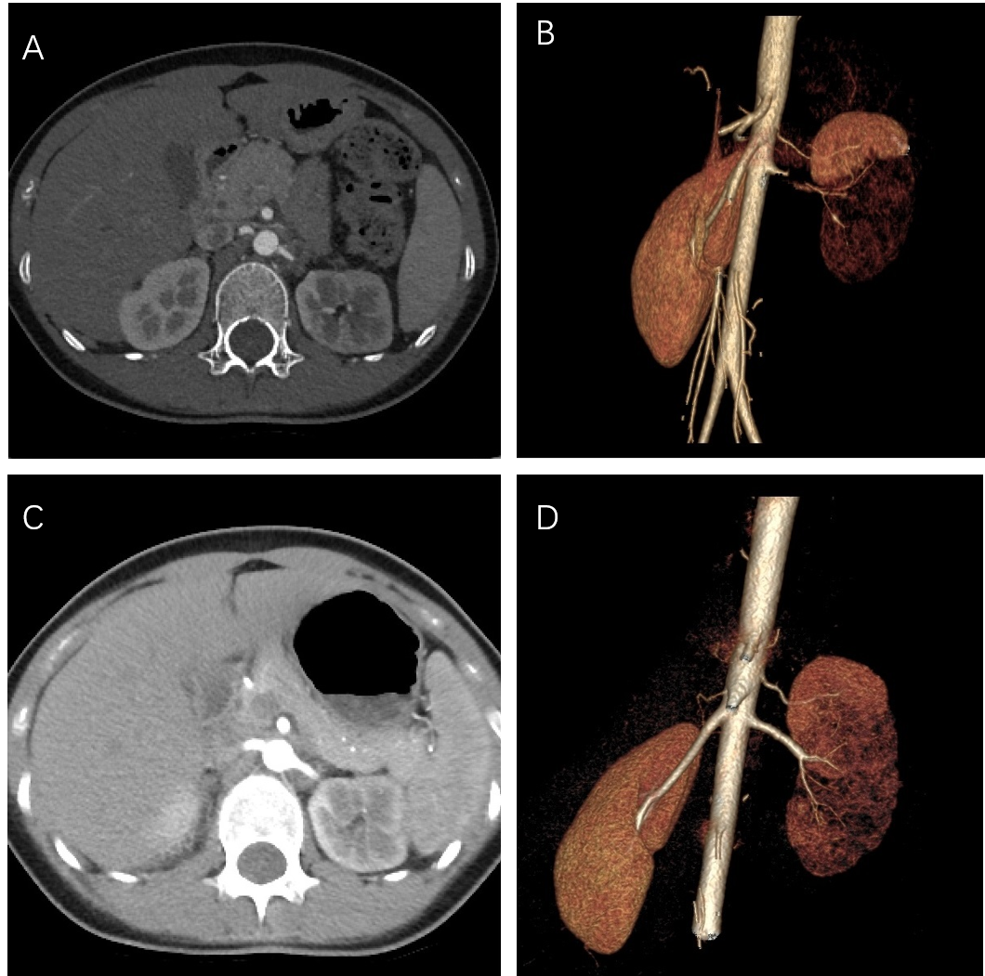Figure 1 Computed tomography angiography before and after the procedure. A and B: Computed tomography angiography of the aorta showed the severe stenosis at the origin of the left renal artery; C and D: The left renal artery was patent after percutaneous transluminal angioplasty.
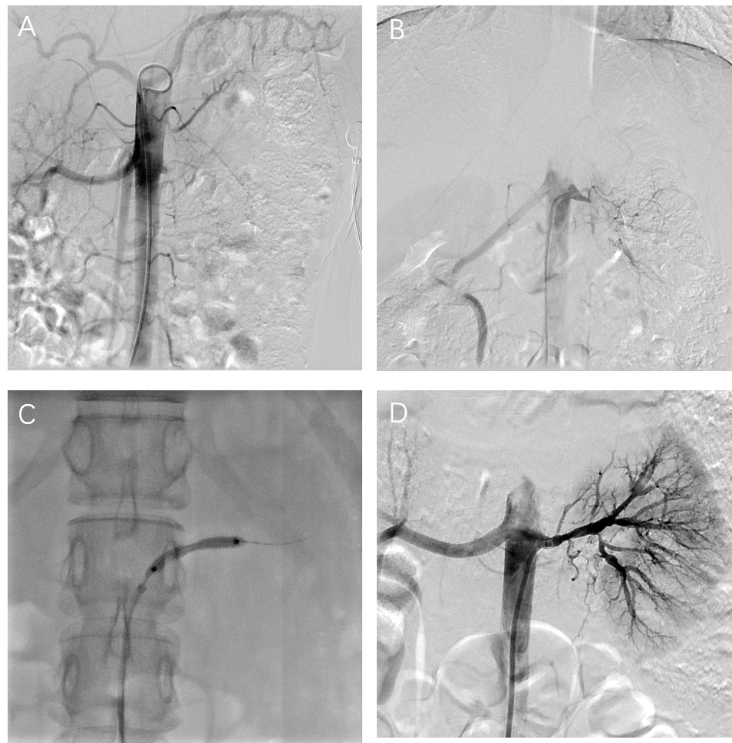Figure 2 Renal angioplasty procedure. A and B: Pre-transluminal renal angioplasty; C: Inflation of the balloon at the left renal artery ostium; D: Post-transluminal renal angioplasty.

Table 1 Patient characteristics before balloon angioplasty
Patient No. | Age, yr | Gender | Blood pressure, mm Hg | No. of antihypertensive drugs | Serum creatinine, mg/dL | eGFR, mL/min/1.73 m² | ESR, mm/h | CRP, mg/L | Diameter of involved artery, mm
1 | 18 | F | 149/69 | 0 | 51 | 16.7 | 12.0 | 4.20 | Occlusive
2 | 16 | F | 146/90 | 1 | 69 | 24.4 | 7.7 | 3.52 | Occlusive
3 | 14 | F | 170/115 | 1 | 55 | 18.6 | 43.0 | 1.50 | Occlusive
4 | 13 | F | 176/104 | 2 | 27 | 19.3 | 3.8 | 1.11 | 0.9
5 | 17 | F | 174/117 | 3 | 75 | 25.1 | 4.3 | 0.78 | 2.5
GFR: Glomerular filtration rate; ESR: Erythrocyte sedimentation rate; CRP: C-reactive protein; F: Female.
Table 2 Patient characteristics before balloon angioplasty
Patient No. | Blood pressure, mm Hg | No. of antihypertensive drugs | Serum creatinine, mg/dL | eGFR, mL/min/1.73 m² | ESR, mm/h | CRP, mg/L | Diameter of involved artery, mm | Follow-up, months
1 | 115/75 | 0 | 67 | 35.29 | 8.9 | 0.30 | 6.0 | 23.8
2 | 126/65 | 0 | 61 | 76.70 | 5.1 | 0.70 | 3.3 | 21.1
3 | 114/72 | 0 | 56 | 91.87 | 7.0 | 0.58 | 4.1 | 5.1
4 | 121/74 | 1 | 24 | 86.27 | 3.5 | 0.33 | 3.0 | 14.4
5 | 123/80 | 1 | 62 | 101.98 | 2.6 | 0.18 | 7.0 | 5.2
GFR: Glomerular filtration rate; ESR: Erythrocyte sedimentation rate; CRP: C-reactive protein.

