Name of journal: World Journal of Gastroenterology
Manuscript NO: 55719
Manuscript type: Minireviews

Accelerating the elimination of hepatitis C in Kuwait: An expert opinion

Hasan F et al. Elimination of HCV in Kuwait

Fuad Hasan, Ahmad Alfadhli, Abeer Al-Gharabally, Mahmoud Alkhaldi, Massimo Colombo, Jeffrey V Lazarus

Fuad Hasan, Ahmad Alfadhli, Department of Internal Medicine, Faculty of Medicine, Kuwait University, Kuwait 12037, Kuwait

Abeer Al-Gharabally, Department of Gastroenterology, Amiri Hospital, Kuwait 13041, Kuwait

Mahmoud Alkhaldi, Public Health Department, Ministry of Health, kuwait 13110, Kuwait

Massimo Colombo, Head Center of Translational Research in Hepatology, Humanitas Clinical and Research Center, Rozzano 20089, Italy

Jeffrey V Lazarus, Barcelona Institute for Global Health, Barcelona Institute for Global Health (ISGlobal), University of Barcelona, Barcelona 08036, Spain

Author contributions: All authors equally contributed to this paper in terms of conception, literature review, critical revision, editing, and final approval for submission.

Corresponding author: Fuad Hasan, FACP, MD, Doctor, Professor, Department of Internal Medicine, Faculty of Medicine, Kuwait University, Jamal Abdul Nasser St, PO Box 24923 Safat 13110, Kuwait 12037, Kuwait. fuad@hsc.edu.kw

Received: March 30, 2020
Revised: June 4, 2020
Accepted: July 22, 2020
Published online: August 14, 2020

Abstract
Hepatitis C virus (HCV) is estimated to affect 71 million people worldwide. In 2016, the World Health Organization adopted the first global health sector strategy to eliminate viral hepatitis as a public health threat by 2030. In December 2018, the European Association for the Study of the Liver, International Liver Foundation convened an expert panel to address the elimination of HCV infection in Kuwait. Several steps have already been taken to eliminate HCV in Kuwait, including free HCV treatment for Kuwait’s citizens, high blood safety standards, and the implementation of screening and awareness programs. The expert panel made numerous recommendations aimed at accelerating the elimination of HCV in Kuwait: the development of a national strategy and action plan to guide all HCV elimination activities; the formation of a coordination mechanism to support collaboration between hepatitis working committees; the prioritization of micro-elimination at primary, secondary or tertiary facilities, in prisons and rehabilitation centers; and ensuring the involvement of multiple stakeholders – including relevant civil society groups – in all activities. Enhanced screening and linkage to care should be prioritized in Kuwait, with the expansion of the prescriber base to primary healthcare providers and nurse practitioners to be considered. Raising awareness and educating people about HCV infection also remain essential to achieve the goal of HCV elimination. Lastly, a national HCV registry should be developed to help monitor the implementation of viral hepatitis plans and progress towards achieving national and international targets.

Key words: Awareness; Hepatitis C virus; Kuwait; Micro-elimination; Registries; Prescribers

Hasan F, Alfadhli A, Al-Gharabally A, Alkhaldi M, Colombo M, Lazarus JV. Accelerating the elimination of hepatitis C in Kuwait: An expert opinion. World J Gastroenterol 2020; 26(30): 4415-4427
URL: https://www.wjgnet.com/1007-9327/full/v26/i30/4415.htm
DOI: https://dx.doi.org/10.3748/wjg.v26.i30.4415

Core tip: Globally, hepatitis C remains a public health threat, causing substantial morbidity and mortality. In 2016, World Health Organization adopted a strategy to eliminate hepatitis C virus (HCV) infection as a public health threat by 2030. The expert panel con in Kuwait explored how to eliminate HCV and developed seven recommendations to accelerate the response, which included developing a national strategy and action plan which outline national priorities for eliminating HCV; increasing awareness and educating people about HCV infection; micro-eliminating HCV in high-risk population groups; ensuring linkage to care; and developing a national HCV registry to monitor progress towards national and international goals in Kuwait.

INTRODUCTION
Hepatitis C virus (HCV) remains a public health threat in many countries, causing substantial morbidity and mortality^{[1,2]}. While 15%-45% of the infected population become HCV free within six months without treatment, 55%-85% of infected people develop chronic infection^{[3,4]}. According to the World Health Organization (WHO), an estimated 71 million people have chronic HCV infection globally^{[3]}, which left untreated can lead to cirrhosis and hepatocellular carcinoma (Figure 1)^{[3,4]}. According to the global hepatitis report, in 2015, 1.75 million new HCV infections occurred^{[5]}, while in 2016, HCV led to an estimated 399000 deaths globally^{[3]}.
In response to the global burden of HCV and the associated morbidity and mortality, the WHO adopted the goal of eliminating viral hepatitis as a public health threat by the year 2030^{[6]}. In 2016, 194 countries, including Kuwait, adopted the first global health sector strategy to combat viral hepatitis (Table 1)^{[6,7]}. Figure 2 shows the continuum of viral hepatitis services and retention cascade, which forms the basic blocks by which these elimination targets will be achieved^{[6,7]}. However, in 2019, only nine of the 194 countries to adopt the strategy were on track to reach the elimination targets. Kuwait, was one of the countries not on track to reach elimination targets before 2050^{[8]}.
Estimated at 1%, the prevalence of HCV in the Arabian Gulf is considered high^{[9]}. In Kuwait, HCV remains a pressing public health issue. The country witnesses high inward migration from HCV-endemic areas^{[10]}, with 75% of the population of 2 million being expatriates^{[11]}. Mohamoud et al^{[9]} 2016 estimate the prevalence of HCV among Kuwaiti nationals at 0.44% [95% confidence interval (CI): 0.29-0.62], rising to 1.45% (95%CI: 0.75-2.34) among the entire resident populations including nationals and expatriates.
In December 2018, the European Association for the Study of the Liver, International Liver Foundation (EILF) convened an expert panel in Kuwait^{[7]} to discuss the country’s HCV elimination efforts and to determine urgent priorities. The expert panel was comprised of 12 local key opinion leaders and other stakeholders, including EILF board members, and gastroenterologists and experts from various health departments in Kuwait^{[7]}. This meeting had the following four objectives: (1) to assess the current state of HCV elimination efforts in Kuwait; (2) to review the action plan of HCV elimination followed in other countries; (3) to identify factors for successes, including knowledge gaps and barriers to HCV elimination in Kuwait; and (4) to develop recommendations to advance HCV elimination efforts in Kuwait^{[7]}.

CURRENT EFFORTS TO ADDRESS HCV IN KUWAIT
The panel identified several targets that have been achieved in Kuwait including mandatory HCV screening for all prisoners followed by free treatment for infected individuals; free HCV treatment for citizens of Kuwait, individuals born or married to a Kuwaiti national, and stateless individuals; high blood safety standards with 100% of blood donations screened for HCV, HBV, and HIV since 1992, 1978, and 1987, respectively; and implementation of several HCV awareness and screening efforts at national and local levels^{[7]}.
An Kuwait Hepatology Association, which includes healthcare practitioners from six major hospitals of Kuwait, has proposed standards of practice for screening. According to these standards, screening should be initiated using an antibody test; in cases with a positive antibody test, confirmation should be made by PCR^{[10]}.
In Kuwait, direct-acting antivirals (DAAs) have been introduced as an effective and shorter HCV treatment option with limited side-effects. There are various DAA regimes available in Kuwait including Pro [Paritaprevir [75 mg]/ritonavir (50 mg) + ombitasvir (12.5 mg)], PrOD [Paritaprevir [75 mg]/ritonavir (50 mg) + ombitasvir (12.5 mg)/dasabuvir (250 mg)], SOF/LDV [sofosbuvir (400 mg) and ledipasvir (90 mg)] and DAC/SOF [daclatasvir (60 mg)/sofosbuvir (400 mg)]. Ribavirin may be administered in combination with these regimes; the decision is based on the previous therapy, the genotype, demographic profile and any comorbidities. However, the cost and accessibility of these therapies are barriers to ensuring treatment for all HCV patients. Combination of grazoprevir/elbasvir has received approval from the European Medical Agency in 2016 but is not available in Kuwait. Moreover, simeprevir/sofosbuvir regimen is not often prescribed in Kuwait as the test for Q80K polymorphism is not available, making it challenging to prescribe for non-cirrhotic patients^{[10]}. In Kuwait, only gastroenterologists and hepatologists can prescribe HCV treatment. Moreover, there is no national strategy or action plan for the prevention and control of HCV. These and the aforementioned barriers hinder Kuwait’s efforts to achieve HCV elimination. Based on these challenges, the panel made recommendations on how to accelerate the elimination of HCV in Kuwait^{[7]}.

RECOMMENDATIONS TO ELIMINATE HCV BURDEN IN KUWAIT
The expert panel discussed the major challenges and bottlenecks around HCV care in Kuwait and strategized priority actions to accelerate its elimination. Informed by the country’s current HCV elimination efforts and evidence of effective approaches from around the world, the panel developed seven recommendations to achieve HCV elimination in Kuwait (Figure 3)^{[7]}.

A national strategy and action plan are critical to guide and drive action for the elimination of HCV as a public health threat in Kuwait by 2025
Ambitious health goals, such as disease elimination, require sustained efforts and targeted action, with a national strategy to guide these efforts. This should be informed by the specific context, including the opportunities and challenges to eliminating HCV, and should include specific objectives and targets^{[7]}. A plan of action plays a critical role in guiding actions towards achieving these goals, providing direction for all stakeholders and ensuring that all critical factors are addressed in parallel^{[12,13]}.
Several countries have developed and implemented strategies and action plans to guide efforts for HCV elimination^{[14,15]}. For example, the United States National Academies, with the support of partners, developed a national strategy for addressing HCV. In the first phase of this process, stakeholders considered the feasibility of HCV elimination from a biological perspective and the specific barriers and challenges the virus presents, such as it being typically asymptomatic. In the second phase, stakeholders outlined the strategy by which elimination could be achieved; this process included establishing targets and measurable indicators to monitor the implementation of the strategy and the overall progress towards elimination^{[14,15]}. Action plans are commonly co-developed by a core team of stakeholders who are directly working to achieve a specific health goal. However, the successful implementation of such plans is only feasible with the support and commitment of a wide range of stakeholders across the public and private sectors, from those engaged in public health approaches (e.g., policymakers, patient groups, social workers and researchers) to those involved in clinical management (i.e., multidisciplinary clinical teams)^{[7]}.
In 2016, at the first European Policy Summit on HCV, the HCV elimination manifesto was launched^{[16]}. A key intent of the manifesto is to highlight the importance of engaging all relevant stakeholders in the development of national elimination strategies. From national working committees, including governmental, medical, and civil society representatives, to specialty care and primary care clinicians, a wide range of stakeholders must be engaged in the development of national HCV elimination action plans. At the clinical level, the management of HCV requires a multi-disciplinary clinical team. Figure 4, adapted and modified from Nazareth et al^{[17]}, highlights the complex nature of HCV management and emphasizes the need for engagement and coordination across health systems. The European HCV elimination manifesto also highlights the need for integrated care pathways incorporated into national elimination strategies^{[16]}.
With respect to HCV elimination, the strategic plan informs the development of the action plan, which outlines the specific activities that will prevent new infections, effectively diagnose and treat existing infections, and ensure infection control^{[11]}. The action plan should outline in detail the steps to achieve HCV elimination, and the roles and responsibilities of the various stakeholders. In 2018, the New York State Department of Health prepared an action plan for HCV elimination. To achieve its aims, a task force was established with five workgroups to cover the following: (1) HCV prevention; (2) HCV care and treatment access; (3) HCV testing and linkage to care; (4) surveillance, data and metrics; and (5) social determinants^{[18]}. Qatar has also published a plan for the elimination of HCV, which includes primary prevention, early detection, clinical management, and continuous monitoring^{[19]}. Evidence from Greece also highlights the importance of an action plan to ensure the effective use of resources and to enhance HCV screening and treatment^{[20]}.
Effective HCV elimination plans have also been shown to benefit the management of liver diseases more generally. Modeling of the HCV elimination plan for Italy’s Liguria region shows that the plan’s successful implementation would lead to significant savings in healthcare costs by averting the need to treat HCV associated liver-related disease^{[21]}. A study from the Netherlands also documented the introduction of the national plan for HCV elimination. The plan provided a structural framework for the implementation of elimination activities and outlined targets related to each step in the HCV healthcare cascade: (1) awareness and prevention; (2) testing and diagnosis; (3) linkage to care; (4) access to medication; (5) monitoring and evaluation; and 6) social welfare and participation for all affected groups^{[16,22]}.
To achieve HCV elimination, tracking of operational performance across the viral hepatitis service continuum is critical. This allows for challenges and bottlenecks to be identified and addressed in a timely manner and enables stakeholders to determine when a reprioritization or refocusing of efforts is required. At the national and municipal level, Rwanda and New York, respectively, have engaged a task force to provide input to healthcare departments regarding the progress of HCV programs^{[17,23]}. Chicago’s task force for HCV elimination has set the aim of reducing the number of new HCV transmissions to zero^{[24]}.
Cascade-of-care (CoC) monitoring is also essential to understand the effectiveness and impact of strategies and to determine improvement or deterioration in the HCV epidemic^{[25,26]}. Defined targets and high-quality data are central to effective monitoring and informing strategic decisions about the program^{[26]}. It is recommended that when devising national targets, including in Kuwait, these align with the goals and indicators of the WHO Global Health Sector Strategy on Viral Hepatitis 2016-2021 and the WHO regional action plan^{[6,7]}.
In summary, a strategy will be essential for guiding hepatitis elimination efforts in Kuwait while a multi-stakeholder plan of action will be required to effectively implement this strategy. For accountability, a committee or taskforce can be established to oversee the implementation of the plan and to monitor progress, in line with the predefined targets. A principal or central person leading these efforts can help to further reinforce accountability.

A coordination mechanism is critical to provide operational oversight of all screening and linkage to care programs to ensure intensive action to eliminate HCV
HCV programs at national and local levels require effective and efficient coordination across and between multiple agencies and disciplines. The key characteristics of a well-coordinated HCV mechanism include the identification of roles and responsibilities of key organizations, individuals, and working groups; quantification of the service needs (i.e., prevention, diagnosis, treatment, and care); and establishing agreed goals and targets. All of this should be accompanied by adequate investment, including in project management expertise, and be underpinned by a robust accountability framework^{[27]}.
Many countries working towards HCV elimination need to ensure proper coordination among the working committees by reporting to a national oversight committee. Such a structure promotes efficiency by minimizing the duplication of efforts with respect to planning and implementing activities to achieve HCV elimination. The US Department of Health and Human Services has made efforts to track the progress of their HCV elimination strategy. The department assisted stakeholders engaged in raising awareness to identify additional volunteers, who spread awareness among the population, local jurisdictions, and non-governmental organizations to support the attainment of the elimination target^{[28]}. One of the goals of the US national viral hepatitis action plan specifically focuses on coordinating, monitoring, and reporting on the implementation of planned activities, highlighting the importance of coordination within efforts to achieving HCV elimination^{[29]}. Similarly, a study from Australia in 2019 used the Delphi method to identify the critical organizational and operational elements of community-based HCV treatment models. The authors reported that integration and coordination of care and support were important from the perspective of both patients and healthcare providers^{[30]}.
As per the expert panel, several HCV screening and linkage to care programs are presently implemented in Kuwait; however, there is currently limited coordination of activities and information sharing among programs^{[7]}. To ensure that every individual receives proper diagnosis and treatment, it is essential to have robust, coordinated linkage to care for all HCV diagnosed individuals. It is also important to differentiate between coordination mechanisms at the national level (i.e., coordination between primary, secondary, and tertiary care) and between specialists (e.g., gastroenterologists, hepatologists, etc.). Moreover, the development of an inventory of existing and proposed screening and linkage to care programs (from the national strategy/action plan) operating in Kuwait would be helpful^{[7]}. Overall, strong coordination mechanisms are key to delivering effective large-scale HCV elimination programs. Coordination mechanisms need to include all key stakeholders (e.g., policy makers, public health professionals, multi-disciplinary clinical teams) and should prioritize the effective utilization of resources and the timely and efficient sharing of information between stakeholders^{[7]}.

Enhanced HCV screening and linkage to care programming is important to achieve HCV elimination
There are various definitions of linkage to care within the HCV literature. Saab et al^{[31]} defined linkage to care as confirmation of HCV diagnosis by an HVC RNA test and establishment of a follow-up appointment for treatment with a specialist. Others defined linkage to care as confirming HCV by HCV RNA testing^{[32]} or referral to a specialist and attending the first appointment within six months of diagnosis^{[33]}. Some include both screening and attending the first appointment^{[34]}.
Generally, HCV infection is detected following an algorithm (Figure 5, adapted from Wilkins et al^{[35]}, 2015). All patients diagnosed with chronic HCV infection should then be considered for treatment. HCV treatment is chosen based upon the virus genotype, the extent of fibrosis or cirrhosis, prior therapy received, comorbid conditions, and adverse effects. However, the principal aim of all therapies is to reduce the complications and mortality associated with HCV^{[35]}.
The development of an inventory of available data to examine the viral hepatitis care cascade (Figure 2) and to determine areas of drop-out is key for improving linkages to care and guiding actions to specifically address bottlenecks and challenges^{[36]}. Monitoring the prevalence of HCV is key to enable effective and efficient resource allocation and utilization. Adequate resource allocation to health care providers as well as diagnostic laboratories and hospitals is critical to enable screening and treatment. Screening and treatment capacity depend upon the resources available in the country^{[37,38]}. It is especially critical that available resources are utilized in the most effective and efficent way.
As part of Rwanda’s initiative to eliminate HCV the country has developed a five-year plan which includes several activities aimed at enhancing screening and linkage to care^{[23]}. The plan includes an expansion of the workforce of general practitioners, nurses, and laboratory personnel, a reduction in the price of DAAs, and the provision of training to the key individuals and those engaged in conducting awareness campaigns. Through these activities, it is estimated that more than 4 million people will be screened and around 112000 adults treated, averting 10638 new infections, and more than 35000 premature deaths^{[23]}.
In certain population groups, such as incarcerated individuals and people who inject drugs (PWID), timely screening and linkage to care can be challenging. For example, in many prison hospitals HCV treatment is provided to all new positive cases in order to prevent re-infection, a concept known as “treatment as prevention^{[39]}.” However, once released from prison, treatment is generally discontinued due to a lack of follow-up^{[39]}. For these types of population groups there is a need to have multiple, parallel approaches for identifying and linking individuals to programs, such as drug harm reduction services for PWID^{[40]}.
Modeling studies can be useful to quantify the screening targets and resources required to meet national and international goals. For example, a recent publication for Malaysia modeled a stepwise approach to scale up HCV screening in order to reach the WHO 2030 targets. The model estimated screening of < 1 million PWID per year between 2018-2026, before expanding to the general population, with a total of 6 million people screened between 2018-2030. The total cost of screening was estimated at $58 million^{[41]}. Zuckerman et al^{[42]}, suggested that there should be established recommendations for screening and diagnosis of HCV to help overcome disparities in diagnosis and linkages to care. A modeling study on the impact of enhanced screening and treatment on HCV in the US estimated a significant reduction in HCV-related deaths. Increasing treatment four-fold was projected to result in an 80% reduction in HCV prevalence by 2025, with significant reduction in liver outcomes including cirrhosis and hepatocellular carcinoma^{[43]}.
To meet the WHO HCV elimination targets, it is essential to implement successful prevention interventions, outreach screening programs, improve infection control, design initiatives for high-risk subpopulations, such as PWID, and link these programs to other harm reduction services, and conduct extensive screening for HCV followed by treatment^{[44]}.

Micro-elimination programs can be a key element of the national strategy and action plan to fast-track HCV elimination in high-risk populations
The micro-elimination approach focuses on eliminating HCV in high-risk subpopulations and can be applied in settings such as hospitals, prisons, and rehabilitation centers^{[37]}. Micro-elimination enables “quick-wins” in a long-term national plan by eliminating HCV in high-risk groups. The approach can be initiated taking geographic areas, sub-populations, or age-cohorts into consideration. As done in screening programs, modeling studies can be utilized to identify and estimate the impact of HCV infection in high-risk regions or population groups^{[37]}.
Lazarus et al^{[45,46]} (2017 and 2018) propose that target groups suitable for micro-elimination include patients with advanced liver disease, hemophilia and/or engaged with drug treatment units, prisoners, children, migrant communities from high prevalence regions, PWID in networks, men who have sex with men, and generational cohorts of high prevalence and geographically defined areas. Hemodialysis patients should also be assessed for HCV infection^{[47]}. People visiting barber shops, beauty salons, tattoo parlors, and fitness centers (the latter because of injectableable steroid use) should also be assessed as per the expert panels recommendations^{[7]}. Adults born between 1945 and 1965, known as “baby boomers”, are also considered a cohort with a high prevalence of HCV and should be screened at least once for HCV^{[33]}. In the US, the prevalence of HCV is expected to be five-fold higher in baby boomers compared to other adults as they are thought to have become infected during its outbreak between 1960-1980^{[48]}. Crowley et al^{[49]} reported screening of prisoners in an Irish prison to be a useful case finding model that enabled the diagnosis of new cases and facilitated linkage to HCV care. Currently, in Kuwait, all prisoners are screened for HCV infection and, if positive, provided free treatment^{[7]}.
The prevalence of HCV is significantly higher in PWID than in the general population^{[50]}. Analysis from the US highlighted the need for PWID to be universally screened for HCV in order to achieve elimination^{[43]}. In the Netherlands, micro-elimination has been at the forefront of HCV elimination efforts, with PWID a key population group screened and linked to care. This pragmatic and efficient approach has taken the country closer to the goal of HCV elimination^{[22]}. In Iceland, the universal HCV treatment program has been combined with an additional screening of PWID in order to achieve the national HCV elimination targets^{[51]}.
To accelerate HCV elimination in PWID, the micro-elimination program should adhere to recognized best practice as follows: (1) access to sterile equipment used for injecting (this would form a part of a large-scale harm reduction program); (2) testing of volunteers after a regular time period (e.g., 12 mo); and (3) following up individuals who reported having a high-risk injection episode^{[7]}. Micro-elimination of HCV in PWID involves expanding and integrating harm reduction services to HCV screening and treatment^{[52]}. In Australia, DAAs were approved for use through the Pharmaceutical Benefits Scheme, which significantly boosted the treatment uptake in marginalized communities, including PWID^{[53]}.
Micro-elimination programs are also associated with numerous challenges. Targeting vulnerable and often disenfranchised populations, such as PWID, homeless people, and prisoners, is resource intensive and poses particular monitoring and linkage to care-related challenges attributable to inaccessibility of those infected, lack of HCV knowledge, impaired mental health, drug-phobia, financial constraints, and a lack of motivation to be screened and treated. Moreover, these programs require multiple visits and follow-up steps, which require additional staff. In some contexts, this may also require new or different models of service delivery^{[54,55]}. Micro-elimination programs need to utilize existing resources and services to overcome these challenges.
Micro-elimination plans should incorporate realistic, annual goals for screening and treatment. As with national action plans, multiple stakeholders, including government officials, health service providers, and civil society groups, should be involved in the design of the micro-elimination programs. Progress should be monitored and reported on a regular basis^{[37]}. Where national action plans are hampered by political and logistical challenges, micro-elimination programs can help to build momentum by delivering tangible results quickly and efficiently^{[56]}.
Overall, the micro-elimination of HCV in high-risk populations in Kuwait should be considered as an essential component of the overall elimination strategy. Involvement of multiple stakeholders, volunteers, and healthcare practitioners is essential. Micro-elimination efforts should be monitored closely to ensure they are contributing to the boarder goal of HCV elimination in the general population.

Expanding the prescriber-base to achieve HCV elimination
Evidence supports the expansion of the HCV treatment prescriber base, which in Kuwait is currently restricted to gastroenterologists and hepatologists, to include primary care providers and nurse practitioners. A non-randomized, open-label clinical study from the US District of Columbia determined that HCV treatment provided by non-specialists (nurse practitioners and primary care physicians) was as safe and effective as treatment provided by specialists^{[56]}. Nazareth et al^{[17]} also support the use of nurse practitioners to increase the prescriber-base to support HCV elimination efforts. Furthermore, to increase treatment capacity Koren et al^{[57]} reported utilizing clinical pharmacists for HCV treatment, which resulted in high rates of sustained virologic response (95.1%).
Evidence suggests that with adequate planning, training, and capacity building, non-specialists can provide treatment comparable to that given by specialists. Kuwait can consider expanding the prescriber base to accelerate HCV elimination efforts. Such a decision will require careful consideration which should be taken in consultation with all relevant stakeholders within the country.

Increased awareness and education on HCV will help to accelerate eradication efforts
Lack of awareness around HCV is one of the major challenges in achieving elimination. A significant number of people living with HCV are unaware of the viral infection and global knowledge of the disease in the general population is low^{[58,59]}. Training and educational courses for health care providers are essential to ensure they have the most up to date knowledge on standards of care and novel approaches for HCV elimination^{[17,55]}. Public information and awareness campaigns are key to address misconceptions about HCV, its modes of transmission, and the treatment options^{[60]}.
Georgia and Egypt, which have both agreed specific targets for the elimination of HCV, have implemented advocacy, awareness, and education activities as part of their elimination programs^{[59]}. Such efforts can focus on the general population or specific population groups such as potential targets for micro-elimination. Novel approaches to HCV awareness creation and education may be required for specific population groups, such as PWID. Integration of awareness creation efforts with other social services or through civil society groups working with the affected population may be beneficial^{[61,62]}.

Development and implementation of a national HCV registry is key for guiding elimination efforts
HCV registries provide vital information to monitor programs and to track progress towards national and international goals^{[63]}. Several countries, including Taiwan and the US, have conducted clinical trials to develop national HCV registries^{[64,65]}. In the US, the Clinical Case Registries (CCR) consist of two registries, CCR: HIV and CCR: HCV. Both are designed to provide population-based data on Veterans Affairs patients infected with HIV or HCV, which share common risk factors^{[66]}. Rizk et al^{[67]} (2019) highlight how disease registries enable follow-up and allow identification of barriers to care, with innovative solutions such as co-located HIV and HCV clinics being developed as a result.
A national HCV registry can guide strategic decision making at national and local levels. Registries support the monitoring of programs and allows stakeholders to review and revise strategies and plans based on the evolving context (e.g., changes in HCV epidemiology) and changing priorities (e.g., transition from micro-elimination to a national program)^{[7]}. They play a vital role in the treatment of hard to reach population groups that present additional challenges related to tracking and follow-up^{[68]} and assist in assessing the rate of diagnosis for HCV. Central disease registries also provide opportunities for assessing screening efforts and identifying future opportunities for expansion^{[69]}.
In the Middle East, there is a lack of reliable information regarding the prevalence of HCV infection. In Kuwait, determining an accurate HCV prevalence is further complicated by the constant migration of expatriates, a proportion of whom are from HCV-endemic regions^{[10]}. To address this challenge, the Ministry of Health can seek to upgrade the medical record systems to capture adequate information and recruit specialists for processing and analyzing data. Registries can also be used to support real word studies, as done in Germany, to determine the effectiveness and safety of different HCV treatments^{[70]}.
An HCV registry is an essential source of information to guide strategic decision making and track the implementation of action plans. The data can also be used to review and revise strategies and plans as the context evolves or new opportunities or challenges emerge. The HCV registry should be designed to incorporate relevant indicators in line with the WHO HCV elimination strategy.

CONCLUSION
Concerted action can substantially reduce the high prevalence of HCV in Kuwait. To eliminate HCV in the country, key stakeholders have followed the WHO strategy and identified the major challenges and opportunities for accelerating progress. Informed by these challenges, an expert panel developed seven recommendations to accelerate the elimination of HCV as a public health threat in Kuwait: (1) developing and implementing a national strategy and action plan; (2) establishing a coordination mechanism between viral hepatitis working committees; (3) following a micro-elimination approach; 4) enhancing screening and linkage to care; (5) expanding the prescriber base; (6) raising awareness and educating the population; and (7) developing a national HCV registry.

ACKNOWLEDGeMENTS
The authors would like to thank all the experts who participated in the meeting.

REFERENCES
1 Stanaway JD, Flaxman AD, Naghavi M, Fitzmaurice C, Vos T, Abubakar I, Abu-Raddad LJ, Assadi R, Bhala N, Cowie B, Forouzanfour MH, Groeger J, Hanafiah KM, Jacobsen KH, James SL, MacLachlan J, Malekzadeh R, Martin NK, Mokdad AA, Mokdad AH, Murray CJL, Plass D, Rana S, Rein DB, Richardus JH, Sanabria J, Saylan M, Shahraz S, So S, Vlassov VV, Weiderpass E, Wiersma ST, Younis M, Yu C, El Sayed Zaki M, Cooke GS. The global burden of viral hepatitis from 1990 to 2013: findings from the Global Burden of Disease Study 2013. Lancet 2016; 388: 1081-1088 [PMID: 27394647 DOI: 10.1016/S0140-6736(16)30579-7]
2 Cooke GS, Andrieux-Meyer I, Applegate TL, Atun R, Burry JR, Cheinquer H, Dusheiko G, Feld JJ, Gore C, Griswold MG, Hamid S, Hellard ME, Hou J, Howell J, Jia J, Kravchenko N, Lazarus JV, Lemoine M, Lesi OA, Maistat L, McMahon BJ, Razavi H, Roberts T, Simmons B, Sonderup MW, Spearman CW, Taylor BE, Thomas DL, Waked I, Ward JW, Wiktor SZ; Lancet Gastroenterology & Hepatology Commissioners. Accelerating the elimination of viral hepatitis: a Lancet Gastroenterology & Hepatology Commission. Lancet Gastroenterol Hepatol 2019; 4: 135-184 [PMID: 30647010 DOI: 10.1016/S2468-1253(18)30270-X]
3 World Health Organization. Hepatitis C. 2019 [Cited 11 October 2019]. Available from: https://www.who.int/news-room/fact-sheets/detail/hepatitis-c
4 Pawlotsky JM. Pathophysiology of hepatitis C virus infection and related liver disease. Trends Microbiol 2004; 12: 96-102 [PMID: 15036326 DOI: 10.1016/j.tim.2003.12.005]
5 World Health Organization. Global hepatitis report 2017 [Cited 13 Aug 2019]. Available from: https://apps.who.int/iris/bitstream/handle/10665/255017/WHO-HIV-2017.06-eng.pdf?sequence=1
6 World Health Organization. Global Health Sector Strategy on Viral Hepatitis 2016-2021 [Cited 11 October 2019]. Available from: https://apps.who.int/iris/handle/10665/246177
7 EASL-ILF. Hepatitis C elimination in Kuwait: Recommendations [Cited 13 Aug 2019]. Available from: https://easl-ilf.org/wp-content/uploads/2019/04/HCV-ELimination-in-Kuwait-EILF-Report.pdf
8 Klein MB. Hepatitis C virus elimination: time for disruptive innovation. J Int AIDS Soc 2019; 22: e25360 [PMID: 31347280 DOI: 10.1002/jia2.25360]
9 Mohamoud YA, Riome S, Abu-Raddad LJ. Epidemiology of hepatitis C virus in the Arabian Gulf countries: Systematic review and meta-analysis of prevalence. Int J Infect Dis 2016; 46: 116-125 [PMID: 26996460 DOI: 10.1016/j.ijid.2016.03.012]
10 Saad MF, Alenezi S, Asker H; Kuwait Hepatology Club. Expert opinion on the management of hepatitis C infection in Kuwait. Hepat Med 2018; 10: 117-132 [PMID: 30319294 DOI: 10.2147/HMER.S154842]
11 Pacsa AS, Al-Mufti S, Chugh TD, Said-Adi G. Genotypes of hepatitis C virus in Kuwait. Med Principles Pract 2001; 10: 55-57 [DOI: 10.1159/000050340]
12 Nasrullah M, Sergeenko D, Gvinjilia L, Gamkrelidze A, Tsertsvadze T, Butsashvili M, Metreveli D, Sharvadze L, Alkhazashvili M, Shadaker S, Ward JW, Morgan J, Averhoff F. The Role of Screening and Treatment in National Progress Toward Hepatitis C Elimination - Georgia, 2015-2016. MMWR Morb Mortal Wkly Rep 2017; 66: 773-776 [PMID: 28749925 DOI: 10.15585/mmwr.mm6629a2]
13 Dowdle WR. The principles of disease elimination and eradication. Bull World Health Organ 1998; 76 Suppl 2: 22-25 [PMID: 10063669]
14 Committee on a National Strategy for the Elimination of Hepatitis B and C; Board on Population Health and Public Health Practice; Health and Medicine Division; National Academies of Sciences, Engineering, and Medicine, Buckley GJ, Strom BL , editors. Eliminating the Public Health Problem of Hepatitis B and C in the United States: Phase One Report. Washington (DC): National Academies Press (US); 2016 [PMID: 27336113 DOI: 10.17226/23407]
15 National Academies of Sciences, Engineering, and Medicine; Health and Medicine Division; Board on Population Health and Public Health Practice; Committee on a National Strategy for the Elimination of Hepatitis B and C, Strom BL, Buckley GJ, editors. A National Strategy for the Elimination of Hepatitis B and C: Phase Two Report. Washington (DC): National Academies Press (US); 2017 [PMID: 28737845 DOI: 10.17226/24731]
16 Papatheodoridis GV, Hatzakis A, Cholongitas E, Baptista-Leite R, Baskozos I, Chhatwal J, Colombo M, Cortez-Pinto H, Craxi A, Goldberg D, Gore C, Kautz A, Lazarus JV, Mendão L, Peck-Radosavljevic M, Razavi H, Schatz E, Tözün N, van Damme P, Wedemeyer H, Yazdanpanah Y, Zuure F, Manns MP. Hepatitis C: The beginning of the end-key elements for successful European and national strategies to eliminate HCV in Europe. J Viral Hepat 2018; 25 Suppl 1: 6-17 [PMID: 29508946 DOI: 10.1111/jvh.12875]
17 Nazareth S, Piercey C, Tibbet P, Cheng W. Innovative practice in the management of chronic Hepatitis C: introducing the nurse practitioner model. Aust J Adv Nurs 2008; 25: 107
18 New York State Department of Health. New York State Hepatitis C Elimination Task Force 2018 [Cited 11 October 2019]. Available From: https://www.health.ny.gov/diseases/communicable/hepatitis/hepatitis_c/elimination.htm
19 Derbala M, Abd Farag E, Al-Romaihi H, Al Kaabi S, Al-Thani M, El Sayed E, Amer A, Himatt S. An overview of the Hepatitis C control plan in Qatar. East Mediterr Health J 2019; 25: 362-365 [PMID: 31364761 DOI: 10.26719/emhj.18.046]
20 Papatheodoridis GV, Goulis J, Sypsa V, Lionis C, Manolakopoulos S, Elefsiniotis I, Anagnostou O, Tsoulas C, Hatzakis A, Dalekos GN. Aiming towards hepatitis C virus elimination in Greece. Ann Gastroenterol 2019; 32: 321-329 [PMID: 31263353 DOI: 10.20524/aog.2019.0375]
21 Cenderello G, Taramasso L, Marra D, Orcamo P, Pasa A, Di Biagio A. HCV elimination plan leads to significant benefits in managing liver-related diseases and hospital interventions: a regional simulation. Expert Rev Pharmacoecon Outcomes Res 2019; 19: 189-193 [PMID: 30321071 DOI: 10.1080/14737167.2019.1537124]
22 Kracht PAM, Arends JE, van Erpecum KJ, Urbanus A, Willemse JA, Hoepelman AIM, Croes EA. Strategies for achieving viral hepatitis C micro-elimination in the Netherlands. Hepatol Med Policy 2018; 3: 12 [PMID: 30288334 DOI: 10.1186/s41124-018-0040-9]
23 Umutesi G, Shumbusho F, Kateera F, Serumondo J, Kabahizi J, Musabeyezu E, Ngwije A, Gupta N, Nsanzimana S. Rwanda launches a 5-year national hepatitis C elimination plan: A landmark in sub-Saharan Africa. J Hepatol 2019; 70: 1043-1045 [PMID: 30948269 DOI: 10.1016/j.jhep.2019.03.011]
24 AIDS Foundation of Chicago. Hepatitis C Elimination Task Force [Cited 13 October 2019]. Available from: https://www.aidschicago.org/page/our-work/prevention/hepatitis-c-elimination-task-force-1
25 Isenhour C, Hariri S, Vellozzi C. Monitoring the hepatitis C care cascade using administrative claims data. Am J Manag Care 2018; 24: 232-238 [PMID: 29851440]
26 Safreed-Harmon K, Blach S, Aleman S, Bollerup S, Cooke G, Dalgard O, Dillon JF, Dore GJ, Duberg AS, Grebely J, Boe Kielland K, Midgard H, Porter K, Razavi H, Tyndall M, Weis N, Lazarus JV. The Consensus Hepatitis C Cascade of Care: Standardized Reporting to Monitor Progress Toward Elimination. Clin Infect Dis 2019; 69: 2218-2227 [PMID: 31352481 DOI: 10.1093/cid/ciz714]
27 Goldberg D, Hutchinson S, Innes H, Dillon J. Scotland’s Hepatitis C Action Plan: Achievements of the First Decade and Proposals for a Scottish Government Strategy (2019) for the Elimination of both Infection and Disease [Cited 6 December 2019]. Available from: http://www.natap.org/2019/HCV/1_HCV-Elimination-Scotland-2019-07-31.pdf
28 US Department of Health and Human Services. Mapping Hepatitis Elimination in Action [Cited 17 August 2019]. Available from: https://www.hhs.gov/hepatitis/get-involved/hepatitis-elimination/index.html
29 US Department of Health and Human Services. National viral hepatitis action plan 2017-2020 [Cited 17 August 2019]. Available from: https://www.hhs.gov/sites/default/files/National%20Viral%20Hepatitis%20Action%20Plan%202017-2020.pdf
30 Pourmarzi D, Smirnov A, Hepworth J, Rahman T, FitzGerald G, Hall L. Elements of community-based models for treating hepatitis C virus in supporting HCV elimination in Australia: A Delphi study. Int J Health Plann Manage 2019; 34: e1247-e1256 [PMID: 30901129 DOI: 10.1002/hpm.2770]
31 Saab S, Challita YP, Najarian LM, Guo R, Saggi SS, Choi G. Hepatitis C Screening: Barriers to Linkage to Care. J Clin Transl Hepatol 2019; 7: 226-231 [PMID: 31608214 DOI: 10.14218/JCTH.2018.00063]
32 Young KL, Huang W, Horsburgh CR, Linas BP, Assoumou SA. Eighteen- to 30-year-olds more likely to link to hepatitis C virus care: an opportunity to decrease transmission. J Viral Hepat 2016; 23: 274-281 [PMID: 26572798 DOI: 10.1111/jvh.12489]
33 Castrejón M, Chew KW, Javanbakht M, Humphries R, Saab S, Klausner JD. Implementation of a Large System-Wide Hepatitis C Virus Screening and Linkage to Care Program for Baby Boomers. Open Forum Infect Dis 2017; 4: ofx109 [PMID: 28752101 DOI: 10.1093/ofid/ofx109
34 Falade-Nwulia O, Mehta SH, Lasola J, Latkin C, Niculescu A, O'Connor C, Chaulk P, Ghanem K, Page KR, Sulkowski MS, Thomas DL. Public health clinic-based hepatitis C testing and linkage to care in Baltimore. J Viral Hepat 2016; 23: 366-374 [PMID: 26840570 DOI: 10.1111/jvh.12507]
35 Wilkins T, Akhtar M, Gititu E, Jalluri C, Ramirez J. Diagnosis and Management of Hepatitis C. Am Fam Physician 2015; 91: 835-842 [PMID: 26131943]
36 Lazarus JV, Pericàs JM, Picchio C, Cernosa J, Hoekstra M, Luhmann N, Maticic M, Read P, Robinson EM, Dillon JF. We know DAAs work, so now what? Simplifying models of care to enhance the hepatitis C cascade. J Intern Med 2019; 286: 503-525 [PMID: 31472002 DOI: 10.1111/joim.12972]
37 Kushner R. Micro-elimination of hepatitis C: A pathway to achieve national elimination goals. 2019 [Cited 7 December 2019]. Available from: https://www.catie.ca/en/pif/spring-2019/micro-elimination-hepatitis-c-pathway-achieve-national-elimination-goals
38 Suthar AB, Harries AD. A public health approach to hepatitis C control in low- and middle-income countries. PLoS Med 2015; 12: e1001795 [PMID: 25757228 DOI: 10.1371/journal.pmed.1001795]
39 Levy MH, Larney S. The ethics of hepatitis C "treatment as prevention" among prisoners. Hepatology 2015; 61: 402 [PMID: 24797497 DOI: 10.1002/hep.27195]
40 Martin NK, Vickerman P, Goldberg D, Hickman M. HCV treatment as prevention in prison: key issues. Hepatology 2015; 61: 402-403 [PMID: 24797358 DOI: 10.1002/hep.27194]
41 Hiebert L, Hecht R, Soe-Lin S, Mohamed R, Shabaruddin FH, Syed Mansor SM, Dahlui M, Azzeri A, McDonald SA. A Stepwise Approach to a National Hepatitis C Screening Strategy in Malaysia to Meet the WHO 2030 Targets: Proposed Strategy, Coverage, and Costs. Value Health Reg Issues 2019; 18: 112-120 [PMID: 30921591 DOI: 10.1016/j.vhri.2018.12.005]
42 Zuckerman A, Carver A, Chastain CA. Building a Hepatitis C Clinical Program: Strategies to Optimize Outcomes. Curr Treat Options Infect Dis 2018; 10: 431-446 [PMID: 30524209 DOI: 10.1007/s40506-018-0177-5]
43 Durham DP, Skrip LA, Bruce RD, Vilarinho S, Elbasha EH, Galvani AP, Townsend JP. The Impact of Enhanced Screening and Treatment on Hepatitis C in the United States. Clin Infect Dis 2016; 62: 298-304 [PMID: 26628566 DOI: 10.1093/cid/civ894]
44 Heffernan A, Cooke GS, Nayagam S, Thursz M, Hallett TB. Scaling up prevention and treatment towards the elimination of hepatitis C: a global mathematical model. Lancet 2019; 393: 1319-1329 [PMID: 30704789 DOI: 10.1016/S0140-6736(18)32277-3]
45 Lazarus JV, Wiktor S, Colombo M, Thursz M; EASL International Liver Foundation. Micro-elimination - A path to global elimination of hepatitis C. J Hepatol 2017; 67: 665-666 [PMID: 28760329 DOI: 10.1016/j.jhep.2017.06.033]
46 Lazarus JV, Safreed-Harmon K, Thursz MR, Dillon JF, El-Sayed MH, Elsharkawy AM, Hatzakis A, Jadoul M, Prestileo T, Razavi H, Rockstroh JK, Wiktor SZ, Colombo M. The Micro-Elimination Approach to Eliminating Hepatitis C: Strategic and Operational Considerations. Semin Liver Dis 2018; 38: 181-192 [PMID: 29986353 DOI: 10.1055/s-0038-1666841]
47 Ashkani-Esfahani S, Alavian SM, Salehi-Marzijarani M. Prevalence of hepatitis C virus infection among hemodialysis patients in the Middle-East: A systematic review and meta-analysis. World J Gastroenterol 2017; 23: 151-166 [PMID: 28104991 DOI: 10.3748/wjg.v23.i1.151]
48 Centers for Disease Control and Prevention (CDC). Hepatitis C [Cited 10 February, 2020]. Available from: https://www.cdc.gov/knowmorehepatitis/media/pdfs/factsheet-boomers.pdf
49 Crowley D, Murtagh R, Cullen W, Keevans M, Laird E, McHugh T, McKiernan S, Miggin SJ, O'Connor E, O'Reilly D, Betts-Symonds G, Tobin C, Van Hout MC, Lambert JS. Evaluating peer-supported screening as a hepatitis C case-finding model in prisoners. Harm Reduct J 2019; 16: 42 [PMID: 31277665 DOI: 10.1186/s12954-019-0313-7]
50 Degenhardt L, Peacock A, Colledge S, Leung J, Grebely J, Vickerman P, Stone J, Cunningham EB, Trickey A, Dumchev K, Lynskey M, Griffiths P, Mattick RP, Hickman M, Larney S. Global prevalence of injecting drug use and sociodemographic characteristics and prevalence of HIV, HBV, and HCV in people who inject drugs: a multistage systematic review. Lancet Glob Health 2017; 5: e1192-e1207 [PMID: 29074409 DOI: 10.1016/S2214-109X(17)30375-3]
51 Scott N, Ólafsson S, Gottfreðsson M, Tyrfingsson T, Rúnarsdóttir V, Hansdottir I, Hernandez UB, Sigmundsdóttir G, Hellard M. Modelling the elimination of hepatitis C as a public health threat in Iceland: A goal attainable by 2020. J Hepatol 2018; 68: 932-939 [PMID: 29274408 DOI: 10.1016/j.jhep.2017.12.013]
52 Lee SS, Crofts N, Hung CC. Macro-efforts for the micro-elimination of hepatitis C targeting people who inject drugs. Int J Infect Dis 2019; 85: 141-142 [PMID: 31229938 DOI: 10.1016/j.ijid.2019.06.003]
53 Butler K, Larney S, Day CA, Burns L. Uptake of direct acting antiviral therapies for the treatment of hepatitis C virus among people who inject drugs in a universal health-care system. Drug Alcohol Rev 2019; 38: 264-269 [PMID: 30548702 DOI: 10.1111/dar.12883]
54 The Lancet Hiv. Microelimination could be a big deal for HCV and HIV services. Lancet HIV 2018; 5: e605 [PMID: 30507440 DOI: 10.1016/S2352-3018(18)30299-6]
55 Crowley D, Van Hout MC, Lambert JS, Kelly E, Murphy C, Cullen W. Barriers and facilitators to hepatitis C (HCV) screening and treatment-a description of prisoners' perspective. Harm Reduct J 2018; 15: 62 [PMID: 30538000 DOI: 10.1186/s12954-018-0269-z]
56 Kattakuzhy S, Gross C, Emmanuel B, Teferi G, Jenkins V, Silk R, Akoth E, Thomas A, Ahmed C, Espinosa M, Price A, Rosenthal E, Tang L, Wilson E, Bentzen S, Masur H, Kottilil S; and the ASCEND Providers. Expansion of Treatment for Hepatitis C Virus Infection by Task Shifting to Community-Based Nonspecialist Providers: A Nonrandomized Clinical Trial. Ann Intern Med 2017; 167: 311-318 [PMID: 28785771 DOI: 10.7326/M17-0118]
57 Koren DE, Zuckerman A, Teply R, Nabulsi NA, Lee TA, Martin MT. Expanding Hepatitis C Virus Care and Cure: National Experience Using a Clinical Pharmacist-Driven Model. Open Forum Infect Dis 2019; 6: [PMID: 31363775 DOI: 10.1093/ofid/ofz316]
58 Terrault NA. Hepatitis C elimination: challenges with under-diagnosis and under-treatment. F1000Res 2019; 8: F1000 Faculty Rev-54 [PMID: 30687501 DOI: 10.12688/f1000research.15892.1]
59 Popping S, Bade D, Boucher C, van der Valk M, El-Sayed M, Sigurour O, Sypsa V, Morgan T, Gamkrelidze A, Mukabatsinda C, Deuffic-Burban S, Ninburg M, Feld J, Hellard M, Ward J. The global campaign to eliminate HBV and HCV infection: International Viral Hepatitis Elimination Meeting and core indicators for development towards the 2030 elimination goals. J Virus Erad 2019; 5: 60-66 [PMID: 30800429]
60 Ha S, Timmerman K. Awareness and knowledge of hepatitis C among health care providers and the public: A scoping review. Can Commun Dis Rep 2018; 44: 157-165 [PMID: 31011296 DOI: 10.14745/ccdr.v44i78a02]
61 Collier MG, Bhaurla SK, Cuevas-Mota J, Armenta RF, Teshale EH, Garfein RS. Awareness of HCV infection among persons who inject drugs in San Diego, California. Am J Public Health 2015; 105: 302-303 [PMID: 25521877 DOI: 10.2105/AJPH.2014.302245]
62 Jost JJ, Tempalski B, Vera T, Akiyama MJ, Mangalonzo AP, Litwin AH. Gaps in HCV Knowledge and Risk Behaviors among Young Suburban People Who Inject Drugs. Int J Environ Res Public Health 2019; 16: 1958 [PMID: 31159479 DOI: 10.3390/ijerph16111958]
63 US Department of Health and Human Services. Action Plan for the Prevention, Care, Treatment of Viral Hepatitis [Cited 10 October 2019]. Available from: https://www.hhs.gov/sites/default/files/viral-hepatitis-action-plan.pdf
64 US National Library of Medicine. Nation-wide Hepatitis C Virus (HCV) Registry in Taiwan [Cited 10 February 2020]. Available from: https://clinicaltrials.gov/ct2/show/NCT03200379
65 US National Library of Medicine. HCV-TARGET- Hepatitis C Therapeutic Registry and Research Network [Cited 10 February 2020]. Available from: https://clinicaltrials.gov/ct2/show/NCT01474811
66 Backus LI, Gavrilov S, Loomis TP, Halloran JP, Phillips BR, Belperio PS, Mole LA. Clinical Case Registries: simultaneous local and national disease registries for population quality management. J Am Med Inform Assoc 2009; 16: 775-783 [PMID: 19717794 DOI: 10.1197/jamia.M3203]
67 Rizk C, Miceli J, Shiferaw B, Malinis M, Barakat L, Ogbuagu O, Villanueva M. Implementing a Comprehensive HCV Clinic within an HIV Clinic: A Model of Care for HCV Micro-elimination. Open Forum Infect Dis 2019; Online ahead of print [PMID: 31412130 DOI: 10.1093/ofid/ofz361]
68 Sarrazin C, Buggisch P, Mauss S, Müller T, Zimmermann T, Klinker H, Pathil-Warth A, Schlag M, Nalpas C, Wegner S, Lonjon-Domanec I, Simon KG. Evolution of HCV patient characteristics and DAA regimens in the German Hepatitis C Registry (DHC-R) in 2014 and 2015. Z Gastroenterol 2019; 57: 584-592 [PMID: 31083746 DOI: 10.1055/a-0859-7561]
69 Bielen R, Koc ÖM, Busschots D, Robaeys G, Aertgeerts B, Vaes B, Mamouris P, Mathei C, Goderis G, Nevens F. Assessing testing rates for viral hepatitis B and C by general practitioners in Flanders, Belgium: a registry-based study. BMJ Open 2019; 9: e026464 [PMID: 31072855 DOI: 10.1136/bmjopen-2018-026464]
70 Berg T, Naumann U, Stoehr A, Sick C, John C, Teuber G, Schiffelholz W, Mauss S, Lohmann K, König B, Pangerl A, Niederau C. Real-world effectiveness and safety of glecaprevir/pibrentasvir for the treatment of chronic hepatitis C infection: data from the German Hepatitis C-Registry. Aliment Pharmacol Ther 2019; 49: 1052-1059 [PMID: 30874328 DOI: 10.1111/apt.15222]

Footnotes
Conflict-of-interest statement: All authors declare no conflicts of interest related to the study. Writing support was provided by Turacoz Healthcare Solutions which was funded by Gilead Sciences.

Open-Access: This article is an open-access article that was selected by an in-house editor and fully peer-reviewed by external reviewers. It is distributed in accordance with the Creative Commons Attribution NonCommercial (CC BY-NC 4.0) license, which permits others to distribute, remix, adapt, build upon this work non-commercially, and license their derivative works on different terms, provided the original work is properly cited and the use is non-commercial. See: http://creativecommons.org/licenses/by-nc/4.0/

Manuscript source: Unsolicited manuscript

Peer-review started: March 30, 2020
First decision: May 21, 2020
Article in press: July 22, 2020

Specialty type: Gastroenterology and hepatology
Country/Territory of origin: Kuwait
Peer-review report’s scientific quality classification
Grade A (Excellent): 0
Grade B (Very good): B
Grade C (Good): C, C
Grade D (Fair): 0
Grade E (Poor): 0

P-Reviewer: Rostaing L, Tuna N, Zheng SJ S-Editor: Gong ZM L-Editor: A P-Editor: Zhang YL

Figure Legends
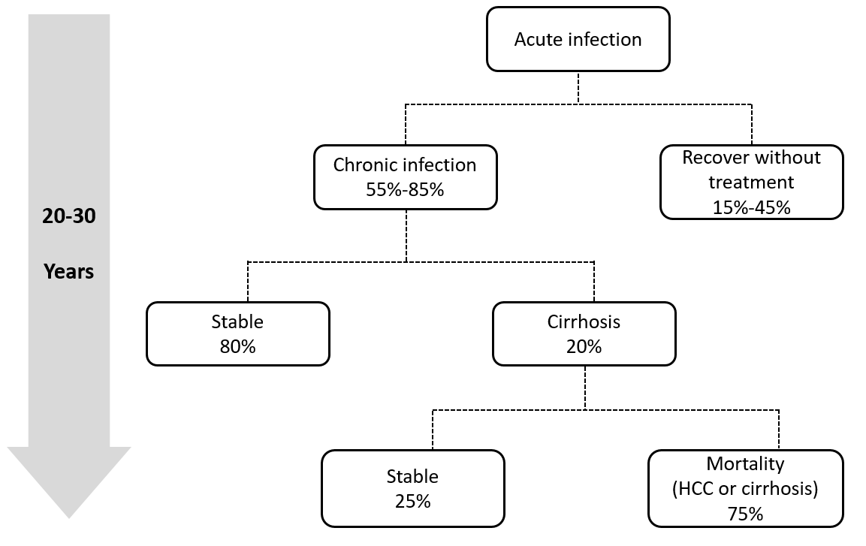
Figure 1 Natural history of hepatitis C infection. HCC: Hepatocellular carcinoma.

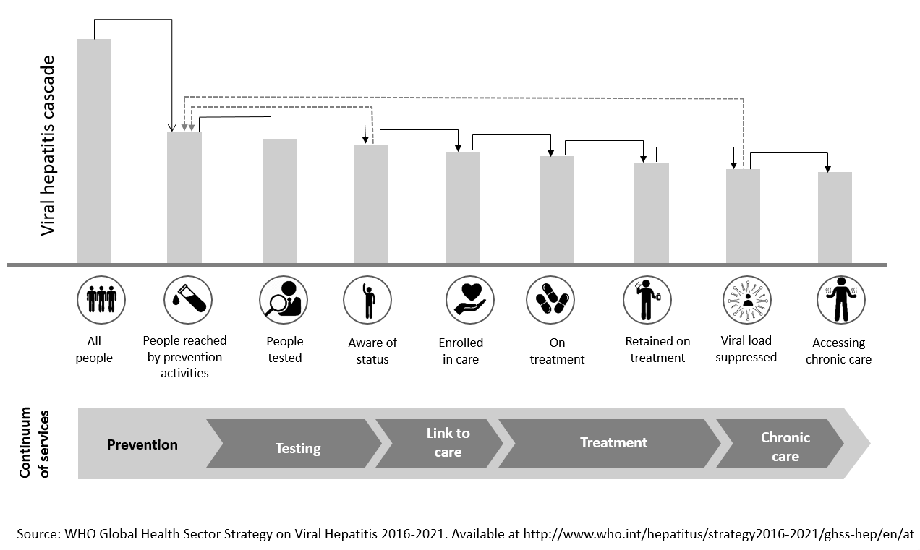
Figure 2 The continuum of hepatitis services and the retention cascade.

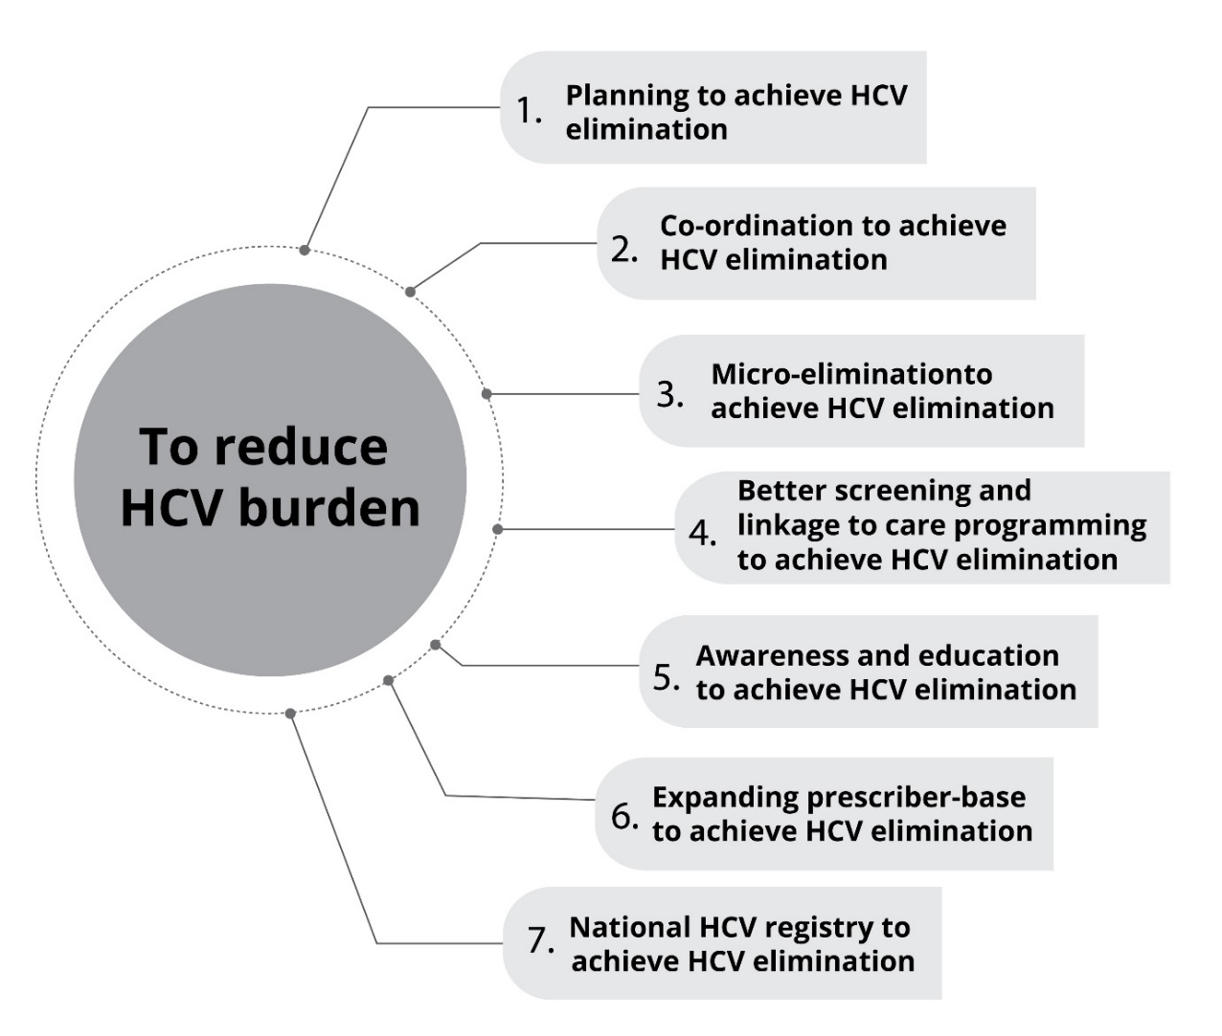
Figure 3 Steps to eliminate hepatitis C virus from Kuwait. HCV: Hepatitis C virus.

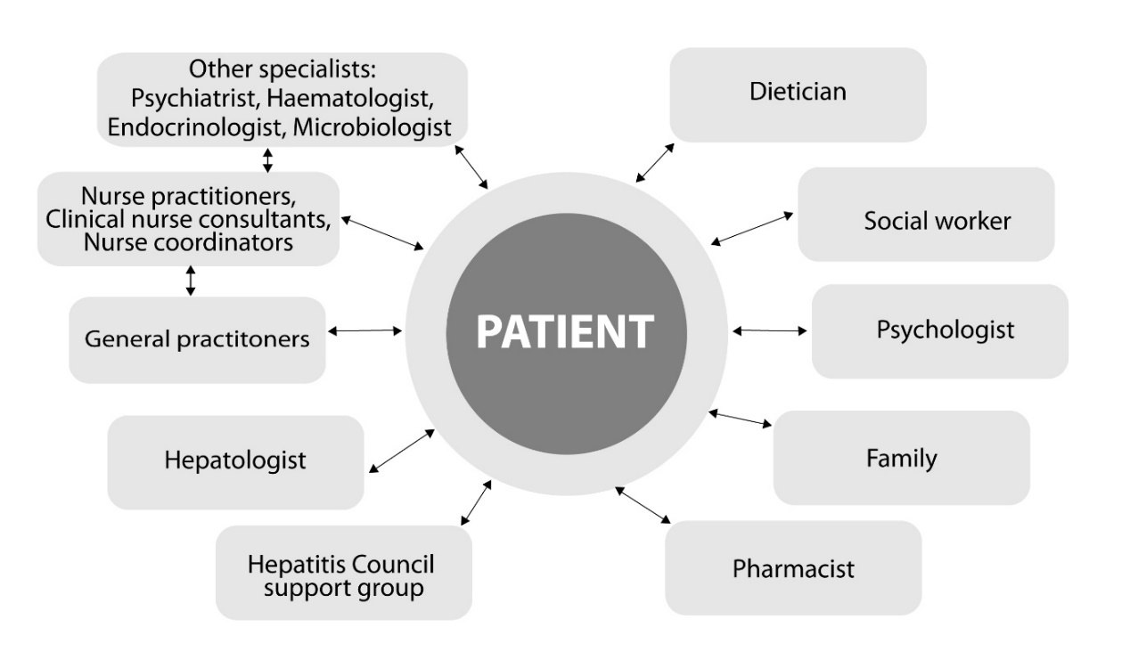
Figure 4 Multidisciplinary team for management of hepatitis C.

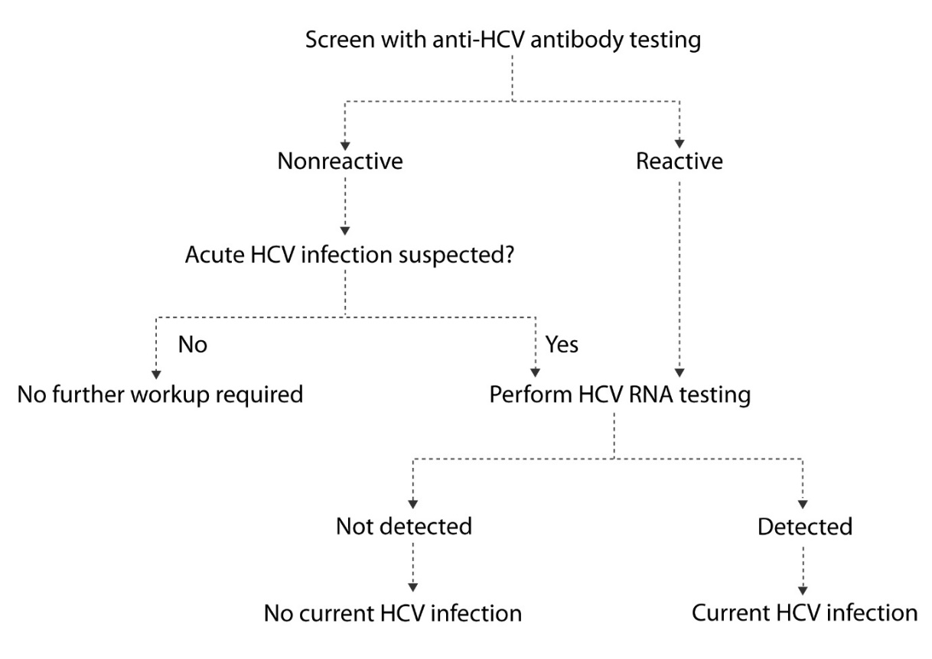
Figure 5 Algorithm for hepatitis C virus diagnosis. HCV: Hepatitis C virus.

Table 1 Global health sector strategy on viral hepatitis targets
Target area | 2020 target | 2030 target
Impact targets
Incidence: New cases of chronic HCV | 30% reduction | 80% reduction
Mortality: HCV related deaths | 10% reduction | 65% reduction
Service coverage targets
Blood safety: Donations screened in a quality assured manner | 95% | 100%
Safe injections: Percentage of injections administered with safety-engineered devices in and out of health facilities | 50% | 90%
Harm reduction: Number of sterile needles and syringes provided per person who injects drugs per year | 200 | 300
HCV diagnosis: Percent of people aware of their diagnosis | 30% | 90%
HCV treatment: Percent of people treated | - | 80%
HCV: Hepatitis C virus.

