Name of Journal: World Journal of Clinical Oncology
Manuscript NO: 55375
Manuscript Type: ORIGINAL ARTICLE

Observational Study
Evolutionary model of brain tumor circulating cells: Cellular galaxy

Mehdipour P et al. Evolutionary model of brain CTCs

Parvin Mehdipour, Firoozeh Javan, Morteza Faghih Jouibari, Mehdi Khaleghi, Masoud Mehrazin

Parvin Mehdipour, Firoozeh Javan, Department of Medical Genetics, Tehran University of Medical Sciences, School of Medicine, Tehran 1417613151, Tehran, Iran

Morteza Faghih Jouibari, Department of Neurosurgery, Shariati University Hospital, Tehran 1417613151, Tehran, Iran

Mehdi Khaleghi, Shariati Hospital, Tehran University of Medical Sciences, Tehran 1417613151, Tehran, Iran

Masoud Mehrazin, Tehran University of Medical Science, Tehran 1417613151, Tehran, Iran

Author contributions: Mehdipour P designed the research and protocols, analyzed the data, and wrote the paper; Javan F performed the technical protocols; Jouibari MF, Khaleghi M, and Mehrazin M provided the samples and patient information.

Supported by Tehran University of Medical Sciences, Research deputy under project, No. 32208-30-04-95.

Corresponding author: Parvin Mehdipour, PhD, Professor, Department of Medical Genetics, Tehran University of Medical Sciences, School of Medicine, Tehran 1417613151, Tehran, Iran. mehdipor@tums.ac.ir

Received: July 29, 2020
Revised: November 5, 2020
Accepted: November 28, 2020
Published online: January 24, 2021

Abstract
BACKGROUND
Although circulating tumor cells (CTCs) have been the focus of consideration for a decade, a categorized cell-based diagnostic strategy is unavailable. The personalized management and complementary/analytical-strategy of data require an alphabetic guide. Therefore, we aimed to determine the behavior of CTCs in tumor and blood in order to provide the hypothetical-based agenda in the brain neoplasms. Exploring the protein expression (PE) using a single cell-based method would clarify the heterogeneity and diversity in tumor and blood, which are key events in the evolution in brain tumors. In fact, heterogeneity, diversity, and evolution are required for cancer initiation and progression.

AIM
To explore CTCs in brain tumors and blood cells and to assay intensity of PE through personalized insight.

METHODS
The focal population included 14 patients with meningioma, and four patients with metastatic brain tumors (T). PE was assayed by immunofluorescence in tumors cells and CTCs in 18 patients with brain tumors. Ratio test was applied between the T cells and CTCs in tumor tissue and in vascular system. T/CTC ratio-based classification of PE in macrophage chemoattractant chemokine ligand 2 (CCL2), vascular endothelial growth factor (VEGF), epidermal growth factor (EGF), CD133, cyclin E, neurofilament marker, cytokeratin 19, cytokeratin 19, and leukocyte common antigen (CD45) were investigated.

RESULTS
Total analyzed cells ranged between 10794-92283 for tumor cells and between 117-2870 for CTCs. Characteristics of histopathologic and status of an ataxia-telangiectasia mutated polymorphism (D1853N) in 18 patients affected with brain tumors were also provided. The course of evolution and metastatic event relied on the elevated protein expression in CTCs, which could be considered as a prognostic value. Diverse protein expression of the migrated cells into the blood stream and the tumor was indicative of the occurrence of evolution. Besides, the harmonic co-expression between CCL2/EGF and CCL2/VEGF could facilitate the tumor progression including the metastatic event. Expression of these proteins in the migrated vasculature and into the buccal tissue offered a non-invasive follow-up detection in neoplastic disorders. PE-exploration of neurofilament marker/CD133/VEGF of the CTCs in meningioma and cytokeratin 19/CD45/ cyclin E in the patients with metastatic brain tumor would clarify the tumor biology of the brain neoplastic disorders.

CONCLUSION
The alphabetical base of the evolutionary mechanisms relies on dual-, triple-, and multi-models with diverse intensity of expression. In fact, cross-talk between initiative and the complementary channels defines the evolutionary insight in cancer. A diverse-model of protein expression, including low, medium, and high intensity, is the key requirement for the completed model. The cluster of cells with diverse expression and remarkable co-expression between CCL2/EGF/VEGF and NM/CD133/VEGF in CTCs may be indicative of probable invasiveness of the tumor. Furthermore, the mode of cytokeratin-19⁺/CD45⁻ can be traced in the metastatic patients.

Key Words: Circulating tumor cells; Brain tumor; Protein expression; Personalized; Somatic/circulating tumor cell evolution; Metastasis

©The Author(s) 2021. Published by Baishideng Publishing Group Inc. All rights reserved.

Citation: Mehdipour P, Javan F, Jouibari MF, Khaleghi M, Mehrazin M. Evolutionary model of brain tumor circulating cells: Cellular galaxy. World J Clin Oncol 2021; 12(1): 13-30
URL: https://www.wjgnet.com/2218-4333/full/v12/i1/13.htm
DOI: https://dx.doi.org/10.5306/wjco.v12.i1.13

Core Tip: The present data revealed that a classified/functional/individualized cell-based preventive and therapeutic strategy is required for the cancer management. An interaction between chemoattractant chemokine ligand 2/epidermal growth factor/vascular endothelial growth factor is an influential and key utility in the approach of cancer cells. Tracing the tumor/circulating tumor cells evolution will facilitate the estimation of functional alterations in blood stream as a model to predict the probable initiative step for metastasis, formulating the progressive status of disease and by planning for a translational/personalized management. Finally, heterogeneity and diversity may minimize the severity of disease.

INTRODUCTION
Based on the World Health Organization system, meningiomas are classified as the second most common-primary brain tumor (T) of the central nervous system in adults. Brain invasion has been included in the diagnostic criteria as atypical meningioma World Health Organization grade II^{[1]}. The pitfalls in neoplastic diagnosis include late detection and unavailability of the precise formulated, classified data, the somatic/circulating tumor cells (CTCs)-based heterogeneity and evolutionary process. Three elements, including angiogenesis, edema, and growth, play a key role in the progression of meningioma. The vascular system of meningioma is rather diverse, extending from sporadic vascularization to the vast mode, like angiomatous meningi-oma^{[2]}.
Chemoattractant chemokine ligand 2 (CCL2/C) is involved in the process of cell migration and plays a key role in regulation of the transferring process through blood brain barrier (BBB)^{[3]}. Macrophages play a role in metastatic programming^{[4]}. Besides, monocytes play a vital role in the seeding process through angiogenesis, so there is a cross-road between CCL2, macrophage, monocytes, and vascular endothelial growth factor (VEGF/V)^{[5]}. However, such configuration is required for a successful event in the developmental seeding process of metastasis. Furthermore, no characterization of the expression on the “human cerebrovascular chemokine” has been provided^{[6,7]}.
VEGF is a key factor for formation, growth, development, and survival of tumor through angiogenesis. VEGF is a remarkable factor associated with the diverse potential of angiogenesis and metastasis in human neoplasms, but the precise functional mode of VEGF is not well known in meningioma. However, a remarkable vascularization related to the vascular permeability factor in some patients with meningioma has been reported^{[2]}. Angiogenesis is essential for progression and the metastatic process^{[8]}. However, it is required to unmask the diverse spectrum of protein expression (PE) in meningioma. This is a hypothesis on the puzzling quality and quantity of VEGF expression.
Epidermal growth factors (EGFs/E) are mainly involved in differentiation, cell proliferation, tumorigenesis, and apoptosis. An association has been found between high expression of EGF and progression, development, invasiveness, metastasis, and poor prognosis in cancer^{[9-12]}. Furthermore, the intravasation/migration to the blood stream (BS) is required for “seed and soil” theory^{[13]}.
Since CTCs were first observed in a patient with metastasis in 1869, this strategy has not been considered a routine diagnostic tool^{[14]}. The biological aspects of CTCs in metastasis have been highlighted previously^{[15]}. It was stated that the invasiveness of CTCs could be related to their characteristics^{[16]}. The CTCs from glioma had no metastatic behavior in the peripheral territory after migration to BS at the microRNA level^{[17]}. Besides, the liquid biopsy for the deoxyribonucleic acid-sequencing-based test was published^{[18,19]}. The CTCs have also been evaluated as a predictor of survival in patients with melanoma^{[20]}. However, metastasis is characterized by the sequential puzzling events with diverse behaviors in different cancers.
The aims of this study are to: (1) Trace the PE diversity in CCL2/VEGF/EGF; and (2) Classify the PE behavior of these proteins at the somatic/CTC level to provide the personalized strategy for the early detection of CTCs. Upon these aims, the preventive/ predictive tasks are provided as a personalized model by exploring eight markers in patients with brain tumors. This strategy offers the initial step of the cell-based/formulated/categorized model for an early diagnosis of probable metastatic process and the follow-up plan through the patients’ life.

MATERIALS AND METHODS
Study population and data collection
Patients and clinical information: The focal population included 10794-92283 cells for tumor cells and between 117-2870 for circulated T cells, which were analyzed in 18 patients, including 14 with meningioma and four patients with metastatic brain tumors [one with lung-, two with breast-origin, and one with cerebellar medullo-blastoma (CM)] (Table 1). The samples were referred from the Department of Neurosurgery, Shariati Hospital, Tehran University of Medical Sciences (TUMS), and the consent letter was signed before surgery. Peripheral blood (PB) and tumor samples of patient were investigated at the Department of Medical Genetics, TUMS.

Study design
Design of this investigation was based on evolutionary and personalized insights.

Analytical strategy
The analytical strategy (AS) was designed as a complementary tool for more precise/specific analysis and categorizing the achieved data. Diverse intensity of PE was categorized as C1, C2, and C3 for CCL2; V1, V2, and V3 for VEGF; and E1, E2, and E3 for EGF.
AS is based on the intensity of expression, which varies in different proteins and is provided as C1 (patient 5), V1 (patients 1 and 5), E1 (patient 5); C2 (in patients 5 and 8), V2 (patient 5), E2 (patient 5); and V3 (patient 4). An equal ratio is, exceptionally, observed in patient 5 for C1 category (Figure 1).
The horizontal comparison presents diversity of ratio between the proteins; and the vertical comparison focuses on the intensity spectrum of PE, diversity, and the manner of any cascade alteration(s). Analysis of cells was based on the fluorescence intensity including 0: Lack of expression; 1: Low; 2: Medium; and 3: High expression for CCL2, EGF, and VEGF and the complementary markers (Figure 1).
The traditional direct/manual-based analysis guaranteed the adequate enumeration and detection of cells and heterogeneous pattern of PE, respectively, with more benefits including: (1) Analyzability of the quantitative and qualitative mode of PE; (2) Tracing the vasculature system; (3) Sensitivity of assay; (4) Possibility of multi-assay of the key markers and co-expression; and (5) Analysis of the multi-clonal populations and sub-population. So, this manner led to the quantitative- and qualitative-based classification of tumor cells in both tumor cells and CTCs. In addition, D1853N polymorphism was tested, which plays a predisposing role for probable occurrence of further exonic and/or intronic alteration(s) through different periods of patients‘ lives^{[21-23]}.

Preparative assessment
The extracted cells from 4 mL heparinized PB were stained with anti-CCL2 (monocyte chemoattractant protein-1) (eBioscience, San Diego, CA, United States), VEGF (Genature, Belgium), and EGF (Novus Biologicals, Littleton, CO, United States). This mixture was incubated at 4 °C. Staining was carried out by second layer antibodies, including fluorescein isothiocyanate for CCL2, R-phycoerythrin for VEGF, and phycoerythrin–indodicarbocyanine (Pe–Cy5) for EGF. Finally, by adding nuclear dye [4′,6-diamidino-2-phenylindole (DAPI)], the status of PE was assayed by the Leica EICA, DM RXA2-fluorescence microscope (Wetzlar, Germany). The CTCs were also assayed with cytokeratin 19 (KRT 19) (ScyTek, Logan, UT, United States), leukocyte common antigen [LCA cocktail (CD45) (BioCare Medical, Pacheco, CA, United States)], neuronal marker (NM) (ScyTek), and DAPI. Identification of brain CTCs was based on positive cells with DAPI/NM, and positive metastatic cells were confirmed through DAPI⁺/cytokeratin⁺/CD45⁻). The Manuel search was also performed to detect CTCs amongst the leukocytes. The CTCs were defined as nucleated cells by: (1) Expressing NM; and (2) Lacking CD45/positive KRT19. CD133 (Biolegend, San Diego, CA, United States), VEGF (Genature), and cyclin E (Zymed, San Francisco, CA, United States) were also assayed.

Ethics and consent declaration
The present study was approved and granted by the deputy of Research, TUMS (32208-30-04-95). The written consent declaration was obtained from the patients at Department of Neurosurgery, Shariati Hospital, TUMS.

Statistical analysis
By considering the personalized insight, the ratio test was applied between the CTCs and the T cells in tumor tissue and the vascular system.

RESULTS
The total analyzed cell population was ranged between 10794-92283 for T cells and between 117-2870 for CTCs. Characteristics of histopathologic and status of an ataxia-telangiectasia mutated polymorphism (D1853N) in 18 patients affected with brain tumors are provided (Table 1). The information in the table was provided by the surgeon and the patients.
Distribution of the intensity-based T/CTCs-ratio of PE for C, V, and E in the blood territory of patients 1-14 affected with meningioma (Figure 1) and in the patients 15-18 affected with malignant brain tumors, including one lung metastatic carcinoma, two metastatic carcinomas with breast origin, and one with CM are provided (Figure 1). The harmonic ratio of tumor cells lacking PE of C, V, and E to the CTCs in patients with meningioma and brain cancer is illustrated in Figure 2A and B. The ratio of co-expression for tumor cells to the migrated tumor cells in the blood and the vascular system between proteins CCL2, VEGF, and EGF of the patients (Nos. 1-14) affected by meningioma is also provided (Figure 3A). The ratio of co-expression in tumor cells to the migrated tumor cells in the blood and the vascular system between these proteins of patients with brain cancer (patients 15-18) are presented (Figure 3B).
The harmonic manner of elevated or declined ratio for each protein is illustrated in a periodic chart (Figure 4). In this figure, the progressive intensity of proteins C, V, and E is traceable. Status of PE and co-expression of C, V, and E in CTCs of patients 1 and 9 (Figure 5) and in patient 4 (Figure 6) with meningioma are provided. Expression status of these proteins in meningioma tumors, vasculatures, and CTCs in patient 11 (Figure 7) and in patient 13 (Figure 8) are also available. In patient 15 with lung metastatic carcinoma, the status of PE and co-expression of CCL2/VEGF/EGF through migration of tumor cells to the blood territory is shown (Figure 9). The migrated vasculature into the BS, the CTCs in patient 15 (Figure 9A-G) and in patient 17, and expression of these three proteins in the migrated vasculature into the BS are presented (Figure 10). The CTCs are shown in patient 18 with CM (Figure 11). Furthermore, the mode of PE of NM/CD133/VEGF in the CTCs of patient 1 with meningioma is presented (Figure 12). The PE of KRT19/CD45/cyclin E in patients 16 and 17 with metastatic brain tumor is provided (Figures 13 and 14, respectively).

DISCUSSION
Somatic/CTCs Ratio-based classification of PE
Programming of neoplasms is based on an evolutionary-mechanism that is not completely clarified in brain tumors. The T/CTCs ratio of cells lacking expression of C, V, and E indicate the highest value amongst all patients (Figure 1). The ratio of cells lacking PE, including C0, V0, and E0, reflects lower value in two patients with metastatic brain tumors (patients 16 and 17) and highlights the lowest value in CM-patient (i.e. more migrated tumor cells to the BS) (Figure 1). Furthermore, the declined or elevated values of T/B ratio play an important role in initiation and promotion of an evolutionary and developmental process through which transformation of the tumor cells lacking PE to the cells with positive PE, by gaining different intensity of expression will be possible. So, the sequential ratio is heterogeneous, varying within ranges of 113.37-903.33 in CCL2, 61-595.14 in VEGF, and 17.70-307.69 in EGF (Figure 1). Such pattern for the tumor cells is a challenging item in cancer initiation and progression. The question is whether such diversity has positive or negative impact on the invasiveness of tumor. An essential step in T progression is the most cooperative manner between relevant proteins, and a successful protein co-expression depends on the stage of disease, frequency of involved cells, and intensity of PE. Besides, systematic classification of the initiator factors would facilitate innovation of therapeutic channels. Distribution of ratios for C, V, and E is indicative of: (1) Diversity between different patients with the same tumor and between the categorized intensity-based ratios and total-based ratios, including total C, total V, and total E (Figure 1); and (2) The origin of evolution at the primary tumor, followed through blood with further behavior in the host organ (unpublished data). Besides, remarkable poor prognosis is related to the ratios less than 1. The AS is based on the intensity of expression that varied in different proteins and is provided as C1 (patient 5), V1 (patients 1 and 5), E1 (patient 5), C2 (in patients 5 and 8), V2 (patient 5), E2 (patient 5), and V3 (patient 4). An equal ratio is, exceptionally, observed in patient 5 for C1 category (Figure 1).
The harmonic- and non-harmonic status of the provided ratios for C/V/E is due to the different intensity-based classification through the course of evolution (Figure 2A and B). According to the co-expression images (Figure 9A and B), the migrated cells are, diversely, observed in the blood territory, ranging between 1.06-24.85 for the meningioma’s and 0.08-0.92 for malignant tumors (Figure 3A and B). Co-expression including CCL2/VEGF, CCL2/EGF, EGF/VEGF, and CCL2/VEGF/EGF reveals the higher frequency of cells in T- than in blood-territory. Interestingly, only the ratio of PE in the vesicles, vasculature, and microvesicles is found to be higher in blood than in tumor, which may be the sign of poor prognosis for patients 5, 7, 8, 9, 13, 15, 16, 17, and 18 (Figure 3A and B). Convincingly, it is aimed that a complementary AS can provide more details on the nature and evolutionary process at tumor and blood levels for providing the road map of CTCs in brain tumors and other neoplasms. The key role of circulating microvesicles has been highlighted in leukemic cell-to-cell cross talk by integrating the key proteins in vitro^{[21]}. They have stated that the quantity of microvesicles can increase cell proliferation. In addition, our results highlight the quantitative analysis of involved proteins including VEGF in microvesicles of the tumor and CTCs with a persuasive impact on the clinical management. Interestingly, our results opposed the complete capability of BBB and highlight a complete availability of brain CTCs.
By considering degree of the PE-intensity, C, V, and E have medium status in common with ratio less than 1. Such pattern may provide poor prognosis for patient 5 with meningioma, micro-metastasis, and positive D1853N polymorphism. Furthermore, this patient had also minimum ratio of T/CTCs for low and medium intensity of VEGF and EGF in common, which is also a sign for poor prognosis. Two patients with metastasis (15 and 16) are unique examples with poor prognosis by having < 1 ratio of cells with low PE in common; patient 16 also had different degree of PE for CCL2 and VEGF (Figure 1). Poor prognosis is related to the low expression of VEGF and EGF (T/B ratio 0.78 and 0.06 respectively) in patient 17 as a breast cancer (BC)-metastatic patient and positive/predisposing D1853N polymorphism. This polymorphism led to occurrence of further exonic and/or intronic alterations with negative impact on the clinical outcome^{[22-24]}.
The ratio of T/CTCs for lacking PE in C, V, and E may be harmonic and categorization of the ratios will have an influential and complementary role in the progression of tumor and clinical management (Figure 2A and B). By considering harmonic ratio of tumor cells lacking PE, seven patients (1-3, 7, 10, 11, and 15) reflect a remarkable triangle harmonic status of C/V/E, followed by dual harmonic status of C/V in patients 4, 5, 8, and 9; dual pattern of V/E in patients 12, 13, 17, and 18; and dual harmonic pattern of C/E in patients 13 and 17. These data reflect involvement of the triangle PE within diverse values in different patients. So, the cooperation between different proteins with diverse ratio may facilitate the initiation and promotion of the harmonic/cascade/evolutionary events as the elevated and/or decreased ratio as well.
By considering a novel categorization, different patterns of evolution, including dual-, triple-, and multi-, model are provided. The altered intensity (low: 1, medium: 2, high: 3) of expression leads to transform low-intensity to medium or high in C, V, and E proteins that include: (1) Dual pattern from V1 > V2 and from E1 > E2 in patients 1, 2, 9, 12, 13, and 18; (2) Dual model as V2 > V3 and E2 > E3 in patients 1 and 12; (3) Triple model as C1 > C2 and V1 > V2 and E1 > E2 alterations in patients 2, 9, 13, 15, and 16; triple pattern formation as C2 > C3, V2 > V3 and E2 > E3 in patients 10, 12, 13, 14 and 17; and (4) Multi pattern development including C1 > C2, V1 > V2, C2 > C3, V2 > V3, and E2 > E3 in patient 8 who harbors the most complicated evolutionary model in which all the initiative events are accompanied by complimentary functional incidents. So, the model is initiated simply by the occurrence of dual-evolution and is followed by further diverse development of triple-events. Conclusively, to form the completed model, diverse dual and triple patterns are required to be formed, and the priority of initial formation could occur from the low expression with further development to medium- and high-intensity of expression (Figure 4A and B). These evolutionary models in our patients reflect the occurrence of cascade events with common origin. The provided model indicates the cross-talk between initiative and the complementary channels to form an evolutionary insight in cancer. Such pattern could occur in all types of neoplastic tumors with further evolution through the metastatic process (unpublished data). It is essential to emphasize that such models vary within different proteins and patients. Therefore, these patterns are rather personalized with specific and multi-combinational patterns.

Status of PE
In patients 5 and 8, the higher PE in CTCs may be indicative of the occurrence of an evolution in favor of the metastatic process (Figure 5). Interestingly, the manner of PE was more diverse between the cells in tumor than in the migrated cells into the vascular system within the tumor region (Figure 6A) and also in the CTCs within the blood territory in patient 4 with meningioma (Figure 6B). Status of PE in CCL2/ VEGF/EGF of the two cell populations from tumor sample of patient 11 and CTCs presents the journey from tumor to the destinations, including the vascular- and BS-territory (Figure 7). In spite of the lowest expression of EGF/VEGF (Figure 7C and D), higher expression with CCL2 and the co-expression within CTCs is noticeable in patient 13 (Figure 8E and G). Migrated tumor cells within tumor territory to the BS are shown by arrows (Figure 9C-H) in which the co-expression of CCL2/VEG and CCL2/VEGF/EGF is more remarkable than in CCL2/EGF (Figure 9F-H). Regarding patient 17, more cells conjugated with CCL2 are observable than with VEGF and EGF (Figure 10B-D). Images C, D, and G reflected an observable expression in a single CTC with proteins VEGF and EGF but not with CCL2 in image B. In contrast, the mode of expression is diverse within the vasculature territory. There was a diverse co-expression pattern indicating more harmonic interaction between CCL2/VEGF than CCL2/EGF. However, co-expression between these proteins was remarkable either in CTCs or within the vasculature territory (Figure 10). In patient 18 with CM, co-expression between CCL2/VEGF/EGF is observable in CTCs (Figure 11A), but there is only a single CTC with high expression of CCL2 (Figure 11B). In contrast, high expression of VEGF and EGF, with slight difference between these two proteins, is observable (Figure 11C and D).
For tracing the tissue origin of CTCs, PE of NM is accompanied by stem cell marker CD133 and VEGF in patient 1 (Figure 12), presenting the cluster of cells with higher expression of NM (Figure 12B) and few cells with lower expression of CD133 and VEGF (Figure 12D and E). Interestingly, remarkable co-expression between NM/CD133/VEGF in CTCs may be indicative of a warning message for probable invasiveness of the tumor. The presence of CTCs was confirmed by the mode of cytokeratin-19⁺/CD45⁻ in patients 16 and 17 (Figures 13 and 14).
The minimal residual disease was traced by CTCs in the blood of BC patients^{[25]}. They have reported a poorer outcome by detecting ≥ 5 CTCs/7.5 mL of PB by automated cell Search® system. Furthermore, presence of ≥ 1 CTC/7.5 mL pre- and post-chemotherapy has led to distant metastasis^{[26]}. They also highlighted that although CTC was correlated with circulating VEGF, there was no association with status of EGF. So they have proposed that the CTCs may be a remarkable predicting response to the angiogenic inhibitors. CTCs are known as epithelial tumor cells, traceable in the BS of solid tumors at the molecular level. CTCs have also been considered in research and clinical management since 1990. But, no categorized cell-based diagnostic strategy as the translational research in cancer has been provided yet. There are the notable challenges on tracing of CTCs, so an alphabetic guideline is required for this topic. Therefore, we aimed to explore the scenario of the behavior of CTCs in brain tumor/blood samples to provide the personalized, hypothetical-based agenda in the brain neoplasms that can be applied in other types of neoplastic disorders; and also as a follow-up approach in the patients and their relatives who are at risk.
The prognostic potential of CTCs and the clinical significances in different tumors and a few examples on BC-brain metastasis are reviewed^{[27]}. They have delivered the application of “Liquid biopsy” at mRNA level. The machinery of CTCs with focus on genomes and transcriptomes is also reviewed^{[28]}. It was also reported that the presence of CTCs plays an independent role in prognosis of BC with brain or bone metastasis^{[29]}. In spite of the presence of only ≥ 5 CTCs, they found a correlation between the undetectable CTCs and occurrence of metastasis in brain but not in bone. So, they concluded that undetected CTCs might be due to an incomplete tracing of CTCs by automated Cell Search system and possibly related to the “epithelial-mesenchymal transition. The first reason is cleared by the enumeration strategy in our present data. However, our data indicate that BBB may have very limited restriction on the tumor cell migration into the BS (Figure 15).

CONCLUSION
Heterogeneity/diversity may be an explanation for the Natural Rescue Mechanism through which the severity of disease may be minimized in brain tumors and hopefully in other neoplasms.
Adequate informative data on CTCs is a guideline for management of metastatic process. Regarding the application of anti-VEGF in brain tumors, the multi-disciplinary insight in the therapeutic strategy is also required. Interestingly, application of anti-CCL2 in tumorigenic models has led to weakening the metastasis and improving the survival period^{[30]}. So, adequate enumeration of CTCs, formulated predictive information with a personalized-based strategy for different types of cancers, will be possible. As questions: Whether the high number of CTCs is reflective of (1) poor developmental course of neoplasms; and (2) poor survival status or recurrence? Or relapse? And does low enumeration of CTCs lead to the false negative diagnosis?

ARTICLE HIGHLIGHTS
Research background
Circulating tumor cells (CTCs) are the most applicable strategy in preventive oncology. The most puzzling items include the lack of: (1) The basic information on the migrated cells into the tumor and into the blood stream; (2) The categorized data for the personalized strategy of CTCs; (3) Information on the application of CTCs for the patients affected with brain tumors as early as possible; and (4) The data on the early detection of the brain tumors in the probands affected with brain tumor and the relatives through their pedigree. Hence, it was aimed to explore the developmental picture of CTC behavior in tumor (T) and blood in the brain neoplasms.

Research motivation
The key target to explore CTCs was revealed to be early detection; therefore, availability of adequate data on the pedigree of proband affected either with brain tumor or any other neoplastic disorder (s) will facilitate application of the preventive strategy for the probands’ relatives who are at risk of being affected with the neoplastic disorders.

Research objectives
In the cancer-prone families: The target objectives, include: (1) The family history of any neoplastic disorders in the proband’s pedigree and age of the onset for the target individuals; (2) The key information for each individual affected with neoplastic disorder including cancer; (3) Tracing and selecting the target relatives of the probands; and (4) Performing the CTC test for the selected individuals.

In the family of the probands without any history of the neoplastic disorders: In case of the influential micro-and/or macro-environmental hazards, the target offspring of the proband through the further generations may be selected for the performance of CTCs.

Research methods
The novelty of this research is relied on the simple Manuel analysis, which provides an adequate single cell screening process. Based on this strategy, diverse pattern of intensity and categorization of different target proteins will be facilitated.

Research results
The course of evolution and possibility of metastatic event rely on the higher protein expression in CTCs. Such a finding is indicative of prognostic value. Besides, diversity in protein expression of the migrated cells into the both tumor and blood stream and diverse pattern of protein expression in both tissues are indicative of the occurrence of evolution. Besides, the harmonic co-expression between C-C chemokine ligand 2/epidermal growth factor and C-C chemokine ligand 2/vascular endothelial growth factor can facilitate the tumor progression including the metastatic event.

Research conclusions
There is a diverse pattern of protein expression of the migrated cells at different territories including tumor and the bloodstream by performing CTCs by Manuel analytical strategy to unmask heterogeneity of the protein expression.

Research perspectives
The direction of further research includes providing: (1) The educational/informative packages on the early detection by CTCs to the cancer clinics or the related hospitals with the available preventive cancer section; and (2) Cancer Genetic counselling to the referral cancer patients for performing an early detection of probable metastasis by CTCs test.

ACKNOWLEDGEMENTS
The authors would like to thank the patients for their participation and providing the required information.

REFERENCES
1 Louis DN, Perry A, Reifenberger G, von Deimling A, Figarella-Branger D, Cavenee WK, Ohgaki H, Wiestler OD, Kleihues P, Ellison DW. The 2016 World Health Organization Classification of Tumors of the Central Nervous System: a summary. Acta Neuropathol 2016; 131: 803-820 [PMID: 27157931 DOI: 10.1007/s00401-016-1545-1]
2 Provias J, Claffey K, delAguila L, Lau N, Feldkamp M, Guha A. Meningiomas: role of vascular endothelial growth factor/vascular permeability factor in angiogenesis and peritumoral edema. Neurosurgery 1997; 40: 1016-1026 [PMID: 9149260 DOI: 10.1097/00006123-199705000-00027]
3 Rossi D, Zlotnik A. The biology of chemokines and their receptors. Annu Rev Immunol 2000; 18: 217-242 [PMID: 10837058 DOI: 10.1146]
4 Joyce JA, Pollard JW. Microenvironmental regulation of metastasis. Nat Rev Cancer 2009; 9: 239-252 [PMID: 19279573 DOI: 10.1038/nrc2618]
5 Qian BZ, Li J, Zhang H, Kitamura T, Zhang J, Campion LR, Kaiser EA, Snyder LA, Pollard JW. CCL2 recruits inflammatory monocytes to facilitate breast-tumour metastasis. Nature 2011; 475: 222-225 [PMID: 21654748 DOI: 10.1038/nature10138]
6 Weiss JM, Downie SA, Lyman WD, Berman JW. Astrocyte-derived monocyte-chemoattractant protein-1 directs the transmigration of leukocytes across a model of the human blood-brain barrier. J Immunol 1998; 161: 6896-6903 [PMID: 9862722]
7 Simpson JE, Newcombe J, Cuzner ML, Woodroofe MN. Expression of monocyte chemoattractant protein-1 and other beta-chemokines by resident glia and inflammatory cells in multiple sclerosis lesions. J Neuroimmunol 1998; 84: 238-249 [PMID: 9628469 DOI: 10.1016/s0165-5728(97)00208-7]
8 Hanahan D, Weinberg RA. The hallmarks of cancer. Cell 2000; 100: 57-70 [PMID: 10647931 DOI: 10.1016/s0092-8674(00)81683-9]
9 Sanson M, Cornu P. Biology of meningiomas. Acta Neurochir (Wien) 2000; 142: 493-505 [PMID: 10898356 DOI: 10.1007/s007010050462]
10 Gullick WJ. Prevalence of aberrant expression of the epidermal growth factor receptor in human cancers. Br Med Bull 1991; 47: 87-98 [PMID: 1863851 DOI: 10.1093/oxfordjournals.bmb.a072464]
11 Modjtahedi H, Dean C. The receptor for EGF and its ligands - expression, prognostic value and target for therapy in cancer (review). Int J Oncol 1994; 4: 277-296 [PMID: 21566922 DOI: 10.3892/ijo.4.2.277]
12 Zhau HY, Chang SM, Chen BQ, Wang Y, Zhang H, Kao C, Sang QA, Pathak SJ, Chung LW. Androgen-repressed phenotype in human prostate cancer. Proc Natl Acad Sci USA 1996; 93: 15152-15157 [PMID: 8986779 DOI: 10.1073/pnas.93.26.15152]
13 Fidler IJ. The pathogenesis of cancer metastasis: the 'seed and soil' hypothesis revisited. Nat Rev Cancer 2003; 3: 453-458 [PMID: 12778135 DOI: 10.1038/nrc1098]
14 Ashworth T. A case of cancer in which cells similar to those in the tumours were seen in the blood after death. Aust Med J 1869; 14: 146
15 Yu M, Stott S, Toner M, Maheswaran S, Haber DA. Circulating tumor cells: approaches to isolation and characterization. J Cell Biol 2011; 192: 373-382 [PMID: 21300848 DOI: 10.1083/jcb.201010021]
16 Sullivan JP, Nahed BV, Madden MW, Oliveira SM, Springer S, Bhere D, Chi AS, Wakimoto H, Rothenberg SM, Sequist LV, Kapur R, Shah K, Iafrate AJ, Curry WT, Loeffler JS, Batchelor TT, Louis DN, Toner M, Maheswaran S, Haber DA. Brain tumor cells in circulation are enriched for mesenchymal gene expression. Cancer Discov 2014; 4: 1299-1309 [PMID: 25139148 DOI: 10.1158/2159-8290.CD-14-0471]
17 Zhang L, Zhang S, Yao J, Lowery FJ, Zhang Q, Huang WC, Li P, Li M, Wang X, Zhang C, Wang H, Ellis K, Cheerathodi M, McCarty JH, Palmieri D, Saunus J, Lakhani S, Huang S, Sahin AA, Aldape KD, Steeg PS, Yu D. Microenvironment-induced PTEN loss by exosomal microRNA primes brain metastasis outgrowth. Nature 2015; 527: 100-104 [PMID: 26479035 DOI: 10.1038/nature15376]
18 Kaiser J. 'Liquid biopsy' for cancer promises early detection. Science 2018; 359: 259 [PMID: 29348215 DOI: 10.1126/science.359.6373.259]
19 Cohen JD, Li L, Wang Y, Thoburn C, Afsari B, Danilova L, Douville C, Javed AA, Wong F, Mattox A, Hruban RH, Wolfgang CL, Goggins MG, Dal Molin M, Wang TL, Roden R, Klein AP, Ptak J, Dobbyn L, Schaefer J, Silliman N, Popoli M, Vogelstein JT, Browne JD, Schoen RE, Brand RE, Tie J, Gibbs P, Wong HL, Mansfield AS, Jen J, Hanash SM, Falconi M, Allen PJ, Zhou S, Bettegowda C, Diaz LA Jr, Tomasetti C, Kinzler KW, Vogelstein B, Lennon AM, Papadopoulos N. Detection and localization of surgically resectable cancers with a multi-analyte blood test. Science 2018; 359: 926-930 [PMID: 29348365 DOI: 10.1126/science.aar3247]
20 Li J, Fu W, Zhang W, Li P. High Number of Circulating Tumor Cells Predicts Poor Survival of Cutaneous Melanoma Patients in China. Med Sci Monit 2018; 24: 324-331 [PMID: 29337932 DOI: 10.12659/msm.904770]
21 Mehdipour P, Habibi L, Mohammadi-Asl J, Kamalian N, Mehr Azin M. Three-hit hypothesis in astrocytoma: tracing the polymorphism D1853N in ATM gene through a pedigree of the proband affected with primary brain tumor. J Cancer Res Clin Oncol 2008; 134: 1173-1180 [PMID: 18465141 DOI: 10.1007/s00432-008-0404-4]
22 Mehdipour P, Mahdavi M, Mohammadi-Asl J, Atri M. Importance of ATM gene as a susceptible trait: predisposition role of D1853N polymorphism in breast cancer. Med Oncol 2011; 28: 733-737 [PMID: 20396981 DOI: 10.1007/s12032-010-9525-0]
23 Mehdipour P, Azarnezhad A. Five-hit hypothesis in ATM gene: An individualized model in a breast cancer patient. Front Biosci (Elite Ed) 2018; 10: 375-383 [PMID: 29293464 DOI: 10.2741/e828]
24 Milani G, Lana T, Bresolin S, Aveic S, Pastò A, Frasson C, Te Kronnie G. Expression Profiling of Circulating Microvesicles Reveals Intercellular Transmission of Oncogenic Pathways. Mol Cancer Res 2017; 15: 683-695 [PMID: 28202504 DOI: 10.1158/1541-7786.MCR-16-0307]
25 Pantel K, Brakenhoff RH, Brandt B. Detection, clinical relevance and specific biological properties of disseminating tumour cells. Nat Rev Cancer 2008; 8: 329-340 [PMID: 18404148 DOI: 10.1038/nrc2375]
26 Lang JE, Mosalpuria K, Cristofanilli M, Krishnamurthy S, Reuben J, Singh B, Bedrosian I, Meric-Bernstam F, Lucci A. HER2 status predicts the presence of circulating tumor cells in patients with operable breast cancer. Breast Cancer Res Treat 2009; 113: 501-507 [PMID: 18327638 DOI: 10.1007/s10549-008-9951-2]
27 Alix-Panabières C, Pantel K. Challenges in circulating tumour cell research. Nat Rev Cancer 2014; 14: 623-631 [PMID: 25154812 DOI: 10.1038/nrc3820]
28 Pantel K, Speicher MR. The biology of circulating tumor cells. Oncogene 2016; 35: 1216-1224 [PMID: 26050619 DOI: 10.1038/onc.2015.192]
29 Mego M, De Giorgi U, Dawood S, Wang X, Valero V, Andreopoulou E, Handy B, Ueno NT, Reuben JM, Cristofanilli M. Characterization of metastatic breast cancer patients with nondetectable circulating tumor cells. Int J Cancer 2011; 129: 417-423 [PMID: 20857493 DOI: 10.1002/ijc.25690]
30 Hitchcock JR, Watson CJ. Anti-CCL2: building a reservoir or opening the floodgates to metastasis? Breast Cancer Res 2015; 17: 68 [PMID: 25990313 DOI: 10.1186/s13058-015-0573-4]

Footnotes
Institutional review board statement: The study was reviewed and approved by the [IR.TUMS.MEDICINE] Institutional Review Board, No. 1395.1893.

Conflict-of-interest statement: The author and co-authors have no conflict of interest.

STROBE statement: The authors have read the STROBE Statement—checklist of items, and the manuscript was prepared and revised according to the STROBE Statement—checklist of items.

Open-Access: This article is an open-access article that was selected by an in-house editor and fully peer-reviewed by external reviewers. It is distributed in accordance with the Creative Commons Attribution Non-Commercial (CC BY-NC 4.0) license, which permits others to distribute, remix, adapt, build upon this work non-commercially, and license their derivative works on different terms, provided the original work is properly cited and the use is non-commercial. See: http://creativecommons.org/Licenses/by-nc/4.0/

Manuscript source: Invited manuscript
Peer-review started: July 29, 2020
First decision: October 18, 2020
Article in press: November 28, 2020

Specialty type: Oncology
Country/Territory of origin: Iran
Peer-review report’s scientific quality classification
Grade A (Excellent): 0
Grade B (Very good): 0
Grade C (Good): C, C
Grade D (Fair): 0
Grade E (Poor): 0

P-Reviewer: Ding L, Zeng YY S-Editor: Fan JR L-Editor: Filipodia P-Editor: Wang LL

Figure Legends
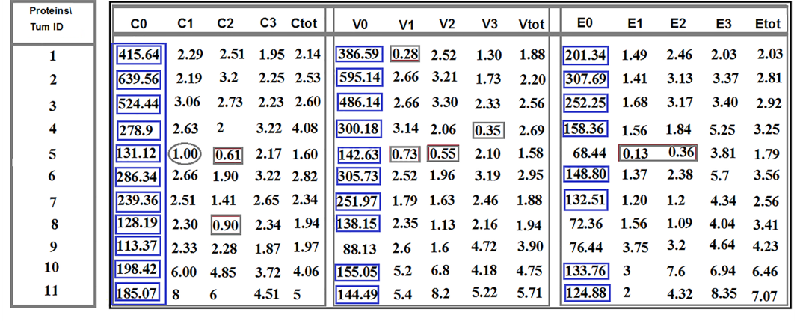
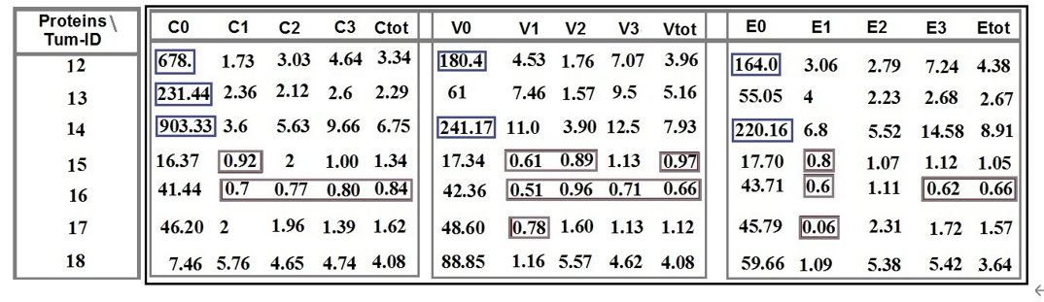
Figure 1 Ratio distribution of the cells lacking- and the classified positive-protein expression of C-C chemokine ligand 2, vascular endothelial growth factor, and epidermal growth factor between tumor cells in tumor sample to the circulated brain tumor cells. Patients 1-11: Are affected with meningioma. Patients 12-14: Are affected with meningioma, and patients 15-18 include three metastatic carcinomas (15: Brain/lung-origin; 16 and 17: Brain breast-origin) and one with cerebellar medulloblastoma. Provided horizontal and vertical indices are related to: C0, V0, and E0: Ratio related to lack of protein expression in C-C chemokine ligand 2 (CCL2), vascular endothelial growth factor (VEGF), and epidermal growth factor (EGF), respectively; C1, V1 and E1: Low expression of CCL2, VEGF, and EGF respectively; C2, V2, and E2: Medium protein expression of CCL2, VEGF, and EGF, respectively; C3, V3, and E3: High expression of CCL2, VEGF, and EGF, respectively; Ctot, Vtot2, and Etot2: Total ratio is related to the low plus medium, plus high protein expression of CCL2, VEGF, and EGF, respectively. C: C-C chemokine ligand 2; V: Vascular endothelial growth factor; E: Epidermal growth factor.

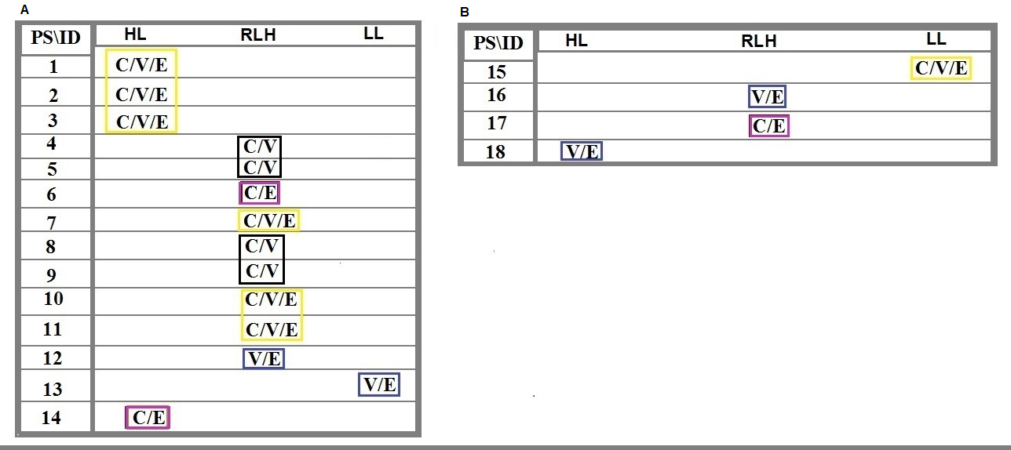
Figure 2 Ratio distribution of the cells lacking any protein expression of C-C chemokine ligand 2, vascular endothelial growth factor and epidermal growth factor between tumor cells in tumor sample to the circulated brain tumor cells in the blood. Patients 1-14: Are affected with meningioma and patients 15-18 include 3 metastatic carcinomas (15: Brain/lung-origin; 16 and 17: Brain/breast-origin) and 1 with cerebellar medulloblastoma (CM). A: Includes patients 1-14 affected with primary meningioma; B: Includes patients 15-18 affected with the metastatic carcinoma and CM. Harmonic ratio of tumor cells to the circulated brain tumor cells are marked as specific colored quadrants related to the intensity shared classification based between different proteins. PS: Protein status; HL: Highest level; RHL: Relatively high level; LL: Low level; ID: Patients’ identification.

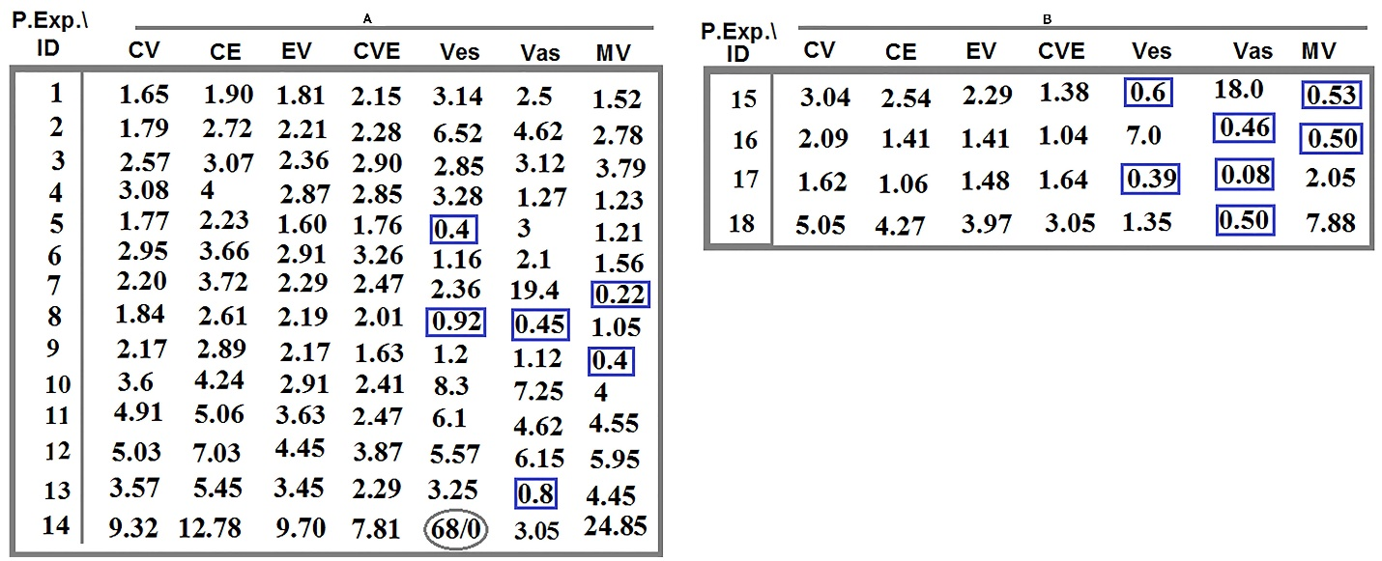
Figure 3 Ratio of co-expression of proteins between tumor cells in tumor region to circulating tumor cells and vasculature system for proteins C-C chemokine ligand 2, vascular endothelial growth factor, and epidermal growth factor in 18 patients with brain tumor. A: The ratio of co-expression between proteins C-C chemokine ligand 2 (CCL2), vascular endothelial growth factor (VEGF), and epidermal growth factor (EGF) traced in tumor cells to the migrated tumor cells in the blood and the vascular system of patients with meningioma (pts. 1-14); B: The ratio of co-expression between proteins CCL2, VEGF, and EGF traced in tumor cells to the migrated tumor cells in the blood and the vascular system of patients with brain cancer (pts. 15-18). The highlighted quadrants with different colors indicate the harmonic evolutionary altered intensity of related proteins in common amongst different patients. Pr. Exp.: Protein expression; ID: Patients’ identification; C: C-C chemokine ligand 2; V: Vascular endothelial growth factor; E: Epidermal growth factor; Ves: Vesicles; Vas: Vasculature; MV: Microvesicles (angiogenesis).

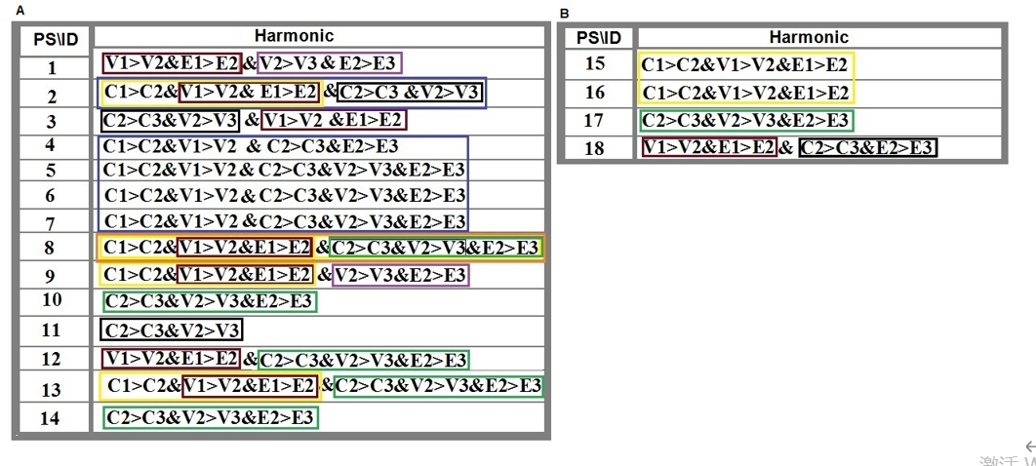
Figure 4 The harmonic ratio of tumor cells with different degree of expression intensity for protein C-C chemokine ligand 2, vascular endothelial growth factor, and epidermal growth factor to the circulating tumor cells in patients with brain tumors. C-C chemokine ligand 2 (CCL2), vascular endothelial growth factor (VEGF), and epidermal growth factor (EGF) are conjugated with fluorescein isothiocyanate, R-phycoerythrin, and phycoerythrin–indodicarbocyanine, respectively. The highlighted quadrants with different colors indicate the harmonic evolutionary altered intensity including increased and/or decreased ratio value of the related proteins in common between different patients or within different proteins. The altered ratio is based on the provided data in Figure 1; Numbers 1 (high), 2 (medium) and 3 (low) are reflective of expression intensity of proteins CCL, VEGF and EGF. C: C-C chemokine ligand 2; V: Vascular endothelial growth factor; E: Epidermal growth factor.

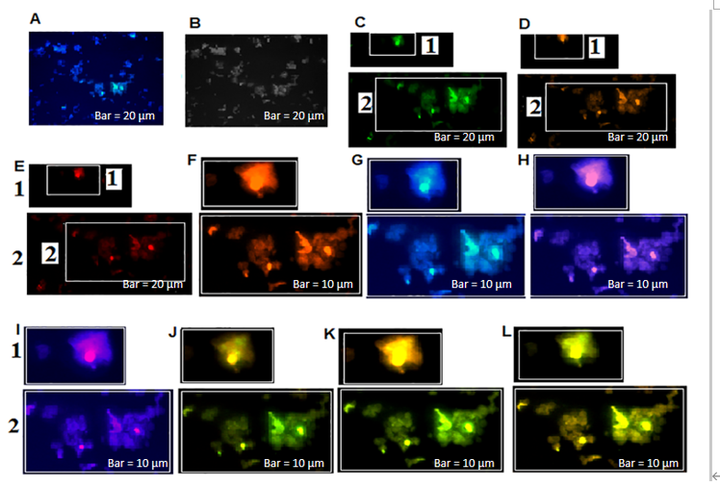
Figure 5 Mode of protein expression and co-expression of C-C chemokine ligand 2, vascular endothelial growth factor, and epidermal growth factor in circulating tumor cells of a patient with meningioma. C-C chemokine ligand 2 (CCL2), vascular endothelial growth factor (VEGF) and epidermal growth factor (EGF) are conjugated with fluorescein isothiocyanate, R-phycoerythrin, and phycoerythrin–indodicarbocyanine, respectively, in patient number 1. A: Merged of 4′,6-diamidino-2-phenylindole/CCL2; B: Phase contrast; C: Same cells with CCL2; D: Cells with VEGF; E: Cells with EGF; F: Merged/cropped cells with VEGF/EGF; G: Merged of 4′,6-diamidino-2-phenylindole /CCL2; H: Merged cells with dai/VEGF; I: Merged cells with dai/EGF; J: Cropped/merged cells with CCL2/VEGF; K: Cropped/merged cells with CCL2/EGF; L: Cropped/merged cells with CCL2/VEGF/EGF.

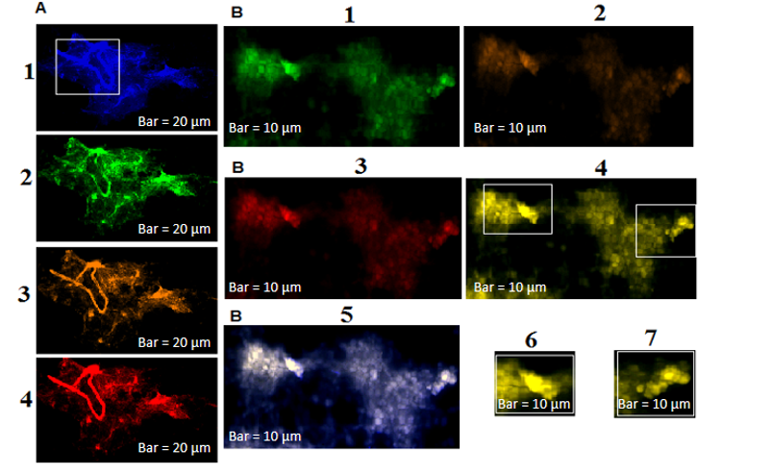
Figure 6 Status of protein expression of C-C chemokine ligand 2, vascular endothelial growth factor, and epidermal growth factor in the tumor and circulating tumor cells of patient 4 affected with meningioma. C-C chemokine ligand 2 (CCL2), vascular endothelial growth factor (VEGF), and epidermal growth factor (EGF) are conjugated with fluorescein isothiocyanate, R-phycoerythrin, and phycoerythrin–indodicarbocyanine, respectively, in patient number 2. A: 4′,6-Diamidino-2-phenylindole, CCL2, VEGF, EGF; B: CCL2, VEGF, EGF, co-expression of CCL2/VEGF/EGF, co-expression of 4′,6-diamidino-2-phenylindole/CCL2/VEGF/EGF, Selected cropping area of image B4, is reflective of diverse co-expression between these three proteins from image B4.

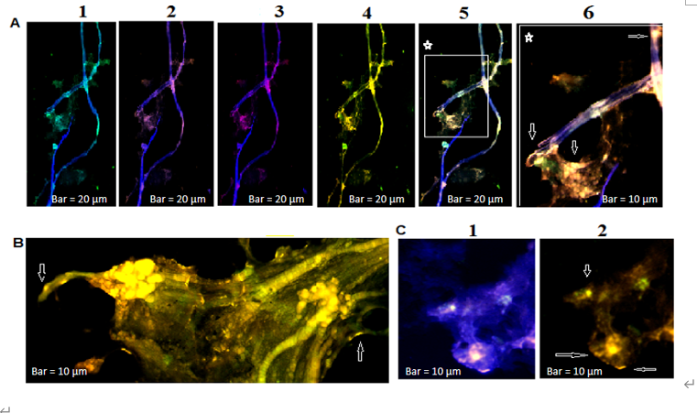
Figure 7 Protein expression status of C-C chemokine ligand 2/vascular endothelial growth factor/epidermal growth factor of two cell population from tumor sample and circulating tumor cells in patient 11 affected with meningioma. C-C chemokine ligand 2 (CCL2), vascular endothelial growth factor (VEGF), and epidermal growth factor (EGF) are conjugated with fluorescein isothiocyanate, R-phycoerythrin, and phycoerythrin–indodicarbocyanine, respectively, in patient number 3. A: Vascular images accompanied by the partial tumor section [1: Merged of 4′,6-diamidino-2-phenylindole (DAPI)/CCL2; 2: Merged of DAPI/VEGF; 3: Merged of DAPI/ EGF; 4: Co-expression of CCL2/EGF/VEGF; 5: Co-expression of DAPI/CCL2/VEGF/EGF; 6: A cropped section of 5]; B: Image of a tumor section reflecting of the Co-expression of CCL2/VEGF/EGF; C: Illustrates the CTCs in the blood sample of the same patient. The arrows are indicative of expression status in tumor cells, in vasculature, and the microvesicles.

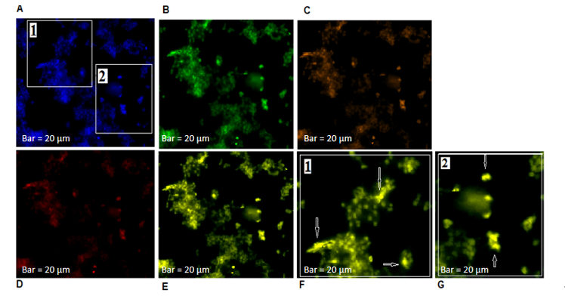
Figure 8 Mode of protein expression and co-expression of C-C chemokine ligand 2, vascular endothelial growth factor, and epidermal growth factor of the circulating tumor cells of patient 13 with meningioma. C-C chemokine ligand 2 (CCL2), vascular endothelial growth factor (VEGF), and epidermal growth factor (EGF) are conjugated with fluorescein isothiocyanate, R-phycoerythrin, and phycoerythrin–indodicarbocyanine, respectively. A: Leukocytes and circulating tumor cells (CTCs) with 4′,6-diamidino-2-phenylindole; B: Image of the same cells with CCL2; C: Image of the same cells with VEGF; D: Image of the same cells with EGF; E: Co-expression of the CCL2/VEGF/EGF in the same cells; F and G: Co-expression of the CCL2/VEGF/EGF in the selected cropping cells (1 and 2) from A. The arrows are reflective of high protein co-expression within CTCs according the mode of expression in images b-din the EGF; and the VEGF reflects the lowest expression.

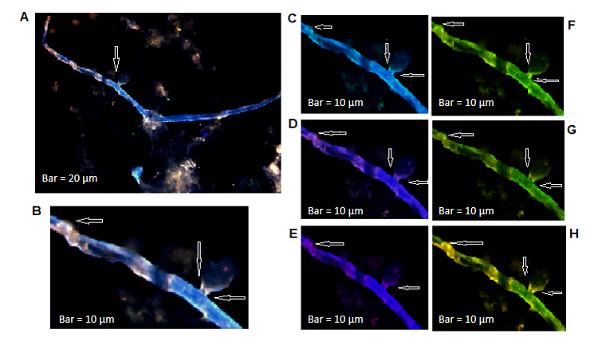
Figure 9 Status of protein expression and co-expression of C-C chemokine ligand 2/vascular endothelial growth factor/epidermal growth factor through migration of circulating tumor cells within tumor territory to the blood stream in a patient with the lung metastatic carcinoma. C-C chemokine ligand 2 (CCL2), vascular endothelial growth factor (VEGF) and epidermal growth factor (EGF) are conjugated with fluorescein isothiocyanate; R-phycoerythrin, and phycoerythrin–indodicarbocyanine, respectively, in patient 15. A: Merged of 4′,6-diamidino-2-phenylindole (DAPI)/CCL2/EGF/VEGF; B: Cropped section of image a; C: Merged of DAPI/CCL2; D: Merged of DAPI/VEGF; E: Merged of DAPI/EGF; F: Co-expression of CCL2/Veg; G: Co-expression of CCL2/EGF; H: Co-expression of CCL2/VEGF/EGF. Merged of DAPI/CCL2/VEGF/EGF is reflective of co-expression between three proteins; B, F-H: Reflect co-expression of CCL2/VEGF/EGF according to the selected of cropped section from images a (arrow on the top/left). The arrows on the left side of images are referred to the migration of tumor cells from tumor to the blood stream destination through a bubble like channel.

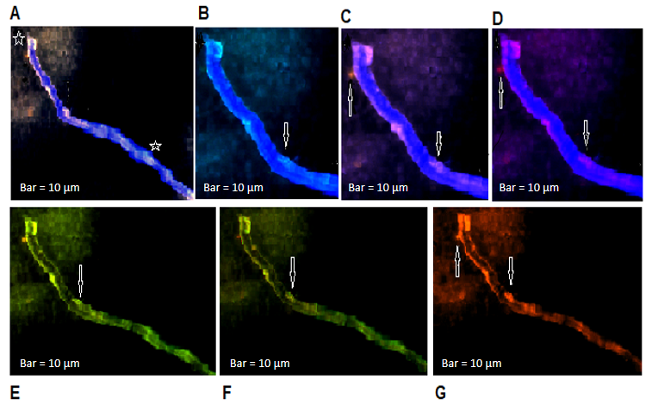
Figure 10 Expression mode of C-C chemokine ligand 2, vascular endothelial growth factor and epidermal growth factor in the migrated vasculature into the blood stream in a patient affected with metastatic brain tumor with breast origin. C-C chemokine ligand 2 (CCL2), vascular endothelial growth factor (VEGF) and epidermal growth factor (EGF) are conjugated with fluorescein isothiocyanate, R-phycoerythrin, and phycoerythrin–indodicarbocyanine, respectively in patient 17. A: Merged of 4′,6-diamidino-2-phenylindole (DAPI)/CCL2/VEG/EGF; B, C and D: Partially cropped section between two asterisk of image A and present the merged of DAPI/CCL2, DAPI/VEGF and DAPI/EGF respectively; B and C: Indicates the involvement of traceable tumor cells with higher expression than EGF within a migrated vasculature to the blood stream; E, F and G: Present co-expression between CCL2/Veg, CCL2/EGF and EGF/VEGF respectively, there is more harmony between CCL2/Veg and CCL2/Veg.

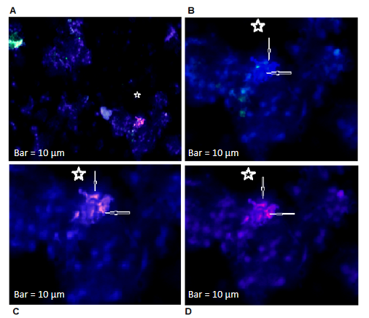
Figure 11 Expression mode of proteins of C-C chemokine ligand 2, vascular endothelial growth factor, and epidermal growth factor in circulating tumor cells from a tumor of patient affected with cerebellar medulloblastoma. A: Merged image of cells conjugated with 4′,6-diamidino-2-phenylindole (DAPI)/C-C chemokine ligand 2 (CCL2)/vascular endothelial growth factor (VEGF)/epidermal growth factor (EGF) is reflective of remarkable co-expression between VEGF/EGF proteins; B: Merged cells with DAPI/CCL2 indicating the absence of expression in the majority of cells; C: Merged cells with DAPI/VEGF with high expression; D: Merged cells with DAPI/EGF reflect lower expression than VEGF. Asterisks are referred to the cluster of CTCs.

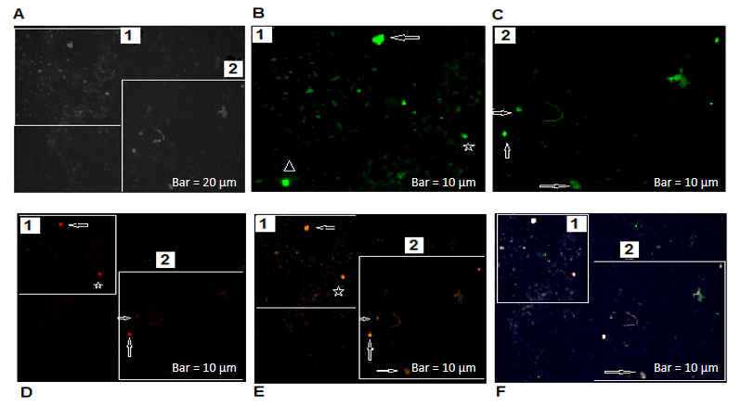
Figure 12 Status of protein expression of neuronal marker, CD133 and vascular endothelial growth factor in the brain circulating tumor cells of patient 1 affected with meningioma. A: Circulating tumor cells (CTCs) with phase contrast; B and C: Present CTCs with Ne conjugated with fluorescein isothiocyanate; D: Present status of vascular endothelial growth factor (VEGF), conjugated with phycoerythrin–indodicarbocyanine; E: Reflect status of CD133, conjugated with R-phycoerythrin; F: Present the merged image of 4′,6-diamidino-2-phenylindole/Ne/VEGF/CD133, reflective of a remarkable co-expression between protein neuronal markers CD133 and VEGF. Arrows on the top of images B, D1, and E1 reflect more involved cells with high-, very less involved cells with much lower-, and less involved cells with high-expression for Ne, VEGF, and CD133, respectively. The asterisks on the down/right of B, B and E illustrate almost same intensity of expression, but with more CTCs involved in image B for Ne, VEGF, and CD133, respectively. A triangle symbol is reflective of a remarkable high expression for neuronal marker in CTCs. Arrows on the below/left-down of images C2, D2, and E2 present higher expression for Ne than VEGF and CD133. Arrows on the bellow/left-up of images C2, D2, and E2 illustrate low expression for Ne and CD133, and lack of expression for VEGF. The arrows down the images of C2, D2, and E2 illustrate the heterogenic (low and lack) of expression for Ne and CD133 and lack of expression for VEGF.

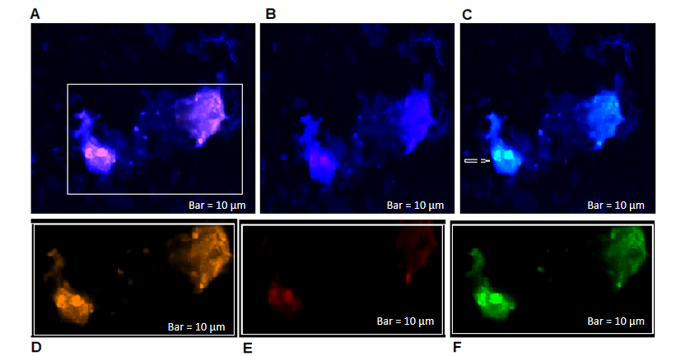
Figure 13 Protein expression of cytokeratin-19, CD45, and cyclin E in circulating tumor cells of a breast-brain metastatic patient. Circulating tumor cells (CTCs) in patient 17 with: A: DAPI (4′,6-diamidino-2-phenylindole)/cytokeratin-19 (CK-19) [highest/positive protein expression (PE)]; B: DAPI/CD45 (negative PE); C: DAPI/cyclin E (positive PE: Partial at left clone of cells); D, E and F: Conjugated cells with CK-19, CD45, and cyclin E, respectively. Harmonic PE between CK-19 and cyclin E in the clone of CTCs at left side of image in patient 17. Arrows indicate the diverse expression of three proteins.

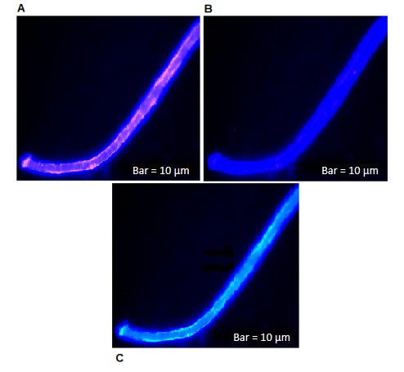
Figure 14 Protein expression of cytokeratin-19, CD45, and cyclin E in circulating tumor cells of a vasculature image of a breast-brain metastatic patient. Cytokeratin-19 (CK-19), CD45, and cyclin E are conjugated with phycoerythrin-indodicarbocyanine, R-phycoerythrin, and fluorescein isothiocyanate, respectively. A: 4′,6-Diamidino-2-phenylindole (DAPI)/CK-19 [highest/positive protein expression (PE)]; B: DAPI/CD45 (negative PE); C: DAPI/cyclin E (positive PE: Partial at left clone of cells). Harmonic PE between CK-19 and cyclin E, arrows indicate lack of cyclin E expression in the middle of vasculature in patient 17.

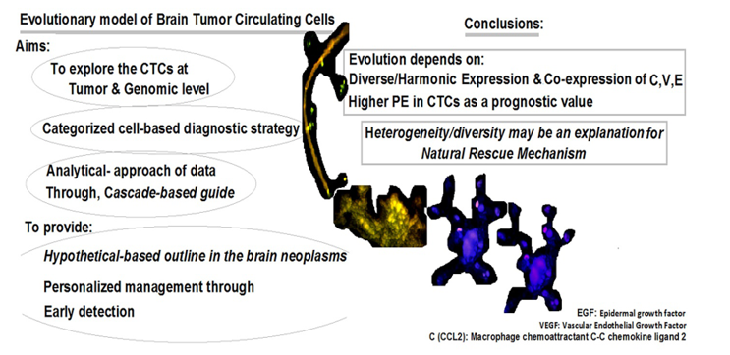
Figure 15 Manuscript at a glance: Evolutionary model of brain tumor circulating cells. CTCs: Circulating tumor cells; PE: Protein expression.

Table 1 Characteristics of histhopathologic and status of ataxia-telangiectasia mutated polymorphism (D1853N) in patients with brain tumors
Patient ID | Age in yr | Histopath/grade | Other complications | D1853N polymorphism status
1 | 46 | Meningiotheliomatous type | - | +
2 | 47 | Meningioma/I | - | -
3 | 34 | Meningothelial type | - | +
4 | 40 | Meningiotheliomatous type | Focal micro-invasion to the underlying brain tissue | +
5 | 37 | Meningioma/angiomatous | - | -
6 | 66 | Meningothelial type | - | -
7 | 56 | Meningothelial type | -
8 | 50 | Meningiotheliomatous type | - | -
9 | 21 | Meningiotheliomatous type/I | - | -
10 | 69 | Meningiotheliomatous type/I | - | +
11 | 43 | Meningioma/transitional type | - | -
12 | 69 | Meningiotheliomatous type/I | - | -
13 | 49 | Meningioma | Thyroid tumor (at the same age) | +
14 | 36 | Meningioma/atypical | - | -
15 | 50 | Metastatic carcinoma | Primary site: Lung | +
16 | 51 | Metastatic brain | Primary site: Breast | +
17 | 53 | Metastatic brain-breast origin | Primary site: Breast | +
18 | 39 | Cerebellar medulloblastoma/IV | Micro-vascular proliferation | +

Published by Baishideng Publishing Group Inc
7041 Koll Center Parkway, Suite 160, Pleasanton, CA 94566, USA
Telephone: +1-925-3991568
E-mail: bpgoffice@wjgnet.com
Help Desk: https://www.f6publishing.com/helpdesk
https://www.wjgnet.com

© 2021 Baishideng Publishing Group Inc. All rights reserved.

