Name of Journal: World Journal of Gastrointestinal Surgery
Manuscript NO: 82846
Manuscript Type: ORIGINAL ARTICLE

Basic Study
Impact of interstitial cells of Cajal on slow wave and gallbladder contractility in a guinea pig model of acute cholecystitis

Ding F et al. Pathology of ICCs during acute cholecystitis

Fan Ding, Run Guo, Fang Chen, Li-Ping Liu, Zheng-Yu Cui, Yi-Xing Wang, Gang Zhao, Hai Hu

Fan Ding, Gang Zhao, Hai Hu, Center of Gallbladder Disease, East Hospital Affiliated to Tongji University, Shanghai 200120, China

Fan Ding, Gang Zhao, Hai Hu, Institute of Gallstone Disease, Tongji University School of Medicine, Shanghai 200331, China

Run Guo, Fang Chen, Li-Ping Liu, Department of Ultrasonography, East Hospital Affiliated to Tongji University, Shanghai 200120, China

Zheng-Yu Cui, Yi-Xing Wang, Department of Internal Medicine of Traditional Chinese Medicine, East Hospital Affiliated to Tongji University, Shanghai 200120, China

Author contributions: Ding F and Guo R performed experiments; Hu H, Zhao G, and Wang YX designed the study; Cui ZY performed data analysis; Chen F and Liu LP drafted the manuscript; all authors reviewed the final manuscript.

Supported by the Pudong New Area Clinical Traditional Chinese Medicine of Top Discipline Project, No. PDZY-2018-0603.

Corresponding author: Hai Hu, MD, PhD, Director, Center of Gallbladder Disease, East Hospital Affiliated to Tongji University, No. 150 Jimo Road, Shanghai 200120, China. huhailc@sina.com

Received: December 29, 2022
Revised: February 21, 2023
Accepted: April 14, 2023
Published online:

Abstract
BACKGROUND
Impaired interstitial cells of Cajal (ICCs) are central to the pathophysiology of acute cholecystitis (AC). Common bile duct ligation is a common model of AC, producing acute inflammatory changes and decrease in gallbladder contractility.

AIM
To investigate the origin of slow wave (SW) in the gallbladder and the effect of ICCs on gallbladder contractions during the process of AC.

METHODS
Methylene blue (MB) with light was used to establish selective impaired ICCs gallbladder tissue. Gallbladder motility was assessed using the frequency of SW and gallbladder muscle contractility in vitro in normal control (NC), AC12h, AC24h, and AC48h groups of guinea pigs. Hematoxylin and eosin and Masson-stained gallbladder tissues were scored for inflammatory changes. ICCs pathological changes alterations were estimated using immunohistochemistry and transmission electron microscopy. The alterations of c-Kit, α-SMA, cholecystokinin A receptor (CCKAR), and connexin 43 (CX43) were assessed using Western blot.

RESULTS
Impaired ICCs muscle strips resulted in the decrease in gallbladder SW frequency and contractility. The frequency of SW and gallbladder contractility were significantly lower in the AC12h group. Compared with the NC group, the density and ultrastructure of ICCs were remarkably impaired in the AC groups, especially in the AC12h group. The protein expression levels of c-Kit were significantly decreased in the AC12h group, while CCKAR and CX43 protein expression levels were significantly decreased in the AC48h group.

CONCLUSION
Loss ICCs could lead to a decrease in gallbladder SW frequency and contractility. The density and ultrastructure of ICCs were clearly impaired in the early stage of AC, while CCKAR and CX43 were significantly reduced at end stage.

Key Words: Interstitial cells of Cajal; Acute cholecystitis; Slow wave; Gallbladder; Contractility

Ding F, Guo R, Chen F, Liu LP, Cui ZY, Wang YX, Zhao G, Hu H. Impact of interstitial cells of Cajal on slow wave and gallbladder contractility in a guinea pig model of acute cholecystitis. World J Gastrointest Surg 2023; In press

Core Tip: Acute cholecystitis (AC) is inflammation of the gallbladder. In this study, we found that loss interstitial cells of Cajal (ICCs) could lead to the decreased of gallbladder slow wave (SW) and contractility. Acute inflammation can cause a reduction in the SW and gallbladder motility deficiency by damaging the density and function of ICCs during early AC stage. At the end stage of AC, the decrease of cholecystokinin A receptor and gap junction leads to the further decrease in gallbladder contractility and electrical conductivity.

INTRODUCTION
Acute cholecystitis (AC) is a common acute inflammatory disease of gallbladder, which occurs in the cystic duct in approximately 90% to 95% of patient, typically caused by gallstone obstruction^{[1]}. In contrast, acute acalculous cholecystitis is another specific type of acute inflammatory disease of the gallbladder without evidence of gallstones, which is present in approximately 5% to 10% of AC^{[2]}. The main pathogenesis of AC is bile ducts obstruction induced by gallstones, bile sludge or lithogenic bile. The extent and duration of biliary obstruction determines the degree of progression of AC and the severity of gallbladder inflammation. More importantly, gallbladder dysmotility is the most critical pathogenic factor, as it could lead to gallstones, cholestasis, secondary bacterial infection, and even gallbladder ischemia^{[3]}.
In gastrointestinal (GI) tracts, interstitial cells of Cajal (ICCs), which characterized by rhythmic, spontaneous depolarization potentials, act as the pacemaker cells that generate and propagate the slow wave (SW). SW has been proven to play a significant role in the regulation of GI motility^{[4]}. The waveform, frequency, amplitude, and duration of SW varies in different species and even in different regions of the GI tract, however the electrophysiological properties of SW always trigger resting membrane potentials of smooth muscle cells (SMCs) into the range of action potentials thus causing GI peristalsis. Thus, the loss of ICCs or disruption of ICCs networks might result in GI motility disorders^{[5]}.
Like GI smooth muscle, this spontaneous periodic electrical activity is also present in gallbladder smooth muscle (GBSM), yet the underlying mechanism is not clear. Recently, the distribution of ICCs has been demonstrated in the muscular layers of the gallbladder and biliary system^{[6,7]}. In cholesterol stones of a guinea pig model, the reduced density of gallbladder ICCs could further cause the dysfunction of gallbladder motility^{[8]}. Furthermore, destroying ICCs in vitro can significantly induce impairment of gallbladder motility^{[9]}. Together, these results indicate that ICCs might contribute to regulation of the spontaneous rhythmic contractions and progression of gallbladder motility disorders. However, there is still a lack of studies of SW in the gallbladder. The relationship between ICCs and SW of the gallbladder remains unclear.
In this study, we firstly recorded gallbladder SW in vivo and in vitro and discussed the relationship between SW and ICCs. Then we investigated the alterations of ICCs, SW of gallbladder, and gallbladder motility in the guinea pigs of AC model. Additionally, we examined changes in the expression levels of c-Kit, α-SMA, cholecystokinin A receptor (CCKAR) and connexin 43 (CX43) protein in the gallbladder of guinea pigs during AC progression.

MATERIALS AND METHODS
Animal model and experimental trials
Adult male guinea pigs (200-250 g) were obtained from Shanghai JieSiJie Laboratory Animal Co., Ltd. (Shanghai, China) and fed under the experimental environment for one week. All protocols were supervised and approved by the Institutional Animal Care and Use Committee of the East Hospital Affiliated to Tongji University (No. 2020-12-102). As described previously, the guinea pig model of AC was established by common bile duct ligation (CBDL)^{[10]}. The guinea pigs were anesthetized with isoflurane (concentration: 1.5% to 2.5%, RWD Life Science, Shenzhen, Guangdong Province, China) by mask inhalation. Sterile laparotomy was performed to carefully isolate the tissue surrounding the CBD, and the distal end of the CBD was ligated (6-0 silk, Johnson & Johnson China Ltd.), with minimal manipulation of the CBD and no operation of the gallbladder. After awakening from anesthesia, animals were housed separately and supplied with food and water ad libitum. Twenty guinea pigs were randomly divided into four groups: the normal control (NC), AC12h, AC24h, and AC48h groups. Each group had five guinea pigs. The NC, AC12h, AC24h, and AC48h groups were all monitored until sacrificed 12 h to 48 h later (see below).

Tissue preparation
Each guinea pig in the NC, AC12h, AC24h, and AC48h groups was briefly anesthetized with isoflurane (concentration: 1.5% to 2.5%). After cervical dislocation, the gallbladder was precisely removed and then opened with a longitudinal incision at 12 h, 24 h, or 48 h after CBDL, respectively. The full-thickness muscle strips were incised along the longitudinal axis of the gallbladder. For the general preparation of muscle strips, the muscle strips (10.0 mm × 3.0 mm) were placed in iced Krebs-Hensleit’s solution (KHS, composition: NaCl 118 mmol/L, KCl 4.7 mmol/L, CaCl₂ 2.5 mmol/L, NaHCO₃ 25 mmol/L, MgSO₄•7H₂O 1.18 mmol/L, KH₂PO₄ 1.18 mmol/L, and D-glucose 11.1 mmol/L, pH 7.4) and processed immediately for muscle contractility studies. Especially, for the preparation of muscle strips with impaired ICCs (MB with light groups), the muscle strips removed from normal guinea pig were incubated in KHS containing 50 μM methylene blue (MB, MedChemExpress, Shanghai, China) at 37 °C bubbled with 95% O₂-5% CO₂ for 40 min in the dark and then immediately exposed to the light (532 nm, 50 mW/cm²) for 5 min, which can selectively inactivate ICCs^{[11,12]}. In addition, each group of the gallbladder tissue samples were either stored at 0-4 °C, which examined by transmission electron microscopy (TEM) and Western blot analysis or fixed in 4% paraformaldehyde (PFA) and then embedded in paraffin for histopathologic and immunohistochemical studies (see below).

Histopathologic analysis
Freshly prepared gallbladder samples were fixed with 4% PFA and then embedded in paraffin (sectioned at 4 μm) for hematoxylin and eosin (H&E) staining and Masson trichrome staining. The sections underwent histopathologic analysis by light microscopy (AX10, Zeiss, Munich, Germany). An inflammation scoring system was used to evaluate the extent of gallbladder inflammation with scores ranging from 0 to 17^{[10]}. Specifically, the degree of inflammatory cell infiltration, hemorrhage, edema, surface ulceration, and fibroblast proliferation were each classified as 0, 1, 2, or 3, respectively. Vascular dilation and Rokitansky-Aschoff (R-A) sinus formation were each counted as 1 if present or 0 if absent.

Slow wave measurement
For in vivo study of gallbladder SW recording, after 12 h of fasting, the guinea pigs were anesthetized with continual inhalation of 1.5% to 2.5% isoflurane and immobilized on a constant temperature heating pad in the supine position. After sterilization, a longitudinal mini-incision was performed along the ventrimeson from the xiphoid to expose the gallbladder. Then, two self-made electrodes (1.0 cm interval) were inserted in parallel into the body of the gallbladder. The reference electrode was placed in the subcutaneous tissue near the incision. For in vitro study of gallbladder muscle strips SW recording, the normal muscle strips and muscle strips with damaged ICCs were pinned and stretched in Sylgard-coated dish and incubated in KHS. The two self-made electrodes (0.5 cm interval) were inserted in parallel into the muscle layer of strips. The electrical signals were recorded by the 8-channels PowerLab (ADInstruments, New South Wales, Australia). The electromyogram (EMG) was collected and analyzed by the LabChart 8.0 (ADInstruments, New South Wales, Australia), and the frequency of SW was calculated by averaging the frequencies of the stabilization section of the EMG recording (times/min). The recording equipment was calibrated to zero prior to experiment beginning. The EMG of the gallbladder in vivo under physiological conditions was recorded for 40 min. The gallbladder strips in vitro were recorded for 10 min. The sampling frequency of the recording system was 4000 Hz. The low-pass filter for SW recording was 0.1 Hz.

In vitro gallbladder muscle contractility studies
The gallbladder muscle strips (10 mm × 3 mm) from NC, AC12h, AC24h, AC48h, and MB with light groups were collected and suspended in organ baths filled with KHS (20 mL). The KHS was bubbled continuously with 95% O₂-5% CO₂, and the temperature was maintained at 37 °C. One side of gallbladder muscle strip is tied to a hook at the bottom of the chamber then the other side was attached to the force transducer (ADInstruments, New South Wales, Australia). Each muscle strip sample was applied for preload tension of 1.0 g and allowed to equilibrate for 40 min before starting the experimental procedures. The direct effects of cholecystokinin octapeptide (CCK-8, 5 μmol/L, Aladdin, Shanghai, China) on the gallbladder tone were examined. The mean preload level was recorded as the control value, meanwhile the effects level of CCK-8 as the response value. Statistical analyses were based on CCK-8 induced the change rate (R) of muscle tension, where R = [|(response value-control value)|/control value].

TEM
Selected fresh gallbladder tissue pieces (3 mm × 3 mm) were put into Eppendorf tubes with fresh 2.5% glutaraldehyde (Wuhan Servicebio Technology, Wuhan, Hubei Province, China) for at 4 °C for fixation and preservation. Before examination, wash the tissues with PBS for 3 times, 15 min each. Then, the samples were fixed with 1% OsO₄ under dark conditions (pH 7.4) for 2 h at room temperature (RT). After remove OsO₄ and gradient dehydration, the samples were embedded in resin. The resin blocks were cut to 60-80 nm thin with the ultra-microtome and fished out onto the 150 meshes cuprum grids with formvar film. After staining with 2% uranyl acetate and 2.6% lead citrate, the ultrastructure of gallbladder tissues was observed and photographed under TEM (supported by Wuhan Servicebio Technology, Wuhan, Hubei Province, China).

Detection of c-Kit, α-SMA expression by immunohistochemistry
Immunohistochemistry (IHC) staining was performed on the paraffin-embedded gallbladder samples using the following antibodies: anti-c-Kit (1:200, Novus Biologicals, Abingdon, United Kingdom) to identify ICCs in the muscular layer; anti-α-SMA (1:200, MyBioSource, San Diego, CA, United States) to identify SMCs in the muscular layer. Non-specific binding of antibody was blocked with 3% bovine serum albumin (BSA) before adding primary antibodies. Then samples were then incubated with appropriate horseradish peroxidase (HRP)-conjugated secondary antibodies (Wuhan Servicebio Technology, Wuhan, Hubei Province, China). Antibody localization was performed using a peroxidase reaction with H₂O₂ and 3,3-diaminobenzidine (DAB) tetrahydrochloride (Wuhan Servicebio Technology, Wuhan, China) as the chromogen. The NC gallbladder included in the histological sample was provided an internal control.

Protein extraction and Western blot analysis
Total protein was extracted from gallbladder tissues with RIPA lysis buffer. Protein concentrations were determined by the BCA protein concentration measurement kit (Beyotime Biotech, Shanghai, China). Protein samples were separated in 10% SDS-PAGE gels, then transferred to the PVDF membrane (Millipore, Burlington, MA, United States). According to the prestained protein markers, the membranes were cropped into strips based on the molecular weight of the individual target proteins and then incubated with QuickBlock blocking buffer (Beyotime Biotech, Shanghai, China) for 20 min at RT to block non-specific binding sites. The anti-c-Kit (1:500, GeneTex, Irvine, CA, United States), anti-α-SMA (1:500, MyBioSource, San Diego, CA, United States), anti-CCKAR (1:1000, ABclonal Technology, Wuhan, Hubei Province, China) and anti-CX43 (1:1000, Invitrogen, Carlsbad, CA, United States) and anti-α-Tubulin (1:500, Invitrogen, Carlsbad, CA, United States) primary antibodies were applied overnight at 4 °C. After washing with TBST 3 times, the membranes were incubated with appropriate HRP-conjugated secondary antibodies for 1 h at RT. Immunoblots were then visualized with ECL Plus chemiluminescence reagent kit (Vazyme Biotech, Nanjing, Jiangsu Province, China) and quantified with optical methods with Image J software (Image J 1.53, NIH, Bethesda, MD, United States). The results were normalized using α-Tubulin as an internal control.

Statistical analysis
All data were analyzed with GraphPad Prism 9.0 (GraphPad, San Diego, CA, United States), and each experiment was repeated three times. Results are presented as mean ± TEM. Statistical differences between groups were either analyzed with a two-tailed Student t-test or one-way analysis of variance (ANOVA) if the data were normally distributed. Otherwise, the Mann-Whitney or Kruskal-Wallis test was used. P < 0.05 was considered statistically significant.

RESULTS
Histology and inflammation score of the AC model
H&E and Masson staining of the gallbladder tissues from the NC, AC12h, AC24h, and AC48h guinea pigs were analyzed. In the NC group, that gallbladder had minimal inflammatory cell infiltration and had no congestion or edema. In contrast, in the AC groups, the gallbladder specimens showed varying degrees of inflammatory cell (mainly neutrophils) infiltration, vascular congestion, edema, and fibroblastic proliferation (Figure 1A). In particular, three of the five guinea pigs in the AC48h group displayed R-A sinus formation. Furthermore, there was a significant increase in the quantitated histologic inflammation score in the AC groups (12 h, 24 h, and 48 h) over time compared with the NC group (ªP < 0.05 vs NC groups, ^{b}P < 0.001 vs NC groups, ^{c}P < 0.0001 vs NC groups, Figure 1B).

ICCs may be the origin of SW in the gallbladder
In order to determine the relationship between gallbladder SW and ICCs, we destroyed the structure of the ICCs by MB with intense light. After incubation with MB, intense illumination partly abolished the activity of SW in the muscle strips (Figure 2A and B). Concurrently, compared to normal muscle strips, the contractions of the impaired ICCs muscle strips were also decreased (Figure 3A). Thus, we suggest that ICCs may be the origin of SW in the gallbladder, and SW could regulate the contractile function of gallbladder.

The SW of gallbladder was damaged in early stage of AC
The SW of guinea pigs exhibited periodic and rhythmic changes after 12 h of fasting (Figure 2C). The mean frequency of the SW in each of the NC and AC groups (12 h, 24 h, and 48 h) was recorded and analyzed. The SW frequencies were 10.66 ± 0.51, 7.13 ± 0.20, 6.46 ± 0.16, and 5.75 ± 0.44, respectively (ªP < 0.0001 vs NC groups, ^{b}P < 0.0001 vs NC groups, ^{c}P < 0.0001 vs NC groups, Figure 2D). Interestingly, the SW frequency of the AC12h group was clearly lower compared with the NC group (ªP < 0.0001 vs NC groups), while there were no significant differences between the AC groups (Figure 2D).

Gallbladder contraction is impaired during AC
In this study, the contractility of gallbladder strips was evaluated using the mean change rate (R) after drug stimulation. Contractility was significantly weakened in all AC groups compared to the NC group with CCK-8 tested (Figure 3B). Notably, the R value of the AC12h group was remarkably reduced in the CCK-8 stimulations compared with the NC group (0.42 ± 0.09 vs 0.96 ± 0.21, ^{b}P < 0.05 vs NC groups). Thus, the data suggest that gallbladder contraction has already been impaired in early stage of AC. These results are consistent with the gallbladder SW measurement data.

The number and formation of gallbladder ICCs are damaged during AC
IHC analysis of cross sections of the gallbladder tissues showed that intensely c-Kit- immunopositive ICCs were mostly identified in the muscular layers. In contrast to the NC group, the ICCs density was extremely decreased in the AC groups (Figure 4). There appears to be no significant differences in the thickness or structure of the GBSM. To further investigate the pathological changes of ICCs, TEM was utilized to detect ultrastructural changes in ICCs during AC progression. In the NC group, TEM showed typically elongated, oval-shaped cell bodies and one to three long processes extending from cell poles. The normal ICCs possess large nuclei, a well-developed smooth endoplasmic reticulum, abundant mitochondria, free ribosome and caveolae (Figure 5A). With prolonged CBDL, the ultrastructure of the gallbladder ICCs underwent significant changes. In the AC12h and AC24h groups, the ICCs were swollen, and the nucleolus became smaller, and processes diminished (Figure 5B and C). The gallbladder ICCs from the AC48h group had especially swollen cytoplasm with ruptures in the cytoplasm membrane. The mitochondria and endoplasmic reticulum were significantly reduced, and the processes often disappeared (Figure 5D). These results indicate that the number and function of ICCs were significantly impaired during AC.

Western blot analysis of c-Kit, α-SMA, CCKAR, and CX43
Compared to the NC group, the c-Kit protein expression levels of gallbladder in the AC groups (especially in the AC12h group) were significant decreased, as observed by Western blot analysis (ªP < 0.05 vs NC groups, ^{b}P < 0.05 vs NC groups, ^{c}P < 0.01 vs NC groups, Figure 6). Interestingly, the α-SMA protein expression levels did not decrease with the progression of AC but had a transient increase in the AC12h group (^{d}P < 0.05 vs NC groups). The CCKAR and CX43 protein expression levels were significantly lower in AC48h (^{e}P < 0.05 vs NC groups, ^{e}P < 0.05 vs NC groups, respectively).

DISCUSSION
AC is currently a major medical problem. The primary standard treatment for AC is cholecystectomy^{[13]}. The pathogenesis of AC is multifactorial. According to widely accepted theories, more than 90% of AC cases are caused by the obstruction at the neck of gallbladder due to gallstones or biliary sludge^{[14]}. Obstruction of the cystic duct rapidly increases the intraluminal pressure within the gallbladder, together with cholesterol supersaturated bile, triggers the acute inflammatory response. The dysmotility of gallbladder results in gallstones as well as persistent biliary sludge, while the sludge itself can cause AC.
In GI tract, the smooth muscle has two types of potentials: SW and functional action potentials^{[15]}. ICCs are distributed throughout the GI tract in mammalian species, including humans^{[7,16,17]}. ICCs form networks at the borders of the circular and longitudinal muscular layers and electrically couple to each other through gap junctions^{[18]}. These electrical-couple networks extend along and around the organs or tissues of the GI tract to all regions involved in phasic rhythmic contractions. Therefore, SW could be both generated by ICCs and actively propagated to neighboring tissue within ICC-networks. SW could determine the conduction speed and direction of GI motility, as well as the basic electrical rhythm. However, SMCs are deficient in specific ionic mechanisms and therefore cannot generate and actively propagate SW^{[19]}. SW, as a consequences of pacesetter potentials, provides electrophysiological conditions for depolarization of the smooth muscle contraction syncytium, increasing the open probability of L-type Ca²⁺ channels in SMCs to generate phasic contractile activity in many regions of the GI tract. Overall, The SW potential in the GI tract is generated by ICCs and spreads to surrounding SMCs, causing excitation-contraction coupling.
Gallbladder ICCs have been identified in mice in 2006^{[7]}, in guinea pigs in 2007^{[17]}, and in humans in 2012^{[20]}. Previous studies have indicated that intense illumination of the canine colon after incubation with MB resulted in the selective inactivation of ICCs^{[11]}. Subsequently, Fan et al^{[9]} verified that the injury effects of MB with light were specifically limited to gallbladder ICCs and led to the reduction in frequency and amplitude of SW recorded from gallbladder muscle strip in vitro. ICCs have been involved in generating and pacemaking spontaneous electrical activity in the gallbladder muscularis propria, because this effect could be eliminated or reduced by exposure to imanitib mesylate, a Kit tyrosine kinase inhibitor^{[17]}. Furthermore, many studies have demonstrated that impairment or loss of ICCs in the biliary system have been associated with various biliary systemic diseases, such as acute inflammation, gallstones, gallbladder cyst, and regional or proximal obstructions^{[21-24]}. However, it remains unclear the relationship between SW and ICCs in gallbladder, and how the ICCs can affect the SW and contraction function of the gallbladder in AC. In the current study, we first recorded the gallbladder SW to determine the relationship between SW and ICCs, then explored the acute inflammation-related alterations in ICCs in a guinea pig model of AC.
As concluded by previous studies, selective lesioning of ICCs by MB and light could result in partly loss of SW^{[11,12]}. Our results also demonstrated that after incubation with MB and light, the frequency of SW of isolated gallbladder muscle strips was remarkably lower than control group (Figure 2A and B). Meanwhile, compared to normal strips, the loss ICCs muscle strips showed lower reactivity to CCK-8 (Figure 3A). These results indicated that ICCs might be the source of SW in the gallbladder, and loss of ICCs reduces gallbladder contractility.
CBDL could produce histological features identical to human AC without chemical or physical manipulation of the gallbladder^{[10]}. In this study, the inflammatory evaluation was consistent with AC according to the pathological score analysis (Figure 1). H&E staining showed that the gallbladder tissues from the NC group were intact and showed no congestion, edema, or obvious inflammatory cell infiltration. The predominant histopathological changes observed in the AC groups included edema, hemorrhage, inflammatory cell infiltration, and blood vessel dilation. R-A sinus was only found in the late stage of AC (AC48h group), which suggests increased intraluminal pressure in the gallbladder and a discontinuous muscle layer associated with AC^{[25]}. Masson staining was used to examine the proliferation of collagen fibers and GBSM in the tissues. There was no significant proliferation of muscle fiber or collagen observed in the gallbladder sample sections between the NC and AC groups.
In recent years, research on the gallbladder SW has only been conducted for isolated muscle strips in vitro. Because of the loss of neural, hormonal, and inflammatory factor regulation, isolated gallbladder strips do not fully reflect the electrophysiological characteristics of the SW in normal and pathological states. To record the gallbladder SW in vivo, we implanted a self-made dual AgCl-electrode (1.0 cm interval) into the body of the gallbladder (Figure 2E). The results revealed that AC significantly decreased the gallbladder SW frequency (Figure 2C and D, P < 0.0001), while a similar trend between the AC groups failed to reach statistical significance. Similarly, the muscle tension of isolated gallbladder muscle strips also showed a significant decrease in AC groups (Figure 3B).
CD117/c-Kit protein expression is a specific marker of ICCs^{[26]}. IHC results showed the density of ICCs (labelled with c-Kit) in each AC group (AC12h, AC24h, and AC48h) was extremely reduced (Figure 4). These pathological changes were most apparent in the AC12h group. Western blot analysis showed the same changing trend about c-Kit protein expression in AC groups (Figure 6). Additionally, Masson staining and IHC assays suggested that GBSM (marked with α-SMA) showed no significant pathological changes in morphology or structure. Interestingly, the protein expression of α-SMA did not decrease with the progression of AC, but rather there was a transient increase in the AC12h group (Figure 6). This may be because in the CBDL model, the increased pressure within the gallbladder leads to a compensatory response of the GBSM. The typical ultrastructural properties of ICCs were obvious, including elongated, fusiform bodies with few processes, discontinuous basal lamina, thin and intermediate filaments, abundant mitochondria and Golgi apparatus, rough and smooth endoplasmic reticulum, intracellular vesicles, free ribosomes and occasional caveolae^{[27]}. With the progression of AC, the impaired ICCs exhibited markedly swollen with impaired or decrease of organelles and showed low contrast for the cytoplasm, and ruptures in the cytoplasm membrane (Figure 5). All these changes might result in the reduction of gallbladder contractile function.
CCK is a kind of gut hormone first identified in extracts from the small intestine, which could vigorously induce gallbladder contraction^{[28]}. This gallbladder contractions effect was once believed to be caused by CCK only through the CCKAR pathway on the SMCs. Recently, CCKAR has been proven be also expressed in ICCs^{[29]}. In this study, loss ICCs muscle strips showed low sensitivity to CCK compared to normal strips (Figure 3A). Therefore, it indicated that CCK acted not only on the CCKAR on the GBSM, but also on the gallbladder ICCs.
CX43 is a member of the gap junction family. Gap junction form transmembrane complexes between adjacent cells that are composed of connexin proteins and allow direct cell-to-cell communication and the transfer of ions and small signaling molecules^{[30]}. In this study, the protein expression of both CCKAR and CX43 showed a significant declining trend in AC48h groups (Figure 6). These changes would cause a further decrease in the electrical conductance of the gallbladder tissue and the responsiveness of the contraction.

CONCLUSION
In conclusion, our study indicates that ICCs may act as pacemaker cells for the SW of the gallbladder. Acute inflammation can cause a reduction in the SW and gallbladder motility deficiency by damaging the density and function of ICCs during early AC stage. At the end stage of AC, the decrease of CCKAR and gap junction leads to the further decrease in gallbladder contractility and electrical conductivity. These changes may further induce functional impairment of gallbladder motility and eventually result in AC. This research strongly suggest that ICCs play a very important role in AC.

ARTICLE HIGHLIGHTS
Research background
Acute cholecystitis (AC) is a common disease with gallbladder dysmotility. Interstitial cells of Cajal (ICCs) damage and loss in the biliary system have been associated with various biliary systemic diseases. However, it remains unclear if or how the pathogenesis affects ICCs morphology, density, distribution, slow waves (SW), and function in gallbladder during AC.

Research motivation
Decreased gallbladder contractile function is an important causative factor in AC. ICCs presented significant pathological changes during AC in various animal and clinical studies. Therefore, ICCs may act as important regulators of gallbladder contractile function.

Research objectives
To investigate the origin of SW in the gallbladder and the effect of ICCs on gallbladder contractions during the process of AC. We hypothesized that ICCs are the origin of SW in the gallbladder, and the impaired leads to the decrease in gallbladder contractile function, which ultimately aggravates the AC.

Research methods
Common bile duct ligation is a common model of AC. Guinea pigs were randomly allocated to four groups: Normal control (NC), AC12h, AC24h, and AC48h. H&E and Masson-stained gallbladder tissues were scored for inflammatory changes. Methylene blue with light was used to establish selective impaired ICCs gallbladder tissue. Gallbladder motility was assessed using the frequency of SW and gallbladder muscle contractility. Then ICCs pathological changes alterations were estimated using immunohistochemistry and TEM. The alterations of c-Kit, α-SMA, cholecystokinin A receptor (CCKAR), and connexin 43 (CX43) were assessed using Western blot.

Research results
Gallbladder strips treated MB with light resulted in the decrease in gallbladder SW frequency and contractility. Compared with the NC group, The frequency of SW, gallbladder contractility, the density and ultrastructure of ICCs were significantly impaired in AC groups. The protein expression levels of c-Kit were significantly decreased in the AC12h group, while CCKAR and CX43 protein expression levels were significantly decreased in the AC48h group.

Research conclusions
This study indicated that ICCs may act as pacemaker cells for the SW of the gallbladder. In acute inflammation stage of AC, impaired ICCs resulted in the reduction of the SW and gallbladder motility deficiency. Then, the decrease of CCKAR and gap junction leads to the further decrease in gallbladder contractility and electrical conductivity, and eventually result in AC.

Research perspectives
This study did not completely destroy ICCs in the gallbladder tissue. The pacing mechanism of ICCs has also not been deeply investigated. These will be examined in the future study.

REFERENCES
1 Walter K. Acute Cholecystitis. JAMA 2022; 327: 1514 [PMID: 35258523 DOI: 10.1001/jama.2022.2969]
2 Fu Y, Pang L, Dai W, Wu S, Kong J. Advances in the Study of Acute Acalculous Cholecystitis: A Comprehensive Review. Dig Dis 2022; 40: 468-478 [PMID: 34657038 DOI: 10.1159/000520025]
3 Abdulrahman R, Hashem J, Walsh TN. A Review of Acute Cholecystitis. JAMA 2022; 328: 76-77 [PMID: 35788800 DOI: 10.1001/jama.2022.7768]
4 Kito Y, Ward SM, Sanders KM. Pacemaker potentials generated by interstitial cells of Cajal in the murine intestine. Am J Physiol Cell Physiol 2005; 288: C710-C720 [PMID: 15537708 DOI: 10.1152/ajpcell.00361.2004]
5 Sanders KM, Koh SD, Ward SM. Interstitial cells of cajal as pacemakers in the gastrointestinal tract. Annu Rev Physiol 2006; 68: 307-343 [PMID: 16460275 DOI: 10.1146/annurev.physiol.68.040504.094718]
6 Hinescu ME, Ardeleanu C, Gherghiceanu M, Popescu LM. Interstitial Cajal-like cells in human gallbladder. J Mol Histol 2007; 38: 275-284 [PMID: 17541711 DOI: 10.1007/s10735-007-9099-0]
7 Sun X, Yu B, Xu L, Dong W, Luo H. Interstitial cells of Cajal in the murine gallbladder. Scand J Gastroenterol 2006; 41: 1218-1226 [PMID: 16990209 DOI: 10.1080/00365520600708800]
8 Huang Y, Mei F, Yu B, Zhang HJ, Han J, Jiang ZY, Zhou DS. Distribution of the interstitial Cajal-like cells in the gallbladder and extrahepatic biliary duct of the guinea-pig. Acta Histochem 2009; 111: 157-165 [PMID: 18676008 DOI: 10.1016/j.acthis.2008.05.005]
9 Fan Y, Wu S, Fu B, Weng C, Wang X. The role of interstitial Cajal-like cells in the formation of cholesterol stones in guinea pig gallbladder. Hepatol Int 2015; 9: 612-620 [PMID: 25788205 DOI: 10.1007/s12072-015-9623-3]
10 Myers SI, Haley-Russell D, Parks L, Husband K. Common bile duct ligation in rabbit: a new model of acute cholecystitis description of histology and bile analysis. J Surg Res 1988; 45: 556-564 [PMID: 3184929 DOI: 10.1016/0022-4804(88)90144-8]
11 Liu LW, Thuneberg L, Huizinga JD. Selective lesioning of interstitial cells of Cajal by methylene blue and light leads to loss of slow waves. Am J Physiol 1994; 266: G485-G496 [PMID: 8166287 DOI: 10.1152/ajpgi.1994.266.3.G485]
12 Thuneberg L, Johansen V, Rumessen JJ, Andersen BG. Interstitial Cells of Cajal: Selective Uptake of Methylene Blue Inhibits Slow Wave Activity. In: Roman C, editor Gastrointestinal Motility: Proceedings of the 9th International Symposium on Gastrointestinal Motility held in Aix-en-Provence. Dordrecht: Springer Netherlands, 1984: 495-502
13 McMahon AJ, Fischbacher CM, Frame SH, MacLeod MC. Impact of laparoscopic cholecystectomy: a population-based study. Lancet 2000; 356: 1632-1637 [PMID: 11089821 DOI: 10.1016/S0140-6736(00)03156-1]
14 Indar AA, Beckingham IJ. Acute cholecystitis. BMJ 2002; 325: 639-643 [PMID: 12242178 DOI: 10.1136/bmj.325.7365.639]
15 Sanders KM, Koh SD, Ro S, Ward SM. Regulation of gastrointestinal motility--insights from smooth muscle biology. Nat Rev Gastroenterol Hepatol 2012; 9: 633-645 [PMID: 22965426 DOI: 10.1038/nrgastro.2012.168]
16 Pasternak A, Szura M, Gil K, Matyja A. Interstitial cells of Cajal - systematic review. Folia Morphol (Warsz) 2016; 75: 281-286 [PMID: 26806433 DOI: 10.5603/FM.a2016.0002]
17 Lavoie B, Balemba OB, Nelson MT, Ward SM, Mawe GM. Morphological and physiological evidence for interstitial cell of Cajal-like cells in the guinea pig gallbladder. J Physiol 2007; 579: 487-501 [PMID: 17204499 DOI: 10.1113/jphysiol.2006.122861]
18 Sanders KM, Ordög T, Koh SD, Torihashi S, Ward SM. Development and plasticity of interstitial cells of Cajal. Neurogastroenterol Motil 1999; 11: 311-338 [PMID: 10520164 DOI: 10.1046/j.1365-2982.1999.00164.x]
19 Foong D, Zhou J, Zarrouk A, Ho V, O'Connor MD. Understanding the Biology of Human Interstitial Cells of Cajal in Gastrointestinal Motility. Int J Mol Sci 2020; 21 [PMID: 32630607 DOI: 10.3390/ijms21124540]
20 Pasternak A, Gajda M, Gil K, Matyja A, Tomaszewski KA, Walocha JA, Kulig J, Thor P. Evidence of interstitial Cajal-like cells in human gallbladder. Folia Histochem Cytobiol 2012; 50: 581-585 [PMID: 23264222 DOI: 10.5603/19673]
21 Huizinga JD, Zarate N, Farrugia G. Physiology, injury, and recovery of interstitial cells of Cajal: basic and clinical science. Gastroenterology 2009; 137: 1548-1556 [PMID: 19778538 DOI: 10.1053/j.gastro.2009.09.023]
22 Fu BB, Zhao JN, Wu SD, Fan Y. Cholesterol gallstones: Focusing on the role of interstitial Cajal-like cells. World J Clin Cases 2021; 9: 3498-3505 [PMID: 34046450 DOI: 10.12998/wjcc.v9.i15.3498]
23 Huang ZP, Qiu H, Yu BP. Acute Cholecystitis Reduces Interstitial Cells of Cajal in Porcine Gallbladder Through Decreased mRNA Synthesis. Cell Physiol Biochem 2018; 47: 535-544 [PMID: 29794438 DOI: 10.1159/000489987]
24 Pasternak A, Gil K, Matyja A, Gajda M, Sztefko K, Walocha JA, Kulig J, Thor P. Loss of gallbladder interstitial Cajal-like cells in patients with cholelithiasis. Neurogastroenterol Motil 2013; 25: e17-e24 [PMID: 23121223 DOI: 10.1111/nmo.12037]
25 Albores-Saavedra J, Angeles-Angeles A. 11-Diseases of the gallbladder. In: Burt AD, Portmann BC, Ferrell LD, editors. MacSween’s Pathology of the Liver. 6th ed. Edinburgh: Churchill Livingstone, 2012: 563-599
26 Burns AJ, Herbert TM, Ward SM, Sanders KM. Interstitial cells of Cajal in the guinea-pig gastrointestinal tract as revealed by c-Kit immunohistochemistry. Cell Tissue Res 1997; 290: 11-20 [PMID: 9377631 DOI: 10.1007/s004410050902]
27 Komuro T. Structure and organization of interstitial cells of Cajal in the gastrointestinal tract. J Physiol 2006; 576: 653-658 [PMID: 16916909 DOI: 10.1113/jphysiol.2006.116624]
28 Ivy AC. A hormone mechanism for gall-bladder contraction & evacuation. Am J Surg 1929; 7: 455-459 [DOI: 10.1016/S0002-9610(29)90551-1]
29 Xu D, Yu BP, Luo HS, Chen LD. Control of gallbladder contractions by cholecystokinin through cholecystokinin-A receptors on gallbladder interstitial cells of Cajal. World J Gastroenterol 2008; 14: 2882-2887 [PMID: 18473415 DOI: 10.3748/wjg.14.2882]
30 Söhl G, Willecke K. Gap junctions and the connexin protein family. Cardiovasc Res 2004; 62: 228-232 [PMID: 15094343 DOI: 10.1016/j.cardiores.2003.11.013]

Footnotes
Institutional animal care and use committee statement: All procedures involving animals were reviewed and approved by the Institutional Animal Care and Use Committee of the East Hospital of Tongji University (approval No. 2020-12-102).

Conflict-of-interest statement: The authors declare no conflict of interest.

Data sharing statement: No additional data are available.

ARRIVE guidelines statement: The authors have read the ARRIVE Guidelines, and the manuscript was prepared and revised according to the ARRIVE Guidelines.

Open-Access: This article is an open-access article that was selected by an in-house editor and fully peer-reviewed by external reviewers. It is distributed in accordance with the Creative Commons Attribution NonCommercial (CC BY-NC 4.0) license, which permits others to distribute, remix, adapt, build upon this work non-commercially, and license their derivative works on different terms, provided the original work is properly cited and the use is non-commercial. See: https://creativecommons.org/Licenses/by-nc/4.0/

Provenance and peer review: Unsolicited article; Externally peer reviewed.
Peer-review model: Single blind

Peer-review started: December 29, 2022
First decision: February 20, 2023
Article in press:

Specialty type: Gastroenterology and hepatology
Country/Territory of origin: China
Peer-review report’s scientific quality classification
Grade A (Excellent): 0
Grade B (Very good): B, B
Grade C (Good): 0
Grade D (Fair): 0
Grade E (Poor): 0

P-Reviewer: Ghannam WM, Egypt; Mechineni A, United States S-Editor: Chen YL L-Editor: A P-Editor:

Figure Legends
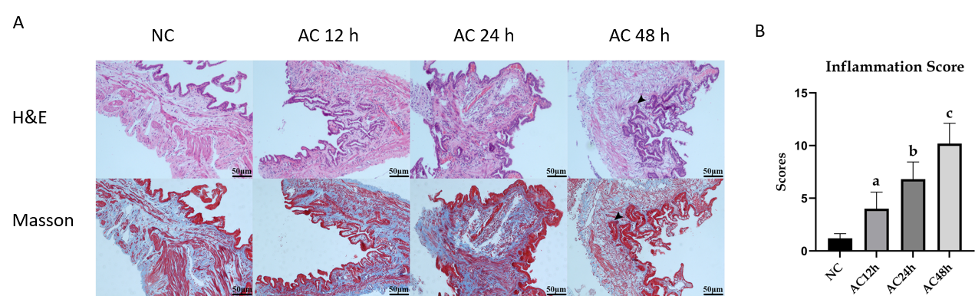
Figure 1 Histopathological analysis of a guinea pig model of acute cholecystitis (100 ×). A: Gallbladders in the normal control (NC) group were intact and showed no congestion, edema, or obvious inflammatory cell infiltration. The gallbladders in the acute cholecystitis (AC) groups showed edema, fibroplasia, congestion, mucosal necrosis, considerable inflammatory cell infiltration, and were significantly aggravated over time. In addition, the R-A sinus was present in the lamina propria of the gallbladders in the AC48h group (arrowhead); B: The inflammation score of the NC, AC12h, AC24h, and AC48h groups were 1.20 ± 0.20, 4.00 ± 0.71, 6.80 ± 0.73, and 10.20 ± 0.86, respectively (ªP < 0.05 vs NC groups, ^{b}P < 0.001 vs NC groups, ^{c}P < 0.0001 vs NC groups). AC: Acute cholecystitis; NC: Normal control; R-A: Rokitansky-Aschoff; H&E: Hematoxylin and eosin.

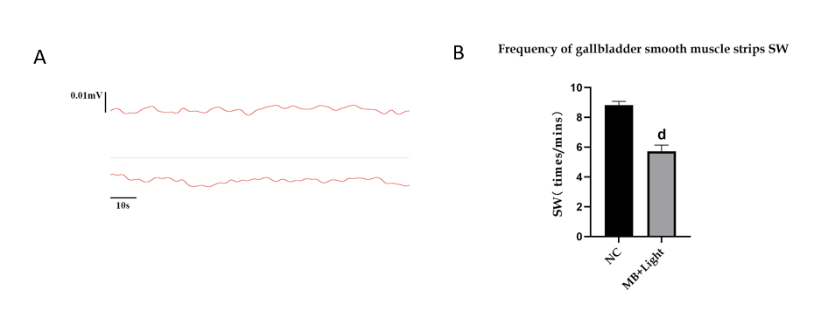
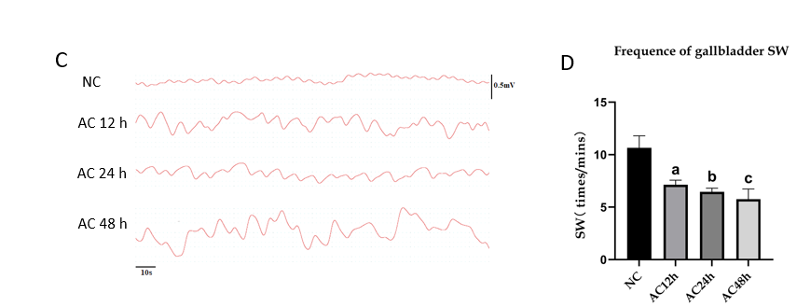
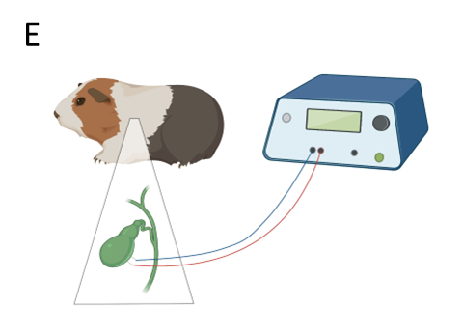
Figure 2 Recording of the gallbladder slow wave by electromyogram. A and B: The mean slow wave (SW) frequency in the normal control (NC), methylene blue + light groups were 8.81 ± 0.25 vs 5.71 ± 0.43 (^{d}P < 0.001 vs NC groups); C and D: The mean SW frequency in the NC, acute cholecystitis 12 h (AC12h), AC24h, and AC48h groups were 10.66 ± 0.51, 7.13 ± 0.20, 6.46 ± 0.16, and 5.75 ± 0.44, respectively (ªP < 0.0001 vs NC groups, ^{b}P < 0.0001 vs NC groups, ^{c}P < 0.0001 vs NC groups); E: Illustration of a SW recording of the guinea pig gallbladder. SW: Slow wave; EMG: Electromyogram; NC: Normal control; AC: Acute cholecystitis; MB: Methylene blue.

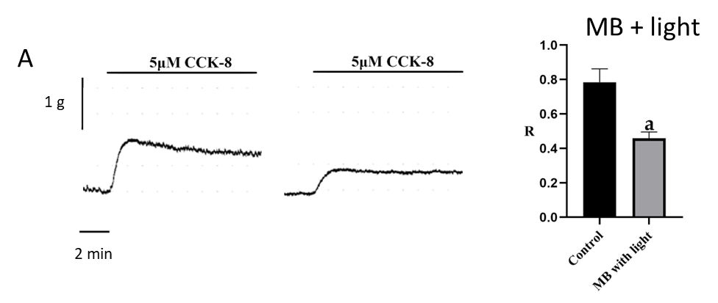
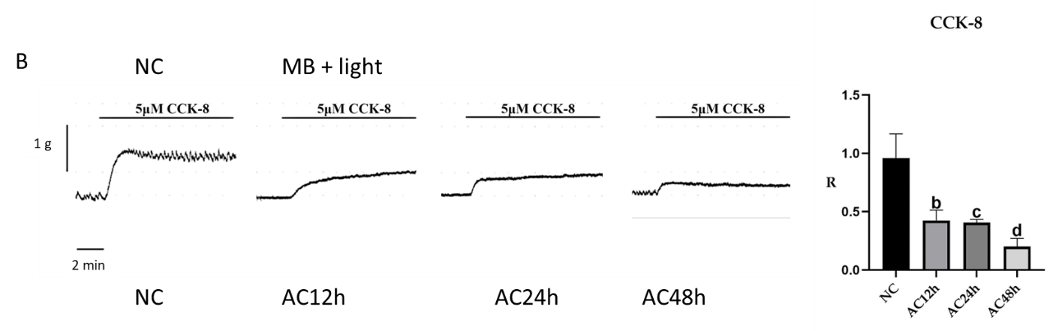
Figure 3 Effects of cholecystokinin octapeptide-induced contraction of gallbladder muscle strips. A: Destroying interstitial cells of Cajal can induce impairment of gallbladder muscle motility by loading methylene blue with light illumination [0.78 ± 0.08 vs 0.46 ± 0.04, ªP < 0.01 vs normal control (NC) groups]; B: The cholecystokinin octapeptide-induced effect of the R value in the NC, AC12h, AC24h, and AC48h groups were 0.96 ± 0.21, 0.42 ± 0.09, 0.41 ± 0.03, and 0.20 ± 0.07, respectively (^{b}P < 0.05 vs NC groups, ^{c}P < 0.05 vs NC groups, ^{d}P < 0.01 vs NC groups). CCK-8: Cholecystokinin octapeptide; ICCs: Interstitial cells of Cajal; MB: Methylene blue; NC: Normal control; AC: Acute cholecystitis.

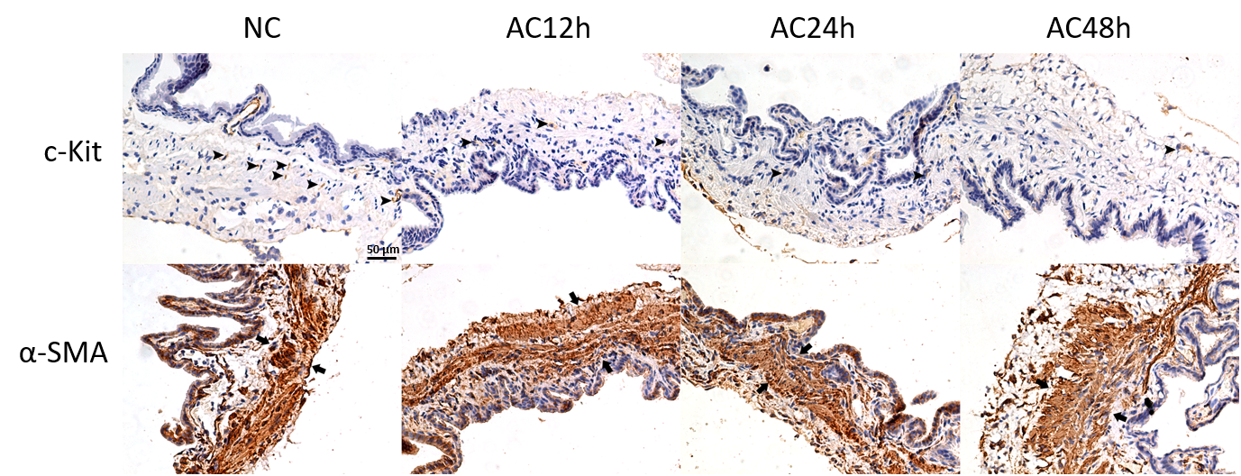
Figure 4 Sections of guinea pig gallbladder were stained with anti-c-Kit and anti-α-SMA antibodies and visualized with 3,3-diaminobenzidine in the normal control and acute cholecystitis groups (200 ×). Interstitial cells of Cajal (ICCs) (arrowheads) were present in the muscular layer of the gallbladder. The number of ICCs was obviously reduced in each acute cholecystitis (AC) group compared with the normal control (NC) group. Notably, there was no significant difference in gallbladder smooth muscle (arrows) morphology and structure between the NC and AC groups. NC: Normal control; AC: Acute cholecystitis; ICCs: Interstitial cells of Cajal; GBSM: Gallbladder smooth muscle.

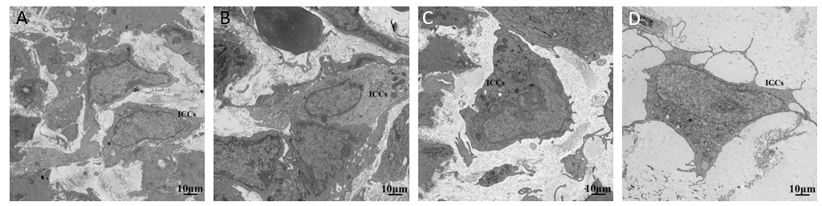
Figure 5 Transmission electron microscopy results of interstitial cells of Cajal of the guinea pig gallbladder in the normal control and acute cholecystitis groups. A: The normal interstitial cells of Cajal (ICCs) had ovoid or triangular bodies, one to three cytoplasmic processes, large nuclei, abundant mitochondria, endoplasmic reticulum, and caveolae; B: ICCs from the AC12h group presented swollen cell bodies with enlarged mitochondria; C: The impaired ICCs from the AC24h group had more swollen cytoplasm. The distance between ICCs and other cells (mainly smooth muscle cells) was increased; D: The isolated ICCs in loose gallbladder tissue was significant swollen with ruptures in the cytoplasm membrane, and processes diminished. TEM: Transmission electron microscopy; ICCs: Interstitial cells of Cajal; NC: Normal control; AC: Acute cholecystitis; SMCs: Smooth muscle cells; ER: Endoplasmic reticulum. Bar: 10 μm.

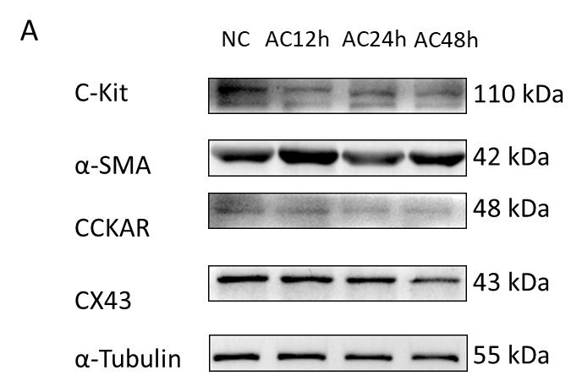
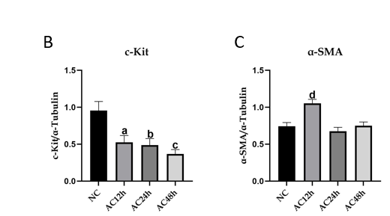
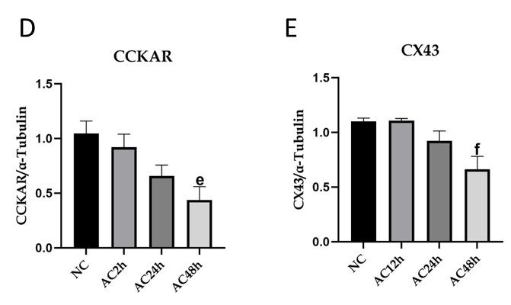
Figure 6 Western blot analysis of the normal control and acute cholecystitis groups. A: The protein expression level of c-Kit, cholecystokinin A receptor (CCKAR) and connexin 43 (CX43) in guinea pig acute cholecystitis (AC) model of gallbladders was decreased; B: The mean grayscale values of c-Kit protein levels in the normal control (NC), AC12h, AC24h, and AC48h groups were 0.96 ± 0.12, 0.53 ± 0.09, 0.49 ± 0.09, and 0.37 ± 0.06, respectively (ªP < 0.05 vs NC groups, ^{b}P < 0.05 vs NC groups, ^{c}P < 0.01 vs NC groups); C: The mean grayscale values of α-SMA protein levels in the NC, AC12h, AC24h, and AC48h groups were 0.74 ± 0.05, 1.05 ± 0.05, 0.67 ± 0.05, and 0.75 ± 0.05, respectively (^{d}P < 0.05 vs NC groups); D: The mean grayscale values of CCKAR protein levels in the NC, AC12h, AC24h, and AC48h groups were 1.05 ± 0.11, 0.92 ± 0.12, 0.66 ± 0.10, 0.44 ± 0.12, respectively (^{e}P < 0.05 vs NC groups); E: The mean grayscale values of CX43 protein levels in the NC, AC12h, AC24h, and AC48h groups were 1.10 ± 0.30, 1.11 ± 0.02, 0.92 ± 0.09, 0.66 ± 0.12, respectively (^{f}P < 0.01 vs NC groups). NC: Normal control; AC: Acute cholecystitis; CCKAR: Cholecystokinin A receptor; CX43: Connexin 43.

