Name of Journal: World Journal of Clinical Cases
Manuscript NO: 78203
Manuscript Type: CASE REPORT

Novel liver vein deprivation technique that promotes increased residual liver volume (with video): A case report

Wu G et al. Laparoscopic liver venous deprivation

Gang Wu, Ji-Peng Jiang, Dong-Hui Cheng, Chong Yang, Dong-Xu Liao, Yu-Bo Liao, Wan-Yee Lau, Yu Zhang

Gang Wu, Ji-Peng Jiang, Dong-Hui Cheng, Dong-Xu Liao, Yu Zhang, Yu-Bo Liao, Department of Hepatobiliary Surgery, Sichuan Provincial People’s Hospital, University of Electronic Science and Technology of China, Chengdu 610072, Sichuan Province, China

Chong Yang, Organ Transplantation Center, Sichuan Provincial People’s Hospital, University of Electronic Science and Technology of China, Chengdu 610072, Sichuan Province, China

Wan-Yee Lau, Faculty of Medicine, The Chinese University of Hong Kong, Prince of Wales Hospital, Hongkong 999077, China

Author contributions: Lau WY, Liao YB and Wu G contributed to manuscript writing and editing, and data collection; Jiang JP, Cheng DH, Yang C and Liao DX contributed to data analysis; Zhang Y contributed to conceptualization and supervision; all authors have read and approved the final manuscript.

Corresponding author: Yu Zhang, MD, Associate Professor, Department of Hepatobiliary Surgery, Sichuan Provincial People’s Hospital, University of Electronic Science and Technology of China, No. 32 Yihuan Road, Chengdu 610072, Sichuan Province, China. 68532815@qq.com

Received: June 29, 2022
Revised: September 9, 2022
Accepted: September 29, 2022
Published online:

Abstract
BACKGROUND
Inadequate volume of future liver remnant (FLR) is a major challenge for hepatobiliary surgeons treating large or multiple liver tumors. As an alternative to associating liver partition and portal vein ligation (ALPPS) for staged hepatectomy and liver venous deprivation (LVD) using stage 1 interventional radiology for vascular embolization combined with stage 2 open liver resection have been used.

CASE SUMMARY
A novel modified LVD technique was performed in a patient with pancreatic neuroendocrine tumor with liver metastases by using stage 1 laparoscopic ligation of the right hepatic vein, right posterior portal vein, and short hepatic veins combined with local excision of three liver metastases in the left hemiliver. The operation was followed three days later by interventional radiology to embolize an anomalous right anterior portal vein to complete LVD. A stage 2 laparoscopic right hemihepatectomy and pancreaticosplenectomy were then carried out.

CONCLUSION
The minimally invasive technique promoted a rapid increase, comparable to ALPPS, in volume of the FLR after the stage 1 operation to allow the laparoscopic stage 2 resection to be performed.

Key Words: Laparoscopic; Liver venous deprivation; Future liver remnant; Case report

Wu G, Jiang JP, Cheng DH, Yang C, Liao DX, Liao YB, Lau WY, Zhang Y. Novel liver vein deprivation technique that promotes increased residual liver volume (with video): A case report. World J Clin Cases 2022; In press

Core Tip: A novel modified technique of liver venous deprivation was carried out in a patient with pancreatic neuroendocrine tumor with liver metastases by using stage 1 laparoscopic ligation of right hepatic vein, right posterior portal vein and short hepatic veins combined with local excision of 3 liver metastases in left hemiliver.

INTRODUCTION
Partial hepatectomy performed with curative intent is the most common treatment for primary and some metastatic tumors of the liver. Inadequate volume of future liver remnant (FLR) is a major limiting factor for major hepatectomy. Surgeons around the world have attempted to solve this problem with portal vein embolization (PVE), portal vein ligation (PVL) or ALPPS. However, these techniques have their own intrinsic defects. The degrees of increase in volume of FLR induced by PVE and PVL are relatively small, thus requiring a long wait period before stage 2 hepatectomy can be performed. ALPPS can produce greater increases in FLR volume but has high operative morbidity and mortality rates. Our center has reported various attempts to overcome these problems, including the use of a totally laparoscopic associating liver tourniquet and portal ligation for staged hepatectomy (LALTPS) via the anterior approach to treat hepatocellular carcinoma (HCC) in 2015, a technique involving liver tourniquet combined with rescue transhepatic arterial embolization for staged hepatectomy in 2017^{[1,2]}, and mono-segmental ALPPS to treat end-stage hepatic alveolar echinococcosis in 2022^{[3]}.
Recently, liver venous deprivation (LVD) involving interventional radiology has been reported to induce a comparable rate of increase in FLR volume to ALPPS but with lower morbidity and mortality^{[4]}. A novel modification of the LVD technique was performed in our center on a patient with pancreatic neuroendocrine tumor (PNET) with liver metastases. The team used stage 1 laparoscopic ligation of right hepatic vein, right portal vein, and thick short hepatic veins (here called laparoscopic liver venous deprivation, or LLVD), combined with laparoscopic local resection of three metastases in the left hemiliver. In this patient, complete LVD was achieved three days later by interventional radiology to embolize the anomalous right anterior portal vein that drained into the left portal vein. A stage 2 laparoscopic pancreatiosplenectomy and right hemi-hepatectomy were then carried out in this patient. The stage 1 minimally invasive LVD procedures significantly increased FLR volume to allow the stage 2 laparoscopic resection. To our knowledge, this is the first report on this new technique–using completely laparoscopic and interventional radiology for the two-stage minimally invasive procedure to achieve complete LVD–to allow a subsequent stage 2 laparoscopic resection surgery.

CASE PRESENTATION
Chief complaints
A 46-year-old woman presented to our clinic with pathologically confirmed pancreatic neuroendocrine tumor with multiple liver metastases (PNET, G2 grade) for 2 mo.

History of present illness
Two months before, she was diagnosed as “multiple space-occupying lesions” with computed tomography (CT) in physical examination.

History of past illness
After the biopsy in department of medical oncology, the patient received two cycles of systemic chemotherapy using streptozotocin and 5-fluorouracil before surgical treatment. However, the tumors failed to significantly respond to chemotherapy.

Personal and family history
The patient denied any family history of malignant tumors.

Physical examination
The vital signs were normal, no abdominal abnormities were found.

Laboratory examinations
Serology showed her to be negative for hepatitis. The preoperative indocyanine green (ICG) R15 for stage 1 surgery was 1.3%, and that for stage 2 surgery 8%. She had normal liver function (Child-Pugh A).

Imaging examinations
Her standardized liver volume (SLV) was 1116.6 cm³ based on the West China Hospital formula. Her body weight (BW) was 60 kg. Her left hemiliver (LHL) volume, including the tumors, was 401.6 mL, and the FLR/BW and FLR/SLV were 0.67% and 36%, respectively. The representative pre-/postoperative CT scans, including the preoperative (stage 1), postoperative day 1 (stage 1), postoperative day 10 (stage 1), postoperative day 60 (stage 1), preoperative (stage 2)/postoperative day 90 (stage 1), and postoperative day 7 (stage 2) are shown in Figure 1. Calculations of the liver residual volumes before and after the stage 1 operation are summarized in Table 1, showing the volume of the left hemiliver without tumors to be 381.7 mL. The preoperative three-dimensional reconstructions of stage 1 (Figure 2H) and stage 2 operations (Figure 2I) are shown in Figure 2.

FINAL DIAGNOSIS
Pancreatic neuroendocrine tumor with multiple liver metastases.

TREATMENT
A two-staged hepatectomy was decided based on the low FLV/BW (0.67%) and the history of chemotherapy.
The stage 1 operation consisted of laparoscopic ligation of right posterior portal vein (RPPV) (Figure 2A), right hepatic vein (RHV) (Figure 2F), and several thick short hepatic veins combined with local resection of three tumors in the left hemiliver (Figure 2B-C). In the operation, after temporarily clamping the RHV with a bulldog clamp, the blood supply to the liver was monitored intraoperatively using ICG staining (Figure 2D-E). The hepatic ischemia induced by LLVD was moderate in the right hemiliver. The RHV was then ligated, followed by the other procedures as described above. The anomalous right anterior port vein (RAPV), which was found preoperatively to drain into the left portal vein, was embolized by interventional radiology on postoperative day (POD) 3. After discharging the patient home after the stage 1 operation, the patient was given 300-mg surufatinib capsules orally daily (Hutchmed, Shanghai, China) until one week before the stage 2 operation. No significant side effects were observed.
Laparoscopic right hemi-hepatectomy and distal pancreaticosplenectomy were performed on POD 90 of the stage 1 operation. The patient was discharged home from the hospital on POD 8 after the stage 2 operation. The detailed procedures are shown in Figure 2 and Video.

OUTCOME AND FOLLOW-UP
After the stage 1 operation, CT volumetry was performed once every 2 d for 10 d, and the results are shown in Table 1. The relative FLR increase in volume of the left hemiliver in percentage, and the kinetic growth rate in mL/day were 27.3/37.5 on POD 1 and 98.4/104.3 on POD 10, respectively. This novel technique of liver vein deprivation is less invasive than using open surgery, and the patient did not suffer from any post-treatment complications, such as bile leakage or hemorrhage. The perioperative laboratory data are shown in Table 2, supporting the safety of this technique. The stage 2 resection surgery was also performed laparoscopically, and the patient was discharged home on POD 8 (Figure 2G).
The patient was followed up till now, more than 6 mo, alive without tumor recurrence.

DISCUSSION
Kinoshita et al^{[4]} reported in 1986 that PVE was able to induce contralateral liver volume enlargement. This procedure has since become an accepted means of increasing FLR volume, though the degree of increase is relatively small. ALPPS is more effective in promoting a more rapid change in the FLR volume (+74% in a median of 9 d). However, the perioperative morbidity and mortality rates are high as a consequence to the extensive surgical procedure and trauma^{[5]}. LVD was initially performed by sequential embolization of the portal vein and then the hepatic vein by using the interventional route^{[6]}. Subsequently, concurrent trans-hepatic PVE and hepatic vein embolization have been shown to be safe, feasible, and effective. The increase in FLR volume has been reported to be 59.3% on day 27^{[7]}. Other authors have reported that extending LVD (eLVD) by embolizing the middle hepatic vein in addition to the RHV can increase the degree of increase in FLR volume to an extent comparable to that obtained produced ALPPS (average 64.3%, range from 28.1% to 107.5%, on day 21)^{[8,9]}. This approach, which is also called “radiological ALPPS,” has been proposed by some authors as a replacement for ALPPS because it is less invasive.

CONCLUSION
In conclusion, this is a case report on a patient with PNET with multiple liver metastases. The PNET G2 is a borderline tumor with malignant characteristics. It was treated with laparoscopic ligation of RPPV, short hepatic veins and RHV. 3 metastases in the left hemiliver were also resected in stage 1, clean-up in ALPPS to prevent growth of FLR tumors^{[10]}. Embolization of RAPV by interventional radiology was performed on POD 3 for an anomalous portal venous branch to complete LVD. This novel approach increased the left hemiliver volume by 27.3% on POD 1 and 98.4% on POD 10. There were no major complications. Like ALPPS, eLVD, and traditional LVD, this procedure was safe and effective. Complete LVD by laparoscopic ligation of RHV, RPPV, and several thick, short hepatic veins and embolization of RAPV, were responsible for the good results. The liver function of this patient recovered rapidly within one week. The multiple hepatic metastatic lesions and the pancreatic tumor were dealt with using a stage 2 laparoscopic pancreaticosplenectomy and right hemi-hepatectomy based on our rich experience in laparoscopic surgery. Concurrent targeted therapy using surufatinib was used to prevent future remnant tumor growth and metastasis. This reported surgical treatment needs further research, and more cases are required to establish its proper role in treating these patients.

REFERENCES
1 Xu J, Lu X, Zhang Y, Yang H, Yu X. Laparoscopic associating liver tourniquet and portal ligation combined rescue transhepatic arterial embolization for staged hepatectomy: A case report. Medicine (Baltimore) 2017; 96: e8378 [PMID: 29069032 DOI: 10.1097/MD.0000000000008378]
2 Zhang Y, Yang H, Chen Y, Zhu S, Lu T, Jun X. Totally Laparoscopic Associating Liver Tourniquet and Portal Ligation for Staged Hepatectomy via Anterior Approach for Cirrhotic Hepatocellular Carcinoma. J Am Coll Surg 2015; 221: e43-e48 [PMID: 26206661 DOI: 10.1016/j.jamcollsurg.2015.04.016]
3 Tang JC, Suolang WJ, Yang C, Wang Y, Tian MW, Zhang Y. Monosegmental ALPPS combined with ante-situm liver resection: A novel strategy for end-stage hepatic alveolar echinococcosis. Hepatobiliary Pancreat Dis Int 2022; 21: 186-189 [PMID: 33879408 DOI: 10.1016/j.hbpd.2021.03.010]
4 Kinoshita H, Sakai K, Hirohashi K, Igawa S, Yamasaki O, Kubo S. Preoperative portal vein embolization for hepatocellular carcinoma. World J Surg 1986; 10: 803-808 [PMID: 3022488 DOI: 10.1007/BF01655244]
5 Schnitzbauer AA, Lang SA, Goessmann H, Nadalin S, Baumgart J, Farkas SA, Fichtner-Feigl S, Lorf T, Goralcyk A, Hörbelt R, Kroemer A, Loss M, Rümmele P, Scherer MN, Padberg W, Königsrainer A, Lang H, Obed A, Schlitt HJ. Right portal vein ligation combined with in situ splitting induces rapid left lateral liver lobe hypertrophy enabling 2-staged extended right hepatic resection in small-for-size settings. Ann Surg 2012; 255: 405-414 [PMID: 22330038 DOI: 10.1097/SLA.0b013e31824856f5]
6 Hwang S, Lee SG, Ko GY, Kim BS, Sung KB, Kim MH, Lee SK, Hong HN. Sequential preoperative ipsilateral hepatic vein embolization after portal vein embolization to induce further liver regeneration in patients with hepatobiliary malignancy. Ann Surg 2009; 249: 608-616 [PMID: 19300228 DOI: 10.1097/SLA.0b013e31819ecc5c]
7 Guiu B, Chevallier P, Denys A, Delhom E, Pierredon-Foulongne MA, Rouanet P, Fabre JM, Quenet F, Herrero A, Panaro F, Baudin G, Ramos J. Simultaneous trans-hepatic portal and hepatic vein embolization before major hepatectomy: the liver venous deprivation technique. Eur Radiol 2016; 26: 4259-4267 [PMID: 27090112 DOI: 10.1007/s00330-016-4291-9]
8 Deshayes E, Schadde E, Piron L, Quenet F, Guiu B. Extended Liver Venous Deprivation Leads to a Higher Increase in Liver Function that ALPPS in Early Assessment : A comment to "Sparrelid, E. et al Dynamic Evaluation of Liver Volume and Function in Associating Liver Partition and Portal Vein Ligation for Staged Hepatectomy. Journal of Gastrointestinal Surgery (2017)". J Gastrointest Surg 2017; 21: 1754-1755 [PMID: 28785933 DOI: 10.1007/s11605-017-3508-9]
9 Guiu B, Quenet F, Escal L, Bibeau F, Piron L, Rouanet P, Fabre JM, Jacquet E, Denys A, Kotzki PO, Verzilli D, Deshayes E. Extended liver venous deprivation before major hepatectomy induces marked and very rapid increase in future liver remnant function. Eur Radiol 2017; 27: 3343-3352 [PMID: 28101681 DOI: 10.1007/s00330-017-4744-9]
10 Alvarez FA, Ardiles V, Sanchez Claria R, Pekolj J, de Santibañes E. Associating liver partition and portal vein ligation for staged hepatectomy (ALPPS): tips and tricks. J Gastrointest Surg 2013; 17: 814-821 [PMID: 23188224 DOI: 10.1007/s11605-012-2092-2]

Footnotes
Informed consent statement: All procedures performed in this study that involved human participants were performed in accordance with the ethical standards of the Human Subjects Committee of the Sichuan Provincial People’s Hospital, University of Electronic Science and Technology of China, and with the 1964 Helsinki Declaration and its later amendments or comparable ethical standards. Informed written consent was obtained from the patient for publication of this report and any accompanying images.

Conflict-of-interest statement: All authors declare that they have no conflicts of interest.

CARE Checklist (2016) statement: The authors have read the CARE Checklist (2016), and the manuscript was prepared and revised according to the CARE Checklist (2016)

Open-Access: This article is an open-access article that was selected by an in-house editor and fully peer-reviewed by external reviewers. It is distributed in accordance with the Creative Commons Attribution NonCommercial (CC BY-NC 4.0) license, which permits others to distribute, remix, adapt, build upon this work non-commercially, and license their derivative works on different terms, provided the original work is properly cited and the use is non-commercial. See: https://creativecommons.org/Licenses/by-nc/4.0/

Provenance and peer review: Unsolicited article; Externally peer reviewed.
Peer-review model: Single blind

Peer-review started: June 29, 2022
First decision: September 5, 2022
Article in press:

Specialty type: Surgery
Country/Territory of origin: China
Peer-review report’s scientific quality classification
Grade A (Excellent): 0
Grade B (Very good): 0
Grade C (Good): C, C
Grade D (Fair): 0
Grade E (Poor): 0

P-Reviewer: Giordano A, Italy; Rather AA, India S-Editor: Wu YXJ L-Editor: A P-Editor: Wu YXJ

Figure Legends
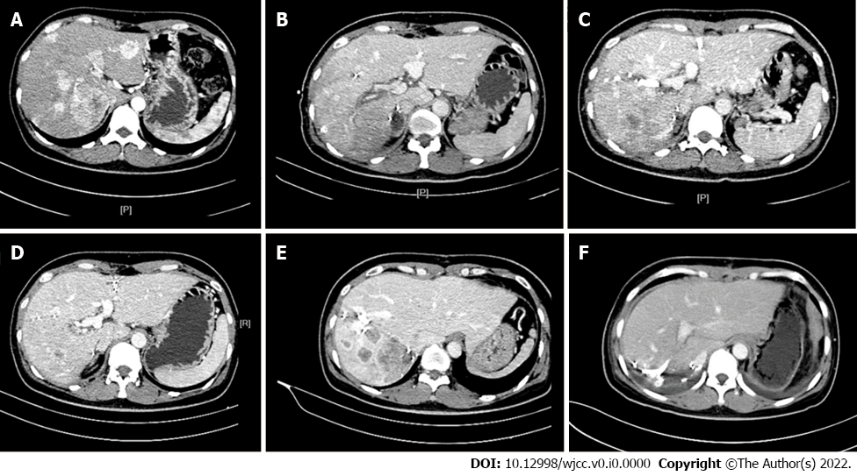
Figure 1 Representative computed tomography scans. A: Representative computed tomography scans before stage 1; B: Representative computed tomography scans before postoperative day (POD) 1; C: Representative computed tomography scans before POD 10; D: Representative computed tomography scans before POD 60; E: Representative computed tomography scans before POD 90/before stage 2; F: Representative computed tomography scans before POD 7, stage 2.

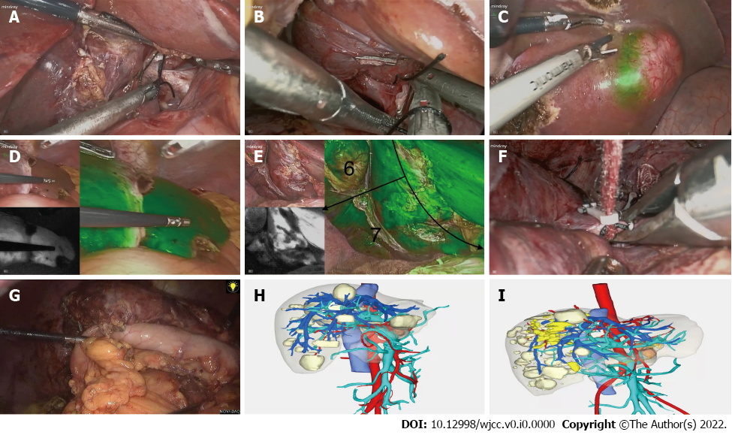
Figure 2 Representative pictures of the stage 1 and stage 2 operations. A-C: Laparoscopic ligation of right posterior portal vein (A), short hepatic vein (B), and complete resection of tumors in the left hemiliver (C); D-F: Post-ligation blood supply of left hemiliver (D) and right hemiliver (E) on indocyanine green staining during the stage 1 operation. Laparoscopic ligation of right hepatic vein (F); G: Stage 2 operation after resectional surgery; H and I: Preoperative three-dimensional reconstructions before stage 1 operation (H) and before stage 2 operation (I).

Table 1 Volumetric data
Time | LHL volume (cm³) | Relative FLR increase (%) | FLR/BW, % | LHL volume /SLV (%)
BO | 381.7 | / | 0.64 | 34.18
POD 1 | 485.9 | 27.3 | 0.81 | 43.52
POD 10 | 757.1 | 98.4 | 1.26 | 67.80
POD 60 | 787.4 | 106.3 | 1.31 | 70.52
POD 90 | 810.5 | 112.4 | 1.35 | 72.58
POD: Postoperative day; LHL: Left hemi liver; FLR: Future liver remnant; BO: Before operation; SLV: Standardized liver volume; BW: Body weight.

Table 2 Perioperative data
Time | AST, U/L | ALT,  U/L | TBIL,  μmmol/L | DBIL,  μmmol/L | Alb,  g/L | INR | PT, s
BO | 38 | 63 | 8.8 | 3.9 | 37.2 | 1.02 | 11.4
POD 1 (STAGE 1) | 402 | 567 | 14.1 | 5.6 | 29.7 | 1.15 | 12.8
POD 3 (STAGE 1) | 141 | 365 | 13.4 | 5.7 | 30.4 | 1.11 | 12.4
POD 5 (STAGE 1) | 74 | 245 | 12.5 | 5.6 | 31.7 | 1.12 | 12.3
POD 7 (STAGE 1) | 56 | 168 | 10.4 | 4.5 | 31.1 | 1.12 | 12.5
POD 9 (STAGE 1) | 47 | 113 | 21.7 | 8.4 | 34.8 | 1.11 | 13.8
POD 1 (STAGE 2) | 320 | 203 | 31.5 | 13.5 | 30.0 | 1.30 | 14.4
POD 3 (STAGE 2) | 143 | 144 | 16.6 | 5.2 | 23.1 | 1.22 | 13.6
POD 5 (STAGE 2) | 73 | 114 | 29.4 | 15.1 | 29.1 | 1.24 | 13.8
POD 7 (STAGE 2) | 29 | 46 | 16.7 | 7.9 | 39.2 | 1.21 | 13.5
Alb: Albumin; ALT: Alanine aminotransferase; AST: Aspartate transaminase; DBIL: Serum direct bilirubin; INR: International normalized ratio; Neu: Neutrophil granulocyte; PT: Prothrombin time; TBIL: Serum total bilirubin.

