Name of Journal: World Journal of Gastrointestinal Surgery
Manuscript NO: 87400
Manuscript Type: ORIGINAL ARTICLE

Basic Study
Mutational separation and clinical outcomes of TP53 and CDH1 in gastric cancer

Liu HL et al.TP53 and CDH1 mutations in GC

He-Li Liu, Huan Peng, Chang-Hao Huang, Hai-Yan Zhou, Jie Ge

He-Li Liu, Jie Ge, Department of Gastrointestinal Surgery, Xiangya Hospital, Central South University, Changsha 410008, Hunan Province, China

Huan Peng, Clinical Nursing Teaching and Research Section, Xiangya Hospital, Central South University, Changsha 410008, Hunan Province, China

Chang-Hao Huang, Teaching and Research Section of Clinical Nursing, Xiangya Hospital, Central South University, Changsha 410008, Hunan Province, China

Hai-Yan Zhou, Department of Pathology, Xiangya Hospital, Central South University, Changsha 410008, Hunan Province, China

Co-first authors: He-Li Liu and Huan Peng.

Author contributions: Liu HL, Peng H, and Ge J designed the study; Huang CH collected and analyzed the clinical data; and Zhou HY wrote the paper; Liu HL and Peng H contributed equally to this work as co-first authors. The reasons for designating Liu HL and Peng H as co-first authors are threefold. First, the research was performed as a collaborative effort, and the designation of co-first authors accurately reflects the distribution of responsibilities and burdens associated with the time and effort required to complete the study and the resulting paper. This also ensures the effective communication and management of post-submission matters, ultimately enhancing the quality and reliability of the paper. Second, the research team encompasses authors with a variety of expertise and skills from different fields, and the designation of co-first authors best reflects this diversity. This also promotes a more comprehensive and in-depth examination of the research topic, ultimately enriching readers' understanding by offering various expert perspectives. Third, Liu HL and Peng H contributed efforts of equal substance throughout the research process. The choice of these researchers as co-first authors acknowledges and respects their equal contribution, while recognizing the spirit of teamwork and collaboration in this study. In summary, we believe that designating Liu HL and Peng H as co-first authors fits our manuscript as it accurately reflects our team's collaborative spirit, equal contributions, and diversity. All authors approved the final version of the article.

Supported by Guangdong Yiyang Healthcare Charity Foundation, No. JZ2022014.

Corresponding author: Jie Ge, MD, Attending Doctor, Department of Gastrointestinal Surgery, Xiangya Hospital, Central South University, No. 87 Xiangya Road, Kaifu District, Changsha 410008, Hunan Province, China. gejie@csu.edu.cn

Received: September 13, 2023
Revised: October 18, 2023
Accepted: November 21, 2023
Published online: December 27, 2023

Abstract
BACKGROUND
Gastric cancer (GC) is a deadly tumor with the fifth highest occurrence and highest global mortality rates. Owing to its heterogeneity, the underlying mechanism of GC remains unclear, and chemotherapy offers little benefit to individuals.

AIM
To investigate the clinical outcomes of TP53 and CDH1 mutations in GC.

METHODS
In this study, 202 gastric adenocarcinoma tumor tissues and their corresponding normal tissues were collected. A total of 490 genes were identified using target capture. Through t-test and Wilcoxon rank-sum test, somatic mutations, microsatellite instability, and clinical statistics, including overall survival, were detected, compared, and calculated.

RESULTS
The mutation rates of 32 genes, including TP53, SPEN, FAT1, and CDH1 exceeded 10%. TP53 mutations had a slightly lower overall occurrence rate (33%). The TP53 mutation rate was significantly higher in advanced stages (stage III/IV) than that in early stages (stage I/II) (P < 0.05). In contrast, CDH1 mutations were significantly associated with diffuse GC. TP53 is related to poor prognosis of advanced-stage tumors; nevertheless, CDH1 corresponds to a diffuse type of cancer. TP53 is exclusively mutated in CDH1 and is primarily affected by two distinct GC mechanisms.

CONCLUSION
Different somatic mutation patterns in TP53 and CDH1 indicate two major mechanisms of GC.

Key Words: Gastric cancer; TP53 mutation; CDH1 mutation; Clinical outcome; Somatic mutation; Diffuse gastric cancer

©The Author(s) 2023. Published by Baishideng Publishing Group Inc. All rights reserved.

Citation: Liu HL, Peng H, Huang CH, Zhou HY, Ge J. Mutational separation and clinical outcomes of TP53 and CDH1 in gastric cancer. World J Gastrointest Surg 2023; 15(12): 2855-2865
URL: https://www.wjgnet.com/1948-9366/full/v15/i12/2855.htm
DOI: https://dx.doi.org/10.4240/wjgs.v15.i12.2855

Core Tip: Mutational separation of TP53 and CDH1 in gastric cancer (GC) reveals their distinct mechanisms. TP53 mutations are associated with advanced-stage tumors and poor prognoses, whereas CDH1 mutations are associated with diffuse GC. This study highlights the heterogeneity of GC and provides insights into potential targeted therapies based on specific mutation patterns. Understanding the mutational landscape of TP53 and CDH1 can contribute to personalized treatment approaches for patients with GC.

INTRODUCTION
Gastric cancer (GC) is one of the most severe malignancies globally, with the fifth leading incidence and highest mortality rates^{[1]}. Global Cancer Statistics in 2018 revealed that GC was the second most prevalent malignant tumor in China, with high morbidity and mortality rates and the third leading cause of cancer-related deaths globally after lung cancer^{[2,3]}. Although it remains unclear, the pathogenesis of GC is caused by several factors, including genetic background and the external environment^{[4]}. Although standardized treatment for GC is continually improving, its overall incidence and mortality rates remain high. The poor prognosis of patients with GC is attributed to limited therapeutic interventions^{[5,6]}. However, detecting hidden symptoms in the early stages is difficult; hence, most patients are diagnosed at advanced stages^{[7,8]}. The current treatment for GC is primarily surgical resection combined with preoperative or postoperative adjuvant chemotherapy or radiochemotherapy^{[5,9]}. Chemotherapy remains the primary method for postoperative treatment of advanced GC. D2 gastrectomy is the recommended treatment for GC, followed by postoperative adjuvant chemotherapy^{[10]}. However, the tumor response rate to postoperative chemotherapy is low, and patients respond differently to chemotherapy^{[11,12]}. This difference in the response to chemotherapy among patients occurs because GC is a heterogeneous disease that can manifest as differences in gene expression, biological features, and drug sensitivity^{[13]}. Studies on the pathogenesis, biological markers, targeted sequencing, and treatment of GC are advancing given the rapid developments in molecular biology, genomics, bioinformatics, and high-throughput next-generation sequencing. Specifically, advancements in individualized treatment and precision medicine for tumors underscore the need to understand the biological characteristics of GC.
The activation of oncogenes or inactivation of tumor suppressor genes caused by somatic gene mutations modulate the development of malignant tumors, as shown by in depth research on the molecular basis of GC^{[14]}. Therefore, identifying potential driver genes and mutations associated with GC is key to understanding the mechanism of GC occurrence and development, as well as in formulating a follow-up treatment scheme. In this study, target-capture sequencing was used to sequence 490 genes from 202 gastric adenocarcinoma (GAC) cases and adjacent tissue samples to detect somatic mutations.

MATERIALS AND METHODS
Samples
This study enrolled 202 patients with GAC comprising 135 and 67 male and female patients, respectively, who underwent surgery at the Department of Gastrointestinal Surgery, Xiangya Hospital, Central South University, China, between January 1, 2014, and December 31, 2015. Primary GAC tumor tissues and matched non-cancerous (NC) tissues located at least 5 cm away from the tumor core were obtained after surgical resection, immediately processed, and stored for subsequent use. None of the recruited patients received chemotherapy or radiotherapy before surgery. Histopathological diagnosis was performed preoperatively and confirmed surgically based on the World Health Organization Classification of Tumors^{[15]}. Tumor stage was defined according to the eighth IASLC (international association for the study of lung cancer)/AJCC (American joint committee on cancer) staging system^{[16]}. Written informed consent was obtained from each patient prior to surgery. This study was approved by the Research Ethics Committee of Central South University (NO. 2023087), China. All specimens were handled and anonymized according to ethical and legal guidelines.

Experiments
DNA was extracted from the cancer and NC tissues using a customized panel from Roche NimbleGen, Inc. The customized panel included the exons and hotspots of 490 genes, with a total length of 1 Mb. An × 10 sequencer (Illumina Inc.) was used for sequencing in the PE150 mode. All patients underwent curative resection; 27 IA-stage patients did not receive comprehensive treatment, 22 IB-stage patients received S1 chemotherapy, and patients with stage II and above received SOX chemotherapy. After treatment, the patient follow-ups were conducted via phone calls and online contact.

Sequencing data analysis
Mapping and somatic mutation calling: quality control was performed on raw sequencing data using FastQC^{[17]}; and the sequences were trimmed for adapters and low-quality bases using Trimmomatic, version 0.38, HEADCROP:3 LEADING:3 TRAILING:3 SLIDINGWINDOW:4:15 MINLEN:36^{[18]}. The trimmed reads were then aligned to GRCh37/hg19 using BWA-MEM version 0.7.17^{[19]}. PICARD^{[20]} was used to add read groups and mark the duplicates. The Genome Analysis Toolkit version 3.8^{[21]} was used for realignment of the indel area and base quality recalibration. The Genome Analysis Toolkit was also used for germline and somatic variant calling with Haplotype Caller and MuTect2, respectively. The variants were annotated using ANNOVAR^{[22]}.
Microsatellite instability (MSI) detection: Five commonly used MSI sites, BAT25, BAT26, NR21, NR24, and MONO27, were used for detection. MSI-high (MSI-H) and MSI-low (MSI-L) were selected if at least two loci between the cancer and NC tissues was correspondingly unstable.

Statistical analysis
All statistical analyses were performed using the SPSS software package (version 23.0 (SPSS Inc., Chicago, IL, United States) and R [R Core Team (2018). R: Language and environment for statistical computing. R Foundation for Statistical Computing, Vienna, Austria. URL: https://www.R-project.org/]. Quantitative data are presented as mean ± SD. Pearson's Chi-squared test was used to compare the difference among ranked data, whereas the one way analysis of variance test was performed to compare the differences among quantitative data. Survival analyses were performed using the Kaplan–Meier method and compared using the Wilcoxon log-rank test. P < 0.05 indicated statistically significant differences. For survival analysis, overall survival (OS) was defined as the period from the date of pathological diagnosis to the date of death or last follow-up. The cause of death in this study was the aggravation of GC.

RESULTS
Sample and sequencing statistics
The average age of the cohort was 55.53 ± 10.25 years, range 26–82 years. Tumor diameters were < 5 cm in 158 patients and ≥ 5 cm in 44 patients. There were 39 and 163 cases in the medium-to-high and low differentiation groups, respectively. In terms of TNM stage, 94 and 108 patients were classified with stage I/II and III/IV disease, respectively. Local lymph node metastasis was detected in 127 patients, and no metastasis was observed in 75 patients.
In all tumor and NC samples, the average sequencing base was 2.17 Gb and 1.19 Gb, and the mean sequencing depths were 829 × and 457 × respectively. In the target area, each pair of samples exhibited a mean somatic mutation of 23.1. Among all mutations, point mutations constitute the majority^{[23]}, of which missense mutations account for the largest fraction^{[24]}. Small indels primarily comprise of frameshift mutations. Among the point mutations, the order of mutation type sorted by proportion was C > T, followed by T > C, and T > G. Simultaneously, the ratio of C > T mutations is related to age. Older patients had a larger ratio of C > T mutations, possibly because of somatic methylation and lifespan. All sites were stable between tissues and the samples were microsatellite-stable (MSS).

MSI and mutations
Among the 202 samples, nine MSI-H, 19 MSI-L, and 172 MSS were detected, whereas the MSI states of the remaining two samples could not be determined^{[25-28]}. Two MSS samples were filtered out for all single-nucleotide variants under standard criteria (variation quality: PASS, location: exon, and mutation frequency > 0.01); thus, 200 samples were used for mutation-related analysis.
The tumor mutation burden (TMB) was calculated as the total number of somatic mutations divided by the capture size in Mb^{[29]}. The TMB values in the MSI-H and MSI-L samples were significantly higher than those in the MSS samples (Wilcoxon rank-sum test, both P < 0.01) (Figure 1). The TMB values were 19.0 and 55.0 in the MSS and MSI samples, respectively, with an average of 52.5 and 56.1 for MSI-H and MSI-L, respectively. Nevertheless, no significant difference was noted in TMB values between the MSI-H and MSI-L groups^{[30,31]}. The proportion of somatic point mutations in MSI samples was significantly higher than that in MSS samples, which is consistent with previous findings^{[32]}. The increase in somatic mutations caused by MSI was not statistically significant according to pathological classification (Lauren classification) or clinical stage (TNM stage).
Nearly all patients harbored somatic mutations in the target area. The most commonly mutated gene was TP53, as previously discovered; however, the mutation rate of TP53 was 33%, which is far lesser than that reported in other studies^{[23,26,27,33,34]}. In total, 32 genes had mutation rates > 10%, and 10 of these genes (including KMT2B, SPEN, and LRP1B) had mutation rates > 20% (Figure 2). Among the MSS and MSI samples, 31.8% (54/170) and 42.8% (12/28), respectively, had somatic mutations in TP53, whereas the difference was not significant between the groups (P < 0.3). Moreover, no obvious differences in the ratio of gene mutations were noted in the tumor differentiation levels or pathological types.
After co-analyzing the top 15 somatically mutated genes, TP53 did not co-mutate with other genes but was exclusively mutated with CDH1. TP53 was the most frequently mutated somatic protein in the GAC and modulated tumorigenesis. Co-analysis results suggested that TP53 mutations may be a special molecular type that does not interact with other genes during GC occurrence (Figure 3). CDH1 is an important gene associated with GAC. Therefore, further investigations were necessary because mutated TP53 and CDH1 may indicate two distinct patterns in the pathogenesis of GAC. Additionally, all genes, including FAT1, MGA, and ZFHX3, were co-mutated, except for TP53 and CDH1. Mutations in TP53 and CDH1 may present different patterns (Figure 4).

Driver genes
The driver genes were identified using OncodriveCLUST in maftools^{[35]}, followed by strict additional filtering criteria to focus on top driver genes (Figure 3). A total of 59 genes (false discovery rate < 0.05) were detected, of which only seven genes, including KMT2B, SPEN, FAT1, MGA, MED12, KIF1B, and ERBB2, overlapped with the top 20 somatically mutated genes. Most of the top driver genes, including HOXB13, AKT3, CHEK1, FGFR3, and CALR, were not included in the list of somatically mutated genes. Meanwhile, the top mutated genes, including TP53 and CDH1 were not important in the driver gene clusters because more regional clusters were identified based on the positions of the gene mutations. Low HOXB13 expression is responsible for poor tumor differentiation, metastasis^{[36]}, and poor prognosis of GC. AKT3, which has a somatic mutation frequency of 7.5%, is an important driver gene. AKT3 is an isoserine/threonine protein kinase that regulates TP53 activity through acetylation. CHEK1 (also known as CHK1), a gene involved in the DNA damage checkpoint pathway, cooperates with mismatch repair (MMR) deficiency to trigger chromosomal instability in MMR-deficient colorectal cancer cells^{[37]}. Among the eight samples with CHEK1 mutations, the numbers of MSI-H, MSI-L, and MSS were two, two, and four, respectively, which were significantly different from those in the whole cohort (P < 0.05). High CALR expression was observed in 20 of 30 patients with GC and was responsible for positive serosal invasion, lymph node metastasis, perineural invasion, and poor survival^{[38,39]}; it is a good biomarker of prognosis in GC^{[40]}.

Survival analysis
The OS of patients with MSS tumors was not significantly better than that of patients with MSI tumors (P = 0.215), whereas in patients with early GC (pT1), the OS of MSS was significantly longer than that of MSI (P = 0.034). The non-significant difference in OS between patients with MSI tumors and those with MSS tumors conflicts with the findings of previous reports. Several GC studies have suggested a positive relationship between MSI-H phenotype, mismatch repair deficiency, and better prognosis^{[41-43]}. Although the outcome was not statistically significant, the survival analysis of 27 patients with stage IA suggested that patients with MSI tumors had a better prognosis than those with MSS tumors, whereas the MSS group had a better prognosis than patients with stage IB disease. Retrospective Asian studies confirmed the hypothesis that patients with MSS tumors benefit from adjuvant 5-fluorouracil-based chemotherapy, whereas those with MSI-H stage II or III GC do not^{[44-47]}. Postoperative adjuvant chemotherapy was administered to patients with stage IB and advanced stages. Therefore, we speculated that adjuvant chemotherapy contributed to the differences in OS between patients with MSS and those with MSI at different stages.
Survival analysis revealed that somatic mutations in TP53 were significantly correlated with a 5-year OS rate of 52.34% and a median survival time of 60.00 mo. Specifically, samples with TP53 somatic mutations had a significantly lower 5-year OS rate than those without TP53 somatic mutations (39% vs. 58%, P = 0.01; Figure 5A). The samples were successfully classified based on pathological stage, and TP53 did not affect the OS rate in the early (I/II) or middle-late (III/IV) stages (Figure 5B and C). Thus, the TP53 mutation ratio was not associated with the pathological type, and a decrease in the OS rate was associated with a high mutation rate of TP53 in middle-late stage cases. The mean OS rate of samples with TP53 mutations was lower in diffuse GC than in those without TP53 mutations (30.87 vs. 37.49, Wilcoxon P = 0.064). In contrast, CDH1 somatic mutations were not significantly associated with OS (63.83% vs. 49.36%, P = 0.33; Figure 5D). Among patients without TP53 mutations, those with CDH1 mutations appeared to have higher survival rates; however, this difference was not significant. Moreover, those with both TP53 and CDH1 mutations had the worst 5-year OS rates (P = 0.02; Figure 5E). Nine patients had both TP53 and CDH1 mutations, of which one case had the highly differentiated intestinal type, whereas the other eight cases had Lauren diffuse GC.
Further investigation of the poorly differentiated diffuse cases led to the identification of 38 TP53 and 36 CDH1 mutations. Low-differentiation and diffuse GC had a higher percentage of CDH1 somatic mutations, which was significantly different from other types of GC. Survival analysis revealed an overall poor prognosis in patients with poorly differentiated diffuse GC; the presence of P53 mutations resulted in the worst prognosis, whereas that of CDH1 had no significant effect.

DISCUSSION
This study analyzed surgical cases between January 2014 and December 2015 at Xiangya Hospital and evaluated survival time after treatment. These results are similar to those of other epidemiological studies of GC in China. However, there is a lack of large-scale molecular genetic research on GC in China, because most existing studies have obtained specimens from Europe, America, Korea, and Vietnam. Our study revealed approximately 24.1 somatic mutations on average in the 1M capture area of GC samples, corroborating previous studies^{[23,26,27,33,34]}. MSI is associated with a number of somatic mutations but may not be directly related to the pathological type and prognosis. The mutation frequencies of 32 genes, including TP53, KMT2B, SPEN, FAT1, and CDH1, in GC exceeded 10%. Our study provides molecular genetic data on Chinese patients with GC.
Our analysis of driver genes differed from that of previous studies in that TP53 and CDH1 were not identified as important driver genes. Driver gene mutations are typically increase the net cell growth under specific microenvironmental conditions in cells in vivo. TP53 and CDH1 did not co-mutate with other genes, showing unique biological features in GC samples.
Other studies have suggested that TP53, a crucial gene associated with GC development, has a somatic mutation rate of approximately 50%^{[27,33,34]}. In this study, the overall mutation rate of TP53 was 33%; however, it was significantly higher in stages III/IV (41%) than in stages I/II (23%; P < 0.01). The mutation type of TP53 was consistent with that reported in previous studies^{[25-27]}, mainly single nucleotide mutations, such as C/T and T/C. Mutations located in exon 5 accounted for approximately 36% of all TP53 mutations, consistent with other studies, hence the overall lower TP53 mutation rate may be due to the composition of the clinical samples. Somatic mutations occur exclusively in TP53 and CDH1. TP53 did not co-mutate with other genes. Therefore, TP53 mutations may represent a unique type of GC tumorigenesis. Notably, the number and probability of lymph node metastases in patients with P53 mutations have increased, which may promote a high incidence of TP53 mutations in stage III/IV GC. Consequently, TP53 mutations modulate lymph node metastasis.
CDH1 is closely associated with GC and is the causative gene of diffuse hereditary lung cancer. In diffuse GC, the CDH1 mutation rate (25%) was higher than that in the non-diffuse type (11%; P < 0.05), which was consistent with previous findings. In contrast to TP53 mutations, CDH1 mutations play an important role in the development of diffuse GC through distinct mechanisms. As there is a clear connection between TP53 and tumor development, tumors with poor prognosis may be more likely to be in advanced stages. Although they have no direct effect on prognosis, the CDH1 mutation is a substantial contributor to diffuse GC. TP53 and CDH1 mutations may indicate two different types of GC at the molecular level, which warrants further investigation. The Cancer Genome Atlas had 23.5 mutations in this area^{[23]}. Moreover, the types and composition of mutations were similar to those reported in previous studies^{[26,27]}. the results reported in previous studies^{[48,49]}.

CONCLUSION
GC is the third most common malignant tumor in China, and its incidence is much higher than that in Western countries. This study provides crucial molecular data on GC in Chinese patients because large-scale Chinese genetic evidence is lacking. This study revealed that TP53 and CDH1 mutations affect two important pathways in the occurrence and development of GC. The pathogenesis of GC in the Han Chinese population (in the middle and lower reaches of the Yangtze River), as well as the diagnosis and treatment of GC, would benefit from our findings. The proportion of MSI samples was consistent with that in previous research^{[30]}. The prevalence of MSI-H GC in Asians is commonly < 10% of all GC cases^{[31]}, which is lower than most of the occurrence rates reported in Western studies.

ARTICLE HIGHLIGHTS
Research background
Gastric cancer (GC) is the third most common malignant tumor in China, and its incidence is much higher than that in Western countries. This study provides crucial molecular data on GC in Chinese patients because large-scale Chinese genetic evidence is lacking. This study revealed that TP53 and CDH1 mutations affect two important pathways in the occurrence and development of GC. The pathogenesis of GC in the Han Chinese population (in the middle and lower reaches of the Yangtze River), as well as the diagnosis and treatment of GC, would benefit from our findings.

Research motivation
One of the challenges to the design of effective treatments for GC is heterogeneity, its poses an obstacle for the uniform therapy plan irrespective of specific subtypes of tumors in clinical practice.

Research objectives
TP53 and CDH1 have been reported to be closely related to GC; therefore, we aimed to investigate the clinical outcomes of TP53 and CDH1 mutations in GC.

Research methods
Two hundred and two primary GC tissues and matched non-cancerous (NC) tissues were sampled via surgery. After DNA extraction for cancer tissue and NC tissue, DNA was captured using customized panel from Roche NimbleGen Inc. The customized panel included the exons and hotspots of 490 genes with a total length of 1 Mb × 10 sequencer (Illumina, Inc).

Research results
The mutation rates of 32 genes exceeded 10% including TP53, SPEN, FAT1, and CDH1 etc. We found that TP53 mutations had a slightly lower overall occurrence rate (33%), whereas the mutation type was similar to that reported in other studies. The TP53 mutation rate was significantly higher in the advanced stages (stage III/IV) than that in the early stages (stage I/II) (P < 0.05). In contrast, we also found that CDH1 mutation is significantly related to diffuse GC. TP53 is related to the poor prognosis of advanced-stage tumors; nevertheless, CDH1 corresponds to a diffuse type of cancer. Moreover, TP53 was exclusively mutated to CDH1, which is the major reason for the two different GC mechanisms.

Research conclusions
Different somatic mutation patterns of TP53 and CDH1 indicate two major mechanisms underlying GC.

Research perspectives
Understanding the mutational landscape of TP53 and CDH1 would positively affect the pathogenesis of GC in the Han Chinese population (in the middle and lower reaches of the Yangtze River), as well as guiding the diagnosis and treatment of GC.

ACKNOWLEDGEMENTS
We are sincerely grateful to Yin-Ming Han and Zhi-Liang Fu for their assistance with data sequencing.

REFERENCES
1 Rawla P, Barsouk A. Epidemiology of gastric cancer: global trends, risk factors and prevention. Prz Gastroenterol 2019; 14: 26-38 [PMID: 30944675 DOI: 10.5114/pg.2018.80001]
2 Bray F, Ferlay J, Soerjomataram I, Siegel RL, Torre LA, Jemal A. Global cancer statistics 2018: GLOBOCAN estimates of incidence and mortality worldwide for 36 cancers in 185 countries. CA Cancer J Clin 2018; 68: 394-424 [PMID: 30207593 DOI: 10.3322/caac.21492]
3 Feng RM, Zong YN, Cao SM, Xu RH. Current cancer situation in China: good or bad news from the 2018 Global Cancer Statistics? Cancer Commun (Lond) 2019; 39: 22 [PMID: 31030667 DOI: 10.1186/s40880-019-0368-6]
4 Yusefi AR, Bagheri Lankarani K, Bastani P, Radinmanesh M, Kavosi Z. Risk Factors for Gastric Cancer: A Systematic Review. Asian Pac J Cancer Prev 2018; 19: 591-603 [PMID: 29579788 DOI: 10.22034/APJCP.2018.19.3.591]
5 Dikken JL, van de Velde CJ, Coit DG, Shah MA, Verheij M, Cats A. Treatment of resectable gastric cancer. Therap Adv Gastroenterol 2012; 5: 49-69 [PMID: 22282708 DOI: 10.1177/1756283X11410771]
6 Yu B, Xie J. Identifying therapeutic targets in gastric cancer: the current status and future direction. Acta Biochim Biophys Sin (Shanghai) 2016; 48: 90-96 [PMID: 26373844 DOI: 10.1093/abbs/gmv084]
7 Maconi G, Manes G, Porro GB. Role of symptoms in diagnosis and outcome of gastric cancer. World J Gastroenterol 2008; 14: 1149-1155 [PMID: 18300338 DOI: 10.3748/wjg.14.1149]
8 Takahashi T, Saikawa Y, Kitagawa Y. Gastric cancer: current status of diagnosis and treatment. Cancers (Basel) 2013; 5: 48-63 [PMID: 24216698 DOI: 10.3390/cancers5010048]
9 Kilic L, Ordu C, Yildiz I, Sen F, Keskin S, Ciftci R, Pilanci KN. Current adjuvant treatment modalities for gastric cancer: From history to the future. World J Gastrointest Oncol 2016; 8: 439-449 [PMID: 27190583 DOI: 10.4251/wjgo.v8.i5.439]
10 Wang FH, Shen L, Li J, Zhou ZW, Liang H, Zhang XT, Tang L, Xin Y, Jin J, Zhang YJ, Yuan XL, Liu TS, Li GX, Wu Q, Xu HM, Ji JF, Li YF, Wang X, Yu S, Liu H, Guan WL, Xu RH. The Chinese Society of Clinical Oncology (CSCO): clinical guidelines for the diagnosis and treatment of gastric cancer. Cancer Commun (Lond) 2019; 39: 10 [PMID: 30885279 DOI: 10.1186/s40880-019-0349-9]
11 Zhao JH, Gao P, Song YX, Sun JX, Chen XW, Ma B, Yang YC, Wang ZN. Which is better for gastric cancer patients, perioperative or adjuvant chemotherapy: a meta-analysis. BMC Cancer 2016; 16: 631 [PMID: 27519527 DOI: 10.1186/s12885-016-2667-5]
12 Li X, Cai H, Zheng W, Tong M, Li H, Ao L, Li J, Hong G, Li M, Guan Q, Yang S, Yang D, Lin X, Guo Z. An individualized prognostic signature for gastric cancer patients treated with 5-Fluorouracil-based chemotherapy and distinct multi-omics characteristics of prognostic groups. Oncotarget 2016; 7: 8743-8755 [PMID: 26840027 DOI: 10.18632/oncotarget.7087]
13 Tan IB, Ivanova T, Lim KH, Ong CW, Deng N, Lee J, Tan SH, Wu J, Lee MH, Ooi CH, Rha SY, Wong WK, Boussioutas A, Yeoh KG, So J, Yong WP, Tsuburaya A, Grabsch H, Toh HC, Rozen S, Cheong JH, Noh SH, Wan WK, Ajani JA, Lee JS, Tellez MS, Tan P. Intrinsic subtypes of gastric cancer, based on gene expression pattern, predict survival and respond differently to chemotherapy. Gastroenterology 2011; 141: 476-485, 485.e1-485.11 [PMID: 21684283 DOI: 10.1053/j.gastro.2011.04.042]
14 Bracken-Clarke D, Kapoor D, Baird AM, Buchanan PJ, Gately K, Cuffe S, Finn SP. Vaping and lung cancer - A review of current data and recommendations. Lung Cancer 2021; 153: 11-20 [PMID: 33429159 DOI: 10.1016/j.lungcan.2020.12.030]
15 Bosman FT, Carneiro F, Hruban RH, Theise ND. WHO classification of tumors of the digestive system. Geneva: World Health Organization, 2010
16 Amin MB, Greene FL, Edge SB, Compton CC, Gershenwald JE, Brookland RK, Meyer L, Gress DM, Byrd DR, Winchester DP. The Eighth Edition AJCC Cancer Staging Manual: Continuing to build a bridge from a population-based to a more "personalized" approach to cancer staging. CA Cancer J Clin 2017; 67: 93-99 [PMID: 28094848 DOI: 10.3322/caac.21388]
17 Andrews S. FastQC: a quality control tool for high throughput sequence data. 2010. Available from: http://www.bioinformatics.babraham.ac.uk/projects/fastqc
18 Bolger AM, Lohse M, Usadel B. Trimmomatic: a flexible trimmer for Illumina sequence data. Bioinformatics 2014; 30: 2114-2120 [PMID: 24695404 DOI: 10.1093/bioinformatics/btu170]
19 Li H. Aligning sequence reads, clone sequences, and assembly contigs with BWA-MEM; 2013 [cited DATE]. Database: figshare [Internet]. Available from: https://doi.org/10.6084/M9.FIGSHARE.963153.V1
20 Lin D, Zou Y, Li X, Wang J, Xiao Q, Gao X, Lin F, Zhang N, Jiao M, Guo Y, Teng Z, Li S, Wei Y, Zhou F, Yin R, Zhang S, Xing L, Xu W, Wu X, Yang B, Xiao K, Wu C, Tao Y, Yang X, Zhang J, Hu S, Dong S, Li X, Ye S, Hong Z, Pan Y, Yang Y, Sun H, Cao G. MGA-seq: robust identification of extrachromosomal DNA and genetic variants using multiple genetic abnormality sequencing. Genome Biol 2023; 24: 247 [PMID: 37904244 DOI: 10.1186/s13059-023-03081-x]
21 McKenna A, Hanna M, Banks E, Sivachenko A, Cibulskis K, Kernytsky A, Garimella K, Altshuler D, Gabriel S, Daly M, DePristo MA. The Genome Analysis Toolkit: a MapReduce framework for analyzing next-generation DNA sequencing data. Genome Res 2010; 20: 1297-1303 [PMID: 20644199 DOI: 10.1101/gr.107524.110]
22 Wang K, Li M, Hakonarson H. ANNOVAR: functional annotation of genetic variants from high-throughput sequencing data. Nucleic Acids Res 2010; 38: e164 [PMID: 20601685 DOI: 10.1093/nar/gkq603]
23 Cancer Genome Atlas Research Network. Comprehensive molecular characterization of gastric adenocarcinoma. Nature 2014; 513: 202-209 [PMID: 25079317 DOI: 10.1038/nature13480]
24 Chen K, Yang D, Li X, Sun B, Song F, Cao W, Brat DJ, Gao Z, Li H, Liang H, Zhao Y, Zheng H, Li M, Buckner J, Patterson SD, Ye X, Reinhard C, Bhathena A, Joshi D, Mischel PS, Croce CM, Wang YM, Raghavakaimal S, Li H, Lu X, Pan Y, Chang H, Ba S, Luo L, Cavenee WK, Zhang W, Hao X. Mutational landscape of gastric adenocarcinoma in Chinese: implications for prognosis and therapy. Proc Natl Acad Sci U S A 2015; 112: 1107-1112 [PMID: 25583476 DOI: 10.1073/pnas.1422640112]
25 Yang Q, Zhu C, Zhang Y, Wang Y, Wang Y, Zhu L, Yang X, Li J, Nie H, Jiang S, Zhang X, Cao X, Li Q, Zhang X, Tian G, Hu L, Zhu L, Zhao G, Zhang Z. Molecular analysis of gastric cancer identifies genomic markers of drug sensitivity in Asian gastric cancer. J Cancer 2018; 9: 2973-2980 [PMID: 30123366 DOI: 10.7150/jca.25506]
26 Tahara T, Shibata T, Okamoto Y, Yamazaki J, Kawamura T, Horiguchi N, Okubo M, Nakano N, Ishizuka T, Nagasaka M, Nakagawa Y, Ohmiya N. Mutation spectrum of TP53 gene predicts clinicopathological features and survival of gastric cancer. Oncotarget 2016; 7: 42252-42260 [PMID: 27323394 DOI: 10.18632/oncotarget.9770]
27 Pan X, Ji X, Zhang R, Zhou Z, Zhong Y, Peng W, Sun N, Xu X, Xia L, Li P, Lu J, Tu J. Landscape of somatic mutations in gastric cancer assessed using next-generation sequencing analysis. Oncol Lett 2018; 16: 4863-4870 [PMID: 30250552 DOI: 10.3892/ol.2018.9314]
28 Podolskiy DI, Lobanov AV, Kryukov GV, Gladyshev VN. Analysis of cancer genomes reveals basic features of human aging and its role in cancer development. Nat Commun 2016; 7: 12157 [PMID: 27515585 DOI: 10.1038/ncomms12157]
29 Takeshima H, Ushijima T. Accumulation of genetic and epigenetic alterations in normal cells and cancer risk. NPJ Precis Oncol 2019; 3: 7 [PMID: 30854468 DOI: 10.1038/s41698-019-0079-0]
30 Zhu L, Li Z, Wang Y, Zhang C, Liu Y, Qu X. Microsatellite instability and survival in gastric cancer: A systematic review and meta-analysis. Mol Clin Oncol 2015; 3: 699-705 [PMID: 26137290 DOI: 10.3892/mco.2015.506]
31 Kim JY, Shin NR, Kim A, Lee HJ, Park WY, Kim JY, Lee CH, Huh GY, Park DY. Microsatellite instability status in gastric cancer: a reappraisal of its clinical significance and relationship with mucin phenotypes. Korean J Pathol 2013; 47: 28-35 [PMID: 23483099 DOI: 10.4132/KoreanJPathol.2013.47.1.28]
32 Park J, Yoo HM, Jang W, Shin S, Kim M, Kim Y, Lee SW, Kim JG. Distribution of somatic mutations of cancer-related genes according to microsatellite instability status in Korean gastric cancer. Medicine (Baltimore) 2017; 96: e7224 [PMID: 28640116 DOI: 10.1097/MD.0000000000007224]
33 Tan P, Yeoh KG. Genetics and Molecular Pathogenesis of Gastric Adenocarcinoma. Gastroenterology 2015; 149: 1153-1162.e3 [PMID: 26073375 DOI: 10.1053/j.gastro.2015.05.059]
34 Li X, Wu WK, Xing R, Wong SH, Liu Y, Fang X, Zhang Y, Wang M, Wang J, Li L, Zhou Y, Tang S, Peng S, Qiu K, Chen L, Chen K, Yang H, Zhang W, Chan MT, Lu Y, Sung JJ, Yu J. Distinct Subtypes of Gastric Cancer Defined by Molecular Characterization Include Novel Mutational Signatures with Prognostic Capability. Cancer Res 2016; 76: 1724-1732 [PMID: 26857262 DOI: 10.1158/0008-5472.CAN-15-2443]
35 Mayakonda A, Lin DC, Assenov Y, Plass C, Koeffler HP. Maftools: efficient and comprehensive analysis of somatic variants in cancer. Genome Res 2018; 28: 1747-1756 [PMID: 30341162 DOI: 10.1101/gr.239244.118]
36 Sui BQ, Zhang CD, Liu JC, Wang L, Dai DQ. HOXB13 expression and promoter methylation as a candidate biomarker in gastric cancer. Oncol Lett 2018; 15: 8833-8840 [PMID: 29928325 DOI: 10.3892/ol.2018.8371]
37 Jardim MJ, Wang Q, Furumai R, Wakeman T, Goodman BK, Wang XF. Reduced ATR or Chk1 expression leads to chromosome instability and chemosensitization of mismatch repair-deficient colorectal cancer cells. Mol Biol Cell 2009; 20: 3801-3809 [PMID: 19570909 DOI: 10.1091/mbc.e09-04-0303]
38 Sun J, Mu H, Dai K, Yi L. Calreticulin: a potential anti-cancer therapeutic target. Pharmazie 2017; 72: 503-510 [PMID: 29441976 DOI: 10.1691/ph.2017.7031]
39 Chen CN, Chang CC, Su TE, Hsu WM, Jeng YM, Ho MC, Hsieh FJ, Lee PH, Kuo ML, Lee H, Chang KJ. Identification of calreticulin as a prognosis marker and angiogenic regulator in human gastric cancer. Ann Surg Oncol 2009; 16: 524-533 [PMID: 19050968 DOI: 10.1245/s10434-008-0243-1]
40 Han Y, Liao Q, Wang H, Rao S, Yi P, Tang L, Tian Y, Oyang L, Wang H, Shi Y, Zhou Y. High expression of calreticulin indicates poor prognosis and modulates cell migration and invasion via activating Stat3 in nasopharyngeal carcinoma. J Cancer 2019; 10: 5460-5468 [PMID: 31632490 DOI: 10.7150/jca.35362]
41 Lin JT, Wu MS, Shun CT, Lee WJ, Wang JT, Wang TH, Sheu JC. Microsatellite instability in gastric carcinoma with special references to histopathology and cancer stages. Eur J Cancer 1995; 31A: 1879-1882 [PMID: 8541117 DOI: 10.1016/0959-8049(95)00349-n]
42 Polom K, Marano L, Marrelli D, De Luca R, Roviello G, Savelli V, Tan P, Roviello F. Meta-analysis of microsatellite instability in relation to clinicopathological characteristics and overall survival in gastric cancer. Br J Surg 2018; 105: 159-167 [PMID: 29091259 DOI: 10.1002/bjs.10663]
43 Mathiak M, Warneke VS, Behrens HM, Haag J, Böger C, Krüger S, Röcken C. Clinicopathologic Characteristics of Microsatellite Instable Gastric Carcinomas Revisited: Urgent Need for Standardization. Appl Immunohistochem Mol Morphol 2017; 25: 12-24 [PMID: 26371427 DOI: 10.1097/PAI.0000000000000264]
44 An JY, Kim H, Cheong JH, Hyung WJ, Kim H, Noh SH. Microsatellite instability in sporadic gastric cancer: its prognostic role and guidance for 5-FU based chemotherapy after R0 resection. Int J Cancer 2012; 131: 505-511 [PMID: 21898388 DOI: 10.1002/ijc.26399]
45 Fang WL, Chang SC, Lan YT, Huang KH, Chen JH, Lo SS, Hsieh MC, Li AF, Wu CW, Chiou SH. Microsatellite instability is associated with a better prognosis for gastric cancer patients after curative surgery. World J Surg 2012; 36: 2131-2138 [PMID: 22669398 DOI: 10.1007/s00268-012-1652-7]
46 Smyth EC, Wotherspoon A, Peckitt C, Gonzalez D, Hulkki-Wilson S, Eltahir Z, Fassan M, Rugge M, Valeri N, Okines A, Hewish M, Allum W, Stenning S, Nankivell M, Langley R, Cunningham D. Mismatch Repair Deficiency, Microsatellite Instability, and Survival: An Exploratory Analysis of the Medical Research Council Adjuvant Gastric Infusional Chemotherapy (MAGIC) Trial. JAMA Oncol 2017; 3: 1197-1203 [PMID: 28241187 DOI: 10.1001/jamaoncol.2016.6762]
47 Kim SY, Choi YY, An JY, Shin HB, Jo A, Choi H, Seo SH, Bang HJ, Cheong JH, Hyung WJ, Noh SH. The benefit of microsatellite instability is attenuated by chemotherapy in stage II and stage III gastric cancer: Results from a large cohort with subgroup analyses. Int J Cancer 2015; 137: 819-825 [PMID: 25614197 DOI: 10.1002/ijc.29449]
48 Donehower LA, Soussi T, Korkut A, Liu Y, Schultz A, Cardenas M, Li X, Babur O, Hsu TK, Lichtarge O, Weinstein JN, Akbani R, Wheeler DA. Integrated Analysis of TP53 Gene and Pathway Alterations in The Cancer Genome Atlas. Cell Rep 2019; 28: 1370-1384.e5 [PMID: 31365877 DOI: 10.1016/j.celrep.2019.07.001]
49 Hansford S, Kaurah P, Li-Chang H, Woo M, Senz J, Pinheiro H, Schrader KA, Schaeffer DF, Shumansky K, Zogopoulos G, Santos TA, Claro I, Carvalho J, Nielsen C, Padilla S, Lum A, Talhouk A, Baker-Lange K, Richardson S, Lewis I, Lindor NM, Pennell E, MacMillan A, Fernandez B, Keller G, Lynch H, Shah SP, Guilford P, Gallinger S, Corso G, Roviello F, Caldas C, Oliveira C, Pharoah PD, Huntsman DG. Hereditary Diffuse Gastric Cancer Syndrome: CDH1 Mutations and Beyond. JAMA Oncol 2015; 1: 23-32 [PMID: 26182300 DOI: 10.1001/jamaoncol.2014.168]

Footnotes
Institutional review board statement: The study was reviewed and approved by the Institutional Review Board of Xiangya Hospital, Central South University (NO. 2023087).

Conflict-of-interest statement: No potential conflicts of interest were disclosed by authors.

Data sharing statement: No additional data are available.

ARRIVE guidelines statement: The authors have read the ARRIVE guidelines and the manuscript was prepared and revised according to the ARRIVE guidelines.

Open-Access: This article is an open-access article that was selected by an in-house editor and fully peer-reviewed by external reviewers. It is distributed in accordance with the Creative Commons Attribution NonCommercial (CC BY-NC 4.0) license, which permits others to distribute, remix, adapt, build upon this work non-commercially, and license their derivative works on different terms, provided the original work is properly cited and the use is non-commercial. See: https://creativecommons.org/Licenses/by-nc/4.0/

Provenance and peer review: Unsolicited article; Externally peer reviewed.
Peer-review model: Single blind

Peer-review started: September 13, 2023
First decision: September 28, 2023
Article in press: November 21, 2023

Specialty type: Gastroenterology and hepatology
Country/Territory of origin: China
Peer-review report’s scientific quality classification
Grade A (Excellent): 0
Grade B (Very good): B
Grade C (Good): C
Grade D (Fair): 0
Grade E (Poor): 0

P-Reviewer: Hauters P, Belgium; Sabzikarian M, Iran S-Editor: Lin C L-Editor: A P-Editor: Yu HG
Figure Legends
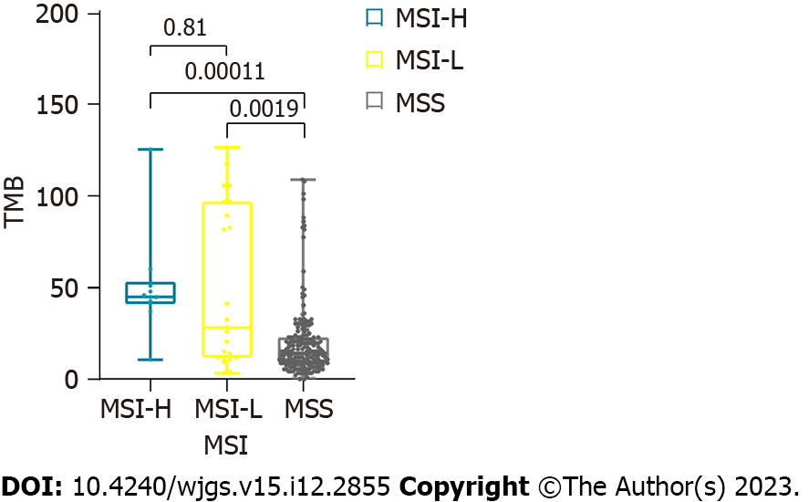
Figure 1 The distribution of tumor mutation burden in microsatellite instability-high, microsatellite instability-low, and microsatellite stable groups. Tumor mutation burden (TMB) in both microsatellite instability-high (MSI-H) and microsatellite instability-low (MSI-L) groups were higher than that in the microsatellite stable group (p < 0.01), whereas no difference was noted between the MSI-H and MSI-L groups. TMB: Tumor mutation burden; MSI-H: Microsatellite instability-high; MSI-L: Microsatellite instability-low; MSS: Microsatellite stable.

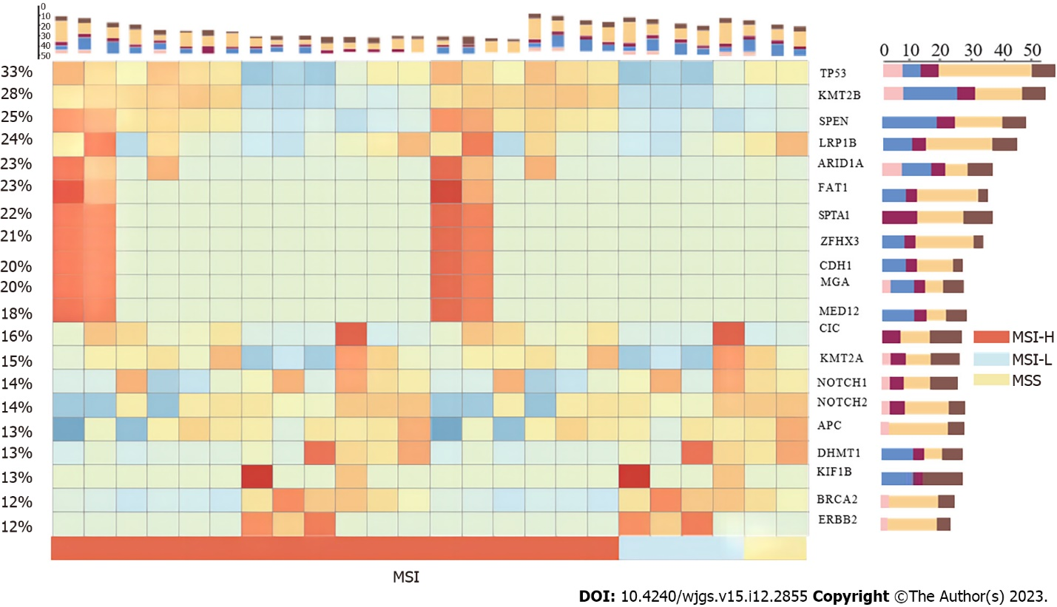
Figure 2 The mutation type and frequency of the top 20 mutated genes in samples clustered by microsatellite instability groups. TP53 was the top mutated gene in gastric adenocarcinoma. MSI: Microsatellite instability; MSI-H: Microsatellite instability-high; MSI-L: Microsatellite instability-low; MSS: Microsatellite stable.

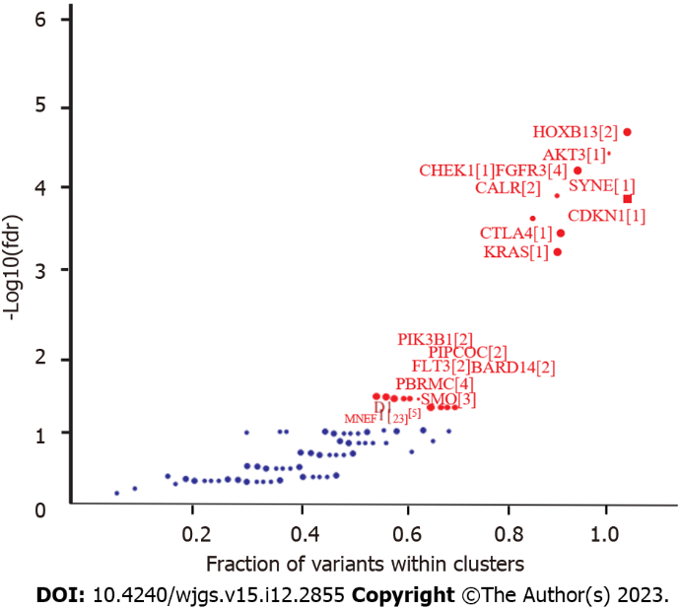
Figure 3 Driver genes identified by OncodriveCLUST in maftools.

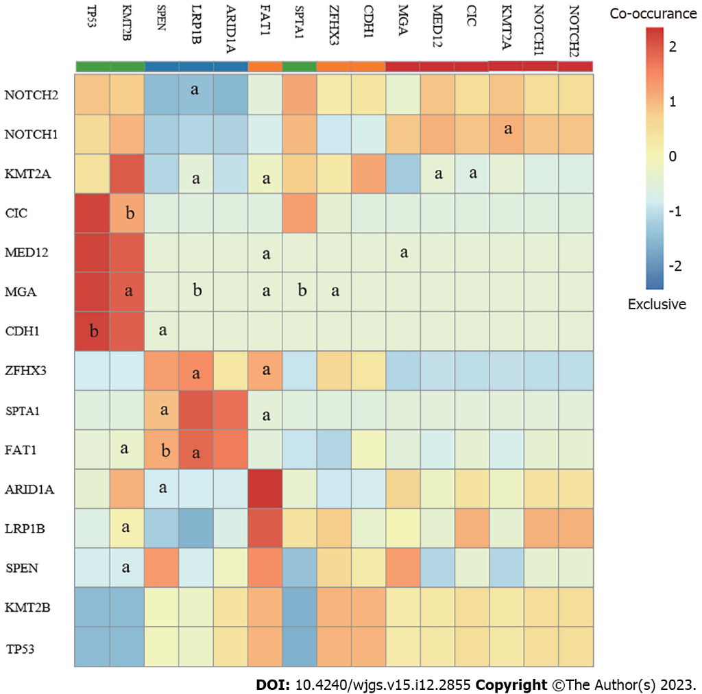
Figure 4 The co-occurrence and exclusion mutation relationships from the top 15 mutated genes in the samples. TP53 and CDH1 were exclusively mutated with P < 0.1, suggesting two different patterns in the pathogenesis of gastric adenocarcinoma. ªP < 0.05; ^{b}P < 0.1.

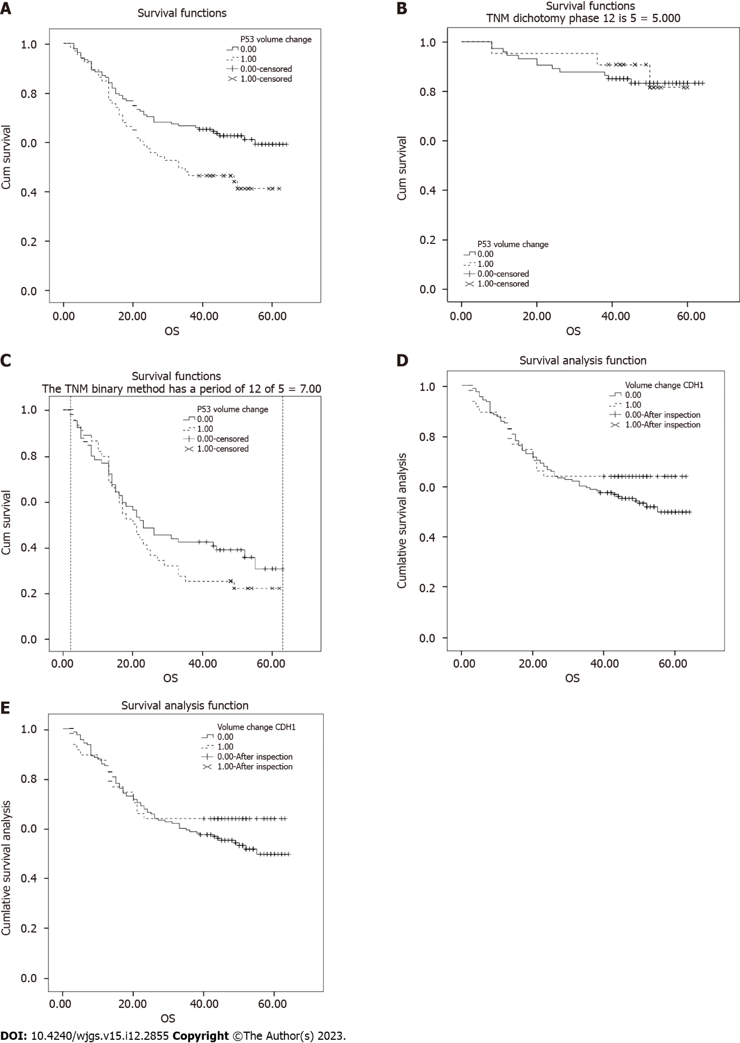
Figure 5 Survival analysis revealed that somatic mutations in TP53. A: Patients carrying the TP53 somatic mutation had significantly lower 5-year overall survival (OS) than those without the mutation; B and C: TP53 did not affect the OS rate in the early (Ⅰ/Ⅱ, B) or middle-late (Ⅲ/Ⅳ, C) stages; D: CDH1 somatic mutation was not significantly related to the OS; E: Patients with both TP53 and CDH1 mutations had the worst 5-year OS rate. OS: Overall survival.

Published by Baishideng Publishing Group Inc
7041 Koll Center Parkway, Suite 160, Pleasanton, CA 94566, USA
Telephone: +1-925-3991568
E-mail: bpgoffice@wjgnet.com
Help Desk: https://www.f6publishing.com/helpdesk
https://www.wjgnet.com

© 2023 Baishideng Publishing Group Inc. All rights reserved.

