Name of Journal: World Journal of Gastrointestinal Surgery
Manuscript NO: 86677
Manuscript Type: CASE REPORT

Giant dedifferentiated liposarcoma of the gastrocolic ligament: A case report

Kassi ABF et al. Gastrocolic ligament dedifferentiated liposarcoma

Assamoi Brou Fulgence Kassi, Kacou Sebastien Yenon, Fian Marc Herve Kassi, Adja Jacob Adjeme, Khader Morel Diarra, Cynthia Bombet-Kouame, Marcellin Kouassi

Assamoi Brou Fulgence Kassi, Kacou Sebastien Yenon, Surgery and Surgical Specialities, Medical Sciences Training and Research Unit, Abidjan Felix Houphouet-Boigny University, Abidjan 01 BP V 34, Cote d'Ivoire

Assamoi Brou Fulgence Kassi, Kacou Sebastien Yenon, Fian Marc Herve Kassi, Adja Jacob Adjeme, Khader Morel Diarra, Cynthia Bombet-Kouame, Marcellin Kouassi, Surgery and Surgical Specialities, Digestive Surgery Unit, University Hospital of Cocody, Abidjan 01 BP V13, Cote d'Ivoire

Author contributions: Kassi ABF proposed the idea, analyzed the literature, wrote and revised the manuscript according reviewers suggestions; Yenon KS supervised and revised the manuscript; Kassi FMH collected the data; Adjemé AJ and Diarra KM assisted with data collection; Kassi ABF, Yenon KS, Bombet-Kouamé C and Kouassi M were the patient’s surgeons and participated in the entire operation; All the authors have read and approved the revised manuscript.

Corresponding author: Assamoi Brou Fulgence Kassi, MD, PhD, Assistant Professor, Surgeon, Surgery and Surgical Specialities, Medical Sciences Training and Research Unit, Abidjan Felix Houphouet-Boigny University, Boulevard de l'université, Abidjan 01 BP V 34, Cote d'Ivoire. kassbrouf@gmail.com

Received: July 1, 2023
Revised: August 17, 2023
Accepted: August 23, 2023
Published online:

Abstract
BACKGROUND
Dedifferentiated liposarcoma (DDLS) has a worse prognosis and occurs most commonly in the retroperitoneal region and rarely in the intraperitoneal region. Histological diagnosis was revolutionized by the combined contributions of histo-immuno-chemistry and molecular biology. Aside from surgery, there is no consensus on the optimal treatment for this chemoresistant cancer.

CASE SUMMARY
A thirty-year-old black female presented with a large painful abdominal mass occupying nearly the entire abdomen and progressive weight loss was admitted for surgery. Abdominal computed tomography showed a large heterogeneous mass of the mesentery that was sized 18 cm × 16 cm in size and had heterogeneous contrast enhancement. During laparotomy, en bloc excision of the large and multilobulated gastrocolic ligament mass was performed. The initial postoperative histopathological diagnosis was undifferentiated sarcoma. Finally, the results of immunohistochemistry and molecular biology allowed us to confirm the diagnosis of DDLS. The tumour followed an aggressive evolution with diffuse metastasis, causing the death of the patient less than 5 mo after the operation.

CONCLUSION
Dedifferentiated liposarcomas are rare tumours that typically originate in the retroperitoneum but may arise in unexpected locations.

Key Words: Dedifferentiated liposarcoma; Gastrocolic ligament mass; En bloc excision; Immunohistochemistry; Molecular biology; Worse prognosis; Case report

Kassi ABF, Yenon KS, Kassi FMH, Adjeme AJ, Diarra KM, Bombet-Kouame C, Kouassi M. Giant dedifferentiated liposarcoma of the gastrocolic ligament: A case report. World J Gastrointest Surg 2023; In press

Core Tip: Dedifferentiated liposarcoma has a worse prognosis and occurs most commonly in a retroperitoneal location but rarely in an intraperitoneal location. Complete surgical excision with a negative microscopic margin (R0) remains the ideal treatment when the tumour is still localized. Here, we report the case of a young woman with disseminated giant dedifferentiated liposarcoma of the gastrocolic ligament. This case demonstrates the poor prognosis of dedifferentiated liposarcomas. To the best of our knowledge, a giant dedifferentiated liposarcoma of the gastrocolic ligament has not yet been reported.

INTRODUCTION
Liposarcoma is a rare malignant tumour of mesodermic origin that derives from adipose tissue^{[1,2]}. Well-differentiated and dedifferentiated liposarcomas (DDLSs) are the most common retroperitoneal types^{[3]}. Liposarcoma is one of the most common soft-tissue sarcomas that mostly affects adults in their 50s or 60s^{[4,5]}.
DDLS, a variant of malignant adipocytic tumours, has a worse prognosis and occurs most commonly in a retroperitoneal location but rarely in an intraperitoneal location^{[6,7,8,9]}. Typically in these locations, the tumour is paucisymptomatic or even asymptomatic until it becomes large enough to compress the surrounding organs^{[10]}. The challenges of histological diagnosis and the lack of consensus on the optimal therapy complicate the management of this cancer^{[8,11]}. Histological diagnosis was revolutionized by the combined contributions of histo-immuno-chemistry and molecular biology^{[12]}. When the tumour is still localized, complete surgical excision with a negative microscopic margin (R0) remains the ideal treatment^{[10,13]}. Additional surgery, chemotherapy, radiotherapy and targeted therapies are also useful in the treatment of advanced or metastatic forms^{[11,14,15]}.
Herein, we report the case of a thirty-year-old black female with a giant DDLS of the gastrocolic ligament. To the best of our knowledge, DDLS originating from this unusual location has not been reported.

CASE PRESENTATION
Chief complaints
A thirty-year-old black female was admitted to our surgical unit with a large painful abdominal mass occupying nearly the entire abdomen.

History of present illness
This abdominal mass appeared eight months earlier. A gradual increase in its volume had been associated with the onset of abdominal pain, constipation and progressive weight loss.

History of past illness
The patient had a good health history.

Personal and family history
No notable events were mentioned in her personal and family history.

Physical examination
The patient was visibly underweight. She presented with an irregular and painful hard abdominal mass with a diameter of approximately 28 cm.

Laboratory examinations
Blood analysis revealed severe nutritional impairment and anaemia. The total protein level was 4.2 g/dL (normal range: 5.8-6.5 g/dL), the albumin level was 2.8 mg/dL (normal range: 3.5-5.5 mg/dL) and the haemoglobin level was 10.5 g/dL (normal range: 12-16 mg/dL).

Imaging examinations
Abdominal computed tomography (CT) showed a large heterogeneous mesentery mass measuring 18 cm × 16 cm × 10.4 cm, and it was compressing the third part of the duodenum with heterogeneous contrast enhancement (Figure 1).

FINAL DIAGNOSIS
The final diagnosis of the presented case was DDLS of the gastrocolic ligament.

TREATMENT
At laparotomy, a large multilobulated mass that was sized 30 cm × 20 cm × 12 cm and arose from the gastrocolic ligament was found (Figure 2A). In addition, many other smaller synchronous lesions were discovered in the liver, small bowel mesentery and peritoneum. An en bloc excision of the giant mass of the gastrocolic ligament was carried out, and associated biopsies of the small lesions were taken. The other smaller lesions virtually ruled out any possibility of curative excision.

OUTCOME AND FOLLOW-UP
Symptomatic treatment, such as nutritional support, was given postoperatively. After two days, the patient was gradually redirected to a normal diet. The patient was discharged 8 d after surgery without any complications. The patient did not undergo any adjuvant treatment for economic reasons. Three months later, follow-up abdominal CT studies revealed multiple peritoneal and vascular implants. The tumour followed an aggressive evolution with diffuse metastasis, causing the death of the patient less than 5 mo after the operation.
Macroscopic examination showed a large yellowish, nodular and myxoid mass with focal areas of haemorrhage and necrosis (Figure 2B).
The histological examination revealed tumorous nodules that were poorly limited, often haemorrhagic, and located in fibrous or fibro-adipose tissue or in the peritoneum. The tumour proliferation was made up of masses with some fusiform cells (Figure 3A), which were sometimes more epithelioid (Figure 3B) and sometimes had pleomorphic nuclei. The mitotic rate was 10/10 per high power field. The tumour was not differentiated and was largely vascularized without necrosis. Immunohistochemical staining revealed that the tumour cells were negative for actin, desmin, calretinin, PS100, melana A, ERG, P63, AE1/AE3, EMA, chromogranin A and CDK4. BAP1 and P16 were partially positive in the neoplastic cells, while MDM2 was strongly expressed. The histo-pathological diagnosis was initially an undifferentiated sarcoma with fusiform and pleomorphic cells. The tumour was reclassified as DDLS according to the histopathological report and immunohistochemical test results.

DISCUSSION
The patient’s young age, unlike the cases usually reported and the rarity of its location at the gastrocolic ligament, makes our observation peculiar. Liposarcoma is the most common soft-tissue sarcoma in adults, with a peak incidence in the 5th-6th decade of life^{[4,5]}. According to the World Health Organization, liposarcoma is classified into five main subtypes: Well-differentiated, dedifferentiated, myxoid, pleomorphic, and myxoid pleomorphic^{[6,14]}. DDLS is a higher grade, often nonlipogenic, sarcoma with metastatic potential that is genetically similar to well-differentiated liposarcoma^{[16]}. However, DDLS arises de novo in more than 90% of cases^{[17]} and can exist without any well-differentiated cells^{[18]}. Usually, DDLS are rare, located in the retroperitoneum and occasionally in the peritoneal cavity^{[6]}. Localizations in the ascending colon, sigmoid colon, mesentery of the small bowel and oesophagus have been described, but no localization in the gastrocolic ligament has been reported to our knowledge^{[7,19,20,21]}. Well-differentiated liposarcoma is typically associated with an adipose mass containing nonlipomatous components on abdominal CT and magnetic resonance imaging; the additional presence of a focal, nodular nonlipomatous region greater than 1 cm in size suggests DDLS^{[22]}. Histo-pathological diagnosis is difficult; initially, this case was diagnosed as an undifferentiated sarcoma with fusiform and pleomorphic cells. In fact, tumours are generally diagnosed as an undifferentiated pleomorphous sarcoma on histology; the diagnosis is suspected in the presence of a well-differentiated liposarcoma^{[23]}. It should be noted, however, that this well-differentiated component may be missing, as noted above. It has been reported that many cases of histological diagnosis of undifferentiated or poorly differentiated sarcoma located in the retroperitoneum were in fact DDLS^{[8]}. The molecular features of DDLS overlap with well-differentiated liposarcoma^{[24,25]}. In immunohistochemistry, both express MDM2 and CDK4 amplifications; MDM2 overexpression confirmed by fluorescence in situ hybridization helps distinguish it from pleomorphic liposarcoma and myxoid liposarcoma^{[16]}. Radical surgery with R0 en bloc resection when possible, seems to offer longer survival and disease-free interval^{[14,18,26]}. In all reported cases, radical surgery was performed as the first-line treatment. However, surgically, it is difficult to distinguish the well-differentiated components of healthy fat, which complicates complete excision surgery^{[16]}. The most important prognostic factor for DDLS is the anatomic site, with retroperitoneal sites having an overall worse prognosis. In our observation, the numerous small lesions did not allow for curative excision, suggesting relapse, as seen three months later. Chemotherapy and radiotherapy remain poorly codified, and their therapeutic benefit has not yet been demonstrated^{[18]}. DDLS is not very sensitive to chemotherapy, so new molecular targets are based on an understanding of disease biology, usually targeting a specific, aberrant genetic or molecular pathway^{[27,28]}. Pazopanib, a tyrosine kinase inhibitor, may provide clinical benefit for patients with DDLS according to recent data^{[29]}.
The patient did not undergo any adjuvant treatment for economic reasons. Approximately 40% of DDLS will have local recurrence, 17% will metastasize, and 28% will have tumour-related mortality^{[6]}. Three months later, follow-up abdominal CT studies revealed multiple peritoneal and vascular implants with necrotic areas. The patient died less than five months after surgery.

CONCLUSION
DDLSs are rare tumours that typically originate in the retroperitoneum but may arise in unexpected locations. The extremely rare primary gastrocolic liposarcoma presented here is an example. Immunohistochemistry and molecular biology are essential to confirm histological diagnosis. Surgical excision with oncologically appropriate margins is the gold standard of treatment.

REFERENCES
1 Bock S, Hoffmann DG, Jiang Y, Chen H, Il'yasova D. Increasing Incidence of Liposarcoma: A Population-Based Study of National Surveillance Databases, 2001-2016. Int J Environ Res Public Health 2020; 17 [PMID: 32326423 DOI: 10.3390/ijerph17082710]
2 Bachmann R, Eckert F, Gelfert D, Strohäker J, Beltzer C, Ladurner R. Perioperative strategy and outcome in giant retroperitoneal dedifferentiated liposarcoma-results of a retrospective cohort study. World J Surg Oncol 2020; 18: 296 [PMID: 33183309 DOI: 10.1186/s12957-020-02069-2]
3 Mansfield SA, Pollock RE, Grignol VP. Surgery for Abdominal Well-Differentiated Liposarcoma. Curr Treat Options Oncol 2018; 19: 1 [PMID: 29335908 DOI: 10.1007/s11864-018-0520-6]
4 Amer KM, Congiusta DV, Thomson JE, Elsamna S, Chaudhry I, Bozzo A, Amer R, Siracuse B, Ghert M, Beebe KS. Epidemiology and survival of liposarcoma and its subtypes: A dual database analysis. J Clin Orthop Trauma 2020; 11: S479-S484 [PMID: 32774015 DOI: 10.1016/j.jcot.2020.04.013]
5 Matone J, Okazaki S, Maccapani GN, Amancio TT, Filippi RZ, Macedo AL. Giant gastric lipossarcoma: case report and review of the literature. Einstein (Sao Paulo) 2016; 14: 557-560 [PMID: 28076606 DOI: 10.1590/S1679-45082016RC3770]
6 Sbaraglia M, Bellan E, Dei Tos AP. The 2020 WHO Classification of Soft Tissue Tumours: news and perspectives. Pathologica 2021; 113: 70-84 [PMID: 33179614 DOI: 10.32074/1591-951X-213]
7 Meher S, Mishra TS, Rath S, Sasmal PK, Mishra P, Patra S. Giant dedifferentiated liposarcoma of small bowel mesentery: a case report. World J Surg Oncol 2016; 14: 250 [PMID: 27654578 DOI: 10.1186/s12957-016-1007-1]
8 Constantinoiu S, Achim IF, Cretu OE, Dumitru T, Constantin A, Enache S, Mates IN; -. Dedifferentiated Liposarcoma of Sigmoid Mesocolon - A Case Report. Chirurgia (Bucur) 2016; 111: 330-336 [PMID: 27604671]
9 Xiao J, Liu J, Chen M, Liu W, He X. Diagnosis and Prognosis of Retroperitoneal Liposarcoma: A Single Asian Center Cohort of 57 Cases. J Oncol 2021; 2021: 7594027 [PMID: 34035812 DOI: 10.1155/2021/7594027]
10 Liao T, Du W, Li X, He S, Guan G, Zhu H, Wu J. Recurrent metastatic retroperitoneal dedifferentiated liposarcoma: a case report and literature review. BMC Urol 2023; 23: 63 [PMID: 37095466 DOI: 10.1186/s12894-023-01252-3]
11 Kilpatrick SE. Dedifferentiated Liposarcoma: A Comprehensive Historical Review With Proposed Evidence-based Guidelines Regarding a Diagnosis in Need of Further Clarification. Adv Anat Pathol 2021; 28: 426-438 [PMID: 34326285 DOI: 10.1097/PAP.0000000000000314]
12 Zelger BG, Zelger B. Correspondence re: Guillou L, Gebhard S, Salmeron M, Coindre JM. Metastasizing fibrous histiocytoma of the skin: a clinicopathologic and immunohistochemical analysis of three cases. Mod Pathol 2000;13:654-60. Mod Pathol 2001; 14: 534-536 [PMID: 11353067 DOI: 10.1038/modpathol.3880344]
13 Varlas VN, Rhazi Y, Ionescu OM, Micu LG, Pop AL, Bacalbaşa N, Peneş NO. A dedifferentiated rare primary breast liposarcoma - case report and literature review. Rom J Morphol Embryol 2021; 62: 301-307 [PMID: 34609436 DOI: 10.47162/RJME.62.1.33]
14 Nishio J, Nakayama S, Nabeshima K, Yamamoto T. Biology and Management of Dedifferentiated Liposarcoma: State of the Art and Perspectives. J Clin Med 2021; 10 [PMID: 34362013 DOI: 10.3390/jcm10153230]
15 Horowitz J, Singhal M, Marrero D, Bashjawish F, Leto D, Winters M, Jeberaeel J. A Multi-Modality Treatment of Retroperitoneal De-Differentiated Liposarcoma. Am J Case Rep 2020; 21: e919245 [PMID: 32115569 DOI: 10.12659/AJCR.919245]
16 Mack T, Purgina B. Updates in Pathology for Retroperitoneal Soft Tissue Sarcoma. Curr Oncol 2022; 29: 6400-6418 [PMID: 36135073 DOI: 10.3390/curroncol29090504]
17 Singer S, Antonescu CR, Riedel E, Brennan MF. Histologic subtype and margin of resection predict pattern of recurrence and survival for retroperitoneal liposarcoma. Ann Surg 2003; 238: 358-70; discussion 370-1 [PMID: 14501502 DOI: 10.1097/01.sla.0000086542.11899.38]
18 Grifasi C, Calogero A, Carlomagno N, Campione S, D'Armiento FP, Renda A. Intraperitoneal dedifferentiated liposarcoma showing MDM2 amplification: case report. World J Surg Oncol 2013; 11: 305 [PMID: 24279301 DOI: 10.1186/1477-7819-11-305]
19 Brett CL, Miller DH, Jiang L, Wolfsen HC, Attia S, Hintenlang L, Jagadesh N, Miller RC. Dedifferentiated Liposarcoma of the Esophagus: A Case Report and Selected Review of the Literature. Rare Tumors 2016; 8: 6791 [PMID: 28191296 DOI: 10.4081/rt.2016.6791]
20 Takeda K, Aimoto T, Yoshioka M, Nakamura Y, Yamahatsu K, Ishiwata T, Naito Z, Miyashita M, Uchida E. Dedifferentiated liposarcoma arising from the mesocolon ascendens: report of a case. J Nippon Med Sch 2012; 79: 385-390 [PMID: 23123398 DOI: 10.1272/jnms.79.385]
21 Winn B, Gao J, Akbari H, Bhattacharya B. Dedifferentiated liposarcoma arising from the sigmoid mesocolon: a case report. World J Gastroenterol 2007; 13: 4147-4148 [PMID: 17696239 DOI: 10.3748/wjg.v13.i30.4147]
22 Murphey MD, Arcara LK, Fanburg-Smith J. From the archives of the AFIP: imaging of musculoskeletal liposarcoma with radiologic-pathologic correlation. Radiographics 2005; 25: 1371-1395 [PMID: 16160117 DOI: 10.1148/rg.255055106]
23 Weaver J, Downs-Kelly E, Goldblum JR, Turner S, Kulkarni S, Tubbs RR, Rubin BP, Skacel M. Fluorescence in situ hybridization for MDM2 gene amplification as a diagnostic tool in lipomatous neoplasms. Mod Pathol 2008; 21: 943-949 [PMID: 18500263 DOI: 10.1038/modpathol.2008.84]
24 Lu J, Wood D, Ingley E, Koks S, Wong D. Update on genomic and molecular landscapes of well-differentiated liposarcoma and dedifferentiated liposarcoma. Mol Biol Rep 2021; 48: 3637-3647 [PMID: 33893924 DOI: 10.1007/s11033-021-06362-5]
25 Watson S, Gruel N, Le Loarer F. New developments in the pathology and molecular biology of retroperitoneal sarcomas. Eur J Surg Oncol 2023; 49: 1053-1060 [PMID: 35151525 DOI: 10.1016/j.ejso.2022.02.005]
26 Vats M, Pandey D, Ahlawat H, Akhtar A, Singh N. Multiple Primary Dedifferentiated Liposarcoma of the Jejunal Mesentery: A Case Report and Review of Literature. J Clin Diagn Res 2016; 10: XD01-XD04 [PMID: 26894164 DOI: 10.7860/JCDR/2016/15009.7090]
27 Peng T, Zhang P, Liu J, Nguyen T, Bolshakov S, Belousov R, Young ED, Wang X, Brewer K, López-Terrada DH, Oliveira AM, Lazar AJ, Lev D. An experimental model for the study of well-differentiated and dedifferentiated liposarcoma; deregulation of targetable tyrosine kinase receptors. Lab Invest 2011; 91: 392-403 [PMID: 21060307 DOI: 10.1038/labinvest.2010.185]
28 Saponara M, Stacchiotti S, Gronchi A. Pharmacological therapies for Liposarcoma. Expert Rev Clin Pharmacol 2017; 10: 361-377 [PMID: 28135854 DOI: 10.1080/17512433.2017.1289086]
29 Gahvari Z, Parkes A. Dedifferentiated Liposarcoma: Systemic Therapy Options. Curr Treat Options Oncol 2020; 21: 15 [PMID: 32026050 DOI: 10.1007/s11864-020-0705-7]

Footnotes
Informed consent statement: Informed written consent was obtained from the patient for publication of this report and any accompanying images.

Conflict-of-interest statement: All authors report no relevant conflicts of interest for this article.

CARE Checklist (2016) statement: The authors have read the CARE Checklist (2016), and the manuscript was prepared and revised according to the CARE Checklist (2016).

Open-Access: This article is an open-access article that was selected by an in-house editor and fully peer-reviewed by external reviewers. It is distributed in accordance with the Creative Commons Attribution NonCommercial (CC BY-NC 4.0) license, which permits others to distribute, remix, adapt, build upon this work non-commercially, and license their derivative works on different terms, provided the original work is properly cited and the use is non-commercial. See: https://creativecommons.org/Licenses/by-nc/4.0/

Provenance and peer review: Unsolicited article; Externally peer reviewed.

Peer-review model: Single blind

Peer-review started: July 1, 2023
First decision: August 4, 2023
Article in press:

Specialty type: Gastroenterology and hepatology
Country/Territory of origin: Cote d'Ivoire
Peer-review report’s scientific quality classification
Grade A (Excellent): 0
Grade B (Very good): B
Grade C (Good): C
Grade D (Fair): 0
Grade E (Poor): 0

P-Reviewer: Li S, China; Mostafavinia A, Iran S-Editor: Lin C L-Editor: P-Editor:
Figure Legends
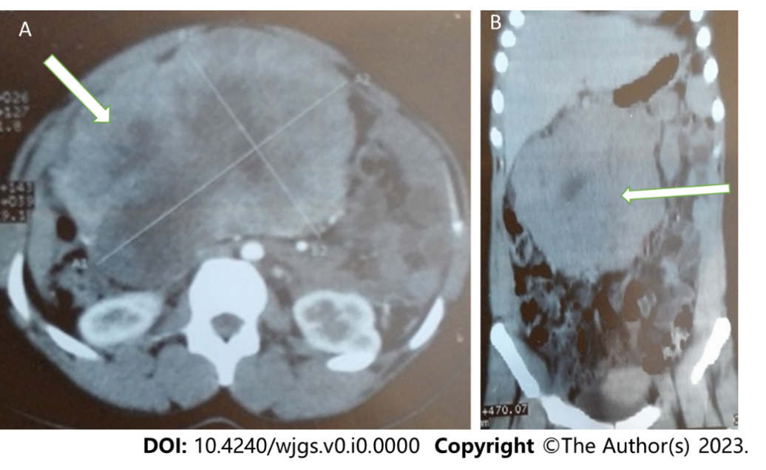
Figure 1 Abdominal computed tomography showed a huge heterogeneous mesentery mass. A: Transverse view; B: Coronal view.

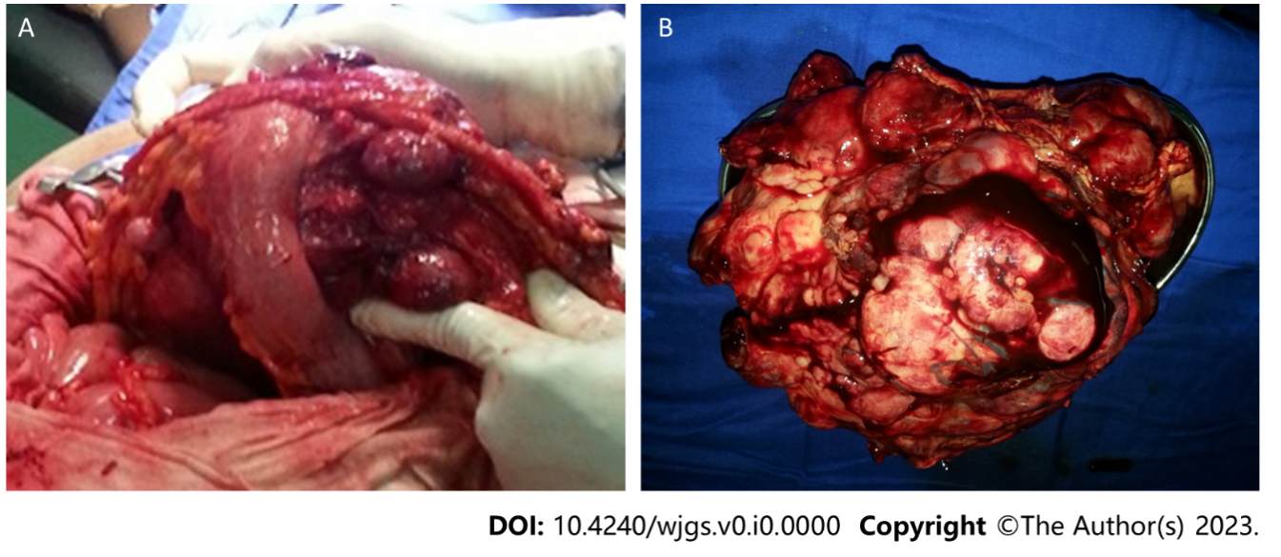
Figure 2 Operatives images of this case report. A: Intraoperative procedure found multi-lobulated mass of gastrocolic ligament; B: Macroscopic aspect of removed giant mass of gastrocolic ligament.

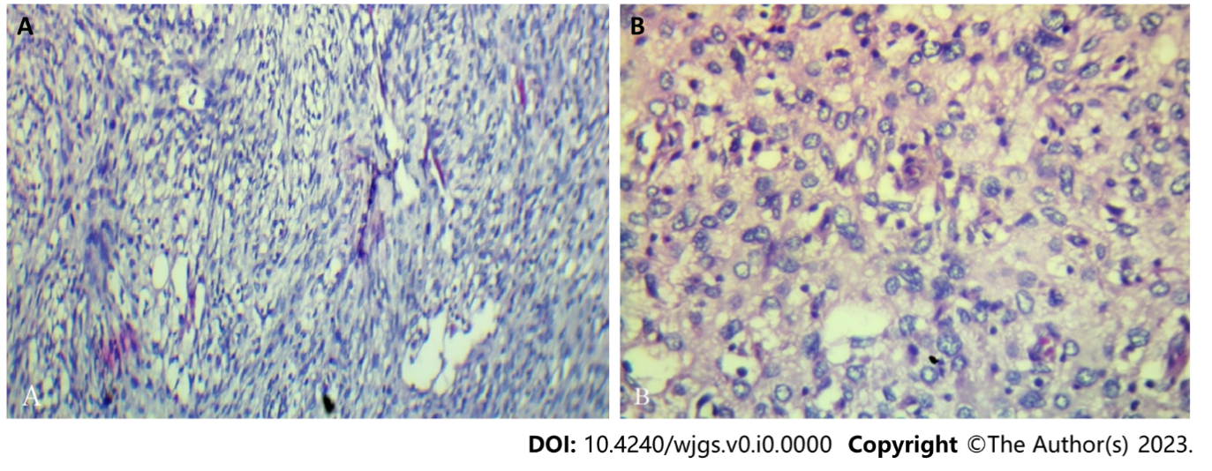
Figure 3 Histopathological analysis. Immunohistochemical results show that the tumours cells are positive for Bap1 (A), p16 (A) and MDM2 (B) and negative for actin, desmin, calretinin, PS100, melana A, ERG, p63, cytokeratin AE1/AE3, EMA, chromogranin A and CDK4. A: A population of fusiform cells (× 200); B: A population of epithelioid cells and atypical adipose cells in a myxoid and vascularized matrix (× 200).

