Name of Journal: World Journal of Clinical Cases
Manuscript NO: 60514
Manuscript Type: CASE REPORT

Haemangiomas in the urinary bladder: Two case reports

Zhao GC et al. Haemangiomas in the urinary bladder

Gui-Cheng Zhao, Chang-Xing Ke

Gui-Cheng Zhao, Chang-Xing Ke, Department of Urology, The Second Affiliated Hospital of Kunming Medical University, Kunming 650101, Yunnan Province, China

Author contributions: All authors participated in the collection of the clinical and pathological data and agreed with its content; Ke CX performed the surgical procedures and assisted with the manuscript review and editing; Zhao GC was the major contributor for writing the manuscript; All authors read and approved of the final manuscript.

Supported by The Project of Yunnan Provincial Health Department, No. 2016NS260.

Corresponding author: Chang-Xing Ke, PhD, Chief Doctor, Department of Urology, The Second Affiliated Hospital of Kunming Medical University, No. 374 Dianmian Road, Xishan District, Kunming 650101, Yunnan Province, China. kyfeyke1973@163.com

Received: November 3, 2020
Revised: November 25, 2020
Accepted: April 8, 2021
Published online: Jun 6, 2021

Abstract
BACKGROUND
Urinary bladder haemangioma is a benign nonurothelial tumour that rarely occurs in paediatric and adolescent patients. Clinical and radiological examinations are not adequate for an accurate diagnosis. The purpose of this serial case report is to raise awareness of urinary bladder haemangioma and appropriate management.

CASE SUMMARY
We described two rare cases of urinary bladder haemangioma that were confirmed by histopathology followed by immunohistochemistry and reviewed the literature on the diagnosis and treatment of patients with this disease. The radical cystectomy was performed with open method surgery associated with an abdominal wall ostomy of the ileal outlet tract for case 1. Case 2 underwent a laparoscopic partial cystectomy. Postoperative pathology confirmed the diagnosis of urinary bladder haemangioma. Haematuria resolved postoperatively, and there was no evidence of tumour recurrence in 3 years follow-up for case 1. Postoperative urinary and pelvic ultrasonography showed no signs of recurrence in 3 mo follow-up for case 2.

CONCLUSION
Careful histopathological and immunohistochemical studies are required to establish the correct diagnosis. There is no “gold standard” treatment for urinary bladder haemangioma, and treatment options are varied for individuals with favourable follow-ups.

Key Words: Haematuria; Haemangioma; Urinary bladder; Case report

©The Author(s) 2021. Published by Baishideng Publishing Group Inc. All rights reserved.

Zhao GC, Ke CX. Haemangiomas in the urinary bladder: Two case reports. World J Clin Cases 2021; 9(16): 3927-3935 URL: https://www.wjgnet.com/2307-8960/full/v9/i16/3927.htm DOI: https://dx.doi.org/10.12998/wjcc.v9.i16.3927

Core Tip: Urinary bladder haemangioma is a benign nonurothelial tumour that rarely occurs in paediatric and adolescent patients. Clinical and radiological examinations are not adequate for an accurate diagnosis. We described two rare cases of urinary bladder haemangioma that were confirmed by histopathology followed by immunohistochemistry and reviewed the literature on the diagnosis and treatment of patients with this disease.
INTRODUCTION
Haemangiomas are benign vascular tumours that can occur almost anywhere in the human body. They more frequently occur in the skin and subcutaneous soft tissues than in the urinary bladder. Bladder haemangioma is rare and accounts for 0.6% of all bladder tumours occurring at all ages. They are more rare in childhood and adolescence. Clinical and radiological examinations are not sufficient for an accurate diagnosis. Careful histopathology and immunohistochemistry are required to establish the correct diagnosis^{[1,2]}. Although haemangiomas in the genitourinary system occur relatively infrequently, cases of bladder haemangiomas have appeared during medical research. In this article, we describe two rare cases of urinary bladder haemangiomas (UBHs) confirmed by histopathology followed by immunohistochemistry, and we review the literature on the diagnosis and treatment of patients with this disease. Written informed consent was obtained from the patients or from his or her guardian for the publication of this case report and accompanying images.

CASE PRESENTATION
Chief complaints
Case 1: Case 1 was a 41-year-old Chinese female who presented with a sudden onset of painless gross haematuria for 1 mo and visited our outpatient clinic.

Case 2: Case 2 was an asymptomatic 30-year-old female.

History of present illness
Case 1: Cystoscopy and biopsy were performed by an outside hospital and showed a bluish ovoid mass with blood clots on the anterior wall of bladder. Transurethral resection of the bladder tumour (partial resection) was performed. The initial histopathological studies showed gland cystitis and local urothelial hyperplasia with nodule formation, but no clear cancer cells were found (Figure 1A and 1B).

Case 2: A large urinary bladder haemangioma in a 30-year-old female who visited our outpatient clinic presented without any symptoms. It was found during a routine examination at an outside facility.

History of past illness
Neither case had past illnesses.

Personal and family history
Neither case had specific family history.

Physical examination
In these two cases, the vital signs and observation results of the physical examination were normal.

Laboratory examinations
Case 1: The blood cell count results were as follows: erythrocyte count, 3.84 × 10¹²/L; haemoglobin, 113 g/L; haematocrit, 34.2%; and platelet, 206/L. Random urinalysis with microscopic examination showed haematuria, > 100 red blood cells, 0-3 white blood cells per high-powered field, and no proteinuria or pyuria.

Case 2: The blood cell count results were within a normal range, and the results of 11 tumour markers were negative. However, urinalysis showed > 100 red blood cells and 3-6 white blood cells per high-powered field.

Imaging examinations
Case 1: Multislice spiral computed tomography urography in the urological system showed the anterior and superior wall of the bladder was thickened and multiple nodules and masses. The larger one was about 5.0 cm × 3.1 cm × 4.0 cm mass, exhibited multiple punctate calcifications, and marked uneven enhancement, which was suspected as urachal (bladder) cancer (Figure 1C-G).

Case 2: Computed tomography scan of the abdomen and pelvis with contrast was also performed to evaluate the extent of the lesions and pelvic lymphadenopathy. The computed tomography images indicated a soft tissue mass arising from the right anterior and upper wall of the urinary bladder (Figure 2A and 2B). The results of contrast-enhanced magnetic resonance imaging scan of the abdomen confirmed that a large 6.2 cm × 6.9 cm × 5.2 cm soft tissue mass arose from the right anterior and superior wall of the bladder, which suggested the possibility of a benign bladder tumour, and several enlarged lymph nodes were seen in the pelvic cavity (Figure 2C-E). We performed cystoscopy and pathological examination of the tissue sample. Cystoscopy confirmed that blue to reddish sessile lesions of a large 6.0 cm × 6.0 cm × 5.0 cm were visualized on the right anterior superior wall of the bladder. The initial pathological report showed gland cystitis, but no characteristic tumour tissue was identified (Figure 2F and 2H).

FINAL DIAGNOSIS
Postoperative pathology and immunohistochemistry confirmed the diagnosis of urinary bladder haemangioma for both cases.

TREATMENT
Case 1
Under suspicion of urachal cancer, radical cystectomy was performed with open method surgery associated with an abdominal wall ostomy of the ileal outlet tract (in February 2016).

Case 2
Based on imaging results and the pathological results, the patient underwent a laparoscopic partial cystectomy (in November 2018).

OUTCOME AND FOLLOW-UP
Case 1
The final pathological results indicated a cavernous haemangioma of the urinary bladder extended into the deep muscular layer of the bladder wall adjacent to the adventitia (an ill-defined, soft, and brown tumour measuring 6.0 cm × 5.0 cm × 5.0 cm in size was seen outside the anterior bladder wall) (Figure 1H-K). Haematuria resolved after surgery, and no evidence of tumour recurrence was found during the 3-year follow-up.

Case 2
The resected partial cystectomy specimen was sent for histopathological examination. The pathological diagnosis was given as bladder angioma consisting of a mixture of cavernous lymphangioma and haemangioma components. The gross histopathology revealed a mass that was well-circumscribed, vesicles-like, 7.0 cm × 5.0 cm × 4.0 cm, and grey-brown cut surface. These anatomical characteristics supported the diagnosis of bladder haemangioma (Figure 2I-L). Postoperative urinary and pelvic ultrasonography showed that the bladder wall was smooth. No abnormal echoes were found in the lumen in 3 mo follow-up (Figure 3). Haematuria was not noted on postoperative urinalysis.

DISCUSSION
Most bladder tumours are epithelial. Nonurothelial neoplasms occur very rarely in the bladder and usually increase the diagnostic challenge for urologists. To the best of our knowledge, the present research about UBHs are mostly congenital malformation of capillaries and blood vessels, and nonurothelial neoplasms are rarely reported clinically, accounting for only 0.6% of all urinary bladder tumours^{[3,4]}.
Although UBH can occur in all age groups, the most common age group is under 30. In a review of the literature, most bladder haemangiomas are solitary (66%), varying from a few millimetres to 10 cm in diameter, and mostly occurred in the dome, posterior wall, and trigone of the bladder, which has increased the diagnostic challenge of intramural tumours of the bladder^{[5]}. Because many bladder haemangiomas occasionally coexist with cutaneous haemangiomas, varicose veins, Sturge-Weber syndrome, or Klippel-Trenaunay-Weber syndrome (both of which predispose patients to their development), systemic evaluation in these patients is highly recommended^{[6,7]}.
UBHs are mostly congenital benign tumour formations of angiogenesis. Nevertheless, several studies have confirmed increased risks of developing soft tissue tumours related to radiation therapy for cancer^{[8,9]}. The predominant clinical symptom of a UBH is the painless recurrence of isolated gross macroscopic haematuria with or without irritative urinary symptoms and abdominal pain^{[10]}. However, hypovolemic shock can be present in cases with massive haemorrhage. Ureteric obstruction by the mass can cause hydroureteronephrosis, and a haematoma can obscure the mass in the bladder when there is massive bleeding^{[11]}.
Here, we conducted a thorough English literature review focusing on literature about UBHs published up to January 2019, and we identified 16 cases published from 2000 to 2019 after strict selection stored in the PubMed database (Table 1)^{[5,6,9,12-22]}. The following key words were used for literature retrieval: (“case report”) and (“Urinary Bladder Hemangioma” or “Bladder hemangioma” or “Hemangioma of the urinary bladder”). Including our two cases, these cases occurred in a wide range of ages, from 2 years to 85 years (mean 27.8), with a median age of 18 years, and the male-to-female ratio was 0.8 with no sex predominance. It was typical with the size of lesions ranging from 1.0 cm to 7.0 cm in diameter, although the characteristic of multiplicity was not usual. In our two cases, the systemic evaluations of all cases were grossly normal, with no cutaneous haemangioma or palpable scrotal varicocele.
Clinically, imaging examinations, such as ultrasonography, pelvic arteriography, computed tomography scan, and magnetic resonance imaging, are helpful in defining the extent and location of a haemangioma^{[2]}. The cystoscopic features of a bluish, sessile mass with gross haematuria are highly suggestive of a haemangioma. The endoscopic differential diagnostic of pigmented raised lesions includes endometriosis, melanoma, and sarcoma. The final accurate diagnosis requires confirmation by biopsy^{[23]}.
Because bladder haemangiomas are not commonly seen in the genitourinary tract, it is important for pathologists and clinicians to carefully differentiate them from malignant nonurothelial neoplasms as they have vital prognostic characteristics as well as therapeutic strategies^{[20]}. Clinical and radiological examinations are not enough for an accurate diagnosis. Careful histopathology and immunohistochemistry are required to establish the correct diagnosis. Histologically, bladder haemangiomas can be classified into cavernous, capillary, and arteriovenous types. Nearly 80% are cavernous type, while the capillary or arteriovenous types occur much less frequently^{[23]}. Bladder haemangiomas are histologically similar to haemangiomas found in other sites and are formed by numerous proliferative capillaries mixed with thin walled, dilated blood-filled vessels lined with flat endothelial cells. The vessels are sometimes thickened by adventitial fibrosis. The histological depth of a bladder haemangioma may be within the submucosa layer or even extend to the muscular layer or perivesical tissues^{[5]}.
Malignant vascular tumours, such as angiosarcoma, have highly aggressive potential with the features of infiltrative growth, clear cytological atypia, high cellularity, and poor prognosis. By contrast, bladder haemangiomas are typically characterized by the proliferation of vessel walls with a clear boundary and spreading between the normal vasculature, which lack typical endothelial atypia or multilayering and have a satisfying prognosis^{[24]}. The differential diagnosis of a polypoid bladder mass found in children with painless gross haematuria includes haemangioma, rhabdomyosarcoma, other vascular tumours, inflammatory pseudotumours, leiomyoma, neurofibromatosis, pheochromocytoma, transitional cell papilloma, transitional cell carcinoma, and pseudotumoural cystitis^{[25,26]}.
The treatment options for UBHs vary according to the individual, and follow-ups show favourable outcomes. The treatment of patients with UBHs is still controversial, and the considered factors include the size, location, and depth of penetration^{[22]}. For small lesions and asymptomatic haemangiomas, surveillance is enough. Therapy is necessary only when the lesions threaten organ function or the patient’s performance condition, such as haematuria resulting in anaemia and the suspicion of some malignant lesions. Optional therapeutic strategies include observation, transurethral resection, electrocoagulation, radiation, systemic steroid administration, the injection of a sclerosing agent, interferon-a-2 therapy, Yttrium-aluminium-garnet-laser therapy, and partial cystectomy or complete cystectomy^{[5,12,22]}. Transurethral endoscopic surgery resection has become the gold standard for the treatment of small bladder cavernous haemangiomas. The risk of uncontrollable bleeding is inconsiderable when the lesion is small (≤ 3 cm), and follow-ups show satisfactory outcomes^{[2,18]}. Biopsy and fulguration do not create severe bleeding and can adequately treat small lesions. Neodymium: yttrium aluminium garnet laser irradiation is another effective and less invasive therapy option, and it allows complete coagulation of the whole bladder thickness^{[16]}. In cases of > 3 cm masses or multiple tumours or those that extend deep into the bladder. However, a transurethral biopsy or the resection of a bladder haemangioma is contraindicated because of the iceberg nature of this tumour and the significant possibility of gross haemorrhage. Open resection of the lesion or partial cystectomy is effective^{[5,11]}. Whereas partial cystectomy may reduce storage function, partial cystectomy and bladder augmentation can preserve storage function, but this treatment may make voiding function worsen^{[19]}.
Although UBHs have a benign course, postoperative follow-up is mandatory for the detection of tumour recurrence or residual disease, and ultrasonography, computed tomography, and even flexible cystoscopy can be used to detect recurrence^{[18,19]}.

CONCLUSION
In conclusion, UBHs are benign, nonurothelial tumours that rarely occur in paediatric and adolescent patients. The accurate diagnosis of UBH is usually confirmed by histopathology and immunohistochemistry due to the difficulty of definitive diagnosis by clinical and radiological examination. It is critical to distinguish UBH from malignant vascular tumours because the required treatment approach and the prognosis may differ dramatically. Due to the limited number of reported cases, there is no “gold-standard” therapy for UBH. Treatment options vary according to the individual, and follow-ups show favourable outcomes. Although the prognosis of patients with UBH is usually excellent, follow-up is necessary to detect evidence of tumour recurrence or residual disease.

ACKNOWLEDGEMENTS
We thank Jie-Shun Yang, Tian-Tian Ma, Cheng Deng, and Prashant Mishra for assistance with evaluation of the pathology and images of these cases.

REFERENCES
1 Castillo OA, Foneron A, Sepúlveda F, Sánchez-Salas R, Martínez V. Bladder hemangioma: case report. Arch Esp Urol 2012; 65: 623-625 [PMID: 22832644 DOI: 10.3747/pdi.2011.00292]
2 Mukai S, Tanaka H, Yamasaki K, Goto T, Onizuka C, Kamoto T, Kataoka H. Urinary bladder pyogenic granuloma: a case report. J Med Case Rep 2012; 6: 149 [PMID: 22704803 DOI: 10.1186/1752-1947-6-149]
3 Cheng L, Nascimento AG, Neumann RM, Nehra A, Cheville JC, Ramnani DM, Leibovich BC, Bostwick DG. Hemangioma of the urinary bladder. Cancer 1999; 86: 498-504 [PMID: 10430259 DOI: 10.1002/(sici)1097-0142(19990801)86:3<498::aid-cncr19>3.0.co;2-6]
4 Dahm P, Gschwend JE. Malignant non-urothelial neoplasms of the urinary bladder: a review. Eur Urol 2003; 44: 672-681 [PMID: 14644119 DOI: 10.1016/s0302-2838(03)00416-0]
5 Tavora F, Montgomery E, Epstein JI. A series of vascular tumors and tumorlike lesions of the bladder. Am J Surg Pathol 2008; 32: 1213-1219 [PMID: 18580491 DOI: 10.1097/PAS.0b013e31816293c5]
6 Kim YY, Kim MJ, Lee MJ, Kim JY. Multiple hemangiomas of the urinary bladder in a child with gross hematuria. Ultrasonography 2015; 34: 231-234 [PMID: 25672772 DOI: 10.14366/usg.14056]
7 Favorito LA. Vesical hemangioma in patient with Klippel-Trenaunay-Weber syndrome. Int Braz J Urol 2003; 29: 149-150 [PMID: 15745499 DOI: 10.1590/s1677-55382003000200010]
8 Sholl LM, Barletta JA, Hornick JL. Radiation-associated neoplasia: clinical, pathological and genomic correlates. Histopathology 2017; 70: 70-80 [PMID: 27960236 DOI: 10.1111/his.13069]
9 Hu X, Deng K. Bladder cavernous hemangioma after pelvic radiotherapy in a female patient: A case report and literature review. Int J Surg Case Rep 2018; 53: 479-482 [PMID: 30567074 DOI: 10.1016/j.ijscr.2018.11.044]
10 Saribacak A, Ozkürkçügil C, Ozkan L. Arteriovenous hemangioma of the urinary bladder following intravesical treatment. Urol J 2011; 8: 251-253 [PMID: 21910110 DOI: 10.1002/pros.21296]
11 Numanoğlu KV, Tatli D. A rare cause of hemorrhagic shock in children: bladder hemangioma. J Pediatr Surg 2008; 43: e1-e3 [PMID: 18639666 DOI: 10.1016/j.jpedsurg.2008.02.057]
12 Kato M, Chiba Y, Sakai K, Orikasa S. Endoscopic neodymium:yttrium aluminium garnet (Nd:YAG) laser irradiation of a bladder hemangioma associated with Klippel-Weber syndrome. Int J Urol 2000; 7: 145-148 [PMID: 10810971 DOI: 10.1046/j.1442-2042.2000.00150.x]
13 Pratap A, Tiwari A, Pandey SR, Agrawal B, Paudel G, Adhikary S, Kumar A. Giant cavernous hemangiolymphangioma of the bladder without cutaneous hemangiomatosis causing massive hematuria in a child. J Pediatr Urol 2007; 3: 326-329 [PMID: 18947766 DOI: 10.1016/j.jpurol.2006.10.010]
14 Macedo A Jr, Ottoni SL, Barroso U Jr, Ortiz V. Bladder hemangiomas and Proteus syndrome: a rare clinical association. J Pediatr Urol 2010; 6: 429-431 [PMID: 20044313 DOI: 10.1016/j.jpurol.2009.11.009]
15 Ashley RA, Figueroa TE. Gross hematuria in a 3-year-old girl caused by a large isolated bladder hemangioma. Urology 2010; 76: 952-954 [PMID: 20627282 DOI: 10.1016/j.urology.2010.03.062]
16 Takemoto J, Yamazaki Y, Sakai K. A case of large bladder hemangioma successfully treated with endoscopic yttrium aluminium garnet laser irradiation. Int J Urol 2011; 18: 854-856 [PMID: 22142464 DOI: 10.1111/j.1442-2042.2011.02879.x]
17 Mager R, Thalhammer A, Riener MO, Frankenau P, Haferkamp A. Coiling the arterial feeder: report on a successfully treated extensive hemangioma of the periprostatic venous plexus and the bladder neck. Urology 2014; 84: e19-e20 [PMID: 25443950 DOI: 10.1016/j.urology.2014.07.037]
18 Jibhkate S, Sanklecha V, Valand A. Urinary bladder hemangioma -a rare urinary bladder tumor in a child. APSP J Case Rep 2015; 6: 6 [PMID: 25628995]
19 Lahyani M, Slaoui A, Jakhlal N, Karmouni T, Elkhader K, Koutani A, Andaloussi AI. Cavernous hemangioma of the bladder: an additional case managed by partial cystectomy and augmentation cystoplasty. Pan Afr Med J 2015; 22: 131 [PMID: 26889312 DOI: 10.11604/pamj.2015.22.131.7838]
20 Jin L, Liu J, Li Y, Sun S, Mao X, Yang S, Lai Y. Anastomosing hemangioma: The first case report in the bladder. Mol Clin Oncol 2016; 4: 310-312 [PMID: 26893881 DOI: 10.3892/mco.2015.699]
21 de Sousa CSM, Viana IL, de Miranda CLVM, Bastos BB, Mendes ILL. Hemangioma of the urinary bladder: an atypical location. Radiol Bras 2017; 50: 271-272 [PMID: 28894340 DOI: 10.1590/0100-3984.2015.0231]
22 Syu SH, Chan KS, Hsiao CH, Chen WY, Lee LM, Wen YC. A Large Urinary Bladder Hemangioma Mimicking Urachal Cancer: A Case Report and Literature Review. Urology 2019; 123: 224-226 [PMID: 30308263 DOI: 10.1016/j.urology.2018.09.033]
23 Lott S, Lopez-Beltran A, Maclennan GT, Montironi R, Cheng L. Soft tissue tumors of the urinary bladder, Part I: myofibroblastic proliferations, benign neoplasms, and tumors of uncertain malignant potential. Hum Pathol 2007; 38: 807-823 [PMID: 17509394 DOI: 10.1016/j.humpath.2007.03.017]
24 Asanuma H, Nakai H, Shishido S, Tajima E, Kawamura T, Morikawa Y, Kawamura T. Inflammatory pseudotumor of the bladder in neonates. Int J Urol 2000; 7: 421-424 [PMID: 11144653 DOI: 10.1046/j.1442-2042.2000.00223.x]
25 Huppmann AR, Pawel BR. Polyps and masses of the pediatric urinary bladder: a 21-year pathology review. Pediatr Dev Pathol 2011; 14: 438-444 [PMID: 21793666 DOI: 10.2350/11-01-0958-OA.1]
26 Sharma AP, Bora GS, Mavuduru RS, Panwar VK, Mittal BR, Singh SK. Management of bladder pheochromocytoma by transurethral resection. Asian J Urol 2019; 6: 298-301 [PMID: 31297323 DOI: 10.1016/j.ajur.2018.05.010]

Footnotes
Informed consent statement: Informed written consent was obtained from the patient for publication of this case report and accompanying images.

Conflict-of-interest statement: The authors declare no conflict of interest.

CARE Checklist (2016) statement: The authors have read the CARE Checklist (2016), and the manuscript was prepared and revised according to the CARE Checklist (2016).

Open-Access: This article is an open-access article that was selected by an in-house editor and fully peer-reviewed by external reviewers. It is distributed in accordance with the Creative Commons Attribution NonCommercial (CC BY-NC 4.0) license, which permits others to distribute, remix, adapt, build upon this work non-commercially, and license their derivative works on different terms, provided the original work is properly cited and the use is non-commercial. See: http://creativecommons.org/Licenses/by-nc/4.0/

Manuscript source: Unsolicited manuscript

Peer-review started: November 3, 2020
First decision: November 20, 2020
Article in press: April 8, 2021

Specialty type: Urology and nephrology
Country/Territory of origin: China
Peer-review report’s scientific quality classification
Grade A (Excellent): 0
Grade B (Very good): 0
Grade C (Good): C
Grade D (Fair): 0
Grade E (Poor): 0

P-Reviewer: Carloni R S-Editor: Zhang L L-Editor: Filipodia P-Editor: Yuan YY

Figure Legends
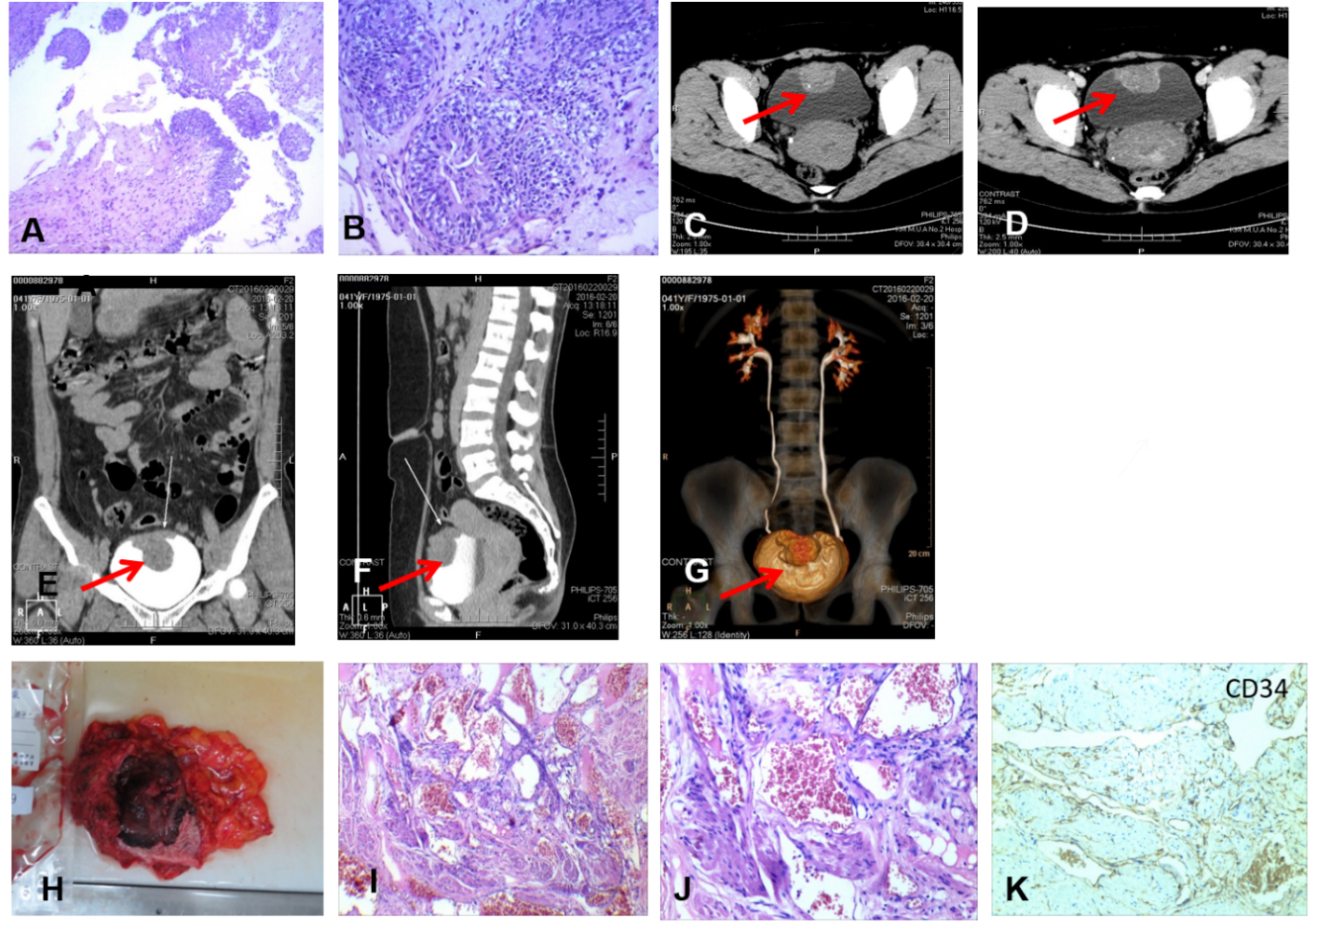
Figure 1 Cystoscopy and biopsy, multislice spiral computed tomography urography scanning, and histological and immunohistochemical characteristics of case 1. A and B: The initial pathological report of cystoscopy and biopsy. Haematoxylin and eosin staining showed gland cystitis and local urothelial hyperplasia with nodule formation, but no clear cancer cells were found (A: 40 ×, B: 100 ×); C-G: Multislice spiral computed tomography urography of the urological system showed a 5.0 cm × 3.1 cm × 4.0 cm mass (orange arrow) arising from the superior and anterior wall of the urinary bladder with visible calcification and uneven enhancement; H: A specimen of the en bloc resected tumour. Macroscopically, it was a 10.0 cm × 7.0 cm × 4.0 cm partial cystectomy specimen, which on cut section showed a large, soft to firm haemorrhagic tumour mass measuring approximately 6.0 cm × 5.0 cm × 5.0 cm; and I-K: Histological and immunohistochemical characteristics of the en bloc resected tumour. Haematoxylin and eosin staining exhibited the urothelium of the bladder mucosa in the resected specimen and dilated thin-walled vessels in the detrusor muscle layer (I: 40 ×). The lesion was composed of small irregular angiomatous spaces lined by a simple layer of endothelial cells (J: 100 ×), and endothelial cells were CD34-positive (K: 100 ×).
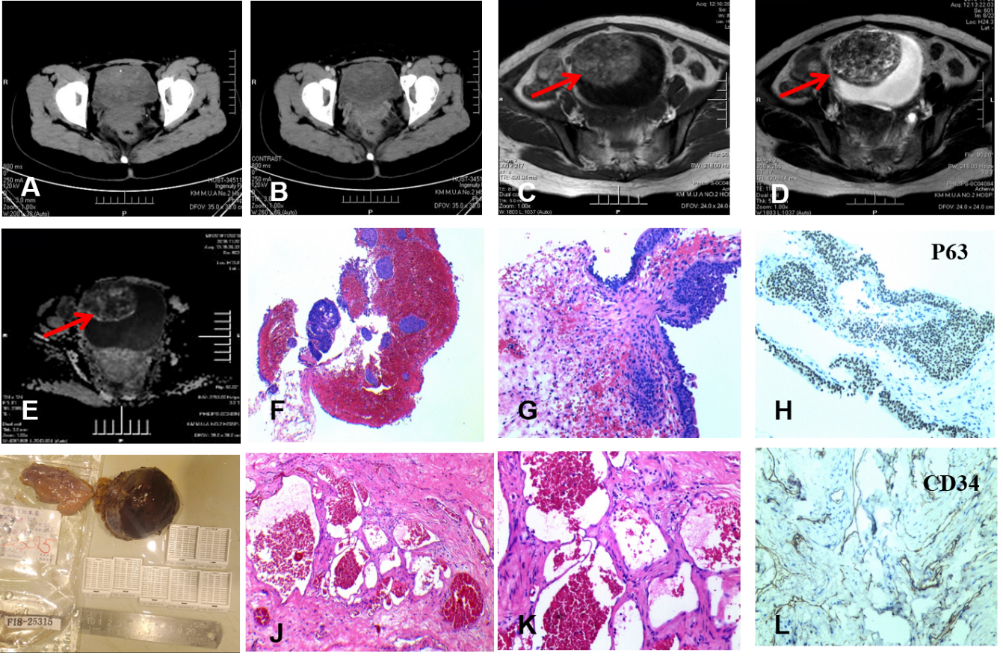Figure 2 Computed tomography scanning, magnetic resonance imaging scanning, cystoscopy and biopsy, and pathological analysis of case 2. A and B: Preoperative computed tomography scan image showed that the bladder wall was thickened, and patchy soft tissue density shadows and punctate calcifications could be seen in the cavity (A) along with uneven enhancement (B); C-E: Preoperative pelvic magnetic resonance imaging. The tumour was a large 6.2 cm × 6.9 cm × 5.2 cm sharply defined lesion on the right anterior and upper bladder wall, which showed intermediate signal intensity on T1-weighted images (C), heterogeneous signal intensity with a predominance of hyperintensity on T2-weighted images, and marked enhancement of the lesion (D). Diffusion weighted imaging showed a slightly higher signal, Apparent Diffusion Coefficient (ADC) showed a slightly lower signal, and the enhancement was slight (E). F and H: Cystoscopy and biopsy. The initial pathological report of haematoxylin and eosin showed gland cystitis and a single-layer flat endothelium with no nuclear atypia (F: 40 ×, G: 100 ×); endothelial cells were P63-positive (H: 100 ×); I: A specimen of the resected tumour: The gross histopathology revealed a well-circumscribed tumour bearing a vesicle-like shape with a size of 7.0 cm × 5.0 cm × 4.0 cm and a grey-brown cut surface; and J-L: Histological and immunohistochemical characteristics after partial cystectomy. Haematoxylin and eosin staining showed that the tissue structure was predominantly formed by large and dilated vessels that were engorged with blood and covered with a thin wall (J: 40 ×) but with no clear atypia of endothelial cells (K: 100 ×). Endothelial cells were CD34-positive (L: 100 ×).
Figure 3 Postoperative urinary and pelvic ultrasonography image taken within 3 mo of surgery for case 2.

Table 1 Literature review of the reported cases of clinicopathologic characteristics of haemangioma in the bladder
Ref. | Case No. | Sex/Age in yr | Clinical manifestation | Site | Tumour size | Pathologic examination | Treatment | Follow-up (mo)
Kato et al^{[12]}, 2000 | 1 | F/8 | Gross haematuria, Klippel Trenaunay Syndrome | The apex of the bladder | 4.0 cm | NA | Nd: YAG laser | NED (10)
Pratap et al^{[13]}, 2007 | 2 | M/5 | Gross haematuria accompanied by lower abdominal pain | The dome and the posterolateral bladder wall | 5.0 cm | Cavernous haemangiolymphangioma | Partial cystectomy | NED (8)
Tavora et al^{[5]}, 2008 | 3 | F/19 | Haematuria alone | Not mentioned | 1.1 cm | Cavernous haemangioma | Biopsy | LFU
 | 4 | M/67 | Haematuria combined with pain | Not mentioned | 3.2 cm | Capillary haemangioma | Biopsy | NED (24)
 | 5 | F/85 | Asymptomatic | Not mentioned | 2.4 cm | Capillary haemangioma | Biopsy | NED (4)
Macedo et al^{[14]}, 2010 | 6 | F/7 | Mild haematuria with clots | Supratrigonal lateral and posterior bladder wall | Numerous haemangiomas | NA | Electrocautery | NED (6)
Ashley et al^{[15]}, 2010 | 7 | F/3 | Gross haematuria | Posterior and left lateral bladder wall | 4.0 cm | Cavernous haemangioma lymphangioma | Cystoscopic illuminated partial cystectomy | NA
Takemoto et al^{[16]}, 2011 | 8 | M/4 | Gross haematuria | Anterior wall, dome, and right lateral bladder wall | Covered about 60% of the bladder | NA | Nd: YAG/ holmium: YAG laser | NED (24)
Mager et al^{[17]}, 2014 | 9 | M/46 | Disabling lower urinary tract symptoms | Prostate, the seminal vesicle, and the bladder neck | Not mentioned | NA | Interventional superselective coiling of the arterial feeder | NED (6)
Jibhkate et al^{[18]}, 2015 | 10 | M/3 | Gross haematuria accompanied by lower abdominal pain | The dome of the bladder | 7.0 cm | Cavernous haemangioma | Partial cystectomy | NED (12)
Kim et al^{[6]}, 2015 | 11 | M/4 | Intermittent and recurrent painless gross haematuria | The bladder dome and along the lateral aspects | 1.3 cm | Cavernous haemangioma | Coagulated with a holmium laser | NA
Lahyani et al^{[19]}, 2015 | 12 | M/60 | Macroscopic haematuria | The dome of the bladder | Not mentioned | Cavernous haemangioma | Partial cystectomy and augmentation cystoplasty | NA
Jin et al^{[20]}, 2016 | 13 | M/46 | Asymptomatic | The right bladder wall | 1.4 cm | Intramural anastomosing haemangioma | Partial cystectomy | NA
de Sousa et al^{[21]}, 2017 | 14 | M/2 | Persistent gross haematuria | The dome of the bladder | Not mentioned | Cavernous haemangioma | Partial cystectomy | NA
Hu et al^{[9]}, 2018 | 15 | F/49 | Painless haematuria | The superior posterior wall | 1.0 cm | Cavernous haemangioma | Transurethral tumour resection | NED (18)
Syu et al^{[22]}, 2019 | 16 | M/17 | Painless gross haematuria | The superior anterior wall | 3.5 cm | Cavernous haemangioma | En bloc resection of the urachus and bladder  tumour with opened surgery | NED (24)
This report | 17 | F/44 | Painless gross haematuria | The superior anterior wall | 5.0 cm | Cavernous haemangioma | Open radical cystectomy | NED (36)
 | 18 | F/31 | Asymptomatic | The right anterior wall | 6.9 cm | Cavernous lymphangioma and haemangioma | Laparoscopic partial cystectomy | NED (12)
LFU: Lost to follow-up; NA: Not available; Nd: Neodymium; NED: No evidence of disease; YAG: Yttrium-aluminium-garnet.

Published by Baishideng Publishing Group Inc
7041 Koll Center Parkway, Suite 160, Pleasanton, CA 94566, USA
Telephone: +1-925-3991568
E-mail: bpgoffice@wjgnet.com
Help Desk: https://www.f6publishing.com/helpdesk
https://www.wjgnet.com

© 2021 Baishideng Publishing Group Inc. All rights reserved.

